HARMONISED EUROPEAN STANDARD
Draft ETSI EN 303 364-2 PRIMARY SURVEILLANCE RADAR V0 1 NEW N (05/04/2016)
Harmonised Standard covering the Essential Requirements of Article 3.2 of the Directive 2014/53/EU Part 2 Primary Surveillance Radar (PSR); S Band Primary ATC Surveillance Radar Sensor in the Frequency Band 2700 MHz to 3100 MHz

C:\USERS\DAVID\DOCUMENTS\ETSI\PRIMARY SURVEILLANCE RADAR V0 2 NEW N.DOCX
HARMONISED EUROPEAN STANDARD
HARMONISED EUROPEAN STANDARD

HARMONISED EUROPEAN STANDARD

Reference
DEN/ERM-JTFEA-31
Keywords
AERONAUTICAL, RADAR and RADIO

ETSI
650 Route des Lucioles
F-06921 Sophia Antipolis Cedex - FRANCE

Tel.: +33 4 92 94 42 00 Fax: +33 4 93 65 47 16

Siret N° 348 623 562 00017 - NAF 742 C
Association à but non lucratif enregistrée à la
Sous-préfecture de Grasse (06) N° 7803/88

Important notice
The present document can be downloaded from:
http://www.etsi.org/standards-search
The present document may be made available in electronic versions and/or in print. The content of any electronic and/or print versions of the present document shall not be modified without the prior written authorization of ETSI. In case of any existing or perceived difference in contents between such versions and/or in print, the only prevailing document is the print of the Portable Document Format (PDF) version kept on a specific network drive within ETSI Secretariat.
Users of the present document should be aware that the document may be subject to revision or change of status. Information on the current status of this and other ETSI documents is available at http://portal.etsi.org/tb/status/status.asp
If you find errors in the present document, please send your comment to one of the following services:
https://portal.etsi.org/People/CommiteeSupportStaff.aspx
Copyright Notification
No part may be reproduced or utilized in any form or by any means, electronic or mechanical, including photocopying and microfilm except as authorized by written permission of ETSI.
The content of the PDF version shall not be modified without the written authorization of ETSI.
The copyright and the foregoing restriction extend to reproduction in all media.

© European Telecommunications Standards Institute 2016.
All rights reserved.
DECTTM, PLUGTESTSTM, UMTSTM and the ETSI logo are Trade Marks of ETSI registered for the benefit of its Members.
3GPPTM and LTE™ are Trade Mark of ETSI registered for the benefit of its Members and of the 3GPP Organizational Partners.
GSM® and the GSM logo are Trade Marks registered and owned by the GSM Association.
Contents
Intellectual Property Rights 5
Foreword 5
Modal verbs terminology 5
Executive summary 6
1 Scope 6
2 References 7
2.1 Normative references 7
2.2 Informative references 7
3 Definitions, symbols and abbreviations 8
3.1 Definitions 8
3.2 Symbols 9
3.3 Abbreviations 10
4. Applicability of Radio Parameters 11
4.1. General 11
4.1.1. Operating frequency range 11
4.1.2. Other information 11
5 Technical parameters for article 3.2 of Directive 2014/53/EU 12
5.1 Environmental profile 12
5.2 Transmitter parameters under article 3.2 of Directive 2014/53/EU 12
5.3 Radar receiver resilience to interference under article 3.2 12
5.4.1 General 12
5.4.2 Receiver sensitivity 14
5.4.3 Receiver co-channel rejection 14
5.4.4 Receiver Selectivity 14
5.4.4.1 General 14
5.4.5 Receiver unwanted emissions in the spurious domain 14
5.4 Antennas 15
5 Testing for compliance with technical requirements 15
6.1 Environmental conditions for testing 15
6.1.1 Introduction 15
6.1.2 Standard operation mode for testing 15
6.1.3 Normal temperature and humidity 15
6.1.4 Normal test power supply 16
6.2 Interpretation of the measurement results 16
6.3 Transmission test measurements 16
6.3.1 Transmitter test specification 16
6.3.2 Operating frequency 16
6.3.3 Transmitter power 17
6.3.4 Out-of-Band-emissions 17
6.3.5 Spurious emissions S band 17
6.3.6 Receiver test specification 18
6.3.6.1 Receiver Selectivity leave this (M4) 18
Annex A (informative) Relationship between the present document and the essential requirements of Directive 2014/53/EU 18
Annex B (normative): Measurement of the transmission of unwanted emissions of radar systems 21
Annex C (normative): Definition of receiver test measurement scenarios 22
1.2 Method 1(note …… should be C.1) 22
1.3 Method 2 (note …… should be C.2) 23
1.4 Method 3 (note …… should be C.3) 24
1.5 Receiver chain assessment (note: should be C.4) 24
1.5.1 Measurement type 1 (note should be C.4.1) 24
1.5.2 Measurement type 2 (note should be C.4.2) 25
1.5.3 Measurement type 3 (note should be C.4.3) 25
Annex D (normative): Definition of test measurement methodologies 30
1.6 Transmitter Function (D.1) 30
1.7 Receiver Function (D.2) 30
[Annex E (informative): Bibliography] 31
Annex F (informative): Change History 32
History 33

Figures

Figure 1. Radio frequency transmission measurements 21
Figure 2. Free space test scenarios and free space test target generation block diagram for conventional rotation PSR (two receive beams shown) 22
Figure 3. Free space interference scenarios and internal injected target generation diagram for conventional rotating PSR 23
Figure 4. Injected Test signal and target generation diagram for conventional rotating PSR 25
Figure 5. Injected test scenarios and injected target generation diagram for phased array receive antenna 26
Figure 6. Possible external interference signal scenario generation 26
Figure 7. Scenario 1 - Adjacent band test signals (i.e. out of allocated radar band) 27
Figure 8. Scenario 2 – In radar band sharing with ‘no implicit‘ IF filter measurement 27
Figure 9. Scenario 3 - In-radar band sharing with ‘implicit‘ IF filter assessment (is this too difficult?) 28

Tables
Table 1: Transmit/Receive Frequency Bands of X, S and L band Primary Radar Sensors 6
Table 2: Definitions 9
Table 3: Symbols 10
Table 4: Abbreviations 11
Table 5: Radar Sensor measurements - maximum measurement uncertainty 16
Table 6: Out-of-Band emissions boundaries 17
Table 7: Spurious emissions measurement bands 17
Table 8: Relationship between the present document and the essential requirements of Directive 2014/53/EU 20
Table 9: Correspondence between the present document and Article 3.2 of Directive 2014/53/EU 20
Table 10: All scenario –Field strength equivelent power at [A] definitions of all values TBD 29
Table 11: Scenario - parameters (a), (b), (c), (d) and (e) (TBA) 30
Table 12: Bibliography 31

Intellectual Property Rights
IPRs essential or potentially essential to the present document may have been declared to ETSI. The information pertaining to these essential IPRs, if any, is publicly available for ETSI members and non-members, and can be found in ETSI SR 000 314: "Intellectual Property Rights (IPRs); Essential, or potentially Essential, IPRs notified to ETSI in respect of ETSI standards", which is available from the ETSI Secretariat. Latest updates are available on the ETSI Web server (http://ipr.etsi.org).
Pursuant to the ETSI IPR Policy, no investigation, including IPR searches, has been carried out by ETSI. No guarantee can be given as to the existence of other IPRs not referenced in ETSI SR 000 314 (or the updates on the ETSI Web server) which are, or may be, or may become, essential to the present document.

Foreword
This draft Harmonised European Standard (EN) has been produced by ETSI Technical Committee Electromagnetic Compatibility and Radio Spectrum Matters (ERM) and is now submitted for the combined Public Enquiry and Vote phase of the ETSI standards EN Approval Procedure.
The present document has been prepared in reply to the Commission's standardisation request Commission Implementing Decision C(2015) 5376 final of 04.08.2015 to provide a means of conforming to the essential requirements of Directive 2014/53/EU [i.1] on the harmonisation of the laws of the Member States relating to the making available on the market of radio equipment – also known as the Radio Equipment Directive.
Once the present document is cited in the Official Journal of the European Union under that Directive, compliance with the normative clauses of the present document given in table […] confers, within the limits of the scope of the present document, a presumption of conformity with the corresponding essential requirements of that Directive, and associated EFTA regulations.
Harmonized EN covering the essential requirements of article 3.2;
" Harmonised Standard covering the Essential Requirements of Article 3.2 of the Directive 2014/53/EU Part 2 Primary Surveillance Radar (PSR); S Band Primary ATC Surveillance Radar Sensor in the Frequency Band 2700 MHz to 3100 MHz ".

Proposed national transposition dates
Date of latest announcement of this EN (doa): | 3 months after ETSI publication
Date of latest publication of new National Standard  or endorsement of this EN (dop/e): | 6 months after doa
Date of withdrawal of any conflicting National Standard (dow): | 18 months after doa

Modal verbs terminology
In the present document "shall", "shall not", "should", "should not", "may", "need not", "will", "will not", "can" and "cannot" are to be interpreted as described in clause 3.2 of the ETSI Drafting Rules (Verbal forms for the expression of provisions).
"must" and "must not" are NOT allowed in ETSI deliverables except when used in direct citation.
The technical definitions referred to shall be as in EG 203 336 dated June 2015 unless otherwise defined and agreed in this document

Executive summary
This document will cover ground based ATC Primary Surveillance Radar systems for civil air navigation operating in the frequency bands L, S and X.
This EN is in three parts
- Part 1: 1215 – 1400 MHz
- Part 2: 2700 – 3100 MHz
- Part 3: 8500 – 10000 MHz

1 Scope
This EN part 1, part 2, part 3, applies to L-band radar sensors and S-band radar sensors and X-band radar sensors intended for aeronautical primary surveillance radar with the following characteristics:

EN 303 364 | Band | Service frequency bands
Part 1 | L band Transmit | 1215 MHz to 1400 MHz
 | L band Receive | 1215 MHz to 1400 MHz
Part 2 | S band Transmit | 2700 MHz to 3100 MHz
 | S band Receive | 2700 MHz to 3100 MHz
Part 3 | X band Transmit | 8500 MHz to 10000 MHz
 | X band Receive | 8500 MHz to 10000 MHz
Table 1: Transmit/Receive Frequency Bands of X, S and L band Primary Radar Sensors
NOTE 1:
The frequency range for measurements of unwanted emissions in the spurious domain that needs to be addressed covers 30 MHz to Fmax * 5 for the 5th harmonic, limited to 26 GHz. The upper and low frequency limits corresponds to the upper and lower limit stated in ERC/Recommendation 74-01 [i.5].
NOTE 2:
According to Article 5 of the International Radio Regulations 2012 [i.6] the band 1 215 MHz to 1 300 MHz is allocated to the Earth Exploration-Satellite (active), Radiolocation, Radionavigation-Satellite and Space Research Services on a co-primary basis. The band 1 300 – 1 350 is allocated to Radiolocation, Aeronautical Radionavigation and Radionavigation Satellite (Earth-to-space) Services on a co-primary basis. The band 1 350 – 1 400 MHz is allocated to Fixed, Mobile and Radiolocation Services on a co-primary basis in region 1.
According to Article 5 of the International Radio Regulations 2012 [i.6] the band 2 700 MHz to 2 900 MHz is allocated to the Aeronautical Radionavigation Service on a primary basis and Radiolocation Service on a secondary basis. The band 2 900 MHz to 3 100 MHz is allocated to the Radiolocation and Radionavigation Services on a co-primary basis
According to Article 5 of the International Radio Regulations 2012 [i.6] the band 8 900 MHz to 9 000 MHz is allocated to Radiolocation and Maritime Radionavigation Services on a co-primary basis. The band 9 000 MHz to 9 200 MHz is allocated to the Radiolocation and Aeronautical Radionavigation Services on a co-primary basis. The band 9 200 MHz to 9 300 MHz is allocated to the Radiolocation and Maritime Radionavigation services on a co-primary basis. The band 9 300 MHz to 9 800 MHz is allocated to the Earth Exploration-Satellite (active), Radiolocation, Radionavigation and Space Research (active) services on a co-primary basis. The band 9 800 MHz to 9 900 MHz is allocated to the Radiolocation service on a primary basis and Earth Exploration-Satellite (active), Fixed and Space research (active) services on a secondary basis. The band 9 900 MHz to 10 000 MHz is allocated to the Radiolocation service on a primary basis and the Fixed service on a secondary basis.
The present document contains requirements to demonstrate that "... Radio equipment shall be so constructed that it both effectively uses and supports the efficient use of radio spectrum in order to avoid harmful interference”. [i.1]
Article 3 of the RE Directive [i.1].

2 References

2.1 Normative references
References are either specific (identified by date of publication and/or edition number or version number) or non-specific. For specific references, only the cited version applies. For non-specific references, the latest version of the referenced document (including any amendments) applies.
Referenced documents which are not found to be publicly available in the expected location might be found at http://docbox.etsi.org/Reference.
NOTE: While any hyperlinks included in this clause were valid at the time of publication, ETSI cannot guarantee their long term validity.

2.2 Informative references
References are either specific (identified by date of publication and/or edition number or version number) or non-specific. For specific references, only the cited version applies. For non-specific references, the latest version of the referenced document (including any amendments) applies.
NOTE: While any hyperlinks included in this clause were valid at the time of publication, ETSI cannot guarantee their long term validity.
The following referenced documents are not necessary for the application of the present document but they assist the user with regard to a particular subject area.
[i.1] Directive 2014/53/EU of the European Parliament and of the Council of 16 April 2014 on the harmonisation of the laws of the Member States relating to the making available on the market of radio equipment and repealing Directive 1999/5/EC.
[i.2] Eurocontrol Standard Document for Radar Surveillance in En-Route and Major Terminal Areas SUR.ET1.ST01.1000-STD-01-01 Edition : 1.0 Date : March 1997.
[i.3] EC Regulation No 552/2004, the Interoperability Regulation, Article 5 and Annex III (3) as amended by EC Regulation No 1070/2009.
[i.4] ECC/Recommendation (02)05 (2012): "Unwanted emissions".
[i.5] ERC/Recommendation 74-01 (2011): "Unwanted emissions in the spurious domain".
[i.6] ITU Radio Regulations (2012).
[i.7] ITU-R Recommendation M.1177-4 (2011): "Techniques for measurement of unwanted emissions of radar systems".
[i.8] ITU-R Recommendation SM.1541-6 (2015) "Unwanted emissions in the out-of-band domain".
[i.9] ITU –R SM329-12 (2012).
[i.10] Regulation (EU) 1025/2012 of the European Parliament and of the Council of 25 October 2012 on European Standardisation, amending Council Directives 89/686EEC and 93/15/EEC and Directives 94/9/EC, 94/25/EC 95/16/EC, 97/23/EC, 98/34/EC, 2004/22/EC, 2007/23/EC, 2009/23/EC and 2009/105/EC and the European Parliaments and of the Council and repealing Council Decision 87/95/EEC and Decision No 1673/2006/EC of the European Parliament and of the Council.
[i.11] ETSI TR 100 028 (all parts) (V1.4.1): “Electromagnetic compatibility and Radio spectrum Matters (ERM); Uncertainties in the measurement of mobile radio equipment characteristics”.
[i.12] ETSI TS 103 052 (V1.1.1) (03-2011): "Electromagnetic compatibility and Radio spectrum Matters (ERM); Radiated measurement methods and general arrangements for test sites up to 100 GHz".ETSI TR 100 028-2 (V1.4.1): "Electromagnetic compatibility and Radio spectrum Matters (ERM); Uncertainties in the measurement of mobile radio equipment characteristics; Part 2".
[i.13] SPI IR 1207/2011 & 1028/2014
[i.14] CISPR 16-1-1:2015: "Specification for radio disturbance and immunity measuring apparatus and methods - Part 1-1: Radio disturbance and immunity measuring apparatus - Measuring apparatus".
[i.15] EUROCONTROL STANDARD DOCUMENT FOR RADAR SURVEILLANCE IN EN-ROUTE AIRSPACE AND MAJOR TERMINAL AREAS. MARCH 1997. SUR.ET1.ST01.1000-STD-01-01. PSR sensor performance requirements for supporting 3 NM and 5 NM horizontal separation (SURVSTD).
[i.16] EUROCONTROL Specification for ATM Surveillance System Performance
- Volume 1 Edition: 1.1 Edition date: September 2015. Reference nr: EUROCONTROL-SPEC-147 ISBN: 978-2-87497-022-1
- Volume 2 Appendices Edition: 1.1 Edition date: September 2015. Reference nr: EUROCONTROL-SPEC-147 ISBN: 978-2-87497-022-1
[i.17] ETSI EN 301 489-1 “Electromagnetic and Radio Spectrum Matters (ERM) Electromagnetic Compatibility (EMC) standards for radio equipment and services Part 1: Common technical requirements”
[i.18] EN 61000-6-1, (immunity- light) EN 61000-6-3 (emissions, light industrial)
Product Safety Compliance with 2006/96/EC European Directive (Low Voltage Directive) and with:
[i.27] EN 60950-1 “Safety of Information Technology Equipment“.
[i.28] 1999/519/CE Council recommendation, from July 1999 relative to t limitation of exposure for public to electromagnetic fields (from 0 Hz to 300 GHz).
[i.29] 2004/40/CE “European directive European parliament and council of 29 April 2004 concerning the minimum health and safety prescriptions relative to workers in EM fields“.

3 Definitions, symbols and abbreviations

3.1 Definitions
For the purposes of the present document, the following terms and definitions apply:
Term | Definition | Note
necessary bandwidth | width of the frequency band which is just sufficient to ensure the transmission of information at the rate and with the quality required under specified conditions for a given class of emission | This definition is taken from ITU Radio Regulation [i.6].
occupied bandwidth | width of a frequency band such that, below the lower and above the upper frequency limits, the mean powers emitted are each equal to a specified percentage β/2 of the total mean power of a given emission. | NOTE 1:  This definition is taken from ITU Radio Regulation [i.6].  NOTE 2:  Unless otherwise specified in an ITU-R Recommendation for the appropriate class of emission, the value of β/2 should be taken as 0.5%.
peak envelope power | average power supplied to the antenna transmission line by a transmitter during one radio frequency cycle at the crest of the modulation envelope taken under normal operating conditions | NOTE:  This definition is taken from ITU Radio Regulation [i.6]).
pulse duration | time between the 50 % amplitude (voltage) points
pulse rise time | time taken for the leading edge of the pulse to increase from 10 % to 90 % of the maximum amplitude (voltage)
radar sensors | Shall be defined as:  On Transmission, the hardware to free space interface (i.e. free space side of antenna) where any RF signal leaves the supplied radar system  On reception it is defined as being from the point of signal entering the radar (i.e. free space side of antenna) from the air to hardware interface to one of the following;  - ASTERIX Plot output  - ASTERIX Track output or  - ASTERIX Video output | Note: Outputs 1,2,3 are the Asterix defined output
The injection of interfering scenarios | The introduction of the interfering signal Scenarios into the radar by either free space summation (Figure 4) or by direct injection into the radar receiver chain at some point after the antenna (Figure 5) | The injection point may vary from radar to radar but it must include the signal transiting any hardware components that may contribute to signal performance degradation in the presence of interference signals as defined in Scenarios 1,2 and 3
Table 2: Definitions

3.2 Symbols

For the purposes of the present document, the following symbols apply:
B-40 | -40 dB bandwidth | Units
BC | Chirp bandwidth
B_{N} | Necessary bandwidth
Bres | 3 dB resolution bandwidth of transceiver
dB/dec | dB per decade
dBpp | dB with respect to peak power
Dno spur | Detectability Factor (function of PD & Pfa)
k | Boltzmann's constant
I/N | Interference to Noise ratio
MDS | Minimum Detectable Signal
NFsys | Noise Figure of the system
PD | Probability of detection
PEP | Peak Envelope Power
Pfa | Probability of false alarm
Pt | Pulse power of transmission
S/N | Signal to Noise ratio
t | Time
tp | Pulse duration
tr | Pulse rise time
T0 | Temperature in Kelvin
TC | Chirp length in sec
λ | Wavelength
Table 3: Symbols

3.3 Abbreviations
For the purposes of the present document, the following abbreviations apply:

AC | Alternating Current
ESASSP | EUROCONTROL Specification for ATM Surveillance System Performance
EIRP | Equivalent Isotropic Radiated Power
FM-CW | Frequency Modulated Continuous Wave
IRS | Interfering radio signal
LNA | Low Noise Amplifier
MHz | Megahertz
OoB | Out-of-Band
RED | Radio Equipment Directive
PEP | Peak Envelop Power
PSR | Primary Surveillance Radar
Table 4: Abbreviations

Applicability of Radio Parameters

General
It is intended that the radio parameters referred to in the present document are tested in a manner that is consistent with the Primary Radar Surveillance needs as defined in ESASSP standards using appropriate measurement methods.
The receive assessment can be based on RF, IF, plot or track measurements and a link to the ESASSP radar related parameters shall be made. However there will be additional parameter associated with false alarm defined in the measurement process.

Operating frequency range
S-band Primary Air Traffic Control Surveillance Radar Sensors in the frequency range 2700 MHz to 3100 MHz.

Other information
N/A

5 Technical parameters for article 3.2 of Directive 2014/53/EU

Environmental profile
The technical requirements of the present document apply under the environmental profile for operation of the equipment, which shall be declared by the supplier, but as a minimum, shall be that specified in the test conditions contained in the present document.

Transmitter parameters under article 3.2 of Directive 2014/53/EU
The detailed definition of OoB/spurious domain boundary and limits is contained in Annex 2 of CEPT ECC Recommendation (02)05 [i.4]. For the case of primary radar systems, the OoB mask rolls off from the -40 dB bandwidth to the spurious limit at a rate specified in Annex 8 of Recommendation ITU-R SM.1541 [i.8]. The equations for determining the B₋₄₀ bandwidth are also given in Annex 8 of Recommendation ITU-R SM.1541.
The spurious limits for radar systems in the radiodetermination service are defined in annex 5, table 5.1 of CEPT/ERC/REC/74-01 [i.5]. The ITU-R.SM329 Category B spurious domain emissions limit for fixed stations is of -30 dBm or 100 dB_{pp} (whichever is less stringent). Multi-frequency and active array radars are however exempted and can revert to the Category A limit of 43 + 10 log(PEP) or 60 dB_{pp} (whichever is less stringent).
According to Annex 2 of CEPT ECC Recommendation (02)05 [i.4], the OoB mask has a roll-off at -30 dB/decade from the calculated -40 dB bandwidth (B₋₄₀) to a level of -60 dB_{pp}. For the limit of -100dB_{pp}, the mask continues until -70 dB_{pp} with -30 dB/decade and then with -60 dB/decade to the -100 dB_{pp} level. For the design objective, the mask has a roll-off at -40 dB/decade from the calculated B₋₄₀ to a level of -80 dB_{pp} and then continues to roll-off at -60 dB/decade to the -100 dB_{pp} level. For the -100 dB_{pp} spurious limit, the mask limit will result in the out-of-band emission domain width of 31.6 times B₋₄₀, and for the excluded radars in 4.6 times B₋₄₀. The design objective mask limits will reduce the out-of-band emission domain to the width of 21.5 times B₋₄₀.

Radar receiver resilience to interference under article 3.2

General
The Primary Surveillance Radar design may have one or more receivers fed from antenna elements such as a receiver horn(s) (see Figure 2) or phased array receive antennas (see Figure 5).
The radar sensor receiver is defined as the receiving part of the radar sensor system that includes the delivered Asterix outputs 1, 2 or 3 (radar sensors definition in Table 2) to the later processing or display system.
The radar sensor receiver itself may consist of smaller receiver elements (from two receivers to the designed value greater than two) that when combined and the data processed, generates the final Asterix outputs (1, 2 and 3)
The design of ATC primary radar systems can be varied and the ability of the radar to operate in the presence of other signals is a function of the Radio Frequency performance and the digital processing algorithms applied in the radar and the characteristics of the other signals.
This EN considers receiver tests that reflects the capacity of the radar sensor receiver and does not focus on a specific radar technology implementation.
The method is based the measurement of designated radar parameters with and without the presence of a set of RF scenarios that comprehensively tests the performance of the radar receiver system.
The scenario consists of the simultaneous injection of test frequencies that exercise a range of receiver parameters as indicated below:
- Receiver sensitivity
- Receiver co-channel rejection
- Adjacent channel selectivity
- Adjacent band selectivity
- Intermodulation susceptibility
- Blocking
- Dynamic range
- Reciprocal mixing
The conformance in this EN includes a requirement is the ability to provide evidence of ‘a known and stated level of performance’ both with and without a series of test scenarios that will exercise the effects 1 to 8 above.
The scenarios are designed to test various aspect of the radar system receiver design and combined with suitable metrics allow all the effects on the radar to be examined.
There are some metrics that ATC radar should meet which are in general the radar related ESASSP requirements that set performance parameters to be measured and met.
This then results in further radar related requirement (as previously indicated in publications such as the Primary Surveillance Radar requirement (SUR.ET1.ST01.1000-STD-01-01) such as probability of detection, and especially probability of false alarm.
The final test for a radar is in the operation in real life with clutter which is a matter for the end customer environment and contractual terms, however this EN focuses on the transmitter and receiver aspects, independent of ‘real life’ RF environmental factors (unless appropriate for measurement environment adopted).
The ESASSP requirements are broader than pure radar requirements but the parameters identified as those suitable for ATC radar assessment are as follows:
- SPI IR reference 1207/2011 & 1028/2014
- EUROCONTROL SPECIFICATION FOR ATM SURVEILLANCE SYSTEM PERFORMANCE (VOLUME 1). MARCH 2012. EUROCONTROL-SPEC-0147. ISBN 978-2-87497-022-1.
- EUROCONTROL Specification for ATM Surveillance System Performance (Volume 2 Appendices) Edition Number : 1.1 Date : 02/09/2015
In addition the following provides specific radar performance requirements:
- Eurocontrol Standard Document for Radar Surveillance in En-Route and Major Terminal Areas SUR.ET1.ST01.1000-STD-01-01 Edition : 1.0 Date : March 1997
To test the acceptability of the radar receiver (i.e. the immunity to RF interference) then there may be two general approaches:
- The injection of interfering scenarios and by RF /IF measurement (e.g. S/N) combined with technical analysis to produce an evidence based compliance with requirements based on the immunity to the scenarios
- The injection of interfering scenarios and simulated targets and assessing the radar performance in the presence of the interference via plot and track analysis
Wideband Gaussian noise is used to allow a consistent interfering signal statistic to be defined.
The scenarios shall be as diagrammatically represented in Annex C (normative): Definition of receiver test measurement scenarios.
Scenario 1 (Figure 6) is the adjacent band scenario where two blocks of Gaussian interferers are defined as occupying two frequency bands with set power levels at the antenna face. The interference is both below and above the radar band under consideration.
Scenario 2 (Figure 7) is the adjacent band scenario where one blocks of Gaussian interference is defined as occupying the entire allocated radar band with set power levels at the antenna face.
Scenario 3 (Figure 8) looks at the measurement similar to Scenario 2 but that considers ‘within IF bandwidth measurement’ and ‘out of IF bandwidth measurement’ again Gaussian interference type. This test allows an assessment of what element of the allocated Radionavigation spectrum in the band 2700 MHz to 3100 MHz is used by one radar system. – THIS MAY BE TOO DIFFICULT
The polarisation of the free space summation shall be assumed to be co-linear with the radar polarisation if the radar operates in a linear polarisation and it should be arbitrary polarisation if the radar is required to operate in circular polarisation at all times in operational use.
If the interfering signal is to be injected after the antenna but before the first component of significance (typically the LNA), then justification and equivalence of the injected signal to the specified free space signal level shall be shown.

Receiver sensitivity
Receiver sensitivity may vary however the requirement is based upon the need for the ESASSP and SUR.ET1.ST01.1000-STD-01-01 requirements to be met with the presence of other interfering sources (in-band or out of band).

Receiver co-channel rejection
Scenario 2 and scenario 3
Wideband Gaussian noise of two instantaneous bandwidths;
- 10MHz BW swept from ARF(1) to ARF(2) and
- 200MHz (x2) instantaneous bandwidth ARF(1) to ARF(2) in two blocks
to be considered, the value (c) is approximately -130 dBm/MHz/m²

Receiver Selectivity

General
The requirement is to meet the relevant requirements in the presence of defined scenarios. The following receiver characteristics will be tested for the EN by the scenarios 1 and scenario 3.
- Single signal selectivity, Receiver adjacent signal selectivity (adjacent channel selectivity), Limit, Receiver multiple signal selectivity Receiver radio-frequency Receiver blocking, intermodulation Reciprocal mixing Receiver dynamic range
Receiver radio frequency intermodulation can be regarded as the generation of third order products by the non-linear response of the receiver chain of signals by unwanted interference level in the receiver. Any detrimental effect would be by the generation of in-band intermodulation by signals by the test scenarios.
Dynamic range varies by radar, frequency, pulse width, etc. The dynamic range must be sufficient to allow the requirement to be met in the presence of the defined signal scenarios.

Receiver unwanted emissions in the spurious domain
The receiver may be active during the interval between transmission periods in the case of ‘monostatic transmit / receive operation and during any operation shall meet unwanted emissions as defined in 74/01 and 02/05
EN 489-1 (EMC for Radio equipment) approach, 480 defines test limits, 489-1,-2, 3 check CENELEC standards

Antennas
If parts from separate sources are integrated then the final system integrator or whoever places the system onto the market that end person is required to provide the technical file, or Declaration of Conformity when complying with a Harmonised standard.
Where the end user integrates products from separate sources then brings that system into service it is the end user that is required to provide the technical file, and Declaration of Conformity.
Need to specify intended use and any further technical additions to meet requires (‘data sheet’)

Testing for compliance with technical requirements
For the purpose of the compliance tests described in the present document, the radar under test shall be set up in a realistic operation mode. This means that the transceiver shall be operating and set-up with parameters which produce the worst-case spectrum (e.g. shortest pulse length, highest peak frequency deviation). Furthermore, the radar has to be supplied with the necessary signals (e.g. antenna azimuth encoder signal, safety loop signals) to simulate normal operation.
NOTE: The standard operating parameters depend on the type of the radar.
In the test-report the mode of operation applied for the tests shall be documented, in conjunction with a rational, why this mode has been chosen.
Tests defined in the present document shall be carried out at representative points within the boundary limits of the declared operational environmental profile.
Where technical performance varies subject to environmental conditions, tests shall be carried out under a sufficient variety of environmental conditions (within the boundary limits of the declared operational environmental profile) to give confidence of compliance for the affected technical requirements.

Environmental conditions for testing

Introduction
Unless otherwise stated, all tests shall take place under the following normal test conditions.

Standard operation mode for testing
During the tests the radar equipment shall be operated in the standard operation mode. This means that the transceiver shall be operating and set-up with parameters which produce the worst-case spectrum i.e. with shortest pulse length and highest peak frequency deviation. Furthermore, the radar shall be supplied with the necessary signals i.e. antenna azimuth encoder signal and safety loop signals to simulate normal operation.
NOTE: The standard operating parameters depend very much on the type of the radar.
In the test-report the mode of operation applied for the tests shall be documented, in conjunction with a rational, why this mode has been chosen.

Normal temperature and humidity
The temperature and humidity conditions for tests shall be a combination of temperature and humidity within the following ranges:
- Temperature: +15 oC to +35 oC; Misunderstanding – not environ test, just std test conditions.
- Relative humidity: 20 % to 75 %.
When the relative humidity is lower than 20 %, it shall be stated in the test report.

Normal test power supply
The test voltage for equipment to be connected to an AC supply shall be the nominal mains voltage declared by the manufacturer -10 % to +10 %. For the purpose of the present document, the nominal voltage shall be the declared voltage or each of the declared voltages for which the equipment is indicated as having been designed. The frequency of the test voltage shall be 50 Hz ± 1 Hz.

Interpretation of the measurement results
The interpretation of the results recorded in a test report for the measurements described in the present document shall be as follows:
- the measured value related to the corresponding limit will be used to decide whether an equipment meets the requirements of the present document;
- the value of the measurement uncertainty for the measurement of each parameter shall be included in the test report;
- the recorded value of the measurement uncertainty shall be, for each measurement, equal to or lower than the figures in Table 5.
For the test methods, according to the present document, the measurement uncertainty figures shall be calculated and shall correspond to an expansion factor (coverage factor) k = 1,96 or k = 2 (which provide confidence levels of respectively 95 % and 95,45 % in the case where the distributions characterising the actual measurement uncertainties are normal (Gaussian)).
Principles for the calculation of measurement uncertainty are contained in TR 100 028 [i.11], in particular in annex D of the TR 100 028-2 [i.12].
Table 5 is based on such expansion factors.

Parameter | Uncertainty
Transmitter measurements
Operating frequency | ±1∙10⁻⁵
Transmitter power | ±1,5 dB
Out-of-Band emissions | ± 4 dB
Spurious emissions | ± 4 dB
Table 5: Radar Sensor measurements - maximum measurement uncertainty

Transmission test measurements

Transmitter test specification

Operating frequency
Alain - replace for S-band Tim for L & Michael for X band
Standard transmitter measurement description

Transmitter power
The transmitted power shall be measured for regulatory use in planning with accuracy as in ‘Table 5: Radar Sensor measurements - maximum measurement uncertainty’

Out-of-Band-emissions
The so-called indirect method shall be applied for the measurement of unwanted emissions of radar systems. At first the transmitter output spectrum is measured with removed antenna at the output port of the transmitter as illustrated in Figure B.1.
NOTE 1: To obtain a sufficient dynamic range the radar signal need to be suppressed by an additional notch-filter.
Further information how to perform the measurement can be found in ITU-R Recommendation M.1177-4 [i.7]. The Out-of-Band power emission shall be measured in the frequency bands given in Table 6. The results obtained shall be compared to the limits in clause XXX and depicted in Figure 2 in order to prove compliance with the requirement.
NOTE 2: These OoB-boundaries are taken from ECC/Recommendation (02)05 [i.4].

Lower OoB boundary | Upper OoB boundary
Carrier frequency -15,8 B-40 | Carrier frequency + 15,8 B-40
Table 6: Out-of-Band emissions boundaries

NOTE 3: Typical PSR parameters are e.g. a centre frequency of 2.8 GHz, a pulse duration of t = ns and a rise time of tr = 10 ns, the 40 dB bandwidth calculated applying the equation from clause XXX is XXX MHz. This leads to OoB boundaries at 15,8 × XXX MHz = 5,372 GHz away from the centre frequency For this example the absolute boundaries between out-of-band emission and spurious emission are: 9,1 GHz – 5,372 GHz = 3,728 GHz and 9,1 GHz + 5,372 GHz = 14,472 GHz (see Figure 5 below).
Figures 4 and 5 depict the calculated emission masks for the aforementioned parameters of a typical SMR applying the mask specification in clause XXX which is corresponding to the standard mask in Figure A2.1c of ECC/Recommendation (02)05 [i.4].
[Respective L & S band companies to consider the value of masks for those bands.]

Spurious emissions S band
For the spurious emission measurements the aforementioned indirect method shall be used. To perform the measurement the radar and the measuring equipment shall be installed as displayed in Figure B.1. The spurious power emission shall be measured in frequency ranges outside the Out-of-Band emissions boundaries.
If required to reach a dynamic amplitude measuring range of 110 dB minimum, a Low Noise Amplifier (LNA), and a notch filter for the operating frequency should be used.
The results obtained shall be compared to the limits in clause XXX in order to prove compliance with the requirement.

Lower measurement band | Upper measurement band
From 2.08/6,56 GHz  to the lower OoB boundary | From the upper OoB boundary  to 15.5/26 GHz
Table 7: Spurious emissions measurement bands

Receiver test specification

Receiver Selectivity leave this (M4)

Annex A (informative)
Relationship between the present document and the essential requirements of Directive 2014/53/EU
The present document has been prepared by ETSI in response to mandate M/xxx from the European Commission to provide a means of conforming to the essential requirements of Directive 2014/53/EU of the European Parliament and of the Council of 16 April 2014 on the harmonisation of the laws of the Member States relating to the making available on the market of radio equipment and repealing Directive 1999/5/EC radio Equipment Directive [i.1].
Once the present document is cited in the Official Journal of the European Union under that Directive, compliance with the normative clauses of the present document given in table A.1 confers, within the limits of the scope of the present document, a presumption of conformity with the corresponding essential requirements of that Directive, and associated EFTA regulations.
Harmonised Standard ETSI EN 303 364
The following requirements are relevant to the presumption of conformity
under the article 3.2 of Directive 2014/53/EU
Requirement |  |  | Requirement Conditionality
No | Description | Reference: Clause No | U/C | Condition
1 | Transmitter power limits |  |  | Do we need to set at a high level as the power is deemed relevant or just a measurement need
2 | Transmitter power accuracy
3 | Spectrum mask
4 | Transmitter frequency stability
5 | Transmitter intermodulation attenuation
6 | Transmitter unwanted emissions in the spurious domain
7 | Unwanted emissions
8 | Unwanted emissions in the out of band domain
9 | Unwanted emissions in the spurious domain
10 | Transmitter time domain characteristics
11 | Transmitter transients
14 | Receiver sensitivity |  |  | Establishes the level of noise in the radar operational channel that the radar can still operate with (i.e. in the radar final bandwidth)
15 | Receiver co-channel rejection |  |  | Establishes the level of noise in the radar operational channel that the radar can still operate with
16 | Receiver Selectivity |  |  | Establishes the selectivity against a set of defined wide band signals (scenarios 1,2,3)
18 | Single signal selectivity |  |  | Incorporated in 16
19 | Receiver adjacent signal selectivity (adjacent channel selectivity) |  |  | Establishes the selectivity against a set of defined wide band signals (scenarios 1,2,3)
20 | Receiver spurious response rejection |  |  | Establishes the level of noise in the radar operational channel that the radar can still operate with
21 | Receiver multiple signal selectivity |  |  | Establishes the selectivity against a set of defined wide band signals (scenarios 1,2,3)
22 | Receiver blocking |  |  | - Establishes the level of noise in the radar operational channel that the radar can still operate with (scenario 3)  - Scenario 1
23 | Receiver radio-frequency intermodulation |  |  | Establishes the selectivity against a set of defined wide band signals (scenarios 1,2,3)
24 | Receiver adjacent signal selectivity (adjacent channel selectivity) |  |  | Establishes the selectivity against a set of defined wide band signals (scenarios 1,2,3)
25 | Other receiver effects
26 | Receiver dynamic range |  |  | ???
27 | Reciprocal mixing |  |  | ???
28 | Desensitization |  |  | ??? Do we want a range where desensitization is ‘linear and a level where the desensitization is non-linear (compression point???)
29 | Receiver unwanted emissions in the spurious domain |  |  | Defined in ….
30 | Protocol elements, interference mitigation techniques and type of modulation | Removed as not applicable to ATC Primary radar |  | Removed as not applicable to ATC Primary radar
31 | General | Removed as not applicable to ATC Primary radar |  | Removed as not applicable to ATC Primary radar
32 | Transmitter Power Control (TPC) | Removed as not applicable to ATC Primary radar |  | Removed as not applicable to ATC Primary radar
33 | Listen Before Talk (LBT) | Removed as not applicable to ATC Primary radar |  | Removed as not applicable to ATC Primary radar
34 | Equipment operating under the control of a network | Under operation of a network the normal EN clauses shall apply to the radar |  | The compliance to the EN parameters is independent of the radar control. I.e. any remote control has suitable restrictive processes to ensure safe operation
Table 8: Relationship between the present document and the essential requirements of Directive 2014/53/EU

Key to columns:
Requirement:
No A unique identifier for one row of the table which may be used to identify a requirement.
Description A textual reference to the requirement.
Clause Number Identification of clause(s) defining the requirement in the present document unless another document is referenced explicitly.
Requirement Conditionality:
U/C Indicates whether the requirement shall be unconditionally applicable (U) or is conditional upon the manufacturers claimed functionality of the equipment (C).
Condition Explains the conditions when the requirement shall or shall not be applicable for a requirement which is classified "conditional".
Presumption of conformity stays valid only as long as a reference to the present document is maintained in the list published in the Official Journal of the European Union. Users of the present document should consult frequently the latest list published in the Official Journal of the European Union.
Other Union legislation may be applicable to the product(s) falling within the scope of the present document.
Essential Requirements of Directive | Clause(s)/sub-clause(s) of the present document | Test specification
Article 3.2 | Operating frequency | Transmit coupler Calibrated Spectrum Analyser ± 1KHz
 | Transmitter power | Transmit coupler Calibrated Spectrum Analyser ± 1KHz
 | Out-of-Band emissions | In band filter Transmit coupler Calibrated Spectrum Analyser accuracy as per table xxx
 | Spurious emissions | In band filter Transmit coupler Calibrated Spectrum Analyser accuracy as per table xxx
 | 4.2.2.1 Receiver Selectivity | As per
Table 9: Correspondence between the present document and Article 3.2 of Directive 2014/53/EU

Annex B (normative):
Measurement of the transmission of unwanted emissions of radar systems
The method for measurement of the operation frequency, transmit power as well as out-of-band and spurious emission shown in Figure B.1 shall be applied.
This is a requirement for repeatable RF emissions (Transmit and Receiver) measurement technique for the appropriate radar technology.
DIAGRAM OF TEST MEASUREMENT SETUP

use ITU-R transmission signal measurement document

+ words to explain measurement

Figure 1. Radio frequency transmission measurements

Annex C (normative):
Definition of receiver test measurement scenarios
Test signal generation
There are three types of scenario generation techniques shown below.

Method 1(note …… should be C.1)
Figure 2 shows the version of test scenario generation where external interference signal and external target RF generation is use.
There are two continuous (in frequency and time) stationary interference signals generated [S1] and [S2]. In addition a simulated radar target is generated.
The mean signal strength for both [S1] and [S2] at [A] is 5 dBm when integrated across the particular band.
The method to establish this is by direct field strength measurement or by measurement at [B] where the transition to the radar system has been achieved by antenna and feed structures.
The lower beam [L] shall use the maximum lower beam gain [Ga(1)] to establish the signal in the radar in the lower beam channel
The upper beam [H] shall use the maximum upper beam gain to establish the signal in the radar [Ga(2)].
If there are other receive beams they should be analysed is the same manner.
The simulated target signal [S3] should be set at a level that allows any loss in radar sensitivity to be determined (usually by setting Pd to be in the region 0.6 to 0.9).
The receiver chain shall be assessed as per 1.5 below (number to be clarified on reformatting)
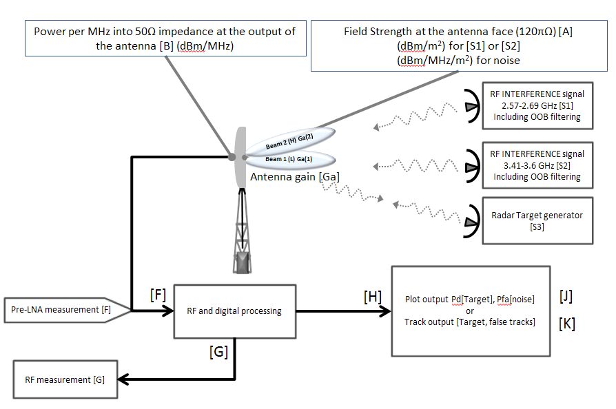
Figure 2. Free space test scenarios and free space test target generation block diagram for conventional rotation PSR (two receive beams shown)

Method 2 (note …… should be C.2)
Figure 3 shows the version of test scenario generation where external interference signal is generated and internal target RF generation is use.
There are two continuous (in frequency and time) interference signals generated [S1] and [S2]. In addition a simulated radar target is generated.
The mean signal strength for both [S1] and [S2] at [A] is 5 dBm when integrated across each band.
The method to establish this is by direct field strength measurement or by measurement at [B] where the transition to the radar system has been achieved by antenna and feed structures.
The lower beam [L] shall use the maximum gain [Ga(1)] to establish the signal in the radar in the lower beam channel
The upper beam [H] shall use the horizontal gain to establish the signal in the radar [Ga(2)].
The simulated target signal [S3] shall be generated by a radar target generation by sampling the radar waveform and be capable of generating simulated target with range rate and Doppler characteristics that are appropriate for the PSR under test to be able to detect the target
The effective RCS should be set at a level that allows any loss in radar sensitivity to be determined (usually by setting Pd to be in the region 0.6 to 0.9).
The RF losses from [B] to [F] should be accounted for especially the additional loss due tom the coupler [C] to [E] (including connector losses).

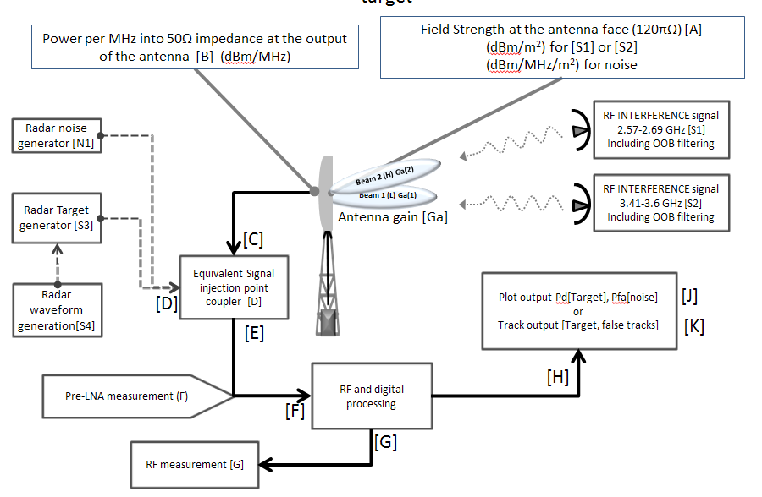
Figure 3. Free space interference scenarios and internal injected target generation diagram for conventional rotating PSR

Method 3 (note …… should be C.3)
Figure 4 shows the version of test scenario generation where internal interference signal is generated and internal target RF generation is use.
There are two continuous (in frequency and time) stationary interference signals generated [S1] and [S2]. In addition a simulated radar target is generated.
The mean signal strength for both [S1] and [S2] at [D] is the value equivalent to 8 dBm when integrated across each band as would be measured at [B].
The method to establish this is by direct field strength measurement or by measurement at [B] where the transition to the radar system has been achieved by antenna and feed structures.
The lower beam [L] shall use the maximum gain [Ga(1)] to establish the signal in the radar in the lower beam channel
The upper beam [H] shall use the maximum gain [Ga(2)] to establish the signal in the radar.
The simulated target signal [S3] shall be generated by a radar target generation by sampling the radar waveform and be capable of generating simulated target with range rate and Doppler characteristics that are appropriate for the PSR under test to be able to detect the target
The effective RCS should be set at a level that allows any loss in radar sensitivity to be easily determined (usually by setting Pd to be in the region 0.6 to 0.9).
The RF losses from [B] to [F] should be accounted for especially the additional loss due to the coupler [C] to [E] (including connector losses).
The signal levels [S1] and [S2] should use the following method to establish the [S1] and [S2] mean levels.
Use the nominal gains of the lower and upper beams to establish an antenna effective area ‘A_{eff}’ for both the lower [Aeff(1)] and upper beams [Aeff (2)] using Equation 1. The gain used shall be the maximum gain of the particular antenna beam (L or H or other if more than two beams)

$Aeff(n)=\frac{Ga(n)*λ^{2}}{4*π*ρ}$ …… Equation 1

This allows the interference to be calculated at [B].
The losses shall be applied so the signal levels are reduced by the losses from [B] to [F].

Receiver chain assessment (note: should be C.4)
There shall be an assessment of the critical elements of the receiver chain and any element that can cause S/N loss shall be included in any measurement (RF, IF, plot or track).

Measurement type 1 (note should be C.4.1)
The first type of measurement can be a RF / IF, measurement at [G] (this point must be justified by the manufacturer) where the criteria shall be that any increase in noise, i.e. loss in signal to noise is sufficiently low in the presence of the interfering scenarios, 1,2,3 such that the declared operational performance (by the manufacturer) would be maintained. There could be a loss in performance but this would have to translate into the declared operational performance still being met.

Measurement type 2 (note should be C.4.2)
A second type of measurement can be at [I] (this point must be justified by the manufacturer ) where the criteria shall be that any increase in false plots [I] is within the declared false plot performance of the radar and the simulated target probability of detection is maintained to be consistent with the declared Pd detection performance specification, i.e. the radar maintains its’ declared Pd and Pfa performance in in the presence of the interfering and target scenarios, 1,2,3 such that the declared operational performance (by the manufacturer) would be maintained. There could be a loss in performance but this would have to translate into the declared operational performance still being met.

Measurement type 3 (note should be C.4.3)
A third type of measurement can be at [J] (this point must be justified by the manufacturer ) where the criteria shall be that any increase in false [J] tracks is within the declared false track performance of the radar and the simulated target probability of detection is maintained to be consistent with the declared track initiation and track continuity specification, i.e. the radar maintains it operational performance in in the presence of the interfering and target scenarios, 1,2,3 such that the declared operational performance (by the manufacturer) would be maintained. There could be a loss in performance but this would have to translate into the declared operational performance still being met.
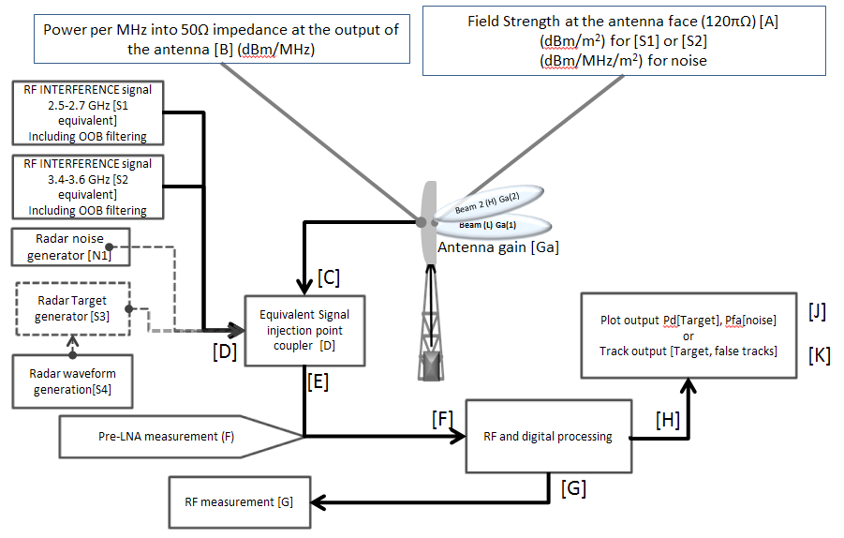
Figure 4. Injected Test signal and target generation diagram for conventional rotating PSR

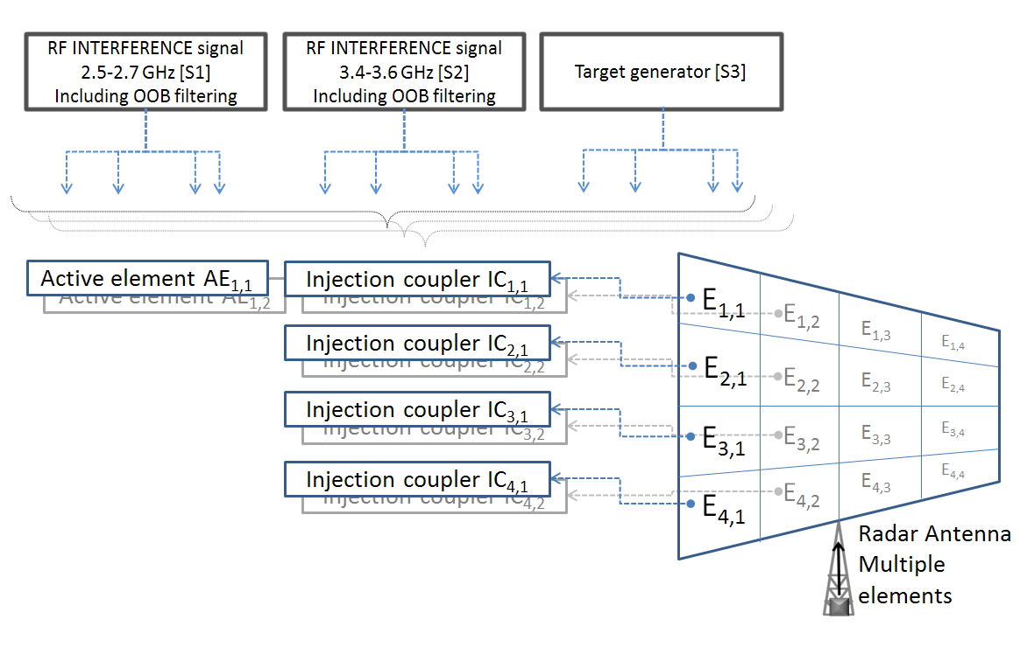
Figure 5. Injected test scenarios and injected target generation diagram for phased array receive antenna

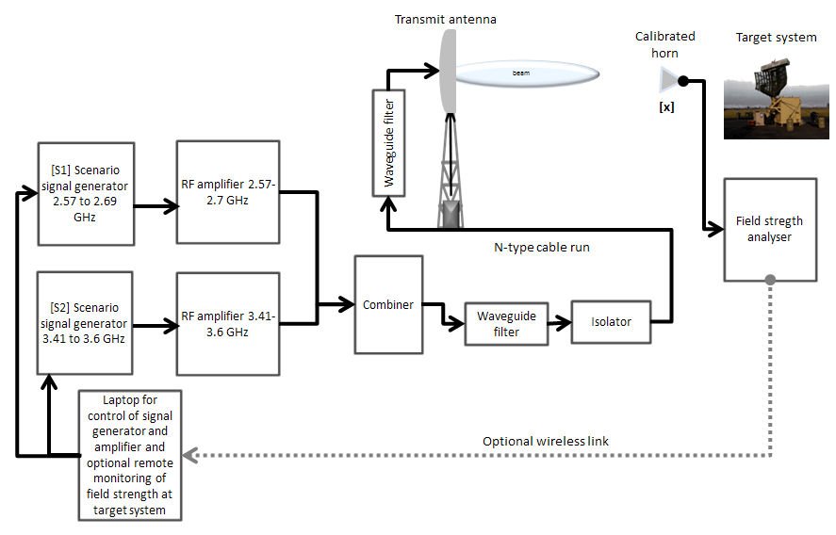
Figure 6. Possible external interference signal scenario generation

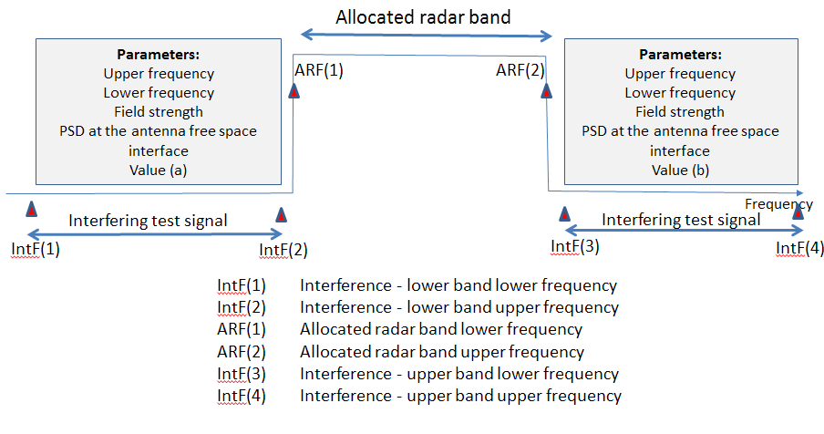
Figure 7. Scenario 1 - Adjacent band test signals (i.e. out of allocated radar band)

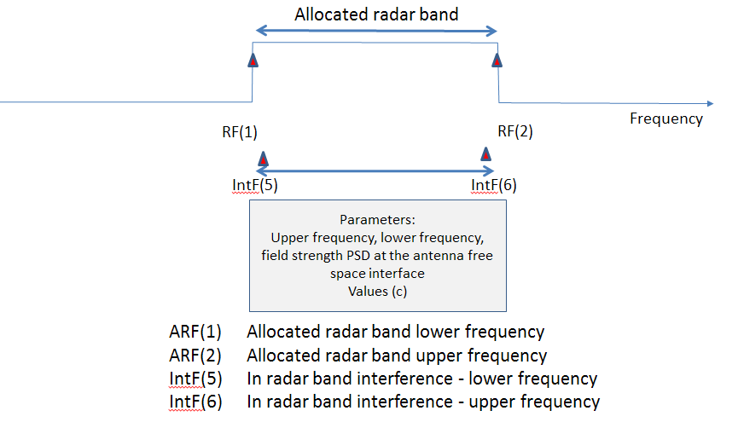
Figure 8. Scenario 2 – In radar band sharing with ‘no implicit‘ IF filter measurement

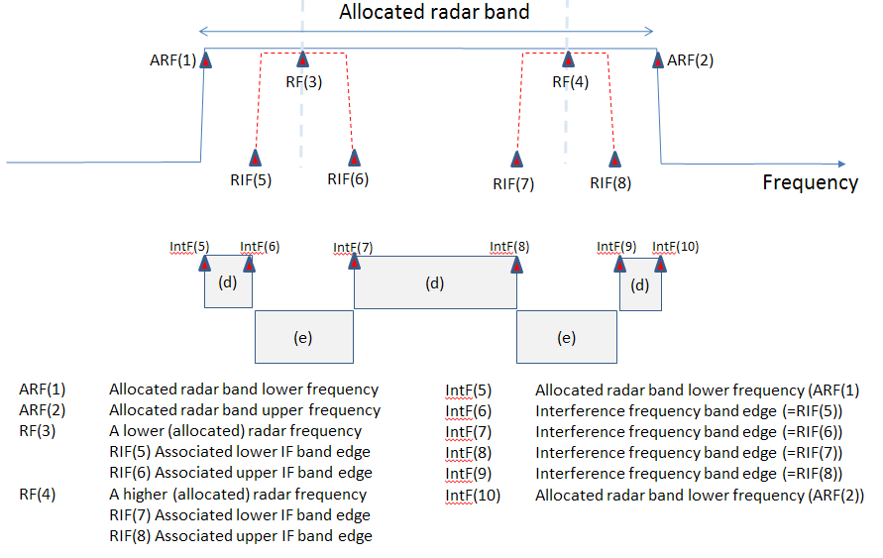
Figure 9. Scenario 3 - In-radar band sharing with ‘implicit‘ IF filter assessment (is this too difficult?)
The radar band (for S-band ) is 2.7 to 3.1 GHz so ARF(1) is 2.7 FGz and ARF(2) is 3.1 GHz
The manufacturer shall declare bands Intf(5) to Intf(6), Intf(7) to Intf(8) and Intf(9) to Intf(10)
Intf(6) to Intf(7) and Intf(8) to Intf(9) to represent bands where any direct interference signal will disrupt the radar and the level needs to be specified for (e) can be specified in the standard
This results in the manufacturer declaring bands Intf(5) to Intf(6), Intf(7) to Intf(8) and Intf(9) to Intf(10) where the tolerable level of interference shall be specified and measured (d)

Parameter | Scenario | Characturistics
(a) | 1 | The signal in (a) shall be based on a field strength and a statistical signal type. Gaussian voltage assumption  IF(1) = 2.57 GHz  IF(2) = 2.69 GHz  Total Field Strength at [A] (integrated power (mean) over entire band (2.570 GHz to 2.69 GHz) = 5 dBm/m²  Amplitude statistics = I,Q Gaussian
(b) | 2 | The signal in (b) shall be based on a field strength and a statistical signal type.  IF(3) = 3.41 GHz  IF(4) = 3.6 GHz  Total Field Strength at [A] (integrated power (mean) over entire band (3.41 GHz to 3.6 GHz)) = 5 dBm/m²  Amplitude statistics = I,Q Gaussian
(c) | 3 | The signal in (c) shall be based on a field strength and a statistical signal type  RF(1) = 2.7 GHz  RF(2) = 3.1 GHz  Field Strength equivelent power at [A] = -130 dBm/MHz/m² at appropriate frequencies across 400 MHz band (2.7 GHz to 3.1 GHz)  Amplitude statistics = I,Q Gaussian
(d) | 3 | The signal in (d) shall be based on a field strength and a statistical signal type  IF(1) = somewhere in region 2.7 to 3.1 GHz  IF(2) = somewhere in region 2.7 to 3.1 GHz  Field Strength equivelent power at [A] = -130 dBm/MHz/m² at appropriate frequencies across 400 MHz band (2.7 GHz to 3.1 GHz)  Amplitude statistics = I,Q Gaussian
(e) | 3 | The signal in (e) shall be based on a field strength and a statistical signal type.  RF(5) = somewhere in region 2.7 to 3.1 GHz  RF(6) = somewhere in region 2.7 to 3.1 GHz  Field Strength equivelent power at [A] = -130 dBm/MHz/m² at appropriate frequencies across 400 MHz band (2.7 GHz to 3.1 GHz)  Amplitude statistics = I,Q Gaussian
Table 10: All scenario –Field strength equivelent power at [A] definitions of all values TBD

 | 2570 – 2690 MHz Interfering signal | 2700 - 2900 MHz Interfering signal | 3410 - 3600 Interfering signal
 | Variable (a) | Variable (c), (d) and (e) | Variable (b)
 | Power flux density threshold for Signals in the 2570-2690 MHz band (dBm/m²) ^{[1,2,3]} | Noise spectral power flux density threshold at 2720 MHz to 3100 MHz (dBm/MHz/m²) ^{[1,2]} | Power flux density threshold for Signals in the 3410-3600 MHz band  (dBm/m²) ^{[1,2,3]}
Interference Scenarios | 5 | -131 | 5
Note ^{[1]}: The protection thresholds are defined at the peak of the radar beam.
Note ^{[2]}: The protection thresholds are defined during the ‘on’ period of the transmit signal.
Note ^{[3]}: the value is for the full band transmission signal
Table 11: Scenario - parameters (a), (b), (c), (d) and (e) (TBA)

Annex D (normative):
Definition of test measurement methodologies

Transmitter Function (D.1)
Input ITU-R measurement

Receiver Function (D.2)
The test methodology will be based on the use of the test scenarios 1, 2 and 3 with signal levels defined in dBm/MHz/m² or dBm/m² for all the interference scenario signals at the antenna.
The method of injection may be by free space summation before the antenna [A] or the injection of the signal behind the antenna point [C / D] but before the critical components and calculated by measured RF losses in the radar and assuming the horizontal gain of the antenna to derive the effective aperture (see . radar measurements and a technical file shall justify the values used.
Polarisation shall be taken into account

[Annex E (informative):
Bibliography]

All to propose
Draft new Recommendation ITU-R P.[BLM] | ‘Method for point-to-area predictions for terrestrial services in the frequency range 30 to 3 000 MHz’ (Doc. 3/BL/26)
Rec. ITU-R P. 452-10 | ‘Prediction procedure for the evaluation of microwave interference between stations on the surface of the Earth at frequencies above 0.7 GHz
SE 21 ECC Report 174 | Compatibility between the mobile service in the band 2500-2690 MHz and the radiodetermination service in the band 2700-2900 MHz March 2012
CEPT ERC Rec. 74-01 | CEPT ERC Rec. 74-01
ITU-R SM.1539 | Variation of the boundary between the out-of-band and spurious domains required for the application of Recommendations ITU-R SM.1541 and ITU-R SM.329
ITU-R M.1460 | Technical and operational characteristics and protection criteria of radiodetermination and meteorological radars in the 2900 – 3100 MHz band
Rec. ITU-R M.1461 | ‘Procedures for determining the potential for interference between radars operating in the Radiodetermination Service and systems in other Services’
ITU-R M.1463 | Characteristics and protection criteria for radars operating in the radiodetermination service in the frequency band 1215 – 1400 MHz
ITU-R M.1464 | ‘Characteristics of and protection criteria for radionavigation and meteorological radars operating in the frequency band 2700-2900 MHz’
ITU-R M.1465 | Characteristics and protection criteria for radars operating in the radiodetermination service in the frequency band 3100 – 3700 MHz
ITU-R SM.1541-6(08/2015) | Unwanted emissions in the out-of-band domain
ECC Recommendation (02)05 | UNWANTED EMISSIONS Approved 11 October 2002 Amended 30 March 2012
Table 12: Bibliography

Annex F (informative):
Change History

Date | Version | Information about changes
December 2015 | 1.1.1 | First publication of the HEN after approval by XXYYY

History
Document history
V1.1.1 | December 2015 | Public Enquiry PE XXXX: yyyy-mm-dd to yyyy-mm-dd
V1.1.1 |  | Vote V XXXX: yyyy-mm-dd to yyyy-mm-dd
V1.1.1 |  | Publication
V1.2.1 |  | EN Approval Procedure AP XXXX: yyyy-mm-dd to yyyy-mm-dd
V1.3.1 |  | Pre-Processing done before TB approval  e-mail: mailto:edithelp@etsi.org
V1.3.2 |  | Clean-up done by editHelp!  e-mail: mailto:edithelp@etsi.org

Radar related ESASSP requirement can be Pd for sure and then track range and angular accuracy. The false alarm rate (against Gaussian interference) should be as determined in the Non-cooperative Surveillance requirements false alarm rate in the following document
5. Eurocontrol Standard Document for Radar Surveillance in En-Route and Major Terminal Areas SUR.ET1.ST01.1000-STD-01-01 Edition : 1.0 Date : March 1997
ESASSP requirements always refers to radar related requirements as in ¹
The technical file must show there will be no further degradation in radar performance caused by subsequent processing [G] to [I] to [J]

