ETSI TR 103 373 V1.1.1_0.0.1 (2017-06)
Remotely Piloted Aircraft Systems (RPAS);
Use cases and System Considerations;
<

TECHNICAL REPORT

Reference
DTR/ERM-TGAERO-32
Keywords
<keywords>

ETSI
650 Route des Lucioles
F-06921 Sophia Antipolis Cedex - FRANCE

Tel.: +33 4 92 94 42 00 Fax: +33 4 93 65 47 16

Siret N° 348 623 562 00017 - NAF 742 C
Association à but non lucratif enregistrée à la
Sous-préfecture de Grasse (06) N° 7803/88

Important notice
The present document can be downloaded from:
http://www.etsi.org/standards-search
The present document may be made available in electronic versions and/or in print. The content of any electronic and/or print versions of the present document shall not be modified without the prior written authorization of ETSI. In case of any existing or perceived difference in contents between such versions and/or in print, the only prevailing document is the print of the Portable Document Format (PDF) version kept on a specific network drive within ETSI Secretariat.
Users of the present document should be aware that the document may be subject to revision or change of status. Information on the current status of this and other ETSI documents is available at https://portal.etsi.org/TB/ETSIDeliverableStatus.aspx.
If you find errors in the present document, please send your comment to one of the following services:
https://portal.etsi.org/People/CommiteeSupportStaff.aspx
Copyright Notification
No part may be reproduced or utilized in any form or by any means, electronic or mechanical, including photocopying and microfilm except as authorized by written permission of ETSI.
The content of the PDF version shall not be modified without the written authorization of ETSI.
The copyright and the foregoing restriction extend to reproduction in all media.

© European Telecommunications Standards Institute 2017.
All rights reserved.
DECTTM, PLUGTESTSTM, UMTSTM and the ETSI logo are Trade Marks of ETSI registered for the benefit of its Members.
3GPPTM and LTE™ are Trade Marks of ETSI registered for the benefit of its Members and
of the 3GPP Organizational Partners.
GSM® and the GSM logo are Trade Marks registered and owned by the GSM Association.

Logos on the front page
If a logo is to be included, it should appear below the title on the right hand side of the cover page

Copyrights on page 2
This paragraph should be used for deliverables processed before WG/TB approval and used in meetings.
Reproduction is only permitted for the purpose of standardization work undertaken within ETSI.
The copyright and the foregoing restriction extend to reproduction in all media.

If an additional copyright is necessary, it shall appear on page 2 after the ETSI copyright.
The additional EBU copyright applies for EBU and DVB documents.
© European Broadcasting Union yyyy.

The additional CENELEC copyright applies for ETSI/CENELEC documents.
© Comité Européen de Normalisation Electrotechnique yyyy.

The additional CEN copyright applies for CEN documents.
© Comité Européen de Normalisation yyyy.

The additional WIMAX copyright applies for WIMAX documents.
© WIMAX Forum yyyy.
Contents
Logos on the front page 3
Copyrights on page 2 3
If an additional copyright is necessary, it shall appear on page 2 after the ETSI copyright. 3
Intellectual Property Rights 5
Foreword 5
Modal verbs terminology 5
Executive summary 5
Introduction 5
1 Scope 6
2 References 6
2.1 Normative references 6
2.2 Informative references 6
3 Definitions, symbols and abbreviations 6
3.1 Definitions 6
3.2 Symbols 6
3.3 Abbreviations 7
4 System Overview 7
5 User case definition 7
5.1 Communication use cases 7
5.2 Surveillance use cases 7
5.3 Navigation use cases 7
5.4 Mission use cases 7
6 Potential System Requirements 7
7 System Technologies 7
8 Spectrum and Bandwidth considerations 7
Annex A: Bibliography 8
Annex B: Change History 9
October 2011 9
1.1.1 9
First publication of the TS after approval by TC SPAN at SPAN#19 (30 September - 2 October 2011; Prague) 9
History 10

<PAGE BREAK>

Intellectual Property Rights
IPRs essential or potentially essential to the present document may have been declared to ETSI. The information pertaining to these essential IPRs, if any, is publicly available for ETSI members and non-members, and can be found in ETSI SR 000 314: "Intellectual Property Rights (IPRs); Essential, or potentially Essential, IPRs notified to ETSI in respect of ETSI standards", which is available from the ETSI Secretariat. Latest updates are available on the ETSI Web server (https://ipr.etsi.org).
Pursuant to the ETSI IPR Policy, no investigation, including IPR searches, has been carried out by ETSI. No guarantee can be given as to the existence of other IPRs not referenced in ETSI SR 000 314 (or the updates on the ETSI Web server) which are, or may be, or may become, essential to the present document.

Foreword
This Technical Report (TR) has been produced by ETSI Technical Committee Electromagnetic compatibility and Radio spectrum Matters (ERM).

Modal verbs terminology
In the present document "should", "should not", "may", "need not", "will", "will not", "can" and "cannot" are to be interpreted as described in clause 3.2 of the ETSI Drafting Rules (Verbal forms for the expression of provisions).
"must" and "must not" are NOT allowed in ETSI deliverables except when used in direct citation.

Executive summary
The document describes current situation regarding frequency use, radio equipment requirements and license requirements related to Unmanned Aircraft Systems (UAS) / Remotely Piloted Aircraft Systems (RPAS).

Introduction
European Commission
In Europe the European Commission aims at establishing a common regulatory framework by 2019.
ICAO
Aircraft Radio Station License
Every aircraft of a contracting State, engaged in international navigation, shall carry an aircraft radio station license according to ICAO doc 7300 Article 29 (e).
Since unmanned aircraft are within the scope of ICAO this means the operator on the ground shall have such an aircraft radio station license when the unmanned aircraft is equipped with radio apparatus.
Often the aircraft radio station licenses are issued by the radiocommunication agency of the country where the operator resides. In some cases this is handled by the civil aviation authority of the country where the operator resides.
Frequency License
Aircraft that are not engaged in international navigation may not need an aircraft radio station license, but they may still need frequency licenses for the frequencies used.
Radio Equipment Directive vs EMC Directive
The DIRECTIVE 2014/53/EU OF THE EUROPEAN PARLIAMENT AND OF THE COUNCIL, Radio Equipment Directive (RED), applies to radio equipment using electromagnetic waves of frequencies lower than 3 000 GHz, propagated in space without artificial guide.
For frequencies above 3000 GHz the EMC Directive may be applicable.
EASA Basic Regulation
According to Article 4(4) of EASA Basic Regulation “unmanned aircraft with an operating mass of no more than 150 kg” are exempted from the scope of the EASA Basic Regulation.
‘Prototype’ Commission Regulation on Unmanned Aircraft Operations
A “‘Prototype’ Commission Regulation on Unmanned Aircraft Operations” has been created and published in which it is indicated that drones down to 0 kg may be covered by the EASA regulation on unmanned aircraft operations in the future. However, this is only a draft which is currently in discussion between EU parliament, Council and Commission and might change before actually becoming an approved and adopted regulation.

EUROCONTROL RPAS CONOPS
The Eurocontrol RPAS Concept of Operations (CONOPS) describes the operation of RPAS in European airpace from an Air Traffic Management (ATM) perspective and is complemental to the EASA CONOPS.
According to the EUROCONTROL CONOPS full implementation of it is targeted after 2023 and then the set of documents, rules and technologies will enable seamless and safe integration of RPAS into ATM.
The EUROCONTROL RPAS CONOPS assumes the required technology, standards, procedures and regulations will be available in the 2018 to 2023 time-frame.
The EUROCONTROL CONOPS addresses the variety of RPAS operations based on traffic classes. RPAS categories and airspace classes are used as secondary typologies.
- Type of operation: (VLOS, BVLOS. IFR/VFR)
  - Class of traffic: Class 1, 2 etc
    - Class of airspace: Class A-Gc
      - Category of RPAS (from EASA CONOPS)

U-space
According to SJU U-space is a set of new services relying on a high level of digitalisation and automation of functions and specific procedures designed to support safe, efficient and secure access to airspace for large numbers of drones.[I,4]
- U1 services provide the foundation
  - Pan-European registration
  - Pan-European identification
  - geo-information to assist compliance with no-fly or restricted zones
- U2 services support the management of drone operations
  - • Semi dynamic geo-fencing
  - • Flight approval
  - • 4D flight trajectory planning and sharing
  - • Weather information sharing
  - • Tracking & surveillance
  - • Drone aeronautical information management.
  - • Avoidance of non-cooperative ground obstacles;
  - • Procedural interface with ATC
  - • Interface with manned aviation
  - • Recovery and emergency
- U3 services support more complex operations in dense areas
  - • Detect & avoid of cooperative obstacles (drones and other air vehicles)
  - • Avoidance of non-cooperative ground & air obstacles;
  - • Dynamic geofencing
  - • Interface with ATC
  - • Live Traffic Feed
  - • Dynamic interface between the U-space and drones (e.g. real-time interface which
  - enables U-space service provider to require drone to re-route or land)
- U4 is the full U-Space
  - particularly services offering integrated interfaces with manned aviation, this block will rely on a very high level of automation, connectivity and digitalisation for both the drone and the U-Space system.

1 Scope
This clause numbered 1 shall start on a new page. More details can be found in clause 2.9 of the EDRs.
The Scope shall not contain requirements. Forms of expression such as the following should be used:

The present document contains information related to use of radio in Remotely Piloted Aircraft Systems (RPAS).

The present document …
EXAMPLE: The present document provides the necessary adoptions to the endorsed document.

2 References

2.1 Normative references
Normative references are not applicable in the present document.

2.2 Informative references
References are either specific (identified by date of publication and/or edition number or version number) or non-specific. For specific references, only the cited version applies. For non-specific references, the latest version of the referenced document (including any amendments) applies.
NOTE: While any hyperlinks included in this clause were valid at the time of publication ETSI cannot guarantee their long term validity.
The following referenced documents are not necessary for the application of the present document but they assist the user with regard to a particular subject area.
[i.1]  [tab] <Standard Organization acronym> <document number>: "<Title>".
[i.1] ICAO doc 7300 ed. 9 “Convention on International Civil Aviation”
[i.2] ICAO business plan
[i.3] EUROCONTROL RPAS ATM CONOPS Edition 4.0
[I,4] SESAR JU, U-space <presentation>, Mara Dame, EASA, Cologne, 05/07/2017
[i.5] ITU-R Rep. ITU-R M.2171 (12/2009) “Characteristics of unmanned aircraft systems and spectrum requirements to support their safe operation in non-segregated airspace”
[i.6] ITU-R Report ITU-R M.2233 (11/2011) “Examples of technical characteristics for unmanned aircraft control and non-payload communications links”
[i.7] ICAO doc 10019 “MANUAL ON REMOTELY PILOTED AIRCRAFT SYSTEMS (RPAS)”, First Edition — 2015
[i.8] ECC Report 268 “Technical and Regulatory Aspects and the Needs for Spectrum Regulation for Unmanned Aircraft Systems (UAS)” Approved <Month> 2017 (?)

3 Definitions, symbols and abbreviations

3.1 Definitions
For the purposes of the present document, the following terms and definitions apply:
<defined term>: <definition>
Radio equipment: electrical or electronic product, which intentionally emits and/or receives radio waves for the purpose of radio communication and/or radio determination, or an electrical or electronic product which must be completed with an accessory, such as antenna, so as to intentionally emit and/or receive radio waves for the purpose of radio communication and/or radio determination; [RED, Article 2(1)(1)]
example 1: text used to clarify abstract rules by applying them literally
NOTE: This may contain additional information.

3.2 Symbols
For the purposes of the present document, the following symbols apply:
t
- Use the EW style and separate this from the definition with a tab. Use the EX style for the last term.
<1st symbol>  [tab]<1st Explanation> (style EW)
<2nd symbol>  [tab]<2nd Explanation> (style EW)
<3rd symbol>  [tab]<3rd Explanation> (style EX)

3.3 Abbreviations
For the purposes of the present document, the following abbreviations apply:
ASBU Aviation System Block Upgrades (ICAO ASBU 2016)
ATC Air traffic control
ATM/ANS Air Traffic Management/Air Navigation Services
BLOS Beyond Line-of-Sight
C2 link Command and control link. The data link between the remotely-piloted aircraft and the remote pilot station for the purposes of managing the flight (ICAO ASBU 2016)
DAA Detect-And-Avoid.
EASA European Aviation Safety Agency
EC European Commission
ECC Electronic Communications Committee
EVLOS Extended Visual Line-of-Sight
EMCD EMC Directive
ICAO International Civil Aviation Organization
LOS Line of Sight
RED Radio Equipment Directive
RF Radio Frequency
RPA Remotely Piloted Aircraft
RPAS Remotely Piloted Aircraft Systems
UA Unmanned Aircraft
UACS Unmanned Aircraft Control Station
UAS Unmanned Aircraft Systems
UAV Unmanned aerial vehicle
UTM UAS Traffic Management
VLOS Visual Line-of-Sight

4 System Overview

5 User case definition

5.1 Communication use cases
Communication between pilot and drone/controller

5.2 Surveillance use cases
Communication between drone and controller

5.3 Navigation use cases
Communication between pilot and drone

5.4 Mission use cases
Communication between pilot and drone

6 Potential System Requirements

7 System Technologies

8 Spectrum and Bandwidth considerations

8.1 Considerations according to ECC (draft) report 268
The ECC report 268 “focusses on UAS that fly in circumstances where they do not need communications with air traffic control (ATC). This is the case of aircraft flying under visual flight conditions (VFR) in airspace classes E (controlled airspace) and F and G (uncontrolled airspace as far as not designated as Radio Mandatory Zone (RMZ))”
The ECC report 268 focusses on UAS in the “Open” and “Specific” categories in the “Prototype Commission regulation” from EASA, a range of UAS in which ECC believes many new UAS applications for professional use will emerge.
The understanding of airspace classes in ECC report 268 is based information in the Annex 4 of the ITU-R Report M.2171, and they claim it roughly corresponds to the “Open” categories “A2” and “A3” and the “Specific” category where a requirement for electronic identification is foreseen.
According to ECC report 268 it is nearly impossible to determine the amount of spectrum that will be needed for UAS applications due to the many possibilities for new innovative UAS applications.
- Command and control subject to aeronautical safety constraints
- Payload not subject to aeronautical safety constraints
The most common channel bandwidth for telecommand and control between 300 kHz and 3 MHz, mostly spread spectrum and duty cycled. Spectrum may be shared. Systems must be robust, possibly under shared licensed access.
Payload bandwidth in the order of 10 MHz max.
Freq. tuning range for cordless cameras, portable video links and mobile video links according to ERC Recommendation 25-10 considered as a possibility for UAS video downlinks.
According to ECC report 268 Non-professional UAS is expected to use frequency opportunities under general authorisations on a non-protected basis, i.e. on a shared, un-coordinated frequency use, e.g.
- 2400-2483.5 MHz according to ERC/REC 70-03 Annexes 1 and 3
- 5725-5875 MHz according to ERC/REC 70-03 Annex 1
5 GHz WAS/RLAN as defined by ECC/DEC/(04)08 is not allowed for UAS. The background is that RLAN operation while in motion may not allow a proper application of the DFS mechanism.
LTE technology may be used for UAS.

8.2 ECC Frequency Considerations according to CG (No formal conclusions yet)
ECC WGFM#88 established a CG looking into some candidate frequency bands for UAS
- 1900-1920 MHz – mobile links –competing spectrum demand and existing licenses? DECT/SRD(?) UAS command and control may need the whole 20 MHz?
- 2010 – 2110 MHz and 2200 – 2500 MHz (?)
- 2300-2400 MHz – may not be an option for harmonisation (?)
- 5000-5010 MHz – limited to internationally standardised aeronautical systems (WRC-12), so do not study further (?)
- 5030-5091 MHz– limited to internationally standardised aeronautical systems(??), aeronautical mobile (R) service
- 5091 – 5150 MHz. – limited to internationally standardised aeronautical systems, limited to surface applications at airports, ref. Resolution 748 (WRC-15)
- 5150 – 5250 MHz – possibility for the drone payload to the ground? May need strict elevation angle related limits to avoid aggregated interference into satellite receiver frontend?
- Use of existing and future MFCN networks
  - 700 MHz?
  - 1.8 GHz ?
- Other options?

8.3 ICAO Spectrum Considerations according to ICAO Doc 10019, “Manual on Remotely Piloted Aircraft Systems (RPAS)”
According to clause 11.3.13 the following bands are potential candidates for RPAS C2 links as of 2012 ITU Radio regulations
- 960- 1 164 MHz for RLOS
- 1 545 – 1 555 / 1 646.5 – 1 610 / 1 610 – 1 626.5 MHz for BRLOS
- 5 030 – 5 091 MHz for RLOS and BRLOS
According to clause 11.3.14 … sharing … 5 030 – 5 091 MHz allocation
According to clause 11.3.15…. 12/14 GHz and 20/30 GHz Fixed Satellite Service (FSS) bands… more study needed…
According to clause 12.3 VOICE AND DATA TO/FROM THE RPS, RELAYED VIA THE RPA
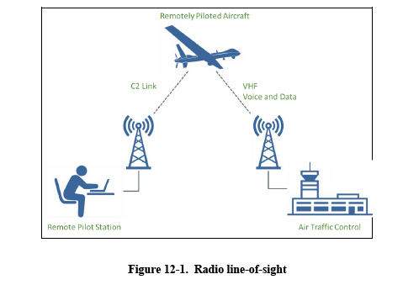
Figur 1. Figure in ICAO RPAS MANUAL
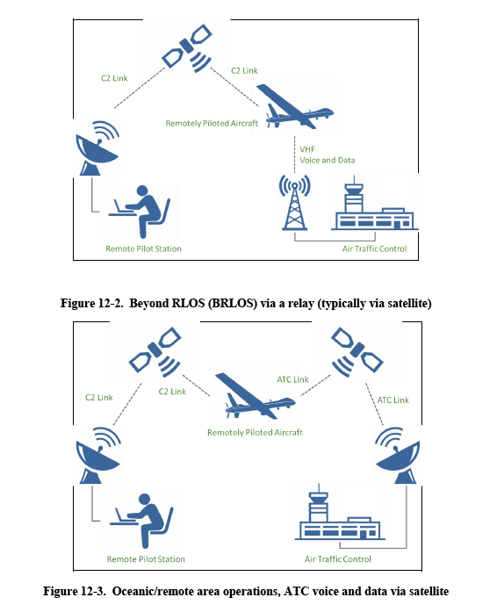
Figur 1. Figures in ICAO RPAS MANUAL

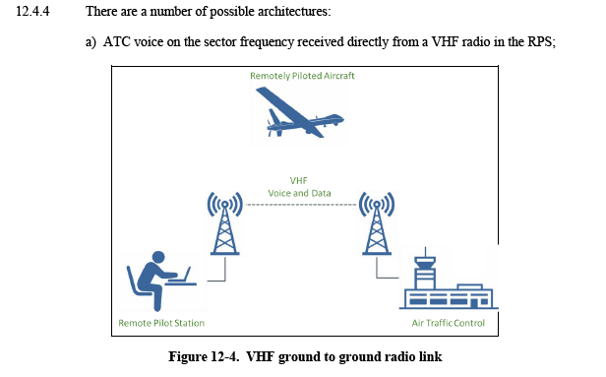
Figur 1. Figure in ICAO RPAS MANUAL

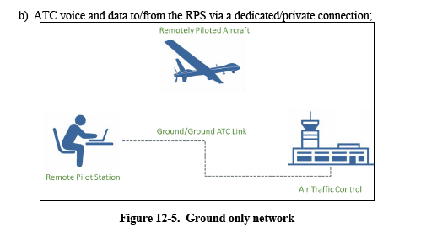
Figur 1. Figure in ICAO RPAS MANUAL

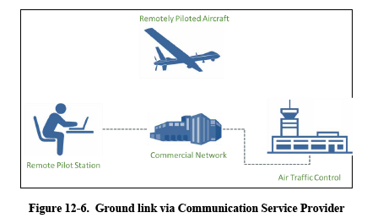
Figur 1. Figure in ICAO RPAS MANUAL

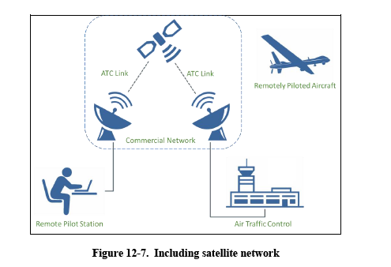
Figur 1. Figure in ICAO RPAS MANUAL

8.4 RESOLUTION 155 (WRC-15)
RESOLUTION 155 (WRC-15)
Regulatory provisions related to earth stations on board unmanned aircraft
which operate with geostationary-satellite networks in the fixed-satellite
service in certain frequency bands not subject to a Plan of Appendices 30,
30A and 30B for the control and non-payload communications of
unmanned aircraft systems in non-segregated airspaces
…
noting
a) that this conference has adopted Resolution 156 on the use of earth stations in motion
communicating with geostationary FSS space stations in the frequency bands 19.7-20.2 GHz and
29.5-30.0 GHz;
b) that Report ITU-R M.2171 provides information on characteristics of UAS and spectrum
requirements to support their safe operation in non-segregated airspace,
…
resolves
1 that assignments to stations of geostationary FSS satellite networks operating in the
frequency bands 10.95-11.2 GHz (space-to-Earth), 11.45-11.7 GHz (space-to-Earth), 11.7-12.2 GHz
(space-to-Earth) in Region 2, 12.2-12.5 GHz (space-to-Earth) in Region 3, 12.5-12.75 GHz (spaceto-
Earth) in Regions 1 and 3 and 19.7-20.2 GHz (space-to-Earth), and in the frequency bands
14-14.47 GHz (Earth-to-space) and 29.5-30.0 GHz (Earth-to-space), may be used for UAS CNPC
links in non-segregated airspace*, provided that the conditions specified in resolves below are met;

…
17 that, in order to protect the radio astronomy service in the frequency band
14.47-14.5 GHz, administrations operating UAS in accordance with this Resolution in the frequency
band 14-14.47 GHz within line-of-sight of radio astronomy stations are urged to take all practicable
steps to ensure that the emissions from the UA in the frequency band 14.47-14.5 GHz do not exceed
the levels and percentage of data loss given in the most recent versions of Recommendations
ITU-R RA.769 and ITU-R RA.1513;
..
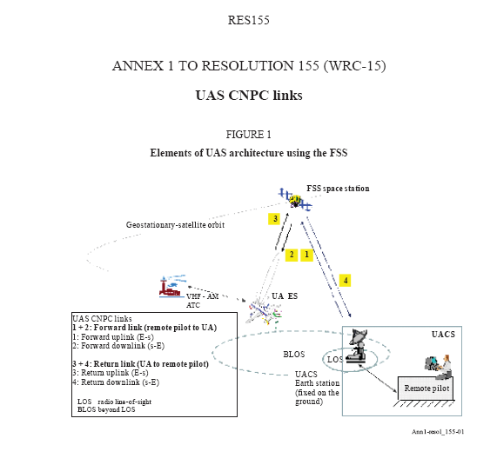
Figur 2. Figure in RES 155

Annex A:
Bibliography

Annex B:
Change History

Date | Version | Information about changes
October 2011 | 1.1.1 | First publication of the TS after approval by TC SPAN at SPAN#19  (30 September - 2 October 2011; Prague)

History

Document history
V1.1.1 | April 20xx | Publication

