Case studies
Ad Hoc Group, JTC 12 – design for all.

Case studies, what for ?

- These case studies are not exhaustive (no more than 1 page), this is only a support for having concrete exchanges a better understanding of the user’s need.
- We implement a library of case studies to have a common understanding of the scope and requirements.
- This case studies are the result of exchanges during the ad hoc group session.
- This helps for also looking more in depth specification with some target users groups users.

The structure is always the same :

Name of the case study

Different ways to explore the case study
- Name of the service, support service, etc.
- Scope of the JTC12
- What is relevant for our requirements ?
- What is not relevant ?
- Still open questions
- Comments
- Illustration (with post-it from the Miro board, which is used to share between us.

Actually, 3 cases studies have been conducted :
- Ticketing vending machine
- Chat bot
- Inassurance contract

Case studies

Ticketing Vending machine

Relation to our scope
Support service related to product : voice, call a person, support

What is relevant for our standards requirement ?
- Where to find the support service informations
- How to switch from text to speak, description ?
- Where to find features for specific support service ?
- relay services : somebody who is able help you when you have specific needs / which translates the information.
- We need to provide guidance for persons who provide the support services, not specific requirements

What is not relevant for our standards requirement ?
- Not the machine herself
- Not the detail of the support service

Still open questions

Comments

Illustration (image of the ticketing machine with post it)

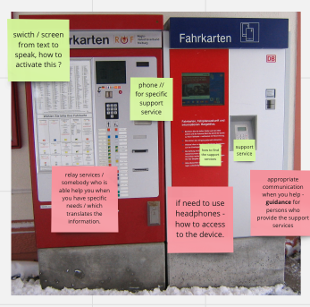

Chatbot

Relation to our scope
- Support service related to service

What is relevant for our standards requirement ?
- Guide the owner in the different specifications in the chatbot
- We have to guide the owner in the specifications
- Organisation of it : the scope of the standard is to guide with a map to engage their own accessibility.
- Information HOW I CAN USE this chatbox, how to configure my computer, increase the size. How to use the service more than the service himself.
- Consideration how to provide accessibility informations

What is not relevant for our standards requirement ?
- Not the details for the button, contrasts, non functional requirements.

Still open questions
- Orientation : we have to choose : mainstream support service with accessibility included, or something more specific ? relevant for all users ?

Comments

Illustrations (image of the chatbot with post it)
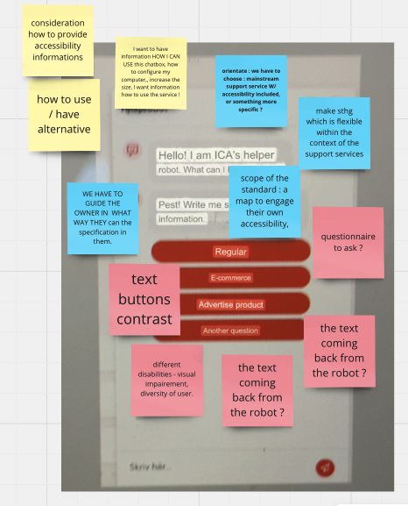

Contract information

Relation to our scope
- Information related to services

What is relevant for our standards requirement ?
- Follow xxxx rules when you use simple langage, plain langage, need for more explaination when it's needed.
- Think to a broad range of users (allophone)
- Guidelines to organize how the service can be understandable.
- Be sure to have on request the necessary to provide information in simple langage

What is not relevant for our standards requirement ?
- Describe the rules

Still open questions
- We can engage user experts and non user experts to give feedbacks
- Find a library of texts to document the good practices, non reinventing the wheel.

Comments

Illustrations (image of the bank service with post it)
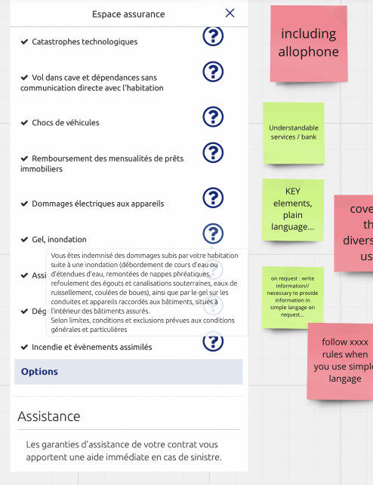

Annex 1
Structure of case studies to implement new ones. Please follow the “charts” for accessibility.

Name of the case study

Relation to our scope

What is relevant for our standards requirement ?

What is not relevant for our standards requirement ?

Still open questions

Comments

Illustrations

