Disclaimer
The present document has been produced and approved by the Experiential Networked Intelligence (ENI) ETSI Industry Specification Group (ISG) and represents the views of those members who participated in this ISG.
It does not necessarily represent the views of the entire ETSI membership.
ETSI GS ENI 038 V4.0.3 (2024-03)

Group Specification
Experiential Networked Intelligence (ENI);
Detailed Procedure of AI Models Centralized Management and Sharing
<

Reference
DGS/ENI-0038_AI Models
Keywords
Capabilities, Sharing

ETSI
650 Route des Lucioles
F-06921 Sophia Antipolis Cedex - FRANCE

Tel.: +33 4 92 94 42 00 Fax: +33 4 93 65 47 16

Siret N° 348 623 562 00017 - APE 7112B
Association à but non lucratif enregistrée à la
Sous-préfecture de Grasse (06) N° w061004871

Important notice
The present document can be downloaded from:
http://www.etsi.org/standards-search
The present document may be made available in electronic versions and/or in print. The content of any electronic and/or print versions of the present document shall not be modified without the prior written authorization of ETSI. In case of any existing or perceived difference in contents between such versions and/or in print, the prevailing version of an ETSI deliverable is the one made publicly available in PDF format at www.etsi.org/deliver.
Users of the present document should be aware that the document may be subject to revision or change of status. Information on the current status of this and other ETSI documents is available at https://portal.etsi.org/TB/ETSIDeliverableStatus.aspx
If you find errors in the present document, please send your comment to one of the following services:
https://portal.etsi.org/People/CommiteeSupportStaff.aspx
If you find a security vulnerability in the present document, please report it through our
Coordinated Vulnerability Disclosure Program:
https://www.etsi.org/standards/coordinated-vulnerability-disclosure
Notice of disclaimer & limitation of liability
The information provided in the present deliverable is directed solely to professionals who have the appropriate degree of experience to understand and interpret its content in accordance with generally accepted engineering or
other professional standard and applicable regulations.
No recommendation as to products and services or vendors is made or should be implied.
No representation or warranty is made that this deliverable is technically accurate or sufficient or conforms to any law and/or governmental rule and/or regulation and further, no representation or warranty is made of merchantability or fitness for any particular purpose or against infringement of intellectual property rights.
In no event shall ETSI be held liable for loss of profits or any other incidental or consequential damages.

Any software contained in this deliverable is provided "AS IS" with no warranties, express or implied, including but not limited to, the warranties of merchantability, fitness for a particular purpose and non-infringement of intellectual property rights and ETSI shall not be held liable in any event for any damages whatsoever (including, without limitation, damages for loss of profits, business interruption, loss of information, or any other pecuniary loss) arising out of or related to the use of or inability to use the software.
Copyright Notification
No part may be reproduced or utilized in any form or by any means, electronic or mechanical, including photocopying and microfilm except as authorized by written permission of ETSI.
The content of the PDF version shall not be modified without the written authorization of ETSI.
The copyright and the foregoing restriction extend to reproduction in all media.

© ETSI 2024.
All rights reserved.
Contents
Intellectual Property Rights 4
Foreword 4
Modal verbs terminology 4
Executive summary 4
Introduction 4
1 Scope 5
2 References 5
2.1 Normative references 5
2.2 Informative references 5
3 Definition of terms, symbols and abbreviations 5
3.1 Terms 5
3.2 Symbols 5
3.3 Abbreviations 5
4 Introduction of AI models centralized management and sharing 5
5 The procedure of AI models centralized management and sharing 6
6 The Methods about sharing AI model 8
6.1 Sharing the AI models within ENI architecture 8
6.2 Sharing the AI models with other systems 8
Annex A (normative or informative): Title of annex 9
A.1 First clause of the annex 9
A.1.1 First subdivided clause of the annex 9
Annex (informative): Bibliography 10
Annex (informative): Change History 11
History 12

Intellectual Property Rights
Essential patents
IPRs essential or potentially essential to normative deliverables may have been declared to ETSI. The declarations pertaining to these essential IPRs, if any, are publicly available for ETSI members and non-members, and can be found in ETSI SR 000 314: "Intellectual Property Rights (IPRs); Essential, or potentially Essential, IPRs notified to ETSI in respect of ETSI standards", which is available from the ETSI Secretariat. Latest updates are available on the ETSI Web server (https://ipr.etsi.org).
Pursuant to the ETSI Directives including the ETSI IPR Policy, no investigation regarding the essentiality of IPRs, including IPR searches, has been carried out by ETSI. No guarantee can be given as to the existence of other IPRs not referenced in ETSI SR 000 314 (or the updates on the ETSI Web server) which are, or may be, or may become, essential to the present document.
Trademarks
The present document may include trademarks and/or tradenames which are asserted and/or registered by their owners. ETSI claims no ownership of these except for any which are indicated as being the property of ETSI, and conveys no right to use or reproduce any trademark and/or tradename. Mention of those trademarks in the present document does not constitute an endorsement by ETSI of products, services or organizations associated with those trademarks.
DECT™, PLUGTESTS™, UMTS™ and the ETSI logo are trademarks of ETSI registered for the benefit of its Members. 3GPP™ and LTE™ are trademarks of ETSI registered for the benefit of its Members and of the 3GPP Organizational Partners. oneM2M™ logo is a trademark of ETSI registered for the benefit of its Members and of the oneM2M Partners. GSM® and the GSM logo are trademarks registered and owned by the GSM Association.

Foreword
This Group Specification (GS) has been produced by ETSI Industry Specification Group Experiential Networked Intelligence (ENI).

Modal verbs terminology
In the present document "shall", "shall not", "should", "should not", "may", "need not", "will", "will not", "can" and "cannot" are to be interpreted as described in clause 3.2 of the ETSI Drafting Rules (Verbal forms for the expression of provisions).
"must" and "must not" are NOT allowed in ETSI deliverables except when used in direct citation.

Executive summary
The present document specifies a high-level functional abstraction of the process of intent policy Multi-Stage translating in ENI system in terms of Functional Modules, Internal Reference Points and working pipelines.

Introduction
With the development of intelligent telecommunication network, multiple AI platforms or AI systems have been developed, resulting in repeated construction and serious fragmented distribution of AI capabilities, and it is impossible to achieve centralized management and sharing of AI capabilities. AI capabilities dispersed to a single point need to be managed and invoked by other systems to provide more efficient services and improve the efficiency of network operation management. AI capability management methods include: extracting AI capability information from registration request; Determine whether the AI capability corresponding to the AI capability information passes the feasibility test; When the AI capability passes the feasibility test, the AI capability is managed according to the preset AI capability management strategy; Store AI capability in a AI capability repository.

1 Scope
The purpose of this work item is to provide consistent mechanisms for operating, administrating, and managing Smaller AI Models (SAM) compared to large models used in network operation management. This will be done using centralised management of SAMs that are used to perform application related operations. The scope of this GS includes: the motivation for centralised management,; the detailed procedure to manage SAMs that are scattered, and how to enable manage SAMs within the ENI system.
2 References

2.1 Normative references
The following referenced documents are necessary for the application of the present document.
[1] ETSI GS ENI 001: "Experiential Networked Intelligence (ENI); ENI use cases".
[2] ETSI GS ENI 005: "Experiential Networked Intelligence (ENI); System Architecture".

2.2 Informative references
References are either specific (identified by date of publication and/or edition number or version number) or non-specific. For specific references, only the cited version applies. For non-specific references, the latest version of the referenced document (including any amendments) applies.
NOTE: While any hyperlinks included in this clause were valid at the time of publication, ETSI cannot guarantee their long-term validity.
The following referenced documents are not necessary for the application of the present document but they assist the user with regard to a particular subject area.
[i.1] ETSI GR ENI 004: "Experiential Networked Intelligence (ENI); Terminology for Main Concepts in ENI".
[i.2]  ETSI GS ENI 005 (V2.1.1): "Experiential Networked Intelligence (ENI); System Architecture".
[i.3] ETSI GR ENI 008: "Experiential Networked Intelligence (ENI); Evaluation of categories for AI application to Networks"

3 Definition of terms, symbols and abbreviations

3.1 Terms
For the purposes of the present document, the terms given in ETSI GR ENI 004 [i.1], ETSI GS ENI 005 [i.2].

3.2 Symbols
Void.

3.3 Abbreviations
For the purposes of the present document, the following abbreviations apply:

4 Introduction of AI models centralized management and sharing
With the continuous accumulation of data and the development of technology，there are many different types of AI models in the AI system. After model training is completed, continuous optimization and update may be required centralized management can realize model iteration and optimization more easily. After the centralized management of the AI model, it can be quickly invoked and applied when needed, improve the utilization rate of the model, but also improve the interpretability and maintainability of the model, and enhance the reliability and stability of the model. Therefore, the centralized management of AI models is very necessary.
AI model centralised management refers to AI model centralised management , the centralized management of all AI models in the system, including model training, deployment, monitoring and optimization, so as to achieve more efficient, consistent and reliable model services and results.
AI model centralised sharing refers to the centralization of AI models into a shared platform or repository so that all users can easily access, use, share, and manage these models. This platform or repository can be internal or external and can provide secure, efficient, and convenient model management and sharing services.
In order to promote model reuse and avoid the cost of training models from scratch, improve model transparency, and increase model reproducibility, this document proposes the process of AI model centralized management and sharing.
SAMs focuses on model management, model deployment, model monitoring and early warning, model evaluation and model iteration in the whole life cycle of machine learning models. Through centralized management, operation and maintenance, application, monitoring, evaluation, and interpretation, operators and customers are provided with easy-to-use, efficient, safe and reliable AI capability operation services to help customers manage the growing machine learning models at scale, improve the efficiency of model use, reduce the cost of model integration management, and control the risk of model production environment.
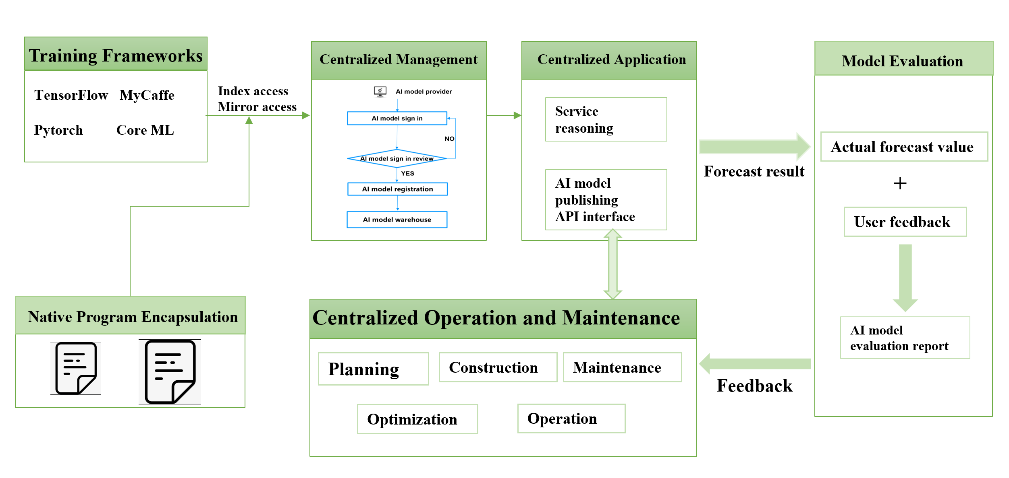
Figure 1. The process of AI model centralized management
Planning: It is necessary to consider the business needs of the enterprise or organization, while ensuring safe, reliable and efficient operation, ensuring that it can meet the needs of future expansion, and selecting the appropriate network architecture model
Construction: Model construction refers to the construction and operation of the network through the construction of network infrastructure, the configuration of network equipment and resources, and the network planning and management in a specific region or scope. It is a comprehensive work, involving network technology, hardware equipment, software system, security and other aspects.
Maintenance: Network model maintenance mainly involves a series of activities to manage, update and optimize the network model. These activities may include:
Monitor the network model: By monitoring the network model regularly or in real time, you can ensure the accuracy and performance of the model. Monitoring can include checking the predictive power of the model, identifying anomalies, and assessing whether the model meets business requirements.
Update the network model: As business requirements and technologies evolve, the network model may need to be updated. Updates may include adding new features, improving the architecture of the model, or adjusting the parameters of the model. By updating the network model regularly or as needed, you can ensure that the model can adapt to changing circumstances.
Optimizing the network model: Optimizing the network model can improve its performance and accuracy. This may involve choosing the right algorithm, adjusting the model parameters, improving the model architecture, or choosing the best combination of features. By optimizing the network model, the prediction ability and accuracy of the model can be improved.
Managing the network model: This includes versioning the model, storing and managing the model's data and documents, and so on. Through effective management, model integrity and traceability can be ensured, while facilitating collaboration and communication among team members.
Troubleshooting: If the network model is faulty or abnormal, you need to rectify the fault in a timely manner. This can involve debugging the model, identifying and fixing errors, and dealing with missing or abnormal data.
Optimization: According to business requirements and data characteristics, design a suitable model structure, including input layer, hidden layer and output layer, as well as the connection mode between each layer, the choice of activation function.
Operation: Model operation refers to the process of applying machine learning models to real business scenarios after they have been trained, and constantly monitoring and adjusting the performance of the models. Specifically, model operation includes the following aspects:
Model deployment: Deploying a model into a production environment so that it can process real-time data, such as publishing the model as an API service to the cloud or a private network.
Model monitoring: Monitor the model in real time, detect whether the model has abnormal behavior or low efficiency, and find and solve the problem in time.
Model adjustment: Optimize and adjust the model according to its performance in actual business scenarios to improve the accuracy and efficiency of the model.
Model update: As data and business scenarios change, the model needs to be updated to adapt to the new situation.
Model evaluation: Evaluate the performance of the model in a certain period of time, check whether the effect and performance of the model meet the expectations, and provide reference for future deployment, update and adjustment.
Through model operation, the machine learning model can be fully applied and played in the actual scene, and the stability and reliability of the model can be guaranteed, and the value and effect of machine learning application can be improved.

5 The procedure of AI models centralized management and sharing

5.1 Overall process introduction
The following figure is an overall view of the management and sharing of AI capabilities. AI capability users first register and register AI capabilities, and then after system verification, they can enter AI capabilities into the AI capability warehouse and publish available AI capabilities. AI capabilities can be invoked and shared by users in different ways.
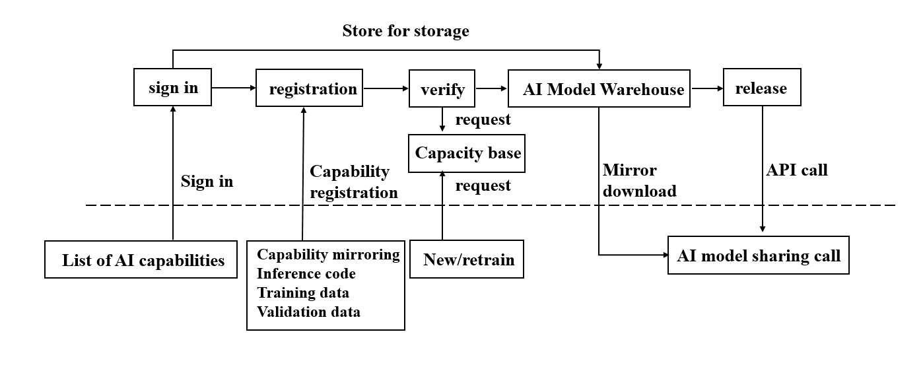

5.2 The procedure of AI model centralized management
The procedure of AI model centralized management, following will be an example of the AI model centralized management process of an operation and maintenance system. The process diagram is shown in Figure 1. The process steps are as follows:
Step 1: AI model sign in: The AI model provider registers the AI model;
Step 2: AI model registration audit: After the registration is completed and submitted, the AI model auditor will audit the information, if the registered fields meet the requirements, the audit will be passed. Extract information about AI capabilities from registration requests Determine whether the AI capability corresponding to the registered AI capability information passes the feasibility test; （AI capabilities include AI models）When the AI capability passes the feasibility test, the intelligent asset is managed according to the preset AI capability management strategy; If there are fields that do not meet the requirements, it will be rejected and the operation and maintenance manager will modify the information again.
Step 3: AI model registration: After registration is complete, submit the registration button.
Step 4: Determine the access type: Determine the AI model access mode of the AI model registration, and upload the corresponding file to the AI model warehouse of the AI management platform. The AI capability management strategy comprises at least one of indicator access strategy（Periodically provide the status information and value evaluation index information of the AI capability to ensure the effectiveness of the AI capability), mirror access strategy (Encapsulate the AI capability and the corresponding operating environment as inference image and training image, and register the inference image and training image). And model access strategy (The code model of the AI model is manage, The code model includes a model parameter file and at least one of the data specification requirements).
Step 5: AI model release: AI models are categorized and managed, and then released to form an AI model catalog, realizing the unified visibility of AI model and saved in AI model warehouse.
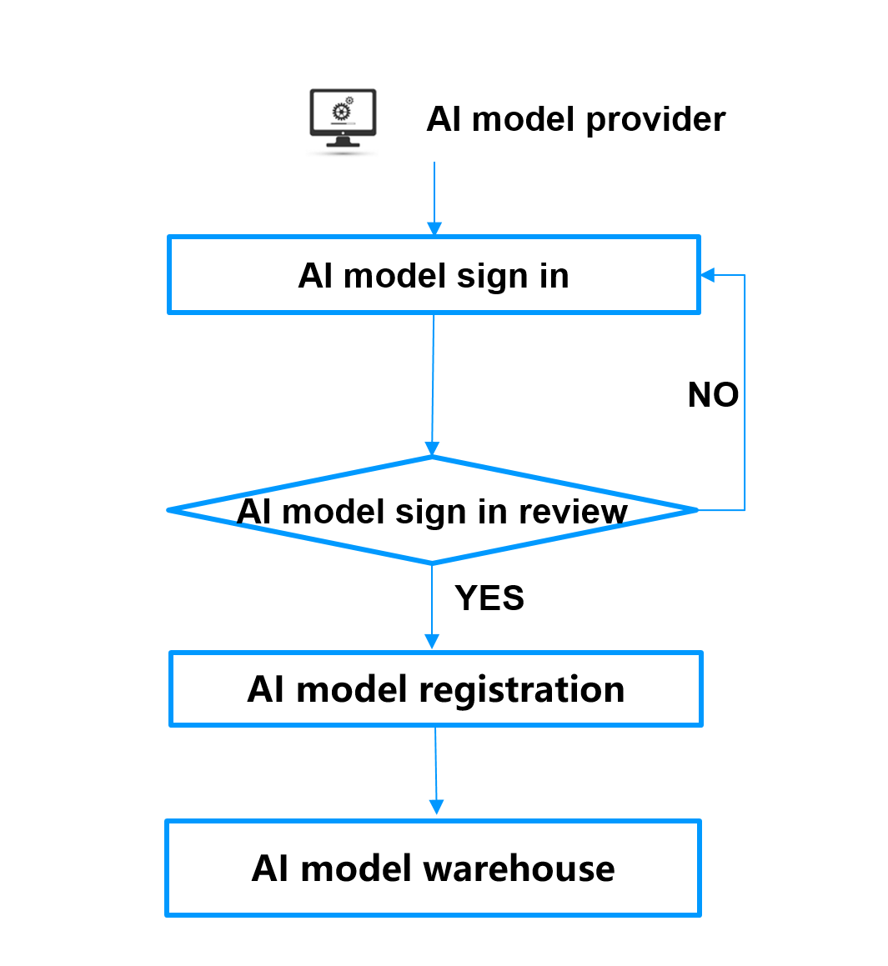
Figure 1：AI model Centralized management process

5.3 The procedure of AI model centralized sharing
The process of AI model centralized sharing will be illustrated as an example below. The flow chart is shown in Figure 2. The process steps are as follows:
Step 1: AI model retrieval: Find the required AI model;
Step 2: AI model subscription: when the required AI model is retrieved, AI model subscription is performed.
Step 3: Judgment of whether retraining is required: determine whether AI model reuse requires retraining, and if retraining is required then proceed to AI model retraining step 4, and if model retraining is not required then proceed directly to step 6 to extract relevant files from the AI model repository;
Step 4: AI model retraining: invoke the model training-related functions of the AIOps platform for AI model retraining;
Step 5: AI model release: the AI capabilities after retraining are released and stored in the AI model repository;
Step 6: AI model warehouse: find the relevant image files of AI models from the AI model repository and extract them, and provide them to AI model subscribers. Determine whether there is a fungible AI capability replaced by the AI capability in the AI capability warehouse; If the replaceable AI capability exists in the AI capability warehouse, the AI capability is stored in the AI capability warehouse and the replaceable AI capability is logged off.
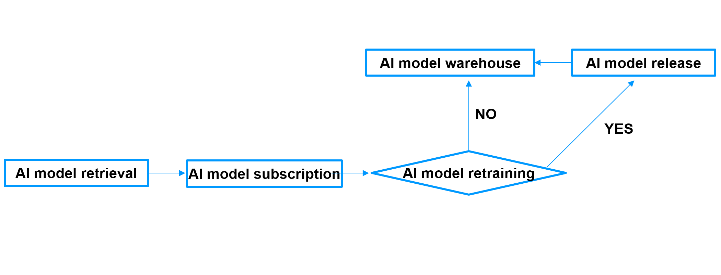
Figure 2：AI model sharing process

6 The Methods about sharing AI model

The way AI models are shared
After receiving the AI capability sharing request, determine the type of AI capability that is requested to be shared; AI capability sharing according to the sharing policy associated with the smart asset type. There are five methods to share AI models:
- Standardized sharing ： using to share specified standardized AI capabilities
- Re-training haring: re-training the AI model that has been accepted to make it reusable in different regions, specialties and scenarios
- Reasoning call: model reasoning in the cloud through API interface call
- Module embedded reference: package the AI model in the form of SDK, embed it in other systems, and provide reasoning environment and computing resources by other systems
- Mirror download: package and download AI reasoning model and its running environment to other systems, and other systems provide computing resources

6.2 The Methods about sharing the AI models within ENI architecture
This section focuses on sharing the AI model internally into the ENI system. The ENI system uses API Broker to negotiate between the ENI system and the secondary system.
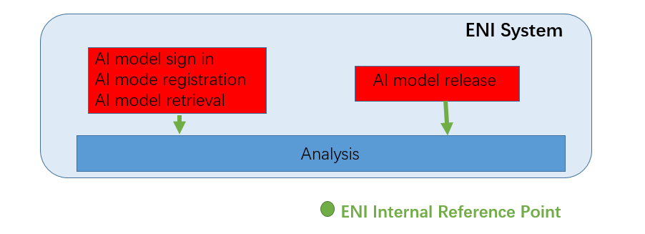
Figure 3 The Methods about sharing the AI models within ENI architecture

6.3 The Methods about sharing the AI models with other systems
This part is mainly about sharing AI models of external systems. The ENI system should be interoperable with other systems such as SDN, MEF etc. Call and use existing functional interfaces and functions as often as possible. The ENI system provides a number of APIs for interworking with external systems to exchange information. If these APIs can satisfy both the ENI system and external systems, ENI systems should reutilize APIs provided by existing external systems as external ENI APIs.
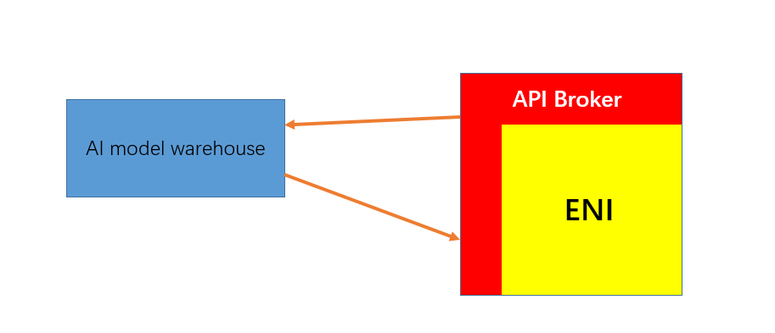
Figure 4 The Methods about sharing the AI models with other systems

Annex A (normative or informative):
Title of annex

A.1 First clause of the annex

A.1.1 First subdivided clause of the annex

Annex (informative):
Bibliography

Annex (informative):
Change History
Date | Version | Information about changes
<Month year> | <#> | <Changes made are listed in this cell>

History
Document history
<Version> | <Date> | <Milestone>

Latest changes made on 2022-03-14

