Disclaimer
The present document has been produced and approved by the Experiential Networked Intelligence (ENI) ETSI Industry Specification Group (ISG) and represents the views of those members who participated in this ISG.
It does not necessarily represent the views of the entire ETSI membership.
ETSI GS ENI 041 V4.0.5 (2024-03)

Group Specification
Experiential Networked Intelligence (ENI);
Network knowledge management enhanced large models for network OAM
<

Reference
DGS/ENI-0041v411_NKMELMNOAM
Keywords
OAM, Maintenancenagement

ETSI
650 Route des Lucioles
F-06921 Sophia Antipolis Cedex - FRANCE

Tel.: +33 4 92 94 42 00 Fax: +33 4 93 65 47 16

Siret N° 348 623 562 00017 - APE 7112B
Association à but non lucratif enregistrée à la
Sous-préfecture de Grasse (06) N° w061004871

Important notice
The present document can be downloaded from:
http://www.etsi.org/standards-search
The present document may be made available in electronic versions and/or in print. The content of any electronic and/or print versions of the present document shall not be modified without the prior written authorization of ETSI. In case of any existing or perceived difference in contents between such versions and/or in print, the prevailing version of an ETSI deliverable is the one made publicly available in PDF format at www.etsi.org/deliver.
Users of the present document should be aware that the document may be subject to revision or change of status. Information on the current status of this and other ETSI documents is available at https://portal.etsi.org/TB/ETSIDeliverableStatus.aspx
If you find errors in the present document, please send your comment to one of the following services:
https://portal.etsi.org/People/CommiteeSupportStaff.aspx
If you find a security vulnerability in the present document, please report it through our
Coordinated Vulnerability Disclosure Program:
https://www.etsi.org/standards/coordinated-vulnerability-disclosure
Notice of disclaimer & limitation of liability
The information provided in the present deliverable is directed solely to professionals who have the appropriate degree of experience to understand and interpret its content in accordance with generally accepted engineering or
other professional standard and applicable regulations.
No recommendation as to products and services or vendors is made or should be implied.
No representation or warranty is made that this deliverable is technically accurate or sufficient or conforms to any law and/or governmental rule and/or regulation and further, no representation or warranty is made of merchantability or fitness for any particular purpose or against infringement of intellectual property rights.
In no event shall ETSI be held liable for loss of profits or any other incidental or consequential damages.

Any software contained in this deliverable is provided "AS IS" with no warranties, express or implied, including but not limited to, the warranties of merchantability, fitness for a particular purpose and non-infringement of intellectual property rights and ETSI shall not be held liable in any event for any damages whatsoever (including, without limitation, damages for loss of profits, business interruption, loss of information, or any other pecuniary loss) arising out of or related to the use of or inability to use the software.
Copyright Notification
No part may be reproduced or utilized in any form or by any means, electronic or mechanical, including photocopying and microfilm except as authorized by written permission of ETSI.
The content of the PDF version shall not be modified without the written authorization of ETSI.
The copyright and the foregoing restriction extend to reproduction in all media.

© ETSI 2024.
All rights reserved.
Contents
Intellectual Property Rights 4
Foreword 4
Modal verbs terminology 4
Executive summary 4
Introduction 4
1 Scope 5
2 References 5
2.1 Normative references 5
2.2 Informative references 5
3 Definition of terms, symbols and abbreviations 5
3.1 Terms 5
3.2 Symbols 5
3.3 Abbreviations 5
4 Introduction 5
5 Network knowledge management 6
5.1 Functional blocks of network knowledge management 6
5.2 Network knowledge source data management 6
5.3 Network knowledge processing 6
5.4 Network knowledge service 6
5.5 Network knowledge scenario application 6
6 Detailed procedure to realize network operation scenarios with the network knowledge 7
Annex A (normative or informative): Title of annex 7
A.1 First clause of the annex 7
A.1.1 First subdivided clause of the annex 7
Annex (informative): Bibliography 8
Annex (informative): Change History 9
History 10

Intellectual Property Rights
Essential patents
IPRs essential or potentially essential to normative deliverables may have been declared to ETSI. The declarations pertaining to these essential IPRs, if any, are publicly available for ETSI members and non-members, and can be found in ETSI SR 000 314: "Intellectual Property Rights (IPRs); Essential, or potentially Essential, IPRs notified to ETSI in respect of ETSI standards", which is available from the ETSI Secretariat. Latest updates are available on the ETSI Web server (https://ipr.etsi.org).
Pursuant to the ETSI Directives including the ETSI IPR Policy, no investigation regarding the essentiality of IPRs, including IPR searches, has been carried out by ETSI. No guarantee can be given as to the existence of other IPRs not referenced in ETSI SR 000 314 (or the updates on the ETSI Web server) which are, or may be, or may become, essential to the present document.
Trademarks
The present document may include trademarks and/or tradenames which are asserted and/or registered by their owners. ETSI claims no ownership of these except for any which are indicated as being the property of ETSI, and conveys no right to use or reproduce any trademark and/or tradename. Mention of those trademarks in the present document does not constitute an endorsement by ETSI of products, services or organizations associated with those trademarks.
DECT™, PLUGTESTS™, UMTS™ and the ETSI logo are trademarks of ETSI registered for the benefit of its Members. 3GPP™ and LTE™ are trademarks of ETSI registered for the benefit of its Members and of the 3GPP Organizational Partners. oneM2M™ logo is a trademark of ETSI registered for the benefit of its Members and of the oneM2M Partners. GSM® and the GSM logo are trademarks registered and owned by the GSM Association.

Foreword
This Group Specification (GS) has been produced by ETSI Industry Specification Group Experiential Networked Intelligence (ENI).

Modal verbs terminology
In the present document "shall", "shall not", "should", "should not", "may", "need not", "will", "will not", "can" and "cannot" are to be interpreted as described in clause 3.2 of the ETSI Drafting Rules (Verbal forms for the expression of provisions).
"must" and "must not" are NOT allowed in ETSI deliverables except when used in direct citation.

Executive summary
The present document specifies a high-level functional abstraction of the process of intent policy Multi-Stage translating in ENI system in terms of Functional Modules, Internal Reference Points and working pipelines.

Introduction
With the development of intelligent telecommunication network, multiple AI platforms or AI systems have been developed, resulting in repeated construction and serious fragmented distribution of AI capabilities, and it is impossible to achieve centralized management and sharing of AI capabilities. AI capabilities dispersed to a single point need to be managed and invoked by other systems to provide more efficient services and improve the efficiency of network operation management.

1 Scope
The purpose of this work item is to investigate the infrastructure of network knowledge management capabilities in network operation scenarios, and support network practice of large models for network OAM, such as maintenance, optimization and decision based on the network knowledge management capabilities.
The scope of this GS includes: the motivation and definition of network knowledge management; the functional blocks of network knowledge management; the detailed procedure to realize network operation scenarios with the network knowledge.

2 References

2.1 Normative references
References are either specific (identified by date of publication and/or edition number or version number) or non-specific. For specific references, only the cited version applies. For non-specific references, the latest version of the referenced document (including any amendments) applies.
Referenced documents which are not found to be publicly available in the expected location might be found at https://docbox.etsi.org/Reference.
NOTE: While any hyperlinks included in this clause were valid at the time of publication, ETSI cannot guarantee their long term validity.
The following referenced documents are necessary for the application of the present document.
[1] ETSI GS ENI 005 (V2.1.1): "Experiential Networked Intelligence (ENI); System Architecture".

2.2 Informative references
References are either specific (identified by date of publication and/or edition number or version number) or non-specific. For specific references, only the cited version applies. For non-specific references, the latest version of the referenced document (including any amendments) applies.
NOTE: While any hyperlinks included in this clause were valid at the time of publication, ETSI cannot guarantee their long-term validity.
The following referenced documents are not necessary for the application of the present document but they assist the user with regard to a particular subject area.
[i.1] ETSI GR ENI 004: "Experiential Networked Intelligence (ENI); Terminology for Main Concepts in ENI".
[i.2] ETSI GR ENI 031: "Experiential Networked Intelligence (ENI); Construction and application of fault maintenance network knowledge graphs.

3 Definition of terms, symbols and abbreviations

3.1 Terms
For the purposes of the present document, the terms given in ETSI GR ENI 004 [i.1], ETSI GS ENI 005 [i.2].

3.2 Symbols
Void.

3.3 Abbreviations
For the purposes of the present document, the abbreviations given in ETSI GR ENI 004 [i.1], ETSI GS ENI 005 [i.2], ETSI GR ENI 008 [i.3].

4 Introduction
With the rapid development of network, the complexity of network operation and management is greatly enhanced. Data-driven artificial intelligence (AI) technology is faced with such problems as high consumption of computing power and training reasoning time, and poor data interpretation, and AI is evolving from data-driven to data & knowledge-driven.
DIKW system model is a system about data, information, knowledge and wisdom, which is used in knowledge management. It constructs a pyramid system of data, information, knowledge and wisdom from bottom to top, which represents the process of gradually increasing the cognitive level of different knowledge levels.
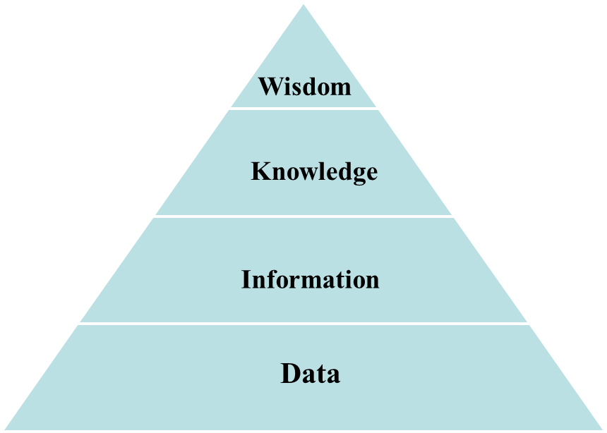
Figure 1: DIKW system model
- Data: It refers to the result of fact or observation, used to represent the raw material of an objective object. In network operation and management, it corresponds to the original data about managed objects, such as alarm data, performance data and so on.
- Information: It refers to the logically related data that can be interpreted in a specific context after processing. In network operation and management, it corresponds to the data content which can reflect the logical relationship and meaning among the network, business and customers after being processed by the system, such as the Operation Index, the work order information after being processed, etc..
- Knowledge: It is an application of information that is filtered, refined, and processed, and relates context-specific information to guide action. Knowledge-based reasoning can generate new knowledge, such as rules, strategies and so on.
- Wisdom: It is the ability to effectively manage knowledge in the context of the environment. It can realize the correct application of knowledge, including knowledge retrieval, knowledge recommendation, knowledge question and answer, causal reasoning and so on.
Network knowledge management refers to the process of collecting, processing, storing and applying knowledge through internet and information technology tools. Network knowledge management is the cognitive foundation of large-scale network model, which provides general knowledge and professional knowledge as training data for large models for network OAM, and provides on-line application of multi-scene knowledge in large models reasoning. The large models for network OAM can generate new knowledge based on existing knowledge and support knowledge completion of network knowledge management.
In addition, network knowledge management can provide necessary knowledge and knowledge application, and support experts in various fields to build and maintain knowledge.

5 Network knowledge management

5.1 Functional blocks of network knowledge management
The functional blocks of network knowledge management are shown in Figure 2, which consist of network knowledge source data management, network knowledge generation, network knowledge classified maintenance, and network knowledge scenario application. The network knowledge management can acquire source data that network knowledge processing needed, existed knowledge from other systems and new knowledge generated by large models for network OAM. Also the knowledge can be shared to large models for network OAM to support the training of the models, or be applied by external systems through knowledge service.
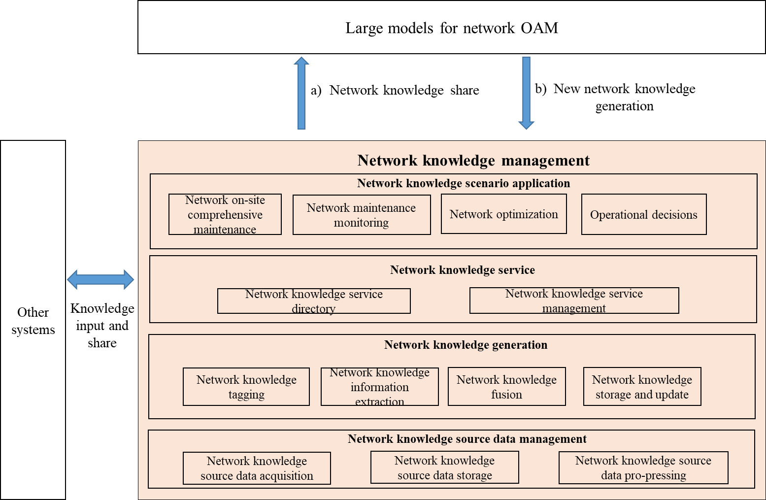
Figure 2: Functional blocks of network knowledge management
- Network knowledge source data management
Network knowledge source data management can mainly acquire, storage and pro-pressing the data of network large model and other systems, as the input of knowledge processing, and provide full data support for knowledge management. It is necessary to select the appropriate data source according to the actual situation.
- Network knowledge source data acquisition: This functional block collects the data from network large model and other systems.
- Network knowledge source data storage: This functional block selects the appropriate database to store the acquired data.

- Network knowledge source data pro-pressing: This functional block processes such as data cleaning, filtering and format conversion to ensure data quality and availability.

- Network knowledge processing
Network knowledge processing can provide the capability to support the generation of network knowledge from network knowledge source data management, including network knowledge tagging, network knowledge information extraction, network knowledge fusion and network knowledge storage and update.
- Network knowledge tagging: This functional block supports the tagging of entities, relations and attributes that make up the network knowledge graph, and provides tagging data for network knowledge information extraction model.
- Network knowledge information extraction: This functional block identifies and acquires knowledge elements and relationships from various sources in different manners such as manually input, template based extraction, customised extraction and automatic extraction.
- Network knowledge fusion: This functional block merges the network knowledge elements to remove redundancy, eliminate ambiguity and form a globally unified knowledge identifier, and supports network knowledge fusion based on different models, algorithms and rules.
- Network knowledge storage and update: This functional block provides appropriate storage functions and repositories for network knowledge in different environment, categories and formats, and updates network knowledge for requirements.
- Network knowledge service
Network knowledge service can provide and manage the fundamental and reusable capabilities packaged as services to enable knowledge utilization in different ways.
- Network knowledge service directory: This functional block provides some services or network knowledge to large models for network OAM or other systems.
- Network knowledge service management: This functional block includes but not limited to knowledge retrieval, intent analysis, knowledge recommendation, knowledge delivery, knowledge assisted decision-making, etc.
- Network knowledge scenario application
Network knowledge scenario application can provide scenario applications and tools with support of well-defined and tested knowledge. The scenarios in network knowledge scenario application layer of could be classified into four types which are network on-site comprehensive maintenance, network maintenance monitoring, network optimization and operational decisions.

5.2 The relationship between network knowledge management and large modelfor network OAM

5.2.1 Network knowledge empowers large models
[TBD]

5.2.2 Large models empowers network knowledge
[TBD]

5.2.3 Network knowledge and large model synergy
[TBD]

6 Detailed procedure to realize network operation scenarios with the network knowledge and large models

6.1 Basic procedure to realize network operation scenarios
The functional blocks in Figure 1 are the functional building blocks for building network knowledge, providing atomic capabilities for the network operation scenario. The basic procedure to realize network operation scenarios with the network knowledge includes:
- Network knowledge generation procedure
Network knowledge generation includes all the stages from network knowledge source data acquisition to network knowledge generating, storing and updating. The specific interaction procedure of network knowledge generation is as follows in Figure 2:
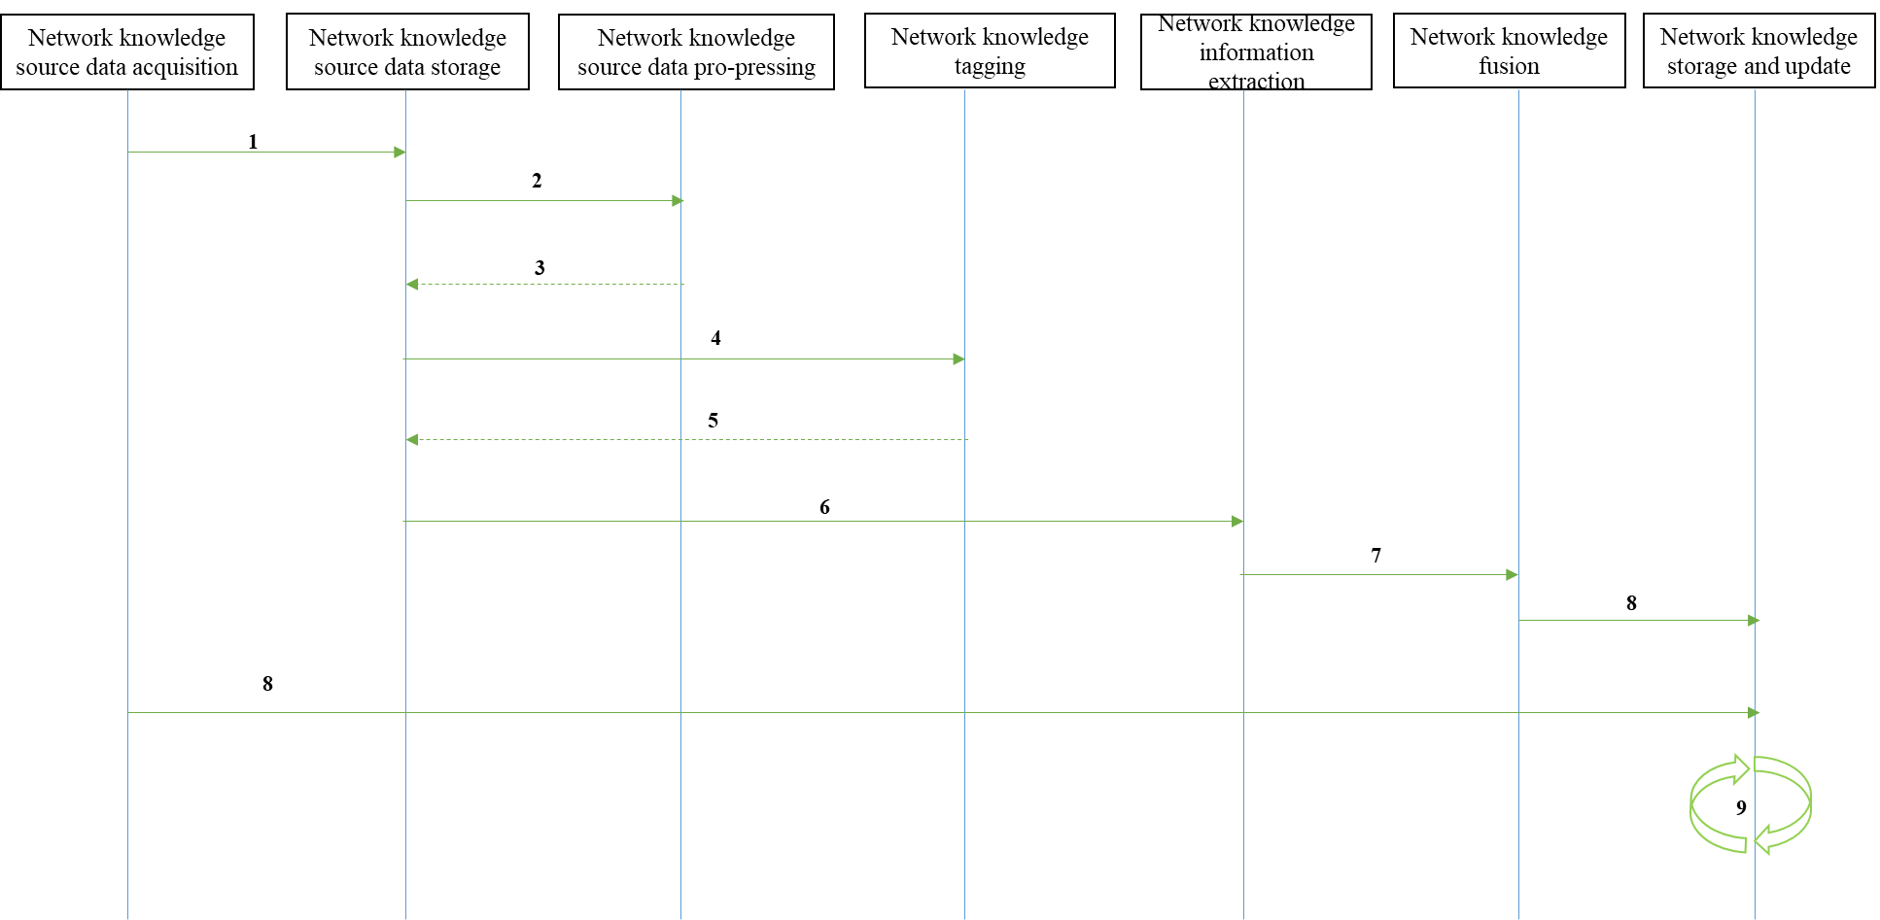
Figure 2: Network knowledge generation procedure
- 1: Obtain the network knowledge source data from other systems, such as resource management system.
- 2-3: Storage network knowledge source data and pre-processed data into data lake or data base.
- 4-5: Tag network knowledge data from network knowledge source data storage, and storage them into network knowledge source data storage.
- 6: Extract network knowledge information based on AI models or other technologies.
- 7: Fuse multiple network knowledge to a network knowledge graph.
- 8: Storage the fused network knowledge and the network knowledge from other systems or large models for network OAM.
Note: There are two eights, one is for storage the fused network knowledge, and the other is for storage the network knowledge from other systems or large models for network OAM.
- 9: Update original network knowledge based on input network knowledge, and storage updated network knowledge.
- Network knowledge application procedure combined with large models
Generated network knowledge can be combined with large models and apply to network on-site comprehensive maintenance, network maintenance monitoring, network optimization and operational decisions scenarios. The specific interaction procedure is as follows in Figure 3:
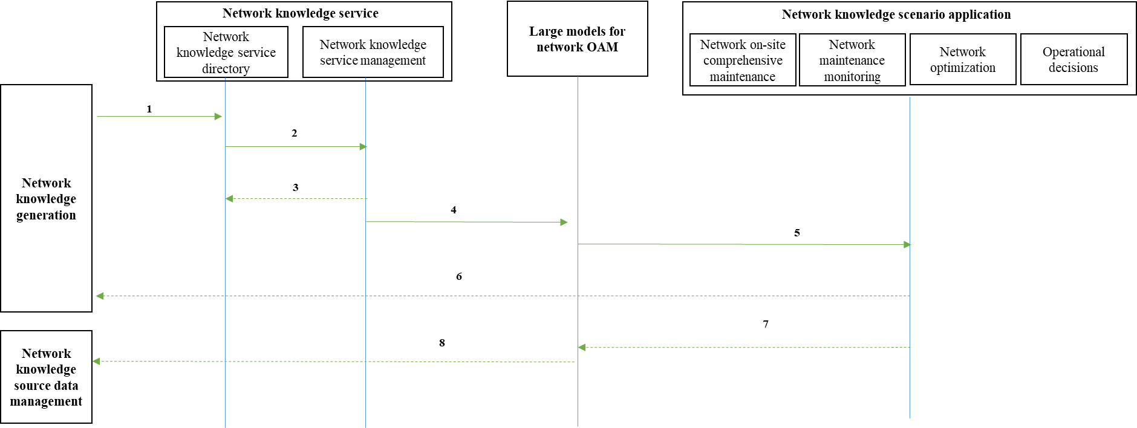
Figure 3: Network knowledge application procedure combined with large models
- 1: Storage network knowledge in network knowledge service directory form network knowledge generation.
- 2-3: Perform network knowledge service based on the generated network knowledge, and the complete service is stored in the network knowledge service directory.
- 4-5: The network knowledge service enhances the network large model, further enriches the scene application.
- 6-7: Application system for application effect feedback, iterative optimization the capabilities of large models and knowledge management.
- 8：The large model generates new knowledge, which is fed back to the network knowledge source data management to expand knowledge iteratively.

6.2 Procedure to realize network on-site comprehensive maintenance
Network on-site comprehensive maintenance scenario includes fault handling, resource change and so on. These scenarios mainly rely on historical work order data, fault case base, hidden danger disposal scheme, operation process specifications, equipment information and other data, precipitate the network knowledge such as fault phenomenon knowledge, fault solution knowledge, hidden trouble treatment knowledge, etc.. For example, network knowledge management can effectively improve patrol efficiency, speed up fault treatment efficiency, optimize fault treatment effect, and enhance the automation ability of the whole process.
The network knowledge of the network knowledge base can be called to identify the faults during the patrol, which can provide potential causes and corresponding solutions. In the security audit stage, it can automatically monitor the standardization of operation based on network knowledge. The implementation procedure is as follows in Figure 4:
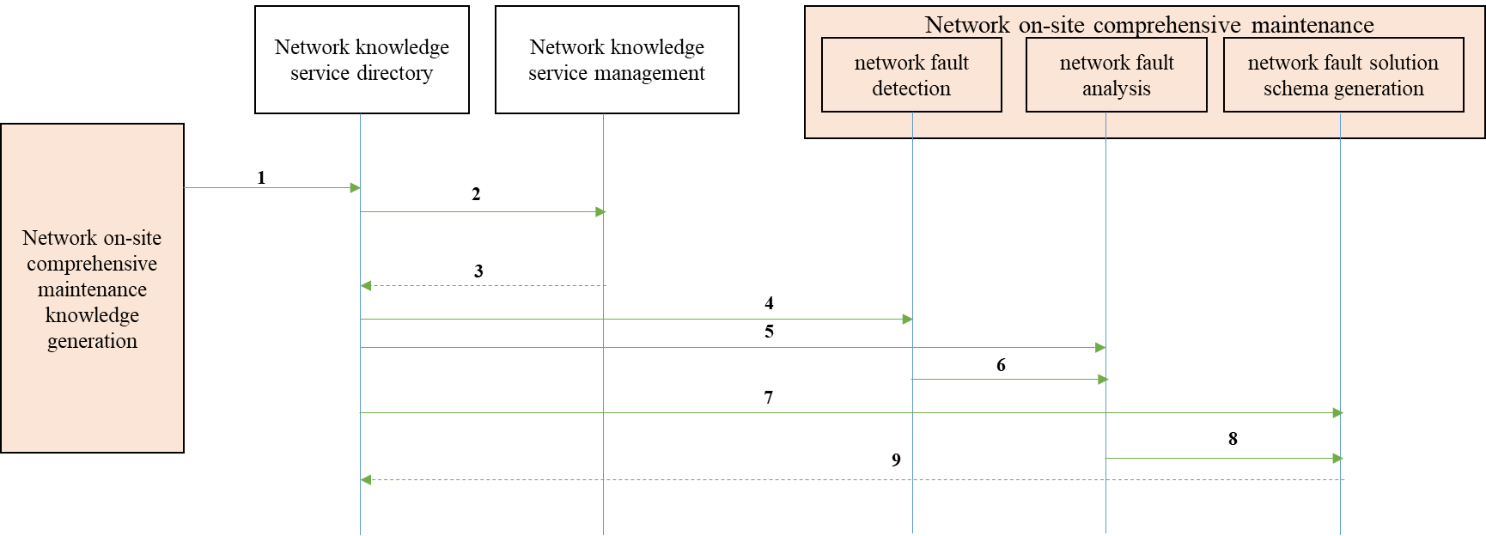
Figure 4: Network on-site comprehensive maintenance procedure based on network knowledge
- 1: Storage network on-site comprehensive maintenance knowledge in network knowledge service directory form network on-site comprehensive maintenance knowledge generation. The generated network on-site comprehensive maintenance knowledge includes but not limited equipment fault knowledge (including the cause of the fault, solutions and processes), inspection/work order record (including equipment operation status, maintenance time and maintenance content), etc..
- 2-3: Perform network knowledge service based on the generated network on-site comprehensive maintenance knowledge, and the complete service is stored in the network knowledge service directory.
- 4: Perform network fault detection based on the network on-site comprehensive maintenance knowledge which is from network knowledge service directory.
- 5-6: Perform network fault analysis based on the network on-site comprehensive maintenance knowledge and the result of network fault detection.
- 7-9: Perform network fault solution schema generation based on the network knowledge service and the result of network fault analysis, and form new knowledge. Storage the new knowledge to network knowledge service directory.

6.3 Procedure to realize network maintenance monitoring
Network maintenance is oriented to integrated network monitoring and maintenance, focusing on the direction of “alarm root cause analysis, intelligent human-computer interaction, decision-making scheme generation” based on network knowledge, the goal of improving quality, reducing cost and increasing efficiency can be realized through the scenario transformation driven by data and knowledge.

6.4 Procedure to realize network optimization

6.5 Procedure to realize operational decisions

Annex A (normative or informative):
Title of annex

A.1 First clause of the annex

A.1.1 First subdivided clause of the annex

Annex (informative):
Bibliography

Annex (informative):
Change History
Date | Version | Information about changes
<Month year> | <#> | <Changes made are listed in this cell>

History
Document history
<Version> | <Date> | <Milestone>

Latest changes made on 2023-10-13

