Disclaimer
The present document has been produced and approved by the Experiential Networked Intelligence (ENI) ETSI Industry Specification Group (ISG) and represents the views of those members who participated in this ISG.
It does not necessarily represent the views of the entire ETSI membership.
ETSI GS ENI-043 V4.0.2 (2024-01)

Group Specification
Experiential Networked Intelligence (ENI);
Intelligent customer service based on large language model
<

Reference
GS/ENI-043v411
Keywords
artificial intelligence, train, service

ETSI
650 Route des Lucioles
F-06921 Sophia Antipolis Cedex - FRANCE

Tel.: +33 4 92 94 42 00 Fax: +33 4 93 65 47 16

Siret N° 348 623 562 00017 - APE 7112B
Association à but non lucratif enregistrée à la
Sous-préfecture de Grasse (06) N° w061004871

Important notice
The present document can be downloaded from:
https://www.etsi.org/standards-search
The present document may be made available in electronic versions and/or in print. The content of any electronic and/or print versions of the present document shall not be modified without the prior written authorization of ETSI. In case of any existing or perceived difference in contents between such versions and/or in print, the prevailing version of an ETSI deliverable is the one made publicly available in PDF format at www.etsi.org/deliver.
Users of the present document should be aware that the document may be subject to revision or change of status. Information on the current status of this and other ETSI documents is available at https://portal.etsi.org/TB/ETSIDeliverableStatus.aspx
If you find errors in the present document, please send your comment to one of the following services:
https://portal.etsi.org/People/CommiteeSupportStaff.aspx
If you find a security vulnerability in the present document, please report it through our
Coordinated Vulnerability Disclosure Program:
https://www.etsi.org/standards/coordinated-vulnerability-disclosure
Notice of disclaimer & limitation of liability
The information provided in the present deliverable is directed solely to professionals who have the appropriate degree of experience to understand and interpret its content in accordance with generally accepted engineering or
other professional standard and applicable regulations.
No recommendation as to products and services or vendors is made or should be implied.
No representation or warranty is made that this deliverable is technically accurate or sufficient or conforms to any law and/or governmental rule and/or regulation and further, no representation or warranty is made of merchantability or fitness for any particular purpose or against infringement of intellectual property rights.
In no event shall ETSI be held liable for loss of profits or any other incidental or consequential damages.

Any software contained in this deliverable is provided "AS IS" with no warranties, express or implied, including but not limited to, the warranties of merchantability, fitness for a particular purpose and non-infringement of intellectual property rights and ETSI shall not be held liable in any event for any damages whatsoever (including, without limitation, damages for loss of profits, business interruption, loss of information, or any other pecuniary loss) arising out of or related to the use of or inability to use the software.
Copyright Notification
No part may be reproduced or utilized in any form or by any means, electronic or mechanical, including photocopying and microfilm except as authorized by written permission of ETSI.
The content of the PDF version shall not be modified without the written authorization of ETSI.
The copyright and the foregoing restriction extend to reproduction in all media.

© ETSI 2024.
All rights reserved.
Contents
Intellectual Property Rights 4
Foreword 4
Modal verbs terminology 4
Executive summary 4
Introduction 4
1 Scope 5
2 References 5
2.1 Normative references 5
2.2 Informative references 5
3 Definition of terms, symbols and abbreviations 5
3.1 Terms 5
3.2 Symbols 5
3.3 Abbreviations 5
4 Introduction 6
4.1 Background on intelligent customer service based on large language model 6
4.2 Introduction for intelligent customer service based on large language model 13
5 Framework 6
5.1 Framework of intelligent customer service based on large language model 16
6 Application of intelligent customer service based on large language model 31
7 Requirements of intelligent customer service based on large language model 41
8 Conclusions 43
Annex A (normative or informative): Title of annex 7
Annex B (normative or informative): Title of annex 8
B.1 First clause of the annex 8
B.1.1 First subdivided clause of the annex 8
Annex (informative): Bibliography 9
Annex (informative): Change history 10
History 11

Intellectual Property Rights
Essential patents
IPRs essential or potentially essential to normative deliverables may have been declared to ETSI. The declarations pertaining to these essential IPRs, if any, are publicly available for ETSI members and non-members, and can be found in ETSI SR 000 314: "Intellectual Property Rights (IPRs); Essential, or potentially Essential, IPRs notified to ETSI in respect of ETSI standards", which is available from the ETSI Secretariat. Latest updates are available on the ETSI Web server (https://ipr.etsi.org).
Pursuant to the ETSI Directives including the ETSI IPR Policy, no investigation regarding the essentiality of IPRs, including IPR searches, has been carried out by ETSI. No guarantee can be given as to the existence of other IPRs not referenced in ETSI SR 000 314 (or the updates on the ETSI Web server) which are, or may be, or may become, essential to the present document.
Trademarks
The present document may include trademarks and/or tradenames which are asserted and/or registered by their owners. ETSI claims no ownership of these except for any which are indicated as being the property of ETSI, and conveys no right to use or reproduce any trademark and/or tradename. Mention of those trademarks in the present document does not constitute an endorsement by ETSI of products, services or organizations associated with those trademarks.
DECT™, PLUGTESTS™, UMTS™ and the ETSI logo are trademarks of ETSI registered for the benefit of its Members. 3GPP™ and LTE™ are trademarks of ETSI registered for the benefit of its Members and of the 3GPP Organizational Partners. oneM2M™ logo is a trademark of ETSI registered for the benefit of its Members and of the oneM2M Partners. GSM® and the GSM logo are trademarks registered and owned by the GSM Association.

Foreword
This Group Specification (GS) has been produced by ETSI Industry Specification Group <long ISGname> (<short ISGname>).

Modal verbs terminology
In the present document "shall", "shall not", "should", "should not", "may", "need not", "will", "will not", "can" and "cannot" are to be interpreted as described in clause 3.2 of the ETSI Drafting Rules (Verbal forms for the expression of provisions).
"must" and "must not" are NOT allowed in ETSI deliverables except when used in direct citation.

Executive summary

Introduction
The present document is: GS/ENI-043v411 to specify:
Introduction of intelligent customer service based on large language model.
Framework of intelligent customer service based on: large language model.
Application of intelligent customer service: based on large language model.
Requirements of intelligent customer service based on large language model.

1 Scope
The present document will investigate telecommunication intelligent customer services that use large language models. The present document will describe different types of telecommunication intelligent customer services, and then specify how to solve multiple scenario problems, improve customer service efficiency and reduce the reliance on manual labour. A large language model also supports rapid adaptation to tasks through fine tuning. The customer service oriented models can be created by analyzing and understanding multiple scenarios.

2 References

2.1 Normative references
References are either specific (identified by date of publication and/or edition number or version number) or non-specific. For specific references, only the cited version applies. For non-specific references, the latest version of the referenced document (including any amendments) applies.
Referenced documents which are not found to be publicly available in the expected location might be found at https://docbox.etsi.org/Reference.
NOTE: While any hyperlinks included in this clause were valid at the time of publication, ETSI cannot guarantee their long term validity.
The following referenced documents are necessary for the application of the present document.
[1] <Standard Organization acronym> <document number>: "<Title>".
[2] <Standard Organization acronym> <document number>: "<Title>".

2.2 Informative references
References are either specific (identified by date of publication and/or edition number or version number) or non-specific. For specific references, only the cited version applies. For non-specific references, the latest version of the referenced document (including any amendments) applies.
NOTE: While any hyperlinks included in this clause were valid at the time of publication, ETSI cannot guarantee their long term validity.
The following referenced documents are not necessary for the application of the present document but they assist the user with regard to a particular subject area.
[i.1] <Standard Organization acronym> <document number><version number/date of publication>: "<Title>".
[i.2]  etc.

3 Definition of terms, symbols and abbreviations

3.1 Terms
For the purposes of the present document, the [following] terms [given in ... and the following] apply:

3.2 Symbols
For the purposes of the present document, the [following] symbols [given in ... and the following] apply:

3.3 Abbreviations
For the purposes of the present document, the [following] abbreviations [given in ... and the following] apply:

4 Introduction

4.1 Background on intelligent customer service based on large language model
Intelligent customer service includes scenarios such as speech recognition, work order processing, knowledge question and answer, ect. The introduction of AI technology helps to handle data of telecommunication intelligent customer service, solve scenario applications, improve customer service efficiency and reduce the reliance on manual labour.
Although AI technology has brought many benefits to intelligent customer service, there are still the following problems to be solved in the application of AI in intelligent customer service: AI models are difficult to reuse in multiple scenarios, data needs to be manually labeled, and models are difficult to process massive data, etc.
The large language model for telecommunication intelligent customer service can process the massive data, realize model pre-training and model fine-tuning for different tasks, and the fine-tuned models can be used in the scenarios of customer service.
The large language model supports efficient annotation of massive data. Large language model supports rapid adaptation to tasks through fine-tuning. The customer service oriented models could be created by analyzing and understanding multiple types of data for comprehensive analysis of multiple scenarios.

4.2 Introduction of intelligent customer service based on large language model
The telecommunication intelligent customer service based on large language model can process the text data, realize model pre-training and model fine-tuning for different tasks, and the fine-tuned models can be used in the scenarios of customer service.

5 Framework

5.1 Framework of intelligent customer service based on large language model
The intelligent customer service based on large language model mainly includes data collection and service module, multimedia data processing module, pre-training service module, fine tune service module and model verification module.
Data collection and service module collects the general data and task data of the telecommunications system. Data is cleaned, annotated, and fused in the data processing module. The large language model pre-trains the model based on the general data. The system fine tunes the model based on the task data, and generate models for specific scenarios. Then the generated model was verified through the model verification module to confirm that it can be adapted to the actual scenario of the intelligent customer service. Ultimately, the generated model is used to solve the specific scenario problem of customer service.
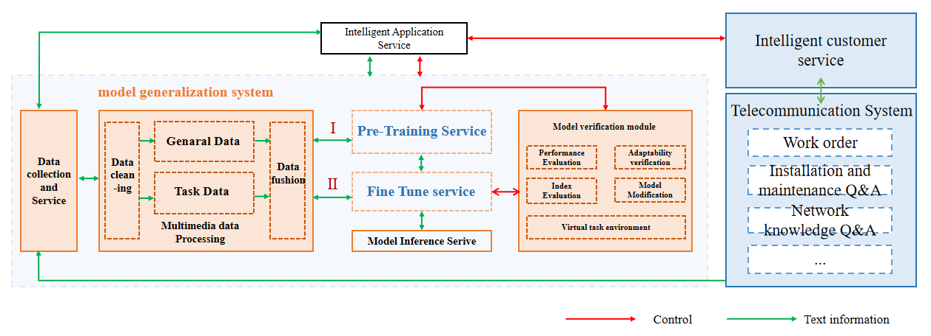

Annex A (normative or informative):
Title of annex

Annex B (normative or informative):
Title of annex

B.1 First clause of the annex

B.1.1 First subdivided clause of the annex

Annex (informative):
Bibliography

Annex (informative):
Change history
Date | Version | Information about changes
<Month year> | <#> | <Changes made are listed in this cell>

History
Document history
<Version> | <Date> | <Milestone>

Latest changes made on 2022-03-14

