Disclaimer
The present document has been produced and approved by the Experiential Networked Intelligence (ENI) ETSI Industry Specification Group (ISG) and represents the views of those members who participated in this ISG.
It does not necessarily represent the views of the entire ETSI membership.
ETSI GS ENI-044 V4.0.2 (2024-02)

Group Specification
Experiential Networked Intelligence (ENI);
Interaction between network large language model and add-on components
<

Reference
GS/ENI-044v411
Keywords
Interaction, API

ETSI
650 Route des Lucioles
F-06921 Sophia Antipolis Cedex - FRANCE

Tel.: +33 4 92 94 42 00 Fax: +33 4 93 65 47 16

Siret N° 348 623 562 00017 - APE 7112B
Association à but non lucratif enregistrée à la
Sous-préfecture de Grasse (06) N° w061004871

Important notice
The present document can be downloaded from:
https://www.etsi.org/standards-search
The present document may be made available in electronic versions and/or in print. The content of any electronic and/or print versions of the present document shall not be modified without the prior written authorization of ETSI. In case of any existing or perceived difference in contents between such versions and/or in print, the prevailing version of an ETSI deliverable is the one made publicly available in PDF format at www.etsi.org/deliver.
Users of the present document should be aware that the document may be subject to revision or change of status. Information on the current status of this and other ETSI documents is available at https://portal.etsi.org/TB/ETSIDeliverableStatus.aspx
If you find errors in the present document, please send your comment to one of the following services:
https://portal.etsi.org/People/CommiteeSupportStaff.aspx
If you find a security vulnerability in the present document, please report it through our
Coordinated Vulnerability Disclosure Program:
https://www.etsi.org/standards/coordinated-vulnerability-disclosure
Notice of disclaimer & limitation of liability
The information provided in the present deliverable is directed solely to professionals who have the appropriate degree of experience to understand and interpret its content in accordance with generally accepted engineering or
other professional standard and applicable regulations.
No recommendation as to products and services or vendors is made or should be implied.
No representation or warranty is made that this deliverable is technically accurate or sufficient or conforms to any law and/or governmental rule and/or regulation and further, no representation or warranty is made of merchantability or fitness for any particular purpose or against infringement of intellectual property rights.
In no event shall ETSI be held liable for loss of profits or any other incidental or consequential damages.

Any software contained in this deliverable is provided "AS IS" with no warranties, express or implied, including but not limited to, the warranties of merchantability, fitness for a particular purpose and non-infringement of intellectual property rights and ETSI shall not be held liable in any event for any damages whatsoever (including, without limitation, damages for loss of profits, business interruption, loss of information, or any other pecuniary loss) arising out of or related to the use of or inability to use the software.
Copyright Notification
No part may be reproduced or utilized in any form or by any means, electronic or mechanical, including photocopying and microfilm except as authorized by written permission of ETSI.
The content of the PDF version shall not be modified without the written authorization of ETSI.
The copyright and the foregoing restriction extend to reproduction in all media.

© ETSI 2024.
All rights reserved.
Contents
Intellectual Property Rights 4
Foreword 4
Modal verbs terminology 4
Executive summary 4
Introduction 4
1 Scope 5
2 References 5
2.1 Normative references 5
2.2 Informative references 5
3 Definition of terms, symbols and abbreviations 5
3.1 Terms 5
3.2 Symbols 5
3.3 Abbreviations 6
4 Background and Overview 6
4.1 Background 6
4.2 Overview 6
5 Add-on components 6
5.1 data lake 7
5.2 knowledge base 7
6 Interaction of network LLM and data lake 7
6.1 Introduction 7
7 Interaction of network LLM and knowledge base 7
7.1 Introduction 7
8 Work flow 7
Annex A (normative or informative): Title of annex 8
Annex B (normative or informative): Title of annex 9
B.1 First clause of the annex 9
B.1.1 First subdivided clause of the annex 9
Annex (informative): Bibliography 10
Annex (informative): Change history 11
History 12

Intellectual Property Rights
Essential patents
IPRs essential or potentially essential to normative deliverables may have been declared to ETSI. The declarations pertaining to these essential IPRs, if any, are publicly available for ETSI members and non-members, and can be found in ETSI SR 000 314: "Intellectual Property Rights (IPRs); Essential, or potentially Essential, IPRs notified to ETSI in respect of ETSI standards", which is available from the ETSI Secretariat. Latest updates are available on the ETSI Web server (https://ipr.etsi.org).
Pursuant to the ETSI Directives including the ETSI IPR Policy, no investigation regarding the essentiality of IPRs, including IPR searches, has been carried out by ETSI. No guarantee can be given as to the existence of other IPRs not referenced in ETSI SR 000 314 (or the updates on the ETSI Web server) which are, or may be, or may become, essential to the present document.
Trademarks
The present document may include trademarks and/or tradenames which are asserted and/or registered by their owners. ETSI claims no ownership of these except for any which are indicated as being the property of ETSI, and conveys no right to use or reproduce any trademark and/or tradename. Mention of those trademarks in the present document does not constitute an endorsement by ETSI of products, services or organizations associated with those trademarks.
DECT™, PLUGTESTS™, UMTS™ and the ETSI logo are trademarks of ETSI registered for the benefit of its Members. 3GPP™ and LTE™ are trademarks of ETSI registered for the benefit of its Members and of the 3GPP Organizational Partners. oneM2M™ logo is a trademark of ETSI registered for the benefit of its Members and of the oneM2M Partners. GSM® and the GSM logo are trademarks registered and owned by the GSM Association.

Foreword
This Group Specification (GS) has been produced by ETSI Industry Specification Group (ISG) Experiential Networked Intelligence (ENI).

Modal verbs terminology
In the present document "shall", "shall not", "should", "should not", "may", "need not", "will", "will not", "can" and "cannot" are to be interpreted as described in clause 3.2 of the ETSI Drafting Rules (Verbal forms for the expression of provisions).
"must" and "must not" are NOT allowed in ETSI deliverables except when used in direct citation.

Executive summary

Introduction

1 Scope
This GS will investigate how the network large language model interacts with multiple add-on components. These components in this GS include a data lake and a knowledge base. The interaction between network LLM and data lake is mainly realised through two forms, API interaction and sending requests directly from network LLM to data lake. The interaction with a knowledge base is mainly focused on providing corpus data for network LLM training. In addition, network LLM also needs to invoke knowledge base through tasks.

2 References

2.1 Normative references
References are either specific (identified by date of publication and/or edition number or version number) or non-specific. For specific references, only the cited version applies. For non-specific references, the latest version of the referenced document (including any amendments) applies.
Referenced documents which are not found to be publicly available in the expected location might be found at https://docbox.etsi.org/Reference.
NOTE: While any hyperlinks included in this clause were valid at the time of publication, ETSI cannot guarantee their long term validity.
The following referenced documents are necessary for the application of the present document.
[1] <Standard Organization acronym> <document number>: "<Title>".
[2] <Standard Organization acronym> <document number>: "<Title>".

2.2 Informative references
References are either specific (identified by date of publication and/or edition number or version number) or non-specific. For specific references, only the cited version applies. For non-specific references, the latest version of the referenced document (including any amendments) applies.
NOTE: While any hyperlinks included in this clause were valid at the time of publication, ETSI cannot guarantee their long term validity.
The following referenced documents are not necessary for the application of the present document but they assist the user with regard to a particular subject area.
[i.1] <Standard Organization acronym> <document number><version number/date of publication>: "<Title>".
[i.2]  etc.

3 Definition of terms, symbols and abbreviations

3.1 Terms
For the purposes of the present document, the [following] terms [given in ... and the following] apply:
Editor’s notes: The term “knowledge base” is to be double check. Whether “knowledge graph” should be used is TBD.
Knowledge base: a collection of various types of knowledge, including structured data and unstructured content.

3.2 Symbols
For the purposes of the present document, the [following] symbols [given in ... and the following] apply:

3.3 Abbreviations
For the purposes of the present document, the [following] abbreviations [given in ... and the following] apply:

4 Background and Overview

4.1 Background
In the process of intelligent network construction, the use of large language model to improve the level of network intelligence has become a new trend. When solving practical business problems, the network LLM, oriented to the communication industry, can activate extensive communication business knowledge by establishing interactions with add-on components. Furthermore, with the support of real business data, it enables closed-loop intelligent optimization of the network, thereby enhancing the level of network self-intelligence.
In business application practice of network LLM, an interaction mode more suitable for the communication industry has been formed. In order to provide better guidance for the application of network LLM in intelligent network, it is necessary to establish a unified standard to clarify the interactions between network LLM and the add-on components.

4.2 Overview
In the practical process of network LLM, some drawbacks hinder its wide application. Without the support of professional knowledge, network LLM cannot fully understand industry-specific terminology, processes, and specifications. This results in a lack of industry characteristics in its output, led to a poor performance in dealing with complex problems, and an inability to solve real practice problems. Moreover, the lack of real business data support makes the network LLM unable to accurately understand the current situation of business problem, so it cannot provide decisions credible enough, which limits the scope of application of network LLM in solving business problems. Therefore, in the implementation of network LLM application, it needs to interact with the data lake and the knowledge base to obtain authentic business data and information, so as to improve its professionalism and accuracy.

The interaction of network LLM and add-on components plays a crucial role in the application practice of network LLM. Data lake and knowledge base contain a large amount of authoritative business data and information, which is not possessed by the network LLM. By capturing the data and the information, network LLM can learn more realistic business patterns, gain a deeper understanding of the business, and produce better results for specific business scenarios. Knowledge base makes network LLM possible to integrate expertise and improve its decision-making power and accuracy in specific business areas.
In conclusion, the interaction of network LLM and add-on components can provide higher accuracy, stronger business adaptability, more professional and personalized services in practice, and bring better user experience and stronger product competitiveness.

5 Add-on components
In the business application based on network LLM, add-on components refer to modules that enhance or extend the functionality of network LLM. They can be customized and configured for specific requirements in order to support network LLM in delivering more advanced capabilities and services and handling more complex tasks. In this GS, add-on components mainly include a data lake and a knowledge base.

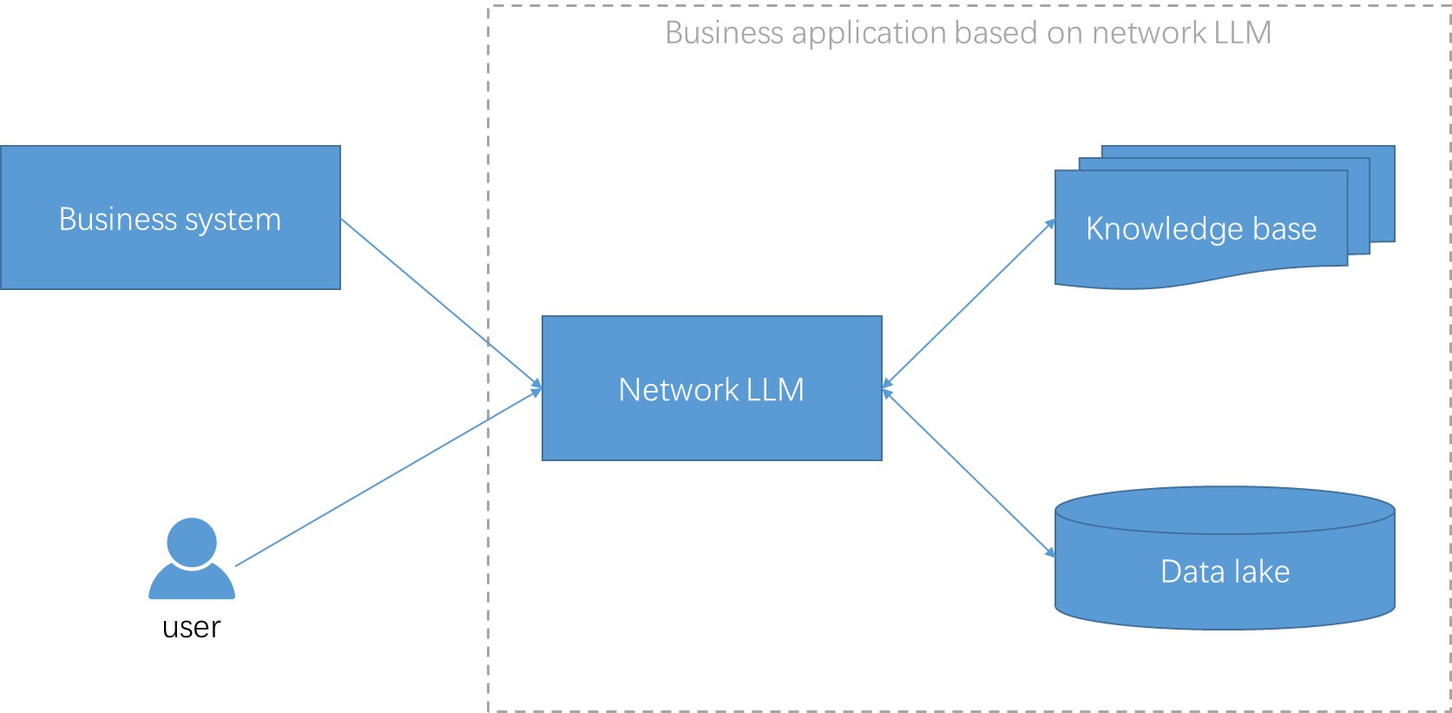

5.1 data lake
Void

5.2 knowledge base
Void

6 Interaction of network LLM and data lake
Void

7 Interaction of network LLM and knowledge base
Void

8 Work flow
Void

Annex A (normative or informative):
Title of annex

Annex B (normative or informative):
Title of annex

B.1 First clause of the annex

B.1.1 First subdivided clause of the annex

Annex (informative):
Bibliography

Annex (informative):
Change history
Date | Version | Information about changes
<Month year> | <#> | <Changes made are listed in this cell>

History
Document history
<Version> | <Date> | <Milestone>

Latest changes made on 2022-03-14

