Disclaimer
The present document has been produced and approved by the <long ISGname> (<short ISGname>) ETSI Industry Specification Group (ISG) and represents the views of those members who participated in this ISG.
It does not necessarily represent the views of the entire ETSI membership.
ETSI GR NFV-TST 012 V0.0.3 (2019-02)

Group REPORT
Network Functions Virtualisation (NFV);
Testing;
VIM & NFVI Control and Management Performance Evaluation
<

Reference
DGS/NFV-xxx
Keywords
NFV, NFVI, VIM, Performance

ETSI
650 Route des Lucioles
F-06921 Sophia Antipolis Cedex - FRANCE

Tel.: +33 4 92 94 42 00 Fax: +33 4 93 65 47 16

Siret N° 348 623 562 00017 - NAF 742 C
Association à but non lucratif enregistrée à la
Sous-préfecture de Grasse (06) N° 7803/88

Important notice
The present document can be downloaded from:
http://www.etsi.org/standards-search
The present document may be made available in electronic versions and/or in print. The content of any electronic and/or print versions of the present document shall not be modified without the prior written authorization of ETSI. In case of any existing or perceived difference in contents between such versions and/or in print, the only prevailing document is the print of the Portable Document Format (PDF) version kept on a specific network drive within ETSI Secretariat.
Users of the present document should be aware that the document may be subject to revision or change of status. Information on the current status of this and other ETSI documents is available at https://portal.etsi.org/TB/ETSIDeliverableStatus.aspx
If you find errors in the present document, please send your comment to one of the following services:
https://portal.etsi.org/People/CommiteeSupportStaff.aspx
Copyright Notification
No part may be reproduced or utilized in any form or by any means, electronic or mechanical, including photocopying and microfilm except as authorized by written permission of ETSI.
The content of the PDF version shall not be modified without the written authorization of ETSI.
The copyright and the foregoing restriction extend to reproduction in all media.

© ETSI yyyy.
All rights reserved.
DECTTM, PLUGTESTSTM, UMTSTM and the ETSI logo are trademarks of ETSI registered for the benefit of its Members.
3GPPTM and LTETM are trademarks of ETSI registered for the benefit of its Members and
of the 3GPP Organizational Partners.
oneM2M logo is protected for the benefit of its Members.
GSM® and the GSM logo are trademarks registered and owned by the GSM Association.

Contents
Intellectual Property Rights 4
Foreword 4
Modal verbs terminology 4
Executive summary 4
Introduction 4
1 Scope 5
2 References 5
2.1 Normative references 5
2.2 Informative references 5
3 Definitions, symbols and abbreviations 5
3.1 Definitions 5
3.2 Symbols 6
3.3 Abbreviations 6
4 Overview 6
4.1 Introduction 6
4.2 Background 7
4.3 Use cases 9
4.3.1 Use cases related to implementation selection 9
5 Framework for Metric and Measurement Definition 10
5.1 Performance Metric Definition Template 10
5.2 Performance Measurement Definition Template 10
6 Test Set-ups and Configuration 11
6.1 Test Setups 11
6.2 Configurations 11
7 Control and Management Performance Metric 11
7.1.1 Duration of compute resource allocation 12
7.1.2 Duration of compute resource termination 13
7.1.3 Duration of compute resource scaling 13
7.1.4 Duration of compute resource migration 14
8 Performance Measurement 14
9 High-level Evaluation 14
Annex A: Title of annex 15
Annex B: Title of annex 16
B.1 First clause of the annex 16
B.1.1 First subdivided clause of the annex 16
Annex : Authors & contributors 17
Annex : Bibliography 18
Annex : Change History 19
History 20

Intellectual Property Rights
Essential patents
IPRs essential or potentially essential to normative deliverables may have been declared to ETSI. The information pertaining to these essential IPRs, if any, is publicly available for ETSI members and non-members, and can be found in ETSI SR 000 314: "Intellectual Property Rights (IPRs); Essential, or potentially Essential, IPRs notified to ETSI in respect of ETSI standards", which is available from the ETSI Secretariat. Latest updates are available on the ETSI Web server (https://ipr.etsi.org).
Pursuant to the ETSI IPR Policy, no investigation, including IPR searches, has been carried out by ETSI. No guarantee can be given as to the existence of other IPRs not referenced in ETSI SR 000 314 (or the updates on the ETSI Web server) which are, or may be, or may become, essential to the present document.
Trademarks
The present document may include trademarks and/or tradenames which are asserted and/or registered by their owners. ETSI claims no ownership of these except for any which are indicated as being the property of ETSI, and conveys no right to use or reproduce any trademark and/or tradename. Mention of those trademarks in the present document does not constitute an endorsement by ETSI of products, services or organizations associated with those trademarks.

Foreword
This Group Report (GR) has been produced by ETSI Industry Specification Group Network Function Vistualiztion (NFV).

Modal verbs terminology
In the present document "should", "should not", "may", "need not", "will", "will not", "can" and "cannot" are to be interpreted as described in clause 3.2 of the ETSI Drafting Rules (Verbal forms for the expression of provisions).
"must" and "must not" are NOT allowed in ETSI deliverables except when used in direct citation.

Executive summary

Introduction

1 Scope
The present document is a group report on methods and metrics for the evaluation of VIM & NFVI control and management performance. The evaluated NFV components in the present document include the NFV Infrastructure (NFVI) and Virtual Infrastructure Management (VIM). The evaluating area considered by this document is the capability of the operation and management of virtual resource which are performed by VIM and executed by NFVI, e.g. the time of virtualization container instantiation, scaling, migration.
Based on the performance evaluation result, the present document provides guidelines for relative comparison of different implementations of VIM & NFVI. The present document also provides advises about how to choose the most suitable implementation in different scenarios.

2 References

2.1 Normative references
Normative references are not applicable in the present document.

2.2 Informative references
References are either specific (identified by date of publication and/or edition number or version number) or non-specific. For specific references, only the cited version applies. For non-specific references, the latest version of the referenced document (including any amendments) applies.
NOTE: While any hyperlinks included in this clause were valid at the time of publication, ETSI cannot guarantee their long term validity.
The following referenced documents are not necessary for the application of the present document but they assist the user with regard to a particular subject area.
[i.1] ETSI GS NFV 004: "Network Function Virtualisation(NFV); Virtualisation Requirements ".
[i.2]  ETSI GS NFV-IFA 027: ”Network Functions Virtualization (NFV); Management and Orchestration; Performance Measurements Specification”.
[i.3] ETSI GS NFV-TST 001: ”Pre-deployment Testing; Report on Validation of NFV Environments and Services”.
[i.4]  ETSI GR NFV-TST 004: ”Guidelines for Test Plan on Path Implementation through NFVI”.
[i.5] RFC 8172: ”Considerations for Benchmarking Virtual Network Functions and Their Infrastructure”.
[i.6] OVP test specification:” https://docs.opnfv.org/en/stable-fraser/submodules/dovetail/docs/testing/ user/testspecification/”.
[i.7] Dovetail home page:” https://wiki.opnfv.org/display/dovetail/Dovetail+Home”.

3 Definitions, symbols and abbreviations

3.1 Definitions
For the purposes of the present document, the [following] terms and definitions [given in ... and the following] apply:

3.2 Symbols

3.3 Abbreviations
For the purposes of the present document, the [following] abbreviations [given in ... and the following] apply:

4 Overview
Editor’s Note：This chapter provides the overview introduction of VIM & NFVI performance evaluation. This chapter explains what is VIM&NFVI performance evaluation and why the performance evaluation is needed.

4.1 Introduction
Note：VIM & NFVI performance evaluation in this document is limited to the control and management plane of VIM. VIM & NFVI is simply referred as Infrastructure Domain in this document.
According to NFV standards, NFV Infrastructure (NFVI) is the key component of the NFV architecture that describes the hardware and software components on which virtual network functions (VNFs) are deployed. And Virtualized Infrastructure Manager (VIM) is a key component of the NFV-MANO architectural framework which is responsible for controlling and managing the NFV infrastructure (NFVI) compute, storage, and network resources. The detailed functional requirements for VIM have been defined in NFV IFA 010.
The main job of infrastructure domain performance evaluation is to measure how well those control and management functional requirements are fulfilled. In another word, it is aimed to evaluate the control and management capability of VIM. The primary assumption of performance evaluation is that those functional requirements have been realized correctly according to the corresponding NFV standards definition. And the interoperability requirements between VIM and NFVI have been met.
Under the current logical NFV framework, the operations for controlling and managing the NFVI resource are initiated by VIM and then executed by NFVI. So, infrastructure domain control and management performance is affected by two main parts:
- The ability of VIM to control and manage the resource
- The response capability of NFVI to the request from VIM
With regarding to industrial implementation, VIM and NFVI are normally delivered as one product. As a consequence, the above two parts are closely related and therefore it is difficult to separate them from each other during the evaluation process. Based on those considerations, VIM and NFVI are considered as a unified system under test/evaluation unity in this document.
The performance evaluation in the present document can serve the following purposes:
- It can be used for the relative comparison of different infrastructure domain implementations. In reality, different NFVIs can be implemented based on different virtualization technologies. And different VIMs may have different controlling and managing strategies and algorithms. Even for the same cloud platform (e.g. Openstack), there exist different enterprise editions. There is in lack of unified and comprehensive performance metrics and methods to find out which implementation performs better. The present document provides the corresponding metrics and methods to measure the performance of different infrastructure domain implementation. It can also provide some guide advises for infrastructure domain selection in different scenarios. The type and size of VNFs vary in different deployment scenarios. Therefore, operators may have different preferences about the capability of infrastructure domain. The performance evaluation in the present document can help operators have a comprehensive and detailed understanding about the capability of infrastructure domain, in order to guide operators to choose the most suitable implementation for the specific deployment scenario.
- It can be used to describe the performance requirements for both operators and vendors. The present document provides a set of metrics for performance evaluation. On the one hand, those metrics can be used by operators to quantitatively describe their own performance requirements. On the other hand, vendors can offer the benchmarking results of these metrics to demonstrate that whether the infrastructure domain implementation meets performance requirements from operators.
- It can help to position resource-related problems. When failures happen to the whole system (VNF + NFVI + MANO), it may be caused by failed resource management, wrong VNF configurations or even a breakdown of MANO. With the help of the proposed benchmarking methods in this document, the operators can easily find out whether infrastructure domain should take responsibility and thus improve the efficiency of troubleshooting.

4.2 Background
Editor’s Note：This subchapter provides the background information about the performance evaluation. This chapter also provides the brief background information about different VIM&NFVI implementations.
For infrastructure domain implementation, there are a lot of different choices provided by companies and communities. OpenStack is an open source virtualization platform which can support operators to deploy VNFs by using virtual machines (VMs) and COTS hardware. And OPNFV community has implemented OpenStack for VIM component according to ETSI NFV specification.
In addition to OpenStack, there are some other commercial implementations which also use VMs for VNF deployment provided by different companies.
With the development of virtualization technology, more and more companies are considering to build the container-based platform for NFV. The container-based platform can provide better service agility (e.g. dynamically provision VNFs for offering on demand services).
In some scenarios, service providers may have strict requirements for VNF isolation based on security considerations. In order achieve both isolation and agility, some companies and communities start looking for possible solutions to combine Kubernetes with OpenStack. For now, there are two main options for combining OpenStack with Kubernetes:
- The first option is to deploy Kubernetes on OpenStack. The advantage of this method is that the Kubernetes can be quickly deployed and flexibly expanded, and the multi-tenancy of the container is indirectly realized by the multi-tenant of the virtual machine with good isolation. The disadvantages is that deploying container on VM may cause little loss to computing performance and multi-layer nesting of network may increase the delay.
- The second option is to integrate Kubernetes with various components of OpenStack. The two communities, OpenStack and Kubernetes, are collaborating with each other to provide a complete suite of integration drives and plugins.
The present document provides metrics and methods which can be used to evaluate the performance of different infrastructure domain implementations. There are some projects in communities and industries which can be as the reference to the present document.
Project Rally in OpenStack designs the test tool to check whether OpenStack works well under high load. The following table lists the test cases provided by Rally which are related to infrastructure domain control and management performance evaluation:
Table 1 Reference Use Cases from Project Rally
OpenStack Component | Test cases | Corresponding requirement
Cinder | Create-and-attach-volume  Create-and-delete-volume  Create-and-list-volume  Create-and-update-volume | Related to performance evaluation for VIM’s storage resource management
 | Create-and-delete-snapshot  Create-and-list-snapshot | Related to performance evaluation for VIM’s virtualized resource snapshot management
Swift | Create-container-and-object-then-delete-all  Create-container-and-object-then-list-object | Related to performance evaluation for VIM’s storage resource management
Glance | Create-and-deactivate-image  Create-and-delete-image  Create-and-get-image  Create-and-list-image  Create-and-update-image | Related to performance evaluation for VIM’s software image management
Neutron | Create-and-delete-network  Create-and-delete-ports  Create-and-delete-routers  Create-and-delete-subnets  Create-and-show-subnets  Create-and-update-subnets | Related to performance evaluation for VIM’s network resource management
Nova | Boot-and-block-migrate  Boot-and-delete  Boot-and-list  Boot-and-live-migrate  Boot-and-migrate | Related to performance evaluation for VIM’s resource instance (VM for  OpenStack ) management
The OPNFV Verified Program (OVP) [i.6] provides a series of test areas aimed to evaluate the operation of an NFV system in accordance with carrier networking needs. OPNFV implements OVP in the Dovetail project [i.7]. Each test area contains a number of associated test cases which are described in detail in the associated test specification. The following table lists the test specifications for image test, VM resource scheduling on multiple nodes test and common virtual machine life cycle events test provided by OVP:
Table 2 Reference Test Specification from Project OVP
Test Specification | Test Cases | Corresponding requirement
Tempest Image test specification | Register Image  Upload Image  Get Image | Related to performance evaluation for VIM’s image management
VM Resource Scheduling on Multiple Nodes test specification | Schedule VM to compute nodes  Create and delete multiple server groups with same name and policy  Create and delete server group with affinity policy  Create and delete server group with anti-affinity policy  List server groups  Show server group details | Related to performance evaluation for VIM’s resource instance (VM) management
Common virtual machine life cycle events test specification | Resize a server  Resizing a volume-backed server  Cold migrate a server  Live migrate a server | Related to performance evaluation for VIM’s resource instance (VM) management
The test cases provided by OVP are designed for function test of VIM and NFVI only. They can be used as the reference for the design of test method in this document.

4.3 Use cases

4.3.1 Use cases related to implementation selection
The use case is limited to the case that multiple infrastructure domain candidates are provided for operators to select. They are installed in the same test environment with same set of testing VNFs. The set of testing VNFs is designed with simple function and different resource requirements. They will be operated (instantiated, scaled, destroyed …) in order to test the control and management plane of infrastructure domain. Continuous monitoring allows the testers (operators) to get the performance data about the infrastructure domain control and management functional behaviours in the same operator environment.
With those performance data, operators can run relative comparison between different infrastructure domains. Those performance data can also help operator to have comprehensive understanding about their capabilities from different dimensions. Combining with the requirements from different VNF deployment scenarios, operator can choose the most suitable infrastructure domain implementation. For example, in the scenarios which has a lot of micro-VNFs with short life cycle, operator may prefer the implementation with better flexibility in resource control and management. The performance data collected from the measurement can help operators to find the most suitable one.
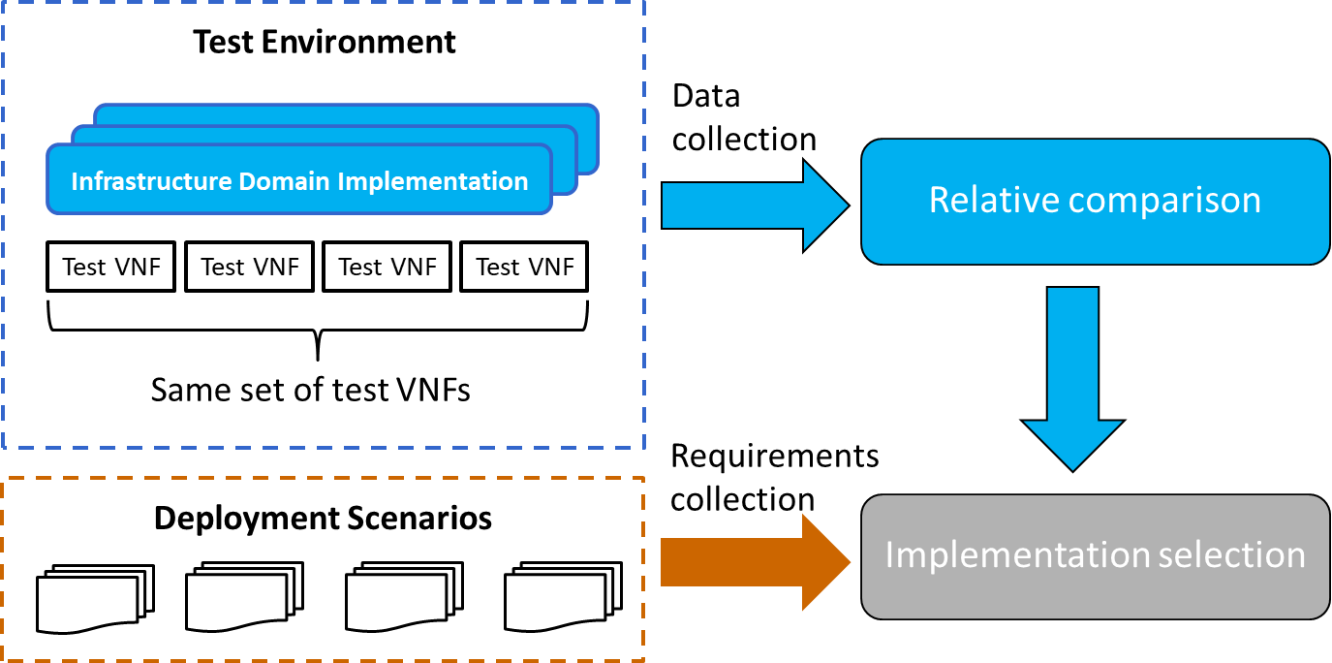
Figure 4-X: Use Case Related to Implementation Selection

5 Framework for Metric and Measurement Definition
Editor’s note: This chapter will introduce the framework for the definition of performance metrics and measurments. Chapter 7 and Chapter 8 will describe the defined metrics and measurement process in the framework defined in this chapter.

5.1 Performance Metric Definition Template
The present document provides the following template of element in separate sub-clauses for performance metrics definition:
- Background Introduction
This sub-clause contains the background information of the performance metric.
- Name
This sub-clause contains the name of performance metric. For the metric which may already exist in industry, it may be renamed in this sub-clause.
- Parameters
This sub-clause contains the parameters (input factors) which need to be specified in order to collect the performance metric.
- Unit(s)
This sub-clause specifies the unit(s) of performance metric.
- Definition
This sub-clause contains the definition of performance metric. It explains which control and management function of VIM the metric is defined to measure.
- Method of Measurement
This sub-clause contain the method to measure the performance metric,
- Discussion
This sub-clause contain the additional information which isn’t covered in the above sub-clause. This sub-clause is not mandatory.

5.2 Performance Measurement Definition Template
The present document provides the following template of element in separate sub-clauses for performance measurement definition:
- Description
This sub-clause contains the description of the performance measurement.
- Measurement Name
This sub-clause contains the name which is used to identify performance measurement.
- Measurement Method
This sub-clause contains the methods in which the measurement is obtained.
- Measured Metric(s)
This sub-clause lists the metrics which can be measured through the performance measurement
- Trigger
This sub-clause contains the trigger which start the measurement.
- Sources of Error
This sub-clause lists the factors which may cause failure to the performance measurement,
- Measurement Procedure
This sub-clause provides the procedure manual of performance measurement.

6 Test Set-ups and Configuration
Editor’s note: This chapter provides the information about set-up and configuration of performance evaluation. The introduction of SUT (system under test) is also covered.

6.1 Test Setups
Editor’s note: This subchapter introduces VM-based set-up and Container-based set-up. It may cover the mix scenarios where both VM and container exist. It requires further discussion.
In the context of performance evaluation, the System Under Test (SUT) is made of infrastructure domain (VIM and NFVI) coming from different providers.
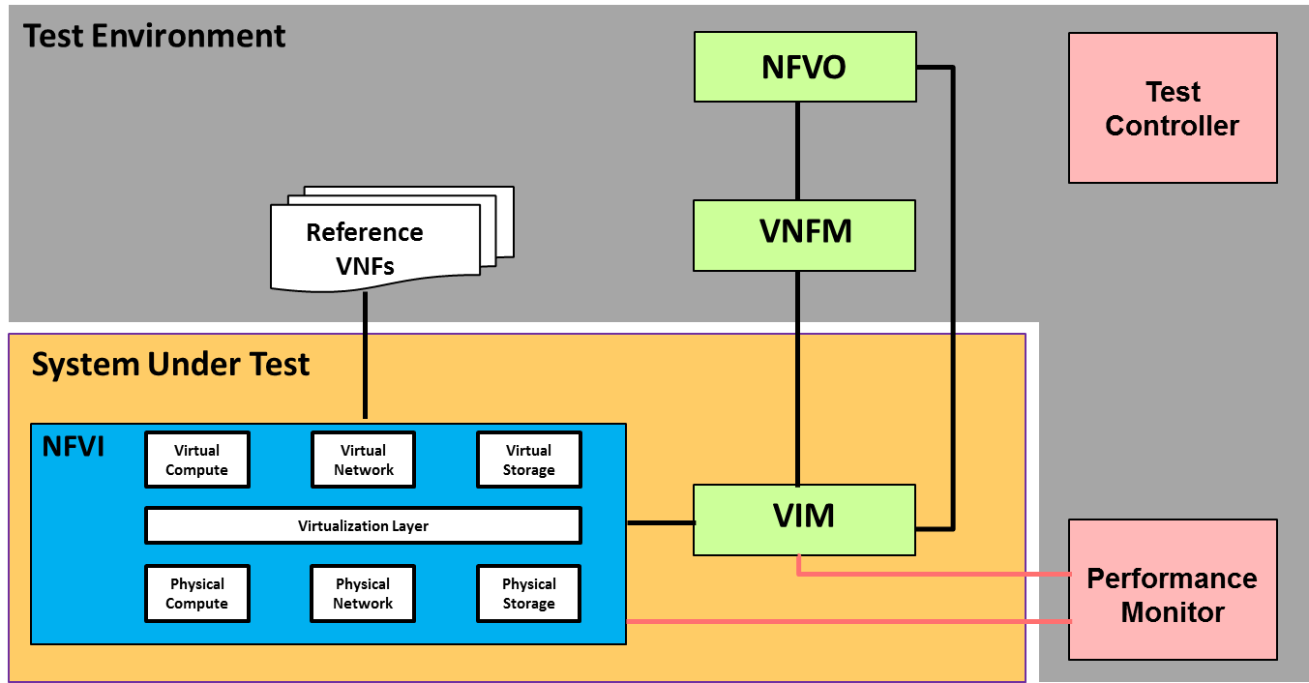
Figure 6-X: System Under Test and Test Environment
As illustrated in figure 6.x, the test environment consists of a reference implementation of the NFV MANO functional components (NFVO and VNFM), reference VNFs, one performance monitor and one test controller.
The testing domain is the performance of the operations and management resource instance and virtual resource. The NFV MANO functional components (NFVO and VNFM) is responsible to help VIM to trigger the control and management operations which need to be evaluated. The test controller in figure 6.x is used to control the whole test procedure. The performance monitor is required to measure the performance indicators from the VIM. According to the definition of testing domain, the performance of VNFs is out of the scope. During the evaluation, a set of VNFs with simple functions and different resource requirements are used as the reference VNFs.

6.2 Configurations
Editor’s note: This subchapter introduces the necessary configurations of each set-up component.

7 Control and Management Performance Metric
Editor’s note: This chapter describes the metrics which are used for VIM & NFVI control and management performance evaluation

7.1 Performance metrics related to compute resource control and management

7.1.1 Duration of compute resource allocation
- Background Introduction
During the instantiation of VNF, infrastructure domains need to perform the operation of compute resource allocation according to the virtual resource requirements of VNF.
Some VNFs have affinity/anti-affinity requirement. For those VNFs, infrastructure domain need to allocate the compute resource from the same/different physical host according to the policies.
In order to guarantee service performance, some VNFs have acceleration requirements. For VNFs that have significant memory requirements or are memory intensive, huge page memory allocation is required from infrastructure domain. To ensures that all memory accesses are local to the node and thus do not consume the limited cross-node memory bandwidth, adding latency to memory accesses, NUMA support is required from infrastructure domain. For the VNF which requires real-time behaviours, infrastructure domain need to assign the vCPU to one particular physical CPU during the allocation of compute resource.
The performance metric in this chapter is defined to measure the agility of compute resource allocation in above VNFs instantiation scenarios.
- Name
Duration of compute resource allocation
- Parameters
The following parameters are specified for the measurement of duration of compute resource allocation:
- Compute Resource Requirement: This parameter should provide the information which specify the CPU requirement using number of cores, memory requirement and the disk requirement using GB.
- Number of Resource Instances: There are two optional method to specify the number of resource instance: (1) X% of max resource instance load is used to specify the number of resource instances. Max resource instance load represents the max number of the chosen type of resource instances which can be deployed in test environment. (2) Absolute value can be used to specify the number of resource instance.
- Affinity/Anti-affinity Constraints: This parameter should specify whether the compute resource allocation have affinity/anti-affinity constraints and which type of constraints need to be fulfilled:
- No Constraints: In this scenario, nothing else need to be specified.
- Affinity Constraints: In this scenario, the scope of affinity policy need to be specified, possible values are "Zone" and "NFVI-node".
- Anti-Affinity Constraints: In this scenario, the scope of affinity policy need to be specified, possible values are "Zone" and "NFVI-node".
- Acceleration Requirements: This parameter should specify whether the compute resource allocation have acceleration requirement and which type of requirement need to be fulfilled:
- No requirement: In this scenario, nothing else need to be specified.
- Hugepage Memory Support: In this scenario, the hugepage memory size need to be specified. The typical values may be “2MB” or “1GB”.
- NUMA Support: In this scenario, the information about the allocation of vCPUs and memory from same or different host NUMA nodes need to be specified.
- CPU Pinning Support: In this scenario, the CPU pinning mode need to be specified, possible values are “Share mode” and “delicate mode”.
- Unit(s)
Duration of compute resource allocation is expressed in microseconds.
- Definition
This metric measures the time slot from VIM receiving request of compute resource allocation to VIM sending response of compute resource allocation.
- Method of Measurement
The method of measuring this performance metric is described in chapter 8.
- Discussion
TBD

7.1.2 Duration of compute resource termination
- Background Introduction
To support the deletion of VNF, infrastructure domains need to perform the operation of terminating the corresponding compute resource. .
- Name
Duration of compute resource termination .
- Parameters
The following parameters are specified for the measurement of duration of compute resource termination:
- Compute Resource Requirement: This parameter should provide the information which specify the CPU requirement using number of cores, memory requirement and the disk requirement using GB.
- Number of Resource Instances: There are two optional method to specify the number of resource instance: (1) X% of max resource instance load is used to specify the number of resource instances. Max resource instance load represents the max number of the chosen type of resource instances which can be deployed in test environment. (2) Absolute value can be used to specify the number of resource instance.
- Unit(s)
Duration of compute resource termination is expressed in microseconds.
- Definition
This metric measures the time slot from VIM receiving the request of compute resource termination to VIM sending response of termination.
- Method of Measurement
The method of measuring this performance metric is described in chapter 8,
- Discussion
TBD

7.1.3 Duration of compute resource scaling
NOTE: The vertical scaling (scale up/down) of VNF is not supported in the current NFV specification.
- Background Introduction
During the maintenance of VNF, for the sake of guaranteeing the performance or saving the resource, resource instances of VNF may need to be resized (Scale up/down).To support the scaling of VNF, infrastructure domain need to perform the operation of compute resource scaling. Operations of scaling in/out resource instance are similar to the operations of allocating/terminating compute resource for VIM. They will not be included in this sub-chapter.
- Name
Duration of compute resource scaling
- Parameters
The following parameters are supported for the measurement of duration of compute resource scaling:
- Size of Compute Resource Instance: This parameter should provide the information about the compute resource instance which need to be scaled. The information should specify the CPU requirement using number of cores, memory requirement and the disk requirement using GB.
- Scaling Step: During the measurement, different scaling steps are chosen in order to evaluate the agility of control and management of SUT. For scaling up, the scaling steps may include 120%, 150%, 200% and 300%. For scaling down, the scaling steps may include 20%, 50% and 70%.
- Unit(s)
Duration of compute resource scaling is expressed in microseconds.
- Definition
This metric measures the time slot from VIM receiving the request of compute resource scaling to VIM sending the response when complete the compute resource scaling.
- Method of Measurement
The method of measuring this performance metric is described in chapter 8,
- Discussion
TBD

7.1.4 Duration of compute resource migration
- Background Introduction
Resource instance may need to be migrated from the original physical machine to the new physical machine when some failures happen to the original physical machine. In this scenario, infrastructure domain need to perform the operation of virtualized compute resource migration.
- Name
Duration of compute resource migration
- Parameters
The following parameters are specified for the measurement of duration of compute resource migration:
- Size of Compute Resource Instance: This parameter should provide the information about the compute resource instance which need to be migrated. The information should specify the CPU requirement using number of cores, memory requirement and the disk requirement using GB.
- Migration Constraint: This parameter specify where to migrate the resource, possible values are “a specified resource zone” or “a specified host”.
- Unit(s)
Duration of compute resource migration is expressed in microseconds.
- Definition
This metric measures the time slot from VIM receiving the request of compute resource migration to VIM sending the response of completing the migration.
- Method of Measurement
The method of measuring this performance metric is described in chapter 8,
- Discussion
TBD

8 Performance Measurement
Editor’s note: This chapter describes the methods and procedures of performance measurement

9 High-level Evaluation
Editor’s note: This chapter may be renamed later. This chapter collects high-level requirements for VIM&NFVI performance and recommends evaluation methods based on the metrices collected from performance measurements.

Annex A:
Title of annex

Annex B:
Title of annex

B.1 First clause of the annex

B.1.1 First subdivided clause of the annex

Annex :
Authors & contributors
The following people have contributed to the present document:
Rapporteur:
Title, Firstname, Lastname, company
Other contributors:
Title, Firstname, Lastname, company

Annex :
Bibliography

Annex :
Change History
Date | Version | Information about changes
<Month year> | <#> | <Changes made are listed in this cell>

History
Document history
<Version> | <Date> | <Milestone>

Latest changes made on 2018-02-09

