Disclaimer
The present document has been produced and approved by the <long ISGname> (<short ISGname>) ETSI Industry Specification Group (ISG) and represents the views of those members who participated in this ISG.
It does not necessarily represent the views of the entire ETSI membership.
ETSI GR PDL 010 V0.0.3 (2021-02)

Group REPORT
PDL Operations in Offline Mode

Release #
<

Reference
DGR/PDL-010_PDL_Offline_Mode
Keywords
PDL, ledger, Smart contracts, Accountability

ETSI
650 Route des Lucioles
F-06921 Sophia Antipolis Cedex - FRANCE

Tel.: +33 4 92 94 42 00 Fax: +33 4 93 65 47 16

Siret N° 348 623 562 00017 - NAF 742 C
Association à but non lucratif enregistrée à la
Sous-préfecture de Grasse (06) N° 7803/88

Important notice
The present document can be downloaded from:
http://www.etsi.org/standards-search
The present document may be made available in electronic versions and/or in print. The content of any electronic and/or print versions of the present document shall not be modified without the prior written authorization of ETSI. In case of any existing or perceived difference in contents between such versions and/or in print, the prevailing version of an ETSI deliverable is the one made publicly available in PDF format at www.etsi.org/deliver.
Users of the present document should be aware that the document may be subject to revision or change of status. Information on the current status of this and other ETSI documents is available at https://portal.etsi.org/TB/ETSIDeliverableStatus.aspx
If you find errors in the present document, please send your comment to one of the following services:
https://portal.etsi.org/People/CommiteeSupportStaff.aspx
Copyright Notification
No part may be reproduced or utilized in any form or by any means, electronic or mechanical, including photocopying and microfilm except as authorized by written permission of ETSI.
The content of the PDF version shall not be modified without the written authorization of ETSI.
The copyright and the foregoing restriction extend to reproduction in all media.

© ETSI yyyy.
All rights reserved.
DECTTM, PLUGTESTSTM, UMTSTM and the ETSI logo are trademarks of ETSI registered for the benefit of its Members.
3GPPTM and LTETM are trademarks of ETSI registered for the benefit of its Members and
of the 3GPP Organizational Partners.
oneM2M™ logo is a trademark of ETSI registered for the benefit of its Members and
of the oneM2M Partners.
GSM® and the GSM logo are trademarks registered and owned by the GSM Association.

Contents
Intellectual Property Rights 5
Foreword 4
Modal verbs terminology 4
Executive summary 4
Introduction 4
1 Scope 5
2 References 5
2.1 Normative references 5
2.2 Informative references 5
3 Definition of terms, symbols and abbreviations 5
3.1 Terms 5
3.2 Symbols 6
3.3 Abbreviations 6
4 Introduction and Prior Art 6
4.1 Introduction To Used Terminologies 6
4.2 General Prior Art, Including Public Ledgers 6
4.3 Specific PDL Offline Solutions 6
4.4 Related Prior Art Enabling Offline PDL 7
5 Storage models 7
5.1 Offline storage models 7
5.2 Online storage models 7
6 Protocols and Architectures 7
6.1 Offline Mechanisms & Enablers 7
6.2 Offline PDL Protocols 7
6.3 Offline PDL Architectures 7
6.4 Offline PDL Reference Design 7
7 Threats and tradeoffs in Offline storages 7
7.1 Security threats 7
7.2 Potential ways to protect 7
7.3 Tradeoffs 7
8 Conclusions and Recommendations 8
Annex A: Title of annex 9
Annex B: Title of annex 10
B.1 First clause of the annex 10
B.1.1 First subdivided clause of the annex 10
Annex: Bibliography 11
Annex : Change History 12
History 13

Intellectual Property Rights
Essential patents
IPRs essential or potentially essential to normative deliverables may have been declared to ETSI. The information pertaining to these essential IPRs, if any, is publicly available for ETSI members and non-members, and can be found in ETSI SR 000 314: "Intellectual Property Rights (IPRs); Essential, or potentially Essential, IPRs notified to ETSI in respect of ETSI standards", which is available from the ETSI Secretariat. Latest updates are available on the ETSI Web server (https://ipr.etsi.org).
Pursuant to the ETSI IPR Policy, no investigation, including IPR searches, has been carried out by ETSI. No guarantee can be given as to the existence of other IPRs not referenced in ETSI SR 000 314 (or the updates on the ETSI Web server) which are, or may be, or may become, essential to the present document.
Trademarks
The present document may include trademarks and/or tradenames which are asserted and/or registered by their owners. ETSI claims no ownership of these except for any which are indicated as being the property of ETSI, and conveys no right to use or reproduce any trademark and/or tradename. Mention of those trademarks in the present document does not constitute an endorsement by ETSI of products, services or organizations associated with those trademarks.

Foreword
This Group Report (GR) has been produced by ETSI Industry Specification Group Permissioned Distributed Ledger (PDL).

Modal verbs terminology
In the present document "should", "should not", "may", "need not", "will", "will not", "can" and "cannot" are to be interpreted as described in clause 3.2 of the ETSI Drafting Rules (Verbal forms for the expression of provisions).
"must" and "must not" are NOT allowed in ETSI deliverables except when used in direct citation.

Executive summary
One paragraph each on:
- general role/importance of ledgers / PDL
- problem statement we are trying to address
- reasons why nodes might be offline
- contribution we make; each subsequent high level section in one paragraph
- summary on high level findings and recommendation

Introduction
Several paragraphs each on:
- general role/importance of ledgers / PDL
- current work done by ETSI PDL and wide ecosystem
- problem statement we are trying to address
- expanded view on why nodes might be offline
- rational of our work and resulting structure of document

Scope
The present document describes the current challenges related to data storage and ledger operations when the PDL nodes are offline (duty cycled or truly offline); the methodologies and techniques that can be applied to Smart Contracts to operate when the nodes are offline and develop secure interim storage and negotiation algorithms that ensure the integrity of the data feed to the PDLs.

References

2.1 Normative references
Normative references are not applicable in the present document.

2.2 Informative references
References are either specific (identified by date of publication and/or edition number or version number) or non-specific. For specific references, only the cited version applies. For non-specific references, the latest version of the referenced document (including any amendments) applies.
NOTE: While any hyperlinks included in this clause were valid at the time of publication, ETSI cannot guarantee their long term validity.
The following referenced documents are not necessary for the application of the present document but they assist the user with regard to a particular subject area.
[i.1] ETSI GR PDL001 V1.1.1/(2020-03): "Permissioned Distributed Ledger (PDL); Landscape of Standards and Technologies".
[i.2]  European Commission CORDIS: "CORDIS: Projects and Results".
NOTE 1: Available at https://cordis.europa.eu/projects/en
[i.3]  ETSI Research and Standards Website /(2020-06-15): "Research and Standards".
NOTE 1: Available at https://www.etsi.org/research
[i.4]

Definition of terms, symbols and abbreviations

Terms
For the purposes of the present document, the [following] terms [given in ... and the following] apply:
Real-Time PDL
Synchronous PDL
Asyncrhonous PDL
Offline PDL

Symbols
For the purposes of the present document, the [following] symbols [given in ... and the following] apply:

Abbreviations
For the purposes of the present document, the [following] abbreviations [given in ... and the following] apply:
AI Artificial Intelligence
DLT Distributed Ledger Technology
ETSI European Telecommunications Standards Institute
EU European Union
H2020 Horizon 2020
ICT Information and Communication Technology
IoT Internet of Things
IP Intellectual Property
PDL Permissioned Distributed Ledger

Introduction

PDL Overview
Some general intro to PDL

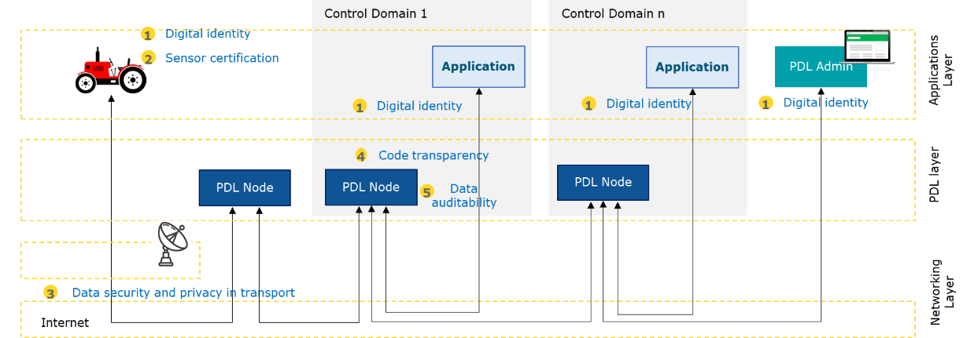

Reasons For Offline
Discuss reasons why parts of the chain go offline.

Offline Challenge
Discuss offline challenges from a very high level point of view
1) Data Integrity:
2) Chain merging
3) Stale transactions

High-Level Reference Architecture

Introduction to Architecture
Verbal description to the architecture, the nodes, and other important issues.

Type of Nodes
Discuss different types of nodes, discuss their roles, and how they interact;

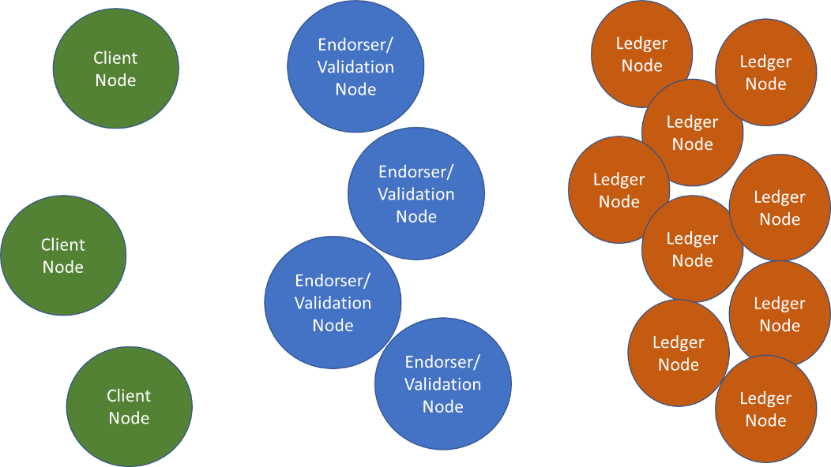

Offline Scenarios
- highlight that temporal causality is important here (in contrast to always-on ledgers); give examples of ledger ways of implementations/ philosophies
- consider both individual nodes going offline; or them going offline in a cluster (both new set of problems but also a new set of solutions)
Scenarios:
- Scenario 0: all nodes online
- Scenario 1: all clients online all endorser node online some ledgers offline
- Scenario 2: all clients online some endorser offline all ledgers online
- Scenario 3: some clients offline all endorses online all ledgers online
- Scenario 4: all clients online some endorser offline some ledgers offline
- Scenario 5: some clients offline all endorser online some ledgers offline
- Scenario 6: some clients offline some endorser offline all ledgers online
- Scenario 7: some clients offline some endorser offline some ledgers offline
Q: validity of parts of a managed ledger going offline?

Temporal Characteristics
- Causality
- Gracefulness

Technical Issues Arising From Offline Mode

Introduction
…

Offline Client Node
- CONCERNED ABOUT:
  - Secure the offline data
  - Enable smart contract operations
  - Enable reconciliation with the main chain
- Also consider proxy nodes for smart contract scenario (scenario where node may not want to advertise it’s conditions of meeting a smart contract trigger; for instance hiding from competitors --- TBC how this is practically done)
- Make sure that offline generated content cannot be compromisesd:
  - Secure vault to temporarily store data / blocks
  - Consider using time-limited assymetric key derived from the moment the PDL was last accessible
  - Consider building a local PDL through Kubernetes clusters (tbc)
  - Ramp up local PDL which could be time limited eg deleted after a certain time to save memory (Tbc)
- Think on how to reconcile content on main PDL:
  - Constrained devices result in nodes that do not maintain the ledger, i.e. replicate the ledger. These nodes do, however, communicate with the ledger through an API; hence, offline services integrated into the API might provide better speed and scalability options.
    - The API should have the necessary facilities/functions for creating the time-limited asymmetric key.
    - The API would then also be responsible for ensuring that the data to be uploaded is in the right format, and has the right credentials.
  - Insert into PDLwhen online again
  - Post-insert and re-run consensus (hindsight consensus)
  - Post-insert but run “zipper” consensus principle
- The main aim of having a set of “orderers” in consensus for permissioned ledgers is to increase the rate of finality which is predicated on reducing the frequency of forks, or removing the possibility of forks. Hindsight consensus would in-effect create forks in the ledger and ultimately disrupt the deterministic execution of transactions.
- Hindsight consensus would also increase the energy consumed in consensus but not to the magnitude required to re-validate the previously accepted blocks, from the block height of the hindsight consensus.
- For nodes to create an offline ledger (side chain), the nodes would need to be able to create blocks while offline. If a consensus model such as the one seen in Hyperledger is assumed, each node in an offline state would assume the roles of “endorser, orderer, and validator”, to successfully append blocks to the offline ledger.

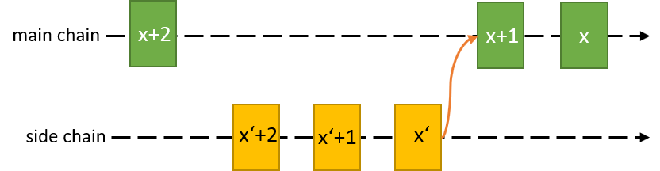
Figure 1 The view of the internal ledger of a node that has previoulsy been offline. The yellow blocks indicate the entries of the node to the ledger while disconnected from the p2p network.

Offline Validation/Endorsement Node

General Considerations

- CONCERNED ABOUT:
  - Graceful disappearance eg due to network congestion (assign proxy node?)
  - Sudden disappearance, thus disrupting ongoing session (MPTCP?)
  - Disappearance of a critical mass of nodes, thus violating quora conditions

Consensus nodes are the type of nodes which partipate in the offline consensus, that is to say, that when the some of the nodes are offline, they can still run consensus among themselves. These nodes can be called as “backup nodes”
There are several situations, when the backup nodes that is the nodes those are running offline consensus, take over and run their own consensus which depends on the service providers and governance of the PDL. Some of them can be as follows:
- When the signal quality reached below a threshold
- When some number of base stations are offline (possibly due to malicious activity)

Transaction Validation

Data Storage

Smart Contracts

Offline Ledger Node

- CONCERNED ABOUT:
  - Unless reaching critical amount of nodes, this is dealt with by the consensus protocol

Normally dealt with through consensus protocol
- Also explore proxy node assignment when gradual decrease in connection can be quantified
  - How can link deterioration trigger a proxy request? (Should the offline node ID be transferred to the proxy node? Important from a smart contract; should there be a specific trigger to a specific other consensus node; or should be a general request which then chooses a random consensus node; so we need to check also the “unproxy” mechanisms to avoid malicious attacks.
  - Consensus nodes in PDL are typically fixed per player (typically 1 consensus node per organisation; if there are more then either fair balance or a specific reason for an org to have more); Consider internal transfer of concensus node rights (deterministic vs random; what happens if there is no replacement within the organisation; etc)
- How do we account for false positives. For example, a temporary interference in signal of 3-5 seconds might cause the consensus node to request a proxy, but then might require the voting rights back immediately after.
- Another example might be a high retransmission rate which occurs during network peak periods. This might create a scenario where a proxy is necessary for he duration of the peak period.

Offline Smart Contracts
We need to see if this warrants a separate section of whether this shouldn’t be absorbed in above sections.

- Consider reverse problem in that smart contract needs to be downloaded locally
- A scenario such as where a cluster of devices depend on the smart contract for the finality of certain operations but have lost connection to the ledger network. This loss of connection might be due to the more resource-heavy node going offline.
- A successful offline smart contract system would require
  - A trusted environment where the virtual machine (for example EVM) required to run the smart contract is hosted.
  - The bytecode for the specific smart contract must be located on the node and a hash proof of the validity of the smart contract, i.e. the smart contract on the node is the same as that on the ledger.
  - The resulting output from the execution of the offline smart contract must be synchronised to with the state of the online ledger. This synchronisation cannot happen individually to avoid a replay attack/scenario. Therefore, the synchronisation might involve a pointer to the block containing said transactions or be a singular entry of the transactions between two nodes, on the online contract.
- The obvious challenge would be reconciling the offline states with the online states. For example, the current price bid for oil online vs the submitted price bid for oil offline.
- How to create secure and trusted environment locally; how to execute locally; and how to inform back the execution results/confirmation (see Section 4.2).

Monitoring Capabilities
- Duty cycling
- Graceful deterioration (proxy nodes)
- Sudden disappearance
- Monitoring/probing infrastructure (cloud, Kubernetes, independent PDL)

Proposed Solutions
Proposed solutions

Monitoring Capabilities

Offline Architecture Proposition
Glues together prior PDL work, as well as the proposed solutions in the context offline operations.

+++++ FROM HERE ONNWARD NOT TO BE DISCUSSED DURING OFFICIAL PDL CALL ++++

SEGMENT FROM TOOBA (15 Dec 2020)

Offline data storages

Introduction:
PDLs are distributed data storages, which means that every node in the network keeps a copy of the ledger; when an update comes all the nodes synchorize their local ledgers accordingly. The problem comes when some of the nodes are offline and they want to update the ledger; if a ledger is unreachable to nodes updating the ledger state, correct information cannot be available to the ledger. This is particularly very important when a transaction is dependent on other transactions. For example, if transaction A is dependent on transaction B, and the node sending sending transaction B is offline, and some other node X and sends transaction C and changes the state of transaction A. A mechanism to storage the data is required, to maintain the data integrity. Two major scenarios when a ledger or some of the nodes of ledgers are offline are discussed below:
- One of the node is offline: This is a simplest scenario, when one of the node is offline. In this case, the node may have to store the data at some iterim storage to prove the integrity of the data.
- Some of the nodes are offline: If two or more of the nodes are offline, they can create their own side-chain and fork to the main ledger when they go back online

Challenges:
The major problem here is that, the state of PDLs changes very quickly and by the time offline nodes come back online, the main ledger might be on a completely different state.

Data Integrity:
One of the major problems is the data integrity, PDLs achieve integrity through ledger replication to all of the node. When a node is offline when the data is stored at some iterim/middle storage, the main problem is the storage features this particular storage uses. Other mechanism of storage such as offline node establish a side-chain, can be adopted and discussed in clause 5.

Chain merging
One possible solution, is that all the offline nodes establish a side-chain, and when they come back online, update the ledger. Since, many nodes have saved the data, and through side chain mechanism established conesus among themselves, can prove integrity of the data to the main legder. However, there are two main problems:
- The main chain state can be moved forward and the old transactions (that is transactions in offline mode) are no longer applicable
- If there are number of side-chains merging to the main chain/ledger number of factors should be considered such as latency of the merging(TBD).

Stale transactions
As discussed in the earlier clause, the transactions in offline mode can become invalid after certain time; particularly when the target state is updated by some other transaction (from an online node). This can cause of monetary losses particularly; for example, if A and B are bidding for item I, and A bids higher then B but goes offline before the bid is received by the ledger, then item I may be sold to B.

When a PDL is offline, one or many nodes cannot access the main ledger, this means, records cannot be updated to the main ledger. The problem is when the offline nodes come back online, they need to prove the integrity of the data to nodes of the main ledger. Some of the methods to prove the integrity of offline ledgers is as follows:
- Maintain a side-chain : The offline nodes can establish connection between themselves and start a side-chain, and when the main ledger comes back online they can fork their branch to the main ledger. In this strategy there are two problems, 1) there should be a minimum number of nodes that establish a side chain. Second, when number of nodes are offline and many side chains are created, forking many of them to the main chain can be a problem.
- Cryptographic Means: In this strategy, the nodes can secure the data with pre-agreed keys(TBD)

Introduction and Prior Art
* discuss structure of this section
The necessity for the classification of an offline mode stems from the need to preserve and validate data that was generated when a previously online node loses connection with the rest of the p2p network. While offline full nodes are able to perform operations based on the most up-to-date version of the local ledger, the rest of the Blockchain network does not benefit from the result of the operations. These results must be cryptographically secure and timestamped in a manner that ensures the successful appending of the results to the ledger, when connection is resumed. Hence, a secure model that promotes offline security of data and the protocol for arriving at successful consensus on the back-dataed data is necessary.
From a security perspective, an offline mode might be desireable as it limits the exposure of the node to attacks i.e. less opportunities for remote attacks and thefts.

Introduction To Used Terminologies

Real-Time PDL
A PDL node is considered to be in a “real-time” stater when two conditions are met:
- The node does not have to initiate a “pull” operation i.e. the pushed blocks from other nodes sufficiently synchronise the node to the global state.
- All nodes in the node list are “active” or “alive”. This provides the nodes with the confidence that the local ledger is up-to-date and that its pushed transactions are disseminated in real time.
Other metrics may be used such as the number of blocks needed the synchronise the node to the global state must not exceed a set threshold, as this may indicate that the node has been considerably offline. An example of such capping or threshold could be the number of blocks or block headers received in the last round from peers are 10 or less. This value can be substituted for a more adaptive figure such as 1-third of the max downloadable block/header count per message.
Synchronous PDL
Asyncrhonous PDL
A node can be considered to be in an asynchronous state when its synchronisation is periodic or where synchronisations are a function of a "pull" request. Traditionally, a node in an "active" state indicates that the node is available for push notifications. This node may still sign “alive” messages to other p2p nodes in the network. However, an additional parameter could be set that identifies the synchronisation preference of active nodes. This parameter would determine the synchronous or asynchronous state of a PDL node.

Offline PDL
Simply put, an offline node is a node that has no active connection to any synchronous or real-time PDL node. This node might be offline due to being duty-cycled of an inconsistent internet connection. This node might still carryout PDL related operations outside of the network either based on data from its most recent view of the ledger or self-generated data. Regardless, this data must be preserved in a state that it can be validated and appended upon connection.

General Prior Art, Including Public Ledgers
Hardware-based Implementations
A cybersecurity company in Israel, GK8, successfully deployed an offline blockchain node. Similar to the offline node proposed by Cryptofuse, this node is fully offline and requires a tailor-made hardware to ensure certain security considerations. Their models are built around the node being “fully offline” i.e. the node will never have an active connection to the p2p network. These nodes through a combination of processes successfully pubish to the ledger network, however, all input or updates from the p2p network are confronted by several firewalls before being appended to the local ledger.

Specific PDL Offline Solutions

Related Prior Art Enabling Offline PDL

Storage models

Offline storage models

Online storage models

Protocols and Architectures

Offline Mechanisms & Enablers
Everything about underlying tech enablers

Offline PDL Protocols
Protcols resulting from above
A protocol similar to the GHOST protocol adopted in Ethereum might serve useful for appending back-dated transactions into the ledger. When the node is offline, all PDL operations and storage should be regarded as a side-chain operation. While these operations remain questionable to the rest of the network, the credentials of the side chain to the local node is valid. Hence, the transactions and storage on the side chain are valid, pending when there is a peg that either reference the data stored or facilitates the cryptographic operations necessary for appending the data to the chain. A peg refers to the protocol involved in achieving consensus on the data stored on the local side chain. The figure below demonstates the local storage of offline transactions and the continual synchronisation of the global ledger, while maintaining the local ledger. The protocol has to ensure the global chain will not be broken due to the presence of the offline, side-chain.

Offline PDL Architectures
Architectures resulting from above

While offline data may be pushed onto the ledger, it should never be used to enhance or ensure any security protocols.

Offline PDL Reference Design
TBC but would be good to extract from above a single reference design; that could help with future TS documentation.

Threats and tradeoffs in Offline storages

Security threats

Potential methods to protect

Tradeoffs

Conclusions

Annex A:
Title of annex

Annex B:
Title of annex

B.1 First clause of the annex

B.1.1 First subdivided clause of the annex

Annex:
Bibliography

Annex :
Change History
Date | Version | Information about changes
<Month year> | <#> | <Changes made are listed in this cell>

History
Document history
v0.0.1 | 12 Nov 2020 | Creation of document, TOC and high-level content

Latest changes made on 2019-09-10

