Disclaimer
The present document has been produced and approved by the ETSI Industry Specification Group on Permissioned Distributed Ledger (ISG-PDL) and represents the views of those members who participated in this ISG.
It does not necessarily represent the views of the entire ETSI membership.
ETSI GS ISG-PDL 012 V0.0.1 (2021-11)

Group Specification
Permissioned Distributed Ledger;
Normative Reference Architecture;
(Group Specification based on PDL-003 “Application Scenarios”)
<

Reference
DGS/PDL-012_Normative_Raference_Architecture
Keywords
PDL, Ledger, Architecture

ETSI
650 Route des Lucioles
F-06921 Sophia Antipolis Cedex - FRANCE

Tel.: +33 4 92 94 42 00 Fax: +33 4 93 65 47 16

Siret N° 348 623 562 00017 - NAF 742 C
Association à but non lucratif enregistrée à la
Sous-préfecture de Grasse (06) N° 7803/88

Important notice
The present document can be downloaded from:
http://www.etsi.org/standards-search
The present document may be made available in electronic versions and/or in print. The content of any electronic and/or print versions of the present document shall not be modified without the prior written authorization of ETSI. In case of any existing or perceived difference in contents between such versions and/or in print, the prevailing version of an ETSI deliverable is the one made publicly available in PDF format at www.etsi.org/deliver.
Users of the present document should be aware that the document may be subject to revision or change of status. Information on the current status of this and other ETSI documents is available at https://portal.etsi.org/TB/ETSIDeliverableStatus.aspx
If you find errors in the present document, please send your comment to one of the following services:
https://portal.etsi.org/People/CommiteeSupportStaff.aspx
Copyright Notification
No part may be reproduced or utilized in any form or by any means, electronic or mechanical, including photocopying and microfilm except as authorized by written permission of ETSI.
The content of the PDF version shall not be modified without the written authorization of ETSI.
The copyright and the foregoing restriction extend to reproduction in all media.

© ETSI yyyy.
All rights reserved.
DECTTM, PLUGTESTSTM, UMTSTM and the ETSI logo are trademarks of ETSI registered for the benefit of its Members.
3GPPTM and LTETM are trademarks of ETSI registered for the benefit of its Members and
of the 3GPP Organizational Partners.
oneM2M™ logo is a trademark of ETSI registered for the benefit of its Members and
of the oneM2M Partners.
GSM® and the GSM logo are trademarks registered and owned by the GSM Association.

Contents
Intellectual Property Rights 6
Foreword 6
Modal verbs terminology 6
Executive summary 6
Introduction 8
1 Scope 9
2 References 9
2.1 Normative references 9
2.2 Informative references 9
3 Definition of terms, symbols and abbreviations 10
3.1 Terms 10
3.2 Symbols 17
3.3 Abbreviations 17
4 Introduction 17
5 ETSI-ISG-PDL Normative Reference Architecture - Ontology 19
5.1 Definition of a Functional Block 19
5.2 Reference Architecture Overview 19
5.3 Development Guiding Principles 23
5.3.1 Platform development guiding principles 23
5.3.1.1 Category Alpha Platform 24
5.3.1.1.1 Category Alpha-1 Platform 24
5.3.1.1.2 Category Alpha-2 Platform 24
5.3.1.2 Category Bravo Platform 24
5.3.1.2.1 Category Bravo-1 Platform 25
5.3.1.2.2 Category Bravo-2 Platform 25
5.3.1.3 Category “Charlie” Platform 25
5.3.1.3.1 Category Charlie-1 Platform 26
5.3.1.3.2 Category Charlie-2 Platform 26
5.3.1.3.3 Category Charlie-3 Platform 26
5.3.1.3.4 Category Charlie-4 Platform 26
5.3.1.4 Category Delta Platform 27
5.3.1.4.1 Category Delta-1 Platform 27
5.3.1.4.2 Category Delta-2 Platform 27
5.3.1.4.3 Category Delta-3 Platform 27
5.3.1.4.4 Category Delta-4 Platform 28
5.3.2 Application development guiding principles 28
5.3.3 Platform Services Dependency 28
5.4 ETSI-ISG-PDL Platform Services 28
5.4.1 ETSI-ISG-PDL Atomic Services 35
5.4.1.1 ETSI-ISG-PDL Namespace Service 35
5.4.1.2 ETSI-ISG-PDL Identity Service 36
5.4.1.3 ETSI-ISG-PDL Location Service 36
5.4.1.4 ETSI-ISG-PDL Registration Service 37
5.4.1.5 ETSI-ISG-PDL Discovery Service 37
5.4.2 ETSI-ISG-PDL Composite Services 38
5.4.2.1 ETSI-ISG-PDL Messaging Service 39
5.4.2.2 ETSI-ISG-PDL Policy Service 39
5.4.2.3 ETSI-ISG-PDL Security Service 40
5.4.2.3.1 ETSI-ISG-PDL Authentication Service 40
5.4.2.3.2 ETSI-ISG-PDL Authorization Service 40
5.4.2.3.3 ETSI-ISG-PDL Cryptography Service 40
5.4.2.3.4 ETSI-ISG-PDL Encryption Service 41
5.4.2.3.5 ETSI-ISG-PDL Identity Management Service 41
5.4.2.3.6 ETSI-ISG-PDL Key Management Service 41
5.4.2.4 ETSI-ISG-PDL Logging Service 41
5.4.2.5 ETSI-ISG-PDL Governance Service 41
5.4.2.5.1 ETSI-ISG-PDL Implementation Agreements 42
5.4.2.5.1.1 Common Implementation Agreements – Common Rules 42
5.4.2.5.1.2 Common Implementation Agreements – Specific Rules 42
5.4.2.5.1.3 Specific Implementation Agreements 43
5.4.2.5.2 ETSI-ISG-PDL Governing Entity 43
5.4.2.5.2.1 Centralized governance 43
5.4.2.5.2.2 Decentralised governance 44
5.4.2.5.2.3 Automated governance 44
5.4.2.5.3 Crating, Changing and Enforcing Governance IAs and rules 44
5.4.2.6 ETSI-ISG-PDL Composition Service 44
5.4.2.7 ETSI-ISG-PDL Access Control Service 45
5.4.2.8 ETSI-ISG-PDL Fault Tolerance Service 45
5.4.2.9 ETSI-ISG-PDL Distribution Transparency Service 46
5.4.2.11 ETSI-ISG-PDL Concurrency Service 46
5.4.2.12 ETSI-ISG-PDL Storage related services 46
5.4.2.12.1 ETSI-ISG-PDL In Memory Storage Tier Service 47
5.4.2.12.2 ETSI-ISG-PDL File System Storage Tier Service 47
5.4.2.12.3 ETSI-ISG-PDL On-Chain Storage Service 47
5.4.2.12.4 ETSI-ISG-PDL Off-Chain Storage Service 48
5.4.2.12.5 ETSI-ISG-PDL Distributed Blockchain Storage Platform Service 48
5.4.2 ETSI-ISG-PDL Modelling Tier 49
5.4.2.13.1 ETSI-ISG-PDL Information Model 49
5.4.2.13.2 ETSI-ISG-PDL Data Model 50
5.4.2.13.3 ETSI-ISG-PDL Model Search 51
5.4.2.13.4 ETSI-ISG-PDL Model Stitching 51
5.4.2.14 ETSI-ISG-PDL Topology Platform Service 51
5.4.2.15 ETSI-ISG-PDL Event Processing Platform Service 52
5.4.2.16 ETSI-ISG-PDL Distributed Data Collection Platform Service 52
5.4.2.17 ETSI-ISG-PDL Distributed Secret Sharing Platform Service 53
5.4.2.18 Resource Management Platform Services 53
5.4.2.18.1 Resource Discovery 53
5.4.2.18.2 Resource Virtualization 54
5.4.2.18.3 Resource Inventory Management 54
5.4.2.18.3.1 Node-specific resources 54
5.4.2.18.3.2 Platform resources 54
5.4.2.18.4 Resource Administration and Management 55
5.4.2.18.5 Resource FCAPS 55
5.4.2.18.6 Resource Composition 55
5.4.2.19 ETSI-ISG-PDL Platform Service Management 55
5.4.2.19.1 Platform Service Discovery 56
5.4.2.19.2 Platform Service Virtualization 56
5.4.2.19.3 Platform Service Inventory Management 56
5.4.2.19.4 Platform Service Admin and Management 56
5.4.2.19.5 Platform Service FCAPS 57
5.4.2.19.6 Service Composition 57
5.4.2.20 ETSI-ISG-PDL Application Management Services 57
5.4.2.20.1 Application Composition 57
5.4.2.20.2 Application and Service Orchestration 57
5.4.2.20.3 Orchestration 58
5.4.2.20.4 Platform exploration 58
5.4.2.20.5 Application Registration 58
5.4.2.21 ETSI-ISG-PDL Transaction Management Service 58
5.4.2.22 ETSI-ISG-PDL Data Model Gateway/Broker 59
5.4.2.22.1 ETSI-ISG-PDL API Presentation Platform Service 60
5.4.2.22.1.1 RESTful-APIs 60
5.4.2.22.1.2 Non-RESTful-APIs 60
5.4.2.23 ETSI-ISG-PDL Application Specific Services 60
5.5 ETSI-ISG-PDL Application Clients 61
5.5.1 ETSI-ISG-PDL Computer Applications 61
5.5.2 ETSI-ISG-PDL Mobile Device Application 61
5.5.3 ETSI-ISG-PDL Cloud Applications 62
5.6 Summary 62
Annex A (normative or informative): Title of annex 63
Annex B (normative or informative): Title of annex 64
B.1 First clause of the annex 64
B.1.1 First subdivided clause of the annex 64
Annex (informative): Bibliography 65
Annex (informative): Change History 66
History 67

Intellectual Property Rights
Essential patents
IPRs essential or potentially essential to normative deliverables may have been declared to ETSI. The information pertaining to these essential IPRs, if any, is publicly available for ETSI members and non-members, and can be found in ETSI SR 000 314: "Intellectual Property Rights (IPRs); Essential, or potentially Essential, IPRs notified to ETSI in respect of ETSI standards", which is available from the ETSI Secretariat. Latest updates are available on the ETSI Web server (https://ipr.etsi.org).
Pursuant to the ETSI IPR Policy, no investigation, including IPR searches, has been carried out by ETSI. No guarantee can be given as to the existence of other IPRs not referenced in ETSI SR 000 314 (or the updates on the ETSI Web server) which are, or may be, or may become, essential to the present document.
Trademarks
The present document may include trademarks and/or tradenames which are asserted and/or registered by their owners. ETSI claims no ownership of these except for any which are indicated as being the property of ETSI, and conveys no right to use or reproduce any trademark and/or tradename. Mention of those trademarks in the present document does not constitute an endorsement by ETSI of products, services or organizations associated with those trademarks.

Foreword
This Group Specification (GS) has been produced by ETSI Industry Specification Group on Permissioned Distributed Ledger (ISG-PDL).

Modal verbs terminology
In the present document "shall", "shall not", "should", "should not", "may", "need not", "will", "will not", "can" and "cannot" are to be interpreted as described in clause 3.2 of the ETSI Drafting Rules (Verbal forms for the expression of provisions).
"must" and "must not" are NOT allowed in ETSI deliverables except when used in direct citation.
Items that are REQUIRED (contain the words SHALL or SHALL NOT) are labeled as [Rx] for required. Items that are RECOMMENDED (contain the words SHOULD or SHOULD NOT) are labeled as [Dx] for desirable. Items that are OPTIONAL (contain the words MAY or OPTIONAL) are labelled as [Ox] for optional.

Executive summary
This Group Specification defines a high level and abstract Normative Reference Architecture (NRA) for a Permissioned Distributed Ledger platform. This Group Specification also describes the characteristics and behaviour of this platform, along with the services that it provides.
The following areas are discussed in detail:
- PDL Network Identity and Communication specifications
- PDL Governance Framework and Processes specifications
- PDL platform abstraction specifications
The objectives of this document are to
- Maximize the choice of technology solutions available to entities using ETSI-ISG-PDL endorsed PDL platforms.
- Maximize ETSI-ISG-PDL endorsed PDL platforms’ scalability in terms of the applications supported and the number of entities able to use them.
The ETSI-ISG-PDL NRA is described in terms of abstract foundational (required minimum) and functional components that support specific sets of functionalities and reference points that describe the standardized interactions between different parts of the platform and with the external entities or platform. This enables technology vendors and developers to focus on their respective areas of expertise and platform users to choose a best-of-breed team of vendors/developers for their specific requirements.

Introduction
This Group Specification defines a NRA for a Permissioned Distributed Ledger platform. This Group Specification also describes the characteristics and behaviour of this platform, along with the services that it provides and exemplary solutions that can be built using it.
A NRA is a template for defining a solution to a particular problem domain (in this case, a PDL platform). It provides a set of common definitions of concepts, terminology, and common characteristics and behavior of the system, including a set of external Reference Points that standardize communication. This Group Specification uses a functional block architecture to define three key aspects of a PDL Platform:
- PDL Common Services, which are services and functionality provided by the PDL platform that serve as building blocks to form composite applications.
- PDL Platform Services, which are services and functionality provided by the PDL platform that all applications may use.
- PDL Communication Services, which define how external clients connect to the PDL platform.
- The objectives of using the NRA are to: Maximize the choice of technology solutions available to entities using ETSI-ISG-PDL-endorsed technologies, Common Services, and applications.
- Maximize ETSI-ISG-PDL endorsed PDL platforms’ scalability in terms of the applications supported and the number of entities able to use them.
The ETSI-ISG-PDL NRA also provides standardized terminology to simplify the interaction between PDL Platforms Services and applications developed by technology vendors/developers.

1 Scope
This Group Specification defines a NRA for a Permissioned Distributed Ledger platform. This Group Specification also describes the characteristics and behaviour of this platform, along with the services that it provides and exemplary solutions that can be built using it.
The objectives of this document are to
- Maximize the choice of technology solutions available to entities using ETSI endorsed PDL platforms.
- Maximize ETSI endorsed PDL platforms’ scalability in terms of the applications supported and the number of entities able to use them.
In scope:
- Definition of Functionalities, Interfaces, Reference points (e.g. Identity Services: PDL identity, Node identity, User identity)
Out of scope:
- Specific implementation details (e.g. Implementation of identity using a specific method). Such implementation details may be added at a later phase as separate documents or as corollaries/annexes to future releases of this document.
The approach taken in this document is to focus on defining what needs to happen, not how it is implemented.

2 References

2.1 Normative references
References are either specific (identified by date of publication and/or edition number or version number) or non-specific. For specific references, only the cited version applies. For non-specific references, the latest version of the referenced document (including any amendments) applies.
Referenced documents which are not found to be publicly available in the expected location might be found at https://docbox.etsi.org/Reference.
NOTE: While any hyperlinks included in this clause were valid at the time of publication, ETSI cannot guarantee their long term validity.
The following referenced documents are necessary for the application of the present document.
[1] <Standard Organization acronym> <document number>: "<Title>".
[2] <Standard Organization acronym> <document number>: "<Title>".

2.2 Informative references
References are either specific (identified by date of publication and/or edition number or version number) or non-specific. For specific references, only the cited version applies. For non-specific references, the latest version of the referenced document (including any amendments) applies.
NOTE: While any hyperlinks included in this clause were valid at the time of publication, ETSI cannot guarantee their long term validity.
The following referenced documents are not necessary for the application of the present document but they assist the user with regard to a particular subject area.
[i.1] MEF Sonata IRP, MEF 55 Lifecycle Service Orchestration, 55.0.1 October 2017: "MEF 55 - LSO Reference Architecture".
[i.2] ABAC, Guide to Attribute Based Access Control (ABAC) Definition and Considerations, NIST Special Publication 800-162, January 2014 “https://doi.org/10.6028/NIST.SP.800-162“

3 Definition of terms, symbols and abbreviations

3.1 Terms
For the purposes of the present document, the following terms apply:

Term | Description | Notes
ABAC | Attribute Based Access Control | Abbreviation
Access Control Policy | Defines the privileges and permissions of a subject entity to perform operations on a set of target entities.
Addressable Storage | Content/Data that can be accessed through a web link (URL).
API | Application Programming Interface | Abbreviation
API Broker | Software that mediates between two systems with different Data Models implemented as APIs. | Also referred to as API Gateway.
API Gateway | See API Broker.
Application (Software) | A program or group of programs designed for end users.
Application Abstraction Layer | APIs and interfaces, including API Gateways, enabling Applications to communicate with ETSI-ISG-PDL Platform. | -
Application Programming Interface | A system of tools and resources in an operating system, enabling developers to create software applications
Asynchronized Data | Data that does not require synchronization with other data.
Attribute Based Access Control | An access control method where the subject requests for performing an operation on objects are granted/denied based on,  - Assigned attributes of the subject.  - Assigned attribute of the object.  - Environmental conditions.  - Set of policies. | As defined by NIST [i.2]
Blockchain | A censorship and tamper-proof growing list of records, called blocks, that are linked using cryptography. Each block contains a cryptographic hash of the previous block, a timestamp, and transaction data
Business service | A service that is delivered to business customers by business units
CA | Certificate Authority | Abbreviation
Category Alpha Application | An application that is developed and delivered to all users of said application by a single vendor/developer using a Category Alpha Platform developed by that same vendor/developer. | Can only use a single DLT type prescribed by the developer.
Category Alpha Platform | A PDL platform that is designed, developed, delivered, and integrated to all users of said platform by a single vendor using a single DLT technology. | Broken down to sub-categories “Alpha-1” and “Alpha-2”.
Category Bravo Application | An application that is developed and delivered to all users of said application by a single vendor/developer using a Category Bravo Platform developed by that same vendor/developer. | Can only use DLT types prescribed by the developer.
Category Bravo Platform | A PDL platform that is designed, developed, delivered, and integrated to all users of said platform by a single vendor, but can operate using two or more underlying DLT technologies. | Broken down to sub-categories “Bravo-1” and “Bravo-2”.
Category Charlie Application | An application that is developed towards a specification of an Application so that any user of an application supporting such specifications can fully interoperate with other users of other applications built towards the same Application specifications.
Category Charlie Platform | A PDL platform that can operate using two or more underlying DLT technologies and is designed and developed towards a specification of an application abstraction layer so that any Application that supports such an abstraction layer can interface with said platform. | Broken down to sub-categories “Charlie-1”, “Charlie-2”, “Charlie-3” and “Charlie-4”.
Category Delta Platform | A Category Charlie platform that only supports a single DLT type. | Broken down to sub-categories “Delta-1”, “Delta-2”, “Delta-3” and “Delta-4”.
Certificate Authority | An entity that issues digital certificates. A digital certificate certifies the ownership of a public key by the named subject of the certificate
Composite Application | Applications using the PDL platform that are dependent on other Applications.
Composition | The act of creating a new object or a new functionality through combination of two or more existing objects or functionalities.
Concurrency | The occurrence of different instances of events at the same time.
Consumer | A PDL Platform entity that consumes data produced by another entity.
DAC | Discretionary Access Control | Abbreviation
Data Model | Represents Application specific, Lifecycle-step specific and Product specific concepts using a technology-specific concrete form. | Data Models are derived from the Information Model.
Data Model Broker | Software that mediates between two systems with different data models. | Also referred to as Data Model Gateway.
Data Model Gateway | Same as Data Model Broker.
Directly Connected Storage | Storage that is local to the node and is either physically connected to the node or is external storage connected using a shared communication channel that is managed by the owner of that node. | Examples of physically connected storage: internal drive, external thunderbolt drive  Examples of network storage: NAS, Cloud.
Discretionary Access Control | An access control policy where the owner of a resource/object defines the access control policy for the users.
Distributed Addressable Storage | Addressable Storage that is distributed across multiple storage devices.
Distributed Ledger Technology | A technology implementing a distributed ledger which is a consensus of replicated, shared, and synchronized digital data geographically spread across multiple sites, countries, or institutions. Unlike with a distributed database, there is no central administrator.
DLT | Distributed Ledger Technology | Abbreviation
DNS | Domain Name System | Abbreviation
Domain Name System | A hierarchical and decentralized naming system for computers, services, or other resources connected to the Internet or a private network. It associates various information with domain names assigned to each of the participating entities.
ETSI | European Telecommunications Standards Institute | Abbreviation
ETSI-ISG-PDL | ETSI Industry Specification Group for Permissioned Distributed Ledger. | Abbreviation
External Data | Data obtained from resources or systems external to the PDL platform.
External IRP | An IRP between a PDL platform and external entities.
Functional Block | A structural representation of the functionality of a component, module, or system. | Functionalities such as capabilities, behavior, and relationships.
Functional Capability | Capabilities that a system has to manage resource in each functional area of operations.
Governance | A collection of rules and tools that control the behavior and function of a PDL platform.
IETF | Internet Engineering Task Force | Abbreviation
IFPS | InterPlanetary File System | Abbreviation
Implementation Agreement | Rules and agreements that describe how a Platform Service is implemented.
Information Model | Represents concepts as abstract objects and relationships between objects using a technology-neutral form.
Insignificant Event | An event that does not affect any node other tan the node where it occurred and does not affect the chain or consensus mechanism.
Interface Reference Point | A communication channels through which functional blocks communicate with each other. | IRPs are given names for reference purposes. E.g. “Debka”.
Internal Data | Data that is generated by a node either through computation or through a directly connected sensor that feeds data to that node.
Internal IRP | An IRP between functional blocks internal to a PDL platform. | -
Internet Corporation for Assigned Names and Numbers | An American multi-stakeholder group and nonprofit organization responsible for coordinating the maintenance and procedures of several databases related to the namespaces and numerical spaces of the Internet, ensuring the network's stable and secure operation.
Internet Engineering Task Force | An open standards organization, which develops and promotes voluntary Internet standards, in particular the standards that comprise the Internet protocol suite.
InterPlanetary File System | A protocol and peer-to-peer network for storing and sharing data in a distributed file system that uses content-addressing to uniquely identify each file in a global namespace connecting all computing devices. | A a global namespace connecting all computing devices such as the public internet.
IRP | Interface Reference Point | Abbreviation
Loosely Coupled | A functionality that has little or no dependency on other functionalities.
MAC | Mandatory Access Control | Abbreviation
Mandatory Access Control | An access control policy defined by system administrators.
Minimum Viable Product | Is a version of a product with just enough features to satisfy early customers and provide feedback for future product development
Non-Addressable Storage | Content/Data that can not be addressed and accessed by any other entity except for the entity that directly manages this data.
Normative Reference Architecture | A template for defining a solution to a particular problem domain. | -
NRA | Normative Reference Architecture | -
Orchestration | The the act of chaining objects in a manner that connects the respective ingress and egress interfaces of such objects in a topology and sequence that yields a required functionality. | Objects may be Resources, Platform Services, Applications.
PBAC | Policy Based Access Control | Abbreviation
PDL Abstraction Layer | APIs and interfaces, including API Gateways, enabling Platform services to communicate with ETSI-ISG-PDL endorsed PDL types. | -
PDL Application | An application using PDL technology | -
PDL Hardware Interface | A point across which electrical, mechanical, and/or optical signals are conveyed from a sender to one or more receivers using one or more protocols.
PDL Data Model Broker/Gateway | Translates between data models allowing entities using different data models to communicate each using its own data model. | -
PDL Platform Atomic Service | A PDL Platform Service that does not use any other PDL Platform Service to perform its functionality. | May use external applications or functions.
PDL Platform Composite Service | A PDL Platform Service that uses one or more other PDL Platform Services to perform its functionality.
PDL Platform Mandatory Service | A PDL Platform Service that is mandated to be included in an ETSI-ISG-PDL compliant PDL platform.
PDL Platform Optional Service | A PDL Platform Service that does not need to be included in a PDL platform for it to be considered ETSI-ISG-PDL compliant.
PDL Platform Service | Services and functionality provided by the PDL platform that all applications may use. | Same as “Platform Service”
PDL Software Interface | A point through which communication with a set of resources of a set of objects is performed. | Resources such as memory or CPU.
Platform Service | Services and functionality provided by the PDL platform that all applications may use. | e.g. Governance, Identity, Storage
Policy | A set of rules, defined by the Governance, stating what to do in particular situations.
Policy Based Access Control | Access Control that is based on a specific Policy.
Principal | The highest authority or most important position in an organization, institution, group or system
Producer | A PDL Platform entity that generates data that other entities may consume.
RAM | Random Access Memory | Abbreviation
RAM Swap Space | A portion of a computing device’s hard drive that is used for virtual memory in the event that there is insufficient physical RAM installed on the device.
Random Access Memory | The hardware in a computing device where the operating system, application programs and data in current use are kept so they can be quickly reached by the device's processor.
RBAC | Role Based Access Control | Abbreviation
Remote Procedure Call | In distributed computing, a remote procedure call is when a computer program causes a procedure to execute in a different address space, which is coded as if it were a normal procedure call, without the programmer explicitly coding the details for the remote interaction.
Role Based Access Control | An access control approach based on the roles the user assumes in a system, rather than the user’s identity.
Service | An instance of a technology product implemented using an ETSI-ISG-PDL compliant platform. | e.g. a communication circuit connection two offices.
Significant Event | An event that occurred on any node that may affect the behavior of the node, the chain or the consensus mechanism.
Software Reference Model | A set of architectural patterns and other supporting artifacts that presents a set of unifying terminology, concepts, axioms, and functional blocks within a particular problem domain | -
Synchronized Data | Data that requires sequencing and has dependency on timing or content of other data being collected.
Tightly Coupled | A functionality that has a high degree of dependency on other functionalities.
Trusted Third Parties | In cryptography, a trusted third party is an entity which facilitates interactions between two parties who both trust the third party; the Third Party reviews all critical transaction communications between the parties, based on the ease of creating fraudulent digital content.
URL | Universal Resource Locator | Abbreviation
Universal Resource Locator | A reference to a web resource that specifies its location on a computer network and a mechanism for retrieving it. A URL is a specific type of Uniform Resource Identifier, although many people use the two terms interchangeably.
Use Case | a specific situation in which a product or service could potentially be used
Virtual Service | A service that uses one or more virtual objects. | Objects such as Resources, Services.
W3C | World Wide Web Consortium | Abbreviation
World Wide Web Consortium | The main international standards organization for the World Wide Web
Table 1 - Terms used in this document

3.2 Symbols
No symbols were used in this document.

3.3 Abbreviations
For the purposes of the present document, the following abbreviations apply:

Abbreviation | Description | Notes
ABAC | Attribute Based Access Control
API | Application Programming Interface
CA | Certificate Authority
DAC | Discretionary Access Control
DLT | Distributed Ledger Technology
DNS | Domain Name System
ETSI | European Telecommunications Standards Institute
ETSI-ISG-PDL | ETSI Industry Specification Group for Permissioned Distributed Ledger.
 | Information and Communications Technology Service Provider | -
IETF | Internet Engineering Task Force
IFPS | InterPlanetary File System
IRP | Interface Reference Point | -
ISG | Industry Specification Group
MAC | Mandatory Access Control
NRA | Normative Reference Architecture | -
PBAC | Policy Based Access Control
PDL | Permissioned Distributed Ledger
RBAC | Role Based Access Control
URL | Universal Resource Locator
W3C | World Wide Web Consortium
Table 2 - Abbreviations used in this document

4 Introduction
This Group Specification defines a NRA for a Permissioned Distributed Ledger platform. This Group Specification also describes the characteristics and behaviour of this platform, along with the services that it provides and exemplary solutions that can be built using it.
A NRA is a template for defining a solution to a particular problem domain (in this case, a PDL platform). It provides a set of common definitions of concepts, terminology, and common characteristics and behavior of the system, including a set of external Reference Points that standardize communication. This Group Specification uses a functional block architecture to define key aspects of a PDL Platform.
The objectives of using the Normative Reference Architecture are to:
- Maximize the choice of technology solutions available to entities using ETSI-ISG-PDL-endorsed technologies, Common Services, and applications.
- Maximize ETSI endorsed PDL platforms’ scalability in terms of the applications supported and the number of entities able to use them.
The ETSI-ISG-PDL NRA also provides standardized terminology to simplify the interaction between PDL Platforms Services and applications developed by technology vendors/developers.
The ETSI-ISG-PDL NRA depicted in Figure 1 below describes the above abstract functional components that support specific sets of functionalities and reference points that describe the standardized interactions between different parts of the platform and users of that platform. This approach enables technology vendors and developers to focus on their respective areas of expertise and market leadership by providing solutions for one or more Normative Reference Architecture functional components and/or services. It also allows users to choose best of breed vendors and solutions for their specific environment and product portfolio.
The architecture aims to be independent of specific implementations to accommodate a wide range of technology solutions that comply with both the requirements of the supported applications and ensures adherence to critical architectural requirements such as interoperability, security, privacy etc.
The ETSI-ISG-PDL NRA comprises two categories of architectural components - those components mandated in all ETSI-ISG-PDL compliant platforms – PDL Mandatory Platform Services, and those components that are optional and may be included or excluded depending on the applications implemented on the PDL - PDL Optional Platform Services. This approach facilitates the introduction and support of new applications in a structured manner without changing the common, mandatory, parts. The NRA also supports the concept of a distributed lifecycle for applications, where different parties take different roles and responsibilities e.g. Buyer versus Seller. This expands the vendor-member space, by allowing vendors to focus on, and members to choose from, specific architectural components in the stacks and focus their offerings on the different PDLs, Platform Services, and applications.
Following the terminology and general architectural requirements, this document discusses the architectural components listed below. Covering Services and their operating model followed by describing the PDL Platform Services and their stacks in detail and concluding with presentation architectural components.
- Orchestration (Governance and process management and coordination in a complex environment. e.g. node and PDL management in an environment involving multiple competing parties or supply chains).
- Applications (commercial related applications using PDL to create/trade value. E.g. Commercial settlement, Cryptocurrency, Asset/inventory tokenization and management).
- External and internal information exchange (e.g. Oracles, APIs, External data sources)
- Functional Capabilities (e.g. Security, Access Control)
- PDLs (common aspects of PDLs which can become agnostic – platform independence/interoperability).
- Off-chain Storage (another chain, local/cloud node that is not part of the PDL, PDL node but not sharing with other nodes of said PDL, trusted by a single node or trusted by all nodes based on governance etc.)
- Smart Contracts (commonalities, interoperability, PDL agnosticism)

5 ETSI-ISG-PDL Normative Reference Architecture - Ontology

5.1 Definition of a Functional Block
This standard uses a functional block architecture to define a software reference architecture.
A Functional Block is an abstract concept that defines a “black box” structural representation of the functionality (i.e., capabilities, behavior, and relationships) of a component, module, or system. A software reference model is an abstract definition of a set of architectural patterns and other supporting artifacts that presents a set of unifying terminology, concepts, axioms, and functional blocks within a particular problem domain. A set of functional blocks interact using a set of Internal and External IRPs that standardize communication, and collectively define the functionality provided independent of specific technologies, implementations, or other concrete details. A software reference architecture provides a template for defining interoperable solutions to a particular problem domain (e.g. an interoperable settlement platform) in accordance with applicable business rules, regulations, and other constraints.
Thus, a software reference architecture specifies the salient characteristics and behavior of a platform. This takes the form of a set of functions and services that can be used to build more complex and detailed functions and services.

5.2 Reference Architecture Overview
The ETSI-ISG-PDL NRA depicted in Figure1 is a software reference architecture for ETSI-ISG-PDL PDL platforms.
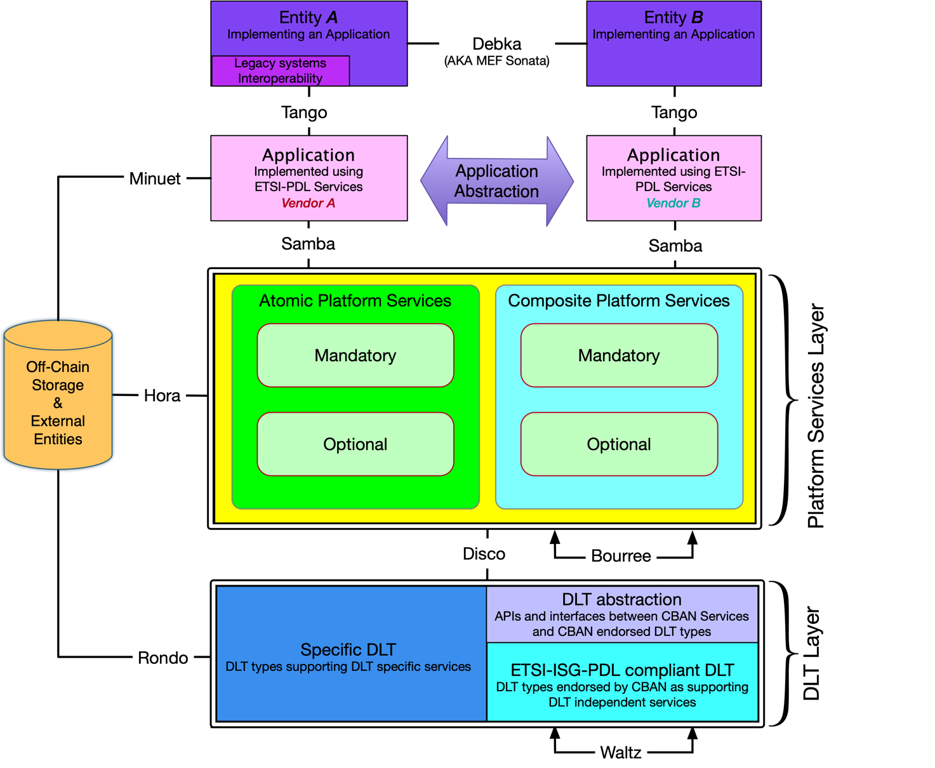
Figure 1. Main Components of the ETSI-ISG-PDL Normative Reference Architecture
The ETSI-ISG-PDL NRA is a modular architecture, and reuses individual Functional Blocks to compose new, more powerful, Functional Blocks. Accordingly:
- PDL Applications, which are applications using PDL technology.
- Application Abstraction Layer, which are Data Model Brokers/Gateways enabling Applications that use different data models to communicate with ETSI-ISG-PDL compliant platforms. This layer is implemented as part of the “Samba” IRP where necessary.
- PDL Platform Services Layer, which may support various types of applications. In general, a good architecture design would have a PDL Service Layer providing useful services for applications. As a result, an application could simply leverage services from the PDL Service Layer, which will reduce the application’s complexity, accelerate application development and deployment and increase interoperability. For example, the PDL Service Layer could have Transaction Management Service to facilitate an application to easily create transactions without knowing details of a specific PDL type (i.e., a specific deployed PDL network); in essence, this Transaction Management Service can perform transaction transformation/adaptation between applications running on different PDL types to facilitate application operations in a complex environment. For abstraction purposes the Service Layer is divided to sub-groups according to the matrix defined in Table 3 herewith. Applications’ access to services is independent of service classification and is subject to governance, identity and security considerations.

 | Mandatory | Optional
Atomic | Mandatory Atomic PDL Platform Services | Optional Atomic PDL Platform Services
Composite | Mandatory Composite PDL Platform Services | Optional Composite PDL Platform Services
Table 3 - Service types

  - PDL Mandatory Platform Services are services which a PDL platform has to include in order to be considered ETSI-ISG-PDL compliant.
  - PDL Optional Platform Services are services a PDL platform does not need to include in order to be considered ETSI-ISG-PDL compliant. Such services should be included if required by the applications running on such platform.
  - PDL Atomic Platform Services, which are services and functionality provided by the PDL platform that are independent of any other PDL Platform Service. Such services may use external resources which are not a PDL Platform Service offered by said PDL platform (e.g. a Location service may use a GPS receiver, an Identity service may use a Certification Authority).
  - PDL Composite Platform Services, which are services and functionality provided by the PDL platform that are dependent on other PDL Platform Services offered by said PDL platform. (e.g. Security service is dependent on Identity service).
In addition to the above matrix there is an additional category of PDL Platform Services:
  - Application Specific Platform Services, which are used by specific applications and are not needed or cannot be made useful for other applications (e.g. measurement of precipitation is useful for agriculture and weather applications but has no use for data storage applications). Such services will typically be integrated into the specific application that requires them, but the developer and platform governance may reach an agreement to include such service as part of the PDL platform in order to make it useful for other applications or in order to make use of the distributed nature of the PDL.
- DLT Abstraction, which consists of a Data Model Broker/Gateway enabling Common and Platform services to communicate with ETSI-ISG-PDL compliant PDL types regardless of the specific type of that underlying PDL. An additional functionality of such abstraction layer is to allow interoperability between different DLT types, which may differ not only in data model structure but also on consensus mechanism and smart-contract functionality. Such abstraction layer hides the differences between PDL types and provides a unified service-facing interface on the services side and a PDL specific interface on the PDL side. This layer is implemented into the “Disco” IRP where applicable.
- DLT, which is an implementation of a PDL using a specific DLT type.
- Interface Reference Points (IRPs), which define communication channels through which the functional blocks defined above communicate with each other. The IRPs are given names for reference purposes (e.g. Debka, Tango…).

A PDL Data Model Broker/Gateway, as discussed in greater detail in section 5.4.2.22 (ETSI-ISG-PDL Data Model Gateway/Broker) allows different clients (applications, external systems/entities) that use proprietary data models to interact and communicate with the PDL platform using APIs or other communication methods. Such brokers/gateways are implemented into the “Samba”, “Disco”, “Rondo”, “Hora” and “Minuet” IRPs where necessary.
- An ETSI-ISG-PDL compliant PDL platform SHALL include all Mandatory Services.
- An ETSI-ISG-PDL compliant PDL platform SHALL include all Optional Services required by applications using such platform.
- An ETSI-ISG-PDL compliant PDL platform MAY include Application Specific Services.

An Interface Reference Point (“IRP”) is a logical point of interaction. ETSI-ISG-PDL defines two types of IRPs. A PDL External IRP is an IRP that is used to communicate between a PDL Functional Block and an external system. A PDL Internal IRP is used to communicate between two or more PDL Functional Blocks. This communication stays within the PDL system and is not seen by systems that are external to the PDL.
Based on Figure 1 the following IRPs are External: Minuet, Hora, Rondo, Tango.
Based on Figure 1 the following IRPs are Internal: Samba, Bouree, Waltz.
Note: The “Disco” IRP may be considered an Internal or an External IRP depending on the implementation. When the Application and PDL are implemented on the same node (physical or logical/virtual) it will be an Internal IRP. When it is implemented on different nodes it becomes an External IRP.
Note: The “Debka” IRP is equivalent to the “Sonata” IRP on the MEF-55 LSO Reference Architecture [i.1].
An Interface describes the public characteristics and behavior that specify a software contract for performing a service specific action that is implemented through an IRP. There may be multiple Interfaces implemented on an IRP. ETSI-ISG-PDL will define software and APIs (application programming interfaces), and optionally, hardware interfaces. A PDL External IRP defines a message channel, which is a dedicated communications path connecting two endpoints that has specific associated semantics.
There are two types of ETSI-ISG-PDL interfaces:
- A PDL Software Interface defines a point through which communication with a set of resources (e.g., memory or CPU) of a set of objects is performed. This decouples the implementation of a software function from the rest of the system. It consists of tools, object methods, and other elements of a model and/or code. A commonly used Software Interface is an Application Programming Interface (API) which is a set of communication mechanisms through which a developer constructs a computer program. APIs simplify producing programs, since they abstract the underlying implementation and only expose the objects, and the characteristics and behavior of those objects that are needed. Other software interfaces may include protocols, DSL (Domain Specific Language) and more.
- A PDL Hardware Interface is a point across which electrical, mechanical, and/or optical signals are conveyed from a sender to one or more receivers using one or more protocols. A Hardware Interface decouples the hardware implementation from other Functional Blocks in a system. Examples may include a sensor (e.g. thermometer) connected by wire to a node, an Ethernet cable connected to a node, a fiber-channel connection between a node and directly-attached storage.
- The ETSI-ISG-PDL platform SHALL use External Reference Points to communicate to external systems.
Note: Platform Services can be either DLT-specific (availability of certain/all features mandates use of a specific DLT type) or DLT-independent (all features are available on all DLTs compliant with the ETSI Normative Reference Architecture).
- ETSI-ISG-PDL Services SHOULD be DLT-Independent.
- ETSI-ISG-PDL Services MAY be DLT-Specific.

5.3 Development Guiding Principles

5.3.1 Platform development guiding principles

ETSI-ISG-PDL platforms fall into four major categories as defined herewith. Some of those major categories can then be broken down to sub-categories.

- Platforms that are designed, developed, delivered, and integrated to all users of said platform by a single vendor using a single DLT technology. Such platforms will be labeled as “Category Alpha Platforms” for the remainder of this document.
- Platforms that are designed, developed, delivered, and integrated to all users of said platform by a single vendor, but can operate using two or more underlying DLT technologies. Such platforms will be labeled “Category Bravo Platforms” for the remainder of this document.
- Platforms that can operate using two or more underlying DLT technologies and are designed and developed towards a specification of an Application abstraction layer so that any Application that supports such an abstraction layer can interface with said platform. Such platforms are labeled as “Category Charlie Platforms” for the remainder of this document.
- Platforms using a single DLT technology that are designed and developed towards a specification of an Application abstraction layer so that any Application that supports such an abstraction layer can interface with said platform. Such platforms are labeled as “Category Delta Platforms” for the remainder of this document.

5.3.1.1 Category Alpha Platform

A Category “Alpha” platform is designed, developed, delivered, and integrated to all users of said platform by a single vendor using a single DLT technology.

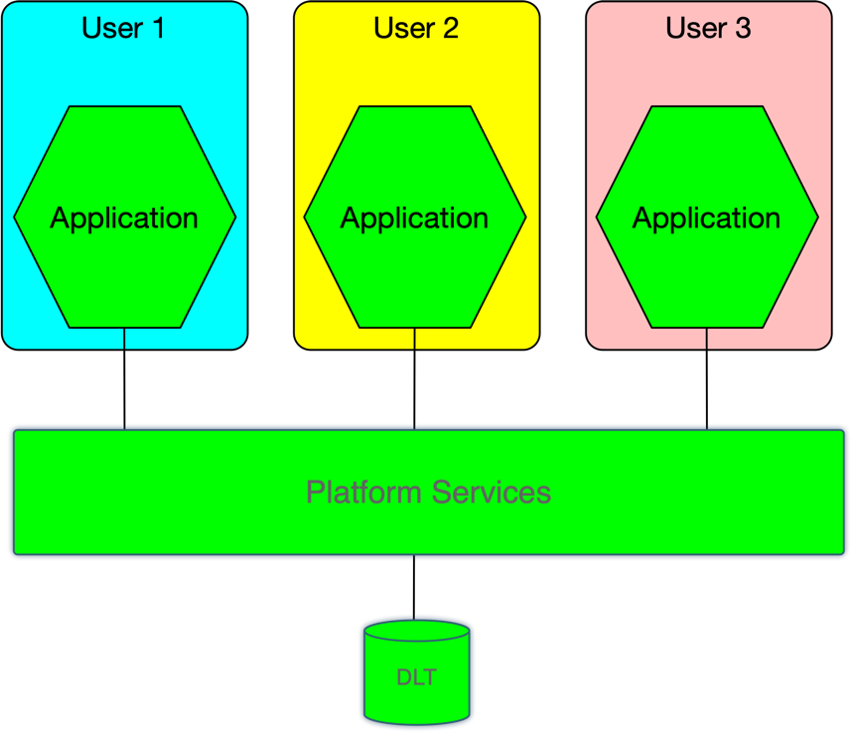
Figure 2 - A Category “Alpha” platform

The “Alpha” category is broken down into two options:

5.3.1.1.1 Category Alpha-1 Platform

The DLT and some or all the Platform services are proprietary to the vendor.

5.3.1.1.2 Category Alpha-2 Platform

The DLT and all the Platform services are open-sourced.

5.3.1.2 Category Bravo Platform

A Category “Bravo” platform is designed, developed, delivered, and integrated to all users of said platform by a single vendor, but can operate using two or more underlying DLT technologies.
A Category “Bravo” platform includes an abstraction layer between the DLT layer and the Services layer that offers a unified northbound interface between the abstraction layer and the
services layer, and a unique, per DLT type, interface between the abstraction layer and the specific DLT types. This abstraction layer is labeled as the “DLT Abstraction Layer” for the remainder of this document.

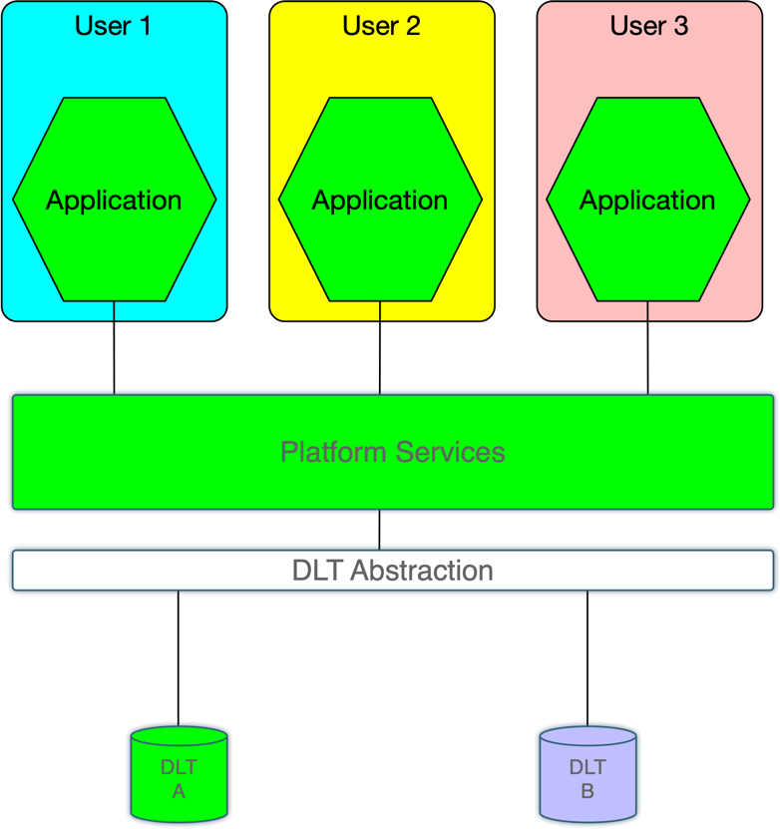
Figure 3 - Category “Bravo” platform

The “Bravo” category is broken down into two options:

5.3.1.2.1 Category Bravo-1 Platform

One or more of the underlying DLT types and some or all the Platform services are proprietary to a vendor.

5.3.1.2.2 Category Bravo-2 Platform

The DLTs and all the Platform services are open-sourced.

5.3.1.3 Category “Charlie” Platform

A Category “Charlie” platform is designed and developed towards a specification of an Application abstraction layer so that any Application that supports such an abstraction layer can interface with said platform.
This abstraction layer is labeled as the “Application Abstraction Layer” for the reminder of this document. The Application Abstraction Layer implements a unified northbound interface between the abstraction layer and the applications using the platform, and a per-platform-specific-service interface between the abstraction layer and the underlying services implemented in the Platform Services layer.

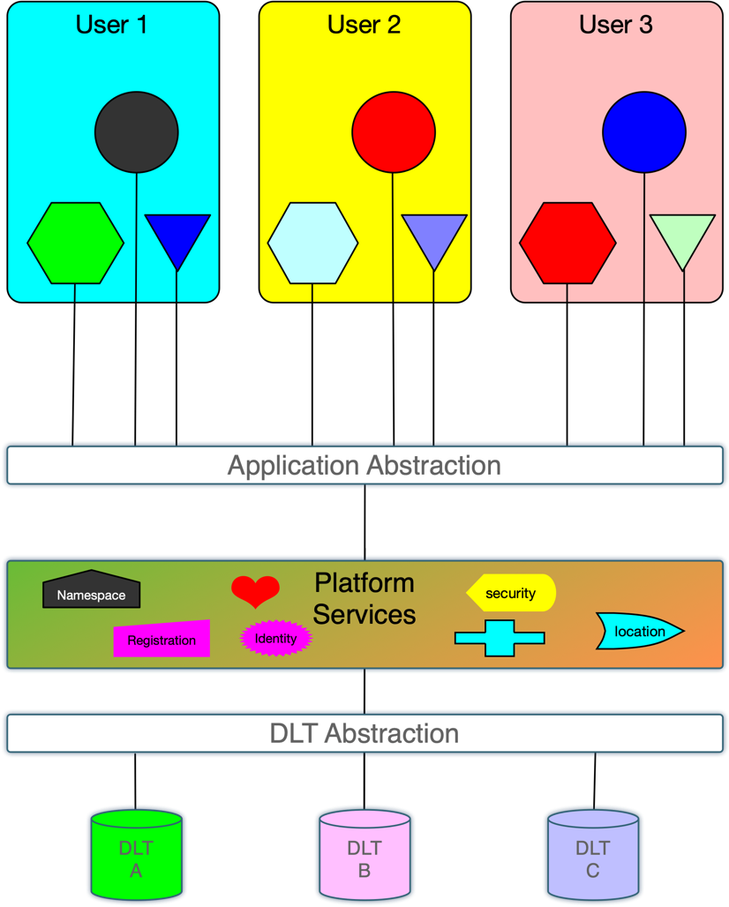
Figure 4 - Category “Charlie” platform

The “Charlie” category is broken down into four options:

5.3.1.3.1 Category Charlie-1 Platform

The platform is being developed and integrated by a single vendor who may integrate third party elements into the platform and may include proprietary elements in the platform.

5.3.1.3.2 Category Charlie-2 Platform

The platform is being developed and integrated by a single vendor who may integrate third party elements into the platform and all elements, including the third-party elements, are open-sourced.

5.3.1.3.3 Category Charlie-3 Platform

The platform consists of a collection of interoperable modules, each offering one or more of the platform services. Such modules may be developed by different vendors towards service specifications defined or endorsed by ETSI-ISG-PDL. Integration of such modules into an operational platform may be performed by any entity as long as the resulting platform complies with certification tests performed by ETSI-ISG-PDL or a certification entity endorsed by ETSI-ISG-PDL. Some or all of the modules may be proprietary.

5.3.1.3.4 Category Charlie-4 Platform

Like Category Charlie-3 Platform but all modules have to be open-sourced.

5.3.1.4 Category Delta Platform

A Category “Delta” platform is the same as Category Charlie with the exception that it uses a single DLT, thus eliminating the need for the DLT Abstraction layer.
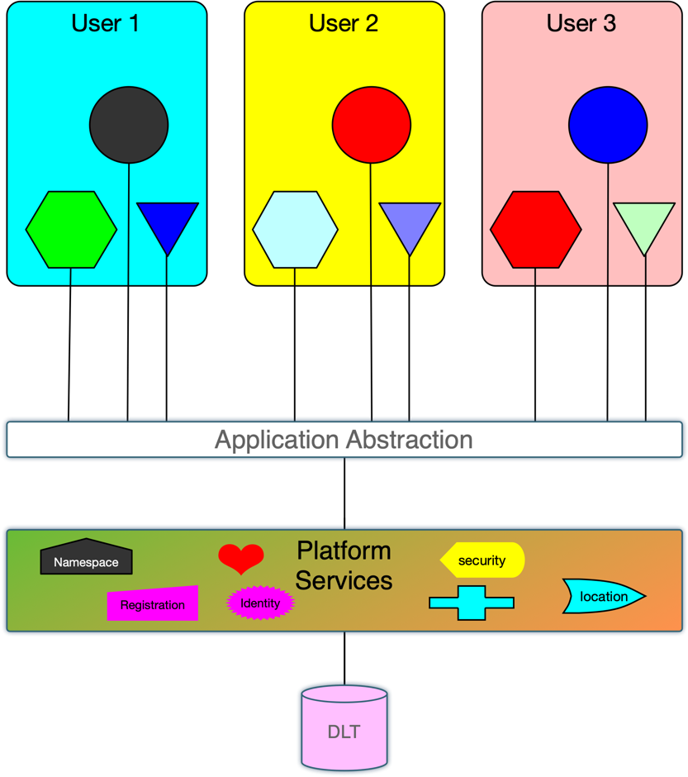
Figure 5 - Category “Delta” platform
The “Delta” category is broken down into four options:

5.3.1.4.1 Category Delta-1 Platform

The platform is being developed and integrated by a single vendor who may integrate third party elements into the platform and may include proprietary elements in the platform.

5.3.1.4.2 Category Delta-2 Platform

The platform is being developed and integrated by a single vendor who may integrate third party elements into the platform and all elements, including the third-party elements, are open-sourced.

5.3.1.4.3 Category Delta-3 Platform

The platform consists of a collection of interoperable modules, each offering one or more of the platform services. Such modules may be developed by different vendors towards service specifications defined or endorsed by ETSI-ISG-PDL. Integration of such modules into an operational platform may be performed by any entity as long as the resulting platform complies with certification tests performed by ETSI-ISG-PDL or a certification entity endorsed by ETSI-ISG-PDL. Some or all of the modules may be proprietary.

5.3.1.4.4 Category Delta-4 Platform

Like Category Delta-3 Platform but all modules have to be open-sourced.

5.3.2 Application development guiding principles

The guiding principles of Application development follow similar logic and categorization of platform development principles:

- Applications that are developed and delivered to all users of said application by a single vendor using a Category Alpha Platform developed by that same vendor and thus can only use a prescribed DLT type. Such applications will be labeled as “Category Alpha Applications” for the remainder of this document.
- Applications that are developed and delivered to all users of said application by a single vendor using a Category Bravo Platform developed by that same vendor. Such applications will be labeled as “Category Bravo Applications” for the remainder of this document. Category Bravo Applications are not limited to a prescribed DLT type and can be implemented using any DLT type supported by the Category Bravo Platform.
- Applications that are developed towards a specification of an Application so that any user of an application supporting such specifications can fully interoperate with other users of other applications built towards the same Application specifications. Such applications are labeled as “Category Charlie Applications” for the remainder of this document.

note: Category Delta Applications, if such category was defined, would be redundant to Category Charlie Applications as the Applications Layer hides the underlying DLT type hence there is no such category defined.

5.3.3 Platform Services Dependency
Due to the dependency of Composite Platform services on other Platform Services, when a Composite Platform Service is implemented in a certain PDL Platform, and that Composite Platform Service is using an Optional Platform Service, that Optional Platform Service has to be implemented on thatAuthentication specific PDL Platform.
- An Optional Platform Service that is dependent upon by a Composite Platform Service implemented in a PDL Platform SHALL be implemented in that PDL Platform.

5.4 ETSI-ISG-PDL Platform Services
As discussed in the previous section, the ETSI-ISG-PDL Platform Services is a set of modular Functional Blocks that are either PDL Platform Services themselves (Atomic Services) or are used to create PDL Platform Composite services. In order to maximize reusability, Composite services are built using composition. This enables improved components of a composition to be used without affecting other services.
Table 2 herewith lists all the ETSI-ISG-PDL Platform Services.

PDL Platform Service name | Mandatory (M) or Optional (O) | Atomic (A) or Composite (C) | Location in this document (section number) | Short description
Namespace | M | A | 5.4.1.1 | Ensures that all of a given set of objects for a particular function have unique names.
Identity | M | A | 5.4.1.2 | Unambiguously identifies an instance of an entity from all other instances of this and other objects.
Location | O | A | 5.4.1.3 | Associates an object with a location.
Registration | O | A | 5.4.1.4 | List a managed object with authorities or registries.
Discovery | O | A | 5.4.1.4 | Discovery of services offered by the services layer and discovery of PDL networks.
Messaging | M | C | 5.4.2.1 | Enables communication between a group of entities.
Policy | O | C | 5.4.2.2 | Manage and control the changing and/or maintaining of the state of managed objects.
Security | M | C | 5.4.2.3 | A collection of services that assess, reduce, protect, and manage security risks.
Authentication | M | C | 5.4.2.3.1 | Verifies that a subject requesting to perform an operation on a target is who they say they are.
Authorization | O | C | 5.4.2.3.2 | Permitting or denying access to a target by a subject.
Cryptography | O | C | 5.4.2.3.3 | Managing protocols that prevent third parties from reading private communications.
Encryption | O | C | 5.4.2.3.4 | Encoding information using a key into an unintelligible form.
Identity Management | O | C | 5.4.2.3.5 | Access control based on the identity of an entity.
Key Management | O | C | 5.4.2.3.6 | Management of cryptographic keys.
Logging | O | C | 5.4.2.4 | Dynamic ingestion and collection of logs.
Governance | M | C | 5.4.2.5 | Rules and tools that control the behavior and function of a PDL.
Implementation Agreements | O | C | 5.4.2.5.1 | Rules and agreements that describe how ETSI-ISG-PDL Services are implemented and control the behavior of a PDL platform.
Governing Entity | M | C | 5.4.2.5.2 | Defines the rules and implementation agreements. Ensures compliance. Resolves conflicts where needed.
Composition | O | C | 5.4.2.6 | Defines who can compose new services and how such new services are composed.
Access Control | M | C | 5.4.2.7 | Defines who can perform which operations on which set of target entities.
Fault Tolerance | O | C | 5.4.2.8 | Defines how to handle faulty instructions.
Distribution Transparency | O | C | 5.4.2.9 | defines how to maintain transparency when distributing information to target entities.
Publish and Subscribe | O | C | 5.4.2.10 | Defines how entities publish services and subscribe to services.
Concurrency | O | C | 5.4.2.11 | Defines how entities handle concurrency.
Storage | M | C | 5.4.2.12 | A group of services related to Storage.
In Memory Storage | M | C | 5.4.2.12.1 | Data that is stored in the RAM of a computer running an application.
File System Storage | M | C | 5.4.2.12.2 | Storage on a directly connected storage device.
On-Chain Storage | M | C | 5.4.2.12.3 | Application data that is stored in blocks on all nodes using the chain.
Off-Chain storge | O | C | 5.4.2.12.4 | Information in a digital, machine-readable medium that is not stored on the main chain.
Distributed Blockchain Storage | M | C | 5.4.2.12.5 | Storage on a Distributed Blockchain ledger.
Modeling | M | C | 5.4.2.13 | A group of services related to Modeling.
Information Model | M | C | 5.4.2.13.1 | Presentation of concepts of interest to platform management environment in a technology-neutral form as abstract objects and relationships between objects.
Data Model | M | C | 5.4.2.13.2 | Representation of applicable concepts in a technology-specific concrete form.
Model Search | O | C | 5.4.2.13.3 | Enables search for specific or generic models within existing information and data models.
Model Stitching | O | C | 5.4.2.13.4 | Enables integrating multiple models or parts of models into a single model.
Topology | M | C | 5.4.2.14 | Allows a node to identify other nodes on the PDL and identify which nodes to communicate with when performing PDL related tasks.
Event Processing | M | C | 5.4.2.15 | Processes node-specific and platform-wide events as they occur.
Distributed Data Collection | O | C | 5.4.2.16 | Performs tasks related to collection of data.
Distributed Secret Sharing | O | C | 5.4.2.17 | Sharing of confidential data between nodes in a manner that maintains confidentiality of the data.
Resource Management | M | C | 5.4.2.18 | Defines how to administer and manage Resources.
Resource Discovery | O | C | 5.4.2.18.1 | Enables discovery of resources available to applications and nodes.
Resource Virtualization | O | C | 5.4.2.18.2 | Creating a virtual resource that mimics the behavior of a physical resource.
Resource Inventory Management | O | C | 5.4.2.18.3 | Management of node-specific and platform-wide resource inventory.
Resource Admin and Management | M | C | 5.4.2.18.4 | Administration and management of node-specific and platform-wide resources.
Resource FCAPS | O | C | 5.4.2.18.5 | Resource management tasks defined by the ISO model.
Resource Composition | O | C | 5.4.2.18.6 | Management of composite resources.
Platform Services Management | M | C | 5.4.2.19 | Defines how to administer and manage Platform Services.
Platform Service Discovery | M | C | 5.4.2.19.1 | Provides means to discover services available to applications and nodes.
Platform Service Virtualization | O | C | 5.4.2.19.2 | Creating a service using virtual resources.
Platform Service Inventory Management | O | C | 5.4.2.19.3 | Keeping track of inventory and serviceability of Platform services.
Platform Service Admin and Management | M | C | 5.4.2.19.4 | Administration and management of Platform Services through governance.
Platform Service FCAPS | O | C | 5.4.2.19.5 | Platform Service management tasks defined by the ISO model.
Platform Service Composition | O | C | 5.4.2.19.6 | Management of the composition of Composite Platform Services.
Application Management | M | C | 5.4.2.20 | Handles composition and orchestration of Applications.
Application Composition | M | C | 5.4.2.20.1 | Composing an Application from two or more managed objects.
Application and Service Orchestration | O | C | 5.4.2.20.2 | Orchestrating multiple managed objects so they are chained in the right sequence and their operation is synchronized.
Orchestration | O | C | 5.4.2.20.3 | Orchestration of objects so they are chained in the right sequence and topology resulting in new functionality.
Platform Exploration | O123 | C | 5.4.2.20.4 | Allows an application to indicate its requirements and explore whether the platform offers such service capabilities
Application Registration | O | C | 5.4.2.20.5 | Registers and lists all applications operated on a platform.
Transaction Management | O | C | 5.4.2.21 | Facilitates transaction related interactions between applications/services and underlying PDL networks.
Data Model Gateway/Broker | O | C | 5.4.2.22 | Defines tools that enable two systems with different data models to interact.
API Presentation | O | C | 5.4.2.22.1 | A specific Data Model Gateway/Broker implementation for environments that use APIs to exchange data between objects.
Application Specific Services | O | C | 5.4.2.23 | Serve a specific application or a group of applications but not required or used by other applications using the platform.
Table 4 - ETSI-ISG-PDL Platform Services

5.4.1 ETSI-ISG-PDL Atomic Services
The ETSI-ISG-PDL Atomic Services are a set of PDL Platform Services that other ETSI-ISG-PDL Services may use, either directly or indirectly. Atomic services do not use any other PDL Platform Service but may use services external to the PDL platform.
- Atomic Platform Services SHALL NOT use any other Platform Service to fulfill their functionality.
- Atomic Platform Services MAY use services external to the PDL Platform.
There are five (5) PDL Atomic Platform Services, four (4) of which are also Mandatory Platform Services. They are shown in Figure 6 herewith.
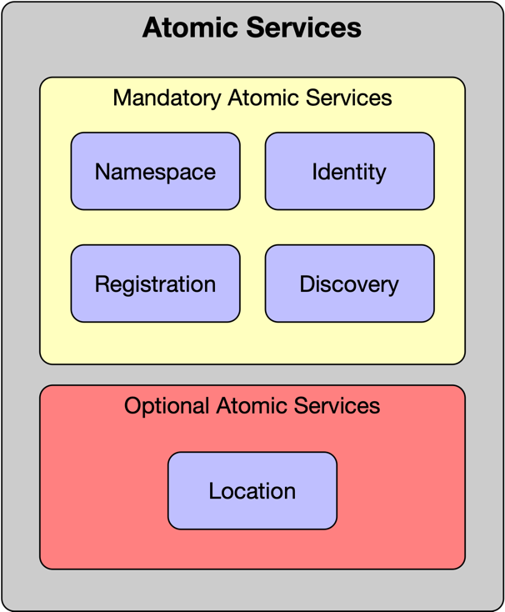
Figure 6 - ETSI-ISG-PDL Atomic Services

5.4.1.1 ETSI-ISG-PDL Namespace Service
The ETSI-ISG-PDL namespace ensures that all of a given set of objects for a particular function have unique names so that they can be easily identified. This enables multiple internal and external domains to communicate and interact with each other while avoiding name collisions between multiple identifiers that share the same name for a given object. Examples of internal domains are different administrative domains within an organization (e.g., engineering and sales), while examples of external domains include different partners (e.g., service and content providers) of an organization.
- An ETSI-ISG-PDL Namespace SHALL provide a unique name that distinguishes each object instance from all other object instances (including multiple instances of the same object) that it contains.
Namespaces provide a scope for names. Namespaces are typically structured as hierarchies to allow reuse of names in different contexts. Examples include file systems and DNS. A namespace is a scoping container. Examples include application container and messaging container services.
- An ETSI-ISG-PDL namespace SHOULD support hierarchical names.
Namespaces may be simplified by using consistent prefixes for each namespace.
- A name in an ETSI-ISG-PDL Namespace SHOULD consist of a namespace identifier and a local (to that namespace) unique name.

5.4.1.2 ETSI-ISG-PDL Identity Service
The Identity of an entity is a set of context-dependent digital identifiers that unambiguously identify an instance of that entity from all other instances of this and other objects. An identity may require multiple attributes to uniquely identify it (e.g., two products with the same name have other different attributes, such as different serial numbers).
- An ETSI-ISG-PDL Identity SHALL be constructed using one or more context-dependent digital identifiers that enable an object instance to be unambiguously identified.
A digital identifier is a secure object that is unique within a particular namespace. It is recommended that every digital identifier is assigned a namespace.
- An ETSI-ISG-PDL digital identifier SHOULD be defined within a namespace to guarantee its uniqueness.
An entity may be used in different situations. Therefore, the same entity may be identified using a different set of digital identifiers for each situation. This enables the semantics of the use of an entity in each situation to be taken into account.
- An ETSI-ISG-PDL Managed Object MAY have multiple context-dependent digital identifiers for establishing the Identity of that Managed Object in different situations in which it is used.
An ETSI-ISG-PDL Identity Service provides a single identity token per instance of an entity for all services so that this instance is identified unambiguously and in the same manner by all services..
- An ETSI-ISG-PDL Identity Service SHALL provide a single digital identity token per instance of an entity.

5.4.1.3 ETSI-ISG-PDL Location Service
The location of an entity may or may not be relevant to the function of a PDL or a service, thus this Atomic Platform Service is optional. In applications and scenarios where location is of essence, it may affect factors such as network latency (and the resulting transaction speeds), governing laws and regulations, costs, access restrictions and more. There are multiple methods of defining locations. There are physical addresses (e.g. GPS longitude/latitude coordinates, street addresses, postal codes, building names), relative addresses (e.g. 50 meters east of the main gate, and Virtual locations (e.g. IP address, Telephone number, MAC address). Certain location descriptors are more accurate than others (e.g. a postal code may relate to a whole street while GPS coordinates may define a location with an accuracy of a few meters).
- An ETSI-ISG-PDL Managed Object MAY be associated with a location.
- The location of an ETSI-ISG-PDL Managed Object associated with a location SHALL be represented in a method understood in the respective geography where it is located.
- The location of an ETSI-ISG-PDL Managed Object associated with a location SHALL be defined using a location method compliant with the level of accuracy required by the respective application.

5.4.1.4 ETSI-ISG-PDL Registration Service
Registration services provide means to list an ETSI-ISG-PDL Managed Object with local or international authorities or registries. Such registries allow reference to such Managed Objects for legal, commercial and Operational purposes. Registration requirements vary with geography. Certain Managed Objects (e.g. a PDL serving a geographically diverse application) operate in multiple geographies and may require multiple registrations.
- An ETSI-ISG-PDL Managed Object MAY be registered in one or more registries.
- A registered ETSI-ISG-PDL Managed Object SHALL be registered in accordance with the regulations and rules applicable in the geographies in which it operates.

5.4.1.5 ETSI-ISG-PDL Discovery Service
Discovery services provide means to:
- discover ETSI-ISG-PDL Platform Services offered by an ETSI-ISG-PDL Platform Services layer; and/or
- discover a registered PDL network.
For example, an application can discover the ETSI-ISG-PDL Platform Services available on a PDL Platform. In another example, an ETSI-ISG-PDL Platform Service can discover an underlying PDL network, which has been registered to an ETSI-ISG-PDL Platform Services layer.
- An ETSI-ISG-PDL Service Layer SHALL have an ETSI-ISG-PDL Discovery Service.
- An ETSI-ISG-PDL Discovery Service SHALL support discovery of ETSI-ISG-PDL Services of an ETSI-ISG-PDL Service Layer.
- An ETSI-ISG-PDL Discovery Service SHALL support discovery of PDL networks that have been registered to an ETSI-ISG-PDL Service Layer.

5.4.2 ETSI-ISG-PDL Composite Services
The ETSI-ISG-PDL Composite Platform Services are a set of Functional Blocks that provide services that other Platform Services use, either directly or indirectly. They use one or more other Platform Service in order to fulfil their functionality. Composition allows building more complex architectural concepts and functions. There is a total of 53 Composite Platform Services, 16 of which are Mandatory. Services are grouped into sub-groups by their function for reference purposes but are non-hierarchical Any Platform Service or application may use any other Platform service. Some of the Composite Platforms are Mandatory and some are Optional. They are shown in Figure 7.

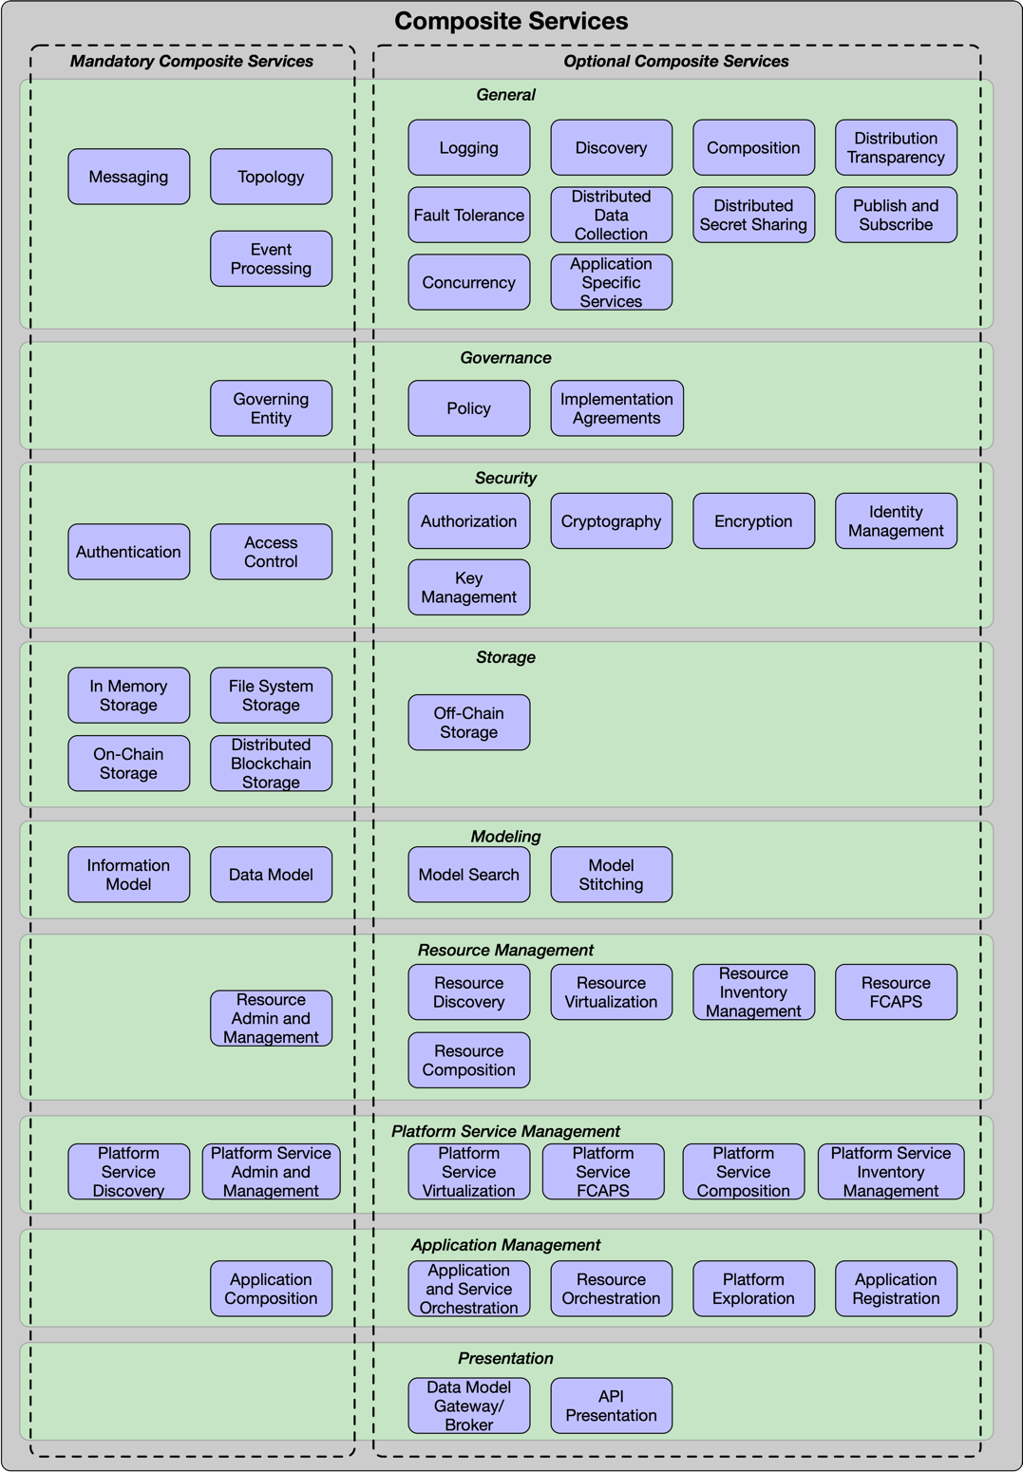
Figure 7 - ETSI-ISG-PDL Composite Services

5.4.2.1 ETSI-ISG-PDL Messaging Service
An ETSI-ISG-PDL Messaging Service enables communication between a group of entities (e.g. PDL nodes, Application users, Platform Services). A message is a discrete unit of communication, sent by a producer and received by a consumer. It is shown in Figure 4. There are two fundamentally different types of messaging:
- Synchronous communication, which is a tightly coupled solution to exchange information (e.g., opening a socket over a connection-oriented protocol such as TCP/IP and transmitting data through it).
- Asynchronous communication, which is a loosely coupled solution that minimizes producer and consumer dependencies.
Synchronous messaging is tightly coupled because of its main three dependencies: temporal (all components have to be available at the same time), location (each component has to know the address of each other component), and data structure (all components have to agree on the data format and on the binary representation). Asynchronous messaging acts as an indirection layer among entities that want to communicate, removing the above three dependencies.
- The ETSI-ISG-PDL Messaging Framework Service SHALL support asynchronous communications.
- The ETSI-ISG-PDL Messaging Framework Service MAY support synchronous communications.
There are two types of asynchronous communication models. A Message Broker is a centralized system that receives messages, determines the correct destination for each message, and sends the message to that destination. A Message Bus enables interacting entities to communicate using a set of shared interfaces.
- The ETSI-ISG-PDL Messaging Framework Service SHALL support a Message Bus.
- The ETSI-ISG-PDL Messaging Framework Service MAY support a Message Broker.

5.4.2.2 ETSI-ISG-PDL Policy Service
A Policy is a set of rules that is used to manage and control the changing and/or maintaining of the state of one or more managed objects. An ETSI-ISG-PDL Policy Service is a collection of technologies that enable policies to be created, validated, read, updated, deleted, and managed. ETSI clients shall use policies to interact with the ETSI-ISG-PDL platform.
- ETSI-ISG-PDL-compliant client implementations SHALL use policies to communicate and interact with the ETSI-ISG-PDL platform.
Policies are used in two important ways. First, they enable a consistent and auditable delivery mechanism for requesting and receiving data, and performing commands, to be implemented. Second, policies provide a common communications mechanism for exchanging information and commands.
- Components of a distributed implementation of the ETSI-ISG-PDL platform SHALL use policies to exchange information and commands.
- ETSI-ISG-PDL-compliant client implementations SHOULD use policies for requesting services of, and exchanging information with, the ETSI-ISG-PDL platform.

5.4.2.3 ETSI-ISG-PDL Security Service
An ETSI-ISG-PDL Security Service is a collection of security technologies that assess, reduce, protect, and manage security risks. These technologies are atomic in nature. This means that a category such as access management is included, since different types of access management solutions (e.g., MAC, DAC, ABAC, and RBAC) use different technologies, but all serve the same fundamental service. In contrast, solutions such as Zero Trust or SASE are NOT included as an ETSI-ISG-PDL Framework Service because both are constructed from multiple atomic services.
The basic ETSI-ISG-PDL Security Services are shown in Figure 8.
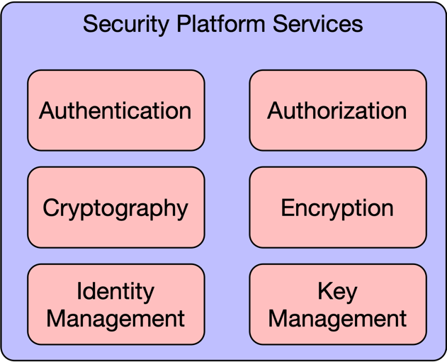
Figure 8 - Security Platform Services

5.4.2.3.1 ETSI-ISG-PDL Authentication Service
Authentication is the process of verifying that a subject requesting to perform an operation on a target is who they claim to be. Policies may be used to dictate the set of verification criteria used. The ETSI-ISG-PDL Authentication Platform Service depends on the ETSI-ISG-PDL Namespace Platform Service and the ETSI-ISG-PDL Identity Platform Service.

5.4.2.3.2 ETSI-ISG-PDL Authorization Service
Authorization is the process that results in permitting or denying access to a target by a subject. Policies may be used to prescribe the criteria for the authorization decision. The ETSI-ISG-PDL Authorization Platform Service depends on the ETSI-ISG-PDL Namespace Platform Service and the ETSI-ISG-PDL Identity Platform Service.

5.4.2.3.3 ETSI-ISG-PDL Cryptography Service
Cryptography is the process of constructing and verifying protocols that prevent third parties from reading private communications. The ETSI-ISG-PDL Cryptography Platform Service depends on the ETSI-ISG-PDL Namespace Platform Service and the ETSI-ISG-PDL Identity Platform Service.

5.4.2.3.4 ETSI-ISG-PDL Encryption Service
Encryption is the process of encoding information using a key into an unintelligible form to protect sensitive information. The unintelligible form of the information has to be decrypted using the key to recover the original information. The ETSI-ISG-PDL Authentication Platform Service depends on the ETSI-ISG-PDL Namespace Platform Service and the ETSI-ISG-PDL Identity Platform Service.

5.4.2.3.5 ETSI-ISG-PDL Identity Management Service
Identity Management defines access control based on the identity of an entity that initiates a particular set of operations on a target according to a set of criteria. The ETSI-ISG-PDL Identity Management Platform Service depends on the ETSI-ISG-PDL Namespace Platform Service and the ETSI-ISG-PDL Identity Platform Service.

5.4.2.3.6 ETSI-ISG-PDL Key Management Service
Key management refers to management of cryptographic keys in a cryptosystem. This includes dealing with the generation, exchange, storage, use, destruction, and replacement of keys. It also includes cryptographic algorithm and protocol design. The ETSI-ISG-PDL Authentication Platform Service depends on the ETSI-ISG-PDL Namespace Platform Service and the ETSI-ISG-PDL Identity Platform Service.

- All the Security services listed above SHALL be implemented in an ETSI-ISG-PDL compliant PDL platform.

5.4.2.4 ETSI-ISG-PDL Logging Service
An ETSI-ISG-PDL Logging Service is a collection of technologies that enable different types of logs to be ingested and collected dynamically. The ETSI-ISG-PDL Logging Service may provide an optional normalization service, which enables related logs generated by different sources using different technologies to be normalized into a single data model.
- A Logging Service SHOULD be implemented in any ETSI-ISG-PDL compliant platform.

5.4.2.5 ETSI-ISG-PDL Governance Service
Governance Platform Service is a collection of rules and tools that control the behavior and function of a PDL Platform. The implementation and enforcement of the rules is carried out using other Platform Services. The Governance Platform Services are depicted in Figure 9 herewith:
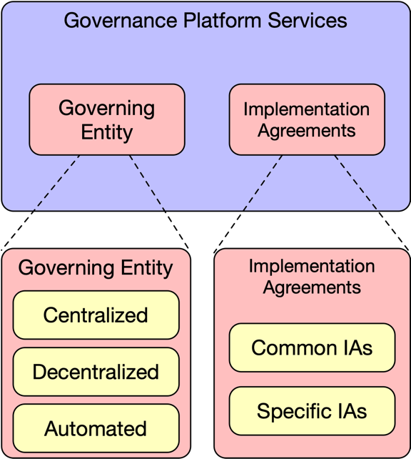
Figure 9 - Governance Platform Services
Governance is divided to two functions:
- Implementation Agreements (“IAs”): A collection of rules and agreements that describe how ETSI-ISG-PDL Services are implemented and control the behavior of the PDL platform. In a Category Carlie/Delta platform such agreements and rules are typically developed in a collaborative manner by the participants of the PDL platform. They would typically be prescribed by the developer in a Category Alpha and Category Bravo type platforms.
- Governing Entity: An entity that performs governance tasks by defining the rules and IAs, as well as ensuring compliance and resolving conflicts where needed. Governance also defines the methods by which the Governing Entity is established, its composition and the methods by which it defines/accepts rules/IAs and enforces compliance.

5.4.2.5.1 ETSI-ISG-PDL Implementation Agreements
Rules and agreements that describe how the ETSI-ISG-PDL Services defined in this document are implemented. Such rules and agreements define the specific details and methods used to implement the services. E.g. the choice of a specific PDL chain type or the acceptance criteria of entities to the PDL platform.
Implementation Agreements are divided to three groups:

5.4.2.5.1.1 Common Implementation Agreements – Common Rules
Those are IAs that are common to all applications, users and entities involved with a PDL platform and the same rules are applicable to all. E.g. a PDL platform may require that all entities and applications use a specific Identity Service and specific security methods.
- All applications, users and entities involved with a PDL platform SHALL comply with all Common Implementation Agreements – Common Rules.

5.4.2.5.1.2 Common Implementation Agreements – Specific Rules
Those are IAs that are common to all applications, users and entities involved with a PDL platform, but the specific rules are application or jurisdiction dependent. E.g. a PDL platform may require that all entities and applications use a specific Location Service but different geographies may use different methods to define a location and different applications may require different granularity/accuracy location information.
- All applications, users and entities involved with a PDL platform SHALL comply with all Common Implementation Agreements – Specific Rules.
- The specific rules MAY vary depending on the specific user, application or jurisdiction.

5.4.2.5.1.3 Specific Implementation Agreements
Those are IAs that are specific to one or more application or jurisdiction and only apply to entities subject to such jurisdiction and/or using such applications. E.g. all European entities are subject to GDPR thus any application operated by an entity subject to European jurisdiction will have to use an Implementation Agreement that complies with GDPR. Another example would be a requirement that all applications involved with monetary transactions use a specific encryption method prescribed by the governance.
- All applications, users and entities involved with a PDL platform SHOULD comply with all Specific Implementation Agreements.
- Specific Applications and Entities MAY be exempt from compliance with Specific Implementation Agreements.

5.4.2.5.2 ETSI-ISG-PDL Governing Entity
The Governing Entity performs governance tasks by defining the rules and AIs, as well as ensuring compliance and resolving conflicts where needed. Governance also defines the methods by which the Governing Entity is established, its composition and the methods by which it defines/accepts rules/IAs and enforces compliance.
There are several types of Governing Entities:

5.4.2.5.2.1 Centralized governance
Centralized Governance is a scenario where the Governing Entity is chosen or agreed upon by the PDL participants.
- The Governing Entity in a Centralized Governance scenario SHALL be elected through consensus.
- The Governing Entity in a Centralized Governance scenario SHOULD be an entity participating in the PDL Platform.
- The Governing Entity in a Centralized Governance scenario MAY be an external entity not participating in the PDL Platform.
- The Governing Entity in a Centralized Governance scenario MAY consist of more than a single entity.
- When the Governing Entity in a Centralized Governance scenario consists of more than a single entity all its decisions SHALL be reached through consensus between the entities of which the Governing Entity consists.

5.4.2.5.2.2 Decentralised governance
Decentralized Governance is a scenario where the Governing Entity consists of all PDL participants or a group of representatives thereof. Governance tasks are performed using PDL consensus and policies.
- The representatives participating in a Governing Entity in a Decentralized Governance scenario SHALL be elected through consensus.
- The Governing Entity in a Decentralized Governance scenario SHALL use PDL consensus and Implementation Agreements to perform governance tasks.

5.4.2.5.2.3 Automated governance
Automated governance is a scenario where decisions, consensus and policy enforcement are taken by software (pre-programmed or Artificial Intelligence) on behalf of the PDL participants.
- Changes to the governing software in an Automated governance scenario SHALL be accepted through consensus.
- Additional governance structures MAY exist.

5.4.2.5.3 Crating, Changing and Enforcing Governance IAs and rules
Governance IAs and rules are created, maintained, changed and enforced by the Governing Entity using consensus. It is recommended that as many of the governance tasks as possible be handled automatically, but some tasks may require manual/human intervention.
- Governance tasks SHOULD be performed automatically.
- Governance tasks MAY be performed manually.
- Any formal or official communication between PDL participants SHALL be routed through, monitored and recorded by the governance.
The above requirement can be fulfilled by storing all such communications on-chain in a manner readable by the governance.

5.4.2.6 ETSI-ISG-PDL Composition Service
ETSI-ISG-PDL Composition Service defines which subject entities can compose new Platform Services and how such new services are composed from other Platform Services.
The requirements related to composition of different object types are listed in the below sections:
- 5.4.2.18.6 Resource Composition
- 5.4.2.19.6 Service Composition
- 5.4.2.20.1 Application Composition

5.4.2.7 ETSI-ISG-PDL Access Control Service
ETSI-ISG-PDL Access Control Service defines which subject entities can perform which operations on which set of target entities according to a set of criteria.
There are four established Access Control Policies in use today: [i.2];
- MAC (Mandatory Access Control)
- DAC (Discretionary Access Control)
- RBAC (Role Based Access Control)
- ABAC (Attribute Based Access Control)
It is beyond the scope of this document to go into discussion of the differences between those policies. Yet, it is recommended that an ETSI-ISG-PDL compliant platform establishes an Access Control Policy.
A Policy is a set of rules that is used to manage and control the changing and/or maintaining of the state of one or more managed objects. An Access Control Policy defines the privileges and permissions of a subject entity to perform operations on a set of target entities. Policy Based Access Control (PBAC) defines the type of Policies required to implement the appropriate type of access control methodology (e.g., MAC, DAC, RBAC, ABAC, or custom), based on the subject and target entity attributes and behavior, the current situation, and applicable business rules.
- ETSI-ISG-PDL Access Control Services SHOULD use Access Control Policies to manage access control for the entities that it protects.
- ETSI-ISG-PDL Access Control Services SHOULD use Policy Based Access Control to determine whether a standard or custom access control services is appropriate for each of the entities that it protects.

5.4.2.8 ETSI-ISG-PDL Fault Tolerance Service
ETSI-ISG-PDL Fault Tolerance Service defines how target entities handle situations where faulty instructions are being given by subject entities according to a set of criteria. Faulty instructions may include, but are not limited to, violation of consensus, violation of security protocol, violation of policy. Faulty instructions may also result from incorrect or inaccurate data ingestion (e.g. a thermometer giving inaccurate readings). It is highly recommended, though not mandated, that an ETSI-ISG-PDL platform establishes processes, automated or manual, to overcome such faults while retaining the platform’s integrity.
- Reasonable measures SHOULD be taken to allow a platform to continue operations in presence of a level of faults that is below a pre-defined threshold.
- Measures SHALL be taken to notify entities using a platform when faults exceed a pre-defined threshold.

5.4.2.9 ETSI-ISG-PDL Distribution Transparency Service
ETSI-ISG-PDL Distribution Transparency Service defines how subject entities maintain transparency when distributing information to target entities. Transparency is defined by Policy and may vary depending on location, regulation, and application. E.g. A commercial agreement between two entities may include confidential commercial information that should not be visible to other parties; yet those other parties may need to be aware that a commercial agreement exists between said entities. Under such scenario the Distribution Transparency service will have to ensure the details of the involved parties are visible to other parties, while the confidential parts of the agreement are encrypted and cannot be read.
- A platform SHALL maintain Distribution Transparency in accordance with all applicable Policies.
5.4.2.10 ETSI-ISG-PDL Publish and Subscribe Service
ETSI-ISG-PDL Publish and Subscribe Service defines how entities publish services and subscribe to Platform Services. The Discovery service can be used to identify published services. This service is optional but it becomes a mandatory service in scenarios where entities need to publish services and/or subscribe to Platform services.
- Entities publishing services and subscribing to Platform Services SHOULD use the Publish and Subscribe Platform Service.
- When entities need to publish services and/or subscribe to Platform Services an ETSI-ISG-PDL compliant platform SHALL make such service available.

5.4.2.11 ETSI-ISG-PDL Concurrency Service
ETSI-ISG-PDL Concurrency Service defines how entities handle concurrency. Concurrency is the occurrence of different instances of events at the same time. Such events may or may not be dependent on each other. Concurrency may be allowed, banned or subject to certain restrictions depending on Policy and use case. An example for a banned concurrency would be for two entities adding a block to a PDL at the same time (which will create a fork). An example of an allowed concurrency may be collection of information from multiple sensors at the same time and writing such information to a table in a certain order (e.g. alphabetical, ascending) as prescribed by Policy.
- An ETSI-ISG-PDL platform SHALL implement a Concurrency Service based on Policy.

5.4.2.12 ETSI-ISG-PDL Storage related services
The ETSI-ISG-PDL Platform Storage related services provide different types of storage services for ETSI-ISG-PDL compliant platforms.
Note: The definition of “Directly Connected Storage” in the context of this section is that the storage is local to the node or is external storage that is managed by the owner of that node. It includes internal RAM, internal file system, external drive, NAS and Cloud storage services. It is not limited to storage that is physically connected to a node.

5.4.2.12.1 ETSI-ISG-PDL In Memory Storage Tier Service
In Memory Storage is any data that is stored in the RAM (or RAM swap space on a local disc) of the computer running an application. Such storage is typically used for confidential information.
There are two types of In-Memory Storage options:
- Volatile - the contents of such storage shall not be recorded anywhere and shall not survive a restart of the computer or application.
- Volatile In Memory Storage SHALL NOT keep a copy of the RAM contents on a disc or any other sort of non-volatile memory.
- If a node uses RAM Swap Space for Volatile Storage the contents of such storage SHALL be erased when the node or application restarts.
- Non-Volatile - the contents of such storage may be recorded on a local disc or non-volatile memory and may survive a restart of the application or computer.
- Non Volatile Storage MAY survive a node/application restart.

5.4.2.12.2 ETSI-ISG-PDL File System Storage Tier Service
Any storage on a directly connected storage such as a local disc, an external drive, a NAS or cloud storage.

- ETSI-ISG-PDL compliant nodes SHALL support directly connected storage.
- Devices used to access or run an ETSI-ISG-PDL compliant application MAY support directly connected storage.

5.4.2.12.3 ETSI-ISG-PDL On-Chain Storage Service
On-Chain storage is any application data that is stored in blocks on all nodes using the chain. Each block in a chain is numbered and is identical to the respective blocks on all nodes using the chain. Data is stored locally on the node or on an external storage managed by the owner of the node.
- Each On-Chain block SHALL have a unique number.
- Each On-Chain block SHALL be identical to all other blocks carrying that unique number on other nodes participating in the chain.
- A node SHOULD store the On-Chain blocks on directly connected storage that is physically connected to the node.
- A node MAY store On-Chain blocks on directly connected storage that is not physically connected to the node as long as it is managed by the owner of the node.
- On-Chain storage SHALL be secured according to the security policy defined by the governance.

5.4.2.12.4 ETSI-ISG-PDL Off-Chain Storage Service
Off-chain data storage is the storing of information in a digital, machine-readable medium that is not stored on the main chain. The main differentiator between On-Chain and Off-Chain storage is that Off-Chain storage is local to a subset of the nodes on a chain (one or more, but not all) and is not loaded as a block to the main chain used by all nodes.
Off-chain storage is a key enabler to scale blockchain-based applications that are data-intensive and/or data sensitive. It is often used to store non-transactional data that is too large to be stored in the blockchain efficiently, or requires the ability to be changed or deleted. Off-Chain data is thus only accessible by a subset of the nodes participating in a chain.
There are two types of off-chain storage:
- Distributed Addressable Storage (e.g. IFPS), which is content that can be accessed through a link (URL). Such URL may be loaded into the main chain thus such off-chain storage is accessible by all nodes even though it is not loaded to the main chain.
- Non-Addressable Storage, which is content that can not be addressed and accessed by any other entity except for the entity that directly manages this data.
- Off-Chain data SHALL be accessible to the node to which it is directly connected.
- Distributed addressable storage based off-chain data SHALL be accessible to all PDL platform members.
- Off-Chain data SHALL be accessible by any other node meeting the access control policies defined by the owner of the node to which it is directly connected.
- Off-Chain data MAY be accessible by any other node meeting the access control policies defined by the governance.
- Off-Chain data MAY be stored on a side-chain.

5.4.2.12.5 ETSI-ISG-PDL Distributed Blockchain Storage Platform Service
Preface: The concepts of Distribution, blocks and a chain are not necessarily interdependent. Data may be stored on a single location or may be distributed, regardless of the type of data (blockchain or other). On the other hand, blocks can be chained (using hashes or other methods) and stored locally on a non-distributed ledger.
The definitions in this section apply to the specific case of a distributed blockchain ledger, that is - scenarios where the blockchain is stored in a distributed ledger. Such scenarios also include provisions to ensure integrity of the data across the distributed nodes.
The Distributed Blockchain Storage Platform Service is inherent to the PDL. Each PDL node stores the exact same copy of the chain as all other nodes in a PDL. However – situations may arise where certain nodes add invalid blocks thus invalidating the entire chain. Those are considered temporary events and the governance and consensus mechanisms offer ways to identify such invalid blocks/chains and to take actions to eliminate the problem. The methods by which such events are treated and such situations are resolved vary by PDL type, consensus mechanism and governance and are beyond the scope of this document.
- Each node SHALL store the exact same chain as all other nodes on a PDL.
- When a node detects an anomaly or a discrepancy between the chain stored on it and the consensus-driven chain stored on other nodes it SHALL flag its chain as “invalid” and replicate the entire chain, or the invalid parts of the chain, from a valid node holding a valid chain.
- Upon replication of a valid chain from a valid node the node SHALL recalculate the hashes to ensure validity of the new blocks and upon successful recalculation it may remove the “invalid” flag.
Due to the structure of the chain as linked blocks, the validation of an invalid chain can be achieved by only replacing the blocks that include and follow the invalid block and any subsequent block or blocks added to the chain afterwards. Thus, it is not required that the entire chain is replaced.

5.4.2 ETSI-ISG-PDL Modelling Tier
The ETSI-ISG-PDL Modeling Tier Platform Services define part of the common vocabulary and concepts for the ETSI-ISG-PDL platform. Those are:
- Information Model
- Data Models
- Model Search
- Model Stitching
The ETSI-ISG-PDL Modeling Tier Platform Services currently consist of services that are fundamental for building more powerful ETSI-ISG-PDL compliant PDL Services as well as distributing an ETSI-ISG-PDL compliant platform. For any ETSI-ISG-PDL compliant PDL platform the ETSI-ISG-PDL Information Model and the ETSI-ISG-PDL Data Model Platform Services are mandatory.
- The ETSI-ISG-PDL Information Model and the ETSI-ISG-PDL Data Model Platform Services SHALL be implemented on all ETSI-ISG-PDL compliant PDLs.

5.4.2.13.1 ETSI-ISG-PDL Information Model
An information model represents concepts of interest to the ETSI-ISG-PDL management environment in a technology-neutral form. An information model represents concepts as abstract objects and relationships between objects.
- ETSI-ISG-PDL compliant implementations SHALL use a single information model to represent managed objects.
In order to accommodate future changes and applications an ETSI-ISG-PDL should be designed in an extensible manner so additional modules could be added to it to facilitate such applications.
- ETSI-ISG-PDL compliant implementations SHOULD use a modular and extensible information model.
An example of an information model would define generic objects such as location, entities, ownership, device types, functionalities and other high level concepts. Such information model may then be used for an abstract description of applications from different disciplines: Agriculture, Health, Telecoms, Weather, Financial services etc.
- Information models SHOULD be specified as a standard in a formal document issued by an SDO.

5.4.2.13.2 ETSI-ISG-PDL Data Model
An ETSI-ISG-PDL data model represents applicable concepts in an ETSI-ISG-PDL compliant implementation in a technology-specific concrete form. An ETSI-ISG-PDL compliant implementation may require multiple data models that represent objects using different repositories, protocols, and data formats. Data Models represent Application specific, Lifecycle-step specific and Product specific implementations and are derived from the respective parts of the Information Model. Since all Managed Objects require at least one interface through which it can be managed, and all Software Interface communications require a Data Model that defines the representation of data exchanged through such interface, each Managed object needs to have at least one Software Interface and at least one Data Model implemented through that interface.
- Each Managed Object SHALL use at least one Data Model for each of its Software Interfaces.
- ETSI-ISG-PDL implementations SHOULD use at least one Data Model to implement managed objects.
- ETSI-ISG-PDL Data Models MAY be Application Specific.
Each Data Model is derived from a single Information Model, which facilitates reconciling these different representations of the same concept into a single object. There are currently two common practices to structuring an Information Model:
- Bottom-Up: Construction of an Information Model from multiple Data Models through iterative, consensus based, manual processes.
- Top-Down: Design of a high-level, abstract and modular, Information Model in a manner that allows adding up content and capabilities as required.
Both processes are typically performed through industry standard body meetings yielding an accepted Information Model. This process may be automated in the future where an application (possibly embedded into the PDL) derives data models from the information model by crossing it with the specific object and functionality.
- Data Models used in ETSI-ISG-PDL implementations SHALL be derived from the ETSI-ISG-PDL information model.
- Data models used in ETSI-ISG-PDL implementations MAY be derived automatically by the PDL platform.
- Data models SHOULD be specified as a standard in a formal document issued by an SDO.
An example of a data model would be the definition of a “Tractor” as an “Agricultural Machine” with specifics about the engine, wheels, power ratings, transmission, manufacturer and other factors. It is obvious that certain attributes of a Tractor are shared with other machine (e.g. cars and tractors both have an engine and transmission) and some attributes may be specific to a tractor (e.g. the power-take-off mechanism that activates attached devices).

5.4.2.13.3 ETSI-ISG-PDL Model Search
Model search is the functionality that allows a developer or an application to search for specific or generic models within existing information and data models. Such search functionality may assist a developer or an application in deciding what needs to be added to a model in order to support certain applications or application functionalities.
- The ETSI-ISG-PDL model search functionality SHALL have full visibility to the Information Model and all Data Models in use by an ETSI-ISG-PDL platform.
- The ETSI-ISG-PDL model search functionality SHOULD provide a readable response to queries based on keywords.
- The ETSI-ISG-PDL model search functionality MAY offer a GUI based search in a model tree representation.
- The ETSI-ISG-PDL model search functionality SHOULD provide API access to queries made through external search engines.
- API access by external search engines SHALL be controlled by the governance.

5.4.2.13.4 ETSI-ISG-PDL Model Stitching
Model stitching is the functionality that enables integrating multiple models or parts of models into a single model. The resulting model shall be duplicate-free so in the event that two models or parts of models each include the same objects or relations between objects – such duplicates are removed. In the event that the models or parts thereof include objects of the same name that offer different purposes or relations, the resulting model shall separate those to unique objects with unique names and relations.
- Stitched models SHALL NOT include duplicate attributes.
- There SHALL be only one attribute carrying a certain name in a Stitched model.

5.4.2.14 ETSI-ISG-PDL Topology Platform Service
The Topology Platform Service allows a node to identify other nodes on the PDL and, depending on consensus mechanism, identify which nodes to communicate with when performing PDL related tasks such as consensus and block replication. The number of nodes with which a node should communicate depends on the consensus mechanism, total number of nodes, number of valid nodes and governance.
- The Topology Service SHALL publish the status of the node and the chain to all other nodes in a PDL.
- The Topology Service SHOULD maintain the status of a sufficient number of nodes as required by the governance.
- The number of nodes required to perform distributed PDL tasks MAY vary with time depending on number of valid nodes at any given moment.
The discovery process through which the Topology Service identifies other nodes depends on the specific governance and PDL type and is out of scope of this section.

5.4.2.15 ETSI-ISG-PDL Event Processing Platform Service
The Event Processing Platform Service processes events as they occur.
Such events are broken to different categories, and are presented here from the perspective of a specific node in a PDL:
  - Events that occurred locally on a specific node and do not affect other nodes nor do they affect the chain or consensus mechanism. E.g. a user had logged in to the node or a backup of data was initiated. Such events are defined as insignificant for the proper function of the PDL.
  - Events that occurred locally on a specific node and may affect other nodes or the behavior of the chain, including the consensus mechanism. E.g. the storage device is reporting errors, CPU usage had reached a threshold, CPU is overheating, a block is validated, a block is invalid thus the node is flagged “invalid”. Such events are defined as significant for the proper function of the PDL.
  - Events that occurred on other nodes and may affect the chain or the consensus mechanism. E.g. a block is validated, a block is invalid, a specific node is flagged as “invalid”, a specific node is in jeopardy (storage errors, CPU overheat etc.). Such events are also defined as significant for the proper function of the PDL.
- The Event Processing Platform Service SHOULD collect platform wide events.
- The Event Processing Platform Service SHALL store the events On-Chain.
- The Event Processing Platform Service SHALL process all Significant Events.
- The Event Processing Platform Service MAY process Insignificant Events.
- The Event Processing Platform Service SHALL notify the governance when Significant Events have caused a change to consensus operations.
- PDL nodes SHALL follow governance on behavior upon occurrence of Significant Events.
- The Event Processing Platform MAY trigger actions independent of the governance, upon occurrence of certain Significant Events, based on smart contracts or prescribed lists of actions.
- The Event Processing Platform Service SHALL trigger actions when specific events occur based on a prescribed list of actions.
- The Event Processing Platform Service MAY use Artificial Intelligence when triggering actions based on events.

5.4.2.16 ETSI-ISG-PDL Distributed Data Collection Platform Service
The ETSI-ISG-PDL Distributed Data Collection Platform Service performs tasks related to collection of data. Data collection is defined in the following matrix:
- Internal / External data.
- Synchronized / Asynchronized data.

Internal data is data that is generated by a node either through calculation or through a directly connected sensor (e.g. a thermometer) that feeds data to a specific node.

External data is data obtained from external resources or systems. E.g. stock value or ForEx rates obtained from the stock exchange or bank.

Synchronized data is data that needs to be stored in synchronization with other data and thus requires sequencing and has dependency on timing or content of other data being collected. The methods used to ratify the integrity of synchronized data may vary depending on PDL and governance.

Asynchronized data is data that does not require synchronization and does not have dependency on other data and other data does not depend on it.

- The governance SHALL define the level of synchronization required for data.
- The level of synchronization MAY vary depending on application and type of data.
- The governance SHALL define the method by which data is synchronized and the method of assuring synchronization meets such criteria.
- The application and governance SHOULD define the type of data that needs to be collected and the duration it should be stored.

5.4.2.17 ETSI-ISG-PDL Distributed Secret Sharing Platform Service
Preface: Secret Sharing is sharing of confidential data between nodes in a manner that maintains confidentiality of the data. The method by which data remains confidential (e.g. encryption) is out of scope of this document.
- A PDL MAY offer a Distributed Secret Sharing service.
- When a Distributed Secret Sharing service is available it SHALL meet the confidentiality requirements defined by the governance.
- The data shared through Secret Sharing does NOT HAVE to be stored on the chain.

5.4.2.18 Resource Management Platform Services
The ETSI-ISG-PDL Resource Management Platform Services consists of a set of platform services that enable resources to be discovered, administered, managed, inventoried, composed and virtualised.

5.4.2.18.1 Resource Discovery
The Resource Discovery Platform Service provide means to discover resources available to ETSI-ISG-PDL Platform applications and nodes.
For example, an application can discover resources available through platform services. Such resources can be computation power, storage space, connectivity between certain locations, sensor or other equipment availability at certain locations.
- An ETSI-ISG-PDL Platform resource SHOULD be discoverable.
- The ETSI-ISG-PDL Resource Discovery Service SHALL support discovery of ETSI-ISG-PDL Platform resources.

5.4.2.18.2 Resource Virtualization
Resource Virtualization is the act of creating a virtual resource that mimics the behavior of a physical resource. A virtual resource is constructed through software based on one or more physical devices. Such device(s) can be used to create one or more virtual resources that can be used by services and applications.
- The ETSI-ISG-PDL Platform SHALL allow use of virtual resources.
- An ETSI-ISG-PDL Platform Virtual Resource MAY be constructed using more than one physical resource.
- An ETSI-ISG-PDL Platform Virtual Resource SHALL offer functionality that complies with the specifications of such resource.

5.4.2.18.3 Resource Inventory Management
Resource Inventory Management is divided to two categories:

5.4.2.18.3.1 Node-specific resources
Node specific resources are only available for use of the node on which such resource is installed. E.g. directly connected storage that is not addressable.
- The node management SHALL keep track of all resources available on that node, both those available to all platform users and those that are node-specific.
- Node-specific resources SHALL be discoverable and usable only by applications, services and users of the specific node to which the resource is connected.

5.4.2.18.3.2 Platform resources
Platform resources are available to all nodes, services, applications and users regardless of the node(s) on which it is implemented or installed. E.g. an addressable IFPS storage or a network printer or a sensor.
- The governance SHALL keep track of inventory and serviceability of all Platform resources.
- Platform resources SHOULD be available to all Services, Applications and users on any node.
- Platform resources MAY be only available to select Services, Applications and users on specific nodes.

5.4.2.18.4 Resource Administration and Management
Resource administration and management is an integral part of any platform. As described in previous sections, in a distributed platform resources may be associated with specific nodes, be accessible by specific nodes or be available and accessible by multiple, possibly all, nodes participating in the platform.
- The ETSI-ISG-PDL Platform SHALL provide means to manage and administer Platform Resources.
- The ETSI-ISG-PDL Platform MAY provide means to manage and administer Node-specific resources.
- The ETSI-ISG-PDL Platform Resource admin and management service SHALL retain the exclusivity of Node-specific resources.
- An ETSI-ISG-PDL node SHALL provide means to manage and administer Node-specific Resources.

5.4.2.18.5 Resource FCAPS
FCAPS is an acronym for fault, configuration, accounting, performance, security, which are the management tasks defined by the ISO model.
- The ETSI-ISG-PDL Platform SHOULD offer FCAPS in accordance with this document.
- ETSI-ISG-PDL Platform resources SHALL support FCAPS functionality.

5.4.2.18.6 Resource Composition
Resources may be composed from other resources. Such resources are referred to as Composite Resources. As such their management and administration should follow the hierarchy of resources so that usage of a composite resource will mark the resources it is composed of as being in use. The same applies to all FCAPS functions.
- ETSI-ISG-PDL Platform resources MAY be composed from other resources.
- Composite ETSI-ISG-PDL Platform resources SHALL support FCAPS functionality.

5.4.2.19 ETSI-ISG-PDL Platform Service Management
The ETSI-ISG-PDL Platform Service Management defines how to discover, administer, and manage Services for an ETSI-ISG-PDL platform. It consists of a set of platform services that enable services to be discovered, administered, managed, inventoried, and virtualised. FCAPS operations, as well as the ability to compose new Services from existing ETSI-ISG-PDL Platform Services, are also included.

5.4.2.19.1 Platform Service Discovery
The Service Discovery services provide means to discover services available to ETSI-ISG-PDL Platform applications and nodes.
For example, an application can discover services available on a platform. Such services can be any of the services described in this document as well as additional services that may be implemented on a platform by any party authorized to do so.
- An ETSI-ISG-PDL Platform service SHOULD be discoverable.
- The ETSI-ISG-PDL Service Discovery Platform Service SHALL support discovery of ETSI-ISG-PDL Platform Services.

5.4.2.19.2 Platform Service Virtualization
In essence all services implemented through software can be considered as being virtual as there is no dedicated machine performing a service and it is done through code running on a processor and using resources of the node it is running on. For the purpose of this document Service Virtualization is the act of creating a service using virtual resources. A virtual service is constructed through software based on one or more virtual resources.
- The ETSI-ISG-PDL Platform SHALL allow use of virtual services.
- An ETSI-ISG-PDL Platform Virtual service MAY be constructed using one or more virtual resource.
- An ETSI-ISG-PDL Platform Virtual service MAY be constructed using two or more other services where at least one of which is virtual.
Note: When a composite service is constructed of multiple objects (e.g. Resources, Services), none of which being virtual, it is considered a regular Composite Service, not a Virtual Service.
- An ETSI-ISG-PDL Platform Virtual service SHALL offer functionality that complies with the specifications of such service.

5.4.2.19.3 Platform Service Inventory Management
The platform manages inventory of Platform Services through the governance that keeps track of inventory and serviceability of all Platform services.
- The governance SHALL keep track of inventory and serviceability of all Platform services.
- Platform services SHOULD be available to all Applications and users on any node.
- Platform services MAY be only available to select Applications and users on specific nodes.

5.4.2.19.4 Platform Service Admin and Management
Service administration and management is an integral part of any platform. In a PDL, management tasks are handled through governance.
- The ETSI-ISG-PDL Platform SHALL provide means to manage and administer Platform services.
- All services implemented on an ETSI-ISG-PDL platform SHALL be authorized by the governance.
- Users SHALL NOT implement platform services without permission from the governance.

5.4.2.19.5 Platform Service FCAPS
FCAPS is an acronym for fault, configuration, accounting, performance, security, which are the management tasks defined by the ISO model.
- ETSI-ISG-PDL Platform services SHALL support FCAPS functionality.

5.4.2.19.6 Service Composition
Services may be composed from other services. Such services are referred to as Composite Services. As such their management and administration should follow the hierarchy of services so that usage of a composite services will mark the resources used by the services it is composed of as being in use. The same applies to all FCAPS functions.
- ETSI-ISG-PDL Platform services MAY be composed from other services.
- Composite ETSI-ISG-PDL Platform services SHALL support FCAPS functionality.

5.4.2.20 ETSI-ISG-PDL Application Management Services
The ETSI-ISG-PDL Application Management Services are a set of platform services that enable services to be composed and orchestrated into an application. In addition, resources that are used to support such services are also able to be orchestrated.

5.4.2.20.1 Application Composition
As described earlier in this document, service composition is the act of composing a service from two or more other services. When Applications are concerned – they too can be composed of other applications or re-use other applications. E.g. A Weather broadcasting application can be composed of a weather forecasting application and data distribution application combined such that the application user can tailor the weather forecast and timing of distribution. An application may also be composed of a mix of applications and services.
- The ETSI-ISG-PDL platform SHALL support Application and Service composition.
- The Governance SHALL provide Application, Service and Resource management services to composite applications.

5.4.2.20.2 Application and Service Orchestration
When Applications and services are combined into a composite application or service there may be a need to orchestrate the construction and behaviour of the composite service. E.g. When an application is using the output of another application as its input, the applications should be orchestrated such that the data traverses the applications in the right sequence.
- The governance SHALL ensure data traverses the applications and services of which a composite service is constructed in the appropriate sequence as designed by the developer of the composite application.

5.4.2.20.3 Orchestration
Composite objects require Orchestration in order to become such. Orchestration is the act of chaining the objects in a manner that connects the respective ingress and egress interfaces of such objects in a topology and sequence that yields the required functionality. The Orchestration service provides the necessary management tools to chain the objects, publish them and manage their composite operation.
- The Orchestration Platform Service SHALL chain objects as defined and designed by the governance.
- The Orchestration Service SHALL apply all Resource, Service and Application management requirements as defined in the previous sections on the resulting composite resource.

5.4.2.20.4 Platform exploration
Platform exploration is a functionality that allows an application to indicate its requirements and explore whether the platform offers such service capabilities.
- An ETSI-ISG-PDL platform SHALL allow applications to explore its capabilities by indicating requirements and identifying Platform Services that may address such requirements.

5.4.2.20.5 Application Registration
Application registration is a functionality that registers and lists all applications operated on a platform.
- An ETSI-ISG-PDL platform SHALL maintain a list of all applications registered and operated on it.

5.4.2.21 ETSI-ISG-PDL Transaction Management Service
Transaction Management Service (TMS) facilitates transaction related interactions between applications/services and underlying PDL networks by providing the following functionalities:
  - Configure transaction-related policy rules for and/or to applications/services;
  - Receive and authenticate transaction-related requests (e.g., a request for creating a transaction) from applications/services;
  - Select an appropriate underlying PDL network for applications/services in scenarios where such a selection exists (e.g. a platform that handles multiple PDL networks);
  - Interact with underlying PDL networks and/or external storage on behalf of application and services, to retrieve and send transaction-related requests and data to and from applications and services; This may include:
    - Retrieve transaction-related data from external data sources for applications/services;
    - Receive responses from underlying PDL networks and/or external storage; and
    - Process and forward the responses to applications and services.
- An ETSI-ISG-PDL Transaction Management Service SHALL authenticate, process and manage incoming transaction operations from applications and services.
- An ETSI-ISG-PDL Transaction Management Service SHALL interact with designated underlying PDL networks and/or external storage to fulfill transaction operations on behalf of applications and services.
- An ETSI-ISG-PDL Transaction Management Service SHALL process responses for transaction operations as received from designated underlying PDL networks and/or external storage and forward them to applications and services.
- An ETSI-ISG-PDL Transaction Management Service MAY configure transaction-related policy rules for applications and services.
- In a platform that handles more than one PDL network, an ETSI-ISG-PDL Transaction Management Service MAY select an underlying PDL network to be used for transactional purposes by applications and services.
- In a platform that handles or has access to external storage, an ETSI-ISG-PDL Transaction Management Service MAY handle transaction related activities using such external storage for applications and services.

5.4.2.22 ETSI-ISG-PDL Data Model Gateway/Broker
In general, each product or functional block has its own Data Model, and possibly one or more interfaces through which it exchanges data with other entities. When different entities that use different Data Models need to exchange information a Data Model Broker, also called a Data Model Gateway, is required in order to ensure information is exchanged correctly. Such Broker/Gateway is software that mediates between two systems with different data models, yet enabling the two different systems to communicate transparently with each other. There are many benefits of using Data Model Brokers, including error reduction via software transmitting data instead of humans and business process automation through automated transfer of data between applications. Data Model Brokers also enable custom applications that integrate different application data.
The purpose of the Data Model Broker/Gateway is to:
- Translate data communicated from an external system/entity into a normalized form that all ETSI-ISG-PDL platform Functional Blocks can understand, and
- Translate recommendations and commands from the normalized form of an ETSI-ISG-PDL platform to a form that the external system/entity can understand, and
- Manage authentication and authorization of the entities that want to communicate with an ETSI-ISG-PDL platform.
As discussed earlier in this document, APIs are the most common method of data exchange between entities and functional blocks, hence an implementation of a Data Model Broker/Gateway in an environment where APIs are in use will be in the form of an API Broker/Gateway.
An ETSI-ISG-PDL API Broker ingests APIs through an appropriate Reference Point, analyses the API, and then routes the functionality of the ingested API to an appropriate ETSI-ISG-PDL Platform Functional Block. Similarly, APIs sent to external clients are sent to the API Broker, which routes the functionality of the API to the appropriate client.
Alternative information exchange methods exist and may be used between an ETSI-ISG-PDL platform and external entities. One such example is the use of “hot-folders” which are IFPS where data can be exchanged by uploading/downloading data files by multiple entities using a file transfer method such as SFTP. The use of such alternative data transfer methods may still require brokering between data models/formats. While “hot folders” may be easier and faster to implement than APIs they are typically less secure than APIs and brokering data models using such “hot folders”
is more complex to implement than an API Broker/Gateway. The respective ETSI-ISG-PDL platform parties may choose an implementation that meets their requirements.
- An ETSI-ISG-PDL platform SHALL exchange data with external entities and users through a Data Model Broker/Gateway.

5.4.2.22.1 ETSI-ISG-PDL API Presentation Platform Service
An API is a set of communication protocols, code, and tools that enable one set of software components to interact with either a human or a different set of software components. APIs are critical for platform and ecosystem development. Effective API programs lay the foundations for digital transformation by enabling organizations to build a platform and develop an ecosystem.

5.4.2.22.1.1 RESTful-APIs
A REST API (also known as RESTful API) is an API that conforms to the constraints of REST architectural style and allows for interaction with RESTful web services. REST stands for representational state transfer. The definition of REST and REST compliance is beyond the scope of this document.

5.4.2.22.1.2 Non-RESTful-APIs
APIs that do not conform to the REST architecture style are considered Non-RESTful.
- All ETSI-ISG-PDL platforms and services SHOULD use RESTful-APIs.
- ETSI-ISG-PDL APIs MAY be non-RESTful.

5.4.2.23 ETSI-ISG-PDL Application Specific Services
As their name implies, Application-Specific Services serve a specific application or a group of applications that require this specific service but is not required by all applications operated using the platform. The characteristics of an Application-Specific service are that:
  - It is only used by applications and cannot be used by other services.
  - It can be implemented as part of the application itself.
- An Application Specific Service SHALL NOT be used by other Platform Services.
- An Application Specific Service MAY use other services.
- An Application Specific Service MAY be implemented as part of an application.
Due to their circumstantial nature this document does not list such specific services. During the evolution of a platform – some application developers may consider moving certain functionalities from the applications they are developing to the platform thus making them available to other applications to use.

5.5 ETSI-ISG-PDL Application Clients
Application clients are the user front end that allows the user to interface with an application and perform application tasks such as initiating a transaction, performing a query, participating in a consensus vote etc.

There may be multiple application clients to the same application, which differ in terms of the hardware and software implementation of the underlying device being used for the application client.

Some of the more common types of application clients are listed herewith:

5.5.1 ETSI-ISG-PDL Computer Applications
Computer applications are running on a personal computer. There are multiple types of personal computers in common use today, notably the Microsoft Windows enabled PC (typically using an Intel or AMD processor), the Apple Mac (which runs on both Intel and Apple processors), Linux, the Chrome devices and numerous others.
An application has to be tailored to the specific hardware and operating system that personal computer is using and offer a uniform interface to the user regardless of that operating system.
- An ETSI-ISG-PDL Computer Application SHOULD offer functionality in a manner agnostic to the underlying hardware and operating system of the computer it is implemented on.
- An ETSI-ISG-PDL Computer Application MAY require specific minimum hardware and software configurations to function properly.
- A computer running an ETSI-ISG-PDL Application MAY also be used as a network node.

5.5.2 ETSI-ISG-PDL Mobile Device Application
Mobile Applications run on mobile devices such as smartphones and tablets. Such mobile devices may run on various hardware types and vary in terms of operating system, screen size, computation power and internal architecture. While there is a challenge to maintain software compatibility with multiple mobile environments the benefit is the wide-spread adoption and availability of such devices which makes the application available to larger audiences. An additional benefit is the portability of mobile devices that makes a mobile device application available in locations where a personal computer cannot be operated or cannot be connected to the network.
Since mobile devices may be limited in resources, computation power and storage space, and would typically not have directly connected storage, they would not typically be used as network nodes. Furthermore, the application interface may lack some functionality that may only be available on other application types.
- An ETSI-ISG-PDL Mobile Device Application SHALL offer sufficient functionality as required by the PDL application to perform tasks required by its user.
- An ETSI-ISG-PDL Mobile Device Application MAY offer reduced functionality compared to other Device application types.

5.5.3 ETSI-ISG-PDL Cloud Applications
Cloud Applications run on a network-based machine (typically a virtual machine) and are accessible through the Public Internet, through private networks or through Intranets, depending on the network environment implementation. Such applications would typically be accessed through an HTML GUI (e,g, Web browser) using HTTP or HTTPS or other mark-up languages as used by the respective developers. The GUI would typically offer access to most, or all, application features.
The GUI implementation may vary depending on the Web browser used and the operating system of the device used to run such web browser.
- An ETSI-ISG-PDL Cloud application SHOULD be compatible with all commonly used Web Browsers on all commonly used operating systems as prescribed by the governance.
The definition of “commonly used” in the context of this requirement may vary with time, and is beyond the scope of this document, thus this document does not list the specifics and leaves such decision to the governance and developers of each specific application or platform.
- An ETSI-ISG-PDL Cloud Application SHALL use a secure connection (e.g. HTTPS) to the web client.
- A cloud application SHALL be compatible with a list of web browsers and operating system environments defined by the governance for each such application.

5.6 Summary
The ETSI-ISG-PDL Normative Reference Architecture defined in this document offers an abstract architecture and an extensive list of Platform Services. To realize an ETSI-ISG-PDL compliant platform the specifics have to be designed and defined through implementation agreements and through adoption of existing implementations of services that can be made compliant with the requirements set forth in this document. While being high level and abstract, this document is all encompassing in the sense that it includes services that may be required in a very large list of use cases and environments. It is designed as general guidelines to be followed when defining the specifics, yet keeps the door open for future expansion, without prescribing the specifics for one use-case or another.

Annex A (normative or informative):
Title of annex

Annex B (normative or informative):
Title of annex

B.1 First clause of the annex

B.1.1 First subdivided clause of the annex

Annex (informative):
Bibliography

Annex (informative):
Change History
Date | Version | Information about changes
<Month year> | <#> | <Changes made are listed in this cell>

History
Document history
0.0.1 | 22/11/2021 | First stable draft submitted to EditHelp

