ETSI GS ISG PDL 022 V0.0.3 (2023-09)
PDL in Wholesale Supply Chain Management;
Permissioned Distributed Ledger;
Group Specification PDL 022
Release 1
<

TECHNICAL SPECIFICATION

Reference
GS/PDL-0022_supply_chain
Keywords
Architecture, Distributed Ledger, ICT

ETSI
650 Route des Lucioles
F-06921 Sophia Antipolis Cedex - FRANCE

Tel.: +33 4 92 94 42 00 Fax: +33 4 93 65 47 16

Siret N° 348 623 562 00017 - APE 7112B
Association à but non lucratif enregistrée à la
Sous-préfecture de Grasse (06) N° w061004871

Important notice
The present document can be downloaded from:
http://www.etsi.org/standards-search
The present document may be made available in electronic versions and/or in print. The content of any electronic and/or print versions of the present document shall not be modified without the prior written authorization of ETSI. In case of any existing or perceived difference in contents between such versions and/or in print, the prevailing version of an ETSI deliverable is the one made publicly available in PDF format at www.etsi.org/deliver.
Users of the present document should be aware that the document may be subject to revision or change of status. Information on the current status of this and other ETSI documents is available at https://portal.etsi.org/TB/ETSIDeliverableStatus.aspx
If you find errors in the present document, please send your comment to one of the following services:
https://portal.etsi.org/People/CommiteeSupportStaff.aspx
If you find a security vulnerability in the present document, please report it through our
Coordinated Vulnerability Disclosure Program:
https://www.etsi.org/standards/coordinated-vulnerability-disclosure
Notice of disclaimer & limitation of liability
The information provided in the present deliverable is directed solely to professionals who have the appropriate degree of experience to understand and interpret its content in accordance with generally accepted engineering or
other professional standard and applicable regulations.
No recommendation as to products and services or vendors is made or should be implied.
No representation or warranty is made that this deliverable is technically accurate or sufficient or conforms to any law and/or governmental rule and/or regulation and further, no representation or warranty is made of merchantability or fitness for any particular purpose or against infringement of intellectual property rights.
In no event shall ETSI be held liable for loss of profits or any other incidental or consequential damages.

Any software contained in this deliverable is provided "AS IS" with no warranties, express or implied, including but not limited to, the warranties of merchantability, fitness for a particular purpose and non-infringement of intellectual property rights and ETSI shall not be held liable in any event for any damages whatsoever (including, without limitation, damages for loss of profits, business interruption, loss of information, or any other pecuniary loss) arising out of or related to the use of or inability to use the software.
Copyright Notification
No part may be reproduced or utilized in any form or by any means, electronic or mechanical, including photocopying and microfilm except as authorized by written permission of ETSI.
The content of the PDF version shall not be modified without the written authorization of ETSI.
The copyright and the foregoing restriction extend to reproduction in all media.

© ETSI 2023.
All rights reserved.
Contents
Intellectual Property Rights 7
Foreword 7
Modal verbs terminology 7
Executive summary 7
Introduction 7
1 Scope 8
2 References 8
2.1 Normative references 8
2.2 Informative references 8
3 Definition of terms, symbols and abbreviations 8
3.1 Terms 8
3.2 Symbols 8
3.3 Abbreviations 8
4 Supply Chains 9
4.1 Preface 9
4.2 Definition of a Supply Chain 9
4.2.1 Functions 9
4.2.1.1 Introduction 9
4.2.1.1.1 Buyer-Seller distinction 10
4.2.1.1.2 Market segment distinction 10
4.2.1.1.3 Extremity entities 10
4.2.1.1.4 Mid-chain entities 10
4.2.1.1.5 Multi role entities 10
4.2.1.2 Retail Customer 11
4.2.1.3 Retail Seller 11
4.2.1.4 Wholesale Buyer 11
4.2.1.5 Wholesale Seller 12
4.2.1.6 Multi-Segment Entity 12
4.2.1.7 Bilateral trade 12
4.2.1.8 Multilateral trade 13
4.2.1.9 Cyclic supply chains 13
4.2.1.10 Interdependent supply chains 14
4.2.2 Transactions 14
4.2.2.1 Definition of a transaction 14
4.2.2.2 Retail transaction 14
4.2.2.3 Wholesale transaction 15
4.2.2.4 Once-off transaction 15
4.2.2.4.1 Definition 15
4.2.2.4.2 Reversibility of a once-off transaction 15
4.2.2.4.3 Payment of once-off transactions through periodical instalments 15
4.2.2.5 Recurring transaction 15
4.2.2.6 Combined transactions 16
4.2.2.7 Hybrid transactions 16
4.3 Types of Supply Chains 16
4.3.1 Introduction 16
4.3.2 Supply Chains for delivery of goods 16
4.3.3 Supply Chains for delivery of services 17
4.3.3 Bilateral Supply Chains 17
4.3.4 Multilateral Supply chains 17
4.4 PDL in Supply Chains 18
4.4.1 Types of PDL related entities and nodes in a supply chain 18
4.4.1.1 Introduction 18
4.4.1.2 Trading entities 18
4.4.1.3 Non-trading entities 18
4.4.1.4 Trading nodes 18
4.4.1.5 Non-trading nodes 18
4.4.2 Buyer-Seller PDL 19
4.4.2.1 Definition 19
4.4.2.2 Unilateral 19
4.4.2.3 Bilateral 19
4.4.2.4 Buyer-seller PDL architecture 20
4.4.3 Multilateral PDL 20
4.4.4 Ecosystem-wide PDL 20
4.4.4.1 Definition of an Ecosystem-wide PDL 20
4.4.4.2 Ecosystem-wide PDL architecture 21
4.4.4.3 Ecosystem-wide PDL plurality 22
5 Lifecycle Management 22
5.1 Definition of a lifecycle 22
5.2 Lifecycle of goods and/or services in a supply chain 23
5.3 Lifecycle stages 24
5.3.1 Inception of an idea or a proposed solution 24
5.3.1.1 Proposing a solution based on market research or prediction of future needs. 24
5.3.1.2 Proposing a solution based on a specific request. 24
5.3.1.3 Data management and DLT aspects 24
5.3.2 Design, Pricing and Presentation 25
5.3.2.1 General discussion 25
5.3.2.2 Internal cost and external cost 25
5.3.2.3 Selling price and Mark-up 25
5.3.2.4 Recursive processes 25
5.3.2.5 Validity of Quotes 26
5.3.2.6 Supply chain depth 27
5.3.2.7 Presentation of a solution and a quote 27
5.3.2.8 Transaction management and PDL management 27
5.3.3 Ordering 28
5.3.3.1 General discussion 28
5.3.3.2 Recursiveness 28
5.3.3.3 Acceptance of order 28
5.3.3.4 Transaction management and PDL management 28
5.3.4 Delivery 29
5.3.4.1 Preface 29
5.3.4.2 Goods and services sold from Stock/Inventory 29
5.3.4.3 Goods that require pre-shipment staging/assembly. 29
5.3.4.4 Goods and/or Services delivered using supply-chain partners. 29
5.3.4.5 Successful delivery 30
5.3.4.6 Integration and chaining 30
5.3.4.7 Failed delivery 30
5.3.4.8 Transaction management and PDL management 30
5.3.4.9 Process Diagrams for various delivery scenarios – Parallel Delivery 30
5.3.5 Operations and Management 32
5.3.5.1 Operations and management considerations 32
5.3.5.2 Monitoring and reporting quality and performance of goods and service 32
5.3.5.2.1 Introduction to Monitoring and Reporting 32
5.3.5.2.2 Report Triggers/Generation 33
5.3.5.2.3 Scheduled Report Request Propagation 33
5.3.5.2.4 Non-Scheduled Report Request Propagation 33
5.3.5.2.5 Performance Reporting Process 34
5.3.5.3 Measuring usage of service (where applicable) 34
5.3.5.4 Fault identification and repair 35
5.3.5.4.1 Decision Tree 35
5.3.5.4.2 Fault Management Scenarios when abandoning a faulty service that is in operation. 36
5.3.5.4.3 Fault Management Scenarios when repairing a faulty service that is in operation. 37
5.3.5.4.4 Fault Management Scenarios when repairing a faulty service that is not in operation. 38
5.3.5.4.5 Fault management when ignoring the fault. 39
5.3.5.4.6 Proactive Fault Management 39
5.3.5.4.7 Reactive Fault Management 39
5.3.5.5 Other Operations and Management activities 39
5.3.6 Settlement 40
5.3.6.1 Once-off settlement 40
5.3.6.2 Periodical settlement 40
5.3.6.3 Usage-based settlement 40
5.3.6.4 Payment process 40
Annex (informative): Bibliography 42
Annex (informative): Change History 43
History 44

List of Tables:

List of Figures
Figure 1 - Architecture of an entity in a supply chain 9
Figure 2 - Entity types 10
Figure 3 - Multi-role entity 11
Figure 4 - Multi segment entity 12
Figure 5 - Bilateral wholesale trade 12
Figure 6 - Cyclic supply chain 13
Figure 7 - Interdependent supply chains 14
Figure 8 - Buy-Sell PDL implementation in a supply chain 19
Figure 9 - Buyer-Seller PDL architecture 20
Figure 10 - Ecosystem-wide PDL 21
Figure 11 - Ecosystem-wide PDL architecture 21
Figure 12 - Ecosystem-wide PDL plurality 22
Figure 13 - Lifecycle stages between a buyer and a seller 23
Figure 14 - Lifecycle stages in a supply chain 23
Figure 15 - Design, pricing and presentation of menu based goods and services 26
Figure 16 - Order Acceptance and Rejection process 29
Figure 17 - Delivery options 31
Figure 18 - Internal Delivery 31
Figure 19 – Staged/Sequential Delivery of External and Internal elements 31
Figure 20 - Service Delivery – Parallel Delivery 32
Figure 21 – Scheduled Monitoring and reporting quality and performance of service 33
Figure 22 - Non-Scheduled service monitoring and reporting process 34
Figure 23 - Measuring usage of service 34
Figure 24 - Fault identification and repair decision tree 36
Figure 25 - Fault management scenarios A & B 37
Figure 26 - Fault management scenario C 37
Figure 27 - Fault management scenarios D & E 38
Figure 28 - Fault management scenarios F and G 38
Figure 29 - Fault management scenarios J and K 39

Intellectual Property Rights
Essential patents
IPRs essential or potentially essential to normative deliverables may have been declared to ETSI. The declarations pertaining to these essential IPRs, if any, are publicly available for ETSI members and non-members, and can be found in ETSI SR 000 314: "Intellectual Property Rights (IPRs); Essential, or potentially Essential, IPRs notified to ETSI in respect of ETSI standards", which is available from the ETSI Secretariat. Latest updates are available on the ETSI Web server (https://ipr.etsi.org).
Pursuant to the ETSI Directives including the ETSI IPR Policy, no investigation regarding the essentiality of IPRs, including IPR searches, has been carried out by ETSI. No guarantee can be given as to the existence of other IPRs not referenced in ETSI SR 000 314 (or the updates on the ETSI Web server) which are, or may be, or may become, essential to the present document.
Trademarks
The present document may include trademarks and/or tradenames which are asserted and/or registered by their owners. ETSI claims no ownership of these except for any which are indicated as being the property of ETSI, and conveys no right to use or reproduce any trademark and/or tradename. Mention of those trademarks in the present document does not constitute an endorsement by ETSI of products, services or organizations associated with those trademarks.
DECT™, PLUGTESTS™, UMTS™ and the ETSI logo are trademarks of ETSI registered for the benefit of its Members. 3GPP™ and LTE™ are trademarks of ETSI registered for the benefit of its Members and of the 3GPP Organizational Partners. oneM2M™ logo is a trademark of ETSI registered for the benefit of its Members and of the oneM2M Partners. GSM® and the GSM logo are trademarks registered and owned by the GSM Association.

Foreword
This Technical Specification (TS) has been produced by ETSI Industry Specification Group Permissioned Distributed Ledgers (ISG-PDL).

Modal verbs terminology
In the present document "shall", "shall not", "should", "should not", "may", "need not", "will", "will not", "can" and "cannot" are to be interpreted as described in clause 3.2 of the ETSI Drafting Rules (Verbal forms for the expression of provisions).
"must" and "must not" are NOT allowed in ETSI deliverables except when used in direct citation.

Executive summary

Introduction

1 Scope
The present document …

2 References

2.1 Normative references
References are either specific (identified by date of publication and/or edition number or version number) or non-specific. For specific references, only the cited version applies. For non-specific references, the latest version of the referenced document (including any amendments) applies.
Referenced documents which are not found to be publicly available in the expected location might be found at https://docbox.etsi.org/Reference.
NOTE: While any hyperlinks included in this clause were valid at the time of publication, ETSI cannot guarantee their long term validity.
The following referenced documents are necessary for the application of the present document.
[1] 

2.2 Informative references
References are either specific (identified by date of publication and/or edition number or version number) or non-specific. For specific references, only the cited version applies. For non-specific references, the latest version of the referenced document (including any amendments) applies.
NOTE: While any hyperlinks included in this clause were valid at the time of publication, ETSI cannot guarantee their long term validity.
The following referenced documents are not necessary for the application of the present document but they assist the user with regard to a particular subject area.
[i.1] Meriam Webster dictionary, Definition of “transaction”, https://www.merriam-webster.com/dictionary/transaction

3 Definition of terms, symbols and abbreviations

3.1 Terms
For the purposes of the present document, the [following] terms [given in ... and the following] apply:

3.2 Symbols
For the purposes of the present document, the [following] symbols [given in ... and the following] apply:

3.3 Abbreviations
For the purposes of the present document, the [following] abbreviations [given in ... and the following] apply:

4 Supply Chains

4.1 Preface
Supply chains are groups of two or more entities involved in the production or delivery of goods or services. They exist in many scenarios that cover multiple aspects of life. In practical terms when an entity delivering goods or services to another entity requires some goods or services provided by an additional entity to deliver those good or services a supply chain is formed. There are multiple types of supply chains and multiple roles within a supply chain. Considering an entity within a supply chain as a link – some links are only resellers who pass goods and services between two entities while other links may contribute some certain elements of the goods and services delivered downstream to the final link – the consuming entity.
This document discusses the types of supply chains, the roles within a supply chain, the types of transactions occurring between the entities the supply chain consists of as well as the roles PDL can play in a supply chain.

4.2 Definition of a Supply Chain

4.2.1 Functions

4.2.1.1 Introduction
A function is a type of activity/role performed by an entity.
An entity may have a single function (role) or multiple functions. Example: A grocer may be both a seller of groceries to its customers and a buyer of groceries from a distributor.
The architecture depicted in Figure 1 shows the different functions of an entity within a supply chain.
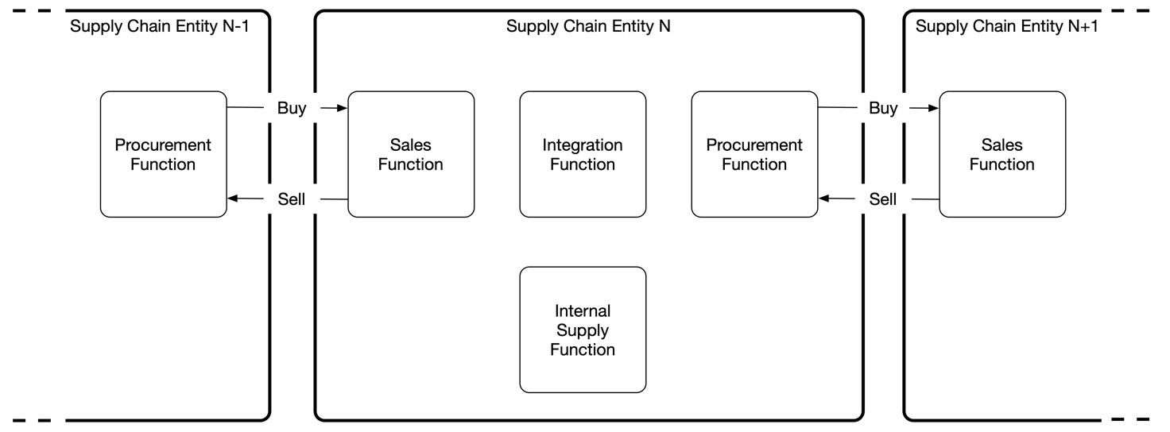
Figure 1 - Architecture of an entity in a supply chain
Some functions are optional and thus may not exist at all in a specific entity. Other functions may be mandatory depending on the type of entity.
Depending on size and structure of an entity the functions may be operated as separate business/operational units or as a single unit that performs multiple functions. Example: a small grocery shop may have a single person performing all roles: negotiating with suppliers, managing stock and selling to consumers, while a large enterprise or a large company may have separate business units that handle the different functions (as well as additional functions not depicted in the above figure such as customer-care, accounting, QA, IT and more).
- The sales function handles selling of goods and/or services to a procurement function of another entity in the supply chain.
- Likewise, the procurement function handles purchase of goods and/or services from the sales function of another entity in the supply chain.
- The internal supply function manages inventory of goods and/or services provided by the supply chain entity.
- The integration function coordinates internal and external supply and integrates them into goods and/or services sold by the sales function.

The functions are further defined in sections 4.2.1.2 through 4.2.1.7.

4.2.1.1.1 Buyer-Seller distinction
The functions are divided to:
- Procurement (buyer) functions.
- Sales functions.
- Internal functions, which in the context of a supply chain include the integration and internal supply functions.

4.2.1.1.2 Market segment distinction
Each of the functions can be also divided to market segments as follows:
- Wholesale functions – where the buyer or seller perform wholesale transactions.
- Retail functions – where the buyer or seller perform retail transactions.

4.2.1.1.3 Extremity entities
There are two extremities to a supply chain:
- The ultimate buyer of good or services has a single function – that of a retail buyer. Such entity only has a procurement function in the context of the supply chain. The sales function of such entity, if in existence, does not participate in the supply chain.
- A seller that does not require any supply chain partners to supply their goods or services and uses only internal supply has a single function – that of a seller, which may be either a wholesale or a retail seller or both, depending on the function of the buyer which the goods or services are being sold to. The procurement function of such entity, if in existence, does not participate in a supply chain.

4.2.1.1.4 Mid-chain entities
Any other entity within a supply chain acts both as a buyer and as a seller and thus has both a sales function and a procurement function.
The different functions of a mid-chain entity may be handled by different departments within an entity. Example: A car dealership may have a sales department that handles sales to consumers (buyers) while a procurement department handles buying the cars from the manufacturers. There may be additional departments within such entities that handle other functions such as accounting, repairs etc.
The different types of entities and are depicted in Figure 2 herewith:
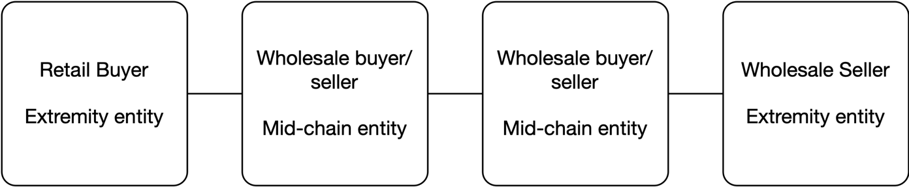
Figure 2 - Entity types

4.2.1.1.5 Multi role entities
An entity may participate in multiple supply chains and may take different functions in each supply chain. E.g., an entity may be a mid-chain entity in one supply chain and an extremity entity in another (either as the ultimate buyer or as a seller that does not require external supply.
A multi-role entity is depicted in Figure 3 herewith where one entity serves both as a mid-chain entity in the red supply chain and as an extremity entity in the green supply chain.
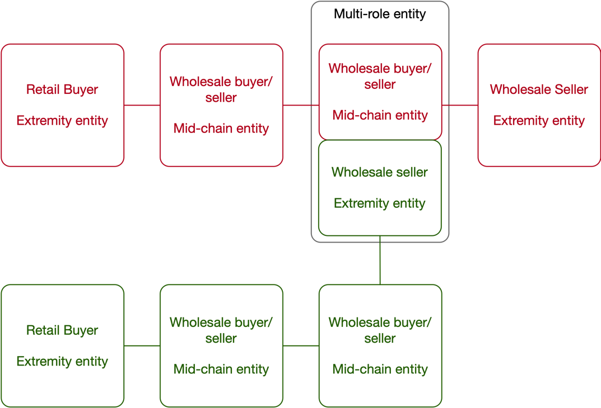
Figure 3 - Multi-role entity

4.2.1.2 Retail Customer
A retail customer buys goods and services for their own individual (or company/enterprise) use and does not resell those goods and service onwards. Such goods and services may be used to produce other goods and services, but not re-sold. Example: An architecture design firm may buy computers and software that are used to design buildings. They are a retail customer of a computer supply chain and do not sell or integrate the computers they bought into their designs.
A retail customer is located at one end of the supply chain and is thus an extremity entity.

4.2.1.3 Retail Seller
A retail seller is an entity that sells to retail customers as defined above.
A retail seller may also sell to wholesale buyers. As a result, a retail seller may also be a wholesale seller, and the distinction between the two depends on the entity the goods and services are sold to.
A retail seller may buy goods and services from wholesale sellers and integrate them into their goods and services or re-sell them without integration. Example: A car dealership that sells cars they buy from the manufacturer. The dealership may add items to the car such as an entertainment system, service packages, bicycle rack or luggage storage roof. On the other hand, a grocer buys products in bulk quantities and resells them in smaller quantities without changing the products.

4.2.1.4 Wholesale Buyer
A wholesale buyer is an entity that buys goods and services from a wholesale seller to resell them directly or to integrate them into new goods and services to be sold onwards.
As defined in clause 4.2.1.1 and depicted in diagram 2 below, an entity that acts as a wholesale buyer may also be a seller, either retail or wholesale.
An entity that performs both procurement and sales (buys and sells) may have different departments for each function.
Wholesale is sometimes associated with procurement of large bulk quantities and selling them as individual items. While this is a possible scenario, there are also wholesale buyers that buy individual items. This is typical to scenarios where the supply chain delivers customized goods and services as described in clause 5.1.2 herewith. Thus, quantity or volume of procurement is not sufficient to define a buyer as a wholesale buyer. The definition, for the purpose of this document, is that a wholesale buyer buys good and/or services that are resold or integrated into other goods and services sold by the selling entity associated with the buyer.
Examples:
- A vegetable warehouse buys vegetables from farmers and resells them to grocery stores and supermarkets.
- A telecom operator buys termination of a telephone call to a certain destination from another telecom operator.

4.2.1.5 Wholesale Seller
A wholesale Seller sells to Wholesale buyers. A wholesale seller may also sell to retail customers and the distinction between the two roles depends on the entity being sold to.
Regulations may exist that limit the ability of a wholesale seller to sell to retail customers or to specific groups of customers.
Agreements may exist that allow specific customers or groups of customers to enjoy reduced/discounted rates either based on volume of purchase or other factors.

4.2.1.6 Multi-Segment Entity
As mentioned previously in this section, an entity may perform both wholesale and retail transactions, in which case its specific function and segment depends on the type of transaction (procurement or selling) and the type of entity such transaction is performed with (Customer, Buyer or Seller).
Figure 4 herewith presents a multi-role entity that performs three functions: A retail seller, a wholesale seller and a wholesale buyer, as well as the respective entities with which each of the functions transacts.
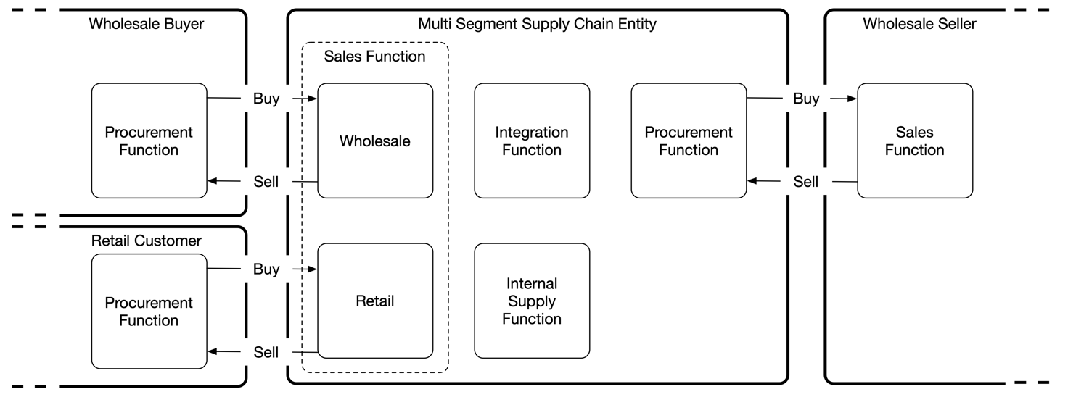
Figure 4 - Multi segment entity

4.2.1.7 Bilateral trade
When two multi-segment entities perform bi-directional transactions with each other (e.g., one such entity both buys from and sells to the other entity) the commercial relations between those entities are considered bilateral. This is depicted in Figure 5 below. For clarity the internal functions (Integration, Internal supply) have been omitted. Bilateral trade is more common in certain industries than others. Example: The international telecom carrier industry trades bilateral international voice and roaming data where calls made from country A to country B and calls made from country B to country A may be handled by a pair of bilateral partners trading such calls with each other.
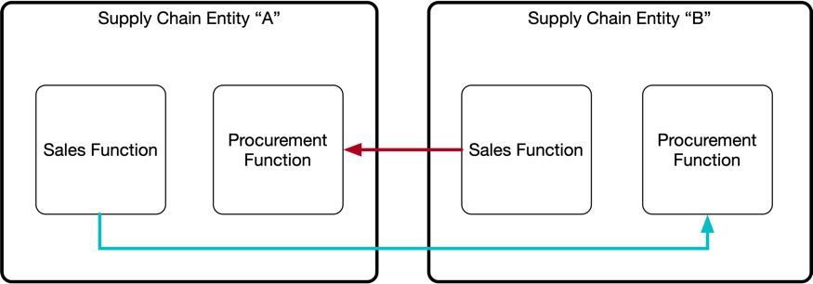
Figure 5 - Bilateral wholesale trade
The volumes, quantities and commercial values of procurement and sales between both sides may differ.
Commercial agreements between entities performing bilateral trade may be subject to regulations.

4.2.1.8 Multilateral trade
The Bilateral trade scenario can be extended to include multiple parties that establish buy and sell relations where some participants establish buy-only or sell-only relations with others and others establish both buy and sell relations, some of which may be bilateral. The same concepts apply for bilateral trade as for unilateral or bilateral trade. The buying is performed by the Procurement Function and the selling is performed by the Sales Function regardless of the nature of the trade (unilateral, bilateral or multilateral).

4.2.1.9 Cyclic supply chains
Certain supply chains may have a cyclic behaviour. In such case while there is wholesale trade between any two adjacent parties in the supply chain, at a certain point one of the parties in the chain consumes goods or services from another, downstream, party in the chain.
Example: One of the sources of raw materials for glass manufacturers is recycled glass collected in recycling bins. There is a likelihood that the bottles sent to a glass wine bottle manufacturer for recycling were manufactured by that same manufacturer before being sold to beverage manufacturers, then to distributors, them to wine shops, then to consumers.
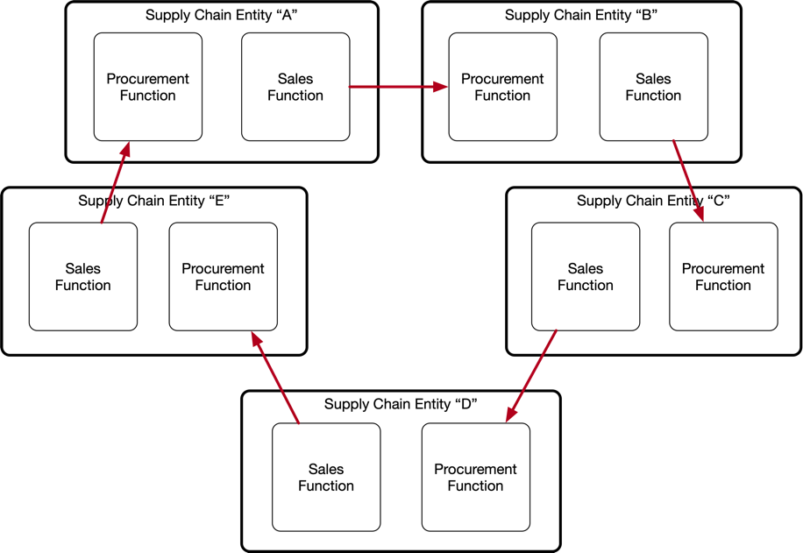
Figure 6 - Cyclic supply chain
While cyclic supply chains exist, the cyclic nature is in many cases occasional rather than planned. In many cases it is impossible to identify bulk items (e.g., a used bottle, an aluminium can) as coming from or passing through a specific supply chain, while in other cases it is possible to identify an item throughout the supply chain based on a serial number or other unique identifier (e.g., serial number of a vehicle’s engine or an electronic device).
PDL can, if properly configured, be used to identify such items and associate them with a specific participant in a chain. This could be useful in certain scenarios where accountability is required and a manufacturer of certain goods (e.g., a polluting battery) is required by law to collect such used goods for recycling.
Considering Figure 6 above the example of using a cyclic supply chain to ensure proper handling of polluting EV batteries can be considered as follows:
- Supply chain entity “A” is a battery manufacturer.
- Supply chain entity “B” is an EV manufacturer that buys batteries from supply chain entity “A” and installs them in their EVs.
- Supply chain entity “C” is a distributor that buys EVs from the EV manufacturer (supply chain entity “B”) and distributes them to dealerships. The distributor may also handle shipping, import, customs, and other functions. The distributor may use additional supply chain entities, such as shipping companies, to transport the EVs from their country of origin to the destination market.
- Supply chain entity “D” can represent the dealership selling the EV to the ultimate customer.
- Supply chain entity “E” represents the service centre that disassembles the used batteries from the EV when they reach their end of life and ships them back to the manufacturer (supply chain entity “A”).

- For a supply chain to be considered cyclic an item processed through it SHALL be uniquely identifiable, as a minimum, upon exit and re-entry from/to the supply-chain participant that had originated such item.

Supply chains may sometimes be partly cyclic. Partially cyclic supply chains are such where only some of the items originated by a participant are returned to that participant. Example: A an electrical vehicles manufacturer may be required to collect and recycle used batteries shipped with the vehicles it produces, but some batteries may be destroyed in a fire or shipped with the vehicle overseas thus cannot be returned to the manufacturer for recycling.
- A cyclic supply chain MAY NOT be cyclic to all items processes through it. A certain fraction of such items MAY NOT re-enter the chain upon completion of the supply cycle.

4.2.1.10 Interdependent supply chains
There are scenarios where a supply chain is dependent on one or more other supply chains.
Example: Pharmaceutical supply chains and medical prescriptions are interdependent. One supply chain handles the manufacturing, packing, storage, and distribution of medical supplies to pharmacies and hospitals, while another supply chain handles the medical records of patients, the laboratory tests, the appointments with doctors and the issuance of prescriptions. To consume certain medications, the two supply chains have to intersect: The patient needs a prescription in order to buy/receive the medicine at the pharmacy and the pharmacy needs to have the medication available in stock.
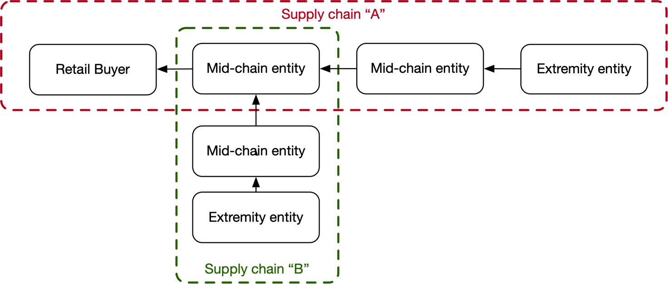
Figure 7 - Interdependent supply chains
When a process in a supply chain is dependent on the outcome of another supply chain those chains are interdependent. PDL is a useful tool to manage such interdependency through smart contracts that can ensure the processes are executed in accordance with the conditions defined in the dependency.

4.2.2 Transactions

4.2.2.1 Definition of a transaction
Although a transaction commonly refers to an exchange or transfer of goods, services, or funds [i.1] it also has a broader, abstract, meaning of an act, process, or instance of transacting: a communicative action or activity involving two parties or things that affect or influence each other.
For the purpose of this document and in the context of supply chains transactions take the broader and abstract form representing any exchange of information, goods, services and/or funds between supply-chain participants.
The different types of transactions covered by this document are listed herewith.

4.2.2.2 Retail transaction
A Retail transaction is a transaction between a Retail buyer and a seller of any type (both Retail and Wholesale).
- The buyer in a retail transaction SHALL be a retail buyer.
- A seller in a retail transaction MAY be either a wholesale or a retail seller.

4.2.2.3 Wholesale transaction
A wholesale transaction is a transaction between a Wholesale Buyer and a wholesale seller.
- The buyer in a wholesale transaction SHALL be a wholesale buyer.
- The seller in a wholesale transaction SHALL be a wholesale seller.
NOTE: The distinction between a retail and a wholesale transaction is determined by the identity of the buyer.

4.2.2.4 Once-off transaction

4.2.2.4.1 Definition
A once-off transaction is a transaction that occurs once. The transaction is final once the information, goods or services have been delivered. Example: Gas refill in a gas station. Example: buying a ticket to a theatre. Example: A buyer checking with a seller the inventory of certain goods in their warehouse. Example: A consumer signing up for a contract with a mobile operator.
NOTE: In the example pf a subscriber signing up for a contract with a mobile operator, although the contract is related to a recurring transaction that will be billed periodically for the duration of the contract, the act of signing up to such contract is a once-off transaction. Such transaction may include a once-off payment.
- A once-off transaction SHALL occur once and be recorded on chain.
- A once-off transaction MAY be recorded in a smart contract.
- Once off transactions executing procurement or sales of goods and/or services MAY include exchange of funds.

4.2.2.4.2 Reversibility of a once-off transaction
Some once-off transactions may be reversed. When such transaction involves exchange of funds it may include full or partial refund. E.g., a pre-paid flight ticket may be cancelled prior to the flight where a full or partial refund may be available depending on the commercial terms related to the purchase.
- Once-off transactions MAY be reversed.
- Reversed once-off transactions MAY be eligible for full or partial refund.

4.2.2.4.3 Payment of once-off transactions through periodical instalments
Certain once-off transactions may be paid in monthly instalments. Such transactions are a special case of once-off transactions because of their recurring nature. Although they are being paid through periodical instalments they are still considered once-off because they are a monetary breakdown of a large amount paid for a once-off purchase into smaller amounts for cash-flow and accounting purposes.
- A once-off transaction MAY be broken down to multiple instalments.
- In the event of a once-off transaction being paid through periodical instalment, the number of instalments and their value SHALL be agreed between the buyer and the seller and recorded in a smart contract.
- Instalments MAY be subject to interest.

4.2.2.5 Recurring transaction
Recurring transaction are subscription-based transaction that reoccur at a certain interval. Such transactions are typically automated and are triggered by a condition. Example: Annual renewal of software license. Example: Automated top-up of public commute card. Example: Monthly mobile subscription bill. The amount of a reoccurring transaction may be fixed or variable. Variable amounts are typically based on usage or consumption.
- Each recurring transaction SHALL be recorded on the chain as a smart contract.
- The interval or triggering conditions of a recurring transaction SHALL be agreed between the buyer and the seller and recorded in the smart contract.
- The commercial conditions between the buyer and the seller SHALL be agreed between the buyer and the seller and recorded in the smart contract.

4.2.2.6 Combined transactions
In certain conditions multiple transactions may be combined into a single, aggregated, transaction. There may be multiple commercial and operational reasons for doing so. Example: The monetary value of a typical IoT transaction is lower than the cost of transacting it through a PDL platform. It thus makes commercial sense to aggregate multiple such transactions into a single transaction prior to processing the aggregated transaction in a PDL platform. The number of individual records to be aggregated into a combined transaction and the frequency of such aggregation and transaction depends on the specific use case and should be agreed between the eco-system participants.
- Multiple transactions MAY be combined into a single combined transaction.
- Each individual transaction in a combined transaction SHALL be identifiable through a unique ID.
- When the transaction involves exchange of funds the combined transaction SHALL carry the monetary sum of all individual transactions contained therein.

4.2.2.7 Hybrid transactions
A hybrid transaction is a special case of a combined transaction that includes both once-off and recurring individual transactions.
The same requirements applicable for combined transactions also apply for hybrid transactions.
Example: A mobile bill may include both a recurring transaction for the domestic mobile usage and a once-off transaction for a roaming package purchased on a certain month in preparation to an overseas travel. Such bill may also include a fee for purchase of a new handset broken down to 12 instalments.
In a hybrid transaction the buyer and seller may treat the transaction as a combined transaction or break it down to its once-off and recurring elements for accounting purpose.
An interesting example of a hybrid transaction is purchase of a house/apartment. Unless the buyer has sufficient funds to pay the full price once-off, the buyer may need to apply to the bank for mortgage. In such case the bank either pays the seller the full amount or provides securities and the buyer returns the mortgage through monthly payments (either to the bank or to the seller, depending on the commercial agreement). Such mortgage payments may be considered either as instalments of a once-off transaction or as recurring transactions.

4.3 Types of Supply Chains

4.3.1 Introduction
The characterization of a supply chain, in the context of the current document, is defined by the type of deliverable to the ultimate consumer of such supply chain. When the deliverable is an object, goods, the supply chain is defined as delivering goods, even if some of the supply-chain participants deliver services. When the deliverable is a service the supply chain is defined as delivering a service even if some of the supply-chain participants deliver goods.

4.3.2 Supply Chains for delivery of goods
When delivery of goods requires elements of supply from multiple entities, those entities form a supply-chain for delivery of goods.
Certain supply-chain participants may be delivering services that are required for the delivery of goods. E.g., a supply chain for the delivery of fruits from the orchard to the grocery may include a farmer that harvests the fruit (goods), a warehouse where the fruit is packed and stored (service), a truck that ships the fruit from the warehouse to the grocery (service) and a grocer selling the fruit to the consumer (goods). Other supply chains may include multiple manufacturers of goods (e.g., computer parts and electronic chips) and an assembly line that assembles all parts into a computer. Additional supply-chain steps may include, among others, QA, shipment of the assembled computer to the consumer and accounting.
The main characteristic of supply chains handling the delivery of goods is that the entire chain is based on once-off transactions that end up with certain goods being delivered to the ultimate user. Procurement of goods, even if such goods are purchased on a regular and recurring basis, is typically handled on a per-occurrence or per specific need basis and does not involve a recurring subscription. There may be a wholesale supply chain behind the delivery of such goods that performs once-off or recurring transactions to enable delivery of the goods to the Retail customer.
Having the above said, being based solely on once-off transactions does not constitute sufficient criteria for the definition of a supply chain as delivering goods, and such definition is derived solely from the nature of the deliverable itself as stated earlier in this section.

4.3.3 Supply Chains for delivery of services
When delivery of a service requires elements of supply provided by multiple entities, those entities form a supply chain for delivery of services.
Certain elements of a service may include goods thus a supply chain for delivery of services may include entities delivering goods. E.g., delivery of a digital TV service subscription may require installing a set-top box at the customer location. Though the delivery of the set-top box is a once-off transaction related to the delivery of goods, it is part of a larger supply chain delivering digital TV services that include production, digital storage and distribution of content, service quality monitoring, usage measurement, accounting, and support.
As stated in section 4.3.1 the main differentiator between supply chains used for delivery of services compared to supply chains used for delivery of goods is the nature of the deliverable. Although certain goods may be required to consume certain services, the element of consumption is the service, not the goods through which it is consumed. E.g., a digital content distribution service will require a device capable of connecting to the digital distribution media (such as the public internet) but that device may be a large screen TV, a computer and even a mobile-phone – all of whom eventually used as a medium to consume the content for which the consumer had subscribed. The focal point, and the deliverable being subscribed to, is the digital media distribution service, not the device used to view it.

4.3.3 Bilateral Supply Chains
As described in section 4.2.1.7 there are scenarios where a pair of neighbouring participants in one supply chain, where one is a buyer and the other is a seller, are also participating in another supply chain where they perform the opposite roles: The buyer in one supply chain in the seller in the other supply chain and vice versa. Such scenario may include more than just a pair of entities and may involve longer chains as well.
Such a scenario is defined as a bilateral supply chain where the buy-sell relations are bi-directional. Consider a scenario where a domestic customer in one country wants to make a telephone call to a domestic customer in another country. Each of those domestic customers is served by a domestic telephone operator in their respective country. Each of those domestic telephone operators uses the services of an international operator to extend the calls from their domestic network to the other domestic network. A supply chain is formed:
Consumer A – Operator A – International Operator – Operator B – Consumer B
Each participant in such supply chain transacts with its neighbour(s).
When Consumer B wants to call Consumer A the same supply chain is formed, but the transactions are now performed in the other direction. The supply chain is bilateral where each participant both buys and sells to/from its neighbours.

4.3.4 Multilateral Supply chains
As defined in clause 4.2.1.8 (Multilateral trade), Multilateral supply chains are such where multiple entities are involved in the supply of goods and/or services where some of the parties buy, others sell and some both buy and sell.
The key concept to adhere to is that from a single entity’s point of view the buy relations are established between the Procurement Function of that entity and the Sales Function of the entities selling to it, and that the sell relations are established between the Sales Function of that entity and the Procurement Function of the entities buying from it.
Multiple supply chains may be established in a multilateral trade environment where a subgroup of bilateral trade partners form one supply chain for the purpose of delivering specific goods and/or services whereas other subgroups may establish other supply chains for the delivery of other goods and/or services.
A typical example of multilateral trade would be the airline industry where some airlines may be both buying and selling seats on other airlines’ flights to build long-haul/multi-segment flights, while other airlines may be only selling seats to others or only buying seats from others but not both.

4.4 PDL in Supply Chains

4.4.1 Types of PDL related entities and nodes in a supply chain

4.4.1.1 Introduction
When using PDL in a supply chain the following entities and node types are defined.

4.4.1.2 Trading entities
Trading entities are entities directly involved in buying and/or selling.
- Buyer nodes
- Seller nodes
- Trading entities SHALL have consensus voting power in each transaction they are involved in.
- In a buyer-seller PDL both trading entities SHOULD have the same voting power.
- The governance MAY assign different consensus voting power to trading entities in a PDL.

4.4.1.3 Non-trading entities
Non trading entities are functions involved in PDL transactions that are not buyers or sellers.
- Governance
- Validators
- Chain operators
- Others
- Non-trading entities MAY have consensus voting power in a PDL they are participating in.

4.4.1.4 Trading nodes
Trading nodes are PDL nodes operated by trading entities that are used to record supply chain related transactions.
- Buy-Sell PDL nodes
- Ecosystem-wide PDL nodes
- Trading nodes SHALL record all transactions related to any supply chain they are associated with.

4.4.1.5 Non-trading nodes
Non-trading PDL nodes are PDL nodes that are used for the proper functionality of the PDL but are not necessarily used to record PDL transactions.
- Validating nodes
- Governance nodes
- Others
- Non-trading nodes MAY record transactions related to supply chains they are associated with.
- Non-trading nodes SHOULD record data related to the functionality of the PDLs they are associated with or participating in.

4.4.2 Buyer-Seller PDL

4.4.2.1 Definition
Buyer-seller PDL is used to handle transaction between a buyer and a seller. The transactions recorded on such PDL are not visible by other entities except for a neutral validating node operated by a third party. Depending on chain type it may be part of a larger, multiuser, chain, a stand-alone chain or a side chain of a larger chain.
- Each buyer and seller in a PDL-based supply chain SHALL be part of a Buyer-Seller PDL.
- Each buyer and seller in a PDL-based supply chain SHALL use a PDL node for each buy-sell relations they have with other entities.
- The Buyer-Seller PDL node MAY use virtual resources.
- The Buyer-Seller PDL node MAY be cloud based.

4.4.2.2 Unilateral
A unilateral PDLs handles unilateral transactions where the relations between the transacting entities are one-way: One of the two entities always acts as a buyer and the other entity always acts as a seller. That is typically the case with Retail transaction where the retail consumer is only buying from the seller and does not sell anything in return.

4.4.2.3 Bilateral
Bilateral PDLs handle transactions in a bilateral environment where the roles of buyer and seller may reverse. In such scenario either entity may both buy from and sell to the other entity. This is typically the case where both buyer and seller are wholesalers.
- A Buyer-Seller PDL MAY be used for both Unilateral and Bilateral transactions between two entities.
Figure 8 depicts an abstract implementation of Buy-Sell PDLs in a supply chain. Each pair of supply chain entities operates a Buy-Sell PDL that includes at least two nodes, one for each entity, and potential additional neutral nodes used for validation.
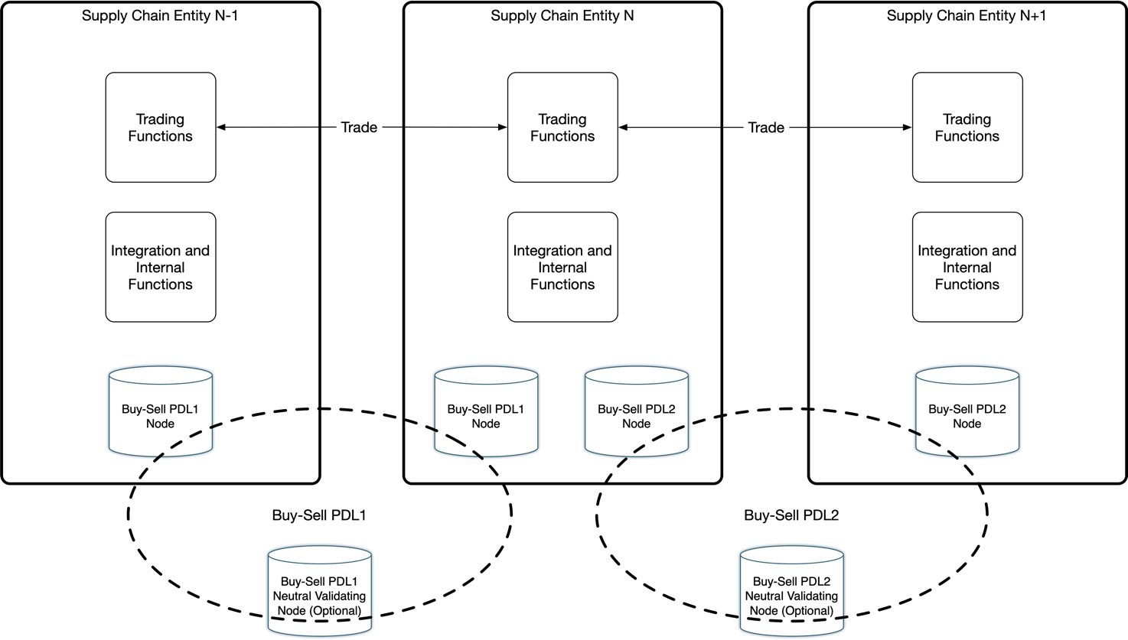
Figure 8 - Buy-Sell PDL implementation in a supply chain
- The data in a Buy-Sell PDL SHOULD NOT be visible to entities other than the two supply chain entities operating that PDL.
- Subject to agreement between the respective supply chain entities and subject to GDPR the information on Buy-Sell PDLs MAY be exposed to a controlled list of third party entities.
- Exposure of Buy-Sell PDL data to third parties SHALL be for the sole purpose of validation of transaction.

4.4.2.4 Buyer-seller PDL architecture
As described in section 4.4.2.3 above, a bilateral PDL has two trading nodes, one on the buyer entity side and one on the seller entity side. The PDL may also include additional nodes used for other purposes such as validating nodes. The architecture is depicted in Figure 9 herewith.
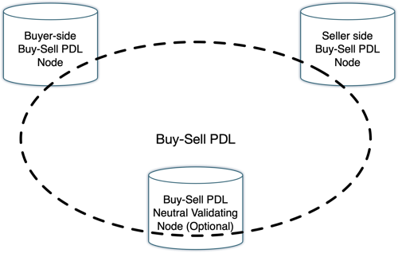
Figure 9 - Buyer-Seller PDL architecture
- A Buyer-Seller PDL SHALL include a Buyer side node and a Seller side node.
- A Buyer-Seller PDL MAY include additional nodes.
In a Bilateral Buyer-Seller PDL node, as defined in section 4.4.2.3 herewith, the roles of the Buyer-side PDL node and of the Seller-side PDL node may interchange in accordance with the roles of the entities involved in the transaction.
- A Bilateral Buyer-Seller PDL SHALL be able to accept buy and sell transactions from both participating entities.

4.4.3 Multilateral PDL
Multilateral PDLs are PDLs that include more than two trading nodes and are used in supply chains that include more than one buyer and one seller. For the remainder of this document such PDLs are referred to as Ecosystem-wide PDLs, where the scope of and ecosystem may vary depending on the use-case.

4.4.4 Ecosystem-wide PDL

4.4.4.1 Definition of an Ecosystem-wide PDL
An ecosystem wide PDL is used in transactions where all stakeholders in an ecosystem are either involved or have interest in. An example is management of reputation in a wholesale supply chain where all stakeholders may want to know the reputation of parties involved in a specific supply chain in order to identify troublesome entities and avoid them if possible.
Figure 10 depicts the implementation of an ecosystem-wide PDL in a supply chain.
The definition of an “ecosystem” depends on the use case and there may be more than a single ecosystem in some scenarios. E.g., A specific airline may participate both in an all-encompassing ecosystem-wide PDL that includes all airlines as well as in a smaller-scale ecosystem-wide PDL that only includes members of the airline alliance of which the airline is a member. Such airline will likely use the airline alliance PDL for information related to flights and bookings restricted to members of the alliance and will use the larger scale PDL for information related to flights and bookings operated by airlines that are not members of the alliance.
- A supply chain participant MAY participate in one or more ecosystem-wide PDLs.
- Each participant in an Ecosystem-wide PDL SHALL operate an Ecosystem-wide PDL node for each Ecosystem-wide PDL they participate in.
- The Ecosystem-wide PDL node MAY use virtual resources.
- The Ecosystem-wide PDL node MAY be cloud based.
- Information shared on an ecosystem-wide PDL SHALL be GDPR compliant.

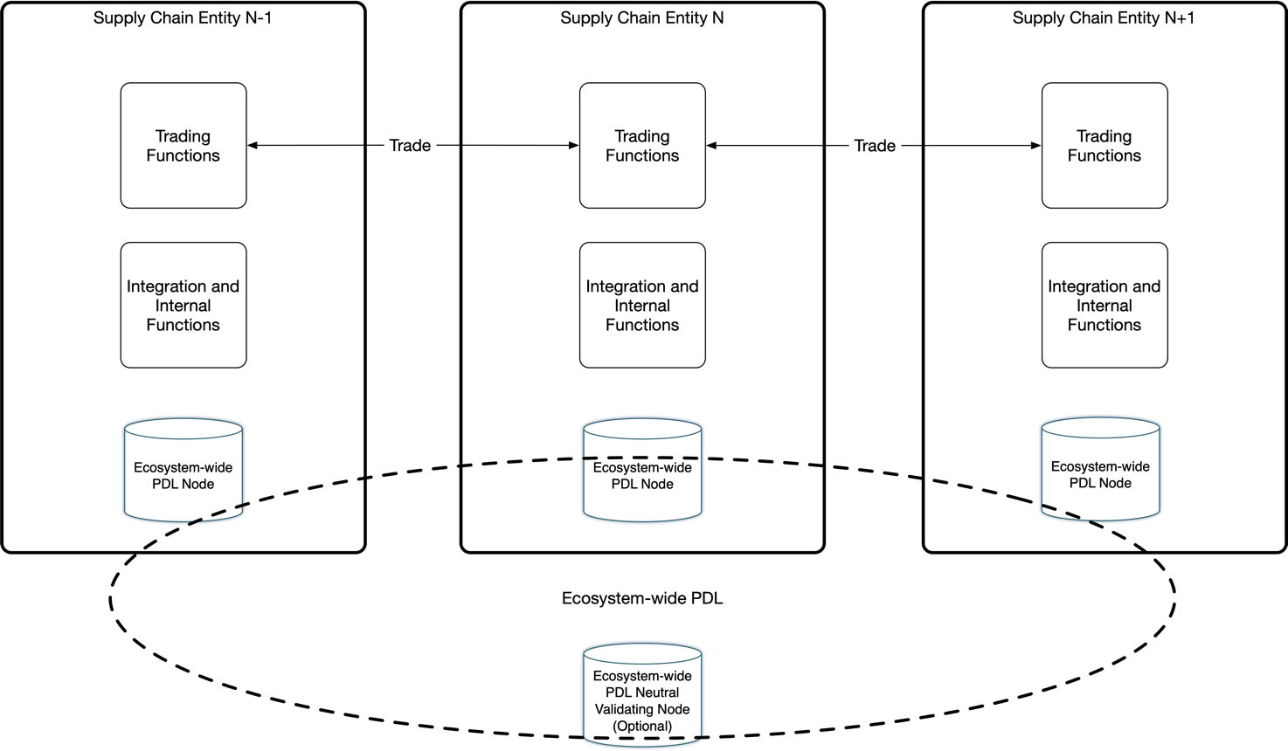
Figure 10 - Ecosystem-wide PDL

4.4.4.2 Ecosystem-wide PDL architecture
As described in the above section, an ecosystem-wide PDL has at least one trading node for each participating trader in the eco-system. The PDL may also include additional nodes used for other purposes such as validating nodes. A trading participant may have more than one trading node in the ecosystem-wide PDL but the voting power of that participant, for consensus purposes, shall be equal to that of all other participants regardless of the number of trading nodes each trading partner has installed on the PDL. The governance is entitled to increase or decrease the voting power of select participating traders through a consensus vote.
The architecture is depicted in Figure 11 herewith.
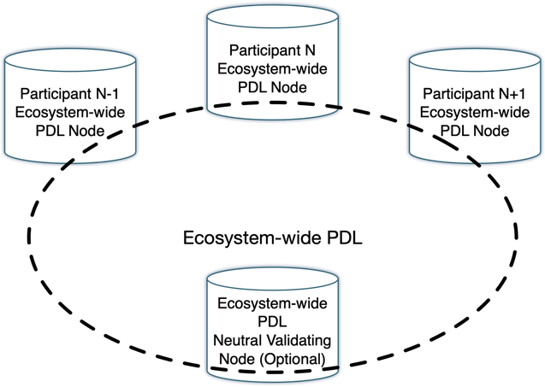
Figure 11 - Ecosystem-wide PDL architecture
- An ecosystem-wide PDL SHALL include at least one trading node for each trading participant in the ecosystem.
- An ecosystem-wide PDL MAY include additional nodes.
- The voting power of each trading participant SHOULD be equal to that of all other trading participants, unless defined otherwise by the governance.
- The governance MAY increase or decrease the voting power of select participating traders through a consensus vote.

4.4.4.3 Ecosystem-wide PDL plurality
An entity may participate in multiple ecosystems. E.g., a trading node may participate in multiple supply chains, and each such supply chain may be defined as an ecosystem. Another example, as described in section 4.4.3.1, is when a trading node is participating in a specific supply chain but also in a larger, non-supply-chain related, group. Each of those groups may be defined as an ecosystem, and as a result, may use its own ecosystem-wide PDL.
As a result, an entity may have ecosystem-wide PDL nodes in multiple ecosystem-wide PDLs. Each such node has to function independently across the PDLs. The current document does not dictate the implementation in terms of physical or virtual nodes, nor does it dictate the physical location or network topology (e.g., in-house/cloud), alas it does require that the nodes are logically isolated and that data can not be shared/leaked between ecosystem-wide PDLs.
- An entity MAY participate in multiple ecosystem-wide PDLs.
- An entity SHALL have an ecosystem-wide PDL node in each ecosystem-wide PDL in which it participates.
- In the event that an entity participates in more than one ecosystem-wide PDL it SHALL keep the data in each PDL isolated from the other PDLs.
The plurality of ecosystem-wide PDLs is depicted in Figure 12 herewith.
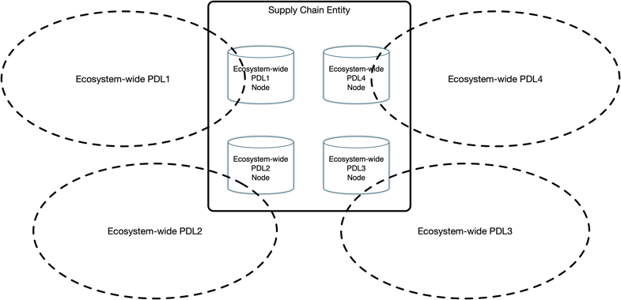
Figure 12 - Ecosystem-wide PDL plurality

5 Lifecycle Management

5.1 Definition of a lifecycle
Lifecycle is a series of stages goods and/or services go through from inception to through evolution to cessation. The stages included in a specific lifecycle may vary depending on the type of goods and/or services and their intended use.
The stages may include one or more of the following:
- Inception of an idea or a requirement.
- Design of goods and/or services that fulfill such idea or requirement.
- Defining the costs involved with the fulfillment of the idea or requirement into goods and/or services.
- Assigning a commercial value that is used to trade the goods and/or services.
- Executing a commercial transaction where monetary value is transferred, or committed to be transferred, from a buyer to a seller and where such seller is delivering, or commits to deliver, said goods and/or services to the buyer.
- The process of delivering goods and/or services from a seller to a buyer.
- Performance and usage monitoring of goods and/or services.
- Stock/inventory management of goods and/or services.
- Reporting and handling of faults of goods and/or services that were delivered by a seller to a buyer.
- Commercial settlement between the buyer and the seller.
- Managing changes to existing goods and/or services which may include:
  - Renewal of contract term
  - Change of commercial terms (e.g., reduction in recurring charges)
  - Change of technical credentials (e.g., Increase of bandwidth of a communications service)
  - Change of contact details (e.g., email-address)
  - Cessation/suspension of a service/contract (a reversible action where the resources required for such service remain in place)
  - Termination of a service/contract (a final and non-reversible action where the resources required for such service may be repurposed)

Figure 13 describes the lifecycle stages between a buyer and a seller.
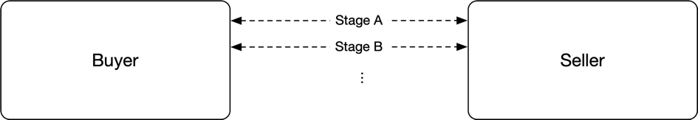
Figure 13 - Lifecycle stages between a buyer and a seller

5.2 Lifecycle of goods and/or services in a supply chain
The lifecycle of goods and/or services delivered through a supply chain may include one or more of the stages listed in section 5.1. the main difference between the two cases is that while in a buyer-seller relations the stages are performed only between the buyer and the seller, in a supply chain case, where a chain of buyers and sellers (stakeholders) is involved, the lifecycle stages are performed across multiple stakeholders in either a serial or a parallel manner.
Figure 14 describes the lifecycle stages in a supply chain where the stage between each pair of entities in the supply chain is marked with tag(s) or asterisk to designate the similarity (in stage) and difference (in entities and thus the contents of the transaction) between the different pairs of entities. The tag/asterisk marks are used for presentation clarity purposes throughout this document only and are not used otherwise in actual implementations.
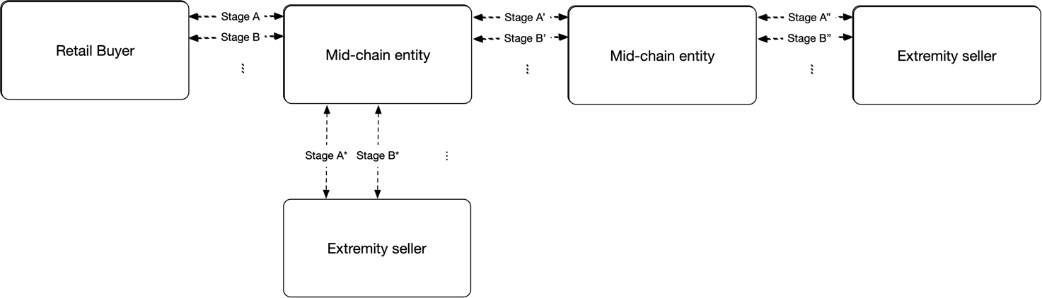
Figure 14 - Lifecycle stages in a supply chain
Certain characteristics of the lifecycle stages described herewith (e.g., recursiveness, storing of transactions into PDL blocks) are similar across the different lifecycle stages. When a certain requirement appearing in a previous lifecycle stage is applicable in other lifecycle stages – the respective requirement number is listed as valid instead of repeating the same requirement again.

5.3 Lifecycle stages
Section 4.3 above lists certain types of supply chains. The lifecycle stages used for each such type of supply chain may vary depending on the case. The following sections specify the processes that are common to all cases per lifecycle stage and discuss the specific unique characteristics of different use cases.

5.3.1 Inception of an idea or a proposed solution

5.3.1.1 Proposing a solution based on market research or prediction of future needs.
The inception of a new idea for goods or services to be sold may be the result of a market research, a prediction of future needs or the result of a specific inquiry coming from an existing or a potential buyer.
When an idea is incepted or a request for a solution/service is received it is turned into either a menu item in a menu-based ordering system, or into an ad-hoc solution, as described below.
Menu-based procurement of goods and services may be used both for the purchase of goods bought from existing inventory, services offered using existing resources, as well as goods and services that may require assembly and staging prior to delivery. Some of such goods and services may be based on wholesale supply. Example-1: Renting a movie on a VOD service. Example-2: Refilling a vehicle’s gas tank (which requires the gas station owner to maintain supply levels in their reservoirs). Example-3: Buy a vacation package (which may include flights, hotels, attractions sourced from different suppliers).
The key characteristic of menu-based procurement is that the price of such goods and services as well as their availability and delivery timeline is known and published in advance, in a manner that allows the buyer to place an order for such goods and services immediately based on available information and does not require any negotiations or design based on a specific inquiry.
Note: A seller may allow potential buyers to haggle for a better price. When a menu-based ordering system is in use such haggling is typically done through a bypass channel. E.g., “If you find a better price elsewhere please contact us.”

5.3.1.2 Proposing a solution based on a specific request.
Certain requests may include non-menu-based items or specific features that may require detailed design that addresses those specific requests. Such specific requests may include a non-standard topology, specific routing or security requirements, or limitations regarding specific vendors or geographies. Examples may include building a home on a stretch of land (vs. buying an apartment); Connecting multiple branches of a corporate using a private network (vs. using the public internet).

5.3.1.3 Data management and DLT aspects
When an idea is incepted or a specific, non-menu-based solution-request, is received, it should be recorded to the bilateral buyer-seller PDL so the commercial, technical and operational features are final and accepted by both the seller and buyer. There is no common process defining this stage as it is by large dependent on occasional demand, market research and visionary leadership. However - recording the information in a PDL eliminates possible disputes related to the details of the demand, the proposed solution, the proposed price and the time such communications took place.
- The commercial, technical and operational features of a proposed solution SHOULD be recorded on the buyer-seller PDL.

DLT may also be used to offer ZKP based assurance that some specific requests are met. E.g., PDL may be used to ensure certain territories or vendors are avoided without necessarily naming the supply chain partners that provide such elements of service or goods. More specific example may be: A buyer is using a certain cloud provider (“Cloud Provider A”) to store their data and may be looking for a backup solution that uses another cloud provider, for diversity purposes. ZKP can be used to ensure the proposed solution does not use “Cloud-Provider-A” for backup.

5.3.2 Design, Pricing and Presentation

5.3.2.1 General discussion
Goods and Services procured through a menu system have to be designed and ready for delivery within a committed timeframe. In order to meet such goal, they need to be designed, priced and made available for ordering through a menu presented as a catalogue or a storefront.
When the goods and services sold through a menu also include elements procured from third-party suppliers, the commercial and operational aspects of such third-party supply (e.g., cost of such elements, supply lead times, stock availability) have to be pre-negotiated between the supplier and any third party supplier to ensure timely delivery.
Goods and services procured through a specific request have to be designed, including nested supply partners, and presented to the buyer in a manner that presents all details requested by the potential buyer. Unlike a menu-based ordering interface, an ad-hoc proposal will be presented as a single item and will typically have limited validity. The presentation of such item can be through a GUI or through messaging systems (e.g., e-mail).
In certain cases a third party supply chain partner may require additional, nested, supply chain partners in which case the supply chain partners shall perform nested negotiations in a recursive manner resulting in the supply chain being able to commit to a timely delivery of goods and services meeting published specifications and capabilities.

5.3.2.2 Internal cost and external cost
There are two types for costs for goods and/or services offered by a seller.
- Internal costs represent costs of goods and/or services delivered by the seller from their own resources. E.g., The cost of production and distribution of a memory chip by their manufacturer. Such costs may also include the cost of operations (HR, facility rentals etc.)
- External costs represent the cost of external elements procured by the seller from other suppliers in order to fulfil the required solution. E.g., The price a wheel manufacturer pays to a tyre and bolts manufacturers before selling a complete wheel to the car manufacturer. Such price paid to third parties is considered an external cost.

5.3.2.3 Selling price and Mark-up
A seller calculates the sum of all internal and external costs and defines a selling price which is presented to the buyer.
The selling price may be defined by using a certain mark-up (e.g., 5% or 30% above the cost) to the external and internal costs or by matching a target price dictated by the market, by a regulator or by the customer.
Note: Different mark-up levels may be applied to different cost elements. This document does not specify such levels and they are entirely up to the seller to decide.
Note: It is, of course, desired that the selling price is higher than the costs, but that is not mandatory. Commercial considerations may lead certain sellers to sell certain products at a loss. This discussion is out of scope of the current document.

5.3.2.4 Recursive processes
A key characteristic of this stage is that the design and pricing has to be completed prior to presentation of the goods and services in a catalogue/storefront and making them available for purchase. Therefore, the design and pricing is a recursive process that progresses through the supply chain where the request for design and pricing progresses from buyer to seller. After receiving the request for a solution from a buyer the seller identifies which elements of the required solution they can deliver and which of them require supply from another supplier. The seller then becomes a buyer and requests a solution for such elements from their own suppliers. When all elements of a solution are available and the price of each such element has been determined by its respective supplier, the solution is presented from seller to buyer. The price offered by a seller to a buyer becomes the external cost for the buyer. Each buyer adds the costs of their external supply to the costs of their internal supply, marks the costs up based on their commercial considerations, and presents the price to their respective buyer.
Figure 15 describes the process flow from design through to publishing a product (goods and/or services) on a storefront/catalogue. The recursive nature is presented through the move from A to A’ then from Z’ to Z which recours through the entire supply chain until a solution is achieved.
Note: The number of participants, their identity and order may change from one supply chain to the other based on the availability of the respective elements of a solution by the different stakeholders. When a buyer requests a solution from a 3rd party supplier – such supplier may not be able to offer a solution that meets the requirements. In such case the buyer may approach other third-party suppliers. Thus, the supply chain may be constructed dynamically during the Design and Pricing phase.
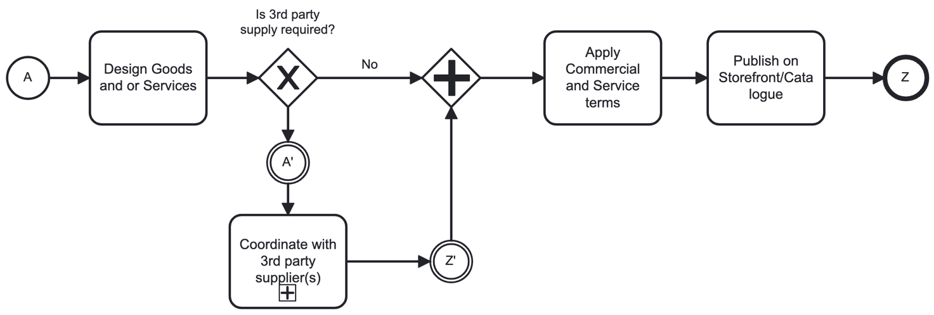
Figure 15 - Design, pricing and presentation of menu based goods and services
The sub-task named “Coordinate with 3rd party supplier(s)” indicates a recursive process where an entity in a supply chain coordinates supply with a supply chain partner. Such supply chain partner implements the same process A’ to Z’) and may, in turn, coordinate supply with additional supply chain partners.

5.3.2.5 Validity of Quotes
Quotes may have limited validity. E.g., a seller may reserve resources required for the delivery of quoted goods and/or services and may have to limit the amount of resources reserved for quotes, under a reasonable assumption that not all request for quotes result in an order (a request for delivery) as in certain cases the buyer may be shopping or comparing prices and may end up delaying the decision or buying from another seller.
- A seller SHOULD specify the validity of a quote either by setting an end-date or a duration from time of quote after which the quote is no longer valid and cannot be used to place and order.
- A seller MAY issue a budgetary quote in which case the quote is not binding.
- When a buyer asks for a firm quote the seller SHOULD provide a firm and binding quote.
- When a buyer asks for a firm quote and the seller is unable to provide a firm and binding quote the seller SHALL respond to the buyer “NO QUOTE”.
Once a product (goods and/or services) had been placed in the menu (storefront/catalogue) all supply chain partners should constantly monitor stock and availability of the resources required for its delivery and shall remove an item from the menu in any event where the product cannot be supplied at the quality and/or timelines stated during design.
- Supply chain partners SHOULD monitor availability of supplies required for the delivery of goods and services published to potential buyers.
Failure to monitor availability of supplies may lead to orders being placed (in future lifecycle stages) that cannot be delivered. This may have a negative effect on customer satisfaction and may also reduce a sellers’ reputation. However, this is not a formal requirement but rather a recommendation.
- Supply chain partners SHALL unpublish goods and services whose published supply lead times and/or quality cannot be met.
- Seller SHALL inform a buyer when resources required for the delivery of a firm quote had become unavailable.

5.3.2.6 Supply chain depth
The designer of supply-chain based goods and/or services may indicate the maximum allowed number of partners in a supply chain. The purpose of such limitation is to reduce complexity of the solution and avoid recursive mark-ups which may increase overall cost.
- The buyer MAY indicate the maximal depth of the supply chain (the number of partners) allowed to be offered by the seller.
- When the buyer indicates to the seller a limit to the depth of the supply chain, the seller SHALL communicate the limit to subsequent supply chain partners excluding their own position from the total depth.
- When the buyer indicates to the seller a limit to the depth of the supply chain, the seller SHALL NOT propose solutions/quotes based on supply chains that exceed such limit.
- When the buyer indicates to the seller a limit to the depth of the supply chain, the seller SHOULD indicate the depth of the supply chain on which the proposed solution and quote are based.
While not presented as a formal requirement – entities in a supply chain are expected to calculate the depth of the supply chain without necessarily knowing the identities of other entities and their position in the supply chain.

5.3.2.7 Presentation of a solution and a quote
- A solution addressing a specific request SHALL address all aspects of such request in their entirety.
- If a solution can not address the requirements in their entirety the seller SHALL respond with a message stating the request can not be addressed.
- If the condition in requirement ‎[R30] is met then the seller MAY suggest an alternative solution.
- If the seller opts to offer an alternative solution as stipulated in ‎[O26] then the seller SHALL specify what parts of the original request can not be met and how the proposed solution deviates from them.
- A proposed solution SHALL include an eBOM (electronic Bill of Materials) that includes details of the solution.
- When a solution is based on a supply chain the eBOM SHALL include details from eBOMs of all supply chain partners and is then called a Nested eBOM.
- A Nested eBOM MAY hide the identity of supply chain partners except those of the seller.

5.3.2.8 Transaction management and PDL management
- All transaction between a buyer and a seller (occurring in locations “A” and “Z” in Figure 15 above) SHALL be recorded in the respective Bilateral PDL operated between the buyer and seller.
- All transaction between a mid-chain entity and a subsequent seller (occurring in locations “A’ ” and “Z’ ” in Figure 15 above) SHALL be recorded in the respective Bilateral PDL operated between the mid-chain entity and the subsequent seller.
- Each request for pricing SHALL have a unique ID assigned by the buyer.
- The seller MAY assign their own unique ID for a request or use the ID assigned by the buyer.
- Both IDs SHALL be recorded to the bilateral PDL on all transactions related to that request for pricing.
- Each transaction recorded on a bilateral PDL SHALL include the following details:
- PDL chain overheads (previous hash, block identifier etc.) where applicable.
- Buyer unique request ID
- Seller unique request ID (same as Buyer unique request ID if not assigned by seller)
- Transaction unique ID (generated by the initiator of the transaction)
- Timestamp (using an atomic clock and UTC+0 time)
- Transaction payload (functional data)
- Multiple transaction MAY be loaded to a single PDL block.
There is no formal requirement to load each transaction to a separate PDL block. Multiple transactions may be loaded to a single block as long as the transactions can be retrieved and used by any entity having access to the PDL.

5.3.3 Ordering

5.3.3.1 General discussion
The ordering of goods and services is done through selection of an item off-of a menu or through acceptance of a valid quote provided at an earlier stage. Once the order is accepted and approved the buyer shall receive a confirmation and an estimated delivery date. The seller may also offer cancellation options, with or without penalty.

5.3.3.2 Recursiveness
When more than one buyer and one seller exist in a supply chain the ordering is handled in a recursive manner: A buyer places an order with their respective seller (step A in Figure 17 below) indicating the valid unique quote ID being ordered. If the quote is based on external resources, the seller places subsequent orders with their subsequent suppliers (step A’ in Figure 17 below). In parallel, the seller verifies availability of internal resources. Two conditions have to be true in order for the order to be accepted:
  - Verification that internal resources are available and ready.
  - Confirmation from subsequent providers that the external resources they provide are available and ready (step Z’ in Figure 16 below).

5.3.3.3 Acceptance of order
- A seller SHALL only confirm acceptance of an order when both internal supply is available and all orders for external supply have been confirmed.
Only when both conditions listed in section 5.3.3.2 are true will the seller accept the order and confirm acceptance to the buyer (step Z in in Figure 17 below).
- The buyer and seller MAY agree on a timeframe for acceptance of an order.
- If the seller fails to confirm acceptance within such timeframe, the buyer MAY cancel the order with no penalty or prejudice.
Figure 17 herewith describes the process of order acceptance and rejection in a supply chain.

5.3.3.4 Transaction management and PDL management
All requirements listed in clause 5.3.2.8 (Transaction management and PDL management) are also valid for the Ordering lifecycle stage.
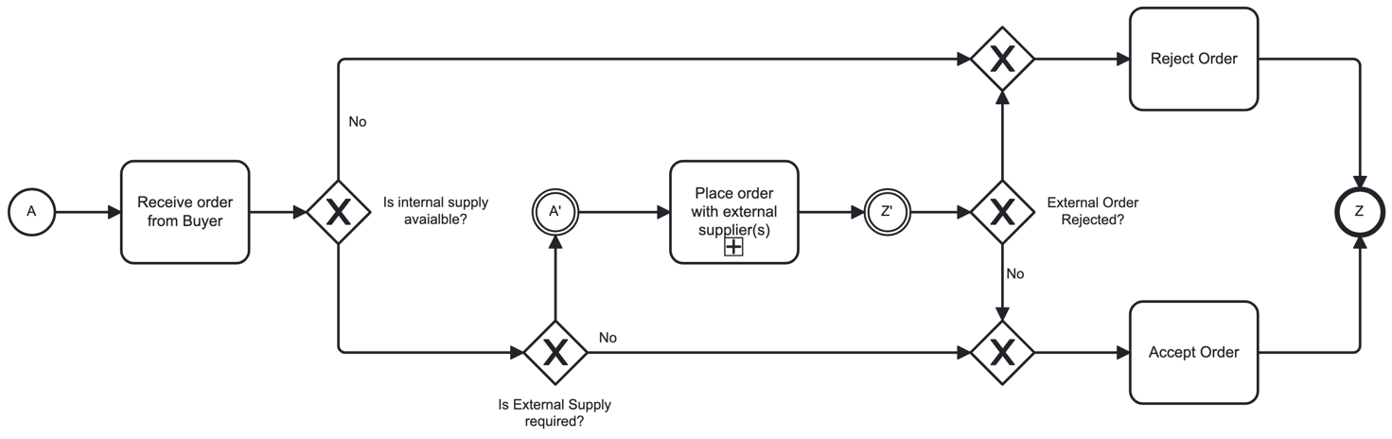
Figure 16 - Order Acceptance and Rejection process

5.3.4 Delivery

5.3.4.1 Preface
Delivery options depend on the type of goods and services and on stock/inventory policies of the supply chain partners.
Menu based orders will be either based on existing inventory available for immediate use or on committed delivery timelines from supply chain partners. As such – menu based orders have committed delivery timelines.
When delivering orders based on an ad-hoc quote for a specific request, the supply chain may have to be built or suited for such delivery, thus timelines for delivery may be more complex to estimate.
- The seller SHOULD provide an estimated delivery timeline upon confirmation of an order to the buyer.
- The buyer and seller MAY include a delivery-timeline clause in their SLA.
- The SLA MAY include penalties for late delivery.

5.3.4.2 Goods and services sold from Stock/Inventory
Certain goods and services are sold from inventory or are using existing inventory and are thus available for shipment or deployment as soon as an order is placed. In certain situations, such delivery is handled during work hours only thus an order performed at night-time or during the weekend may only be processed and shipped/deployed on the next business day. In other cases, specifically when automated services are involved, orders can be delivered/fulfilled with immediacy.

5.3.4.3 Goods that require pre-shipment staging/assembly.
In certain scenarios goods are ready for assembly and are being assembled and staged upon receipt of order. This is typically the case with modular goods where particular options can be tuned during assembly. An example would be a computer that can be configured with different amounts of RAM and storage. The manufacturer may not want to keep large inventory of pre-configured computers, especially when expensive high-end models are involved, and may prefer to keep all the parts handy and assemble the computer upon receipt of order.

5.3.4.4 Goods and/or Services delivered using supply-chain partners.
In certain scenarios the delivery of goods or activation of a service may require the delivery of goods or activation of another service provided by a supply chain partner.
- When a seller receives an order that is based on a quote that included supply partners, the seller SHALL propagate the respective parts of the order to the supply partners so that they can start the delivery process of their respective elements of the service.

5.3.4.5 Successful delivery
- When a seller has completed the delivery of their internal goods and/or service and there were no external supply elements the seller MAY proceed to hand the service over to the buyer.
In certain scenarios such successful delivery also involves sending a notification by the seller to the buyer stating the goods and/or services have been delivered. Such notification may include additional commercial and operational details (e.g., reference numbers, commercially binding dates, troubleshooting instructions etc.). This optional notification stage is referred to as Handover.
- A Handover notification MAY include commercial and operational information related to the goods and/or service handed over.
- The buyer MAY be required to accept or dispute the handover document within a certain period.
- If the buyer had not disputed the handover document within said period it SHALL be deemed accepted.
- The interactions described in this clause SHOULD be recorded on the bilateral PDL.
- All transactions recorded on the bilateral PDL SHALL be considered final and binding.

5.3.4.6 Integration and chaining
This stage is optional and only occurs when the seller uses external supply by supply chain partners. In such event, when a seller has completed the delivery of their internal goods and/or service and has received confirmation from all its supply partners that they have successfully delivered their respective elements of the goods/services, the seller may need to perform chaining and integration of the different elements into cohesive operating goods/services. When such integration/chaining is complete the seller may hand the service over to the buyer.
- A seller SHALL ONLY perform integration, chaining and handover of goods and/or services if both the delivery of their internal supply and that of all its external supply had been successful.

5.3.4.7 Failed delivery
- When the delivery of a service by a seller to a buyer has failed, the seller SHALL report to the buyer that the delivery has failed.
The failure may be the related to internal supply (e.g., the inventory assigned for the order is malfunctioning) or related to external supply (when a supply chain partner reports failure to deliver their part).
- In the event of failed delivery, the seller MAY negotiate with the buyer an alternative solution.
Failure to deliver a service in a timely manner is subject to the SLA between the buyer and seller, if one exists.

5.3.4.8 Transaction management and PDL management
All requirements listed in clause 5.3.2.8 (Transaction management and PDL management) are also valid for the Delivery lifecycle stage.

5.3.4.9 Process Diagrams for various delivery scenarios – Parallel Delivery
The Delivery process in BPMN 2.0 notation depicted in Figure 17 herewith defines the different delivery scenarios:
  - Delivery of a goods or services that do not require any additional supply chain partner and is based entirely on internal supply.
  - Delivery of goods or services that require a supply chain partner and is being delivered in a sequential manner: The internal supply is only being delivered when all external supply elements have been delivered. The logic behind this approach is to eliminate allocation of internal resources in scenarios where there is:
    - Likelihood that the supply chain delivery may fail, and such resources will then be allocated in vain.
    - Internal delivery timelines are short such that sequential delivery will not impact overall delivery timelines.
  - Delivery of goods or services that require a supply chain partner and where internal and external delivery elements are being delivered in parallel. The logic behind this approach is to accelerate delivery when:
    - It is unlikely that supply chain partners will fail in delivery of their respective elements.
    - Timeliness of delivery is of essence and sequential processing may slow delivery down.

It is the prerogative of each supply chain partner to choose between options b and c listed above depending on their assessment of capabilities, risks, timelines and contractual commitments.
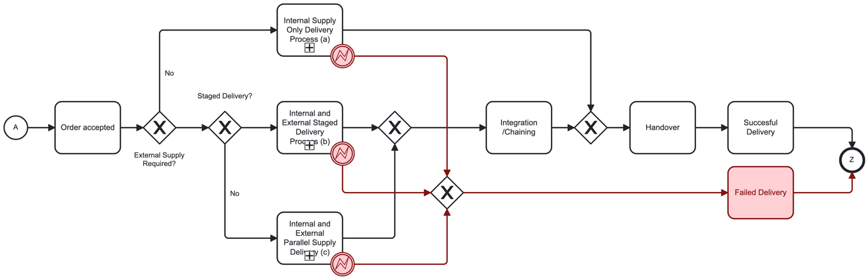
Figure 17 - Delivery options

Figure 18 depicts the process of delivery where no external elements are required and in scenario (a) in Figure 18.
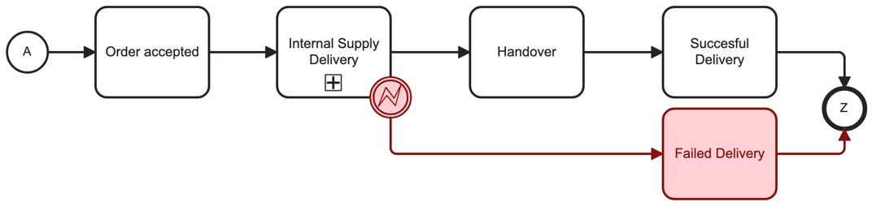
Figure 18 - Internal Delivery

Figure 19 depicts the process of staged/sequential delivery where the internal delivery elements are only delivered if and when all external elements have been delivered as in scenario (b) in Figure 18.
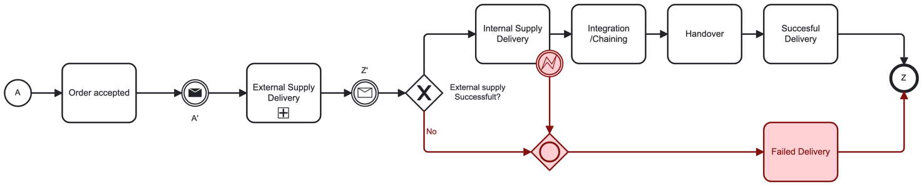
Figure 19 – Staged/Sequential Delivery of External and Internal elements

Figure 21 depicts the process of parallel delivery where the internal supply and external supply are initiated in parallel. There is no requirement that the internal and external processes end simultaneously as in scenario (c) in Figure 18.
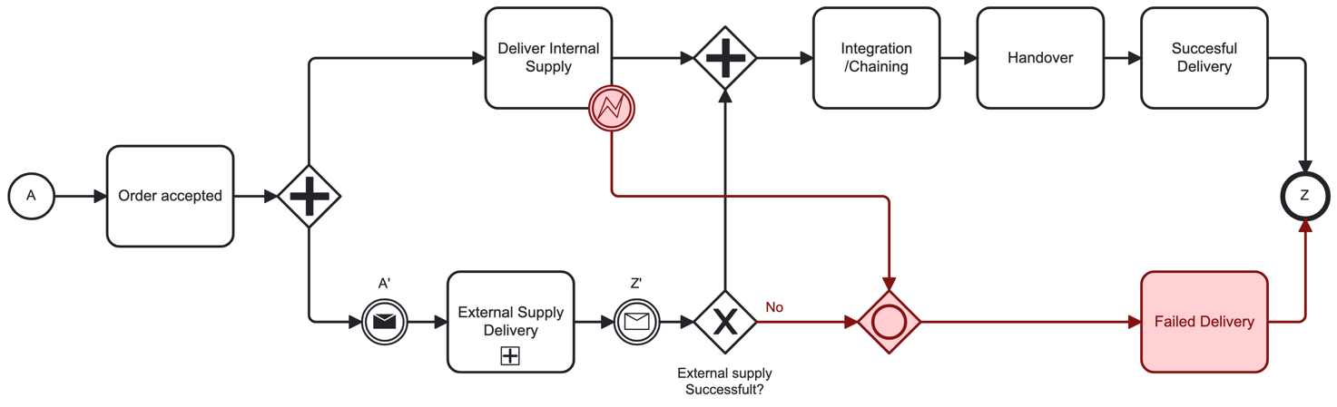
Figure 20 - Service Delivery – Parallel Delivery
Note: The External Supply Delivery depicted in Figure 18, Figure 19 and Figure 20 is a recursion of the internal delivery process described in Figure 17.

5.3.5 Operations and Management

5.3.5.1 Operations and management considerations
The Operations and Management lifecycle phase, sometimes called “SOAM” (standing for Service Operations and Maintenance) covers the following aspects of lifecycle of goods and/or services:
- Monitoring and reporting quality and performance of goods and services.
- Monitoring and reporting usage of measurable services.
- Maintenance and repair of faults of goods and services.

5.3.5.2 Monitoring and reporting quality and performance of goods and service

5.3.5.2.1 Introduction to Monitoring and Reporting
Quality of goods is handled through QA processes by the respective manufacturers resulting in delivery of goods in good working order according to specifications (where such specifications or standards exist). It is beyond the scope of the current document to discuss the specifics of QA processes for goods.
Service quality measurement and reporting in a supply chain environment requires each supply chain partner to measure their respective service quality and utilization and reporting of the results upstream to the buyer. The buyer, on their part, uses the information provided by their suppliers and integrates it with their own reports related to their internal supply, yielding an integrated report that can then be reported further upstream.
The seller is responsible for monitoring performance and utilization of each internally and externally sourced element of service. The parameters to be monitored vary by service type and are subject to agreements between the seller and its buyers. MEF-52 Error! Reference source not found. defines a framework for performance monitoring and reporting of MEF compliant carrier ethernet services delivered through a supply chain.
- When a performance report indicates that there is a breach of SLA an internal ticket SHOULD be opened by the Seller.
- When a performance report indicates that there is a breach of SLA an External ticket MAY be opened by the Buyer.
- A Seller SHALL integrate quality, usage and performance reports from its external suppliers and integrate them and their internal supply report into a unified report that SHALL then be reported to the buyer.
- When no external suppliers are present the seller SHALL report its internal supply quality, usage and performance to the buyer.
- In a PDL based supply chain PDL SHOULD be used to record the quality and performance information captured by a seller and the quality and performance information exchanged between buyers and sellers.
- Smart contracts SHOULD be used to manage the schedule and sequence of SOAM reports.
The methods by which quality and performance are measured and reported vary depending on specific use cases and are beyond the scope of the current document.
- All participants in a supply chain SHALL agree on the methods, data models and frequency of monitoring and reporting quality and performance of services.

5.3.5.2.2 Report Triggers/Generation
Reports may be triggered/generated in one of two ways:
- Scheduled reports that are generated automatically at agreed upon intervals.
- On-request reports that are triggered by any participant in the Supply Chain and apply to that participant and its sellers.

5.3.5.2.3 Scheduled Report Request Propagation
- A seller SHALL generate and propagate performance reports on a pre-defined and agreed-upon schedule/frequency.
- A seller MAY trigger the generation of non-scheduled performance reports.
- A seller SHALL generate and propagate to its sellers (if any) performance reports triggered by its buyer.
Figure 21 depicts the process of monitoring and reporting of quality and performance in a supply chain.
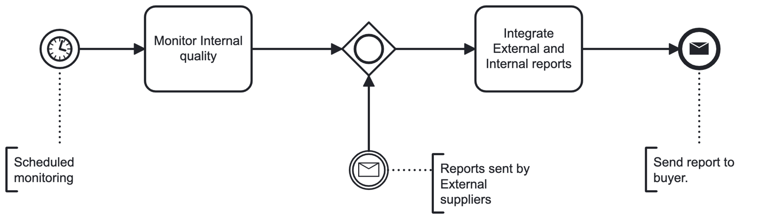
Figure 21 – Scheduled Monitoring and reporting quality and performance of service

5.3.5.2.4 Non-Scheduled Report Request Propagation
Propagation of a request for a non-scheduled performance report:
- Upon receipt of request from a buyer the seller SHALL request an internal report for each and every internally-sourced Service Element.
- Upon receipt of request from a buyer the seller SHALL request an external report from each and every seller providing an externally-sourced Service Element for said service.
Figure 22 depicts the process of non-scheduled reporting. Steps A’-Z’ are recursive and optional hence they only occur in the event that the seller is using an external supplier for the delivery of the service.
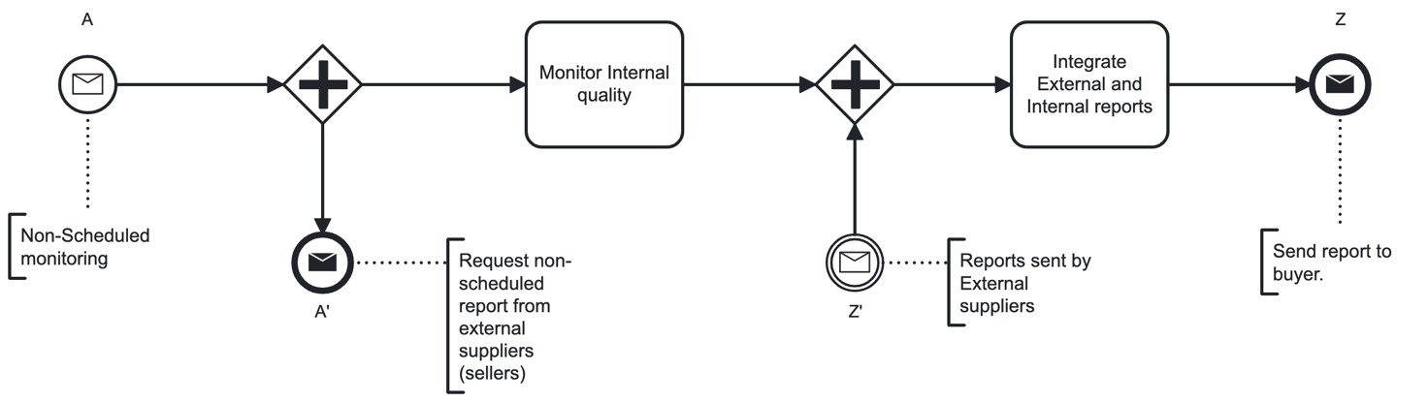
Figure 22 - Non-Scheduled service monitoring and reporting process

5.3.5.2.5 Performance Reporting Process
Collection and aggregation of report data in performance reports varies between scheduled and unscheduled performance reports. The processes are depicted in Figure 21 and Figure 22 above.
There are certain commonalities in both cases as defined below:
- Performance reports from both the seller and buyer SHALL be logged to the Bilateral Ledger.
- The seller SHALL aggregate the performance data for all internally and externally-sourced Service Elements based on chaining sequence and topology, generate a Seller-End performance report and send such report to the buyer.

5.3.5.3 Measuring usage of service (where applicable)
- The requirements listed in this clause 5.3.5.3 SHALL NOT be valid if all buyers and sellers involved in the delivery of such service agree that usage of service is not to be measured or in case usage of service is not measurable.
- Usage SHALL be measured and reported using methods agreed upon by all participants in the supply chain.
- Smart contracts SHOULD be used to ensure conformance of reports with such agreed methods.

Figure 23 depicts the process of measuring usage and reporting of usage in a supply chain.
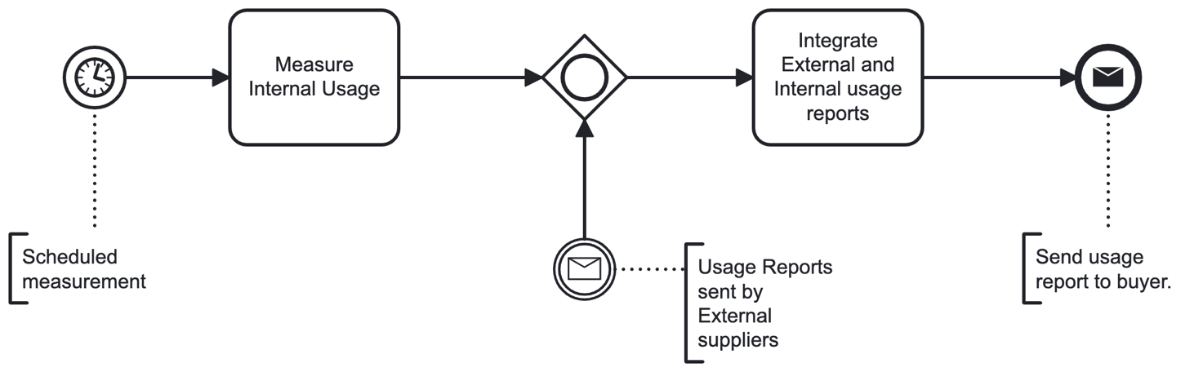
Figure 23 - Measuring usage of service
The methods of measurement of usage vary depending on the use-case and feature/metric being measured and their description is beyond the scope of this document. However, there are certain concepts to consider:
- Certain metrics are uniform across the entire supply chain and thus only need to be measured once (e.g., the bandwidth used in a communication line that flows across multiple supplies is the same end to end and does not need to be measured by all supply chain participants for usage purposes except for one participant. Other supply chain participants may still choose to monitor and record the usage to be able to provide proof in case of a dispute). It is thus recommended but not mandated that all supply chain participants measure and report usage. A discrepancy may indicate a fault, either in the measurement or in the functional operation of the service.

- Certain metrics can only be measured by a subset of the supply chain participants. (e.g., The volume of storage on a device that is part of a supply chain can only be measured by the supply chain partner operating that device).
- Supply chain partners SHALL measure the metrics of elements of the service they deliver internally and report such metrics to the buyer.
- Supply chain partners SHOULD measure the metrics of elements of services they participate in delivery of.
- In the event the metric measured by a supply chain partner deviates from the same metric reported by a downstream partner in a manner that exceeds an agreed upon tolerance, the supply chain partner SHALL report an error in measurement both to the buyer and to the downstream supply chain partner.
- In the event a metric reported by a downstream supply chain partner (seller) is not measurable by the supply chain partner, that supply chain partner SHALL pass the metric as-is to their buyer.
- In a PDL based supply chain PDL SHOULD be used to record the usage details captured by a seller and the usage details exchanged between buyers and sellers.

5.3.5.4 Fault identification and repair

5.3.5.4.1 Decision Tree
- When a monitoring function detects a fault or failure to meet the agreed upon quality criteria it SHALL create a notification and mark the time of the event, the Service Level criteria that has not been met, and the actual values measured.
- When a monitoring function detects that the service has returned to normal Service Level it SHALL create a notification and mark the time of the event, the Service Level criteria that has been met, and the actual values measured. It shall also calculate and record the duration between failure and resumption to normal Service Level.
- All notifications and reports listed in this section 5.3.5 SHOULD be recorded on the bilateral PDL.
- Smart Contracts MAY be used to automate and manage the actions described in this section 5.3.5.
When encountering a fault, the following questions should be addressed:
- Is the fault affecting a live (in-operation) service?
- Following a Root Cause Analysis should the service be restored? Should the Service be abandoned? Should the fault be ignored so that the service continues (perhaps degraded) operation albeit the fault?
- Is the source of the fault internal (caused by an element of service provided by the Seller) or external (caused by a downstream supply chain partner)?
- Will Outage (downtime) be required in order to carry out the repair?
- Are there external, downstream, suppliers to the Seller?
The course of action is determined by the answers to those questions.
Figure 23 shows the decision tree used in order to select the appropriate course of action (defined in Scenarios A through K in the following sections).
A seller may identify a fault through its own monitoring capabilities and may also be informed of a fault through a notification from the buyer or from a downstream participant. When a fault has been identified internally or notified by an external party the Seller performs a Root Cause Analysis where the fault is explored and investigated and until the root cause has been identified.
- The Seller SHALL perform a Root Cause Analysis upon identifying or being notified of a fault.
- Such Root Cause Analysis MAY be done manually or using automated tools.
- Smart Contracts SHOULD be used to facilitate the flow of actions, the logging of information and the exchange of information between the supply chain partners as defined in the scenarios defined in clause 5.3.5.1.3 (Fault identification and repair).
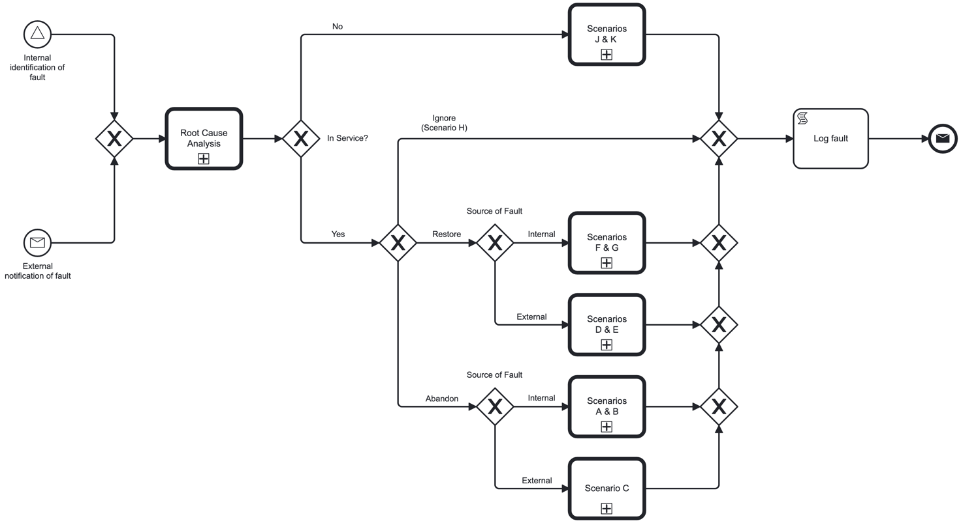
Figure 24 - Fault identification and repair decision tree
The following sections describe the flow of actions for each of the scenarios defined in the decision tree in Figure 23.

5.3.5.4.2 Fault Management Scenarios when abandoning a faulty service that is in operation.
When a decision has been made to abandon a faulty service that is currently in operation, the following actions have to take place at the Seller and on any downstream supply chain partner involved in the delivery of said service.
- The faulty element (if one exists) SHALL be removed from inventory.
- The faulty element MAY be repaired and returned to inventory for future use.
- The service SHALL be terminated with all downstream supply chain partners (if any).
Scenario A is a situation where the source fault is internal to the seller and there are no external suppliers.
Scenario B is a situation where the source of the fault is internal to the seller and there are external, downstream, supply chain partners whose elements of service are not at fault.
Figure 24 describes the flow of actions that are taken for Scenarios A and B.
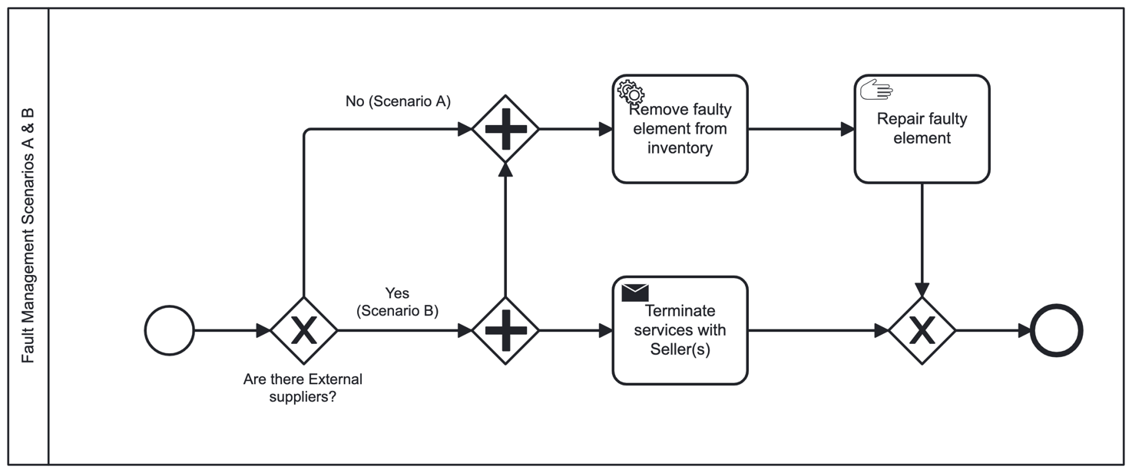
Figure 25 - Fault management scenarios A & B
Scenario C is a situation where the source of the fault is external.
Figure 25 describes the flow of actions that are taken for Scenario C.
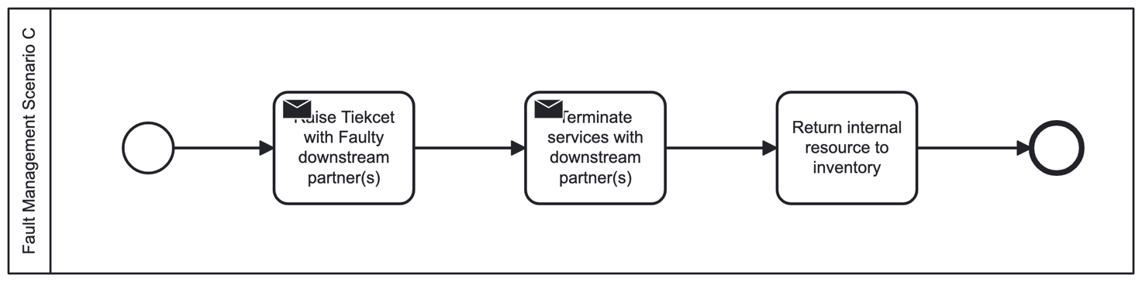
Figure 26 - Fault management scenario C
The commercial implications of terminating a service are subject to agreements between the supply chain partners and are beyond the scope of the current document.

5.3.5.4.3 Fault Management Scenarios when repairing a faulty service that is in operation.
When a decision has been made to repair a faulty service that is currently in operation the following considerations and actions are required at the Seller and on any downstream supply chain partner involved in the delivery of said service:
- The seller SHALL determine if downtime is required in order to repair the fault.
- In the event that the fault is of an element of service supplied by a supply chain partner the seller SHALL open a trouble ticket with that supply chain partner and check with them if downtime is required in order to repair the fault.
- If it is determined that downtime is required, the seller SHALL coordinate a maintenance window with the buyer and communicate such window to the downstream suppliers where necessary or applicable.
- The supply chain partner whose element of service is at fault SHALL repair the fault during the maintenance window and report completion upstream.
Figure 26 describes the flow of actions that are taken for Scenarios D and E.
Scenario D is a situation where the source of the fault is external, and an outage (maintenance window) is required.
Scenario E is a situation where the source of the fault is external, and an outage (maintenance window) is not required.
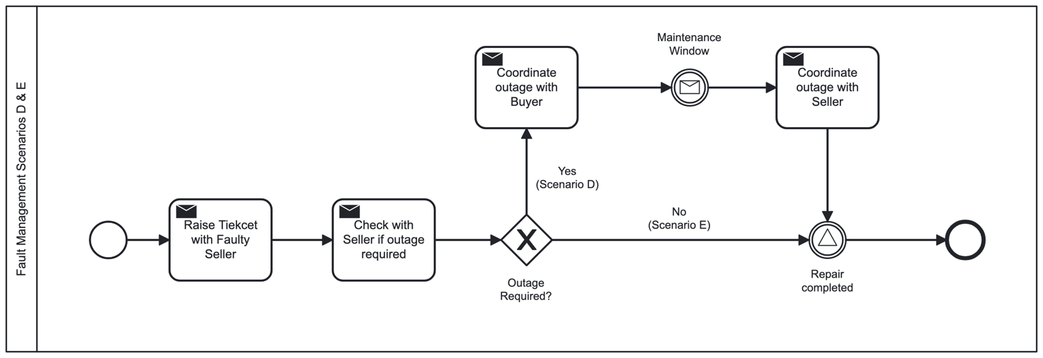
Figure 27 - Fault management scenarios D & E
Figure 27 describes the flow of actions that are taken for Scenarios F and G.
Scenario F is a situation where the source of the fault is internal, and an outage (maintenance window) is required.
Scenario G is a situation where the source of the fault is internal, and an outage (maintenance window) is not required.
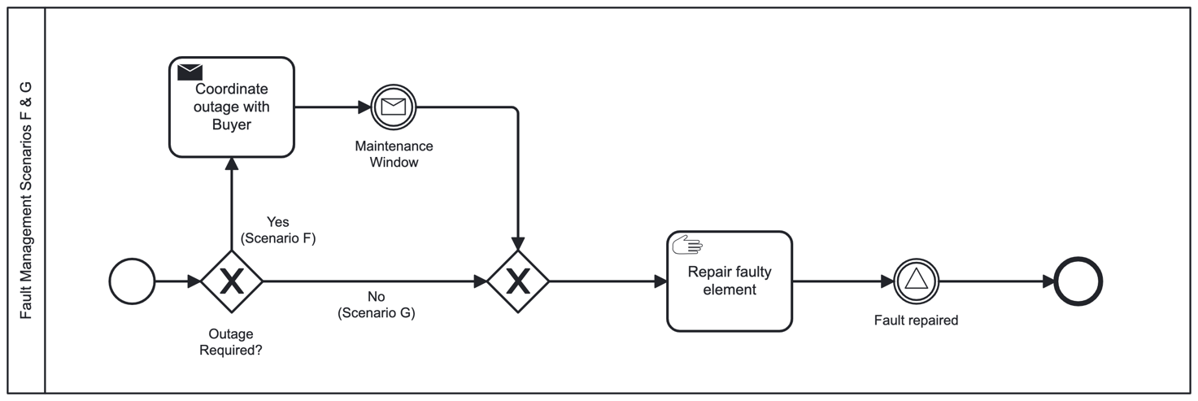
Figure 28 - Fault management scenarios F and G

5.3.5.4.4 Fault Management Scenarios when repairing a faulty service that is not in operation.
When a decision has been made to repair a faulty service that is currently not in operation the following considerations and actions are required at the Seller and on any downstream supply chain partner involved in the delivery of said service:
- The seller SHALL remove the faulty element from inventory.
- If the faulty element is repairable the seller MAY repair the faulty element and return it to inventory for future use.
- If the faulty element was supplied by a downstream supply chain partner the seller SHALL notify said partner of the fault.
- Said supply chain partner SHOULD recourse Scenarios J and K until resolved.

Figure 28 describes the flow of actions that are taken for Scenarios J and K.
Scenario J is a situation where the source of the fault is external, and the service is not in operation.
Scenario K is a situation where the source of the fault is internal, and the service is not in operation.
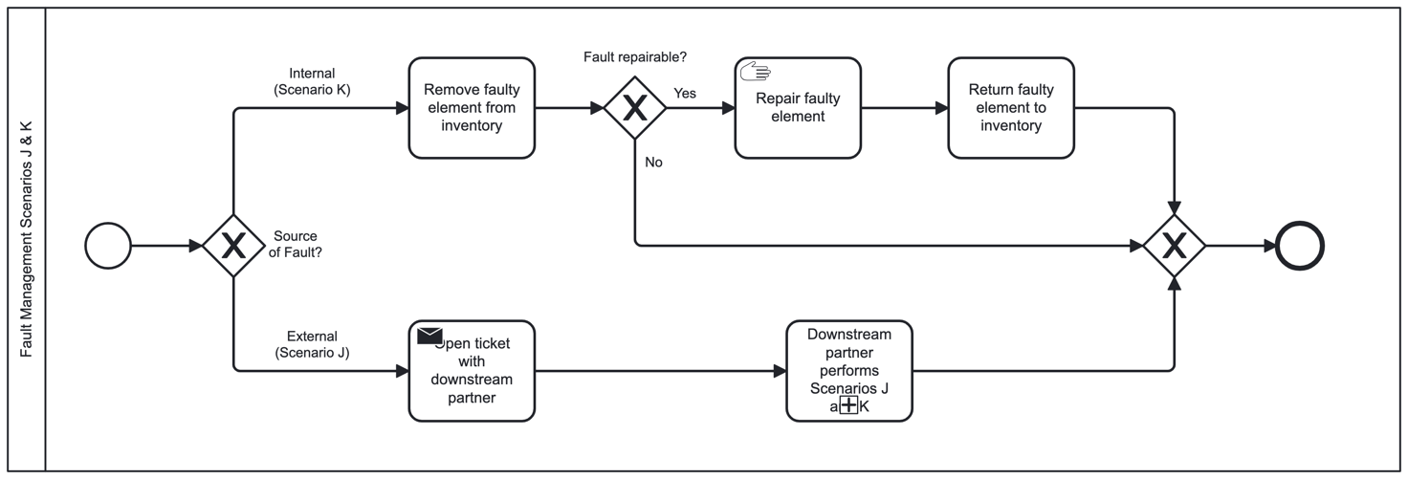
Figure 29 - Fault management scenarios J and K

5.3.5.4.5 Fault management when ignoring the fault.
Scenario H is a situation where the service is in operation, and it had been decided to ignore the fault and continue using the service as-is.
- In such case the respective supply chain participants SHOULD notify each other of their decision to ignore the fault and continue operations.

A decision to ignore the fault does not nullify the SLA performance considerations and the buyer may be eligible to service credits as per agreement.

5.3.5.4.6 Proactive Fault Management
Each Participant SP may proactively handle faults that it has identified.
- The Seller SHOULD be able to proactively identify, and trigger handling of, service faults.
- If the Buyer has not opened a ticket for said fault, the Seller MAY open an internal ticket.

5.3.5.4.7 Reactive Fault Management
Tickets may be opened by the Buyer through a message sent from the Buyer to the Seller.
- Seller MAY open a trouble ticket with one or more of its Sellers in the event of identifying a fault or being notified of a fault by its Buyer.
- A Seller SHOULD take actions to remedy a fault once it is identified.

5.3.5.5 Other Operations and Management activities
Services provided by a seller to a buyer may require additional maintenance and management support activities such as:
- Software activation
- Software upgrades (e.g., new software release. E.g., applying a security patch).
- Hardware upgrades (e.g., adding memory or storage or computational capacity)
- Preventive maintenance (e.g., improvement of ventilation/cooling capacity)
- Other activities not listed in the current document.

Such activities may require downtime of one or more operational services, as well as temporary suspension of certain inventory items temporarily preventing them from being used to establish new services.
- Software and hardware activation, upgrade and maintenance that affects services in operation SHOULD be coordinated with the buyer of such services and be performed during a maintenance window agreed between the buyer and seller.
- In the event of an emergency operation where the seller has not been able to coordinate a maintenance window with the buyer, the seller MAY perform such maintenance and notify the buyer after the act.
- The downtime related to maintenance windows (coordinated in advance and emergency) SHALL be subject to an SLA signed between the buyer and the seller.
- An SLA MAY consider planned maintenance differently than it considers emergency maintenance and may state different penalties and/or credits, if any, for different scenarios.
- When inventory items and resources become temporarily unavailable for use they SHALL be removed from list of available items/resources until such time that they become available.

5.3.6 Settlement

5.3.6.1 Once-off settlement
Certain goods and services are procured as a once-off transaction where the buyer pays for the good or services and is not required to make any further payments. An example would be buying a theatre ticket or a snack.
Such settlement is typically handled in advance where the goods or services are being paid prior to provisioning of the goods or services.
However – there are scenarios where the final bill is only known after the goods or services are delivered. In such cases the settlement will occur in arears. An example is a periodical service to a vehicle where the final bill depends on the number of items replaced/maintained and the number of hours of work spent.

5.3.6.2 Periodical settlement
Certain goods and services involve a periodical settlement. Those are typically:
- Scenarios where goods are consumed and need to be replenished periodically (e.g., a water filter in an espresso machine may need to be replaced every 6 months, thus the seller will ship a new filter ahead of the replacement due date and will charge the buyer for that filter using an agreed upon payment method).
- A service is in use for prolonged durations and is paid for on a periodical basis (e.g., a 36 month term mobile phone service billed monthly where the bill includes certain fixed elements and certain usage-based elements).
- Threshold based settlement where a transaction occurs once a certain threshold had been reached (e.g., a debit card is topped-up once the remaining funds drop below a certain amount).

5.3.6.3 Usage-based settlement
Settlement of certain services may be based on level of usage of such services. E.g., A telephone bill where the amount to be settled is based on the number of calls made, their duration and destinations.
- For usage-based services to be implemented at least one party (buyer, seller or a designated third party) SHALL measure the usage of such service.
- Usage records SHOULD be logged onto the bilateral ledger by any party performing such measurements.
- When more than one party measures usage the parties SHALL agree on the process of resolving differences in measurements if such differences exist.

5.3.6.4 Payment process
Seller sends an invoice to the buyer and, unless disputed by the buyer, the parties settle through an agreed upon payment method on an agreed upon schedule. E.g., the parties may agree on a 30-day payment terms where the buyer has to pay an undisputed invoice within 30 days of its issuance by the seller.
- The seller SHALL invoice the buyer in accordance with an agreement signed between the buyer and the seller.
- When the buyer disputes the invoice both parties SHOULD negotiate the dispute and arrive at a conclusion.
- The buyer SHALL pay an undisputed invoice according to an agreed upon schedule in accordance with the terms stipulated in the agreement.
- The agreement, invoice and payment MAY take any agreed upon form and format, including digital format, smart contracts, digital currency transfers as well as paper based and traditional banking processes.
- The form of payment SHALL be agreed upon by both parties in the contract.
- All transactions SHOULD be logged in the bilateral ledger.
Dispute resolution is beyond the scope of the current document.
The use of cryptographic currency for settlement is beyond the scope of the current document.
- The agreement between the parties SHOULD include clauses defining the required actions in the event of a dispute.

Annex (informative):
Bibliography

Annex (informative):
Change History
Date | Version | Information about changes
<Month year> | <#> | <Changes made are listed in this cell>

History
Document history
<Version> | <Date> | <Milestone>

Latest changes made on 2022-03-14

