Disclaimer
The present document has been produced and approved by the Permissioned Distributed Ledger (PDL) ETSI Industry Specification Group (ISG) and represents the views of those members who participated in this ISG.
It does not necessarily represent the views of the entire ETSI membership.
ETSI GR ISG-PDL 008 V0.0.6 (2021-06)

Group REPORT
Permissioned Distributed Ledger (PDL);
Research and Innovation Landscape
<

Reference
DGR/PDL-008_RaI_Landscape
Keywords
blockchain, ledger, PDL, survey

ETSI
650 Route des Lucioles
F-06921 Sophia Antipolis Cedex - FRANCE

Tel.: +33 4 92 94 42 00 Fax: +33 4 93 65 47 16

Siret N° 348 623 562 00017 - NAF 742 C
Association à but non lucratif enregistrée à la
Sous-préfecture de Grasse (06) N° 7803/88

Important notice
The present document can be downloaded from:
http://www.etsi.org/standards-search
The present document may be made available in electronic versions and/or in print. The content of any electronic and/or print versions of the present document shall not be modified without the prior written authorization of ETSI. In case of any existing or perceived difference in contents between such versions and/or in print, the prevailing version of an ETSI deliverable is the one made publicly available in PDF format at www.etsi.org/deliver.
Users of the present document should be aware that the document may be subject to revision or change of status. Information on the current status of this and other ETSI documents is available at https://portal.etsi.org/TB/ETSIDeliverableStatus.aspx
If you find errors in the present document, please send your comment to one of the following services:
https://portal.etsi.org/People/CommiteeSupportStaff.aspx
Copyright Notification
No part may be reproduced or utilized in any form or by any means, electronic or mechanical, including photocopying and microfilm except as authorized by written permission of ETSI.
The content of the PDF version shall not be modified without the written authorization of ETSI.
The copyright and the foregoing restriction extend to reproduction in all media.

© ETSI 2021.
All rights reserved.
DECTTM, PLUGTESTSTM, UMTSTM and the ETSI logo are trademarks of ETSI registered for the benefit of its Members.
3GPPTM and LTETM are trademarks of ETSI registered for the benefit of its Members and
of the 3GPP Organizational Partners.
oneM2M™ logo is a trademark of ETSI registered for the benefit of its Members and
of the oneM2M Partners.
GSM® and the GSM logo are trademarks registered and owned by the GSM Association.

Contents
Intellectual Property Rights 4
Foreword 4
Modal verbs terminology 4
Executive summary 4
Introduction 4
1 Scope 6
2 References 6
2.1 Normative references 6
2.2 Informative references 6
3 Definition of terms, symbols and abbreviations 7
3.1 Terms 7
3.2 Symbols 8
3.3 Abbreviations 8
4 PDL Research and Innovation Landscape 9
4.1 Introduction 9
4.2 Related Documents and Information Sources 9
5 European Research Programmes and EU Standardization 9
5.1 Research 9
5.1.1 Horizon 2020 9
5.1.2 Horizon Europe 10
5.1.3 Other Research Funding Programmes 11
5.2 Standardization 12
5.2.1 European ICT Standardization 12
5.2.2 Blockchain Standardization 12
5.2.3 EC Rolling Plan 2021 for ICT Standardisation 12
6 PDL related Research and Innovation Activities 13
6.1 Introduction 13
6.2 Horizon 2020 Projects related to DLT and Blockchain 13
6.3 Research and Innovation Programmes related to PDL 14
6.3.1 Scope 14
6.3.2 Research Programmes: EU 14
6.3.3 Research Programmes: Germany 17
6.3.4 Research Programmes: United Kingdom 18
6.3.5 Research Programmes: United States of America 19
6.3.6 Research Programmes: Spain 19
7 Importance of PDL Standardization 19
Annex A: List of EU Horizon 2020 Projects related to DLT and Blockchain 21
Annex B: Overview Horizon 2020 Research Topics 52
B.1 Horizon 2020 Research Topics 52
Annex C: Overview International Research Programmes and Topics 57
C.1 Research Programmes US 57
Annex : Change History 61
History 62

Intellectual Property Rights
Essential patents
IPRs essential or potentially essential to normative deliverables may have been declared to ETSI. The information pertaining to these essential IPRs, if any, is publicly available for ETSI members and non-members, and can be found in ETSI SR 000 314: "Intellectual Property Rights (IPRs); Essential, or potentially Essential, IPRs notified to ETSI in respect of ETSI standards", which is available from the ETSI Secretariat. Latest updates are available on the ETSI Web server (https://ipr.etsi.org).
Pursuant to the ETSI IPR Policy, no investigation, including IPR searches, has been carried out by ETSI. No guarantee can be given as to the existence of other IPRs not referenced in ETSI SR 000 314 (or the updates on the ETSI Web server) which are, or may be, or may become, essential to the present document.
Trademarks
The present document may include trademarks and/or tradenames which are asserted and/or registered by their owners. ETSI claims no ownership of these except for any which are indicated as being the property of ETSI, and conveys no right to use or reproduce any trademark and/or tradename. Mention of those trademarks in the present document does not constitute an endorsement by ETSI of products, services or organizations associated with those trademarks.

Foreword
This Group Report (GR) has been produced by ETSI Industry Specification Group Permissioned Distributed Ledger (PDL).

Modal verbs terminology
In the present document "should", "should not", "may", "need not", "will", "will not", "can" and "cannot" are to be interpreted as described in clause 3.2 of the ETSI Drafting Rules (Verbal forms for the expression of provisions). The words "must" and "must not" are NOT allowed in ETSI deliverables except when used in direct citation.

Executive summary
This Group Report gives an overview of relevant research and standardisation projects in the field of permissioned distributed ledgers and Blockchain, in particular identifying projects from the EU's Horizon 2020 programme, the US' National Science Foundation's programme, national programmes in the UK and Germany, in addition to worldwide standardization activities in this field.

Introduction
Clause 4 introduces research and innovation programmes relevant to permissioned distributed ledgers, in particular the European Union's Framework Programme Horizon 2020 and its primary information repository, the Community Research and Development Information Service (CORDIS). Clause 5.1 gives a general overview of the EU's Horizon 2020 Framework Programme, its successor Horizon Europe and the Connecting Europe Facility (CEF), while Clause 5.2 focuses on the legal framework for standardization and an overview of blockchain-related standardization activities.
Clause 6 provides an overview of public research and innovation programmes and grants related to PDL, covering the EU in more detail, and in addition national programmes in Germany, the UK and the US. Clause 7 emphasizes the importance of PDL standardization. Annex A identifies in detail those EU Horizon 2020 projects that are related to DLT and Blockchain, sorted by project name, while Annex B identifies for those same projects the related Horizon 2020 research topics and thematic priorities. Finally, Annex C lists US National Science Foundation (NSF) projects related to DLT and Blockchain.

1 Scope
This document shows the current research and innovation programmes related to permissioned distributed ledgers, distributed digital ledger technologies and blockchain with the goal of identifying advanced technologies and innovative research results relevant or essential to PDL standardization.

2 References

2.1 Normative references
Normative references are not applicable in the present document.

2.2 Informative references
References are either specific (identified by date of publication and/or edition number or version number) or non-specific. For specific references, only the cited version applies. For non-specific references, the latest version of the referenced document (including any amendments) applies.
NOTE: While any hyperlinks included in this clause were valid at the time of publication, ETSI cannot guarantee their long term validity.
The following referenced documents are not necessary for the application of the present document but they assist the user with regard to a particular subject area.
[i.1] ETSI GR PDL001 V1.1.1/(2020-03): "Permissioned Distributed Ledger (PDL); Landscape of Standards and Technologies".
NOTE: Available at https://www.etsi.org/deliver/etsi_gr/PDL/001_099/001/01.01.01_60/gr_PDL001v010101p.pdf
[i.2] European Commission CORDIS: "CORDIS: Projects and Results".
NOTE: Available at https://cordis.europa.eu/projects/en
[i.3] European Commission, DG for Communication Networks, Content and Technology Call for tenders /(25-11-2020): “(European Commission Call for tenders CNECT/2020/OP/0055),EU Blockchain Pre-commercial Procurement, Open procedure, Tender Specifications”.
NOTE: Available at https://etendering.ted.europa.eu/cft/cft-document.html?docId=81917; https://etendering.ted.europa.eu/document/document-file-download.html?docFileId=95923
[i.4] ETSI Annual Report 2019, published in 2020
NOTE: Available at https://www.etsi.org/e-brochure/Annual-Reports/AR-202012/mobile/index.html
[i.5] EC Rolling Plan for ICT Standardization, Published April 2021
NOTE: Available at https://joinup.ec.europa.eu/collection/rolling-plan-ict-standardisation/rolling-plan-2021 , the Rolling Plan addresses technology areas in need of ICT standards and explores the role that standards and technical specifications can play in achieving the policy objectives. It reaches out to both European Standardisation Organisations (ESOs) -ETSI, CEN and CENELEC and aforementioned global standard development bodies that can respond to the proposed actions and support the respective policy objectives with standardisation deliverables.
[i.6] European Commission Horizon 2020 Work Programme /(2020-06-17): "EN Horizon 2020 Work Programme 2018-2020, 5.i. Information and Communication Technologies".
NOTE: Available at https://ec.europa.eu/research/participants/data/ref/h2020/wp/2018-2020/main/h2020-wp1820-leit-ict_en.pdf
[i.7] European Commission European Research Council 2021 Work Programme /(2021-02-22): “(European Commission Decision C(2021) 930 of 22/02/2021), ERC Work Programme 2021, European Research Council”.
NOTE: Available at https://ec.europa.eu/info/funding-tenders/opportunities/docs/2021-2027/horizon/wp-call/2021/wp_horizon-erc-2021_en.pdf
[i.8] Federal Ministry for Economic Affairs and Energy, Federal Ministry of Finance/(2019-09-18): "Blockchain Strategy of the Federal Government, We Set Out the Course for the Token Economy".
NOTE: Available at https://www.bmwi.de/Redaktion/EN/Publikationen/Digitale-Welt/blockchain-strategy.pdf
[i.9] T. Faisal et el., "Automated Quality of Service Monitoring for 5G and Beyond Using Distributed Ledgers", IWQoS 2021
[i.10] T. Faisal et el., "How to Request Network Resources Just-in-Time using Smart Contracts", ICBC 2021
[i.11] T. Faisal et el., "AJIT: Accountable Just-in-Time Network Resource Allocation with Smart Contracts", MobiArch 2020
[i.12] T. Maksymyuk, M. Volosin, G. Bugar, D. Horvath, J. Gazda, M. Klymash and Mischa Dohler, “Blockchain-Based Comprehensive Network Management in 5G and Beyond,” IEEE Communications Magazine, accepted 23 August 2020.
[i.13] C. Ngubo, Mischa Dohler, “WiFi Dependent Consensus Mechanism For Constrained Devices using Blockchain Technology,” IEEE Access (Journal), accepted 24 July 2020.
[i.14] R. Pirmagomedov, et al, and Mischa Dohler, “Applying Blockchain Technology for Users Incentivization in mmWave-based Mesh Networks,” IEEE Access (Journal), accepted 17 Feb 2020.
[i.15] See https://www.sofie-iot.eu/news/setting-standards-for-the-future
[i.16] See https://www.5gzorro.eu/our-objectives/

3 Definition of terms, symbols and abbreviations

3.1 Terms
Void.

3.2 Symbols
Void.

3.3 Abbreviations
For the purposes of the present document, the following abbreviations apply:
AI Artificial Intelligence
BBI-CSA Bio-Based Industries - Coordination and Support Action
BDLT Blockchain and DLT
BDTI Big Data Test Infrastructure
BMBF German Federal Ministry of Education and Research (Bundesministerium für Bildung und Forschung)
BMWi German Federal Ministry for Economic Affairs and Energy (Bundesministerium für Wirtschaft und Energie)
CCF Connecting Capability Fund
CEF Connecting Europe Facility
CEN European Committee for Standardization (Comité Européen de Normalisation)
CENELEC European Committee for Electrotechnical Standardization (Comité Européen de Normalisation Électrotechnique)
CORDIS Community Research and Development Information Service
CSA Coordination and Support Action
CSA-LS Coordination and Support Action Lump Sum
DG CNECT Directorate-General for Communications Networks, Content and Technology
DLT Distributed Ledger Technology
EBSI European Blockchain Services Infrastructure
EC European Commission
ECSEL-RIA ECSEL Research and Innovation Action
eIDAS Electronic IDentification, Authentication and trust Services
EIC European Innovation Council
EIT European Institute of Innovation and Technology
ERA European Research Area
ERC European Research Council
ETSI European Telecommunications Standards Institute
EU European Union
EPSRC Engineering and Physical Sciences Research Council
GDPR General Data Protection Regulation
H2020 Horizon 2020
HEIF Higher Education Innovation Fund
HEP Higher Education Providers
IA Innovation Action
ICN Information-Centric Networking
I-Corps Innovation Corps
ICT Information and Communication Technologies
IMI2-RIA Innovative Medicines Initiative 2 - Research and Innovation Action
INEA (European Commission's) Innovation and Networks Executive Agency
INNOSUPSME Innovation Support for SME
IoT Internet of Things
IP Intellectual Property
ITA Innovations and Technologies Analysis
MSCA Marie Skłodowska-Curie Actions
NeTS Networking Technology and Systems
NGI Next Generation Internet
NIS Network and Information Systems
NSF National Science Foundation
PCP Pre-Commercial Procurement
PDL Permissioned Distributed Ledger
RIA Research and Innovation Action
SaTC Secure and Trustworthy Cyberspace
SBIR Small Business Innovation Research
SESAR-RIA Single European Sky ATM Research - Research and Innovation Action
SGA-CSA Specific Grant Agreement - Coordination and Support Action
SME Small- and Medium-sized Enterprise
SME-1 Small- and Medium-sized Enterprise Instrument Phase 2
SME-2 Small- and Medium-sized Enterprise Instrument Phase 2
SME-2b Small- and Medium-sized Enterprise Instrument (grant only and blended finance)
STTR Small Business Technology Transfer
UK United Kingdom
US United States

4 PDL Research and Innovation Landscape

4.1 Introduction
This document discusses the current research and innovation programmes related to permissioned distributed ledgers, distributed digital ledger technologies and blockchain with the goal of identifying advanced technologies and innovative research results relevant or essential to PDL standardization. Without limitation to other research and innovation initiatives, this document focuses on PDL research and innovation activities funded under the European Union’s Research and Innovation Framework Programme Horizon 2020.

4.2 Related Documents and Information Sources
This document relates to the Permissioned Distributed Ledger (PDL) Landscape of Standards and Technologies Annex B: List of EU funded Horizon 2020 Research and Innovation Projects on Blockchain and/or Distributed Ledger ([i.1] pages 18-25).
For the identification of Horizon 2020 Research Projects related to blockchain and DLT the Community Research and Development Information Service (CORDIS) [i.2] has been used. CORDIS serves as the European Commission’s primary source of information on results from projects funded under the European Research Framework Programmes. CORDIS itself is governed and funded as part of the EU Horizon 2020 research framework programme.
The CORDIS public repository with Horizon 2020 project information held by the European Commission provides search functionalities that have been used to identify projects that have blockchain or distributed ledger technologies in any of their objectives, work program, deliverables, results or publications mentioned.

5 European Research Programmes and EU Standardization

5.1 Research
In Europe, research and innovation has a high priority. The EU provides funding for research projects in Europe within the EU-Framework Programmes for Research. These Programmes have been established since 1984 with the overall objective to strengthen the competitiveness and growth of the European market.

5.1.1 Horizon 2020
Horizon 2020 is the 8th EU Framework Programme for Research and Innovation. Reflecting on the growing importance of innovation from previous EU Framework Programmes for Research the Horizon 2020 Framework Programme has a strong focus on Innovation. In particular Horizon 2020 has implemented instruments for scaling-up the ICT innovation ecosystem in Europe. Support for ICT innovation plays a central role in Horizon 2020 together with the creation of better framework conditions for innovation in Europe through ICT standardization. The ICT innovation strategy is to ensure that the rapidly changing ICT technology directly transforms into substantial benefits for European citizens and society.
Horizon 2020 is funding research projects covering the whole innovation chain from foundational research towards the preparation of market-ready products. With a total budget of about 80 billion euros over a runtime of seven years, i.e. from 2014 to 2020, Horizon 2020 has been one of the largest research and innovation funding programmes worldwide.
- Horizon 2020 is structured into the three research and innovation programme priorities:Excellent Science;
- Leadership in Enabling and Industrial Technologies;
- Societal Challenges.
An overview of the overall EU Horizon 2020 signed grants over the period from 2014 to 2020 is provided in Figure 5.1, whereby the information was retrieved from the EU Horizon Dashboard website https://webgate.ec.europa.eu
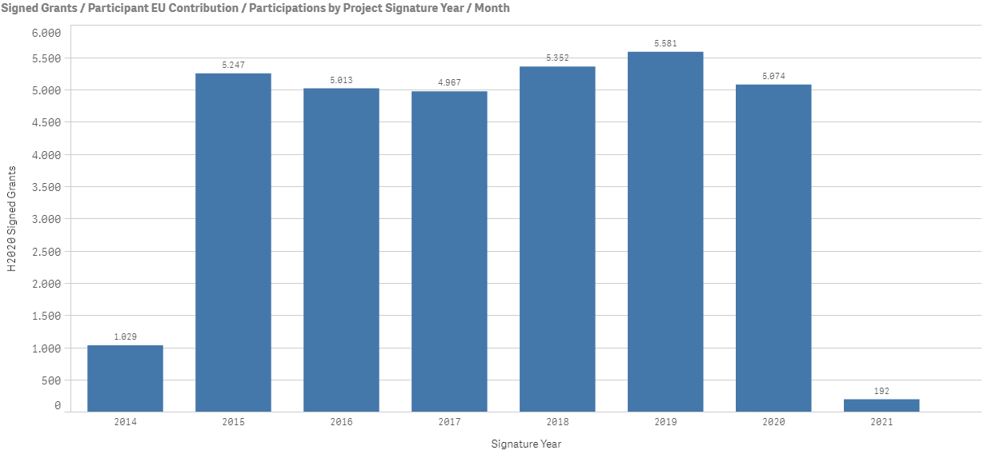
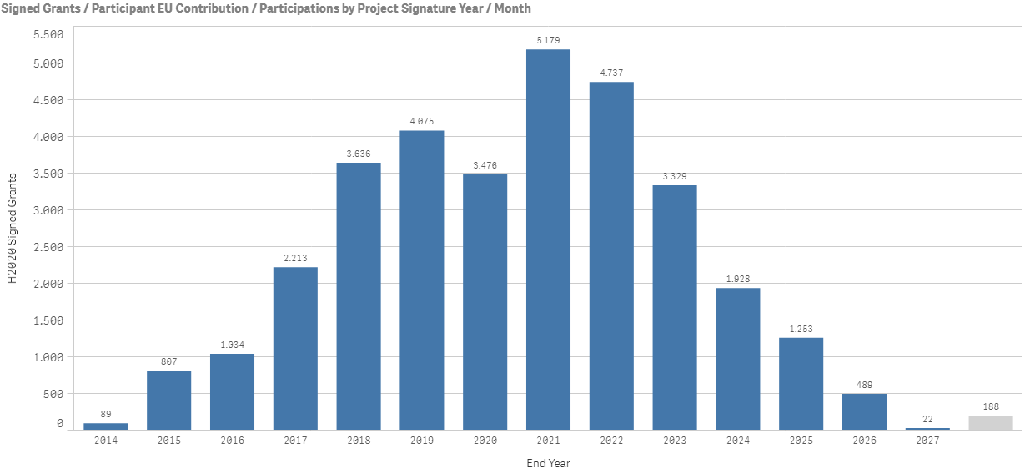
Figure 5.1: Overview on EU Horizon 2020 signed grants by signature year and end year

5.1.2 Horizon Europe
Horizon Europe is the successor of Horizon 2020 and will be the largest EU Research and Innovation Framework Programme following up on the implementation and maintenance of well-established programmes from Horizon 2020 with a budget of around 95.5 billion euro over a runtime of seven years from 2021 until 2027.
Horizon Europe is set out to strengthen research and innovation in Europe further and to drive the digital transformation for supporting the creation of innovative services and new markets and to provide more targeted solutions to global and societal challenges. Horizon Europe has the objective to create impact more effectively through a clear mission orientation and a strategy towards active engagement and involvement of society and citizens as well as stronger dissemination and exploitation of research and innovation results. With an exclusive focus on civil applications the specific programme implementing Horizon Europe is structured into the three priority areas:
- Excellent Science;
- Global Challenges and European Industrial Competitiveness; and
- Innovative Europe.
The ‘Excellent Science’ work programme comprises ‘European Research Council’ (ERC), ‘Marie Skodowska-Curie’ and ‘Research Infrastructures’ actions set up to strengthen excellent European science and technology through more investments into individual and highly skilled researchers and leading-edge innovations.
The ‘Global Challenges & European Industrial Competitiveness’ work programme is set-up to advance the industrial competiveness and innovation capacities of the EU. It encompasses funding of research activities through clusters relating to global challenges (i.e. ‘Health’; ‘Culture, Creativity and Inclusive Society’; ‘Civil Security for Society’; ‘Digital Industry and Space’, ‘Climate, Energy and Mobility’; ‘Food, Bio economy, Natural Resources, Agriculture and Environment’) and also includes support activities by the ‘Joint Research Centre’ for policies
The ‘Innovative Europe’ work programme is grouped into ‘European Innovation Council’ (EIC), ‘European Innovation Ecosystems’ and ‘European Institute of Innovation and Technology’ (EIT) activities. The Horizon Europe Research and Innovation Programme is based on the Widening Participation and Strengthening the European Research Area (ERA)
In order to provide solutions to major societal challenges, research and innovation missions will be an integral part of the Horizon Europe Framework Programme. Missions and related actions will be launched under Horizon Europe in the five areas: ‘Adaptation to climate change including societal transformation’; ‘Cancer’; ‘Climate-neutral and smart cities’; ‘Healthy oceans, seas, coastal and inland waters’; ‘Soil health and food’. The missions will be implemented through a range of dedicated actions from research projects, policy measures towards legislative initiatives thus complementing the scope and effectiveness of individual actions and contributing to the Sustainable Development Goals, to the goals of the European Green Deal and the Beating Cancer Plan.

5.1.3 Other Research Funding Programmes
The Connecting Europe Facility (CEF) run by the European Commission’s Innovation and Networks Executive Agency (INEA) is a fund for European infrastructure investments in transport, energy as well as digital projects leveraging not only intra- but also cross-border connectivity within and between the EU member states. CEF funding and grants are organised through calls for proposals are particularly set out to support the adoption of the CEF Building Blocks.
CEF Building Blocks are most commonly needed digital services based on European legislation and standards helping to implement the development and adoption of the required digital infrastructures in a more efficient way by using existing technologies and synergies. The European Commission's Directorate-General for Communications Networks, Content and Technology (DG CNECT) is responsible for managing the Digital Agenda and is defining the CEF Building Blocks. Among the currently available CEF Building Blocks including eID, eDelivery, eInvoicing, eSignature, Context Broker, eArchiving, eTranslation and the Big Data Test Infrastructure (BDTI), in the context of DLT related Research and Innovation programmes the CEF Building Block European Blockchain Services Infrastructure (EBSI) needs to be highlighted. The goal of the CEF EBSI also described in [i.1] is to provide cross-border pan-European public services using blockchain technology with the highest standards of security and privacy.
In November 2020, the EC launched a call for tenders on EU Blockchain pre-commercial procurement (PCP) [i.3] for novel, innovative distributed ledger or blockchain solutions helping to establish the future European Blockchain Services Infrastructure for the European Citizens in compliance with the EU legal framework (i.e. GDPR, eIDAS and NIS Directive). In particular the PCP call is set out to support a number of new types of use cases with high-volume and high-velocity requirements improving interoperability, security, robustness and sustainability of EBSI. The European Blockchain PCP will award Research and Development service contracts to a number of blockchain solution providers for the development of innovative solutions covering all phases from design, prototyping towards installation and testing. Among others these solutions should provide for identification and traceability of objects, and the management of their data, automation of tasks through smart contracts, also relevant interfaces for the exchange and interoperability with external solutions e.g. IoT and AI , improving scalability and providing security levels addressing new cyber threats, addressing potential use cases like digital product passport within the circular economy, tracking of digital records and associated rights or other IoT use cases. Through the European Blockchain PCP call for tender around 7 contractors, which may include consortia, will be funded progressively in three different phases of 3, 6 and 12 months. The first phase launched in April/May 2021.

5.2 Standardization

5.2.1 European ICT Standardization
There are a number of ongoing individual as well as joint efforts and programs to bring innovative solutions and research results related to distributed ledger technologies and blockchain into standardization activities of the major and relevant standardization organizations. The following sections highlight a few research and standardization support and coordination activities bringing together the relevant research and standardization communities.
A description of the related SDOs and their scope of work can be found in ETSI GR PDL001 Landscape of Standards and Technologies [i.1].
The European Union Regulation (1025/2012), adopted by the European Parliament and by the Council of the EU, established the current legal framework for standardization. It entered into force on 1 January 2013. The three European Standardization Organizations, CEN, CENELEC and ETSI are officially recognized as the competent authorities in the area of voluntary technical standardization, including ICT.
The ISG PDL document [i.1] provides some overview of various standardization activites. Regarding all activities in ETSI, the annual report [i.4] covers past results to end of 2019 and the ETSI work programme 2020-21 gives an overview of ongoing an upcoming activities.

5.2.2 Blockchain Standardization
Within ETSI, the key group for distributed ledger technology is ISG PDL (source of this document).
Within CEN/CENELEC, the key group is CEN/CLC/JTC 19 for Blockchain and Distributed Ledger Technologies.
There are several activities of the EC to monitor and promote distributed ledger standardization, for example:
- EU Blockchain Observatory and Forum https://www.eublockchainforum.eu
- European Blockchain Partnership https://digital-strategy.ec.europa.eu/en/policies/blockchain-partnership
- EC Roundtable ICT Vertical and Horizontal Projects for Blockchain Standardization
- StandICT.eu EU Observatory for ICT Standardisation (EUOS), TWG BLOCK https://www.standict.eu/discussion-groups/twg-block-blockchain/302

5.2.3 EC Rolling Plan 2021 for ICT Standardisation
Standardisation is a means, not an end. In particular, standards are an essential component of European policies for the digital transformation. The EC publishes annually, in collaboration with stakeholders and standardisation bodies, a "Rolling Plan" review of standards areas which are relevant to current policies and that identifies where possible gaps where further work would be advisable [i.5]. In particular, the Rolling Plan 2021 contains a special five-page section "BLOCKCHAIN AND DISTRIBUTED LEDGER TECHNOLOGIES" which concludes with a list of eight requested actions.
Particularly relevant for the ISG PDL work are Actions 5 and 6:
- ACTION 5: Standardisation of the operation and reference implementation of permissioned distributed ledgers and distributed applications, with the purpose of creating an open ecosystem of industrial interoperable solutions
- ACTION 6: Standards Development Organisations active in blockchain/DLT standardisation to liaise and coordinate to take advantage of synergies and maximise resources, including with relevant public and private partnerships
Additionally, the following points are clearly within the scope of ISG PDL:
- ACTION 1: The standardisation community should continue analysing possible standardisation gaps and reflect on best way to fill them. [...]
- ACTION 3: Continue identifying use cases which are relevant for EU (including EU regulatory requirements like from GDPR, ePrivacy, eIDAS, TOOP, etc) and submit them to relevant standardisation bodies, including CEN-CENE- LEC and ETSI, and also ISO, ITU
- ACTION 7: A general framework for Governance of the European networks based on DLT should be developed to allow the flow of smart contracts between different networks.
- ACTION 8: ESOs to develop the standards needed for the introduction of a programmable Euro (CBDC) and token economy (upcoming MiCA Regulation), in particular to ensure interoperability with smart-contracts, legacy systems, etc.

6 PDL related Research and Innovation Activities

6.1 Introduction
In this section an overview of public research and innovation programmes and grants related to BDLT/PDL research topics and related thematic priorities and challenges is provided. Starting from an European level with the Horizon 2020 Research Programme and the Horizon 2020 Work Programme 2018-2020, Information and Communication Technologies [i.6], is analysed with respect to research topics and programme objectives related to PDL application domains.
The focus of the following sections is then on selected national research and innovation funding programmes and projects related to BDLT/PDL; in particular there is an overview on recent as well as upcoming BDLT related public national research programmes and investments in the US; UK, Germany, and Spain.
Readers should be aware that no overview remains current very long and this section can only provide a partial insight.

6.2 Horizon 2020 Projects related to DLT and Blockchain
A comprehensive list of EU Horizon 2020 Projects related to DLT and blockchain can be found in the ANNEX A, Table A.1 of this document. The information on the projects in this table has been retrieved from the CORDIS data base. The majority of the projects is funded under the Research and Innovation Action (RIA) schemes, followed by the Small- and Medium-sized Enterprise (SME) instrument funding schemes, then by the Innovation Action (IA) schemes and finally the Coordination and Support Action (CSA) funding schemes. This is illustrated in Figure 6.1 below, where the left figure shows the distribution of all the projects listed in ANNEX A, Table A.1 and the right figure shows DLT related grants under the MSCA and ERC funding scheme.
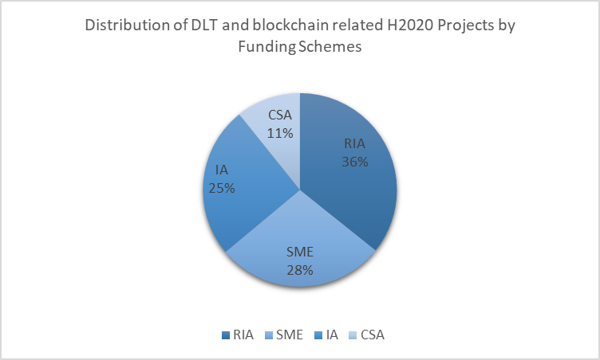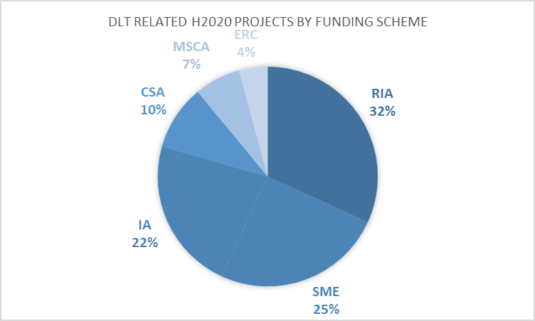

Figure 6.1: BDLT related projects by funding scheme
The PDL Application Domain or Field of Research of the Horizon 2020 projects related to blockchain and DLT is distributed as shown in the Figure 6.2 below, which shows the distribution of all the projects listed in Table A.1, ANNEX A.
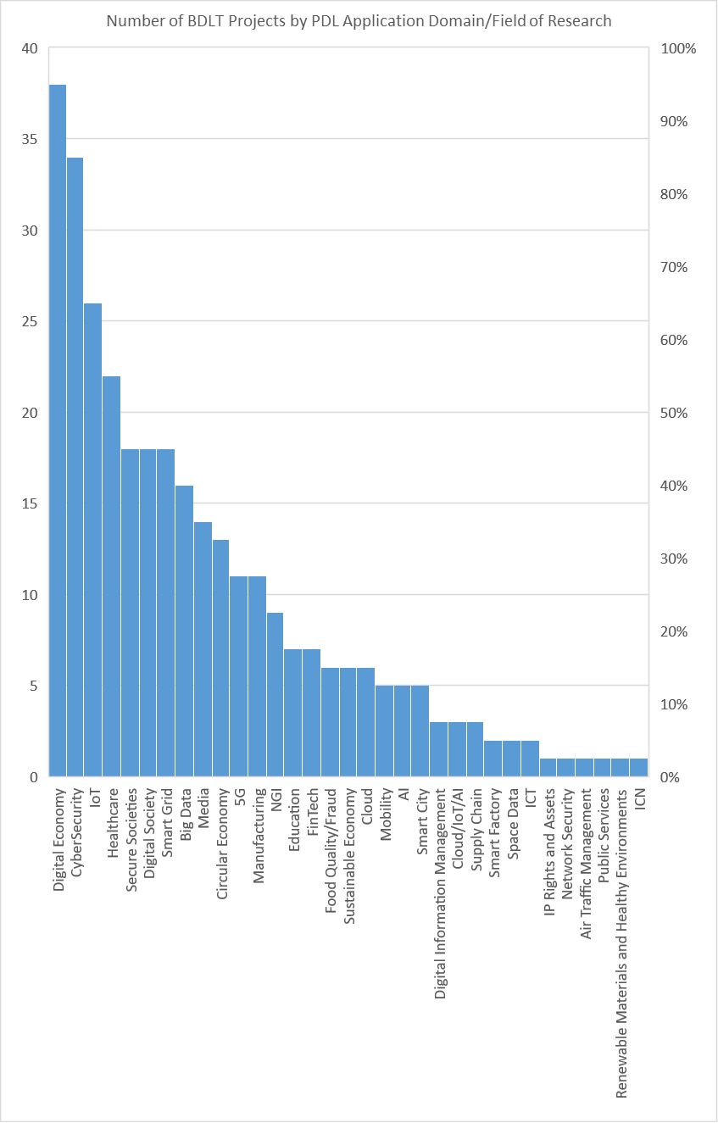

Figure 6.2: BDLT related projects by PDL Application Domain/Field of Research

6.3 Research and Innovation Programmes related to PDL

6.3.1 Scope
This section provides some comparisons of European research programmes, EU national research programmes and some similar projects in other jurisdictions.

6.3.2 Research Programmes: EU
Within the EC European Research Council 2021 Work Programme [i.7] there are three dedicated research topics with thematic focus on Blockchain under these three blockchain research topics seven H2020 grants with a total volume of around 32.8 million euros have been provided by the EU. These seven blockchain projects relate to three thematic priorities/pillars of the H2020 Programme: Information and Communication Technology (ICT), Innovation Support for SME (INNOSUPSME) and Health (HEALTH).
Table 6.1: H2020 Blockchain Research Topics
Topic Code | Research Topic | Thematic Priority | H2020  Projects | H2020 EU Contribution
ICT-54-2020 | Blockchain for the Next Generation Internet | ICT | 3 | € 20.066.094
INNOSUP-03-2018 | Blockchain and distributed ledger technologies for SMEs | INNOSUPSME | 3 | € 4.493.900
IMI2-2018-15-02 | Blockchain Enabled Healthcare | HEALTH | 1 | € 8.290.694
Total | 3/147 |  | 7 | € 32.850.688
NOTE 1: The data in this table is based on the analysis of the Research Topics of the 316 EU Horizon 2020 Projects related to DLT and Blockchain provided in Annex A, Table A.1.
NOTE 2: No guarantee can be given for the completeness, correctness and topicality of the information and contents compiled here

According to CORDIS the H2020 projects in Annex A, Table A.1 relate to 147 distinct H2020 Research Topics which are listed in Annex B, Table B.1. Three of the 147 H2020 Research Topics are the Blockchain Research Topics listed in Table 6.1. From the 147 Research Topics, thirty three are Research Topics of the thematic Priority ICT.
An overview of the Horizon 2020 Projects in Annex A related to research topics with thematic Priority ICT is provided in the following table:
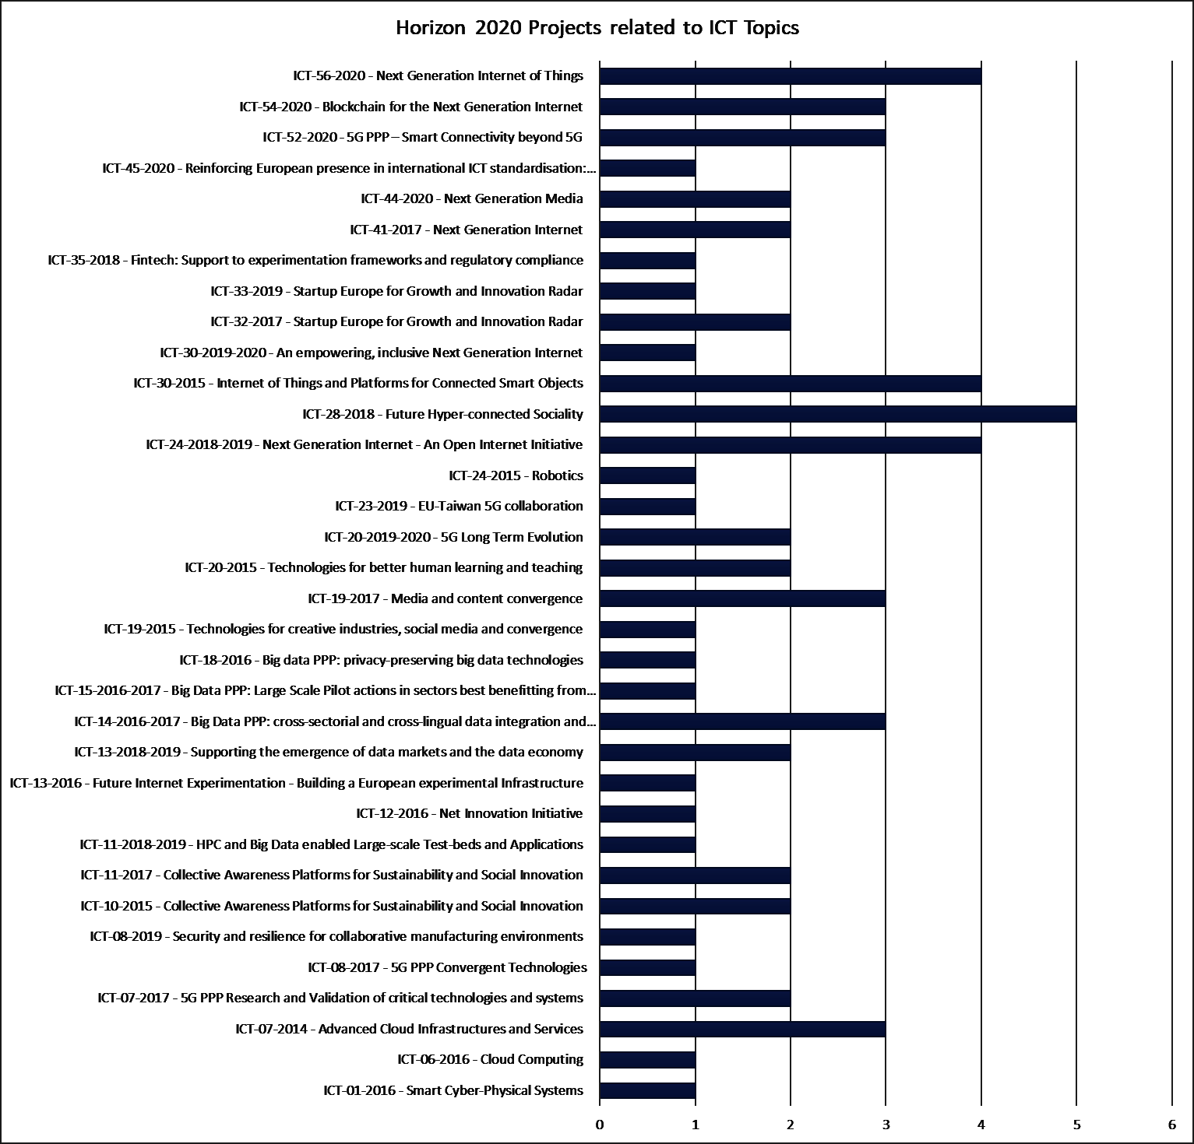
Figure 6.3: Horizon 2020 projects related to ICT Topics

An overview on BDLT H2020 Projects by thematic priorities and Research Topics: (Cybersecurity, 5G; Cloud; IoT, AI, etc.) is shown in Figure 6.4 and 6.5.

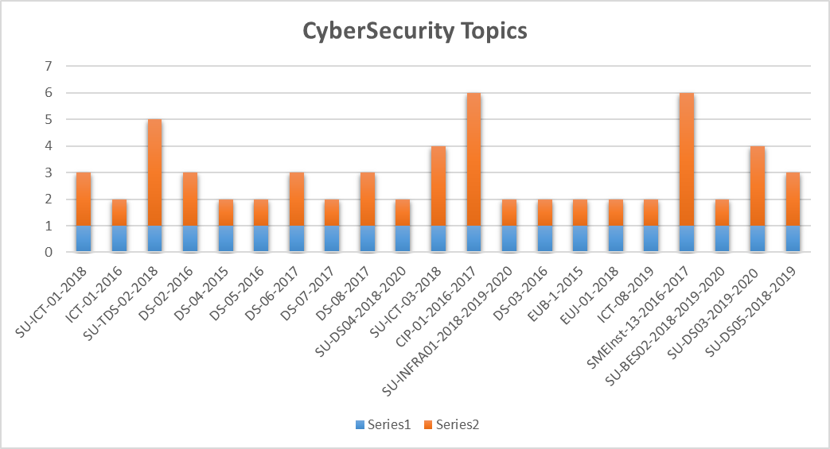
Figure 6.4: Horizon 2020 projects related to Cybersecurity Research Topics

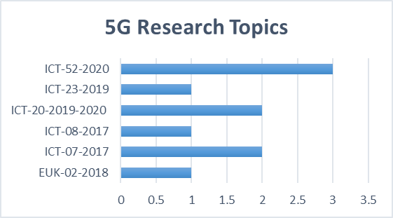
Figure 6.5: Horizon 2020 projects related to 5G Research Topics
Finally, the very wide span of topics influenced by DLT and PDL can be seen by analysing Annex A into the form of a mindmap of broad categories as shown in Figure 6.6, which can be more finely distinguished as for example in Figure 6.7
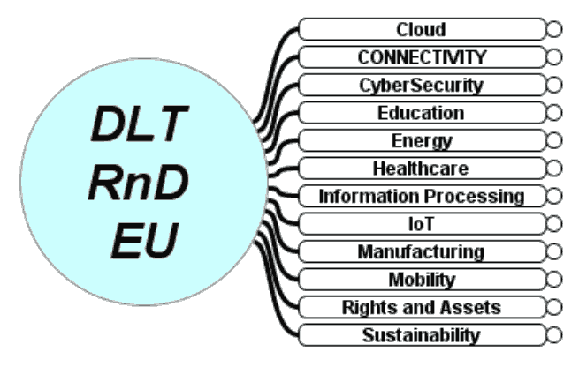
Figure 6.6: A mindmap of DLT projects in Horizon 2020, under broad categories

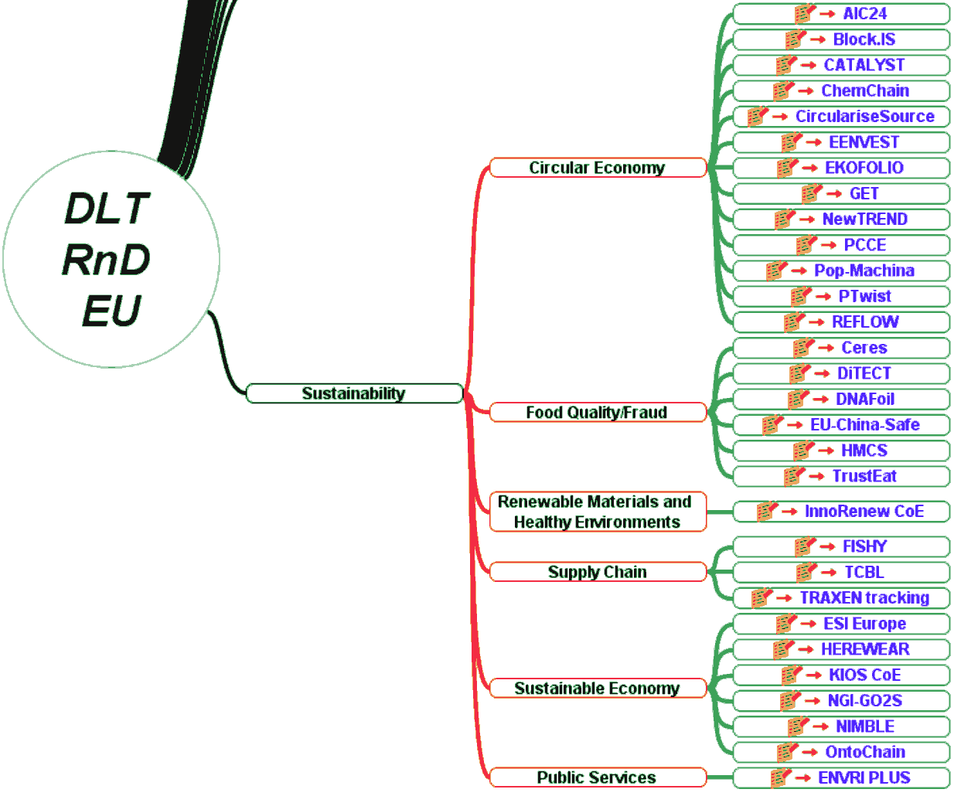
Figure 6.7: Some details of the mindmap of Figure 6.6, for Horizon 2020 projects

6.3.3 Research Programmes: Germany
In 2019 the Federal Government of Germany adopted a comprehensive “Blockchain –Strategy” [i.8] to strengthen and advance an innovative blockchain ecosystem in Germany further. The blockchain strategy of the German federal government comprises 44 measures in five priority areas of action to foster the development and scaling of blockchain applications. It entails related strategic investments in these areas to be launched by the end of 2021. With its blockchain strategy, the German federal government aims to exploit the opportunities offered by the blockchain technology and intends to activate its potentials for driving the digital transformation.
National public funding programmes for research projects related to blockchain and DLT have been established among others by the German Federal Ministry of Education and Research (BMBF-“Bundesministerium für Bildung und Forschung). The BMBF is funding research on blockchain-based verification of university education certificates (Blockchain in Education).
The most recent research funding programme of the BMBF, announced in January 2021, is the research funding framework programme “Insight – Interdisciplinary perspectives of the societal and technological change” formerly also known as “ITA - Innovations - and Technologies Analysis”. The Insight research framework programme is a strategic instrument and has the objective to analyse and evaluate the perspectives and challenges of new societal and technological developments and innovations in order to produce research results relevant for shaping politics and future strategies and policies. The Insight research programme has a holistic approach towards research and the funding comprises besides the scientific and technological aspects of research also ethical, social, legal, economic and political aspects in order to allow for an impact as well as potential risk assessment of innovative solutions in several dimensions. The Insight programme also has a focus on communication and direct participation and involvement of citizens. The funding is directed towards multi-perspective scientifically interdisciplinary research projects, in order to develop several alternative solution options and recommendations for action, addressing future challenges as well as opportunities of technological and social innovations. In particular, the BMBF will be funding research projects on innovation of-political activities, with thematic topics Application of Blockchain, Digital Education, Hydrogen, and impact assessment of social innovation scenarios.

6.3.4 Research Programmes: United Kingdom
UK Research Projects on application of PDL/DLT/Blockchain/Smart Contract enabling IoT adoption include the following.
The Engineering and Physical Sciences Research Council (EPSRC) (https://epsrc.ukri.org/) is a British Research Council that provides government funding for grants to undertake research and postgraduate degrees in engineering and the physical sciences, mainly to universities in the United Kingdom. EPSRC Projects include: "Accountable Just-in-Time Resource Reservation with Smart Contracts". E.g. King’s College London, UK has contributed a paper under this project, on “AJIT: Accountable Just-in-Time Network Resource Allocation with Smart Contracts” (https://dl.acm.org/doi/pdf/10.1145/3411043.3412506), which was presented at the ACM MobiArch- 15th Workshop on Mobility in the Evolving Internet Architecture (London, UK September 25, 2020)(http://cosafe.org.uk/mobiarch2020.html)
Research England's Connecting Capability Fund (CCF) (https://re.ukri.org/knowledge-exchange/the-connecting-capability-fund-ccf/) complements Higher Education Innovation Fund (HEIF) by supporting Higher Education Providers' (HEP) collaboration in commercialisation through competitive projects and formula funds. The CCF aims to share good practice and capacity internally across the higher education sector, forge external technological, industrial and regional partnerships, and deliver the Government's Industrial Strategy priorities. The CCF funds among other projects the Pitch-In “Connecting Capabilities for the Internet of Things” project (https://pitch-in.ac.uk/), a research collaboration project between the Universities of Cambridge, Newcastle, Oxford and Sheffield, UK, which is connecting capabilities to enable the Internet of Things adoption.
BEAT, Blockchain-Enabled Accountable and Transparent Infrastructure Sharing in 6G: BEAT introduces an end-to-end accountable and transparent infrastructure sharing architecture e blockchains and smart contracts. BEAT enables multi-vendor and multi-operator operations by solving the challenges of a transparent sharing of infrastructure and network resources by means of PDL smart contracts. A PDL is formed among consortium members owning or wanting access to networking resources. In BEAT, Service Level Agreements (SLAs) are recorded as smart contracts, which automatically record any networking and API flow details to monitor and enforce the SLAs between the consortium members.
Pitch-in Project: https://pitch-in.ac.uk – this project give presentation to the PDL group.
AJIT: Accountable Just-in-Time Network Resource Allocation with Smart Contracts: with the surge in demand for network resources, operators need to cope with this grown demand. In future, more devices are expected to request network services and more often than before, this means operators need an automated system to accommodate these requests. Moreover, the requirement for differentiated services adds an additional challenge. Operators need to rethink current resource allocation methods and should introduce more flexible, short-term and tailor-made service offerings considering their coverage and capacity, and if and only if they can guarantee the Service Level Agreement(SLA) promised.
Providing flexible, dynamic network connectivity along with strict and guaranteed SLAs for millions, probably billions, of devices is not an easy task. This approach will cause substantial management overheads, and customers will need to contact operators more frequently for new service contracts, causing additional staff and operating expenses. Another problem is that SLAs are often opaque to the customer, making it difficult for them to detect an infringement.
AJIT exploits the inherent transparency, automation, and immutability properties of Distributed Ledger Technology (DLT) to solve the issues above. Service contracts are deployed as smart contracts on a Permissioned Distributed Ledger (PDL) that records all the service provisioning and can provide an impartial record for SLA accountability. AJIT provides an end-to-end system architecture for dynamic resource provisioning with smart contracts and side channels [i.9], [i.10], [i.11].
BCDMA - Blockchain Division Multiple Access for IEEE 802.11: Carrier Sense Multiple Access with Collision Avoidance (CSMA/CA) has become the de facto multiple access mechanism for Wireless Local Area Network (WLAN). WLAN introduces an element of flexibility into LAN architecture, providing mobility to users, while still ensuring network access via a wireless medium. It is built on contention for the transmission medium. With contention, there is bound to be collisions, so a necessary step was the inclusion of special frames which avoid collision but significantly lower the bandwidth utilisation.
To this end, and with interest by UK industry and regulator, a novel multiple access protocol titled BCDMA has been introduced [i.12], [i.13], [i.14]. In essence, BCDMA allocates access to the transmission medium using dedicated time slots. This allocation ensures a certain level of throughput due to devices transmitting strictly within their time slot. BCDMA also has a higher goodput, given that there are no retransmissions as a result of collisions. By treating the time-slots as assets on a smart contract, BCDMA allocates time-slots to devices.
Compared to CSMA/CA, the proposed BCDMA protocol yields improvements of more than 85% throughput when the load capacity of the network is near saturation. Furthermore, we observe qualitative improvements in terms of security with regards to authentication within the WLAN. By using PDL, BCDMA is not prone to the attack rate experienced in public networks.
Standardisation is essential to adopt smart contract as SLAs, because this will enable automated, transparent and automated service contracts.

6.3.5 Research Programmes: United States of America
Table C.1.1 in Annex C includes a list of selected ongoing blockchain-related projects in the United States (US), which have been funded by the National Science Foundation (NSF). These projects were funded through various NSF programs such as Faculty Early Career Development (CAREER), Innovation Corps (I-Corps), Networking Technology and Systems (NeTS), Secure and Trustworthy Cyberspace (SaTC), Small Business Innovation Research (SBIR), and Small Business Technology Transfer (STTR). Please note that Table C.1.1. does not aim to provide an exhaustive list of all blockchain-related projects in the US. But Table C.1.1. shows:
1) These projects cover broad technical areas from core technologies (e.g., interledger communications, payment channel networks, scalability, smart contract) to vertical domains (e.g., cybersecurity, digital economy, digital information management, fintech, healthcare, IoT, media);
2) The projects related to blockchain core technologies are funded before the projects about blockchain-enabled vertical domains.

6.3.6 Research Programmes: Spain
In Spain, the Government, regulators and prominent entities in the business field have been active to create an ecosystem since around 2017, while avoiding or warning against certain risks on several occasions e.g. initial coin offerings and digital currencies. The Spanish National Strategy for Science, Technology and Innovation (EECTI) for the 2021-2027 defines a set of strategic lines, grouped in six wider areas, as the framework for the actions of the Spanish Government to support research and technology development. Two of these areas, titled “Security for Society” and “Digitalization”, include mentions to DLT and its applications as matters for research, specifically in three strategic lines: “Cybersecurity”, “Artificial Intelligence and Robotics” and “Next-generation Internet”.
The Council of University Rectors (CRUE) started in 2019 project BLUE, in collaboration with the public entity for the promotion of the Information Society (Red.es) and the academic network (RedIRIS). The project is focused on the applications of DLT within the academic sector, with special emphasis on academic certifications and lifelong learning support. The project started by producing a survey on the applicability of these technologies in the university environment and continued with several development projects that are consolidating into a first field trial involving three universities, integrated within the EBSI Early Adopters program, and planning cross-border pilots before the end of 2021.
The blockchain observatory provided by BI (https://blockchainintelligence.es/en/map/) lists 13 active projects working on DLT, addressing matters related with fintech, energy, legal and compliance, logistics and transportation, documents and traceability, and health. Alastria, the non-profit association promoting the development of decentralized ledger technologies and participant in ISG PDL, hosts a “project counter” (https://alastria.io/en/mesa-de-proyectos/) to support research and development initiatives in these areas.

7 Importance of PDL Standardization
Horizon 2020, the 8th EU Framework Programme for Research and Innovation, injected about 13 billion euro per year from 2015 to 2020 into the EU research ecosystem, whereas the follow on programme Horizon Europe increases that by about 20%, with a much stronger dissemination and exploitation emphasis. The years 2015-2020 saw the launch of several hundred research projects involving DLT, in the areas of Digital Economy (38), Cyber Security (34), IoT (26), Healthcare (22) and so on as listed in Annex A. Various national programmes in the UK, Germany, Spain, etc, boosted the work even more.
Many of these research and innovation projects considered how to disseminate results in the marketplace, and in particular how to promote the technology by helping to create appropriate (international) standards. Two projects can serve as examples: SOFIE (now completed) and 5GZORRO.
SOFIE (Secure Open Federation for Internet Everywhere) was funded under EC contract Nr. 779984 and concluded that
Standardization is a framework of agreements for all relevant parties in an industry to ensure the creation of well-performing systems, products and services in accordance with set guidelines. The objective is to maximize compatibility, interoperability, safety, repeatability, and quality. [...] When it comes to blockchains and Distributed Ledger Technology (DLT), standardization is happening in all relevant technology standardization groups. Questions that we initially did not find good answers to in the SOFIE project were: What is the right way for us to contribute to standardization in a situation where the focus and maturity in blockchain adoption varied a lot between different standardization groups? Should we aim for more widespread collaboration or target our efforts to specific standardization groups? In retrospective [...]with ETSI Industry Special Group for Private Distributed Ledgers (ETSI ISG PDL) [...] active collaboration was initiated [...] by Ericsson as group member and strongly supported by Aalto University and Athens University of Economics and Business. [This work has been] complemented by contributions by other SOFIE partners also in other standardization groups, for example W3C and IETF/IRTF [i.15]
The project 5GZORRO (Zero-touch security and trust for ubiquitous computing and connectivity in 5G networks), funded under Horizon 2020 contract 871533, started in November 2019 and has decided to "ensure the long-term success of the project through standardization and dissemination in scientific, industrial, and commercial fora, and by contributing to relevant open source communities & SDOs" [i.16]. It has as one of its core objectives:
contributions to target SDOs/SSOs (Standards Developing Organization / Standards Setting Organization) [in ETSI ISG PDL, ETSI ISG ENI, ETSI ISG ZSM, ETSI ISG NFV, ECSO, IRTF, IETF, etc[...] ranging from involvement in technical discussions and sharing 5GZORRO results, to active contribution to standardisation efforts and/or open-source projects and communities.[i.16]
In particular, 5GZORRO has identified the following potential collaborations with ISG PDL: PoCs on the applicability of Smart Contracts in network services, Trust computations for smart contracts and federated data, Distributed Ledger interoperability and Trusted Execution Environmens, particularly in use cases such as NFV resource brokering, Spectrum trading, Service deployment and activation.
In summary for this chapter and indeed for this document, the EC has heavily promoted research in Distributed Ledger Technologies and the projects have individually seen the importance of contributing to the (international) standardisation ecosystems, in order to:
- promote interoperability of solutions and "future-proof" solutions in the market place
- improve the reliability of services
- improve transparency of operations for service providers and ultimately for European citizens
- offer verifiable proof or benchmarking of features such as privacy or tamper-proofing
- ensure fair procurement by means of transparent reference to best-of-breed technological solutions (according to World Trade Office recommendations)
- improve the results of "due dilligence" investigations for government and private services
- build efficient ecosystems (and avoid vendor "lock in")

Annex A:
List of EU Horizon 2020 Projects related to DLT and Blockchain
Information about EU funded research and innovation projects under the Horizon 2020 research framework programme that are related to blockchain and/or distributed ledger technologies as obtained from CORDIS project database has been collected by ISG PDL and a list of all Horizon 2020 projects on DLT and blockchain under the funding schemes RIA, IA, CSA, as well as SME has been extracted. This list of Horizon 2020 projects related to DLT and blockchain contains for each project the following information: project acronym, project name, project ID, project funding scheme, a link to the projects factsheet in CORDIS and an indication of the projects potential application domain or field of research as specified by ISG PDL. The project list is sorted in alphabetical order by the project acronym as presented in table A.1.
NOTE 1: The latest status update of the project information from CORDIS database is March 2021.
NOTE 2: The classification of the projects Application Domain and Field of Research is based on an ISG PDL assessment and therefore might differ from the actual projects application domain or field of research.
NOTE 3: No guarantee can be given for the completeness, correctness and topicality of the information and contents compiled here.

Table A.1: EU Horizon 2020 Projects related to DLT and Blockchain as of March 2021
Horizon 2020  Project Acronym | Horizon 2020  Project Name | Horizon 2020  Project ID | Horizon 2020  Funding Scheme | CORDIS  Project Factsheet | ISG PDL classification of Domain
5GaaS | 5G-as-a-Service | 958832 | IA | https://cordis.europa.eu/project/id/958832 | 5G
5G-CORAL | 5G-CORAL: A 5G Convergent Virtualised Radio Access Network Living at the Edge | 761586 | RIA | https://cordis.europa.eu/project/id/761586 | 5G
5G-DIVE | eDge Intelligence for Vertical Experimentation | 859881 | RIA | https://cordis.europa.eu/project/id/859881 | 5G
5G-TRANSFORMER | 5G-TRANSFORMER: 5G Mobile Transport Platform for Verticals | 761536 | RIA | https://cordis.europa.eu/project/id/761536 | 5G
5GZORRO | Zero-touch security and trust for ubiquitous computing and connectivity in 5G networks | 871533 | RIA | https://cordis.europa.eu/project/id/871533 | AI
Access2Europe | Help startups to scale by leveraging the access to European markets offered by four major startup hubs | 780237 | IA | https://cordis.europa.eu/project/id/780237 | Digital Economy
AEGIS | Advanced Big Data Value Chain for Public Safety and Personal Security | 732189 | IA | https://cordis.europa.eu/project/id/732189 | Big Data
AEOLIX | Architecture for EurOpean Logistics Information eXchange | 690797 | RIA | https://cordis.europa.eu/project/id/690797 | Digital Economy
AGILE | Adoptive Gateways for dIverse muLtiple Environments | 688088 | RIA | https://cordis.europa.eu/project/id/688088 | IoT
AI4DI | Artificial Intelligence for Digitizing Industry | 826060 | ECSEL-RIA | https://cordis.europa.eu/project/id/826060 | AI
AIC24 | Sustainable Datacenters Through Immersed Computing | 816831 | SME-1 | https://cordis.europa.eu/project/id/816831 | Circular Economy
AICHAIN | A platform for privacy-preserving Federated Machine Learning using Blockchain to enable Operational Improvements in ATM | 894162 | SESAR-RIA | https://cordis.europa.eu/project/id/894162 | Digital Information Management
AMable | AdditiveManufacturABLE | 768775 | IA | https://cordis.europa.eu/project/id/768775 | Manufacturing
AMBRPAY | Decentralized subscription payments with cryptocurrency | 887968 | SME-1 | https://cordis.europa.eu/project/id/887968 | Digital Economy
ANITA | Advanced tools for fighting oNline llegal TrAfficking | 787061 | RIA | https://cordis.europa.eu/project/id/787061 | CyberSecurity
ARCAone | Next generation security platform to safeguard critical applications and sensitive digital assets | 888406 | SME-1 | https://cordis.europa.eu/project/id/888406 | CyberSecurity
ARTICONF | smART socIal media eCOsytstem in a blockchaiN Federated environment | 825134 | RIA | https://cordis.europa.eu/project/id/825134 | Media
ASSIST-IoT | Architecture for Scalable, Self-*, human-centric, Intelligent, Secure, and Tactile next generation IoT | 957258 | RIA | https://cordis.europa.eu/project/id/957258 | IoT
ASSURED | Future Proofing of ICT Trust Chains: Sustainable Operational Assurance and Verification Remote Guards for Systems-of-Systems Security and Privacy | 952697 | RIA | https://cordis.europa.eu/project/id/952697 | Network Security
ATARCA | Accounting Technologies for Anti-Rival Coordination and Allocation | 964678 | RIA | https://cordis.europa.eu/project/id/964678 | Digital Economy
AudioCommons | Audio Commons: An Ecosystem for Creative Reuse of Audio Content | 688382 | RIA | https://cordis.europa.eu/project/id/688382 | Media
AVANGARD | Advanced manufacturing solutions tightly aligned with business needs | 869986 | IA | https://cordis.europa.eu/project/id/869986 | Manufacturing
B4CM | Blockchains as a Distributed Ledger for Attribution of RCM Data in Rail | 826156 | CSA | https://cordis.europa.eu/project/id/826156 | Mobility
B4TDM | Making Contracts Digital with Civilised Blockchain | 858630 | SME-2 | https://cordis.europa.eu/project/id/858630 | Digital Economy
BD4NRG | BD4NRG: Big Data for Next Generation Energy | 872613 | IA | https://cordis.europa.eu/project/id/872613 | Big Data
BD4OPEM | Big Data for OPen innovation Energy Marketplace | 872525 | IA | https://cordis.europa.eu/project/id/872525 | Smart Grid
BEACON | Boosting Agricultural Insurance based on Earth Observation data | 821964 | IA | https://cordis.europa.eu/project/id/821964 | Space Data
B-HUB FOR EUROPE | Blockchain HUB FOR EUROPEan startups acceleration and growth | 871869 | IA | https://cordis.europa.eu/project/id/871869 | Digital Economy
BIG | Enhancing the research and innovation potential of Tecnico through Blockchain technologies and design Innovation for social Good | 952226 | CSA | https://cordis.europa.eu/project/id/952226 | Digital Society
BILLON | Disrupting the economy - FinTech blockchain solution revolutionises direct payments. Secure, low-cost and simple bank-free payments for everyone | 783861 | SME-2 | https://cordis.europa.eu/project/id/783861 | FinTech
bIoTope | Building an IoT OPen innovation Ecosystem for connected smart objects | 688203 | RIA | https://cordis.europa.eu/project/id/688203 | IoT
BitBox | Enterprise - Enterprise-grade Solution for Digital Assets Custody | 855049 | SME-1 | https://cordis.europa.eu/project/id/855049 | CyberSecurity
Bitwala | Next generation banking tools for the blockchain economy | 854346 | SME-1 | https://cordis.europa.eu/project/id/854346 | FinTech
Bitztribution | Towards a fully decentralized distribution for next generation of travel and tourism distribution | 876748 | SME-1 | https://cordis.europa.eu/project/id/876748 | Digital Economy
Block.IS | Blockchain Innovation Spaces | 824509 | IA | https://cordis.europa.eu/project/id/824509 | Circular Economy
BlockchainKYC | Blockchain-based, 100% automated KYC (Know Your Customer) service | 774802 | SME-1 | https://cordis.europa.eu/project/id/774802 | Secure Societies
BlockchainKYC | Blockchain-based, 100% automated KYC (Know Your Customer) service | 850059 | SME-2 | https://cordis.europa.eu/project/id/850059 | Secure Societies
BLOCKCHERS | BLOCKCHAIN TECHNOLOGIES FOR SMEs | 828840 | CSA | https://cordis.europa.eu/project/id/828840 | Big Data
Blocknetwork | Fusing Big Data and Implementing Novel Cyber Security Solutions | 827457 | SME-1 | https://cordis.europa.eu/project/id/827457 | Big Data
BLOCKPOOL | Pooling SME adoption and deployment of Blockchain and other DLTs | 828888 | CSA | https://cordis.europa.eu/project/id/828888 | Education
BlockStart | Helping SMEs take the first steps into the Blockchain | 828853 | CSA | https://cordis.europa.eu/project/id/828853 | Education
BLOOMEN | Blockchains in the new era of participatory media experience | 762091 | IA | https://cordis.europa.eu/project/id/762091 | Media
BodyPass | API-ecosystem for cross-sectorial exchange of 3D personal data | 779780 | IA | https://cordis.europa.eu/project/id/779780 | Healthcare
Bonseyes | Platform for Open Development of Systems of Artificial Intelligence | 732204 | RIA | https://cordis.europa.eu/project/id/732204 | IoT
BOOST 4.0 | Big Data Value Spaces for COmpetitiveness of European COnnected Smart FacTories 4.0 | 780732 | IA | https://cordis.europa.eu/project/id/780732 | Big Data
BRAIN-IoT | model-Based fRamework for dependable sensing and Actuation in INtelligent decentralized IoT systems | 780089 | RIA | https://cordis.europa.eu/project/id/780089 | IoT
BrainPatch | BrainPatch – Breakthrough noninvasive brain stimulation using AI | 867386 | SME-1 | https://cordis.europa.eu/project/id/867386 | Healthcare
BRIGHT | Boosting DR through increased communIty-level consumer engaGement by combining Data-driven and blockcHain technology Tools with social science approaches and multi-value service design | 957816 | IA | https://cordis.europa.eu/project/id/957816 | Smart Grid
C4IIoT | Cyber security 4.0: protecting the Industrial Internet Of Things | 833828 | IA | https://cordis.europa.eu/project/id/833828 | CyberSecurity
CATALYST | Converting DCs in Energy Flexibility Ecosystems (CATALYST) | 768739 | IA | https://cordis.europa.eu/project/id/768739 | Circular Economy
CATTLECHAIN 4.0 | Enhancing farm productivity and guaranteeing CATTLE traceability and welfare with blockCHAIN | 853864 | IA | https://cordis.europa.eu/project/id/853864 | IoT
CEITER | Cross-Border Educational Innovation thru Technology-Enhanced Research | 669074 | CSA | https://cordis.europa.eu/project/id/669074 | Education
Ceres | Proactive system to forecast and reduce environmental footprint while maximising agriculture performance | 832681 | SME-1 | https://cordis.europa.eu/project/id/832681 | Food Quality/Fraud
CHARIOT | Cognitive Heterogeneous Architecture for Industrial IoT | 780075 | RIA | https://cordis.europa.eu/project/id/780075 | IoT
ChemChain | Blockchain Platform to Track Chemicals along the Value Chain | 875783 | SME-1 | https://cordis.europa.eu/project/id/875783 | Circular Economy
CirculariseSource | Certifying recycled material while keeping market prices and allowing mass adoption | 961989 | SME-2b | https://cordis.europa.eu/project/id/961989 | Circular Economy
CITADEL | Empowering Citizens to TrAnsform European PubLic Administrations | 726755 | RIA | https://cordis.europa.eu/project/id/726755 | Digital Society
CITIES2030 | Co-creating resIlient and susTaInable food systEms towardS FOOD2030 | 101000640 | IA | https://cordis.europa.eu/project/id/101000640 | Smart City
ClearFarm | Co-designed Welfare Monitoring Platform for Pig and Dairy Cattle | 862919 | IA | https://cordis.europa.eu/project/id/862919 | Digital Economy
CLINICOVERY | CLINICOVERY, a versatile, high quality, environmental-friendly, easy to use e-Clinical solution for clinical research | 808543 | SME-1 | https://cordis.europa.eu/project/id/808543 | Healthcare
CO3 | Digital Disruptive Technologies to Cocreate, Co-produce and Co-manage Open Public Services along with Citizens | 822615 | RIA | https://cordis.europa.eu/project/id/822615 | Digital Society
COBAFRA | Combatting Banking Fraud with SiSid: A unique solution for preventing corporate payments fraud using AI and blockchain | 835813 | SME-1 | https://cordis.europa.eu/project/id/835813 | Digital Economy
COG-LO | COGnitive Logistics Operations through secure, dynamic and ad-hoc collaborative networks | 769141 | RIA | https://cordis.europa.eu/project/id/769141 | IoT
COLLABS | A COmprehensive cyber-intelligence framework for resilient coLLABorative manufacturing Systems | 871518 | RIA | https://cordis.europa.eu/project/id/871518 | Manufacturing
COMPOSITION | Ecosystem for Collaborative Manufacturing Processes – Intra- and Interfactory Integration and Automation | 723145 | RIA | https://cordis.europa.eu/project/id/723145 | Manufacturing
Community Cloud | Cubbit - the first distributed data-center recycling the internet resources we waste into the most competitive cloud provider. | 874313 | SME-2 | https://cordis.europa.eu/project/id/874313 | Cloud
CONCORDIA | Cyber security cOmpeteNce fOr Research anD Innovation | 830927 | RIA | https://cordis.europa.eu/project/id/830927 | CyberSecurity
CONNECARE | Personalised Connected Care for Complex Chronic Patients | 689802 | RIA | https://cordis.europa.eu/project/id/689802 | Healthcare
Consentio | Boosting conversations to disrupt horticulture trading | 836175 | SME-1 | https://cordis.europa.eu/project/id/836175 | Digital Economy
COOL-SENS | Advanced monitoring solution to prevent losses and assure full transparency along the cold chain | 855554 | SME-1 | https://cordis.europa.eu/project/id/855554 | IoT
CoordiNet | Large scale campaigns to demonstrate how TSO-DSO shall act in a coordinated manner to procure grid services in the most reliable and efficient way | 824414 | IA | https://cordis.europa.eu/project/id/824414 | Smart Grid
COPA EUROPE | COllaborative Platform for trAnsmedia storytelling and cross channel distribution of EUROPEan sport events | 957059 | IA | https://cordis.europa.eu/project/id/957059 | Media
CPN | Content Personalisation Network | 761488 | IA | https://cordis.europa.eu/project/id/761488 | Media
CREST | Fighting Crime and TerroRism with an IoT-enabled Autonomous Platform based on an Ecosystem of Advanced IntelligEnce, Operations, and InveStigation Technologies | 833464 | RIA | https://cordis.europa.eu/project/id/833464 | Secure Societies
CRITICAL-CHAINS | IOT- & Blockchain-Enabled Security Framework for New Generation Critical Cyber-Physical Systems In Finance Sector | 833326 | IA | https://cordis.europa.eu/project/id/833326 | CyberSecurity
CUREX | seCUre and pRivate hEalth data eXchange | 826404 | RIA | https://cordis.europa.eu/project/id/826404 | Healthcare
CyberKit4SME | Democratizing a Cyber Security Toolkit for SMEs and MEs | 883188 | IA | https://cordis.europa.eu/project/id/883188 | CyberSecurity
CyberSec4Europe | Cyber Security Network of Competence Centres for Europe | 830929 | RIA | https://cordis.europa.eu/project/id/830929 | CyberSecurity
CYBER-TRUST | Advanced Cyber-Threat Intelligence, Detection, and Mitigation Platform for a Trusted Internet of Things | 786698 | RIA | https://cordis.europa.eu/project/id/786698 | CyberSecurity
cyberwatching,eu | The European watch on cybersecurity privacy | 740129 | CSA | https://cordis.europa.eu/project/id/740129 | CyberSecurity
D4FLY | Detecting Document frauD and iDentity on the fly | 833704 | RIA | https://cordis.europa.eu/project/id/833704 | Secure Societies
DataVaults | Persistent Personal Data Vaults Empowering a Secure and Privacy Preserving Data Storage, Analysis, Sharing and Monetisation Platform | 871755 | IA | https://cordis.europa.eu/project/id/871755 | Big Data
Dawex GDM | Dawex Data Marketplace deployment: unlocking European companies’ data value | 829729 | SME-2 | https://cordis.europa.eu/project/id/829729 | Digital Economy
DE4A | Digital Europe for All | 870635 | RIA | https://cordis.europa.eu/project/id/870635 | Digital Society
DECENTER | Decentralised technologies for orchestrated cloud-to-edge intelligence | 815141 | RIA | https://cordis.europa.eu/project/id/815141 | Cloud/IoT/AI
DECODE | Decentralised Citizens Owned Data Ecosystem | 732546 | RIA | https://cordis.europa.eu/project/id/732546 | IoT
DEDICAT 6G | Dynamic coverage Extension and Distributed Intelligence for human Centric applications with assured security, privacy and trust: from 5G to 6G | 101016499 | RIA | https://cordis.europa.eu/project/id/101016499 | 5G
DEFENDER | Defending the European Energy Infrastructures | 740898 | IA | https://cordis.europa.eu/project/id/740898 | CyberSecurity
DEL4ALL | Digital Enhanced Learning for ALL | 871573 | CSA | https://cordis.europa.eu/project/id/871573 | NGI
DELTA | Future tamper-proof Demand rEsponse framework through seLfconfigured, self-opTimized and collAborative virtual distributed energy nodes | 773960 | RIA | https://cordis.europa.eu/project/id/773960 | Smart Grid
DFS | Democratized Financial Services | 865430 | SME-1 | https://cordis.europa.eu/project/id/865430 | FinTech
DiFacturo | The Unique International Independent Decentralized Invoice Network | 889930 | SME-1 | https://cordis.europa.eu/project/id/889930 | Digital Economy
DigiJourney | Digital transformation journey for SMEs | 870625 | CSA-LS | https://cordis.europa.eu/project/id/870625 | Big Data
DigiPharm | Value-based Healthcare Platform Secured with Blockchain Technology | 888950 | SME-1 | https://cordis.europa.eu/project/id/888950 | Healthcare
DiTECT | DIgital TEChnologies as an enabler for a conTinuous transformation of food safety system | 861915 | RIA | https://cordis.europa.eu/project/id/861915 | Food Quality/Fraud
DLInnociate | DLInnociate Innovation Associate knowledgeable in blockchain technologyfor real time economy platform business development | 739782 | CSA | https://cordis.europa.eu/project/id/739782 | Digital Economy
DNAFoil | Rapid DNA screening to secure the global food supply chains | 836046 | SME-1 | https://cordis.europa.eu/project/id/836046 | Food Quality/Fraud
DOMINOES | Smart Distribution Grid: a Market Driven Approach for the Next Generation of Advanced Operation Models and Services | 771066 | RIA | https://cordis.europa.eu/project/id/771066 | Smart Grid
DrBox | eHealth platform to assess patient clinical progress due to prescribed medication | 807509 | SME-1 | https://cordis.europa.eu/project/id/807509 | Healthcare
DRIVE | Demand Response Integration tEchnologies: unlocking the demand response potential in the distribution grid | 774431 | RIA | https://cordis.europa.eu/project/id/774431 | Smart Grid
DSISCALE | Supporting the scale and growth of Digital Social Innovation in Europe through coordination of Europe’s DSI and CAPS Networks | 780473 | CSA | https://cordis.europa.eu/project/id/780473 | Digital Society
EBSIS | Event Based Systems in Iaşi - A Twinning between Universitatea Alexandru Ioan Cuza din Iaşi, Université de Neuchâtel and Technische Universität Dresden | 692178 | CSA | https://cordis.europa.eu/project/id/692178 | Big Data
ECHO | European network of Cybersecurity centres and competence Hub for innovation and Operations | 830943 | RIA | https://cordis.europa.eu/project/id/830943 | CyberSecurity
eDREAM | enabling new Demand REsponse Advanced, Market oriented and Secure technologies, solutions and business models | 774478 | RIA | https://cordis.europa.eu/project/id/774478 | Smart Grid
EENVEST | Risk reduction for Building Energy Efficiency investments | 833112 | CSA | https://cordis.europa.eu/project/id/833112 | Circular Economy
eFactory | European Connected Factory Platform for Agile Manufacturing | 825075 | IA | https://cordis.europa.eu/project/id/825075 | Smart Factory
EKOFOLIO | Expanding Key Opportunities in FOrest Investments: Liquidity, Impact and Ownership through Blockchain | 876676 | SME-1 | https://cordis.europa.eu/project/id/876676 | Circular Economy
ENHANCE | Building an Excellency Network for Heightening Agricultural ecoNomic researCh and Education in Romania | 691681 | CSA | https://cordis.europa.eu/project/id/691681 | Education
ENIT Agent 2.0 | The world's first edge computing solution for SMEs enabling energy efficiency, Industry 4.0 and new business models for the energy sector | 811640 | SME-2 | https://cordis.europa.eu/project/id/811640 | Smart Grid
ENSURESEC | End-to-end Security of the Digital Single Market’s E-commerce and Delivery Service Ecosystem | 883242 | IA | https://cordis.europa.eu/project/id/883242 | CyberSecurity
ENVRI PLUS | Environmental Research Infrastructures Providing Shared Solutions for Science and Society | 654182 | RIA | https://cordis.europa.eu/project/id/654182 | Public Services
ePIcenter | Enhanced Physical InternetCompatible Earth-frieNdly freight Transportation answER | 861584 | RIA | https://cordis.europa.eu/project/id/861584 | Cloud/IoT/AI
ERIGrid | European Research Infrastructure supporting Smart Grid Systems Technology Development, Validation and Roll Out | 654113 | RIA | https://cordis.europa.eu/project/id/654113 | Smart Grid
euCANSHare | An EU-Canada joint infrastructure for next-generation multi-Study Heart research | 825903 | RIA | https://cordis.europa.eu/project/id/825903 | Healthcare
ESCUDO-CLOUD | Enforceable Security in the Cloud to Uphold Data Ownership | 644579 | RIA | https://cordis.europa.eu/project/id/644579 | Cloud
ESI Europe | Driving Investment in Energy Efficiency through Energy Savings Insurance in Europe | 785061 | CSA | https://cordis.europa.eu/project/id/785061 | Sustainable Economy
EU-China-Safe | Delivering an Effective, Resilient and Sustainable EU-China Food Safety Partnership | 727864 | RIA | https://cordis.europa.eu/project/id/727864 | Food Quality/Fraud
EUNOMIA | User-oriented, secure, trustful & decentralised social media | 825171 | IA | https://cordis.europa.eu/project/id/825171 | Media
European IPR Helpdesk | The European IPR Helpdesk | 641474 | CSA | https://cordis.europa.eu/project/id/641474 | IP Rights and Assets
EVEARA | EVEARA: Testing a New Business Model for Digital Music Distribution | 735359 | SME-1 | https://cordis.europa.eu/project/id/735359 | Digital Economy
EyeCode | A frictionless two-factor authentication software for secure transactions | 816804 | SME-1 | https://cordis.europa.eu/project/id/816804 | CyberSecurity
FAR-EDGE | Factory Automation Edge Computing Operating System Reference Implementation | 723094 | RIA | https://cordis.europa.eu/project/id/723094 | Manufacturing
FASTER | First responder Advanced technologies for Safe and efficienT Emergency Response | 833507 | RIA | https://cordis.europa.eu/project/id/833507 | Healthcare
FeatureCloud | Privacy preserving federated machine learning and blockchaining for reduced cyber risks in a world of distributed healthcare | 826078 | RIA | https://cordis.europa.eu/project/id/826078 | Healthcare
FENTEC | Functional Encryption Technologies | 780108 | RIA | https://cordis.europa.eu/project/id/780108 | CyberSecurity
FEVER | Flexible Energy Production, Demand and Storage-based Virtual Power Plants for Electricity Markets and Resilient DSO Operation | 864537 | IA | https://cordis.europa.eu/project/id/864537 | Smart Grid
FINSEC | Integrated Framework for Predictive and Collaborative Security of Financial Infrastructures | 786727 | IA | https://cordis.europa.eu/project/id/786727 | CyberSecurity
FIN-TECH | A FINancial supervision and TECHnology compliance training programme | 825215 | CSA | https://cordis.europa.eu/project/id/825215 | FinTech
FISHY | A coordinated framework for cyber resilient supply chain systems over complex ICT infrastructures | 952644 | RIA | https://cordis.europa.eu/project/id/952644 | Supply Chain
FLEXI-GRID | ENABLING FLEXIBILITY FOR FUTURE DISTRIBUTION GRID | 864048 | IA | https://cordis.europa.eu/project/id/864048 | Smart Grid
FleXunity | Scaling-up Power Flexible Communities business models empowered by Blockchain and AI | 870146 | IA | https://cordis.europa.eu/project/id/870146 | Digital Economy
FOrLedger | A Blockchain-based Middleware Platform for Food Tracking Ledger Builder | 856065 | SME-1 | https://cordis.europa.eu/project/id/856065 | Digital Economy
GASTEJO | Decentralized Travel Apartment Distribution Platform | 832537 | SME-1 | https://cordis.europa.eu/project/id/832537 | Digital Economy
GATEKEEPER | SMART LIVING HOMES - WHOLE INTERVENTIONS DEMONSTRATOR FOR PEOPLE AT HEALTH AND SOCIAL RISKS | 857223 | IA | https://cordis.europa.eu/project/id/857223 | Healthcare
GDC | A Genetic Data CUBE - An innovative business model applied to predictive and prescriptive analytics, exploring Big Data an empowering cloudservices and urgent computation | 697581 | SME-1 | https://cordis.europa.eu/project/id/697581 | Big Data
GET | Green Energy Tracker. The international tracking system for guarantees of origin, green energy certificates and green labels | 775225 | SME-1 | https://cordis.europa.eu/project/id/775225 | Circular Economy
GHOST | Safe-Guarding Home IoT Environments with Personalised Realtime Risk Control | 740923 | IA | https://cordis.europa.eu/project/id/740923 | CyberSecurity
GLASS | SinGLe Sign-on eGovernAnce paradigm based on a distributed file exchange network for Security, transparency, cost effectiveness and truSt | 959879 | RIA | https://cordis.europa.eu/project/id/959879 | Big Data
GOIN | Development of a fintech saving and investment application based on datadriven learning algorithms and blockchain technology | 889276 | SME-1 | https://cordis.europa.eu/project/id/889276 | FinTech
GRECA | GRECA: Revolution in corporate transactions | 888213 | SME-1 | https://cordis.europa.eu/project/id/888213 | Digital Economy
HEREWEAR | Bio-based local sustainable circular wear | 101000632 | IA | https://cordis.europa.eu/project/id/101000632 | Sustainable Economy
HMCS | Handheld Molecular Contaminant Screener | 854670 | SME-1 | https://cordis.europa.eu/project/id/854670 | Food Quality/Fraud
HUB4NGI | A Collaborative Platform to Unlock the Value of Next Generation Internet Experimentation | 732569 | CSA | https://cordis.europa.eu/project/id/732569 | NGI
Human City Platform | A Human City Platform for town and city councils to foster citizen engagement | 711389 | SME-2 | https://cordis.europa.eu/project/id/711389 | Smart City
I Go Slow | BLOCKCHAIN BASED PLATFORM FOR BRINGING SLOW FOOD IDEAS AND FAMILY OWNED FARMING TO CYBERSPACE | 868842 | SME-1 | https://cordis.europa.eu/project/id/868842 | Digital Economy
ICARUS | Aviation-driven Data Value Chain for Diversified Global and Local Operations | 780792 | IA | https://cordis.europa.eu/project/id/780792 | Big Data
ICN2020 | ICN2020: Advancing ICN towards real-world deployment through research, innovative applications, and global scale experimentation | 723014 | RIA | https://cordis.europa.eu/project/id/723014 | ICN
ICONET | New ICT infrastructure and reference architecture to support Operations in future PI Logistics NETworks | 769119 | RIA | https://cordis.europa.eu/project/id/769119 | IoT
ICT-BIOCHAIN | ICT Tools in Efficient Biomass Supply Chains for Sustainable Chemical Production | 792221 | BBI-CSA | https://cordis.europa.eu/project/id/792221 | IoT
ID Ward | ID Ward: blockchain-based universal ID for privacy-preserving personalisation | 887317 | SME-1 | https://cordis.europa.eu/project/id/887317 | Digital Society
I-Media-Cities | Innovative e-environment for Research on Cities and the Media | 693559 | IA | https://cordis.europa.eu/project/id/693559 | Media
IMPULSE | Identity Management in PUbLic SErvices | 101004459 | RIA | https://cordis.europa.eu/project/id/101004459 | AI
IN2DREAMS | INtelligent solutions 2ward the Development of Railway Energy and Asset Management Systems in Europe | 777596 | Shift2Rail-  RIA | https://cordis.europa.eu/project/id/777596 | Cloud/IoT/AI
INFINITECH | Tailored IoT & BigData Sandboxes and Testbeds for Smart, Autonomous and Personalized Services in the European Finance and Insurance Services Ecosystem | 856632 | IA | https://cordis.europa.eu/project/id/856632 | Big Data
InnoRenew CoE | Renewable materials and healthy environments research and innovation centre of excellence | 739574 | SGA-CSA | https://cordis.europa.eu/project/id/739574 | Renewable Materials and Healthy Environments
INSPECTO | INSPECTO: A disruptive portable device with an innovative Method for Pesticides and contaminants Detection in Food | 808038 | SME-1 | https://cordis.europa.eu/project/id/808038 | Digital Economy
INSPECTr | Intelligence Network and Secure Platform for Evidence Correlation and Transfer (INSPECTr) | 833276 | RIA | https://cordis.europa.eu/project/id/833276 | Secure Societies
INSPIRE-5Gplus | INtelligent Security and PervasIve tRust for 5G and Beyond | 871808 | RIA | https://cordis.europa.eu/project/id/871808 | 5G
IntellIoT | Intelligent, distributed, human-centered and trustworthy IoT environments | 957218 | RIA | https://cordis.europa.eu/project/id/957218 | IoT
INTERFACE | TSO-DSO-Consumer INTERFACE aRchitecture to provide innovative grid services for an efficient power system | 824330 | IA | https://cordis.europa.eu/project/id/824330 | Smart Grid
INTERLACE | Interacting Decentralized Transactional and Ledger Architecture for Mutual Credit | 754494 | CSA | https://cordis.europa.eu/project/id/754494 | FinTech
InteropEHRate | Interoperable EHRs at user edge | 826106 | RIA | https://cordis.europa.eu/project/id/826106 | Healthcare
InterQ | Interlinked Process, Product and Data Quality framework for Zero-Defects Manufacturing | 958357 | IA | https://cordis.europa.eu/project/id/958357 | Smart Factory
IoTCrawler | IoTCrawler | 779852 | RIA | https://cordis.europa.eu/project/id/779852 | IoT
IoT-NGIN | Next Generation IoT as part of Next Generation Internet | 957246 | RIA | https://cordis.europa.eu/project/id/957246 | IoT
iReceptor Plus | ARCHITECTURE AND TOOLS FOR THE QUERY OF ANTIBODY AND T-CELL RECEPTOR SEQUENCING DATA REPOSITORIES FOR ENABLING IMPROVED PERSONALIZED MEDICINE AND IMMUNOTHERAPY | 825821 | RIA | https://cordis.europa.eu/project/id/825821 | Healthcare
JUMP2Excel | Joint Universal activities for Mediterranean PV integration Excellence | 810809 | CSA | https://cordis.europa.eu/project/id/810809 | Smart Grid
KIOS CoE | KIOS Research and Innovation Centre of Excellence | 739551 | SGA-CSA | https://cordis.europa.eu/project/id/739551 | Sustainable Economy
KONFIDO | Secure and Trusted Paradigm for Interoperable eHealth Services | 727528 | RIA | https://cordis.europa.eu/project/id/727528 | Healthcare
KRAKEN | Brokerage and market platform for personal data | 871473 | IA | https://cordis.europa.eu/project/id/871473 | Digital Information Management
LEDGER | decentraLizEd Data Governance for nExt geneRation internet | 825268 | RIA | https://cordis.europa.eu/project/id/825268 | NGI
LightKone | Lightweight Computation for Networks at the Edge | 732505 | RIA | https://cordis.europa.eu/project/id/732505 | Cloud
LOCARD | Lawful evidence collecting and continuity platform development | 832735 | RIA | https://cordis.europa.eu/project/id/832735 | Secure Societies
LPS | For a full data privacy on the go. | 886716 | SME-1 | https://cordis.europa.eu/project/id/886716 | CyberSecurity
MANTIS | Cyber Physical System based Proactive Collaborative Maintenance | 662189 | RIA | https://cordis.europa.eu/project/id/662189 | CyberSecurity
MANU-SQUARE | MANUfacturing ecoSystem of QUAlified Resources Exchange | 761145 | RIA | https://cordis.europa.eu/project/id/761145 | Manufacturing
MARCO | Modern framework for Blockchain applications of corporate use | 832468 | SME-1 | https://cordis.europa.eu/project/id/832468 | Digital Economy
MARKET4.0 | A Multi-Sided Business Platform for Plug and Produce Industrial Product Service Systems | 822064 | IA | https://cordis.europa.eu/project/id/822064 | Manufacturing
MARSAL | MACHINE LEARNING-BASED, NETWORKING AND COMPUTING INFRASTRUCTURE RESOURCE MANAGEMENT OF 5G AND BEYOND INTELLIGENT NETWORKS | 101017171 | RIA | https://cordis.europa.eu/project/id/101017171 | 5G
MAtchUP | MAximizing the UPscaling and replication potential of high level urban transformation strategies | 774477 | IA | https://cordis.europa.eu/project/id/774477 | Smart City
MATRYCS | Modular Big Data Applications for Holistic Energy Services in Buildings | 101000158 | iA | https://cordis.europa.eu/project/id/101000158 | Big Data
MDOT | Medical Device Obligations Taskforce | 814654 | IA | https://cordis.europa.eu/project/id/814654 | Healthcare
MediaRoad | MediaRoad – European Media Ecosystem for Innovation | 761412 | CSA | https://cordis.europa.eu/project/id/761412 | Media
MediaVerse | A universe of media assets and cocreation opportunities at your fingertips | 957252 | IA | https://cordis.europa.eu/project/id/957252 | Media
MERWIS | Melanoma Early Warning System | 878237 | SME-1 | https://cordis.europa.eu/project/id/878237 | Healthcare
MH-MD | My Health - My Data | 732907 | RIA | https://cordis.europa.eu/project/id/732907 | Healthcare
Minespider | Blockchain protocol for responsible mineral sourcing | 835775 | SME-1 | https://cordis.europa.eu/project/id/835775 | Digital Economy
MINESPIDER | Blockchain Protocol for Responsible Mineral Sourcing | 946437 | SME-2b | https://cordis.europa.eu/project/id/946437 | Digital Economy
MOLIERE | MObiLIty sERvices Enhanced by GALILEO & Blockchain | 101004275 | IA | https://cordis.europa.eu/project/id/101004275 | Mobility
M-Sec | Multi-layered Security technologies to ensure hyper connected smart cities with Blockchain, BigData, Cloud and IoT | 814917 | RIA | https://cordis.europa.eu/project/id/814917 | Smart City
Navigato | CaaS – Car Charging as a Service for Smart Mobility | 886231 | SME-1 | https://cordis.europa.eu/project/id/886231 | Mobility
NECOS | Novel Enablers for Cloud Slicing | 777067 | RIA | https://cordis.europa.eu/project/id/777067 | AI
NeMo | NeMo : Hyper-Network for electroMobility | 713794 | RIA | https://cordis.europa.eu/project/id/713794 | Mobility
netCommons | network infrastructure as commons | 688768 | RIA | https://cordis.europa.eu/project/id/688768 | Digital Society
NEWTRAL | First real-time fact-checking tool to fight against the fake news and disinformation | 855556 | SME-1 | https://cordis.europa.eu/project/id/855556 | Media
NewTREND | New integrated methodology and Tools for Retrofit design towards a next generation of ENergy efficient and sustainable buildings and Districts | 680474 | IA | https://cordis.europa.eu/project/id/680474 | Circular Economy
NEXTLEAP | NEXTLEAP | 688722 | RIA | https://cordis.europa.eu/project/id/688722 | Secure Societies
NGI FORWARD | NGI FORWARD | 825652 | CSA | https://cordis.europa.eu/project/id/825652 | NGI
NGI MOVE | Ecosystem building blocks for the Next Generation Internet movement | 780271 | CSA | https://cordis.europa.eu/project/id/780271 | NGI
NGI_TRUST | Partnership for innovative technological solutions to ensure privacy and enhance trust for the human-centric Internet | 825618 | RIA | https://cordis.europa.eu/project/id/825618 | IoT
NGI0-Discovery | NGI Zero Discovery | 825322 | RIA | https://cordis.europa.eu/project/id/825322 | NGI
NGI0-PET | NGI Zero - Privacy Enhancing Technologies | 825310 | RIA | https://cordis.europa.eu/project/id/825310 | NGI
NGI-GO2S | NGI Research Goes To Standardisation | 957073 | RIA | https://cordis.europa.eu/project/id/957073 | Sustainable Economy
Ngrave | The World’s Most Secure Cryptocurrency Safeguarding Solution | 882699 | SME-1 | https://cordis.europa.eu/project/id/882699 | Digital Society
NIMBLE | Collaboration Network for Industry, Manufacturing, Business and Logistics in Europe | 723810 | RIA | https://cordis.europa.eu/project/id/723810 | Sustainable Economy
nIoVe | A Novel Adaptive Cybersecurity Framework for the Internet-of-Vehicles | 833742 | IA | https://cordis.europa.eu/project/id/833742 | CyberSecurity
NRG-5 | Enabling Smart Energy as a Service via 5G Mobile Network advances (NRG-5) | 762013 | RIA | https://cordis.europa.eu/project/id/762013 | 5G
OLYMPUS | Oblivious identitY Management for Private and User-friendly Services | 786725 | IA | https://cordis.europa.eu/project/id/786725 | Digital Information Management
OntoChain | Trusted, traceable and transparent ontological knowledge on blockchain | 957338 | RIA | https://cordis.europa.eu/project/id/957338 | Sustainable Economy
OPTIMAI | Optimizing Manufacturing Processes through Artificial Intelligence and Virtualization | 958264 | IA | https://cordis.europa.eu/project/id/958264 | AI
P2B | PEERS TO BLOCKCHAIN | 851033 | CSA | https://cordis.europa.eu/project/id/851033 | Digital Society
PANACEA | Protection and privAcy of hospital and health iNfrastructures with smArt Cyber sEcurity and cyber threat toolkit for dAta and people | 826293 | RIA | https://cordis.europa.eu/project/id/826293 | CyberSecurity
PANORAMIX | Privacy and Accountability in Networks via Optimized Randomized Mix-nets | 653497 | IA | https://cordis.europa.eu/project/id/653497 | Secure Societies
PARITY | Pro-sumer AwaRe, Transactive Markets for Valorization of Distributed flexibilITY enabled by Smart Energy Contracts | 864319 | IA | https://cordis.europa.eu/project/id/864319 | Smart Grid
PatientDataChain | Blockchain approach to disrupt patient-provider medical records data exchange | 886084 | SME-1 | https://cordis.europa.eu/project/id/886084 | Healthcare
PCCE | Pricing carbon with a dedicated currency to empower economic agents | 817104 | SME-1 | https://cordis.europa.eu/project/id/817104 | Circular Economy
PCHP | Complete and optimize the PeachPie compiler technology to be fully compatible with the PHP language in order to increase th performance of up to 80% of the internet. | 853706 | SME-1 | https://cordis.europa.eu/project/id/853706 | ICT
PERISCOPE | Pan-European Response to the ImpactS of COVID-19 and future Pandemics and Epidemics | 101016233 | RIA | https://cordis.europa.eu/project/id/101010233 | Healthcare
PharmaLedger | PharmaLedger | 853992 | IMI2-RIA | https://cordis.europa.eu/project/id/853992 | Healthcare
PHOENIX | Electrical Power System’s Shield against complex incidents and extensive cyber and privacy attacks | 832989 | IA | https://cordis.europa.eu/project/id/832989 | CyberSecurity
Place to Plug | THE COLLABORATIVE BLOCKCHAIN BACKED PLATFORM BRINGING TOGETHER DISPERSE PUBLIC AND PRIVATE EV CHARGING POINT PROVIDERS AND DRIVERS | 868489 | SME-1 | https://cordis.europa.eu/project/id/868489 | Smart Grid
PLANET | Progress towards Federated Logistics Through The Integration Of TEN-T into A Global Trade Network | 860274 | RIA | https://cordis.europa.eu/project/id/860274 | Digital Economy
PlatOne | PLATform for Operation of distribution NEtworks | 864300 | IA | https://cordis.europa.eu/project/id/864300 | Smart Grid
Pop-Machina | Collaborative production for the circular economy; a community approach | 821479 | IA | https://cordis.europa.eu/project/id/821479 | Circular Economy
PoSeID-on | Protection and control of Secured Information by means of a privacy enhanced Dashboard | 786713 | IA | https://cordis.europa.eu/project/id/786713 | CyberSecurity
Preemie | Personalised nutrition of low-birthweight infants | 879228 | SME-2 | https://cordis.europa.eu/project/id/879228 | Healthcare
PriMO-5G | Virtual Presence in Moving Objects through 5G | 815191 | RIA | https://cordis.europa.eu/project/id/815191 | 5G
PRIViLEDGE | Privacy-Enhancing Cryptography in Distributed Ledgers | 780477 | RIA | https://cordis.europa.eu/project/id/780477 | CyberSecurity
PROCESS | PROviding Computing solutions for ExaScale ChallengeS | 777533 | RIA | https://cordis.europa.eu/project/id/777533 | Big Data
Productive4.0 | Electronics and ICT as enabler for digital industry and optimized supply chain management covering the entire product lifecycle | 737459 | IA | https://cordis.europa.eu/project/id/737459 | Digital Economy
PROFILE | Data Analytics, Data Sources, and Architecture for Upgraded European Customs Risk Management | 786748 | RIA | https://cordis.europa.eu/project/id/786748 | Big Data
PROTECTIVE | Proactive Risk Management through Improved Cyber Situational Awareness | 700071 | IA | https://cordis.europa.eu/project/id/700071 | Secure Societies
ProtonSuite | The most secure collaboration suite in the world | 848554 | SME-2 | https://cordis.europa.eu/project/id/848554 | Secure Societies
ProtonSuite | The world’s largest secure collaboration suite | 791727 | SME-1 | https://cordis.europa.eu/project/id/791727 | Secure Societies
PROVENANCE | Providing Verification Assistance for New Content | 825227 | IA | https://cordis.europa.eu/project/id/825227 | Media
PTwist | An open platform for plastics lifecycle awareness, monetization, and sustainable innovation | 780121 | IA | https://cordis.europa.eu/project/id/780121 | Circular Economy
PUZZLE | Towards a Sophisticated SIEM Marketplace for Blockchain-based Threat Intelligence and Security-as-aService | 883540 | IA | https://cordis.europa.eu/project/id/883540 | CyberSecurity
QU4LITY | Digital Reality in Zero Defect Manufacturing | 825030 | IA | https://cordis.europa.eu/project/id/825030 | Manufactoring
QualiChain | Decentralised Qualifications' Verification and Management for Learner Empowerment, Education Reengineering and Public Sector Transformation | 822404 | RIA | https://cordis.europa.eu/project/id/822404 | Digital Society
QuardCard | Powered smart card with a biometric one time password system | 757096 | SME-2 | https://cordis.europa.eu/project/id/757096 | Secure Societies
QuidProQuo | True digitalisation of all transactional administration in the trade value chain through smart legal contracts | 855945 | SME-1 | https://cordis.europa.eu/project/id/855945 | Digital Economy
REFLOW | constRuctive mEtabolic processes For materiaL flOWs in urban and periurban environments across Europe | 820937 | IA | https://cordis.europa.eu/project/id/820937 | Circular Economy
ResearchProof | An online digital logbook to protect and prove authorship, and to share scientific results | 782642 | SME-1 | https://cordis.europa.eu/project/id/782642 | Digital Economy
RESISTO | RESIlience enhancement and risk control platform for communication infraSTructure Operators | 786409 | IA | https://cordis.europa.eu/project/id/786409 | CyberSecurity
RISE | Research Center on Interactive Media, Smart System and Emerging Technologies | 739578 | SGA-CSA | https://cordis.europa.eu/project/id/739578 | Digital Society
Roksnet | e-Society Interconnections Software | 816731 | SME-1 | https://cordis.europa.eu/project/id/816731 | Digital Economy
SAFECARE | SAFEguard of Critical heAlth infrastructure | 787002 | IA | https://cordis.europa.eu/project/id/787002 | CyberSecurity
SafeLog | Safe human-robot interaction in logistic applications for highly flexible warehouses | 688117 | RIA | https://cordis.europa.eu/project/id/688117 | Digital Economy
SAGRIS | Sentinels-based Agriculture Information Service Component | 782116 | SME-1 | https://cordis.europa.eu/project/id/782116 | Space Data
SCOTT | Secure COnnected Trustable Things | 737422 | IA | https://cordis.europa.eu/project/id/737422 | 5G
SeafoodTrace | Intelligent Traceability Platform enabling full transparency in the Seafood supply chain | 816070 | SME-1 | https://cordis.europa.eu/project/id/816070 | IoT
SECREDAS | Cyber Security for Cross Domain Reliable Dependable Automated Systems | 783119 | ECSEL-RIA | https://cordis.europa.eu/project/id/783119 | CyberSecurity
SecureCloud | Secure Big Data Processing in Untrusted Clouds | 690111 | RIA | https://cordis.europa.eu/project/id/690111 | Cloud
SELIS | Towards a Shared European Logistics Intelligent Information Space | 690588 | RIA | https://cordis.europa.eu/project/id/690588 | Digital Economy
SerIoT | Secure and Safe Internet of Things | 780139 | RIA | https://cordis.europa.eu/project/id/780139 | IoT
SERUMS | Securing Medical Data in Smart Patient-Centric Healthcare Systems | 826278 | RIA | https://cordis.europa.eu/project/id/826278 | Healthcare
SettleMint | The distributed Blockchain middleware that allows business worldwide to build business solutions with Blockchain technology | 849969 | SME-2 | https://cordis.europa.eu/project/id/849969 | Digital Economy
SHAR-Q | Storage capacity sharing over virtual neighbourhoods of energy ecosystems | 731285 | RIA | https://cordis.europa.eu/project/id/731285 | Smart Grid
SHOGANAI | World´s first real-time solution for controlling airplane operating costs | 806470 | SME-2 | https://cordis.europa.eu/project/id/806470 | Digital Economy
Signa2.0 | Signaturit | 778550 | SME-2 | https://cordis.europa.eu/project/id/778550 | Secure Societies
SIGNATURIT_2016 | Signaturit - The smartest e-Signature solution to send and sign documents on the go | 735095 | SME-1 | https://cordis.europa.eu/project/id/735095 | Secure Societies
SKIN | Short supply chain Knowledge and Innovation Network | 728055 | CSA | https://cordis.europa.eu/project/id/728055 | Digital Economy
SlideWiki | Large-scale pilots for collaborative OpenCourseWare authoring, multiplatform delivery and Learning Analytics | 688095 | IA | https://cordis.europa.eu/project/id/688095 | Education
SlotMachine | A Privacy-Preserving Marketplace for Slot Management | 890456 | SESAR-RIA | https://cordis.europa.eu/project/id/890456 | Air Traffic Management
SMark2.0 | our next level product authentication, anti-counterfeiting and track and trace system | 878178 | SME-1 | https://cordis.europa.eu/project/id/878178 | Manufacturing
SmartCertificate | The trusted solution for issuing certified documents to the blockchain, checkable in just a click | 837292 | SME-1 | https://cordis.europa.eu/project/id/837292 | Secure Societies
SmartCOOLBOX | Smart modular passive cool boxes for sustainable logistics | 827231 | SME-1 | https://cordis.europa.eu/project/id/827231 | Secure Societies
SmartDegrees | First anti-fraud plataform for the registration and certification of diplomas and academic certificates based in blockchain | 887349 | SME-1 | https://cordis.europa.eu/project/id/887349 | Education
Smart-Trust | Secure Mobile ID for Trusted Smart Borders | 778571 | SME-2 | https://cordis.europa.eu/project/id/778571 | Secure Societies
SMASH | Smart Sharing | 738441 | SME-2 | https://cordis.europa.eu/project/id/738441 | Mobility
SMESEC | Protecting Small and Medium-sized Enterprises digital technology through an innovative cyber-SECurity framework | 740787 | IA | https://cordis.europa.eu/project/id/740787 | CyberSecurity
SoBigData | SoBigData Research Infrastructure | 654024 | RIA | https://cordis.europa.eu/project/id/654024 | Big Data
Social Digital Lab | Gamified and collaborative digital learning open-source platform with a blockchain-based system to facilitate crowdsourced learning and the implementation of personalized education strategies | 817456 | SME-1 | https://cordis.europa.eu/project/id/817456 | Education
SocialTruth | Open Distributed Digital Content Verification for Hyper-connected Sociality | 825477 | IA | https://cordis.europa.eu/project/id/825477 | Media
SocKETs | SOCIETAL ENGAGEMENT WITH KEY ENABLING TECHNOLOGIES | 958277 | CSA | https://cordis.europa.eu/project/id/958277 | Digital Society
SOFIE | Secure Open Federation for Internet Everywhere | 779984 | RIA | https://cordis.europa.eu/project/id/779984 | IoT
Solar Bank | Virtual Energy Trading IT System to couple photovoltaic production and electric vehicles charging. | 815019 | SME-1 | https://cordis.europa.eu/project/id/815019 | Digital Economy
SONNETS | SOcietal Needs aNalysis and Emerging Technologies in the public Sector | 692868 | CSA | https://cordis.europa.eu/project/id/692868 | Digital Society
SOTER | cyberSecurity Optimization and Training for Enhanced Resilience in finance | 833923 | IA | https://cordis.europa.eu/project/id/833923 | CyberSecurity
SpeakNGI.eu | Citizen-driven open consultation on Next Generation Internet | 780125 | CSA | https://cordis.europa.eu/project/id/780125 | NGI
SpecEMS | Spectral Energy Management System for appliance-level analytics, control, and microgrid renewables trading. | 856213 | SME-1 | https://cordis.europa.eu/project/id/856213 | Digital Economy
SPHINX | A Universal Cyber Security Toolkit for Health-Care Industry | 826183 | RIA | https://cordis.europa.eu/project/id/826183 | CyberSecurity
StandICT.eu 2023 | ICT Standardisation Observatory and Support Facility in Europe | 951972 | CSA | https://cordis.europa.eu/project/id/951972 | ICT
Startup Lighthouse | Lighthouse: Lighting the way for European scale-ups | 780738 | IA | https://cordis.europa.eu/project/id/780738 | Digital Economy
STMS | Smart Tyre Management System for Safer, Greener and More Economic Transport | 728922 | SME-1 | https://cordis.europa.eu/project/id/728922 | Manufacturing
STOP-IT | Strategic, Tactical, Operational Protection of water Infrastructure against cyber-physical Threats | 740610 | IA | https://cordis.europa.eu/project/id/740610 | CyberSecurity
STOPTHEFRAUDINOLIVEO | Fighting counterfeiting in Olive Oil with blockchain - a working product has arrived | 866703 | SME-1 | https://cordis.europa.eu/project/id/866703 | Digital Economy
SUNFISH | SecUre iNFormation SHaring in federated heterogeneous private clouds | 644666 | RIA | https://cordis.europa.eu/project/id/644666 | Cloud
SUPERCLOUD | USER-CENTRIC MANAGEMENT OF SECURITY AND DEPENDABILITY IN CLOUDS OF CLOUDS | 643964 | RIA | https://cordis.europa.eu/project/id/643964 | Cloud
symbIoTe | Symbiosis of smart objects across IoT environments | 688156 | RIA | https://cordis.europa.eu/project/id/688156 | IoT
Synx BIOS | Synx BIOS: The revolutionary webBIOS that fully enables the Internet of Things (IoT) through the Real Time Web | 855028 | SME-1 | https://cordis.europa.eu/project/id/855028 | IoT
System EYE | сutting-edge innovation to make your drive safer, collect and monetize automotive data | 837186 | SME-1 | https://cordis.europa.eu/project/id/837186 | IoT
TALENT SWARM 7D | Collaborative Work Environment for Project Lifecycle Management (PLM) of Complex Industrial Assets | 816333 | SME-1 | https://cordis.europa.eu/project/id/816333 | IoT
TCBL | Textile and Clothing Business Labs Transformative Business Models for the Textile Clothing Sector | 646133 | IA | https://cordis.europa.eu/project/id/646133 | Supply Chain
TeraFlow | Secured autonomic traffic management for a Tera of SDN flows | 101015857 | RIA | https://cordis.europa.eu/project/id/101015857 | 5G
TERMINET | nexT gEneRation sMart INterconnectEd ioT | 957406 | RIA | https://cordis.europa.eu/project/id/957406 | IoT
TeSLA | An Adaptive Trust-based eassesment System for Learning | 688520 | IA | https://cordis.europa.eu/project/id/688520 | Digital Society
TITANIUM | Tools for the Investigation of Transactions in Underground Markets | 740558 | RIA | https://cordis.europa.eu/project/id/740558 | CyberSecurity
TNT | Truth-not-Trust | 881092 | SME-2 | https://cordis.europa.eu/project/id/881092 | CyberSecurity
TOKEN | Transformative Impact Of BlocKchain tEchnologies iN Public Services | 870603 | RIA | https://cordis.europa.eu/project/id/870603 | Digital Society
TRAPEZE | TRAPEZE - TRAnsparency, Privacy and security for European citiZEns | 883464 | IA | https://cordis.europa.eu/project/id/883464 | Secure Societies
TRAXEN tracking | TRAXEN – Ultra low power, long life tracking sensor | 836660 | SME-1 | https://cordis.europa.eu/project/id/836660 | Supply Chain
TreBlo | Trusted and reliable content on future blockchains | 957228 | RIA | https://cordis.europa.eu/project/id/957228 | NGI
TRESCA | Trustworthy, Reliable and Engaging Scientific Communication Approaches | 872855 | RIA | https://cordis.europa.eu/project/id/872855 | Media
TrustEat | Building a trusty future food system by using blockchain tech | 952600 | CSA | https://cordis.europa.eu/project/id/952600 | Food Quality/Fraud
TXpp | A technological solution for the 50 billion EUR VAT fraud problem | 835042 | SME-1 | https://cordis.europa.eu/project/id/835042 | Digital Economy
UNIFIED SCIENCE | THE FIRST ACADEMIC SOCIAL NETWORK CREATOR THAT EMPOWERS RESEARCHERS TO COLLABORATE, CONTROL PRIVACY AND INCREASE THEIR IMPACT | 854728 | SME-1 | https://cordis.europa.eu/project/id/854728 | Digital Society
UNIGEM | Next Generation ‘Unified Guest Engagement System’ for Smart Hospitality Services and Unparalleled Guest Loyalty | 775371 | SME-1 | https://cordis.europa.eu/project/id/775371 | Digital Society
VerifiedID | The online platform for Identity Verification that gives back personal data ownership to the citizens | 835783 | SME-1 | https://cordis.europa.eu/project/id/835783 | FinTech
VICINITY | Open virtual neighbourhood network to connect intelligent buildings and smart objects | 688467 | RIA | https://cordis.europa.eu/project/id/688467 | IoT
VPP4ISLANDS | Virtual Power Plant for Interoperable and Smart isLANDS | 957852 | IA | https://cordis.europa.eu/project/id/957852 | Smart Grid
WaMos | Wastewater Treatment Monitoring and Advisory System | 868462 | SME-1 | https://cordis.europa.eu/project/id/868462 | IoT
WeldGalaxy | Digital Dynamic Knowledge Platform for Welding in Manufacturing Industries | 822106 | IA | https://cordis.europa.eu/project/id/822106 | Manufacturing
WeVerify | WIDER AND ENHANCED VERIFICATION FOR YOU | 825297 | IA | https://cordis.europa.eu/project/id/825297 | Media
WIDGET 3.0 | Online tool to crowdfund NGO and Charity projects through the booming e-commerce market andbeyond! | 711367 | SME-2 | https://cordis.europa.eu/project/id/711367 | Digital Society
WORKERO | WORKERO – Connecting Space & Knowledge | 827608 | SME-1 | https://cordis.europa.eu/project/id/827608 | Smart City

Annex B:
Overview Horizon 2020 Research Topics

B.1 Horizon 2020 Research Topics
In the following an overview of all the H2020 Research Topics and thematic priorities under which the EU H2020 projects related to DLT and Blockchain from Annex A, table A.1 have been funded under is provided.
The different Horizon 2020 Research Topics are sorted by the H2020 Topic-ID in alphabetical order.
NOTE 1: The latest status update of the Horizon 2020 Research Topics related to the EU Horizon 2020 Projects information from CORDIS database is March 2021.
NOTE 2: The Thematic Priority information on the Horizon 2020 Research Topics has been retrieved from the
NOTE 3: No guarantee can be given for the completeness, correctness and topicality of the information and contents compiled here.
Table B.1: Overview H2020 Research Topics
Topic ID | H2020 Research Topic | Nr. of Projects
BBI.2017.S2 | BBI.2017.S2 - Identify opportunities for ICT to increase the efficiency of biomass supply chains for the bio-based industry | 1
CE-FNR-07-2020 | CE-FNR-07-2020 - FOOD 2030 - Empowering cities as agents of food system transformation | 1
CE-FNR-14-2020 | CE-FNR-14-2020 - Innovative textiles – reinventing fashion | 1
CE-SC5-03-2018 | CE-SC5-03-2018 - Demonstrating systemic urban development for circular and regenerative cities | 2
CIP-01-2016-2017 | CIP-01-2016-2017 - Prevention, detection, response and mitigation of the combination of physical and cyber threats to the critical infrastructure of Europe. | 5
CULT-COOP-11-2016-2017 | CULT-COOP-11-2016-2017 - Understanding the transformation of European public administrations | 1
DS-01-2014 | DS-01-2014 - Privacy | 1
DS-02-2016 | DS-02-2016 - Cyber Security for SMEs, local public administration and Individuals | 2
DS-03-2016 | DS-03-2016 - Increasing digital security of health related data on a systemic le | 1
DS-04-2015 | DS-04-2015 - Information driven Cyber Security Management | 1
DS-05-2016 | DS-05-2016 - EU Cooperation and International Dialogues in Cybersecurity and Privacy Research and Innovation | 1
DS-06-2017 | DS-06-2017 - Cybersecurity PPP: Cryptography | 2
DS-07-2017 | DS-07-2017 - Cybersecurity PPP: Addressing Advanced Cyber Security Threats and Threat Actors | 1
DS-08-2017 | DS-08-2017 - Cybersecurity PPP: Privacy, Data Protection, Digital Identities | 2
DT-FOF-08-2019 | DT-FOF-08-2019 - Pilot lines for modular factories (IA 50%) | 1
DT-FOF-11-2020 | DT-FOF-11-2020 - Quality control in smart manufacturing (IA) | 2
DT-GOVERNANCE-05-2018-2019-2020 | DT-GOVERNANCE-05-2018-2019-2020 - New forms of delivering public goods and inclusive public services | 2
DT-ICT-07-2018-2019 | DT-ICT-07-2018-2019 - Digital Manufacturing Platforms for Connected Smart Factories | 2
DT-ICT-11-2019 | DT-ICT-11-2019 - Big data solutions for energy | 2
DT-NMBP-02-2018 | DT-NMBP-02-2018 - Open Innovation Test Beds for Safety Testing of Medical Technologies for Health (IA) | 1
DT-NMBP-20-2018 | DT-NMBP-20-2018 - A digital 'plug and produce' online equipment platform for manufacturing (IA) | 2
DT-SPACE-01-EO-2018-2020 | DT-SPACE-01-EO-2018-2020 - Copernicus market uptake | 1
DT-SPACE-EGNSS-2-2019-2020 | DT-SPACE-EGNSS-2-2019-2020 - EGNSS applications fostering digitisation | 1
DT-TDS-01-2019 | DT-TDS-01-2019 - Smart and healthy living at home | 1
DT-TRANSFORMATIONS-02-2018-2019-2020 | DT-TRANSFORMATIONS-02-2018-2019-2020 - Transformative impact of disruptive technologies in public services | 4
ECSEL-01-2014 | ECSEL-01-2014 - ECSEL Key Applications and Essential Technologies (RIA) | 1
ECSEL-2016-2 | ECSEL-2016-2 - ECSEL Key Applications and Essential Technologies (IA) | 2
ECSEL-2017-2 | ECSEL-2017-2 - RIA | 1
ECSEL-2018-2 | ECSEL-2018-2-RIA-Special-Topic - H2020-ECSEL-2018-2-RIA-Special-Topic | 1
EE-20-2017 | EE-20-2017 - Bringing to market more energy efficient and integrated data centres | 1
EE-23-2017 | EE-23-2017 - Innovative financing schemes | 1
EeB-05-2015 | EeB-05-2015 - Innovative design tools for refurbishing of buildings at district level | 1
EIC-FTI-2018-2020 | EIC-FTI-2018-2020 - Fast Track to Innovation (FTI) | 3
EIC-SMEInst-2018-2020 | EIC-SMEInst-2018-2020 - SME instrument | 68
EINFRA-21-2017 | EINFRA-21-2017 - Platform-driven e-infrastructure innovation | 1
EUB-01-2017 | EUB-01-2017 - Cloud Computing | 1
EUB-1-2015 | EUB-1-2015 - Cloud Computing, including security aspects | 1
EUJ-01-2018 | EUJ-01-2018 - Advanced technologies (Security/Cloud/IoT/BigData) for a hyper-connected society in the context of Smart City | 1
EUJ-03-2016 | EUJ-03-2016 - Experimental testbeds on Information-Centric Networking | 1
EUK-01-2018 | EUK-01-2018 - Cloud, IoT and AI technologies | 1
EUK-02-2018 | EUK-02-2018 - 5G | 1
EURO-6-2015 | EURO-6-2015 - Meeting new societal needs by using emerging technologies in the public sector | 1
FETOPEN-01-2018-2019-2020 | FETOPEN-01-2018-2019-2020 - FET-Open Challenging Current Thinking | 1
FETOPEN-04-2016-2017 | FETOPEN-04-2016-2017 - FET Innovation Launchpad | 1
FOF-11-2016 | FOF-11-2016 - Digital automation | 3
FOF-12-2017 | FOF-12-2017 - ICT Innovation for Manufacturing SMEs (I4MS) | 1
GV-8-2015 | GV-8-2015 - Electric vehicles’ enhanced performance and integration into the transport system and the grid | 1
H2020-TWINN-2015 | H2020-TWINN-2015 - Twinning | 2
ICT-01-2016 | ICT-01-2016 - Smart Cyber-Physical Systems | 1
ICT-06-2016 | ICT-06-2016 - Cloud Computing | 1
ICT-07-2014 | ICT-07-2014 - Advanced Cloud Infrastructures and Services | 3
ICT-07-2017 | ICT-07-2017 - 5G PPP Research and Validation of critical technologies and systems | 2
ICT-08-2017 | ICT-08-2017 - 5G PPP Convergent Technologies | 1
ICT-08-2019 | ICT-08-2019 - Security and resilience for collaborative manufacturing environments | 1
ICT-10-2015 | ICT-10-2015 - Collective Awareness Platforms for Sustainability and Social Innovation | 2
ICT-11-2017 | ICT-11-2017 - Collective Awareness Platforms for Sustainability and Social Innovation | 2
ICT-11-2018-2019 | ICT-11-2018-2019 - HPC and Big Data enabled Large-scale Test-beds and Applications | 1
ICT-12-2016 | ICT-12-2016 - Net Innovation Initiative | 1
ICT-13-2016 | ICT-13-2016 - Future Internet Experimentation - Building a European experimental Infrastructure | 1
ICT-13-2018-2019 | ICT-13-2018-2019 - Supporting the emergence of data markets and the data economy | 2
ICT-14-2016-2017 | ICT-14-2016-2017 - Big Data PPP: cross-sectorial and cross-lingual data integration and experimentation | 3
ICT-15-2016-2017 | ICT-15-2016-2017 - Big Data PPP: Large Scale Pilot actions in sectors best benefitting from data-driven innovation | 1
ICT-18-2016 | ICT-18-2016 - Big data PPP: privacy-preserving big data technologies | 1
ICT-19-2015 | ICT-19-2015 - Technologies for creative industries, social media and convergence | 1
ICT-19-2017 | ICT-19-2017 - Media and content convergence | 3
ICT-20-2015 | ICT-20-2015 - Technologies for better human learning and teaching | 2
ICT-20-2019-2020 | ICT-20-2019-2020 - 5G Long Term Evolution | 2
ICT-23-2019 | ICT-23-2019 - EU-Taiwan 5G collaboration | 1
ICT-24-2015 | ICT-24-2015 - Robotics | 1
ICT-24-2018-2019 | ICT-24-2018-2019 - Next Generation Internet - An Open Internet Initiative | 4
ICT-28-2018 | ICT-28-2018 - Future Hyper-connected Sociality | 5
ICT-30-2015 | ICT-30-2015 - Internet of Things and Platforms for Connected Smart Objects | 4
ICT-30-2019-2020 | ICT-30-2019-2020 - An empowering, inclusive Next Generation Internet | 1
ICT-32-2017 | ICT-32-2017 - Startup Europe for Growth and Innovation Radar | 2
ICT-33-2019 | ICT-33-2019 - Startup Europe for Growth and Innovation Radar | 1
ICT-35-2018 | ICT-35-2018 - Fintech: Support to experimentation frameworks and regulatory compliance | 1
ICT-41-2017 | ICT-41-2017 - Next Generation Internet | 2
ICT-44-2020 | ICT-44-2020 - Next Generation Media | 2
ICT-45-2020 | ICT-45-2020 - Reinforcing European presence in international ICT standardisation: Standardisation Observatory and Support Facility | 1
ICT-52-2020 | ICT-52-2020 - 5G PPP – Smart Connectivity beyond 5G | 3
ICT-54-2020 | ICT-54-2020 - Blockchain for the Next Generation Internet | 3
ICT-56-2020 | ICT-56-2020 - Next Generation Internet of Things | 4
IMI2-2018-15-02 | IMI2-2018-15-02 - Blockchain Enabled Healthcare | 1
INFRADEV-4-2014-2015 | INFRADEV-4-2014-2015 - Implementation and operation of cross-cutting services and solutions for clusters of ESFRI and other relevant research infrastructure initiatives | 1
INFRAIA-1-2014-2015 | INFRAIA-1-2014-2015 - Integrating and opening existing national and regional research infrastructures of European interest | 2
INNOSUP-01-2018-2020 | INNOSUP-01-2018-2020 - Cluster facilitated projects for new industrial value chains | 1
INNOSUP-02-2016 | INNOSUP-02-2016 - European SME innovation Associate - pilot | 1
INNOSUP-03-2018 | INNOSUP-03-2018 - Blockchain and distributed ledger technologies for SMEs | 3
INNOSUP-05-2018-2020 | INNOSUP-05-2018-2020 - Peer learning of innovation agencies | 2
INNOSUP-2-2014 | INNOSUP-2-2014 - IPR helpdesk | 1
INSO-10-2015 | INSO-10-2015 - SME business model innovation | 2
INSO-10-2015-1 | INSO-10-2015-1 - SME business model innovation | 1
IoT-03-2017 | IoT-03-2017 - R&I on IoT integration and platforms | 5
LCE-01-2016-2017 | LCE-01-2016-2017 - Next generation innovative technologies enabling smart grids, storage and energy system integration with increasing share of renewables: distribution network | 5
LC-SC3-B4E-6-2020 | LC-SC3-B4E-6-2020 - Big data for buildings | 1
LC-SC3-EC-3-2020 | LC-SC3-EC-3-2020 - Consumer engagement and demand response | 1
LC-SC3-EE-10-2018-2019-2020 | LC-SC3-EE-10-2018-2019-2020 - Mainstreaming energy efficiency finance | 1
LC-SC3-ES-1-2019 | LC-SC3-ES-1-2019 - Flexibility and retail market options for the distribution grid | 4
LC-SC3-ES-4-2018-2020 | LC-SC3-ES-4-2018-2020 - Decarbonising energy systems of geographical Islands | 1
LC-SC3-ES-5-2018-2020 | LC-SC3-ES-5-2018-2020 - TSO – DSO – Consumer: Large-scale demonstrations of innovative grid services through demand response, storage and small-scale (RES) generation | 2
MG-2-9-2019 | MG-2-9-2019 - InCo Flagship on Integrated multimodal, low-emission freight transport systems and logistics | 2
MG-5-2-2017 | MG-5-2-2017 - Innovative ICT solutions for future logistics operations | 1
MG-5-4-2017 | MG-5-4-2017 - Potential of the Physical Internet | 1
MG-6.3-2015 | MG-6.3-2015 - Common communication and navigation platforms for pan-European logistics applications | 2
NMBP-22-2017 | NMBP-22-2017 - Business models and industrial strategies supporting novel supply chains for innovative product-services | 1
NMBP-38-2020 | NMBP-38-2020 - Citizens and industrial technologies (CSA) | 1
NMP-35-2014 | NMP-35-2014 - Business models with new supply chains for sustainable customer-driven small series production | 1
PHC-25-2015 | PHC-25-2015 - Advanced ICT systems and services for integrated care | 1
REFLECTIVE-6-2015 | REFLECTIVE-6-2015 - Innovation ecosystems of digital cultural assets | 1
RUR-10-2016-2017 | RUR-10-2016-2017 - Thematic Networks compiling knowledge ready for practice | 1
S2R-OC-IP3-01-2017 | S2R-OC-IP3-01-2017 - Smart metering and asset management of railway systems | 1
S2R-OC-IPX-03-2018 | S2R-OC-IPX-03-2018 - Innovative/breakthrough mobility concepts (with rail as backbone) | 1
SC1-BHC-05-2018 | SC1-BHC-05-2018 - International flagship collaboration with Canada for human data storage, integration and sharing to enable personalised medicine approaches | 2
SC1-DTH-08-2018 | SC1-DTH-08-2018 - Prototyping a European interoperable Electronic Health Record (EHR) exchange | 1
SC1-PHE-CORONAVIRUS-2020-2C | SC1-PHE-CORONAVIRUS-2020-2C - Behavioural, social and economic impacts of the outbreak response | 1
SCC-1-2016-2017 | SCC-1-2016-2017 - Smart Cities and Communities lighthouse projects | 1
SEC-12-FCT-2016-2017 | SEC-12-FCT-2016-2017 - Technologies for prevention, investigation, and mitigation in the context of fight against crime and terrorism | 2
SEC-17-BES-2017 | SEC-17-BES-2017 - Architectures and organizations, big data and data analytics for customs risk management of the international goods supply chain trade movements | 1
SESAR-ER4-04-2019 | SESAR-ER4-04-2019 - Digital Information Management | 1
SESAR-ER4-27-2019 | SESAR-ER4-27-2019 - Digitalisation of the ATM Architecture | 1
SFS-08-2018-2019 | SFS-08-2018-2019 - Improving animal welfare | 1
SFS-37-2019 | SFS-37-2019 - Integrated approaches to food safety controls across the food chain | 1
SFS-45-2016 | SFS-45-2016 - Increase overall transparency of processed agri-food products | 1
SMEInst-01-2016-2017 | SMEInst-01-2016-2017 - Open Disruptive Innovation Scheme | 7
SMEInst-04-2016-2017 | SMEInst-04-2016-2017 - Engaging SMEs in space research and development | 1
SMEInst-06-2016-2017 | SMEInst-06-2016-2017 - Accelerating market introduction of ICT solutions for Health, Well-Being and Ageing Well | 1
SMEInst-07-2016-2017 | SMEInst-07-2016-2017 - Stimulating the innovation potential of SMEs for sustainable and competitive agriculture, forestry, agri-food and bio-based sectors | 1
SMEInst-09-2016-2017 | SMEInst-09-2016-2017 - Stimulating the innovation potential of SMEs for a low carbon and efficient energy system | 1
SMEInst-10-2016-2017 | SMEInst-10-2016-2017 - Small business innovation research for Transport and Smart Cities Mobility | 2
SMEInst-13-2016-2017 | SMEInst-13-2016-2017 - Engaging SMEs in security research and development | 5
SU-BES02-2018-2019-2020 | SU-BES02-2018-2019-2020 - Technologies to enhance border and external security | 1
SU-DRS02-2018-2019-2020 | SU-DRS02-2018-2019-2020 - Technologies for first responders | 1
SU-DS03-2019-2020 | SU-DS03-2019-2020 - Digital Security and privacy for citizens and Small and Medium Enterprises and Micro Enterprises | 3
SU-DS04-2018-2020 | SU-DS04-2018-2020 - Cybersecurity in the Electrical Power and Energy System (EPES): an armour against cyber and privacy attacks and data breaches | 1
SU-DS05-2018-2019 | SU-DS05-2018-2019 - Digital security, privacy, data protection and accountability in critical sectors | 2
SU-FCT02-2018-2019-2020 | SU-FCT02-2018-2019-2020 - Technologies to enhance the fight against crime and terrorism | 3
SU-ICT-01-2018 | SU-ICT-01-2018 - Dynamic countering of cyber-attacks | 2
SU-ICT-02-2020 | SU-ICT-02-2020 - Building blocks for resilience in evolving ICT systems | 2
SU-ICT-03-2018 | SU-ICT-03-2018 - Establishing and operating a pilot for a Cybersecurity Competence Network to develop and implement a common Cybersecurity Research & Innovation Roadmap | 3
SU-INFRA01-2018-2019-2020 | SU-INFRA01-2018-2019-2020 - Prevention, detection, response and mitigation of combined physical and cyber threats to critical infrastructure in Europe | 1
SU-TDS-02-2018 | SU-TDS-02-2018 - Toolkit for assessing and reducing cyber risks in hospitals and care centres to protect privacy/data/infrastructures | 4
SwafS-19-2018-2019-2020 | SwafS-19-2018-2019-2020 - Taking stock and re-examining the role of science communication | 1
WIDESPREAD-01-2016-2017 | WIDESPREAD-01-2016-2017 - Teaming Phase 2 | 3
WIDESPREAD-05-2017 | WIDESPREAD-05-2017 - Twinning | 1
WIDESPREAD-05-2020 | WIDESPREAD-05-2020 - Twinning | 1
WIDESPREAD-06-2020 | WIDESPREAD-06-2020 - ERA Chairs | 1
WIDESPREAD-2-2014 | WIDESPREAD-2-2014 - ERA Chairs | 1

Annex C:
Overview International Research Programmes and Topics

C.1 Research Programmes US
In table C.1.1 an overview of DLT and blockchain related research projects funded under the United States (US) National Science Foundation (NSF) programmes is provided.
NOTE 1: The latest status update of the project information is February 2021.
NOTE 2: The classification of the projects Core Technologies and or Vertical Domain is based on an ISG PDL assessment and therefore might differ from the actual projects core technologies or vertical domain.
NOTE 3: No guarantee can be given for the completeness, correctness and topicality of the information and contents compiled here.
Table C.1.1: US NSF Projects related to DLT and Blockchain as of February 2021
US NSF Award  Project Name | US NSF Award # | US NSF Program | US NSF Project Starting Date | US NSF  Award Factsheet | ISG PDL classification  Core Technologies and/or Vertical Domain
Measurement, Analysis, and Novel Applications of Blockchains | 1651938 | CAREER | 2017-02-15 | https://www.nsf.gov/awardsearch/showAward?AWD_ID=1651938 | Core Technology Applications
Making Blockchains Scale Privately and Reliably | 1719196 | SaTC | 2017-08-15 | https://www.nsf.gov/awardsearch/showAward?AWD_ID=1719196 | Core Technology Scalability
Towards Privacy and Availability of Inter-blockchain Communication | 1846316 | CAREER | 2019-02-15 | https://www.nsf.gov/awardsearch/showAward?AWD_ID=1846316 | Core Technology InterLedger
Reducing Claims Denials in Healthcare Through Blockchain and Machine Learning | 1914203 | STTR  (Phase I) | 2019-07-01 | https://www.nsf.gov/awardsearch/showAward?AWD_ID=1914203 | Vertical Domain Healthcare
The Use of Distributed Ledger Technology in Climate Governance | 1932220 | NSF 2026 Fund | 2019-08-15 | https://www.nsf.gov/awardsearch/showAward?AWD_ID=1932220 | Vertical Domain Climate
Toward Enforceable Data Usage Control in Cloud-based IoT Systems | 1916902 | SaTC | 2019-10-01 | https://www.nsf.gov/awardsearch/showAward?AWD_ID=1916902 | Vertical Domain IoT
Blockchain Architectures for Resource-Constrained Devices | 1937357 | SaTC | 2019-10-01 | https://www.nsf.gov/awardsearch/showAward?AWD_ID=1937357 | Vertical Domain IoT, Healthcare
Network Architecture and Routing Protocols for Payment Channel Networks | 1910676 | NeTS | 2019-10-01 | https://www.nsf.gov/awardsearch/showAward?AWD_ID=1910676 | Core Technology Payment Channel Networks
Blockchain-Backed Financial Services for Refugees and Migrants | 1946229 | SBIR  (Phase I) | 2020-02-01 | https://www.nsf.gov/awardsearch/showAward?AWD_ID=1946229 | Vertical Domain FinTech
Blockchain-backed System that Establishes the Provenance of Digital Images and Videos | 2011744 | I-Corps | 2020-06-01 | https://www.nsf.gov/awardsearch/showAward?AWD_ID=2011744 | Vertical Domain Media
Distributed Ledger Technology as a Security and Tracking Mechanism for Online Gaming | 2038357 | I-Corps | 2020-07-01 | https://www.nsf.gov/awardsearch/showAward?AWD_ID=2038357 | Vertical Domain Media
Automated Support for Writing High-Assurance Smart Contracts | 1801369 | SaTC | 2020-07-01 | https://www.nsf.gov/awardsearch/showAward?AWD_ID=1801369 | Core Technology Smart Contract
Blockchain-Enabled Machine Learning on Confidential Data | 2026404 | STTR  (Phase II) | 2020-08-01 | https://www.nsf.gov/awardsearch/showAward?AWD_ID=2026404 | Vertical Domain Digital Information Management
Secure blockchain communication for federal benefit assessments during COVID-19 | 2031813 | SBIR  (Phase I) | 2020-09-01 | https://www.nsf.gov/awardsearch/showAward?AWD_ID=2031813 | Vertical Domain Healthcare
Self-Adaptive Cyber Risk Management via Machine to Machine Economy Supported by Blockchain and Smart Contracts Technology | 2000792 | SaTC | 2020-10-01 | https://www.nsf.gov/awardsearch/showAward?AWD_ID=2000792 | Vertical Domain Digital Economy
Blockchain-based Mechanisms for Timed Data Release and Timed Transactions | 2020071 | SaTC | 2020-10-01 | https://www.nsf.gov/awardsearch/showAward?AWD_ID=2020071 | Vertical Domain Digital Information Management
Self-Adaptive Cyber Risk Management via Machine to Machine Economy Supported by Blockchain and Smart Contracts Technology | 2000792 | SaTC | 2020-10-01 | https://www.nsf.gov/awardsearch/showAward?AWD_ID=2000792 | Vertical Domain CyberSecurity

Annex :
Change History
Date | Version | Information about changes
June 2021 | 0.0.5 | Inserted mindmaps, inserted RP2021 action requests, inserted Section 7 text.

History
Document history
<Version> | <Date> | <Milestone>
 | 18.06 | Merge of inputs reviewed on screen 17.06, tidy of references

