ETSI EG 202 237 V1.1.2 (2007-04)
ETSI Guide
Methods for Testing and Specification (MTS);
Internet Protocol Testing (IPT);
Generic approach to interoperability testing

Reference
DEG/MTS-IPT-025-IOP-TstApproac
Keywords
interoperability, IP, telephony, testing
ETSI
650 Route des Lucioles
F-06921 Sophia Antipolis Cedex - FRANCE

Tel.: +33 4 92 94 42 00 Fax: +33 4 93 65 47 16

Siret N° 348 623 562 00017 - NAF 742 C
Association à but non lucratif enregistrée à la
Sous-Préfecture de Grasse (06) N° 7803/88

Important notice
Individual copies of the present document can be downloaded from:
http://www.etsi.org
The present document may be made available in more than one electronic version or in print. In any case of existing or perceived difference in contents between such versions, the reference version is the Portable Document Format (PDF). In case of dispute, the reference shall be the printing on ETSI printers of the PDF version kept on a specific network drive within ETSI Secretariat.
Users of the present document should be aware that the document may be subject to revision or change of status. Information on the current status of this and other ETSI documents is available at http://portal.etsi.org/tb/status/status.asp
If you find errors in the present document, please send your comment to one of the following services:
http://portal.etsi.org/chaircor/ETSI_support.asp
Copyright Notification
No part may be reproduced except as authorized by written permission.
The copyright and the foregoing restriction extend to reproduction in all media.

© European Telecommunications Standards Institute 2007.
All rights reserved.
DECTTM, PLUGTESTSTM and UMTSTM are Trade Marks of ETSI registered for the benefit of its Members.
TIPHONTM and the TIPHON logo are Trade Marks currently being registered by ETSI for the benefit of its Members. 3GPPTM is a Trade Mark of ETSI registered for the benefit of its Members and of the 3GPP Organizational Partners.
Contents
Intellectual Property Rights 5
Foreword 5
1 Scope 6
2 References 6
3 Definitions and abbreviations 7
3.1 Definitions 7
3.2 Abbreviations 7
4 Types of testing 8
4.1 Interoperability testing 8
4.2 Conformance testing 9
4.3 Combining interoperability testing and conformance testing 9
5 Interoperability testing process overview 10
6 Basic concepts 10
6.1 Means of Testing 11
6.2 Equipment Under Test (EUT) 11
6.3 Qualified Equipment (QE) 11
6.3.1 QEs and Devices 11
6.3.2 Designating the first QE 12
6.4 System Under Test (SUT) 12
6.5 Test interface 12
6.6 Test driver 12
6.7 Test coordinator 13
6.8 Interoperability test cases 13
6.9 Means of Communication 13
7 Generic interoperability test architectures 13
7.1 Test architectures with a single QE 14
7.2 Test architectures with multiple QEs 14
7.2.1 An example using 3 QEs 15
7.2.2 Testing IP hosts with multiple QEs 15
8 Developing interoperability tests 16
8.1 Overview 16
8.2 Specify abstract architecture 17
8.3 Prepare draft IFS Proforma 18
8.4 Specify Test Suite Structure 19
8.4.1 Identify test groups 19
8.4.2 Define test coverage within each test group 19
8.5 Write Test Purposes 19
8.6 Write test cases 20
8.6.1 Pre-test conditions 20
8.6.2 Test steps and verdicts 20
8.6.2.1 Test steps 20
8.6.2.2 Verdicts 21
8.6.2.3 Specification of test steps and verdicts 21
8.6.3 Example 21
8.6.4 Pre-amble and post-amble 23
8.6.4.1 Alternative test case presentation forms 24
8.7 Validate test cases 27
8.8 Finalize IFS 28
9 Interoperability testing process 28
9.1 Overview 28
9.2 Prepare for testing 29
9.2.1 Test arrangement 29
9.2.2 Test planning 30
9.3 Testing 31
9.3.1 Manual testing 31
9.3.2 Automated testing 31
9.4 Write test report 31
Annex A (informative): Example IFS (Internet Key Exchange protocol, IKEv2) 32
A.1 Introduction 32
A.2 Instructions for completing the IFS proforma 32
A.2.1 General structure of the IFS proforma 32
A.2.2 Additional information 32
A.3 IFS proforma 33
A.3.1 Implementation identification 33
A.3.2 Protocol Summary, RFC 4306 33
A.4 IKEv2 entities 33
A.4.1 Roles 33
A.4.2 IKEv2 Initiator functions 34
A.4.2.1 IKE exchange types 34
A.4.2.1.1 IKE SA establishment functions 34
A.4.2.1.2 Child SA establishment functions 34
A.4.2.1.3 INFORMATIONAL exchange functions 35
A.4.3 IKEv2 Responder functions 35
A.4.3.1 IKE exchange types 35
A.4.3.1.1 IKE SA establishment functions 35
A.4.3.1.2 Child SA establishment functions 36
A.4.3.1.3 INFORMATIONAL exchange functions 36
Annex B (informative): Example IFS (TIPHON Profile of SIP, Release 3) 37
B.1 Introduction 37
B.2 Instructions for completing the IFS proforma 37
B.2.1 General structure of the IFS proforma 37
B.2.2 Additional information 37
B.3 IFS proforma 38
B.3.1 Implementation identification 38
B.3.2 Protocol Summary, EN 301 xxx 38
B.4 SIP entities 38
B.4.1 Roles 38
B.4.2 User Agent capabilities 39
B.4.2.1 Registration 39
B.4.2.2 Basic call 39
B.4.3 Registrar capabilities 40
B.4.3.1 Registration 40
B.4.4 Proxy capabilities 40
B.4.4.1 Proxy in the serving and intermediate network 40
B.4.4.1.1 Registration 40
B.4.4.1.2 Basic call 40
B.4.4.2 Proxy in the home network 41
B.4.4.2.1 Registration 41
B.4.4.2.2 Basic call 41
B.4.5 Gateway capabilities 41
B.4.5.1 Basic call 41
Annex C (informative): Bibliography 42
History 43

Intellectual Property Rights
IPRs essential or potentially essential to the present document may have been declared to ETSI. The information pertaining to these essential IPRs, if any, is publicly available for ETSI members and non-members, and can be found in ETSI SR 000 314: "Intellectual Property Rights (IPRs); Essential, or potentially Essential, IPRs notified to ETSI in respect of ETSI standards", which is available from the ETSI Secretariat. Latest updates are available on the ETSI Web server (http://webapp.etsi.org/IPR/home.asp).
Pursuant to the ETSI IPR Policy, no investigation, including IPR searches, has been carried out by ETSI. No guarantee can be given as to the existence of other IPRs not referenced in ETSI SR 000 314 (or the updates on the ETSI Web server) which are, or may be, or may become, essential to the present document.

Foreword
This ETSI Guide (EG) has been produced by ETSI Technical Committee Methods for Testing and Specification (MTS).

1 Scope
The present document, "A generic approach to interoperability testing", gives general guidance on the specification and execution of interoperability tests for communication systems specifically in the context of product certification. It provides a framework within which interoperability test specifications for a wide range of product types can be developed. The guidelines are expressed as recommendations rather than strict rules and leave enough freedom to allow test specifiers to adopt and adapt processes to suit each particular project while still ensuring that test specifications accurately reflect the requirements of the base standards and can be executed consistently across a range of configurations.
Interoperability testing is the structured and formal testing of functions supported remotely by two or more items of equipment communicating by means of standardized protocols. It is not the detailed verification of protocol requirements specified in a conformance test suite, neither is it the less formal development testing often associated with "plug-fest" and "interop" events (frequently referred to as "bake-offs"). A methodology for the latter type of testingis reported in [8].
Although some consideration is given within the methodology to the operating and reporting aspects of interoperability testing, the primary focus of the present document is on the specification of interoperability testing architectures, test plans and test suites.

2 References
The following documents contain provisions which, through reference in this text, constitute provisions of the present document.
- References are either specific (identified by date of publication and/or edition number or version number) or non-specific.
- For a specific reference, subsequent revisions do not apply.
- For a non-specific reference, the latest version applies.
Referenced documents which are not found to be publicly available in the expected location might be found at http://docbox.etsi.org/Reference.
NOTE: While any hyperlinks included in this clause were valid at the time of publication ETSI cannot guarantee their long term validity.
[1] ETSI ES 201 873-1: "Methods for Testing and Specification (MTS); The Testing and Test Control Notation version 3; Part 1: TTCN-3 Core Language".
[2] ETSI ES 201 873-3: "Methods for Testing and Specification (MTS); The Testing and Test Control Notation version 3; Part 3: TTCN-3 Graphical presentation Format (GFT)".
[3] ETSI TS 101 884: "Telecommunications and Internet Protocol Harmonization Over Networks (TIPHON) Release 3; Technology Mapping; Implementation of TIPHON architecture using SIP".
[4] ETSI EG 202 107: "Methods for Testing and Specification (MTS); Planning for validation and testing in the standards-making process".
[5] ISO/IEC 9646 (parts 1 to 7): "Information technology - Open Systems Interconnection - Conformance testing methodology and framework".
[6] IETF RFC 3261: "SIP: Session Initiation Protocol".
[7] IETF RFC 4306: "Internet Key Exchange (IKEv2) Protocol".
[8] ETSI EG 202 810: “Methods for Testing and Specification (MTS); Automated Interoperability Testing; Methodology and Framework”.

3 Definitions and abbreviations

4 Definitions
For the purposes of the present document, the following terms and definitions apply:
conformance: compliance with requirements specified in applicable standards ISO/IEC 9646 [5]
conformance testing: testing the extent to which an Implementation Under Test (IUT) satisfies both static and dynamic conformance requirements ISO/IEC 9646 [5]
NOTE: The purpose of conformance testing is to determine to what extent a single implementation of a particular standard conforms to the individual requirements of that standard.
device: item of software or hardware which either alone or in combination with other devices implements the requirements of a standardized specification
Equipment Under Test (EUT): grouping of one or more devices which has not been previously shown to interoperate with previously Qualified Equipment (QE)
Implementation Under Test (IUT): an implementation of one or more Open Systems Interconnection (OSI) protocols in an adjacent user/provider relationship, being the part of a real open system which is to be studied by testing (ISO/IEC 9646-1 [5])
interoperability: ability of two systems to interoperate using the same communication protocol
interoperability testing: activity of proving that end-to-end functionality between (at least) two communicating systems is as required by the base standard(s) on which those systems are based
interoperability test suite: collection of test cases designed to prove the ability of two (or more) systems to interoperate
InterWorking Function (IWF): translation of one protocol into another one so that two systems using two different communication protocols are able to interoperate
Qualified Equipment (QE): grouping of one or more devices that has been shown and certified, by rigorous and well-defined testing, to interoperate with other equipment
NOTE: Once an EUT has been successfully tested against a QE, it may be considered to be a QE, itself.
NOTE2: Once a QE is modified, it looses its its status as QE and becomes again an EUT.
System Under Test (SUT): one or more QEs and an EUT
test case: specification of the actions required to achieve a specific test purpose, starting in a stable testing state, ending in a stable testing state and defined in either natural language for manual operation or in a machine-readable language (such as TTCN-3) for automatic execution
test purpose: description of a well-defined objective of testing, focussing on a single interoperability requirement or a set of related interoperability requirements

5 Abbreviations
For the purposes of the present document, the following abbreviations apply:
API Application Programming Interface
EP End Point
EUT Equipment Under Test
GFT Graphical presentation Format for TTCN-3
IFS Interoperable Features Statement
IUT Implementation Under Test
IWF InterWorking Function
MMI Man-Machine Interface
MoC Means of Communication
MoT Means of Testing
PICS Protocol Implementation Conformance Statement
QE Qualified Equipment
SIP Session Initiation Protocol
SUT System Under Test
TP Test Purpose
TSS Test Suite Structure

6 Types of testing
Equipment implementing standardized protocols and services can be formally tested in two related but different ways, which each have benefits and limitations:
- conformance testing can show that a product correctly implements a particular standardized protocol:
- establishes whether or not the implementation in question meets the requirements specified for the protocol itself. For example, it will test protocol message contents and format as well as the permitted sequences of messages.
- interoperability testing can demonstrate that a product will work with other like products:
- assesses the ability of the implementation to support the required trans-network functionality between itself and another, similar implementation to which it is connected.
Conformance testing in conjunction with interoperability testing provides both the proof of conformance and the guarantee of interoperation.

7 Interoperability testing
The term "interoperability testing" is often used in relation to the semi-formal testing carried out at multi-vendor events as part of the product development process. While such events, often referred to as "plug-fests", "interops" and "bake-offs", are valuable sources of information on the ability of similar products to communicate, they generally do not offer the structured and, therefore, repeatable, testing that is an essential part of a certification scheme. For a certification (or branding or logo) scheme to be meaningful, it is necessary that interoperability testing is carried out in accordance with a comprehensive and structured suite of tests. In the context of the present document, it is exactly this type of testing which is referred to as "interoperability testing". For other types of schemes, such as those arranged between manufacturers for marketing or other purposes this approach is still valid.
NOTE: It is possible that other organizations within the global standardization community will have interpretations of this term which differ to a greater or lesser extent.
The purpose of interoperability testing is to prove that end-to-end functionality between (at least) two communicating systems is as required by the standard(s) on which those systems are based.
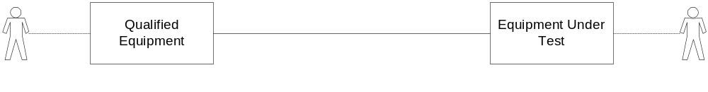
Figure 1: Illustration of interoperability testing
The important factors which characterize interoperability testing are:
- the Equipment Under Test (EUT) and the Qualified Equipment (QE) together define the boundaries for testing (Figure 1);
- the EUT and QE come from different suppliers (or, at least, different product lines);
- interoperability tests are performed at interfaces that offer only normal user control and observation (i.e. not at specialized interfaces introduced solely for testing purposes);
- interoperability tests are based on functionality as experienced by a user (i.e. they are not specified at the protocol level). In this context a user may be human or a software application;
- the tests are performed and observed at functional interfaces such as Man-Machine Interfaces (MMIs), protocol service interfaces and Application Programming Interfaces (APIs).
The fact that interoperability tests are performed at the end points and at functional interfaces means that interoperability test cases can only specify functional behaviour. They cannot explicitly cause or test protocol error behaviour.

8 Conformance testing
The purpose of conformance testing is to determine to what extent a single implementation of a particular standard conforms to the individual requirements of that standard.
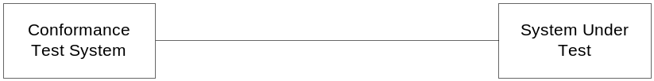
Figure 2: Illustration of conformance testing
The important factors which characterize conformance testing are as follows:
- the System or Implementation Under Test (SUT or IUT) defines the boundaries for testing (Figure 2);
- the tests are executed by a dedicated test system that has full control of the SUT and the ability to observe all communications from the SUT;
- the tests are performed at open standardized interfaces that are not (usually) accessible to a normal user.
(i.e. they are specified at the protocol level).
Because the conformance tester maintains a high degree of control over the sequence and contents of the protocol messages sent to the IUT it is able to explore a wide range of both expected and unexpected (invalid) behaviour.
It is not within the scope of the present document to define a conformance testing methodology. However, because interoperability testing and conformance testing complement one another, the reader of the present document would be well-advised to study the established ISO conformance testing methodology defined in ISO/IEC 9646 parts 1 to 7 [5] as applied in all ETSI conformance test specifications.

9 Combining interoperability testing and conformance testing
Conformance and interoperability are both important and useful approaches to the testing of standardized protocol implementations although it is unlikely that one will ever fully replace the other. Conformance testing is able to show that a particular implementation complies with the protocol requirements specified in the associated base standard. However, it is difficult for such testing to be able to prove that the implementation will interoperate with similar implementations in other products. On the other hand, interoperability testing can clearly demonstrate that two implementations will cooperate to provide the specified end-to-end functions but cannot easily prove that either of them conforms to the detailed requirements of the protocol specification.
The purpose of interoperability testing is not only to show that products from different manufacturers can work together but also to show that these products can interoperate using a specific protocol. Without this additional aspect, interoperability testing could be considered to be almost meaningless. Within the context of standardization, it is of little interest to know that two products can interoperate unless there is a guarantee that they are connected together by means of a standardized protocol. It is, therefore, advisable to test the conformance of an implementation before testing for interoperability with other (similarly tested) implementations.
Although there are quite distinct differences between conformance testing and interoperability testing, it is valid to consider using the techniques together to give combined results. Such an approach will almost certainly involve some compromise and it is unlikely that it would provide the breadth and depth of testing that conformance and interoperability can offer when applied individually. However, some limited conformance testing with extensive interoperability testing, for example, may be useful in certain situations. The test configuration shown in figure 3 permits complete interoperability testing to be undertaken while limited protocol conformance monitoring takes place.
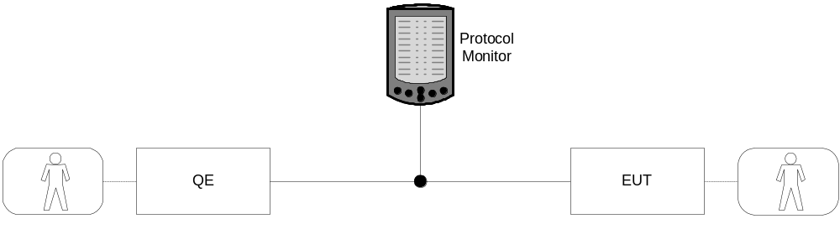
Figure 3: Interoperability testing with conformance monitoring
While this arrangement cannot provide a complete proof of conformance, analysis of the protocol monitor output will be able to show whether protocol signalling between the EUT and QE conformed to the appropriate standard(s) throughout the testing.

10 Interoperability testing process overview
The present document provides users with guidelines on the main steps associated with interoperability testing. The intention is that the guidelines should be simple and pragmatic so that the document can be used as a "cook-book" rather than a rigid prescription of how to perform interoperability testing.
The main components of the guidelines are described in clauses 28 and 47 and are as follows:
- development of interoperability test specifications, including:
- identification of interoperable functions;
- identification of abstract architectures;
- specification of interoperability test suite structure and test purposes;
- specification of interoperability test cases.
- the testing process, including:
- test planning;
- specification of test configurations;
- execution of the tests;
- logging results and producing test reports.
As their name implies, guidelines are only for guidance and the actual process followed should use and adapt whichever of these guidelines are most applicable in each particular situation. In some cases this may mean the application of all aspects.

11 Basic concepts
Figure 4 illustrates the main concepts specified in the present document. It shows the two main components of the methodology, namely the Means of Testing (MoT) and the System Under Test (SUT). The MoT includes the roles of test drivers and a test coordinator, the interoperability test cases and mechanisms for logging and reporting. The SUT comprises the Equipment Under Test (EUT) and one or more Qualified Equipment (QE). The Means of Communication (MoC) between the QE and the EUT is considered to be neither part of the SUT nor of the MoT.

QE
EUT
Means of communication
Test Interface
Test Interface
System Under Test (SUT)
Test Driver
(QE Side)
Test Driver
(EUT Side)
Test Coordinator
Test Cases
Test Logs
Test Reports
Means of Testing (MoT)
Figure 4: Illustration of main concepts

12 Means of Testing
The combination of equipment and procedures that realizes and performs the selection and execution of test cases is known as the Means of Testing (MoT). Test cases may be executed either by a human operator or by an automated program (see clause 19). The MoT should also be capable of logging test results and of producing test reports (see clause 55). The MoT includes neither the System Under Test nor the means by which devices in the System Under Test communicate.

13 Equipment Under Test (EUT)
In any interoperability testing architecture there will always be one connected item which is the subject of the test. This item is referred to as the Equipment Under Test or EUT. In general, any single test configuration will only have one EUT (with the exception of the case illustrated in clause 6.3.2) . An EUT may be end-user equipment (such as a terminal), network equipment (such as a router) or a software application.
EUTs can be composed of any number of component parts each of which is referred to as a device. This may be a physical device, a software package or a combination of the two. The simplest case is where the EUT is a single device.
The interconnection configuration between devices in an EUT is purely a matter for the supplier and is not prescribed in the test architectures, nor is it considered to be an explicit part of the interoperability test for that EUT.
An EUT will not have been previously tested successfully for interoperability in a similar configuration although it may have been tested for conformance. While this methodology does not require previous conformance testing, it is recommended that this activity is performed, for the reasons mentioned in clause 9.

14 Qualified Equipment (QE)

15 QEs and Devices
When testing an EUT for interoperability, it is essential that the test architecture includes equipment that has already been proven to interoperate with similar equipment from other suppliers. Such items are referred to as the Qualified Equipment (QE). Any single test configuration may have one or more QEs. A QE may be end-user equipment (such as a terminal), network equipment (such as a router) or a software application.
QEs can also be composed of a number of component parts, each of which is, again, referred to as a device. This may be a physical device, a software package or a combination of the two. The simplest case is where the QE is a single device. Thus, a QE is a collection of devices that, in a given configuration, has undergone and passed certification based on interoperability testing.
The interconnection configuration between devices in a QE is purely a matter for the test system implementer and is not prescribed in the test architectures.
Any given QE will have initially been tested as an EUT but, once the full range of interoperability tests have been successfully performed, it can be considered to be a QE.
The status of a product being a QE is not final. It may loose this status in case its implementation modified, e.g., when a new version is released, or ifit is found to cause a failure in a troubleshotting analysis of an interoperability test.
NOTE: This methodology uses the concepts of QEs speed up analysis work in practice. In theory, however the status of being QE has to be regained in every single test.

This methodology does not force an EUT to be tested against all possible QEs in the pool of QEs that may be available in a particular testing scheme. However, the likelihood of multi-vendor interoperability is increased if it can be demonstrated that a particular EUT interoperates with a large number of different QEs.

16 Designating the first QE
In cases of new and developing technologies, no Qualified Equipment is likely to exist. The first instance of interoperability testing for a particular scheme will involve two (or more) EUTs rather than a number of QEs and one EUT. For this type of testing the methodology presented in [8] may be used.
Once these EUTs are shown to successfully interoperate, they will all be designated as QEs with none having precedence over any other. The testing scheme can then continue with new EUTs joining the pool of the existing QEs that have already been tested in a given configuration.
It is strongly recommended that both the two initial EUTs have undergone conformance testing prior to interoperability testing.
One or more products may establish themselves also in the community as a reference implementation and gain this way the status of QE by reputation.

17 System Under Test (SUT)
The System Under Test (SUT) is the combination of one or more QEs and one single EUT (with the exception of the case illustrated in clause 6.3.2). It does not, however, include the Means of Communication (MoC) (see clause 22).

18 Test interface
The interfaces that are made available by the SUT in order to perform testing are known as the test interfaces. These interfaces are accessed by the test drivers. Interfaces internal to the SUT may be used for logging and/or analysis but they are not considered to be an essential part of the test configuration.
In the simplest case, a test interface will be the normal user interfaces offered by the product undergoing testing (EUT) and by the QEs that are part of the SUT. Terminal equipment, for example, may be tested using a keypad, or a point-and-click dialog, or a combination of the two. Other EUTs, such as protocol stacks, may offer an API over which interoperability testing can be performed either manually using a terminal application or automatically using programmable test equipment.
An EUT will offer at least one interface to either the test driver and/or the QEs.
Any interface between the SUT and the Means of Communication (see clause 22) is not considered to be a test interface.

19 Test driver
As interoperability testing involves control and observation at the functional (rather than signalling) level, interoperability tests should be described in terms of activities by the user of the endpoint equipment. A test driver realizes the actions specified to be performed in a test case on one specific test interface. In many cases, this user can be considered to be a human but in others it will be more appropriate to think of the user as an application within a software system.
As a means of improving testing efficiency and consistency, the role of the test driver may be performed by an automatic device programmed to carry out the specified test steps.
The following examples illustrate both of these cases:
EXAMPLE 1: Human User: A test architecture is established with two IP telephony terminals connected to the same network supporting VoIP. Interoperability tests are specified at the terminals in terms such as "Take telephone A off-hook; Dial the E.164 number of telephone B etc.".
EXAMPLE 2: Application User: A test architecture is established with two SIP Servers connected together but no user terminals because at the time of testing there are no suitable applications available. Interoperability tests are specified in terms such as "Cause INVITE message to be sent from QE to IP address at EUT; On receipt of INVITE from QE, cause 100 TRYING message to be sent from EUT to QE; etc.".
In the first case, the human test driver will be performing valid tasks of a normal user of the system, using only the interfaces (e.g. MMI) offered by a product. In the second case, the test driver will be manipulating the EUT and the QE by whatever means is possible (for example, over an API) to ensure that specific messages are sent and observed.

20 Test coordinator
In any given instance of testing there will be at least two interfaces over which the tests will be run (see clause 18). The test coordinator is responsible for managing the two (or more) test drivers and synchronizing their actions, if neededs.
The test coordinator is only a conceptual role and, in a practical case of testing, this role may be taken by, for instance, one of the test drivers.

21 Interoperability test cases
An Interoperability test case is the detailed set of instructions (or steps) that needs to be followed in order to perform the test. In the case where the test driver is a human operator, these instructions will be in natural language (see
clause 36). In the case where the tests are automated, they may be written in a programming language or test language such as TTCN-3. The combined test cases should cover all events at each of the available test interfaces.

22 Means of Communication
The QE and EUT are connected by the Means of Communication (MoC). This, for example, may be a simple wire or a complex network of interconnected devices. In all cases this underlying transport mechanism is not considered to be part of the SUT.
It is assumed that the underlying communication layers have been previously tested to establish that they are conformant.

23 Generic interoperability test architectures
Figure 5 shows a generic architecture for interoperability testing. All interoperability testing architectures that show the relationship between the EUT, the QEs and the test operators can be derived from this model. The test driver for the EUT is optional, depending on the kind of equipment being tested. As an example, an EUT which is an interworking function (see clause 25) would probably not require a test driver function.
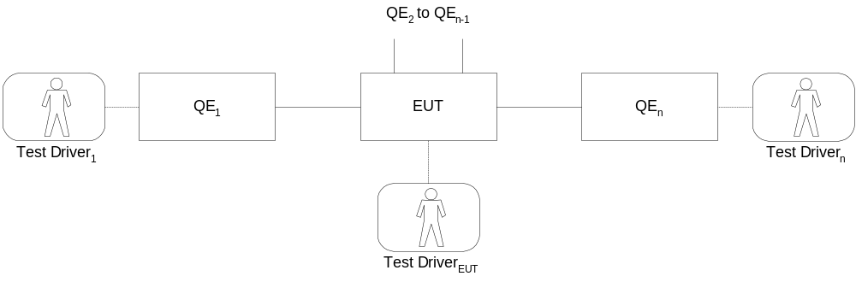
Figure 5: Generalized interoperability testing architecture
For simplicity, figure 5 shows that the QE and the EUT offer only a single interface to a single test driver. However, it is possible that an EUT or QE could offer more than one interface to one or more test drivers. This relationship need not necessarily be a one-to-one mapping.

24 Test architectures with a single QE
Figure 6 shows the simplest architecture where there is only one QE.

Figure 6: Basic interoperability test architecture
A typical example of this would be the case of testing terminal equipment such as a SIP phone from a given manufacturer. The QE is a SIP phone (from a different manufacturer) that has been tested previously. This is illustrated in figure 7.
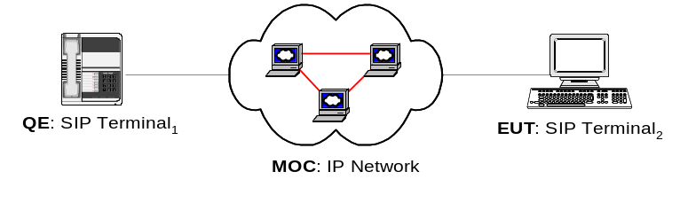
Figure 7: Example of the basic interoperability test architecture for SIP phones

25 Test architectures with multiple QEs
Figure 8 shows the generic architecture for an SUT with two QEs and with no test driver for the EUT.

Figure 8: Basic interoperability test architecture with 2 QEs and no EUT test driver
The generic test architecture in figure 8 is illustrated by the specific example in figure 9 which shows, in abstract form, the interconnection of a SIP Server (the EUT) with two SIP-capable terminals (QE1 and QE2).
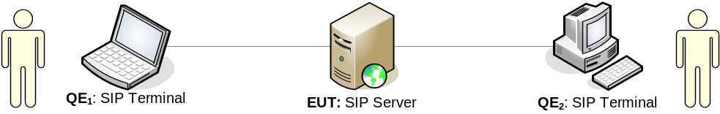
Figure 9: Interoperability test architecture for a SIP Server

26 An example using 3 QEs
Figure 10 shows the generic architecture with 3 QEs and with no test driver for the EUT.
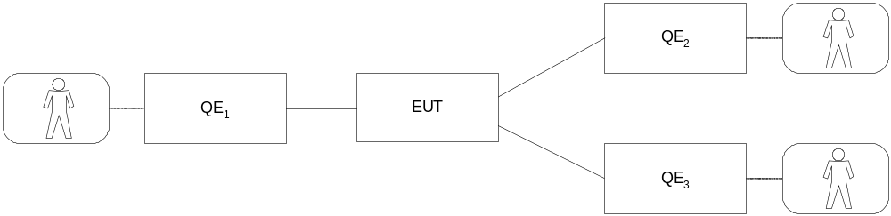
Figure 10: Basic interoperability architecture with 3 QEs and no EUT test driver
A concrete example of this architecture is shown in figure 11 which shows interoperability testing of the call diversion service using three QEs; one to make a call and two to show that the transfer has indeed taken place.
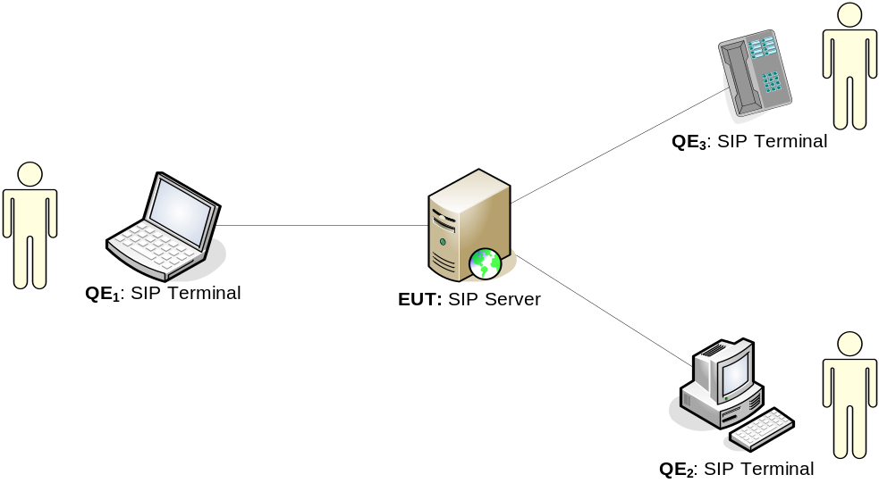
Figure 11: Using three QEs to test the call diversion service

27 Testing IP hosts with multiple QEs
Figure 12 shows a more complex architecture for testing the interoperability of an Internet host (Host4) with routers and other hosts. The Means of Communication in this architecture is the Internet and the Ethernet local network. Because the interplay between the two routers and host is a key part of the test the routers are not included in the MoC.
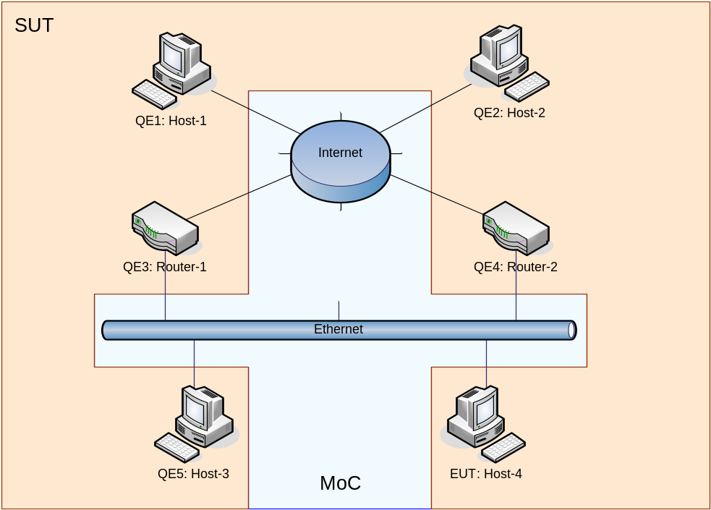
Figure 12: Interoperability testing an IP host with multiple QEs

28 Developing interoperability tests

29 Overview
The development of an interoperability test specification should follow a similar path to that taken when developing a conformance test specification. A close parallel can also be seen between the component parts of each type of test specification.
The steps involved in the process of developing an interoperability test specification are as follows:
- specify abstract architecture;
- prepare draft Interoperable Features Statement (IFS);
- specify Test Suite Structure (TSS);
- write Test Purposes (TP);
- write test cases;
- validate test cases;
- finalize IFS.
This process is expressed graphically in Figure 13.
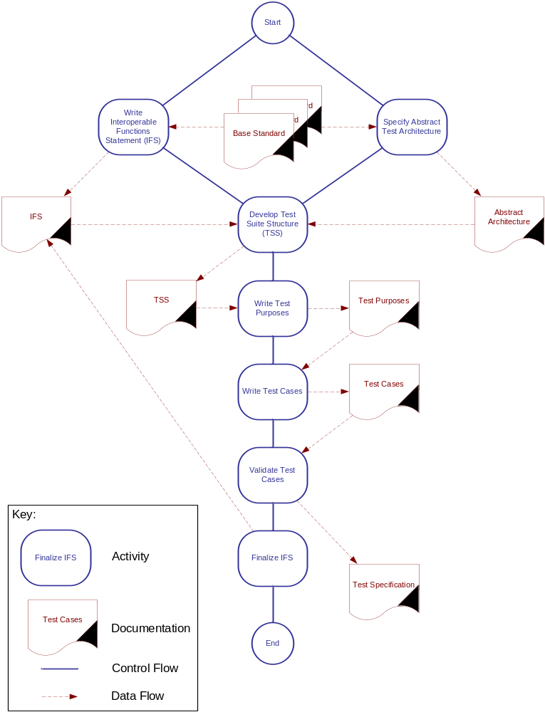
Figure 13: Developing an interoperability test specification

30 Specify abstract architecture
An abstract testing architecture provides a general framework within which specific test arrangements must fit in order to perform the specified suite of tests. Defining this architecture at an early stage should help to provide a structure for the test cases specified later. Abstract architectures can be expressed in diagrammatic, tabular or textual form and should clearly identify:
- the EUT;
- the QE(s);
- the communications paths between the EUT and QE(s);
- valid types of equipment for the EUT and QE(s);
- if required, the expected protocol to be used in providing communication between the EUT and QE(s).
Figure 14 shows in diagrammatic form an example of an abstract architecture for the testing of a stateful SIP proxy. In this example, one SIP proxy is identified as the EUT with another proxy plus two SIP end points identified as QEs. The Means of Communication is not specified although it is implied that it must carry SIP.
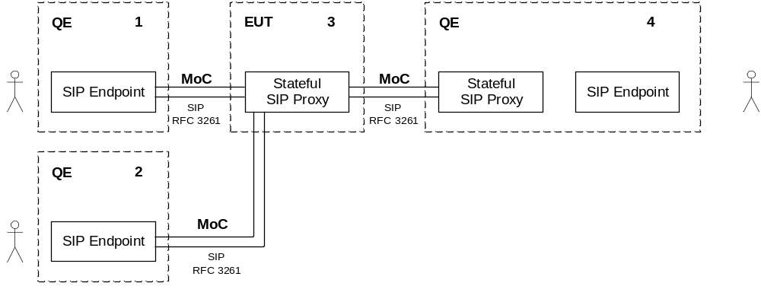
Figure 14: Example abstract architecture diagram
This abstract architecture could equally well be represented in a table, as shown in Table 1.
Table 1: Example abstract architecture table
Item | EUT/QE | Equipment type | Connected to item | MoC
1 | QE | SIP Endpoint | 3 | SIP (RFC 3261 [6])
2 | QE | SIP Endpoint | 3 | SIP (RFC 3261 [6])
3 | EUT | Stateful SIP Proxy | 1 | SIP (RFC 3261 [6])
 |  |  | 2 | SIP (RFC 3261 [6])
 |  |  | 4 | SIP (RFC 3261 [6])
4 | QE | Stateful SIP Proxy + SIP Endpoint | 3 | SIP (RFC 3261 [6])

The abstract architecture should be derived from the requirements of the base protocol standard(s), and should be specified in a form that makes it simple to map each element of a concrete test scenario to it.

31 Prepare draft IFS Proforma
The purpose of an Interoperable Features Statement (IFS) is to identify those standardized functions which an EUT must support, those which are optional and those which are conditional on the support of other functions. Although not strictly part of the interoperability test suite, the IFS helps to provide a structure to the suite of tests which will subsequently be developed.
In addition, the IFS can be used as a proforma by a manufacturer in identifying which functions an EUT will support when interoperating with similar equipment from other manufacturers.
If it exists, the ideal starting point in the development of an IFS is the Protocol Implementation Conformance Statement (PICS) which should clearly identify the options and conditions which apply to the protocol to be tested. Like the PICS, the IFS should be considered part of the base protocol specification and not a testing document.
At this stage of the test suite development, the IFS can only be considered as a complete draft. As the test suite evolves, it is possible that errors and omissions in the IFS will be identified. These should be recorded for correction at a later stage (see clause 46). Example IFSs (for the IETF Internet Key Exchange protocol, IKEv2 [7] and the TIPHON profile of IETF SIP [3]) can be found in annexes A and B.

32 Specify Test Suite Structure

33 Identify test groups
There is no hard and fast rule that can be used to determine how a test suite should be divided up into test groups other than to say that there should be a logical basis to the choice of groups. In many cases, the division will be rather arbitrary and based on the preferences of the author(s). However, the following categorizations should be considered when identifying appropriate test groups within a Test Suite Structure (TSS):
- Abstract architecture: A test group for each valid configuration specified. For example:
- terminal-to-terminal direct;
- terminal-to-terminal via a gatekeeper;
- terminal-to-terminal via an intervening network.
- Functionality: A test group for each of the major functions supported. For example:
- basic voice call establishment;
- basic voice call clearing;
- supplementary service, call transfer.
- Success or failure: A test group for normal behaviour and another for exceptional behaviour.

34 Define test coverage within each test group
Once a logical set of test groups has been defined, the required range of functions to be tested in each group should be specified. As an example, the coverage for a basic voice call establishment test group might include:
- successful call from User A to User B;
- successful call from User B to User A;
- unanswered call from User A to User B;
- unanswered call from User B to User A;
- call attempt from User A to a busy User B;
- call attempt from User B to a busy User A.
NOTE: In the examples above, it would be necessary to have specified the meaning of "User A" and "User B" in the context of the abstract architecture.
There should be enough information in the test coverage to ensure that tests can be specified for all of the interoperable functions of an implementation.

35 Write Test Purposes
Before writing the individual steps that are required to complete a test case, a full description of the objective of each test case should be specified in its Test Purpose (TP). Without this objective, it may not be clear how the test should be defined. The following example explains the intent of the associated test case in enough detail that there should be no ambiguity for the test writer.
Test Purpose: To verify that a call to User B can be successfully established by User A and that speech communication is possible between User A and User B.
It is worth noting that the above example might be considered too complex as a conformance TP in that it specifies two test criteria (successful call establishment and speech communication) but as an interoperability TP, it is perfectly valid.
It is acceptable to write TPs in natural English (as can bee seen in the example above). Indeed, ISO 9646 [5] recommends that test specifications include a concise and unambiguous description of each test which focuses on its purpose. TPs define what is to be tested rather than how the testing is performed and are based on the requirements identified in the relevant standard (or standards) from which the test specification is derived.
There is considerable benefit to be gained by having all TPs written in a similar and consistent way. This can be achieved using the structured Test Purpose notation, TPLan (see ES 202 553).
The benefits of using TPLan are:
- a consistency in test purpose descriptions - less room for misinterpretation;
- a clear identification of the TP pre-conditions, test description, and verdict criteria;
- the ability to check syntax automatically and to highlight it in text editors;
- the ability to graphically or textually render TP descriptions for the needs of different users.
TPLan provides a framework for a consistent representation (format, layout, structure and logical ordering) and a consistent use of words and patterns of words. This is achieved without unnecessarily restricting the expressive power of pure prose. TPLan allows the use of an extendable set of keywords in combination with free-text strings (enclosed by single quotes). Thus, the TP writer has considerable freedom of expression in the use of unstructured text between the keywords. The following example shows how a TP can be fully specified using TPLan.
TP id : TP_CALL_0347
Summary : 'User A is able to call User B'
RQ ref : RQ_003_0592
Role : PINX
Config : CF_CALL_05
TC Ref : TC_CALL_0347

with { User_B idle
and User_A configured 'to be able to make calls to User B'
}
ensure that {
when { User_A initiates a call to the address of User_B }
then { User_B indicates an incoming_call }
when { User_B answers the incoming_call }
then { User_A and User_B can communicate }
}

36 Write test cases

37 Pre-test conditions
In some instances, although not necessarily all, it is useful to be able to specify some pre-conditions to a test case. This often takes the form of instructions for configuring the EUT and QE to ensure that the Test Purpose is met fully. An example of a valid pre-test condition is "Configure EUT and QE to communicate using SIP with G.711 µLaw codec".

38 Test steps and verdicts

39 Test steps
Test cases describe the detailed steps that must be followed in order to achieve the stated purpose of each test. These steps should be specified in a clear and unambiguous way but without placing unreasonable restrictions on how the step is performed. Clarity and precision are important to ensure that the step is followed exactly. The lack of restrictions is necessary if the test could apply to a range of different types of implementation. As an example, the test step "Pick up User A's telephone handset and dial the number of User B" is certainly clear and unambiguous but it can only apply to a classical, physical telephone and not to a soft phone or even a mobile handset. Expressing this step as "Initiate a new call at User A to the address of User B" is no less clear or unambiguous but it can be applied to any type of telephone.

40 Verdicts
At the end of each test case (and, where necessary, interspersed with the test steps) it is important to specify the criterion for assigning a verdict to the test case. This is probably best expressed as a question such as "Can speech from User B be heard and understood?". Verdict criteria need to be specified as clearly and unambiguously as test steps and without restrictions. If a criterion is expressed as a question, it should be constructed in such a way that "Yes" and "No" are the only possible answers and it should be clear which result represents a "Pass" verdict and which represents a "Fail".
Both intermediate and final verdicts should be constructed in such a way that failure automatically implies failure of the overall test. Intermediate verdicts should not be included simply to provide information. As an example, in an interoperability test suite for telephony functions, it would not be necessary to have an intermediate verdict "Is dial-tone present?" if dial-tone is intended to be generated locally. If, on the other hand, dial-tone should (or could) be generated by the remote end, such a verdict would be perfectly valid.
Although it is clear that a "Pass" verdict will always mean that, for a specific test, the EUT and QE(s) interoperate correctly, it may not be the case that a "Fail" verdict implies that they do not. The MoC plays an essential role in almost all interoperability tests but is not part of the SUT (see figure 4). A "Fail" verdict may be caused by a fault or unexpected behaviour in the MoC. Thus, each "Fail" verdict should be investigated thoroughly, possibly using monitoring equipment as shown in figure 3, to determine its root cause before either validating the verdict as a true failure (if the root cause is within the SUT) or retesting (if the root cause is determined to be outside the SUT).

41 Specification of test steps and verdicts
Test steps and verdicts should be specified at the level appropriate to the functions to be tested. For example, if the purpose of an interoperability test suite is to test a telephony application where SIP is the underlying protocol, the test steps should specify actions and observations at the user terminal or agent (e.g. "Answer incoming call" and "Is ringing tone heard?"). If, however, the object is to establish the interoperability of two SIP protocol stacks, the tests should specify actions and observations possible at the application interfaces of the stacks (e.g. "Cause SIP INVITE message to be sent" or "Was 180 Ringing received?").
As interoperability testing most often involves the activation and observation of user functions, it is reasonable for test cases to be specified as series of steps to be performed by human test drivers. Such test cases are more often referred to as Test Descriptions. In situations where automation of user functions is possible, test cases could also be written in any of the following:
- test specification languages (e.g. TTCN-3);
- programming languages (e.g. C++);
- scripting languages (e.g. PERL).
It should be noted that although test cases written only in machine-readable form offer great benefits in terms of repeatability and speed of execution, they cannot, generally, be used by human test drivers as instruction for running the tests manually. Thus, when it is not known how the tests will be performed, it is advisable to write them in a structured form of a natural language such as English. However, while an automated test programme or script can easily accommodate alternative behaviour paths to handle exceptional conditions (such as an unexpected error message), such multiple paths are very difficult to include in a structured and easy-to-read English test description.

42 Example
No assumptions should be made about the knowledge of the EUT or QE possessed by the person (or machine) carrying out the test. The sequence of actions involved in each test case should be specified in full. An example of a complete test case description (including Test Purpose and pre-conditions) is shown in Table 2.
Table 2: Example test description specification
Identifier |  | TC_SS_0001_01
Summary: |  | Supervised call transfer from User B to User A
Test Purpose: |  | ensure that {  when { A call is established between User_C and User_B }  then { User_B can transfer the call from User_B to User_A  after User_B and User_A communicate }  }
TP Identifier |  | TP_SS_0001 | Configuration: | Test Architecture 2
Pre-test conditions: |  | - User A, User B and User C configured with Bearer Capability set to "Speech, 64 kbit/s"  - User A configured to support the Call Transfer service
Step | Test sequence |  |  |  | Verdict
 |  |  |  |  | Pass | Fail
1 | Initiate new call at User C to the address of User B
2 | Accept call at User B
3 | Activate the "recall" button (or equivalent) at User B's terminal
4 | Is dial tone (or an equivalent indication) present at User B's terminal? |  |  |  | Yes | No
5 | Initiate a new call from User B to the address of User A
6 | Is User A's terminal alerting (visual or audible indication)? |  |  |  | Yes | No
7 | Accept call at User A
8 | Apply speech at User A
9 | Can speech from User A be heard and understood at User B? |  |  |  | Yes | No
10 | Can speech from User A be heard and understood at User C? |  |  |  | No | Yes
11 | Apply speech at User B
12 | Can speech from User B be heard and understood at User A? |  |  |  | Yes | No
13 | Can speech from User B be heard and understood at User C? |  |  |  | No | Yes
14 | Clear call at User B
15 | Apply speech at User A
16 | Can speech from User A be heard and understood at User C? |  |  |  | Yes | No
17 | Apply speech at User C
18 | Can speech from User C be heard and understood at User A? |  |  |  | Yes | No
19 | Clear the call at User A
20 | Clear the call at User C
Observations:

43 Pre-amble and post-amble
In the example test description shown in Table 2 it is clear that Steps 1 and 2 are essential for establishing the call and that Steps 19 and 20 are equally necessary for clearing the call but none of these steps play a significant part in the test itself as there are no verdicts associated with them. In conformance testing terminology, they can be considered to be the pre-amble (Steps 1 and 2) and the post-amble (Steps 19 and 20) and it may be useful to segregate these steps from the main testing sequence as shown by the dotted lines in Table 3. Other methods of segregation (such as shading or the use of prefixes to the step numbers) are equally valid and may even be combined for greater effect.
Table 3: Test case example showing segregation of pre-amble and post-amble
Identifier |  | TC_SS_0002_01
Summary: |  | Supervised call transfer from User B to User A
Test Purpose: |  | ensure that {  when { A call is established between User_C and User_B }  then { User_B can transfer the call from User_B to User_A  after User_B and User_A communicate }  }
TP Identifier |  | TP_SS_0001 | Configuration: | Test Architecture 2
Pre-test conditions: |  | - User A, User B and User C configured with Bearer Capability set to "Speech, 64 kbit/s"  - User A configured to support the Call Transfer service
Step | Test sequence |  |  |  | Verdict
 |  |  |  |  | Pass | Fail
P1 | Initiate new call at User C to the address of User B
P2 | Accept call at User B
3 | Activate the "recall" button (or equivalent) at User B's terminal
4 | Is dial tone (or an equivalent indication) present at User B's terminal? |  |  |  | Yes | No
5 | Initiate a new call from User B to the address of User A
6 | Is User A's terminal alerting (visual or audible indication)? |  |  |  | Yes | No
7 | Accept call at User A
8 | Apply speech at User A
9 | Can speech from User A be heard and understood at User B? |  |  |  | Yes | No
10 | Can speech from User A be heard and understood at User C? |  |  |  | No | Yes
11 | Apply speech at User B
12 | Can speech from User B be heard and understood at User A? |  |  |  | Yes | No
13 | Can speech from User B be heard and understood at User C? |  |  |  | No | Yes
14 | Clear call at User B
15 | Apply speech at User A
16 | Can speech from User A be heard and understood at User C? |  |  |  | Yes | No
17 | Apply speech at User C
18 | Can speech from User C be heard and understood at User A? |  |  |  | Yes | No
P19 | Clear the call at User A
P20 | Clear the call at User C
Observations:

44 Alternative test case presentation forms
Test descriptions written in a structured and tabulated natural language (as in Table 3) are ideal when the tests themselves are to be performed manually by human test drivers. If, however, tests are to be performed automatically using computer-based test drivers, test cases should, perhaps, be written in an appropriate programming or scripting language. The following text shows how the example test case could be expressed in the TTCN-3 core language [1].
// Supervised Transfer test case
testcase tc_supervisedTransfer()
runs on UserTerminalType
{ timer t_response := 100E-3;

var default def := activate( a_catchTimeout() );

// Preamble: Establish call between Users B & C
m3s.send (m_CallEstablish_1);
m2s.receive (m_CallEstablish_1);
m2s.send (m_CallAccept_1);
m3s.receive (m_CallAccept_1);

// Register recall test
m2s.send (m_Recall);
t_response.start;

m2d.receive (m_DialTone);
setverdict(pass);
t_response.stop;

// Hold call test
m2s.send (m_CallEstablish_2);
m1s.receive (m_CallEstablish_2);
t_response.start;
m1s.send (m_Alerting);

m2s.receive (m_Alerting)
setverdict(pass);
t_response.stop;

// Speech test 1
m1s.send (m_CallAccept_2);
m2s.receive (m_CallAccept_2);
m1d.send (m_DTMF123456);
t_response.start;
alt
{ [] m3d.receive (m_DTMF123456)
{ setverdict(fail);
stop;
}

[] m2d.receive (m_DTMF123456)
{}
}
setverdict(pass);
ResponseTimer.stop

// Speech test 2
m2d.send (m_DTMF123456);
t_response.start
alt
{ [] m3d.receive (m_DTMF123456)
{ setverdict(fail);
stop
}

[] m1d.receive (m_DTMF123456)
{ setverdict(pass);
t_response.stop
}
}

// Transfer test 1
m2s.send (m_CallRelease_1);
m1d.send (m_DTMF123456);
t_response.start;

m3d.receive (m_DTMF123456)
setverdict(pass);
t_response.stop;

// Transfer test 2
m3d.send (m_DTMF123456);
t_response.start;

m1d.receive (m_DTMF123456)
setverdict(pass);
t_response.stop

// Postamble: Clear down the call
m3s.send (m_CallRelease_2);
m1s.send (mCallRelease_2);

}

}

45 Validate test cases
The ideal method of validating test cases is to set up a physical test configuration and then perform each of the tests to ensure that:
- the specified pre-conditions establish the EUT and QE in the necessary configuration for the test;
- no unnecessary pre-conditions are specified;
- the abstract architecture can be realized in a concrete configuration which enables the specified test to be executed;
- the individual test steps are expressed in an unambiguous way and are easy to follow;
- all necessary steps are covered from the start of the test to its completion;
- each test case fully realizes the objective of its test purpose;
- the combined intermediate and final verdicts do, in fact, lead to a true assessment of the test purpose.
In many cases, it will not be possible to validate the test cases by execution because there will not be suitable equipment available. In such situations, the simplest alternative is to carry out a structured walk-through of each test case (preferably with independent reviewers) checking every step and verdict in turn to assess the completeness and validity of the test case. Further information on walk-through and other validation methods can be found in EG 202 107 [4], "Planning for validation and testing in the standards-making process".

46 Finalize IFS
During the development of the Test Purposes, test description and test cases it is possible that inconsistencies, gaps and other inaccuracies will be identified in the draft IFS. Now that the development is complete, these identified changes should be consolidated into the final IFS ready for publication.

47 Interoperability testing process

48 Overview
Although it is possible to automate interoperability testing, it is likely that test cases will be written in a structured natural language instead of a scripting language, to be followed by human test drivers in case of manual execution. It is, therefore, important to ensure that the defined steps and verdicts of each test case are carefully followed and recorded.
Interoperability testing involves the following three stages:
- preparing for testing;
- testing;
- writing the Test Report.
The process is expressed graphically in Figure 13.
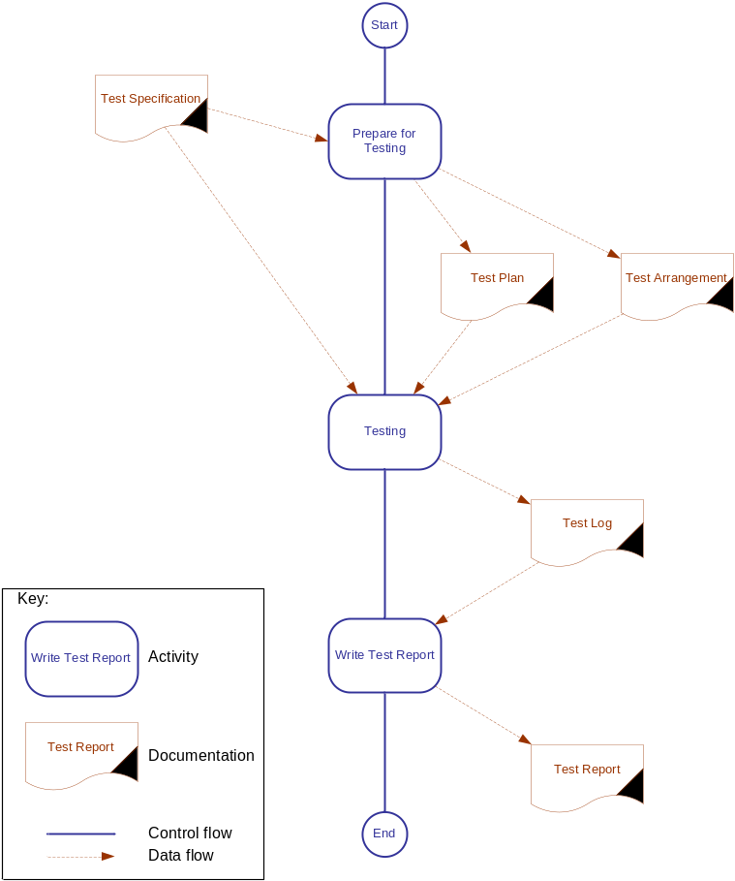
Figure 17: Interoperability testing

49 Prepare for testing

50 Test arrangement
Before actual testing can take place, there are a number of activities that must be completed. The first of these is to specify a test arrangement (Figure 19) mapping the abstract architecture (Figure 18) in the test specification to the concrete configurations that are going to be used for testing. This mapping should identify the manufacturer, product name and build status of the EUT and the QE(s). It should also specify how the various items of equipment are to be physically interconnected.
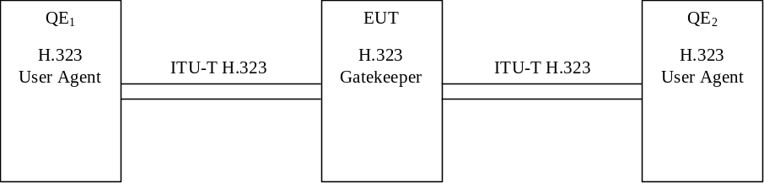
Figure 18: Example of an abstract architecture
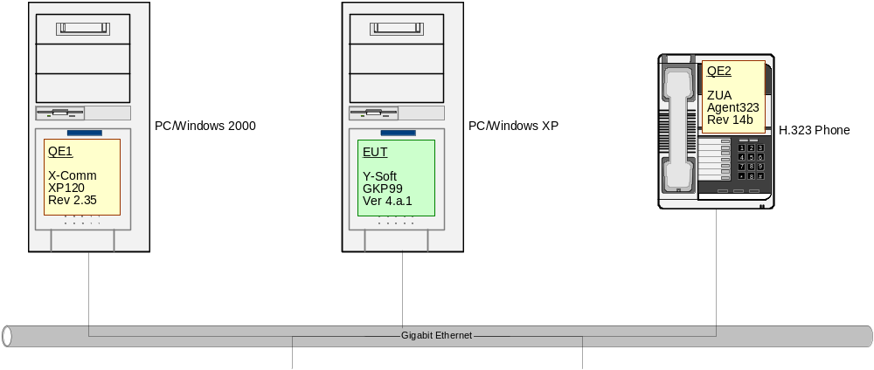
Figure 19: Test arrangement based on the example abstract architecture
In addition to the definition of physical test arrangements, it may also be useful to specify other system configuration requirements which could include items such as the necessary numbering plan and the choice of codecs to be used in the testing.

51 Test planning
It is always advisable to take the time to prepare a plan of testing before beginning the work itself. A test plan should include:
- identification of which test cases are to be included;
- identification of which (optional) test cases are not to be included;
- indication of the order in which the tests are to be performed and the relationships between tests;
- specification of the test arrangements required for each group of tests;
- identification of equipment and facilities required to establish the necessary test configurations;
- identification of the human resources required during the testing period.
The information above should be consolidated into a formal plan against which progress can be monitored. Figure 20 shows an example test plan presented as a Gantt chart although any form of planning diagram (e.g. PERT or Timeline) could also be used.
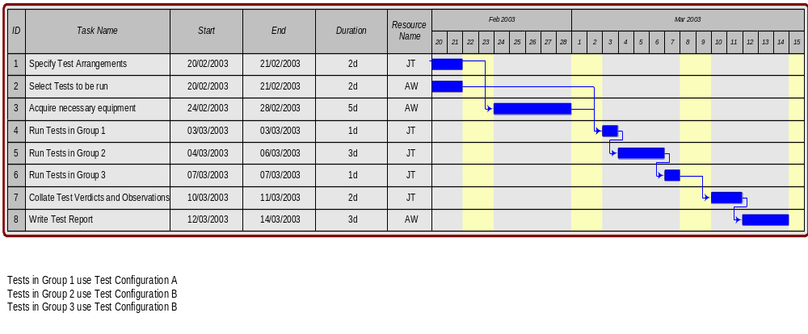
Figure 20: Example test plan

52 Testing

53 Manual testing
The sequence of tests specified should be grouped in a logical way that ensures efficient use of test configurations and a "bottom-up" flow of tests (testing basic functionality first and then progressing to more complex functions). It is, therefore, important to carry out the tests in the sequence specified, exactly following the steps defined in each test case.
Throughout the testing process, it is essential that a record of each verdict (both intermediate and final) is kept for each test case. If the test cases are specified in a tabular form, this can be used as a proforma for logging the test results. Alternatively, a simple table listing each of the test cases and their associated verdicts could be used. An example of how such a table could be constructed is shown in Table 4.
Table 4: Example table summarizing test verdicts
Test case | Title | Verdict |  |  |  |  |  | Overall verdict | Observations
Test case | Title | 1 | 2 | 3 | 4 | 5 | 6 | Overall verdict | Observations
BS-1 | Voice call establishment from User A to User B | ✓ | ✓ | ✓ | ✓ | ✓ | ✓ | Pass
BS-2 | Voice call establishment from User B to User A | ✓ | ✓ | ✓ | ✓ | ✓ | ✓ | Pass
BS-3 | Call establishment from User A to User B using en-bloc sending | ✗ |  |  |  |  |  | Fail | User B's terminal failed to alert although ringing tone was heard at User A's terminal

Table 4 shows a test summary in fairly simple form. If necessary, additional information, such as a time-stamp or identification of the test driver(s), can be included.

54 Automated testing
If the test cases have been automated (as described in clause 41), the sequencing of tests and the logging of verdicts will be predetermined by the test programme. It will still be necessary to take care in establishing and modifying the test arrangements as required to ensure that the expected configurations are tested.

55 Write test report
A test report should summarize the testing activity and provide a clear indication of whether the tested equipment can be considered to be interoperable or not. It should include the following:
- Organizational information:
- when the testing took place;
- where the testing took place;
- who carried out the testing.
- Equipment information:
- test configurations used;
- hardware and software identities for EUT and all QEs;
- hardware and software revision states for EUT and all QEs;
- identification of the standards (including versions) implemented in each MoC.
- Testing information:
- identification of the specific test specification upon which the testing was based;
- identification of omitted tests (with a reason for omission if appropriate);
- full summary of test verdicts.

Annex A (informative):
Example IFS (Internet Key Exchange protocol, IKEv2)

A.1 Introduction
The supplier of an Internet Key Exchange version 2 (IKEv2) protocol implementation which is claimed to conform to RFC 4306 [7] may complete the following Interoperable Features Statement (IFS) proforma if the implementation is to be submitted for interoperability testing. The IFS is a statement of which functions supported by the protocol have been implemented. The IFS can have a number of uses, including:
- as a detailed indication of the functional capabilities of the implementation;
- as a basis for initially checking the possibility of interoperating with another implementation;
- as the basis for selecting appropriate tests against which to assess the ability of the implementation to interoperate with other implementations.

A.2 Instructions for completing the IFS proforma

A.2.1 General structure of the IFS proforma
The IFS proforma is a fixed format questionnaire divided into clauses and sub-clauses each containing a group of individual items. Each item is identified by an item number, the name of the item (question to be answered), and the reference(s) to the clause(s) that specifies (specify) the item in the main body of the standard.
The "Status" column indicates whether an item is applicable and if so whether support is mandatory or optional. The following terms are used:
M mandatory (the function is required by RFC 4306 [7]);
O optional (the function is not required by RFC 4306 [7], but if the function is implemented, it is required to conform to the protocol specifications);
O.<n> optional, but support of at least one of the group of options labelled by the same numeral <n> is required;
C:<cond> conditional requirement, depending on support for the item or items listed in condition <cond> explained below the table of appearance;
N/A not applicable, this feature is not contained in the profile.
References to the specification are made in the column "Reference".
Answers to the questionnaire items are to be provided either in the "Support" column, by simply marking an answer to indicate a restricted choice (Yes or No), or in the "Not Applicable" column (N/A).

A.2.2 Additional information
Items of additional information allow a supplier to provide further information intended to assist the interpretation of the IFS. It is not intended or expected that a large quantity will be supplied, and a IFS can be considered complete without any such information. Examples might be an outline of the ways in which a (single) implementation can be set up to operate in a variety of environments and configurations.
References to items of additional information may be entered next to any answer in the questionnaire, and may be included in items of exception information.

A.3 IFS proforma

A.3.1 Implementation identification
Supplier

Contact point for queries about the IFS

Implementation name(s) and version(s) (see note)

Other information necessary for full identification - e.g. name(s) and version(s) for machines and/or operating systems; system name(s)
NOTE: The terms name and version should be interpreted appropriately to correspond with a suppliers terminology (e.g. type, series, model).

A.3.2 Protocol Summary, RFC 4306
Protocol version
Addenda implemented (if applicable)
Amendments implemented
Date of statement

A.4 IKEv2 entities
Table A.1: IKEv2 entities
Item | IKEv2 entities | Reference | Support
IE_1 | IKE Endpoint
Comments:

A.4.1 Roles
Table A.2: IKE Endpoint roles
Item | Role | Reference | Support
EP_1 | Initiator | RFC 4306 [7]
EP_2 | Responder | RFC 4306 [7]
Comments:

A.4.2 IKEv2 Initiator functions

A.4.2.1 IKE exchange types
Table A.3: Initiator's IKE exchange types
Item | Function | Reference | Status | Support
IX_1 | IKE (parent) SA establishment | 1.2 | M
IX_2 | Child SA establishment | 1.3 | M
IX_3 | INFORMATIONAL exchange | 1.4 | M
Comments:

A.4.2.1.1 IKE SA establishment functions
Table A.4: Initiator's IKE SA establishment functions
Item | Function | Reference | Status | Support
IS_1 | Use of retransmission timers | 2.1 | M
IS_2 | Use of sequence numbers for Message ID | 2.2, 3.1 | M
IS_3 | Window Size for overlapping requests | 2.3, 3.10.1 | M
IS_4 | State synchronization & connection timeouts | 2.4 | M
IS_5 | Version number and forward compatibility | 2.5, 3.1 | M
IS_6 | Cookies | 2.6, 3.10.1 | M
IS_7 | Cryptographic Algorithm Negotiation | 2.7, 3.3.2 | M
IS_8 | Rekeying | 2.8, 2.17, 3.10.1 | M
IS_9 | Authentication of the IKE_SA | 2.15, 3.8 | M
IS_10 | Extensible Authentication Protocol Method | 2.16, 3.16 | M
IS_11 | Error handling | 2.21, 3.10.1 | M
IS_12 | NAT Traversal | 2.23, 3,10.1 | M
Comments:

A.4.2.1.2 Child SA establishment functions
Table A.5: Initiator's Child SA establishment functions
Item | Function | Reference | Status | Support
IC_1 | Use of retransmission timers | 2.1 | M
IC_2 | Use of sequence numbers for Message ID | 2.2, 3.1 | M
IC_3 | Window Size for overlapping requests | 2.3, 3.10.1 | M
IC_4 | State synchronization & connection timeouts | 2.4 | M
IC_5 | Version number and forward compatibility | 2.5, 3.1 | M
IC_8 | Cookies | 2.6, 3.10.1 | M
IC_6 | Rekeying | 2.8, 2.17, 3.10.1 | M
IC_7 | Traffic Selector Negotiation * | 2.9, 3.13 | M
IC_8 | Requesting an internal address on a remote network * | 2.19, 3.15 | O
IC_9 | Error handling | 2.21, 3.10.1 | M
IC_10 | IP Compression (IPComp) * | 2.22, 3.10.1 | O
Comments:
* Included in the implicit establishment of a Child SA as part of an IKE SA establishment.

A.4.2.1.3 INFORMATIONAL exchange functions
Table A.6: Initiator's INFORMATIONAL exchange functions
Item | Function | Reference | Status | Support
II_1 | Notification exchange | 1.4, 3.10 | M
II_2 | Delete exchange | 1.4, 3.11 | M
II_3 | Configuration exchange | 1.4, 3.15 | M
II_4 | Informational messages outside an IKE_SA | 1.5 | O
II_5 | Use of retransmission timers | 2.1 | M
II_6 | Use of sequence numbers for Message ID | 2.2, 3.1 | M
II_7 | Window size for overlapping requests | 2.3, 3.10.1 | M
II_8 | Version numbers and forward compatibility | 2.5, 3.1 | M
II_9 | Requesting the peer's version | 2.20, 3.15 | O
II_10 | Error handling | 2.21, 3.10.1 | M
Comments:

A.4.3 IKEv2 Responder functions

A.4.3.1 IKE exchange types
Table A.7: Responder's IKE exchange types
Item | Function | Reference | Status | Support
RX_4 | IKE (parent) SA establishment | 1.2 | M
RX_5 | Child SA establishment | 1.3 | M
RX_6 | INFORMATIONAL exchange | 1.4 | M
Comments:

A.4.3.1.1 IKE SA establishment functions
Table A.8: Responder's IKE SA establishment functions
Item | Function | Reference | Status | Support
RS_13 | Use of sequence numbers for Message ID | 2.2, 3.1 | M
RS_14 | Window Size for overlapping requests | 2.3, 3.10.1 | M
RS_15 | Version number and forward compatibility | 2.5, 3.1 | M
RS_16 | Cookies | 2.6, 3.10.1 | M
RS_17 | Cryptographic Algorithm Negotiation | 2.7, 3.3.2 | M
RS_18 | Rekeying | 2.8, 2.17, 3.10.1 | M
RS_1 | Address and port agility | 2.11 | M
RS_19 | Authentication of the IKE_SA | 2.15, 3.8 | M
RS_20 | Extensible Authentication Protocol Method | 2.16, 3.16 | M
RS_21 | Error handling | 2.21, 3.10.1 | M
RS_22 | NAT Traversal | 2.23, 3,10.1 | M
Comments:

A.4.3.1.2 Child SA establishment functions
Table A.9: Responder's Child SA establishment functions
Item | Function | Reference | Status | Support
RC_11 | Use of sequence numbers for Message ID | 2.2, 3.1 | M
RC_12 | Window Size for overlapping requests | 2.3, 3.10.1 | M
RC_13 | Version number and forward compatibility | 2.5, 3.1 | M
RC_8 | Cookies | 2.6, 3.10.1 | M
RC_14 | Rekeying | 2.8, 2.17, 3.10.1 | M
RC_15 | Traffic Selector Negotiation * | 2.9, 3.13 | M
RC_1 | Address and port agility | 2.11 | M
RC_16 | Requesting an internal address on a remote network * | 2.19, 3.15 | O
RC_17 | Error handling | 2.21, 3.10.1 | M
RC_18 | IP Compression (IPComp) * | 2.22, 3.10.1 | O
Comments:
* Included in the implicit establishment of a Child SA as part of an IKE SA establishment.

A.4.3.1.3 INFORMATIONAL exchange functions
Table A.10: Responder's INFORMATIONAL exchange functions
Item | Function | Reference | Status | Support
RI_11 | Notification exchange | 1.4, 3.10 | M
RI_12 | Delete exchange | 1.4, 3.11 | M
RI_13 | Configuration exchange | 1.4, 3.15 | M
RI_14 | Informational messages outside an IKE_SA | 1.5 | O
RI_15 | Use of sequence numbers for Message ID | 2.2, 3.1 | M
RI_16 | Window size for overlapping requests | 2.3, 3.10.1 | M
RI_17 | Version numbers and forward compatibility | 2.5, 3.1 | M
RI_5 | Address and port agility | 2.11 | M
RI_18 | Requesting the peer's version | 2.20, 3.15 | O
RI_19 | Error handling | 2.21, 3.10.1 | M
Comments:

Annex B (informative):
Example IFS (TIPHON Profile of SIP, Release 3)

B.1 Introduction
The supplier of a protocol implementation which is claimed to conform to TS 101 884 [3] may complete the following Interoperable Features Statement (IFS) proforma if the implementation is to be submitted for interoperability testing. The IFS is a statement of which functions supported by the protocol have been implemented. The IFS can have a number of uses, including:
- as a detailed indication of the functional capabilities of the implementation;
- as a basis for initially checking the possibility of interoperating with another implementation;
- as the basis for selecting appropriate tests against which to assess the ability of the implementation to interoperate with other implementations.

B.2 Instructions for completing the IFS proforma

B.2.1 General structure of the IFS proforma
The IFS proforma is a fixed format questionnaire divided into clauses and sub-clauses each containing a group of individual items. Each item is identified by an item number, the name of the item (question to be answered), and the reference(s) to the clause(s) that specifies (specify) the item in the main body of the standard.
The "Status" column indicates whether an item is applicable and if so whether support is mandatory or optional. The following terms are used:
M mandatory (the function is required by TS 101 884 [3]);
O optional (the function is not required by TS 101 884 [3], but if the function is implemented, it is required to conform to the protocol specifications);
O.<n> optional, but support of at least one of the group of options labelled by the same numeral <n> is required;
C.<cond> conditional requirement, depending on support for the item or items listed in condition <cond> explained below the table of appearance;
N/A not applicable, this feature is not contained in the profile.
References to the specification are made in the column "Reference".
Answers to the questionnaire items are to be provided either in the "Support" column, by simply marking an answer to indicate a restricted choice (Yes or No), or in the "Not Applicable" column (N/A).

B.2.2 Additional information
Items of additional information allow a supplier to provide further information intended to assist the interpretation of the IFS. It is not intended or expected that a large quantity will be supplied, and a IFS can be considered complete without any such information. Examples might be an outline of the ways in which a (single) implementation can be set up to operate in a variety of environments and configurations.
References to items of additional information may be entered next to any answer in the questionnaire, and may be included in items of exception information.

B.3 IFS proforma

B.3.1 Implementation identification
Supplier

Contact point for queries about the IFS

Implementation name(s) and version(s) (see note)

Other information necessary for full identification - e.g. name(s) and version(s) for machines and/or operating systems; system name(s)
NOTE: The terms name and version should be interpreted appropriately to correspond with a suppliers terminology (e.g. type, series, model).

B.3.2 Protocol Summary, EN 301 xxx
Protocol version
Addenda implemented (if applicable)
Amendments implemented
Date of statement

B.4 SIP entities
Table B.1: SIP entities
Item | SIP entities | Reference | Support
SE1 | User agent
SE2 | Registrar
SE3 | Proxy
SE4 | Gateway
Comments:

B.4.1 Roles
Table B.2: User agent roles
Item | Role | Reference | Support
UA1 | Originating user agent
UA2 | Terminating user agent
Comments: The roles "originating" and "terminating" apply to a User Agent's role regarding a call. Since a user agent is going to take each position during its usage the capabilities are not listed separately in the following clauses. If there are capabilities that apply only for one role the status field will show a "condition" that will be explained below the corresponding table.

Table B.3: Registrar roles
Item | Role | Reference | Support
RE1 | Registrar in the home network
Comments:

Table B.4: Proxy roles
Item | Role | Reference | Support
PR1 | Proxy in serving network
PR2 | Proxy in intermediate network
PR3 | Proxy in home network
Comments:

Table B.5: Gateway roles
Item | Role | Reference | Support
GW1 | Originating gateway
GW2 | Terminating gateway
Comments: The roles "originating" and "terminating" apply to a gateway's role regarding a call. Since a gateway is going to take each position during its usage the capabilities are not listed separately in the corresponding clauses. If there are capabilities that apply only for one role the status field will show a "condition" that will be explained below the corresponding table.

B.4.2 User Agent capabilities

B.4.2.1 Registration
Table B.6: User Agent registration capabilities
Item | Function | Reference | Status | Support
U_REG1 | Unicast registration | [3] 5.1.1 | M
U_REG2 | Multicast registration | [6] 10.2.6 | O
U_REG3 | Authenticated registration | [3] 5.1.1.1 | M
U_REG3 | Additive registration | [3] 5.1.1.1 | M
U_REG4 | Refreshing contact addresses | [3] 5.2.1 | M
U_REG5 | Removing contact addresses/Deregistration | [3] 5.3.1 | M
Comments:

B.4.2.2 Basic call
Table B.7: User agent basic call capabilities
Item | Function | Reference | Status | Support
U_BC1 | Call establishment without authentication | [3] 5.2.2.1.1 | M
U_BC2 | Call establishment with authentication | [3] 6.2.1 | O
U_BC3 | Call clearing of an active call | [3] 6.2.1 | M
U_BC4 | Call clearing before destination answers | [3] 6.2.1 | M
U_BC5 | Rejection of incoming call | [3] 6.2.1.1 | M
U_BC6 | Call clearing authenticated | [3] 6.2.1.2 | M
Comments:

B.4.3 Registrar capabilities

B.4.3.1 Registration
Table B.8: Registrar capabilities
Item | Function | Reference | Status | Support
U_REG1 | Unicast registration | [3] 5.1.1 | M
U_REG2 | Multicast registration | [6] 10.2.6 | O
U_REG3 | Authenticated registration | [3] 5.1.2.1.1 | M
U_REG4 | Additive registration | [3] 5.1.1.1 | M
U_REG5 | Refreshing contact addresses | [3] 5.2.2 | M
U_REG6 | Removing contact addresses/Deregistration | [3] 5.3.2 | M
Comments:

B.4.4 Proxy capabilities

B.4.4.1 Proxy in the serving and intermediate network

B.4.4.1.1 Registration
Table B.9: Serving/Intermediate proxy registration capabilities
Item | Function | Reference | Status | Support
S_REG1 | Unicast registration | [3] 5.1.2 | M
S_REG2 | Multicast registration | [6] 10.2.6 | C.1
S_REG3 | Additive registration | [3] 5.1.1.1 | M
S_REG4 | Refreshing contact addresses | [3] 5.2.3 | M
S_REG5 | Removing contact addresses/Deregistration | [3] 5.3.3 | M
Comments:

C.1: if PR1 then M else N/A.

B.4.4.1.2 Basic call
Table B.10: Serving/Intermediate proxy basic call capabilities
Item | Function | Reference | Status | Support
S_BC1 | Call establishment without authentication | [3] 6.3.1 | M
S_BC2 | Call clearing of an active call | [3] 6.3.1 | M
S_BC3 | Call clearing before destination answers | [3] 6.3.1 | M
Comments:

B.4.4.2 Proxy in the home network

B.4.4.2.1 Registration
Table B.11: Home proxy registration capabilities
Item | Function | Reference | Status | Support
H_REG1 | Unicast registration | [3] 5.1.2 | M
H_REG3 | Additive registration | [3] 5.1.1.1 | M
H_REG4 | Refreshing contact addresses | [3] 5.2.2 | M
H_REG5 | Removing contact addresses/Deregistration | [3] 5.3.3 | M
Comments:

B.4.4.2.2 Basic call
Table B.12: Home proxy basic call capabilities
Item | Function | Reference | Status | Support
H_BC1 | Call establishment with authentication | [3] 6.4.1 | M
H_BC2 | Call clearing of an active call | [3] 6.4.2 | M
H_BC3 | Call clearing before destination answers | [3] 6.4.2 | M
H_BC4 | Call clearing authenticated | [3] 6.4.2 | M
Comments:

B.4.5 Gateway capabilities

B.4.5.1 Basic call
Table B.13: User agent basic call capabilities
Item | Function | Reference | Status | Support
G_BC1 | Call establishment without authentication | [3] 5.2.2.1.1 | M
G_BC2 | Call establishment with authentication | [3] 6.10.1 | C.1
G_BC3 | Call clearing of an active call | [3] 6.9/6.10.2 | M
G_BC4 | Call clearing before destination answers | [3] 6.10.2 | C.2
Comments:

C.1: if GW1 then O else N/A.
C.2: if GW1 then M else N/A.

Annex C (informative):
Bibliography
"Interconnectability testing method-AICTS", Sawai, K.; Konno, T.; Hatafuku, M.; Gotoh, K.; Suzuki, S.; Kazama, K., Networks, 1995. Theme: Electrotechnology 2000: Communications and Networks. [in conjunction with the] International Conference on Information Engineering, Proceedings of IEEE Singapore International Conference on, 1995 Page(s): 289 - 293.
"Relating interoperability testing with conformance testing", Sungwon Kang, Global Telecommunications Conference, 1998. GLOBECOM 1998. The Bridge to Global Integration. IEEE, Volume: 6, 1998 Page(s): 3768 -3773 vol.6.
"Interoperability testing of VoIP systems", Griffeth, N.; Hao, R.; Lee, D. Sinha, R.K.; Global Telecommunications Conference, 2000. GLOBECOM '00. IEEE, Volume: 3, 2000 Page(s): 1565 -1570 vol.3.
IEEE 100: "The Authoritative Dictionary of IEEE Standards Terms", Seventh Edition.
ETSI ES 202 553: "Methods for testing and Specification (MTS); TPLan: A notation for expressing test Purposes".

History
Document history
V1.1.2 | April 2007 | Publication
V1.1.3 | Mar 2010 | Change proposals by STF 370:  - Clarification should that the status of being a QE is not absolute but relative. It is subject to agreement by parties, needs to be regained after any change to a QE (in code or hardware, etc.)  - Update of core language code to ETSI naming conventions. Removed GFT as it has not established itself as a main stream presentation format.  - Update to designation of first QE  - Clarification in scope that this standard looks a IOT in context of product certification  - Revised Figure 4. And updated figure references in general

