|  |  |  |  |
| --- | --- | --- | --- |
|  | | | |
| **Title*:** | **Synchronizing ETSI and ITU-T TTCN-3 publications** (Comparing ITU-T AAP and ETSI MAP to find sync. points) | | |
|  |  | | |
| from **Source**\*: | ETSI SecretariatI | | |
| Contact: | Laurent Vreck | | |
|  |  | | |
| input for **Committee**\***:** | MTS | | |
|  |  | | |
| Contribution **For*:** | Decision |  |  |
|  | Discussion | **X** |  |
|  | Information |  |  |
|  |  | | |
| Submission date**\***: | 2011-03-07 | | |
|  |  | | |
| Meeting & Allocation: | MTS#53 - | | |
| Relevant WI(s), or deliverable(s): | Future editions of TTCN-3 deliverables. | | |
|  | | | |

**ABSTRACT:** *This contribution compares the ETSI and the ITU-T standard making processes and intends to propose points of synchronization aiming at a simultaneous publication of the TTCN-3 Standards by ETSI and ITU-T.*

The present analysis aims at finding « synchronization points » between the two processes in order to:

1- Allow ETSI MTS and ITU-T SG17 to both publish aligned releases of the TTCN-3 standard with the **minimum delay** possiblebetween the two publications (ETSI ES 201 873-x and ITU-T Z.160).

2- Ensure that **editorial adjustments** (between ITU-T and ETSI editing departments) can be resolved before publication.

This proposal **does not** aim at a joint-approval of the TTCN-3 drafts by MTS and SG17. The TTCN-3 standards (ETSI ES 201 873-x) are and remain maintained at ETSI by TC MTS. Discussions and decisions related to their technical aspects take place in ETSI. Technical changes can be proposed to MTS either by direct contribution of ETSI members or by the means of Liaison Statement (from ITU-T SG17). Technical Changes Requests contained in Liaison Statements received by MTS will we treated with care and consideration, however their implementation (when accepted) in a release will depend on the release status.

As a result, the foremost goal of the present proposal is to guarantee **sufficient delay** for the exchange of editorial adjustments between the two parties (ITU-T and ETSI) and their inclusion in the on-going TTCN-3 release.

The synchronization of technical changes **in the same release** is not the object of this proposal. This would require a more complex mechanism, which may imply:

* organisation of joint meetings for CR review & approval (to avoid back-and-forth re-approval of CRs & drafts)
* synchronization of approval periods:
  + - ITU-T: SG17 meetings, Last Call, Additional Review,…
    - ETSI: MTS meetings, AbC, Member Vote
* addition of “waiting points” in the processes (additional delay),
* organization of joint meetings for the resolution of comments.

If the two groups express the will for such a closer cooperation, then a second analysis will be carried over.

Note: this analysis only encompasses ETSI ESs and EGs deliverable types (TTCN-3 series are ESs), other types of ETSI deliverables are not covered since they do not follow the same approval and publication processes.

*If you are familiar with both ETSI and ITU-T Standard Making Processes, then jump directly to page 4.*

**ETSI MAP Process:**



The **M**ember **A**pproval **P**rocess of a draft deliverable starts once the draft has reached TB Approval status **(I)**.

The TB Approval of a draft by its parent Technical Body can be reached in 2 ways:

- **Approval during a meeting**: approval must be announced on the meeting agenda, and final draft must be available for at least 30 days before to the face-to-face approval.

- **Approval by Correspondence (AbC)**: the final draft is available and its approval takes place electronically during a period of 30 days. If consensus is reached at the end of the period the draft is then considered as TB Approved.

MAP can start…

**(I)** The draft, approved by the Technical Body is submitted to the ETSI Secretariat within 30 days of the TB approval.

**(II)** Providing that the draft complies with the ETSI Drafting Rules, the ETSI Secretariat prepares the draft for submission to the members within 30 days.

**(III)** The vote is performed over a period of 60 days and involves each ETSI full and associate member.

**(IV)** The ETSI Secretariat prepares a voting report within 15 days. The report is made available to all ETSI members.

**(V)** If the vote is **successful**, the ETSI Secretariat shall, within 15 days, publish the ES (or EG) without modifications (other than editorial).

**(VI)** If the vote is **unsuccessful**, the TB Chairman shall decide on how to proceed with the ETSI work item.

Editorial adjustments can take place before and after MTS approval **(I).** In theory it is possible to correct editorial errors until the draft is published, however, in practice, changes arriving after the end of the Members Vote ***(IV)***are likely to arrive too late.

**ITU-T AAP Process:** (extracted from ITU-T A.8-200810-I “Alternative approval process for new and revised ITU-T Recommendations”)

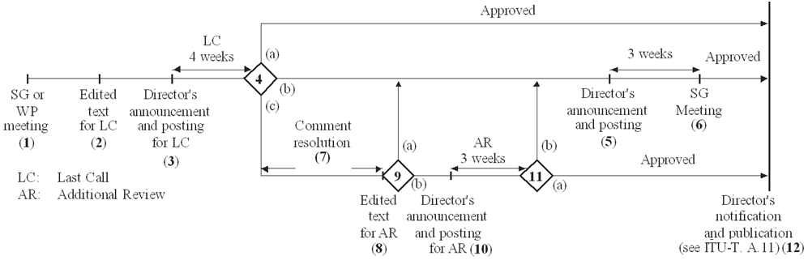

1) *SG or WP consent*

2) *Edited text available* – The final, edited, draft text is provided to TSB

3) *Director's last call announcement and posting* – The Director announces the beginning of the last call […].

4) *Last call judgement* – The study group chairman, in consultation with TSB, makes the judgement whether:

a) no comments other than those indicating typographical errors have been received. In this case, the Recommendation is considered as approved;

b) a planned study group meeting is sufficiently close to consider the comments received; or

c) to save time and/or because of the nature and maturity of the work, comment resolution should be initiated leading to the preparation of edited texts.

5) *Director's study group announcement and posting* – The Director announces that the next study group meeting will consider the draft Recommendation for approval and will include reference to either:

a) the draft Recommendation (the edited text (LC) version) plus the comments received from the last call; or

b) if comment resolution has been carried out, the revised draft Recommendation text.

6) *Study group decision meeting* – The study group meeting reviews and addresses all written comments and either:

a) proceeds under WTSA Resolution 1 or clause 5.8,[…] or

b) approves the draft Recommendation; or

c) does not approve the draft Recommendation. If it is concluded that a further attempt at addressing comments received is appropriate, then additional work should be done and the process returns to step 2 (without further CONSENT at a working party or study group meeting).

7) *Comment resolution* – The study group chairman, with assistance from TSB and experts, via electronic correspondence and rapporteur and working party meetings, where appropriate, addresses the comments and prepares a new edited draft Recommendation text.

8) *Edited text available* – The revised edited text, including summary, is provided to TSB.

9) *Next step judgement* – The study group chairman, in consultation with TSB, makes the judgement whether:

a) a planned study group meeting is sufficiently close to consider the draft Recommendation for approval; or

b) to save time and/or because of the nature and maturity of the work, an additional review should be initiated.

10) *Director's additional review announcement and posting* – The Director announces the beginning of the additional review […].

11) *Additional review judgement* – The study group chairman, in consultation with TSB, makes the judgement whether:

a) no comments other than those indicating typographical errors have been received. In this case, the Recommendation is considered approved or

b) comments other than those indicating typographical errors have been received. In this case, the process proceeds to the study group meeting .

12) *Director's notification* – The Director notifies the members that the draft Recommendation has been approved.

**A**: After MTS Approval and final editing by ETSI secretariat, drafts are sent to SG17 (Liaison) BEFORE a SG17 meeting, in order to reach CONSENT (no electronic CONSENT).



**B**: ITU issue a summary of proposed adjustments (either after their editing *(2)* of after the Last Call *(4*)). These adjustments must be received by ETSI before the end of the Members Vote so that they can be considered all at once together with the comments submitted by ETSI members during the vote (if any).

Ideally, a rapporteur’s conference call should be organized after the end of the Members Vote **(IV)** to inform TTCN-3 rapporteurs of the suggested changes received both from ITU and from the Members Vote … ETSI & ITU editing teams could be involved to ensure a good synchronization of the alignments to be done.

**C**: all accepted editorial adjustments are included in the drafts. **D**: editorial changes received during MV are forwarded to ITU-T (not needed if conf-call).

**Implication:**

Sync point **A** has to happen before an SG17 meeting, i.e. AbC of the TTCN-3 drafts should start no later than 60 days before the SG17 meeting.

A look at the SG17 meeting calendar for 2011-2012 shows that the next potential window for synchronisation would take place in early 2012:

|  |  |  |  |  |  |
| --- | --- | --- | --- | --- | --- |
| **Start Date** | **End Date** | **Group** | **Title** | **Place** | **Status** |
| 2011-04-11 | 2011-04-20 | SG/WP 17 | Security | [Geneva] | Confirmed |
| 2011-08-24 | 2011-09-02 | SG/WP 17 | Security | [Geneva] | Proposed |
| **2012-02-20** | **2012-03-02** | **SG/WP 17** | **Security** | **[Geneva]** | **Planned** |
| 2012-09-03 | 2012-09-07 | SG/WP 17 | Security | [Geneva] | Planned |

* TTCN-3 Drafts AbC would start by mid/end Dec
* AbC would end by mid/end Jan
* ETSI editing would be finished by mid/end Feb
* LS sent to SG17 just before their meeting
* … Etc…