Title*: | ETSI Portal video demos
from Source*: | ETSI
Contact: | ETSI Portal Team
input for Committee*: | MTS
Contribution For*: | Decision
 | Discussion
 | Information | x
Submission date*:
Meeting & Allocation: | MTS#54 - Session 1: Opening Formalities

In order to help ETSI members to work with the portal, several video demos have been prepared.
Any comments on these videos are welcome, please contact charlotte.perret@etsi.org

13 videos available:
- Contribution Application (x9 videos):
  - How to reserve a Contribution of type ''Other''
  - How to Update Contribution Details
  - How to get a pre filled Contribution Template
  - How to Upload-Make Available a Contribution of type ''Other'’
  - How to revise a contribution
  - How to contribute a New Work Item Proposal
  - How to Upload-Make Available a contribution of type New Work Item
  - How to approve a New Work Item Proposal
  - How to contribute a NWI proposal from the WG to the TB (update and progress)

- Remote Consensus Application (x4):
  - Introduction and scope of the Remote Consensus application
  - How to create a Remote Consensus
  - How to add contribution(s) to a Planned Remote Consensus
  - How to remove a contribution from a Remote Consensus

videos to be released soon:
- Contribution Application
  - How to contribute a New draft (from the portlet Latest Drafts and from the contribution application)
  - How to make available a contribution of type draft
  - How to change the status of a draft

- Remote Consensus Application:
  - How to comment/Raise opposition on a contribution in RC
  - How to monitor a contribution in RC
  - How to ratify a RC

Videos to be produced later:
- Work Plan Hierarchical View
- Action List
- Contribution ++ - Ergonomics

Video location
There are two entry points to access these videos:

- On Youtube which allows to broadcast to a large audience as well as to give the possibility to users to find them easily using any search engine.
Users can :
  - subscribe to the "NGPP Channel" and be aware of new/updates video demos production
  - post comments/like/unlike on the videos
  - send emails

http://www.youtube.com/user/NGPPeLearning?feature=mhsn#p/a

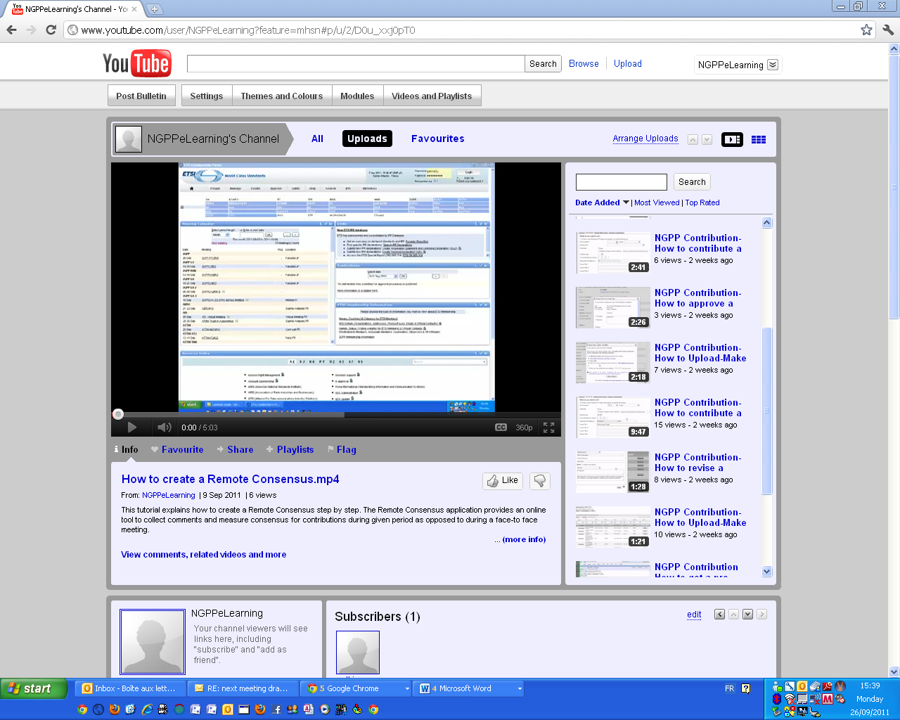

- Video Demos have also been embedded in the ETSI WIKI help site at http://help.etsi.org/
  - This site provides additional written explanation and screen captures

