Title*: | MTS#57 Agenda
from Source*: | ETSI
Contact: | Laurent Vreck
input for Committee*: | MTS
Contribution For*: | Decision | X
 | Discussion
 | Information
Submission date*: | 2012-09-07
Meeting & Allocation: | MTS#57

Decision/action requested: Approval at meeting opening

Venue Sophia Antipolis – AGORA Einstein (next to ETSI buildings).
Start 19 Sept 2:00pm End 20 Sept 5:30 pm

Meeting Invitation: MTS(12)57_002
Remote participation URL: https://www2.gotomeeting.com/join/274170242 (see details in annex 1)
Registration URL (& access to documents): http://webapp.etsi.org/MeetingCalendar/MeetingDetails.asp?mid=13802

Day 1: Wednesday (afternoon)

Opening

Introduction & welcome, Local arrangements, IPR call [Schulz, Hogrefe, Vreck]
Call for IPRs (clause 4.1 of the ETSI IPR Policy, Annex 6 of the Rules of Procedure):
"The attention of the members of this Technical Body is drawn to the fact that ETSI Members shall use reasonable endeavours to inform ETSI of Essential IPRs in a timely fashion. This covers the obligation to notify its own IPRs but also other companies’ IPRs.
The members take note that they are hereby invited:
-to investigate in their company whether their company does own IPRs which are, or are likely to become essential in respect of the work of the Technical Body,
-to notify to the Chairman or to the ETSI Director-General all potential IPRs that their company may own, by means of
the IPR Information Statement and the Licensing Declaration forms that they can obtain from the secretariat"
Members are encouraged to make general IPR undertakings/declarations that they will make licenses available for all their IPRs under FRAND terms and conditions related to a specific standardization area and then, as soon as feasible, provide (or refine) detailed disclosures.

Approval of agenda, allocation of contributions to Agenda Items [Vreck]
Topics: review agenda content, allocation of contribution to agenda items, agenda items time scheduling.
Related Contributions: MTS(12)57_001r1” MTS#57 Draft Agenda”

Action List status [Vreck]
Related Contributions: MTS(12)56_017r1 “MTS#56 meeting report”, see also Annex 2 of the present document.

Workprogramme status [Vreck]
Topics: status of workprogramme, review/update WI schedules (need rapporteur feedback), progress since previous meeting (publications, AbC…), review of meeting goals (expected final drafts for approval).
Related Contributions: MTS(12)57_009 “Status of MTS WorkProgramme as of 2012.09.19 (before MTS#57)”
Progress: No progress to the Work programme since MTS#56 (May 2012): no approval, no publication, no new draft uploaded.
Status of the 26 active WIs (before start of meeting): several “Late” work items, 5 candidates for stopping. See figure on next page and MTS(12)57_009 for more details.

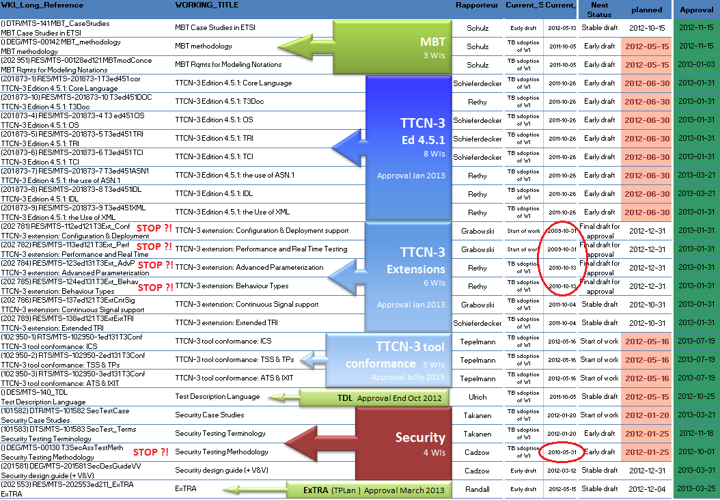

Presentation of incoming Liaisons & follow-up decisions
Topics: discussion of incoming liaisons (if any) and decision on potential responses & follow-up actions.
Related Contributions:
There was no incoming liaison to be discussed.

Reports from GA, Board, & OCG Meetings [Schulz]
Topics: feedback on decisions and information relevant for the work of MTS.
OCG endorsed a proposal to modify the way STFs are selected (selection criteria), to report on closed STF (Chairmen to report to Board on every after every STF closure) and a new STF ToR template. See Clause 4 of the present document.

Board#88 (June 2012) approved MTS request (in MTS(12)56_09r1) for an STF on ”Extension of Conformance tests for TTCN-3 tools” (53,8md granted), CfE is now closed, Prep meeting planned (20120921).

Election and appointments (of officials) [Vreck]
Topics: Renewal of (vice) Chair mandates in Jan 2013
The current mandate of MTS officials are due for renewal (they should have been renewed by the end of the spring this year), hence elections or (re-)appointment of officials should either take place online, or during the MTS#58 meeting. Chairman elections/appointment must be announced at least 6 weeks before the election, candidates should declare their interest 4 weeks before the elections and provide a short bio.

Security & Performance

Security SIG [Rennoch]
Topics: report on interim meetings, status of drafts.
Related Contributions: MTS(12)57_011 “MTS-Security SIG report”

Status report on active WIs [Takanen, Cadzow]
Topics: terminology, security design, etc….
- DEG/MTS-00130 T3SecAssTestMeth Security Testing Methodology
No progress since June 2012, WI is Candidate for stopping, decision to be confirmed during MTS#57
The SIG group proposed to STOP this WIs since there is no foreseen activity , MTS accepted this proposal and decided to STOP MTS-00130 T3SecAssTestMet.. The content of this document will be covered in DEG/MTS-201581 SecDesGuideVV the “Security design guide (+ V&V)”

- (101 583) DTS/MTS-00101583 SecTest_Terms Security Testing Terminology
The progress on this draft is visible on the Codenomicon collaboration platform,(specific login can be obtained from Ari TAKANEN). A recent version is available in MTS(12)SIG013 (updated since the SIG#5 session). The schedule for this WI was revised: stable draft is now planned to MTS#58 and final draft for MTS#60. The draft will have to be progressed via SIG conference calls.
- (101 582) DTR/MTS-00101582 SecTestCase Security Case Studies
This draft is dependant on the “terminology” draft (DTS/MTS-00101583 SecTest_Terms), hence shifting the schedule of the “terminology” draft will also have an impact on the schedule of this one. Early draft shifted to MTS#58 and Stable draft to MTS#59.
- (201 581) DEG/MTS-201581 SecDesGuideVV “Security design guide (+ V&V)”
No progress on this WI since the last meeting. Stable draft status was shifted to MTS#58 with an attempt to approve the final draft at MTS#59 in May.

Day 2: Thursday morning

TTCN-3

Status of TTCN-3 base standards & extensions work - [Rethy]
Topics: status report, STF446 progress report.
Related Contributions: MTS(12)57_005 “STF446's Progress Report #1“
MTS(12)57_008 “STF446_Summary_Progress_Report_1”
Related WIs:
- (201 873-1) RES/MTS-201873-1 T3ed451 cor TTCN-3 Edition 4.5.1: Core Language
- (201 873-4) RES/MTS-201873-4 T3 ed451 OS TTCN-3 Edition 4.5.1: OS
- (201 873-5) RES/MTS-201873-5 T3ed451 TRI TTCN-3 Edition 4.5.1: TRI
- (201 873-6) RES/MTS-201873-6 T3ed451 TCI TTCN-3 Edition 4.5.1: TCI
- (201 873-7) RES/MTS-201873-7 T3ed451ASN1 TTCN-3 Edition 4.5.1: the use of ASN.1
- (201 873-8) RES/MTS-201873-8 T3ed451IDL TTCN-3 Edition 4.5.1: IDL
- (201 873-9) RES/MTS-201873-9 T3ed451XML TTCN-3 Edition 4.5.1: the Use of XML
- (201 873-10) RES/MTS-201873-10 T3ed451DOC TTCN-3 Edition 4.5.1: T3Doc

- (202 781) RES/MTS-112ed121 T3Ext_Conf TTCN-3 extension: Configuration & Deployment support
No progress since October 2009, Candidate for stopping
- (202 782) RES/MTS-113ed121 T3Ext_Perf TTCN-3 extension: Performance and Real Time Testing
No progress since October 2009, Candidate for stopping
- (202 784) RES/MTS-123ed131 T3Ext_AdvP TTCN-3 extension: Advanced Parameterization
No progress since October 2010, Candidate for stopping
- (202 785) RES/MTS-124ed131 T3Ext_Behav TTCN-3 extension: Behaviour Types
No progress since October 2010, Candidate for stopping
- (202 786) RES/MTS-137ed121 T3ExtCntSig TTCN-3 extension: Continuous Signal support
- (202 789) RES/MTS-138ed121 T3ExtExtTRI TTCN-3 extension: Extended TRI

ATS development checklist [S. Müller]
Topics: current status
Related Contributions: MTS(12)57_004r1 “ETSI_TS_skeleton_CTI“

TTCN-3 Conformance testing (STF XC) [Tepelmann]
Topics: status of drafts, status of STF team, workplan,…
Related Contributions:
Related WIs:
- (102 950-1) RTS/MTS-102950-1ed131 T3Conf TTCN-3 tool conformance: ICS
- (102 950-2) RTS/MTS-102950-2ed131 T3Conf TTCN-3 tool conformance: TSS & TPs
- (102 950-3) RTS/MTS-102950-3ed131 T3Conf TTCN-3 tool conformance: ATS & IXIT

Miscellaneous TTCN-3

Update on T3UC 2012, future of T3UC [Schulz, Rethy, Kull, Grabowski, Ulrich, Schieferdecker, Vassiliou, …]
Topics: : MTS testing user conference?

TTCN-3.org web site progress [Tepelmann, Chaulot]
Topics: : status of TTCN-3.org project, draft web template presentation, discussion/approval of the maintenance process (TET).
Related Contributions: MTS(12)57_003 “TTCN-3.org revamping project update“
MTS(12)57_010 “TTCN-3.org Editorial Team (TET) - Rules and Processes”

Status of ITU synchronization [Hogrefe/Vreck]

Future STFs Planning
Topics: Discussion on future STF proposals for the 2013 FWP 1st allocation, new STF funding criteria, new ToRs structure…
Related Contributions:
- BOARD(12)88_030r1 and BOARD(12)88_030a1 “Review of ETSI STF funding criteria”
- BOARD(12)88_038 ETSI STF budget 2013 – 1st allocation process
- Note that new STF requests under the ETSI budget must use a new ToR template.
See also the STF proposal page on the portal.
- MTS(12)57_006 “Proposed TTCN-3 FWP request for 2013“

Day 2: Thursday Afternoon

Model Based Testing
Related Contributions: MTS(12)57_007 “MBT UC PC Guidelines”

MBT standards [Schulz]
Topics:
- Feedback from the June MBT workshop in Bangalore
- Status of MBTUC 2012 preparation
- Planning of work
- Collection of extension or refinement proposals to MBT ES 202 951
Related Contributions: MTS(12)MBT012 MBT WG Sep 2012

Related WIs:
- RES/MTS-00128ed121 MBTmodConce
- DTR/MTS-00141 MBT_CaseStudies
- DEG/MTS-00142 MBT_methodology

Test Description Language [Ulrich]
Topics: Review of Test Description Language draft,
Related Work Items: () DES/MTS-140_TDL Test Description Language

ExTRA (Extensible notation for expressing Test Purposes, Requirements and Assertions) [Randall, Wiles]
Topics: status of active draft
Related Work Items: RES/MTS-202553ed211_ExTRA
Related Contributions
No progress since the last meeting, … call for contribution?

Other ongoing work

AOB [All]

Meeting wrap up

Approvals (review & confirmation) [All]
Topics: recapitulation of New WIs, final drafts, LS out approved during the meeting, presentation of remaining ones to be approved, announcement expected revisions to be approved by remote consensus after the meeting.
Related Contributions:

LS OUT

STF Reports

Final drafts

New WIs

Stopped WIs

actions list
Topics: review of actions list & draft meeting minutes
Related Contributions:

Calendar of future meetings & Events

 | Event | Date | Venue - [host] | Status
 | MBTUC 2012 | 25-27 Sept | Tallinn (Estonia) | confirmed
 | SIG#6 | 19th Nov 2-4pm | ONLINE only
 | 2013
 | SIG#7 | just before MTS#58 plenary | Helsinki (Finland) | To be confirmed
 | MTS#58 | 16-17 Jan 2013 | Helsinki (Finland) | To be confirmed
 | MTS#59 | May 2013 | Sophia Antipolis | tbc
 | MTS#60 | Sept 2013 | Germany | tbc

Meeting Closure

ANNEX 1: joining the meeting remotely:

The easiest way to join the meeting is to follow these instructions:

1- Follow the meeting URL: https://www2.gotomeeting.com/join/274170242
Once connected to the web interface check the "Audio" section of the application interface and choose an audio option: “Telephone” or “Mic & Speaker” (VoIP).

- VoIP is free and provides a variable audio quality (from acceptable to excellent).
- “Telephone” is not free (but cheap), and provides a stable good audio quality.

2- AUDIO
2.1 - using “Mic & Speaker” (VoIP)
To preserve a good audio quality for other listeners, it is strongly recommented that remote VoIP participants use a headset rather than their PC microphone & Loudspeaker: PC mic often transmit background noise, echo and keystroke noise to other users…

2.2- using a telephone
Dial in using one of the numbers in the list below (depending on your country)
-enter the meeting ID (last 9 digits of the meeting URL above, also shown in the Web application)
-enter your individual Audio PIN (see "Audio" section of the web application)

During the call, you can use the following in-band commands:
*6 Mute/ un-mute the participant’s line.
*4 Provides a menu of available conference commands.
Headphones are preferable to handset, since they are more comfortable for the user and don’t transmit background, echo, and keystroke noise to other listeners…
Please avoid using the handsfree function of your phone (except if your phone has excellent audio-conference features).

Australia: +61 2 6108 4655
Austria: +43 (0) 7 2088 1403
Belgium: +32 (0) 28 08 4294
Canada: +1 (416) 800-9295
Denmark: +45 (0) 69 91 88 65
Finland: +358 (0) 942 41 5781
France: +33 (0) 182 880 459
Germany: +49 (0) 811 8899 6901
Ireland: +353 (0) 14 845 979
Italy: +39 0 699 36 98 81
Netherlands: +31 (0) 208 080 382
New Zealand: +64 (0) 4 974 7214
Norway: +47 21 03 58 99
Spain: +34 931 81 6669
Sweden: +46 (0) 852 503 499
Switzerland: +41 (0) 435 0167 09
United Kingdom: +44 (0) 207 151 1857
United States: +1 (619) 550-0006

ANNEX 2: Actions Items List

MTS(12)AI033  COMPLETED | Jens Grabowski  Check availability of STF442 experts for the next MBT working meeting (check proposed dates in MTS#56 minutes), and confirm dates (by end of May)
MTS(12)AI032  COMPLETED | Gyorgy RETHY  Contact Telecom Italia and Broadbit to get confirmation of their support to the proposal of an STF to revise and progress the TTCN-3 Conformance Test Suite.
MTS(12)AI031  COMPLETED | Milan Zoric  plan a conference-call on the 8th of June (time tbd) to discuss the establishment of an editing team (allowing participation of volunteers) for the maintenance of the TTCN-3.org web site.
MTS(12)AI030  NEEDS-ACTION | Stephan Schulz  Follow-up with ISPRAS on turning document MTS(12)000012 into an ETSI Technical Report.  If Nikolai Pakulin is willing to takerapporteurship then he should prepare a NWI proposal contribution corresponding to the text in MTS(12)000012.
MTS(12)AI029  NEEDS-ACTION | Ian BRYANT  check by MTS#57, with Scott and with the rest of the SIG group if the proposal in MTS(12)56_012 should lead to anew WI proposal or be included into existing (101 583) DTS/MTS-00101581 Security Design Guide.
MTS(12)AI028  NEEDS-ACTION | CTI  Propose a roadmap to turn www.ttcn-3.org into an active user portal as described in contribution MTS(12)55_018
MTS(12)AI027  NEEDS-ACTION | CTI  Update the TTCN-3 public test suites page by adding Link to the IPT library (http://www.ipt.etsi.org/iptlib/)
MTS(12)AI020  IN-PROCESS | CTI  Provide a more dominant place (on TTCN-3 web pages) to give more visibility to the TTCN-3 conformance test suites and allow download of all versions.  2012-05-15: Milan reported that work is ongoing…
MTS(12)AI017  NEEDS-ACTION | Stephan Schulz, Laurent vreck  Find a representative from ITS committee that could take part to the STF 442steering group.
MTS(11)AI013  NEEDS-ACTION | CTI  Handle the updated ETSI TS skeleton in MTS(11)0061 to EditHelp to update the "official" ETSI TS skeleton.  2012-01-23 (Sebastian Müller): This action is still ongoing. Tasks is to update the skeleton to correct description of how to attach TTCN-2 and TTCN-3 code.
MTS(11)AI005  NEEDS-ACTION | CTI  Collect all existing info used at ETSI forTTCN-3 specs and group them in a contribution to MTS.  2011-09-30: Question from AW: is it still applicable?

ANNEX 3: Participants List

 |  | Delegate | Representing Organization
 | Present | Mr. Ian BRYANT | NPIA
 | Present | Mr. Scott CADZOW | Cadzow Communications
 | Present | Mrs. Emmanuelle CHAULOT-TALMON | ETSI
 | Present | Mr. Pierfranco FERRONATO | NORMAPME
 | ? | Mr. Emmanuel GAUDIN - GUEST - | PragmaDev
 | Present | Mr. Dieter HOGREFE | Institut für Informatik
 | ? | Mr. Andrus LEHTMETS | OU Elvior
 | Present | Mr. Steve RANDALL | PQM Consultants
 | Present | Mr. Axel RENNOCH | Fraunhofer FOKUS
 | Present | Dr. Gyorgy RETHY | Telefon AB LM Ericsson
 | Present | Mr. Stephan SCHULZ | Conformiq Software Ltd.
 | ? | Mr. Ari TAKANEN | Codenomicon Oy
 | Present | Mr. Dirk TEPELMANN | Testing Technologies
 | ? | Dr. Andreas ULRICH | Siemens AG
 | ? | Mr. Theofanis VASSILIOU-GIOLES | Testing Technologies
 | ? | Mr. Margus VEANES | MICROSOFT EUROPE SARL
 | Present | Mr. Laurent VRECK | ETSI
 | ? | Mr. Anthony WILES | ETSI
 | ? | Mr. Milan ZORIC | ETSI

