Title*: | Dirk Tepelmann’s candidature for the Vice-chairmanship of TC MTS
from Source*: | ETSI
Contact: | Emmanuelle Chaulot-Talmon
input for Committee*: | MTS
Contribution For*: | Decision
 | Discussion
 | Information | X
Submission date*: | 2012-12-18
Meeting & Allocation: | MTS#58 -
Relevant WI(s), or deliverable(s):

ABSTRACT: Dirk Tepelmann’s candidature for the Vice-chairmanship of TC MTS

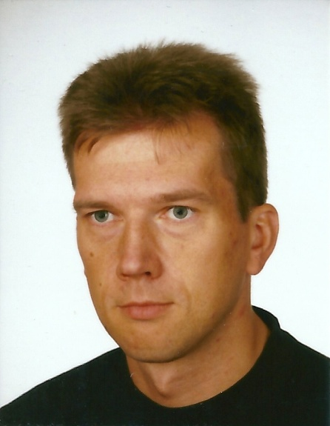

Family Name: Tepelmann

First Name: Dirk

Company: Testing Technologies

Address: Michaelkirchstr. 17/18, 10179 Berlin, GERMANY

E-mail address: tepelmann@testingtech.com

Phone: +49 30 7261919 19

Date: 14/12/2012

Curriculum Vitae
Dirk Tepelmann works as Senior Software Engineer and is responsible for product development and customer projects at Testing Technologies. He actively participates to different standardization bodies. In particular at ETSI he is engaged with MTS, where he represents Testing Technologies, and in various STFs over the last 6 years. Besides his activities at the STFs he has initiated new activities like the renewal of the ttcn-3.org website, where he leads this task.
Before joining Testing Technologies he worked for more than 9 years for Alcatel as software and test engineer. There he was responsible for test development for different protocols for fixed and mobile telecommunication and test automation product development. He has more than 15 years of expertise in testing, in particular in using standardized technologies like SDL, ASN.1, TTCN-2 and TTCN-3 in different domains like telecommunication, network protocols and automotive.
Dirk Tepelmann studied Computer Engineering with focus to telecommunication engineering in Berlin, Germany. He holds a B.Sc. from the Berlin School of Economics and Law.

