Sophia-Antipolis, 11 February 2014
Invitation to the MTS#62 meeting
on 14-15 May 2014 in Munich
Link to registration & meeting documents
http://webapp.etsi.org/MeetingCalendar/MeetingDetails.asp?mid=15330
Dear Colleague,
On behalf of Andreas Ulrich, Siemens has the pleasure of informing you of the arrangements for the above-mentioned meeting.
Address of the meeting |  | Siemens AG  Conference Centre (Building 12), Room 1 (Berkeley)  Otto-Hahn-Ring 6, 81739 München  U/S-Bahn station: Neuperlach Süd  Google Maps: http://goo.gl/maps/6Qlfq
mEETING SCHEDULE |  | The meeting will start on 14 May 2014 at 14:00  and end on the 15 May 2014 at 17:30  Distribution of badges will start ½ hour before the start of the meeting
REGISTRAtion |  | Please use this link to REGISTER.  Non ETSI members are usually not permitted to attend ETSI meetings unless authorized by the Chairman.  Please collect your badge at the registration desk or (in case of late arrival) at the reception.
Documents for the meeting |  | Reserve contribution numbers HERE  Note that contributions assigned to this meeting can be retrieved from the meeting details page or in docbox.  If in doubt or if your company is not an ETSI member contact MTSsupport@etsi.org
ELECTRONIC WORKING |  | You may log onto the ETSI network. For assistance please follow the instructions in this link: http://portal.etsi.org/helpdesk/ (click on "Network Facilities" in menu).
Local information |  | List of hotels and public transport are provided on page 2.
I look forward to seeing you in Munich.
Yours sincerely
Emmanuelle Chaulot-Talmon
MTS Meeting Secretary

ETSI MTS#62 Meeting
Siemens AG, Munich, May 14/15, 2014

Location
Siemens AG
Conference Centre (Building 12), Room 1 (Berkeley)
Otto-Hahn-Ring 6, 81739 München
U/S-Bahn station: Neuperlach Süd
Google Maps: http://goo.gl/maps/6Qlfq
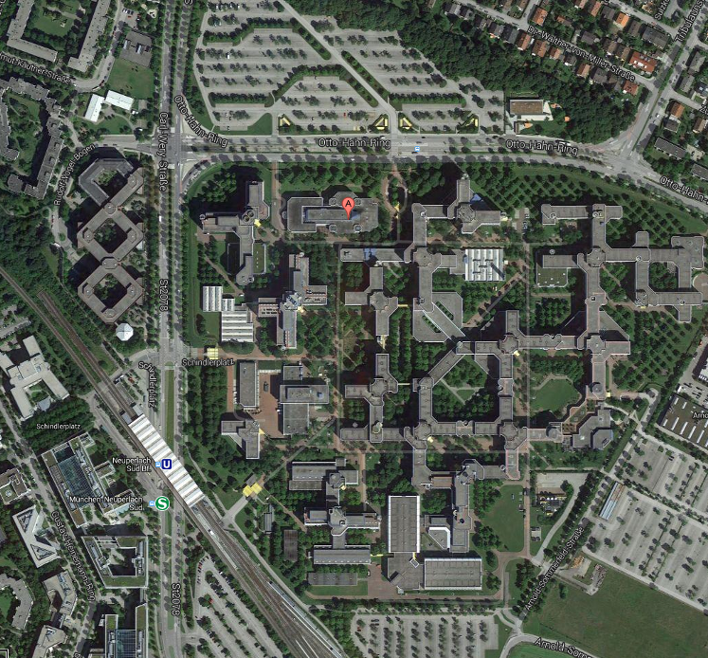

The conference centre is marked with the (A) sign in the map. To access the Siemens premises there are two gates (appearing yellow in the map): the north gate on the right of the (A) and the south gate next to the U/S-Bahn station, about 100m away. The latter one is preferred if you arrive by metro.

Contact
Andreas Ulrich, mobile: +49 (162) 449 09 21

Recommended List of Hotels

Within Walking Distance to the Siemens Premises
Mercure Hotel
München Neuperlach Süd
Rudolf-Vogel-Bogen 3, 81739 München
http://www.mercure.com/de/hotel-0792-mercure-hotel-muenchen-neuperlach-sued/index.shtml
Golden Leaf Hotel
Golden Leaf Hotel Perlach Allee Hof
Therese-Giehse-Allee 76, 81739 München
http://www.golden-leaf-hotel.de/en/muenchen/hotel-hpa/uebersicht.html
Mercure Hotel Orbis
München Perlach
Karl Marx Ring 87, 81735 München
http://www.mercure.com/de/hotel-1374-mercure-hotel-orbis-muenchen-perlach/index.shtml

Close to City Centre
Holiday Inn
Munich City Centre
Hochstraße 3, 81669 München
http://www.holidayinn.com/hotels/us/en/munich/muchb/hoteldetail
Hilton
Hilton Munich City Hotel
Rosenheimer Straße 15, 81667 München
http://www.hilton.de/muenchencity

Public Transport
Website: http://www.mvv-muenchen.de/
Munich has an excellent public transport system. For single trips it is recommended to buy the “Streifenkarte” (stripe ticket, 10 stripes for 12.50€). Use 2 stripes for one travel within the city, from/to the airport you need 8 stripes (fold the needed numbers of stripes and then stamp them).
Another option is a day ticket, which costs 6.00 € (“Single-Tageskarte, Innenraum”) for unlimited travel within the city on a single calendar day or 11.70 € (“Single-Tageskarte, Gesamtnetz”) if you want to use it from/to the airport.
All tickets must be stamped before entering the train (on first use for a day ticket). Tickets can be bought at all U/S-Bahn stations from vending machines or at kiosks.

Getting there from the Airport
On arrival follow the green (S) sign to go to the suburban railway. There are two lines S8 and S1 that can be taken (S8 is 10 min. faster) to go to the city. Commute to the metro line U5 direction “Neuperlach Süd” at one of the following stations: Ostbahnhof, Karlsplatz (Stachus) or Hauptbahnhof (main train station). The trip takes about 50 min. in total. Using a taxi takes about the same time and costs about 70 €.

Local Information
Munich and its surroundings offer many attractions. If you bring some additional time you won’t be disappointed. A good starting place to explore the possibilities is: http://www.muenchen.de/int/en/sights.html.

