UCAAT 2014

(User Conference on Advanced Automated Testing)
Event Summary

http://ucaat.etsi.org/2014/index.html

UCAAT 2014
Event Summary

(User Conference on Advanced Automated Testing)
http://ucaat.etsi.org/2014/index.html

ETSI – The European Telecommunications Standards Institute, QualityMinds and German Testing Day have jointly organized this international conference dedicated to test automation.

UCAAT is dedicated to the practical engineering and application aspects of automated and model-based testing. It addresses test methodologies, test management and use of test languages such as TTCN-3. This industrial conference gives users from different application domains a chance to meet, discuss new ideas, debate on the problems and exchange their personal experiences with various testing tools.

UCAAT 2014 attracted 151 guests from 22 countries, including Germany, France, Hungary, Finland, USA, China, Turkey, Great Britain, Israel, and many more. The participants represented various industrial sectors (such as: automotive, defence, telecommunications, banking, internet and information technology) as well as international academic circles, research facilities and testing tool providers. The event was supported by 8 sponsors and 2 media partners.

The participants of the conference had a chance to find out about the newest developments in research, discuss possible solutions to current problems and exchange their opinions after each presentation. The program consisted of a Special Session on Standardization in Testing, two parallel tutorial tracks and many interesting session focusing on various issues from the field of automated testing. During coffee and lunch breaks the guests had an excellent opportunity to further discuss their interests and to network. The online feedback questionnaire distributed to the participants after the event proved that UCAAT met user expectations and provided them with an interesting, varied, high-quality program.

ETSI would like to thank all the sponsors for their support and express their gratitude to this year hosts: QualityMinds and German Testing Day. Their excellent, fully engaged and smooth organisation as well as friendly service helped make this event a big success.

UCAAT 2014
Program

UCAAT 2014 was a three-day event consisting of a special session, two parallel tutorial tracks (Day 1) and the conference program (Days 2 and 3). The poster session took place on the second day of the event.

All presentations are available for download as PDF on the conference website:
http://ucaat.etsi.org/2014/Program.html

Tuesday, September 16th - Special Session on Standardization in Testing

9:00 – 9:15 | Welcome  Stephan Schulz  (ETSI TC MTS Chairman)
9:15 – 9:45 | Keynote speech  Why standardization is important  Klaus Vedder (Giesecke & Devrient)
9:45 – 12:15 | Fishbowl session: Challenges, experiences and success stories in standardization  Moderator : Andrej Pietschker (Giesecke & Devrient)  With position statements from:  - Prof. Ina Schieferdecker (Fraunhofer FOKUS)  Applied Research Perspective  - Markus Bechter (BMW)  AUTOSAR  - Heiko Englert (Siemens)  Smart Grid Interoperability – Profiling and Testing  - Tibor Csöndes (Ericsson)  Using a standard test language – a success story in unifying testing. Retrospection and future  - Gyorgy Rethy (Ericsson)  MTS success story: TTCN-3

Tuesday, September 16th – Tutorials

10.45 - 12.15 | From Test Legacy to Model-Based Testing - How to refactor an existing test repository into an MBT model?  Bruno Legeard & Arnaud Bouzy (Smartesting) | Introduction to TTCN-3  Theofanis Vassiliou-Gioles  (Testing Technologies)
12.15 - 13.30 | Networking Lunch
13.30 - 15.00 | Cutting MBT Adoption Time with Domain-Specific Modelling  Juha-Pekka Tolvanen (MetaCase) & Stephan Schulz (Conformiq) | Property-Based Testing  Thomas Arts (Quviq)
15.00 - 15.20 | Coffee Break
15.20 - 17.00 | Bringing TDL to Users: A Hands-on Tutorial  Philip Makedonski (University of Göttingen), Andreas Ulrich (Siemens) , Gusztav Adamis (Budapest University of Technology and Economics), Martti Käärik (Elvior) & Marc-Florian Wendland (Fraunhofer FOKUS) | Strategy-driven Test Generation with Open Source Frameworks  Dimitry Polivaev (Giesecke & Devrient)

Wednesday, September 17th – Conference Day 1

9:15- 9:30 | CONFERENCE OPENING
9:30- 10:15 | Testing with Fault Models  Alexander Pretschner (Technical University of Munich)
Session 1, ETSI Activities
10:15-10:35 | Applying TDL to describe tests of a distributed real-time control system  Joachim Froehlich, Sylvia Jell and Andreas Ulrich (Siemens)
10:35-10:55 | A TTCN-3-based Compliance Assessment Framework for Intelligent Transport Systems  Sebastian Mueller (ETSI)
10.55 - 11.25 | Coffee Break
Session 2, Robustness
11:25 - 11:45 | Property verification on traces  Emmanuel Gaudin (PragmaDev)
11:45 - 12:05 | Using MBT to Generate Test Suites for Robustness Testing  Håkan Fredriksson (Ericsson)
12:05 - 12:25 | Model Based Testing of a Game Engine using a Mono/.NET port of GraphWalker  Marek Turski (Unity Technologies)
12:25 - 12:30 | Poster Session
12:55 - 13:45 | Networking Lunch
Session 3, Application in industry
13:45 – 14:05 | Automated testing of an X-Ray medical device  Bryan Bakker (Sioux Embedded Systems)
14:05 – 14:25 | Test generation from functional 3D virtual environment models  Barath Kumar (dSPACE) , Rainer Drath (ABB) & Jürgen Jasperneite (Fraunhofer IOSB)
14:25 - 14:45 | Deploying MBT-based test automation in an agile development project for financial industry  Jani Koivulainen (Conformiq)& Simone Krämer (brightONE)
14:45 – 15:05 | MBT and Test automation for ADAS validation  Laurent Raffaelli (ALL4TEC), Xavier Rouah (Intempora) and Philippe De Souza (SNCF)
15:05 – 15:35 | Coffee Break

Session 4, Cloud
15:35 – 15:55 | Test@Cloud - MBT and cloud-testing - a powerful combination  Martin Beisser (sepp.med), Matthias Pruksch (sepp.med) & Steffen Limmer (Fraunhofer HHI)
15:55 - 16:15 | Model-driven Testing in the Cloud  Steffen Herbold (University of Göttingen)
16:15 – 17:15 | Vendor Track
17:45 | Departure Social Event

Thursday, September 18th – Conference Day 2

9:00 – 9:45 | Mining Oracles for Fully Automated Test Generation  Andreas Zeller (University of Saarbrücken)
Session 5, Security
9:45 – 10:05 | Model-Based Security Testing with Test Patterns  Julien Botella (Smartesting), Jürgen Grossmann (Fraunhofer FOKUS), Bruno Legeard (Smartesting), Fabien Peureux (University of Franche-Comté), Martin Schneider(Fraunhofer FOKUS) & Fredrik Seehusen (SINTEF ICT)
10:05 - 10:25 | Compositional risk analysis combined with automated security testing - the RACOMAT tool  Johannes Viehmann (Fraunhofer FOKUS)
10:25 - 10:45 | How to derive high level test procedures from a risk model  Fredrik Seehusen (SINTEF ICT)
10:45 - 11:15 | Coffee Break
Session 6, Experiences from applied research
11:15 - 11:35 | Raspberry Pi Single-Board Computers for Testing: How Berry Traces have Changed our Lives  Andreas Lauterbach, Dirk Lüdtke & Fabian Staudinger (AWTC Europe)
11:35 - 11:55 | Testing a webservices based ecosystem using MBT: the case of the Future Internet Public Private Partnership (FI-PPP)  Franck Le Gall & David Guillén Jiménez (Easy Global Market), Laurent Artusio & Thierry Nagellen (Orange), Julien Bernard (University of Franche-Comté), Lucas Gruber (Jet1Oeil), Eddie Jaffuel (Smart-Consulting) & Bruno Legeard (Smartesting)
11:55 - 12:15 | An efficient Approach for Model-Based Testing: Siemens Use case in the MBAT European Project  Helene Le Guen (ALL4TEC), Ralf Pinger (Siemens) & Deepa Vijayaraghavan (MBTech)
12:15 - 13:30 | Networking Lunch
Session 7, Advanced topics
13:30 - 13:50 | Towards UML Testing Profile 2  Marc-Florian Wendland (Fraunhofer FOKUS), Markus Schacher (KnowGravity), Jon Hagar (Grand Software Testing) , Zhen Ru Dai (Hamburg University of Applied Sciences), Ina Schieferdecker (Fraunhofer FOKUS), Andreas Hoffmann (Mohnke Facility Management), Alessandra Bagnato & Etienne Brosse (Softeam), Shaukat Ali & Tao Yue (Simula)
13:50 - 14:10 | Acceptance testing in Devops projects with a Business Domain Language & refactoring techniques  Arnaud Bouzy (Smartesting)
14:10 – 14:30 | Automatic test generation based on functional coverage  Emmanuel Gaudin (PragmaDev)
14:30 – 14:50 | A structured approach to identify the best fitting test automation solution for a specific project  René Biewald, Michael Karlinsky & Simone Krämer (brightONE)
14:50- 15:20 | Coffee Break
Session 8, Process
15:20 - 15:40 | Interactive Testing of Automotive Functions  Hermann Ilmberger (BMW)
15:40 - 16:00 | Making a MBT-based test process more efficient  by the reuse of analysis models  Alexander Kraas (T-Systems)
16:00 – 17:00 | Best Presentation Award and Conference Closure

Conference Floor Plan

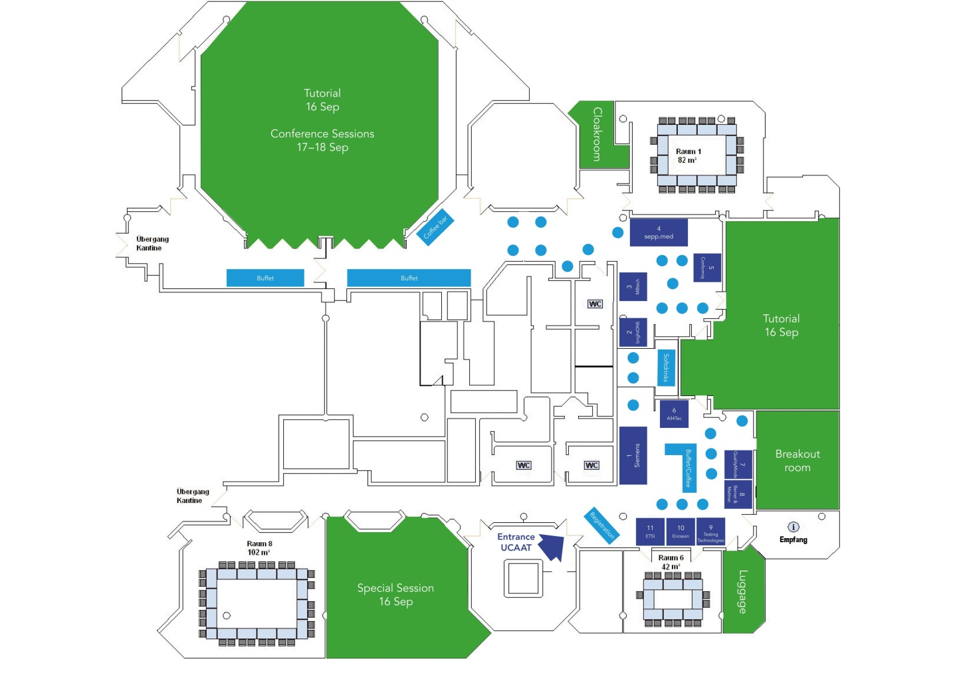

Sponsors and Partners:

Platinum Sponsors
Gold Sponsors
Media Partners

Media Clippings

(direct clippings June to September 2014, without calendar entries, blogs or social media posts)

http://www.hanser-automotive.de/aktuelle-branchen-news/article/ucaat-user-conference-on-automated-testing-2014-erstmal-in-muenchen.html

http://www.pressebox.de/inaktiv/qualityminds-gmbh/Die-Leitkonferenz-fuer-Software-und-Embedded-Testing-Automation-UCAAT-2014-erstmals-in-Muenchen/boxid/692783

http://www.all-electronics.de/texte/anzeigen/55434

http://www.austriantestingboard.at/node/957

http://www.nature.com/natureevents/science/events/28181-UCAAT_2014_conference_for_Industry_Test_Automation

http://www.actioner.de/veranstaltungen/974335/2nd-user-conference-on-advanced-automated-testing-ucaat

http://www.german-testing-board.info/service/events/testing-events.html

http://www.conference-service.com/conferences/de/software-engineering.html

http://www.professionaltester.com/events/event.asp?id=225

http://www.druckerzubehoer.neue-autonachrichten.de

http://blog.utest.com/2014/07/24/focus-on-automated-testing-discount-for-utesters-ucaat/

http://www.meetup.com/UCAAT_User-ConferenceAdvancedAutomatedTesting/

http://model-based-testing.info/tag/ucaat/

https://www.seppmed.de/aktuelles/news/detailansicht/backpid/629/chash/7b39562f41ca04a58a777b2865503939/newsid/719.html

http://www.mechatronik.info/ME/cms.nsf/me.Events.lookupByID/ME2118607?Open&SessionID=9859371-101614

http://www.gretler.com/newsdetails.php?press_id=2823698&cid=110136

http://www.rasenproject.eu/rasen-project-at-ucaat-2014-security-session/

http://www.brightone.de/events/
http://www.hs-owl.de/init/publications/a/filteroff/2011/single.html

http://www.berner-mattner.com/presentations

http://www.muenchen.de/rathaus/home_en/Tourist-Office/Congress/Congresses-Conferences-and-Events/Congresses-Conferences-and-Events-2014

http://www.worldconferencecalendar.com/index.php?option=com_conference&Itemid=26&page=search&text_search=UCAAT

http://www.softwaretestingmagazine.com

http://www.automotiveit.eu/ucaat-2014/termine/id-0047143

http://www.sps-magazin.de/?Termine&art=Sonstiges

https://www.imbus.de

http://www.embedded-design.net/?seminare

http://news.safetrans-de.org/ausgabe-2014-02/termine.html

http://www.testingexperience.com

http://02elf.net/wirtschaft/brightone-laedt-auf-der-ucaat-zum-informationsaustausch-ueber-testmethoden-modellbasiertes-testen-und-testautomatisierung-ein-783759

http://newsundservice.info/news-2/telekommunikation/79565-brightone-laedt-auf-der-ucaat-zum-informationsaustausch-ueber-testmethoden-modellbasiertes-testen-und-testautomatisierung-ein

http://www.brd-info.net/nachrichten/wirtschaft-industrie/top_707424_1.html

http://www.ad-hoc-news.de/brightone-laedt-auf-der-ucaat-zum-informationsaustausch--/de/News/38709608

http://www.f-tor.de/news.anzeige_bs4.php?do=detail&NEWS_ID=361501

http://www.nachrichten.de/kultur/UCAAT-brightONE-laedt-auf-der-UCAAT-zum-Informationsaustausch-ueber-Testmethoden-modellbasiertes-aid_1754926190738848074.html

http://www.openpr.de/news/813806/Hochkaraetige-Vortraege-garantieren-ein-spannendes-Programm-auf-der-UCAAT-2014-in-Muenchen.html

http://www.aktiencheck.de/news/Artikel-brightONE_laedt_auf_UCAAT_zum_Informationsaustausch_ueber_Testmethoden_modellbasiertes_Testen_und_Testautomatisierung_ein-5987444
http://www.finanznachrichten.de/nachrichten-2014-09/31329001-brightone-laedt-auf-der-ucaat-zum-informationsaustausch-ueber-testmethoden-modellbasiertes-testen-und-testautomatisierung-ein-007.htm

http://www.wallstreet-online.de/nachricht/6983280-brightone-laedt-ucaat-informationsaustausch-ueber-testmethoden-modellbasiertes-testen-testautomatisierung

https://www.xing.com/net/pric89f54x/XINGmunich/veranstaltungshinweise-von-xing-mitgliedern-12542/die-leitkonferenz-fur-software-und-embedded-testing-automation-ucaat-2014-erstmals-in-munchen-46783524/46783524/#46783524

https://www.xing.com/communities/groups/software-test-user-group-muenchen-d084-1049432?sc_o=b5178_20_601

UCAAT 2014 in Social Media:

Facebook Event Page:

https://www.facebook.com/events/1422238358055089/

Xing Event Page:

https://www.xing.com/events/ucaat-2014-user-conference-advanced-automated-testing-1409608

LinkedIn event group:

https://www.linkedin.com/groups/User-Conference-on-Advanced-Automated-6733756/about

Photos from the event

All pictures from the event can be found under the following link:

http://photo.ucaat.qualityminds.de

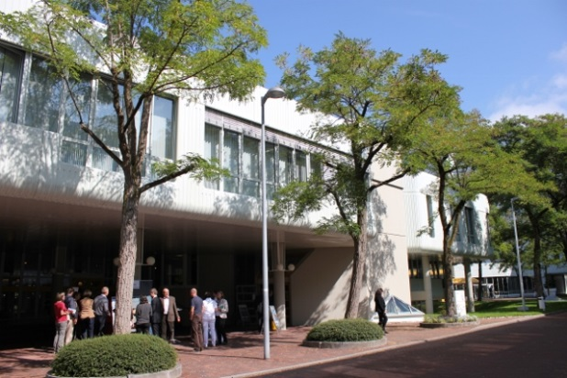 | 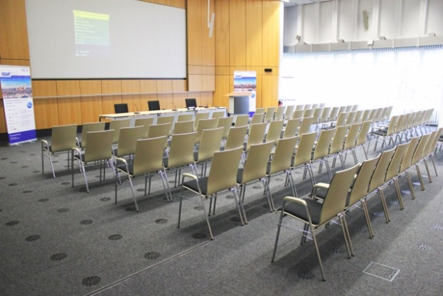
Siemens Conference Center | Main Conference Room
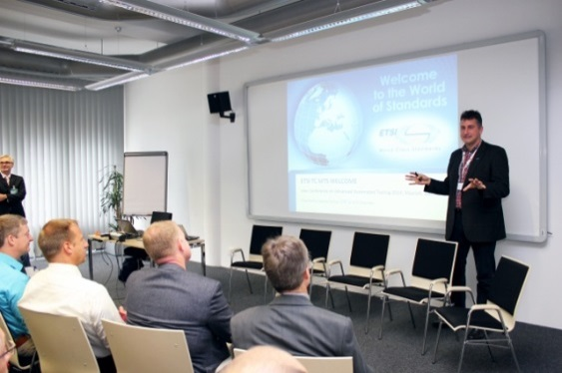 | 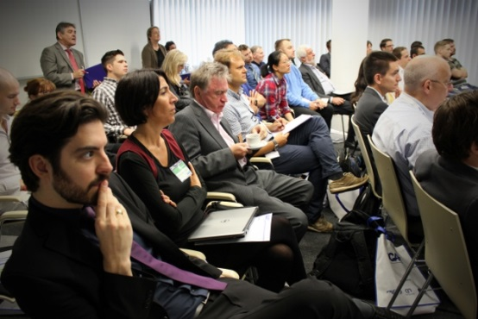
Special Session | Special Session

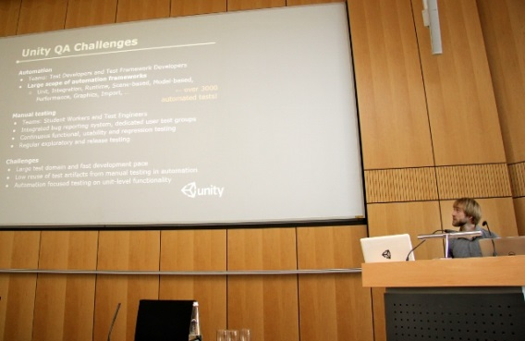 | 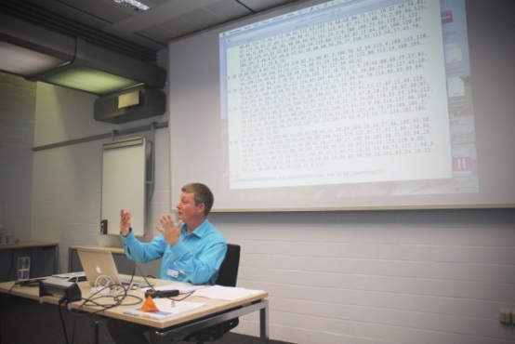
Presentations | Tutorials
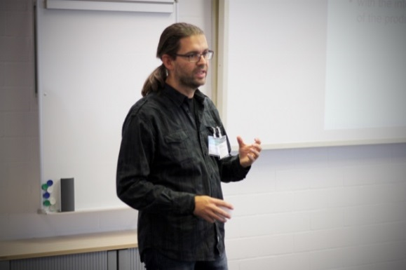 | 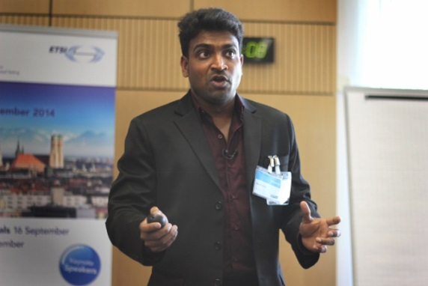
Tutorials | Speakers
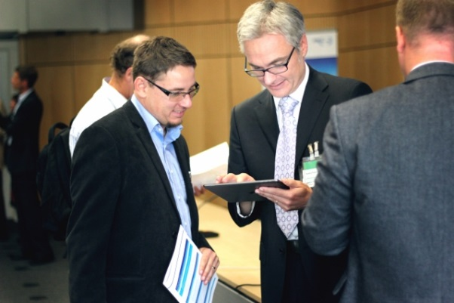 | 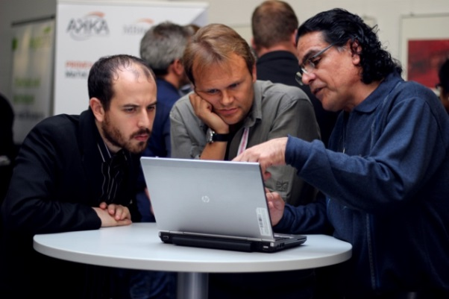
Networking

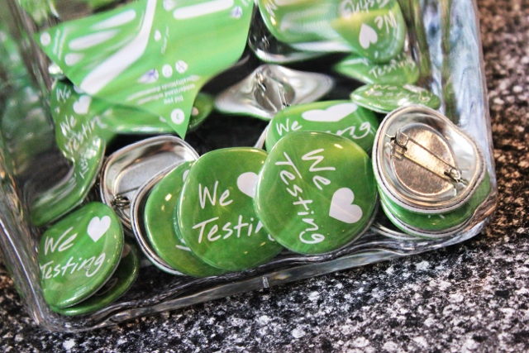 | 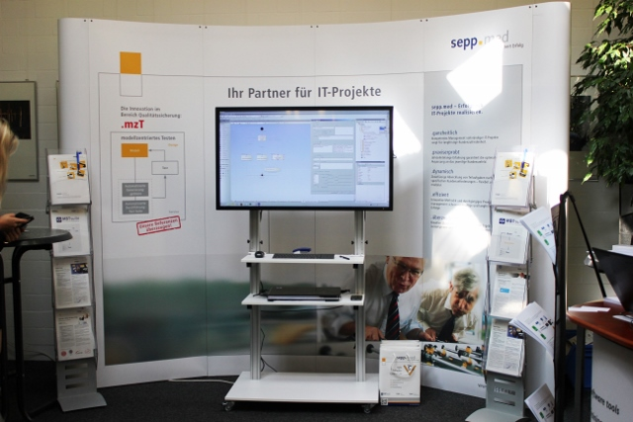
Sponsor and Organizer Booths
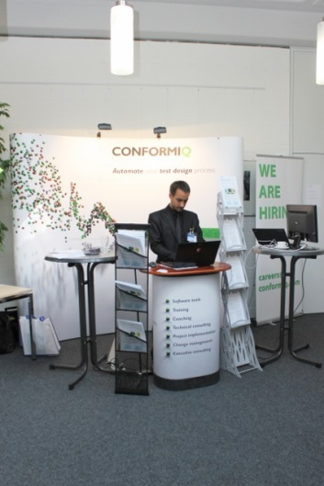 | 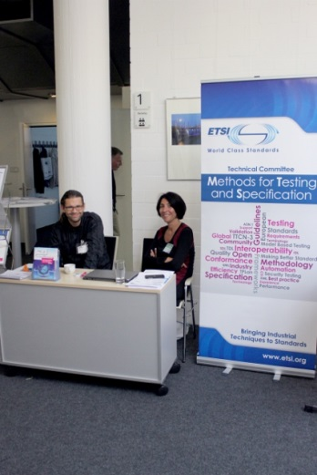
Sponsor and Organizer Booths
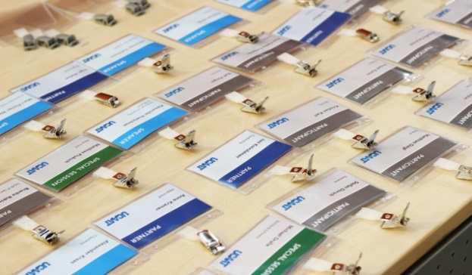 | 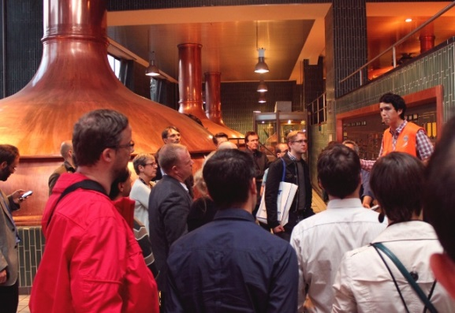
Registration | Paulaner Brewery Tour

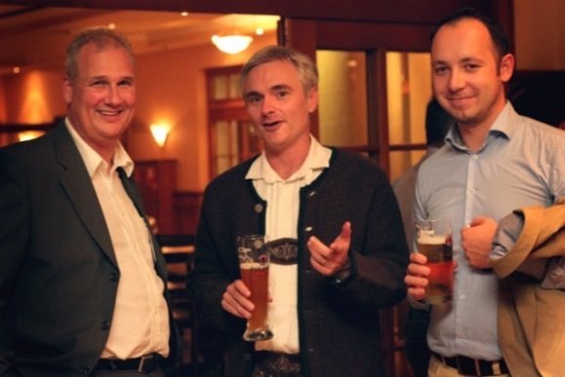 | 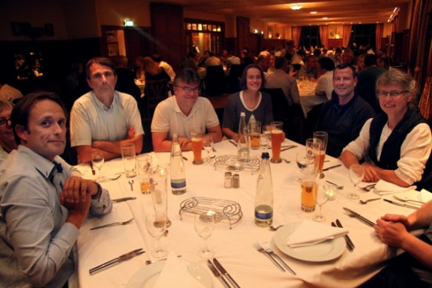
Social Event | Social Event
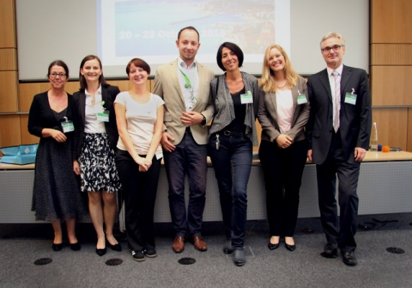
QualityMinds Team with Emmanuelle and Andrej | Bavarian Tradition

