FinalDraft ETSI ES 203 119-1 V1.2.1 (2015-01)
Methods for Testing and Specification (MTS);
The Test Description Language (TDL);
Part 1: Abstract Syntax and Associated Semantics

<

ETSI Standard

Reference
RES/MTS-203119-1v1.2.1
Keywords
language, MBT, methodology, testing, TSS&TP, TTCN-3, UML

ETSI
650 Route des Lucioles
F-06921 Sophia Antipolis Cedex - FRANCE

Tel.: +33 4 92 94 42 00 Fax: +33 4 93 65 47 16

Siret N° 348 623 562 00017 - NAF 742 C
Association à but non lucratif enregistrée à la
Sous-Préfecture de Grasse (06) N° 7803/88

Important notice
The present document can be downloaded from:
http://www.etsi.org
The present document may be made available in electronic versions and/or in print. The content of any electronic and/or print versions of the present document shall not be modified without the prior written authorization of ETSI. In case of any existing or perceived difference in contents between such versions and/or in print, the only prevailing document is the print of the Portable Document Format (PDF) version kept on a specific network drive within ETSI Secretariat.
Users of the present document should be aware that the document may be subject to revision or change of status. Information on the current status of this and other ETSI documents is available at http://portal.etsi.org/tb/status/status.asp
If you find errors in the present document, please send your comment to one of the following services:
http://portal.etsi.org/chaircor/ETSI_support.asp
Copyright Notification
No part may be reproduced or utilized in any form or by any means, electronic or mechanical, including photocopying and microfilm except as authorized by written permission of ETSI.
The content of the PDF version shall not be modified without the written authorization of ETSI.
The copyright and the foregoing restriction extend to reproduction in all media.

© European Telecommunications Standards Institute 2014.
All rights reserved.
DECTTM, PLUGTESTSTM, UMTSTM and the ETSI logo are Trade Marks of ETSI registered for the benefit of its Members.
3GPPTM and LTE™ are Trade Marks of ETSI registered for the benefit of its Members and
of the 3GPP Organizational Partners.
GSM® and the GSM logo are Trade Marks registered and owned by the GSM Association.

Contents
Intellectual Property Rights 6
Foreword 6
1 Scope 7
2 References 7
2.1 Normative references 7
2.2 Informative references 7
3 Definitions and abbreviations 8
3.1 Definitions 8
3.2 Abbreviations 8
4 Basic Principles 9
4.1 What is TDL? 9
4.2 Applicability of the present document 9
4.3 Design Considerations 10
4.4 Document Structure 11
4.5 Notational Conventions 11
4.6 Conformance 12
5 Foundation 12
5.1 Overview 12
5.2 Abstract Syntax and Classifier Description 13
5.2.1 Element 13
5.2.2 NamedElement 14
5.2.3 PackageableElement 14
5.2.4 Package 14
5.2.5 ElementImport 15
5.2.6 Comment 16
5.2.7 Annotation 16
5.2.8 AnnotationType 17
5.2.9 TestObjective 17
6 Data 18
6.1 Overview 18
6.2 Data Definition – Abstract Syntax and Classifier Description 18
6.2.1 DataResourceMapping 18
6.2.2 MappableDataElement 19
6.2.3 DataElementMapping 19
6.2.4 ParameterMapping 20
6.2.5 DataType 20
6.2.6 DataInstance 21
6.2.7 SimpleDataType 21
6.2.8 SimpleDataInstance 21
6.2.9 StructuredDataType 22
6.2.10 Member 23
6.2.11 StructuredDataInstance 23
6.2.12 MemberAssignment 23
6.2.13 Parameter 24
6.2.14 FormalParameter 24
6.2.15 Variable 25
6.2.16 Action 25
6.2.17 Function 25
6.3 Data Use – Abstract Syntax and Classifier Description 26
6.3.1 DataUse 26
6.3.2 ParameterBinding 27
6.3.3 StaticDataUse 27
6.3.4 DataInstanceUse 28
6.3.5 SpecialValueUse 28
6.3.6 AnyValue 29
6.3.7 AnyValueOrOmit 29
6.3.8 OmitValue 29
6.3.9 DynamicDataUse 30
6.3.10 FunctionCall 30
6.3.11 FormalParameterUse 31
6.3.12 VariableUse 31
7 Time 31
7.1 Overview 31
7.2 Abstract Syntax and Classifier Description 32
7.2.1 Time 32
7.2.2 TimeLabel 33
7.2.3 TimeLabelUse 33
7.2.4 TimeConstraint 33
7.2.5 TimeOperation 34
7.2.6 Wait 35
7.2.7 Quiescence 35
7.2.8 Timer 36
7.2.9 TimerOperation 36
7.2.10 TimerStart 37
7.2.11 TimerStop 37
7.2.12 TimeOut 37
8 Test Configuration 38
8.1 Overview 38
8.2 Abstract Syntax and Classifier Description 38
8.2.1 GateType 38
8.2.2 GateInstance 39
8.2.3 ComponentType 39
8.2.4 ComponentInstance 40
8.2.5 ComponentInstanceRole 40
8.2.6 GateReference 41
8.2.7 Connection 41
8.2.8 TestConfiguration 42
9 Test Behaviour 42
9.1 Overview 42
9.2 Test Description – Abstract Syntax and Classifier Description 43
9.2.1 TestDescription 43
9.2.2 BehaviourDescription 44
9.3 Combined Behaviour – Abstract Syntax and Classifier Description 45
9.3.1 Behaviour 45
9.3.2 Block 46
9.3.3 CombinedBehaviour 46
9.3.4 SingleCombinedBehaviour 46
9.3.5 CompoundBehaviour 47
9.3.6 BoundedLoopBehaviour 47
9.3.7 UnboundedLoopBehaviour 48
9.3.8 MultipleCombinedBehaviour 48
9.3.9 AlternativeBehaviour 48
9.3.10 ConditionalBehaviour 49
9.3.11 ParallelBehaviour 49
9.3.12 ExceptionalBehaviour 50
9.3.13 DefaultBehaviour 51
9.3.14 InterruptBehaviour 51
9.3.15 PeriodicBehaviour 52
9.4 Atomic Behaviour – Abstract Syntax and Classifier Description 53
9.4.1 AtomicBehaviour 53
9.4.2 Break 54
9.4.3 Stop 54
9.4.4 VerdictAssignment 54
9.4.5 Assertion 55
9.4.6 Interaction 55
9.4.7 Target 57
9.4.8 TestDescriptionReference 58
9.4.9 ComponentInstanceBinding 59
9.4.10 ActionBehaviour 60
9.4.11 ActionReference 61
9.4.12 InlineAction 61
9.4.13 Assignment 61
10 Predefined TDL Model Instances 62
10.1 Overview 62
10.2 Predefined Instances of the 'SimpleDataType' Element 62
10.2.1 Boolean 62
10.2.2 Verdict 62
10.2.3 TimeLabelType 62
10.3 Predefined Instances of 'SimpleDataInstance' Element 62
10.3.1 true 62
10.3.2 false 63
10.3.3 pass 63
10.3.4 fail 63
10.3.5 inconclusive 63
10.4 Predefined Instances of 'Time' Element 63
10.4.1 Second 63
10.5 Predefined Instances of the 'Function' Element 63
10.5.1 Overview 63
10.5.2 Functions of Return Type 'Boolean' 63
10.5.3 Functions of Return Type 'TimeLabelType' 64
10.5.4 Functions of Return Type of Instance of 'Time' 64
Annex A (informative): Technical Representation of the TDL Meta-Model 65
Annex B (informative): Examples of a TDL Concrete Syntax 66
B.1 Introduction 66
B.2 A 3GPP Conformance Example in Textual Syntax 66
B.3 An IMS Interoperability Example in Textual Syntax 68
B.4 An Example Demonstrating TDL Data Concepts 70
B.5 TDL Textual Syntax Reference 72
B.5.1 Conventions for the TDLan Syntax Definition 72
B.5.2 TDL Textual Syntax EBNF Production Rules 72
Annex C (informative): Bibliography 77
History 78

Intellectual Property Rights
IPRs essential or potentially essential to the present document may have been declared to ETSI. The information pertaining to these essential IPRs, if any, is publicly available for ETSI members and non-members, and can be found in ETSI SR 000 314: "Intellectual Property Rights (IPRs); Essential, or potentially Essential, IPRs notified to ETSI in respect of ETSI standards", which is available from the ETSI Secretariat. Latest updates are available on the ETSI Web server (http://ipr.etsi.org).
Pursuant to the ETSI IPR Policy, no investigation, including IPR searches, has been carried out by ETSI. No guarantee can be given as to the existence of other IPRs not referenced in ETSI SR 000 314 (or the updates on the ETSI Web server) which are, or may be, or may become, essential to the present document.

Foreword
This ETSI Standard (ES) has been produced by the ETSI Technical Committee Methods for Testing and Specification (MTS).
The present document is part 1 of a multi-part deliverable on the Test Description Language as detailed below:
Part 1: Abstract Syntax and Associated Semantics
Part 2: Graphical Syntax
Part 3: Exchange Format
Part 4: Structured Test Objective Specification

1 Scope
The present document specifies the abstract syntax of the Test Description Language (TDL) in the form of a meta-model based on the OMG Meta Object Facility (MOF) [1] and also specifies the semantics of the individual elements of the TDL meta-model. The intended use of the present document is to serve as the basis for the development of TDL concrete syntaxes aimed at TDL users and enable TDL tools such as documentation generators, specification analyzers, and code generators.
The specification of concrete syntaxes for TDL is outside the scope of the present document. However, for illustrative purposes, an example of a possible textual syntax together with its application on some existing ETSI test descriptions are provided.

2 References
References are either specific (identified by date of publication and/or edition number or version number) or non-specific. For specific references, only the cited version applies. For non-specific references, the latest version of the referenced document (including any amendments) applies.
Referenced documents which are not found to be publicly available in the expected location might be found at http://docbox.etsi.org/Reference.
NOTE: While any hyperlinks included in this clause were valid at the time of publication, ETSI cannot guarantee their long term validity.

2.1 Normative references
The following referenced documents are necessary for the application of the present document.
[1] "OMG Meta Object Facility (MOF) Core Specification V2.4.1", formal/2013-06-01.
NOTE: Available at http://www.omg.org/spec/MOF/2.4.1/.
[2] "OMG Unified Modeling LanguageTM (OMG UML) Superstructure, Version 2.4.1",
formal/2011-08-06.
[3] ETSI ES 203 119-2 (V1.1.1): "Methods for Testing and Specification (MTS); The Test Description Language (TDL); Part 2: Graphical Syntax".
[4] ETSI ES 203 119-3 (V1.1.1): "Methods for Testing and Specification (MTS); The Test Description Language (TDL); Part 3: Exchange Format".
[5] ETSI ES 203 119-4 (V1.1.1): "Methods for Testing and Specification (MTS); The Test Description Language (TDL); Part 4: Structured Test Objective Specification (Extension)".
[6] ISO/IEC 9646-1:1994: "Information technology - Open Systems Interconnection -- Conformance testing methodology and framework -- Part 1: General concepts".

2.2 Informative references
The following referenced documents are not necessary for the application of the present document but they assist the user with regard to a particular subject area.
[i.1] ETSI ES 201 873-1 (V4.5.1): "Methods for Testing and Specification (MTS); The Testing and Test Control Notation version 3; Part 1: TTCN-3 Core Language".
[i.2] ETSI TS 136 523-1 (V10.2.0): "LTE; Evolved Universal Terrestrial Radio Access (E-UTRA) and Evolved Packet Core (EPC); User Equipment (UE) conformance specification; Part 1: Protocol conformance specification (3GPP TS 36.523-1 version 10.2.0 Release 10)".
[i.3] ETSI TS 186 011-2: "Technical Committee for IMS Network Testing (INT); IMS NNI Interoperability Test Specifications; Part 2: Test descriptions for IMS NNI Interoperability".

3 Definitions and abbreviations

3.1 Definitions
For the purposes of the present document, the following terms and definitions apply:
abstract syntax: graph structure representing a TDL specification in an independent form of any particular encoding
NOTE: The TDL abstract syntax is defined in terms of the TDL meta-model.
action: any procedure carried out by a component of a test configuration or an actor during test execution; see clause 9.4.10
actor: abstraction of entities outside a test configuration that interact directly with the components of that test configuration
component: active element of a test configuration that is either in the role tester or system under test; see clauses 8.2.3 and 8.2.4
concrete syntax: particular representation of a TDL specification, encoded in a textual, graphical, tabular or any other format suitable for the users of this language
interaction: any form of communication between components that is accompanied with an exchange of data; see clause 9.4.6
NOTE: An interaction can be a point-to-point or a point-to-multipoint communication.
meta-model: modelling elements representing the abstract syntax of a language
system under test (SUT): role of a component within a test configuration whose behaviour is validated when executing a test description; see clause 8.2.5
TDL model: instance of the TDL meta-model
TDL specification: representation of a TDL model given in a concrete syntax
test configuration: specification of a set of components that contains at least one tester component and one system under test component plus their interconnections via gates and connections; see clause 8.2.8
test description: specification of test behaviour that runs on a given test configuration; see clause 9.2.1
test verdict: result from executing a test description [6]
tester: role of a component within a test configuration that controls the execution of a test description against the components in the role system under test; see clause 8.2.5
tester-input event: an event that occurs at a component in the role tester and determines the subsequent behaviour of this tester component; it typically impacts the test verdict; a tester-input event is one of the following: an interaction which targets a tester component (clause 9.4.6), a timeout (clause 7.2.12), or a quiescence (clause 7.2.7)
<undefined>: a semantical concept denoting an undefined data value; see clause 6.1

3.2 Abbreviations
For the purposes of the present document, the following abbreviations apply:
ADT Abstract Data Type
EBNF Extended Backus-Naur Form
IMS IP Multimedia Subsystem
MBT Model-Based Testing
MOF Meta-Object Facility
SUT System Under Test
TDD Test Driven Development
TDL Test Description Language
TTCN-3 Testing and Test Control Notation version 3
UML Unified Modelling Language
URI Unified Resource Identifier
UTP UML Testing Profile

4 Basic Principles

4.1 What is TDL?
TDL is a language that supports the design and documentation of formal test descriptions that can be the basis for the implementation of executable tests in a given test framework, such as TTCN-3 [i.1]. Application areas of TDL that will benefit from this homogeneous approach to the test design phase include:
- Manual design of test descriptions from a test purpose specification, user stories in test driven development or other sources.
- Representation of test descriptions derived from other sources such as MBT test generation tools, system simulators, or test execution traces from test runs.
TDL supports the design of black-box tests for distributed, concurrent real-time systems. It is applicable to a wide range of tests including conformance tests, interoperability tests, tests of real-time properties and security tests based on attack traces.
Being a formal notation, TDL clearly separates the specification of tests from their implementation by providing an abstraction level that lets users of TDL focus on the task of describing tests that cover the given test objectives rather than getting involved in implementing these tests to ensure their fault detection capabilities onto an execution framework.
TDL is designed to support different abstraction levels of test specifications. On one hand, the concrete syntax of the TDL meta-model can hide meta-model elements that are not needed for a declarative (more abstract) style of specifying test descriptions. For example, a declarative test description could work with the time operations wait and quiescence instead of explicit timers and operations on timers (see clause 9).
On the other hand, an imperative (less abstract or refined) style of a test description supported by a dedicated concrete syntax could provide additional means necessary to derive executable test descriptions from declarative test descriptions. For example, an imperative test description could include timers and timer operations necessary to implement the reception of SUT output at a tester component and further details. It is expected that most details of a refined, imperative test description can be generated automatically from a declarative test description. Supporting different shades of abstraction by a single TDL meta-model offers the possibility of working within a single language and using the same tools, simplifying the test development process that way.

4.2 Applicability of the present document
The TDL language design is centred around the three separate concepts of abstract syntax, concrete syntax, and semantics (see figure 4.1). The present document covers the TDL abstract syntax given as the TDL meta-model and its associated semantics.
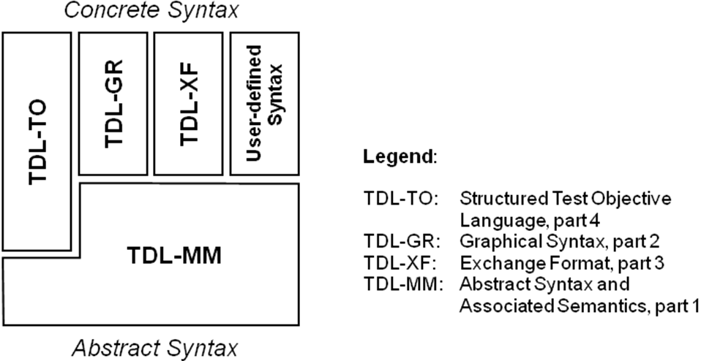
Figure 4.1: The TDL standards and their relation
The TDL concrete syntax is application or domain specific and is not specified in the present document. However, for information, see annex B for an example of a concrete textual syntax. A proposed concrete graphical syntax can be found in [3].
The semantics of the meta-model elements are captured in the individual clauses describing the meta-model elements defined in the present document.
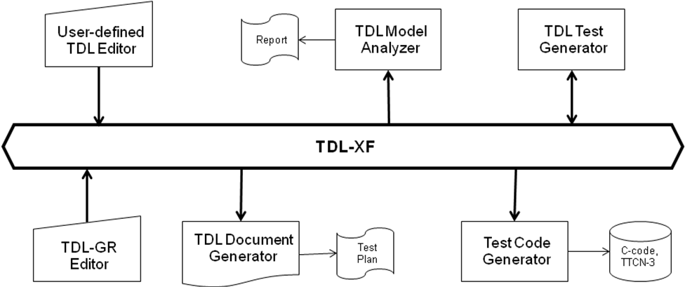
Figure 4.2: A scalable TDL tool architecture
The TDL abstract syntax (TDL meta-model) and semantics defined in the present document serve as the basis for the development of TDL tools such as editors for TDL specifications in graphical, textual or other forms of concrete syntaxes, analyzers of TDL specifications that check the consistency of TDL specifications, test documentation generators, and test code generators to derive executable tests. The TDL exchange format [4] serves as the connector to hold all TDL tools together (see figure 4.2).

4.3 Design Considerations
TDL makes a clear distinction between concrete syntax that is adjustable to different application domains and a common abstract syntax, which a concrete syntax is mapped to (an example concrete syntax can be found in annex B). The definition of the abstract syntax for a TDL specification plays the key role in offering interchangeability and unambiguous semantics of test descriptions. It is defined in this TDL standard in terms of a MOF meta-model.
A TDL specification consists of the following major parts that are also reflected in the meta-model:
- A test configuration consisting of at least one tester and at least one SUT component and connections among them reflecting the test environment.
- A set of test descriptions, each of them describing one test scenario based on interactions between the components of a given test configuration and actions of components or actors. The control flow of a test description is expressed in terms of sequential, alternative, parallel, iterative, etc. behaviour.
- A set of data definitions that are used in interactions and as parameters of test description invocations.
- Behavioural elements used in test descriptions that operate on time.
Using these major ingredients, a TDL specification is abstract in the following sense:
- Interactions between tester and SUT components of a test configuration are considered to be atomic and not detailed further. For example, an interaction can represent a message exchange, a remote function/procedure call, or a shared variable access.
- All behavioural elements within a test description are totally ordered, unless it is specified otherwise. That is, there is an implicit synchronization mechanism assumed to exist between the components of a test configuration.
- The behaviour of a test description represents the expected, foreseen behaviour of a test scenario assuming an implicit test verdict mechanism, if it is not specified otherwise. If the specified behaviour of a test description is executed, the 'pass' test verdict is assumed. Any deviation from this expected behaviour is considered to be a failure of the SUT, therefore the 'fail' verdict is assumed.
- An explicit verdict assignment can be used if in a certain case there is a need to override the implicit verdict setting mechanism (e.g. to assign 'inconclusive' or any user-defined verdict values).
- The data exchanged via interactions and used in parameters of test descriptions are represented as values of an abstract data type without further details of their underlying semantics, which is implementation-specific.
- There is no assumption about verdict arbitration, which is implementation-specific. If a deviation from the specified expected behaviour is detected, the subsequent behaviour becomes undefined. In this case an implementation might stop executing the TDL specification.
A TDL specification represents a closed system of tester and SUT components. That is, each interaction of a test description refers to one source component and at least one target component that are part of the underlying test configuration a test description runs on. The actions of the actors (entities of the environment of the given test configuration) can be indicated in an informal way.
Time in TDL is considered to be global and progresses in discrete quantities of arbitrary granularity. Progress in time is expressed as a monotonically increasing function. Time starts with the execution of the first ('base') test description being invoked.
TDL can be extended with tool, application, or framework specific information by means of annotations.

4.4 Document Structure
The present document defines the TDL abstract syntax expressed as a MOF meta-model. The TDL meta-model offers language features to express:
- Fundamental concepts such as structuring of TDL specifications and tracing of test objectives to test descriptions (clause 5).
- Abstract representations of data used in test descriptions (clause 6).
- Concepts of time, time constraints, and timers as well as their related operations (clause 7).
- Test configurations, on which test descriptions are executed (clause 8).
- A number of behavioural operations to specify the control flow of test descriptions (clause 9).
- A set of predefined instances of the TDL meta-model for test verdict, time, data types and functions over them that can be extended further by a user (clause 10).

4.5 Notational Conventions
In the present document, the following notational conventions are applied:
'element' The name of an element or of the property of an element from the meta-model, e.g. the name of a meta-class.
«metaclass» Indicates an element of the meta-model, which corresponds to a node of the abstract syntax, i.e. an intermediate node if the element name is put in italic or a terminal node if given in plain text.
«Enumeration» Denotes an enumeration type.
/ name The value with this name of a property or relation is derived from other sources within the meta-model.
[1] Multiplicity of 1, i.e. there exists exactly one element of the property or relation.
[0..1] Multiplicity of 0 or 1, i.e. there exists an optional element of the property or relation.
[*] or [0..*] Multiplicity of 0 to many, i.e. there exists a possibly empty set of elements of the property or relation.
[1..*] Multiplicity of one to many, i.e. there exists a non-empty set of elements of the property or relation.
{unique} All elements contained in a set of elements shall be unique.
{ordered} All elements contained in a set of elements shall be ordered, i.e. the elements form a list.
{readOnly} The element can be accessed read-only, i.e. cannot be modified. Used for derived properties.
Furthermore, the definitions and notations from the MOF 2 core framework [1] and the UML class diagram definition [2] apply.

4.6 Conformance
For an implementation claiming to conform to this version of the TDL meta-model, all features specified in the present document shall be implemented consistently with the requirements given in the present document. The electronic attachment in annex A can serve as a starting point for a TDL meta-model implementation conforming to the present document.

5 Foundation

5.1 Overview
The 'Foundation' package specifies the fundamental concepts of the TDL meta-model. All other features of the TDL meta-model rely on the concepts defined in this 'Foundation' package.

5.2 Abstract Syntax and Classifier Description
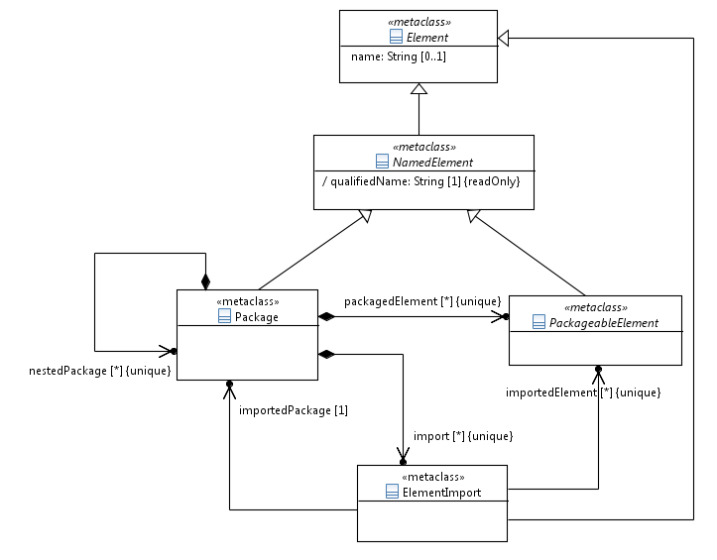
Figure 5.1: Foundational language concepts

5.2.1 Element
Semantics
An 'Element' represents any constituent of a TDL model. It is the super-class of all other meta classes. It provides the ability to add comments and annotations. An 'Element' may contain any number of 'Comment's and 'Annotation's.
Generalization
There is no generalization specified.
Properties
- name: String [0..1]
The name of the 'Element'. It can contain any character, including white-spaces. Having no name specified is different from an empty name (which is represented by an empty string).
- comment: Comment [0..*] {unique}
The contained set of 'Comment's attached to the 'Element'.
- annotation: AnnotationType [0..*] {unique}
The contained set of 'Annotation's attached to the 'Element'.
Constraints
There are no constraints specified.

5.2.2 NamedElement
Semantics
A 'NamedElement' represents any element of a TDL model that mandatorily has a name and a qualified name.
The 'qualifiedName' is a compound name derived from the directly and all indirectly enclosing parent 'Package's by concatenating the names of each 'Package'. As a separator between the segments of a 'qualifiedName' the string '::' shall be used. The name of the root 'Package' that (transitively) owns the 'PackageableElement' shall always constitute the first segment of the 'qualifiedName'.
Generalization
- Element
Properties
- / qualifiedName: String [1] {readOnly}
A derived property that represents the unique name of an element within a TDL model.
Constraints
- Mandatory name
A 'NamedElement' shall have the 'name' property set and the 'name' shall be not an empty String.
- Distinguishable qualified names
All qualified names of instances of the same meta-class shall be distinguishable within a TDL model.
NOTE: It is up to the concrete syntax definition and tooling to resolve any name clashes between instances of the same meta-class in the qualified name.

5.2.3 PackageableElement
Semantics
A 'PackageableElement' denotes elements of a TDL model that can be contained in a 'Package'.
The visibility of a 'PackageableElement' is restricted to the 'Package' in which it is directly contained. A 'PackageableElement' may be imported into other 'Package's by using 'ElementImport'. A 'PackageableElement' has no means to actively increase its visibility.
Generalization
- NamedElement
Properties
There are no properties specified.
Constraints
There are no constraints specified.

5.2.4 Package
Semantics
A 'Package' represents a container for 'PackageableElement's. A TDL model contains at least one 'Package', i.e., the root 'Package' of the TDL model. A 'Package' may contain any number of 'PackageableElement's, including other 'Package's.
A 'Package' constitutes a scope of visibility for its contained 'PackageableElement's. A 'PackageableElement' is only accessible within its owning 'Package' and within any 'Package' that directly imports it. 'PackageableElement's that are defined within a nested 'Package' are not visible from within its containing 'Package'.
A 'Package' may import any 'PackageableElement' from any other 'Package' by means of 'ElementImport'. By importing a 'PackageableElement', the imported 'PackageableElement' becomes visible and accessible within the importing 'Package'. Cyclic imports of packages are not permitted.
Generalization
- NamedElement
Properties
- packagedElement: PackageableElement [0..*] {unique}
The set of 'PackageableElement's that are directly contained in the 'Package'.
- import: ElementImport [0..*] {unique}
The contained set of import declarations.
- nestedPackage: Package [0..*] {unique}
The contained set of 'Package's contained within this 'Package'.
Constraints
- No cyclic imports
A 'Package' shall not import itself directly or indirectly.

5.2.5 ElementImport
Semantics
An 'ElementImport' allows importing 'PackageableElement's from arbitrary 'Package's into the scope of an importing 'Package'. By establishing an import, the imported 'PackageableElement's become accessible within the importing 'Package'.
Only those 'PackageableElement's can be imported via 'ElementImport' that are directly contained in the exporting 'Package'. That is, the import of 'PackageableElement's is not transitive. After the import, all the imported elements become accessible within the importing 'Package'. The set of imported elements is declared via the 'importedElement' property.
If the set 'importedElement' is empty, it implies that all elements of the 'importedPackage' are imported.
Generalization
- Element
Properties
- importedPackage: Package [1]
Reference to the 'Package' whose 'PackageableElement's are imported.
- importedElement: PackageableElement [0..*] {unique}
A set of 'PackageableElement's that are imported into the context 'Package' via this 'ElementImport'.
Constraints
- Consistency of imported elements
All imported 'PackageableElement's referenced by an 'ElementImport' shall be directly owned by the imported 'Package'.
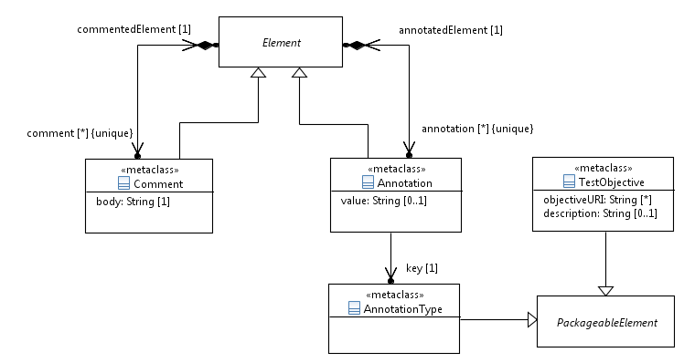
Figure 5.2: Miscellaneous elements

5.2.6 Comment
Semantics
'Comment's may be attached to 'Element's for documentation or for other informative purposes. Any 'Element', except for a 'Comment' or an 'Annotation', may contain any number of 'Comment's. The contents of 'Comment's shall not be used for adding additional semantics to elements of a TDL model.
Generalization
- Element
Properties
- commentedElement: Element [1]
The 'Element' to which the 'Comment' is attached.
- body: String [1]
The content of the 'Comment'.
Constraints
- No nested comments
A 'Comment' shall not contain 'Comment's.
- No annotations to comments
A 'Comment' shall not contain 'Annotation's.

5.2.7 Annotation
Semantics
An 'Annotation' is a means to attach user or tool specific semantics to any 'Element' of a TDL model, except to a 'Comment' and an 'Annotation' itself. An 'Annotation' represents a pair of a ('key', 'value') properties. Whereas the 'key' is mandatory for each 'Annotation', the 'value' might be left empty. This depends on the nature of the Annotation.
Generalization
- Element
Properties
- annotatedElement: Element [1]
The 'Element' to which the 'Annotation' is attached.
- key: AnnotationType [1]
Reference to the 'AnnotationType'.
- value: String [0..1]
The 'value' mapped to the 'key'.
Constraints
- No nested annotations
An 'Annotation' shall not contain 'Annotation's.
- No comments to annotations
An 'Annotation' shall not contain 'Comment's.

5.2.8 AnnotationType
Semantics
An 'AnnotationType' is used to define the 'key' of an 'Annotation'. It can represent any kind of user or tool specific semantics.
Generalization
- PackageableElement
Properties
There are no properties specified.
Constraints
There are no constraints specified.

5.2.9 TestObjective
Semantics
A 'TestObjective' specifies the reason for designing either a 'TestDescription' or a particular 'Behaviour' of a 'TestDescription'. A 'TestObjective' may contain a 'description' directly and/or refer to an external resource for further information about the objective.
The 'description' of a 'TestObjective' should be in natural language, however, it may be provided as structured (i.e. machine-readable) format. In the latter case, a structured test objective specification language is provided in part 4 of this standard series [5].
Generalization
- PackageableElement
Properties
- description: String [0..1]
A textual description of the 'TestObjective'.
- objectiveURI: String [0..*] {unique}
A set of URIs locating resources that provide further information about the 'TestObjective'. These resources are typically external to a TDL model, e.g. part of requirements specifications or a dedicated test objective specification.
Constraints
There are no constraints specified.

6 Data

6.1 Overview
The 'Data' package describes all meta-model elements required to specify data and their use in a TDL model. It introduces the foundation for data types and data instances and distinguishes between simple data types and structured data types. The package also introduces parameters and variables and deals with the definition of actions and functions. It makes a clear separation between the definition of data types and data instances (clause 6.2) and their use in expressions (clause 6.3). The following main elements are described in this package:
- Elements to define data types and data instances, actions and functions, parameters and variables;
- Elements to make use of data elements in test descriptions, e.g. in guard conditions or data in interactions;
- Elements to allow the mapping of data elements (types, instances, actions, functions) to their concrete representations in an underlying runtime system.
For the purpose of defining the semantics of some data related meta-model elements, the semantical concept <undefined> is introduced denoting an undefined data value in a TDL model. The semantical concept <undefined> has no syntactical representation.
It is completely valid to use data elements in a TDL model that render to an <undefined> value. Though this implies that one cannot establish the executable semantics also of other elements that rely on such undefined data elements. In a given TDL model, this may affect a large portion of that model. Therefore a specific tool supporting TDL, e.g. a compiler, may disallow the presence of an <undefined> value.

6.2 Data Definition – Abstract Syntax and Classifier Description
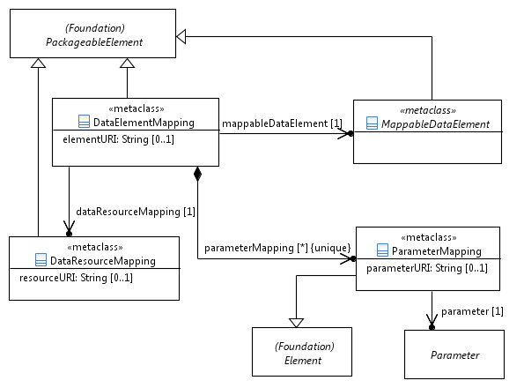
Figure 6.1: Data mapping concepts

6.2.1 DataResourceMapping
Semantics
A 'DataResourceMapping' specifies a resource, in which the platform-specific representation of a 'DataType' or a 'DataInstance', i.e. their representation in a concrete data type system, is located as identified in the 'resourceURI' property. The 'DataResourceMapping' thus connects a TDL model with resources and artefacts that are outside the scope of TDL.
Generalization
- PackageableElement
Properties
- resourceURI: String [0..1]
Location of the resource that contains concrete data definitions. The location shall resolve to an unambiguous name.
Constraints
There are no constraints specified.

6.2.2 MappableDataElement
Semantics
A 'MappableDataElement' is the super-class of all data-related elements that can be mapped to a platform-specific representation by using a 'DataResourceMapping' and a 'DataElementMapping'. Each 'MappableDataElement' can be mapped to any number of concrete representations located in different resources. However the same 'MappableDataElement' shall not be mapped more than once to different concrete representations in the same 'DataResourceMapping'.
Generalization
- PackageableElement
Properties
There are no properties specified.
Constraints
There are no constraints specified.

6.2.3 DataElementMapping
Semantics
A 'DataElementMapping' specifies the location of a single concrete data definition within an externally identified resource (see clause 6.2.1). The location of the concrete data element within the external resource is described by means of the 'elementURI' property. A 'DataElementMapping' maps arbitrary data elements in a TDL model to their platform-specific counterparts.
If the 'DataElementMapping' refers to a 'StructuredDataType', an 'Action', or a 'Function', it is possible to map specific 'Members' (in the first case) or 'Parameters' (in the other cases) to concrete data representations explicitly.
Generalization
- PackageableElement
Properties
- elementURI: String [0..1]
Location of a concrete data element within the resource referred in the referenced 'DataResourceMapping'. The location shall resolve to an unambiguous name within the resource.
- dataResourceMapping: DataResourceMapping [1]
The 'DataResourceMapping' that specifies the URI of the external resource containing the concrete data element definitions.
- mappableDataElement: MappableDataElement [1]
Refers to a 'MappableDataElement' that is mapped to its platform-specific counterpart identified in the 'elementURI'.
- parameterMapping: ParameterMapping [0..*] {unique}
The set of 'Member's of a 'StructuredDataType' or 'FormalParameter's of an 'Action' or 'Function' that are mapped.
Constraints
- Restricted use of parameter mapping
A set of 'ParameterMapping's shall only be provided if 'mappableDataElement' refers to a 'StructuredDataType', an 'Action' or a 'Function' definition.

6.2.4 ParameterMapping
Semantics
A 'ParameterMapping' is used to provide a mapping of 'Member's of a 'StructuredDataType' or 'FormalParameter's of an 'Action' or a 'Function'. It represents the location of a single concrete data element within the resource according to the 'DataResourceMapping', which the containing 'DataElementMapping' of the 'ParameterMapping' refers to. The location within the resource is described by means of the 'memberURI' property.
Generalization
- Element
Properties
- memberURI: String [0..1]
Location of a concrete data element within the resource referred indirectly via the 'DataElementMapping' in the 'DataResourceMapping'. The location shall resolve to an unambiguous name within the resource.
- parameter: Parameter [1]
Refers to the 'Parameter' ('Member' of a 'StructuredDataType' or 'FormalParameter' of an 'Action' or a 'Function') to be mapped to a concrete data representation.
Constraints
There are no constraints specified.
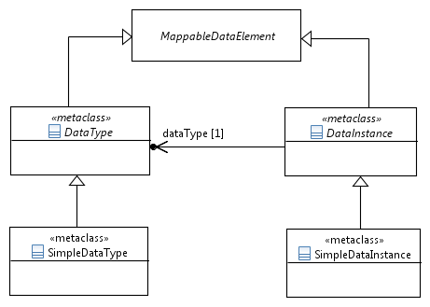
Figure 6.2: Basic data concepts and simple data

6.2.5 DataType
Semantics
A 'DataType' is the super-class of all type-related concepts. It is considered as abstract in several dimensions:
1) It is an abstract meta-class that is concretized by 'SimpleDataType' and 'StructuredDataType'.
2) It is abstract regarding its structure (simple or structured), semantics and operations that can operate on it. It, thus, shall be considered as an abstract data type (ADT).
3) It is abstract with respect to its manifestation in a concrete data type system.
A 'DataType' is expected to be mapped to a concrete data type definition contained in a resource, which is external to the TDL model.
Generalization
- MappableDataElement
Properties
There are no properties specified.
Constraints
There are no constraints specified.

6.2.6 DataInstance
Semantics
A 'DataInstance' represents a symbolic value of a 'DataType'.
Generalization
- MappableDataElement
Properties
- dataType: DataType [1]
Refers to the 'DataType', which this 'DataInstance' is a value of.
Constraints
There are no constraints specified.

6.2.7 SimpleDataType
Semantics
A 'SimpleDataType' represents a 'DataType' that has no internal structure. It resembles the semantics of ordinary primitive types from programming languages such as Integer or Boolean.
A set of predefined 'SimpleDataType's is provided by TDL by default (see clause 10.2).
Generalization
- DataType
Properties
There are no properties specified.
Constraints
There are no constraints specified.

6.2.8 SimpleDataInstance
Semantics
A 'SimpleDataInstance' represents a symbolic value of a 'SimpleDataType'. This symbolic value can denote either one specific value or a set of values in a concrete type system (the latter is similar to the notion of template in TTCN-3, see clause 15 in [i.1]).
EXAMPLE: Assuming the 'SimpleDataType' Integer, 'SimpleDataInstance's of this type can be specified as Strings: "0", "1", "2", "max", "[-10..10]" etc. These symbolic values need to be mapped to concrete definitions of an underlying concrete type system to convey a specific meaning.
Generalization
- DataInstance
Properties
There are no properties specified.
Constraints
- SimpleDataInstance shall refer to SimpleDataType
The inherited reference 'dataType' from 'DataInstance' shall refer to instances of 'SimpleDataType' solely.
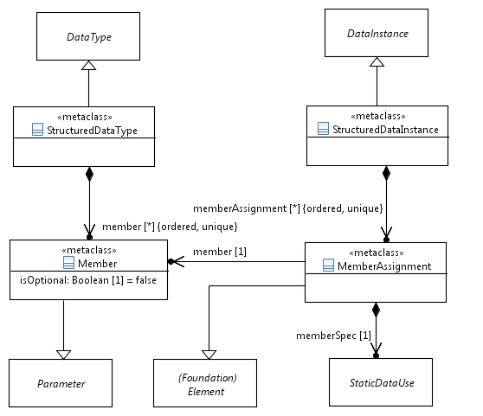
Figure 6.3: Structured data type and instance

6.2.9 StructuredDataType
Semantics
A 'StructuredDataType' represents a 'DataType' with an internal structure expressed by the concepts of 'Member's. It resembles the semantics of a complex data type in XML Schema, a record in TTCN-3 or a class in Java.
Generalization
- DataType
Properties
- member: Member [0..*] {ordered, unique}
The contained ordered set of individual elements of the 'StructuredDataType'.
Constraints
There are no constraints specified.

6.2.10 Member
Semantics
A 'Member' specifies a single part of the internal structure of a 'StructuredDataType'. It can be an optional or a mandatory part. By default, all 'Member's of a 'StructuredDataType' are mandatory.
An optional member of a structured data type has an impact on the use of 'StructuredDataInstance's of this type (see clause 6.3.1).
Generalization
- Parameter
Properties
- isOptional: Boolean [1] = false
If set to 'true' it indicates that the member is optional within the containing 'StructuredDataType'.
Constraints
- Different member names in a structured data type
All 'Member' names of a 'StructuredDataType' shall be distinguishable.

6.2.11 StructuredDataInstance
Semantics
A 'StructuredDataInstance' represents a symbolic value of a 'StructuredDataType'. It contains 'MemberAssignment's for none, some or all 'Member's of the 'StructuredDataType'. This allows initialising the 'Member's with symbolic values.
If a 'StructuredDataInstance' has no 'MemberAssignment' for a given 'Member' of its 'StructuredDataType', it is assumed that the 'Member' has the value <undefined> assigned to it.
Generalization
- DataInstance
Properties
- memberAssignment: MemberAssignment [0..*] {ordered, unique}
Refers to the contained list of 'MemberAssignment's, which are used to assign values to 'Member's.
Constraints
- StructuredDataInstance shall refer to StructuredDataType
The inherited reference 'dataType' from 'DataInstance' shall refer to instances of 'StructuredDataType' solely.

6.2.12 MemberAssignment
Semantics
A 'MemberAssignment' specifies the assignment of a symbolic value to a 'Member' of a 'StructuredDataType'.
Generalization
- Element
Properties
- member: Member [1]
Refers to the 'Member' of the 'StructuredDataType' definition that is referenced via the 'dataType' property of the 'StructuredDataInstance'.
- memberSpec: StaticDataUse [1]
The contained 'StaticDataUse' specification for the referenced 'Member'. The symbolic value of this 'StaticDataUse' will be assigned to the 'Member'.
Constraints
- 'Member' of the 'StructuredDataType'
The 'Member' shall be referenced in the 'StructuredDataType' that the 'StructuredDataInstance', which contains this 'MemberAssignment', refers to.
- Type of a 'memberSpec' and 'Member' shall coincide
The 'DataType' of the 'StaticDataUse' of 'memberSpec' shall coincide with the 'DataType' of the 'Member' of the 'MemberAssignment'.
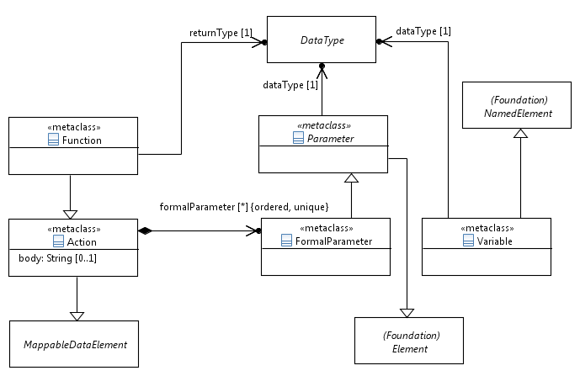
Figure 6.4: Action, function, parameter and variable

6.2.13 Parameter
Semantics
A 'Parameter' is used to define some common operations over 'FormalParameter' and 'Member' such as data mapping and assignments.
Generalization
- Element
Properties
- dataType: DataType [1]
Refers to the 'DataType', which the 'Parameter' can be bound to.
Constraints
There are no constraints specified.

6.2.14 FormalParameter
Semantics
A 'FormalParameter' represents the concept of a formal parameter as known from programming languages.
Generalization
- Parameter
Properties
There are no properties specified.
Constraints
There are no constraints specified.

6.2.15 Variable
Semantics
A 'Variable' is used to denote a component-wide local variable. When it is defined, which occurs when the 'ComponentInstance' that is assumed to hold this variable is created (see clause 8.2.4), the 'Variable' has the value <undefined> assigned to it.
Generalization
- NamedElement
Properties
- dataType: DataType [1]
Refers to the 'DataType' of 'DataInstance's, which the 'Variable' shall be bound to.
Constraints
There are no constraints specified.

6.2.16 Action
Semantics
An 'Action' is used to specify any procedure, e.g. a local computation, physical setup or manual task. The interpretation of the 'Action' is outside the scope of TDL. That is, its semantics is opaque to TDL. The implementation of an 'Action' can be provided by means of a 'DataElementMapping'.
An 'Action' may be parameterized. Actual parameters are provided in-kind. That is, executing an 'Action' does not change the values of the parameters provided; execution of an 'Action' is side-effect free.
Generalization
- MappableDataElement
Properties
- body: String [0..1]
An informal, textual description of the 'Action' procedure.
- formalParameter: FormalParameter [0..*] {ordered, unique}
The ordered set of contained 'FormalParameter's of this 'Action'.
Constraints
There are no constraints specified.

6.2.17 Function
Semantics
A 'Function' is a special kind of an 'Action' that has a return value. 'Function's are used to express calculations over 'DataInstance's within a 'TestDescription' at runtime. The execution of a 'Function' is side-effect free. That is, a 'Function' does not modify any passed or accessible 'DataInstance's or 'Variable's of the 'TestDescription'. The value of a 'Function' is defined only by its return value.
Generalization
- Action
Properties
- returnType: DataType [1]
The 'DataType' of the 'DataInstance' that is returned when the 'Function' finished its calculation.
Constraints
There are no constraints specified.

6.3 Data Use – Abstract Syntax and Classifier Description
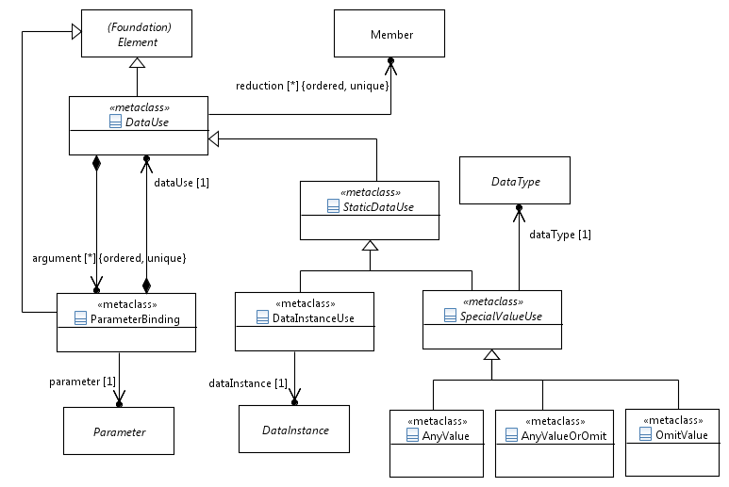
Figure 6.5: Data use concepts and static data use

6.3.1 DataUse
Semantics
A 'DataUse' denotes an expression that evaluates to a 'DataInstance' of a given 'DataType'. Thus, a 'DataUse' delivers the symbolic value that can be used in assignments and invocations. Sub-classes of 'DataUse' are used in specific situations, e.g. to invoke a 'Function' or refer to a 'DataInstance'. The decision on what a 'DataUse' refers to is made by the concrete sub-classes. This is called the context of a 'DataUse'.
A 'DataUse' offers the capability to be parameterised. This is achieved by the use of a 'ParameterBinding'.
In case that the context of a 'DataUse' evaluates to a 'StructuredDataInstance', it is possible to specify a location expression over nested 'StructuredDataInstance's in order to reduce the 'DataUse' to the symbolic value contained in a potentially nested 'Member'. This is called reduction. The reduction is semantically equivalent to the dot-notation typically found in programming languages, e.g. in Java or TTCN-3, in order to navigate from a context object, i.e. the 'StructuredDataInstance', which this 'DataUse' evaluates to at runtime, to a specific location. The starting point of a location expression is the implicitly or explicitly referenced 'StructuredDataInstance' obtained after the 'DataUse' has been evaluated at runtime. The first element of the 'reduction' has to be a 'Member' of the context 'StructuredDataInstance'. In case that a 'Member' in the reduction list represents a 'SimpleDataType', no more 'Member's shall occur in the location expression after this 'Member'.
Generalization
- Element
Properties
- argument: ParameterBinding [0..*] {ordered, unique}
The contained ordered set of 'ParameterBinding's that handles the assignment of symbolic values to 'Parameter's or 'Member's depending on the respective context of this 'DataUse'.
- reduction: Member [0..*] {ordered, unique}
Location expression that refers to potentially nested 'Member's of a 'StructuredDataType'. Each 'Member' of the ordered set represents one fragment of the location expression. The location expression is evaluated after all 'argument' assignments have been put into effect.
Constraints
- No mixed use of 'Member' and 'FormalParameter' in 'argument' set
All 'ParameterBinding's that are referenced in the 'argument' set shall refer only to one kind of 'Member' or 'FormalParameter'.
- Occurrence of 'argument' and 'reduction'
Both, 'argument' and 'reduction', shall be provided only in case of a 'FunctionCall'.
- Structured data types in 'reduction' set
A 'Member' at index i of a 'reduction' shall be contained in the 'StructuredDataType' of the 'Member' at index (i – 1) of that 'reduction'.
- Use of a 'StructuredDataInstance' with non-optional 'Member's
Non-optional members of a 'StructuredDataInstance' shall have 'DataUse' specifications assigned to them that are different from 'OmitValue'.

6.3.2 ParameterBinding
Semantics
A 'ParameterBinding' is used to assign a 'DataUse' specification to a 'FormalParameter' or 'Member'.
Generalization
- Element
Properties
- dataUse: DataUse [1]
Refers to the contained 'DataUse' specification whose symbolic value shall be assigned to the 'Parameter'.
- parameter: Parameter [1]
Refers to the parameter, which gets the symbolic value of a 'DataUse' specification assigned to.
Constraints
- Matching data type
The provided 'DataUse' shall match the 'DataType' of the referenced 'Parameter'.

6.3.3 StaticDataUse
Semantics
A 'StaticDataUse' specification denotes an expression that evaluates to a symbolic value that does not change during runtime, in other words, a constant.
Generalization
- DataUse
Properties
There are no properties specified.
Constraints
- Static data use in structured data
If the 'DataInstance' refers to a 'StructuredDataInstance', all its members shall obtain 'ParameterBinding's that refer to 'StaticDataUse'.

6.3.4 DataInstanceUse
Semantics
A 'DataInstanceUse' refers either to a 'SimpleDataInstance' or a 'StructuredDataInstance'. It is provided as a 'DataUse' specification.
In case it refers to a 'StructuredDataInstance', its value can be modified inline by providing arguments as 'ParameterBinding's. This allows replacing the current value of the referenced 'Member' with a new value evaluated from the provided 'DataUse' specification.
Generalization
- StaticDataUse
Properties
- dataInstance: DataInstance [1]
Refers to the 'DataInstance' that is used in this 'DataUse' specification.
Constraints
- Either argument list or reduction list provided
Either one of the 'argument' list or 'reduction' list or none of them shall be provided.

6.3.5 SpecialValueUse
Semantics
A 'SpecialValueUse' is the super-class of all 'StaticDataUse' specifications that represent predefined wildcards instead of values.
Generalization
- StaticDataUse
Properties
- dataType: DataType [1]
Refers to the 'DataType' of the 'SpecialValueUse'.
Constraints
- Empty 'argument' and 'reduction' sets
The 'argument' and 'reduction' sets shall be empty.

6.3.6 AnyValue
Semantics
An 'AnyValue' denotes an unknown symbolic value from the set of all possible values of a 'DataType' that is not restricted to values explicitly specified as 'DataInstance's in a given TDL model, but excluding the 'OmitValue' and the <undefined> value.
Its purpose is to be used as a placeholder in the specification of a data value when the actual value is not known or irrelevant.
Generalization
- SpecialValueUse
Properties
There are no properties specified.
Constraints
There are no constraints specified.

6.3.7 AnyValueOrOmit
Semantics
An 'AnyValueOrOmit' denotes an unknown symbolic value from the union set of 'AnyValue' and 'OmitValue'.
Its purpose is to be used as a placeholder in the specification of a data value when the actual value is not known or irrelevant.
NOTE: 'AnyValueOrOmit' is semantically equivalent to 'AnyValue' if applied on mandatory 'Member's of a 'StructuredDataType'.
Generalization
- SpecialValueUse
Properties
There are no properties specified.
Constraints
There are no constraints specified.

6.3.8 OmitValue
Semantics
An 'OmitValue' denotes a symbolic value indicating that the value of the corresponding optional 'Member' of a 'StucturedDataType' is omitted from a 'StructuredDataInstance' of that 'StucturedDataType' at runtime.
NOTE: An 'OmitValue' can be applied in a 'MemberAssignment' for an optional 'Member' of a 'StructuredDataType' only.
Generalization
- SpecialValueUse
Properties
There are no properties specified.
Constraints
There are no constraints specified.
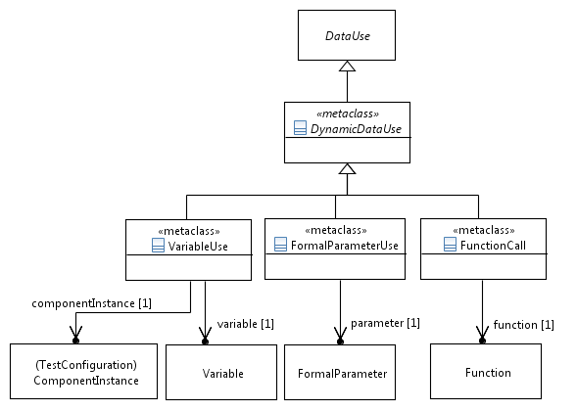
Figure 6.6: Dynamic data use

6.3.9 DynamicDataUse
Semantics
A 'DynamicDataUse' is the super-class for all symbolic values that are evaluated at runtime.
Generalization
- DataUse
Properties
There are no properties specified.
Constraints
There are no constraints specified.

6.3.10 FunctionCall
Semantics
A 'FunctionCall' specifies the invocation of a 'Function' with its arguments.
If the invoked 'Function' has declared 'FormalParameter's the corresponding arguments shall be specified by using 'ParameterBinding'.
If a 'reduction' is provided, it applies to the return value of the 'Function', which implies that the return value is of 'StructuredDataType'.
If one of the 'DataUse' specifications provided in the 'ParameterBinding' of the 'FormalParameter's has the value <undefined>, the 'FunctionCall' represents also the <undefined> value.
Generalization
- DynamicDataUse
Properties
- function: Function [1]
Refers to the function being invoked.
Constraints
- Matching parameters
The arguments specified by the 'ParameterBinding' shall match (in terms of number and data type) the list of 'FormalParameter's of the invoked 'Function'.

6.3.11 FormalParameterUse
Semantics
A 'FormalParameterUse' specifies the access of a symbolic value stored in a 'FormalParameter' of a 'TestDescription'.
Generalization
- DynamicDataUse
Properties
- parameter: FormalParameter [1]
Refers to the 'FormalParameter' of the containing 'TestDescription' being used.
Constraints
- Either argument list or reduction list provided
Either one of the 'argument' list or 'reduction' list or none of them shall be provided.

6.3.12 VariableUse
Semantics
A 'VariableUse' denotes the use of the symbolic value stored in a 'Variable'.
If the accessed 'Variable' has the value <undefined> assigned to it, the 'VariableUse' represents also the <undefined> value.
Generalization
- DynamicDataUse
Properties
- variable: Variable [1]
Refers to the 'Variable', whose symbolic value shall be retrieved.
- componentInstance: ComponentInstance [1]
Refers to the 'ComponentInstance' that references the 'Variable' via its 'ComponentType'.
Constraints
- Either argument list or reduction list provided
Either one of the 'argument' list or 'reduction' list or none of them shall be provided.
- Local variables of tester components only
All variables used in a 'DataUse' specification via a 'VariableUse' shall be local to the same 'componentInstance' and the 'componentInstance' shall be in the role 'Tester'.

7 Time

7.1 Overview
The 'Time' package defines the elements to express time, time constraints, timers and operations over time and timers.

7.2 Abstract Syntax and Classifier Description
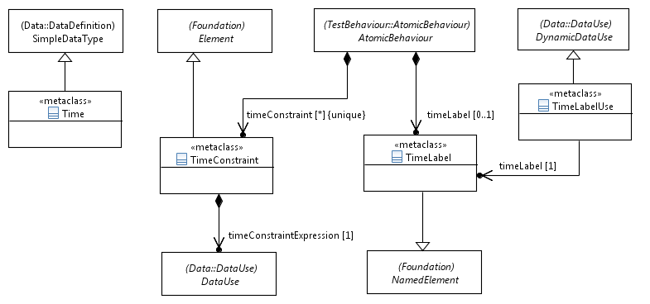
Figure 7.1: Time, time label and time constraint

7.2.1 Time
Semantics
A 'Time' element extends the 'SimpleDataType' and is used to measure time and helps expressing time-related concepts in a TDL model.
Time in TDL is considered to be global and progresses in discrete quantities of arbitrary granularity. Time starts with the execution of the first 'TestDescription' being invoked. Progress in time is expressed as a monotonically increasing function, which is outside the scope of TDL.
A time value is expressed as a 'SimpleDataInstance' of an associated 'Time' 'SimpleDataType'. The way how a time value is represented, e.g. as an integer or a real number, is kept undefined in TDL and can be defined by the user via a 'DataElementMapping'.
The 'name' property of the 'Time' element expresses the granularity of time measurements. TDL defines the predefined instance 'Second' of the 'Time' data type, which measures the time in the physical unit seconds. See clause 10.4.
NOTE: When designing a concrete syntax from the TDL meta-model, it is recommended that the 'Time' data type can be instantiated at most once by a user and the same 'Time' instance shall be used in all 'DataUse' expressions within a TDL model; let it be the predefined instance 'Second' or a user-defined instance. This assures a consistent use of time-related concepts throughout the TDL model.
Generalization
- SimpleDataType
Properties
There are no properties specified.
Constraints
There are no constraints specified.

7.2.2 TimeLabel
Semantics
A 'TimeLabel' is a symbolic name attached to an 'AtomicBehaviour' that represents an ordered list of timestamps of execution of this atomic behaviour. A 'TimeLabel' allows the expression of time constraints (see subsequent clauses). It is contained in the 'AtomicBehaviour' that produces the timestamps at runtime.
If the atomic behaviour the 'TimeLabel' is attached to is executed once, the 'TimeLabel' contains only a single timestamp. Otherwise, if the atomic behaviour is executed iteratively, e.g. within a loop, the 'TimeLabel' represents a list of timestamps. In the latter case, some functions are predefined that return a single timestamp from this list (see clause 10.5.3). To enable the definition of these functions, it is assumed that all 'TimeLabel's belong to the predefined data type 'TimeLabelType' (see clause 10.2.3).
There is no assumption being made when the timestamp is taken: at the start or the end of the 'AtomicBehaviour' or at any other point during its execution. It is however recommended to have it consistently defined in an implementation of the TDL model.
Generalization
- NamedElement
Properties
There are no properties specified.
Constraints
There are no constraints specified.

7.2.3 TimeLabelUse
Semantics
A 'TimeLabelUse' enables the use of a time label in a 'DataUse' specification. The most frequent use of that will be within a 'TimeConstraint' expression.
Generalization
- DynamicDataUse
Properties
- timeLabel: TimeLabel [1]
Refers to the time label being used in the 'DataUse' specification.
Constraints
- Empty argument and reduction lists
The 'argument' and 'reduction' lists shall be empty.

7.2.4 TimeConstraint
Semantics
A 'TimeConstraint' is used to express a time requirement for an 'AtomicBehaviour'. The 'TimeConstraint' is usually formulated over one or more 'TimeLabel's. A 'TimeConstraint' constrains the execution time of the 'AtomicBehaviour' that contains this 'TimeConstraint'.
If the 'AtomicBehaviour' is a tester-input event, the 'TimeConstraint' is evaluated after this 'AtomicBehaviour' happened. If it evaluates to Boolean 'true' it implies a 'pass' test verdict; otherwise a 'fail' test verdict. In other cases of 'AtomicBehaviour', the 'TimeConstraint' is evaluated before its execution. Execution is blocked and keeps blocking until the 'TimeConstraint' evaluates to Boolean 'true'.
The occurrence of the <undefined> value within the 'DataUse' of 'timeConstraintExpression' causes also an <undefined> value for the 'TimeConstraint'.
Generalization
- Element
Properties
- timeConstraintExpression: DataUse [1]
Defines the time constraint over 'TimeLabel's as an expression of predefined type 'Boolean'.
Constraints
- Time constraint expression of type Boolean
The expression given in the 'DataUse' specification shall evaluate to predefined type 'Boolean'.
- Use of local variables only
The expression given in the 'DataUse' specification shall contain only 'Variable's that are local to the 'AtomicBehaviour' that contains this time constraint. That is, all 'Variable's shall be referenced in the 'ComponentInstance' that executes the 'AtomicBehaviour'.
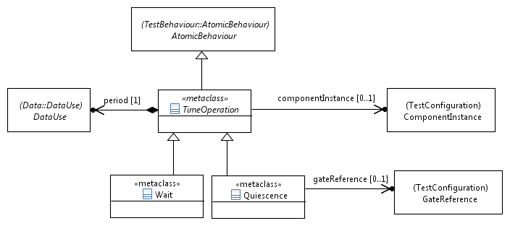
Figure 7.2: Time operations

7.2.5 TimeOperation
Semantics
A 'TimeOperation' summarizes the two possible time operations that can occur at a 'Tester' 'ComponentInstance': 'Wait' and 'Quiescence'.
The occurrence of the <undefined> value within the 'DataUse' specification causes undefined semantics of the 'TimeOperation' behaviour at runtime.
Generalization
- AtomicBehaviour
Properties
- period: DataUse [1]
The 'period' defines the time duration of the 'TimeOperation'.
- componentInstance: ComponentInstance [0..1]
The 'ComponentInstance', to which the 'TimeOperation' is associated.
Constraints
- Time operations on tester components only
A 'TimeOperation' shall be performed only on a 'ComponentInstance' in the role 'Tester'.
- 'Time' data type for period expression
The 'DataUse' expression assigned to the 'period' shall evaluate to a data instance of the 'Time' data type.

7.2.6 Wait
Semantics
A 'Wait' defines the time duration that a 'Tester' component instance waits before performing the next behaviour.
Any input arriving at the 'Tester' component during 'Wait' at runtime is handled by the following behaviour and is not a violation of the test description. The specific mechanism of implementing 'Wait' is not specified.
NOTE: 'Wait' is implemented typically by means of a timer started with the given 'period' property. After the timeout, the 'Tester' component continues executing the next behaviour.
Generalization
- TimeOperation
Properties
There are no properties specified.
Constraints
- Tester component for 'Wait' shall be known
The relation to a 'ComponentInstance' of a 'Wait' shall be set and refer to a 'Tester' component instance.

7.2.7 Quiescence
Semantics
A 'Quiescence' is called a tester-input event and defines the time duration, during which a 'Tester' component shall expect no input from a 'SUT' component at a given gate reference (if 'Quiescence' is associated to a gate reference) or at all the gate references the 'Tester' component instance contains of (if 'Quiescence' is associated to a component instance).
When a 'Quiescence' is executed, the 'Tester' component listens to 'Interaction's that occur at the defined gate reference(s). If such an 'Interaction' occurs during the defined 'period' (time duration), the test verdict is set to 'fail'; otherwise to 'pass'.
Input arriving during 'Quiescence' that matches an 'Interaction' of an alternative block in 'AlternativeBehaviour' or 'ExceptionalBehaviour' is allowed and not a violation of the test description. A similar statement holds for the use of 'Quiescence' in 'ParallelBehaviour'.
If 'Quiescence' occurs as the first behaviour element in an alternative block of an 'AlternativeBehaviour' or 'ExceptionalBehaviour', then its behaviour is defined as follows. The measurement of the quiescence duration starts with the execution of the associated alternative or exceptional behaviour. The check for the absence of an 'Interaction' occurs only if none of the alternative blocks have been selected.
NOTE: 'Quiescence' is implemented typically by means of a timer with the given 'period' property and listening at the indicated gate reference(s). The occurrence of the timeout indicates the end of a 'Quiescence' with verdict 'pass'.
Generalization
- TimeOperation
Properties
- gateReference: GateReference [0..1]
The 'GateReference', to which the 'Quiescence' is associated.
Constraints
- Exclusive use of gate reference or component instance
If a 'GateReference' is provided, a 'ComponentInstance' shall be not provided and vice versa.
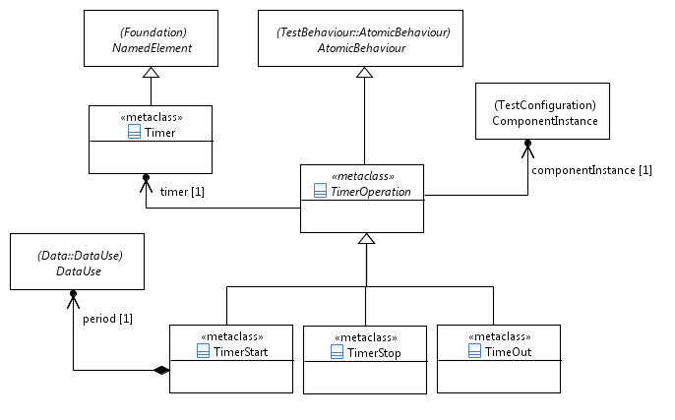
Figure 7.3: Timer and timer operations

7.2.8 Timer
Semantics
A 'Timer' defines a timer that is used to measure time intervals. A 'Timer' is contained within a 'ComponentType' assuming that each 'ComponentInstance' of the given 'ComponentType' has its own local copy of that timer at runtime.
Generalization
- NamedElement
Properties
There are no properties specified.
Constraints
- Initial state of a timer
When a timer is defined, it is operationally in the state idle.

7.2.9 TimerOperation
Semantics
A 'TimerOperation' operates on an associated 'Timer'. It is an element that summarizes the operations on timers: timer start, timeout and timer stop.
Generalization
- AtomicBehaviour
Properties
- timer: Timer [1]
This property refers to the 'Timer' on which the 'TimerOperation' operates.
- componentInstance: ComponentInstance [1]
The 'ComponentInstance', to which the 'TimerOperation' is associated.
Constraints
- Timer operations on tester components only
A 'TimerOperation' shall be performed only on a 'ComponentInstance' in the role 'Tester'.

7.2.10 TimerStart
Semantics
A 'TimerStart' operation starts a specific timer and the state of that timer becomes running. If a running timer is started, the timer is stopped implicitly and then (re-)started.
The occurrence of the <undefined> value within the 'DataUse' specification causes undefined semantics of the 'TimerStart' behaviour at runtime.
Generalization
- TimerOperation
Properties
- period: DataUse [1]
Defines the duration of the timer from start to timeout.
Constraints
- 'Time' data type for period expression
The 'DataUse' expression assigned to the 'period' shall evaluate to a data instance of the 'Time' data type.

7.2.11 TimerStop
Semantics
A 'TimerStop' operation stops a running timer. If an idle timer is stopped, then no action shall be taken. After performing a 'TimerStop' operation on a running timer, the state of that timer becomes idle.
Generalization
- TimerOperation
Properties
There are no properties specified.
Constraints
There are no constraints specified.

7.2.12 TimeOut
Semantics
A 'TimeOut' is called a tester-input event and is used to specify the occurrence of a timeout event when the period set by the 'TimerStart' operation has elapsed. At runtime, the timer changes from running state to idle state.
Generalization
- TimerOperation
Properties
There are no properties specified.
Constraints
There are no constraints specified.

8 Test Configuration

8.1 Overview
The 'Test Configuration' package describes the elements needed to define a 'TestConfiguration' consisting of tester and SUT components, gates, and their interconnections represented as 'Connection's. A 'TestConfiguration' specifies the structural foundations on which test descriptions can be built upon. The fundamental units of a 'TestConfiguration' are the 'ComponentInstance's. Each 'ComponentInstance' specifies a functional entity of the test system. A 'ComponentInstance' may either be a (part of a) tester or a (part of an) SUT. That is, both the tester and the SUT can be decomposed, if required. The communication exchange between 'ComponentInstance's is established through interconnected 'GateInstance's via 'Connection's and 'GateReference's. To offer reusability, TDL introduces 'ComponentType's and 'GateType's.

8.2 Abstract Syntax and Classifier Description
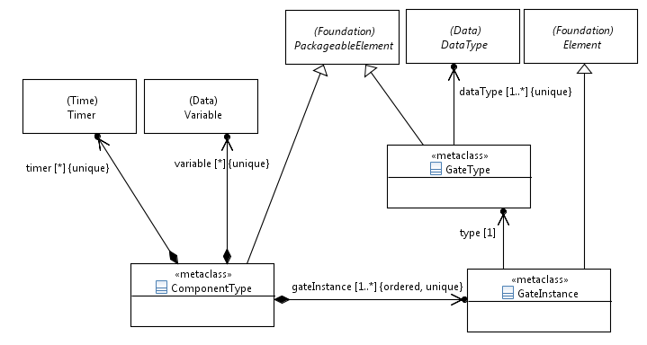
Figure 8.1: Component and gate type

8.2.1 GateType
Semantics
A 'GateType' represents a type of communication points, called 'GateInstance's, for exchanging information between 'ComponentInstance's. A 'GateType' specifies the 'DataType's that can be exchanged via 'GateInstance's of this type in both directions.
Generalization
- PackageableElement
Properties
- dataType: DataType [1..*] {unique}
The 'DataType's that can be exchanged via 'GateInstance's of that 'GateType'. The arguments of 'Interactions' shall adhere to the 'DataType's that are allowed to be exchanged.
Constraints
There are no constraints specified.

8.2.2 GateInstance
Semantics
A 'GateInstance' represents an instance of a 'GateType'. It is the means to exchange information between connected 'ComponentInstance's. A 'GateInstance' is contained in a 'ComponentType'.
Generalization
- Element
Properties
- type: GateType [1]
The 'GateType' of the 'GateInstance'.
Constraints
There are no constraints specified.

8.2.3 ComponentType
Semantics
A 'ComponentType' specifies the type of one or several functional entities, called 'ComponentInstance's, that participate in a 'TestConfiguration'. A 'ComponentType' contains at least one 'GateInstance' and may contain any number of 'Timer's and 'Variable's.
Generalization
- PackageableElement
Properties
- gateInstance: GateInstance [1..*] {ordered, unique}The 'GateInstance's used by 'ComponentInstance's of that 'ComponentType'.
- timer: Timer [0..*] {unique}
The 'Timer's owned by the 'ComponentType'.
- variable: Variable [0..*] {unique}
The 'Variable's owned by the 'ComponentType'.
Constraints
There are no constraints specified.
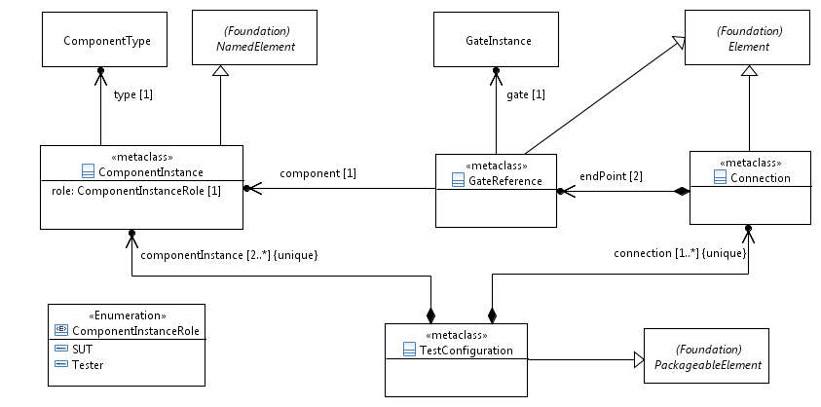
Figure 8.2: Test configuration

8.2.4 ComponentInstance
Semantics
A 'ComponentInstance' represents an active, functional entity of the 'TestConfiguration', which contains it. Its main purpose is to exchange information with other connected components via 'Interaction's. It acts either in the role of a 'Tester' or an 'SUT' component.
A 'ComponentInstance' derives the 'GateInstance's, 'Timer's, and 'Variable's from its 'ComponentType' for use within a 'TestDescription'. However, component-internal 'Timer's and 'Variable's shall be only used in 'TestDescription's if the role of the component is of 'Tester'. When a 'ComponentInstance' is created, a 'Timer' shall be in the idle state (see clause 7.2.8) and a 'Variable' shall have the value 'NoneValue' (see clause 6.2.15).
Generalization
- NamedElement
Properties
- type: ComponentType [1]
The 'ComponentType' of this 'ComponentInstance'.
- role: ComponentInstanceRole [1]
The role that the 'ComponentInstance' plays within the 'TestConfiguration'. It can be either 'Tester' or 'SUT'.
Constraints
There are no constraints specified.

8.2.5 ComponentInstanceRole
Semantics
'ComponentInstanceRole' specifies the role of a 'ComponentInstance', whether it acts as a 'Tester' or as an 'SUT' component.
Generalization
There is no generalization specified.
Literals
- SUT
The 'ComponentInstance' assumes the role 'SUT' in the enclosing 'TestConfiguration'.
- Tester
The 'ComponentInstance' assumes the role 'Tester' in the enclosing 'TestConfiguration'.
Constraints
There are no constraints specified.

8.2.6 GateReference
Semantics
A 'GateReference' is an endpoint of a 'Connection', which it contains. It allows the specification of a connection between two 'GateInstance's of different component instances in unique manner (because 'GateInstance's are shared between all 'ComponentInstance's of the same 'ComponentType').
Generalization
- NamedElement
Properties
- component: ComponentInstance [1]
The 'ComponentInstance' that this 'GateReference' refers to.
- gate: GateInstance [1]
The 'GateInstance' that this 'GateReference' refers to.
Constraints
- Gate instance of the referred component instance
The referred 'GateInstance' shall be contained in the 'ComponentType' of the referred 'ComponentInstance'.

8.2.7 Connection
Semantics
A 'Connection' defines a communication channel for exchanging information between 'ComponentInstance's via 'GateReference's. It does not specify or restrict the nature of the communication channel that is eventually used in an implementation. For example, a 'Connection' could refer to an asynchronous communication channel for the exchange of messages or it could rather refer to a programming interface that enables the invocation of functions.
A 'Connection' is always bidirectional and point-to-point, which is assured by defining exactly two endpoints, given as 'GateReference's. A 'Connection' can be established between any two different 'GateReference's acting as 'endPoint' of this connection. That is, self-loop 'Connection's that start and end at the same 'endPoint' are not permitted.
A 'Connection' can be part of a point-to-multipoint communication relation. In this case, the same pair of 'GateInstance'/'ComponentInstance' occurs multiple times in different 'Connection's. However, multiple connections between the same two pairs of 'GateInstance'/'ComponentInstance' are not permitted in a 'TestConfiguration' (see clause 8.2.8).
Generalization
- Element
Properties
- endPoint: GateReference [2]
The two 'GateReference's that form the endpoints of this 'Connection'.
Constraints
- Self-loop connections are not permitted
The 'endPoint's of a 'Connection' shall not be the same. Two endpoints are the same if both, the referred 'ComponentInstance's and the referred 'GateInstance's, are identical.
- Unique type of a connection
The 'GateInstance's of the two 'endPoint's of a 'Connection' shall refer to the same 'GateType'.

8.2.8 TestConfiguration
Semantics
A 'TestConfiguration' specifies the communication infrastructure necessary to build 'TestDescription's upon. As such, it contains all the elements required for information exchange: 'ComponentInstance's and 'Connection's.
It is not necessary that all 'ComponentInstance's contained in a 'TestConfiguration' are actually connected via 'Connection's. But for any 'TestConfiguration' at least the semantics of a minimal test configuration shall apply, which comprises one 'Tester' component and one 'SUT' component that are connected via one 'Connection'.
Generalization
- PackageableElement
Properties
- componentInstance: ComponentInstance [2..*] {unique}
The 'ComponentInstance's of the 'TestConfiguration'.
- connection: Connection [1..*] {unique}
The 'Connection's of the 'TestConfiguration' over which 'Interaction's are exchanged.
Constraints
- 'TestConfiguration' and components roles
A 'TestConfiguration' shall contain at least one 'Tester' and one 'SUT' 'ComponentInstance'.
- Minimal 'TestConfiguration'
Each 'TestConfiguration' shall specify at least one 'Connection' that connects a 'GateInstance' of a 'ComponentInstance' in the role 'Tester' with a 'GateInstance' of a 'ComponentInstance' in the role 'SUT'.
- At most one connection between any two 'GateInstance'/'ComponentInstance' pairs
Given the set of 'Connection's contained in a 'TestConfiguration'. There shall be no two 'Connection's containing 'GateReference's that in turn refer to identical pairs of 'GateInstance'/'ComponentInstance'.

9 Test Behaviour

9.1 Overview
The 'TestBehaviour' package defines all elements needed to describe the behaviour of a test description.

9.2 Test Description – Abstract Syntax and Classifier Description
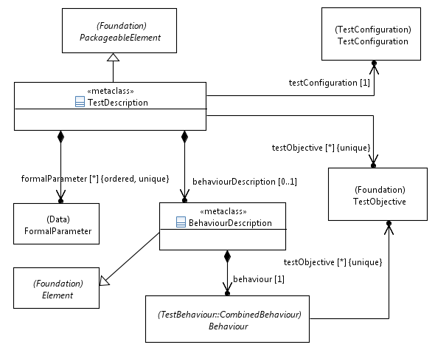
Figure 9.1: Test description

9.2.1 TestDescription
Semantics
A 'TestDescription' is a 'PackageableElement' that may contain a 'BehaviourDescription' defining the test behaviour based on ordered 'AtomicBehaviour' elements. It may also refer to 'TestObjective' elements that it realizes.
A 'TestDescription' is associated with exactly one 'TestConfiguration' that provides 'ComponentInstance's and 'GateInstance's to be used in the behaviour.
A 'TestDescription' may contain 'FormalParameter' that are used to pass data to behaviour.
If a 'TestDescription' with formal parameters is invoked within another 'TestDescription', actual parameters are provided via a 'TestDescriptionReference' (see clause 9.4.8). The mechanism of passing arguments to a 'TestDescription' that is invoked by a test management tool is not defined.
Generalization
- PackageableElement
Properties
- testConfiguration: TestConfiguration [1]
Refers to the 'TestConfiguration' that is associated with the 'TestDescription'.
- behaviourDescription: BehaviourDescription [0..1]
The actual behaviour of the test description in terms of 'Behaviour' elements.
- formalParameter: FormalParameter [0..*] {ordered, unique}
The formal parameters that shall be substituted by actual data when the 'TestDescription' is invoked.
- testObjective: TestObjective [0..*]
The 'TestObjective's that are realized by the 'TestDescription'.
Constraints
There are no constraints specified.

9.2.2 BehaviourDescription
Semantics
A 'BehaviourDescription' contains the behaviour of a 'TestDescription'.
Generalization
- Element
Properties
- behaviour: Behaviour [1]
The contained root 'Behaviour' of the 'TestDescription'.
Constraints
There are no constraints specified.

9.3 Combined Behaviour – Abstract Syntax and Classifier Description
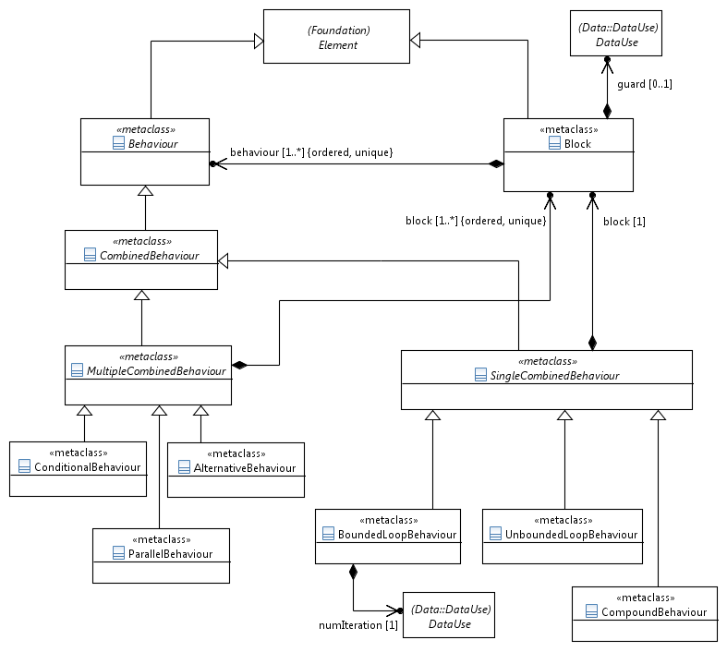
Figure 9.2: Combined behaviour concepts

9.3.1 Behaviour
Semantics
A 'Behaviour' is a constituent of the 'BehaviourDesciption' of a 'TestDescription'. It represents the super-class for any concrete behavioural units a 'BehaviourDescription' is composed of. It offers the capability to refer to 'TestObjective's to enable traceability among 'TestObjective's and any concrete subclass of 'Behaviour'.
If a 'Behaviour' references a 'TestObjective', the 'Behaviour' is considered to realize/cover that 'TestObjective'.
Generalization
- Element
Properties
- testObjective: TestObjective [0..*] {unique}
A set of 'TestObjective's that are realized by the 'Behaviour'.
Constraints
There are no constraints specified.

9.3.2 Block
Semantics
A 'Block' serves as a container for behavioural units that are executed sequentially. If a 'Block' has a 'guard', it shall only be executed if that guard evaluates to Boolean 'true'. If a 'Block' has no 'guard', it is equivalent to a 'guard' that evaluates to 'true'.
The occurrence of the <undefined> value within the 'DataUse' specification of the 'guard' causes undefined semantics of the 'Block' behaviour at runtime.
Generalization
- Element
Properties
- behaviour: Behaviour [1..*] {unique, ordered}
The ordered set of 'Behaviour's that describe the sequentially executed units of 'Behaviour' contained in the 'Block'.
- guard: DataUse [0..1]
An expression, whose type shall resolve to the predefined 'DataType' 'Boolean'.
Constraints
- Guard shall evaluate to Boolean
The type of 'guard' shall be 'Boolean'.

9.3.3 CombinedBehaviour
Semantics
A 'CombinedBehaviour' is a behavioural constituent over all 'ComponentInstance's and 'GateReference's defined in the associated 'TestConfiguration' the containing 'TestDescription' operates on.
Additionally, a 'CombinedBehaviour' may contain any number of ordered 'PeriodicBehaviour's and 'ExceptionalBehaviour's that are evaluated in combination with the directly defined behaviour of the 'CombinedBehaviour'.
Generalization
- Behaviour
Properties
- periodic: PeriodicBehaviour [0..*] {unique, ordered}
The ordered set of 'PeriodicBehaviour's attached to this 'CombinedBehaviour'.
- exceptional: ExceptionalBehaviour [0..*] {unique, ordered}
The ordered set of 'ExceptionalBehaviour's attached to this 'CombinedBehaviour'.
Constraints
There are no constraints specified.

9.3.4 SingleCombinedBehaviour
Semantics
A 'SingleCombinedBehaviour' contains a single 'Block' of 'Behaviour'.
Generalization
- CombinedBehaviour
Properties
- block: Block [1]
The 'Block' that is contained in the 'SingleCombinedBehaviour'.
Constraints
There are no constraints specified.

9.3.5 CompoundBehaviour
Semantics
A 'CompoundBehaviour' serves as a container for sequentially ordered 'Behaviour's. Its purpose is to group or structure behaviour, for example to describe the root behaviour of a 'TestDescription' or enable the assignment of 'PeriodicBehaviour's and/or 'ExceptionalBehaviour's.
Generalization
- SingleCombinedBehaviour
Properties
There are no properties specified.
Constraints
There are no constraints specified.

9.3.6 BoundedLoopBehaviour
Semantics
A 'BoundedLoopBehaviour' represents a recurring execution of the contained behaviour 'Block'. It has the same semantics as a for-loop statement in programming languages, i.e., the 'Block' shall be executed as many times as is determined by the 'numIteration' property.
The evaluation of the 'numIteration' expression happens once at the beginning of the 'BoundedLoopBehaviour'. For dynamically evaluated loop conditions, the 'UnboundedLoopBehaviour' shall be used.
The concrete mechanism of counting is not defined.
The occurrence of the <undefined> value within the 'DataUse' specification of 'numIteration' causes undefined semantics of the 'BoundedLoopBehaviour' behaviour at runtime.
Generalization
- SingleCombinedBehaviour
Properties
- numIteration: DataUse [1]
An expression that determines how many times the 'Block' of a 'BoundedLoopBehaviour' shall be executed.
Constraints
- No guard constraint
The 'Block' of a 'BoundedLoopBehaviour' shall not have a 'guard'.
- Iteration number shall be countable and positive
The expression assigned to the 'numIteration' property shall evaluate to a countable 'SimpleDataInstance' of an arbitrary user-defined data type, e.g. a positive Integer value.

9.3.7 UnboundedLoopBehaviour
Semantics
An 'UnboundedLoopBehaviour' represents a recurring execution of the contained behaviour 'Block'. It has the same semantics as a while-loop statement in programming languages, i.e., the 'Block' shall be executed as long as the 'guard' of the 'Block' evaluates to Boolean 'true'. If the 'Block' has no guard condition, it shall be executed an infinite number of times, unless it contains a 'Break' or a 'Stop'.
Generalization
- SingleCombinedBehaviour
Properties
There are no properties specified.
Constraints
There are no constraints specified.

9.3.8 MultipleCombinedBehaviour
Semantics
A 'MultipleCombinedBehaviour' contains at least one potentially guarded 'Block' (in case of 'ConditionalBehaviour') or at least two ordered and potentially guarded 'Block's (in case of 'AlternativeBehaviour' or 'ParallelBehaviour').
Generalization
- CombinedBehaviour
Properties
- block: Block [1..*] {unique, ordered}
The contained ordered list of 'Block's that specifies the behaviour of the 'MultipleCombinedBehaviour'.
Constraints
There are no constraints specified.

9.3.9 AlternativeBehaviour
Semantics
An 'AlternativeBehaviour' shall contain two or more 'Block's, each of which starting with a distinct tester-input event (see definition in clause 3.1).
Guards of all blocks are evaluated at the beginning of an 'AlternativeBehaviour'. Only blocks with guards that evaluate to Boolean 'true' are active in this 'AlternativeBehaviour'. If none of the guards evaluates to 'true', none of the 'Block's are executed, i.e. execution continues with the next 'Behaviour' following this 'AlternativeBehaviour'.
Only one of the alternative 'Block's will be executed. The evaluation algorithm of an alternative 'Block' at runtime is a step-wise process:
1) All guards are evaluated and only those 'Block's, whose guards evaluated to 'true' are collected into an ordered set of potentially executable 'Block's.
2) The tester-input event of each potentially executable 'Block' is evaluated in the order, in which the 'Block's are specified.
3) The first 'Block' with an executable tester-input event is entered; the tester-input event itself and the subsequent 'Behaviour' of this 'Block' are executed.
Generalization
- MultipleCombinedBehaviour
Properties
There are no properties specified.
Constraints
- Number of 'Block's
An 'AlternativeBehaviour' shall contain at least two 'Block's.
- First behaviour of 'Block's
Each block of an 'AlternativeBehaviour' shall start with a tester-input event.

9.3.10 ConditionalBehaviour
Semantics
A 'ConditionalBehaviour' represents an alternative choice over a number of 'Block's. A 'ConditionalBehaviour' is equivalent to a if-elseif-else statement in programming languages, e.g. select-case statement in TTCN-3.
Only one of the alternative 'Block's will be executed. The evaluation algorithm of an alternative 'Block' at runtime is a step-wise process:
1) The guards of the specified 'Block's are evaluated in the order of their definition.
2) The first 'Block', whose guard is evaluated to 'true', is entered and the 'Behaviour' of this 'Block' are executed.
If none of the guards evaluates to 'true', none of the 'Block's are executed, i.e. execution continues with the next 'Behaviour' following this 'ConditionalBehaviour'.
NOTE: Typically, 'Block's are specified with a 'guard'. If a guard is missing, it is equivalent to a guard that evaluates to 'true' (see clause 9.3.2). The latter case is also known as the else branch of an if-elseif-else statement in a programming language. Blocks specified after this else block would never be executed.Therefore it shall be not permitted to define another 'Block' after a 'Block' with no 'guard'.
Generalization
- MultipleCombinedBehaviour
Properties
There are no properties specified.
Constraints
- Guard for 'ConditionalBehaviour' with single block
If there is only one 'Block' specified, it shall have a 'guard'.
- Possible else block for 'ConditionalBehaviour' with multiple blocks
All 'Block's specified, except the last one, shall have a 'guard'.
- First 'AtomicBehaviour' allowed
The first 'AtomicBehaviour' of any 'Block' of a 'ConditionalBehaviour' shall not be a tester-input event.

9.3.11 ParallelBehaviour
Semantics
A 'ParallelBehaviour' represents the parallel execution of 'Behaviour's contained in the multiple 'Block's. That is, the relative execution order of the 'Behaviour's among the different 'Block's is not specified. The execution order of 'Behaviour's within the same 'Block' shall be kept as specified, even though it might be interleaved with 'Behaviour's from other parallel 'Block's.
'Block's may have guards. Guards of all blocks are evaluated at the beginning of a 'ParallelBehaviour'. Only blocks with guards that evaluate to Boolean 'true' are executed in this 'ParallelBehaviour'. If none of the guards evaluates to 'true', none of the 'Block's are executed, i.e. execution continues with the next 'Behaviour' following this 'ParallelBehaviour'.
The 'ParallelBehaviour' terminates when the all 'Block's are terminated.
Generalization
- MultipleCombinedBehaviour
Properties
There are no properties specified.
Constraints
- Number of blocks in 'ParallelBehaviour'
There shall be at least two 'Block's specified.
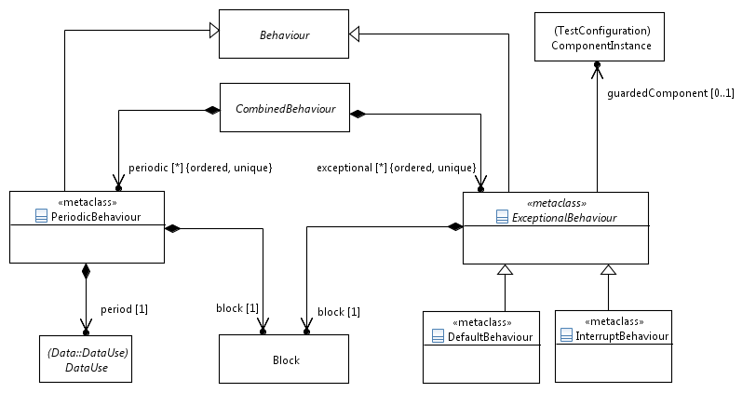
Figure 9.3: Exceptional and periodic behaviour

9.3.12 ExceptionalBehaviour
Semantics
'ExceptionalBehaviour' is optionally contained within a 'CombinedBehaviour'. It is a 'Behaviour' that consists of one 'Block' that shall have no guard and shall start with a tester-input event (see definition in clause 3.1).
An 'ExceptionalBehaviour' may specify the 'ComponentInstance' that it guards. This allows restricting the possible situations when the 'Behaviour' of the 'CombinedBehaviour' containing this 'ExceptionalBehaviour' is executed. In this case only those 'Behaviour's that are defined in the scope of the 'guardedComponent' force the 'ExceptionalBehaviour' to be activated.
An 'ExceptionalBehaviour' defines 'Behaviour' that is an alternative to every 'Interaction' directly or indirectly contained in the enclosing 'CombinedBehaviour' that matches one of the following two conditions:
- If no 'guardedComponent' reference is present, an interaction whose target 'GateInstance' is associated to a 'ComponentInstance' with the role of 'Tester';
- If a 'guardedComponent' reference is present, an interaction whose target 'GateInstance' is associated to the same 'ComponentInstance' as referenced by the 'guardedComponent' property.
In case of more than one 'ExceptionalBehaviour' is attached to the same 'CombinedBehaviour', the corresponding 'AlternativeBehaviour' would contain the 'Blocks' of all the attached 'ExceptionalBehaviour's in the same order.
An 'ExceptionalBehaviour' can be either a 'DefaultBehaviour' or an 'InterruptBehaviour'.
Generalization
- Behaviour
Properties
- block: Block [1]
The contained 'Block' that specifies the 'Behaviour' of the 'ExceptionalBehaviour'.
- guardedComponent: ComponentInstance [0..1]
Reference to a 'ComponentInstance' with role 'Tester', for which the 'ExceptionalBehaviour' is to be applied.
Constraints
- No guard
The 'Block' shall have no guard.
- First 'AtomicBehaviour' in block allowed
Each block of an 'ExceptionalBehaviour' shall start with a tester-input event.
- Guarded component shall be a 'Tester' component
The 'guardedComponent' shall refer to a 'ComponentInstance' with the role of 'Tester'.

9.3.13 DefaultBehaviour
Semantics
A 'DefaultBehaviour' is a specialisation of an 'ExceptionalBehaviour'.
If a 'DefaultBehaviour' of the 'CombinedBehaviour', which it is attached to, becomes executable and the 'Behaviour' defined in the 'Block' of the 'DefaultBehaviour' subsequently completes execution, the execution of the 'CombinedBehaviour' continues with the next 'Behaviour' that follows the 'Behaviour' that caused the execution of the 'DefaultBehaviour'.
Generalization
- ExceptionalBehaviour
Properties
There are no properties specified.
Constraints
There are no constraints specified.

9.3.14 InterruptBehaviour
Semantics
An 'InterruptBehaviour' is a specialisation of an 'ExceptionalBehaviour'.
If an 'InterruptBehaviour' of the 'CombinedBehaviour', which it is attached to, becomes executable and the 'Behaviour' defined in the 'Block' of the 'InterruptBehaviour' subsequently completes execution, the execution of the 'CombinedBehaviour' continues with the same 'Behaviour' that caused the execution of the 'InterruptBehaviour'.
Generalization
- ExceptionalBehaviour
Properties
There are no properties specified.
Constraints
There are no constraints specified.

9.3.15 PeriodicBehaviour
Semantics
A 'PeriodicBehaviour' defines a 'Behaviour' in a single 'Block' that is executed periodically in parallel with the 'CombinedBehaviour' it is attached to. The recurrence interval of the execution is specified by its 'period' property. If the execution of the contained 'Block' takes longer than the specified period, the semantics of the resulting behaviour is unspecified.
The execution of 'PeriodicBehaviour' terminates if the 'CombinedBehaviour', which it is attached to, terminates.
The occurrence of the <undefined> value within the 'DataUse' specification of 'period' causes undefined semantics of the 'PeriodicBehaviour' behaviour at runtime.
Generalization
- Behaviour
Properties
- block: Block [1]
The contained 'Block', whose 'Behaviour' is executed periodically in parallel with the 'Behaviour' of the 'CombinedBehaviour', which this 'PeriodicBehaviour' is attached to.
- period: DataUse [1]
The recurrence interval of executing the behaviour of the 'Block' specified by the 'block' property.
Constraints
- First 'AtomicBehaviour' allowed
The first 'AtomicBehaviour' of any 'Block' of a 'PeriodicBehaviour' shall not be a tester-input event.
- 'Time' data type for period expression
The 'DataUse' expression assigned to the 'period' shall evaluate to a data instance of the 'Time' data type.

9.4 Atomic Behaviour – Abstract Syntax and Classifier Description
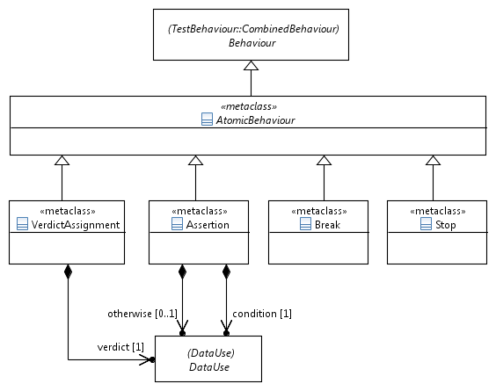
Figure 9.4: Global atomic behaviour concepts

9.4.1 AtomicBehaviour
Semantics
An 'AtomicBehaviour' defines the simplest form of behavioural activity of a 'TestDescription' that cannot be decomposed further.
An 'AtomicBehaviour' can have a 'TimeLabel' that holds the timestamp of this behaviour when it is executed (see clause 7.2.2). In addition, an 'AtomicBehaviour' may contain a list of 'TimeConstraint' expressions that affect its execution time (see clause 7.2.4).
If one of the provided 'TimeConstraint's represents the <undefined> value, the semantics of 'AtomicBehaviour' becomes undefined at runtime.
Generalization
- Behaviour
Properties
- timeLabel: TimeLabel [0..1]
Refers to the time label contained in the 'AtomicBehaviour'.
- timeConstraint: TimeConstraint [0..*] {unique}
Refers to a contained list of 'TimeConstraint's that determines the execution of the given 'AtomicBehaviour' by means of time constraint expressions.
Constraints
There are no constraints specified.

9.4.2 Break
Semantics
A 'Break' terminates the execution of the behavioural 'Block', in which the 'Break' is contained. Execution continues with the 'Behaviour' that follows afterwards. In case of 'ParallelBehaviour', a 'Break' terminates only the execution of its own 'Block', but does not affect the execution of the other parallel 'Block'(s).
Generalization
- AtomicBehaviour
Properties
There are no properties specified.
Constraints
There are no constraints specified.

9.4.3 Stop
Semantics
'Stop' is used to describe an explicit and immediate stop of the execution of the entire 'TestDescription' that was initially invoked. No further behaviour shall be executed beyond a 'Stop'. In particular, a 'Stop' in a referenced (called) 'TestDescription' shall also stop the behaviour of the referencing (calling) 'TestDescription'(s).
Generalization
- AtomicBehaviour
Properties
There are no properties specified.
Constraints
There are no constraints specified.

9.4.4 VerdictAssignment
Semantics
The 'VerdictAssignment' is used to set the verdict of the test run explicitly. This might be necessary if the implicit verdict mechanism described below is not sufficient.
By default, the test description specifies the expected behaviour of the system. If an execution of a test description performs the expected behaviour, the verdict is set to 'pass' implicitly. If a test run deviates from the expected behaviour, the verdict 'fail' will be assigned to the test run implicitly. Other verdicts, including 'inconclusive' and user-definable verdicts, need to be set explicitly within a test description.
Generalization
- AtomicBehaviour
Properties
- verdict: StaticDataUse [1]
Stores the value of the verdict to be set.
Constraints
- Verdict of type 'Verdict'
The 'verdict' shall evaluate to a, possibly predefined, instance of a 'SimpleDataInstance' of data type 'Verdict'.

9.4.5 Assertion
Semantics
An 'Assertion' allows the specification of a test 'condition' that needs to evaluate to 'true' at runtime for a passing test, in which case the implicit test verdict is set to 'pass'. If the 'condition' is not satisfied, the test verdict is set to 'fail' or to the optionally specified verdict given in 'otherwise'.
The occurrence of the <undefined> value within the 'DataUse' specification of 'condition' causes undefined semantics of the 'Assertion' behaviour at runtime.
Generalization
- AtomicBehaviour
Properties
- condition: DataUse [1]
Refers to the test condition that is evaluated.
- otherwise: StaticDataUse [0..1]
Refers to the value of the verdict to be set if the assertion fails.
Constraints
- Boolean condition
The 'condition' shall evaluate to predefined 'DataType' 'Boolean'.
- Otherwise of type 'Verdict'
The 'otherwise' shall evaluate to a, possibly predefined, instance of a 'SimpleDataInstance' of data type 'Verdict'.
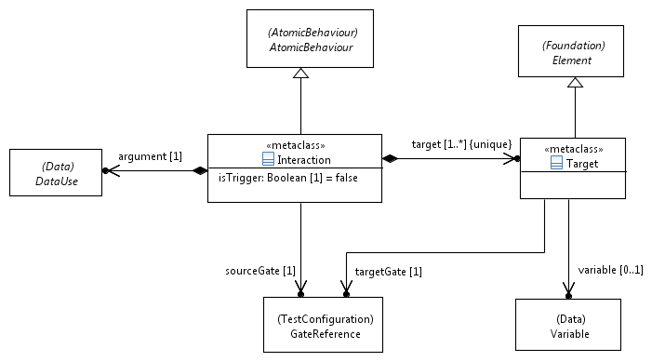
Figure 9.5: Interaction behaviour

9.4.6 Interaction
Semantics
An 'Interaction' is a representation of any information exchanged between connected components. An 'Interaction' is an 'AtomicBehaviour', i.e. it cannot be decomposed into smaller behavioural activities. It is also directed, i.e. the information being exchanged is sent by a component via the 'sourceGate' and received by one or many components via the other 'targetGate's (point-to-point and point-to-multipoint communication, see clause 8.2.7).
An 'Interaction' with a 'Target' that in turn—via its 'GateReference'—refers to a 'ComponentInstance' in the role 'Tester' is called a tester-input event.
The 'argument' property of an 'Interaction' refers to the expected data value being exchanged. Executing an 'Interaction' implies that this expected data value occurs at runtime among the participating components and the implicit test verdict 'pass' shall be set. If the expected value does not occur, i.e. either the interaction with the expected value does not occur at all within an arbitrary time or an interaction with different value occurs, the test verdict 'fail' shall be set.
NOTE: The time period to wait for the specified interaction to occur is defined outside the scope of TDL.
If an 'Interaction' is a trigger 'Interaction' ('isTrigger' property is set), execution of the 'Interaction' terminates only if the expected data occurred (test verdict 'pass') or the expected data did not occur within an arbitrary time (test verdict 'fail'). Intermediate 'Interaction'(s) with data values that do not match the expected value are discarded during the execution of that trigger 'Interaction'.

The 'DataUse' specification, which the 'argument' refers to, can contain 'Variable's of 'ComponentInstance's participating in this 'Interaction'. Use of a 'Variable' in an 'argument' specification implies the use of its value. Additionally, placeholders such as 'AnyValue' or 'AnyValueOrOmit' can be used if the concrete value is not known or irrelevant (see clauses 6.3.6 and 6.3.7).
The occurrence of the <undefined> value within the 'DataUse' specification of 'argument' causes undefined semantics of the 'Interaction' behaviour at runtime.
To store the 'argument' of an 'Interaction' received at the 'Target' side, a 'Variable' with the same data type as the 'argument' specification can be used, provided that the 'Variable' is local to the same 'ComponentInstance' that is also referred to in the 'targetGate'.
NOTE: In a concrete realization, an interaction can represent typically one of the following options, among others:
- Message-based communication: The data of an interaction argument represents a message being sent (from 'sourceGate') and received (by 'targetGate').
- Procedure-based communication: The data of an interaction argument represents a remote function call being initiated (from 'sourceGate') and invoked (at 'targetGate') or its return values being transmitted back.
- Shared variable access: The data of an interaction argument represents a shared variable being read ('sourceGate' is the gate of the component that owns this variable, 'targetGate' is the gate of the reading component) or written ('sourceGate' is the gate of the component that wants to change the value of a shared variable, 'targetGate' is the gate of the component that owns this variable).
Generalization
- AtomicBehaviour
Properties
- isTrigger: Boolean [1] = false
If set to 'true', this property denotes a trigger interaction that is successful only if a matching 'argument' has occurred in this interaction. Previously occurring unmatched 'argument's are discarded.
- argument: DataUse [1]
Refers to a 'DataUse' that is taken as the argument (data value) of this interaction.
- sourceGate: GateReference [1]
Refers to a 'GateReference' that acts as the source of this interaction.
- target: Target [1..*] {unique}
Refers to a contained list of 'Target' 'GateReference's of different component instances. If the list contains more than one element, it implies point-to-multipoint communication.
Constraints
- Gate references of an interaction shall be different
All 'GateReference's that act as source or target(s) of an 'Interaction' shall be different from each other.
- Gate references of an interaction shall be connected
The 'GateReference's that act as source or target(s) of an 'Interaction' shall be interconnected by a 'Connection'.
- Type of interaction argument
The 'DataUse' specification referred to in the 'argument' shall match one of the 'DataType's referenced in the 'GateType' definition of the 'GateInstance's referred to by the source and target 'GateReference's of the 'Interaction'.
- Use of variables in the 'argument' specification
The use of 'Variable's in the 'DataUse' specification shall be restricted to 'Variable's of 'ComponentInstance's that participate in this 'Interaction' via the provided 'GateReference's.
- Matching data type for 'argument' and 'variable'
The 'DataUse' specification of the 'argument' and the referenced 'Variable' of any 'Target' shall refer to the same 'DataType'.

9.4.7 Target
Semantics
A 'Target' holds the 'GateReference' that acts as target for the 'Interaction', which in turn contains this 'Target', and an optional 'Variable' that stores the received data value from this 'Interaction'.
Generalization
- Element
Properties
- targetGate: GateReference [1]
Refers to the 'GateReference' that acts as target for an interaction.
- variable: Variable [0..1]
Refers to a 'Variable' that stores the received data value from the 'Interaction'.
Constraints
- Variable and target gate of the same component instance
The referenced 'Variable' shall exist in the same 'ComponentType' as the 'GateInstance' that is referred to by the 'GateReference' of the 'targetGate'.
- Variable of a tester component only
If a 'Variable' is specified, the 'ComponentInstance' referenced by 'targetGate' shall be in the role 'Tester'.
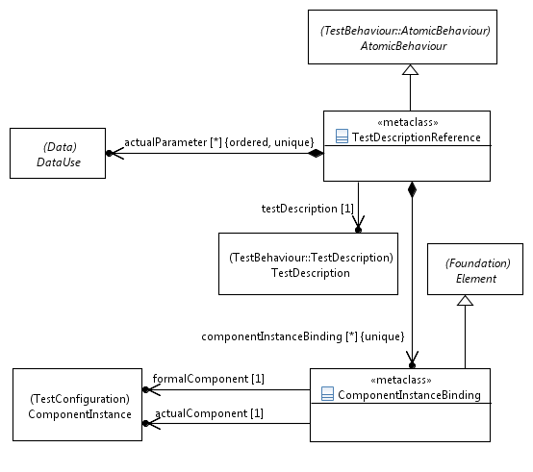
Figure 9.6: Test description reference

9.4.8 TestDescriptionReference
Semantics
A 'TestDescriptionReference' is used to describe the invocation of the behaviour of a test description within another test description. The invoked behaviour is executed in its entirety before the behaviour of the invoking test description is executed further. A 'TestDescriptionReference' has a possibly empty list of actual parameters which is passed to the referenced 'TestDescription'. It also has an optional list of bindings between component instances of the involved test configurations that shall be present if the test configurations of the referencing (invoking) and referenced (invoked) test descriptions are different.
If the 'TestConfiguration' of the invoked 'TestDescription' is different from the one of the invoking 'TestDescription', it shall be compatible with it. The compatibility rule is defined below. In case of different test configurations, 'ComponentInstance's contained in the 'TestConfiguration' of the invoked 'TestDescription' will be substituted with 'ComponentInstance's of the 'TestConfiguration' of the invoking 'TestDescription'. Substitution is implicit when both test configurations coincide. Explicit substitution is defined using the 'ComponentInstanceBinding'.
The occurrence of the <undefined> value within the 'DataUse' specification of 'actualParameter' causes undefined semantics of the 'TestDescriptionReference' behaviour at runtime.

Generalization
- AtomicBehaviour
Properties
- testDescription: TestDescription [1]
Refers the test description whose behaviour is invoked.
- actualParameter: DataUse [0..*] {ordered}
Refers to an ordered set of actual parameters passed to the referenced test description.
- componentInstanceBinding: ComponentInstanceBinding [0..*] {unique}
Defines explicit bindings between 'ComponentInstance's from 'TestConfiguration' of invoking 'TestDescription' and those from the 'TestConfiguration' of the invoked 'TestDescription'.
Constraints
- Number of actual parameters
The number of actual parameters in the 'TestDescriptionReference' shall be equal to the number of formal parameters of the referenced 'TestDescription'.
- No use of variables in actual parameters
The 'DataUse' expressions used to describe actual parameters shall not contain variables directly or indirectly.
- Matching parameters
The actual parameter AP[i] of index i in the ordered list of 'actualParameter's shall match 'DataType' of the 'FormalParameter' FP[i] of index i in the ordered list of formal parameters of the referenced 'TestDescription'.
- Restriction to 1:1 component instance bindings
If component instance bindings are provided, the component instances referred to in the bindings shall occur at most once for the given test description reference.
- Compatible test configurations
The test configuration TConf2 of the referenced (invoked) test description shall be compatible with the test configuration TConf1 of the referencing (invoking) test description under the provision of a list of bindings between component instances in TConf1 and TConf2. Compatibility is then defined in the following terms:
- All component instances in TConf2 can be mapped to component instances of TConf1.
A component instance B of test configuration TConf2 can be mapped to a component instance A of test configuration TConf1if and only if
a) there is a binding pair (A, B) provided, b) A and B refer to the same component type, and c) A and B have the same component instance role {SUT, Tester} assigned.
- All connections between component instances in TConf2 exist also between the mapped component instances in TConf1 and the type of a connection in TConf2 equals the type of the related connection in TConf1.
Two connections of the two test configurations are equal if and only if the same gate instances are used in the definition of the gate references of the connections.
NOTE 1: The compatibility between test configurations is defined asymmetrically. That is, if TConf2 is compatible with TConf1, it does not imply that TConf1is compatible with TConf2. If TConf2 is compatible with TConf1, it is said that TConf2 is a sub-configuration of TConf1 under a given binding.
NOTE 2: If two test configurations are equal, then they are also compatible.

9.4.9 ComponentInstanceBinding
Semantics
The 'ComponentInstanceBinding' is used with the 'TestDescriptionReference' in case when the 'TestConfiguration' of the invoked 'TestDescription' differs from that of the invoking 'TestDescription'. It specifies that a (formal) 'ComponentInstance' in the invoked 'TestDescription' will be substituted with an (actual) 'ComponentInstance' from the invoking 'TestDescription'.
Additional rules and semantics are defined in clause 9.4.8.
Generalization
- Element
Properties
- formalComponent: ComponentInstance [1]
Refers to a 'ComponentInstance' contained in the 'TestConfiguration' of the invoked 'TestDescription'.
- actualComponent: ComponentInstance [1]
Refers to a 'ComponentInstance' contained in the 'TestConfiguration' of the invoking 'TestDescription'.
Constraints
- Matching component types
Both, the formal and the actual component instances, shall refer to the same 'ComponentType'.
- Matching component instance roles
Both, the formal and the actual component instances, shall have the same 'ComponentInstanceRole' assigned to.
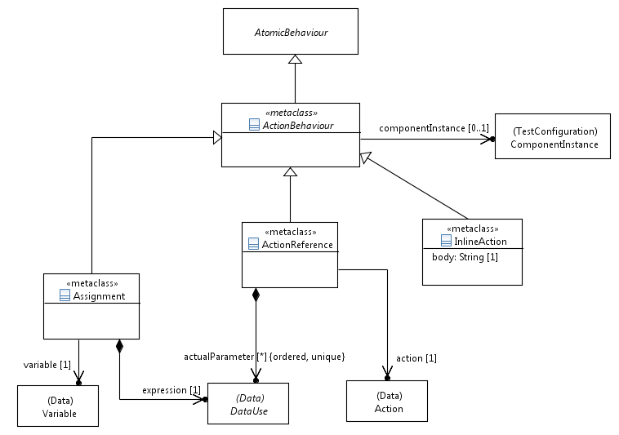
Figure 9.7: Action behaviour concepts

9.4.10 ActionBehaviour
Semantics
'ActionBehaviour' is a refinement of 'AtomicBehaviour' and a super-class for 'ActionReference', 'InlineAction' and 'Assignment'.
It may refer to a 'Tester' 'ComponentInstance' that specifies the location, on which the 'ActionBehaviour' is executed. If no reference to a 'ComponentInstance' is given, the 'ActionBehaviour' is executed in the global scope of the associated 'TestConfiguration'.
Generalization
- AtomicBehaviour
Properties
- componentInstance: ComponentInstance [0..1]
Refers to a 'ComponentInstance' from the 'TestConfiguration', on which the 'ActionBehaviour' is performed.
Constraints
- 'ActionBehaviour' on 'Tester' components only
The 'ComponentInstance' that an 'ActionBehaviour' refers to shall be of role 'Tester'.

9.4.11 ActionReference
Semantics
An 'ActionReference' invokes an 'Action'. It may carry a list of 'DataUse' specifications to denote actual parameters of this 'Action'.
The occurrence of the <undefined> value within the 'DataUse' specification of an 'actualParameter' causes undefined semantics of the 'TimeOperation' behaviour at runtime.

Generalization
- ActionBehaviour
Properties
- action: Action [1]
Refers to the 'Action' to be executed.
- actualParameter: DataUse [0..*] {ordered, unique}
Refers to an ordered set of actual parameters passed to the referenced action.
Constraints
- Matching parameters
The actual parameter AP[i] of index i in the ordered set of 'actualParameter's shall match the 'DataType' of the 'FormalParameter' FP[i] of index i in the ordered set of formal parameters of the referenced 'Action'.

9.4.12 InlineAction
Semantics
An 'InlineAction' denotes the execution of an informally defined action. The semantics of its execution is outside the scope of TDL.
Generalization
- ActionBehaviour
Properties
- body: String [1]
The action described as free text.
Constraints
There are no constraints specified.

9.4.13 Assignment
Semantics
An 'Assignment' denotes the assignment of a value that is expressed as a 'DataUse' specification to a variable within a component instance.
Generalization
- ActionBehaviour
Properties
- variable: Variable [1]
Refers to the variable that is assigned the data value resulting from evaluating the 'expression'.
- expression: DataUse [1]
Refers to the 'DataUse' specification, which is evaluated at runtime and whose value is assigned to the referenced 'Variable'.
Constraints
- Known component instance
The property 'componentInstance' shall be set to identify the 'Variable' in this 'Assignment'.
- Matching data type
The provided 'DataUse' expression shall match the 'DataType' of the referenced 'Variable'.
- No 'OmitValue'
The 'expression' shall not refer to 'OmitValue'.

10 Predefined TDL Model Instances

10.1 Overview
This clause lists the predefined element instances for various meta-model elements that shall be a part of a standard-compliant TDL implementation. It is not specified how these predefined instances are made available to the user. However, it is implied that in different TDL models predefined instances with the same name are semantically equivalent. This statement implies further that predefined instances shall not be overwritten with different instances of the same name, but with a different meaning.

10.2 Predefined Instances of the 'SimpleDataType' Element

10.2.1 Boolean
The predefined 'SimpleDataType' 'Boolean' denotes the common Boolean data type with the two values (instances of 'SimpleDataInstance') 'true' and 'false' to denote truth values (see clause 10.3) and support logical expressions.
No assumptions are made about how 'Boolean' is implemented in an underlying concrete type system.

10.2.2 Verdict
The predefined 'SimpleDataType' 'Verdict' denotes the data type that holds the possible test verdicts of a 'TestDescription' (see clause 10.3). The 'Verdict' allows the definition of functions that use this data type as an argument or as the return type.
No assumptions are made about how 'Verdict' is implemented in an underlying concrete type system.

10.2.3 TimeLabelType
The predefined 'SimpleDataType' 'TimeLabelType' denotes the data type that holds all instances of 'TimeLabel' elements defined in a 'BehaviourDescription' of a 'TestDescription'. Its mere purpose is to enable the definition of functions over time labels; some of them are predefined (see clause 10.5.2).
No assumptions are made about how 'TimeLabelType' is implemented in an underlying concrete type system.

10.3 Predefined Instances of 'SimpleDataInstance' Element

10.3.1 true
The predefined 'SimpleDataInstance' 'true' shall be associated with the 'SimpleDataType' 'Boolean' (see clause 10.2.1). It denotes one of the two truth values with the usual meaning.

10.3.2 false
The predefined 'SimpleDataInstance' 'false' shall be associated with the 'SimpleDataType' 'Boolean' (see clause 10.2.1). It denotes one of the two truth values with the usual meaning.

10.3.3 pass
The predefined 'SimpleDataInstance' 'pass' shall be associated with the predefined 'SimpleDataType' 'Verdict' (see clause 10.2.2). It denotes the valid behaviour of the SUT as observed by the tester in correspondence to the definition in ISO 9646-1 [6].

10.3.4 fail
The predefined 'SimpleDataInstance' 'fail' shall be associated with the predefined 'SimpleDataType' 'Verdict' (see clause 10.2.2). It denotes the invalid behaviour of the SUT as observed by the tester in correspondence to the definition in ISO 9646-1 [6].

10.3.5 inconclusive
The predefined 'SimpleDataInstance' 'inconclusive' shall be associated with the predefined 'SimpleDataType' 'Verdict' (see clause 10.2.2). It denotes behaviour of the SUT as observed by the tester in cases when neither 'pass' nor 'fail' verdict can be given in correspondence to the definition in ISO 9646-1 [6].

10.4 Predefined Instances of 'Time' Element

10.4.1 Second
The predefined instance 'Second' of the 'Time' element denotes a data type that represents the physical quantity time measured in seconds. Values of this time data type, i.e. instances of 'SimpleDataInstance', denote a measurement of time with the physical unit second.
No assumptions are made about how 'Second' is implemented in an underlying concrete type system.

10.5 Predefined Instances of the 'Function' Element

10.5.1 Overview
In this clause, the predefined functions are provided in one of the following two syntax forms:
- Prefix notation: <function name>: <parameter type>, <parameter type>, ... <return type>
- Infix notation: _<function name>_: <parameter type>, <parameter type> <return type>
The <parameter type> and <return type> names from above refer to (predefined) instance names of meta-model elements. If arbitrary instances are supported, the function instanceOf(<element>) shall provide such an arbitrary instance of the given meta-model element.
No assumptions are made about how these functions are implemented in an underlying concrete type system.

10.5.2 Functions of Return Type 'Boolean'
The following functions of return type 'Boolean' shall be predefined.
- _==_: instanceOf(DataInstance), instanceOf(DataInstance) Boolean
Denotes equality of any two data instances of arbitrary, but same data type.
- _!=_: instanceOf(DataInstance), instanceOf(DataInstance) Boolean
Denotes inequality of any two data instances of arbitrary, but same data type.
- _and_: Boolean, Boolean Boolean
Denotes the standard logical AND operation.
- _or_: Boolean, Boolean Boolean
Denotes the standard logical OR operation.
- not: Boolean Boolean
Denotes the standard logical NOT operation.

10.5.3 Functions of Return Type 'TimeLabelType'
The following functions of return type 'TimeLabelType' shall be predefined. Their purpose is to identify unique occurrences of a time label if it occurs in an iterative behaviour, e.g. within bounded or unbounded loops. All functions listed below will return the time label itself if they are applied to time labels that are outside of iterative behaviour.
- first: TimeLabelType TimeLabelType
Returns the first occurrence of a time label in an iterative behaviour.
- last: TimeLabelType TimeLabelType
Returns the last occurrence of a time label in an iterative behaviour.
- prev: TimeLabelType TimeLabelType
Returns the occurrence of a time label in the previous iteration. The previous occurrence of a time label in the first iteration shall be equal to the first occurrence of this time label.

10.5.4 Functions of Return Type of Instance of 'Time'
The following functions of return type of instance of the 'Time' meta-model element shall be predefined.
- _+_: instanceOf(Time), instanceOf(Time) instanceOf(Time)
Returns the sum of two time values of the same time data type, i.e. all parameters of the function definition shall refer to the same instance of the 'Time' element as data type.
- obs: TimeLabelType instanceOf(Time)
Returns the timestamp of a time label attached to an atomic behaviour instance, i.e. the time point when this behavioural activity is observed. The timestamp is returned as a time value of the given time data type.
- span: TimeLabelType , TimeLabelType instanceOf(Time)
Returns the time span between two time labels attached to two atomic behaviour instances, i.e. the elapsed time between the two behavioural activities. The time span is returned as a value of the given time data type.

Annex A (informative):
Technical Representation of the TDL Meta-Model
The technical representation of the TDL meta-model is included as an electronic attachment es_203119v010201p0.zip which accompanies the present document. The purpose of this annex is to serve as a possible starting point for implementing the TDL meta-model conforming to the present document. See the readme contained in the zip file for details.

Annex B (informative):
Examples of a TDL Concrete Syntax

B.1 Introduction
The applicability of the TDL meta-model that is described in the main part of the present document depends on the availability of TDL concrete syntaxes that implement the meta-model (abstract syntax). Such a TDL concrete syntax can then be used by end users to write TDL specifications. Though a concrete syntax will be based on the TDL meta-model, it can implement only parts of the meta-model if certain TDL features are not necessary to handle a user's needs.
This annex illustrates an example of a possible TDL concrete syntax in a textual format that supports all features of the TDL meta-model, called "TDLan". Three examples are outlined below - two examples translated from existing test descriptions taken from [i.2] and [i.3], as well as an example illustrating some of the TDL data parameterization and mapping concepts. The examples are accompanied by a complete reference description of the textual syntax of TDLan given in EBNF.

B.2 A 3GPP Conformance Example in Textual Syntax
This example describes one possible way to translate clause 7.1.3.1 from TS 136 523-1 [i.2] into the proposed TDL textual syntax, by mapping the concepts from the representation in the source document to the corresponding concepts in the TDL meta-model by means of the proposed textual syntax. The example has been enriched with additional information, such as explicit data definitions and test configuration details for completeness where applicable.
//Translated from [i.5], Section 7.1.3.
TDLan Specification Layer_2_DL_SCH_Data_Transfer {
//Procedures carried out by a component of a test configuration
//or an actor during test execution
Action preCondition : "Pre-test Conditions:
RRC Connection Reconfiguration" ;
Action preamble : "Preamble:
The generic procedure to get UE in test state Loopback
Activated (State 4) according to TS 36.508 clause 4.5
is executed, with all the parameters as specified in the
procedure except that the RLC SDU size is set to return no
data in uplink.
(reference corresponding behavior once implemented" ;

//User-defined verdicts
//Alternatively the predefined verdicts may be used as well
Type Verdict ;
Verdict PASS;
Verdict FAIL;

//User-defined annotation types
Annotation TITLE ; //Test description title
Annotation STEP ; //Step identifiers in source documents
Annotation PROCEDURE ; //Informal textual description of a test step
Annotation PRECONDITION ; //Identify pre-condition behaviour
Annotation PREAMBLE ; //Identify preamble behaviour.

//Test objectives (copied verbatim from source document)
Test Objective TP1 {
from : "36523-1-a20_s07_01.doc::7.1.3.1.1 (1)" ;
description : "with { UE in E-UTRA RRC_CONNECTED state }
ensure that {
when { UE receives downlink assignment on the PDCCH
for the UE’s C-RNTI and receives data in the
associated subframe and UE performs HARQ
operation }
then { UE sends a HARQ feedback on the HARQ
process }
}" ;
}
Test Objective TP2 {
from : "36523-1-a20_s07_01.doc::7.1.3.1.1 (2)" ;
description : "with { UE in E-UTRA RRC_CONNECTED state }
ensure that {
when { UE receives downlink assignment on the PDCCH
with a C-RNTI unknown by the UE and data is
available in the associated subframe }
then { UE does not send any HARQ feedback on the
HARQ process }
}" ;
}

//Relevant data definitions
Type PDU;
PDU mac_pdu ;

Type ACK ;
ACK harq_ack ;

Type C_RNTI;
C_RNTI ue;
C_RNTI unknown;

Type PDCCH (optional c_rnti of type C_RNTI);
PDCCH pdcch;

Type CONFIGURATION;
CONFIGURATION RRCConnectionReconfiguration ;

//User-defined time units
Time SECONDS;

SECONDS five;

//Gate type definitions
Gate Type defaultGT accepts ACK, PDU, PDCCH, C_RNTI, CONFIGURATION ;

//Component type definitions
Component Type defaultCT having {
gate g of type defaultGT;
}

//Test configuration definition
Test Configuration defaultTC {
create Tester SS of type defaultCT;
create SUT UE of type defaultCT ;
connect UE.g to SS.g ;
}

//Test description definition
Test Description TD_7_1_3_1 uses configuration defaultTC {
//Pre-conditions and preamble from the source document
perform action preCondition with { PRECONDITION ; } ;
perform action preamble with { PREAMBLE ; } ;

//Test sequence
SS.g sends pdcch (c_rnti=ue) to UE.g with {
STEP : "1" ;
PROCEDURE : "SS transmits a downlink assignment
including the C-RNTI assigned to
the UE" ;
} ;
SS.g sends mac_pdu to UE.g with {
STEP : "2" ;
PROCEDURE : "SS transmits in the indicated
downlink assignment a RLC PDU in
a MAC PDU" ;
} ;
UE.g sends harq_ack to SS.g with {
STEP : "3" ;
PROCEDURE : "Check: Does the UE transmit an
HARQ ACK on PUCCH?" ;
test objectives : TP1 ;
} ;
set verdict to PASS ;
SS.g sends pdcch (c_rnti=unknown) to UE.g with {
STEP : "4" ;
PROCEDURE : "SS transmits a downlink assignment
to including a C-RNTI different from
the assigned to the UE" ;
} ;
SS.g sends mac_pdu to UE.g with {
STEP : "5" ;
PROCEDURE : "SS transmits in the indicated
downlink assignment a RLC PDU in
a MAC PDU" ;
} ;

//Interpolated original step 6 into an alternative behaviour,
//covering both the incorrect and the correct behaviours of the UE
alternatively {
UE.g sends harq_ack to SS.g ;
set verdict to FAIL ;
} or {
gate SS.g is quiet for five ;
set verdict to PASS ;
} with {
STEP : "6" ;
PROCEDURE : "Check: Does the UE send any HARQ ACK
on PUCCH?" ;
test objectives : TP2 ;
}
} with {
Note : "Note 1: For TDD, the timing of ACK/NACK is not
constant as FDD, see Table 10.1-1 of TS 36.213." ;
}
} with {
Note : "Taken from 3GPP TS 36.523-1 V10.2.0 (2012-09)" ;
TITLE : "Correct handling of DL assignment / Dynamic case" ;
}

B.3 An IMS Interoperability Example in Textual Syntax
This example describes one possible way to translate clause 4.5.1 from TS 186 011-2 [i.3] into the proposed TDL textual syntax, by mapping the concepts from the representation in the source document to the corresponding concepts in the TDL meta-model by means of the proposed textual syntax. The example has been enriched with additional information, such as explicit data definitions and test configuration details for completeness where applicable.
//Translated from [i.6], Section 4.5.1.
TDLan Specification IMS_NNI_General_Capabilities {
//Procedures carried out by a component of a test configuration
//or an actor during test execution
Action preConditions : "Pre-test conditions:
- HSS of IMS_A and of IMS B is configured according to table 1
- UE_A and UE_B have IP bearers established to their respective
IMS networks as per clause 4.2.1
- UE_A and IMS_A configured to use TCP for transport
- UE_A is registered in IMS_A using any user identity
- UE_B is registered user of IMS_B using any user identity
- MESSAGE request and response has to be supported at II-NNI
(TS 129 165 [16]
see tables 6.1 and 6.3)" ;

//User-defined verdicts
//Alternatively the predefined verdicts may be used as well
Type Verdict ;
Verdict PASS ;
Verdict FAIL ;

//User-defined annotation types
Annotation TITLE ; //Test description title
Annotation STEP ; //Step identifiers in source documents
Annotation PROCEDURE ; //Informal textual description of a test step
Annotation PRECONDITION ; //Identify pre-condition behaviour
Annotation PREAMBLE ; //Identify preamble behaviour.
Annotation SUMMARY ; //Informal textual description of test sequence

//Test objectives (copied verbatim from source document)
Test Objective TP_IMS_4002_1 {
//Location in source document
from : "ts_18601102v030101p.pdf::4.5.1.1 (CC 1)" ;
//Further reference to another document
from : "TS 124 229 [1], clause 4.2A, paragraph 1" ;
description : "ensure that {
when { UE_A sends a MESSAGE to UE_B
containing a Message_Body greater than 1 300
bytes }
then { IMS_B receives the MESSAGE containing the
Message_Body greater than 1 300 bytes }
}" ;
}
Test Objective UC_05_I {
//Only a reference to corresponding section in the source document
from : "ts_18601102v030101p.pdf::4.4.4.2" ;
}

//Relevant data definitions
Type MSG (optional TCP of type CONTENT);
MSG MESSAGE ;
MSG DING ;
MSG DELIVERY_REPORT ;
MSG M_200_OK

Type CONTENT ;
CONTENT tcp;

Time seconds;
seconds default_timeout;

//Gate type definitions.
Gate Type defaultGT accepts MSG, CONTENT ;

//Component type definitions
//In this case they may also be reduced to a single component type
Component Type USER having {
gate g of type defaultGT ;
}
Component Type UE having {
gate g of type defaultGT ;
}
Component Type IMS having {
gate g of type defaultGT ;
}
Component Type IBCF having {
gate g of type defaultGT ;
}

//Test configuration definition
Test Configuration CF_INT_CALL {
create Tester USER_A of type USER;
create Tester UE_A of type UE;
create Tester IMS_A of type IMS;
create Tester IBCF_A of type IBCF;
create Tester IBCF_B of type IBCF;
create SUT IMS_B of type IMS;
create Tester UE_B of type UE;
create Tester USER_B of type USER;
connect USER_A.g to UE_A.g ;
connect UE_A.g to IMS_A.g ;
connect IMS_A.g to IBCF_A.g ;
connect IBCF_A.g to IBCF_B.g ;
connect IBCF_B.g to IMS_B.g ;
connect IMS_B.g to UE_B.g ;
connect UE_B.g to USER_B.g ;
}

//Test description definition
Test Description TD_IMS_MESS_0001 uses configuration CF_INT_CALL {
//Pre-conditions from the source document
perform action preConditions with { PRECONDITION ; };

//Test sequence
USER_A.g sends MESSAGE to UE_A.g with { STEP : "1" ; } ;
UE_A.g sends MESSAGE to IMS_A.g with { STEP : "2" ; } ;
IMS_A.g sends MESSAGE to IBCF_A.g with { STEP : "3" ; } ;
IBCF_A.g sends MESSAGE to IBCF_B.g with { STEP : "4" ; } ;
IBCF_B.g sends MESSAGE (TCP = tcp) to IMS_B.g with { STEP : "5" ; } ;
IMS_B.g sends MESSAGE to UE_B.g with { STEP : "6" ; } ;
UE_B.g sends DING to USER_B.g with { STEP : "7" ; } ;
UE_B.g sends M_200_OK to IMS_B.g with { STEP : "8" ; } ;
IMS_B.g sends M_200_OK to IBCF_B.g with { STEP : "9" ; } ;
IBCF_B.g sends M_200_OK to IBCF_A.g with { STEP : "10" ; } ;
IBCF_A.g sends M_200_OK to IMS_A.g with { STEP : "11" ; } ;
IMS_A.g sends M_200_OK to UE_A.g with { STEP : "12" ; } ;
alternatively {
UE_A.g sends DELIVERY_REPORT to USER_A.g with { STEP : "13" ; } ;
} or {
gate USER_A.g is quiet for default_timeout;
}
} with {
SUMMARY : "IMS network shall support SIP messages greater than
1 500 bytes" ;
}
} with {
Note : "Taken from ETSI TS 186 011-2 V3.1.1 (2011-06)" ;
TITLE : "SIP messages longer than 1 500 bytes" ;
}

B.4 An Example Demonstrating TDL Data Concepts
This example describes some of the concepts related to data and data mapping in TDL by means of the proposed TDL textual syntax. It illustrates how data instances can be parameterized, mapped to concrete data entities specified in an external resource, e.g. a TTCN-3 file, or to a runtime URI where dynamic concrete data values might be stored by the execution environment during runtime in order to facilitate some basic data flow of dynamic values between different interactions. The example considers a scenario where the SUT is required to generate and maintain a session ID between subsequent interactions using a similar test configuration as defined for the first example in clause B.2, and an alternative realisation where data flow is expressed with variables.
//A manually constructed example illustrating the data mapping concepts
TDLan Specification DataExample {
//User-defined verdicts
//Alternatively the predefined verdicts may be used as well
Type Verdict ;
Verdict PASS ;
Verdict FAIL ;

//Test objectives
Test Objective CHECK_SESSION_ID_IS_MAINTAINED {
//Only a description
description : "Check whether the session id is maintained
after the first response." ;
}

//Data definitions
Type SESSION_ID;
SESSION_ID SESSION_ID_1 ;
SESSION_ID SESSION_ID_2 ;

Type MSG (optional session of type SESSION_ID);
MSG REQUEST_SESSION_ID(session = no SESSION_ID);
MSG RESPONSE(session = any SESSION_ID);
MSG MESSAGE(session = any SESSION_ID);

//Data mappings

//Load resource.ttcn3
Use "resource.ttcn3" as TTCN_MAPPING ;

//Map types and instances to TTCN-3 records and templates, respectively
//(located in the used TTCN-3 file)
Map MSG to "record_message" in TTCN_MAPPING as MSG_mapping with {
session mapped to "session_id";
};
Map REQUEST_SESSION_ID to "template_message_request" in TTCN_MAPPING as REQUEST_mapping ;
Map RESPONSE to "template_response" in TTCN_MAPPING as RESPONSE_mapping ;
Map MESSAGE to "template_message" in TTCN_MAPPING as MESSAGE_mapping ;

//Use a runtime URI for dynamic data available at runtime, such as
//session IDs
Use "runtime://sessions/" as RUNTIME_MAPPING ;
//Map session ID data instances to locations within the runtime URI
Map SESSION_ID_1 to "id_1" in RUNTIME_MAPPING as SESSION_ID_1_mapping ;
Map SESSION_ID_2 to "id_2" in RUNTIME_MAPPING as SESSION_ID_2_mapping ;

//Gate type definitions
Gate Type defaultGT accepts MSG , SESSION_ID;

//Component type definitions
Component Type defaultCT having {
gate g of type defaultGT ;
}

//Test configuration definition
Test Configuration defaultTC {
create SUT UE of type defaultCT;
create Tester SS of type defaultCT;
connect SS.g to UE.g ;
}

//Test description definition
Test Description exampleTD uses configuration defaultTC {
//Tester requests a session id
SS.g sends REQUEST_SESSION_ID to UE.g ;
//SUT responds with a session id that is assigned to the URI
//provided by the execution environment
UE.g sends RESPONSE (session=SESSION_ID_1) to SS.g ;
//Tester sends a message with the session id
//from the runtime URI
SS.g sends MESSAGE (session=SESSION_ID_1) to UE.g ;

alternatively {
//SUT responds with the same session id
UE.g sends RESPONSE (session=SESSION_ID_1) to SS.g ;
set verdict to PASS;
} or {
//SUT responds with a new session id
UE.g sends RESPONSE (session=SESSION_ID_2) to SS.g ;
set verdict to FAIL;
} with {
test objectives : CHECK_SESSION_ID_IS_MAINTAINED ;
}
}

//Alternative approach with variables

//Component type definitions
Component Type defaultCTwithVariable having {
variable v of type MSG;
gate g of type defaultGT ;
}

//Test configuration definition
Test Configuration defaultTCwithVariables {
create SUT UE of type defaultCT;
create Tester SS of type defaultCTwithVariable;
connect SS.g to UE.g ;
}

Test Description exampleTD uses configuration defaultTC {
//Tester requests a session id
SS.g sends REQUEST_SESSION_ID to UE.g ;

//SUT responds with a response message containing a session ID
//The response could contain any of the known session IDs
//The received response is stored in the variable v of the SS
UE.g sends RESPONSE to SS.g where it is assigned to v;

//Tester sends a message with the session ID
//from the response stored in the variable v of the SS
SS.g sends MESSAGE(session=SS->v.session) to UE.g ;

alternatively {
//SUT responds with the same session ID that is stored in
//the variable v of the SS from the previous response
UE.g sends RESPONSE(session=SS->v.session) to SS.g ;
set verdict to PASS;
} or {
//SUT responds with a any session ID, including the one from the
//previous response stored in v. The ordering of evaluation will
//always select the first alternative in that case. Alternatively
//a function can be defined and called that checks explicitly that
//a the specific session ID from the previous response stored in v
//is not received e.g.
// UE.g sends RESPONSE(session=not(SS->v.session)) to SS.g;
UE.g sends RESPONSE to SS.g ;
set verdict to FAIL;
} with {
test objectives : CHECK_SESSION_ID_IS_MAINTAINED ;
}
}
}

B.5 TDL Textual Syntax Reference

B.5.1 Conventions for the TDLan Syntax Definition
This annex describes the grammar of the used concrete textual syntax in the Extended Backus-Naur Form (EBNF) notation. The EBNF representation is generated from a reference implementation of the TDL meta-model. The EBNF representation can be used either as a concrete syntax reference for TDL end users or as input to a parser generator tool. Table B.1 defines the syntactic conventions that are to be applied when reading the EBNF rules. To distinguish this concrete textual syntax from other possible concrete textual syntax representations, it is referred to as "TDLan". This proposed syntax is complete in the sense that it covers the whole TDL meta-model.
Table B.1: Syntax definition conventions used
::= | is defined to be
abc | the non-terminal symbol abc
abc xyz | abc followed by xyz
abc | xyz | alternative (abc or xyz)
[abc] | 0 or 1 instance of abc
{abc}+ | 1 or more instances of abc
{abc} | 0 or more instances of abc
'a'-'z' | all characters from a to z
(...) | denotes a textual grouping
'abc' | the terminal symbol abc
; | production terminator
\ | the escape character

B.5.2 TDL Textual Syntax EBNF Production Rules
TDLSpec | ::= | 'TDLan Specification' Identifier '{' [ ElementImport { ElementImport } ] [ PackageableElement { PackageableElement } ] [ Package { Package } ] '}' [ 'with' '{' [ Comment { Comment } ] [ Annotation { Annotation } ] '}' ] ;
Action | ::= | Action_Impl | Function ;
ActionReference | ::= | 'perform' 'action' Identifier [ '(' DataUse { ',' DataUse } ')' ] [ 'on' Identifier ] [ 'with' '{' [ Comment { Comment } ] [ Annotation { Annotation } ] [ 'test objectives' ':' Identifier { ',' Identifier } ';' ] [ 'name' Identifier ] [ 'time' 'label' TimeLabel ] [ 'time' 'constraints' ':' TimeConstraint { ',' TimeConstraint } ';' ] '}' ] ';' ;
Action_Impl | ::= | 'Action' Identifier [ '(' FormalParameter { ',' FormalParameter } ')' ] [ ':' String0 ] [ 'with' '{' [ Comment { Comment } ] [ Annotation { Annotation } ] '}' ] ';' ;
AlternativeBehaviour | ::= | 'alternatively' Block { 'or' Block } [ 'with' '{' [ Comment { Comment } ] [ Annotation { Annotation } ] [ 'test objectives' ':' Identifier { ',' Identifier } ';' ] [ 'name' Identifier ] [ PeriodicBehaviour { PeriodicBehaviour } ] [ ExceptionalBehaviour { ExceptionalBehaviour } ] '}' ] ;
Annotation | ::= | Identifier [ ':' String0 ] [ 'with' '{' [ Comment { Comment } ] [ Annotation { Annotation } ] Identifier '}' ] ';' ;
AnnotationType | ::= | 'Annotation' Identifier [ 'with' '{' [ Comment { Comment } ] [ Annotation { Annotation } ] '}' ] ';' ;
AnyValueOrOmit | ::= | 'any' 'or' 'no' Identifier [ 'with' '{' [ 'reduction' '(' Identifier { ',' Identifier } ')' ] [ 'argument' '{' ParameterBinding { ',' ParameterBinding } '}' ] [ Comment { Comment } ] [ Annotation { Annotation } ] [ 'name' Identifier ] '}' ] ;
AnyValue | ::= | 'any' Identifier [ 'with' '{' [ 'reduction' '(' Identifier { ',' Identifier } ')' ] [ 'argument' '{' ParameterBinding { ',' ParameterBinding } '}' ] [ Comment { Comment } ] [ Annotation { Annotation } ] [ 'name' Identifier ] '}' ] ;
ParameterBinding | ::= | Identifier '=' DataUse [ 'with' '{' [ Comment { Comment } ] [ Annotation { Annotation } ] [ 'name' Identifier ] '}' ] ;
Assertion | ::= | 'assert' DataUse [ 'otherwise' 'set verdict' 'to' DataUse ] [ 'with' '{' [ Comment { Comment } ] [ Annotation { Annotation } ] [ 'test objectives' ':' Identifier { ',' Identifier } ';' ] [ 'name' Identifier ] [ 'time' 'label' TimeLabel ] [ 'time' 'constraints' ':' TimeConstraint { ',' TimeConstraint } ';' ] '}' ] ';' ;
Assignment | ::= | [ Identifier '->' ] Identifier '=' DataUse [ 'with' '{' [ Comment { Comment } ] [ Annotation { Annotation } ] [ 'test objectives' ':' Identifier { ',' Identifier } ';' ] [ 'name' Identifier ] [ 'time' 'label' TimeLabel ] [ 'time' 'constraints' ':' TimeConstraint { ',' TimeConstraint } ';' ] '}' ] ';' ;
Behaviour | ::= | TimerStart
 |  | | TimerStop
 |  | | TimeOut
 |  | | Wait
 |  | | Quiescence
 |  | | PeriodicBehaviour
 |  | | AlternativeBehaviour
 |  | | ParallelBehaviour
 |  | | BoundedLoopBehaviour
 |  | | UnboundedLoopBehaviour
 |  | | ConditionalBehaviour
 |  | | CompoundBehaviour
 |  | | DefaultBehaviour
 |  | | InterruptBehaviour
 |  | | VerdictAssignment
 |  | | Assertion
 |  | | Stop
 |  | | Break
 |  | | Assignment
 |  | | InlineAction
 |  | | ActionReference
 |  | | TestDescriptionReference
 |  | | Interaction ;
BehaviourDescription | ::= | Behaviour [ 'with' '{' [ Comment { Comment } ] [ Annotation { Annotation } ] [ 'name' Identifier ] '}' ] ;
Block | ::= | [ '[' DataUse ']' ] '{' [ Comment { Comment } ] [ Annotation { Annotation } ] [ 'name' Identifier ] Behaviour { Behaviour } '}' ;
Boolean | ::= | 'true' | 'false' ;
BoundedLoopBehaviour | ::= | 'repeat' DataUse 'times' Block [ 'with' '{' [ Comment { Comment } ] [ Annotation { Annotation } ] [ 'test objectives' ':' Identifier { ',' Identifier } ';' ] [ 'name' Identifier ] [ PeriodicBehaviour { PeriodicBehaviour } ] [ ExceptionalBehaviour { ExceptionalBehaviour } ] '}' ] ;
Break | ::= | 'break' [ 'with' '{' [ Comment { Comment } ] [ Annotation { Annotation } ] [ 'test objectives' ':' Identifier { ',' Identifier } ';' ] [ 'name' Identifier ] [ 'time' 'label' TimeLabel ] [ 'time' 'constraints' ':' TimeConstraint { ',' TimeConstraint } ';' ] '}' ] ';' ;
Comment | ::= | 'Note' Identifier ':' String0 [ 'with' '{' [ Comment { Comment } ] [ Annotation { Annotation } ] '}' ] ';' ;
ComponentInstance | ::= | 'create' ComponentInstanceRole Identifier 'of type' Identifier [ 'with' '{' [ Comment { Comment } ] [ Annotation { Annotation } ] '}' ] ';' ;
ComponentInstanceBinding | ::= | 'bind' Identifier 'to' Identifier [ 'with' '{' [ Comment { Comment } ] [ Annotation { Annotation } ] [ 'name' Identifier ] '}' ] ;
ComponentType | ::= | 'Component Type' Identifier 'having' '{' { Timer } { Variable } { GateInstance } '}' [ 'with' '{' [ Comment { Comment } ] [ Annotation { Annotation } ] '}' ] ;
CompoundBehaviour | ::= | Block [ 'with' '{' [ Comment { Comment } ] [ Annotation { Annotation } ] [ 'test objectives' ':' Identifier { ',' Identifier } ';' ] [ 'name' Identifier ] [ PeriodicBehaviour { PeriodicBehaviour } ] [ ExceptionalBehaviour { ExceptionalBehaviour } ] '}' ] ;
ConditionalBehaviour | ::= | 'if' Block [ ( ( 'else' Block ) ) | ( { 'else' 'if' Block } | ( 'else' Block ) ) ] [ 'with' '{' [ Comment { Comment } ] [ Annotation { Annotation } ] [ 'test objectives' ':' Identifier { ',' Identifier } ';' ] [ 'name' Identifier ] [ PeriodicBehaviour { PeriodicBehaviour } ] [ ExceptionalBehaviour { ExceptionalBehaviour } ] '}' ] ;
Connection | ::= | 'connect' GateReference 'to' GateReference [ 'with' '{' [ Comment { Comment } ] [ Annotation { Annotation } ] [ 'as' Identifier ] '}' ] ';' ;
DataElementMapping | ::= | 'Map' Identifier [ 'to' String0 ] 'in' Identifier [ 'as' Identifier ] [ 'with' '{' { ParameterMapping } [ Comment { Comment } ] [ Annotation { Annotation } ] '}' ] ';' ;
DataInstance | ::= | SimpleDataInstance_Impl | StructuredDataInstance ;
DataInstanceUse | ::= | Identifier [ '(' ParameterBinding { ',' ParameterBinding } ')' ] { '.' Identifier } [ 'with' '{' [ 'name' Identifier ] [ Comment { Comment } ] [ Annotation { Annotation } ] '}' ] ;
DataResourceMapping | ::= | 'Use' String0 [ 'as' Identifier ] [ 'with' '{' [ Comment { Comment } ] [ Annotation { Annotation } ] '}' ] ';' ;
DataType | ::= | SimpleDataType_Impl
 |  | | StructuredDataType
 |  | | Time ;
DataUse | ::= | DataInstanceUse
 |  | | FunctionCall
 |  | | FormalParameterUse
 |  | | TimeLabelUse
 |  | | VariableUse
 |  | | AnyValue
 |  | | AnyValueOrOmit
 |  | | NoneValue ;
DefaultBehaviour | ::= | 'default' [ 'on' Identifier ] Block [ 'with' '{' [ Comment { Comment } ] [ Annotation { Annotation } ] [ 'test objectives' ':' Identifier { ',' Identifier } ';' ] [ 'name' Identifier ] '}' ] ;
Identifier | ::= | ID ;
IdentifierDot | ::= | ID '.' ID ;
ElementImport | ::= | 'Import' ( 'all' | ( Identifier | { ',' Identifier } ) ) 'from' Identifier [ 'with' '{' [ Comment { Comment } ] [ Annotation { Annotation } ] Identifier '}' ] ';' ;
ExceptionalBehaviour | ::= | DefaultBehaviour | InterruptBehaviour ;
Function | ::= | 'Function' Identifier '(' [ FormalParameter { ',' FormalParameter } ] ')' 'returns' Identifier [ ':' String0 ] [ 'with' '{' [ Comment { Comment } ] [ Annotation { Annotation } ] '}' ] ';' ;
FunctionCall | ::= | 'instance' 'returned' 'from' Identifier '(' [ ParameterBinding { ',' ParameterBinding } ] ')' { '.' Identifier } [ 'with' '{' [ 'name' Identifier ] [ Comment { Comment } ] [ Annotation { Annotation } ] '}' ] ;
GateInstance | ::= | 'gate' Identifier 'of type' Identifier [ 'with' '{' [ Comment { Comment } ] [ Annotation { Annotation } ] '}' ] ';' ;
GateReference | ::= | Identifier '.' Identifier [ 'with' '{' [ Comment { Comment } ] [ Annotation { Annotation } ] [ 'name' Identifier ] '}' ] ;
GateType | ::= | 'Gate Type' Identifier 'accepts' Identifier { ',' Identifier } [ 'with' '{' [ Comment { Comment } ] [ Annotation { Annotation } ] '}' ] ';' ;
InlineAction | ::= | 'perform' 'action' ':' String0 [ 'on' Identifier ] [ 'with' '{' [ Comment { Comment } ] [ Annotation { Annotation } ] [ 'test objectives' ':' Identifier { ',' Identifier } ';' ] [ 'name' Identifier ] [ 'time' 'label' TimeLabel ] [ 'time' 'constraints' ':' TimeConstraint { ',' TimeConstraint } ';' ] '}' ] ';' ;
Interaction | ::= | IdentifierDot ( 'sends' | Trigger ) DataUse 'to' Target { ',' Target } [ 'with' '{' [ Comment { Comment } ] [ Annotation { Annotation } ] [ 'test objectives' ':' Identifier { ',' Identifier } ';' ] [ 'name' Identifier ] [ 'time' 'label' TimeLabel ] [ 'time' 'constraints' ':' TimeConstraint { ',' TimeConstraint } ';' ] '}' ] ';' ;
Trigger | ::= | 'triggers' ;
InterruptBehaviour | ::= | 'interrupt' [ 'on' Identifier ] Block [ 'with' '{' [ Comment { Comment } ] [ Annotation { Annotation } ] [ 'test objectives' ':' Identifier { ',' Identifier } ';' ] [ 'name' Identifier ] '}' ] ;
MappableDataElement | ::= | SimpleDataType_Impl
 |  | | SimpleDataInstance_Impl
 |  | | StructuredDataType
 |  | | StructuredDataInstance
 |  | | Action_Impl
 |  | | Function
 |  | | Time ;
Member | ::= | Optional Identifier 'of type' Identifier [ 'with' '{' [ Comment { Comment } ] [ Annotation { Annotation } ] '}' ] ;
Optional | ::= | 'optional' ;
MemberAssignment | ::= | Identifier '=' StaticDataUse [ 'with' '{' [ Comment { Comment } ] [ Annotation { Annotation } ] [ 'name' Identifier ] '}' ] ;
ParameterMapping | ::= | Identifier [ 'mapped' 'to' String0 ] [ 'as' Identifier ] [ 'with' '{' [ Comment { Comment } ] [ Annotation { Annotation } ] '}' ] ';' ;
NoneValue | ::= | 'no' Identifier [ 'with' '{' [ 'argument' '{' ParameterBinding { ',' ParameterBinding } '}' ] [ 'reduction' '(' Identifier { ',' Identifier } ')' ] [ Comment { Comment } ] [ Annotation { Annotation } ] [ 'name' Identifier ] '}' ] ;
Package | ::= | 'Package' Identifier '{' [ ElementImport { ElementImport } ] [ PackageableElement { PackageableElement } ] [ Package { Package } ] '}' [ 'with' '{' [ Comment { Comment } ] [ Annotation { Annotation } ] '}' ] ;
PackageableElement | ::= | AnnotationType
 |  | | TestObjective
 |  | | DataResourceMapping
 |  | | DataElementMapping
 |  | | SimpleDataType_Impl
 |  | | SimpleDataInstance_Impl
 |  | | StructuredDataType
 |  | | StructuredDataInstance
 |  | | Action_Impl
 |  | | Function
 |  | | ComponentType
 |  | | GateType
 |  | | Time
 |  | | TestConfiguration
 |  | | TestDescription ;
ParallelBehaviour | ::= | 'run' Block { 'in' 'parallel' 'to' Block } [ 'with' '{' [ Comment { Comment } ] [ Annotation { Annotation } ] [ 'test objectives' ':' Identifier { ',' Identifier } ';' ] [ 'name' Identifier ] [ PeriodicBehaviour { PeriodicBehaviour } ] [ ExceptionalBehaviour { ExceptionalBehaviour } ] '}' ] ;
Parameter | ::= | Member | FormalParameter ;
FormalParameter | ::= | Identifier 'of type' Identifier [ 'with' '{' [ Comment { Comment } ] [ Annotation { Annotation } ] '}' ] ;
TimeLabelUse | ::= | Identifier [ 'with' '{' [ 'name' Identifier ] [ Comment { Comment } ] [ Annotation { Annotation } ] '}' ] ;
FormalParameterUse | ::= | 'parameter' Identifier [ '(' ParameterBinding { ',' ParameterBinding } ')' ] { '.' Identifier } [ 'with' '{' [ 'name' Identifier ] [ Comment { Comment } ] [ Annotation { Annotation } ] '}' ] ;
PeriodicBehaviour | ::= | 'every' DataUse Block [ 'with' '{' [ Comment { Comment } ] [ Annotation { Annotation } ] [ 'test objectives' ':' Identifier { ',' Identifier } ';' ] [ 'name' Identifier ] '}' ] ;
Quiescence | ::= | ( ( 'component' | Identifier ) | ( 'gate' | IdentifierDot ) ) 'is' 'quiet' 'for' DataUse [ 'with' '{' [ Comment { Comment } ] [ Annotation { Annotation } ] [ 'test objectives' ':' Identifier { ',' Identifier } ';' ] [ 'name' Identifier ] [ 'time' 'label' TimeLabel ] [ 'time' 'constraints' ':' TimeConstraint { ',' TimeConstraint } ';' ] '}' ] ';' ;
SimpleDataInstance_Impl | ::= | Identifier Identifier [ 'with' '{' [ Comment { Comment } ] [ Annotation { Annotation } ] '}' ] ;
SimpleDataType_Impl | ::= | 'Type' Identifier [ 'with' '{' [ Comment { Comment } ] [ Annotation { Annotation } ] '}' ] ';' ;
StaticDataUse | ::= | DataInstanceUse
 |  | | AnyValue
 |  | | AnyValueOrOmit
 |  | | NoneValue ;
Stop | ::= | 'terminate' [ 'with' '{' [ Comment { Comment } ] [ Annotation { Annotation } ] [ 'test objectives' ':' Identifier { ',' Identifier } ';' ] [ 'name' Identifier ] [ 'time' 'label' TimeLabel ] [ 'time' 'constraints' ':' TimeConstraint { ',' TimeConstraint } ';' ] '}' ] ';' ;
String0 | ::= | STRING ;
StructuredDataInstance | ::= | Identifier Identifier [ '(' MemberAssignment { ',' MemberAssignment } ')' ] [ 'with' '{' [ Comment { Comment } ] [ Annotation { Annotation } ] '}' ] ';' ;
StructuredDataType | ::= | 'Type' Identifier [ '(' Member { ',' Member } ')' ] [ 'with' '{' [ Comment { Comment } ] [ Annotation { Annotation } ] '}' ] ';' ;
Target | ::= | IdentifierDot [ 'where it is' 'assigned' 'to' Identifier ] [ 'with' '{' [ Comment { Comment } ] [ Annotation { Annotation } ] [ 'name' Identifier ] '}' ] ;
TestConfiguration | ::= | 'Test Configuration' Identifier '{' ComponentInstance { ComponentInstance } Connection { Connection } '}' [ 'with' '{' [ Comment { Comment } ] [ Annotation { Annotation } ] '}' ] ;
TestDescription | ::= | 'Test Description' Identifier [ '(' FormalParameter { ',' FormalParameter } ')' ] 'uses' 'configuration' Identifier ( BehaviourDescription | ';' ) [ 'with' '{' [ Comment { Comment } ] [ Annotation { Annotation } ] [ 'test objectives' ':' Identifier { ',' Identifier } ';' ] '}' ] ;
TestDescriptionReference | ::= | 'execute' Identifier [ '(' DataUse { ',' DataUse } ')' ] [ 'with' '{' [ 'bindings' '{' ComponentInstanceBinding { ',' ComponentInstanceBinding } '}' ] [ Comment { Comment } ] [ Annotation { Annotation } ] [ 'test objectives' ':' Identifier { ',' Identifier } ';' ] [ 'name' Identifier ] [ 'time' 'label' TimeLabel ] [ 'time' 'constraints' ':' TimeConstraint { ',' TimeConstraint } ';' ] '}' ] ';' ;
TestObjective | ::= | 'Test Objective' Identifier '{' [ 'from' ':' String0 ';' { 'from' ':' String0 ';' } ] [ 'description' ':' String0 ';' ] '}' [ 'with' '{' [ Comment { Comment } ] [ Annotation { Annotation } ] '}' ] ;
Time | ::= | 'Time' Identifier [ 'with' '{' [ Comment { Comment } ] [ Annotation { Annotation } ] '}' ] ';' ;
TimeConstraint | ::= | Identifier DataUse [ 'with' '{' [ Comment { Comment } ] [ Annotation { Annotation } ] '}' ] '}' ;
TimeLabel | ::= | Identifier [ 'with' '{' [ Comment { Comment } ] [ Annotation { Annotation } ] '}' ] ';' ;
TimeOut | ::= | Identifier '.' Identifier 'times' 'out' [ 'with' '{' [ Comment { Comment } ] [ Annotation { Annotation } ] [ 'test objectives' ':' Identifier { ',' Identifier } ';' ] [ 'name' Identifier ] [ 'time' 'label' TimeLabel ] [ 'time' 'constraints' ':' TimeConstraint { ',' TimeConstraint } ';' ] '}' ] ';' ;
Timer | ::= | 'timer' Identifier [ 'with' '{' [ Comment { Comment } ] [ Annotation { Annotation } ] '}' ] ';' ;
TimerStart | ::= | 'start' Identifier '.' Identifier 'for' DataUse [ 'with' '{' [ Comment { Comment } ] [ Annotation { Annotation } ] [ 'test objectives' ':' Identifier { ',' Identifier } ';' ] [ 'time' 'label' TimeLabel ] [ 'time' 'constraints' ':' TimeConstraint { ',' TimeConstraint } ';' ] [ 'name' Identifier ] '}' ] ';' ;
TimerStop | ::= | 'stop' Identifier '.' Identifier [ 'with' '{' [ Comment { Comment } ] [ Annotation { Annotation } ] [ 'test objectives' ':' Identifier { ',' Identifier } ';' ] [ 'name' Identifier ] [ 'time' 'label' TimeLabel ] [ 'time' 'constraints' ':' TimeConstraint { ',' TimeConstraint } ';' ] '}' ] ';' ;
UnboundedLoopBehaviour | ::= | 'repeat' Block [ 'with' '{' [ Comment { Comment } ] [ Annotation { Annotation } ] [ 'test objectives' ':' Identifier { ',' Identifier } ';' ] [ 'name' Identifier ] [ PeriodicBehaviour { PeriodicBehaviour } ] [ ExceptionalBehaviour { ExceptionalBehaviour } ] '}' ] ;
Variable | ::= | 'variable' Identifier 'of type' Identifier [ 'with' '{' [ Comment { Comment } ] [ Annotation { Annotation } ] '}' ] ';' ;
VariableUse | ::= | Identifier '->' Identifier [ '(' ParameterBinding { ',' ParameterBinding } ')' ] { '.' Identifier } [ 'with' '{' [ 'name' Identifier ] [ Comment { Comment } ] [ Annotation { Annotation } ] '}' ] ;
PredefinedVerdict | ::= | 'Verdict' ;
VerdictAssignment | ::= | 'set verdict' 'to' DataUse [ 'with' '{' [ Comment { Comment } ] [ Annotation { Annotation } ] [ 'test objectives' ':' Identifier { ',' Identifier } ';' ] [ 'name' Identifier ] [ 'time' 'label' TimeLabel ] [ 'time' 'constraints' ':' TimeConstraint { ',' TimeConstraint } ';' ] '}' ] ';' ;
Wait | ::= | ( 'component' Identifier ) 'waits' 'for' DataUse [ 'with' '{' [ Comment { Comment } ] [ Annotation { Annotation } ] [ 'test objectives' ':' Identifier { ',' Identifier } ';' ] [ 'name' Identifier ] [ 'time' 'label' TimeLabel ] [ 'time' 'constraints' ':' TimeConstraint { ',' TimeConstraint } ';' ] '}' ] ';' ;
ComponentInstanceRole | ::= | ( 'SUT' | 'Tester' ) ;
ID | ::= | ( ['^'] ( 'a'-'z' | 'A'-'Z' | '_' ) { 'a'-'z' | 'A'-'Z' | '_' | '0'-'9' } ) ;
INT | ::= | '0'-'9' ;
STRING | ::= | ( ( '"' | { ( '\\' | ( 'b' | 't' | 'n' | 'f' | 'r' | 'u' | '"' | "'" | '\\' ) ) | ( '\\' | '"' ) } | '"' ) | ( "'" | { ( '\\' | ( 'b' | 't' | 'n' | 'f' | 'r' | 'u' | '"' | "'" | '\\' ) ) | ( '\\' | "'" ) } | "'" ) ) ;
ML_COMMENT | ::= | ( '/*' '*/') ;
SL_COMMENT | ::= | ( '//' ( '\\n' | '\\r' ) [ ['\\r'] '\\n' ] ) ;
WS | ::= | { ' '
 |  | | '\\t'
 |  | | '\\r'
 |  | | '\\n' }+ ;

Annex C (informative):
Bibliography
ETSI ES 202 553 (V1.2.1): "Methods for Testing and Specification (MTS); TPLan: A notation for expressing Test Purposes".
ISO/IEC/IEEE 29119-3:2013: "Software and Systems Engineering - Software Testing; Part 3: Test Documentation".
OMG: "UML Testing Profile (UTP) V1.2", formal/2013-04-03.

History
Document history
V1.1.1 | February 2014 | Membership Approval Procedure MV 20140418: 2014-02-17 to 2014-04-18
V1.1.1 | April 2014 | Publication
V1.2.1 | February 2015 | Membership Approval Procedure

