Final Draft ES 203 119-2 V1.1.1 (2014-12)
Methods for Testing and Specification (MTS);
The Test Description Language (TDL);
Part 2: Graphical Syntax

<

ETSI SPECIFICATION
Reference
DES/MTS 203 119-2 V1.1.1
Keywords
language, MBT, methodology, testing,
TSS&TP, TTCN-3, UML
ETSI
650 Route des Lucioles
F-06921 Sophia Antipolis Cedex - FRANCE

Tel.: +33 4 92 94 42 00 Fax: +33 4 93 65 47 16

Siret N° 348 623 562 00017 - NAF 742 C
Association à but non lucratif enregistrée à la
Sous-Préfecture de Grasse (06) N° 7803/88

Important notice
The present document can be downloaded from:
http://www.etsi.org
The present document may be made available in electronic versions and/or in print. The content of any electronic and/or print versions of the present document shall not be modified without the prior written authorization of ETSI. In case of any existing or perceived difference in contents between such versions and/or in print, the only prevailing document is the print of the Portable Document Format (PDF) version kept on a specific network drive within ETSI Secretariat.
Users of the present document should be aware that the document may be subject to revision or change of status. Information on the current status of this and other ETSI documents is available at http://portal.etsi.org/tb/status/status.asp
If you find errors in the present document, please send your comment to one of the following services:
http://portal.etsi.org/chaircor/ETSI_support.asp
Copyright Notification
No part may be reproduced or utilized in any form or by any means, electronic or mechanical, including photocopying and microfilm except as authorized by written permission of ETSI.
The content of the PDF version shall not be modified without the written authorization of ETSI.
The copyright and the foregoing restriction extend to reproduction in all media.

© European Telecommunications Standards Institute 2014.
All rights reserved.
DECTTM, PLUGTESTSTM, UMTSTM and the ETSI logo are Trade Marks of ETSI registered for the benefit of its Members.
3GPPTM and LTE™ are Trade Marks of ETSI registered for the benefit of its Members and
of the 3GPP Organizational Partners.
GSM® and the GSM logo are Trade Marks registered and owned by the GSM Association.

Contents
Contents 3
Intellectual Property Rights 5
Foreword 6
1 Scope 7
2 References 8
2.1 Normative references 8
2.2 Informative references 8
3 Definitions, symbols and abbreviations 9
3.1 Definitions 9
3.2 Symbols 9
3.3 Abbreviations 9
4 Basic principles 10
4.1 Introduction 10
4.2 Document Structure 10
4.3. Notational Conventions 10
4.3.1 Symbols and meanings for shapes 10
4.3.2 Symbols for non-terminal textual labels 11
4.3.3 Example 12
4.4. Conformance 13
5 Diagram 14
6 Shapes 15
6.1 Foundation 15
6.1.1 NamedElement 15
6.1.2 ElementImport 15
6.1.3 Package 16
6.1.4 Comment 17
6.1.5 AnnotationType 17
6.1.6 Annotation 18
6.1.7 TestObjective 18
6.2 Data 19
6.2.1 SimpleDataType 19
6.2.2 StructuredDataType 19
6.2.3 Time 20
6.2.4 DataInstance 20
6.2.5 SimpleDataInstance 20
6.2.6 StructuredDataInstance 21
6.2.7 Parameter 22
6.2.8 Action 22
6.2.9 Function 22
6.2.10 DataResourceMapping 23
6.2.11 ParameterMapping 23
6.2.12 DataElementMapping 24
6.2.13 DataUse 24
6.2.14 StaticDataUse 25
6.2.15 DataInstanceUse 25
6.2.16 AnyValue 25
6.2.17 AnyValueOrOmit 26
6.2.18 OmitValue 26
6.2.19 DynamicDataUse 26
6.2.20 FunctionCall 27
6.2.21 FormalParameterUse 27
6.2.22 VariableUse 28
6.3 Time 28
6.3.1 TimeLabel 28
6.3.2 TimeLabelUse 28
6.3.3 Wait 29
6.3.4 Quiescence 29
6.3.5 TimeConstraint 29
6.3.6 TimerStart 30
6.3.7 TimeOut 30
6.3.8 TimerStop 30
6.4 Test Configuration 31
6.4.1 TestConfiguration 31
6.4.2 GateType 31
6.4.3 GateInstance 31
6.4.4 ComponentType 32
6.4.5 ComponentInstance 32
6.4.6 Connection 33
6.5 Test Behaviour 34
6.5.1 TestDescription 34
6.5.2 Behaviour 35
6.5.3 CombinedBehaviour 36
6.2.4 Block 36
6.5.5 CompoundBehaviour 37
6.5.6 BoundedLoopBehaviour 38
6.5.7 UnboundedLoopBehaviour 38
6.5.8 AlternativeBehaviour 39
6.5.9 ConditionalBehaviour 39
6.5.10 ParallelBehaviour 40
6.5.11 DefaultBehaviour 40
6.5.12 InterruptBehaviour 41
6.5.13 PeriodicBehaviour 41
6.5.14 Break 42
6.5.15 Stop 42
6.5.16 VerdictAssignment 42
6.5.17 Assertion 43
6.5.18 Interaction 43
6.5.19 ActionReference 44
6.5.20 InlineAction 45
6.5.21 Assignment 45
6.5.22 TestDescriptionReference 46
Annex A (informative): Examples 47
A.1 Illustration of Data use in TDL Graphical Syntax 48
A.2 Interface Testing 50
A.3 Interoperability Testing 52
History 55

Intellectual Property Rights
IPRs essential or potentially essential to the present document may have been declared to ETSI. The information pertaining to these essential IPRs, if any, is publicly available for ETSI members and non-members, and can be found in ETSI SR 000 314: "Intellectual Property Rights (IPRs); Essential, or potentially Essential, IPRs notified to ETSI in respect of ETSI standards", which is available from the ETSI Secretariat. Latest updates are available on the ETSI Web server (http://ipr.etsi.org).
Pursuant to the ETSI IPR Policy, no investigation, including IPR searches, has been carried out by ETSI. No guarantee can be given as to the existence of other IPRs not referenced in ETSI SR 000 314 (or the updates on the ETSI Web server) which are, or may be, or may become, essential to the present document.

Foreword
This ETSI Standard (ES) has been produced by the ETSI Technical Committee Methods for Testing and Specification (MTS).
The present document is Part 2 of a multi-part deliverable on the Test Description Language.
Part 1: Abstract Syntax and Associated Semantics [1]
Part 2: Graphical Syntax
Part 3: Exchange Format [2]
Part 4: Structured Test Objective Specification [3]

1 Scope
The present document specifies the concrete graphical syntax of the Test Description Language (TDL). The intended use of the present document is to serve as the basis for the development of graphical TDL tools and TDL specifications. The meta-model of TDL and the meanings of the meta-classes are described in [1].

2 References
References are either specific (identified by date of publication and/or edition number or version number) or non-specific. For specific references,only the cited version applies. For non-specific references, the latest version of the referenced document (including any amendments) applies.
Referenced documents which are not found to be publicly available in the expected location might be found at http://docbox.etsi.org/Reference.
NOTE: While any hyperlinks included in this clause were valid at the time of publication, ETSI cannot guarantee their long term validity.

2.1 Normative references
- ETSI ES 203 119-1 (V1.2.1.): "Methods for Testing and Specification (MTS); The Test Description Language (TDL); Part 1: Abstract Syntax and Associated Semantics"
- ETSI ES 203 119-3 (V1.1.1): "Methods for Testing and Specification (MTS); The Test Description Language (TDL); Part 3: Exchange Format"
- ETSI ES 203 119-4 (V1.1.1): "Methods for Testing and Specification (MTS); The Test Description Language (TDL); Part 4: Structured Test Objective Specification (Extension)"

2.2 Informative references
- ETSI TS 136 523-1 V10.2.0 (2012-10): "LTE; Evolved Universal Terrestrial Radio Access (E-UTRA) and Evolved Packet Core (EPC); User Equipment (UE) conformance specification; Part 1: Protocol conformance specification (3GPP TS 36.523-1 version 10.2.0 Release 10)"
- ETSI TS 186 011-2 V3.1.1 (2011-06): " IMS Network Testing (INT); IMS NNI Interoperability Test Specifications; Part 2: Test Descriptions for IMS NNI Interoperability "

3 Definitions, symbols and abbreviations

3.1 Definitions
diagram: the placeholder of TDL shapes.
lifeline: a vertical line originates from a gate instance, to which the behavioural element can be attached.
A lifeline from top to down represents how time passes.
shape: the layout of the graphical representation of a TDL meta-class.

3.2 Symbols
None.

3.3 Abbreviations
For the purposes of the present document, the following abbreviations shall apply:
BNF Backus-Naur Form
IMS IP Multimedia Subsystem
IP Internet Protocol
OCL Object Constraint Language
TDL Test Description Language

4 Basic principles

4.1 Introduction
The meta-model of the Test Description Language is specified in [1]. The presentation format of the meta-model can be different according to the needs of the users or the requests of the domain, where the TDL is applied. These presentation formats can either be text-oriented or graphic-oriented and may cover all the functionalites of the TDL meta-model or just a part of it, which is relevant to satisfy the needs of a specific application domain.
The present document specifies a concrete graphical syntax that provides a graphical representation for the whole functionality of the TDL meta-model.
The document specifies the TDL diagram, where the graphical representations of the instances of the TDL meta-classes can be placed. A graphical representation can contain a shape with textual labels placed into it. The rules, how these labels shall be interpreted are described in OCL-like expressions.

4.2 Document Structure
The present document specifies the concrete graphical syntax of the Test Description Language (TDL).
Clause 5 specifies the TDL Diagram.
Clause 6 specifies the concrete shapes defined for the TDL meta-classes. (The meta-model of TDL and the meanings of the meta-classes are described in [1].)
- Foundation (clause 6.1)
- Data (clause 6.2)
- Time (clause 6.3)
- Test Configuration (clause 6.4)
- Test Behaviour (clause 6.5)
At the end of the document several examples illustrating the features of the TDL Graphical Syntax can be found.

4.3. Notational Conventions
Elements from the TDL meta-model [1] are typed in italic, e.g., StructuredDataType.
The definition of the TDL Concrete Graphical Syntax consists of both shapes and textual labels placed into these shapes. Textual labels are differentiated into non-terminal textual labels and terminal textual labels. The production rule of a non-terminal textual label is specified by a combination of EBNF symbols and OCL-like expressions to navigate over the abstract syntax meta-model of TDL.

4.3.1 Symbols and meanings for shapes
Shapes consist of outermost borders, compartments, and textual labels (i.e., non-terminal textual labels and terminal-textual labels). The the following conventions apply:
- Non-terminal textual labels are typed in small captials (e.g., ProductionRuleLabel). The name of the label refers to a production rule with the same name that specifies how the result of the production rule is determined.
- If a non-terminal symbol name is typed in special, e.g. underlined or bold small capitals, underlined or bold font shall be used in the shape for the result of the production rule of that non-terminal symbol, e.g. SimpleDataInstanceNameLabel (non-terminal) and MyValue:MyType (a result of the production rule of that non-terminal) or ComponentRoleLabel (non-terminal) and TESTER (a result of the production rule of that non-terminal)), etc.
- Terminal textual labels are typed in non-small capital characters. They shall be typeset in the same font, as they appear on the figure, e.g if a terminal textual label is typed in bold, bold font shall be used in the shape for that terminal textual symbol, e.g., timer, etc.
- The outermost border of a shape shall not be hidden, unless it is stated explicitly.
- Compartments and non-terminal textual labels may be hidden to simplify the internal structure of the shape.
- In the figures, optional compartments are shaded in a light grey colour, while optional non-terminal textual labels are typed in grey colour. However, the colour and the shading indicates only the optionality of a compartment or a non-terminal label. That is, if they are actually present in a test description, they shall not be shaded and shall be typed in black.
- If a non-terminal textual label is defined to be optional, that non-terminal textual label can only be shown if the surrounding compartment is shown and the corresponding non-terminal textual production rule results in a non-empty string or a non-empty collection of strings.
- If an optional compartment contains a mandatory terminal or non-terminal textual label, the text shall only be shown if the surrounding compartment is shown.
- References to non-terminal textual procution rules external to the given shape are represented by the name of the referenced production rule enclosed in angle brackets (e.g., <ReferencedProcutionRule>).
- A non-terminal textual label in between hashmarks (e.g. #Element#) dentotes a placeholder for a shape identified by that non-terminal textual label.

4.3.2 Symbols for non-terminal textual labels
Non-terminal textual labels are specified by production rules (so called non-terminal textual label production rule). The formal specification of a non-terminal textual label production rule is expressed by OCL. The context meta-model element for the OCL expression is specified prior to the non-terminal textual label specification. In some cases, the definition of OCL expression would be too complex for understanding. In that case, pseudo-code like helper notations are used.
The OCL expressions are combined with a variant of the Backus-Naur Form (BNF). The conventions within this specification for the production rules are:
- OCL keywords and helper functions are typed in bold
- The keyword context followed by the name of TDL metaclass determines the context element for the following production rule (e.g., context Package)
- Non-terminal textual labels production rule identifiers are always represented in small capitals (e.g., LabelProductionRule)
- Non-terminal textual label production rule definitions are signified with the '::= ' operator.
- OCL expressions are written in lower case characters (e.g., self.name)
- Non-terminal textual labels may contain terminal symbols. A terminal symbol is enclosed in single quotes (e.g., 'keyword' or '[').
- Alternative choices between symbols in a production are separated by the '|' symbol (e.g., symbol1 | symbol2).
- Symbols that are optional are enclosed in square brackets ' [ ] ' (e.g., [symbol]).
- In case the context of an OCL expression need to be changed for non-terminal textual label production rule, the predefined function variable as context in <LabelProductionRule> shall be used to invoke a production rule of a different metaclass, where variable refers to an instance of a metaclass that complies with the context of the invoked <LabelProductionRule>.
- If the OCL expression of a production rule results in a collection of strings, a collection helper function separator(String) can be used to specify the delimiter between any two strings in the collection, e.g., self.collectionProperty->separator(','). The collection helper function newline( ) inserts a line break between any two strings in the collection.
- Iterations over collections of attributes of a metaclass use a verbatim (non-OCL) helper function foreach with the following syntax: foreach VariableName ':' VariableType [separator(String)|newline( )] in OCLexpression end. VariableName is an alphanumeric word signifying the variable used for subsequent statement. VariableType is a string that shall be the same as a TDL metaclass name. OCLexpression is an OCL statement that resolves in a collection of metaclass elements compliant to the metaclass given in VariableType. For example, the statement Label ::= foreach e:Element in self.attribute end, iterates of the elements in the collection self.attribute and stores resulting element of each iteration in variable e. The variable e can be used in the body of the loop for further calculcations. In every iteration, the non-terminal textual production rule Label is invoked, and the respective instance of metaclass Element that is stored in e will be used in the invoked production rule. The collection helper functions separator(String) and newline( ) can also be applied directly to the foreach construct.

4.3.3 Example
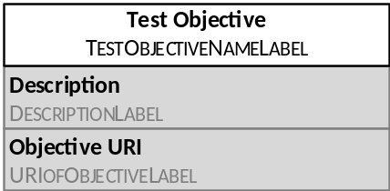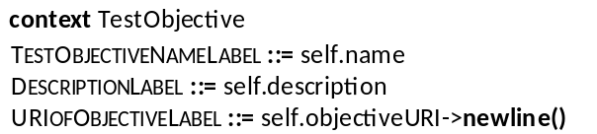

Figure 4.1. Notational convention example 1
In Figure 4.1, the following notational concepts of the TDL Concrete Graphical Syntax are shown:
- The uppermost compartment contains a terminal textual label (a keyword) 'Test Objective' typed in bold.
- The context meta-model element of this shape is TestObjective.
- The non-terminal textual label production rule TestObjectiveNameLabel results in the name of the context element (i.e., self.name).
- There are two optional compartmens (i.e., shaded grey) shown ordered from top to down.
- Both comparments contain a mandatory terminal textual label (i.e., the label shall be shown if the surrounding compartment is shown). The terminal textual labels shall be typed in bold (Description and Objective URI, respectively).
- Both compartments contain an optional non-terminal textual label (i.e., the label shall be shown if the surrounding compartment is shown and the production rules results in a non-empty string or a non-empty collection of strings).
- The separator between the elements of the self.objectiveURI in production rule URIofObjectiveLabel is a new line.

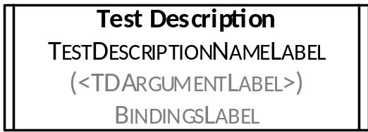
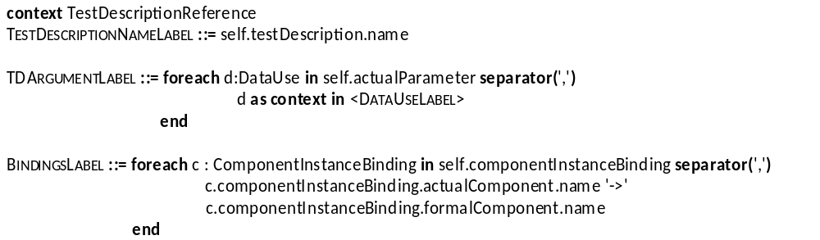

Figure 4.2. Notational convention example showing the foreach helper function
In Figure 4.2, the use of a non-OCL foreach helper function is illustrated. The context element when entering the foreach loop is TestDescriptionReference. The first foreach loop assigns iteratively each element in the collection self.actualParameter to the variable d of type DataUse. The variable d then used as it is described in the referenced production rule DataUseLabel. The separator between the results of the iterations is ',' (a comma character). The second foreach loop assigns iteratively each element in the collection self.componentInstanceBinding to the variable c of type ComponentInstanceBinding. The variable c is then used in a subsequent non-terminal textual label prodocution rule to build the label for the production rule. The separator between the results of the iterations is ',' (a comma character).

4.4. Conformance
For an implementation claiming to conform to this version of the TDL Concrete Graphical Syntax, all features specified in the present document and in [1] shall be implemented consistently with the requirements given in the present document and with [1].

5 Diagram
There is only one diagram kind provided by TDL Concrete Graphical Syntax. This diagram is called TDL Diagram. There can be multiple instances of a TDL Diagram at the same time.
The shapes that can be placed onto a TDL Diagram are specified in Clause 6.

6 Shapes

6.1 Foundation

6.1.1 NamedElement
Concrete Graphical Notation
This is an abstract metaclass, therefore no graphical representation is defined.
Formal Description
context NamedElement
NamedElementLabel ::= self.name
Comments

6.1.2 ElementImport
Concrete Graphical Notation
This metaclass has no dedicated shape, it is used solely in the shapes of other metaclasses.
Formal Description
context ElementImport
ImportLabel ::= 'from' self.importedPackage.qualifiedName
if self.importedElement->isEmpty() then
'all'
else
self.importedElement.name->separator(',')
endif
Comments

6.1.3 Package
Concrete Graphical Notation
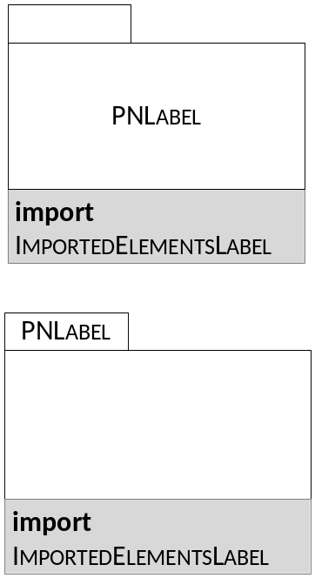
Formal Description
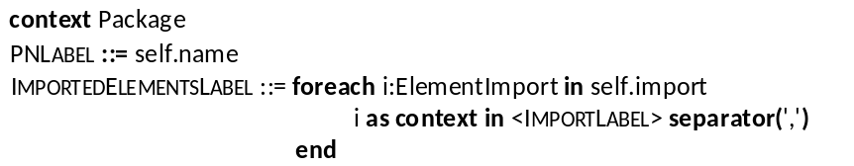
Comments
The figures above indicate the two possible representations of the Package shape: the PNLabel can be written either in the top, small compartment or in the middle one.
The elements the package contains (packagedElements) may be shown within the large rectangle in the middle. In this case the PNLabel shall be in the upper small compartment.
The lower import compartment is optional, it shall only be represented if the package imports other package(s) or elements from other package(s). If this compartment is present, its content shall also be present.

6.1.4 Comment
Concrete Graphical Notation
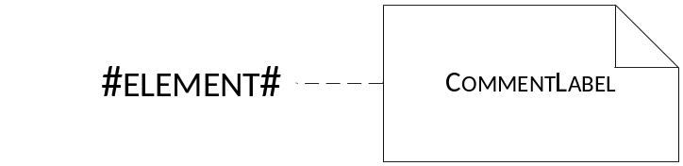
Formal Description
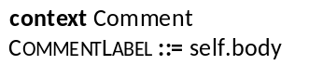
Comments
A Comment shape shall be attached to the commented element by a thin dashed line.

6.1.5 AnnotationType
Concrete Graphical Notation
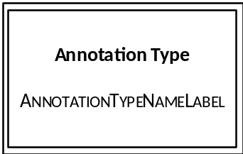
Formal Description
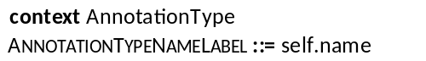
Comments

6.1.6 Annotation
Concrete Graphical Notation
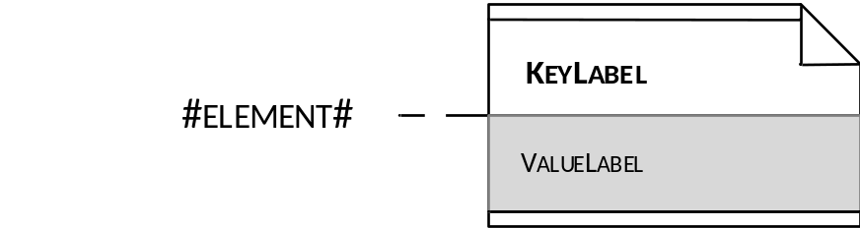
Formal Description
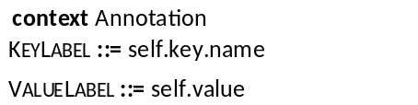
Comments
The lower compartment is optional, it shall be shown if the value of the Annotation is given.
An Annotation shape shall be attached to the annotated element by a thin dashed line.

6.1.7 TestObjective
Concrete Graphical Notation
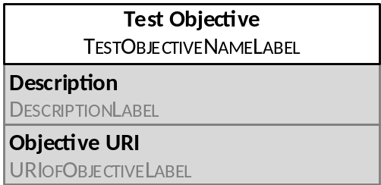
Formal Description
Comments
The compartments containing Description and ObjectiveURI are optional (that is any of them or both can be omitted). If an optional compartment is present, the contained terminal symbol (Description or ObjectiveURI, respectively) is mandatory, but the result of the production rule of the non-terminals (DescriptionLabel or URIofObjectiveLabel), respectively) is optional.

6.2 Data

6.2.1 SimpleDataType
Concrete Graphical Notation
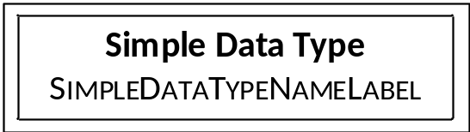
Formal Description
context SimpleDataType
SimpleDataTypeNameLabel ::= self.name
Comments

6.2.2 StructuredDataType
Concrete Graphical Notation
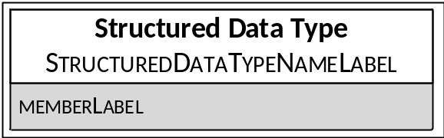
Formal Description
context StructuredDataType
StructuredDataTypeNameLabel ::= self.name
MemberLabel ::= foreach m: Member in self.member newline()
if m.isOptional then '['m as context in <ParameterLabel>']'
else
m as context in <ParameterLabel>
endif
end
Comments
The compartment containing MemberLabel is optional, it shall be shown if the StructuredDataType has at least one member.

6.2.3 Time
Concrete Graphical Notation
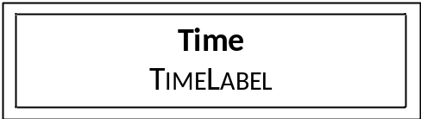
Formal Description
context Time
TimeLabel ::= self.name
Comments

6.2.4 DataInstance
Concrete Graphical Notation
This is an abstract metaclass, therefore no graphical representation is defined.
Formal Description
context DataInstance
DataInstanceLabel ::= self.name ':' self.dataType.name

Comments

6.2.5 SimpleDataInstance
Concrete Graphical Notation
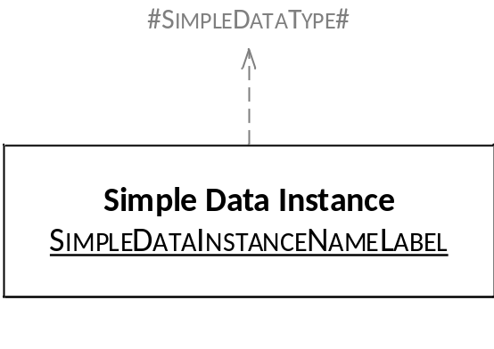
Formal Description
Comments
The result of the production rule of SimpleDataInstanceNameLabel shall be typed by underline font.
A SimpleDataInstance shape can optionally be connected to a SimpleDataType shape by dashed arrow. If this connection is present, then the ':' and the self.dataType.name can be omitted in the SimpleDataInstanceNameLabel.

6.2.6 StructuredDataInstance
Concrete Graphical Notation
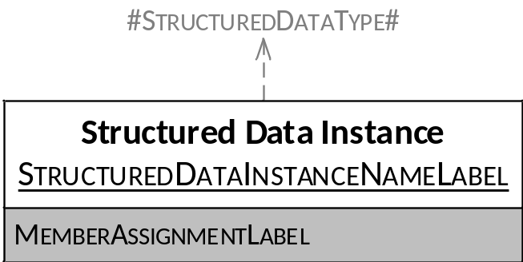
Formal Description
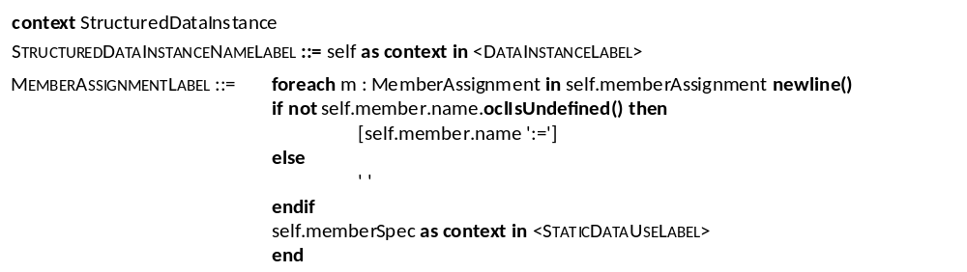
Comments
The result of the production rule of StructuredDataInstanceNameLabel shall be typed by underline font.
The lower compartment containing MemberAssignmentLabel is optional. For each member the name is optional.
The StructuredDataInstance shape can optionally be connected to a StructuredType shape by dashed arrow. If this connection is present, then the ':' and the self.dataType.name can be omitted in the StructuredDataInstanceNameLabel.

6.2.7 Parameter
Concrete Graphical Notation
This metaclass has no dedicated shape, it is used solely in the shapes of other metaclasses.
Formal Description
context Parameter
ParameterLabel ::= self.name ':' dataType.name
Comments

6.2.8 Action
Concrete Graphical Notation
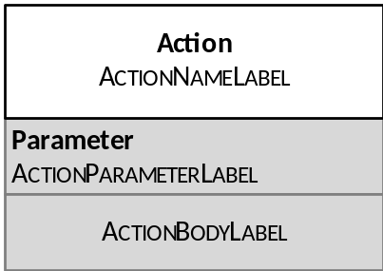
Formal Description
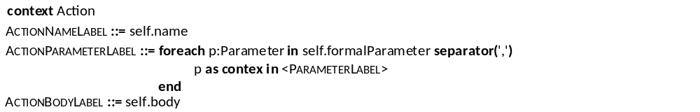
Comments
The compartments containing Parameter and ActionBodyLabel are optional (that is any of them or both can be omitted). If an optional compartment is present, its content shall also be present.

6.2.9 Function
Concrete Graphical Notation
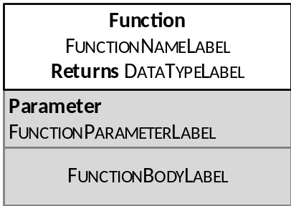
Formal Description
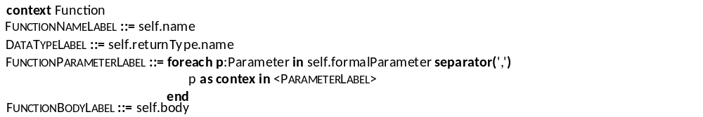
Comments
The compartments containing Parameter and FunctionBodyLabel are optional (that is any of them or both can be omitted). If an optional compartment is present, its content shall also be present.

6.2.10 DataResourceMapping
Concrete Graphical Notation
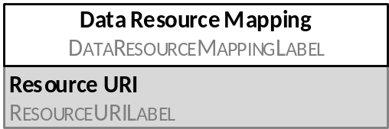
Formal Description
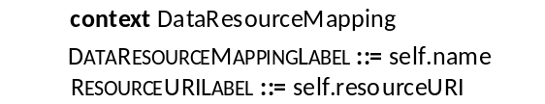
Comments
The DataResourceMappingLabel is optional.
The compartment containing the Resource URI is optional. This compartment shall be shown when the optional ResourceURILabel is present.

6.2.11 ParameterMapping
Concrete Graphical Notation
This metaclass has no dedicated shape, it is used solely in the DataElementMapping shape.
Formal Description
context ParameterMapping
ParameterURLLabel ::= self.parameter.name [':=' self.memberURI]
Comments

6.2.12 DataElementMapping
Concrete Graphical Notation

Formal Description
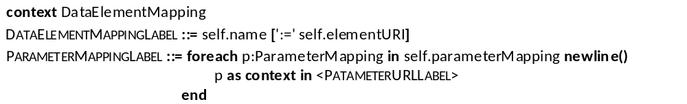
Comments
In the DataElementMappingLabel the elementURI is optional.
The lower compartment containing Parameter Mapping is optional.

6.2.13 DataUse
Concrete Graphical Notation
This is an abstract metaclass, therefore no graphical representation is defined.
Formal Description
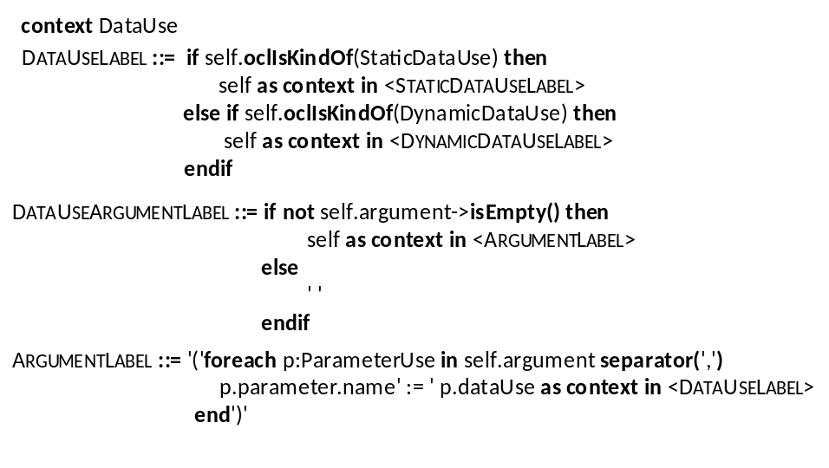

Comments

6.2.14 StaticDataUse
Concrete Graphical Notation
This is an abstract metaclass, therefore no graphical representation is defined.
Formal Description
context StaticDataUse
StaticDataUseLabel ::= if self.oclIsKindOf(DataInstanceUse) then
self as context in <DataInstanceUseLabel>
else if self.oclIsKindOf(AnyValue) then
self as context in <AnyValueLabel>
else if self.oclIsKindOf(AnyValueOrOmit) then
self as context in <AnyValueOrOmitLabel>
else if self.oclIsKindOf(OmitValue) then
self as context in <OmitValueLabel>
endif
Comments

6.2.15 DataInstanceUse
Concrete Graphical Notation
This metaclass has no dedicated shape, it is used solely in the shapes of other metaclasses.
Formal Description
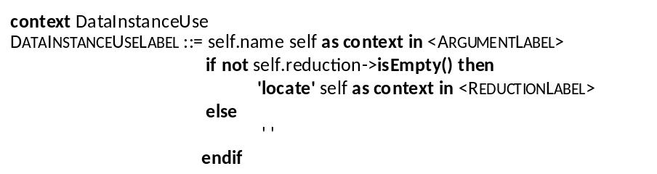
Comments

6.2.16 AnyValue
Concrete Graphical Notation
?
Formal Description
context AnyValue
AnyValueLabel ::= '?'
Comments

6.2.17 AnyValueOrOmit
Concrete Graphical Notation
*
Formal Description
context AnyValueOrOmit
AnyValueOrOmitLabel ::= '*'
Comments

6.2.18 OmitValue
Concrete Graphical Notation
omit
Formal Description
context OmitValue
OmitValueLabel ::= 'omit'
Comments

6.2.19 DynamicDataUse
Concrete Graphical Notation
This is an abstract metaclass, therefore no graphical representation is defined.
Formal Description
context DynamicDataUse
DynamicDataUseLabel ::= if self.oclIsTypeOf(VariableUse) then
self as context in <VariableUseLabel>
else if self.oclIsTypeOf(FormalParameterUse) then
self as context in <FormalParameterUseLabel>
else if self.oclIsTypeOf(FunctionCall) then
self as context in <FunctionCallLabel>
else if self.oclIsTypeOf(TimeLabel) then
self as context in <TimeLabel>
endif
Comments

6.2.20 FunctionCall
Concrete Graphical Notation
This metaclass has no dedicated shape, it is used solely in the shapes of other metaclasses.
Formal Description
context FunctionCall
FunctionCallLabel ::= self as context in <DataUseArgumentLabel>
if not self.reduction->isEmpty() then
'returns' self as context in <ReductionLabel>
else
' '
endif
Comments

6.2.21 FormalParameterUse
Concrete Graphical Notation
This metaclass has no dedicated shape, it is used solely in the shapes of other metaclasses.
Formal Description
context FormalParameterUse
FormalParameterUseLabel ::= self.name self as context in <DataUseArgumentLabel> self as context in <ReductionLabel>
Comments

6.2.22 VariableUse
Concrete Graphical Notation
This metaclass has no dedicated shape, it is used solely in the shapes of other metaclasses.
Formal Description
context VariableUse
VariableUseLabel ::= self.componentInstance.name'.'variable.name self as context in <DataUseArgumentLabel>
if not self.reduction->isEmpty() then
'locate' self as context in <ReductionLabel>
else
' '
endif

Comments

6.3 Time

6.3.1 TimeLabel
Concrete Graphical Notation

Formal Description
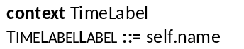
Comments
A TimeLabel shape shall be attached to the labelled AtomicBehaviour by a thin dashed line.

6.3.2 TimeLabelUse
Concrete Graphical Notation
This metaclass has no dedicated shape, it is used solely in the shapes of other metaclasses.
Formal Description
context TimeLabelUse
TimeLabelUseLabel ::= self.timeLabel.name
Comments

6.3.3 Wait
Concrete Graphical Notation
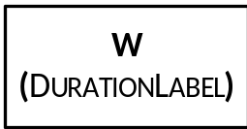
Formal Description
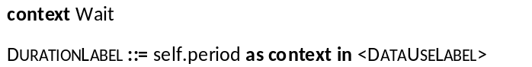
Comments
The Wait shape shall cover all the lifelines of that component instance, which is referred to by self.componentInstance.

6.3.4 Quiescence
Concrete Graphical Notation
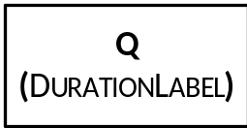
Formal Description
Comments
If the Quiescence refers to a component instance (self.componentInstance is set), then the Quiescence shape shall cover all the lifelines of that component instance, otherwise the Quiescence shape shall cover only the lifeline of that gate, which is referred to by self.gateReference.

6.3.5 TimeConstraint
Concrete Graphical Notation

Formal Description
Comments
A TimeConstraint shape shall be attached to an AtomicBehaviour shape by a thin dashed line.

6.3.6 TimerStart
Concrete Graphical Notation
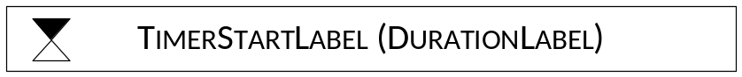
Formal Description
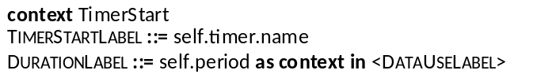
Comments
The TimerStart shape shall cover all the lifelines of that component instance, which is referred to by self.componentInstance.

6.3.7 TimeOut
Concrete Graphical Notation
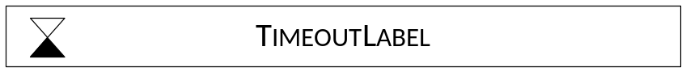
Formal Description

Comments
The TimeOut shape shall cover all the lifelines of that component instance, which is referred to by self.componentInstance.

6.3.8 TimerStop
Meta-Model Reference
Concrete Graphical Notation
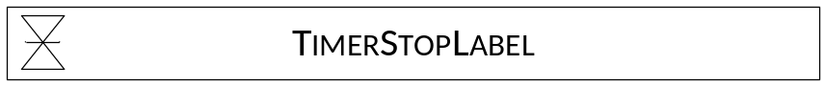
Formal Description
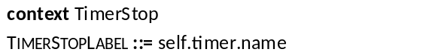
Comments
The TimerStop shape shall cover all the lifelines of that component instance, which is referred to by self.componentInstance.

6.4 Test Configuration

6.4.1 TestConfiguration
Concrete Graphical Notation
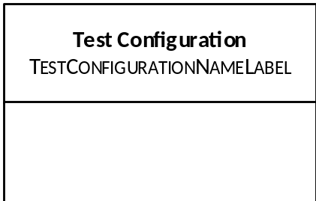
Formal Description
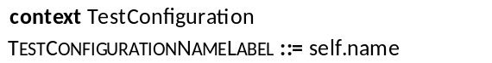
Comments
Into the lower empty compartment the elements of the TestConfiguration shall be placed.

6.4.2 GateType
Concrete Graphical Notation

Formal Description
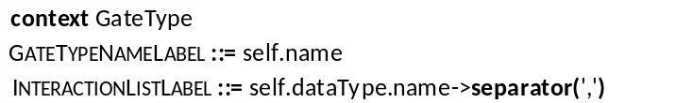
Comments

6.4.3 GateInstance
Concrete Graphical Notation

Formal Description
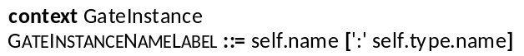
Comments
In GateInstanceNameLabel the ':' self.type.name is optional.

6.4.4 ComponentType
Concrete Graphical Notation
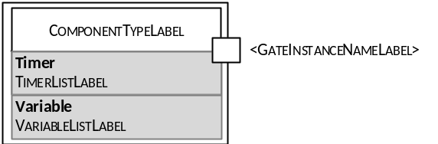
Formal Description
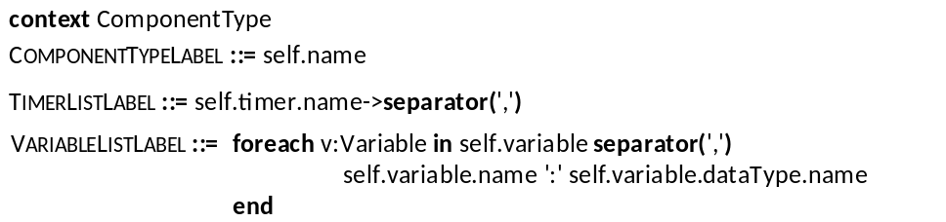
Comments
A ComponentType shape may contain one or more GateInstance shapes at any side or corner.
The compartments containing Timer and Variable are optional (that is any of them or both can be omitted). If an optional compartment is present, its content shall also be present.

6.4.5 ComponentInstance
Concrete Graphical Notation
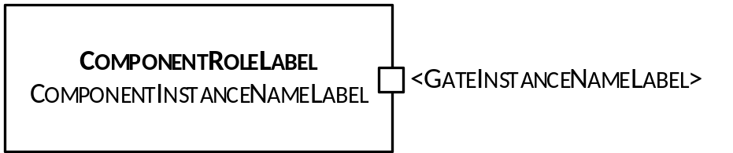
Formal Description
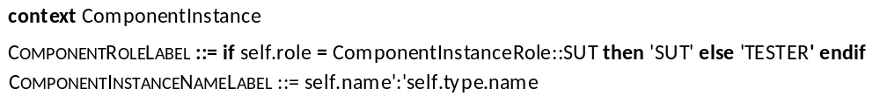
Comments
A ComponentInstance shape may contain one or more GateInstance shapes at any side or corner.
The terminal symbol 'SUT' or 'TESTER' shall be typed in bold.

6.4.6 Connection
Concrete Graphical Notation
Formal Description
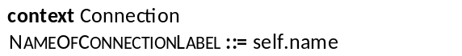
Comments
NameOfConnectionLabel is optional.

6.5 Test Behaviour

6.5.1 TestDescription
Concrete Graphical Notation
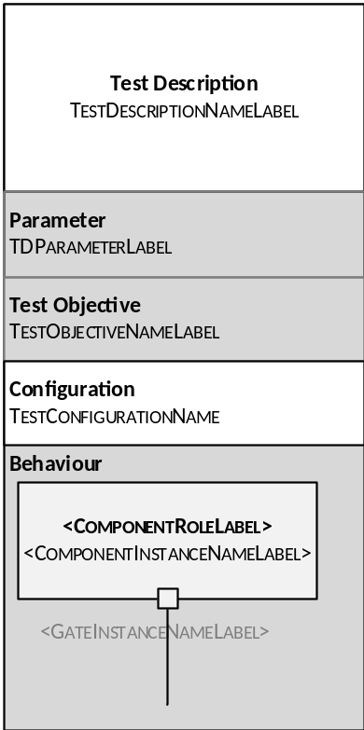

Formal Description
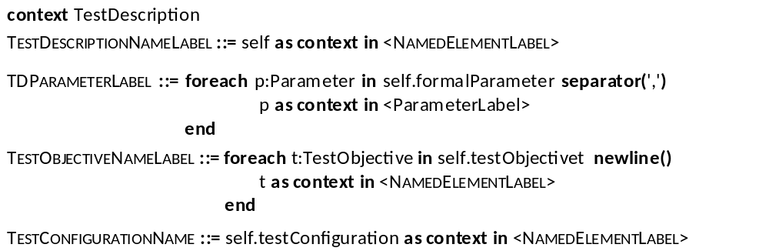
Comments
The compartments containing Parameter, TestObjective and Behaviour are optional (that is any or all of them can be omitted). If an optional compartment is present, its content shall also be present.
In the lowest compartment describing the behaviour of the test description:
- There shall be as many ComponentInstance shapes as there are component instances defined in the TestConfiguration referenced in a Configuration compartment.
- If a component instance has only one gate, the rectangle representing the GateInstance and the GateInstanceNameLabel are optional.
- From each gate instance a vertical line ("lifeline") originates, to which each Behaviour element defined in that test description and associated with that gate is attached.

6.5.2 Behaviour
Concrete Graphical Notation
This is an abstract metaclass, therefore no graphical representation is defined.
Formal Description

Comments
To a shape of any subclass of Behaviour, the following test objective reference shape can be attached by a thin dashed line.
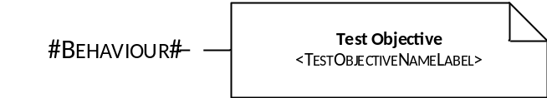

6.5.3 CombinedBehaviour
Concrete Graphical Notation
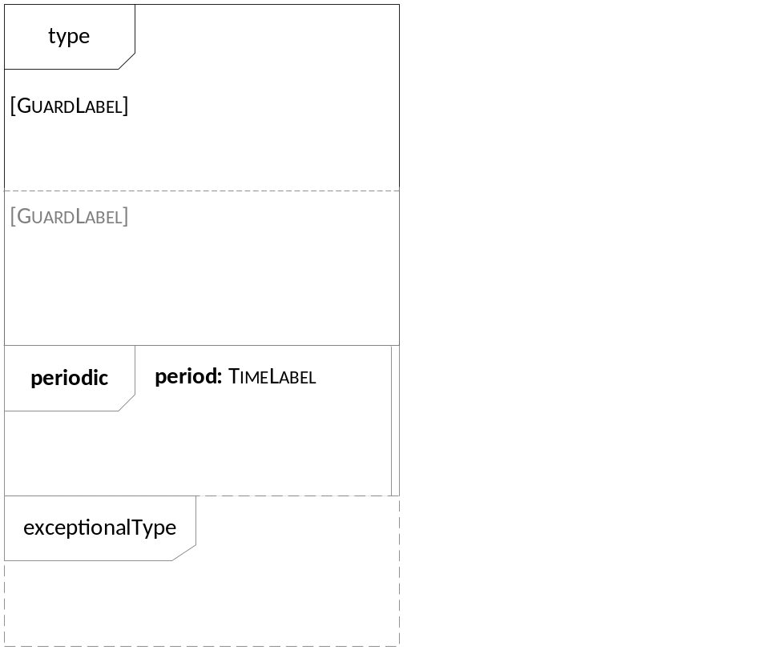
Formal Description

Comments
CombinedBehaviour is an abstract metaclass that can be refined to several subclasses. The figure above gives a general overview, how the combined behaviour elements shall be organized. Further constraints are explained in the respective subclauses describing the shymbols of subclasses of CombinedBehaviour. Depending on the concrete type of the CombinedBehaviour, it may or may not contain more than one blocks. The outermost border of the contained Block(s) are not visible. If more than one blocks are defined, they shall be separated by thin dashed lines. Any number of periodic and/or exceptional behaviour can be attached in any order to a CombinedBehaviour.
A CombinedBehaviour shape shall cover all the lifelines.

6.2.4 Block
Concrete Graphical Notation
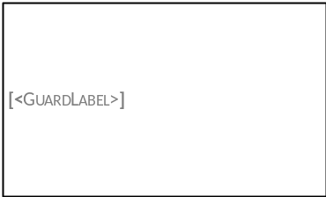
Formal Description
context Block
GuardLabel ::= self.block.guard as context in <DataUseLabel>
Comments
A Block cannot stand on its own, only as a part of a CombinedBehaviour. Therefore the border of the Block is not visible (the border on the Figure above is indicated only for visualization purposes). If a CombinedBehaviour contains more than one Block, they are separated by dashed lines.
The [GuardLabel] is optional. If a Block of a CombinedBehaviour contains a GuardLabel, it shall be placed in between square brackets ( '[' and ']').

6.5.5 CompoundBehaviour
Concrete Graphical Notation
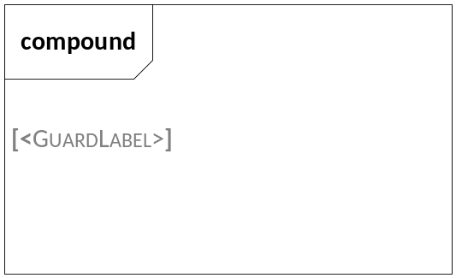
Formal Description

Comments
[GuardLabel] is optional.

6.5.6 BoundedLoopBehaviour
Concrete Graphical Notation
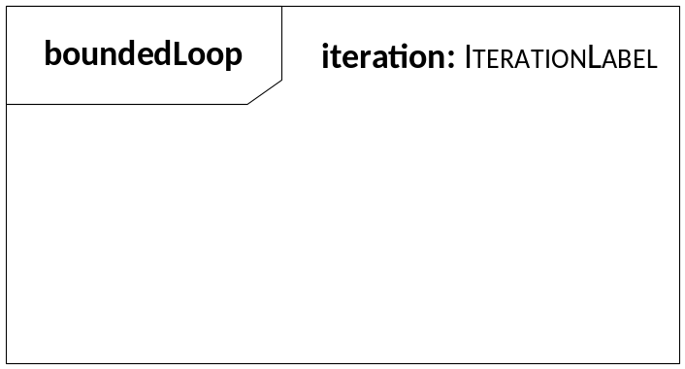
Formal Description
Comments

6.5.7 UnboundedLoopBehaviour
Concrete Graphical Notation
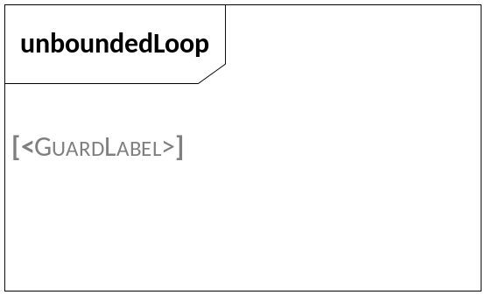
Formal Description

Comments
[GuardLabel] is optional.

6.5.8 AlternativeBehaviour
Concrete Graphical Notation
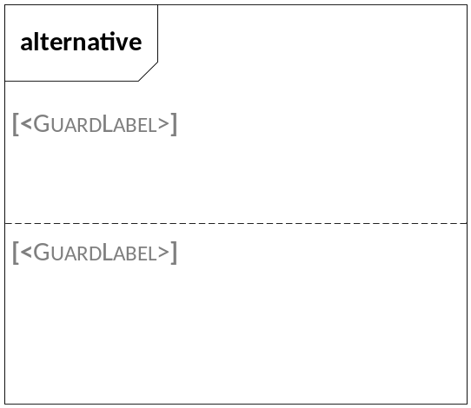
Formal Description

Comments
Any number of blocks can be contained, they are separated by dashed lines.
[GuardLabel] of any block is optional.

6.5.9 ConditionalBehaviour
Concrete Graphical Notation
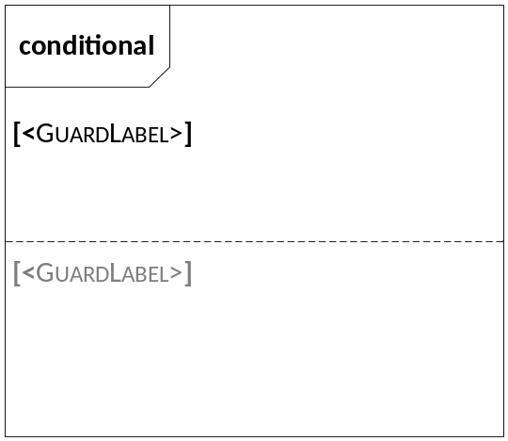
Formal Description

Comments
Any number of blocks can be contained, they are separated by dashed lines.
[GuardLabel] of the last block is optional.

6.5.10 ParallelBehaviour
Concrete Graphical Notation
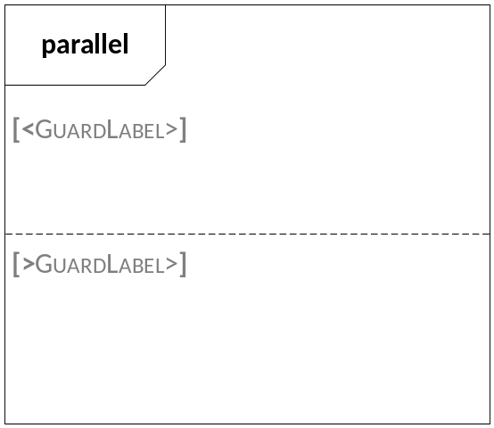
Formal Description

Comments
Any number of blocks can be contained, they are separated by dashed lines.
[GuardLabel] of any block is optional.

6.5.11 DefaultBehaviour
Concrete Graphical Notation
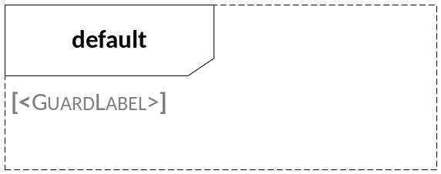
Formal Description

Comments
A DefaultBehaviour shape can be attached to any CombinedBehaviour.
[GuardLabel] is optional.

6.5.12 InterruptBehaviour
Concrete Graphical Notation
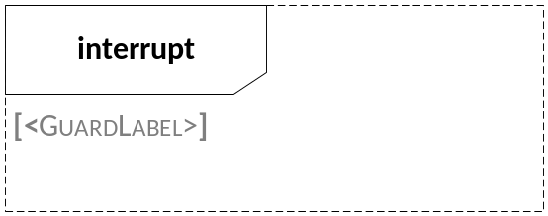
Formal Description

Comments
An InterruptBehaviour shape can be attached to any CombinedBehaviour.
[GuardLabel] is optional.

6.5.13 PeriodicBehaviour
Concrete Graphical Notation
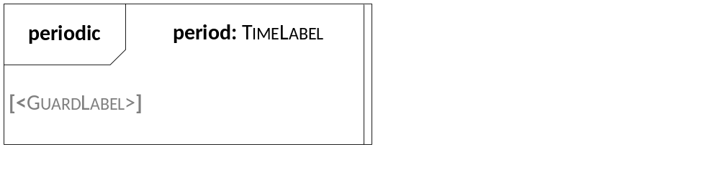
Formal Description
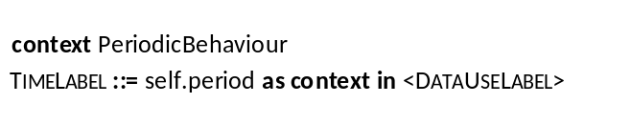
Comments
A PeriodicBehaviour shape can be attached to any CombinedBehaviour.
[GuardLabel] is optional.

6.5.14 Break
Concrete Graphical Notation

Formal Description

Comments
The Break shape shall cover all the lifelines.

6.5.15 Stop
Concrete Graphical Notation

Formal Description

Comments
The Stop shape shall cover all the lifelines.

6.5.16 VerdictAssignment
Concrete Graphical Notation

Formal Description
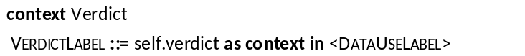
Comments
The VerdictAssignment shape shall cover all the lifelines.

6.5.17 Assertion
Concrete Graphical Notation

Formal Description
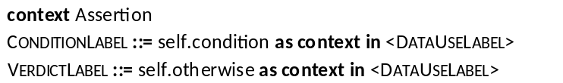
Comments
'otherwise' and VerdictLabel are optional.
The Assertion shape shall cover all the lifelines.

6.5.18 Interaction
Concrete Graphical Notation
Unicast Interaction

Unicast Trigger Interaction


Multicast Interaction


Multicast Trigger Interaction


Formal Description
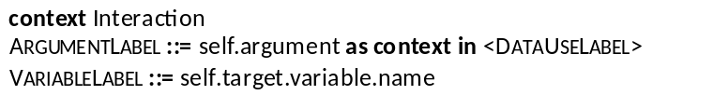
Comments
The two ends of an interaction (GateReference and Target) shall be placed onto the lifeline of the corresponding gate instances.
VariableLabel and ':= ' are optional.
In case of a unicast or unicast trigger interaction, the VariableLabel – if present – can be placed either above the arrow as an assignment or under the arrowhead.
In case of a multicast or multicast trigger interaction, the originating GateReference shall be indicated by a small black square, and there shall be as many arrows present as there are destinations in the multicast interaction. In this case, optionally there may be a VariableLabel presented under each arrowhead.

6.5.19 ActionReference
Concrete Graphical Notation
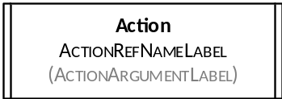
Formal Description
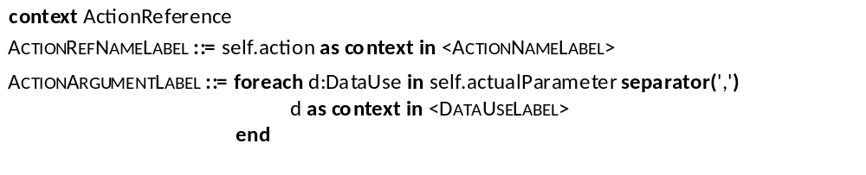
Comments
(ActionArgumentLabel) is optional.
In case the ActionReference is not related to a ComponentInstance (the componentInstance property is not set), the ActionReference shape shall cover all the lifelines, otherwise only all the lifelines of the referenced ComponentInstance.

6.5.20 InlineAction
Concrete Graphical Notation
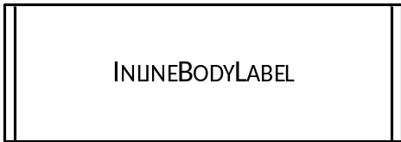
Formal Description
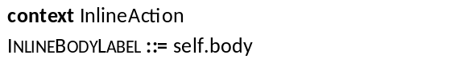
Comments
In case the InlineAction is not related to a ComponentInstance (the componentInstance property is not set), the InlineAction shape shall cover all the lifelines, otherwise only all the lifelines of the referenced ComponentInstance.

6.5.21 Assignment
Concrete Graphical Notation
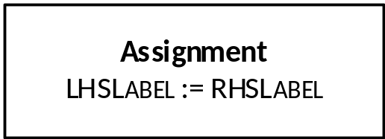
Formal Description
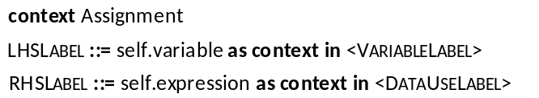
Comments
The Assignment shape shall cover all the lifelines of that ComponentInstance which is referred to by the componentInstance property of the Assignment.

6.5.22 TestDescriptionReference
Concrete Graphical Notation
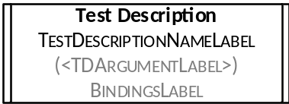
Formal Description
Comments
(ArgumentLabel) and BindingsLabel are optional (that is any of them or both can be omitted).
The TestDescriptionReference shape shall cover all the lifelines.

Annex A (informative):
Examples
This Annex provides several examples to illustrate how the different elements of the TDL Graphical Syntax can be used and demonstrates the applicability of TDL in several different areas.
The first example in A.1 Illustration of Data use in TDL Graphical Syntax demonstrates the usage of data-related concepts.
The second example in A.2 Interface Testing shows a scenario when a 'Tester' performs a test scenario on one interface of the 'SUT'. The example is taken from [i.1].
The third example in A.3 Interoperability Testing provides an example for interoperability testing in IMS. The example is taken from [i.2].

A.1 Illustration of Data use in TDL Graphical Syntax
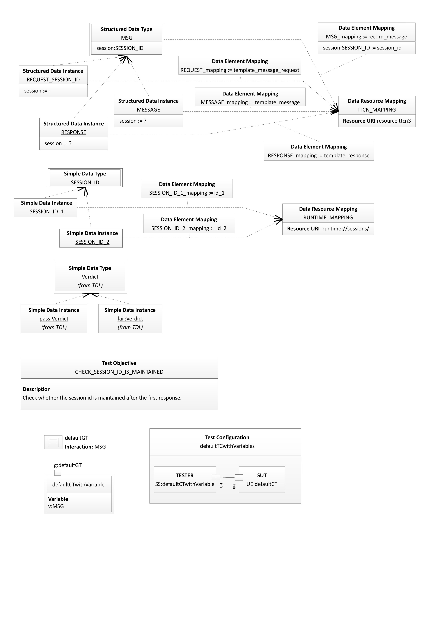
Figure A.1.1 Illustration of Data use in TDL Graphical Syntax Part 1
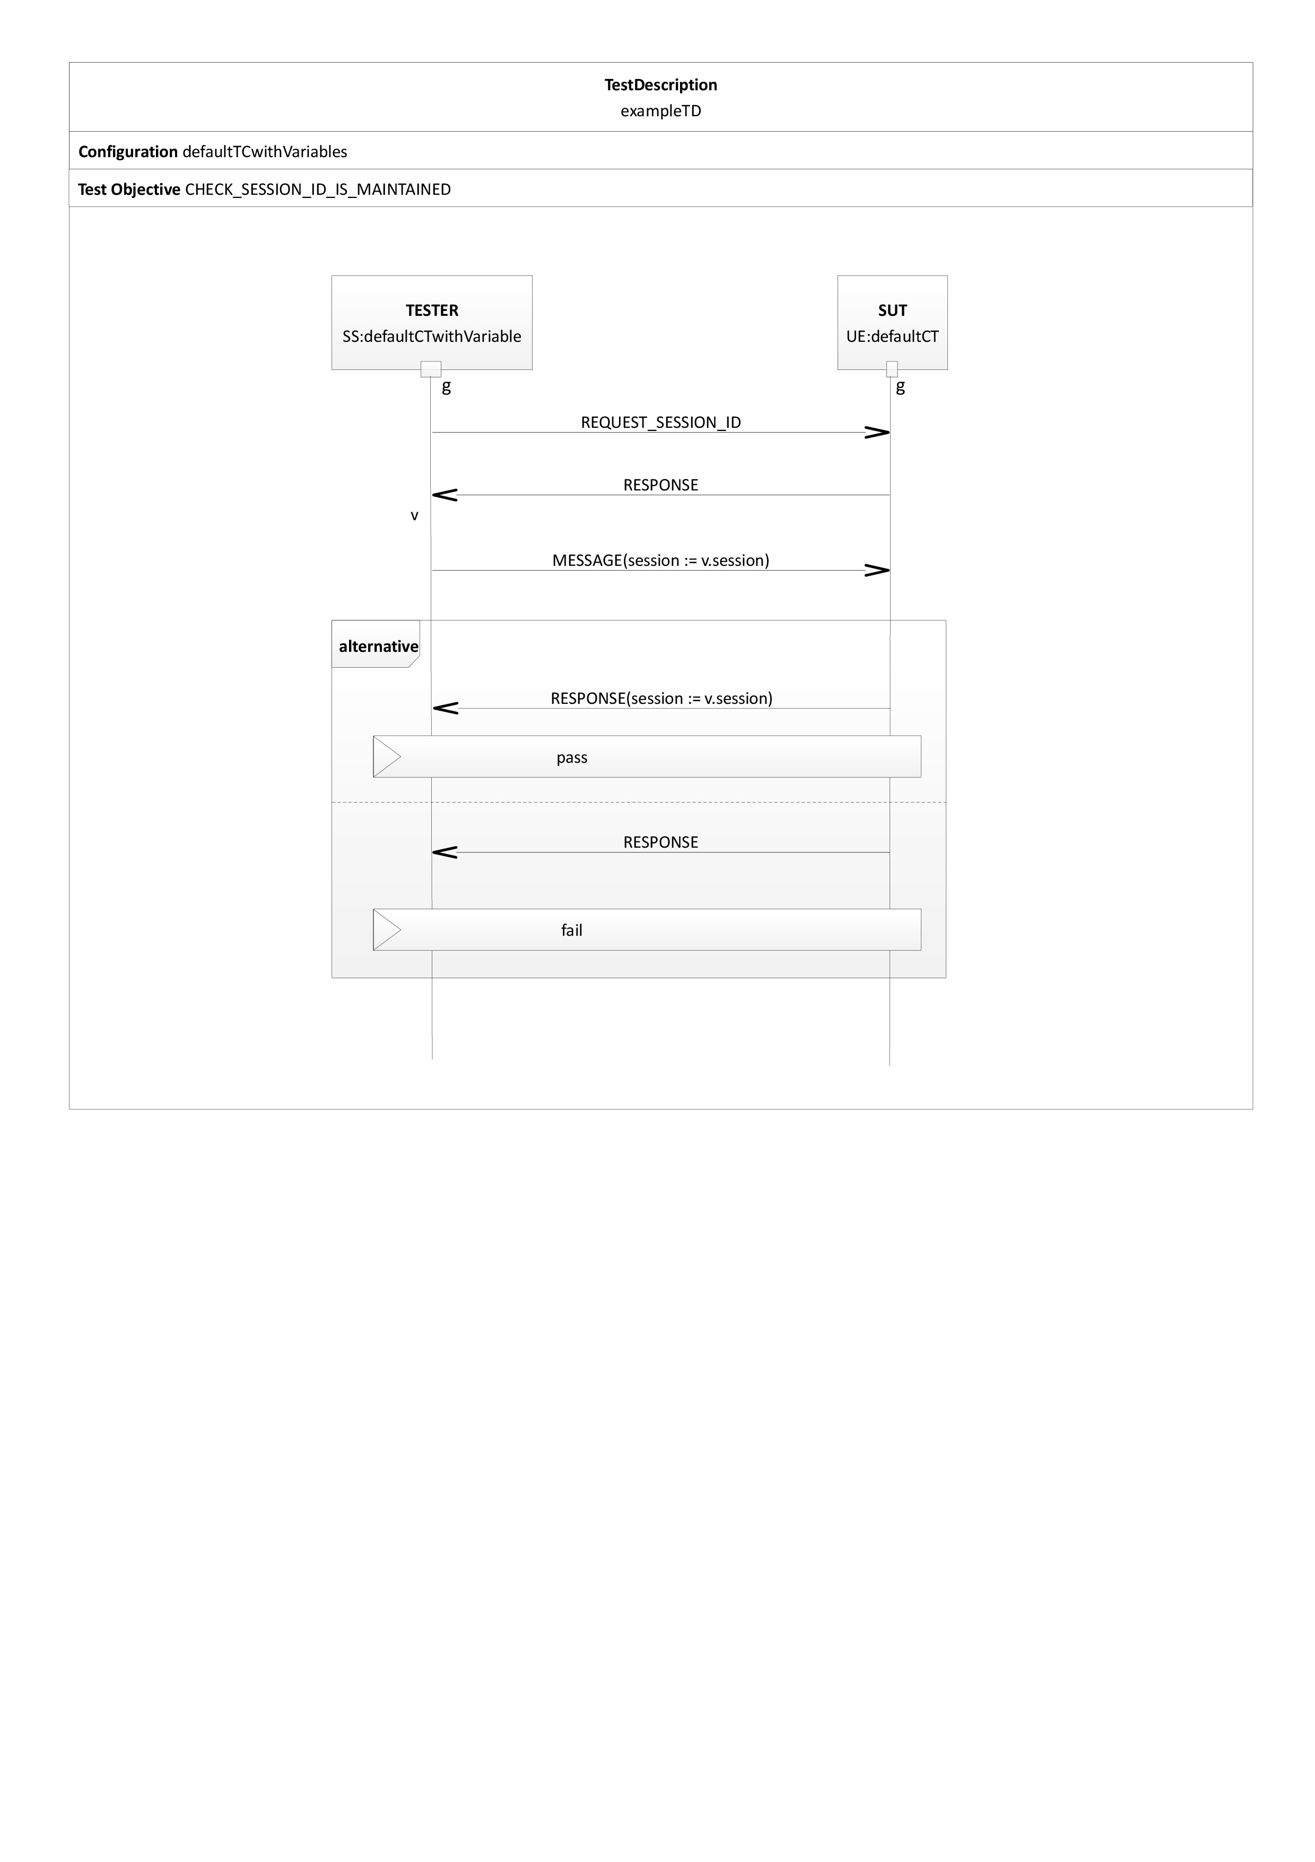
Figure A.1.2 Illustration of Data use in TDL Graphical Syntax Part 2

A.2 Interface Testing
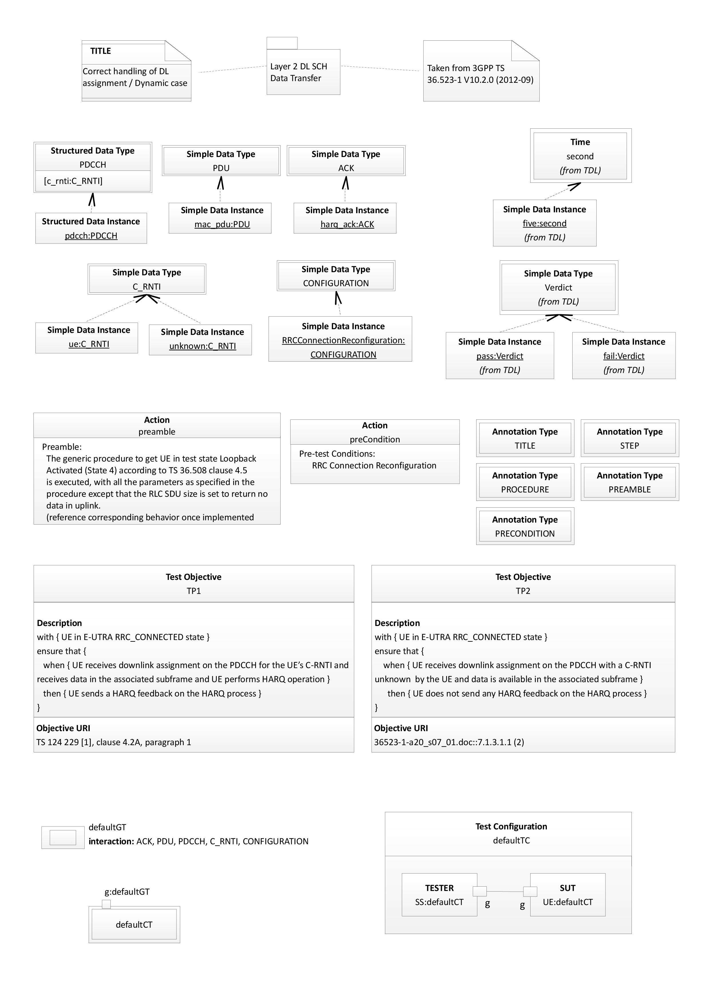
Figure A.2.1 Illustration of an interface testing in TDL Graphical Syntax Part 1
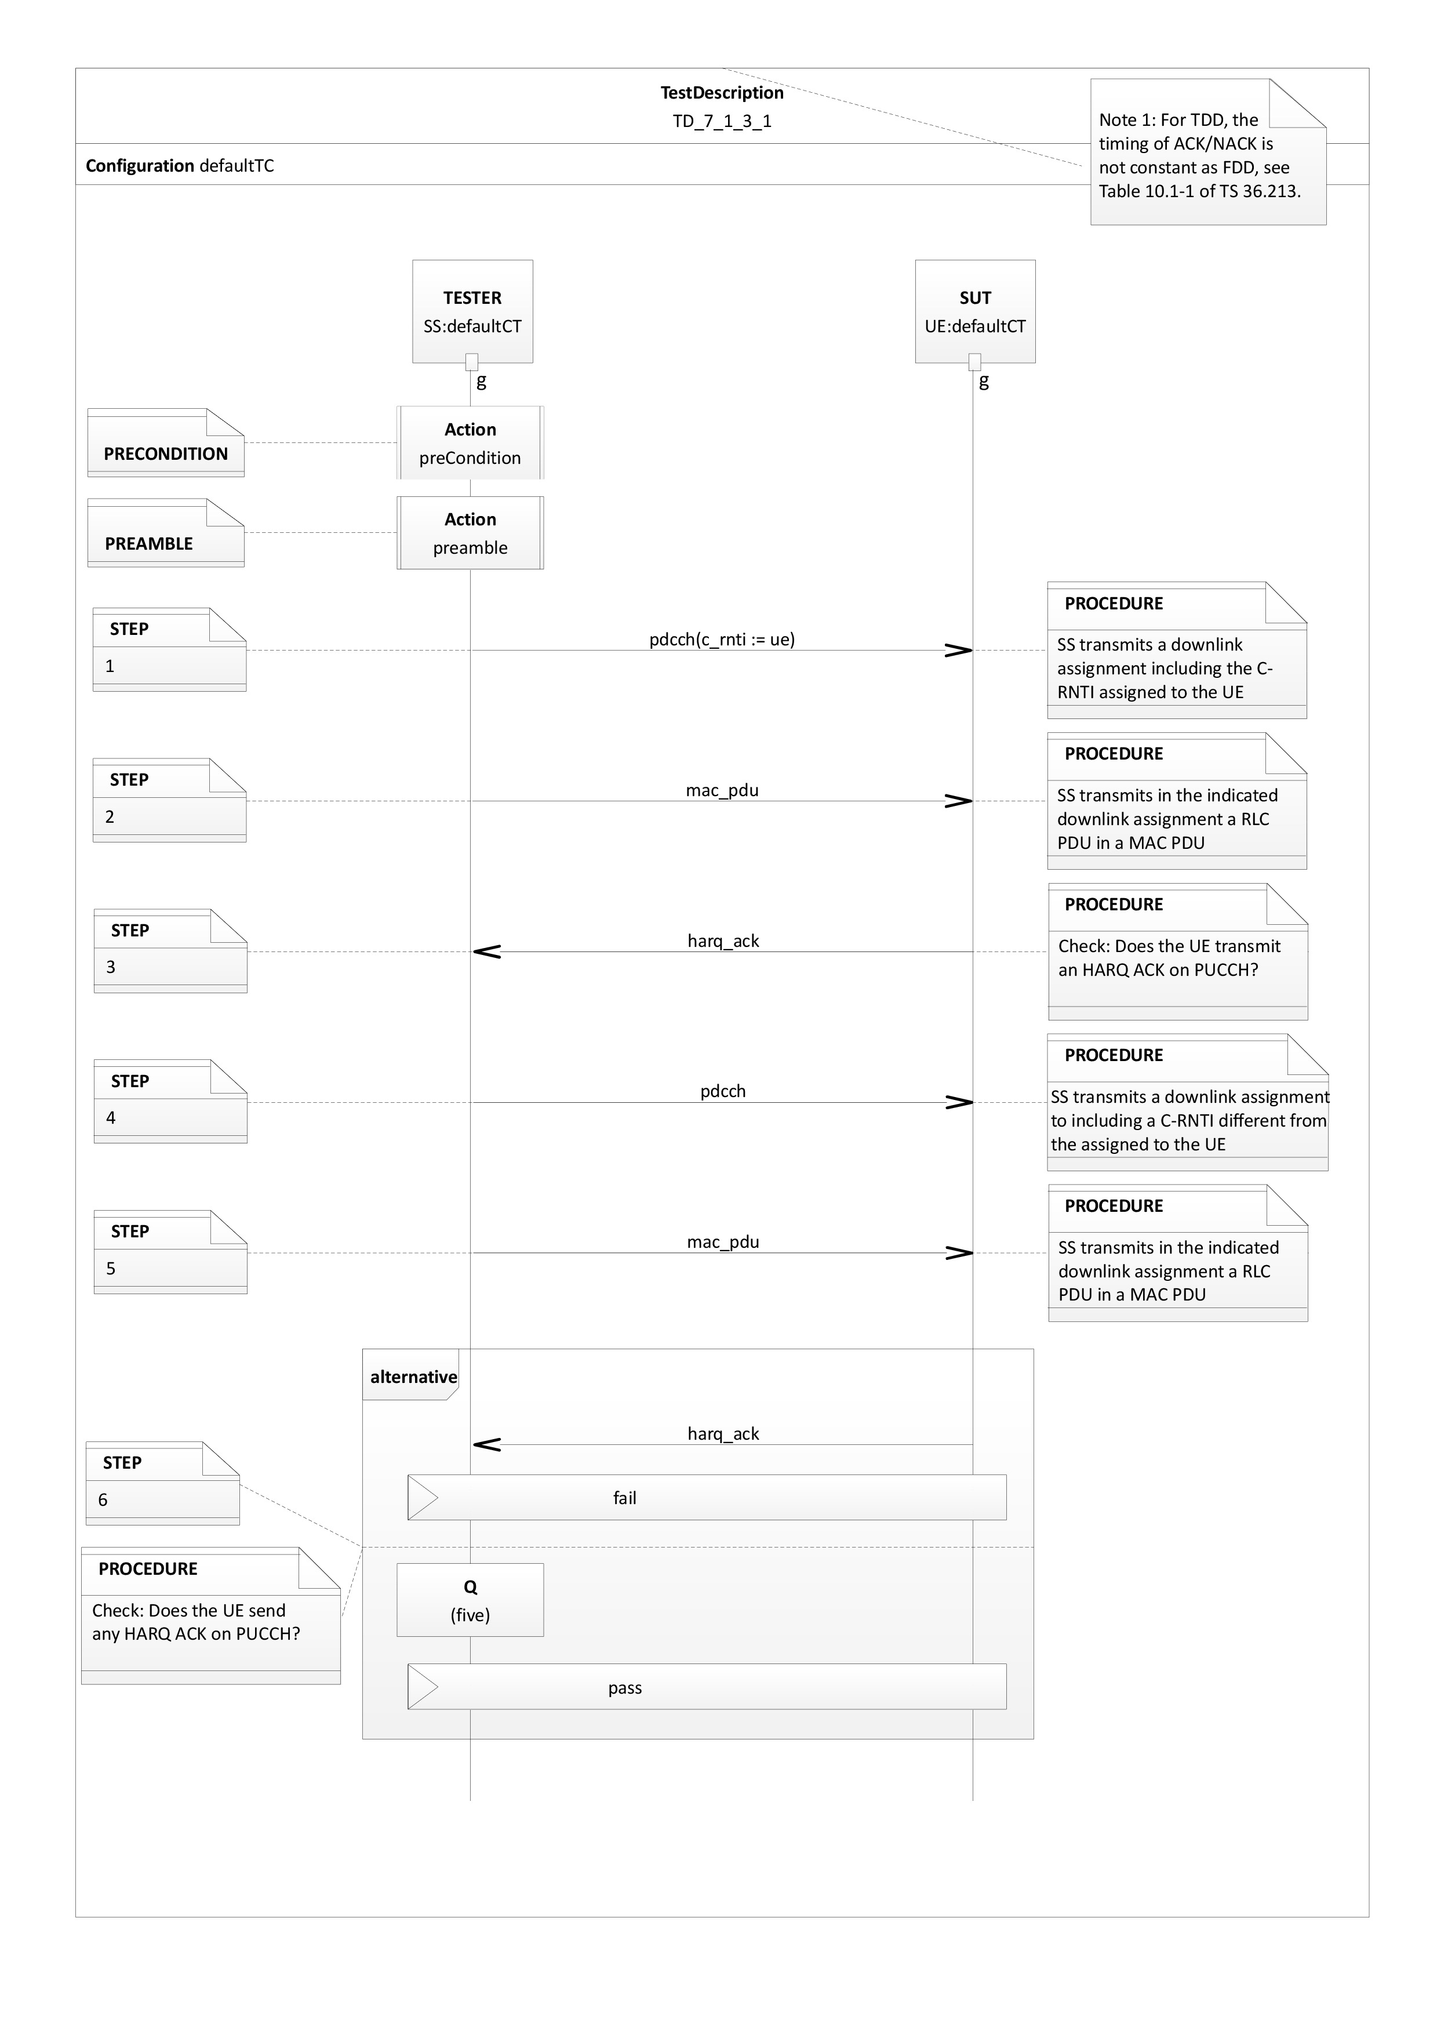
Figure A.2.2 Illustration of an interface testing in TDL Graphical Syntax Part 2

A.3 Interoperability Testing
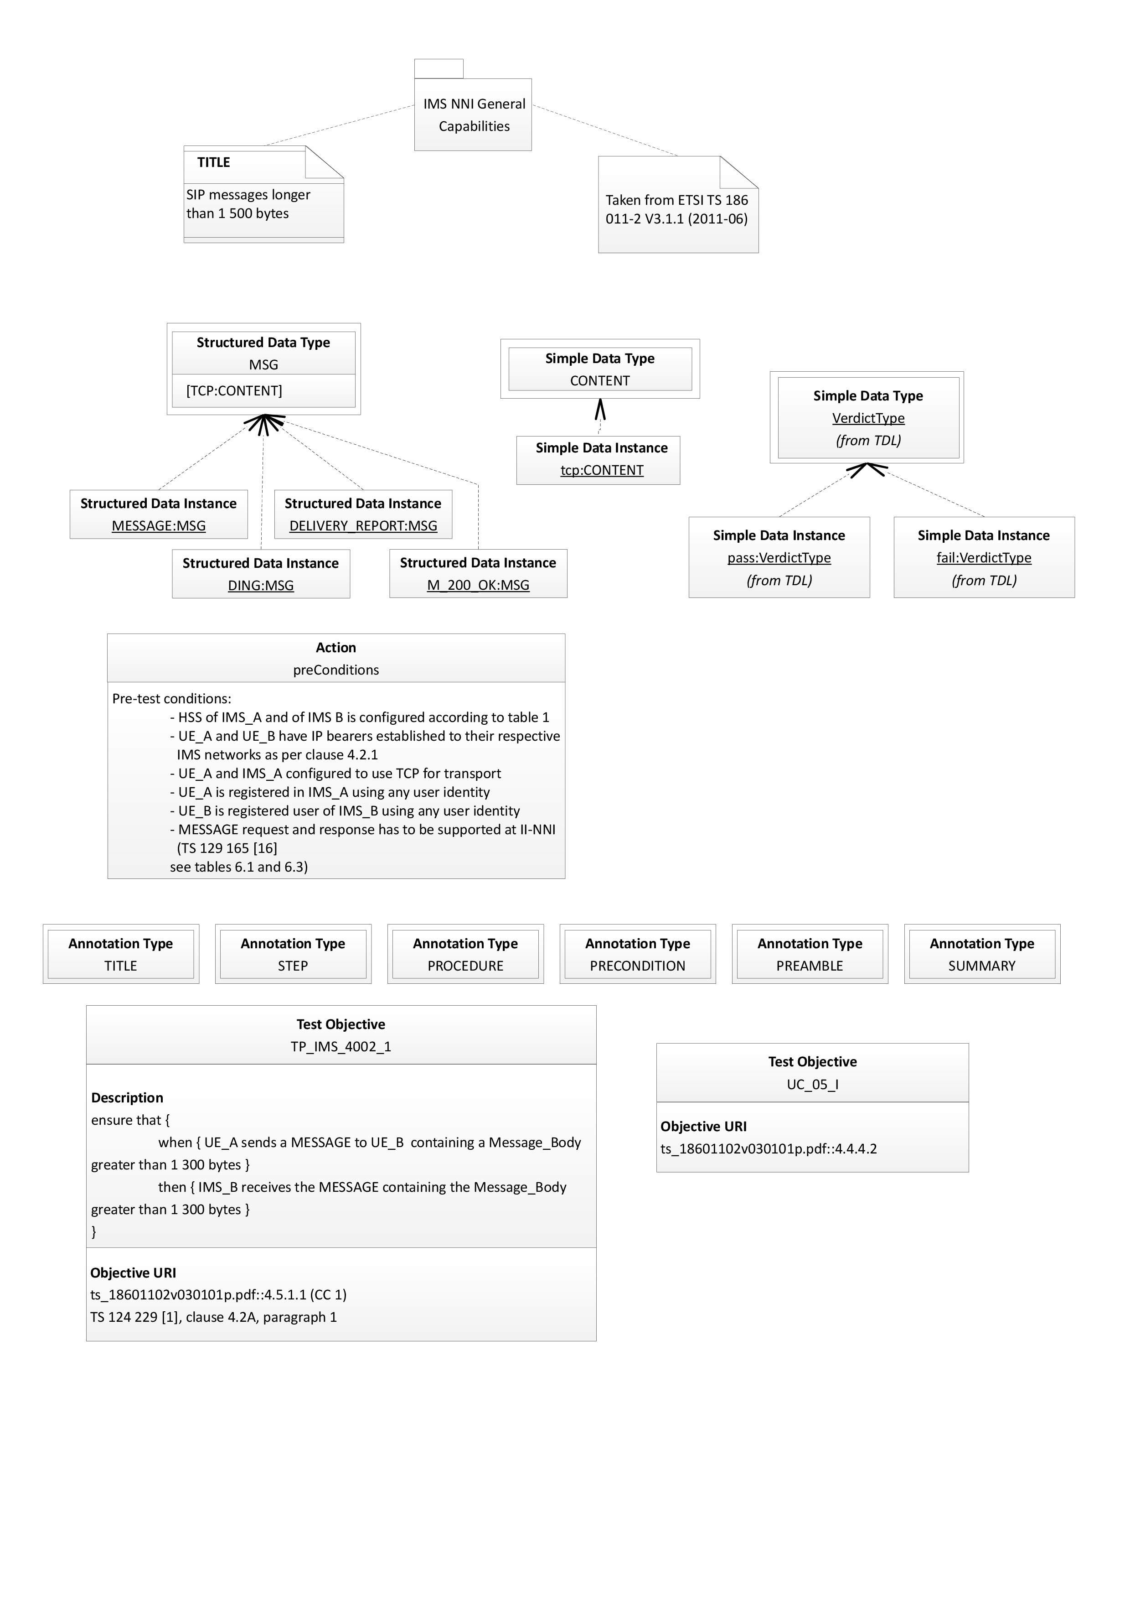
Figure A.3.1 Illustration of an interoperability testing in TDL Graphical Syntax Part 1
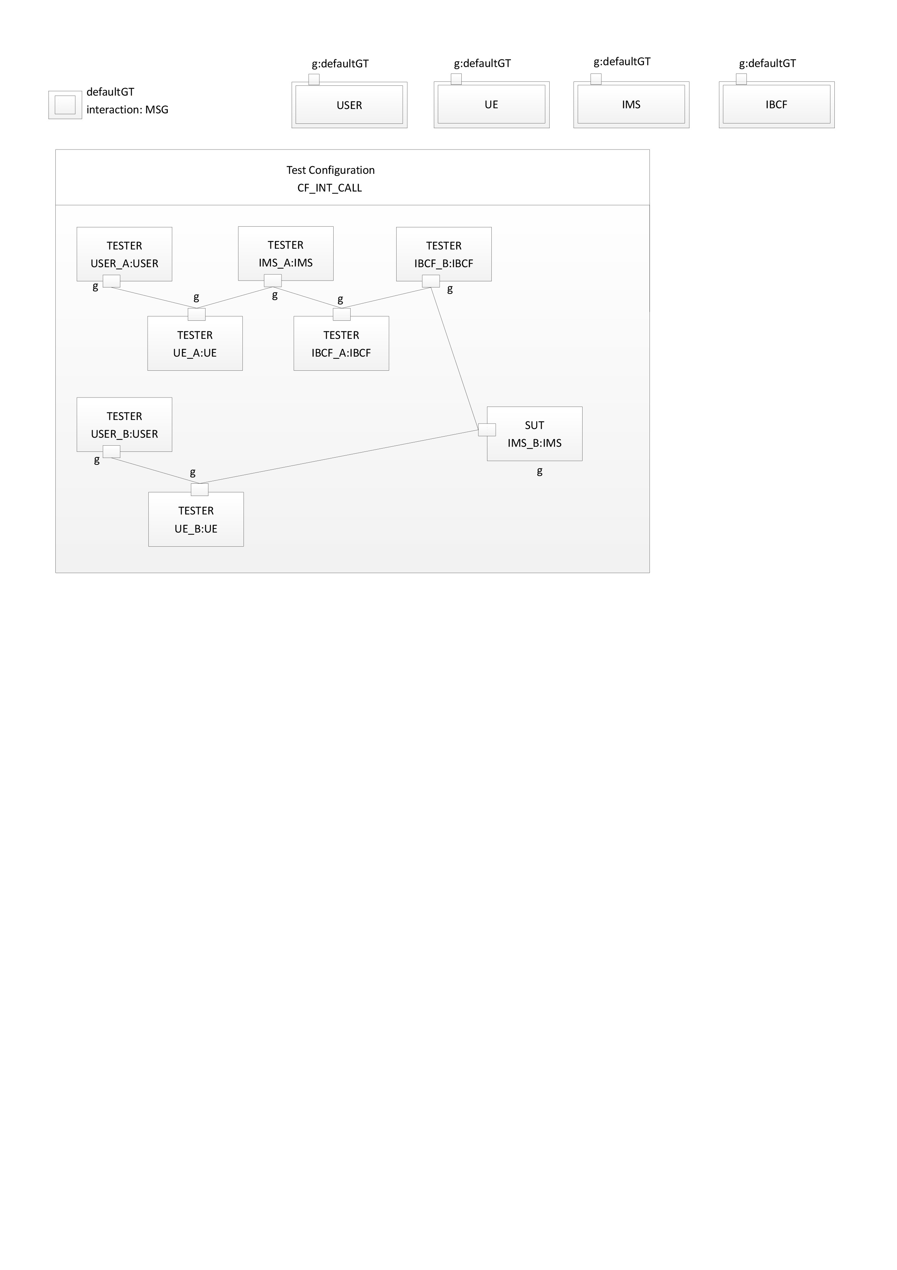
Figure A.3.2 Illustration of an interoperability testing in TDL Graphical Syntax Part 2
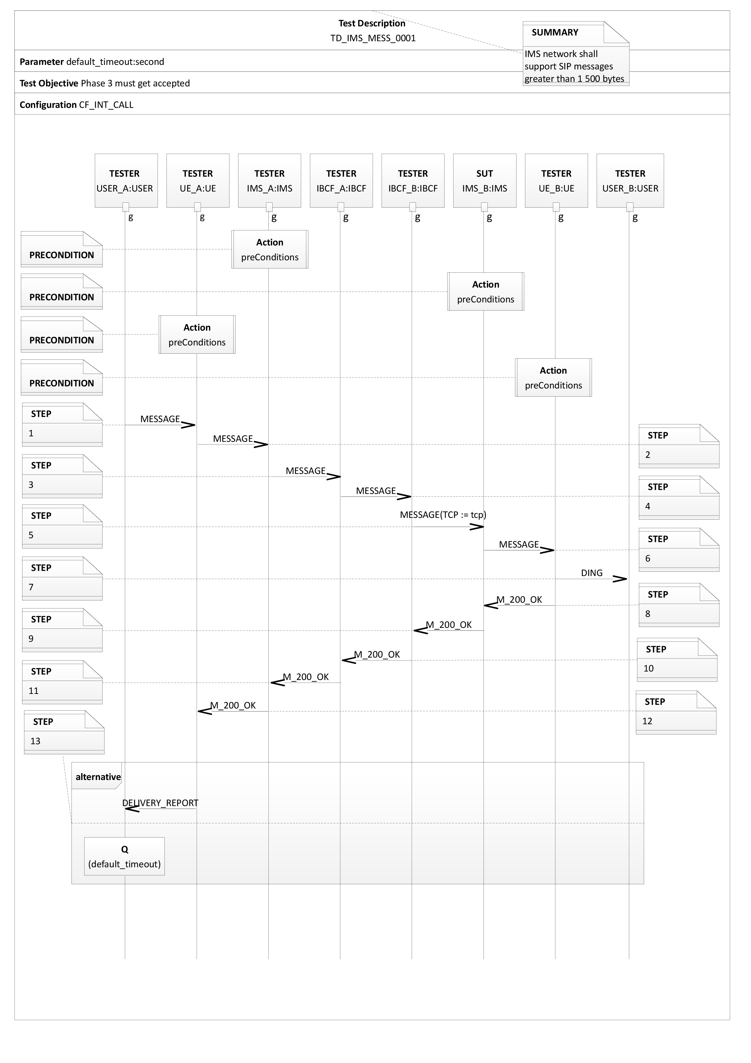
Figure A.3.3 Illustration of an interoperability testing in TDL Graphical Syntax Part 3

History
Document history
V1.1.1 | December 2014 | Final draft submitted for approval

Latest changes made on 2014-12-17

