Title*: | TDL SC meeting Agenda
 | 05 Feb 2015
from Source*: | L.M.Ericsson
Contact: | György Réthy
input for Committee*: | MTS
Contribution For*: | Decision | X
 | Discussion
 | Information
Submission date*: | 2015-02-04
Meeting & Allocation: | MTS-TDL_SC meeting

Agenda
Input documents:
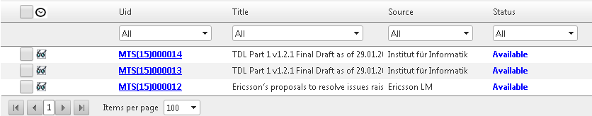

Baseline MM document for the further discussions

Decisions on Ericsson’s proposed solutions

