Final draft ETSI ES 203 119-7 V1.1.1 (2017-12)
Methods for Testing and Specification (MTS);
The Test Description Language (TDL);
Part 7: Extended Test Configurations

<

ETSI Standard

Reference
RES/MTS-203119-7v1.1.1
Keywords
language, MBT, methodology, testing, test description

ETSI
650 Route des Lucioles
F-06921 Sophia Antipolis Cedex - FRANCE

Tel.: +33 4 92 94 42 00 Fax: +33 4 93 65 47 16

Siret N° 348 623 562 00017 - NAF 742 C
Association à but non lucratif enregistrée à la
Sous-Préfecture de Grasse (06) N° 7803/88

Important notice
The present document can be downloaded from:
http://www.etsi.org/standards-search
The present document may be made available in electronic versions and/or in print. The content of any electronic and/or print versions of the present document shall not be modified without the prior written authorization of ETSI. In case of any existing or perceived difference in contents between such versions and/or in print, the only prevailing document is the print of the Portable Document Format (PDF) version kept on a specific network drive within ETSI Secretariat.
Users of the present document should be aware that the document may be subject to revision or change of status. Information on the current status of this and other ETSI documents is available at https://portal.etsi.org/TB/ETSIDeliverableStatus.aspx
If you find errors in the present document, please send your comment to one of the following services:
https://portal.etsi.org/People/CommiteeSupportStaff.aspx
Copyright Notification
No part may be reproduced or utilized in any form or by any means, electronic or mechanical, including photocopying and microfilm except as authorized by written permission of ETSI.
The content of the PDF version shall not be modified without the written authorization of ETSI.
The copyright and the foregoing restriction extend to reproduction in all media.

© ETSI 2017.
All rights reserved.
DECTTM, PLUGTESTSTM, UMTSTM and the ETSI logo are trademarks of ETSI registered for the benefit of its Members.
3GPPTM and LTE™ are trademarks of ETSI registered for the benefit of its Members and
of the 3GPP Organizational Partners.
oneM2M logo is protected for the benefit of its Members.
GSM® and the GSM logo are trademarks registered and owned by the GSM Association.

Contents
Intellectual Property Rights 4
Foreword 4
Modal verbs terminology 4
Executive summary 4
Introduction 4
1 Scope 5
2 References 5
2.1 Normative references 5
2.2 Informative references 5
3 Definitions, symbols and abbreviations 5
3.1 Definitions 5
3.2 Symbols 5
3.3 Abbreviations 5
4 User defined clause(s) from here onwards 6
4.1 User defined subdivisions of clause(s) from here onwards 6
Annex A (normative or informative): Title of annex 7
Annex (informative): Bibliography 8
Annex (informative): Change History 9
History 10

Intellectual Property Rights
Essential patents
IPRs essential or potentially essential to the present document may have been declared to ETSI. The information pertaining to these essential IPRs, if any, is publicly available for ETSI members and non-members, and can be found in ETSI SR 000 314: "Intellectual Property Rights (IPRs); Essential, or potentially Essential, IPRs notified to ETSI in respect of ETSI standards", which is available from the ETSI Secretariat. Latest updates are available on the ETSI Web server (https://ipr.etsi.org).
Pursuant to the ETSI IPR Policy, no investigation, including IPR searches, has been carried out by ETSI. No guarantee can be given as to the existence of other IPRs not referenced in ETSI SR 000 314 (or the updates on the ETSI Web server) which are, or may be, or may become, essential to the present document.
Trademarks
The present document may include trademarks and/or tradenames which are asserted and/or registered by their owners. ETSI claims no ownership of these except for any which are indicated as being the property of ETSI, and conveys no right to use or reproduce any trademark and/or tradename. Mention of those trademarks in the present document does not constitute an endorsement by ETSI of products, services or organizations associated with those trademarks.

Foreword
This ETSI Standard (ES) has been produced by ETSI Technical Committee Methods for Testing and Specification (MTS).
The present document is part 7 of a multi-part deliverable. Full details of the entire series can be found in part 1 [1].

Modal verbs terminology
In the present document "shall", "shall not", "should", "should not", "may", "need not", "will", "will not", "can" and "cannot" are to be interpreted as described in clause 3.2 of the ETSI Drafting Rules (Verbal forms for the expression of provisions).
"must" and "must not" are NOT allowed in ETSI deliverables except when used in direct citation.

Introduction
This extension package to TDL introduces additional features for the specification of extended test configurations by reusing existing test configurations. Existing test configurations can be instantiated within an extended test configuration. By means of test configuration operations, the test configuration instances can be modified within an extended test configuration, without affecting the original test configuration specification that is instantiated.
The present document describes the relevant abstract syntax (meta-model) extensions as well as the corresponding concrete syntactical notation.

1 Scope
The present document defines extensions to the Test Description Language (TDL) to support the re-use of test configurations.

2 References

2.1 Normative references
References are either specific (identified by date of publication and/or edition number or version number) or non-specific. For specific references,only the cited version applies. For non-specific references, the latest version of the referenced document (including any amendments) applies.
Referenced documents which are not found to be publicly available in the expected location might be found at https://docbox.etsi.org/Reference/.
NOTE: While any hyperlinks included in this clause were valid at the time of publication, ETSI cannot guarantee their long term validity.
The following referenced documents are necessary for the application of the present document.
[1] ETSI ES 203 119-1 (V1.4.1): "Methods for Testing and Specification (MTS); The Test Description Language (TDL); Part 1: Abstract Syntax and Associated Semantics".
[2] ETSI ES 203 119-2 (V1.3.1): "Methods for Testing and Specification (MTS); The Test Description Language (TDL); Part 2: Graphical Syntax".
[3] ETSI ES 203 119-3 (V1.3.1): "Methods for Testing and Specification (MTS); The Test Description Language (TDL); Part 3: Exchange Format".

2.2 Informative references
References are either specific (identified by date of publication and/or edition number or version number) or non-specific. For specific references,only the cited version applies. For non-specific references, the latest version of the referenced document (including any amendments) applies.
NOTE: While any hyperlinks included in this clause were valid at the time of publication, ETSI cannot guarantee their long term validity.
The following referenced documents are not necessary for the application of the present document but they assist the user with regard to a particular subject area.
[i.1] 

3 Definitions, symbols and abbreviations

3.1 Definitions
For the purposes of the present document, the terms and definitions given in given in ETSI ES 203 119-1 [1] and the following] apply:
component reference: a reference to a unique component instance in an extended test configuration
extended test configuration: a specification of a test configuration which includes a set test configuration instances and test configuration operations, as well as additional component instnaces and connections
flattened test configuration: a test configuration resulting from the transformation of an extended test configuration into a test configuration that includes all the component instances and connections from the instantiated test configurations after applying the test configuration operations, as well as additional component instances and connections defined within the extended test configuration
test configuration instance: an instantiation of an existing test configuration
test configuration operation: an operation on a component instance in an extended test configuration
extended gate reference: a extension to gate reference that makes it possible to specify gate references from different component instances in a unique manner within an extended test configuration.

3.2 Abbreviations
For the purposes of the present document, the following abbreviations apply:
TDL Test Description Language
OCL Object Constraint Language™

4 Basic Principles

4.1 Extended Test Configurations
Re-use of test configurations with the capability to modify a test configuration as part of the re-use is an essential feature for managing larger test specifications in TDL. This extension for the specification of extended test configurations in TDL provides the necessary capabilities for instantiating existing test configuration within an extended test configuration, as well as modifying the instantiated test configurations by means of test configuration operations. Extended test configurations are intented for higher-level specification of reusable test configurations. An extended test configuration shall be transformed into a "flattened" test configuration in order to be used in a test description. The flattened test configuration shall contain all the component instances and connections from the instantiated test configurations after applying the test configuration operations, as well as additional component instances and connections defined within the extended test configuration.

4.2 Document Structure
The present document defines the composite test configuration extensions for TDL comprising:
- Meta-model extensions describing additional concepts required for the specification of extended test configurations (clause 5).
- Concrete syntax extension describing corresponding shapes for the representation of the additional concepts (clause 6).
- An informative annex with examples (annex A).

4.3 Notational Conventions
The present document inherits the notational conventions defined in ETSI ES 203 119-1 [1] and ETSI ES 203 119 2 [2].
The abstract syntax specification and the classifier descriptions follow the notational conventions defined in clause 4.5 of Abstract Syntax and Associated Semantics [1]. The concrete syntax notation specification follows the notational conventions described in clause 4.5 of the Graphical Syntax [2].

4.4 OCL Constraints Requirements
The formalized constraints for the present document rely on operations provided by the standard library of OCL and in ETSI ES 203 119-1 [1].

4.5 Conformance
For an implementation claiming to conform to this extension of the TDL meta-model, all concepts specified in the present document and in ETSI ES 203 119-1 [1], as well as the concrete syntax representation specified in the present document shall be implemented consistently with the requirements given in the present document and in ETSI ES 203 119-1 [1]. The electronic attachment from annex A in ETSI ES 203 119-1 [1] may serve as a starting point for a TDL meta-model implementation conforming to the present document and the overall abstract syntax of TDL [1].

5 Meta-Model Extensions

5.1 Overview
The extended test configuration concepts are defined within a single package in the TDL meta-model. The additional concepts are 'self-contained' in that a specification that relies on them shall be transformed into a test configuration that does not make any use of the additional concepts before using the test configuration in a test description.

5.2 ExtendedTestConfiguration
Figure 5.1: Extended test configuration specification concepts

Semantics
An 'ExtendedTestConfiguration' is a refinement of 'TestConfiguration' that contains the 'TestConfigurationInstance's and 'TestConfigurationOperation's enabling the reuse of existing 'TestConfiguration's. The 'TestConfigurationOperation's shall be applied in the specified order.
Generalization
- TestConfiguration
Properties
- configurations: TestConfigurationInstance [0..*]
The instantiated 'TestConfiguration's.
- operations: TestConfigurationsOperation [0..*]
The 'TestConfigurationOperation's for the refinement of the instantiated 'TestConfiguration's.
Constraints
There are no constraints specified.

5.3 TestConfigurationInstance
Semantics
A 'TestConfigurationInstance' represents an instantiation of an existing 'TestConfiguration' All 'ComponentInstance's and 'Connection's of the instantiated 'TestConfiguration' shall be replicated.
Generalization
- Element
Properties
- configuration: TestConfiguration [1]
A reference to the instantiated 'TestConfiguration'.
Constraints
There are no constraints specified.

5.4 TestConfigurationOperation
Semantics
An abstract super-class for any concrete operation on 'ComponentInstances' within an 'ExtendedTestConfiguration'.
Generalization
- Element
Properties
- component: ComponentReference [1]
A reference to the 'ComponentInstance' on which the operation shall be applied.
Constraints
There are no constraints specified.

5.5 ComponentReference
Semantics
A 'ComponentReference' is a target of a 'TestConfigurationOperation'. It allows 'ComponentInstance's within an 'ExtendedTestConfiguration' to be referenced in unique manner, where multiple instances of the same 'TestConfiguration' would otherwise create ambiguity.
Generalization
- Element
Properties
- component: ComponentInstance [1]
The 'ComponentInstance' that the 'ComponentReference' refers to.
- configuration: TestConfigurationReference [0..1]
The 'TestConfigurationInstance' that the 'ComponentReference' refers to.
Constraints
There are no constraints specified.

5.6 ExtendedGateReference
Semantics
An extension to 'GateReference' enabling the specification of 'GateReferences' of different 'ComponentInstance's in different 'TestConfigurationInstance's in a unique manner.
Generalization
- GateReference
Properties
- configuration: TestConfigurationReference [0..1]
The 'TestConfigurationInstance' that the 'ExtendedGateReference' refers to.
Constraints
There are no constraints specified.

5.7 ComponentMerge
Semantics
A 'ComponentMerge' enables two 'ComponentInstance's of the same 'ComponentType' to be merged into one where the target 'ComponentInstance' shall inherit the 'Connection's of the source 'ComponentInstance' while keeping the role of the target 'ComponentInstance'.
Generalization
- TestConfigurationOperation
Properties
- target: ComponentReference [1]
A reference to the target 'ComponentInstance' which the 'ComponentInstance' shall be merged into.
Constraints
- No self-merging
A 'ComponentInstance' shall not be merged with itself, i.e. the source and target 'ComponentInstance's specified by means of the 'ComponentReference's shall be different.
inv: NoSelfMerge:
not (self.component.component = self.target.component and
self.component.configuration = self.target.configuration)
- Same component type
The 'ComponentInstance's specified by means of the source and target 'ComponentReference's shall refer to the same 'ComponentType'.
inv: ComponentMergeType:
self.component.component.type = self.target.component.type

5.8 ComponentAlias
Semantics
A 'ComponentAlias' is a 'TestConfigurationOperation' that enables 'ComponentInstance' from an instantiated 'TestConfiguration' to be renamed.
Generalization
- TestConfigurationOperation
Properties
There are no properties specified.
Constraints
- Mandatory name
The 'name' property of the 'ComponentAlias' shall be set and it shall not be an empty String.
inv: AliasMandatoryName:
not self.name.oclIsUndefined() and self.name.size() > 0

5.9 ComponentHide
Semantics
A 'ComponentHide' is a 'TestConfigurationOperation' enabling the hiding of a 'ComponentInstance' from an instantiated 'TestConfiguration'.
Generalization
- TestConfigurationOperation
Properties
There are no properties specified.
Constraints
There are no constraints specified.

5.10 RoleReassignment
Semantics
A 'RoleReassignment' is a 'TestConfigurationOperation' that enables the re-assignment of the role of a 'ComponentInstance' from an instantiated 'TestConfiguration'.
Generalization
- TestConfigurationOperation
Properties
- role: ComponentInstanceRole [1]
The new role of the referenced 'ComponentInstance'.
Constraints
There are no constraints specified.

6 Graphical Syntax Extensions

6.1 ExtendedTestConfiguration
Concrete Graphical Notation
Formal Description
context ExtendedTestConfiguration
c ::= self.name
TestConfigurationOperationsLabel ::= foreach o:TestConfigurationOperation in self.operations
o as context in <TestConfigurationOperationLabel>
end
Comments
The elements of the ExtendedTestConfiguration shall be placed into the middle empty compartment. The compartment containing Operations is optional (that is it can be omitted). If the optional compartment is present, its content shall also be present.

6.2 TestConfigurationInstance
Concrete Graphical Notation
Formal Description
context ExtendedTestConfiguration
TestConfigurationInstanceNameLabel ::= self.name ':' self.configuration.name
Comments
The elements of the instantiated TestConfiguration shall be placed into the lower empty compartment.

6.3 TestConfigurationOperation
Concrete Graphical Notation
There is no shape associated with this element as it is abstract.
Formal Description
context TestConfigurationOperation
TestConfigurationOperationLabel ::= if self.oclIsTypeOf(ComponentHide) then self as context in <ComponentHideLabel>
else if self.oclIsTypeOf(ComponentAlias) then self as context in <ComponentAliasLabel>
else if self.oclIsTypeOf(ReassignRole) then self as context in <ReassignRoleLabel>
else if self.oclIsTypeOf(ComponentMerge) then self as context in <ComponentMergeLabel>
endif
Comments
No comments.

6.4 ComponentReference
Concrete Graphical Notation
There is no shape associated with this element. Instead, it is represented as a label within the context of a 'TestConfigurationOperation'.
Formal Description
context ComponentReference
ComponentReferenceLabel ::= self.configuration.name '.' self. component.name
Comments
No comments.

6.5 ComponentMerge
Concrete Graphical Notation
There is no shape associated with this element. Instead, it is represented as a label within the context of a 'TestConfigurationOperation'.
Formal Description
context ComponentMerge
ComponentMergeLabel ::= 'merge' self.component as context in <ComponentReferenceLabel>
'into' self.target as context in <ComponentReferenceLabel>
Comments
No comments.

6.6 ComponentAlias
Concrete Graphical Notation
There is no shape associated with this element. Instead, it is represented as a label within the context of a 'TestConfigurationOperation'.
Formal Description
context ComponentAlias
ComponentAliasLabel ::= 'rename' self.component as context in <ComponentReferenceLabel> 'to' self.name
Comments
No comments.

6.6 ComponentHide
Concrete Graphical Notation
There is no shape associated with this element. Instead, it is represented as a label within the context of a 'TestConfigurationOperation'.
Formal Description
context ComponentHide
ComponentHideLabel ::= 'hide' self.component as context in <ComponentReferenceLabel>
Comments
No comments.

6.7 RoleReassignment
Concrete Graphical Notation
There is no shape associated with this element. Instead, it is represented as a label within the context of a 'TestConfigurationOperation'.
Formal Description
context RoleReassignment
ReassignRoleLabel ::= 'reassign' self.component as context in <ComponentReferenceLabel> 'to' self as context in <ComponentRoleLabel>
ComponentRoleLabel ::= if self.role = ComponentInstanceRole::SUT then 'SUT' else 'Tester' endif
Comments
No comments.

7 Exchange Format Extensions
The exchange format for the extension is fully governed by the exchange format for TDL as specified in ETSI ES 203 119 3 [3]. No additional specification is provided.

Annex A (informative):
Examples

A.0 Overview
This annex provides several examples to illustrate the use of extended test configurations by means of the graphical syntax. The first example in clause A.1 illustrates the instantiation of an existing test configuration. The second example in clause A.2 illustrates the application of the component hide, role reassignment, and component alias operations. The third example in clause A.3 illustrates the application of the component merge operation.

A.1 Test Configuration Instantiation
In this example, an example test configuration 'defaultTC' which will be instantiated and reused multiple times subsequently is shown in Figure A.1.1. An extended test configuration 'compositeTC' which features two instances 'source' and 'target' of the test configuration 'defaultTC' and the resulting test configuration after the flattening transformation are illustrated in Figure A.1.2.
Figure A.1.1: An example test configuration which will be reused

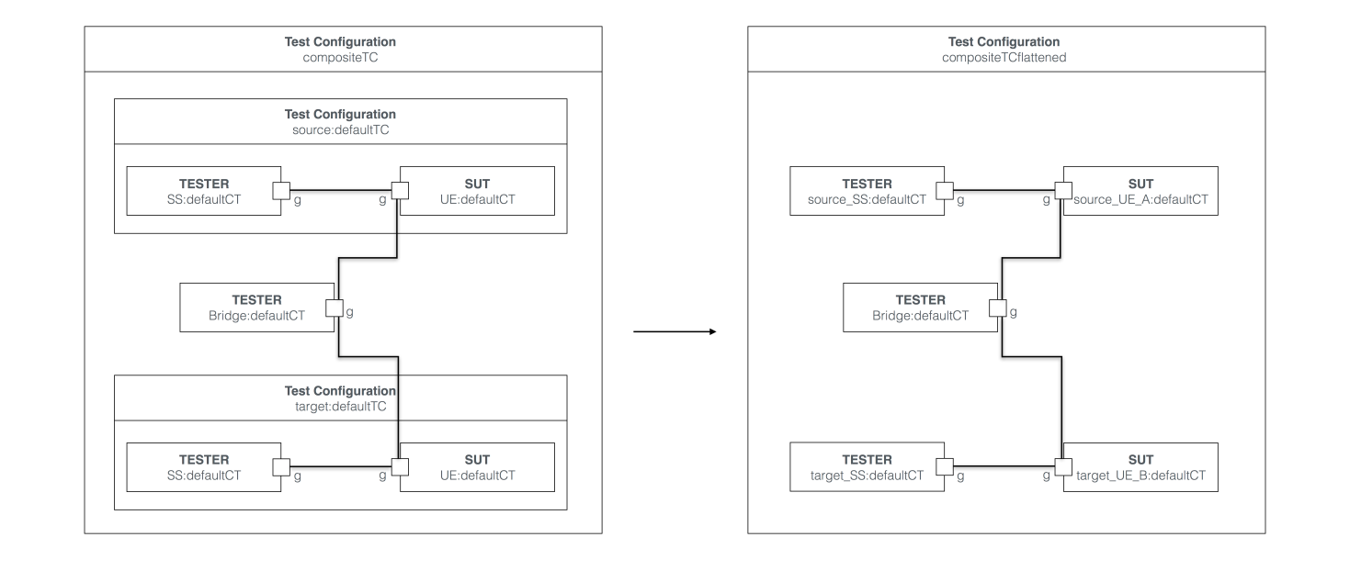
Figure A.1.2: Extended test configuration with test configuration instances and flattening

A.2 Test Configuration Operations
In this example, the extended test configuration 'compositeTC' from Figure A.1.2 is refined further by applying the component hide, component alias and role reassignment operations. The extended test configuration resulting from the application of the test configuration operations is illustrated in FigureA.2.1. The corresponding test configuration after the flattening transformation is illustrated in Figure A.2.2.
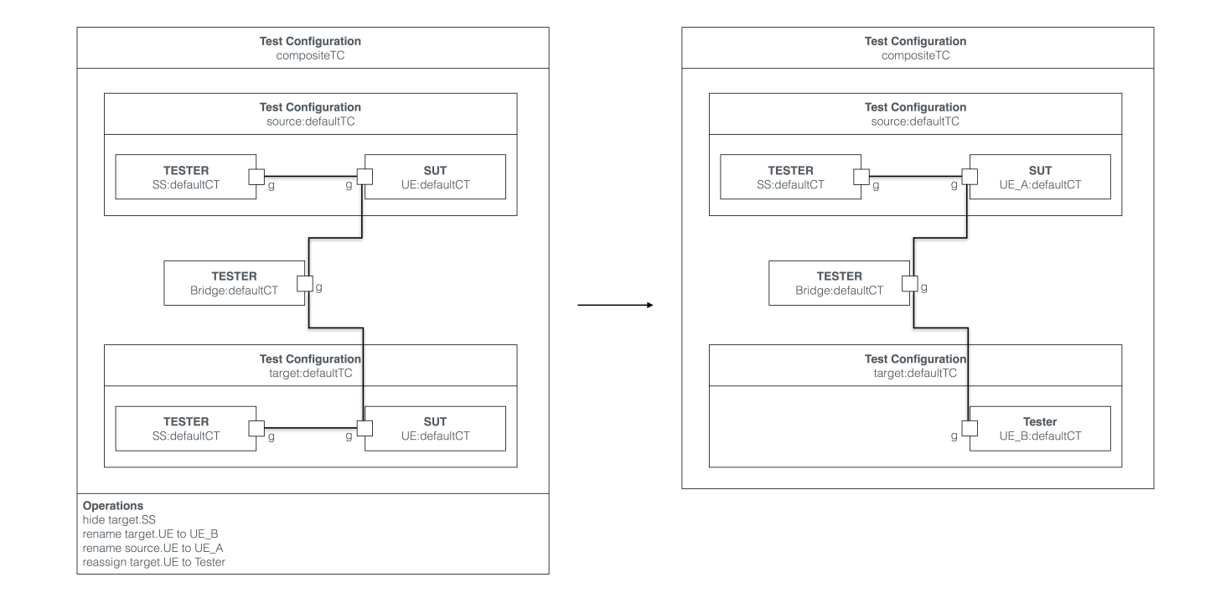
Figure A.2.1: Extended test configuration with operations and resulting test configuration
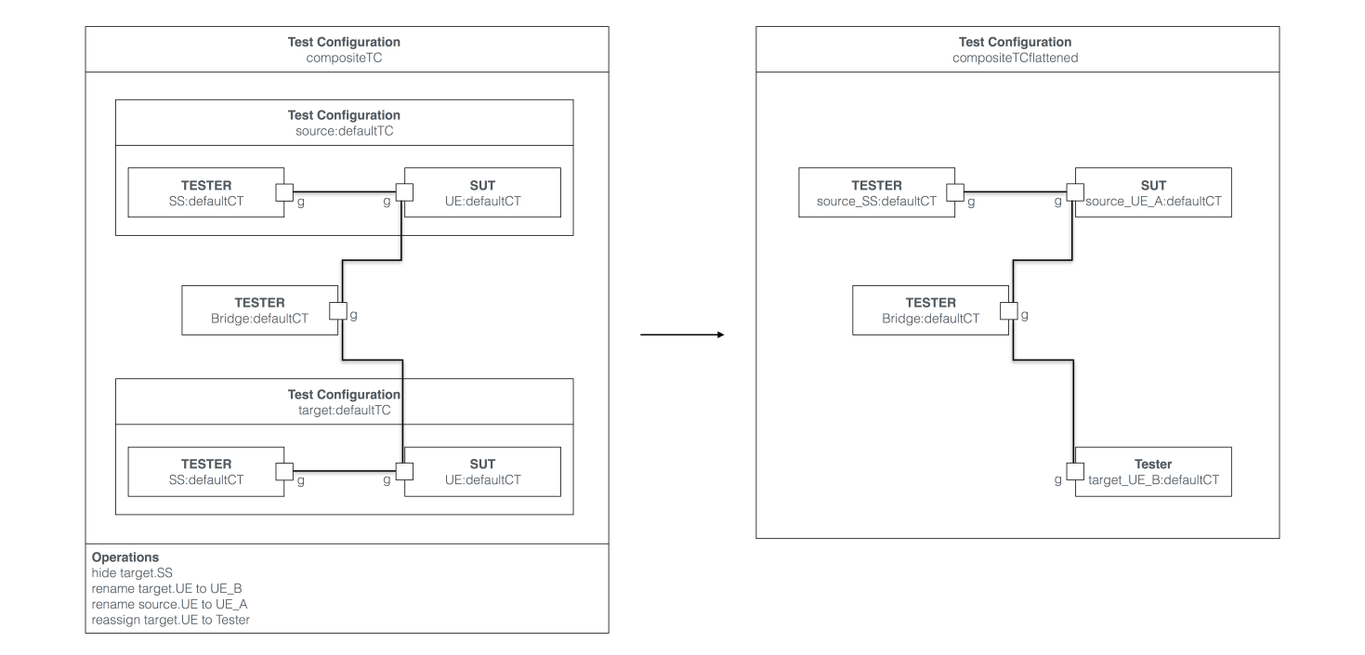
Figure A.2.2: Extended test configuration with operations and resulting flattened test configuration

A.3 Component Merging
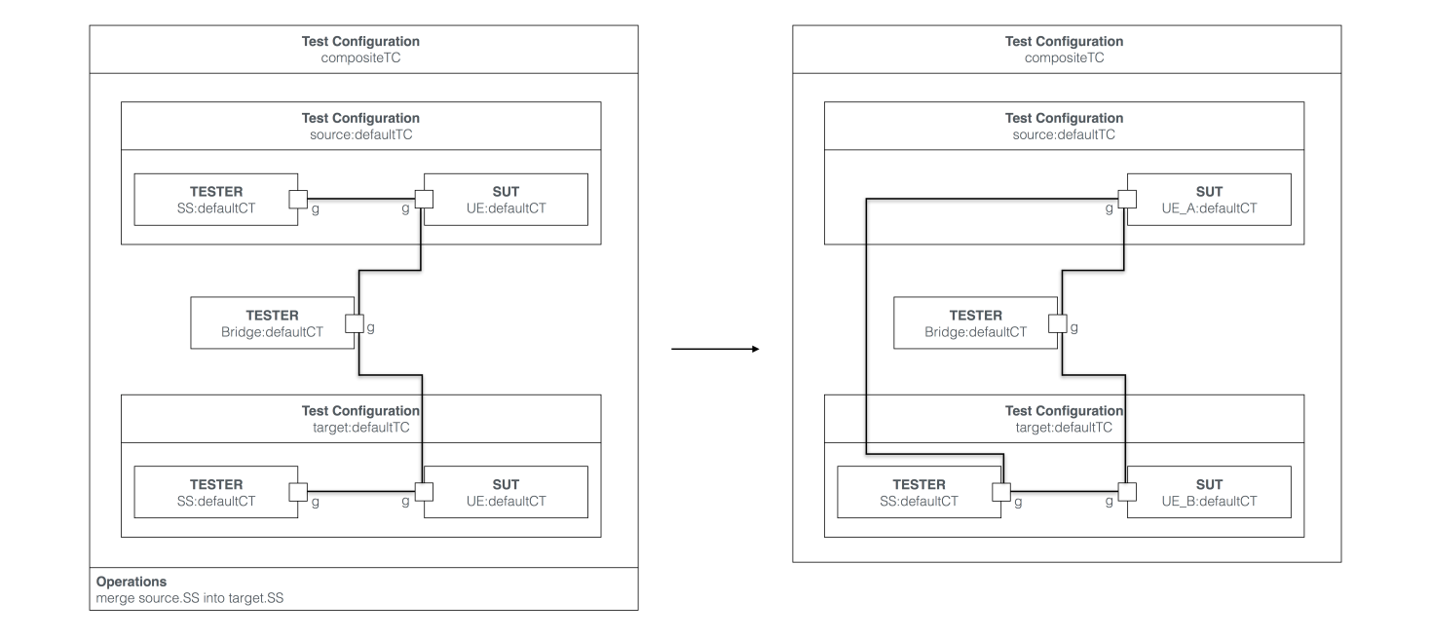
Figure A.3.1: Extended test configuration with merging and resulting test configuration
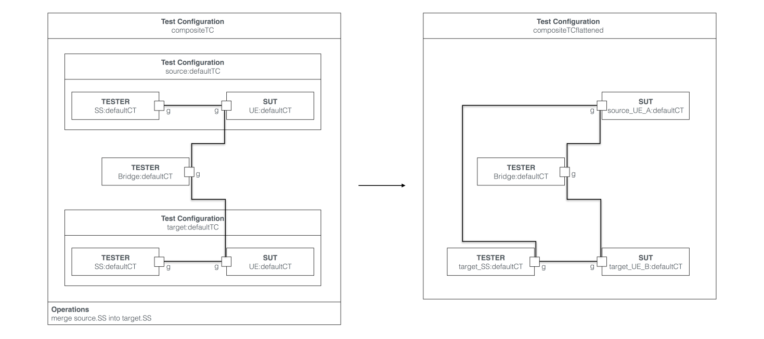
Figure A.3.2: Extended test configuration with merging and resulting flattened test configuration
In this example, the extended test configuration 'compositeTC' from Figure A.1.2 is refined further by applying the component merge operation. The extended test configuration resulting from the application of the test configuration operations is illustrated in FigureA.3.1. The corresponding test configuration after the flattening transformation is illustrated in Figure A.3.2.

History
Document history
1.1.1 | December 14, 2017 | Final draft

