Wednesday 22nd May (09:00-10:00)

Opening

Introduction & welcome, Local arrangements, IPR call [Rennoch]<<<<<

Call for IPRs (clause 4.1 of the ETSI IPR Policy, Annex 6 of the Rules of Procedure):
"The attention of the members of this Technical Body is drawn to the fact that ETSI Members shall use reasonable endeavours to inform ETSI of Essential IPRs in a timely fashion. This covers the obligation to notify its own IPRs but also other companies’ IPRs.
The members take note that they are hereby invited:
-to investigate in their company whether their company does own IPRs which are, or are likely to become essential in respect of the work of the Technical Body,
-to notify to the Chairman or to the ETSI Director-General all potential IPRs that their company may own, by means of
the IPR Information Statement and the Licensing Declaration forms that they can obtain from the secretariat"
Members are encouraged to make general IPR undertakings/declarations that they will make licenses available for all their IPRs under FRAND terms and conditions related to a specific standardization area and then, as soon as feasible, provide (or refine) detailed disclosures.

"The attention of all participants to the meeting was drawn to the fact that ETSI activities are subject to all applicable antitrust and competition laws and that compliance with said laws is therefore required by any participant of the meeting, including the Chairman and Vice-Chairmen."

Approval of agenda, allocation of contributions to Agenda Items

Topics: review agenda content, allocation of contribution to agenda items, agenda items time scheduling.

Contributions: five updated Technical drafts, two presentations from the DIN IoT meeting and OPCF call

Reports from previous MTS Meetings [Rennoch]

Topics: TST#6 minutes review MTSTST(19)006006

Topics: Review of Action list

Action Number | Action | Status
AP(02)03 | Provide latest information on TDL tool support (Michaele) | Ongoing
AP(02)05 | Contact LoRa alliance regarding available tests (Frank/EGM) | Open
AP(05)03 | Forward link to AIOTI landscape document with appearance of MTSTST (Sascha) | Ongoing
AP(06)01 | Contact Abbas and report/confirm the updated schedule (Axel) | Closed
AP(06)02 | Invite/include TDL experts from ETSI/MTS for discussion with OPCF experts (Axel) | Ongoing

Planning/status on TST work items for 2019 [All]

Topics: Status of accepted WIs:
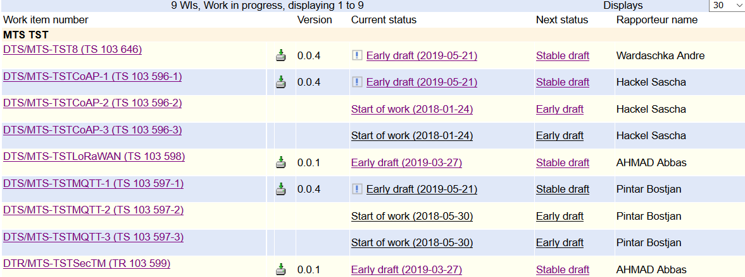

Sascha: CoAP WI has been continued, client tests have been added, but still not in stable draft status.
Time schedule to be updated

Bostjan: MQTT WI similar like in CoAP, 128 TPs (106 server/22 client) Time schedule to be updated

Andre: Sec TPs has been reordered due to update of base standard IEC 62443-4-2, approach has been reviewed by DKE in Germany, under discussion on international level, no modification of the time schedule.

AP (Axel): to contact Abbas regarding the status of the WI draft contributed by EGM

Planning/status on TST liaisons for 2019 [All]

 | Topics: Status of contacts/liaisons:  Meeting/presentation at DIN AA IoT  AP (Axel): upload the slides from the meeting in March -> MTSTST(19)007006  Communication with OPCF compliance group  AP (Axel): upload the slides from the phone call in April -> MTSTST(19)007005  Upcoming meeting with OPCF at 29th May is for promotion of ETSI methods and techniques (TDL and TTCN-3) only and  a good possibility to share promotional material regarding TDL and TTCN-3. | approaches for OPCF

Meeting wrap up

Approvals (review & confirmation) [All]

Topics: recapitulation of current drafts, LS out approved during the meeting, presentation of remaining ones to be approved, announcement expected revisions to be approved by remote consensus after the meeting.
Related Contributions:

LS OUT

New WI

Actions list

Action Number | Action | Status
AP(02)03 | Provide latest information on TDL tool support (Michaele) | Ongoing
AP(02)05 | Contact LoRa alliance regarding available tests (Frank/EGM) | Open
AP(05)03 | Forward link to AIOTI landscape document with appearance of MTSTST (Sascha) | Ongoing
AP(06)02 | Invite/include TDL experts from ETSI/MTS for discussion with OPCF experts (Axel) | Ongoing
AP(07)01 | Contact Abbas and report/confirm the updated schedule (Axel) | Open

Calendar of future meetings & Events

Proposal: September 7th, before the MTS#78 meeting, Munich

Participants List:

Title | Last name | First Name | Organisation
Mrs. | Chaulot-Talmon | Emmanuelle | ETSI
Mr. | Pintar | Bostjan | Sintesio
Mr. | Hackel | Sascha | Fraunhofer FOKUS
Mr. | Wardaschka | André | DEKRA Exam
Mr. | Makedonski | Philip | Uni Göttingen
Dr. | Réthy | György | Ericsson LM
Mr. | Carignani | Michele | ETSI
Mr. | Kristoffersen | Finn | Cinderella ApS
Mr. | Rennoch | Axel | Fraunhofer FOKUS
Mr. | Stomber | Jens | AUDI
Mr. | Jäkel | Frank-Walter | Fraunhofer IPK
Mr. | Wolff | Tobias | Fraunhofer IPK
Dr. | Ulrich | Andreas | Siemens
Mr. | Mulligan | Ultan | ETSI
Mr. | Massoudian | Frank | Huawei Technologies (UK) Co., Ltd.
Dr. | Pershwitz | Edward | Huawei Technologies (UK) Co., Ltd.
Dr. | Hogrefe | Dieter | Uni Göttingen
Mr. | Käärik | Martti | OÜ Elvior
Mr. | Wiles | Anthony | ETSI

