Terms of Reference Template
Testing Task Force (TTF)

INSTRUCTIONS for completing the document:

The template is for TTF use and it consists in four parts:

Part I – TTF technical proposal: Provides the D-G/OCG/Board with the essential elements to mainly understand the rationale and objective

The parts hereinafter are composed of the TTF details that may be updated prior to the final set-up of the project team.

Part II – Details of the TTF Technical Proposal: Organisation of the work and links with other stakeholders.

Part III - Execution of the work: detailed description of the work to be done, deliverables to be produced, tasks structure, milestones estimate of the maximum budget to be allocated. The information provided in this is part must be precise enough to be used to select contractors in the Call for Expertise.

Part IV - Performance Indicators: these must provide the elements for the Reference Body report to the D-G on the performance of the TTF.

PLEASE REMOVE ALL GUIDELINE TEXT IN THE FINAL VERSION OF THE ToRs
(hint: search for style “Guideline” and delete the paragraphs)

For any questions e-mail to CTI Director Ultan.Mulligan@etsi.org

ToR TTF XXX (Ref. Body XXX)
Version: 0.0
Author: Firstname Lastname – Date: 20YY-mm-dd
Last updated by: Firstname Lastname – Date: 20YY-mm-dd
page 1 of 4

Terms of Reference –Testing Task Force Proposal
TTF XXX (Ref. Body XXX)
Subject

Summary information
Approval status | Approved by Ref. Body (doc ref: XXXX) |  | YES/NO
Reference Body | Ref. Body XXX
ETSI Funding | Maximum budget : XXX XXX EUR
Minimum of 4 ETSI Members Support | YES/NO
Time scale | From | 20YY-mm-dd
 | To | 20YY-mm-dd
Work Items | Work Item Working titles only
TTF Roadmap reference

Part I –TTF Technical Proposal

Rationale & Objectives
This section must present in clear and concise terms the business case to support the request for funding.

This section must allow non-experts understand the background and the objective of the TTF, the interest for ETSI Members for the standards to be produced and the reason why an TTF is required to achieve these objectives.

Rationale
The TTCN-3 testing language has intensively been developed by ETSI during the last 15 years and by today it has become a significantly important testing technology in different domains, used by standardization bodies as well as by EU research projects and open source initiatives, and reaching very high deployment at various ETSI member companies.
The language is also endorsed by ITU-T as the Z.16x and Z.17x Recommendation series.
(see more details at http://www.ttcn-3.org/index.php/about/references/applicatio-domains).

In standardization TTCN-3 is an enabler technology for several conformance, end-to-end and interoperability test standards. 3GPP uses it for several UE conformance test suites from Rel. 8 onward, for LTE, VoLTE and lately for NB-IoT. ETSI TBs INT, ERM. In the C-ITS area several TTCN-3 test suites have been developed and they are playing important roles in ITS PlugtestsTM events, with automated C-ITS interoperability testing being in progress. In 2016 oneM2M has started using TTCN-3 for IoT/M2M conformance test development that has been continued in ETSI smartM2M from 2017. Other bodies and alliances using TTCN-3 are TCCA, EUROCONTROL, MOST and AUTOSAR
(see more details at http://www.ttcn-3.org/index.php/about/references).

In research at least the EU projects ARMOUR, PHANTOM, 5GTANGO and SMESEC are using TTCN-3, while in the smart grid area CEAList has developed a model driven testing solution, using TTCN-3 to implement the user domain of the solution. The open source Eclipse project IoT-Testware (https://projects.eclipse.org/projects/technology.iottestware) is using the language to develop conformance and security test suites for IoT protocols with major contribution from Fraunhofer FOKUS and relayr. The Osmocom project is an open source initiative implementing mobile communication standards, including GSM, DECT, TETRA, 3G and others (https://osmocom.org/) and intensively using TTCN-3 for functional and regression testing. TTCN-3 plays an important role in the industry as well. It is used by several ETSI member and non-member companies as an essential test enabler language (e.g. Ericsson, Easy Global Market, Software Radio Systems).

Especially industrial users want low time to market of their new products. For this reason, they have introduced agile ways of working with continuous integration (CI) and continuous delivery (CD) machineries. Agile and CI/CD are heavily relying on automated testing (AT), including TTCN-3 based AT solutions. Resolving new requirements and user requests with short response time is important for user satisfaction and to really keep time-to-market low.

Significant number of TTCN-3 test toolsets are available on the market (at least 7 commercial tools and 2 internal tools of industrial ETSI members) that also indicate the high interest and use of the language. Due to serving several domains and application areas, the TTCN-3 standards which provide the foundation for this testing technology, are quite complex and encompass multiple hundreds of pages. Part 1 of the TTCN-3 series, the TTCN-3 core language, alone is estimated to contain on the order of 5,000 requirements. Over the past 10 years the TTCN-3 community has repeatedly requested by for some kind of assurance that tools conform to TTCN-3 standards. A standardized testing language such as TTCN-3 should lead by example, i.e., tools that check conformance of systems to standards should also be tested for their compliance to standard.
oneM2M conformance test tool based on Titan , driven by KETI and a number of Korean universities

TC MTS is committed to keep the language powerful, still easy-to-use, up-to-date, well maintained and following the changing user needs. The series of TTCN-3 standards consists of 17 ETSI standards, altogether comprising more than 1650 pages (not counting the tool conformance test suite code) today. This requires very high experteese and experts knowing the standards in detail.

TC MTS’s target with this STF request is to re-synchronize the development of the TTCN3 language and its conformance test suite, considering the changes being introduced in v4.10.1 and v4.11.1, and to validate the extensions of the conformance test suite over preliminary implementations in multiple TTCN-3 tools. This way the updated core language standard can be published together with the updated conformance test suite. This would support that TTCN-3 test suites will also in the future compile on multiple TTCN-3 tools, by removing possible misunderstandings and ambiguities when implementing a new language feature in test tools. In addition, this planned STF shall be developing (non-validated) conformance tests for the draft v4.11.1 of the TTCN-3 standard; the availability of such conformance test suite shall aid the work of the TTCN-3 tool implementers for avoiding mistakes or standard-related misunderstandings with the new tool upgrade.

Objectives of the work to be executed
TTCN-3 language evolution STFs in the last years enabled continuous maintenance and extension of the TTCN-3 standards in the ES 201 873 series and the 7 published language extensions for specific use cases and domains. The object-orientation extension to come in mid-2018. This has essentially contributed to the success of TTCN-3.

The volume of the work done and to be maintained are shown on figures 1 and 2.

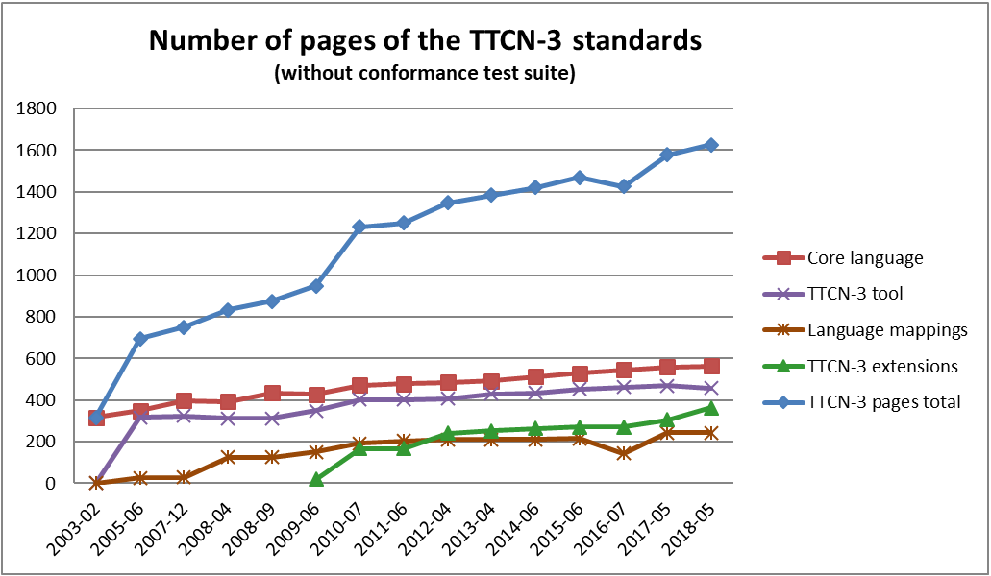
Figure 1: Number of pages of the TTCN-3 standards

Figure 2: Number of TTCN-3 CRs resolved and implemented by previous STFs
Note: In 2017 it was planned to concentrate resources on the new ‘object orientation’ feature.

The TTCN-3 language evolution work in general will comprise the following tasks:
Review and resolve change requests reporting technical defects or requesting clarifications and new language features for all existing TTCN-3 language standards.
Develop proposals for language extensions requested by ETSI TBs, 3GPP, oneM2M, ETSI members and the TTCN-3 community and consent the solution with the contributor(s).
Implement agreed solutions.
Manage the change request (CR) process.
Manage the interim versions of the standard according to 3GPP needs (when requested), and the versions for approval.
Present the TTCN-3 standards’ status and the work of the STF at the conference(s) associated with ETSI TB MTS and at ETSI TC MTS meetings.

While developing the first version of the TTCN-3 extension “Object Oriented features” in 2017 several issues were raised regarding
- guidelines for the use of the Object Oriented (OO) TTCN-3 features in general and in combination with TTCN-3 which do not make use of OO features (e.g., for the further development of legacy test suites),
- the implementation of further OO features (identified after the first user and tool vendor evaluations of the new OO extension package), and
- the need for standard OO-based libraries.

Due to these issues TC MTS has recognized the need for:
- Educational material explaining the effective use of the TTCN-3 OO features.
- Further development of the TTCN-3 extension “Object Oriented features”.
- Start of the development of a standard OO-based library (i.e., based on the collection of similar functionalities implemented by several users).

Previous funded activities in the same domain
Based on the above requests, TC MTS developed a first conformance test suite in STF 409 which lead to the discovery of 19 issues or ambiguities in the TTCN-3 standard version v4.2.1 when covering about 1/3 of the clauses in the main standard with some tests. The test suite was extended, re-based to TTCN-3 v4.9.1 by STF433, STF454, STF470, STF487, STF521, and STF548 and a new coverage analysis approach, reaching 100 % coverage of the core language clauses, and synchronized with the up-to-date revision. TTCN-3 is, however, a living language. A new version is published by ETSI each year; the latest published version is v4.9.1.

Consequences if not agreed
This section must provide factual elements on the consequences if the TTF is not accepted, e.g. whether it would be impossible to do the work or it would only be delayed, which other Standard Organizations may take the lead, how ETSI Members may be damaged by a fragmented market or miss the opportunity to enter a new domain. If possible, identify time to market deadlines.

ETSI Members Support
Provide the list of ETSI Members supporting the request for this TTF (minimum 4), the name of the supporting delegate.

Note: This support is not the same as for the Work Item. ETSI Members listed here are supporting that ETSI invests financial resources for an TTF to produce the Work Item(s).

# | ETSI Member | Supporting delegate
1
2
3
4

Deliverables

Base documents
Document | Title | Status
ETSI XXX XXX-X

New deliverables
Working titles sufficient for part I. Complete with full WI reference when final ToR are submitted
Deliv. | Work Item code  Standard number | Working title | Expected date for publication
D1 | D/XXX-XXXXX-XX  XXX XXX-X | Working title:
D2 | D/XXX-XXXXX-XX  XXX XXX-X | Working title
D3

Maximum budget

Task summary/Manpower Budget

Provide the budget per task that should be allocated for this TTF considering the provision of the expertise for the qualification required

The estimate of the manpower must include the cost for travels which are necessary to attend the working session.

Task short description | Budget (EUR)
TOTAL

Travel budget

Provide an estimate of the maximum budget to reimburse the real cost for travels where Service Provider attendance is requested by ETSI.

Other budget line
Indicate here if the TTF budget requires other cost than manpower and travel.
If not applicable, you can remove this section.

Part II – Details on TTF Technical Proposal

Tasks, Technical Bodies and other stakeholders

Organization of the work

Describe how the work will be organized.

Indicate whether a Steering Group (SG) will be created, its role, the frequency of the meetings, participants to this SG

Identify how the relation with other Reference Bodies and stakeholders will be managed, the interfaces and the critical timing.

Other interested ETSI Technical Bodies
List the other ETSI Reference Bodies that must be involved in this activity.
This is more than a “bullet points” list. For each Reference Body you must identify their role (e.g. consultation, dissemination, joint review/approval of deliverables, etc.). The interactions with these Reference Bodies must be specified in the Work Plan.

Other stakeholders
Provide the same information concerning stakeholder inside and outside ETSI (e.g. other Standard Organizations, governmental institutions, industry partners, research projects, Universities etc.).

Part III: Execution of Work

Work plan, time scale and resources

Task description

This section must provide detailed information on the tasks to be performed by the TTF.

The suggested structure “Objectives/Input/Output/Interactions/Resources” may be consolidated in the table below, if this can provide the equivalent information. However, task descriptions cannot be limited to text such as “producing the stable draft”: these are milestones.

Fill-in as many tables as tasks needed
Task # | Title
Objectives | Indicate here the objective of the task in general terms.
Input | Identify the base documents/information/decisions that are required to perform the task and, if these are not yet available, at which point in time they are needed and who is responsible to provide.
Output | Give a precise description the outcome of the task in qualitative and, if possible, quantitative terms.
Interactions | Identify the interactions with the Reference Body and other stakeholders that are required to complete the task (e.g. guidance, consultation, approval).
Resources required | Identify the type of resources and expertise required.  The estimated effort may be summarized in the task table below.

Milestones
Milestone A – Title
Objectives to be achieved (e.g. maturity and content of the deliverables)
Date at which the documents must be available (e.g. with respect to the Reference Body meeting calendar).
Level of approval required

Reproduce as much milestones as needed
Milestone | Description | Cut-Off Date
A | General Description | 20YY-MM-DD
Reference Body Deliverable | Early/Stable Draft approved by Reference Body
ETSI Deliverable | Progress/Interim/Final Report approved by Reference Body

Examples:
Tasks 1 and 2 completed. Early draft XX/X-XXX available for review. Progress Report approved by Ref. Body#XX (date). Documents must be uploaded on the Ref. Body docbox at least two weeks before the start of the Ref. Body plenary.

Final draft XX/X-XXXX approved by Ref. Body #XX (date) and accepted by the ETSI Secretariat for publication. TTF Final Report approved by Ref. Body.

Task summary
Code | Task / Milestone | Target Date |  | Estimated Cost (EUR)
 |  | From | To
 | Start of work
T1
T2
Milestone A
T3
T4
Milestone  Z | Deliverables published, TTF closed
 |  |  |  | 0

Task/ Mil. | J | F | M | A | M | J | J | A | S | O | N | D |  | J | F | M | A | M | J | J | A | S | O | N | D
T1
T2
MA
T3
T4
MB

Expertise required

Team structure
Define precisely the type of competence required. These items will be used in the Call for Expertise to assess whether the applicants are qualified to be short-listed for the final selection.

(Up to) X participants to ensure the following mix of competences:
Priority | Qualifications and competences
High/Low
High/Low
High/Low
High/Low
High/Low

Part IV: TTF performance evaluation criteria

Performance Indicators
In this section you must identify indicators to assess the quality of the result and the interest of ETSI Members and other stakeholders.

In the course of the activity, the TTF Leader will collect the relevant information, as necessary to measure the performance indicators. The result must be presented in the Final Report.

After the conclusion of the TTF, the Reference Body Chairman will report to the D-G on the actual achievement of the performance indicators set in these ToRs. This information will be used to assess further requests from the Reference Body.

The performance indicators must include qualitative and quantitative assessment of the following elements, as applicable:

Select relevant Performance indicators applicable for these ToR (X)
Contribution from ETSI Members to TTF work
Direct financial contribution (co-funding)
Support to the TTF work (e.g., provision of test–beds, organization of workshops, events)
Steering Group meetings (number of meetings / participants / duration)
Number of delegates directly involved in the review of the deliverables
Contributions/comments received from the Reference Bodies
Contributions/comments received from other Reference Bodies
Contribution from the TTF to ETSI work
Contributions to Reference Body meetings (number of documents / meetings / participants)
Contributions to other Reference Bodies
Presentations in workshops, conferences, stakeholder meetings
Liaison with other stakeholders
Stakeholder participation in the project (category, business area)
Cooperation with other standardization bodies
Potential interest of new members to join ETSI
Liaison to identify requirements and raise awareness on ETSI deliverables
Comments received on drafts (e.g. on WEB site, mailing lists, etc.)
Quality of deliverables
Approval of deliverables according to schedule
Respect of time scale, with reference to start/end dates in the approved ToR
Comments from Quality review by Reference Body
Comments from Quality review by ETSI Secretariat

Document history
 | Date | Author | Status | Comments
0.0 | 20YY-mm-dd

