Tuesday, 10th September (09:00-10:15)

Opening

Introduction & welcome, Local arrangements, IPR call [Rennoch]

Call for IPRs (clause 4.1 of the ETSI IPR Policy, Annex 6 of the Rules of Procedure):
"The attention of the members of this Technical Body is drawn to the fact that ETSI Members shall use reasonable endeavours to inform ETSI of Essential IPRs in a timely fashion. This covers the obligation to notify its own IPRs but also other companies’ IPRs.
The members take note that they are hereby invited:
-to investigate in their company whether their company does own IPRs which are, or are likely to become essential in respect of the work of the Technical Body,
-to notify to the Chairman or to the ETSI Director-General all potential IPRs that their company may own, by means of
the IPR Information Statement and the Licensing Declaration forms that they can obtain from the secretariat"
Members are encouraged to make general IPR undertakings/declarations that they will make licenses available for all their IPRs under FRAND terms and conditions related to a specific standardization area and then, as soon as feasible, provide (or refine) detailed disclosures.

"The attention of all participants to the meeting was drawn to the fact that ETSI activities are subject to all applicable antitrust and competition laws and that compliance with said laws is therefore required by any participant of the meeting, including the Chairman and Vice-Chairmen."

Approval of agenda, allocation of contributions to Agenda Items

Topics: review agenda content, allocation of contribution to agenda items, agenda items time scheduling.

Contributions: seven updated Technical drafts, slides for OPCF meeting in Berlin (31st May 2019)

Reports from previous MTS Meetings [Rennoch]

Topics: TST#7 minutes review MTSTST(19)007007

Topics: Review of Action list

Action Number | Action | Status
AP(02)03 | Provide latest information on TDL tool support (Michaele) | Ongoing
AP(02)05 | Contact LoRa alliance regarding available tests (Frank/EGM) | Open
AP(05)03 | Forward link to AIOTI landscape document with appearance of MTSTST (Sascha) | Ongoing
AP(06)02 | Invite/include TDL experts from ETSI/MTS for discussion with OPCF experts (Axel) | Closed
AP(07)01 | Contact Abbas and report/confirm the updated schedule (Axel) | Closed

Philip: TDL STF will start soon, any requests should be reported to the new STF.
Em/Axel: Contact Frank le Gal for rapporteur of two WIs, AP (Axel): inform Em about the communication with EGM.

Planning/status on TST work items for 2019/2020 [All]

Topics: Status of accepted WIs:

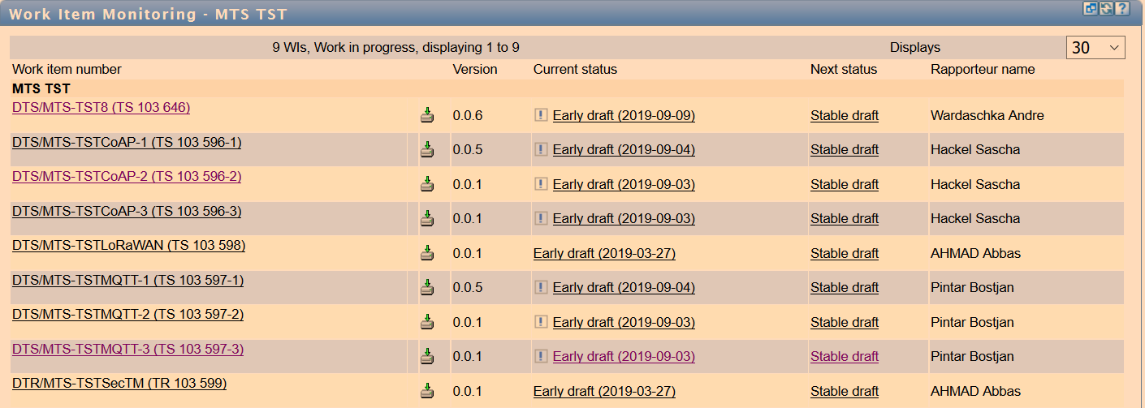

Andre: Security TP for IEC 62443 profile: almost finished, next step is to clean up and to start internal review, should be finished during next month

Liaison request to TC CYBER, with a link to the new draft (request for comments)
Liaison to JTC1 SC41 (to be checked), no meeting required, but exchange of documents (comments)

Axel: MQTT/CoAP conformance testing work improved, final reviews will happen soon

Daniel: new early draft on performance testing (MQTT/CoAP), presentation from the meeting MTSTST(19)008011

György: may provide comments/feedback on MQTT-3 performance testing

Axel: MQTT/CoAP security testing (MQTT/CoAP) early drafts are on the portal

EGM: status and contacts need to be confirmed (AP for EM/Axel)

Planning/status on TST liaisons for 2019/2020 [All]

 | Topics: Status of contacts/liaisons:  Communication with OPCF compliance group  Axel: upload the slides from the meeting in Berlin -> MTSTST(19)008012, still waiting for a response  Discuss possibilities for liaison with ISO JTC1 SC41 (IoT) to receive feedback on current draft and  to promote the TST work | approaches for OPCF

Meeting wrap up

Approvals (review & confirmation) [All]

Topics: recapitulation of current drafts, LS out approved during the meeting, presentation of remaining ones to be approved, announcement expected revisions to be approved by remote consensus after the meeting.
Related Contributions:

LS OUT

New WI

Actions list

Action Number | Action | Status
AP(02)03 | Provide latest information on TDL tool support (Michaele) | Ongoing
AP(02)05 | Contact LoRa alliance regarding available tests (Frank/EGM) | Open
AP(05)03 | Forward link to AIOTI landscape document with appearance of MTSTST (Sascha) | Ongoing
AP(08)01 | Contact EGM/Frank le Gal to confirm the WI rapporteur (Em/Axel) | Open

Calendar of future meetings & Events

Proposal: January 22nd, before the MTS#79 meeting, ETSI (tbc)

Participants List:

Title | Last name | First Name | Organisation
Mrs. | Chaulot-Talmon | Emmanuelle | ETSI
Mr. | Gheorghe-Pop | Ilie-Daniel | Fraunhofer FOKUS
Mr. | Wardaschka | André | DEKRA Exam
Mr. | Makedonski | Philip | Uni Göttingen
Dr. | Réthy | György | Ericsson LM
Mr. | Kristoffersen | Finn | Cinderella ApS
Mr. | Rennoch | Axel | Fraunhofer FOKUS
Dr. | Ulrich | Andreas | Siemens

