- A General Guide on the Benefits of Artificial Intelligence (AI) in Test Systems, with illustrations of Artificial Intelligence (AI) in Test Systems and the Benefits
- AI in Performance Test Systems
- AI in Functional Test Systems
- AI in Online Test Systems
- Stakeholders that should consider the Benefits in their Business Models: Test Solution Vendors; Testers, xxxxxxx

- A General Guide for Testing AI Models in General, and the Definitions of Standardized Metrics for Measurements and Assessments in Testing and Certification of AI Models, including Certification of AI Models of Autonomic Components/Systems
- A General Methodology for Testing AI Models
- Standardization of Metrics of specific classes of AI Models so as to enable Test Systems and Certification communities to test the AI Models and to provide certification services
- Stakeholders that should make use of the Guide
- Generic Test Framework for Testing AI Models / Systems during their lifecycles
1. Testing and Validation: of an AI Model (or a collective bundle of interworking AI Models) based on well-defined criteria for verdict
passing
2. Conformance Testing (against a well-defined specification of behavioural and structural features expected of the AI Model)
3. Interoperability Testing (based on what is expected to be communicated at Reference Points involving the AI Model (as a Component/ System) and other entities required to interact with it); and against what is expected of the AI model behaviour by the target integration and deployment environment
4. Integration and User Acceptance Testing of the AI Model that has been integrated to interwork with other AI Models in the network that is also being tested as a whole
5. Self-Testing Capability of a AI Model as a Component or System
6. Validation phase of an AI Model (or collective bundle of interworking AI Models)
7. Trustworthiness building phase of an AI Model (or collective bundle of interworking AI Models)
8. Certification Phase for the AI Model (or collective bundle of interworking AI Models)
9. Test Network Deployment Phase (pertaining to a Test Network in which the AI Model(s) is being deployed)
10 AI Model Deployment and Activation Phase
11. Test Network Operation phase (pertaining to a Test Network in which the AI Model(s) has been deployed)
12. Test Network Optimization Phase (pertaining to a Test Network in which the AI Model(s) has been deployed)
- Testing Offline AI Models which need a programmable configurable (re)-Training process in the CSPs’ Training environment before being exposed to new data (real data) in the Production environment
- Testing Online AI Models that are directly deployed in the CSP’s Production environment, and are continuously exposed to real and new data and they have the ability to learn and modify their behavior continuously. They require a continuous testing, with faster response time.

- Testing ETSI GANA Model's Cognitive Decision Elements (DEs) as AI Models for Autonomic (Closed-Loop) Network Automation in the space of Autonomic Management & Control (AMC) of Networks and Services, with illustrations of AI Models for Autonomic Management & Control of 5G Network Slices

- Generic Test Framework for Testing ETSI GANA Multi-Layer Autonomics & their AI Algorithms for Closed-Loop Network Automation. An ETSI Technical Report (TR) will be produced in 2020/2021 to extend the early Draft Generic Test Framework in ETSI EG 203 341 V1.1.1

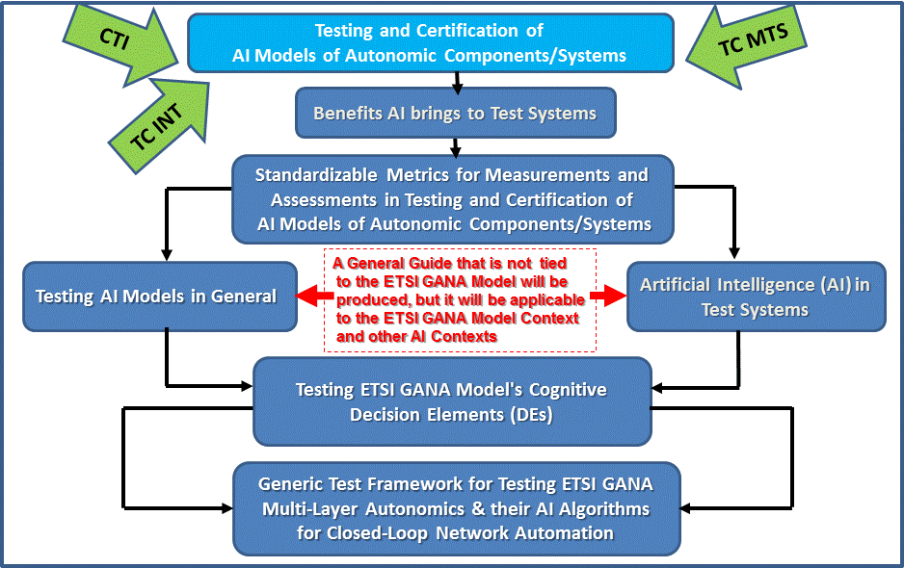
Figure 1: Topics and Deliverables to be produced by
the Newly Launched Work Item (AI in Test Systems, and Testing AI Models)

How to mechanize and operationalize the mentioned Testing concepts of AI systems
The following means and tools are considered and described in ETSI TC INT PoC Whitepaper#5 on “AI in Test Systems, Testing AI Models”: https://intwiki.etsi.org/index.php?title=Accepted_PoC_proposals:
- A Methodology for Testing AI Models
- The Metrics on what AI brings to Performance Test Systems, and Products that can be used by Testers to achieve such Objectives
- Standardization of Metrics of specific classes of AI Models so as to enable Test Systems and Certification communities to test the AI Models and to provide certification services
- Testers for Performance Testing of Complex Systems can leverage the understanding of Metrics that AI brings to Performance Test Systems to partner with Organizations that have Products/Solutions in this space in order to benefit from such solutions/products and the overall benefits of AI in Test Systems
- Test Solution Vendors shall benefit from both a Methodology for Testing AI Models and the Generic Test Framework for Testing Multi-Layer Autonomics & AI Algorithms for Closed-Loop Network Automation in developing Test Solutions for emerging and future networks such as 5G embedding AI and Autonomic Management and Control capabilities

