Title*: | Call for Candidates for MTS Chair and Vice Chairs position
from Source*: | ETSI Secretariat
Contact: | Emmanuelle Chaulot-Talmon
input for Committee*: | MTS
Contribution For*: | Decision
 | Discussion
 | Information | X
Submission date*: | 2019-08-20
Meeting & Allocation: | MTS#79
Relevant WI(s), or deliverable(s):

The mandate period of Dirk Tepelmann as TC MTS chairman will come to an end in January 2020.

The mandate period of Dieter Hogrefe and Gyorgy Réthy as TC MTS Vice chairmen will come to an end in January 2020.

According to the ETSI Directives/Technical Working (TWP) procedures, Clause 1.3.1 "A TB Chairman shall be appointed by the TB for a period of two (2) years. The appointment shall be confirmed by the Board.”
The Chairman’s duties are described in Clause 1.3.3 of ETSI Directives/TWP “Responsibilities of Chairmen”.

Interested representatives of ETSI Members are invited to present their candidatures for this position.

Please announce your candidature by email to Emmanuelle.chaulot-talmon@etsi.org filling in the corresponding form (see Annex A) by 13th January 2020 at the latest. The information provided in this form will be needed for the ETSI Board.

If more than one candidature is received, a vote will be held at our next MTS meeting, i.e. MTS#79 that will be held on 28-29 January 2020 in ETSI.
Candidates are requested to physically attend this meeting.

Please note that candidatures will be made available to the MTS Members and uploaded as a meeting document to MTS#79.

Annex A : Chairman Application Form
Candidature for the Chairmanship and Vice Chairmanship of ETSI MTS

To submit your candidature, please fill in the form below 13th January 2020 and send it to emmanuelle.chaulot-talmon@etsi.org
Family Name: Makedonski | 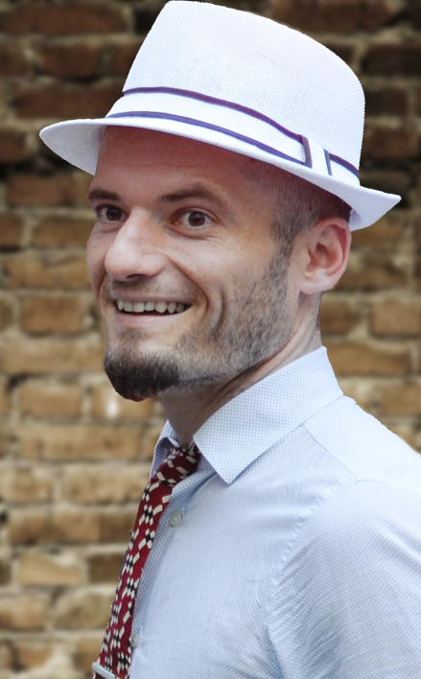
First Name: Philip

Company: Institut für Informatik, Universität Göttingen

Address: Goldschmidtstr. 7, 37077 Göttingen, Germany

E-mail address: makedonski@cs.uni-goettingen.de

Tel: +49 551 39172035

ETSI member organization: Institut für Informatik, Universität Göttingen

MOTIVATION of your application:

Dr. Makedonski has been actively involved in ETSI MTS activities for more than 10 years. During that period, he has been interacting and cooperating with various other stakeholders to support and communicate the activities of ETSI MTS, both within and outside of ETSI. Dr. Makedonski currently serves as a vice-chairman for the MTS-TDL working group and is looking forward to the opportunity to officially represent ETSI MTS as a whole as acting vice-chairman.

PROFESSIONAL EXPERIENCE:

Dr. Philip Makedonski has been working as a researcher at the Institute of Computer Science, University of Göttingen, Germany since 2009. His work within the Software Engineering for Distributed Systems group has covered a broad spectrum of topics, including:
- Researching software evolution and developer-centric software assessment
- Researching health-related information dissemination in online social networks
- Researching model-based domain-specific languages
- Researching model-based software mining infrastructures
- Researching quality assurance of test specifications using TTCN-3
- Maintaining and evolving the NFV information model (ETSI STF 570)
- Collaboration on the development of the Test Description Language (ETSI STF 454, 476, 492, 522, 577)
- Developing and collaborating on prototypical implementations of the Test Description Language within the TDL open-source project
- Survey and Methodology for the Specification and Testing of RESTful APIs (ETSI STF 576)
- Developing and maintaining tools to aid the quality assurance and documentation of TTCN-3 test specifications for ETSI in close collaboration with STF 160
- Extending and adapting existing TTCN-3 tools to accommodate project specific needs and evolving standards
- Collaboration within the TEMEA project towards the quality assurance of TTCN-3 test specifications for embedded and realtime systems

Beyond that, Dr. Makedonski has been actively involved in ETSI MTS activities over the past 10+ years, including interacting and cooperating with various other stakeholders to support and communicate the activities of ETSI MTS, both within ETSI and beyond. He currently serves as a vice-chairman for the MTS-TDL working group.

OTHER INFORMATION:

None.

