Tuesday, 28th January (09:00-10:00)

Opening

Introduction & welcome, Local arrangements, IPR call [Rennoch]

Call for IPRs (clause 4.1 of the ETSI IPR Policy, Annex 6 of the Rules of Procedure):
"The attention of the members of this Technical Body is drawn to the fact that ETSI Members shall use reasonable endeavours to inform ETSI of Essential IPRs in a timely fashion. This covers the obligation to notify its own IPRs but also other companies’ IPRs.
The members take note that they are hereby invited:
-to investigate in their company whether their company does own IPRs which are, or are likely to become essential in respect of the work of the Technical Body,
-to notify to the Chairman or to the ETSI Director-General all potential IPRs that their company may own, by means of
the IPR Information Statement and the Licensing Declaration forms that they can obtain from the secretariat"
Members are encouraged to make general IPR undertakings/declarations that they will make licenses available for all their IPRs under FRAND terms and conditions related to a specific standardization area and then, as soon as feasible, provide (or refine) detailed disclosures.

"The attention of all participants to the meeting was drawn to the fact that ETSI activities are subject to all applicable antitrust and competition laws and that compliance with said laws is therefore required by any participant of the meeting, including the Chairman and Vice-Chairmen."

Approval of agenda, allocation of contributions to Agenda Items

Topics: review agenda content, allocation of contribution to agenda items, agenda items time scheduling.

Contributions: six updated Technical drafts, slides from DIN meeting in Frankfurt (25th October 2019)

Reports from previous MTS Meetings [Rennoch]

Topics: TST#8 minutes review MTS(19)078004

Topics: Review of Action list

Action Number | Action | Status
AP(02)03 | Provide latest information on TDL tool support (Michaele/Philip) | Ongoing
AP(02)05 | Contact LoRa alliance regarding available tests (Frank/EGM) | Stopped
AP(05)03 | Forward link to AIOTI landscape document with appearance of MTSTST (Sascha) | Closed
AP(08)01 | Contact EGM/Frank le Gal to confirm the WI rapporteur (Em/Axel) | Stopped

Philip: TDL STF started, any requests should be reported to the new STF. Work will close in May 2020.
Em/Axel: Contact to EGM / Frank le Gal for rapporteur of two WIs, no response

AIOTI link Download IoT LSP standard framework concepts Release 2.9 October 2019 (pages 59-62)

Planning/status on TST work items for 2020 [All]

Topics: Status of accepted WIs:

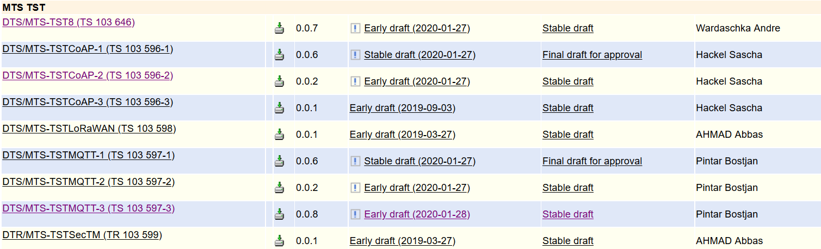

Sascha: CoAP Conformance reached stable draft status, some formal introduction and editorial part to be finished, final draft in May, CoAP Security well progressed: updated ToC, content will not cover 100 % security tests, but give help to perform security tests for developers/users. Same progress for the MQTT Security document, e.g. testing of vulnerabilities (based on CVEs), available in TDL-TO

Time schedule for COAP conformance update in 2-3 weeks, review in 2 month, review by others groups should follow

Bostjan MQTT Conformance changes, good progress for client and server side; final draft in a few month, update of the schedule to be done, final draft in May

Daniel: proposed to become the rapporteur of the MQTT/CoAP performance documents, ETSi TR 101577 is base document, MQTT stable draft in March, CoAP in May, so far TDL-TO appears to be complete to describe performance TPs

Philip: On the TDL website CR on TDL could be issued, STF session soon will be soon

Andre: updated document available, question on status “stable”: end of February the stable draft

EGM working drafts need new rapporteurs, people interested in LoRaWan can have a look to the early draft and take over the rapporteurship to finish work by end of 2020

Proposed updated time schedules:
- Conformance DTS/MTS-TSTCoAP-1 (TS 103 596-1), DTS/MTS-TSTMQTT-1 (TS 103 597-1)
  - Final Draft 29th May 2020
- Security DTS/MTS-TSTCoAP-2 (TS 103 596-2), DTS/MTS-TSTMQTT-2 (TS 103 597-2)
  - Stable draft 29th May 2020
  - Final Draft 30th September 2020
- Performance DTS/MTS-TSTCoAP-3 (TS 103 596-3), DTS/MTS-TSTMQTT-3 (TS 103 597-3)
  - Stable draft 31st March 2020
  - Final Draft 30th June 2020
- IoT-Profil DTS/MTS-TST8 (TS 103 646)
  - Stable draft 31st March 2020
  - Final Draft 30th June 2020

Proposed update of rapporteurship:
Gheorghe-Pop Ilie-Daniel is proposed to become rapporteur for
- DTS/MTS-TSTCoAP-3 (TS 103 596-3),
- DTS/MTS-TSTMQTT-3 (TS 103 597-3)

Planning/status on TST liaisons for 2020 [All]

 | Topics: Status of contacts/liaisons:  Discuss possibilities for liaison with ISO JTC1 SC41 (IoT) to receive feedback on current draft and  to promote the TST work  AP (Axel): provide exact name of the committee to Em | approaches for OPCF

Meeting wrap up

Approvals (review & confirmation) [All]

Topics: recapitulation of current drafts, LS out approved during the meeting, presentation of remaining ones to be approved, announcement expected revisions to be approved by remote consensus after the meeting.
Related Contributions:

LS OUT

New WI

Actions list

Action Number | Action | Status
AP(02)03 | Provide latest information on TDL tool support (Michaele/Philip) | Ongoing
AP(09)01 | Provide contact and find liaison status with ISO JTC1 SC41 “IoT” (Axel/Em) | Open

Calendar of future meetings & Events

Proposal: May 12th, before the MTS#80 meeting, Budapest (tbc)

Participants List:

Title | Last name | First Name | Organisation
Mrs. | Chaulot-Talmon | Emmanuelle | ETSI
Mr. | Gheorghe-Pop | Ilie-Daniel | Fraunhofer FOKUS
Mr. | Hackel | Sascha | Fraunhofer FOKUS
Mr. | Wardaschka | André | DEKRA Testing and Certification GmbH
Mr. | Makedonski | Philip | Uni Göttingen
Mr. | Kristoffersen | Finn | Cinderella ApS
Mr. | Rennoch | Axel | Fraunhofer FOKUS
Mr. | Käärik | Martti | OU Elvior
Mr. | Tepelmann | Dirk | Spirent

