Tuesday 28th January (10:00-13:00)

Opening

Introduction & welcome, Local arrangements, IPR call [Makedonski]

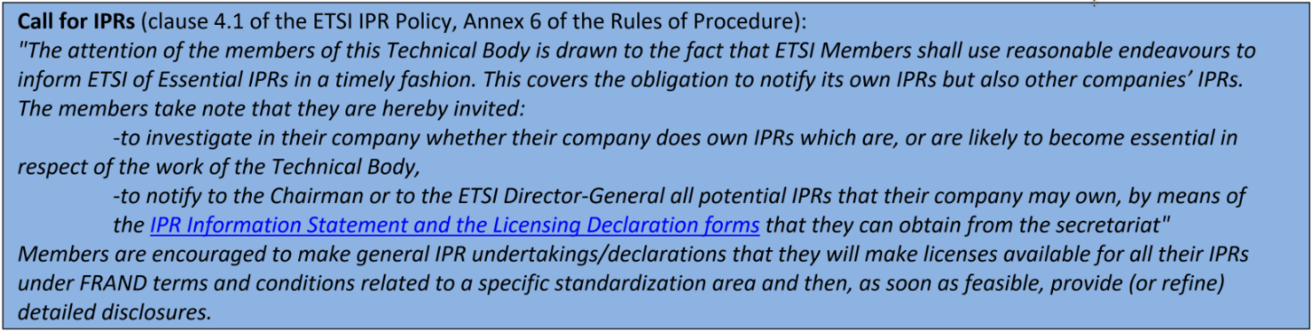

Approval of agenda, allocation of contributions to Agenda Items

Topics: review agenda content, allocation of contribution to agenda items, agenda items time scheduling.

Review of Action List

Action Number | Action | Status
AP(02)01 | Andreas: Monitor state of the TDL/TOP website. | Pending
AP(02)02 | Michele: Approach NFV TST to discuss the situation caused with the loss of work by Futurewei, in particular JADL. | Ongoing
AP(02)03 | Philip, Andreas: Prepare slides on TDL/TOP to be shown at UCAAT. | Done

Status and Planning of Work at MTS TDL

Review of WI Status

MTS TDL
RTR/MTS-TDL103119v121 (TR 103 119) |  |  |  | Start of work (2019-07-01) | Early draft | Makedonski Philip
RES/MTS-TDL1191v151 (ES 203 119-1)  TDL Meta-Model |  |  |  | Start of work (2019-07-01) | Early draft | Käärik Martti
RES/MTS-TDL1192v141 (ES 203 119-2) |  |  |  | Start of work (2019-07-01) | Early draft | Kristoffersen Finn
RES/MTS-TDL1193v141 (ES 203 119-3) |  |  |  | Start of work (2019-07-01) | Early draft | Makedonski Philip
RES/MTS-TDL1197v121 (ES 203 119-7) |  |  |  | Start of work (2019-07-01) | Early draft | Makedonski Philip
DTR/MTS-TDL1 (TR ) |  |  |  | TB adoption of WI (2019-07-11) | Start of work | Massoudian Frank
RES/MTS-TDL1-6v121 (ES 203 119-6)  Mapping to TTCN-3 |  |  |  | Start of work (2019-07-01) | Early draft | Käärik Martti
RES/MTS-TDL4v141 (ES 203 119-4) |  |  |  | Start of work (2019-07-01) | Early draft | Kristoffersen Finn

Status of TDL/JADL Joint Work [Ulrich]
- Andreas to reach out to Futurewei to check if there is any perspective on further work until MTS#80 otherwise we need to decide how to proceed with the WI in May.
- Target dates to be updated once we have feedback from Frank and Edward.

Status of TDL STF [Makedonski]
- Start of work delayed due to the usual administrative hiccups.
- Additional delays due to availability constraints, UCAAT, holidays, other issues.
- Progress on key topics during remote work and bi-weekly conference calls.
- Face-to-face working session co-located with MTS#79.
- Drafts expected on Jan 31st.

Review of TDL 2020+ Roadmap [Makedonski]
- No updates since last meeting. Potential for cooperation with NWM group, further details to be clarified after NWM presentation at MTS#79.
- General methodology and tool support for integration with repositories and cross references of machine readable assets.
- Ownership and responsibilities need to be clear. Existing procedural frameworks (IPR, etc.) need to be supported.
- Procedures need to be unified and aligned between groups.
- Initially a guideline can be helpful. Standardised approach may follow.
- Important to keep track of TTF deadlines so that MTS can participate in the calls for applications. We can target Autumn 2020 / Beginning of 2021. Tentative deadline in June, communicate intent with tasks and resources by then. Draft proposal for approval in May during MTS#80 / MTS-TDL#4.
- TC INT cooperation on AI-related work item and white paper (further discussion during MTS#79).
- Share roadmap on website, TDL presentations. Shall be phrased carefully to not set expectations but rather indicate a perspective for future development soliciting contributions and informing potential users and other stakeholders.

UCAAT 2019 Recap [Makedonski]
- Slideshow was running at MTS booth, invited plenty of interesting discussions.
- Need to reach more stakeholders within ETSI. New TTFs? SCP testing? CIM? INT? ITS (TDL TO)?
- If UCAAT is not taking place in autumn 2020, we can consider scheduling an ETSI MTS / TDL session / open meeting in that time period (only if UCAAT 2020 does not take place). Approach new topics (REST, AI, others). Expand awareness of TDL within ETSI and beyond. Further discussion after UCAAT update during MTS#79 and during the week after. Dedicated MTS workshop may be scheduled immediately before UCAAT.
- Target other events? Reaching out beyond ETSI events. Suggestions need to be collected by mid February in order to provide enough time to arrange participation (submission, logistics, etc.)

Status of TOP [Makedonski]
- The work on TOP projects is ongoing within the new STF 577 according to its ToR. Migration towards GitLab and eventually ETSI labs is being discussed. Current contributions under STF GitLab space.
- ETSI labs is expected in Q1 / March 2020.
- Continue development within STF GitLab space.
- Need to evaluate which services are at tdl.etsi.org and which ones are moved to GitLab / ETSI labs.
- Loss of top.etsi.org -> move to e.g. labs.etsi.org/top (not a concern, it was always just a redirection URL).
- STF 577 to propose desired URLs and other details, as well as remaining items (Issues, Wiki, etc.) that need to be moved. tdl.etsi.org to remain as landing page for high-level overview. All content related to TOP to be moved to ETSI labs.

Meeting Wrap-Up

Approvals (Review & Confirmation) [All]

Topics: recapitulation of current drafts, LS out approved during the meeting, presentation of remaining ones to be approved, announcement expected revisions to be approved by remote consensus after the meeting.

LS Out

New WI

Action List

Action Number | Action | Status
AP(03)01 | Andreas: Reach out to NFV TST and other stakeholders to check if there are news regarding the status of the Work Item on joint TDL/JADL methodology
AP(03)02 | Philip, Andreas: Draft initial proposal for follow-up TTF activity for MTS#80
AP(03)03 | Philip: Draft a page for the roadmap to be published on the TDL website
AP(03)04 | Andreas, Philip: Gather list of other events to target, share on mailing list by mid February
AP(03)05 | Michele: Prepare a list of new TTFs that can be candidates for adopting TDL
AP(03)06 | STF 577: Provide details for migration (URLs, content, etc.)

Calendar of Future Meetings and Events
12 May 2020: TDL#4 (co-located with MTS#80)

