Monday, 11th May (15:00-16:00)

Opening

Introduction & welcome, Local arrangements, IPR call [Rennoch]

Call for IPRs (clause 4.1 of the ETSI IPR Policy, Annex 6 of the Rules of Procedure):
"The attention of the members of this Technical Body is drawn to the fact that ETSI Members shall use reasonable endeavours to inform ETSI of Essential IPRs in a timely fashion. This covers the obligation to notify its own IPRs but also other companies’ IPRs.
The members take note that they are hereby invited:
-to investigate in their company whether their company does own IPRs which are, or are likely to become essential in respect of the work of the Technical Body,
-to notify to the Chairman or to the ETSI Director-General all potential IPRs that their company may own, by means of
the IPR Information Statement and the Licensing Declaration forms that they can obtain from the secretariat"
Members are encouraged to make general IPR undertakings/declarations that they will make licenses available for all their IPRs under FRAND terms and conditions related to a specific standardization area and then, as soon as feasible, provide (or refine) detailed disclosures.

"The attention of all participants to the meeting was drawn to the fact that ETSI activities are subject to all applicable antitrust and competition laws and that compliance with said laws is therefore required by any participant of the meeting, including the Chairman and Vice-Chairmen."

NOTED

Approval of agenda, allocation of contributions to Agenda Items

Topics: review agenda content, allocation of contribution to agenda items, agenda items time scheduling.

Contributions: five updated Technical drafts

Reports from previous MTS Meetings [Rennoch]

Topics: TST#9 minutes review MTS(20)079034r1

Topics: Review of Action list

Action Number | Action | Status
AP(02)03 | Provide latest information on TDL tool support (Michaele/Philip) | Ongoing
AP(09)01 | Provide contact and find liaison status with ISO JTC1 SC41 “IoT” (Axel/Em) | Closed

Andreas: presented TDL roadmap from the WG TDL (slides will be uploaded later)

Planning/status on TST work items for 2020 [All]

Topics: Status of accepted WIs:

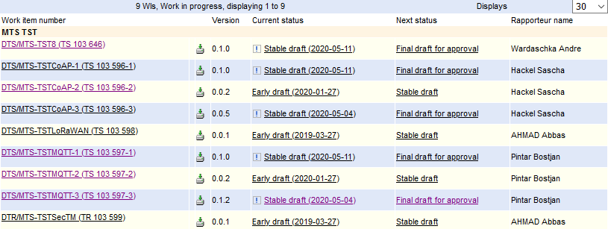

Sascha:
Andre left the company and we need a new rapporteur (Sascha offers to take over the work item)
TST8: all TP have been done with TDL-TO (main work has been done and can be presented to TC Cyber for review); close to “final draft for approval”
CoAP-1 (conf test): some little work to be done (can be presented to TC SmartM2M for review)
CoAP-2 and MQTT-2 (security test): no progress since TST#9

Bostjan:
MQTT-1 (conf test): some editorial changes done (can be presented to TC SmartM2M for review)

Daniel:
CoAP-3 and MQTT-3: same structure (performance metrics, configuration, benchmarking, examples of tests), some editorial work to be done, ready for review by TC SmartM2M; less attention to client side testing (so many devices possible); source code of TPs to be included as an attachment (like TTCN-3 source code)

Axel:
EGM working drafts need new rapporteurs (since 2019): proposal is to stop work items TSTLoRaWAN and TSTSecTM

Proposed update of rapporteurship:
- Gheorghe-Pop Ilie-Daniel is proposed to become rapporteur for
  - DTS/MTS-TSTCoAP-3 (TS 103 596-3),
  - DTS/MTS-TSTMQTT-3 (TS 103 597-3)

- Hackel Sascha is proposed to become rapporteur for
  - DTS/MTS-TST8 (TS 103 646)

Proposed updated time schedules:
- Conformance DTS/MTS-TSTCoAP-1 (TS 103 596-1), DTS/MTS-TSTMQTT-1 (TS 103 597-1)
  - Final Draft for approval 30th September 2020
- Security DTS/MTS-TSTCoAP-2 (TS 103 596-2), DTS/MTS-TSTMQTT-2 (TS 103 597-2)
  - Stable draft 30th September 2020
  - Final Draft for approval 31st January 2021
- Performance DTS/MTS-TSTCoAP-3 (TS 103 596-3), DTS/MTS-TSTMQTT-3 (TS 103 597-3)
  - Final Draft for approval 30th September 2020
- IoT-Profil DTS/MTS-TST8 (TS 103 646)
  - Final Draft for approval 30th September 2020

Planning/status on TST liaisons/promotion for 2020 [All]

 | Topics: Status of contacts/liaisons:  Final drafts of workitem documents to be presented to other ETSI groups  Idea from WG TDL: Experience report from our work with TDL-TO for promotion of TDL (probably as a workshop paper)  Finn, Andreas, Philip and all TST members  - IEEE STV’20 workshop @QRS conference (deadline 15th June): https://www.fokus.fraunhofer.de/go/stv20  AP (Axel): structure of experience report to be circulated in WG TST soon, TST/TDL members will assign themselves to selected sections  Andres: WG TDL invites WG TST feedback towards future work/activities on textual syntax on TDL | approaches for OPCF

Meeting wrap up

Approvals (review & confirmation) [All]

Topics: recapitulation of current drafts, LS out approved during the meeting, presentation of remaining ones to be approved, announcement expected revisions to be approved by remote consensus after the meeting.
Related Contributions:

LS OUT

Information of other ETSI groups on final draft (invite for comments):
TST#8 to TC Cyber
CoAP-1, CoAP-3, MQTT-1 and MQTT-3 to TC SmartM2M

New WI

Actions list

Action Number | Action | Status
AP(10)01 | structure of experience report (publication) to be circulated in WG TST (Axel) | open
AP(10)02 | Change of WI time schedules and rapporteurs (see above) (Axel/Em)) | open
AP(10)03 | Information of TC Cyber and TC SmartM2M on final drafts (Axel/Em) | open

Calendar of future meetings & Events

Proposal: September 11th or 12th, before the MTS#81 meeting

Participants List:

Title | Last name | First Name | Organisation
Mr. | Gheorghe-Pop | Ilie-Daniel | Fraunhofer FOKUS
Mr. | Hackel | Sascha | Fraunhofer FOKUS
Mr. | Pintar | Bostjan | Sintesio
Dr. | Makedonski | Philip | Uni Göttingen
Mr. | Kristoffersen | Finn | Cinderella ApS
Dr. | Réthy | György | Ericsson LM
Dr. | Ulrich | Andreas | Siemens
Mr. | Rennoch | Axel | Fraunhofer FOKUS

