Liaison Statement
Title: | ETSI Technology Radar, status and request for feedback
Date: | 17.12.2021
From: | ETSI BOARD TREND BOARD_TREND@list.etsi.org
Contact(s): | Christian Toche Christian Toche christian.toche@huawei.com  David Boswarthick (David.Boswarthick@etsi.org)
To: | All ETSI TBs, ISGs, oneM2M TC & 3GPP SA, 3GPP SA1
cc: | OCG
- Overall description:
During the period 2020-2021, the ETSI BOARD TREND group performed a thorough analysis of various market reports, analyst papers, market surveys and other relevant literature in order to identify the most relevant future technology trends relating to the ICT sector.
The result of this work can be found in the ETSI Technology Radar (ETR), published as a whitepaper in April 2021. https://www.etsi.org/images/files/ETSIWhitePapers/etsi_wp45_ETSI_technology_radar.pdf
The ETR describes, from a relatively high perspective, the 10 most predominant ICT trends for the coming years. For each selected technology trend, the ETR identifies;
- affinities and/or eventual gaps with respect to current ETSI activities as documented in the ETSI Work Programme 2020/21,
- the definition of an estimated time frame of maturity for standardization activities,
- a set of recommendations for future more detailed analysis at ETSI OCG and/or ETSI Board level on the eventual way forward to fill the identified standards gaps.
The ETSI Technology Radar is intended to be updated at regular intervals, with the next edition being planned for the end of 2022. The revision will include updates to the already selected (10) technology trends as well as the addition of new trends as they become relevant in the ICT space.

The ETR was recently presented to the OCG and the presentation can be accessed from the ETSI portal https://docbox.etsi.org/OCG/OCG/05-CONTRIBUTIONS/2021/OCG(21)000005_Presenting_the_ETR_to_the_OCG.pptx

2. Actions:
BOARD_TREND would like to invite your group and/or individuals within your group to consider and possibly review the identified technology trends and to provide any observations back to the BOARD_TREND group. Comments and suggestions are encouraged on the existing (10) trends (see next figure).
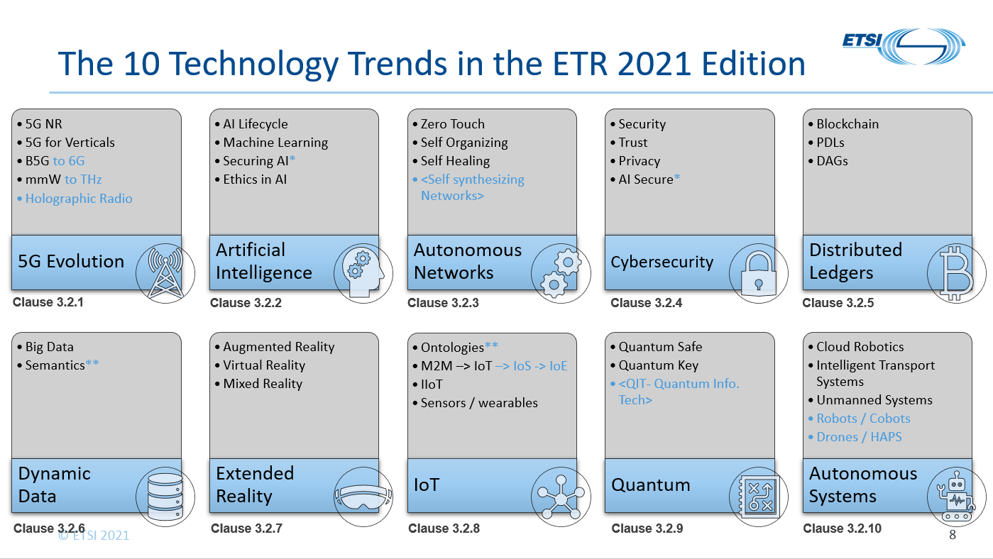
In addition, BOARD_TREND is currently considering a set of new technology trends to be added to the 2022 edition of the ETR and would greatly appreciate comments and feedback on these proposed trends and others that may be missing from our future technology radar, (see next figure).
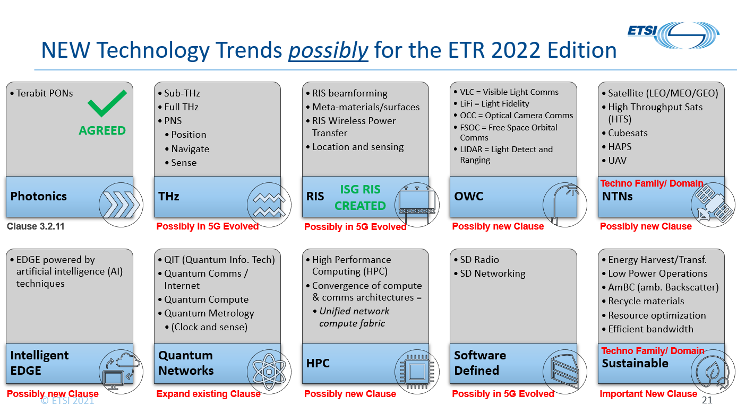

In addition is currently considering some use case scenarios and would appreciate the feedback from you group, (see next figure).
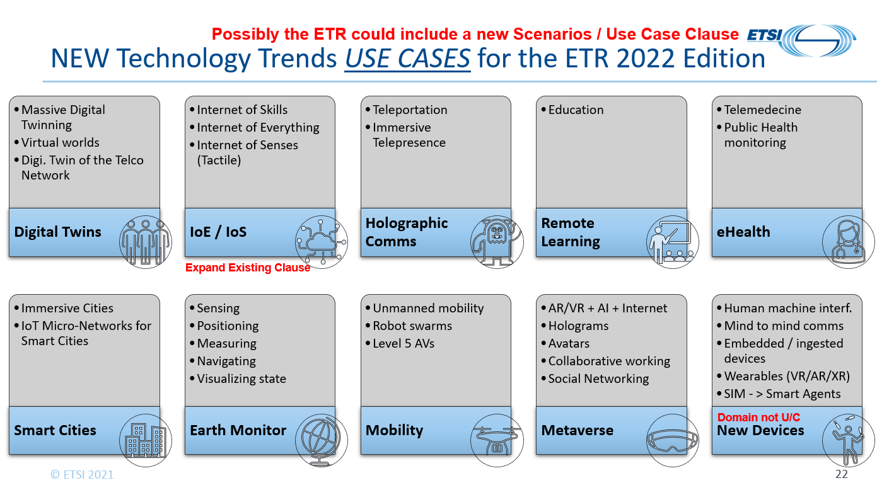
Finally, we would be interested to know if your group has any similar work planning activity and/or technology mapping activities that could link into the ETSI Technology Radar

Feedback on the ETR would be appreciated before 31st January 2022.

Many thanks for your kind consideration and eventual feedback.

3. Date of next meeting(s):
TREND#11: 11th January 2022 14:00 – 16:00 CET
TREND#12: 8th February 2022 14:00 – 16:00 CET

