Terms of Reference Template
Testing Task Force (TTF)

INSTRUCTIONS for completing the document:

The template is for TTF use and it consists in four parts:

Part I – TTF technical proposal: Provides the D-G/OCG/Board with the essential elements to mainly understand the rationale and objective

The parts hereinafter are composed of the TTF details that may be updated prior to the final set-up of the project team.

Part II – Details of the TTF Technical Proposal: Organisation of the work and links with other stakeholders.

Part III - Execution of the work: detailed description of the work to be done, deliverables to be produced, tasks structure, milestones estimate of the maximum budget to be allocated. The information provided in this is part must be precise enough to be used to select contractors in the Call for Expertise.

Part IV - Performance Indicators: these must provide the elements for the Reference Body report to the D-G on the performance of the TTF.

PLEASE REMOVE ALL GUIDELINE TEXT IN THE FINAL VERSION OF THE ToRs
(hint: search for style “Guideline” and delete the paragraphs)

For any questions e-mail to CTI Director Ultan.Mulligan@etsi.org

ToR TTF XX (TC MTS / WG TDL)
Version: 0.1
Authors: Kristoffersen, Makedonski – Date: 2022-07-26
Last updated by: Makedonski – Date: 2022-07-28
page 1 of 7

Terms of Reference –Testing Task Force Proposal
TTF XXX (TC MTS / WG TDL)
TOP/TDL Enhancements for Better User Experience

Summary information
Approval status | Approved by TC MTS |  | YES
Reference Body | TC MTS / WG TDL
ETSI Funding | Maximum budget : XXX XXX EUR
Minimum of 4 ETSI Members Support | YES
Time scale | From | 2023-08-01
 | To | 2024-07-31
Work Items | See clause 3.2 below
TTF Roadmap reference | https://docbox.etsi.org/MTS/MTS/05-CONTRIBUTIONS/2020//MTS(20)080001_TDL_Roadmap.docx

Part I –TTF Technical Proposal

Rationale & Objectives

Rationale
The ETSI TC MTS provides technologies, tools, and guidelines on conformance and interoperability testing and certification of protocols and other systems, including AI systems, that are under standardisation at various ETSI groups and committees. The Test Description Language (TDL) is such a testing technology. Its standards that define formal textual and graphical notations and transformations to deliver test objectives and executable test specifications have reached a mature state. In addition to the standardisation work on TDL, the ETSI TDL Open-Source Project (TOP) was created. Its initial purpose was to serve as a test bed for the validation of new TDL language features and to offer a kick-start to early technology adopters.

The recent TC MTS work on TDL has been focused on providing enhanced features of the TOP tools and provide better user-support in all phases of the testing process when using TDL. These enhancements include easier access to the TOP toolset, user-guides and examples illustrating the use of all TDL features. Also, an initial exploratory prototype for a web-based TDL editor has been implemented, that can further simplify access to the TOP tools.

The collaborative platform for drafting ETSI and 3GPP specifications, New Working Methods (NWM), and the trend towards remote working also need TOP tool support for creating and maintaining test specifications, in order to make TDL the obvious choice to ETSI TCs when working on standardisation of test suite specifications.

The continued work on TDL enables the application of modern model-based development techniques within ETSI standardisation processes for the benefit of all ETSI members. It also puts ETSI in the leading position to address new testing challenges coming from distributed computing platforms in the cloud and AI domains.

Objectives of the work to be executed
The work of this TTF will focus on specification and implementation of TOP tool features to enable easy integration with the New Working Methods (NWM) platform. It will also integrate and enhance the initial web-based TOP tool for this purpose. In addition, support for Continuous Integration development will be defined and an extended protocol server component will be developed.

- Description and provision of an adapted TDL TOP toolset that enables integrated use of TDL models in the NWM and other web-based platforms. This may imply modification both to the standalone TOP toolset and the initial prototype for a web-based TOP toolset.
- Enhanced support for Continuous Integration development using TDL.
- Description and provision of an extensible protocol server component to ease the specification integration, and execution of TDL models for a wider range of systems. The protocol server component can be re-used in other platforms.
- An updated methodology and guideline document to reflect the latest advances in TDL and a TOP feature demonstration that concludes all implementation efforts of this TTF.
- Maintenance and enhancements of the TDL standards (as needed).

The TOP tool development was performed according to the conceptual tool architecture, shown below, to provide the illustrated building blocks using state-of-the-art software development technologies.

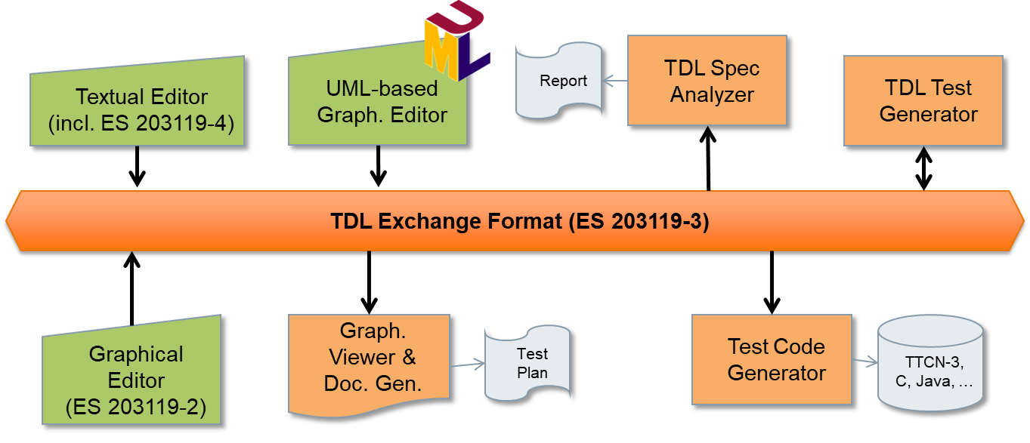

Previous funded activities in the same domain
The previous standardisation efforts on TDL and TOP can be briefly summarised as follows. They provide the foundation of work proposed in this ToR.

- The previous TDL/TOP TTF 022 provided an updated TOP toolset with enhanced user features for test description development, validation, execution, and analysis as well as updated user guidelines and an initial prototype for a web-based TDL editor.
- TTF 013 added support for RESTful API testing using OpenAPI, extended the TDL data type system and worked towards a test execution engine. It also provided a new standardized textual syntax for TDL. Moreover, the TDL methodology guidelines for test description derivation from test objectives were updated to support semi-automatic workflows.
- Earlier STFs, the first one started in 2013, laid the foundation of TDL and defined its principal building blocks of abstract syntax (meta-model), concrete syntax (textual, graphical and transfer syntax), and the principal tool architecture and its integration into ETSI’s test specification process. These STFs also standardised the separation of totally ordered and locally ordered test descriptions and established the connection between TDL and TTCN-3 to enable the generation of executable tests from TDL.

Consequences if not agreed
The focus of this TTF on the TOP implementation is to enable close integration with the ETSI New Working Methods (NWM) and provide enhancements of the web-based TOP toolset for broader use cases and further integrations. If not performed this could cause a delay in the uptake of TDL for ETSI TC using NWM as their standardisation platform. It could also lead to more overhead in the handling and maintenance of ETSI test standards.

This TTF is a continuation of the work done in TTF 022 as well as earlier STFs with the aim to speed up progress in the adoption of TDL by making the tooling in TOP easier to use by end-users in general and especially for ETSI TCs using NWM. A cloud-based platform will provide an easier alternative for end-users to get started with using TDL and collaborating on TDL test specifications. Without this TTF, the application of the TDL standard by end-users such as other ETSI technical bodies and industrial partners will likely be delayed.

In addition, more and more practices on system and software design are influenced from open-source technologies that implement commonly agreed approaches in system and software engineering and make them freely available. This development could lead to a fragmented landscape of system and test specification languages that might not be in ETSI’s interest as it needs a common, strong, and sound formal approach to certification and other ways of testing of the complex systems it designs. Moreover, ETSI might lose influence in the area of modern system and software engineering practices if there is a standstill on this proposed work.

ETSI Members Support
# | ETSI Member | Supporting delegate
1 | Cinderella ApS | Finn Kristoffersen
2 | Elvior LLC | Martti Käärik
3 | Ericsson Hungary Ltd | Dr. György Réthy
4 | Fraunhofer FOKUS | Dr. Axel Rennoch
5 | Institut für Informatik, Universität Göttingen | Prof. Dr. Dieter Hogrefe
6 | Siemens AG | Dr. Andreas Ulrich

Deliverables

Base documents
Document | Title | Status
ES 203 119-1 V1.7.1 | Methods for Testing and Specification (MTS); The Test Description Language (TDL); Part 1: Abstract Syntax and Associated Semantics | Early draft
ES 203 119-2 V1.5.1 | Methods for Testing and Specification (MTS); The Test Description Language (TDL); Part 2: Graphical Syntax | Final draft
ES 203 119-3 V1.5.1 | Methods for Testing and Specification (MTS); The Test Description Language (TDL); Part 3: Exchange Format | Final draft
ES 203 119-4 V1.5.1 | Methods for Testing and Specification (MTS); The Test Description Language (TDL); Part 4: Structured Test Objective Specification (Extension) | Final draft
ES 203 119-6 V1.3.1 | Methods for Testing and Specification (MTS); The Test Description Language (TDL); Part 6: Mapping to TTCN-3 | Final draft
ES 203 119-7 V1.3.1 | Methods for Testing and Specification (MTS); The Test Description Language (TDL); Part 7: Extended Test Configurations | Final draft
ES 203 119-8 V1.2.1 | Methods for Testing and Specification (MTS); The Test Description Language (TDL); Part 8: Textual Syntax | Early draft
TR 103 119 V1.4.1 | Methods for Testing and Specification (MTS); The Test Description Language (TDL); Reference Implementation and User Guidelines | Early draft
EG 203 647 V1.1.1 | Methods for Testing and Specifications (MTS); Methodology for RESTful APIs specifications and testing | Published

New deliverables
The main deliverable of this TTF is the TDL TOP tools available for download as a configured package to install. The deliverable will potentially include a means to access and use the TOP tools in an online platform, also in combination with the NWM platform. Updated versions of the base TDL standards parts may also be part of the deliverable of the TTF.

Deliv. | Work Item code  Standard number | Working title | Expected date for publication
D1 | RTS/TR 103 119 V1.5.1 | Methods for Testing and Specification (MTS); The Test Description Language (TDL); Reference Implementation and User Guidelines | 2024-07
D2* | RES/ES 203 119-1 V1.8.1 | Methods for Testing and Specification (MTS); The Test Description Language (TDL); Part 1: Abstract Syntax and Associated Semantics | 2024-07
D3* | RES/ES 203 119-8 V1.3.1 | Methods for Testing and Specification (MTS); The Test Description Language (TDL); Part 8: Textual Syntax | 2024-07

*) Work items of the TDL standard series which are not affected by CRs will not be updated. If other parts of the TDL standard series are affected by CRs, they will be opened as work items during the work of the TTF as well.

Maximum budget

Task Summary and Manpower Budget

Task short description | Budget (EUR)
T0 Project Management | 5.800
T1 TOP Requirements and Validation | 8.800
T2 TOP Architecture Design | 19.200
T3 TOP Features Implementation | 56.800
T4 TOP Protocol Server | 16.600
T5 TDL Methodology, Enhancements, and Maintenance | 12.700
TOTAL | 117.300

Travel budget
Travel is required for the TTF lead or deputy to attend the three MTS Plenary Meetings and TDL Work Group Meetings to discuss the achieved progress. Additional budget is required for promotion activities at conferences and workshops inside and outside ETSI. Given the persistent trend towards virtual meetings caused by the Covid-19 pandemic, the estimated costs are only indicators for potential travels.

Expected travels | Cost estimate (EUR)
Participation at MTS#90 (Sep 2023) | 800
Participation at MTS#91 (Jan 2024) | 800
Participation at MTS#92 (May 2024) | 800
Participation at UCAAT 2023 to promote TDL and TOP (to be determined) | 1.500
TOTAL | 3.900

Other budget line
None.

Document history
Ver. | Date | Author | Status | Comments
0.1 | 2022-07-26 | Kristoffersen | Initial
0.2 | 2022-07-27 | Makedonski | Revised | Minor refinements to Part I
0.3 | 2022-07-28 | Makedonski, Kristoffersen | Revised, Cleaned | Additional refinements to Part I, budget adjustments

