Thursday 30th October (Morning)

Opening

Introduction & welcome, Local arrangements, IPR call [Tepelmann, Rennoch]

Call for IPRs (clause 4.1 of the ETSI IPR Policy, Annex 6 of the Rules of Procedure):
"The attention of the members of this Technical Body is drawn to the fact that ETSI Members shall use reasonable endeavours to inform ETSI of Essential IPRs in a timely fashion. This covers the obligation to notify its own IPRs but also other companies’ IPRs.
The members take note that they are hereby invited:
-to investigate in their company whether their company does own IPRs which are, or are likely to become essential in respect of the work of the Technical Body,
-to notify to the Chairman or to the ETSI Director-General all potential IPRs that their company may own, by means of
the IPR Information Statement and the Licensing Declaration forms that they can obtain from the secretariat"
Members are encouraged to make general IPR undertakings/declarations that they will make licenses available for all their IPRs under FRAND terms and conditions related to a specific standardization area and then, as soon as feasible, provide (or refine) detailed disclosures.

"The attention of all participants to the meeting was drawn to the fact that ETSI activities are subject to all applicable antitrust and competition laws and that compliance with said laws is therefore required by any participant of the meeting, including the Chairman and Vice-Chairmen."

Approval of agenda, allocation of contributions to Agenda Items

Topics: review agenda content, allocation of contribution to agenda items, agenda items time scheduling.

Reports from MTS Meetings [Rennoch]

Topics: - TST#1 minutes review MTSTST(17)001002
- Call for candidates MTS TST WG Chairmanship closed by 31th October 2017
- E-mail distribution list available for subscription: MTS_TST@LIST.ETSI.ORG (please join!)

Topics: Review of Action list

Action Number | Action | Status
AP(01)01 | All: Provide written technical input statements on IoT testing landscape and priorities for TST#2 | closed

Planning/brainstorming on TST activities/liaisons for 2017 & beyond [All]

- Landscape of IoT Testing activities
see figure below, presented at ETSI IoTweek (October 2017):
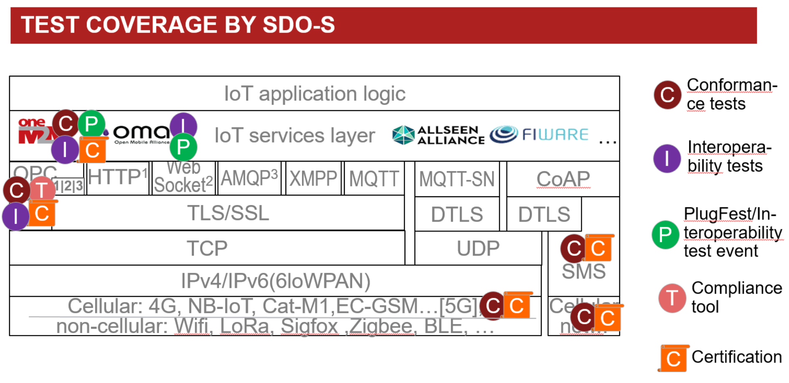

- Input regarding new work items proposals:
  - Fokus: MTSTST(17)002002

OPC-UA tests may also be addressed by the NWI, in particular security, but we have limited resources and need to check any parallel work with OPC Foundation.

TDL-TO will be studied by partners. ETSI is waiting on the latest information regarding tool support.
AP: ETSI will inform MTS_TST on available tool asap.

  - Ericsson
There is interest in OPC-UA and LwM2M (OMA), but resources are to be checked.

  - EGM: MTSTST(17)002003,
AP (EGM): contact LoRa alliance regarding existing tests

EGM MTSTST(17)002003a1r1
The NWI is related to security TPs. The ARMOUR methods is one approach to retrieve such TPs.
There may be additional methods to get security test purposes.
AP: feedback of FOKUS/DEKRA on this NWI to EGM

  - DEKRA: Focus should be on the formal description of security related tests, the standardization of related methods and the definition of pass criteria
  - Relayr
Methodologies are very welcome.
Usability of the TP documents is an important interesting topic.
  - Sintesio
let’s start with this initial scope
  - Spirent
good start

- possible liaisons have been proposed from the following groups:
  - AIOTI WG3 “Standards”
  - ITU-T SG11 WP3/11 “Conformance and interoperability testing”
  - ISO/IEC JTC 1/SC 41 WG “Interoperability”

AP (Axel): Send TST introduction to participants regarding future liaisons.
Initial TST information is part of latest MTS flyer https://portal.etsi.org/Portals/0/TBpages/MTS/Docs/MTS%20Q42017.pdf (2nd page)

- AOB:
Michele: The TDL Steering Group is preparing an article for the ETSI magazine (the Standard) on the last news from TDL and the TOP project. TST group agrees to mention our approach to use TDL for TP definitions, but the NWIs have to be endorsed by TC MTS.

Meeting wrap up

Approvals (review & confirmation) [All]

Topics: recapitulation of New WIs, final drafts, LS out approved during the meeting, presentation of remaining ones to be approved, announcement expected revisions to be approved by remote consensus after the meeting.

The NWI provided in MTSTST(17)002002 and MTSTST(17)002003 will be proposed for remote consensus at TC MTS.

LS OUT
n/a

Actions list

Action Number | Action | Status
AP(02)01 | Provide the NWI input to TC MTS (Axel) | open
AP(02)02 | Promotional material about MTS_TST (Axel) | ongoing
AP(02)03 | Provide latest information on TDL tool support (Michaele) | open
AP(02)04 | Input regarding the NWI MTSTST(17)002003a1r1 on security test purpose methods, incl. ARMOUR. (Axel, Andre) | open
AP(02)05 | contact LoRa alliance regarding available tests (Frank) | open

Calendar of future meetings & Events

TST#3: January 23rd (morning), 2018, before MTS#73 in Munich

Participants List:

Title | Last name | First Name | Organisation
Mr. | Carignani | Michele | ETSI
Mr. | Kaiser | Alexander | relayr GmbH
Mr. | Pintar | Bostjan | Sintesio
Dr. | Réthy | György | Ericsson LM
Mr. | Wardaschka | André | DEKRA Exam GmbH
Mr. | Stanca-Kaposta | Bogdan | Spirent Communications
Mr. | Tepelmann | Dirk | Spirent Communications
Mr. | Le Gall | Franck | EasyGlobalMarket
Mr. | Ahmad | Abbas | EasyGlobalMarket
Mr. | Martin | Jordan | EasyGlobalMarket
Mr. | Spaseski | Naum | EasyGlobalMarket
Mrs. | Jost | Marion | Fraunhofer FOKUS
Mr. | Kretzschmann | Sascha | Fraunhofer FOKUS
Mr. | Rennoch | Axel | Fraunhofer FOKUS

