Draft ETSI TR 1XX WI24 V2.0.0 (2007-10)
Technical Report
PowerLine Telecommunications (PLT);
Report from Plugtests™ 2007 on
coexistence between PLT and short wave radio broadcast
Part 2 - Report from Plugtest

Reference
DTR/PLT-00024
Keywords
EMC, Powerline, RADIO
ETSI
650 Route des Lucioles
F-06921 Sophia Antipolis Cedex - FRANCE

Tel.: +33 4 92 94 42 00 Fax: +33 4 93 65 47 16

Siret N° 348 623 562 00017 - NAF 742 C
Association à but non lucratif enregistrée à la
Sous-Préfecture de Grasse (06) N° 7803/88

Important notice
Individual copies of the present document can be downloaded from:
http://www.etsi.org
The present document may be made available in more than one electronic version or in print. In any case of existing or perceived difference in contents between such versions, the reference version is the Portable Document Format (PDF). In case of dispute, the reference shall be the printing on ETSI printers of the PDF version kept on a specific network drive within ETSI Secretariat.
Users of the present document should be aware that the document may be subject to revision or change of status. Information on the current status of this and other ETSI documents is available at http://portal.etsi.org/tb/status/status.asp
If you find errors in the present document, please send your comment to one of the following services:
http://portal.etsi.org/chaircor/ETSI_support.asp
Copyright Notification
No part may be reproduced except as authorized by written permission.
The copyright and the foregoing restriction extend to reproduction in all media.

© European Telecommunications Standards Institute yyyy.
All rights reserved.
DECTTM, PLUGTESTSTM and UMTSTM are Trade Marks of ETSI registered for the benefit of its Members.
TIPHONTM and the TIPHON logo are Trade Marks currently being registered by ETSI for the benefit of its Members. 3GPPTM is a Trade Mark of ETSI registered for the benefit of its Members and of the 3GPP Organizational Partners.
Contents
Foreword 4
Parts . 4
Introduction 4
1 Scope 5
2 References 5
2.1 Normative references 5
2.2 Informative references. 5
3 Definitions, symbols and abbreviations 6
3.1 Definitions 6
3.2 Symbols 6
3.3 Abbreviations 6
4 PlugtestsTM specification 6
4.1 Verification of concept in a Building 7
4.1.1 Test environment 7
4.1.2 Verify Reception Quality of Radio Stations 8
4.1.3 Revise thresholds, Level and Timings 11
4.1.4 More Tests in the Building 11
4.1.5 Further tests to verify the concept in Lab / Anechoic chamber 11
4.2 Laboratory Test with Participants 12
4.2.1 Test environment 12
4.2.2 Test Procedure 12
4.3 Field-tests with Participants in Building 13
4.3.1 Test environment 13
4.3.2 Test procedure 13
History 15

Intellectual Property Rights
IPRs essential or potentially essential to the present document may have been declared to ETSI. The information pertaining to these essential IPRs, if any, is publicly available for ETSI members and non-members, and can be found in ETSI SR 000 314: "Intellectual Property Rights (IPRs); Essential, or potentially Essential, IPRs notified to ETSI in respect of ETSI standards", which is available from the ETSI Secretariat. Latest updates are available on the ETSI Web server (http://webapp.etsi.org/IPR/home.asp).
Pursuant to the ETSI IPR Policy, no investigation, including IPR searches, has been carried out by ETSI. No guarantee can be given as to the existence of other IPRs not referenced in ETSI SR 000 314 (or the updates on the ETSI Web server) which are, or may be, or may become, essential to the present document.

Foreword
This Technical Report (TR) has been produced by ETSI Technical Committee PowerLine Telecommunications (PLT) STF 332.

Parts .
The present document is part <i> of a multi-part deliverable covering [the] <common element of the title>, as identified below:
Part 1: "Test cases";
Part 2: "Report from Plugtests™ 2007 on coexistence between PLT and short wave radio broadcast";

Introduction
In order to verify Draft TS of Work Item 21 (WI21) [5] which deals with coexistence between PLT and short wave radio services including DRM (Digital Radio Mondiale) a PlugtestsTM was requested by many ETSI members.
During the coexistence PlugtestsTM, different PLT modems from different vendors implementing the draft TS related to WI21 will be evaluated. A Special Task Force (STF) 332 has been established to perform the PlugtestsTM.
The STF will validate the concept of ‘Smart Notching’ which is specified in ETSI PLT WI21 [5]. Measurements demonstrating the ingress of SW radio broadcasts to the electrical installation in a building will be made. Further, using real implementations of PLT modems the practicality of the draft TS will be verified. Verification of levels and thresholds will be carried out along with the performance of the coexistence implementations. Recommendations for possible improvement to the current draft TS of Work Item 21(WI21) will be made as appropriate.
The tasks of the STF are in detail:
- validate or revise the thresholds and resolution bandwidths needed to detect ingress from a receivable radio broadcast
- verify test bench levels and thresholds
- provide feedback from implementations to the ongoing work in ETSI PLT WI21 as well as to PLT modem implementers
- check the feasibility of detecting and notching narrow bands
- determine, if it is possible to detect SW radio ingress without demodulating signals by PLT PHY
- determine probability of false detection by PLT modems
- Verify if there is a way of classifying the narrow band signals’ source (radio station or switching power supply, or class D amp)

Therefore STF 332 will organize the PlugtestsTM. At the execution of the PlugtestsTM any ETSI member is free to participate in the execution of any or all of the PlugtestsTM proposed in this document.

Scope
Results of the verification of the proposed mechanism to improve coexistence between PLT and short wave radio broadcast.

2 References

The following text block applies:
References are either specific (identified by date of publication and/or edition number or version number) or non-specific.
- For a specific reference, subsequent revisions do not apply.
- Non-specific reference may be made only to a complete document or a part thereof and only in the following cases:
- if it is accepted that it will be possible to use all future changes of the referenced document for the purposes of the referring document;
- for informative references.
Referenced documents which are not found to be publicly available in the expected location might be found at http://docbox.etsi.org/Reference.
For online referenced documents, information sufficient to identify and locate the source shall be provided. Preferably, the primary source of the referenced document should be cited, in order to ensure traceability. Furthermore, the reference should, as far as possible, remain valid for the expected life of the document. The reference shall include the method of access to the referenced document and the full network address, with the same punctuation and use of upper case and lower case letters.
NOTE: While any hyperlinks included in this clause were valid at the time of publication ETSI cannot guarantee their long term validity.
The following clauses are only to be used where appropriate.

2.2 Informative references.
[1] ITU-R Radio Regulations, edition of 2004.
[2] ETSI ES 201 980 (V2.2.1): "Digital Radio Mondiale (DRM); System Specification"
[3] ITU-R BS.1284 General methods for the subjective assessment of sound. Additional information can be found: SINPO: (S)ignal, (I)nterference, (N)oise, (P)ropagation, (O)verall
http://stason.org/TULARC/radio/shortwave/08-What-is-SINPO-SIO-Shortwave-radio.html
[4] CISPR 16- Part 1-1: (2006-11): "Specification for radio disturbance and immunity measuring apparatus and methods - Part 1-1: Radio disturbance and immunity measuring apparatus - Measuring apparatusSpecification for radio disturbance and immunity measuring apparatus and methods - Part 1: Radio disturbance and immunity measuring apparatus".
[5] ETSI draft TS 102 578 V1.1.10 (2007-08): PLT43_TD_07

3 A

bbreviations
For the purposes of the present document, the following abbreviations apply:
AE Auxiliary Equipment
AM Amplitude Modulation
CE Consumer Electronics
DRM Digital Radio Mondiale
NOTE: See ES 201 980 [2] (http://www.drm.org/).
EUT Equipment Under Test

LI Level of Ingress (in dBm)

NHB Noise higher frequency block (in dBm)
NLB Noise lower frequency block (in dBm)
PLT PowerLine Telecommunications (http://www.etsi.org/plt)

SW Short Wave

4 PlugtestsTM specification
There are 2 test to be performed:
- The concept, as specified in the current draft spec of WI21 shall be verified.
Levels, Thresholds, Timing, definition of useable radio service reception quality, lower level and slopes of the notch, verification method, etc.
This test will be performed on 10th / 11th of October 2007 in Stuttgart area (Germany).
Revised values will be published until 17th of October 2007
- Tests with participants. Implementations from modem manufacturers will be verified versus this test specification.
These tests will be performed from 19th to 23rd of November 2007.

4.1 Verification of concept in a Building

4.1.1 Test environment
Test will be carried out in a private home. The detailed installation of the power infrastructure is unknown to test participants. The 300kW SW radio broadcast station in Skelton (UK) (STF 332 will check availability) will schedule some radio transmission according to the demands of this test. A Spectrum Analyzer, Test Receiver and a selection of DRM and AM SW radio receives are available to perform the tests. A calibrated active biconal antenna verifies the field strength in the air.
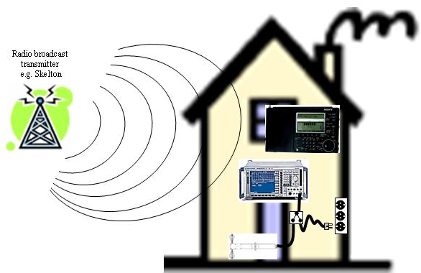
Figure 1: Test Setup in a private living unit
Equipment needed:
- CE SW Radio receiver
  - AOR AR7030, Sony ICF-SW77, ICF-1000, Sangean ATS909, TECSUN 9700, etc
- DRM: Roberts MP-40, etc
- Cable snap ferrites
- Spectrum Analyzer, PLT coupler 50:100 Ω Impedance matching
- Calibrated antenna in 1MHz < f < 30MHz, wooden tripod
- Artificial white noise generator
  - Coupler to feed noise to the mains grid
  - Antenna to broadcast noise inside the building

4.1.2 Verify Reception Quality of Radio Stations
This test was done at the 10th and 11th of October 2007
Using a SW radio receiver, scan the SW radio band and record the frequency, service name and reception quality wherever the automatic scan stops. Check for a good position of the receiver in the living unit and monitor the field strength there.
Connect the Spectrum Analyzer to the mains (sequentially at several outlets) and measure the level of ingress of HF broadcast signals there. Do this process in turn 3 times and take the average from the numeric reading as result.
Classification for reception quality of AM stations shall be according to SINPO system [3]. The empirical rating of the signal quality will be done ‘democratically’ by the three STF 332 experts. Table 1 and 2 will be compiled during the tests.
Unfortunately during execution of tests the transmission schedule of some services changed. Often it was monitored, that stations were switched of after receiving them with the radio and before verifying the level of it in the air or connected to the mains. This is why some fields in the following tables are empty.
Many services showed a strong fading behaviour. This could be seen in the SINPO assessment of Propagation:
SINPO Propagation = 5: no fading visible at all
SINPO Propagation = 4: fading was less than 3 dB
SINPO Propagation = 3: fading was less than 10 dB
SINPO Propagation = 2: fading was less than 20 dB
SINPO Propagation = 1:fading was more than 20 dB
The values listed in table 1 to table 6 show a one time shot of the level of this service. (Note, [5] requires to notch a frequency if the threshold is passed once and to reuse a frequency if the ingress is lower than threshold longer than 60sec.)

Dombovar Str 18, D-71394 Kernen |  |  | Used AM Radio:  Sony SW 1000 |  |  |  |  |  | in dBm:
Fre-quen-cy  in kHz | Station name | Field strength  in dB (µV/m) | SINPO  Signal | SINPO  Interference | SINPO  Noise | SINPO  Propagation | SINPO  Overall |  | measured at outlet No:  Level of Ingress  noise levels of adjacent frequency block: Lower Block / Higher Block
 |  |  |  |  |  |  |  |  | 1 | 2 | 3 | 4
6075 | Deutsche Welle | 65.6 | 2 | 4 | 4 | 2 | 3 | LI | -63 | -65 | -52 | -70
 |  |  |  |  |  |  |  | NLB | -98 | -95 | -97 | -102
 |  |  |  |  |  |  |  | NHB | -93 | -95 | -96 | -93
9640 | Skelton | 71.8 | 5 | 3 | 3 | 3 | 3 | LI
 |  |  |  |  |  |  |  | NLB | -104 | -99 | -98 | -107
 |  |  |  |  |  |  |  | NHB | -104 | -103 | -98 | -108
9545 | German Language | 48.2 | 3 | 3 | 2 | 2 | 2 | LI | -68 | -78 | -70 | -68
 |  |  |  |  |  |  |  | NLB | -104 | -99 | -98 | -107
 |  |  |  |  |  |  |  | NHB | -104 | -103 | -98 | -108
9480 | German Language | 50.3 | 3 | 4 | 3 | 4 | 3 | LI | -70 | -75 | -65 | -63
 |  |  |  |  |  |  |  | NLB | -104 | -99 | -98 | -107
 |  |  |  |  |  |  |  | NHB | -104 | -103 | -98 | -108
9430 | Skelton 2 | 64.8 | 4 | 4 | 3 | 3 | 4 | LI | -52 | -58 | -55 | -55
 |  |  |  |  |  |  |  | NLB | -104 | -107 | -98 | -107
 |  |  |  |  |  |  |  | NHB | -104 | -107 | -98 | -108
6155 | Austrian Transmission | 57,2 | 2 | 3 | 3 | 2 | 2 | LI | -61 |  | -53 | -58
 |  |  |  |  |  |  |  | NLB | -98 | -95 | -97 | -102
 |  |  |  |  |  |  |  | NHB | -93 | -95 | -96 | -93

Table 1: Reception quality, field strength and level of ingress of AM services
Table 1 is not a complete list. Due to time reasons it was not possible to note all SW radio services in this location
Classification for reception quality of DRM stations shall be done according the reception of a DRM channel:
DRM Radio Stations using e.g. Roberts MP-40
Dombovar Str 18, D-71394 Kernen |  |  | Used DRM Radio:  Roberts MP-40 | in dBm
Frequency  in kHz | Station name | Field strength  in dB(µV/m) | Service receive-able?  Y/N | measured at outlet No:  Level of Ingress /  noise levels of adjacent frequency block:  Noise Lower Block /  Noise Higher Block
Frequency  in kHz | Station name | Field strength  in dB(µV/m) |  |  | 1 | 2 | 3 | 4
7190 | Radio Vatican | 56,7 | Y | LI
 |  |  |  | NLB | -97 | -98 | -98 | -96
 |  |  |  | NHB | -100 | -98 | -98 | -99
7275 | Deutsche Welle  Sometimes receivable | 59.5 | intermittend | LI | -82 | -80 | -78 | -72
 |  |  |  | NLB | -97 | -98 | -98 | -96
 |  |  |  | NHB | -100 | -98 | -98 | -99
6085 | Bavaria 5 | 61.6 | Y | LI | -75 | -90 | -74 | -80
 |  |  |  | NLB | -98 | -95 | -97 | -102
 |  |  |  | NHB | -93 | -95 | -96 | -93
Table 2: Reception quality, field strength and level of ingress of DRM services
Table 2 is not a complete list. Due to time reasons it was not possible to note all SW radio services in this location

Hotel Unger  Kronenstraße 17 70173 Stuttgart |  |  | Used AM Radio:  Sony SW 1000 |  |  |  |  |  | in dBm:
Fre-quen-cy  in kHz | Station name | Field strength  in dB (µV/m) | SINPO  Signal | SINPO  Interference | SINPO  Noise | SINPO  Propagation | SINPO  Overall |  | measured at outlet No:  Level of Ingress  noise levels of adjacent frequency block: Lower Block / Higher Block
 |  |  |  |  |  |  |  |  | 1 | 2 | 3 | 4
7335 | Skelton | 56.4 | 3 | 3 | 3 | 3 | 3 | LI | -84 | -82 | -84 | -83
 |  |  |  |  |  |  |  | NLB | -95 | -93 | -89 | -95
 |  |  |  |  |  |  |  | NHB | -97 | -93 | -91 | -95
5955 | Radio Netherland | 46.3 | 3 | 4 | 4 | 3 | 4 | LI | -80 | -76
 |  |  |  |  |  |  |  | NLB | -95 | -91
 |  |  |  |  |  |  |  | NHB | -94 | -91
5970 | German | 43 | 3 | 2 | 2 | 2 | 2 | LI | -80 | -85 | -79 | -82
 |  |  |  |  |  |  |  | NLB | -95 | -91 | -81 | -87
 |  |  |  |  |  |  |  | NHB | -94 | -91 | -76 | -95
9420 | Spanish | 48 | 3 | 4 | 4 | 3 | 4 | LI | -91 | -85 | -88 | -90
 |  |  |  |  |  |  |  | NLB | -90 | -97 | -93 | -100
 |  |  |  |  |  |  |  | NHB | -87 | -91 | -89 | -98
9465 | Arabic(?) | 58 | 2 | 1 | 1 | 2 | 1 | LI | -93 | -96 | -91 | -98
 |  |  |  |  |  |  |  | NLB | -90 | -97 | -93 | -100
 |  |  |  |  |  |  |  | NHB | -87 | -91 | -89 | -98
15215 | Eastern Europe | 46 | 2 | 2 | 2 | 3 | 2 | LI | -95 | -82 | -85 | -89
 |  |  |  |  |  |  |  | NLB | -103 | -102 | -100 | -96
 |  |  |  |  |  |  |  | NHB | -102 | -102 | -103 | -101

Table 3: Reception quality, field strength and level of ingress of AM services
Table 3 is not a complete list. Due to time reasons it was not possible to note all SW radio services in this location.

Hotel Unger  Kronenstraße 17 70173 Stuttgart |  |  | Used DRM Radio:  Roberts MP-40 | in dBm
Frequency  in kHz | Station name | Field strength  in dB(µV/m) | Service receive-able?  Y/N | measured at outlet No:  Level of Ingress /  noise levels of adjacent frequency block:  Noise Lower Block /  Noise Higher Block
Frequency  in kHz | Station name | Field strength  in dB(µV/m) |  |  | 1 | 2 | 3 | 4
 | No DRM receiveable |  |  | LI
 |  |  |  | NLB
 |  |  |  | NHB
Table 4: Reception quality, field strength and level of ingress of DRM services
Table 4 is not a complete list. Due to time reasons it was not possible to note all SW radio services in this location

Rosenstr 26 71364 Winnenden |  |  | Used AM Radio:  Sony SW 1000 |  |  |  |  |  | in dBm:
Fre-quen-cy  in kHz | Station name | Field strength  in dB (µV/m) | SINPO  Signal | SINPO  Interference | SINPO  Noise | SINPO  Propagation | SINPO  Overall |  | measured at outlet No:  Level of Ingress  noise levels of adjacent frequency block: Lower Block / Higher Block
 |  |  |  |  |  |  |  |  | 1 | 2 | 3 | 4
5955 | Radio Netherlands | 72.5 | 4 | 5 | 4 | 4 | 4 | LI | -50 | -52 | -54
 |  |  |  |  |  |  |  | NLB | -95 | -98 | -93
 |  |  |  |  |  |  |  | NHB | -93 | -100 | -92
6035 | Netherland (?) | 48 | 2 | 3 | 2 | 2 | 2 | LI | -71 | -68 | -74
 |  |  |  |  |  |  |  | NLB | -95 | -98 | -93
 |  |  |  |  |  |  |  | NHB | -93 | -100 | -92
6075 | DW | 61 | 3 | 2 | 2 | 2 | 3 | LI
 |  |  |  |  |  |  |  | NLB | -95 | -98 | -93
 |  |  |  |  |  |  |  | NHB | -93 | -100 | -92
6155 | Austria | 64 | 3 | 4 | 4 | 2 | 3 | LI
 |  |  |  |  |  |  |  | NLB | -95 | -98 | -93
 |  |  |  |  |  |  |  | NHB | -93 | -100 | -92
7345 | Lost in the meantime |  |  |  |  |  |  | LI
 |  |  |  |  |  |  |  | NLB | -100 | -107 | -101
 |  |  |  |  |  |  |  | NHB | -102 | -109 | -105
9420 | ? | 52 | 3 | 4 | 3 | 3 | 3 | LI
 |  |  |  |  |  |  |  | NLB | -104 | -107 | -103
 |  |  |  |  |  |  |  | NHB | -104 | -105 | -104
9545 | (German) | 41 | 2 | 4 | 3 | 2 | 3 | LI | -90 | -88 | -82
 |  |  |  |  |  |  |  | NLB | -104 | -107 | -103
 |  |  |  |  |  |  |  | NHB | -104 | -105 | -104
9575 | (French) | 43 | 1 | 1 | 1 | 1 | 2 | LI | -92 | -93 | -94
 |  |  |  |  |  |  |  | NLB | -104 | -107 | -103
 |  |  |  |  |  |  |  | NHB | -104 | -105 | -104
9710 |  | 36 | 1 | 1 | 1 | 1 | 2 | LI
 |  |  |  |  |  |  |  | NLB | -104 | -107 | -103
 |  |  |  |  |  |  |  | NHB | -104 | -105 | -104
11645 | (Italian,Czech) | 43 | 1 | 1 | 1 | 1 | 1 | LI | -75 | -80 | -77
 |  |  |  |  |  |  |  | NLB | -105 | -104 | -102
 |  |  |  |  |  |  |  | NHB | -106 | -105 | -101
11690 | Not anymore measureable |  |  |  |  |  |  | LI
 |  |  |  |  |  |  |  | NLB | -105 | -104 | -102
 |  |  |  |  |  |  |  | NHB | -106 | -105 | -101
11785 | (Chinese ?) | 55 | 4 | 2 | 3 | 1 | 3 | LI
 |  |  |  |  |  |  |  | NLB | -105 | -104 | -102
 |  |  |  |  |  |  |  | NHB | -106 | -105 | -101
12020 | (Slovakia ?) | 57 | 4 | 4 | 4 | 2 | 4 | LI
 |  |  |  |  |  |  |  | NLB | -105 | -104 | -102
 |  |  |  |  |  |  |  | NHB | -106 | -105 | -101
12035 | (Spanish) | 63 | 4 | 4 | 3 | 2 | 3 | LI
 |  |  |  |  |  |  |  | NLB | -105 | -104 | -102
 |  |  |  |  |  |  |  | NHB | -106 | -105 | -101
13710 | (Voice of America ?) | 59 | 4 | 4 | 4 | 1 | 4 | LI
 |  |  |  |  |  |  |  | NLB | -104 | -102 | -104
 |  |  |  |  |  |  |  | NHB | -104 | -101 | -105
15350 | (Russian?) | 55 | 3 | 2 | 2 | 2 | 2 | LI
 |  |  |  |  |  |  |  | NLB | -105 | -99 | -106
 |  |  |  |  |  |  |  | NHB | -104 | -105 | -106
15380 | (Arabic) | 48 | 2 | 4 | 3 | 1 | 3 | LI
 |  |  |  |  |  |  |  | NLB | -104 | -102 | -104
 |  |  |  |  |  |  |  | NHB | -104 | -101 | -105
15665 | (Russian) | 46 | 2 | 3 | 2 | 1 | 2 | LI | -77 | -100 | -78
 |  |  |  |  |  |  |  | NLB | -104 | -102 | -104
 |  |  |  |  |  |  |  | NHB | -104 | -101 | -105
15760 | (Greek or Turkish) | 49 | 3 | 3 | 2 | 1 | 2 | LI
 |  |  |  |  |  |  |  | NLB | -104 | -102 | -104
 |  |  |  |  |  |  |  | NHB | -104 | -101 | -105
17490 | (English)  Country Music | 48 | 3 | 4 | 3 | 1 | 3 | LI | -93 | -74 | -78
 |  |  |  |  |  |  |  | NLB | -105 | -107 | -108
 |  |  |  |  |  |  |  | NHB | -106 | -107 | -107
17650 | Two stations | 46 | 2 | 1 |  | 2 | 1 | LI
 |  |  |  |  |  |  |  | NLB | -105 | -107 | -108
 |  |  |  |  |  |  |  | NHB | -106 | -107 | -107
17730 | Very noise, but speech temporarily recognisable | 36 | 1 | 2 | 1 | 1 | 1 | LI
 |  |  |  |  |  |  |  | NLB | -105 | -107 | -108
 |  |  |  |  |  |  |  | NHB | -106 | -107 | -107
17740 | Not anymore receivable |  |  |  |  |  |  | LI
 |  |  |  |  |  |  |  | NLB | -105 | -107 | -108
 |  |  |  |  |  |  |  | NHB | -106 | -107 | -107
17785 | (French) | 40 | 1 | 2 | 2 | 1 | 2 | LI | -100 | -96 | -85
 |  |  |  |  |  |  |  | NLB | -105 | -107 | -108
 |  |  |  |  |  |  |  | NHB | -106 | -107 | -107
Table 5: Reception quality, field strength and level of ingress of AM services
Table 5 lists all SW radio services receivable in this location when the tests were performed. Due to the transmission schedule of some services it was not possible to note the ingress to the mains of all SW radio services in this location

Rosenstr 26 71364 Winnenden |  |  | Used DRM Radio:  Roberts MP-40 | in dBm
Frequency  in kHz | Station name | Field strength  in dB(µV/m) | Service receive-able?  Y/N | measured at outlet No:  Level of Ingress /  noise levels of adjacent frequency block:  Noise Lower Block /  Noise Higher Block
Frequency  in kHz | Station name | Field strength  in dB(µV/m) |  |  | 1 | 2 | 3 | 4
6085 | B5 | 50 |  | LI |  |  | -55
 |  |  |  | NLB | -95 | -98 | -93
 |  |  |  | NHB | -93 | -100 | -92
6175 | RMC | 46 |  | LI |  | -75 | -80
 |  |  |  | NLB | -95 | -98 | -93
 |  |  |  | NHB | -93 | -100 | -92
7325 | Not receivable | 40 |  | LI
 |  |  |  | NLB | -100 | -107 | -101
 |  |  |  | NHB | -102 | -109 | -105
13810 | DW | 60 |  | LI |  |  | -50
 |  |  |  | NLB | -104 | -102 | -104
 |  |  |  | NHB | -104 | -101 | -105
5990 | RTL | 48 |  | LI |  |  | -66
 |  |  |  | NLB | -100 | -107 | -101
 |  |  |  | NHB | -102 | -109 | -105
6095 | RTL | 56 |  | LI |  |  | -61
 |  |  |  | NLB | -100 | -107 | -101
 |  |  |  | NHB | -102 | -109 | -105
Table 6: Reception quality, field strength and level of ingress of DRM services
Table 6 lists all SW radio services receivable in this location when the tests were performed.
After monitoring radio broadcast services at the PlugtestsTM location, the HFCC Database provides information on day and seasonal variations of reception quality. The HFCC Database may help to give an estimate of the necessity of notch parameters.

4.1.3 Revise thresholds, Level and Timings
Revise threshold of ingress as defined in [5] clause 4.1 (Equation (2) and (3) to create a notch:
Revise lower level of Notch defined in [5] clause 6.4 (Equation (7) and (8) by feeding known noise level to the mains in vicinity of outlet where radio receiver is connected to. Record the level when reception quality gets worse (using SINPO). Human ears were listening if the additional noise affects SW radio reception.
Sony ICF-SW77 was tuned to 5970kHz (German Voice).
Feeding noise of -69dBm (exactly the lower level of the notch for class B devices proposed in [5]) was detectable with SW77. A noise with a level of -79dBm was no more detectable.
If SW77 was battery driven noise of -59dBm was hardly detectable. Lower noise levels were no more detectable.
Sony ICF-SW77 was tuned to 9420kHz (Spanish transmission).
Feeding noise of -63dBm was detectable with SW77. A noise with a level of -66dBm was no more detectable.
Sony ICF-SW77 was tuned to 15215kHz (any Eastern Europe transmission).
Feeding noise of -69dBm was hardly detectable with SW77. Lower noise levels were no more detectable.
If SW77 was battery driven noise of -59dBm was hardly detectable. Lower noise levels were no more detectable.
Table 4: Effects on SW Radio reception @Hotel Unger, if additional noise is feed into the mains
Sony ICF-SW1000 was tuned to 6075kHz (Deutsche Welle).
Feeding noise of -69dBm was not detectable with SW1000
-59dBm: not detectable
-49dBm: not detectable
-39dBm: only just detectable
-34dBm: hearable
-29dBm: clearly hearable
Battery-operation:
up to-39dBm noise was not detectable
Sony ICF-SW1000 was tuned to 9545kHz (a German station)
Feeding noise of -69dBm was not detectable
-59dBm hardly detectable
Battery-operation:
Noise with the level of -59dBm was hearable
-69dBm: Not detectable
Sony ICF-SW1000 was tuned to 15760kHz (Greek or Turkish station)
Feeding noise of -69dBm was not detectable
-64dBm: hardly detectable
-59dBm: detectable
Battery-operation:
-64dBm: hardly detectable
-69dBm: Not detectable
Table 7: Effects on SW Radio reception @Rosenstr, if additional noise is feed into the mains
Revise response timings to activate notch (10sec) and reuse frequencies (60sec). Monitor fading behaviour in time domain of a transmission to the test location.
These timings were considered to be fine!
Schedule Skelton (UK) test broadcast transmission with 300kW to monitor its field strength at various times in the test location. Compare it with 2nd location.

4.1.4 More Tests in the Building
If there is enough time at the test day, following tests shall be performed.
Check various receiver positions.
Done, the receives was paced close to window, in the centre of the ledge or table next to the window.
Pick out smallest receivable service, verify reception quality using CE radio devices:
- AOR AR7030, Sony ICF-SW77, ICF-1000, Sangean ATS909, TECSUN 9700, etc. and
- verify the field strength of this frequency at various locations in the building.

Check how far mains filters might remove interferences in Radio reception, when the receivers are powered by a mains adaptor.
Check level of interference to adjacent (neighbour) living unit.
Due to time reasons, unfortunately these tests could not be performed.

4.1.5 Further tests to verify the concept in Lab / Anechoic chamber
This test will be done at the 11th of October 2007
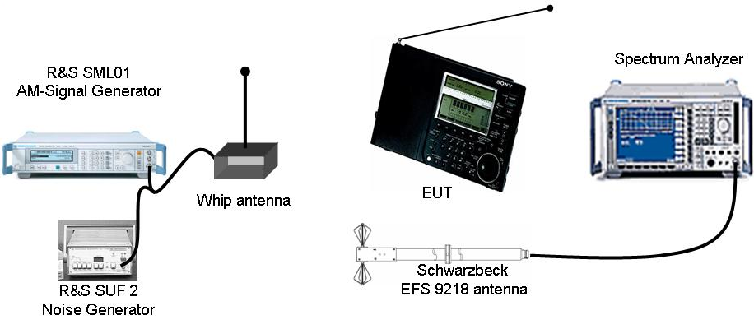
Figure 2: Test Setup anechoic chamber
Revise noise floor and relative level of ingress above noise floor in an anechoic chamber. An AM signal with added noise will be generated and feed into the antenna input of a radio receiver. Check the SNR when the signal becomes an acceptable quality.
At the setup as depicted in Figure 2 an AM-service was found that a speaking voice was no more able to be understood (this frequency is no more worth to be notched by PLT) if the field of the AM service was 31.1dB(µV/m) and the noise signal was 14,1dB(µV/m), using a spectrum analyzer or measurement receiver according to [4]. This results in an SNR of 17dB.
Tue to the fact, that DRM reception [2] in most robust transmission starts to be received at around 12dB SNR this value was chosen to be noted in [5].
Check Consumer Electronic Radio devices when they identify a service as useable when scanning the band.
Due to time reasons, unfortunately this test could not be performed.

4.2 Laboratory Test with Participants

4.2.1 Test environment
Test will be done in a laboratory. Depending on organization and logistics of the plugtest the lab equipment might be transported into one of the private homes.
The tests will be carried out as described in the current draft TS of WI21.

Equipment needed:
- Measurement apparatus
- Ground plane, 1m²
- Signal Ingress Generator
  - Test signals known to participants: PLT43_TD_08 / PLT43_TD_09 TS102578_V1.1.8_VerifyPattern.
  - More Test signals not known to participants before tests:
    - more or less carriers, DRM and / or AM
    - use other frequencies
    - incl. noise
- Spectrum Analyzer
- PLT Modems
- Data traffic generation for PLT modems
Specification of the unknown signals will be published after the PlugtestsTM. Test Signals will be shared with participants. So these tests could be reproduced by participants in their lab.

4.2.2 Test Procedure
Follow the test procedure as described in [5] (clause 6.5).
Data throughput will be measured using IPERF: transmit UDP traffic monitoring packet loss and throughput
Modems will be connected to data source and sink via Ethernet plugs.
Table 3 will be compiled during the lab tests:
Participant A | Max PLT throughput without any notches in Mbps |  |  | Timing from switch on artificial ingress signal till notch is established in sec | Max PLT throughput with notches in Mbps |  |  | Are all frequencies notched where a carrier ingress?  Yes / No | Are more frequencies notched? (Where no carrier ingress?)  Which? | Lower Level of the notch in dBm  Readout value as described in latest draft of WI21 TS §6.4 | Timing from switch off artificial ingress signal till frequency is reused by PLT in sec
Participant A | Attenuation from EUT to AE in dB |  |  |  | Attenuation from EUT to AE in dB
Participant A | 20 | 40 | 60 |  | 20 | 40 | 60
Known signal PLT43_TD_08
Unknown Signal A
Unknown Signal B
Unknown Signal C
Table 3: Results sheet of WI21 Lab tests
Record screen shot of Spectrum Analyzer of each ITU-R Radio band.
Monitor notch slopes for checking AM- / DRM Protection ratios: Fine Sweep using Spectrum analyzer on 1-2 notches
Additionally the threshold at which notches are inserted may be measured by changing the power of artificial signal ingress.

4.3 Field-tests with Participants in Building

4.3.1 Test environment
Test environment includes everything as described in clause 4.1.1 of this document (without biconal antenna).
Additionally the PLT modem equipment from participants is required.
Data throughput will be measured as described in clause 4.2.2

4.3.2 Test procedure
Connect the PLT modems to (various combinations of) outlets in building.
Tune SW-radio DRM / AM to e.g. 5 frequencies as described in clause 4.1.2 and record reception quality of radio stations. (The 5 with the lowest power) Table 4 will be compiled during the field tests in Buildings:

Participant A
Without Smart Notching: PLT throughput in Mbps:
Frequency  in kHz | Station name | SINPO  Signal | SINPO  Interference | SINPO  Noise | SINPO  Propagation | SINPO  Overall | Level of Ingress in dBm  measured at outlet where PLT Modem is connected.
 |  |  |  |  |  |  | Tx Modem | Rx Modem
6123 | Example AM | 2 | 3 | 3 | 5 | 3 | -75 | -70
Smart Notching active: PLT throughput in Mbps:
Frequency  in kHz | Station name | SINPO  Signal | SINPO  Interference | SINPO  Noise | SINPO  Propagation | SINPO  Overall | Level of Ingress in dBm  measured at outlet where PLT Modem is connected.
 |  |  |  |  |  |  | Tx Modem | Rx Modem
6123 | Example AM | 5 | 5 | 5 | 5 | 5 | -75 | -70
Quick test for ‘false detections’ of PLT modems:
Are there any frequencies notched which does not coincident with a receivable SW radio broadcast?
Schedule Skelton (UK) test broadcast transmission and monitor when PLT modem notches this frequency in sec:
Turn off Skelton (UK) test broadcast transmission and monitor when PLT reuses this frequency in sec:
Table 4: Results sheet of WI21 Field Tests in buildings

Notwithstanding the provisions of the copyright clause related to the text of the present document, ETSI grants that users of the present document may freely reproduce the <proformatype> proforma in this {clause|annex} so that it can be used for its intended purposes and may further publish the completed <proformatype>.
<PAGE BREAK>

Annex A (informative): .
Some pictures from the tests in 10th and 11th of October 2007:
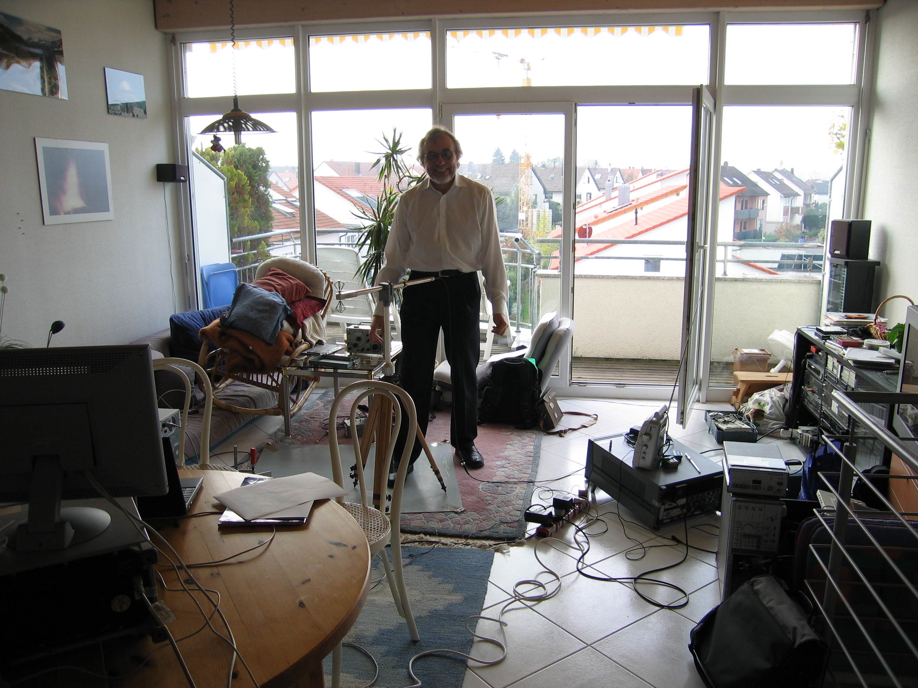
Mike Hate adjusting Biconal antenna in Dombovarstr. 18
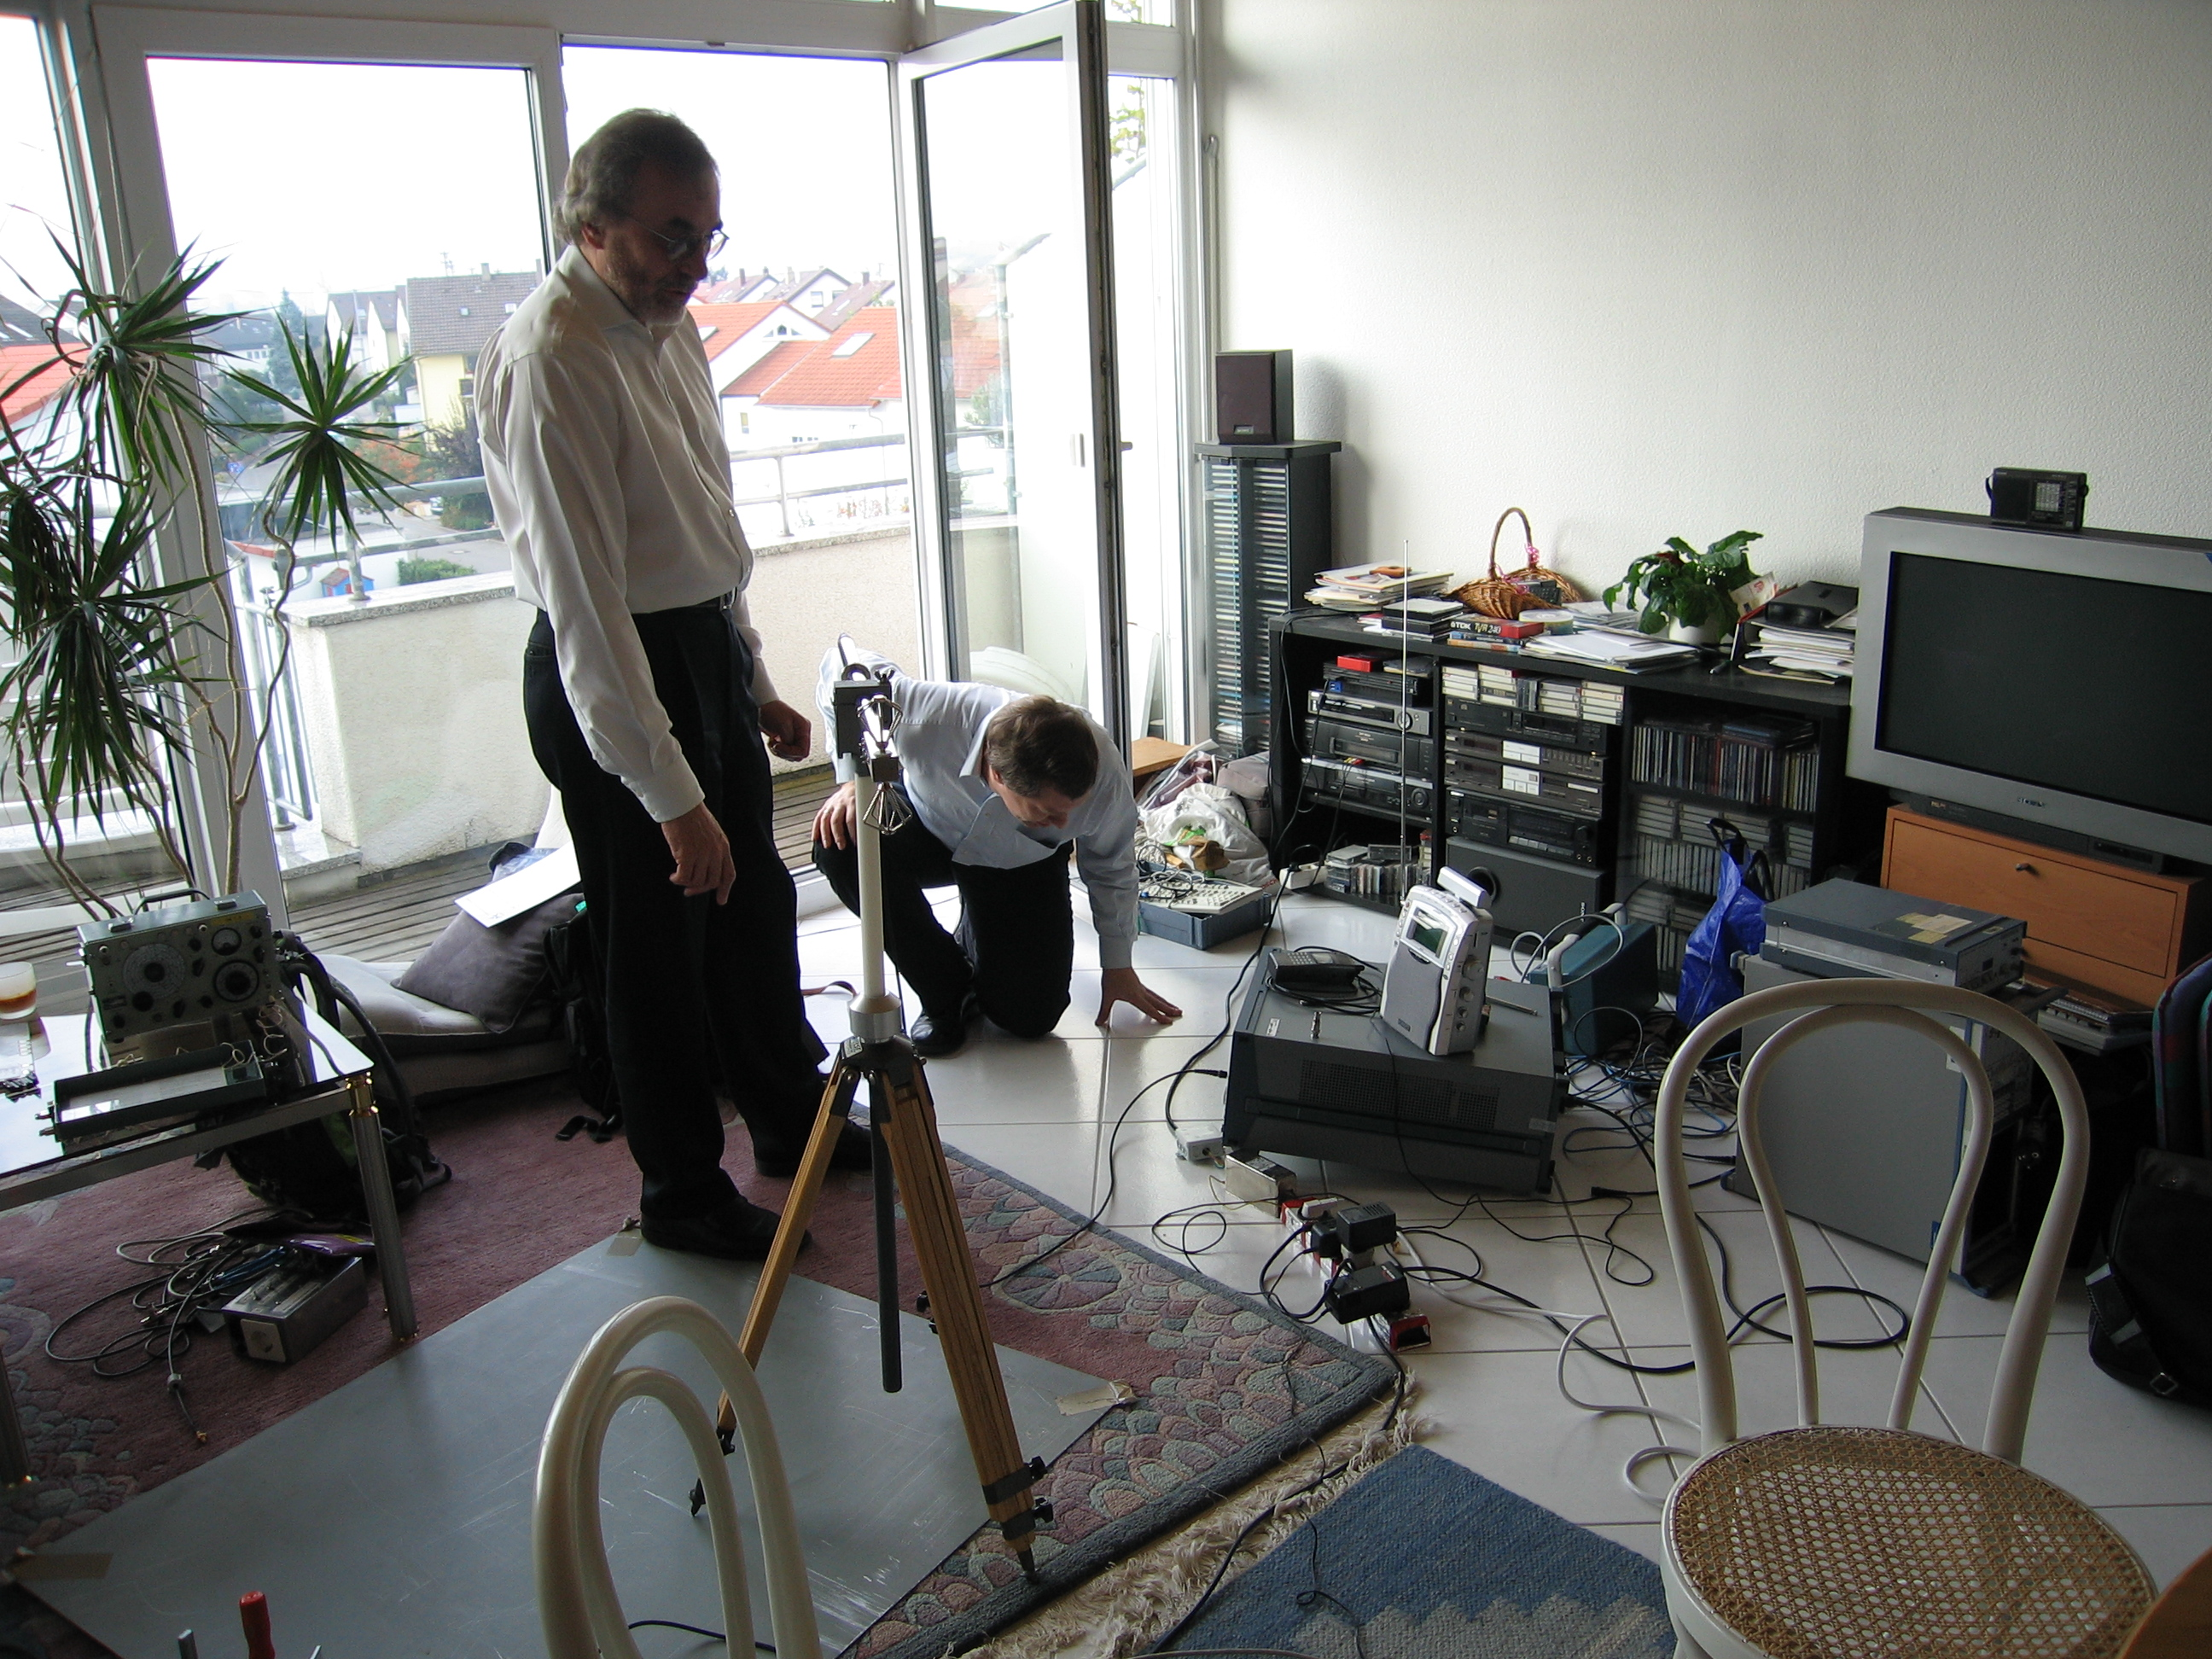
Mike Hate and Prof Holger Hirsch checking field strength.
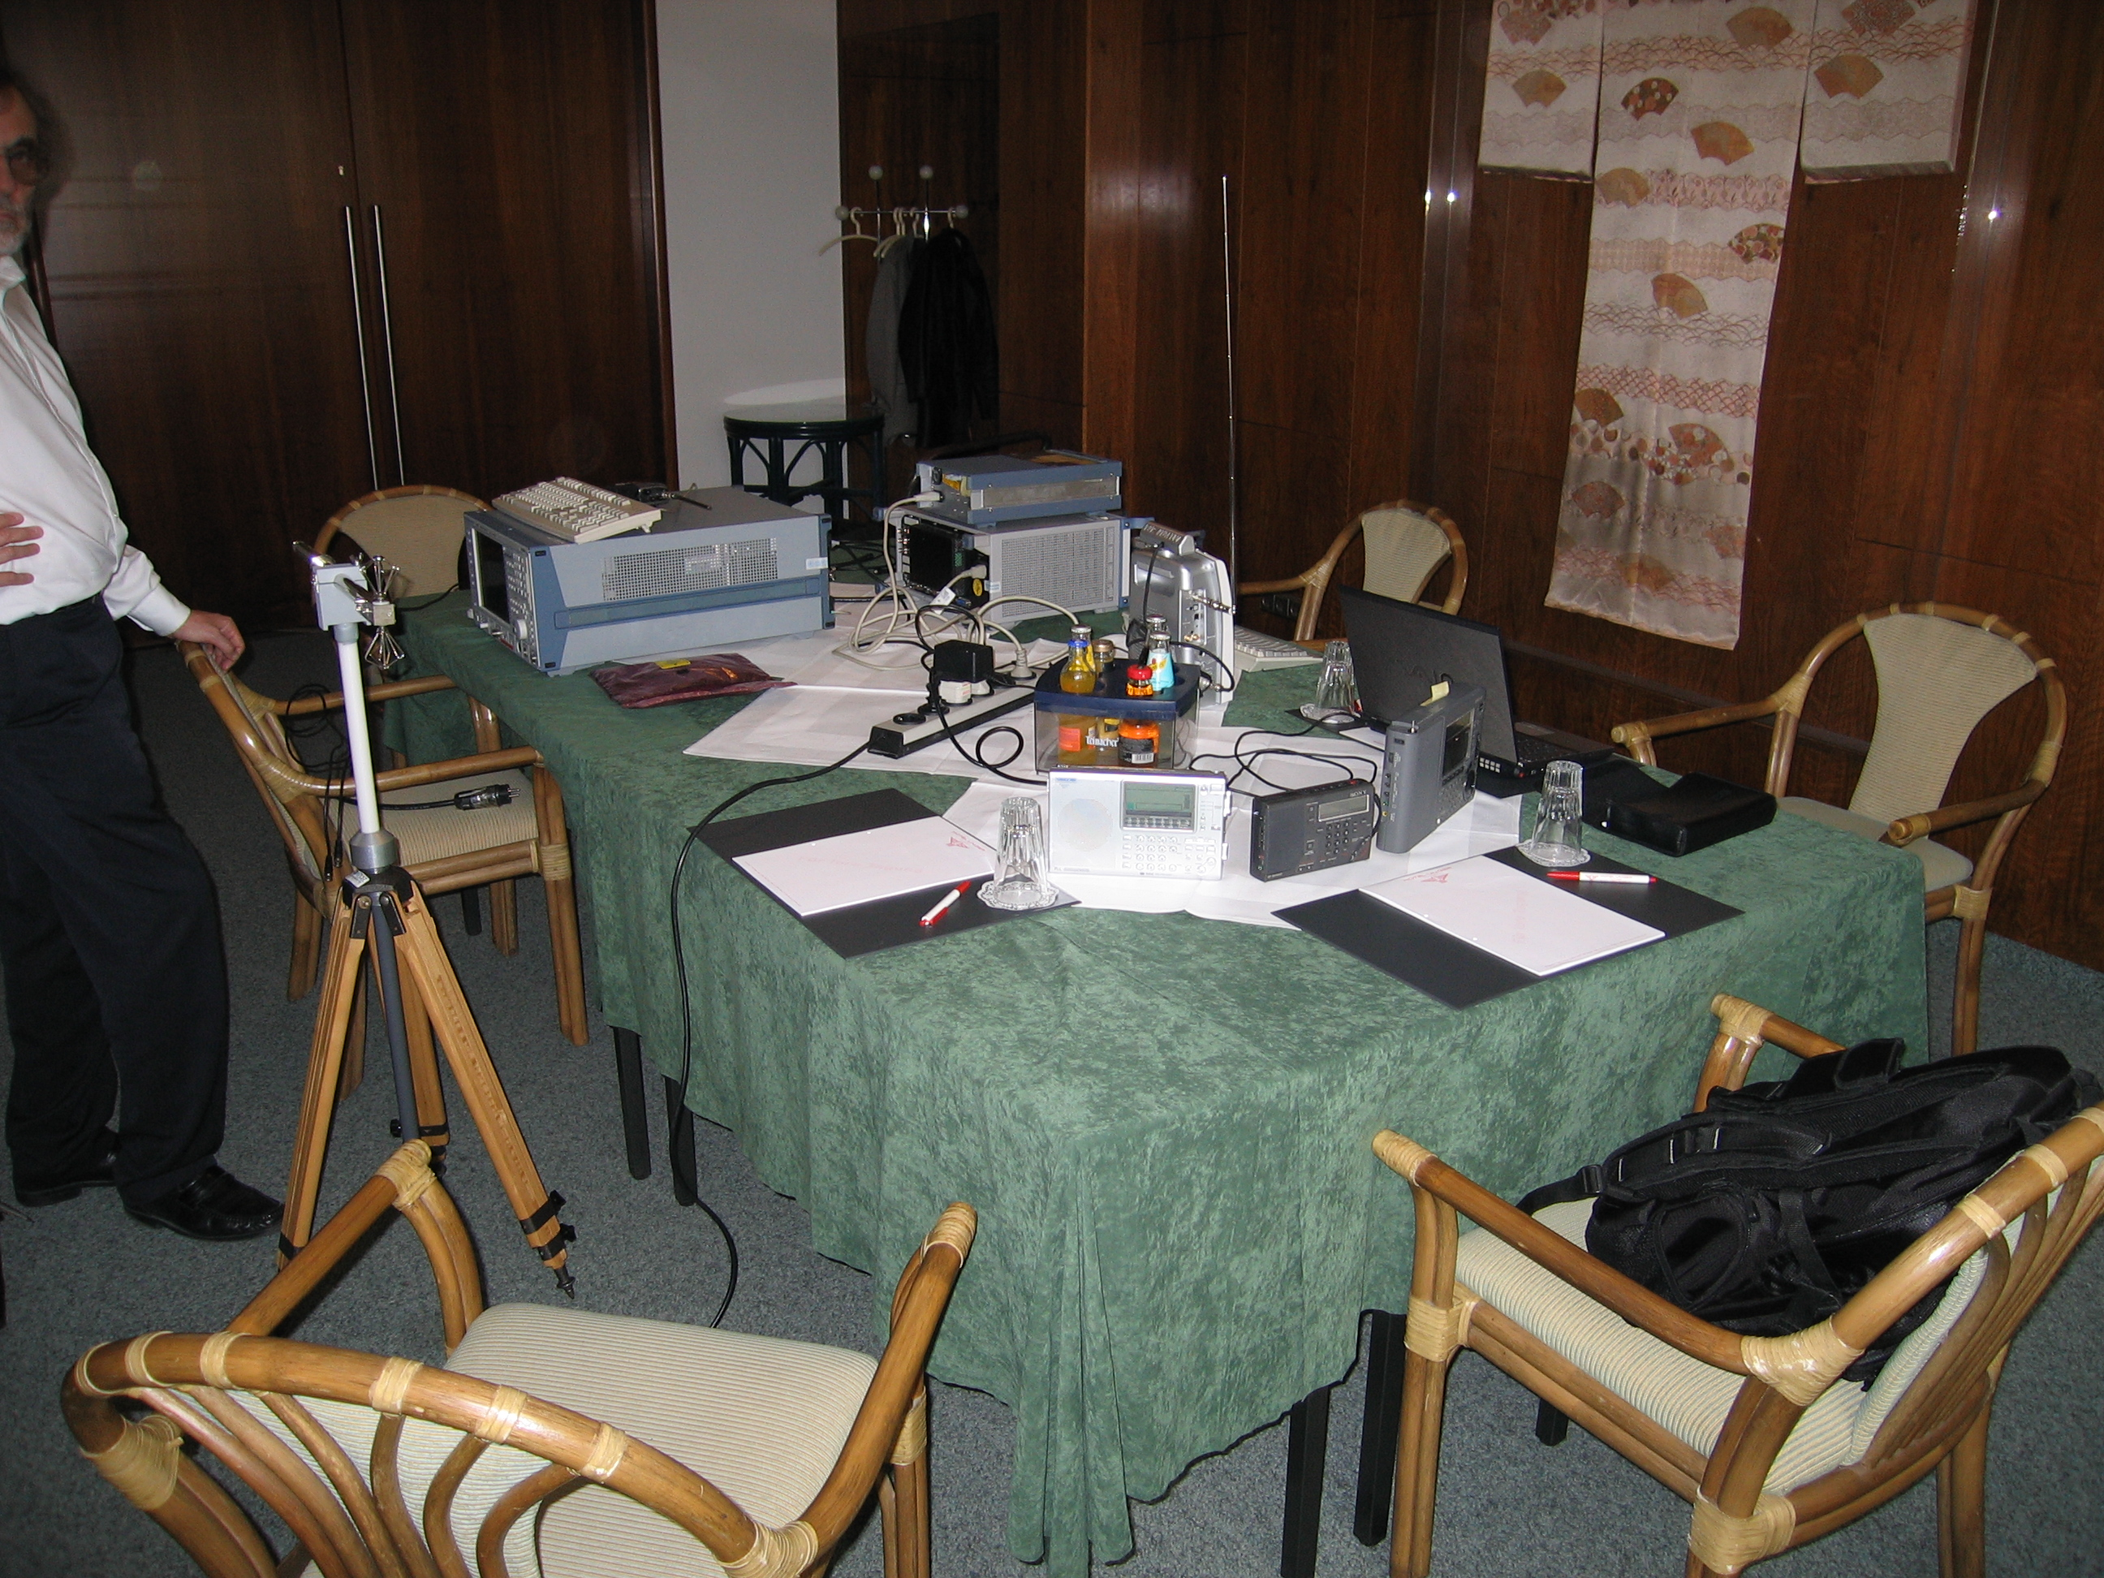
Test & measurement setup in Hotel Unger 1
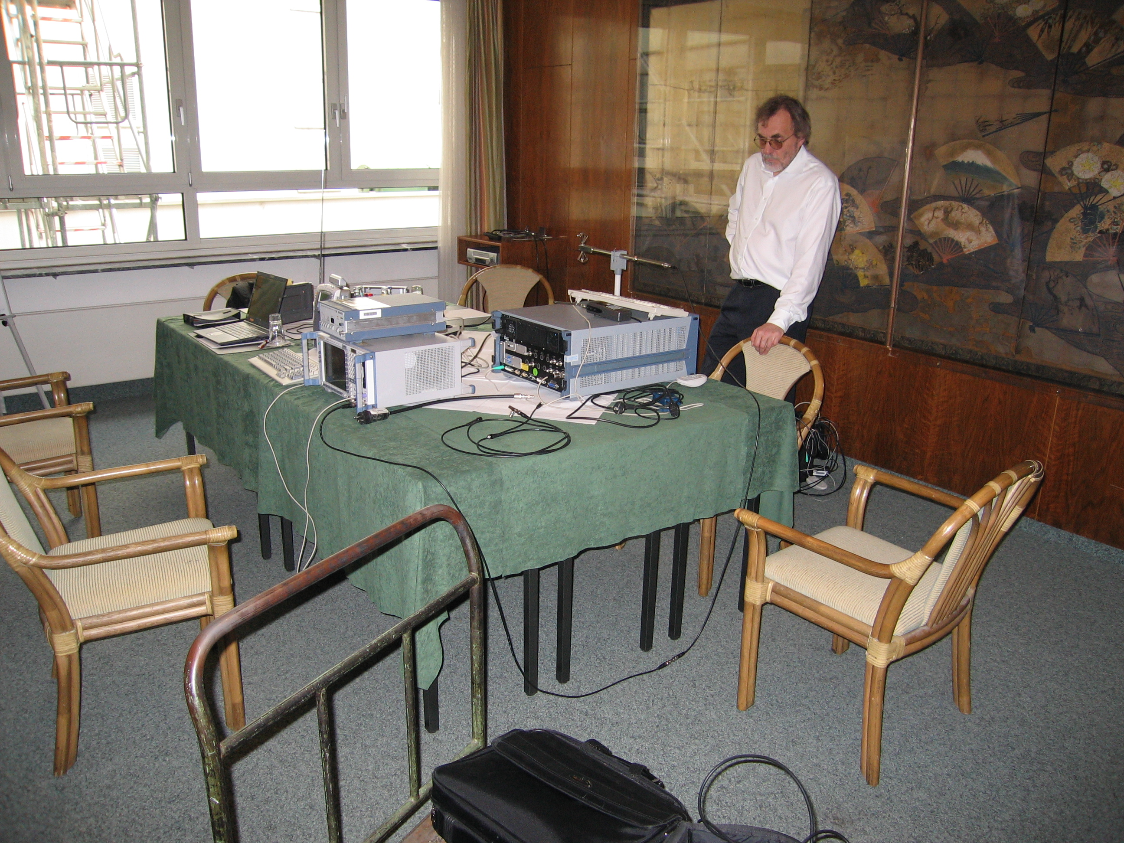
Test & measurement setup in Hotel Unger 2
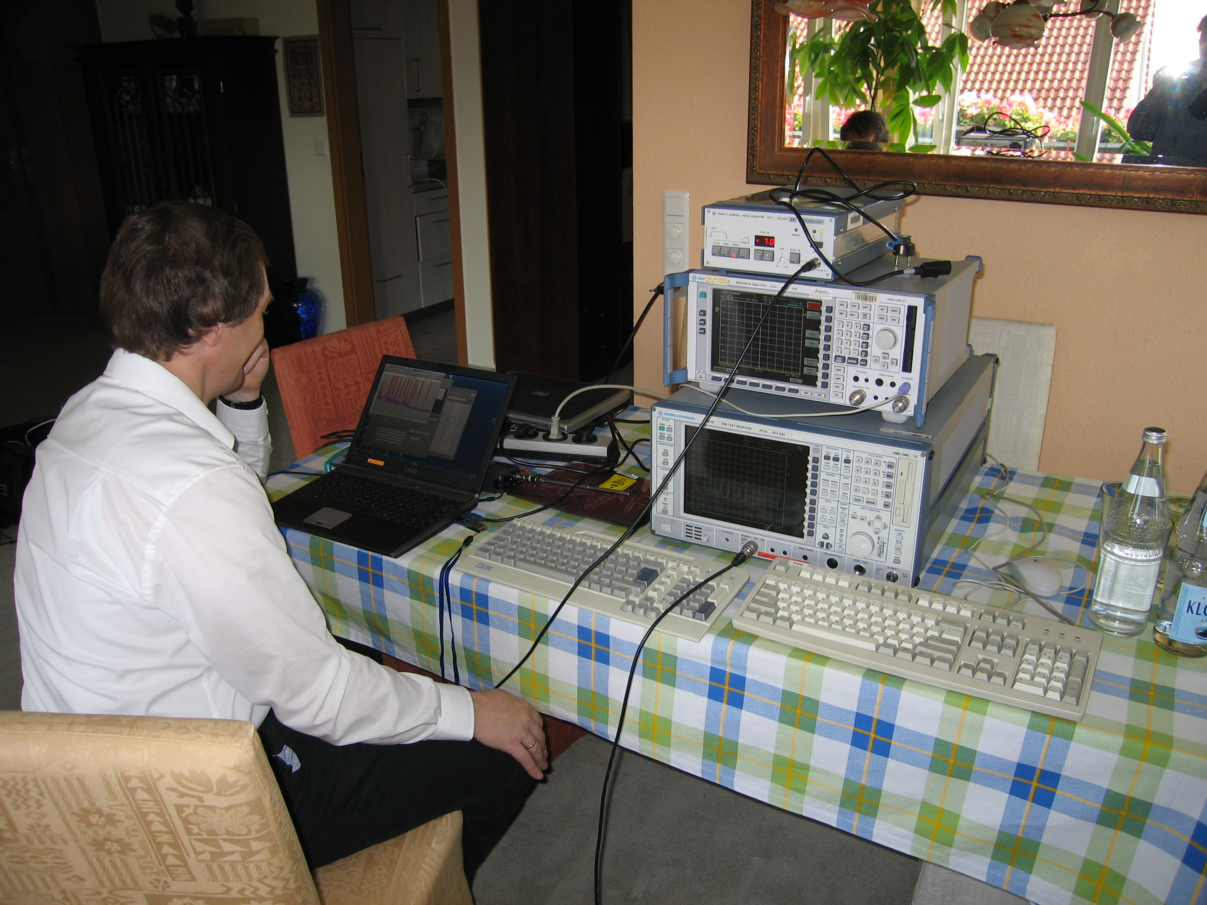
Measurement equipment in Rosenstr on the table from the top:
- R&S SUF2: White noise generator to feed signals into the mains
- R&S FSP Spectrum analyzer to do frequency scans and calculate median values of noise blocks
- R&S EMI tests receiver to perform measurements according to [4]

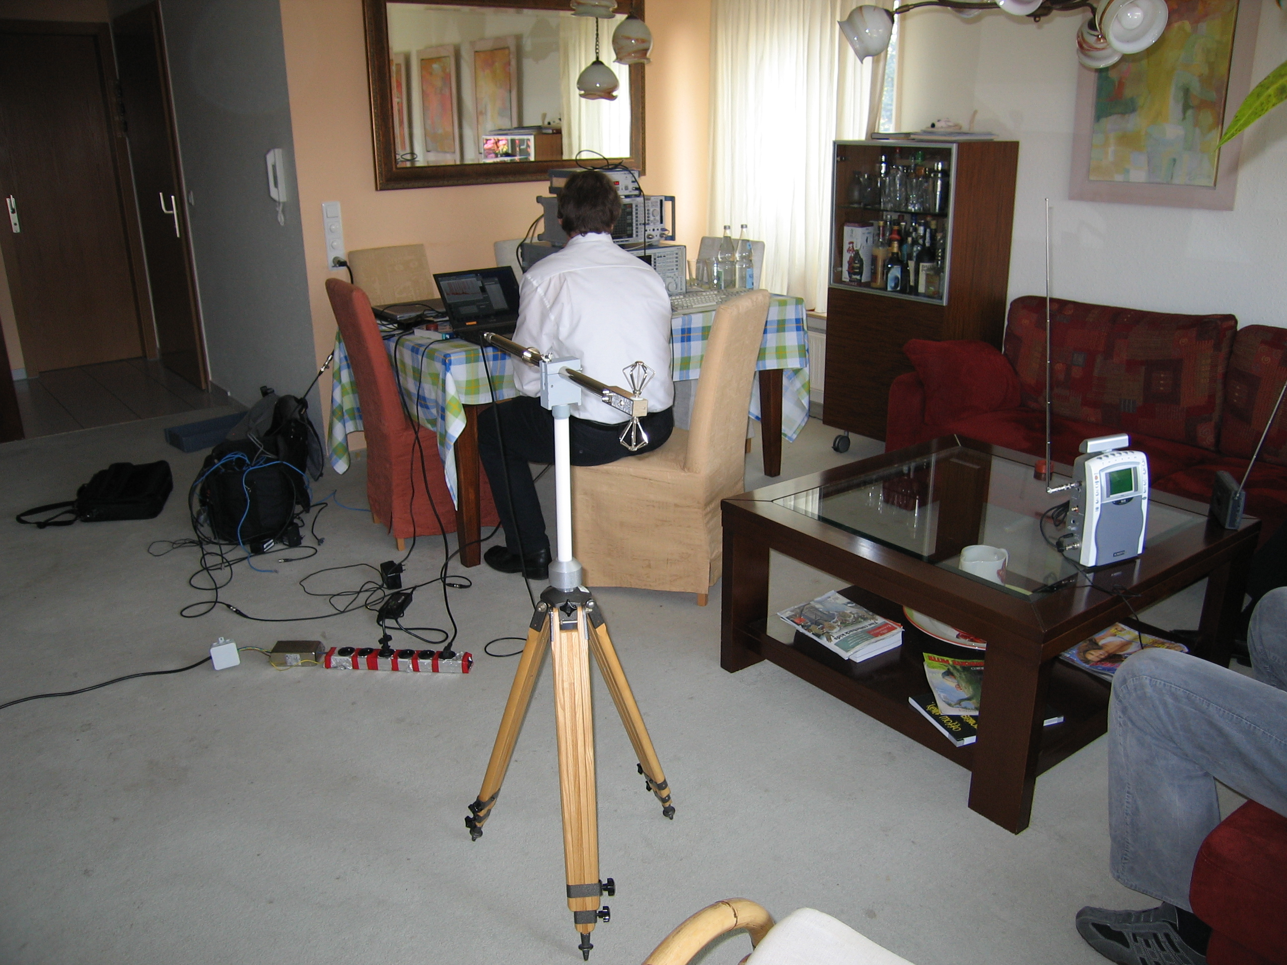
Biconal Antenna in Rosenstr.

History
Document history
<Version> | <Date> | <Milestone>
V0.0.1 | 17th of Aug 2007 | Initial Plugtest specification
V0.0.2 | 20th of Aug 2007 | editorial
V0.0.3 | 22th of Aug 2007 | editorial
V0.0.4 | 24th of Aug 2007 | editorial
V0.1.0 | 27th of Aug 2007 | Version uploaded to ETSI PLT #43
V0.1.1 | 30th of Aug 2007 | Picture added Test setup Isolation Cahmber
V0.1.2 | 8th of Oct 2007 | Bug fixed (date of tests) in Clause 4
V2.0.0 | 16th of Oct 2007 | 1st draft with test results

