Draft TR 102 801 V0.0.2 (2014-04)
“Test reports from technology demonstrator implementing sections of TS 102 800 on protocols for spectrum access and sound quality control systems for PMSE using cognitive interference mitigation techniques”

<

TECHNICAL REPORT
Reference
DTR/ERM-TG17WG3-013 (Phase 3)
ETSI STF 386
Keywords
PMSE; C-PMSE; SAB/SAP; ENG; OB; [check with ETSI]
ETSI
650 Route des Lucioles
F-06921 Sophia Antipolis Cedex - FRANCE

Tel.: +33 4 92 94 42 00 Fax: +33 4 93 65 47 16

Siret N° 348 623 562 00017 - NAF 742 C
Association à but non lucratif enregistrée à la
Sous-Préfecture de Grasse (06) N° 7803/88

Important notice
The present document can be downloaded from:
http://www.etsi.org
The present document may be made available in electronic versions and/or in print. The content of any electronic and/or print versions of the present document shall not be modified without the prior written authorization of ETSI. In case of any existing or perceived difference in contents between such versions and/or in print, the only prevailing document is the print of the Portable Document Format (PDF) version kept on a specific network drive within ETSI Secretariat.
Users of the present document should be aware that the document may be subject to revision or change of status. Information on the current status of this and other ETSI documents is available at http://portal.etsi.org/tb/status/status.asp
If you find errors in the present document, please send your comment to one of the following services:
http://portal.etsi.org/chaircor/ETSI_support.asp
Copyright Notification
No part may be reproduced or utilized in any form or by any means, electronic or mechanical, including photocopying and microfilm except as authorized by written permission of ETSI.
The content of the PDF version shall not be modified without the written authorization of ETSI.
The copyright and the foregoing restriction extend to reproduction in all media.

© European Telecommunications Standards Institute yyyy.
All rights reserved.
DECTTM, PLUGTESTSTM, UMTSTM and the ETSI logo are Trade Marks of ETSI registered for the benefit of its Members.
3GPPTM and LTE™ are Trade Marks of ETSI registered for the benefit of its Members and
of the 3GPP Organizational Partners.
GSM® and the GSM logo are Trade Marks registered and owned by the GSM Association.

Contents
If you need to update the table of content you would need to first unlock it.
To unlock the Table of Contents: select the Table of Contents, click simultaneously: Ctrl + Shift + F11.
Then lock it: reselect the Table of Contents and then click simultaneously: Ctrl + F11.
Contents 3
Intellectual Property Rights 6
Foreword 6
Introduction 6
Overview 6
Aim of this document 6
Applicability 7
1 Scope 8
Overview STF386 phases 1,2 and 3 8
2 References → TDOC 216 8
2.1 Normative references 8
2.2 Informative references 8
3 Definitions, symbols and abbreviations 10
3.1 Definitions 10
3.2 Symbols 10
3.3 Abbreviations 10
4 Specialities of PMSE (Tdoc204_v3) 12
4.1 Overview 12
4.2 Latency of service 12
4.3 Availability of service 12
4.4 Mobility 13
4.5 SNR operational conditions 13
4.6 Intermodulation 13
5 Terminology on spectrum use (TDOC212_v3) 13
5.1 Overview 13
5.2 Definitions 13
5.2.1 Spectral efficiency of a point to point connection 13
5.2.2 Spectral efficiency of a wireless communication system 14
5.2.3 Efficiency of spectrum use, sometimes also called short “spectral efficiency” 14
5.3 Objective in the context of a C-PMSE system 14
5.4 Spectral efficiency of a PMSE link 14
6 Cognitive Properties TDOC 205 14
6.1 Scope 14
6.2 Definition of Cognitive PMSE 14
6.2 General description of cognitive functionality 15
7 Concept of C-PMSE 15
7.1 Implementation of BMWi C-PMSE demonstrator 16
7.1.1 Ask before talk 16
7.1.2 Spectrum sensing (Listen before talk) 16
7.1.3 Spectrum Rating 16
7.1.4 Reaction 17
8 The Demonstrator in the BMWi C-PMSE Project 17
8.1 Scope 17
8.2 BMWi C-PMSE Project Overview 17
8.3 Architecture of BMWi C-PMSE Demonstrator 18
8.3.1 Elements of BMWi C-PMSE Demonstrator 19
8.3.2 Interfaces of realized Demonstrator 21
8.3.3 Limits of realized Demonstrator 21
9 Generalized C-PMSE system architecture 21
9.1 Elements of the architecture 21
9.1.1 Functionality of SCS 22
9.1.2 Functionality of LSDB 22
9.1.3 Functionality of C-PMSE 23
9.2 Interfaces 23
9.2.1 Scanning Interface (sci) 23
9.2.2 Local Spectrum Portfolio Manager Interface (lsi) 27
9.2.3 Tdoc 217 Radio Link Management Interface (rli) 29
9.2.3.1 Scope 29
9.2.3.2 Overview 29
9.2.3.3 Device Management Process 30
9.2.3.4 Dynamic Link Management Process 31
9.2.3.5 Commands on rli interface 31
10 TDoc 211 – Recommended Test Procedures for Individual Elements of SCS, LSDB and C-PMSE 32
10.1 Technical Requirement Specification 32
10.1.1 Scanning System (SCS) 32
10.1.2 Scanning Antenna (SCA) 32
10.1.2.1 Definition 32
10.1.2.2 Requirement 32
10.1.2.3 Conformance 33
10.1.3 Scanning Receiver (SCR) 33
10.1.3.1 Definition 33
10.1.3.2 Requirement 33
10.1.3.3 Conformance 33
10.1.4 Scanning Controller (SCC) 33
10.1.4.1 Definition 33
10.1.4.2 Requirement 33
10.1.4.3 Conformance 33
10.2 Local Spectrum Database (LSDB) 33
10.2.1 Definition 33
10.2.2 Requirement 34
10.2.3 Conformance 34
10.3 C-PMSE 34
10.3.1 Definition 34
10.3.2 Requirements 34
10.3.3 Conformance 34
10.4 Cognitive Engine (CEN) 34
10.4.1 Definition 34
10.4.2 Requirements 35
10.4.3 Conformance 35
11 Testing for compliance with technical requirements 35
11.1 Test suites SCS 35
11.2 Test suites LSDB 35
11.3 Test suites C-PMSE 35
11.3.1 LSDB related tests 35
11.3.2 C-PMSE dynamic reaction tests 36
12 Example: Demonstration Cases of the BMWi C-PMSE Platform 36
12.1 Scope 36
12.2 Description of demonstration cases 36
12.2 Automatic Setup Mode 36
12.3 Operational Mode (Automatic / Interactive) 37
12.3.1 Frequency agile behaviour 37
• Automatic mode 38
• Interactive mode 38
12.3.2. Transmit power agile behaviour 38
• Automatic mode 38
• Interactive mode 38
13 TDoc 208 - Demo Cases Beyond C-PMSE Project 38
13.1 Heterogeneous C-PMSE operation 38
13.1.1 Using the same frequency resources / databases 38
13.1.2 Interconnected with legacy PMSE systems 42
13.1.3 Capability of location awareness (e.g. GPS) 42
13.1.4 Coexistence of various types PMSE systems e.g. Video Cameras, IEM (In Ear Monitor) 42
13.1.5 Extension to frequency control, power control, adaptive modulation and coding (AMC) 42
13.2 Coexistence of PMSE with other kinds of systems such as White Space Devices or adjacent band LTE 42
13.3 Alignment of different databases (nationally controlled) 43
13.3.1 Suggestions for a standardised interface between C-PMSE systems and nationally designated databases 43
13.3.2 Database Discovery 43
13.3.3 Device Initialization 43
13.3.4 Device Registration 44
13.3.5 Available Spectrum Query 44
13.4.6 Device Validation 45
13.5 Fully automatic operation without manual intervention or setup 46
15 Signalling for C-PMSE (TDOC214) 46
15.1 Overview 46
15.2 Incorporating of Signalling in existing Standards 47
16 Findings and Suggestions TDoc 209 (not available) 48
Key Findings 48
Suggestions for standardisation 48
Suggestions for spectrum access = regulatory 48
17 Necessary Additions to EN 300 422 regarding C-PMSE (TDOC220) 48
17.1 Introduction 48
17.2 Proposals for modifications to existing parts 49
17.3 Proposals for addition of a new Part III 49
Proforma copyright release text block 49
Annexes 50
Annex <A>: 50
Annex B: Further Reading in the context of BMWi C-PMSE Project 50
<X.1> The TTCN-2 Machine Processable form (TTCN.MP) (style H1) 52
Annex <X+1>: ATS in TTCN-3 (style H9) 52
<X+1.1> TTCN-3 files and other related modules (style H1) 52
<X+1.2> HTML documentation of TTCN-3 files (style H1) 52
Annex <X+2>: Title of annex (style H9) 52
<X+2.1> First clause of the annex (style H1) 52
<X+2.1.1> First subdivided clause of the annex (style H2) 52
Annex <X+3> (informative): Change History 53
Annex <X+4>: Bibliography 53
History 54
A few examples: 54

<PAGE BREAK>

Intellectual Property Rights
This clause is always the first unnumbered clause.
IPRs essential or potentially essential to the present document may have been declared to ETSI. The information pertaining to these essential IPRs, if any, is publicly available for ETSI members and non-members, and can be found in ETSI SR 000 314: "Intellectual Property Rights (IPRs); Essential, or potentially Essential, IPRs notified to ETSI in respect of ETSI standards", which is available from the ETSI Secretariat. Latest updates are available on the ETSI Web server (http://ipr.etsi.org).
Pursuant to the ETSI IPR Policy, no investigation, including IPR searches, has been carried out by ETSI. No guarantee can be given as to the existence of other IPRs not referenced in ETSI SR 000 314 (or the updates on the ETSI Web server) which are, or may be, or may become, essential to the present document.
<PAGE BREAK>

Foreword
This Technical Report (TR) has been produced by ETSI STF386 PMSE – Cognitive Radio ERM / TG17 WP3: “Methods, parameters and test procedures for cognitive interference mitigation techniques for use by PMSE devices (Programme Makitng and Special Events)”; DTR/ERM-TG17WG3-013 (Phase 3).

Introduction

Overview
This document TR 102 801 is the deliverable of phase 3 work by ETSI STF386. It is a refinement of the concepts and methods depicted in earlier documents by phase 1 and phase 2. Phase 1 has generated document TR 102 799 “Electromagnetic compatibility and Radio spectrum Matters (ERM); Operation methods and principles for spectrum access systems for PMSE technologies and the guarantee of a high sound production quality on selected frequencies utilising cognitive interference mitigation techniques” and phase 2 document TS 102 800 “Electromagnetic compatibility and Radio spectrum Matters (ERM); Cognitive Programme Making and Special Events (C-PMSE); Protocols for spectrum access and sound quality control systems using cognitive interference mitigation techniques”.
The refinement is based on the experience and lessons learnt during the course of a German national research project called “C-PMSE” funded by the German Federal Ministry of Economics and Technology (BMWI). This project had the aim of ensuring the high quality of productions with PMSE under a dynamically changing interference situation.
This document therefore reflects several modifications to the originally proposed architecture of a cognitive interference mitigation system and spectrum access for PMSE and to the methods of operating it.
As the majority of partners and experts participating in STF386 are also partners on the German Research project a smooth transfer of public information gained in the research project to the STF work was ensured.

Aim of this document
This document will highlight the changes made to the architectural concepts and operation methods for cognitive interference mitigation with PMSE over the phase 1 and phase 2 deliverables as a consequence of the findings by the German research project. It provides the explanation for these changes.
This document provides recommendations on the interfaces that need to be standardised to ensure proper functionality of interference mitigiation.
As the german research project is running a large demonstration at Messe Berlin, several tests of cognitive behaviour have been conducted there and a deep understanding of necessary tests has been developed which serves as the basis for defining recommended test cases in this document. The aim is to recommend test cases that should be incorporated in the relevant standards.
C-PMSE technology should be incorporated in EN 300 422 and EMC 301 489-1 as soon as practicable in order to encourage the development and widespread use of cognitive PMSE systems in the market.

Applicability
Although the testings and demonstrations with the German reseacrh project have focussed on UHF, the findings on refinement of architecture and operation method are applicable to other bands.
<PAGE BREAK>

1 Scope

Overview STF386 phases 1,2 and 3
During Phases 1 and 2, the STF has done the following work:
Investigate methods, principles and techniques for spectrum access systems for PMSE technologies and for the guarantee of a high sound production quality on selected frequencies utilising cognitive interference mitigation techniques.
Deliver an ETSI Technical Report on “Operation methods and principles for spectrum access systems for PMSE technologies and for the guarantee of a high sound production quality on selected frequencies utilising cognitive interference mitigation techniques”, based on the findings under (). This Report will analyse the various possible techniques and recommend a specific method.
Deliver an ETSI Technical Specification on the recommended spectrum access technique, defined in ().
During Phase 3, the STF will:
Specify input test scenarios for a demonstrator for the TS developed under () and test its compliance.
Deliver an ETSI Technical Report of the defined RF compliance tests, carried out under (), for the selected spectrum access mechanism defined in () STF386 will propose the type of compliance required, which will be different from the current EN 300 422 specifications.
Please note that although the technology demonstrator will concentrate on one particular PMSE application and frequency band, the theory will be applicable to all PMSE applications.

2 References → TDOC 216
The following text block applies. More details can be found in clause 12 of the EDRs.
References are either specific (identified by date of publication and/or edition number or version number) or non-specific. For specific references,only the cited version applies. For non-specific references, the latest version of the referenced document (including any amendments) applies.
Referenced documents which are not found to be publicly available in the expected location might be found at http://docbox.etsi.org/Reference.
NOTE: While any hyperlinks included in this clause were valid at the time of publication ETSI cannot guarantee their long term validity.

2.1 Normative references
As the ETSI Technical Report (TR) is entirely informative it shall not list normative references.
The following referenced documents are necessary for the application of the present document.
Not applicable.

2.2 Informative references
Clause 2.2 shall only contain informative references which are cited in the document itself.
The following referenced documents are not necessary for the application of the present document but they assist the user with regard to a particular subject area.
[i.?] ETSI EN 300 422 (V1.3.2): "Electromagnetic compatibility and Radio spectrum Matters (ERM); Wireless microphones in the 25 MHz to 3 GHz frequency range".
[i.?] ETSI EN 300 726 (V7.0.2): "Digital cellular telecommunications system (Phase 2+) (GSM); Enhanced Full Rate (EFR) speech transcoding (GSM 06.60 version 7.0.2 Release 1998)".
[i.?] ETSI TR 102 683 (V1.1.1): "Reconfigurable Radio Systems (RRS); Cognitive Pilot Channel (CPC)".
[i.?] ETSI TR 102 546 (V1.1.1): "Electromagnetic compatibility and Radio spectrum Matters (ERM); Technical characteristics for Professional Wireless Microphone Systems (PWMS); System Reference Document".
[i.?] ETSI TR 102 799: "Electromagnetic compatibility and Radio spectrum Matters (ERM); Operation methods and principles for spectrum access systems for PMSE technologies and the guarantee of a high sound production quality on selected frequencies utilising cognitive interference mitigation techniques".
[i.?] ETSI TR 102 801: "Electromagnetic compatibility and Radio spectrum Matters (ERM); Test reports from technology demonstrator implementing TS 102 800 on protocols for spectrum access and sound quality control systems for PMSE applications using cognitive interference mitigation techniques".
[i.?] ETSI TR 102 802: "Reconfigurable Radio Systems (RRS); Cognitive Radio System Concept".
[i.?] Draft ECC Report 147: "Additional compatibility studies relating to PWMS in the band 1518-1559 MHz excluding the band 1544-1545 MHz".
[i.?] Li, Y., Quang, T. T., Kawahara, Y., Asami, T., and Kusunoki, M. 2009. Building a spectrum map for future cognitive radio technology. In Proceedings of the 2009 ACM Workshop on Cognitive Radio Networks (Beijing, China, September 21 - 21, 2009). CoRoNet '09. ACM, New York, NY, 1-6.
[i.?] WiMAX Forum Spectrum and Regulatory Database.
NOTE:
http://www.wimaxforum.org/resources/wimax-forum-spectrum-and-regulatory-database
[i.?] TEDDI database.
NOTE: http://webapp.etsi.org/Teddi/
[i.?] ERC Recommendation 70-03 (2009): "Relating to the use of Short Range Devices (SRD) PWMS: Annex 10 + Annex 13".
[i.?] CEPT Report 30: "Technical identification of common and minimal (least restrictive) technical conditions for 790 - 862 MHz for the digital dividend in the European Union".
[i.?] CEPT Report 32: "Recommendation on the best approach to ensure the continuation of existing Program Making and Special Events (PMSE) services operating in the UHF (470-862 MHz), including the assessment of the advantage of an EU-level approach".
[i.?] OET Report, FCC/OET 08-TR-1005: "Evaluation of the Performance of Prototype TV-Band White Space Devices Phase II".
[i.?] Commission Decision 2010/267/EU of 6 May 2010 on harmonised technical conditions of use in the 790-862 MHz frequency band for terrestrial systems capable of providing electronic communications services in the European Union.
<PAGE BREAK>

3 Definitions, symbols and abbreviations
Delete from the above heading the word(s) which is/are not applicable, (see clauses 13 and 14 of EDRs).
Definitions and abbreviations extracted from ETSI deliverables can be useful when drafting documents and can be consulted via the Terms and Definitions Interactive Database (TEDDI) (http://webapp.etsi.org/Teddi/).

3.1 Definitions
For the purposes of the present document, the following terms and definitions apply:
Adaptive Modulation and Coding (AMC): a protocol that sets modulation and coding parameters depending on channel state
Audio Basestation: The audio PMSE equipment that is fixed and part of C-PMSE Device
Audio Terminal: The audio PMSE equipment that is moving
CENbase: radio resource management including all time critical processes of CEN
Content plane: Contains audio and / or video information, analogue or digital
NOTE: The term data plane / data channel is not used in the present document due to potential irritations. Instead control and content plane are used.
Control Plane: a plane which contains only control information (signalling), e.g. Radio Resource commands, battery status, etc.
NOTE: The term data plane / data channel is not used in the present document due to potential irritations. Instead control and content plane are used.
ePMSE: evolved PMSE, a combination of content and signalling plane whose radio parameters of content plane can be altered electronically simultaneously on both ends of radio link
PMSE link: Describes the content-plane only.
Signalling link: Describes the signalling-plane only
Shared Infrastructure: C-PMSE information acquisition can be shared among multiple C-PMSE, regardless of mobile, nomadic or fixed use.

3.2 Symbols
Present document does not use special symbols

3.3 Abbreviations
ABT Ask Before Talk
AMC Adaptive Modulation and Coding
AMCT Adaptive Modulation and Coding Table
ASQ Action Sequencer
BMWi German Ministry of Research and Education
CEN Cognitive Engine
CENbase Time cricitcal processes of CEN
C-PMSE Cognitive PMSE
C-PMSE IA C-PMSE Information Acquisition
cpi Interface between co-located Radio Resource Managers
CR Cognitive Radio
CRS Cognitive Radio System
DAT Device Allocation Table
DBC Internal Database of CEN
DMO Demonstration Monitor
DUT Device Under Test
DVB-T Digital Video Broadcasting – Terrestrial
ePMSE Evolved PMSE
FAT Frequency Allocation Table
FCO Frequency Coordinator
fci Interface between CEN and LSPM
FM Frequency Modulation
GLDB Geolocation Database
gli Interface between Local Spectrum Database and Gelocation Database
GPS Global Positioning System
GNSS Global Navigation Satellite System
GSM Global System for Mobile Communication
GUI Graphical User Interface
HAL Hardware Abstraction Layer
HW Hardware
IA Information Acquisition, combines Scanning System and Frequency Booking
IEM In Ear Monitor
IM Intermodulation
IETF Internet Engineering Task Force
LAT Link Allocation Table
LBT Listen Before Talk
LQI Link Quality Indicator
LSDB Local Spectrum Database
LSPM Local Spectrum Portfolio Manager
lsi Interface between Local Spectrum Database and CEN
LTE Long Term Evolution
NRA National Regulatory Authority
P2P Point to Point
P2MP Point to Multipoint
PAT Power Allocation Table
PAWS Protocol to Access White Space Database
PMO Performance Monitor
PMSE Program Making and Special Events
REM Radio Environment Map
RF Radio Frequency
rli Interface between Hardware Abstraction Layer and CEN
RRM Radio Resource Manager
SCA Scanning Antenna
SCC Scanning Controller
sci Interface between Scanning System and CEN
SCR Scanning Receiver
SCS Scanning System
SINR Signal to interference plus noise ratio
SLA Service Level Agreement
SLE Service Level Entry
SNR Signal to noise ratio
SPM Spectrum Portfolio Manager
SW Software
TCP/IP Transmission Control Protocol / Internet Protocol
WSD White Space Device

<PAGE BREAK>

4 Specialities of PMSE (Tdoc204_v3)

4.1 Overview
PMSE especially PWMS have specific requirements that differ from other wireless systems. In the following some aspects are discussed.

4.2 Latency of service
PMSE has to serve very stringent latency requirements. The difference to most other wireless systems is that with PMSE the information source is co-located with the information sink, e.g. an artist is using a wireless microphone and simultaneously an In Ear Monitor.
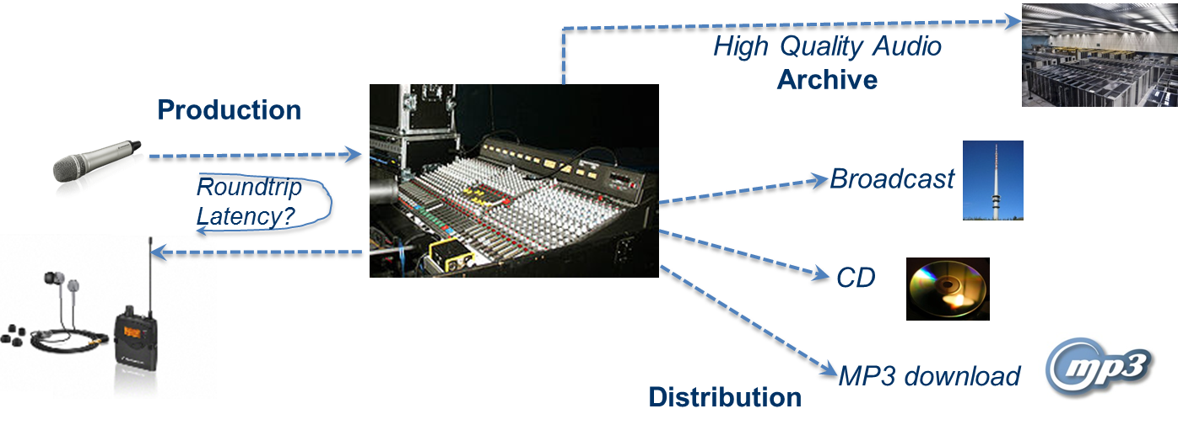
Roundtrip Problem scenario
The loopback from the artist back to the artist is enriched by the mixing console, where the information from other artists are added.
Experience from drummer artists tells that a roundtrip of smaller than 5 ms is needed for a high quality artistic performance. Assuming 1 ms for the mixing console, one PMSE link would be allowed to have maximum 2 ms latency, which is not in place today.
If with an event multiple microphones are used there is also a further requirement on the latency differences between the links as this may lead to acoustic holes (comb filtering) in spatial sound production or loss of synchronisation between audio and video production.

4.3 Availability of service
PMSE applications have high requirements in terms of availability of service. Availability should be 100%. In a high quality production loss of a wireless link, leading to interruptions of the audio link, called drop-outs, are not acceptable. In general no perceived interruption whatever root cause can be tolerated. As variations of received signal strength due to fading may easily reach 30 dB, typically a high margin and diversity gains are implemented on the link budget.
An event or performance cannot be repeated. Mostly these are unique events, so information would be lost totally. In other systems data can be repeated, which of course adds latency.
Robustness of transmission cannot be gained by wide temporal interleaving as this would introduce unacceptably large latency.

4.4 Mobility
Some artistic performances and ENG applications involve high speed by mobile terminals, like wireless microphones with singers on skates e.g. with Musicals Cats and Holiday on Ice or reports from cars. Therefore typically speeds up to 80 km/h have to be supported. It is not the case that PMSE doesn’t involve mobility.

4.5 SNR operational conditions
RF SINR Operational conditions for analogue FM links are higher than for other systems. As the 20 kHz audio bandwidth is typically expanded to 200 kHz wide RF channels, there is only a 10 dB bandwidth expansion gain by FM. This means that audio SNR is only 10 dB better than the RF SNR. So if an non-companded audio SNR of 60 dB is demanded, the SINR at RF has to be 50 dB. For reference GSM could work successfully with 7…9 dB SINR and CDMA systems may also work with negative SINR.

4.6 Intermodulation
In PMSE deployments one may face not only strong receiver, but also strong transmitter intermodulation. If for example an artist carries a wireless microphone and an instrument transmitter or if two singers stand close with their wireless microphones, reverse intermodulation can happen, meaning that part of the transmitter power from one wireless microphone enters the output stages of the other wireless microphone. Intermodulations products will be generated due to non-lienar behaviour of the output stage. As the operational RF SINR values are typically much higher than in other systems, PMSE is more vulnerable to transmitter and receiver intermodulation. This is the reason why intermodulation products are carefully planned up to IM5 products.

5 Terminology on spectrum use (TDOC212_v3)

5.1 Overview
For performing an optimization in terms of spectrum use, it is important to have a clear understanding of the metrics to be improved. In the following various metrics are presented. As there is also a lot of confusion in the definition of the term “spectral efficiency” the terminology is revisited here.

5.2 Definitions

5.2.1 Spectral efficiency of a point to point connection
The term “spectral efficiency of a P2P connection” describes the properties of a transmission scheme for a point-to-point link. It reflects the number of bits transported per second within a given bandwidth. It is measured as bit/s/Hz. It can be increased by several options:
- Increasing the order of modulation, e.g. from QPSK to 256 QAM.
- Appliying Source coding. With digital transmission e.g. MP3 could be used to reduce the amount of data to be transmitted. With analogue transmission an analogue compander reduces the dynamic range and by that also is a way of increasing spectral efficiency. Source coding is not only applicable to digital transmission, it is also applicable to analogue transmission.
- MIMO. This means multiple antennas at the transmitter and multiple antennas at the receiver. If the propagation channel offers a lot of reflections, the spectral efficiency more or less scales linearly with the number of antennas.

5.2.2 Spectral efficiency of a wireless communication system
The term “Spectral efficiency of a wireless communication system” describes the number of bits transported within a second and within a given bandwidth summed over all users normalized to served area. It is measured as bit/s/Hz/km² . It therefore reflects an aggregation over all users, thus multiple links, versus above definition which reflects only one link.
This spectral efficiency of a wireless communication system can be increased by smaller cells, i.e. smaller cell radius equivalent to more dense placing of communication nodes. Femto basestations with cellular networks are a good example for this approach.

5.2.3 Efficiency of spectrum use, sometimes also called short “spectral efficiency”
The term “Efficiency of spectrum use” describes the number of bits transported within a second and within a given bandwidth summed over all users normalized to area regardless what communication system the link belongs to. It is measured as: bit/s/Hz/km². It therefore reflects an aggregation over all users and all communication systems that share a spectrum.
It can be increased by implementation of co-primary and secondary systems, that make use of resources actually not in use by primary systems. So it is an opportunistic access by the secondary users.
As sometimes the “efficiency of spectrum use” is also named spectral efficiency, a conflict with the first definition arises. Therefore it should be avoided.

5.3 Objective in the context of a C-PMSE system
The objective with running a C-PMSE plus infrastructure is to increase the metric “efficiency of spectrum use”. This optimization is different from the activities on digitizing PMSE which mainly is related to the first definition “spectral efficiency” of the individual PMSE link. A C-PMSE system makes use of unused spectrum pieces for transmission, while still ensuring a high quality audio link at high availability level (no drop-outs).

5.4 Spectral efficiency of a PMSE link
There is large expectation that digitizing PMSE would increase “spectral efficiency” per se. This is not the case. Instead digital transmission implies additional overhead by e.g. signalling and channel training.
Spectral efficiency increase is not the primary scope of a C-PMSE system, but ensuring high quality, robustness and availability of PMSE links.

6 Cognitive Properties TDOC 205

6.1 Scope
The following sections provide general definitions of terms, general concepts, and high-level functionalities to be implemented by a cognitive PMSE. Furthermore, the high-level implementation of a C-PMSE demonstrator is described.

6.2 Definition of Cognitive PMSE
A cognitive PMSE is a Cognitive Radio System (CRS) designed for the purpose and the specific requirements of PMSE applications. [Editorial note: Reference ECC Report 002 FM51]

The ITU definition of Cognitive Radio Systems (CRS) [refer to Report ITU-R SM.2152, (09/2009) ] is as follows:
Definition | Actions
“A radio system employing technology that allows  - the system to obtain knowledge of its operational and geographical environment, established policies and its internal state;  - to dynamically and autonomously adjust its operational parameters and protocols according to its obtained knowledge in order to achieve predefined objectives ;  - and to learn from the results obtained.” | Orient, Observe  Plan, Decide, Act  Learn

Note: The implementations to obtain knowledge of its operational and geographical environment, and established policies (Orient, Observe) can include technology approaches such as geolocation database, sensing of the radio environment or cognitive pilot channels (CPC).

6.2 General description of cognitive functionality
Cognitive functionality includes at least following sequence of stages:
- Acquisition of context-awareness (Orient, Observe)
  - Gathering information about geo-location, radio spectrum environment, operational goals and parameters
  - Understanding and translating acquired information into suitable assessment criteria (e.g. rating of radio spectrum resources, definition of a suitable cost function for resource usage)
- Autonomous dynamic system reconfiguration (Plan, Decide, Act)
  - Planning and decision-making in order to achieve goals of operation, usually involving reasoned judgment of acquired knowledge and some optimization procedures
  - Implementation of decisions through reconfiguration and adaptation of operational parameters
Additional cognitive functionality may include learning from past actions and reoccurring situations. Learning functionality implies in general following system capabilities:
- Recognizing patterns of behaviour
- Evaluation of risks and prediction of future events

7 Concept of C-PMSE
In the light of the definition a cognitive PMSE, C-PMSE are able to acquire and use appropriate radio spectrum and autonomously avoid or minimise harmful interference while ensuring high audio quality by:
- obtaining knowledge about appropriate operating frequency ranges at the system’s geographic location and a certain time
- measuring the radio link quality and/or sensing the radio environment
- switching the wireless audio links to (alternative) operating frequencies and adapting their link parameters
- learning from past system behaviour and events

For that, a minimum C-PMSE consists of:
- a wireless audio link with control link, accessible by a base station
- a base station, possibly with access to a sensing system and/or a geo-location database
- a mechanism to obtain knowledge about appropriate operating frequency ranges (e.g. by contacting the administration, by access to a suitable database)
- a mechanism to assess the wireless audio link quality or possible interferences (e.g. by a sensing system or internal measuring capabilities)

7.1 Implementation of BMWi C-PMSE demonstrator
BMWi C-PMSE demonstrator considers only professional wireless microphone systems with state of the art analogue transmission scheme (FM). Digital audio transmission schemes are not in the focus of the BMWi C-PMSE demonstrator.

BMWi C-PMSE demonstrator consists of three main blocks:
- C-PMSE containing the C-PMSE master including cognitive engine, and the wireless audio links
- Scanning subsystem (SCS) with scanning receivers (SCR) and scanning controller (SCC).
- Local Spectrum Portfolio Manager (LSPM) maintains the local available spectrum portfolio for operation.

Not the complete concept but a subset of its functionality is implemented in the BMWi C-PMSE platform.
The implemented features are:
- Ask before talk
- Spectrum sensing (Listen before talk)
- Reaction on changes in spectrum environment and in transmission quality respectively.

7.1.1 Ask before talk
At start-up C-PMSE negotiates with a local spectrum portfolio manager (LSPM) and/or GLDB a spectrum range for operating at a certain time. Without negotiation C-PMSE shall not start wireless audio transmission.
With help of the LSPM it is possible to account for requirements to separate the useable spectrum range into different service classes, which offer different levels of transmission quality and spectrum allocation respectively.

Periodically C-PMSE has to renegotiate its operational spectrum ranges.

7.1.2 Spectrum sensing (Listen before talk)
The SCS is used for spectrum observation matters. It allows continuous sensing of the used spectrum range not only at system start-up but also during operation. To overcome hidden node and fading problems a grid of small, low cost scanning receivers (SCR) is employed.

7.1.3 Spectrum Rating
The spectrum rating process continuously translates measurement data of SCS into two assessment criteria:
risk: expressing the potential for getting interfered
quality: expressing the expected noise / interference level of free spectrum
expressing the measured signal-to-noise-ratio of used spectrum.

7.1.4 Reaction
During initialisation:
- C-PMSE rates the spectrum range provided by LSPM by means of measurement data coming from SCS to perform an initial frequency planning. The resulting frequency list is executed at C-PMSE operation start.

During operation:
- C-PMSE rates continuously the possible useable radio spectrum using measurement data from SCS. This includes by wireless audio links occupied and non-occupied radio spectrum.
- By wireless audio links occupied radio spectrum is rated by means of link quality indicator (LQI) data of each wireless audio link.
- The outcomes of rating processes can trigger related actions.

8 The Demonstrator in the BMWi C-PMSE Project

8.1 Scope
The following sections provide a detailed overview on the BMWi C-PMSE project and its demonstrator including architecture overview, elements, functionalities, and limits of the realized demonstrator. Furthermore, the interfaces to its LSPM and its distributed Scanning Subsystem (SCS) are provided as initial input for standardisation.

8.2 BMWi C-PMSE Project Overview
The C-PMSE project was started on April 1st, 2011 and will run in three phases for 32 month until November 30th, 2013.

The consortium of the BMWi C-PMSE project consists of five partners from industry, one research institute, and three universities.
Within the consortium Robert Bosch GmbH and Sennheiser electronic GmbH & Co. KG are representing the PMSE industry. The Institut für Rundfunktechnik GmbH (IRT), a research institute serving German, Austrian, and Swiss public broadcasters, represents the broadcasters as users of PMSE technology and the broadcasting services (like DVB-T) as primary user of radio spectrum in the UHF-TV bands. eesy-id GmbH is involved to develop sensor nodes, wiseSense GmbH for wireless coexistence and related standardization & regulation activities, and RFmondial GmbH develops monitoring software and data base infrastructures. The universities Friedrich-Alexander-Universität Erlangen-Nürnberg, Gottfried Wilhelm Leibniz Universität Hannover, and Ruhr Universität Bochum provide the practical and scientific expertise in electronics, signal processing, software defined radio, cognitive radio, radio resource management, signal classification, measurements, channel modelling, and link and system level simulation.

The C-PMSE project has two main objectives:
- Setting up a research platform for lab and field trials, and
- Driving standardization and regulation for cognitive PMSE systems.

Beside of the realization and setup of the lab and field trial platforms, the main goals include the development of all-necessary hardware and software components, the development and installation of a distributed scanning system with signal processing, network and data base infrastructure, and the verification of feasibility. Finally functional demonstrations and test operations on the lab and field trial platforms, which may include activities of the working group ETSI STF 386, will be performed. Coexistence investigations with other wireless services and devices, like white space devices, mobile communications, digital video broadcasting terrestrial (DVB-T), will be executed.
Standardisation and regulation activities of the project consider cognitive radio (CR)-enabled approaches for PMSE applications in worldwide regulatory frameworks. The BMWi C-PMSE project aims therefore, to provide appropriate and validated inputs for standardisations and frequency regulations.

Parts of the field trial platform will remain at Messe Berlin (fairground MBE) after the end of the project and is intended to be used for further field trials and follow up projects.

8.3 Architecture of BMWi C-PMSE Demonstrator
Figure 1 shows the block diagram of the C-PMSE demonstrator.

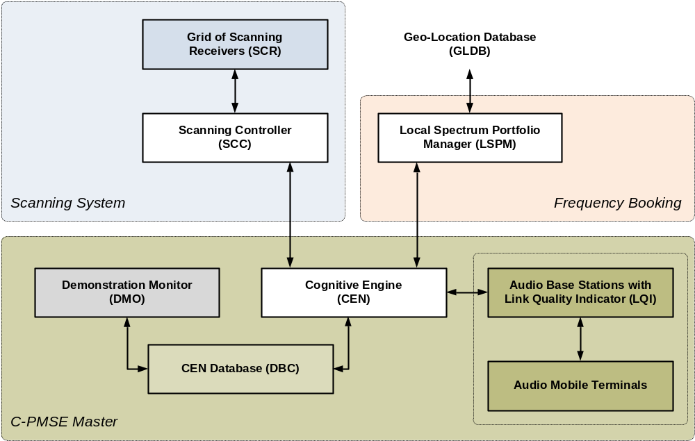
Figure 1: Block diagram of BMWi C-PMSE demonstrator

The three main blocks are:
- Local spectrum portfolio manager (LSPM) with interface to C-PMSE master and to the geo-location database (GLDB):
  - Lowest level of hierarchical GLDB
  - Task: Radio spectrum assignment to C-PMSE
- Scanning system (SCS):
  - Scanning grid with low cost scanning receivers (SCR)
  - Scanning controller (SCC)
  - Task: Continuous, and dedicated grid sensing of radio spectrum
- Cognitive PMSE (C-PMSE):
  - C-PMSE master with cognitive engine (CEN), internal database (DBC) and demonstration monitor (DMO)
  - Wireless audio links with one audio base station, one audio mobile terminal and one control channel per link.
  - Task: Maintaining high quality and availability of the wireless audio links

8.3.1 Elements of BMWi C-PMSE Demonstrator
- Local Spectrum Portfolio Manager (LSPM)
  - LSPM is the project’s realization of the lowest level of a geo-location based database (GLDB) hierarchy. It tells C-PMSE, which radio frequency ranges are available for operation. LSPM can also connect to GLDB maintained by IRT.
  - In TS 102800 LSPM is called frequency coordinator (FCO).

- Scanning System (SCS)
  - SCS comprises one Scanning Controller (SCC) and several Scanning Receivers (SCR). SCC is in charge of managing all SCR connected to it.
  - The Internal Database (DBS) within SCC is used for data exchange and act as a common interface within SCS to CEN of C-PMSE master.
  - Following a request from CEN, SCC schedules scanning jobs among its SCR, performs pre-processing (e.g. signal detection, parameter extraction) of data acquired and provides essential information to CEN. Allowing data pre-processing in SCC serves to distribute the computational load of the required signal processing and to significantly reduce the load on the interface between SCS and CEN.

- C-PMSE
  - Reconfigurable wireless audio links (audio base station + audio mobile terminal)
  - C-PMSE master

- C-PMSE master
  - C-PMSE master consists of a Cognitive Engine (CEN), an Internal Database (DBC), a Demonstration Monitor (DMO)
  - CEN constitutes the central control unit of the C-PMSE master and embodies the cognitive functionalities described in TDOC 205. CEN has the aim to guarantee interference-free high audio quality transmission of the reconfigurable wireless audio link.
  - Therefore,
    - it connects to LSPM in order to negotiate suitable radio frequency ranges for operation,
    - it continuously merges and analyses all information acquired via SCS with link quality indicators of the individual wireless audio links, and
    - it performs adequate dynamic resource allocation and transmit power control.
  - CEN is built up by different layers (see Figure 2), of which the higher layers are named CEN and the lower layers CENbase, which contains all time critical processes. CENbase is the equivalent to the Radio Resource Manager (RRM) depicted in TS 102800 without ASQ and AMCT. ASQ is not necessary in the current implementation anymore, because every system’s reaction is based on the current rating of the given solutions independent on the kind of interference scenario. AMCT is not implemented, because supported wireless audio links are frequency modulated, which means, that frequency and power are adjustable only (FAT/PAT).

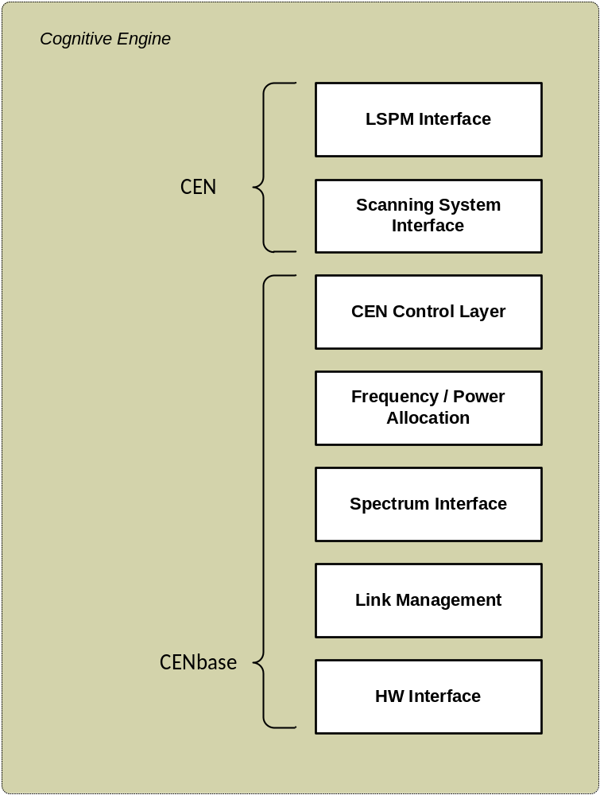
Figure 2: Layer model of cognitive engine

  - The Internal Database (DBC) is used for data exchange and as a common interface for all available components within C-PMSE Master.
  - DBC contains FAT/PAT, DAT, LAT, REM (see TS 102800) and the solution pool of the genetic algorithm

  - DMO allows visualization, tracing, and control of the behaviour and status of C-PMSE master operation. It also provides advanced storage capabilities to store measurement traces and log files. It combines the functionality of the performance monitor (PMO) and the service level entry (SLE) described in TS 102800 and TR 102799 respectively. SLE is realized as a lookup-table read in at system start-up. SLE cannot be adjusted during operation.

- Reconfigurable wireless audio links (audio base station + audio mobile terminal)
    - Frequency agile, or
    - Transmit output power agile
    - Audio base station is equipped with link quality indicator functionality

8.3.2 Interfaces of realized Demonstrator
Two interfaces are realized:
- sci: interface between CEN and SCC
- fci: interface between CEN and LSPM.
Original fci descript in TS 102800 is between RRM and FCO. Now it is rearranged and placed between CEN and LSPM. It is shifted from RRM (now CENbase) to higher layer CEN due to its less time critical character.

Original cpi (interface between RRMs of collocated C-PMSE) is omitted in the realization. Every inter C-PMSE communication shall be done via LSPM.

A more detailed view on the interfaces can be found in TDOC 213.

8.3.3 Limits of realized Demonstrator
There are several limits in the implementation of the BMWi C-PMSE demonstrator:
- Control plane is limited to a maximum of seven links
- LQI measurement hardware supports a maximum of eight links
- Six frequency agile wireless microphones are available
- Four RF output power agile microphones are available
- CEN handles either reconfigurable frequency or reconfigurable output power mode but not both simultaneously
- HW Management layer of CENbase supports Sennheiser or Electro-Voice products only
- DBC causes time delay when acquiring measurement data from a high number of SCR
- CEN expects technology and feature homogenous wireless audio links
- FM wireless audio links need long time for settling after frequency switching caused by the very low phase noise PLL
- Frequency range of frequency agile wireless audio links is limited from 718 to 790 MHz
- Output power range of transmit power controlled links is limited to approx. 20dB
- SLE is fixed during operation

General concept of BMWi C-PMSE is open for more links and frequency resources

9 Generalized C-PMSE system architecture

9.1 Elements of the architecture
Figure 3 depicts the generalized logical C-PMSE system architecture. The physical structure does not have to be identical with the logical structure.

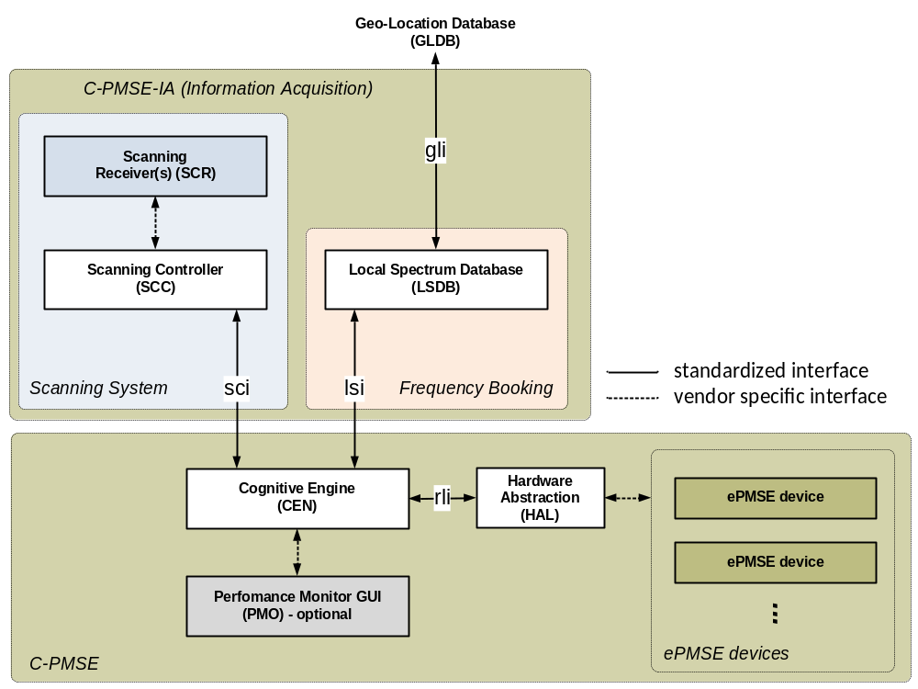
Figure 3: Generalized logical C-PMSE system architecture.

9.1.1 Functionality of SCS
The SCS consist of one SCC and one or more SCRs connected to the SCC. With the help of the connected SCRs the SCC generates a radio environment map which is power over frequency and time of the SCS installation location. The location can be divided into multiple zones. For each zone a separate radio environment map is generated. In the case that the SCS is part of shared infrastructure, the SCS is connected to the C-PMSE over the sci interface. The SCC provides the radio environment map of one or more zones upon request of the C-PMSE. Optional features of the SCS include classification or localization capabilities.
Furthermore, the SCC delivers information about capabilities, location and zone configuration of the SCS to the C-PMSE.

9.1.2 Functionality of LSDB
The LSDB is a database which contains a list of regional usable frequency ranges for the C-PMSE. The list is entered manually or could be granted from the GLDB automatically. The LSDB delivers the list of available frequencies to connected C-PMSE upon request. In the case that the LSDB is part of shared infrastructure, the SCS is connected to the C-PMSE over the lsi interface.
As an optional feature the LSDB contains a list of the currently used frequencies. Therefore, each connected C-PMSE can deliver its current link allocation to the LSDB. The LSDB distributes the list of the used frequencies to all connected C-PMSEs. There is no guarantee that the list of used frequencies is complete or consistent.

9.1.3 Functionality of C-PMSE

The C-PMSE provides the functionality to transmit the content of a production (e.g. audio) over the air. Therefore, it uses at least two ePMSE devices. These devices are configured according to the information from the ePMSE devices, the LSDB and the SCS.

9.2 Interfaces

9.2.1 Scanning Interface (sci)
The interconnection of a shared Scanning System (SCS) and one or more C-PMSE is realized with the bidirectional Scanning Interface (sci) based on Ethernet and TCP/IP. After an initial login and authentication procedure (which is not part of this interface description) the C-PMSE basically requests power spectral density and/or signal identification information for a certain frequency range from the SCS. The SCS answers which the corresponding measured data.

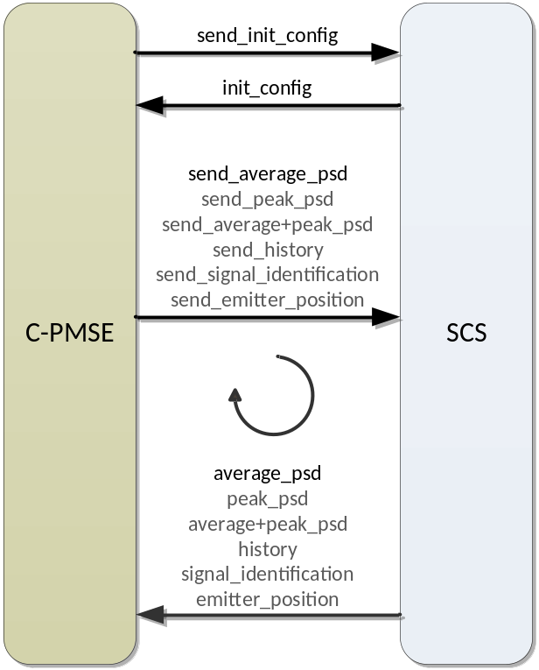
Figure 4: sci communication.

Table … summarises all mandatory (M) and optional (O) commands which could be send over the sci interface from C-PMSE to SCS.Error: Reference source not found

Command Name | Parameters
‘send_init_config’ (M) | -
‘send_average_psd’ (M) | f_range (f_start, f_stop)[Hz, Hz](M)  f_res [Hz](O)  avg_nmb [-](M)  zone [-](M)
‘send_peak_psd’ (O) | f_range (f_start, f_stop)[Hz, Hz](M)  f_res [Hz](O)  avg_nmb [-](M)  zone [-](M)
‘send_average+peak_psd’ (O) | f_range (f_start, f_stop)[Hz, Hz](M)  f_res [Hz](O)  avg_nmb [-](M)  zone (array{zone_number})[-](O)
‘send_history’ (O) | f_range (f_start, f_stop)[Hz, Hz](M)  time_range (time_start, time_stop)[timestamp,timestamp](O)  f_res [Hz](O)  zone [-](M)
‘send_signal_identification’ (O) | f_center [Hz](M)  bw [Hz](M)  zone [-](M)
‘send_emitter_position’ (O) | f_center [Hz](M)  bw [Hz](M)  zone [-](M)
Table 1: List of commands send from C-PMSE to SCS.

‘send_init_config’
A ‘send_init_config’ command includes no parameters. This mandatory command requests the initial configuration of the SCS.
‘send_average_psd’
A ‘send_average_psd’ command includes the frequency range f_range, the frequency resolution f_res in Hz with a typical value of 25 kHz, the number of averaged measurements avg_nmb and a zone number as parameters. This mandatory command requests the average power spectral density for a certain frequency range and resolution in the requested zone.
‘send_peak_psd’
A ‘send_peak_psd’ command includes the frequency range f_range, the frequency resolution f_res in Hz with a typical value of 25 kHz, the number of measurements avg_nmb over which the peak value is calculated and a zone number as parameter. This optional command requests the peak power spectral density for a certain frequency range and resolution in the requested zone.
send_average+peak_psd’
A ‘send_average+peak_psd’ command includes the frequency range f_range, the frequency resolution f_res in Hz with a typical value of 25 kHz, the number of average cycles avg_nmb and a zone number as parameters. This optional command requests the average as well as peak power spectral density for a certain frequency range and resolution in the requested zone.
‘send_history’
A ‘send_history’ command includes the frequency range f_range, the frequency resolution f_res in Hz with a typical value of 25 kHz and a zone number and a time_range as parameters. This optional command requests the SCS history for a certain frequency range and resolution in the requested zone over the requested time_range.
‘send_signal_identification’
A ‘send_signal_identification’ command includes the center frequency f_center in Hz, the bandwidth bw in Hz and a zone number as parameters. This optional command requests the signal identification inside of a certain frequency range in the requested zone.
‘send_emitter_position’
A ‘send_emitter_position’ command includes the center frequency f_center in Hz, the bandwidth bw in Hz and one zone number as parameters. This optional command requests an estimation on the emitter position inside of a confidence radius in the requested zone.
Table … summarises all mandatory (M) and optional (O) reports which could be send over the sci interface from SCS to C-PMSE.Error: Reference source not found

Command Name | Dataset
‘init_config’ (M) | time [timestamp]  scs_name [verbose]  zone_config (array{zone_number, zone_loc}[array{-,GNSS}]  f_range (start_freq, stop_freq) [MHz, MHz]  f_res (array{f_res}) [array{Hz}]  supported_commands (array{cmd}) [array{verbose}]
‘average_psd’ (M) | time [timestamp]  spectrum (array{freq_bin, psd_rms})[array{Hz, dBm}]
‘peak_psd’ (O) | time [timestamp]  spectrum (array{freq_bin, psd_peak})[array{Hz, dBm}]
‘average+peak_psd’ (O) | time [timestamp]  spectrum (array{freq_bin, psd_rms, psd_peak})[array{Hz, dBm, dBm}]
‘history’ (O) | time [timestamp]  spectrum (array{freq_bin, hx_rms, hx_peak, hx_dev})[array{Hz, dBm, dBm, dBm}]
‘signal_identification’ (O) | time [timestamp]  signal_type [verbose]
‘emitter_position’ (O) | time [timestamp]  location (em_loc, conf_r) [GNSS, m]
Table 2: List of reposts send from SCS to C-PMSE.
‘init_config’
An ‘init_config’ report includes a time stamp taken when the report is processed in the SCS, verbose name information of the SCS, the zone_configuration which is the zone_number and the corresponding zone location zone_loc in GNSS format, the frequency range f_range covered by the SCS, a vector of available frequency resolutions f_res as well as a list of supported_commands. This is a response to the mandatory ‘send_init_config’ command.
‘average_psd’
An ‘average_psd’ report includes a time stamp taken when the report is processed in the SCS and the spectrum dataset with the frequency bins and the average values of the power spectral density psd_rms in the requested zone as a response to the mandatory ‘send_average_psd’ command.
‘peak_psd’
A ‘peak_psd’ report includes a time stamp taken when the report is processed in the SCS and the spectrum dataset with the frequency bins and the average values of the power spectral density psd_peak in the requested zone as a response to the optional ‘send_peak_psd’ command.
‘average+peak_psd’
An ‘average+peak_psd’ report includes a time stamp taken when the report is processed in the SCS and the spectrum dataset with the frequency bins and the average and peak values of the power spectral density psd_rms and psd_peak in the requested zone as a response to the optional ‘send_average+peak_psd’ command.
‘history'
A ‘history’ report includes a time stamp taken when the report is processed in the SCS and the spectrum dataset with the frequency bins in Hz, the average and peak values of the SCS scanning history, hx_rms and hx_peak, and the deviation of the SCS scanning history over time hx_dev. These statistics are calculated over the requested time range with the data from the requested zone. This is a response to the optional ‘send_history’ command.
‘signal_identification’
A ‘signal_identification’ report includes a time stamp taken when the report is processed in the SCS and a verbose signal type identification information (e.g. 'DVB-T', 'LTE', 'PMSE', …) as a response to the optional ‘send_signal_identification’ command.
‘emitter_position’
An ‘emitter_position’ report includes a time stamp taken when the report is processed in the SCS and an estimation of the emitter location which is a GNSS coordinate em_loc and a confidence radius conf_r as a response to the optional ‘send_emitter_position’ command.

9.2.2 Local Spectrum Portfolio Manager Interface (lsi)
The interconnection of the Local Spectrum Portfolio Manager (LSDB) and one or more C-PMSE is realized with the bidirectional Local Spectrum Portfolio Interface (lsi) based on Ethernet and TCP/IP. After an initial login an authentication procedure (which is not part of this interface description) the C-PMSE requests available spectrum from the LSDB which offers available local spectrum resources over the lsi interface. During operation the C-PMSE can update its current frequency allocation to the LSDB. On the other hand, the LSDB notifies the C-PMSE about changes in spectrum usage which is optional.

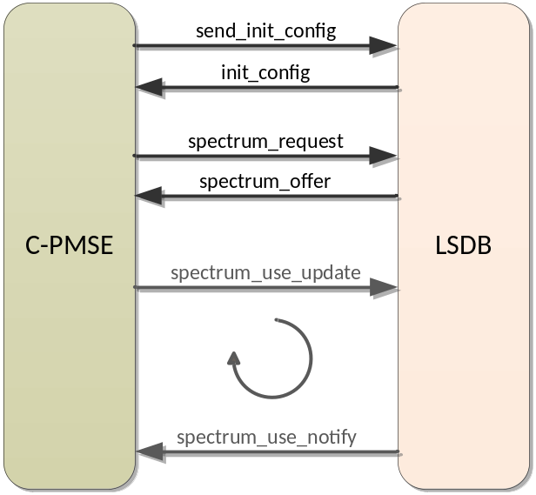
Figure 5: lsi communication.

Table … summarises all mandatory (M) and optional (O) commands which could be send over the lsi interface from C-PMSE to LSDB.Error: Reference source not found

Command name | Dataset
‘send_init_config’ (M) | -
‘spectrum_request’ (M) | location [GNSS coordinates] (M)  operation_radius [m] (M)  duration (start_time, stop_time)[timestamp, timestamp] (M)  freq_range (start_freq, stop_freq)[Hz, Hz] (O)
‘spectrum_use_update’ (O) | spectrum_usage (array{center_freq, keep_free_bandwidth, output_power}) [array{Hz, Hz, dBm}] (M)  potential_generated_imd (array{center_freq, bandwidth}) [array{Hz, Hz}](O)
Table 3: List of commands send from C-PMSE to LSDB.

‘send_init_config’
A ‘send_init_config’ command includes no parameters. This mandatory command requests the initial configuration of the LSDB.
‘spectrum_request’
The ‘spectrum_request’ command requests available spectrum from the LSDB. Beside the information where (location) and when (duration) the spectrum should be used, the parameter radius gives the spatial extend of the intended spectrum usage. With the parameter freq_range the requested frequency range could be limited.
‘spectrum_use_update’
The current spectrum usage of the C-PMSE can be signalled to the LSDB via the ‘spectrum_use_update’ command. The spectrum_usage dataset contains the current link allocation of the C-PMSE which is an array containing all center frequencies (center_freq), the corresponding bandwidth which should be kept free by other devices (keep_free_bandwidth) and the used output power (output_power). The optional dataset potential_generated_imd contains a list of potential disturbed frequencies by intermodulation products.

Table … summarises all mandatory (M) and optional (O) commands which could be send over the lsi interface from LSDB to C-PMSE.

Command name | Dataset
‘init_config’ (M) | time [timestamp]  lsdb_name [verbose]  supported_commands (array{cmd}) [array{verbose}]
‘spectrum_offer’ (M) | available_frequency_ranges (array{start_freq, stop_freq, max_allowed_output_power, validity_period}) [array{Hz, Hz, dBm, timestamp}] (M)  spectrum_usage(array{center_freq, keep_free_bandwidth, output_power}) [array{Hz, Hz, dBm}] (O)  potential_generated_imd (array{center_freq, bandwidth}) [array{Hz, Hz}](O)
‘spectrum_use_notify’ (O) | spectrum_usage (array{center_freq, keep_free_bandwidth, output_power}) [array{Hz, Hz, dBm}] (M)  potential_generated_imd (array{center_freq, bandwidth}) [array{Hz, Hz}](O)
Table 4: List of commands send from LSDB to C-PMSE.

‘init_config’
An ‘init_config’ report includes a time stamp taken when the report is processed in the SCS, verbose name information of the LSDB and a list of supported_commands. This is a response to the mandatory ‘send_init_config’ command.

‘spectrum_offer’
After a ‘spectrum_request’ command from the C-PMSE, the LSDB answers with a ‘spectrum_offer’. The available_frequency_ranges dataset contains an array of the potential usable frequency ranges (start_freq, stop_freq) with the maximum allowed output power in this range (max_allowed_output_power) and the validity of this spectrum grant (validity_period). Optionally, the already used and registered frequencies at the requested location are returned with the spectrum_usage dataset. The list of potential disturbed frequencies by intermodulation products are returned with the potential_generated_imd dataset.
‘spectrum_use_notify’
Each time the link allocation list in the LSDB changes (e.g. another C-PMSE reallocates its links and signals this to the LSDB via the ‘spectrum_use_update’ command) it notifies all connected C-PMSE about this frequency change with the ‘spectrum_use_notify’ command. This is done via the spectrum_usage and potential_generated_imd dataset as described above.

9.2.3 Tdoc 217 Radio Link Management Interface (rli)

9.2.3.1 Scope
The following sections provide a detailed overview on the interface between cognitive engine and connected wireless ePMSE links. Two processes for rli communication are described.

9.2.3.2 Overview
Radio link management interface connects the hardware abstraction layer (HAL) with the cognitive engine (CEN) as depicted in Figure 6.
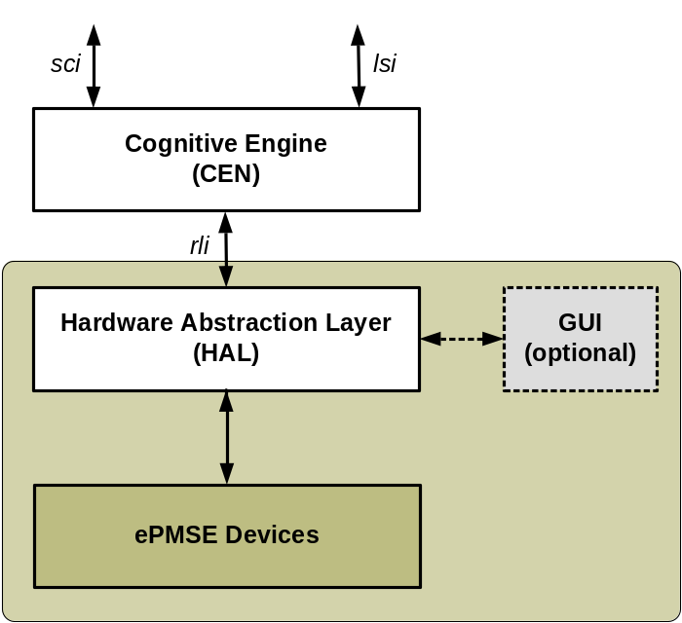
Figure 6: Architecture overview

rli is a bi-directional interface carrying commands, status and hardware information. It provides device capability information from ePMSE devices to CEN (e. g. RF bandwidth, minimum channel spacing, output power settings, …) and management commands from CEN to ePMSE devices. Status information like link quality indicator and battery state are communicated from ePMSE devices to CEN.
The hardware abstraction layer serves as vendor specific bridge to translate vendor specific hardware language to standardized commands for rli communication. For that reason HAL shall be provided by the corresponding vendor of ePMSE devices.
To get access to HAL without a cognitive engine or any other higher layer software an optional GUI is provided.
If more than one kind of PMSE devices is co-located, all devices can be managed by one CEN when connected to it via a specific HAL (see ). So it is possible to share one CEN with C-PMSE of different vendors or with different command syntaxes.
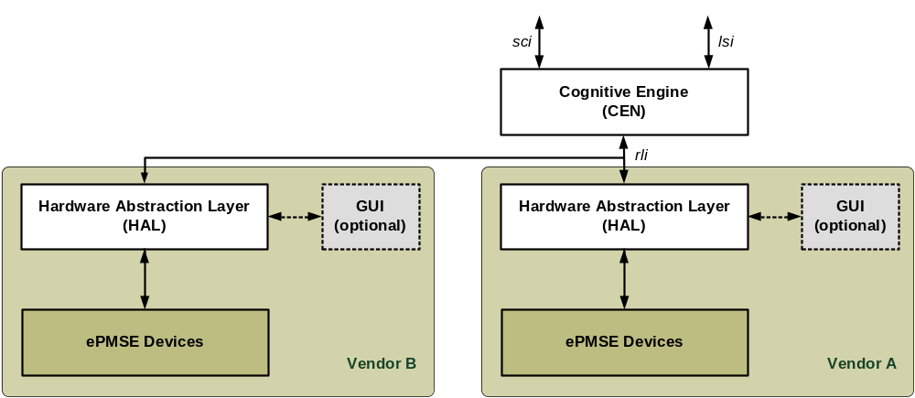
Figure 7: Two co-located C-PMSE connected to one CEN
Two processes are running. The Device Management Process is in charge of detecting what devices are connected and what capabilities they are having.
The Dynamic Link Management Process ensures that decisions by the CEN are immediately implemented in the PMSE devices.
The Device Management process is less time critical than the Dynamic Link Management Process.

9.2.3.3 Device Management Process
The Device Management Process run by CEN includes detection of PMSE devices like audio basestations that are connected to the Hardware Abstraction Layer (HAL) and passes their capabilities to the CEN. An example could be supported frequency range by a ePMSE device.
The detection could be a one time process during initialisation of a C-PMSE or a continuous process supporting adding and removing ePMSE links during operation. Such a Plug and Play scheme would support automatic configuration of the system.
As a minimum set a detection scheme during initialisation must be supported.
Commands that interrogate and pass capabilities of connected ePMSE links can be found in below section.

9.2.3.4 Dynamic Link Management Process
Dynamic Link Management Process reflects the alteration of radio link parameters based on decisions by the cognitive engine. The HAL translates commands on the rli into vendor specific commands to PMSE devices. As drop-out time has to be minimized the Dynamic Link Management Process running in the CEN has to be conducted in real time. Decisions by the CEN signalled on rli have to be implemented at the ePMSE links with low latency.
Dynamic Link Management Process includes alteration of parameters like carrier frequency, transmit power, modulation and coding. As a minimum set the commands for alteration of frequency must be supported.
The commands generated by the two processes have identical syntax.

9.2.3.5 Commands on rli interface
Below the necessary commands on rli interface are given. First the commands from CEN to HAL are given and then vice versa.
From CEN to HAL:
rli Command | Parameters | Notes
set_frequency_link (M) | Link_number #, f_carrier [Hz], Acknowlede mode (yes/no) | To allow also a mix of very narrowband and wideband transmission schemes, e.g. PMSE effect control.  Acknowledged mode is optional.
set_power_link (M) | link_number #, power [dBm]
set_AMC_link (O) | link Number #, AMC# | AMC modes are vendor specific
ask_capabilities_link (M) | link Number # | Returns link capabilities
set_RFpower_onoff_link (M) | link_number #, on/off | Switches transmit device on / off
ask_identity_link (M) | link_number #
ask_quality_link (M) | link_number #
ask_rssi_link (M) | link_number #
ask_status_link (O) | link_number #

From HAL to CEN:
rli Command | Parameters | Notes
confirm_set_frequency_link (O) | link_number # | This acknowledge reflects that a frequency change was successfully implemented on ePMSE link and the link is up and running again.
capabilities_link (M) | link number #,  f_start [Hz], f_stop [Hz],  stepsize [Hz],  channel_bandwidth [Hz]  min_channel_spacing [Hz],  min_IMD_spacing [Hz],  output_power [dBm],  TX_IMD_performance [dBc]  RX_IMD_performance [dBc] | Channel_bandwidth and output_power are lists of possible discrete settings;  RX_IMD_performance may be set to infinity if not relevant;  dBc-values are always positive
identification_link (M) | link_number #, PMSE type (Audio/Video/Effect/Safety/Others), text string | Text string may contain equipment code
quality_link (M) | link_number #, LQI [SNR dB] | EVM and BER figures can be converted to SNR
rssi_link (M) | link_number #, RSSI [dBm]
status_link (O) | link_number #, yes/no | “yes” implies that content plane and bidirectional control plane works.

Note
In a P2MP environment like conference systems a link is comprised out of all links to all paired devices. In such scenarios the weakest RSSI and the lowest SNR are returned from HAL to CEN.

10 TDoc 211 – Recommended Test Procedures for Individual Elements of SCS, LSDB and C-PMSE
Comment:
This TR can not place essential requirements to put product on the market (like EN300422). We provide fundamental requirements and testing recommendations.

10.1 Technical Requirement Specification

10.1.1 Scanning System (SCS)
Definition:
A Scanning System (SCS) is an component of the C-PMSE-IA.
Note: The C-PMSE-IA can be part of a C-PMSE (single device including all).
The Scanning System (SCS) is composed of one or more Scanning Receivers (SCR) with Scanning Antennas (SCA) and one Scanning Controller (SCC).
Multiple SCR can be distributed within areas of interest.

10.1.2 Scanning Antenna (SCA)

10.1.2.1 Definition
A Scanning Antenna (SCA) is an integral or non-integral antenna connected to the Scanning Receiver (SCR). SCA may include antenna systems, e.g. multi-antenna systems, beamforming systems, or Multi-Beam.

10.1.2.2 Requirement
The SCA should be built for a radio frequency range including the radio frequencies of interest.
Further information on the antenna should be available for testing and calibration purposes.

10.1.2.3 Conformance
Requirements shall be fulfilled by the manufacturer via product specification and user manual.

10.1.3 Scanning Receiver (SCR)

10.1.3.1 Definition
A SCR is a device able to acquire measurements or information on the radio spectrum and its usage.
A SCR may have integral or non-integral SCA.

10.1.3.2 Requirement
The Scanning Receiver (SCR) shall be built for a radio frequency range including the radio frequencies of interest.
Calibration information on the SCR shall be available by the manufacturer.
The SCR shall provide an interface and protocol supported by SCC.

10.1.3.3 Conformance
Requirements shall be fulfilled by the manufacturer via product specification and user manual.

10.1.4 Scanning Controller (SCC)

10.1.4.1 Definition
A SCC is built to cope with one or multiple SCR using a protocol for control and data exchange.
Note: A multitude of standardized or vendor-specific protocols could be supported by SCC.
A SCC is built to cope with one or multiple C-PMSE using a protocol for control and data exchange.

10.1.4.2 Requirement
The interface and protocol as specified in Tdoc 213 (sci) shall be used for communications among SCC and C-PMSE, if the sci is available to attach shared infrastructure. Shared infrastructure, means C-PMSE IA can be shared among multiple C-PMSE, regardless of mobile, nomadic or fixed use.

10.1.4.3 Conformance
Adequate protocol tests shall be used to verify the communications between SCC and C-PMSE, if sci is available.
(Editorial Note: Requirement for EN300422)

10.2 Local Spectrum Database (LSDB)

10.2.1 Definition
The LSDB is part of the C-PMSE-IA.
The LSDB holds information on the frequencies locally allowed for usage by C-PMSE.
Note: There are several ways to provide this information:
- Manual license entering in case of written frequency grants by NRA.
- Automatic license entering via some kind of GLDB operated by or on behalf of an NRA.
- Manual or automatic entering of frequency bands allowing license exempt operation by C-PMSE.
In addition, the LSDB can be used to share information on spectrum usage among co-located C-PMSE.

10.2.2 Requirement
The LSDB shall provide an interface and protocol corresponding to TDOC 213 to interact with C-PMSE, if the LSDB is part of shared infrastructure (lsi).
Note: The LSDB should also support corresponding interfaces and protocols to frequency information databases/GLDB. This note gets an requirement, if access to GLDB is required by NRA.

10.2.3 Conformance
- It is recommend to use an adequate protocol tester to verify the communications between LSDB and frequency information databases/GLDB.
- It is mandatory to test the communication between LSDB and C-PMSE, if lsi is available to external.

10.3 C-PMSE

10.3.1 Definition
A C-PMSE consists of a Cognitive Engine (CEN) and ePMSE devices.
A Performance Monitor (PMO) could be included.
The ePMSE devices are dynamically adjustable concerning their radio link parameters and shall report Link Quality Indicator (LQI).
Note: Radio link parameters can include: RF carrier frequency, RF output power, Occupied RF bandwidth, Adaptive Modulation and Coding

10.3.2 Requirements
A C-PMSE shall provide lsi and/or sci, if the C-PMSE can be attached to shared infrastructure.

10.3.3 Conformance
- It is mandatory to test the communication between C-PMSE-IA and C-PMSE, if lsi and/or sci is available.

10.4 Cognitive Engine (CEN)

10.4.1 Definition
A Cognitive Engine (CEN) is an entity that is part of C-PMSE.
A CEN performs tasks required for information rating, decision making, and optional learning based on C-PMSE-IA input and PMSE device information.
A CEN is capable of configuring radio link parameters parameters to be used by attached ePMSE devices according to its decisions. A CEN can communicate with ePMSE devices via a Hardware Abstraction Layer (HAL) as specified in TDOC217 for their dynamic management.

10.4.2 Requirements
The radio link parameters defined by CEN shall not generate harmful interference to other systems.
Note: The operation of CEN should lead to a time stable and efficient utilization of the radio spectrum.
A CEN shall employ the Hardware Abstraction Layer (HAL) as specified in TDOC217 for dynamic management of ePMSE devices, if the CEN is shared for the purpose of different (e.g. multi-vendor) PMSE device support.

10.4.3 Conformance
- Radio link parameter sets definable by CEN shall excludes sets locally disallowed for usage by C-PMSE systems based on LSDB information.
- Radio link parameters sets definable by CEN shall excludes sets, which include frequencies already in-use by other based on LSDB information.
- It is recommend to use adequate protocol tests to verify the communications between CEN and C-PMSE-IA, ePMSE devices via HAL.

11 Testing for compliance with technical requirements

11.1 Test suites SCS
A adequate protocol tester shall be used to verify proper sci communications.

11.2 Test suites LSDB
A adequate protocol tester shall be used to verify proper lsi communications.

11.3 Test suites C-PMSE

11.3.1 LSDB related tests
The following test aims on verification that C-PMSE follows LSDB restrictions on operational frequency range.
A Test-LSDB is used to enable testing of a device under test (DUT), e.g. a C-PMSE.
Test 1: Test-LSDB is not available or deactivated.
Verify that there are no transmission by DUT, which ever state it has.
Test 2: Test-LSDB is configured in such a way that it disallows operation on allowed frequencies.
Verify that there are no transmission by DUT, which ever state it has.
Test 3: Test-LSDB is configured in such a way that it allows only a specific frequency range supported by DUT.
Step 1 - The frequency range shall be randomly drawn between the minimum and maximum frequencies supported by DUT.
Step 2 - There should be no transmission by DUT outside the allowed frequency range, which ever state it has.
Step 1 and Step 2 are repeated N times.
Test 4: Test-LSDB is configured in such a way that it disallows a before allowed frequency range.
Verify that the DUT stops transmission in the disallowed part within N seconds.

11.3.2 C-PMSE dynamic reaction tests
The following tests are applied to verify that C-PMSE shows a dynamic reaction when interference occurs.
Test-LSDB is configured in such a way that it allows a frequency range, which is N x 8 MHz wide. where N is an integer equal or greater than 1.
For test 1 N is chosen to 1 that all ePMSE links can be placed successfully.
Test 1: Reaction to PMSE-like interferer
N is set to 1, at least 1 ePMSE link is up and running.
Step 1 - Place narrowband interferer (e.g. PMSE like signal) on one ePMSE link. The power of interferer is the maximum allowed RF output power for ePMSE links.
Step 2 - Verify, that the DUT adjusts frequency utilization and that there are no transmissions outside Test-LSDB allowed frequency range.

Test 2: Reaction to WSD-like interfere
N is set to 2, at least 1 ePMSE link is up and running. If more than one ePMSE link is active, all ePMSE links should be placed in one 8MHz TV channel.
Step 1 – Place a noise signal of 8MHz bandwidth occupying the TV channel which is used by ePMSE links. The Power Spectral Density of the interferer is equal to the maximum RF output power of ePMSE links.
Step 2 – Verify, that the DUT adjusts frequency utilization and there are no transmissions outside Test-LSDB allowed frequency range.

12 Example: Demonstration Cases of the BMWi C-PMSE Platform

12.1 Scope
The following sections provide detailed descriptions of demonstration cases employed by the BMWi C-PMSE project to showcase some features of its demonstrator.

12.2 Description of demonstration cases
The demonstrations cases include
- Automatic setup mode of BMWi C-PMSE, and
- Operational modes for automatic and user interactive operation of BMWi C-PMSE.

The demonstration cases of BMWi C-PMSE highlight frequency agile or RF output power agile actions of BMWi C-PMSE under different coexistence conditions, and/or especially highlight features.

12.2 Automatic Setup Mode
The goal of this demonstration case is to show the automatic process of BMWi C-PMSE setup.
BMWi C-PMSE is the first PMSE system offering a totally automated setup procedure.

The automatic setup process is composed of the following steps:
- Registration of wireless audio links in the DBC
- This process is currently manual and represents a limitation of the demonstrator
- Negotiation of available frequencies with LSPM [Editorial Note: Reference to Tdoc 211/213]
- The result of this negotiation process is a set of frequency ranges (Note: this set could be empty) available for C-PMSE operation at the event location.
- Scanning of the assigned frequency ranges making use of SCS
- CEN rates the spectrum data coming from the SCS in terms of two assessment criteria: Quality and Risk
- CEN starts initial frequency planning taking into account
- Number of managed wireless audio links
- Current spectrum conditions in terms of quality and risk metrics [Note: Can be visualised in the DMO]
- CEN transfers the wireless audio link parameters (i.e. frequencies) to the HW (wireless microphones) for execution.
- CEN registers the wireless audio link frequencies by LSPM. Registration will be done at event location for a certain time.

12.3 Operational Mode (Automatic / Interactive)
In general two different parameters of the wireless audio links are reconfigurable during operation which leads to two demonstration sets:
- demonstration of frequency agile behaviour
- demonstration of RF output power agile behaviour.
Both are shown in two different operational modes:
- automatic mode: system’s reaction is done without user interaction
- interactive mode: every system’s reaction must be confirmed by the user and / or can be initiated by him, additionally the user has the choice to accept recommendations / solutions from the CEN or to modify / renew it.

SCS monitors the useable radio spectrum (granted by LSPM) continuously while CEN computes convenient solutions (radio frequency or transmit power allocations) to fit on that spectrum. The spectrum rating process continuously translates scanning data into two assessment Criteria – Quality, Risk [Ref Tdoc 205])- which are then used to evaluate the suitability of the present solution and to trigger action if environmental changes occur.

12.3.1 Frequency agile behaviour
The idea of radio frequency agile behaviour is to mitigate interference by switching from an interfered frequency to a less interfered frequency during operation.
An interferer is switched on inside the operational frequency range of C-PMSE. This causes a decrease of Quality or an increase of Risk of one or several wireless audio links of C-PMSE.

Automatic mode
In automatic mode CEN takes the best possible solution – that with the highest fitness value [Ref. Tdoc205]- and executes it immediately, i.e., all interfered wireless audio links are shifted in frequency.

Interactive mode
In interactive mode CEN proposes the user a list of alternative solutions to improve the interference situation. CEN waits for user input. The user has now the opportunity to accept one of the proposed solutions or even to combine and modify them.. After getting user input CEN transfers the selected solution to the wireless audio links for execution and restarts computation of solutions..

12.3.2. Transmit power agile behaviour
Transmit power agile behaviour is used to mitigate interference by adating transmit power.. Two demonstration cases are covered:
- Interference generated by a white space device
- Interference caused by self generated intermodulation products

Automatic mode
The transmit power control algorithm is deterministic, based on the Quality assessment metric. The transmit power of each C-PMSE audio mobile terminal will be adjusted during operation as to keep the optimal signal-to-interference ratio. Minimizing the output power of each audio mobile terminal is desired in order to keep the interference levels as low as possible.
If a white space device causes interference, increasing the transmit power will help to mitigate interference.
If interference is caused by self generated intermodulation products, decreasing the transmit power of the audio mobile terminals generating the intermodulation will help to mitigate interference.

Interactive mode
Not applicable

13 TDoc 208 - Demo Cases Beyond C-PMSE Project

13.1 Heterogeneous C-PMSE operation
############explain###########

13.1.1 Using the same frequency resources / databases
In a large event, it is possible that multiple C-PMSE systems might be in operation. The transmission range of the associated PMSE links may be partially or completely overlapping. The most critical case occurs when these co-located systems share the same frequency resources, but they might also operate in completely different bands; e.g. UHF and 1.8 GHz. However, even if C-PMSE systems are using separate frequency resources, the possibility of interactions should still be considered.

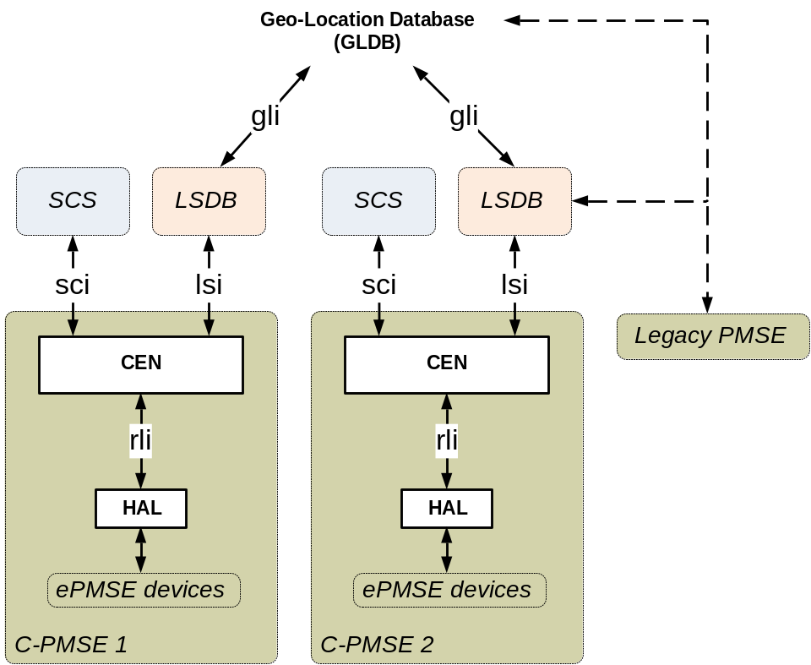

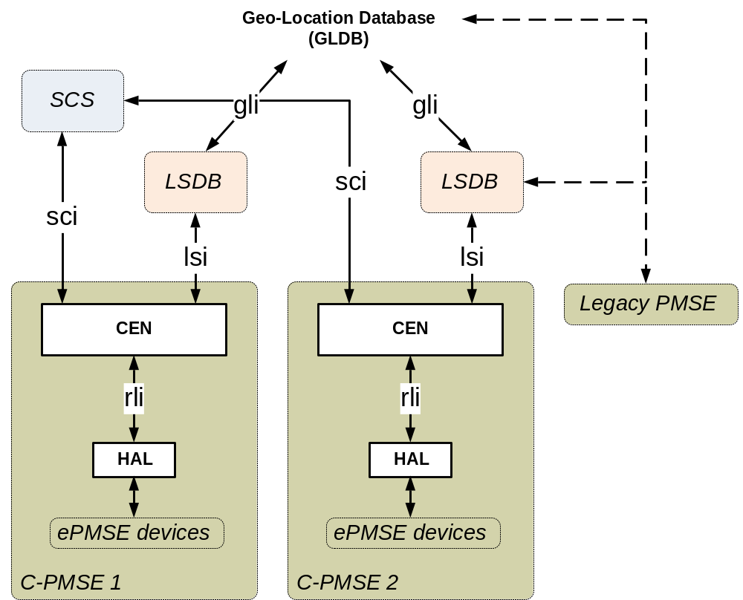

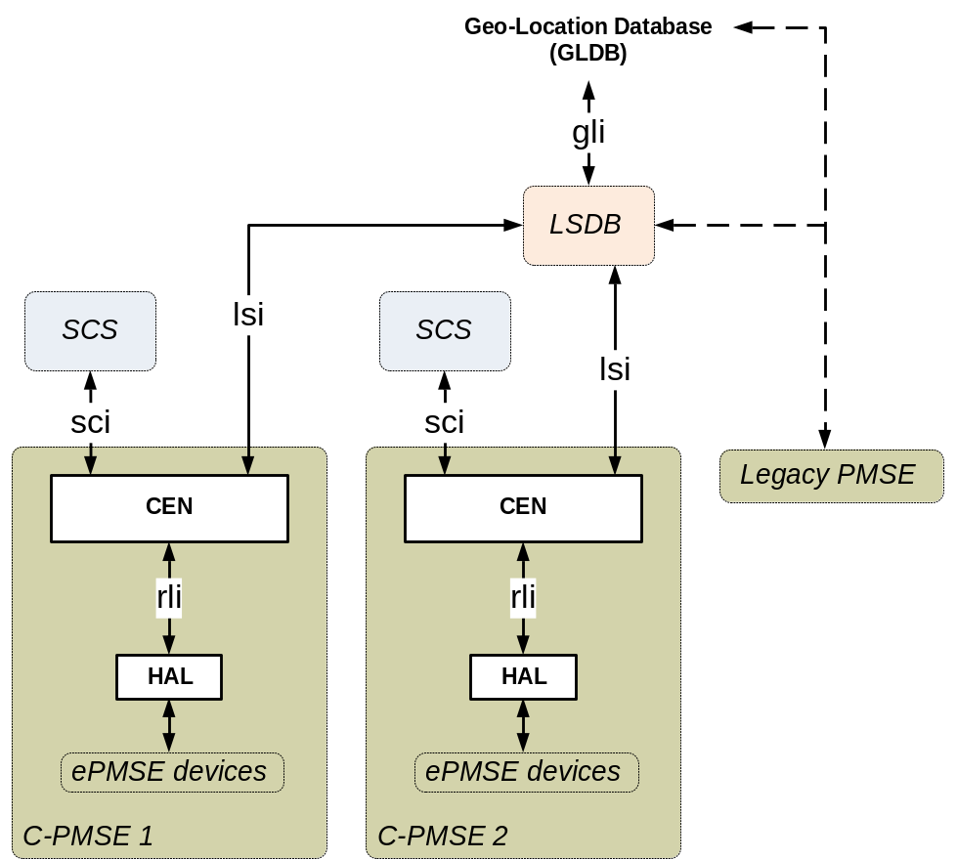

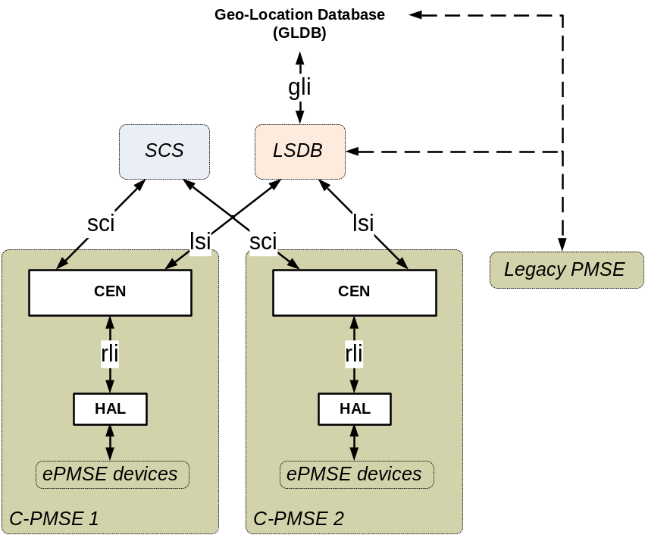

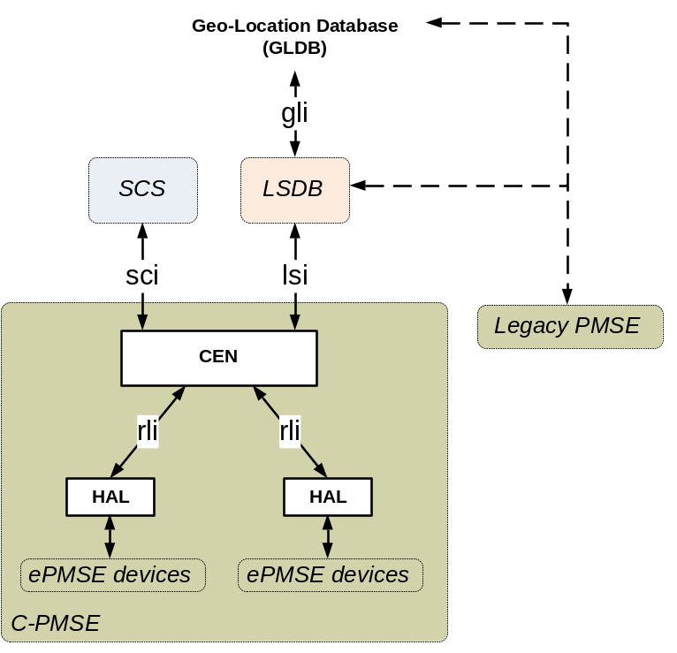

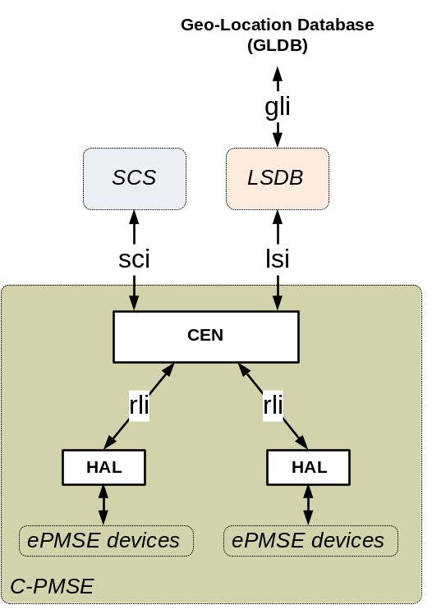

Co-located C-PMSE systems are interconnected at various levels. It is important to consider what type(s) of interfaces and data formats will need to be supported. It is assumed that interconnected systems would use the same Information Acquistion C-PMSE-IA.
But if these systems are not interconnected, they might or might not use the same database. However, if a local database is available, it is desirable that all nearby systems access that database, because it would have more specific intormation than a national database. Information from the local database should be used to inform the configuration of these C-PMSE systems.

13.1.2 Interconnected with legacy PMSE systems
For the foreseeable future, it is likely that C-PMSE systems will sometimes be operated together with conventional (i.e., non-cognitive) PMSE systems. These legacy systems will in most cases only support a limited subset of C-PMSE [No-CEN, but cognitive features] features. It is important to consider what benefits can be obtained, if they are interconnected with such systems and how such interconnections can be accomplished; i.e., what type(s) of interfaces and data formats need to be supported. In the limiting case, information about co-located legacy systmems might have to be exchanged manually with the LSDB.
There are several interfaces at legacy PMSE systems like an Ethernet connection with information about the used frequencies, transmitter power level and the keep-free-bandwidth. But this knowledge is in general only possible within one manufacturer. It could be advantageous, if a C-PMSE system allows manually to input any kind of information from a legacy device.

13.1.3 Capability of location awareness (e.g. GPS)
In order for a C-PMSE system to operate in fully-automatic mode, it will need to have location awareness capability. Otherwise, the operator must enter this information manually. Many consumer devices now have satellite-based geolocation capability built-in. However, PMSE systems are often installed indoors where satellite signals cannot be received reliably, if at all. Therefore, a different kind of geolocation technology is needed. Work is presently ongoing in this area. Cellular and other currently available geolocation technologies do not yield sufficient accuracy (e.g., within +/- 50 meters) for PMSE applications.

13.1.4 Coexistence of various types PMSE systems e.g. Video Cameras, IEM (In Ear Monitor)
It is often the case that audio PMSE devices must share spectrum with other kinds of PMSE systems, such as In Ear Monitors (IEM), Wireless Intercoms, and Video Cameras. These systems have very different spectrum requirements, transmission duty cycles, Signal-to-Noise requirements, interference potential, etc. It is desirable that a C-PMSE system has the capability to manage coexistence between these systems when they are sharing the same or nearby frequency resources. To do this, the C-PMSE system must have knowledge of the parameters of these systems. It might be helpful, if wideband devices like video cameras use different frequency ranges to avoid interference with C-PMSE systems.

13.1.5 Extension to frequency control, power control, adaptive modulation and coding (AMC)

It is possible to include the capability within a C-PMSE system to dynamically control the operating frequency and output power of its component C-PMSE transmitters for the purpose of avoiding interference with its own or other PMSE systems in use locally or to improve spectrum use efficiency. Such capability requires the C-PMSE system to incorporate a control link. Further, the modulation and coding scheme could also be changed adaptively to match the requirements of the particular audio program being carried over the link.

13.2 Coexistence of PMSE with other kinds of systems such as White Space Devices or adjacent band LTE
In next gereration C-PMSE devices from one or more manufacturers will occur at the same location and at the same time. This will lead to sharing of the valuable frequency resources between devices in use. Therefore the C-PMSE devices preferably should be coordinated, i.e. they should exchange or at least show their internal frequency lists. This can be achieved via a common database (LSDB or GLDB). If a coordination between several C-PMSE systems is not wanted or possible, each C-PMSE device will be regarded as a potential interferer to the other systems.
To avoid the interference from one C-PMSE system to another, the allocation of frequencies or audio links should be done manually beforehand. Also some frequencies could be manually blocked to allow the operation of C-PMSE systems with higher priority. This method is known as Safe Harbour Channel concept.
If one or more C-PMSE systems are used together with White Space Devices mechanisms like spectrum sensing, beacon transmitting or even the connection to geolocation databases are imaginable. A WSD is probably limited by a certain maximum transmit power and allowed bandwidth. If a certain WSD is detected by a C-PMSE system it is tracked and regarded as an interferer to the C-PMSE System. This is the case, if a specific power and bandwith threshold is exceeded. Temporary and moving WSD should also be detected by a C-PMSE system.
During the migration process towards a fully automatic C-PMSE system a mixture of building blocks of different vendors will appear. In addition the performance and parameter setting like the intermodulation sensitivity or frequency spacing might be diverging.
The coming transmission systems (i.e. LTE, 5G) will be more frequency agile and variable in their modulation and coding schemes. Also the symbol duration as well as the duty cycle will increase. Therefore the requirements concerning the behaviour of a future C-PMSE device will rise. The consequence will be, that a higher flexible, faster and a more complex processing within the C-PMSE device will be necessary.

13.3 Alignment of different databases (nationally controlled)

13.3.1 Suggestions for a standardised interface between C-PMSE systems and nationally designated databases
To standardize an international format to exchange information between national authorities and local or temporary databases the IETF PAWS group proposes a specification called “Protocol to Access White-Space Databases”. It seems appropriate to use this specification for the gli rather than to invent a new protocol. For this purpose only a small subset of the PAWS is required. For the commutation of data on international level between regulatory authorities the full range of the PAWS should be utilized. In the following a small subset of protocol commands and their messages is described.

13.3.2 Database Discovery
Due to different requirements for the approval and operation of databases by the regulators it is necessary that the Master Device must support a database discovery. The Database Listing request procedure uses two commands:

Command – ‘LISTING_REQ’
This command is used for the database-listing request message.
Command – ‘LISTING_RESP’
A ‘LISTING_RESP’ command is used for the database-listing response message.

13.3.3 Device Initialization
The IETF PAWS group proposes two commands wich should be used by a master device for an initialization procedure to establish an information exchange with a database whenever the Master Device powers up or initiates communication with the Database. The followed commands are used to establishe a communitcation.

Initialization Commands | Parameters
‘INIT_REQ’ | deviceDesc:DeviceDescriptor (M)  location:GeoLocation (M)
‘INIT_RESP’ | rulesetInfos:list (M)  databaseChange:DbUpdateSpec (O)

Command – ‘INIT_REQ’
A ‘INIT_REQ’ command is used to initialize a request message by a master device with the Database.

Command – ‘INIT_RESP’
A ‘INIT_RESP’ command is used to communicate the initialization response messag with database parameters to the requesting device.

13.3.4 Device Registration
(MAY be used by the Master Device and MAY be implemented by the Database as a separate component or as part of the Available Spectrum Query (Section 4.4) component)
If a device has to be registered it has to send its registration information to the database to establish certain operational parameters. The following commands are used to perform the registration.

Registration Commands | Parameters
‘REGISTRATION_REQ’ | deviceDesc:DeviceDescriptor (M)  location:GeoLocation (M)  deviceOwner:DeviceOwner (M)  antenna:AntennaCharacteristics (O)
‘REGISTRATION_RESP’ | rulesetInfos:list (M)  databaseChange:DbUpdateSpec (O)

Command - ‘REGISTRATION_REQ’
The ‘REGISTRATION_REQ’ message contains the required registration parameters as the ruleset IDs to indicate the regulatory domains for which the Device wishes to register.
Command - ‘REGISTRATION_RESP’
The ‘REGISTRATION_RESP’ command is the response message to acknowledge the registration. The RulesetInfo is inclueded for each regulatory domain in which the registration is accepted. An error must be returned if none of the regulatory domains it supports is accepted.

13.3.5 Available Spectrum Query
The commands for the inquiry of available spectrum must be supported by the Master Device as well by the Database. The request contains the geo-location of the Master Device and any parameters required by the regulatory rules. The respons of the database contains the description which frequencies are available, the allowed transmit power and the schedule of the time when they can be used.
The main commands are as follows.

Registration Commands | Parameters
‘AVAIL_SPECTRUM_REQ’ | deviceDesc:DeviceDescriptor (O)  location:GeoLocation (O)  owner:DeviceOwner (O)  antenna:AntennaCharacteristics (O)  capabilities:DeviceCapabilities (O)  masterDeviceDesc:DeviceDescriptor (O)  masterDeviceLocation:GeoLocation (O)  requestType:string (O)
‘AVAIL_SPECTRUM_RESP’ | timestamp:string (M)  deviceDesc:DeviceDescriptor (M)  spectrumSpecs:list (M)

Command - ‘AVAIL_SPECTRUM_REQ’
The ‘AVAIL_SPECTRUM_REQ’ message is used to query available spectrum and it must include the geo-location of the device.

Command - ‘AVAIL_SPECTRUM_RESP’
This response message includes elements containing a list of one or more spectrum schedules with permissible power levels over time. Each element is used for one corresponding regulatory domain supported at the location requested by the ‘AVAIL_SPECTRUM_REQ’ command.

13.4.6 Device Validation
If the regulatory domain requires Slave Device validation, appropriate commands must be implemented by the database as well by the Master Device to ensure that the Slave Device is permitted to operate.

Registration Commands | Parameters
‘DEV_VALID_REQ’ | deviceDescs:list (M)  masterDeviceDesc:DeviceDescriptor (O)
‘DEV_VALID_RESP’ | deviceValidities:list (M)  databaseChange:DbUpdateSpac (O)

Command - ‘DEV_VALID_REQ’
The ‘DEV_VALID_REQ’ command is used to request the permission for operation of a Slave Device. The inquiry is made by the Master Device to the Spectrum Database.

Command - ‘DEV_VALID_RESP’
The response message is handled with the ‘DEV_VALID_RESP’ command containing a list of Slave Devices and whether this devices are valid.

13.5 Fully automatic operation without manual intervention or setup

A C-PMSE system may support semi-automatic or fully automatic operation. In this case, the following services must be provided:
Location awareness, supported by geolocation or another service, to an accuracy of +/- 50m
Policy awareness, policy defined by the regulator (e.g. Interconnection with a geolocation data base )
Awareness of operational parameters and its internal state

Even in the case of fully-automatic operation, some options must still be chosen by the user, as follows:
Service level (required number of links, their quality and area of operation)
Lease time period(s) during which operation will be required

Kapitel 14

15 Signalling for C-PMSE (TDOC214)

15.1 Overview
The CEN decides on necessary changes to PMSE links. The implementation of those changes with the radio links requires that audio basestation and audio terminals are parametrized identically e.g. both have to be tuned to the same carrier frequency or the same codec with digital transmission. The C-PMSE has to signal to the basestation and the terminal, which parameters to use. The question now is how such a signalling can be implemented and incorporated in standards.
Content and signalling plane can be mapped on different radio technologies. E.g. an analog audio link could be accompanied by a digital signalling link at another radio resource. The transmission schemes do not depend on each other.
A reliable functionality of signalling is important for any cognitive resource management. If the content plane is interfered and a frequency change is necessary, the signalling plane should still work to ensure that the situation can be overcome. One may consider also doing signalling in acknowledged mode.
The other question is which radio resource could be used for signalling? An inband birectional signalling imposes strong requirements on e.g. a wireless microphone. While transmitting with 100% duty cycle, the microphone would have to be enabled to receive signalling, which would be a strong blocking case.
Another frequency band and even another type of physical layer could be used. Pairing by infrared that is used today can be considered already as an initial step of bidirectional signalling.

15.2 Incorporating of Signalling in existing Standards
ITU-R BT.2069-5 (as of May 2011) and ECC Report 002 (as of February 2002) describe the "Telecommand/remote control" as "Radio links for the remote control of cameras and other programme-making equipment and for signalling". Therefore signalling with PMSE is already reflected in ITU and ECC reports. However both do not specifically address the SAP/SAB service links.
The current EN 300 422 does not consider signalling. German DKE has started the evaluation on required changes of EN 300 422 in June 2013. It is suggested to address the expected standard modification.
In addition ECC FM51 is working on a new revised ECC Report 002. It is suggested that ETSI sends a LS to FM51 to consider the expected implementation.

16 Findings and Suggestions TDoc 209 (not available)

Key Findings
The following points are relevant to implementing C-PMSE systems in standards;
- Real-time connection to a GLDB is not a requirement, but could provide benefits in terms of capacity and interference protection
- A C-PMSE does not necessarily provide, in of itself, an increase in efficiency of spectrum use. It mainly assures the reliability and quality of service required for PMSE links.
- PMSE has very unique and stringent requirements in terms of quality, availability, and latency.
- The risk of frequency re-use can only be accepted if there is knowledge of location of system components. Knowledge of location accuracy on the order of ~ 1 meter would be very useful.
- To avoid the need for manual entry and to facilitate tracking of movements of transmitters and receivers, indoor location systems would be very beneficial.
- The content plane and signaling plane can be treated independently. The signaling is not required to be an integral part of transmission.
- Digital transmission of content is not a prerequisite for a cognitive radio resource management system
- Dynamic link adaptation could provide additional efficiency of spectrum use
- Integration of legacy equipment is possible and likely necessary for the foreseeable future
- Link quality supervision and management is a key element of a C-PMSE system

Suggestions for standardisation
What is manufacturer specific, what is interoperable?... mixing of different hardware
Manufacturer inputs!

Suggestions for spectrum access = regulatory
e.g. Facts and figures how often to scan!
QoS insurance
CAPTURE the whole Learning curve!
Not limited to BMWI C-PMSE demonstrator
Prevent access to master database inside PMSE spectrum– should be outside spectrum]

17

17 Necessary Additions to EN 300 422 regarding C-PMSE (TDOC220)

17.1 Introduction
This chapter deals with the necessary additions to EN 300 422-1 V1.4.2 (2011-08) recommended by ETSI STF 386 to cover the necessary changes implied by the introduction of cognitive properties for PMSE.
STF386 proposes to add a Part III on cognitive radio resource management. Part III should cover the following aspects:
- Definition of new terms (e.g. definition of ePMSE)
- Discuss the role of content and control planes
- Definition of new elements of a C-PMSE system
- Interface definitions and their protocols
- New protocols
- Requirements
- Testing setups
- Testing for compliance
- References (e.g. TR102 801)

17.2 Proposals for modifications to existing parts
Proposal addition to Section 2.1, Normative Reference
- Include TR 102 801 (Outcome document of phase C STF386)
Proposal additions to Section 3.3
- Include new definitions, symbols, and abbreviations

17.3 Proposals for addition of a new Part III
Proposal Section 17
- Definition of C-PMSE (include sketch). General overview on the behaviour of a C-PMSE system. Explain the breakdown of each of the elements and how they interact. Discuss the purpose of each interface.
Proposal Section 18
- Define the elements of the C-PMSE (18.1, 18.2…)
Proposal Section 19
- Define the interfaces (sci, lsi, rli)
Proposal Section 20
- Conformance Testing of a C-PMSE System (e.g. apply stimulus to the system as a whole)
- Maybe defined as a sole “OTA” (over the air) test stimulus
- Interface tests (if interfaces are provided) – One Sentence only adequate protocol tester

The following text is to be used when appropriate:

Proforma copyright release text block
This text box shall immediately follow after the heading of an element (i.e. clause or annex) containing a proforma or template which is intended to be copied by the user. Such an element shall always start on a new page.
Notwithstanding the provisions of the copyright clause related to the text of the present document, ETSI grants that users of the present document may freely reproduce the <proformatype> proforma in this {clause|annex} so that it can be used for its intended purposes and may further publish the completed <proformatype>.
<PAGE BREAK>

Annexes
Each annex shall start on a new page (insert a page break between annexes A and B, annexes B and C, etc.).
Use the Heading 9 style for the title and the Normal style for the text.

Annex <A>:
Abstract Test Suite (ATS) text block
This text should be used for ATSs using either TTCN-2 or TTCN-3. In case:
- TTCN-2 is used: attach the TTCN.MP;
- TTCN-3 is used: attach the TTCN-3 files and other related modules, as well as the HTML documentation of the TTCN-3 files.
<PAGE BREAK>

Annex B:
Further Reading in the context of BMWi C-PMSE Project
In the following literature that was generated in the context of the BMWI C-PMSE project is listed:
- Various Authors, Proceedings of the C-PMSE Project, Shaker (book to be published in 2014)
- B. Meiners; J. Barowski; S. Dortmund; S. Sczyslo; I. Rolfes (Hg.) (2012): Modellierung des Interferenzverhaltens von frequenzagilen PMSE Geräten mit bestehenden Funkstandards im UHF Bereich. U.R.S.I. Landesausschuss in der Bundesrepublik Deutschland e.V.
- B. Meiners; S. Dortmund; S. Sczyslo; J. Barowski; A. Nalobin; I. Rolfes (Hg.) (2013): Algorithmus zur Interpolation von Kanalimpulsantworten mit Hilfe stochastischer Prozesse. U.R.S.I. Landesausschuss in der Bundesrepublik Deutschland e.V.
- Barowski, J.; Dortmund, S.; Sczyslo, S.; Rolfes, I. (Hg.) (2013): Nonlinear modeling of PMSE receiver frontends using Volterra Series.
- Bastian Meiners; Sven Dortmund; Sebastian Sczyslo; Ilona Rolfes (Hg.) (2012): Modellierung der Pfadanzahl in Kanalimpulsantworten bei applikativen Positionsänderungen der drahtlosen Audioübertragung mittels Brownscher Brücke. U.R.S.I. Landesausschuss in der Bundesrepublik Deutschland e.V.
- Brendel, J.; Riess, S.; Schroeter, S.; Fischer, G. (Hg.) (2014): Noise Floor Dependent Data Fusion for Reliable REM Generation with a Spectrum Sensing Grid. McLean / USA.
- Brendel, J.; Riess, S.; Stoeckle, A.; Rose, R.; Rummel, R.; Fischer, G. (Hg.) (2012): A Spectrum Sensing Network for Cognitive PMSE Systems.
- Brendel, J.; Riess, S.; Stoeckle, A.; Rummel, R.; Fischer, G. (2012): A Spectrum Sensing Network for Cognitive PMSE Systems. In: FREQUENZ - Journal of RF-Engineering and Telecommunications 66 (9-10).
- Brendel, J.; Riess, S.; Weigel, R.; Fischer, G. (Hg.) (2013): A Cognitive System for Future-Proof Wireless Microphones: Concept, Implementation and Results (Invited Paper).
- Brendel, J.; Schmidt, A.; Fischer, G. (Hg.) (2013): A Link Quality Indicator for analog FM Transmission Systems. Gold Coast / Australien.
- Fabian Schuh; Andreas Schenk; Johannes Huber (Hg.) (2013): Matched Decoding for Punctured Convolutional Encoded Transmission Over ISI-Channels. Munich, Germany.
- Fabian Schuh; Andreas Schenk; Johannes Huber (Hg.) (2013): Reduced Complexity Super-Trellis Decoding for Convolutionally Encoded Transmission Over ISI-Channels. San Diego, USA.
- Fabian Schuh; Johannes Huber (Hg.) (2013): Nonlinear Trellis Description for Convolutionally Encoded Transmission Over ISI-channels with Applications for CPM. Munich, Germany.
- J. Barowski; S. Dortmund; B. Meiners; A. Nalobin; S. Sczyslo; I. Rolfes (Hg.) (2013): Analyse eines verteilten spectrum-sensing Systems für kognitive Funksysteme. U.R.S.I. Landesausschuss in der Bundesrepublik Deutschland e.V.
- König, C.; Bredel, M.; Perez Guirao, M. D. (Hg.) (2013): Spectrum-aware frequency planning for professional wireless microphone systems.
- König, Christoph; Perez-Guirao, M. D.; Lübben, Ralf (Hg.) (2014): Distributed Indoor Spectrum Occupancy Measurements in the UHF TV Band: IEEE.
- Meiners, B.; Dortmund, S.; Sczyslo, S.; Rolfes, I. (Hg.) (2013): Interpolation of channel impulse responses combining the Brownian bridge with a modified birth and death process.
- Nalobin, A.; Dortmund, S.; Barowski, J.; Meiners, B.; Sczyslo, S.; Rolfes, I. (Hg.) (2013): Differenzierung von Large- und Small-Scale Gebieten von Indoor-Fadingkanälen mittels Fourier-Analys.
- Nalobin, A.; Dortmund, S.; Rolfes, I. (Hg.) (2013): Detection of Programme Making and Special Event Devices in Indoor Channels.
- Nalobin, A.; Dortmund, S.; Rolfes, I. (Hg.) (2013): Empirical and Site Specific Eigenmode Characterization of an Indoor Radio Propagation Channel in the UHF Band.
- Nalobin, A.; Dortmund, S.; Sczyslo S.; Rolfes, I. (Hg.) (2012): Konzept zur simulatorischen Koexistenzanalyse kognitiver Übertragungssysteme mit Schwerpunkt C-PMSE unter Berücksichtigung realer Ausbreitungsbedingungen.
- Nalobin, A.; Sczyslo, S.; Dortmund, S.; Rolfes, I. (Hg.) (2012): Untersuchung zur Verwendung von hochauflösenden Winkelschätzalgorithmen unter Berücksichtigung realistischer Antennenstrahler im Nahfeld.
- Riess, S.; Brendel, J.; Fischer, G. (Hg.) (2013): Model-Based Implementation for the Calculation of Power Spectral Density in an FPGA System. Gold Coast / Australia.
- Riess, S.; Brendel, J.; Stoeckle, A.; Rose, R.; Fischer, G. (Hg.) (2012): Concept of an UHF Band Receiver for Spectrum Sensing Applications. Potsdam, Germany.
- Riess, S.; Brendel, J.; Stoeckle, A.; Rose, R.; Fischer, G. (Hg.) (2013): Components and Implementation of a Spectrum Sensing Network for the UHF TV Band. Nuremberg, Germany.
- Schroeter, S.; Zimmermann, L.; Schwender, O.; Fischer, G.; Koelpin, A. (2011): Demonstrator of a Scanning Receiver Subsystem for Cognitive Professional Wireless Microphone Systems. In: ITU Telecom World (ITU WT).
- Sczyslo, S.; Dortmund, S.; Rolfes, I. (2012): Reducing antennas’ influence on wideband indoor channel characterization in the UHF range by means of a Wiener-Filter. In: 42nd European Microwave Conference (EuMC) 2012.
- Sczyslo, S.; Rolfes, I.; Kaiser, T. (2012): On the fidelity of ultra-wideband antennas. In: IEEE-APS Topical Conference on Antennas and Propagation in Wireless Communications (APWC) 2012.
- Sczyslo, Sebastian; Dortmund, Sven; Rolfes, Ilona (2012): Determination of the delay spread of an indoor channel measurement campaign in the UHF band. In: IEEE Antennas and Propagation Society International Symposium and USNC/URSI National Radio Science Meeting Chicago, IL, USA 2012.
- Sebastian Sczyslo; Sven Dortmund; Ilona Rolfes (2011): Konzept zur hybriden Kanalmodellierung kognitiver ’Programme Making and Special Event’ Applikationen. In: Radar, Com-mu-ni-ca-ti-on and Me-a-su-re-ment (RAD-COM) 2011.
- Stoeckle, A.; Brendel, J.; Riess, S.; Rose, R.; Fischer, G. (Hg.) (2012): A Low Cost Ultra-Wide-Band Inverted F-Antenna for Cognitive PMSE Systems. Maui / Hawaii.
- Uwe Beutnagel-Buchner; Norbert Hilbich; Andreas Wilzeck (Hg.) (2012): C-PMSE ‐ Improved Spectrum Utilization and Coexistence by Cognitive PMSE Systems: IEEE.

<X.1> The TTCN-2 Machine Processable form (TTCN.MP) (style H1)
The TTCN.MP representation corresponding to this ATS is contained in an ASCII file (<any_name>.MP contained in archive <Shortfilename>.ZIP) which accompanies the present document.
<PAGE BREAK>

Annex <X+1>:
ATS in TTCN-3 (style H9)
This text shall only be used for ATSs using TTCN version 3 (TTCN-3):
This ATS has been produced using the Testing and Test Control Notation (TTCN) according to ES 201 873-1 [<i.x>].
Indicated here which parts of the ES 201 873 series and its versions (editions) have been used; also indicate any extensions which have been used.

<X+1.1> TTCN-3 files and other related modules (style H1)
The TTCN-3 and other related modules are contained in archive <Shortfilename>.zip which accompanies the present document.

<X+1.2> HTML documentation of TTCN-3 files (style H1)
The HTML documentation of the TTCN-3 and other related modules are contained in archive <Shortfilename>.zip which accompanies the present document.
<PAGE BREAK>

Annex <X+2>:
Title of annex (style H9)
<Text>

<X+2.1> First clause of the annex (style H1)
<Text>

<X+2.1.1> First subdivided clause of the annex (style H2)
<Text>
<PAGE BREAK>

Annex <X+3> (informative):
Change History
This informative annex is optional. If present, it describes the list of changes implemented in a new version of the deliverable.
Its format is tabular, it may contain the Change Request numbers and titles or textual explanations of the changes that lead to each new version number of the deliverable.
date | Version | Information about changes
October 2011 | v1.1.1 | First publication of the TS after approval by TC SPAN at SPAN#19  (30 September - 2 October 2011; Prague)
February 2012 | v1.2.1 | Implemented Change Requests:  SPAN(12)20_019 Error message information clarifications  SPAN(12)20_033 Revised error message information  SPAN(12)20_046 update of figure 3 clause 9.2  These CRs were approved by TC SPAN#20 (3 - 5 February 2012; Sophia)  Version 1.2.1 prepared by the Rapporteur
July 2013 | v1.3.1 | Implemented Changes:  Correction needed because the previously approved version did not contain the last version of the ASN.1 and XML attachments.  Version 1.3.1 prepared by the Rapporteur

<PAGE BREAK>

Annex <X+4>:
Bibliography
The annex entitled "Bibliography" is optional.
It shall contain a list of standards, books, articles, or other sources on a particular subject which are not mentioned in the document itself (see clause 12.2 of the EDRs http://portal.etsi.org/edithelp/Files/other/EDRs_navigator.chm).
It shall not include references mentioned in the document.
Use the Heading 9 style for the title and B1+ or Normal for the text.
- <Publication>: "<Title>".
OR
<Publication>: "<Title>".
<PAGE BREAK>

History
This clause shall be the last one in the document and list the main phases (all additional information will be removed at the publication stage).
Document history
<Version> | <Date> | <Milestone>

A few examples:
Document history
V1.1.1 | April 2001 | Publication
V1.3.1 | June 2011 | Pre-Processing done before TB approval  e-mail: mailto:edithelp@etsi.org
V2.0.0 | March 2013 | Clean-up done by editHelp!  e-mail: mailto:edithelp@etsi.org

Latest changes made on 2014-02-19

