TS 103 246 V0.0.7 (2014-05)
Satellite Earth Stations and Systems (SES);
Global Navigation Satellite System (GNSS)
based location systems;
GNSS Location System Performance Requirements



TECHNICAL SPECIFICATION

Reference
DTR/SES-00317
Keywords
GNSS, location, navigation, performance, parameters, satellite, system, terminal

ETSI
650 Route des Lucioles
F-06921 Sophia Antipolis Cedex - FRANCE

Tel.: +33 4 92 94 42 00 Fax: +33 4 93 65 47 16

Siret N° 348 623 562 00017 - NAF 742 C
Association à but non lucratif enregistrée à la
Sous-Préfecture de Grasse (06) N° 7803/88

Important notice
Individual copies of the present document can be downloaded from:
http://www.etsi.org
The present document may be made available in more than one electronic version or in print. In any case of existing or perceived difference in contents between such versions, the reference version is the Portable Document Format (PDF). In case of dispute, the reference shall be the printing on ETSI printers of the PDF version kept on a specific network drive within ETSI Secretariat.
Users of the present document should be aware that the document may be subject to revision or change of status. Information on the current status of this and other ETSI documents is available at http://portal.etsi.org/tb/status/status.asp
If you find errors in the present document, please send your comment to one of the following services:
http://portal.etsi.org/chaircor/ETSI_support.asp
Copyright Notification
No part may be reproduced except as authorized by written permission.
The copyright and the foregoing restriction extend to reproduction in all media.

© European Telecommunications Standards Institute yyyy.
All rights reserved.
DECTTM, PLUGTESTSTM, UMTSTM and the ETSI logo are Trade Marks of ETSI registered for the benefit of its Members.
3GPPTM and LTE™ are Trade Marks of ETSI registered for the benefit of its Members and
of the 3GPP Organizational Partners.
GSM® and the GSM logo are Trade Marks registered and owned by the GSM Association.

Contents
Contents 3
Intellectual Property Rights 5
1 Scope 6
2 References 7
2.1 Normative references 7
2.2 Informative references 7
3 Definitions, symbols and abbreviations 8
3.1 Definitions 8
3.2 Symbols 9
3.3 Abbreviations 10
4 Location System Performance Features 12
5 Performance Requirements 13
5.1 Horizontal Position Accuracy 13
5.1.1 Operational conditions 13
5.1.2 Use case: Moving Location Target 13
5.1.2.1 Target movement 13
5.1.2.2 Performance requirement 13
5.1.3 Use case: Static Location Target 15
5.1.3.1 Target position 15
5.1.3.2 Performance requirement 16
5.2 Vertical Position Accuracy 17
5.2.1 Operational conditions 17
5.2.2 Use case: Moving Location Target 17
5.2.2.1 Performance requirement 17
5.2.3 Use case: Static Location Target 17
5.2.3.1 Performance requirement 17
5.3 Availability of required accuracy 18
5.4 Precise GNSS time restitution 18
5.4.1 Operational conditions 18
5.4.2 Use case: Moving Target 18
5.4.2.1 Target movement 18
5.4.2.2 Performance requirement 18
5.4.3 Use case: Static Target 19
5.4.3.1 Target position 19
5.4.3.2 Performance requirement 19
5.5 Time to First Fix 19
5.6 Position Authentication 19
5.6.1 Operational conditions 19
5.6.2 Use case: Moving location Target fault free scenario 20
5.6.2.1 Target movement 20
5.6.2.2 Performance requirement 20
5.6.3 Use case: Moving location Target faulty scenarios 21
5.6.3.1 Target movement 21
5.6.3.2 Performance requirement 21
5.6.4 Use case: Static Location Target Fault-free scenario 22
5.6.4.1 Performance requirement 23
5.6.5 Use case: Static Location Target Faulty scenarios 23
5.6.5.1 Performance requirement 23
5.6.6 Use case: Threat scenario #1 23
5.6.6.1 Performance requirement 24
5.7 Interference Localisation 24
5.8 Robustness to Interference 24
5.9 GNSS denied survival 24
5.9.1 Operational conditions 24
5.9.1.1 Special masking conditions 24
5.9.2 Use case: Moving Target 25
5.9.2.1 Target movement 25
5.9.2.2 Performance requirement 25
5.10 GNSS Sensitivity 26
5.11 Position Integrity Protection Level 26
5.12 Position Integrity Alarm Limit and TTA 27
Annex A (Normative): Definition of performance metrics 28
A.1 Horizontal position accuracy 28
A.2 Vertical position accuracy 28
A.3 Availability of required accuracy 29
A.4 Position Integrity performance 29
A.5 Restituted GNSS time accuracy 29
A.6 Time to first fix (TTFF) 30
A.7 Position authentication 30
A.8 Direction of arrival accuracy 30
A.9 PVT degradation under interference sources 30
A.10 Recovery time of normal performance after termination of pulse interference 31
Annex B (normative): Threat scenario for Integrity and Authentication features 32
A.1 Authentication threat scenarios 32
A.1.1 Threat scenarios description 32
A.1.1.1 Scenarios pre-conditions 32
A.1.1.2 Scenarios chronology 32
A.1.1.3 Scenarios parameters 32
.1.1.3.1 Attack classification 33
.1.1.3.2 Total spoofing power 34
.1.1.3.3 Misleading information category 34
.1.1.3.4 Target movement 35
A.1.2 Threat scenarios for moving target 35
A.1.3 Threat scenarios for static targets 35
A.2 Integrity threat scenarios 36
A1 Annex <X> (informative): Bibliography 36
A1 History 36

Intellectual Property Rights
IPRs essential or potentially essential to the present document may have been declared to ETSI. The information pertaining to these essential IPRs, if any, is publicly available for ETSI members and non-members, and can be found in ETSI SR 000 314: "Intellectual Property Rights (IPRs); Essential, or potentially Essential, IPRs notified to ETSI in respect of ETSI standards", which is available from the ETSI Secretariat. Latest updates are available on the ETSI Web server (http://ipr.etsi.org).
Pursuant to the ETSI IPR Policy, no investigation, including IPR searches, has been carried out by ETSI. No guarantee can be given as to the existence of other IPRs not referenced in ETSI SR 000 314 (or the updates on the ETSI Web server) which are, or may be, or may become, essential to the present document.
Foreword
This Technical Report (TR) has been produced by ETSI Technical Committee Satellite Earth Stations and Systems (SES).

Scope
The present document addresses integrated location systems that combine Global Navigation Satellite System (GNSS), with other navigation technologies in order to deliver location-based services to users.
The requirements herein are intended to address the growing use of complex location systems needed for the expansion of location-based applications in the mass-market.
The Location System architecture is defined in [7]
This Technical Specification defines the performance requirements applicable to these systems.

References
References are either specific (identified by date of publication and/or edition number or version number) or non-specific. For specific references, only the cited version applies. For non-specific references, the latest version of the referenced document (including any amendments) applies.
Referenced documents which are not found to be publicly available in the expected location might be found at http://docbox.etsi.org/Reference.
NOTE: While any hyperlinks included in this clause were valid at the time of publication, ETSI cannot guarantee their long term validity.

Normative references
The following referenced documents are necessary for the application of the present document.
- Galileo OS Signal in Space ICD (OS SIS ICD), Draft 0, Galileo Joint Undertaking, May 23rd, 2006.
- IS-GPS-200, Revision D, Navstar GPS Space Segment/Navigation User Interfaces, March 7th, 2006.
- IS-GPS-705, Navstar GPS Space Segment/User Segment L5 Interfaces, September 22, 2005.
- IS-GPS-800, Navstar GPS Space Segment/User Segment L1C Interfaces, September 4, 2008.
- IS-QZSS, Quasi Zenith Satellite System Navigation Service Interface Specifications for QZSS, Ver.1.1, July 31, 2009.
- Global Navigation Satellite System GLONASS Interface Control Document, Version 5.1, 2008.
- ETSI TS 103 247 "Satellite Earth Stations and Systems (SES); Global Navigation Satellite System (GNSS) based location systems; Reference Architecture”

Informative references
The following referenced documents are not necessary for the application of the present document but they assist the user with regard to a particular subject area.
- ETSI TR 103 183 (V1.1.1): "Satellite Earth Stations and Systems (SES); Global Navigation Satellite Systems (GNSS) based applications and standardisation needs".
- RTCA DO-229D (2006-12): "Minimum Operational Performance Standards for Global Positioning System/Wide Area Augmentation System Airborne Equipment".
- OMA-TS-ULP-V2-0-20100816-C (2010-08): "User Plane Location Protocol".
- ETSI TS 122 071 (V9.0.0): "Digital cellular telecommunications system (Phase 2+); Universal Mobile Telecommunications System (UMTS); LTE; Location Services (LCS); Service description; Stage 1 (3GPP TS 22.071 version 9.0.0 Release 9)".
- ETSI TR 101 593 (V1.1.1): "Satellite Earth Stations and Systems (SES); Global Navigation Satellite Systems (GNSS) based location systems; Minimum performance and features ".

Definitions, symbols and abbreviations

Definitions
For the purposes of the present document, the following terms and definitions apply:
Accuracy: The term accuracy relates to the location-related information reported by the location system, i.e. the mobile target position, velocity, acceleration and GNSS system time estimate. The accuracy is thus characterized by the difference between the quantity estimated by the location system, and its actual value. It is expressed in m (position), m.s⁻¹ (speed), m.s⁻² (acceleration) or seconds (time), and usually characterized through statistical values (mean, standard deviation, root mean square, percentile, etc.). When not further specified in the present technical context, the term accuracy usually refers to the position accuracy. By extenstion, accuracy is one of the key performance features which can be required from a location system.
Application module: entity in charge of retrieving from a Location system the Location-related information associated to one or more mobile targets, and processing it in order to deliver to the application user(s) the location based service it has been designed for.
NOTE: The application module can be collocated with the positioning module inside a terminal.
Authentication: Authentication is the provision of assurance that the location-related information associated to a mobile target is trustworthy. By extenstion, authentication is one of the key performance features which can be required to a location system
Availability: Availability measures percentage of time when a location system is able to provide the required location-related information. Note that the required location-related information might vary from one location based application to the other: it can not only contain a required type of information (position, speed, …), but also a required quality of service (accuracy, protection level, authentication, etc. ).
Coverage: The coverage of the location system is the surface area or space volume in which the signals are adequate to determine the mobile targets location-related information to a specified level of accuracy. Coverage is influenced by receiver sensitivity and environmental conditions affecting the signal availability.
Electromagnetic Interference: Any source of RF transmission that is within the frequency band used by a communication link, which degrades the performance of this link. Jamming is a particular case of electromagnetic interference, where interfering radio signal is deliberately broadcast to disrupt the communication.
Horizontal plane: plane locally defined for the mobile target, orthogonal to the zenith/nadir axis.
Integrity: Integrity is an optional function of a location system that aims at measuring the trust that can be placed in the accuracy of the location-related information provided by the location system. In the present technical context, it is expressed through a pair protection level / integrity risk. By extenstion, integrity is one of the key performance features which can be required from a location system
Integrity risk: The integrity risk is the probability that the actual error of the location-related information is larger than the protection level. The integrity risk is, with the protection level, one of the 2 sub-features of integrity feature.
Jamming: Deliberate transmission of radio signals in order to disrupt communications by decreasing the signal to noise ratio. In the present technical context, targeted communication signals are GNSS or telecommunication signals.
Latency: The latency of a location system measures the time elapsed between the event triggering the determination of the location-related information for (a) mobile target(s) (i.e. location request from external client, external or internal event triggering location reporting), and the availability of the location-related information at the user interface.
Location: a place where something is or could be located. In the present technical context, the place where the mobile target is.
NOTE: the term position can have several meaning. In the present technical context, the only relevant meaning is considered to be equivalent to location (and therefore excludes interpretation such as “body posture”, “state of mind or principle”, “job or activity”). The term location will arbitrarily be preferred, except when referring to the action of “determining a location”, for which the term positioning will be used.
Location based application: application which is able to deliver a location-based service to one or several users.
Location based service: service built on the processing of the Location-related information associated to one or several mobile targets
Location-related information: set of data associated to a given mobile target, containing one or several of the following information, all time-tagged: mobile target position, mobile target motion indicators (linear or angular speed and acceleration), and Quality of service indicators (estimates of the position accuracy, reliability or authenticity indicators).
NOTE: It is the main output of a Location system.
Location system: system in charge of providing to a location based application the Location-related information of one or several mobile targets.
Location system central facility: centralized logical entity, inside a Location system, that manages the provision of the location-related information to the application module, which is the location system external client.
Mobile target: physical entity whose position the location system builds the location-related information on, and with which the positioning terminal is attached
Positioning terminal: logical entity, inside a Location system, in charge of providing the relevant measurements to the location system central facility (enabling it to determine the mobile target location-related information) or directly providing the mobile target location-related information to the “Application module”. It is composed of a GNSS receiver and possibly additional sensors.
NOTE: It executes the measurements needed to determine its position, and implements part of the location determination functions. It embeds the group of sensors needed to execute these tasks. This group can include navigation sensors (GNSS, Inertial, Odometers, etc.), wireless network modems (terrestrial or satellite). It might be collocated with the mobile target or not.
Privacy: privacy is a function of a location system that aims at ensuring that the mobile target user private information (identity, bank accounts etc.) and its location-related information cannot be accessed by a non authorized third party.
Protection level : The protection level PL is an estimated error value which comply with the following condition: P(ε > PL) < I_{risk} , where I_{risk} is the Integrity risk and ε the actual error. The protection level is provided by the location system, and is, with the integrity risk, one of the 2 sub-features of integrity feature. The protection level can be measured by a statistical metric similar the the one used for the size of the error (Accuracy).
Quality of service: the quality of service associated to a location based service is a set of indicators which can accompany the mobile target(s) position/motion information and is intended to reflect the quality of the information provided by the location system. QoS indicators can be accuracy estimate, protection level statistics / integrity risk, authentication flag, etc.
Security: security is a function of a location system that aims at ensuring that the location-related information is safeguarded against unapproved disclosure or usage inside or outsite the location system, and that it is also provided in a secure and reliable manner that ensures it is neither lost nor corrupted.
Time to First Fix : The Time To First Fix (TTFF) is a measure of performance of a GNSS receiver that accounts for the time elapsed from the GNSS receiver switch-on until the output of a navigation solution within a certain performance.
Vertical axis: axis locally defined for the mobile target, collinear to the zenith/nadir axis.

Symbols
For the purposes of the present document, the following symbols apply:
ϕ Carrier phase
εAccel Error on sensor acceleration (from INS)
εAtt Error on sensor attitude (from INS)
εGyro Error on sensor gyroscopes (from INS)
εPos Error on sensor position (from INS)
εPos_{3D} Uncertainty on sensor position (from GNSS)
εV Error on sensor attitude (from INS)
εV_{3D} Uncertainty on sensor speed (from GNSS)
d Carrier Doppler
P_{GNSS} Position estimate coming from GNSS sensor
P_{INS} Position estimate coming from the INS
V_{GNSS} Speed estimate coming from GNSS sensor
V_{INS} Speed estimate coming from the INS

Abbreviations
For the purposes of the present document, the following abbreviations apply:
All below to be reviewed
3GPP 3rd Generation Partnership Project
ADAS Advanced Driver Assistance Systems
AL Alarm Limit
BTS Base station Transceiver System
DOA Direction Of Arrival
ECEF Earth Centred Earth Fixed
EDGE Enhanced Data for GSM Evolution
EGNOS European Geostationary Navigation Overlay System
EMI Electro-Magnetic Interference
FDAF Frequency Domain Adaptive Filtering
GCF Global Certification Forum
GEO Geostationary Earth Orbit
GIVE Grid Ionospheric Vertical Error
GLONASS Global Navigation Satellite System (Russian based system)
GNSS Global Navigation Satellite System
GPRS General Packet Radio Service
GPS Global Positioning System
GSM Global System for Mobile communications
HPE Horizontal Positioning Error
HPL Horizontal Protection Level
IMU Inertial Measurement Unit
INS Inertial Navigation Sensor
IRS Inertial Reference System
ITS Intelligent Transport Systems
LCS LoCation Services
LEO Low Earth Orbit
LOS Line Of Sight
LTE Long Term Evolution
MEMS Micro Electro-Mechanical Systems
MEXSAT Mexican Satellite System
MI Mis-Integrity
MMI Man-Machine Interface
MOPS Minimum Operational Performance Specification
MP Multipath
MPS Minimum Performance Standard
MS Mobile Station
NCO Numerically Controlled Oscillator
NMR Network Measurement Results
ODTS Orbit Determination and Time Synchronisation
OMA Open Mobile Alliance
OTDOA Observed Time Difference Of Arrival
PAYD Pay As You Drive
PE Positioning Error
PL Protection Level
PRS Public Regulated Services
PVT Position, Velocity and Time
QoS Quality of Service
QZSS Quasi-Zenith Satellite System
RAIM Receiver Autonomous Integrity Monitoring
RF Radio Frequency
RMS Root Mean Square
RTCA Radio Technical Commission for Aeronautics
RTK Real Time Kinematic
SBAS Satellite Based Augmentation System
SCN Satellite Communications and Navigation (Working Group of TC-SES)
SMLC Serving Mobile Location Center
SUPL Secure User Plane for Location
SV Satellite Vehicle
TBC To Be Confirmed
TBD To Be Defined
TC-SES Technical Committee Satellite Earth Stations and Systems
TTA Time To Alarm
TTFF Time To First Fix
UDRE User Differential Range Error
UERE User Equivalent Range Error
UHF Ultra-High Frequency
UMTS Universal Mobile Telecommunications System
VPL Vertical Protection Level
WAAS Wide Area Augmentation System
WI-FI Wireless Fidelity

Location System Performance Features
Based on the Location System Architecture defined in [7], the associated location system performance requirements specified in clause 5 are:
- horizontal position accuracy: The relevant parameter to be monitored is the horizontal position. This measurement parameter is contained in the xxx IE, which is included in the yyy IE provided in the LPPe message of type zzz.
- vertical position accuracy --> parameter is vertical position (is it accurate ?)
- Availability of required accuracy --> horizontal (vertical) position (is it accurate when available ?)
- Precise GNSS time restitution
- Time to first fix --> parameter is horizontal position (when is it available ?)
- Position Authentication --> authentication flag
- Interference Localisation --> interference position: [azimuth, elevation] or [latitude, longitude, altitude] + uncertainty
- Robustness to Interference --> horizontal position (is it accurate ? it is available ?)
- GNSS denied survival --> horizontal position (it is available ?)
- GNSS Sensitivity --> horizontal position (it is available ?)
- Position Integrity Protection Level --> protection level
- Position Integrity Alarm Limit and TTA --> protection level

Performance Requirements
This clause defines the minimum performance requirements for each of the performance features defined in clause 4. The definitions of performance metrics for these features are given in Annex A.
The Applicable Conditions for these features are given in Annex B.
Other references to Annexes

Horizontal Position Accuracy
Location systems implementing performance feature “horizontal position accuracy” shall comply with the minimum performance requirements described in clauses 5.1.2 and 5.1.3 below.

Operational conditions
Table 5-1 below provides the operational conditions used to define the minimum required performance for feature “Horizontal Position Accuracy”, and the masking parameters tuning applicable for each of them.
Environment type | Applicability | Masking parameters
 |  | x1 | x2 | x3
Open area | Yes | See table B.x6
Rural area | Yes | See table B.x6
Suburban | Yes | See table B.x6
Urban | Yes | See table B.x6
Assymetric area | Yes | See table B.x6
Industrial area | Yes | See table B.x6
Table 5-1: Environment applicability for “horizontal position accuracy”

Use case: Moving Location Target

Target movement
The location target follows the trajectory described in clause B.3. The reference point {0;0;0} has coordinates expressed in [WGS84] system: longitude = [tbd], latitude = [tbd].
The trajectory parameters are provided in Table 5-2 below.
Trajectory parameter | Value
v₁ | 25 km/h
v₂ | 100 km/h
v₃ | 100 km/h
d₁ | 250 m
D₂ | 250 m
Table 5-2: Mobile target movement parameters

Performance requirement
The location target position estimated by the location system shall meet the accuracy specified in Table 5-3 to Table 5-8 below, depending on:
- the grade of the location system
- the operational environment considered, as defined in clause B.2.3.
This performance level shall be met when the trajectory is travelled in both directions.
Metric  (as per clause 4.2) | Performance requirement – Open Area
 | Low grade | Medium grade | High grade
Mean value | 8,4 | 0,5 | 0,2
Standard deviation | Tbd | Tbd | Tbd
67th percentile | 8,8 | 0,4 | 0,3
95th percentile | 22,1 | 0,8 | 0,4
99th percentile | 23,8 | 1,4 | 0,5
Cross track error - Mean value | 4,8 | 0,2 | 0,1
Cross track error - 67th percentile | 5,8 | 0,3 | 0,1
Cross track error - 95th percentile | 16,5 | 0,7 | 0,2
Cross track error - 99th percentile | 20 | 1,2 | 0,3
Along track error - Mean value | 5,4 | 0,3 | 0,2
Along track error - 67th percentile | 6,4 | 0,3 | 0,3
Along track error - 95th percentile | 21,9 | 0,5 | 0,4
Along track error - 99th percentile | 22,4 | 1 | 0,5
Table 5-3: performance requirement for Horizontal position, Open Area, Moving target

Metric  (as per clause 4.2) | Performance requirement – Rural Area
 | Low grade | Medium grade | High grade
Mean value | 9,6 | 1 | 0,4
Standard deviation | Tbd | Tbd | Tbd
67th percentile | 12,2 | 1,1 | 0,5
95th percentile | 19 | 2,1 | 0,9
99th percentile | 22,7 | 2,8 | 1,1
Cross track error - Mean value | 5,3 | 0,6 | 0,3
Cross track error - 67th percentile | 6,5 | 0,8 | 0,3
Cross track error - 95th percentile | 13,7 | 1,8 | 0,8
Cross track error - 99th percentile | 16,7 | 2,4 | 1,1
Along track error - Mean value | 6,6 | 0,4 | 0,2
Along track error - 67th percentile | 10,1 | 0,5 | 0,3
Along track error - 95th percentile | 18,1 | 1 | 0,6
Along track error - 99th percentile | 18,7 | 1,5 | 0,8
Table 5-4: performance requirement for Horizontal position, Rural Area, Moving target

Metric  (as per clause 4.2) | Performance requirement – Suburban Area
 | Low grade | Medium grade | High grade
Mean value | 9,3 | 1,5 | 0,4
Standard deviation | Tbd | Tbd | Tbd
67th percentile | 10,4 | 1,5 | 0,4
95th percentile | 15,1 | 5 | 0,7
99th percentile | 21,5 | 8,1 | 0,9
Cross track error - Mean value | 5,1 | 1,1 | 0,2
Cross track error - 67th percentile | 6,6 | 1 | 0,2
Cross track error - 95th percentile | 12,4 | 4,3 | 0,5
Cross track error - 99th percentile | 19,2 | 7,4 | 0,8
Along track error - Mean value | 6,5 | 0,7 | 0,3
Along track error - 67th percentile | 8,4 | 0,6 | 0,3
Along track error - 95th percentile | 14,6 | 2,5 | 0,6
Along track error - 99th percentile | 15,1 | 4,8 | 0,7
Table 5-5: performance requirement for Horizontal position, Suburban Area, Moving target

Metric  (as per clause 4.2) | Performance requirement – Urban Area
 | Low grade | Medium grade | High grade
Mean value | 40,8 | 24,2 | 1,6
Standard deviation
67th percentile | 52,5 | 29,2 | 0,8
95th percentile | 75,3 | 49,9 | 9,3
99th percentile | 98,7 | 62,9 | 19
Cross track error - Mean value | 26,9 | 15,2 | 1
Cross track error - 67th percentile | 37,9 | 18,8 | 0,6
Cross track error - 95th percentile | 59 | 42,6 | 3,7
Cross track error - 99th percentile | 66,9 | 51,4 | 13,8
Along track error - Mean value | 21,9 | 15,4 | 1,1
Along track error - 67th percentile | 25,6 | 19,2 | 0,5
Along track error - 95th percentile | 68,3 | 44,3 | 6,2
Along track error - 99th percentile | 90,4 | 56,3 | 14,6
Table 5-6: performance requirement for Horizontal position, Urban Area, Moving target

Metric  (as per clause 4.2) | Performance requirement – Assymetric Area
 | Low grade | Medium grade | High grade
Mean value | 31,7 | 12,1 | 0,5
Standard deviation
67th percentile | 45,4 | 13,6 | 0,5
95th percentile | 79 | 38 | 1
99th percentile | 99,5 | 54,9 | 1,2
Cross track error - Mean value | 15,3 | 10,2 | 0,3
Cross track error - 67th percentile | 19,3 | 11,4 | 0,4
Cross track error - 95th percentile | 59 | 32,4 | 0,8
Cross track error - 99th percentile | 77,3 | 50,4 | 1,1
Along track error - Mean value | 21,4 | 5,1 | 0,3
Along track error - 67th percentile | 33,6 | 5,6 | 0,3
Along track error - 95th percentile | 68,1 | 18,3 | 0,6
Along track error - 99th percentile | 92 | 28,3 | 0,9
Table 5-7: performance requirement for Horizontal position, Assymetric Area, Moving target

Metric  (as per clause 4.2) | Performance requirement – Industrial Area
 | Low grade | Medium grade | High grade
Mean value | 57,6 | 6,5 | 0,7
Standard deviation | Tbd | Tbd | Tbd
67th percentile | 75,2 | 5 | 0,8
95th percentile | 96,7 | 23,2 | 1,7
99th percentile | 100,2 | 44,1 | 2,4
Cross track error - Mean value | 33,6 | 5,1 | 0,5
Cross track error - 67th percentile | 46,5 | 3,7 | 0,6
Cross track error - 95th percentile | 77 | 19,2 | 1,6
Cross track error - 99th percentile | 81,8 | 40,9 | 2,2
Along track error - Mean value | 38,3 | 2,7 | 0,4
Along track error - 67th percentile | 62 | 2,1 | 0,5
Along track error - 95th percentile | 84,6 | 10,9 | 1
Along track error - 99th percentile | 88,5 | 22,1 | 1,4
Table 5-8: performance requirement for Horizontal position, Industrial Area, Moving target

Use case: Static Location Target

Target position
The location target is located in coordinates expressed in WGS84 [tbc] system: longitude = [tbd], latitude = [tbd].

Performance requirement
The location target position estimated by the location system shall meet the accuracy specified in Table 5-9 to Table 5-14 below, depending on:
- the grade of the location system.
- the operational environment considered, as defined in clause B.2.3.
Metric  (as per clause 4.2) | Performance requirement
 | Low grade | Medium grade | High grade
Mean value | [tbd] | [tbd] | [tbd]
Standard deviation | [tbd] | [tbd] | [tbd]
67th percentile | [tbd] | [tbd] | [tbd]
95th percentile | [tbd] | [tbd] | [tbd]
99th percentile | [tbd] | [tbd] | [tbd]
Table 5-9: performance requirement for Horizontal position, Open area, Static target

Metric  (as per clause 4.2) | Performance requirement – Rural Area
 | Low grade | Medium grade | High grade
Mean value | [tbd] | [tbd] | [tbd]
Standard deviation | [tbd] | [tbd] | [tbd]
67th percentile | [tbd] | [tbd] | [tbd]
95th percentile | [tbd] | [tbd] | [tbd]
99th percentile | [tbd] | [tbd] | [tbd]
Table 5-10: performance requirement for Horizontal position, Rural Area, Static target

Metric  (as per clause 4.2) | Performance requirement – Suburban Area
 | Low grade | Medium grade | High grade
Mean value | [tbd] | [tbd] | [tbd]
Standard deviation | [tbd] | [tbd] | [tbd]
67th percentile | [tbd] | [tbd] | [tbd]
95th percentile | [tbd] | [tbd] | [tbd]
99th percentile | [tbd] | [tbd] | [tbd]
Table 5-11: performance requirement for Horizontal position, Suburban Area, Static target

Metric  (as per clause 4.2) | Performance requirement – Urban Area
 | Low grade | Medium grade | High grade
Mean value | [tbd] | [tbd] | [tbd]
Standard deviation | [tbd] | [tbd] | [tbd]
67th percentile | [tbd] | [tbd] | [tbd]
95th percentile | [tbd] | [tbd] | [tbd]
99th percentile | [tbd] | [tbd] | [tbd]
Table 5-12: performance requirement for Horizontal position, Urban Area, Static target

Metric  (as per clause 4.2) | Performance requirement – Assymetric Area
 | Low grade | Medium grade | High grade
Mean value | [tbd] | [tbd] | [tbd]
Standard deviation | [tbd] | [tbd] | [tbd]
67th percentile | [tbd] | [tbd] | [tbd]
95th percentile | [tbd] | [tbd] | [tbd]
99th percentile | [tbd] | [tbd] | [tbd]
Table 5-13: performance requirement for Horizontal position, Assymetric Area, Static target

Metric  (as per clause 4.2) | Performance requirement – Industrial Area
 | Low grade | Medium grade | High grade
Mean value | [tbd] | [tbd] | [tbd]
Standard deviation | [tbd] | [tbd] | [tbd]
67th percentile | [tbd] | [tbd] | [tbd]
95th percentile | [tbd] | [tbd] | [tbd]
99th percentile | [tbd] | [tbd] | [tbd]
Table 5-14: performance requirement for Horizontal position, Industrial Area, Static target

Vertical Position Accuracy

Operational conditions
Environment type | Applicability | Masking parameters  to be used
 |  | x1 | x2 | x3
Open area | Yes | See table B.x6
Rural area | Yes | See table B.x6
Suburban | Yes | See table B.x6
Urban | Yes | See table B.x6
Assymetric area | Yes | See table B.x6
Industrial area | Yes | See table B.x6

Use case: Moving Location Target

Performance requirement

Metric  (as per clause 4.2) | Performance requirement – Open Area
 | Low grade | Medium grade | High grade
Mean value | tbd | tbd | tbd
Standard deviation | tbd | tbd | tbd
67th percentile | tbd | tbd | tbd
95th percentile | tbd | tbd | tbd
99th percentile | tbd | tbd | tbd
Table 5-15 Performance requirement for Vertical position, Open Area, Moving location target

Use case: Static Location Target

Performance requirement

Metric  (as per clause 4.2) | Performance requirement – Open Area
 | Low grade | Medium grade | High grade
Mean value | tbd | tbd | tbd
Standard deviation | tbd | tbd | tbd
67th percentile | tbd | tbd | tbd
95th percentile | tbd | tbd | tbd
99th percentile | tbd | tbd | tbd
Table 5-16 Performance requirement for Vertical position accuracy, Open Area, Static location target

Availability of required accuracy
<Text>

Precise GNSS time restitution

Operational conditions
GNSS signals defined as per clause B.1.2.
The operational environment, applicable for the location system performance requirements in fault-free conditions are defined in Table 5-17 below.
Environment type | Applicability | Masking parameters  to be used
 |  | x1 | x2 | x3
Open area | Yes | See table B.x6
Rural area | Yes | See table B.x6
Suburban | Yes | See table B.x6
Urban | Yes | See table B.x6
Assymetric area | Yes | See table B.x6
Industrial area | Yes | See table B.x6
Table 5-17 Environment applicability for feature “precise GNSS time restitution”

Use case: Moving Target

Target movement
The location target follows the trajectory described in clause B.3. The reference point {0;0;0} has coordinates expressed in [WGS84] system: longitude = [tbd], latitude = [tbd].
The trajectory parameters are provided in Table 5-18 below.
Trajectory parameter | Value
v₁ | 25 km/h
v₂ | 100 km/h
v₃ | 100 km/h
d₁ | 250 m
D₂ | 250 m
Table 5-18: Mobile target movement parameter

Performance requirement
The location target position estimated by the location system shall meet the accuracy specified in Table 5-19 to […] below, depending on:
- the grade of the location system
- the operational environment considered, as defined in clause B.2.3.
This performance level shall be met when the trajectory is travelled both ways.
Metric  (as per clause 4.2) | Performance requirement
 | Low grade | Medium grade | High grade
Mean value
95th percentile
Table 5-19 Performance requirement for Precise GNSS time restitution
Open Area, Moving Location target

Use case: Static Target

Target position
The location target is located in coordinates expressed in WGS84 [tbc] system: longitude = [tbd], latitude = [tbd].

Performance requirement
The location target position estimated by the location system shall meet the accuracy specified in Table 5-20 to […] below, depending on
- the grade of the location system.
- the operational environment considered, as defined in clause B.2.3.

Metric  (as per clause 4.2) | Performance requirement
 | Low grade | Medium grade | High grade
Mean value
95th percentile
Table 5-20 Performance requirement for Precise GNSS time restitution
Open Area, Static Location target

Time to First Fix
<Text>

Position Authentication
Location systems implementing performance feature “Position authentication” shall comply with the performance requirements described in clauses and below.
The performance specification is organized as follows:
- Two main use cases are considered: static location target, and moving location target
- For each of these use cases, the requirements cover:
  - Fault-free scenario. In this scenario, no authentication threat is considered. Location system performance is measured as a probability of false alarm
  - Faulty scenarios. In these scenarios, elementary threats are considered. Location system performance is measured as the ability of the system to detect these threats.

Operational conditions
GNSS signals defined as per clause B.1.2.
The operational environment, applicable for the location system performance requirements in fault-free conditions are defined in Table 5-21 below.
Environment type | Applicability | Masking parameters  to be used
 |  | x1 | x2 | x3
Open area | Yes | See table B.x6
Rural area | Yes | See table B.x6
Suburban | Yes | See table B.x6
Urban | Yes | See table B.x6
Assymetric area | Yes | See table B.x6
Industrial area | Yes | See table B.x6
Table 5-21 Environment applicability for feature “position authentication”

Use case: Moving location Target fault free scenario

Target movement
The location target follows the trajectory described in clause B.3. The reference point {0;0;0} has coordinates expressed in [WGS84] system: longitude = [tbd], latitude = [tbd].
The trajectory parameters are provided in Table 5-22 below.
Trajectory parameter | Value
v₁ | 25 km/h
v₂ | 100 km/h
v₃ | 100 km/h
d₁ | 250 m
D₂ | 250 m
Table 5-22: Mobile target movement parameter

Performance requirement
The false alarm probability achieved by the location system “position authentication” function shall meet the level specified in Table 5-23 below, depending on:
- the grade of the location system
- the operational environment considered, as defined in clause B.2.3.
This performance level shall be met when the trajectory is travelled both ways.
Environment type | Maximum False Alarm probability
 | Low grade | Medium grade | High grade
Open area | 0 [tbc] | 0 [tbc] | 0 [tbc]
Rural area | 0 [tbc] | 0 [tbc] | 0 [tbc]
Suburban | 0 [tbc] | 0 [tbc] | 0 [tbc]
Urban | 0 [tbc] | 0 [tbc] | 0 [tbc]
Assymetric area | 0 [tbc] | 0 [tbc] | 0 [tbc]
Industrial area | 0 [tbc] | 0 [tbc] | 0 [tbc]
Table 5-23: Authentication False Alarm performance
In addition to the requirements above, the latency to provide authenticity shall not exceed 6 [tbc] seconds.

Use case: Moving location Target faulty scenarios

Target movement
The location target follows the trajectory described in clause B.3. The reference point {0;0;0} has coordinates expressed in [WGS84] system: longitude = [tbd], latitude = [tbd].
The trajectory parameters are provided in Table 5-22 below.
Trajectory parameter | Value
v₁ | 25 km/h
v₂ | 100 km/h
v₃ | 100 km/h
d₁ | 250 m
D₂ | 250 m
Table 5-24: Mobile target movement parameter

Performance requirement
The location system shall meet the following performance requirements in terms of spoofing attempt detection performance.
For a given spoofing scenario, the indicated TSP and error values are the TSP and error (jump or drift depending of the applicable model in the scenario) values that the location system shall be able to detect. This required ability is given as a function of:
- the grade of the location system
- the operational environment considered, as defined in clause B.2.3.
Spoofing scenario | Probability of detection | Low grade |  | Medium grade |  | High grade
 |  | TSP (dBW) | Error (m) | TSP (dBW) | Error (m) | TSP (dBW) | Error (m)
M-1 | 90%
 | 99%
 | 100%
M-2 | 90%
 | 99%
 | 100%
M-3 | 90%
 | 99%
 | 100%
M-4 | 90%
 | 99%
 | 100%
M-5 | 90%
 | 99%
 | 100%
M-6 | 90%
 | 99%
 | 100%
Table 5-25: Detection performance, Open Area, Static location target
[…]
Table 5-26: Detection performance, Rural Area, Static location target
[…]
Table 5-27: Detection performance, Suburban Area, Static location target
[…]
Table 5-28: Detection performance, Urban Area, Static location target
[…]
Table 5-29: Detection performance, Assymetric Area, Static location target
[…]
Table 5-30: Detection performance, Industrial Area, Static location target

In addition to the requirements above, the latency to provide authenticity shall not exceed 6 [tbc] seconds.

Use case: Static Location Target Fault-free scenario

Performance requirement

Use case: Static Location Target Faulty scenarios

Performance requirement

Use case: Threat scenario #1

Performance requirement
Authentication | Requirements
Position, Velocity and Time | Y/Y/Y
Period | Once in <1 minute
Latency (Time To Authenticate) | Not to exceed 6 seconds
Availability | 99%
Error rate | <1%

Spoofing threat(s) to be defined as part of this clause.

Interference Localisation
<Text>

Specific Interference conditions to be specified: interference localisation to be specified.

Robustness to Interference
<Text>
Specific Interference conditions to be specified: interference characteristics to be specified: received power, frequency, spectral shape (tbc), temporal shape (tbc). In this case, this definition supersedes the one provided as part of the typical environments.

GNSS denied survival

Operational conditions
Table 5-31 below provides the operational conditions used to define the required performance for feature “Horizontal Position Accuracy”, and the masking parameters tuning applicable for each of them.

Environment type | Applicability | Masking parameters
Open area | Yes | Special
Rural area | Yes | Special
Suburban | Yes | Special
Urban | Yes | Special
Assymetric area | Yes | Special
Industrial area | Yes | Special
Table 5-31: Environment applicability for feature “horizontal position accuracy”
The specific masking conditions to be used are defined in clause below.

Special masking conditions
In order to measure the ability of a location system to maintain the mobile target position determination within GNSS denied environments, it proposed to use the operational environments defined in X.X, the trajectory defined in X.X but to remove all GNSS and telecommunications-derived (TELCO) signals over a portion of the trajectory, as described in the graph below.

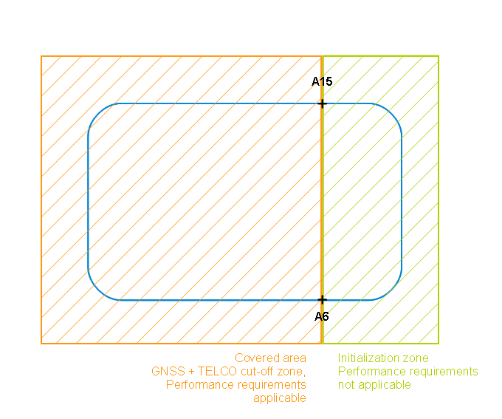
Figure B-1. Sky conditions definition method.

Use case: Moving Target

Target movement
The location target follows the trajectory described in clause B.3. The reference point {0;0;0} has coordinates expressed in [WGS84] system: longitude = [tbd], latitude = [tbd].
The trajectory parameters are provided in Table 5-2 below.
Trajectory parameter | Value
v₁ | 25 km/h
v₂ | 100 km/h
v₃ | 100 km/h
d₁ | 250 m
D₂ | 250 m
Table 5-32: Mobile target movement parameter

Performance requirement
The location target position estimated by the location system after crossing the covered area (i.e. in point A6 or A15 according to the way the trajectory is travelled) shall meet the accuracy specified in Table 5-33 to Table 5-38 below, depending on:
- the grade of the location system
- the operational environment considered, as defined in clause B.2.3.
This performance level shall be met when the trajectory is travelled in reverse directions.

Metric  (as per clause 4.2) |  | Requirements for position error after covered area crossing – Open Area
 |  | Low grade | Medium grade | High grade
Horizontal Position error | Mean value
 | Std value
 | Max value
Cross track error | Mean value
 | Std value
 | Max value
Along track error | Mean value
 | Std value
 | Max value
Vertical Position error | Mean value
 | Std value
 | Max value
Table 5-33: performance requirement for GNSS denied survival, Open Area

Table 5-34: performance requirement for GNSS denied survival, Rural Area

Table 5-35: performance requirement for GNSS denied survival, Suburban Area

Table 5-36: performance requirement for GNSS denied survival, Urban Area

Table 5-37: performance requirement for GNSS denied survival, Asymmetric Area

Table 5-38: performance requirement for GNSS denied survival, Industrial Area

GNSS Sensitivity
<Text>

<Text>

Position Integrity Protection Level
<Text>
Threat scenarios to be defined as part of this clause.
The following define the perimeter of the failing modes of GNSS systems:
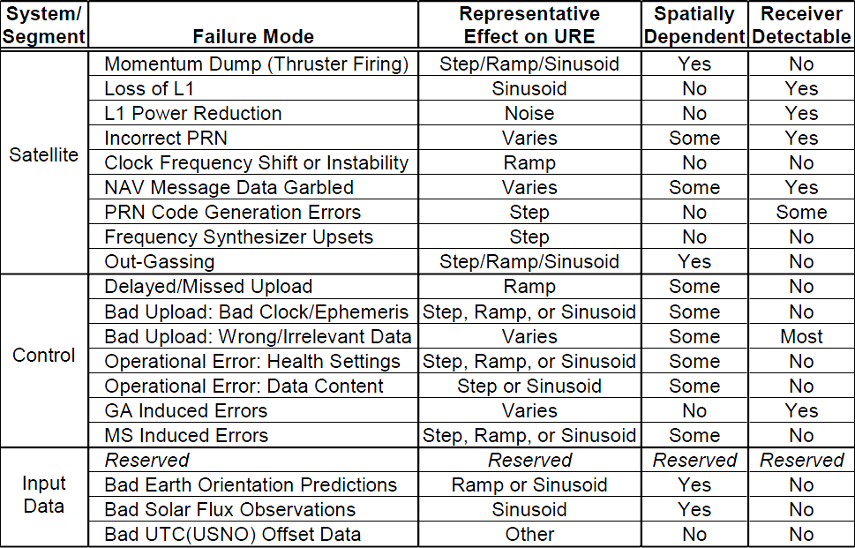
 | Predicted MI Failure Type | Block I, II, IIA Predicted MI Probability | Assigned Test Range | Assigned MI Failure  Probability
1 | Ramp 0.01 m/s | 2×10⁻⁷/hour/SV | Ramp 0.01-0.05 m/s | 1×10⁻⁶/hour/SV
2 | Ramp 0.1 m/s | 1×10⁻⁷/hour/SV | Ramp 0.05-0.25 m/s | 1×10⁻⁶/hour/SV
3 | Ramp 0.5 m/s | 3×10⁻⁷/hour/SV | Ramp 0.25-0.75 m/s | 1×10⁻⁶/hour/SV
4 | Ramp 1 m/s | 10×10⁻⁷/hour/SV | Ramp 0.75-2.5 m/s | 3.5×10⁻⁶/hour/SV
5 | Ramp 5 m/s | 12×10⁻⁷/hour/SV | Ramp 2.5-5.0 m/s | 4.1×10⁻⁶/hour/SV
6 | Step 300 m | 1×10⁻⁷/hour/SV | Step 300-700 m | 1×10⁻⁶/hour/SV
7 | Step 3000 m | 34×10⁻⁷/hour/SV | Step 700-3000 m | N/A

Position Integrity Alarm Limit and TTA
<Text>

Annex A (Normative):
Definition of performance metrics
This section defines how performance shall be determined for each parameter.

Horizontal position accuracy
The horizontal position accuracy is the projection of the position accuracy on the horizontal plane containing the mobile target true position (i.e. 2-dimensional projection).
The metrics used in order to statistically characterize this accuracy is composed of the following quantities:
  - Mean value of the horizontal position error computed over a specified time interval.
  - Standard deviation of the horizontal position error computed over a specified time interval.
  - 67th, 95th and 99th percentiles of the horizontal position error distribution computed over a specified time interval.
These metrics are defined as follows.
  - Let p be the true position of the mobile target
  - Let be the position estimates collected over a specified time interval (N samples), projected on the local horizontal plane containing the mobile target true position
  - {ε}_{i} is the positioning error vector, defined as {ε}_{i} = p - {p*}_{i} . Note that this vector is contained in the local horizontal plane.
  - The mean value is defined as:
  - The standard deviation is defined as:
  - The percentiles, noted σ_{x} (i.e. respectively σ₆₇ σ₉₅ σ₉₉ ) is defined as the smallest error verifying:
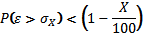
In addition to the above, when the use case considers a moving mobile target, the following metrics apply:
  - Along-track error
  - Across-track error
[definition with diagram to be added]

Vertical position accuracy
The vertical position accuracy is the projection of the position accuracy on the vertical axis containing the mobile target true position.
The metrics used in order to statistically characterize this accuracy is composed of the following quantities:
  - Mean value of the vertical position error computed over a specified time interval.
  - Standard deviation of the vertical position error computed over a specified time interval.
  - 67th, 95th and 99th percentiles of the vertical position error distribution computed over a specified time interval.
These metrics are defined as follows.
  - Let p be the true position of the mobile target
  - Let be the position estimates collected over a specified time interval (N samples), projected on the local vertical axis containing the mobile target true position
  - {ε}_{i} is the positioning error vector, defined as {ε}_{i} = p - {p*}_{i} . Note that this vector is contained in the local vertical axis.
  - The mean value is defined as:
  - The standard deviation is defined as:
  - The percentiles, noted σ_{x} (i.e. respectively σ₆₇ σ₉₅ σ₉₉ ) is defined as the smallest error verifying:

Availability of required accuracy
The availability is expressed as the percentage of time the required location-related information is available, over a predefined time windows (e.g.: 1 hour). Consequently, in order to be properly characterized, the following information shall be provided:
  - The availability rate, expressed in percent.
  - A description of the required location-related information, including required quality of service.
The required quality of service can a maximum required accuracy, an integer position, an authenticated position, etc.

Position Integrity performance
The integrity performance is characterized by a pair protection level / integrity risk.
As far as position integrity is concerned, the metrics to be used are therefore:
  - The position protection level (PPL) expressed in meters
  - The integrity risk, expressed as the probability that the actual position accuracy exceeds the position protection level under fault-free and faulty modes.

Restituted GNSS time accuracy
The restituted GNSS time accuracy is the difference, measured in seconds, between the true GNSS time (as implemented in the GNSS system timing facility) and the GNSS time restituted by the GNSS sensor based on the PVT solution.
The metrics used in order to statistically characterize this accuracy is composed of the following quantities:
  - Mean value of the restituted GNSS time error computed over a specified time interval.
  - Standard deviation of the restituted GNSS time error computed over a specified time interval.
  - 67th, 95th and 99th percentiles of the restituted GNSS time error computed over a specified time interval.

Time to first fix (TTFF)
The time to first fix is the time elapsed between the time the location request is triggered by the location system (i.e. either from external immediate request, or following a location report trigger), and the time the position answer is delivered to the location system external interface.
The metrics used in order to statistically characterize this quantity is composed of the following quantities:
  - and maximum values of the TTFF computed over a specified number of trials.
  - Mean value of the TTFF computed over a specified number of trials.
  - Standard deviation of the TTFF computed over a specified number of trials.
  - 67th, 95th and 99th percentiles of the TTFF computed over a specified number of trials.

Position authentication
The authenticity performance is characterised by the ability of the system to identify accurately spoofing attempts cases.
For position authenticity, the metrics to be used are therefore:
  - Probability of missed-detection in case of spoofing attempt (threat scenario)
  - Probability of false alarm in case of no spoofing is attempted (fault free scenario)
  - Mean time to provide position authenticity (latency)

Direction of arrival accuracy
The direction of arrival accuracy is the error between the actual direction of arrival of a signal coming from a given interference source, and the DoA of this same signal estimated by the location system.
The metrics used in order to statistically characterize this quantity is composed of the following quantities:
  - Mean value of the DoA error computed over a specified time interval.
  - Standard deviation of the DoA error computed over a specified time interval.
  - 67th, 95th and 99th percentiles of the DoA error computed over a specified time interval.

PVT degradation under interference sources
PVT degration is measured as increase of the position, speed and time estimation error caused by interference sources.

Recovery time of normal performance after termination of pulse interference

Annex B (normative): Applicable conditions
RJM: needs an explanation of the purpose of this and a reference to the Annex introduced in the main body above.

B.1 General

B.1.1 Parameter values
[This section provides the values to be used for testing for the parameters contained in the appropriate request addressed to the location system.]

B.1.2 GNSS systems parameters

B.1.2.1 Systems constellation geometry and signal parameters
Table B.x5 below provides the reference documents applicable in the frame of the present performance specification. They provide for each system:
- - the constellation geometry to be used
- - the signal parameters to be used, in particular the signal modulation parameters, and the minimum received power on ground in nominal conditions.

GNSS system | System/User interface description | Number of visible satellites | HDOP range
GPS L1C/A | [2] | Variable | 1.6 to 2.5 [tbc]
GALILEO OS | [1] | Variable | 1.6 to 2.5 [tbc]
GLONASS | [6] | Variable | 1.6 to 2.5 [tbc]
GPS L5 | [3] | Variable | 1.6 to 2.5 [tbc]
GPS L1C | [4] | Variable | 1.6 to 2.5 [tbc]
Beidou | [x] | Variable | 1.6 to 2.5 [tbc]
Table B.x5: Trajectory Parameters

B.1.2.1 GNSS System Time Offsets
If more than one GNSS is used in a test, the accuracy of the GNSS-GNSS Time Offsets used at the system simulator shall be better than 3 ns.

B.1.2 SBAS systems parameters

B.1.3 Cellular systems parameters
[tbd]
[rationale: list in the paragraph all relevant references towards standards for GSM, UMTS, LTE, WiFi, Bluetooth, DVB, allowing to properly define the applicable

B.2 Operational environments
Operational environments applicable to the performance specification given in clause 5 are defined in sub clause B.2.3 of the present annex.
These environments are defined by a list of characteristics:
- characteristics related to the GNSS sensor performance, which are preliminarily described in sub clause B.2.1.
- characteristics related to the other sensors performance, which are preliminarily described in sub clause B.2.2.

B.2.1 GNSS-related environment characteristics
The following characteristics are related to the reception conditions of the GNSS signals.
These reception conditions concerns:
GNSS signals masking or attenuation from a terminal perspective, due to obstacles (buildings, walls, trees, windows, vehicles, etc) located on the signal propagation path. This is referred to as “sky conditions” in the rest of the document
Existence of undesired GNSS signals echoes at terminal antenna input, caused by specular or diffuse reflections, and affecting the performance of the navigation solution. This is referred to as “multipath” in the rest of the document.
Presence of electro-magnetic interference sources in the terminal vicinity, causing an observable increase of noise in the terminal RF chain processing. This is referred to as “interference” in the rest of the document.
NOTE: the above phenomena are considered local contributors to GNSS signals quality. GNSS signal characteristics prior to being affected by these conditions (i.e. ignoring contribution of terminal vicinity, such as direction of arrival (and hence HDOP), received signal power) are assumed to be in line with Interface Control Documents of each of the considered GNSSs (see [1], [2], [3], [4], [5], and [6])

B.2.1.1 Sky conditions
Sky conditions are proposed to be defined as follows.
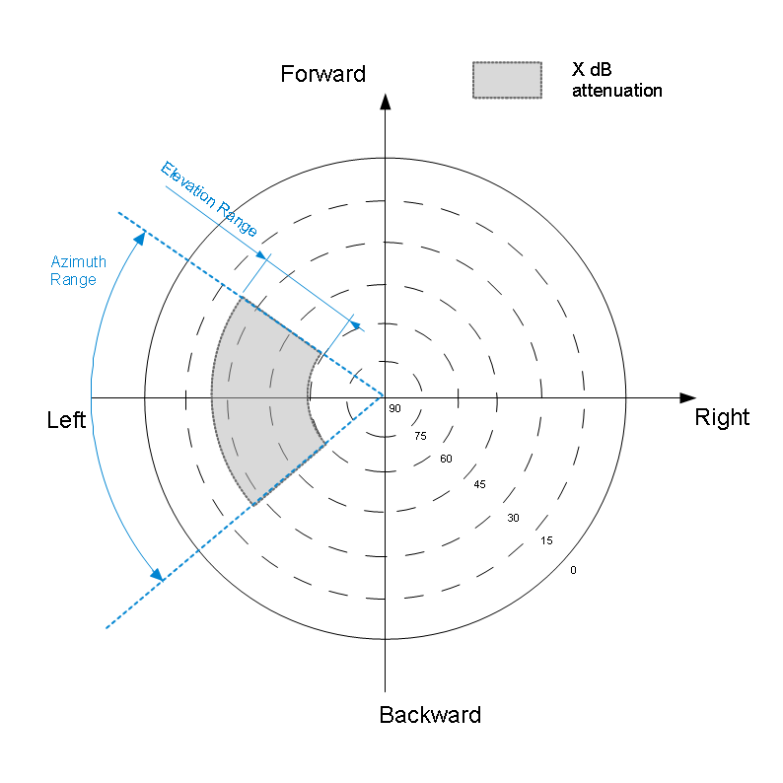
Figure B-1. Sky conditions definition method.

A sky plot provides:
- the area of the sky above the receiver being affected by total signal masking. When Satellite azimuth and elevation coordinates (from terminal point of view) falls into these area, GNSS signal is considered blocked.
- the area of the sky above the receiver being affected by partial signal masking. When Satellite azimuth and elevation coordinates (from terminal point of view) falls into these area, GNSS signal is considered attenuated. The amount of this attenuation is defined for each operational environment.
Note: several distinct areas can be defined for a single operational environment.
Typical sky conditions are defined in clause B.2.3.

B.2.1.2 Multipath
The multipath model applicable to the performance specification is described below.
Doppler frequency difference between direct and reflected signal paths is applied to the carrier and code frequencies. The Carrier and Code Doppler frequencies of LOS and multi-path for GNSS signal are defined in table B.x1
Initial relative Delay  [m] | Carrier Doppler frequency of tap [Hz] | Code Doppler frequency of tap [Hz] | Relative mean Power [dB]
0 | Fd | Fd / N | 0
X | Fd - 0.1 | (Fd-0.1) /N | Y
NOTE: Discrete Doppler frequency is used for each tap.
Table B.x1: Trajectory Parameters
X, Y and N depend on the GNSS signal type. In addition, Y depends on the intensity of multipath faced in the operational environments. N is the ratio between the transmitted carrier frequency of the signals and the transmitted chip rate.
The initial carrier phase difference between taps shall be randomly selected between 0 and 2π. The initial value shall have uniform random distribution.
Table B.x below provides the parameters values of 3 levels of multipath intensity, from low to high. k in Table B.x3 is the GLONASS frequency channel number.

Multipath level |  |  | Low | Med | High
System | Signals | X [m] | Y [dB] | Y [dB] | Y [dB]
Galileo | E1 | 125 | [tbd] | -4.5 | [tbd]
 | E5a | 15 | [tbd] | -6 | [tbd]
 | E5b | 15 | [tbd] | -6 | [tbd]
GPS/Modernized GPS | L1 C/A | 150 | [tbd] | -6 | [tbd]
 | L1C | 125 | [tbd] | -4.5 | [tbd]
 | L2C | 150 | [tbd] | -6 | [tbd]
 | L5 | 15 | [tbd] | -6 | [tbd]
GLONASS | G1 | 275 | [tbd] | -12.5 | [tbd]
 | G2 | 275 | [tbd] | -12.5 | [tbd]
Table B. x2: Parameter values

System | Signals | N
Galileo | E1 | 1540
 | E5a | 115
 | E5b | 118
GPS/Modernized GPS | L1 C/A | 1540
 | L1C | 1540
 | L2C | 1200
 | L5 | 115
GLONASS | G1 | 3135.03 + k ⋅ 1.10
 | G2 | 2438.36 + k ⋅ 0.86
Table B.x3 Ratio between Carrier Frequency and Chip Rate

B.2.1.3 Electro-magnetic Interference
The EMI model applicable to the performance specification is described below.
Interference conditions are modelled by the total noise power density after correlation , . It is derived from the interference source spectral characteristics according to the following formula:
where
- stands for considered GNSS signal (e.g. Galileo E5a, GPS L1C …)
- is the carrier frequency of the considered GNSS signal X
- is the GNSS sensor filtering bandwidth of the considered GNSS signal X
- is the external noise power density at the antenna level,
- is the spreading gain enabled by the receiver correlator while processing signal X
In the frame of this technical specification, three levels of impact of the interference environments are considered, from low to high.
EMI level | NI
Low | -200 dBW/Hz
Medium | -195 dBW/Hz
High | -185 dBW/Hz
Table B.x4 Interference levels

B.2.2 Additional environment characteristics
Further to the above environment characteristics, addition characteristics are defined. They are relevant to the specification of performance for system embedding technical enablers other than GNSS sensor.

B.2.2.1 Telecommunication beacons deployment
According to [7], location systems might embed telecommunication sensors which enable the provision of measurements participating to the navigation solution. This sub clause defines additional environment characteristics relevant to these type of sensors.
Depending on the claimed compatibility of the location system under test, the beacon deployment(s) applicable to the present performance specification shall be as follows (one or several clauses applicable).

Quid of masking conditions to be applied to the base stations signals ?

B.2.2.1.1 Cellular telecommunications base stations caracteristics and deployment
Relevant standard reference, providing the Base Station (BS) signal specification (transmitter power, …) , is provided in clause B.1.3.

B.2.2.1.1.1 Base stations deployment height

B.2.2.1.1.1 Base stations deployment density

B.2.2.1.1 Wi-Fi access points characteristics and deployment
Relevant standard reference, providing the Base Station (BS) signal specification (transmitter power, …) , is provided in clause B.1.3.

B.2.2.1.1.1 Access points deployment height
[random from – to -]

B.2.2.1.1.1 Access points deployment density

B.2.2.1.1 Blue-tooth transmitters caracteristics and deployment
Relevant standard reference, providing the Base Station (BS) signal specification (transmitter power, …) , is provided in clause B.1.3.

B.2.2.1.1 DVB transmitters caracteristics and deployment
Relevant standard reference, providing the Base Station (BS) signal specification (transmitter power, …) , is provided in clause B.1.3.

B.2.2.1.1.1 Transmitters deployment height

B.2.2.1.1.1 Transmitters deployment density

B.2.2.2 Interference source definition
<Text>
Definition of the interference model chosen in the operational environment.

NB: user dynamics will be specified in each individual test scenarios (per key features, in section 5)

B.2.2.2 Magnetic conditions

B.2.3 Operational environments definition
Typical environments. Each environments foresees a given set of values for each characteristics listed above.
Operational environment type | Masking conditions |  |  | Multipath Level | Interference level | Magnetic conditions | Telco beacons distribution
 | Polar plot | Zone | Atten
Open Area | Open sky | x1 | 0 dB | Null | Null | Nominal | Rural distribution
 |  | x2 | [tbd] (total)
Rural Area | Light masking | x1 | 0 dB | Low | Low | Nominal | Rural distribution
 |  | x2 | Total
 |  | x3 | 10 dB
Suburban Area | Dense masking | x1 | 0 dB | Medium | Low | Nominal | Suburban distribution
 |  | x2 | Total
 |  | x3 | Total
Urban Area | Urban Canyon | x1 | 0 dB | High | Medium | Degraded | Urban distribution
 |  | x2 | Total
Assymetric Area | Assymetric visibility | x1 | 15 dB | High | Medium | Degraded | Urban distribution
 |  | x2 | Total
 |  | x3 | Total
Industrial Area | Dense masking | x1 | 0 dB | High | High | Degraded | Suburban distribution
 |  | x2 | Total
 |  | x3 | Total
Table B.x6 Operational environments definition

B.2.3.1 Open area

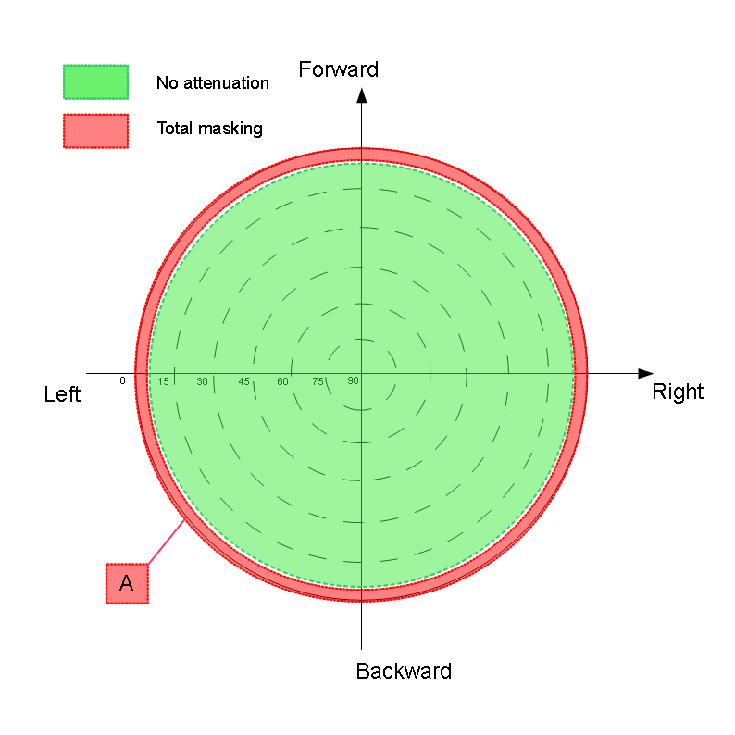
Figure B-2. Open area sky conditions
The following default parameters are defined:

Zone | Elevation range |  | Azimuth range |  | Signal Attenuation
A | 0 - 5 | degrees | 0 - 360 | degrees | Masked | dB
Background | Area out of Zone A |  |  |  | 0 | dB
Table B. x2: Open area default parameters

B.2.3.2 Rural area

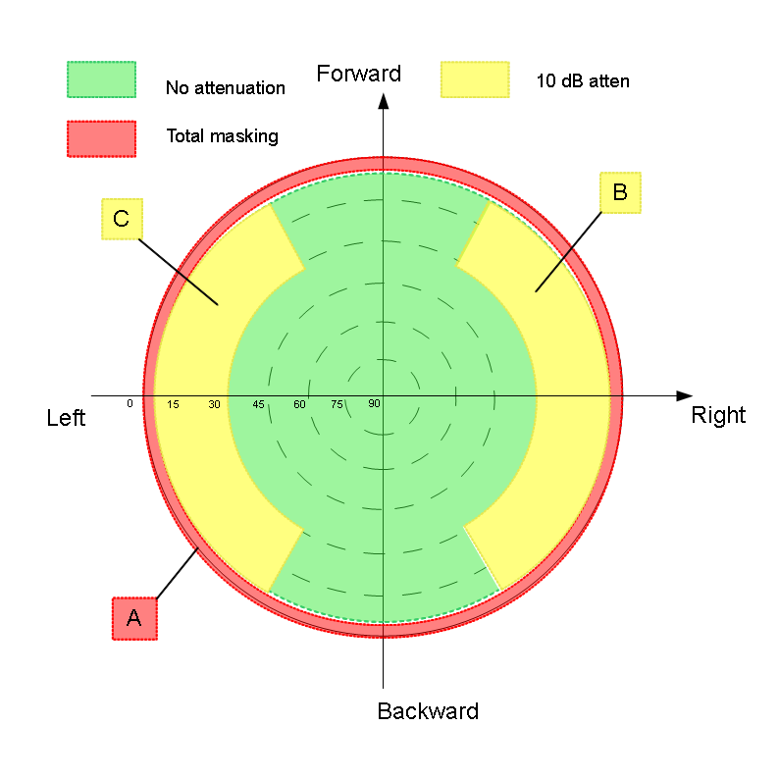
Figure B-3. Rural area sky conditions

Zone | Elevation range |  | Azimuth range |  | Signal Attenuation
A | 0 - 5 | degrees | 0 - 360 | degrees | Masked | dB
B | 5 - 30 | degrees | 210 – 330 | degrees | 10 | dB
C | 5 - 30 | degrees | 30 - 150 | degrees | 10 | dB
Background | Area out of Zones A, B, C |  |  |  | 0 | dB
Table B. x2: Open area default parameters

B.2.3.3 Suburban area
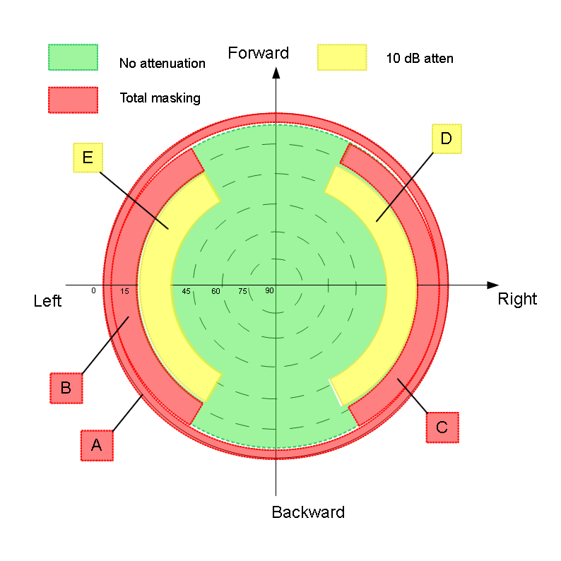
Figure B-4. Suburban area sky conditions

- Zone | - Elevation range |  | - Azimuth range |  | - Signal Attenuation
- A | - 0 – 5 | - degrees | - 0 – 360 | - degrees | - Masked | - dB
- B | - 5 – 20 | - degrees | - 210 – 330 | - degrees | - Masked | - dB
- C | - 5 – 20 | - degrees | - 30 - 150 | - degrees | - Masked | - dB
- D | - 20 – 40 | - degrees | - 30 - 150 | - degrees | - 10 | - dB
- E | - 20 – 40 | - degrees | - 210 – 330 | - degrees | - 10 | - dB
- Background | - Area out of Zones A, B, C, D, E |  |  |  | - 0 | - dB
Table B. x2: Open area default parameters

B.2.3.4 Urban area
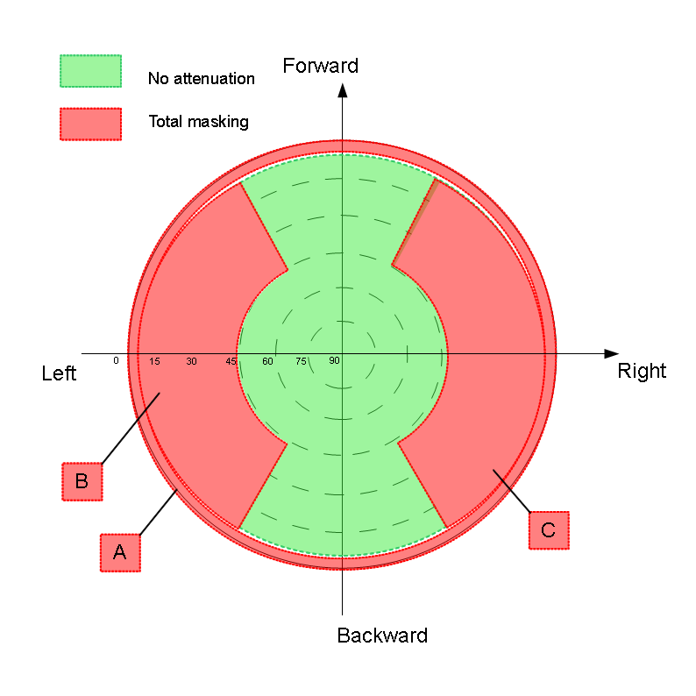
Figure B-5. Urban area sky conditions

Zone | Elevation range |  | Azimuth range |  | Signal Attenuation
A | 0 - 5 | degrees | 0 - 360 | degrees | Masked | dB
B | 5 – 60 | degrees | 210 - 330 | degrees | Masked | dB
C | 5 – 60 | degrees | 30 - 150 | degrees | Masked | dB
Background | Area out of Zones A, B, C |  |  |  | 0 | dB
Table B. x2: Open area default parameters

B.2.3.6 Asymmetric area
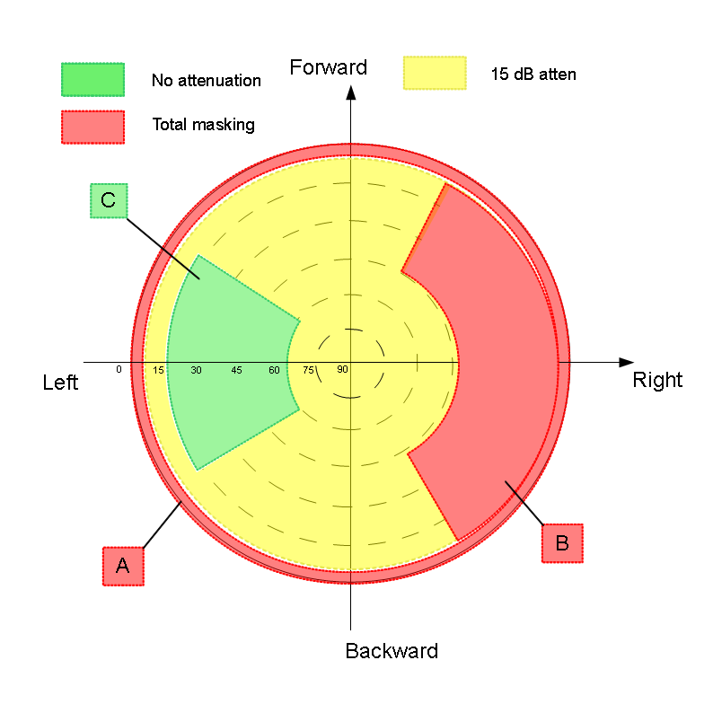
Figure B-6. Assymetric area sky conditions

- Zone | - Elevation range |  | - Azimuth range |  | - Signal Attenuation
- A | - 0 - 5 | - degrees | - 0 - 360 | - degrees | - Masked | - dB
- B | - 5 - 60 | - degrees | - 30 - 150 | - degrees | - Masked | - dB
- C | - 10 - 60 | - degrees | - 230 - 310 | - degrees | - 0 | - dB
- Background | - Area out of Zones A, B, C |  |  |  | - 15 | - dB
Table B. x2: Open area default parameters

B.2.3.7 Industrial area
Figure B-6. Industrial area sky conditions

- Zone | - Elevation range |  | - Azimuth range |  | - Signal Attenuation
- A | - 0 – 5 | - degrees | - 0 – 360 | - degrees | - Masked | - dB
- B | - 5 – 20 | - degrees | - 210 – 330 | - degrees | - Masked | - dB
- C | - 5 – 20 | - degrees | - 30 - 150 | - degrees | - Masked | - dB
- D | - 20 – 40 | - degrees | - 30 - 150 | - degrees | - 10 | - dB
- E | - 20 – 40 | - degrees | - 210 – 330 | - degrees | - 10 | - dB
- Background | - Area out of Zones A, B, C, D, E |  |  |  | - 0 | - dB
Table B. x2: Open area default parameters

B.3 Moving scenario description
The diagram below describes a reference trajectory used in clause 5.
Point {0;0;0} is used as reference of the local coordinate system (X,Y), defining an horizontal plane.
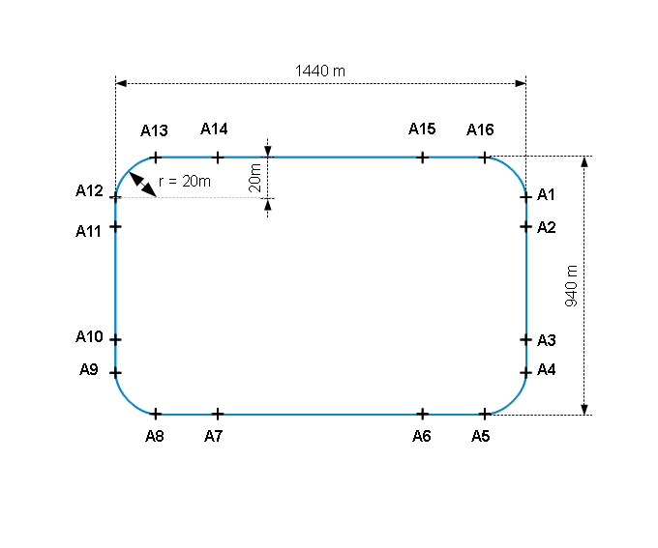
Figure B-7. Mobile target trajectory

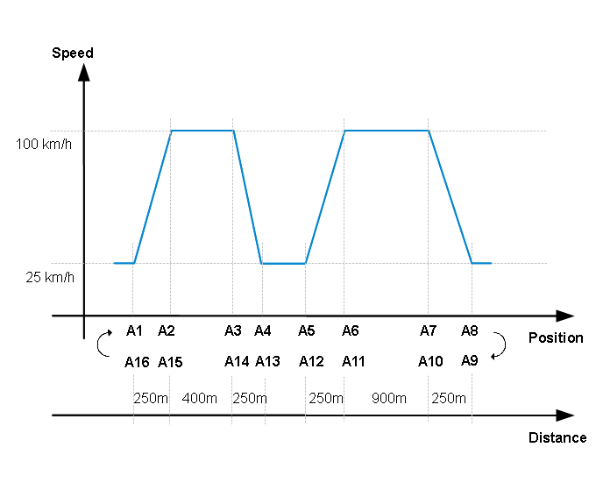
Figure B-7. Mobile target speed profile

Annex C (normative):
Threat scenario for Integrity and Authentication features

Authentication threat scenarios
This clause described the threat scenario used as reference scenarios for the definition of the minimu performance requirements related to authentication key feature.

Threat scenarios description
The threat scenarios all consider spoofing attempts on the mobile target GNSS sensor. Such spoofing is executed by the broadcast of an intentional RF signal whose characteristics make it processable by the GNSS sensor, and pushing towards it misleading information.
The misleading information considered concern the pseudo-range domain or the time and position domain.

Scenarios pre-conditions
The following pre-conditions apply to the location system:
- location-related information of the mobile target are available
- all tracked GNSS signals are authentic

Scenarios chronology
The considered scenarios all follow the chronology depicted in figure D-f1.:
Figure D-f1. Threat scenario chronology

T₀ is the start of the scenario
T_{s} is the time of occurrence of the threat. Duration J is the time elapsed between the scenario start and the occurrence of the threat.
T_{e} is the end of the scenario. Duration S is the time elapsed between the occurrence of the threat and the scenario end.

Scenarios parameters
The scenarios are defined by the following list of parameters
- attack classification: it defines classes of spoofing attempts, based on the method used to have the GNSS sensor track the spoofed GNSS signals
- misleading information category: it determines categories of misleading information based on the impact of the spoofing attack on the GNSS sensor output.
- total spoofing power (TSP): it is the sum of signal powers for different spoofing GNSS signals.
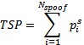, where is the power of the i^{th} spoofed signal at the output of the GNSS sensor antenna.
- target movement: in case the target is moving, it provides the its trajectory and dynamics

The following sub-clause define each of these parameters.

Attack classification
Two main classes of attacks are identified based on the method used to have the GNSS sensor track the spoofed GNSS signals. Several spoofed PRNs can be generated. For both classes it is considered that the spoofed GNSS signal(s) is (are) radiated from a single antenna.
- Direct spoofed GNSS signal introduction
In this method, the spoofed GNSS signal is generated and radiated towards the GNSS sensor without consideration of the overall context (i.e. sensor position, authentic PRN visibility).
In order to enable the tracking of spoofed PRNs by the GNSS sensor, in case of direct signal introduction, an outage of authentic GNSS signals is applied between T₀ and T_{s}.At T_{s}, the spoofed GNSS signals are radiated towards the GNSS sensor, and the power received by the GNSS sensor is in line with the TSP specified.
- Shadowed spoofed GNSS signal introduction
In this method, the spoofed GNSS signal is generated and radiated towards the GNSS sensor so that the correlation peak computed by the GNSS sensor using the spoofed PRN rises in the shadow of the correlation peak computed by the GNSS sensor using the same authentic PRN.
The figure D-f2 illustrates this concept.
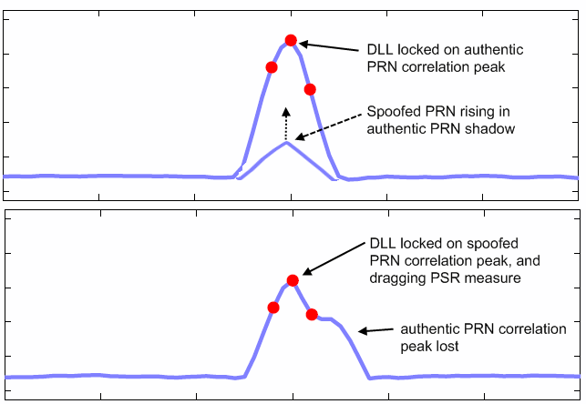
Figure D-f2. Spoofed PRN shadowed introduction

NOTE: It therefore means that GNSS constellation geometry, current GNSS time, and GNSS sensor position are known from the spoofing source in order to estimate the authentic PRN code delay, and that the spoofed PRN correspond to an actually visible authentic PRN.

Total spoofing power
The total spoofing power (TSP) is the sum of signal powers for different spoofing GNSS signals.
It is defined as:
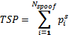 [dBW]
where is the power of the i^{th} spoofed signal at the output of the GNSS sensor antenna.
The TSP is variable for each scenario, and used as a metric to measure the location system authentication performance.

Misleading information category
The spoofing attacks can cause three types of misleading information at GNSS sensor level:
- erroneous PSR measurement
- erroneous GNSS resolved time
- erroneous GNSS sensor estimated position (for both static of moving scenario).
The following error models are used for each of the above misleading information.
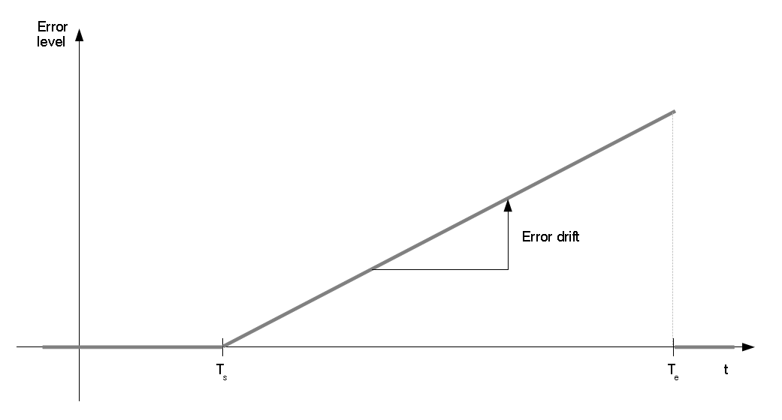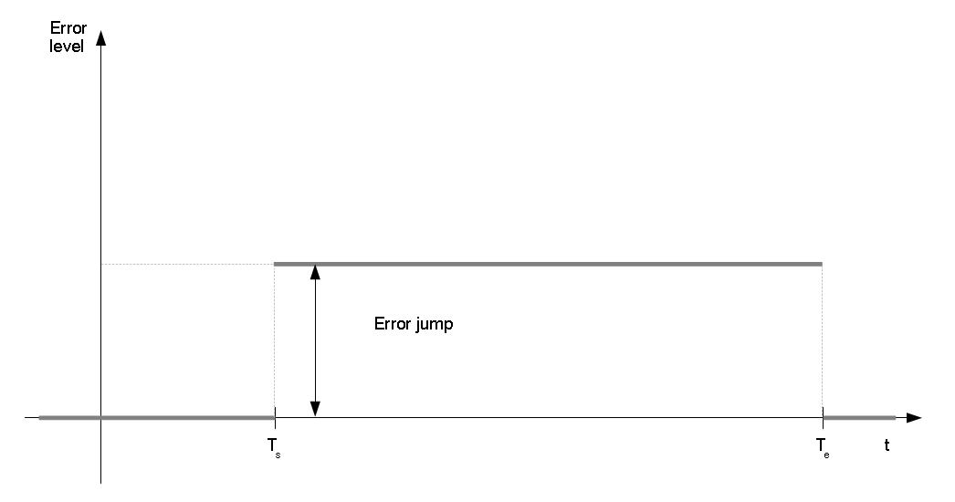
Figure D-f3. Threat scenario error models

These models are applied for each type of misleading information according to table D-t1 below:

Misleading information | Error | Error unit | Jump unit | Drift unit
PSR measurement | Pseudorange error | Meters | m | m/s
GNSS resolved time | Time delay | Seconds | s | s/s
Estimated position | Position error (1) | Meters | m | m/s
Table D-t1: Misleading information model parameters
NOTE (1): The position error is measured on the across track axis.
The models parameters (jump and drift) are variable for each scenario, and used as a metric to measure the location system authentication performance.

Target movement
For use cases where target is moving the following trajectory shall be used.
Figure D-f4. Threat scenario trajectory

Point A is crossed at T₀, point B is crossed at T_{e}.

The mobile target speed shall be 50 km/h on the entire trajectory.

Threat scenarios for moving target
The threat scenarios listed in table D-t2 are defined for moving targets.
Pre-conditions defined in clause D.1.1.1 apply.
Trajectory defined in clause D.1.1.3.4 applies
Scenario identifier | Attack class | Number of spoofed PRNs | TSP range  (dBW) | Misleading information category | Error model | Error value range
M-1 | Shadow | P | [tbd | GNSS resolved time | Drift | [tbd-tbd] s/s
M-2 | Shadow | 1 | [tbd | Pseudorange measurement | Drift | [tbd-tbd] m/s
M-3 | Shadow | P | [tbd | Esimated Position | Drift | [tbd-tbd] m/s
M-4 | Direct | P | [tbd | Esimated Position | Jump | [tbd-tbd] m
M-5 | Direct | P | [tbd | Esimated Position | Drift | [tbd-tbd] m/s
M-6 | Direct | P | [tbd | GNSS resolved time | Drift | [tbd-tbd] s/s
Table D-t2: Threat scenario for moving target
Number of the spoofed PRNs P is [tbd].

Threat scenarios for static targets
The threat scenarios listed in table D-t3 are defined for static targets.
Pre-conditions defined in clause D.1.1.1 apply.

Scenario identifier | Attack class | Number of spoofed PRNs | TSP range  (dBW) | Misleading information category | Error model | Error value range
S-1 | Direct | P | [tbd-tbd] | GNSS resolved time | Jump | [tbd-tbd] s
S-2 | Direct | P | [tbd | Esimated Position | Jump | [tbd-tbd] m
S-3 | Direct | P | [tbd | GNSS resolved time | Drift | [tbd-tbd] s/s
S-4 | Direct | P | [tbd | Esimated Position | Drift | [tbd-tbd] m/s
S-5 | Shadow | P | [tbd | GNSS resolved time | Drift | [tbd-tbd] s/s
S-6 | Shadow | 1 | [tbd | Pseudorange measurement | Drift | [tbd-tbd] m/s
S-4 | Shadow | P | [tbd | Esimated Position | Drift | [tbd-tbd] m/s
Table D-t3: Threat scenario for static target

Integrity threat scenarios

Annex <X> (informative):
Bibliography
The annex entitled "Bibliography" is optional.
It shall contain a list of standards, books, articles, or other sources on a particular subject which are not mentioned in the document itself (see clause 12.2 of the EDRs http://portal.etsi.org/edithelp/Files/other/EDRs_navigator.chm).
It shall not include references mentioned in the document.

History
Document history
V0.0.1
V0.0.2
V0.0.3
V0.0.4
V0.0.5 | April 2014 | Modified and commented by STF 474
V0.0.6 | May 2014 | Inputs from TAS etc.
V0.0.7 | May 2014 | Previous Annex 5 reinstated and renamed, and further corrections

