StableDraft ETSI ES 203 119-1 V1.2.1 (2014-09)
Methods for Testing and Specification (MTS);
The Test Description Language (TDL);
Part 1: Abstract Syntax and Associated Semantics

<

ETSI Standard
Reference
RES/MTS-203119-1v1.2.1
Keywords
language, MBT, methodology, testing, TSS&TP, TTCN-3, UML
ETSI
650 Route des Lucioles
F-06921 Sophia Antipolis Cedex - FRANCE

Tel.: +33 4 92 94 42 00 Fax: +33 4 93 65 47 16

Siret N° 348 623 562 00017 - NAF 742 C
Association à but non lucratif enregistrée à la
Sous-Préfecture de Grasse (06) N° 7803/88

Important notice
The present document can be downloaded from:
http://www.etsi.org
The present document may be made available in electronic versions and/or in print. The content of any electronic and/or print versions of the present document shall not be modified without the prior written authorization of ETSI. In case of any existing or perceived difference in contents between such versions and/or in print, the only prevailing document is the print of the Portable Document Format (PDF) version kept on a specific network drive within ETSI Secretariat.
Users of the present document should be aware that the document may be subject to revision or change of status. Information on the current status of this and other ETSI documents is available at http://portal.etsi.org/tb/status/status.asp
If you find errors in the present document, please send your comment to one of the following services:
http://portal.etsi.org/chaircor/ETSI_support.asp
Copyright Notification
No part may be reproduced or utilized in any form or by any means, electronic or mechanical, including photocopying and microfilm except as authorized by written permission of ETSI.
The content of the PDF version shall not be modified without the written authorization of ETSI.
The copyright and the foregoing restriction extend to reproduction in all media.

© European Telecommunications Standards Institute 2014.
All rights reserved.
DECTTM, PLUGTESTSTM, UMTSTM and the ETSI logo are Trade Marks of ETSI registered for the benefit of its Members.
3GPPTM and LTE™ are Trade Marks of ETSI registered for the benefit of its Members and
of the 3GPP Organizational Partners.
GSM® and the GSM logo are Trade Marks registered and owned by the GSM Association.

Contents
Intellectual Property Rights 9
Foreword 9
1 Scope 10
2 References 10
2.1 Normative references 10
2.2 Informative references 10
3 Definitions and abbreviations 11
3.1 Definitions 11
3.2 Abbreviations 11
4 Basic Principles 12
4.1 What is TDL? 12
4.2 Applicability of the present document 12
4.3 Design Considerations 13
4.4 Document Structure 14
4.5 Notational Conventions 14
4.6 Conformance 14
5 Foundation 15
5.1 Overview 15
5.2 Abstract Syntax 15
5.3 Classifier Description 17
5.3.1 Element 17
5.3.2 PackageableElement 17
5.3.3 Package 18
5.3.4 ElementImport 18
5.3.5 Comment 19
5.3.6 Annotation 19
5.3.7 AnnotationType 20
5.3.8 TestObjective 20
5.3.9 TestObjectiveRealizer 20
6 Data 21
6.1 Overview 21
6.2 Abstract Syntax 23
6.3 Classifier Description 26
6.3.1 DataResourceMapping 27
6.3.2 DataElementMapping 27
6.3.3 MappableDataElement 28
6.3.4 DataSet 28
6.3.5 DataInstance 29
6.3.x DataKind <requires further discussion> 29
6.3.6 SimpleDataType 30
6.3.7 SimpleDataInstance 30
6.3.8 AnyValue 30
6.3.9 StructuredDataType 31
6.3.10 TupleElement 31
6.3.11 StructuredDataInstance 32
6.3.12 TupleElementInstance 32
6.3.13 DataProxy 32
6.3.14 Parameter 33
6.3.15 Variable 33
6.3.16 Action 34
6.3.17 Function 34
6.3.18 DataInstanceSpecification 34
6.3.19 DataProxySpecification 35
6.3.x AnyValueSpec 35
6.3.x SimpleDataSpec 36
6.3.20 ParameterisedDataInstanceSpec 36
6.3.21 ArgumentSpec 36
6.3.22 ReferencedDataInstanceSpecification 37
6.3.23 InlineDataInstanceSpecification 37
7 Test Configuration 38
7.1 Overview 38
7.2 Abstract Syntax 38
7.3 Classifier Description 39
7.3.1 TestConfiguration 39
7.3.2 GateType 39
7.3.3 GateInstance 40
7.3.4 ComponentType 40
7.3.5 ComponentInstanceRole 40
7.3.6 ComponentInstance 41
7.3.7 Connection 42
8 Test Behaviour 42
8.1 Overview 42
8.2 Abstract Syntax 43
8.3 Classifier Description 46
8.3.1 TestDescription 46
8.3.2 Block 47
8.3.3 Behaviour 48
8.3.4 CombinedBehaviour 48
8.3.5 SingleCombinedBehaviour 49
8.3.6 CompoundBehaviour 49
8.3.7 OptionalBehaviour 49
8.3.8 BoundedLoopBehaviour 50
8.3.9 UnboundedLoopBehaviour 50
8.3.10 MultipleCombinedBehaviour 51
8.3.11 AlternativeBehaviour 51
8.3.12 ConditionalBehaviour 51
8.3.13 ParallelBehaviour 52
8.3.14 AtomicBehaviour 52
8.3.15 Break 53
8.3.16 Stop 53
8.3.17 VerdictAssignment 53
8.3.18 VerdictType 54
8.3.19 Interaction 54
8.3.21 ActionReference 56
8.3.22 TestDescriptionReference 56
8.3.23 ComponentInstanceBinding 58
8.3.28 ExceptionalBehaviour 60
8.3.29 DefaultBehaviour 61
8.3.30 InterruptBehaviour 62
8.3.31 PeriodicBehaviour 62
9 Time 62
9.1 Overview 62
9.2 Abstract Syntax 63
9.3 Classifier Description 64
9.3.1 Time 64
9.3.2 TimeUnit 64
9.3.3 TimeOperation 64
9.3.4 Wait 65
9.3.5 Quiescence 65
9.3.6 TimeConstraint 66
9.3.7 Timer 66
9.3.8 TimerOperation 67
9.3.9 TimerStart 67
9.3.10 TimeOut 67
9.3.11 TimerStop 68
10 Predefined Types 68
10.1 Overview 68
10.2 Predefined Element Instances of 'VerdictType' 68
10.2.1 pass 68
10.2.2 fail 68
10.2.3 inconclusive 68
10.3 Predefined Element Instances of 'TimeUnit' 69
10.3.1 tick 69
10.3.2 nanosecond 69
10.3.3 microsecond 69
10.3.4 millisecond 69
10.3.5 second 69
10.3.6 minute 69
10.3.7 hour 69
Annex A (informative): Technical Representation of the TDL Meta-Model 70
Annex B (informative): Examples of a TDL Concrete Syntax 71
B.1 Introduction 71
B.2 A 3GPP Conformance Example in Textual Syntax 71
B.3 An IMS Interoperability Example in Textual Syntax 73
B.4 An Example Demonstrating TDL Data Concepts 75
B.5 TDL Textual Syntax Reference 77
B.5.1 Conventions for the TDLan Syntax Definition 77
B.5.2 TDL Textual Syntax EBNF Production Rules 77
Annex C (informative): Bibliography 87
History 88

Intellectual Property Rights
IPRs essential or potentially essential to the present document may have been declared to ETSI. The information pertaining to these essential IPRs, if any, is publicly available for ETSI members and non-members, and can be found in ETSI SR 000 314: "Intellectual Property Rights (IPRs); Essential, or potentially Essential, IPRs notified to ETSI in respect of ETSI standards", which is available from the ETSI Secretariat. Latest updates are available on the ETSI Web server (http://ipr.etsi.org).
Pursuant to the ETSI IPR Policy, no investigation, including IPR searches, has been carried out by ETSI. No guarantee can be given as to the existence of other IPRs not referenced in ETSI SR 000 314 (or the updates on the ETSI Web server) which are, or may be, or may become, essential to the present document.

Foreword
This ETSI Standard (ES) has been produced by the ETSI Technical Committee Methods for Testing and Specification (MTS).
[Editor note: This stable draft presents the additions and modifications in the meta-model and its documentation that will be worked on in STF 476.]
The present document is part 1 of a multi-part deliverable on the Test Description Language as detailed below:
Part 1: Abstract Syntax and Associated Semantics
Part 2: Graphical Syntax
Part 3: Exchange Format

1 Scope
The present document specifies the abstract syntax of the Test Description Language (TDL) in the form of a meta-model based on the OMG Meta Object Facility (MOF) [1] and also specifies the semantics of the individual elements of the TDL meta-model. The intended use of the present document is to serve as the basis for the development of TDL concrete syntaxes aimed at TDL users and enable TDL tools such as documentation generators, specification analyzers, and code generators.
The specification of concrete syntaxes for TDL is outside the scope of the present document. However, for illustrative purposes, an example of a possible textual syntax together with its application on some existing ETSI test descriptions are provided.

2 References
References are either specific (identified by date of publication and/or edition number or version number) or non-specific. For specific references, only the cited version applies. For non-specific references, the latest version of the referenced document (including any amendments) applies.
Referenced documents which are not found to be publicly available in the expected location might be found at http://docbox.etsi.org/Reference.
NOTE: While any hyperlinks included in this clause were valid at the time of publication, ETSI cannot guarantee their long term validity.

2.1 Normative references
The following referenced documents are necessary for the application of the present document.
[1] "OMG Meta Object Facility (MOF) Core Specification V2.4.1", formal/2013-06-01.
NOTE: Available at http://www.omg.org/spec/MOF/2.4.1/.
[2] "OMG Unified Modeling LanguageTM (OMG UML) Superstructure, Version 2.4.1",
formal/2011-08-06.
[3] ISO/IEC 9646-1:1994: "Information technology - Open Systems Interconnection -- Conformance testing methodology and framework -- Part 1: General concepts".

2.2 Informative references
The following referenced documents are not necessary for the application of the present document but they assist the user with regard to a particular subject area.
[i.1] ETSI ES 201 873-1 (V4.5.1): "Methods for Testing and Specification (MTS); The Testing and Test Control Notation version 3; Part 1: TTCN-3 Core Language".
[i.2] ETSI TS 136 523-1 (V10.2.0): "LTE; Evolved Universal Terrestrial Radio Access (E-UTRA) and Evolved Packet Core (EPC); User Equipment (UE) conformance specification; Part 1: Protocol conformance specification (3GPP TS 36.523-1 version 10.2.0 Release 10)".
[i.3] ETSI TS 186 011-2: "Technical Committee for IMS Network Testing (INT); IMS NNI Interoperability Test Specifications; Part 2: Test descriptions for IMS NNI Interoperability".

3 Definitions and abbreviations

3.1 Definitions
For the purposes of the present document, the following terms and definitions apply:
abstract syntax: graph structure representing a TDL specification in an independent form of any particular encoding
NOTE: The TDL abstract syntax is defined in terms of the TDL meta-model.
action: any procedure carried out by a component of a test configuration or an actor during test execution that could result in changes to the test verdict
actor: abstraction of entities outside a test configuration that interact directly with the components of that test configuration
component: active element of a test configuration that is either in the role tester or system under test
concrete syntax: particular representation of a TDL specification, encoded in a textual, graphical, tabular or any other format suitable for the users of this language
interaction: any form of communication between components that is accompanied with an exchange of data
NOTE: An interaction can be a point-to-point or a point-to multipoint communication.
meta-model: modelling elements representing the abstract syntax of a language
System Under Test (SUT): role of a component within a test configuration whose behaviour is validated when executing a test description
TDL model: instance of the TDL meta-model
TDL specification: representation of a TDL model given in a concrete syntax
test configuration: specification of a set of components that contains at least one tester component and one system under test component plus their interconnections via gates and connections
test description: specification of test behaviour that runs on a given test configuration
test verdict: Result from executing a test description [3].
tester: role of a component within a test configuration that controls the execution of a test description against the components in the role system under test

3.2 Abbreviations
For the purposes of the present document, the following abbreviations apply:
EBNF Extended Backus-Naur Form
IMS IP Multimedia Subsystem
MBT Model-Based Testing
MOF Meta-Object Facility
SUT System Under Test
TDD Test Driven Development
TDL Test Description Language
TTCN-3 Testing and Test Control Notation version 3
UML Unified Modelling Language
URI Unified Resource Identifier
UTP UML Testing Profile

4 Basic Principles

4.1 What is TDL?
TDL is a language that supports the design and documentation of formal test descriptions that can be the basis for the implementation of executable tests in a given test framework, such as TTCN-3 [i.1]. Application areas of TDL that will benefit from this homogeneous approach to the test design phase include:
- Manual design of test descriptions from a test purpose specification, user stories in test driven development (TDD) or other sources.
- Representation of test descriptions derived from other sources such as MBT test generation tools, system simulators, or test execution traces from test runs.
TDL supports the design of black-box tests for distributed, concurrent real-time systems. It is applicable to a wide range of tests including conformance tests, interoperability tests, tests of real-time properties and security tests based on attack traces.
Being a formal notation, TDL clearly separates the specification of tests from their implementation by providing an abstraction level that lets users of TDL focus on the task of describing tests that cover the given test objectives rather than getting involved in implementing these tests to ensure their fault detection capabilities onto an execution framework.
TDL is designed to support different abstraction levels of test specifications. On one hand, the concrete syntax of the TDL meta-model can hide meta-model elements that are not needed for a declarative (more abstract) style of specifying test descriptions. For example, a declarative test description could work with the time operations wait and quiescence instead of explicit timers and operations on timers (see clause 9).
On the other hand, an imperative (less abstract or refined) style of a test description supported by a dedicated concrete syntax could provide additional means necessary to derive executable test descriptions from declarative test descriptions. For example, an imperative test description could include timers and timer operations necessary to implement the reception of SUT output at a tester component and further details. It is expected that most details of a refined, imperative test description can be generated automatically from a declarative test description. Supporting different shades of abstraction by a single TDL meta-model offers the possibility of working within a single language and using the same tools, simplifying the test development process that way.

4.2 Applicability of the present document
The TDL language design is centered around the three separate concepts of abstract syntax, concrete syntax, and semantics (see figure 4.1). The present document covers the TDL abstract syntax given as the TDL meta-model and its associated semantics.
The TDL concrete syntax is application or domain specific and is not specified in the present document. However, for information, see annex B for an example of a concrete textual syntax.
The semantics of the meta-model elements are captured in the individual clauses describing the meta-model elements defined in the present document.
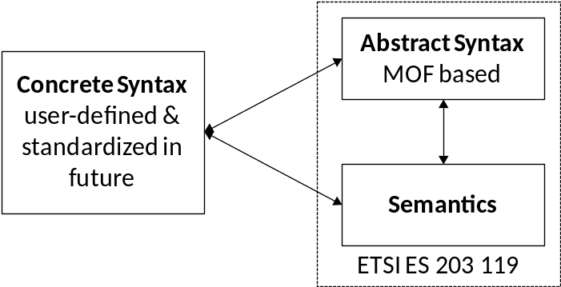
Figure 4.1: TDL language concepts
The abstract syntax (TDL meta-model) and semantics defined in the present document serve as the basis for the development of TDL tools such as editors for TDL specifications in graphical, textual or other forms of concrete syntaxes, analyzers of TDL specifications that check the consistency of TDL specifications, test documentation generators that retransform a TDL specification into another concrete syntax that is more appealing to some stakeholders, and (test) code generators to derive executable tests.

4.3 Design Considerations
TDL makes a clear distinction between concrete syntax that is adjustable to different application domains and a common abstract syntax, which a concrete syntax is mapped to (an example concrete syntax can be found in annex B). The definition of the abstract syntax for a TDL specification plays the key role in offering interchangeability and unambiguous semantics of test descriptions. It is defined in this TDL standard in terms of a MOF meta-model.
A TDL specification consists of the following major parts that are also reflected in the meta-model:
- A test configuration consisting of at least one tester and at least one SUT component and connections among them reflecting the test environment.
- A set of test descriptions, each of them describing one test scenario based on interactions between the components of a given test configuration and actions of components or actors. The control flow of a test description is expressed in terms of sequential, alternative, parallel, iterative, etc. behaviour.
- A set of data instances grouped into data sets that are used in interactions and as parameters of test description invocations.
- Behavioural elements used in test descriptions that operate on time.
Using these major ingredients, a TDL specification is abstract in the following sense:
- Interactions between tester and SUT components of a test configuration are considered to be atomic and not detailed further. For example, an interaction can represent a message exchange, a remote function/procedure call, or a shared variable access.
- All behavioural elements within a test description are totally ordered, unless it is specified otherwise. That is, there is an implicit synchronization mechanism assumed to exist between the components of a test configuration.
- The behaviour of a test description represents the expected, foreseen behaviour of a test scenario assuming an implicit test verdict mechanism, if it is not specified otherwise. If the specified behaviour of a test description is executed, the 'pass' test verdict is assumed. Any deviation from this expected behaviour is considered to be a failure of the SUT, therefore the 'fail' verdict is assumed. There is a possibility for explicit verdict assignment if in a certain case there is a need to override this implicit verdict setting mechanism (e.g. to assign 'inconclusive' or any user-defined verdict values). However, there is no assumption about verdict arbitration, which is implementation-specific.
- The data exchanged via interactions and used in parameters of test descriptions are represented as name tuples without further details of their underlying semantics, which is implementation-specific.
A TDL specification represents a closed system of tester and SUT components. That is, each interaction of a test description refers to one source component and at least one target component that are part of the underlying test configuration a test description runs on. The actions of the actors (entities of the environment of the given test configuration) can be indicated in an informal way.
Time in TDL is considered to be global and progresses in discrete quantities of arbitrary granularity. Progress in time is expressed as a monotonically increasing function. Time starts with the execution of an unreferenced ('base') test description.
TDL can be extended with tool, application, or framework specific information by use of annotations.

4.4 Document Structure
The present document defines the TDL abstract syntax expressed as a MOF meta-model. The TDL meta-model offers language features to express:
- Fundamental concepts such as structuring of TDL specifications and tracing of test objectives to test descriptions (clause 5).
- Abstract representations of data used in test descriptions (clause 6).
- Test configurations, on which test descriptions are executed (clause 7).
- A number of behavioural operations to specify the control flow of test descriptions (clause 8).
- Concepts of time, time constraints over behavioural elements of a test description, and timers; as well as their related operations (clause 9).
- Predefined values for verdicts and time units that can be extended by a user (clause 10).

4.5 Notational Conventions
In the present document, the following notational conventions are applied:
'element' The name of an element or of the property of an element from the meta-model, e.g. the name of a meta-class.
«metaclass» Indicates an element of the meta-model, which corresponds to a node of the abstract syntax, i.e. an intermediate node if the element name is put in italic or a terminal node if given in plain text.
«Enumeration» Denotes an enumeration type.
/name The value with this name of a property or relation is derived from other sources within the meta-model.
[1] Multiplicity of 1, i.e. there exists exactly one element of the property or relation.
[0..1] Multiplicity of 0 or 1, i.e. there exists an optional element of the property or relation.
[*] or [0..*] Multiplicity of 0 to many, i.e. there exists a possibly empty set of elements of the property or relation.
[1..*] Multiplicity of one to many, i.e. there exists a non-empty set of elements of the property or relation.
{unique} All elements contained in a set of elements shall be unique.
{ordered} All elements contained in a set of elements shall be ordered, i.e. the elements form a list.
{readOnly} The element can be accessed read-only, i.e. cannot be modified. Used for derived properties.
Furthermore, the definitions and notations from the MOF 2 core framework [1] and the UML class diagram definition [2] apply.

4.6 Conformance
For an implementation claiming to conform to this version of the TDL meta-model, all features specified in the present document shall be implemented consistently with the requirements given in the present document. The electronic attachement in annex A can serve as a starting point for a TDL meta-model implementation conforming to the present document.

5 Foundation

5.1 Overview
The 'Foundation' package specifies the fundamental concepts of the TDL meta-model. All other features of the TDL meta-model rely on the concepts defined in this 'Foundation' package.

5.2 Abstract Syntax and Classifier Description
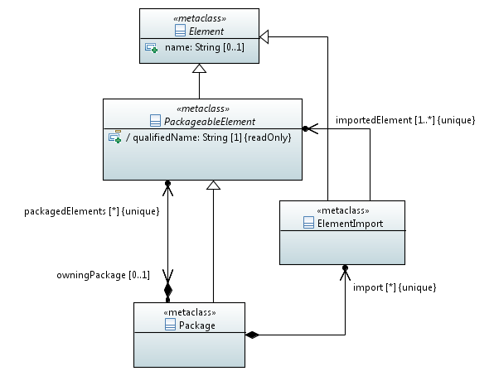
Figure 5.1: Foundational Language Concepts

5.2.1 Element
Semantics
An 'Element' represents any constituent of a TDL Specification. It is the super-class of all other classes in the meta-model. It provides the ability to add comments and annotations.
Generalizations
There are no generalizations specified.
Properties
- name : String [0..1]
The optional name of the 'Element'. The 'name' can contain any character, including white-spaces. Having no name specified is different from the empty name (which is represented by an empty string).
- comment : Comment [0..*] {unique}
A possibly empty set of 'Comment's attached to the 'Element'.
- annotation : AnnotationType [0..*] {unique}
A possibly empty set of 'Annotation's attached to the 'Element'.
Constraints
There are no constraints specified.

5.2.2 PackageableElement
Semantics
A 'PackageableElement' is contained in a 'Package'. It has a mandatory 'qualifiedName' that shall be unique throughout the owning and any imported 'Package'. The 'qualifiedName' distinguishes equally named 'PackageableElement's of different 'Package's from each other. This makes it possible that a 'PackageableElement' with the same name can be imported into a 'Package' without causing a name clash.
The 'qualifiedName' is a compound name derived from the directly and all indirectly enclosing parent 'Package's by concatenating the names of each 'Package'. As a separator between the segments of a 'qualifiedName' the string '::' shall be used. The name of the root 'Package' that (transitively) owns the 'PackageableElement' shall always constitute the first segment of the 'qualifiedName'.
The visibility of a 'PackageableElement' is restricted to the 'Package' in which it is directly contained. A 'PackageableElement' may be imported into other 'Package's by using 'ElementImport'. A 'PackageableElement' has no means to actively increase its visibility.
Generalizations
- Element
Properties
- / qualifiedName : String [1] {readOnly}
A derived property that represents the unique name of a package within a TDL model.
- owningPackage : Package [0..1]
The 'Package' that owns the 'PackageableElement'.
Constraints
Distinguishable qualified names
All qualified names shall be distinguishable within a TDL model.
Ownership of a 'PackageableElement'
A 'PackageableElement' shall not be owned by more than one 'Package'.

5.2.3 Package
Semantics
A 'Package' represents a container for 'PackageableElement's. A TDL model may contain any number of 'Package's, which may have any arbitrary substructure. A 'Package' may contain any number of 'PackageableElement's, including other 'Package's.
A 'Package' builds a scope of visibility for its contained 'PackageableElement's. A 'PackageableElement' is only accessible within its owning 'Package' and within any 'Package' that directly import it.
A 'Package' may import any 'PackageableElement' from any other 'Package' with the means of 'ElementImport'. By importing a 'PackageableElement', the imported 'PackageableElement' becomes visible and accessible within the importing 'Package'. Cyclic imports of packages are not permitted.
Generalizations
- PackageableElement
Properties
- packagedElements : PackageableElements [0..*] {unique}
The 'PackageableElement's that are directly contained in the 'Package'.
- import : ElementImport [0..*] {unique}
The list of import declarations.
Constraints
No cyclic imports
Cyclic imports are not allowed. That is, a package shall not import itself directly or indirectly via other packages.

5.2.4 ElementImport
Semantics
An 'ElementImport' allows importing 'PackageableElement's from other 'Package's into the scope of an importing 'Package'. By establishing an import, the imported 'PackageableElement's become accessible within the importing 'Package'.
Only those 'PackageableElement's can be imported via 'ElementImport' that are directly contained in the exporting 'Package', that is, the import is not transitive. If an 'ElementImport' declares the import of a 'Package', all the directly contained 'PackageableElement's in that imported 'Package' become accessible within the importing 'Package'.
Generalizations
- Element
Properties
- importedElement : PackageableElement [1..*] {unique}
The 'PackageableElement's that are imported into the context package via this 'ElementImport'.
Constraints
There are no constraints specified.

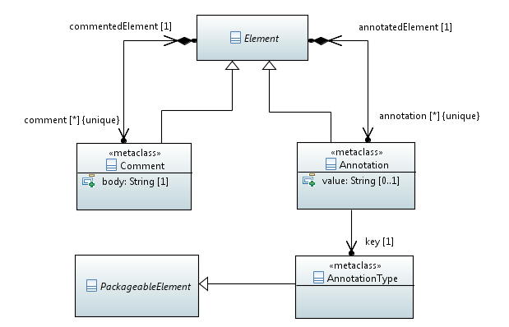
Figure 5.2: Comments and Annotations

5.2.5 Comment
Semantics
'Comment's may be attached to elements for documentation or for other informative purposes. Any 'Element' except a 'Comment' itself may contain any number of 'Comment's. The contents of comments shall not be used for adding semantics to elements.
Generalizations
- Element
Properties
- commentedElement : Element [1]
The 'Element' to which the 'Comment' is attached.
- body : String [1]
The content of the 'Comment'.
Constraints
No nested comments
A 'Comment' shall not contain other 'Comment's or 'Annotation's.

.

5.2.6 Annotation
Semantics
An 'Annotation' is a means to attach user- or tool-defined semantics to any 'Element' of a TDL model, except to 'Comment' and 'Annotation' itself. An 'Annotation' provides a pair of a 'key'/'value' attributes, whereas the 'value' might be empty.
Generalizations
- Element
Properties
- annotatedElement : Element [1]
The 'Element' to which the 'Annotation' is attached.
- key : AnnotationType [1]
Reference to a user-defined 'AnnotationType'.
- value : String [0..1]
The 'value' mapped to the 'key'.
Constraints
No nested annotations
An 'Annotation' shall not contain other 'Comment's or 'Annotation's.

5.2.7 AnnotationType
Semantics
An 'AnnotationType' is a 'PackageableElement' used to define the 'key' attribute of an 'Annotation'.
Generalizations
- PackageableElement
Properties
There are no properties specified.
Constraints
There are no constraints specified.
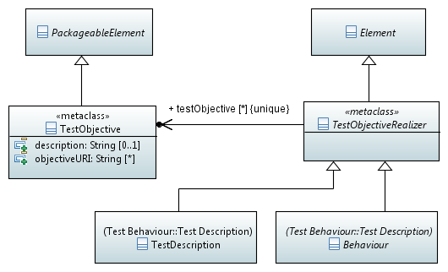
Figure 5.3: Test Objective Concepts

5.2.8 TestObjective
Semantics
A 'TestObjective' specifies the reason for designing either a 'TestDescription' or a particular 'Behaviour' of a 'TestDescription'. A 'TestObjective' may either contain a 'description' of the objective directly or refer to an external resource for further information about the objective.
The 'description' of a 'TestObjective' should be in natural language, however, it may be provided as structured (i.e. machine-readable) text.
Generalizations
- PackageableElement
Properties
- description : String [0..1]
A textual description of the 'TestObjective'.
- objectiveURI : String [0..*]
A set of URIs locating resources that provide further information about the 'TestObjective'. These resources are usually external to a TDL model such as requirements specifications or TPLan artefacts.
Constraints
There are no constraints specified.

5.2.9 TestObjectiveRealizer
Semantics
A 'TestObjectiveRealizer' establishes links to 'TestObjectives'. The semantics of such a trace are that a 'TestObjectiveRealizer' realizes the objective stated or referred to by the 'TestObjective'.
Generalizations
- Element
Properties
- testObjective : TestObjective [0..*] {unique}
The set of 'TestObjective's that is realized by the 'TestObjectiveRealizer'.
Constraints
There are no constraints specified.

6 Data

6.1 Overview
The 'Data' package describes all meta-model elements required to specify data in test descriptions. It introduces the foundation for data types and data instances, distinguishes between simple data types and structured data types, and introduces essential common data types that are predefined in a TDL specification. The package also introduces parameters and variables and deals with the definition of actions and functions. The following main elements are described in this package:
- Elements to allow the mapping of data elements (types, instances, actions, functions) to their concrete representations in an underlying runtime system;
- Elements to allow the definition of data types and data instances, actions and functions, parameters and variables;
- Elements to allow the use of data elements in test descriptions, e.g. in guard conditions or data in interactions;
- Elements to allow the definition and expression of time.

6.2 Abstract Syntax and Classifier Description
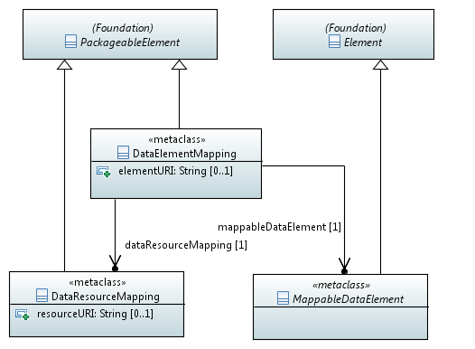
Figure 6.1: Data Mapping Concepts

6.2.1 DataResourceMapping
Semantics
A 'DataResourceMapping' is a 'PackageableElement'. It defines the resource where the concrete data definitions from an underlying concrete data type system are located as identified by the 'resourceURI' property.
Generalizations
- PackageableElement
Properties
- resourceURI: String [0..1]
Location of the resource that contains concrete data definitions. The location shall resolve to an unambiguous name.
Constraints
There are no constraints specified.

6.2.2 DataElementMapping
Semantics
A 'DataElementMapping' is a 'PackageableElement'. It represents the location of a single concrete data definition within the resource referred to in the referenced 'DataResourceMapping' element. The location within the resource is described by means of the 'elementURI' property.
Generalizations
- PackageableElement
Properties
- elementURI : String [0..1]
Location of a concrete data element within the resource it refers to in the 'DataResourceMapping' element. The location shall resolve to an unambiguous name within the resource.
- mappableDataElement : MappableDataElement [1]
Refers to the mappable data element (data set or data instance) to be mapped to a concrete data definition.

- dataResourceMapping : DataResourceMapping [1]
Refers to the data resource that contains the actual data definition of the referred mappable data element.
Constraints
There are no constraints specified.

6.2.3 MappableDataElement
Semantics
An abstract 'MappableDataElement' is a element used to link data elements in a TDL specification with the runtime test environment.
Generalizations
- Element
Properties
There are no properties specified.
Constraints
There are no constraints specified.

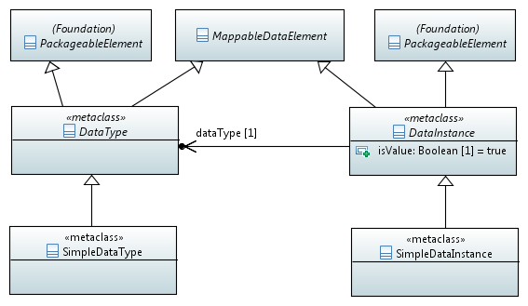
Figure 6.2: Basic Data Concepts

6.2.4 DataType
Semantics
An abstract 'DataSet' is a 'MappableDataElement' and a 'PackageableElement'. It may correspond to and be mapped to a concrete data type specification outside of TDL. Mapping is done by means of a ' DataElementMapping'.
It contains the special data instance 'AnyValue' which represents any value of the given data set.
Generalizations
- PackageableElement
- MappableDataElement
Properties
- anyValue : AnyValue [1]
Represents any value of the given data set.
Constraints
There are no constraints specified.

6.2.5 DataInstance
Semantics

An abstract 'DataInstance' is an element used to represent data (in terms of values or templates, see below) of a certain data set denoting the data type. It may be mapped to a concrete data representation by means of a 'DataElementMapping'.
Generalizations
- Element
Properties
- dataKind: DataKind [1] = 'value'
Indicates whether the data instance reflects a single value (dataKind = 'value', default) or a set of possible values (dataKind = 'expected').
Constraints

There are no constraints specified.

6.2.6 SimpleDataType
Semantics
A 'SimpleDataType' element represents a simple data type in TDL such as Integer or Boolean or a user-defined simple type.
It contains all simple data instances of this type.
Generalizations
- DataSet
Properties
- simpleDataInstance : SimpleDataInstance [0..*] {unique}
Refers to the set of data instances that belongs to this simple data type.
Constraints
There are no constraints specified.

6.2.7 SimpleDataInstance
Semantics
Represents a concrete or symbolic value or template of a simple data type, e.g. in case of type Integer simple data instances can be: 0, 1, 2, max, -10..10, etc.. A simple data instance may be mapped to its concrete data instance representation by means of a 'DataElementMapping'.
Generalizations
- DataInstance
- MappableDataElement
Properties
There are no properties specified.
Constraints
There are no constraints specified.
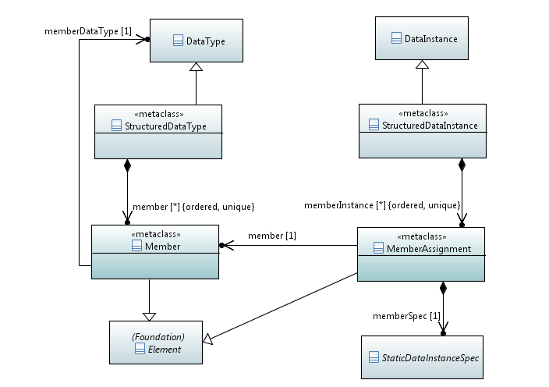
Figure 6.3: Structured Data Concepts

6.2.8 StructuredDataType
Semantics
Represents a structured data type with one or more members. In a mathematical sense it is considered as a tuple of elements. It contains the ordered list of 'TupleElement' elements to describe its structure and the set of data instances of this data type.
Generalizations
- DataSet
Properties
- tupleElement: TupleElement [1..*] {ordered, unique}
Refers to the individual elements of the structured data type.
- structuredDataInstance: StructuredDataInstance [0..*] {unique}
Refers to the set of data instances that belong to this structured data type.
Constraints
No cyclic type definition
The tuple element names shall refer to data sets that are different from the structured data type they are contained in, directly and indirectly via other structured data type definitions.

6.2.9 Member
Semantics
Refers to a tuple element of a structured data type and its data type. May optionally carry a name.
Generalizations
- Element
Properties
- elementDataType: DataSet [1]
Refers to the type of the tuple element of a structured data type, i.e. another data set.
Constraints
There are no constraints specified.

6.2.10 StructuredDataInstance
Semantics
Represents values and templates of a structured data type. Structured data instances may be optionally named, for example to express a constant definition. A structured data instance may be mapped to its concrete representation by means of a 'DataElementMapping'.
A structured data instance contains no, some or all the tuple element instances in correspondence to the 'TupleElement' elements of the definition of the related structured data type.
Generalizations
- DataInstance
- MappableDataElement
Properties
- tupleElementInstance: TupleElementInstance [0..*] {ordered, unique}
Refers to the elements of a structured data instance in accordance with its type definition.
Constraints
Corresponendence with type definition
If given, the list of tuple element instances shall coincide with the list of tuple elements of the corresponding structured data type.

6.2.11 MemberAssignment
Semantics
The data instance of a single tuple element (value or template) of a structured data instance.
Generalizations
- Element
Properties
- tupleElement: TupleElement [1]
Refers to the tuple element definition of the associated structured data type definition.
- elementDataInstance: DataInstance [1]
Refers to the data instance of this particular tuple element.
Constraints
Type of a tuple element instance
The referenced data instance of a tuple element shall match the data type (i.e. it shall belong to the 'DataSet') as defined in the referenced tuple element of the structured data type.
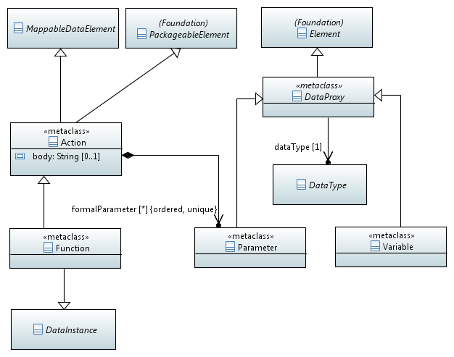
Figure 6.4: Action,Function, Parameter and Variable

6.2.12 DataProxy
Semantics
An abstract 'DataProxy' is an 'Element' that serves as a placeholder for 'DataInstance' elements. A ‘DataProxy’ is refined further to represent component variables and formal parameters of actions, functions, and test descriptions. A data proxy is bound to a data instance when calling an action, function or test description or when used in assignments.
Generalizations
- Element
Properties
- proxyDataType : DataSet [1]
Refers to the data set of acceptable data instances, to which the 'DataProxy' element can be bound in actual test description parameters.
Constraints
Named data proxy
A data proxy shall have a name.

6.2.13 Parameter
Semantics
A 'Parameter' element is a refinement of a 'DataProxy' to reflect a formal parameter that can be used in the definition of a test description, an action, or a function.
Generalizations
- DataProxy
Properties
There are no properties specified.
Constraints
There are no constraints specified.

6.2.14 Variable
Semantics
A 'Variable' element is a refinement of a 'DataProxy' to reflect a component variable.
Generalizations
- DataProxy
Properties
There are no properties specified.
Constraints
There are no constraints specified.

6.2.15 Action
Semantics
An 'Action' element can be used to specify any procedure (e.g. local computation, function call, physical setup, etc.). The interpretation of the action is outside the scope of TDL and can be specified by means of an appropriate mapping.
An action can contain a list of formal parameters.
Generalizations
- MappableDataElement
- PackageableElement
Properties
- body : String [0..1]
If provided, this property describes the action as an informal text.
- formalParameter : DataProxy [0..*] {ordered, unique}
Refers to a list of formal parameters of this action; to be bound to actual parameters when this action is referenced in a test description.
Constraints
Named action
An action shall have a name.

6.2.16 Function
Semantics
A function is a specialization of an action by adding the provision of a return value. Functions are used to express calculations within a test description. For this purpose it is referenced, i.e. used, whenever a data instance can be applied via a 'DataInstanceSpecification', e.g. as an actual parameter of an interaction argument, test description reference, action reference or another function reference or in an assignment to a variable.
Generalizations
- Action
- DataInstance
Properties
- returnType : DataSet [1]
Refers to the data type of the data instance (value or template) to be returned by this function.
Constraints
There are no constraints specified.
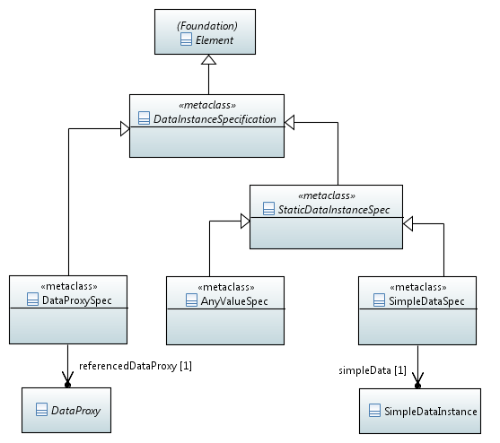
Figure 6.5: Data Instance Specification (part 1)
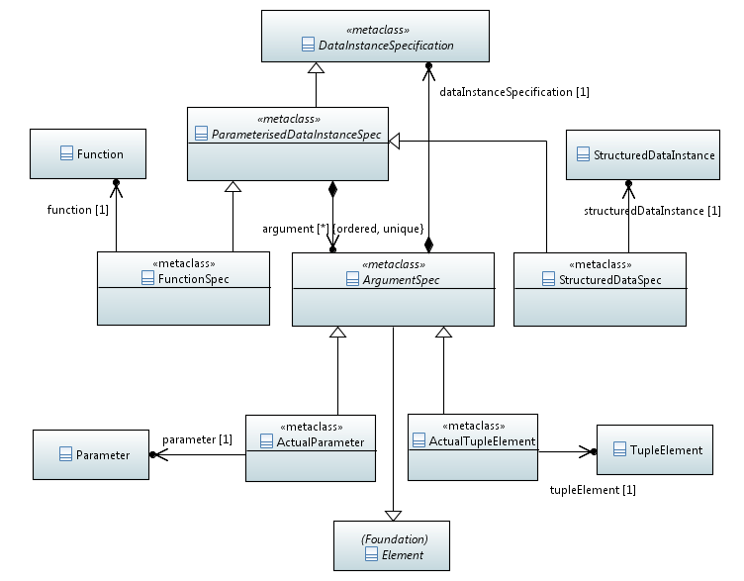
Figure 6.6: Data Instance Specification (part 2)
<
diagram on use of structured data, "dot" notation, to be elaborated
>
Figure 6.7: Data Instance Specification (part 3)

6.3.18 DataInstanceSpecification
Semantics
The abstract element 'DataInstanceSpecification' specifies the use of data in test descriptions, while previous meta-model elements on data (see Clauses 6.3.4–12) serve for data definition. Data instance specifications can be used to specify data in interaction arguments, assignments to component variables, and actual parameters of functions, action references and test description references. A data instance specification is understood to be an expression that is evaluated to a data instance (value or template) of a given type (data set).
Generalizations
- Element
Properties
There are no properties specified.
Constraints
There are no constraints specified.

6.3.19 DataProxySpecification
Semantics
A 'DataProxySpecification' is a refinement of a 'DataInstanceSpecification' that refers to the use of a data proxy (formal parameter of a test description or function; or a component variable). It is assumed that the data proxy is bound to a data instance when it is applied in a data proxy specification, i.e., a value or a template has been assigned to this data proxy before.
Generalizations
- DataInstanceSpecification
Properties
- referencedDataProxy : DataProxy [1]
Refers to the data proxy (formal parameter or variable) that is used in this data instance specification.
Constraints
There are no constraints specified.

6.3.x AnyValueSpec
Semantics
'AnyValueSpec' is a refinement of a 'DataInstanceSpecification' to denote any value of a given data type.
Generalizations
- DataInstance
Properties
There are no properties specified.
Constraints
There are no constraints specified.

6.3.x SimpleDataSpec
Semantics
’SimpleDataSpec’ is a refinement of ‘DataInstanceSpecification’ that refers to the use of xxx.
Generalizations
- DataInstance
Properties
- simpleData: SimpleDataInstance [1]
Refers to the xxx that is used in this data instance specification.
Constraints
There are no constraints specified.

6.3.20 ParameterisedDataInstanceSpec
Semantics
‘ParameterisedDataInstanceSpec’ is an abstract element that refines ‘DataInstanceSpecification’ to contain a list of arguments as actual parameters (in case of a parameterised function) or actual tuple elements (in case of a structured data instance) in accordance with the corresponding data type definition.
It contains a list of arguments.
Generalizations
- DataInstanceSpecification
Properties
- argument: ArgumentSpec [0..*] {ordered, unique}
Refers to a list of individual data instance specifications that are used as arguments.
Constraints
Matching list of actual parameters in case of a structured data instance
If the referenced data instance is a structured data instance, the list of actual parameters shall match the list of its tuple elements.
Matching list of actual parameters in case of a function
If the referenced data instance is a function, the list of actual parameters shall match the list of formal parameters in its 'Function' element and shall be empty in case of a parameter-less function.

6.3.21 ArgumentSpec
Semantics
If the data instance specification refers to a structured data instance or a function, the 'ActualParameterSpecification' element provides the reference to the data instance specification of this particular parameter (tuple name of a structured data instance or actual parameter of a function).
Generalizations
- Element
Properties
- dataInstanceSpecification : DataInstanceSpecification [1]
Refers to the data instance specification of this element.
Constraints
There are no constraints specified.
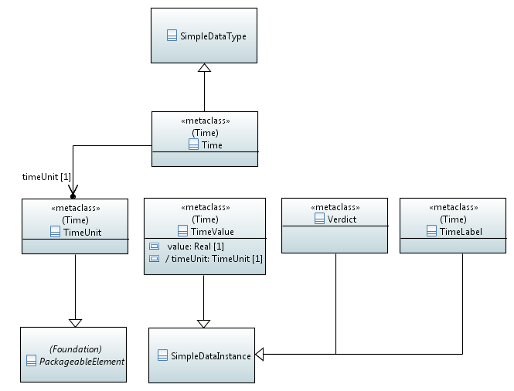
Figure 6.8: Predefined Data Types and Data Instances

7 Test Configuration

7.1 Overview
The 'Test Configuration' package describes the elements needed to define a 'TestConfiguration' consisting of tester and SUT components, gates, and their interconnections represented as 'Connection's. A 'TestConfiguration' specifies the structural foundations on which test descriptions can be built upon. The fundamental units of a 'TestConfiguration' are the 'ComponentInstance's. Each 'ComponentInstance' specifies a functional entity of the test system. A 'ComponentInstance' may either be a ( part of a) tester or a ( part of an) SUT. That is, both the tester and the SUT can be decomposed, if required. The communication exchange between 'ComponentInstance's is established through interconnected 'GateInstance's. To offer reusability, TDL introduces 'ComponentType's and gate types.

7.2 Abstract Syntax
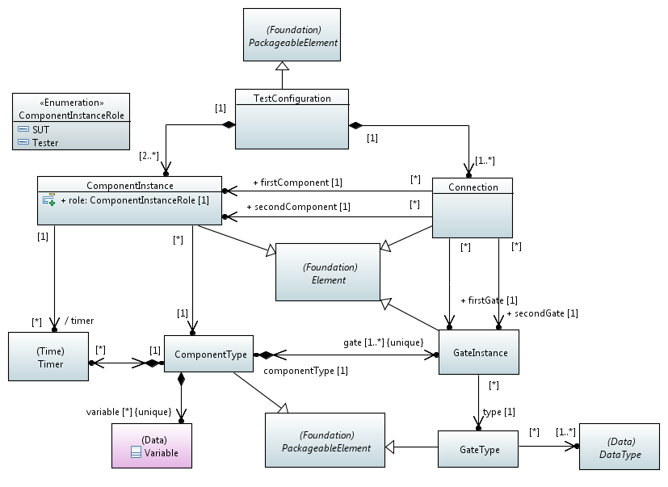
Figure 7.1: Test Configuration Concepts

7.3 Classifier Description

7.3.1 TestConfiguration
Semantics
A 'TestConfiguration' specifies the communication infrastructure necessary to build 'TestDescription's upon. As such, it contains all the elements required for information exchange, such as 'ComponentInstance's and 'Connection's.
It is not necessary that all 'ComponentInstance's contained in a 'TestConfiguration' are actually connected via 'Connection's but for any 'TestConfiguartion' at least the semantics of a minimal 'TestConfiguration' shall apply.
Generalizations
- PackageableElement
Properties
- componentInstance : ComponentInstance [2..*] {unique}
The 'ComponentInstance's of the 'TestConfiguration'.
- connection : Connection [1.*] {unique}
The 'Connection's of the 'TestConfiguration' over which 'Interaction's are sent and received.
Constraints
'TestConfiguration' and components roles
A 'TestConfiguration' shall contain at least one 'Tester' and one 'SUT' 'ComponentInstance'.
Minimal 'TestConfiguration'
Each 'TestConfiguration' shall specify at least one 'Connection' that connects a 'GateInstance' of a 'ComponentInstance' in the role 'Tester' with a 'GateInstance' of a 'ComponentInstance' in the role 'SUT'.

7.3.2 GateType
Semantics
A 'GateType' represents a point of communication for exchanging information between 'ComponentInstance's. A 'GateType' specifies the 'DataSets' (and, thus, the DataProxies and DataInstances that belong to that 'DataSet') that can be exchanged via that 'GateType'.
The same 'GateType' can be shared among multiple 'ComponentType's, thus, allowing for reuse.
Generalizations
- PackageableElement
Properties
- dataset : DataSet [1..*] {unique}
The 'DataSet's that can be exchanged via that 'GateType'. The arguments of 'Interactions' shall adhere to the 'DataSet' that are allowed to be exchanged via the 'GateType'.
Constraints
There are no constraints specified.

7.3.3 GateInstance
Semantics
A 'GateInstance' represents an instance of a 'GateType'. 'GateInstance's are the means to exchange information by specifying an 'Interaction' and to execute 'TimeOperation's.
A 'GateInstance' may, but need not, be connected by a 'Connection'. Additionally, a 'GateInstance' may be the endpoint of more than one 'Connection's.
Generalizations
- Element
Properties
- type : GateType [1]
The 'GateType' of the 'GateInstance'.
Constraints
No additional constraints specified.

7.3.4 ComponentType
Semantics
A 'ComponentType' specifies the type of one or several 'ComponentInstance's that participate in a 'TestConfiguration'. A 'ComponentType' contains at least one 'GateInstance' and may contain any number of 'Timer's and 'Variable's. Instances of 'ComponentType's represent the functional entities of a test system.
An instance of a 'ComponentType' has local copies of the 'Timer's and 'Variable's that are listed in the 'ComponentType' definition.
Instances of 'ComponentType's may either act as a 'Tester' or as an 'SUT' within a 'TestConfiguration'. It is possible that the very same 'ComponentType' participates in one 'TestConfiguration' as a 'Tester' and in another 'TestConfiguration' as an 'SUT'.
Generalizations
- PackageableElement
Properties
- gate : GateInstance [1..*] {unique}The 'GateInstance's used by 'ComponentInstance's of that 'ComponentType'.
- timer : Timer [0..*] {unique}
The 'Timer's owned by a 'ComponentType'.
- variable : Variable [0..*] {unique}
The 'Variable's owned by a 'ComponentType'.
Constraints
There are no constraints specified.

7.3.5 ComponentInstanceRole
Semantics
'ComponentInstanceRole' specifies the role of a 'ComponentInstance', whether it acts as a 'Tester' or as an 'SUT' component.
Generalizations
There are no generalizations specified.
Literals
- SUT
The 'ComponentInstance' assumes the role 'SUT' in the enclosing 'TestConfiguration'.
- Tester
The 'ComponentInstance' assumes the role 'Tester' in the enclosing 'TestConfiguration'.
Constraints
There are no constraints specified.

7.3.6 ComponentInstance
Semantics
A 'ComponentInstance' represents a communication entity of the test system. It acts either as a 'Tester' or as an 'SUT'. A 'ComponentInstance' derives one or more 'GateInstance's from the 'ComponentType' this 'ComponentInstance' is an instance of.
The 'Timer's that can be utilized by timer-related 'Behaviour's of a 'TestDescription' are derived from the 'Timer's that the corresponding 'ComponentType's possesses. Thus, only 'Timer's that are known by the 'ComponentInstance's can be used within a 'TestDescription'.
Generalizations
- Element
Properties
- type : ComponentType [1]
The 'ComponentType' of this 'ComponentInstance'.
- role : ComponentInstanceRole [1]
The role of the 'ComponentInstance' plays within the given 'TestConfiguration'. It can be either 'Tester' or 'SUT'.

- /timer : Timer [0..*] {unique, read-only}
The set of timers is derived from the set of timers contained in the 'ComponentType' of the 'ComponentInstance'. That is, a 'ComponentInstance' shall have the same set of timers as specified in the 'ComponentType', which the 'ComponentInstance' belongs to.
Constraints
Named component instances
A component instance shall have a name.

Timers of 'ComponentInstance's
A 'ComponentInstance' shall refer exactly to the same set of timers as contained in the associated 'ComponentType'.

7.3.7 Connection
Semantics
A 'Connection' is a communication channel for exchanging information between 'ComponentInstance's and the 'GateInstance's that are derived from 'ComponentType' of given 'ComponentInstance's. 'Connection's do not specify or restrict the nature of the communication channel that is eventually used in an implementation.
'Connection's are always binary and shall have exactly two endpoints both defined by a 'ComponentInstance' and a 'GateInstance'. A 'Connection' can be established between 'GateInstance's of the same ‘GateType’ as long as there is at most one 'Connection' between any two endpoints. The endpoints of a 'Connection' shall not be identical, i.e. self-looped 'Connection's are not permitted.
A 'GateInstance' in the conrtext of a 'ComponentInstance' can be part of multiple 'Connection's. This allows for specifying multicast communication exchange capability.
The endpoints are formed by pairing 'GateInstance' from firstGate with 'ComponentInstance' from firstComponent. The secondGate and secondComponent are paired accordingly.
Generalizations
- Element
Properties
- firstGate, secondGate : GateInstance [1]
The two 'GateInstance's that the endpoints of this 'Connection' refer to.
- firstComponent, secondComponent : ComponentInstance [1]
The two 'ComponentInstance's that the endpoints of this 'Connection' refer to.
Constraints
Self-looped connections not allowed
If the firstComponent and secondComponent refer to the same 'ComponentInstance' then the two 'GateInstance's shall be different from each other, i.e. no self-loop 'Connection' is allowed.
Only one connection allowed
Between any two endpoints – combination of a 'ComponentInstance' and 'GateInstance' – at most one 'Connection' can exist.
Unique type of a connection
The two 'GateInstance's of a 'Connection' shall refer to the same 'GateType'.
Only gates derived by a component of the endpoint are allowed
'GateInstance' of an endpoint shall belong to the derived list of gates of the 'ComponentInstance' defined in the same endpoit.

8 Test Behaviour

8.1 Overview
The 'Test Behaviour' package defines all elements needed to describe the behaviour of a test description.

8.2 Abstract Syntax
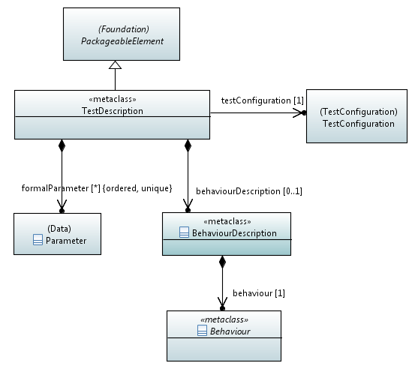
Figure 8.1: Test Description Concepts
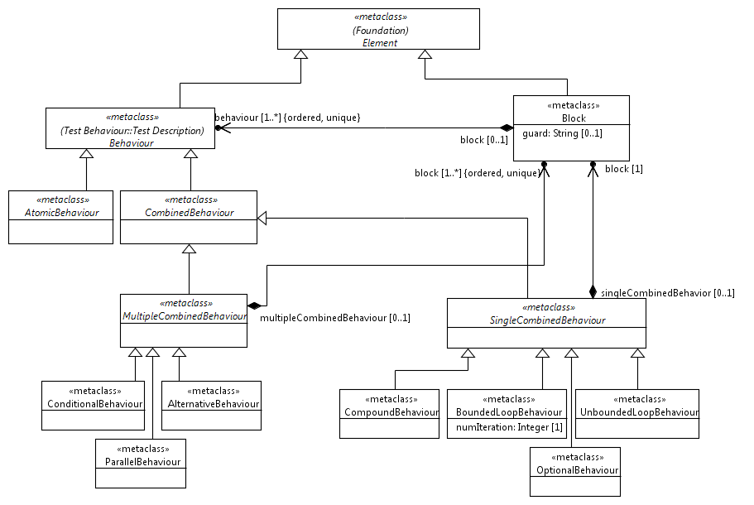
Figure 8.2: Behaviour Concepts
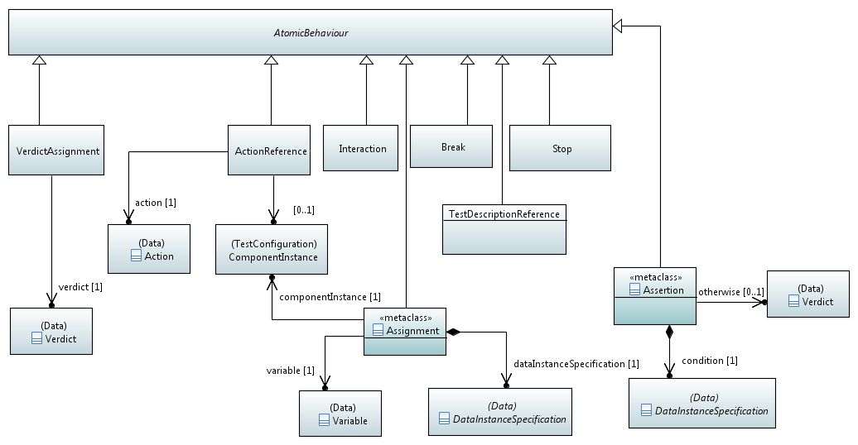
Figure 8.3: Atomic Behaviour Concepts

Figure 8.4: Interaction Concepts
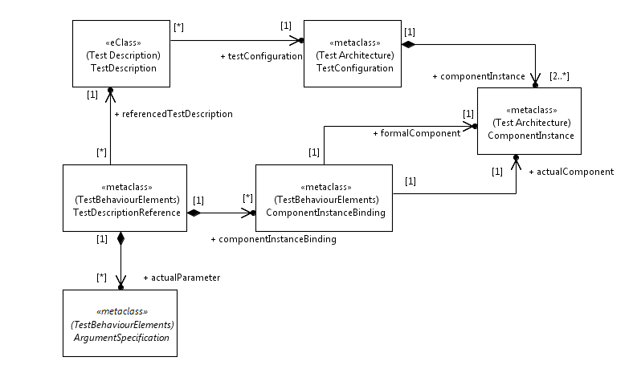
Figure 8.5: Test Description Reference Concepts

8
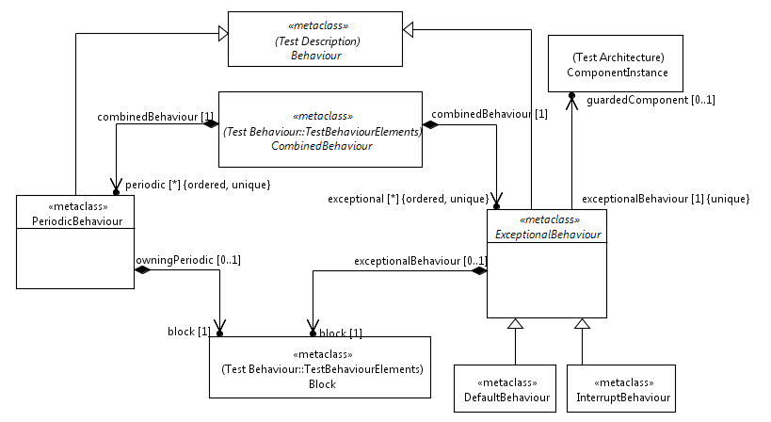
Figure 8.7: Exceptional Behaviour and Periodic Behaviour Concepts

8.3 Classifier Description

8.3.1 TestDescription
Semantics
The 'TestDescription' is a 'PackageableElement' and a 'TestObjectiveRealizer'. A 'TestDescription' defines the test behaviour based eventually on ordered 'AtomicBehaviour' elements. A test description may contain a 'CompoundBehaviour' defining the behaviour of the test description. It may also contain a list of 'DataProxy' elements that act as formal parameters of this test description.
A test description is associated with exactly one 'TestConfiguration' and may be associated with any number of 'DataProxy' elements. These 'DataProxy' elements represent the formal parameters of the 'TestDescription' used for parameterization.
If a ‘TestDescription’ has formal parameter(s), that ‘TestDescription’ shall be invoked within another ‘TestDescription’ that is possibly parameter-free in order to be able to provide actual parameters.

Generalizations
- PackageableElement
- TestObjectiveRealizer
Properties
- testConfiguration : TestConfiguration [1]
The property 'testConfiguration' refers to the 'TestConfiguration' that is associated with the 'TestDescription'.
- behaviour : CompoundBehaviour [0..1]
The property 'behaviour', if present, defines the actual behaviour of the test description in terms of a 'CompoundBehaviour' element.
- timeConstraint : TimeConstraint [0..*] {unique}
This property, if present, refers to the expressions that shall be evaluated to Boolean. It is used to express time constraints between behavioural elements within this test description.
- formalParameter : DataProxy [0..*] {ordered}
This property refers to 'DataProxy' elements. The property, if present, defines the formal parameters that shall be substituted by actual data elements when the 'TestDescription' is executed.
Constraints
Named test description
A test description shall have a name.

8.3.2 Block
Semantics
A 'Block' element is a container for 'Behaviour' elements that are executed in a strictly sequential way. A 'Block' element may have a 'guard' defined. If a 'Block' has a 'guard', that ‘Block’ shall only be executed if its guard condition evaluates to true.
Generalizations
- Element
Properties
- behaviour : Behaviour [1..*] {unique, ordered}
This property is a list of 'Behaviour' elements describing the behaviour of the 'Block' element. The 'Behaviour' elements shall be executed in their definition order.
- guard : String [0..1]
The 'guard' property is a String that represents a Boolean expression. The 'guard' when present determines if the behaviour of the 'Block' element shall be executed or not. If the 'guard' expression evaluates to true, the behaviour is executed, otherwise not. If a 'Block' element has no 'guard' it is unconditionally executed.
Constraints
Guard shall evaluate to Boolean
The 'guard' property is a String that shall represent a Boolean expression.

8.3.3 Behaviour
Semantics
A 'Behaviour' is a generic, abstract 'Element' that is refined into 'AtomicBehaviour' and 'CombinedBehaviour'. Some 'Behaviour's operate on gate instances or component instances and some are completely independent.
Generalizations
- TestObjectiveRealizer
Properties
There are no properties specified.
Constraints
No additional constraints specified.

8.3.4 CombinedBehaviour
Semantics
A 'CombinedBehaviour' element is a 'Behaviour' that involves all gate instances defined in the associated test configuration. It can contain a single potentially guarded 'Block' element (in case of 'SingleCombinedBehaviour') or a list of ordered and potentially guarded 'Block' elements (in case of 'MultipleCombinedBehaviour'). A 'CombinedBehaviour' may have any number of ordered 'PeriodicBehaviour' and 'ExceptionalBehaviour' elements. The 'PeriodicBehaviour' and the 'ExceptionalBehaviour' elements shall be evaluated in their definition order.
Generalizations
- Behaviour
Properties
- periodic : PeriodicBehaviour [0..*] {unique, ordered}
A 'CombinedBehaviour' element can contain any number of 'PeriodicBehaviour' elements. The 'periodic' property refers to the list of 'PeriodicBehaviour' elements.
- exceptional : ExceptionalBehaviour [0..*] {unique, ordered}
A 'CombinedBehaviour' element can contain any number of 'ExceptionalBehaviour' elements. The 'exceptional' property refers to the list of 'ExceptionalBehaviour' elements.
Constraints
There are no constraints specified.

8.3.5 SingleCombinedBehaviour
Semantics
A 'SingleCombinedBehaviour' element is a 'CombinedBehaviour' that contains a single potentially guarded 'Block' element. It can be further refined to a 'CompoundBehaviour', a 'BoundedLoopBehaviour', an 'UnboundedLoopBehaviour', or an 'OptionalBehaviour'.
Generalizations
- CombinedBehaviour
Properties
- block : Block [1]
The 'block' property refers to a 'Block' element that specifies the behaviour of the 'SingleCombinedBehaviour'.
Constraints
There are no constraints specified.

8.3.6 CompoundBehaviour
Semantics
A 'CompoundBehaviour' element groups at least one 'Behaviour' element together in an ordered list of 'Behaviour' elements contained in a single 'Block' element. The list defines the execution order of the 'Behaviour' elements of the 'CompoundBehaviour'. As a derived 'CombinedBehaviour' element, a 'CompoundBehaviour' element can have also exceptional or periodic behaviour attached to it.
Generalizations
- SingleCombinedBehaviour
Properties
There are no properties specified.
Constraints
There are no constraints specified.

8.3.7 OptionalBehaviour
Semantics
An 'OptionalBehaviour' element is a 'SingleCombinedBehaviour', therefore it shall contain one 'Block' element, which may have a guard condition and shall start with one of the following 'AtomicBehaviour' elements: 'Interaction', 'TimeOut', or 'Quiescence'. For the 'Interaction' element it is required that the target 'GateInstance' shall be associated to a 'ComponentInstance' with the 'role' of 'Tester'.
If a 'Block' has no guard condition, it is equivalent to a 'Block' with a guard condition of true. If the guard condition of the 'Block' element is evaluated to true and the first event of the 'Block' occurs, the 'OptionalBehaviour' will be executed, otherwise the execution continues with the next behaviour after the 'OptionalBehaviour' element.
Generalizations
- SingleCombinedBehaviour
Properties
There are no properties specified.
Constraints
First event allowed
The contained 'Block' element shall start with one of the following 'AtomicBehaviour' elements: 'Interaction' received by a 'Tester' component, 'TimeOut', or 'Quiescence'.

8.3.8 BoundedLoopBehaviour
Semantics
A 'BoundedLoopBehaviour' element is a 'SingleCombinedBehaviour', therefore it shall contain one 'Block' element, which shall not have a guard condition. The 'Block' element shall be executed as many times as is determined by its 'numIteration' attribute.
Generalizations
- SingleCombinedBehaviour
Properties
- numIteration : Integer [1]
This property of a 'BoundedLoopBehaviour' element determines how many times the 'Block' element of a 'BoundedLoopBehaviour' element shall be executed.
Constraints
No guard constraint
The 'Block' element of a 'BoundedLoopBehaviour' element shall not have a guard condition.
Iterations number shall be positive
The 'numIteration' attribute of a 'BoundedLoopBehaviour' element shall be a positive Integer value.

8.3.9 UnboundedLoopBehaviour
Semantics
An 'UnboundedLoopBehaviour' element is a 'SingleCombinedBehaviour', therefore it shall contain one 'Block' element, which may have a guard condition. The 'Block' element shall be executed as long as the guard condition of the 'Block' element evaluates to true. If the 'Block' element has no guard condition, it shall be executed an infinite number of times.
Generalizations
- SingleCombinedBehaviour
Properties
There are no properties specified.
Constraints
There are no constraints specified.

8.3.10 MultipleCombinedBehaviour
Semantics
A 'MultipleCombinedBehaviour' element is a 'CombinedBehaviour' that contains at least one potentially guarded 'Block' element (in case of 'ConditionalBehaviour') or at least two ordered and potentially guarded 'Block' elements (in case of 'AlternativeBehaviour' or 'ParallelBehaviour').
Generalizations
- CombinedBehaviour
Properties
- block : Block [1..*] {unique, ordered}
The 'block' property refers to a list of 'Block' elements that specifies the behaviour of the 'MultipleCombinedBehaviour' element.
Constraints
There are no constraints specified.

8.3.11 AlternativeBehaviour
Semantics
An 'AlternativeBehaviour' element is a 'MultipleCombinedBehaviour' that shall contain at least two 'Block' elements. Each block of an 'AlternativeBehaviour' element may have a guard condition and shall start with one of the following 'AtomicBehaviour' elements: 'Interaction', 'TimeOut' or 'Quiescence'. For the 'Interaction' element it is required that the target 'GateInstance' shall be associated to a 'ComponentInstance' with the 'role' of 'Tester'.
If a 'Block' element has no guard condition, it is equivalent to a 'Block' element with a guard condition of true. The first 'Block' element whose guard condition is evaluated to true and whose first event occurs, will be executed.
Generalizations
- MultipleCombinedBehaviour
Properties
There are no properties specified.
Constraints
Blocks
An 'AlternativeBehaviour' element shall contain at least two 'Block' elements. Each block of an 'AlternativeBehaviour' element may have a guard condition and shall start with one of the following 'AtomicBehaviour' elements: 'Interaction' received by a 'Tester' component, 'TimeOut' or 'Quiescence'.

8.3.12 ConditionalBehaviour
Semantics
A 'ConditionalBehaviour' element is a 'MultipleCombinedBehaviour' that can contain one or more 'Block' elements. All the 'Block' elements shall have a guard condition except for the last 'Block' element, which may have no guard if the 'ConditionalBehaviour' element contains more than one 'Block' elements. In this case, the last 'Block' element is equivalent to a 'Block' element with a guard condition of true ("else" block). The guard conditions of the 'Block' elements are evaluated in the order of their definition. The first 'Block' element, whose guard condition is evaluated to true, will be executed. If none of the guard conditions are evaluated to true, the execution continues with the next behaviour after the 'ConditionalBehaviour' element.
Generalizations
- MultipleCombinedBehaviour
Properties
There are no properties specified.
Constraints
Guards required
All the 'Block' elements shall have a guard condition except for the last 'Block' element, which may have no guard if the 'ConditionalBehaviour' element contains more than one 'Block' elements. In this case, the last 'Block' element is equivalent to a 'Block' element with a guard condition of true ("else" block).

8.3.13 ParallelBehaviour
Semantics
A 'ParallelBehaviour' element is a 'MultipleCombinedBehaviour' that shall contain at least two 'Block' elements. Some or all of the 'Block' elements of a 'ParallelBehaviour' element may have a guard condition. If a guard condition is provided, it shall evaluate to true to enable the execution of that block. The 'Block' elements are executed in parallel (i.e. the relative execution order of the behaviours of the different 'Block' elements of a 'ParallelBehaviour' element is not specified). The execution of a 'ParallelBehaviour' element shall terminate when all its 'Block' elements are terminated.
Generalizations
- MultipleCombinedBehaviour
Properties
There are no properties specified.
Constraints
There are no constraints specified.

8.3.14 AtomicBehaviour
Semantics
'AtomicBehaviour' is a 'Behaviour'. An 'AtomicBehaviour' element defines the simplest form of behaviour that cannot be decomposed further. An 'AtomicBehaviour' can be: 'TimerOperation', 'TimeOperation', 'VerdictAssignment', 'Break', 'Stop', 'ActionReference', 'Interaction', or 'TestDescriptionReference'.
Generalizations
- Behaviour
Properties
- timeConstraint : TimeConstraint [0..*] {unique}
This property specifies a set of 'TimeConstraint' elements that determines the execution of the given 'AtomicBehaviour' element with respect to the passed time.
Constraints
There are no constraints specified.

8.3.15 Break
Semantics
'Break' terminates the execution of the enclosing 'CombinedBehaviour' element. Execution continues with the 'Behaviour' element that follows the enclosing 'CombinedBehaviour' element.
Generalizations
- AtomicBehaviour
Properties
There are no properties specified.
Constraints
There are no constraints specified.

8.3.16 Stop
Semantics
'Stop' is used to describe an explicit stop of the execution of a test description. No further behaviour shall be executed beyond a 'Stop'. In particular, a 'Stop' element in a referenced (called) test description shall also stop the behaviour of the referencing (calling) test description(s) recursively.
Generalizations
- AtomicBehaviour
Properties
There are no properties specified.
Constraints
There are no constraints specified.

8.3.17 VerdictAssignment
Semantics
The 'VerdictAssignment' is used to set the verdict of the test run explicitly. This might be necessary if the implicit verdict mechanism described below is not sufficient.
By default, the test description specifies the expected behaviour of the system. If an execution of a test description performs the expected behaviour, the verdict is set to 'pass' implicitly. If a test run deviates from the expected behaviour, the verdict 'fail' will be assigned to the test run implicitly. Other verdicts, including 'inconclusive' and user-definable verdicts, need to be set explicitly within a test description.
Generalizations
- AtomicBehaviour
Properties
- verdictType : VerdictType [1]
Stores the value of the verdict to be set.
Constraints
There are no constraints specified.

8.3.18 VerdictType
Semantics
'VerdictType' is a 'PackageableElement' that specifies the possible verdict of a test description. At minimum, the following 'VerdictType's shall be defined : 'pass', 'inconclusive', 'fail'. (See Clause 10.1) This list can be extended by the user according to the needs of concrete implementations.
Generalizations
- PackageableElement
Properties
There are no properties specified.
Constraints
Minimum set of values of the VerdictType
The 'VerdictType' shall contain at least the following three instances: 'pass', 'inconclusive', 'fail'.

8.3.19 Interaction
Semantics
An 'Interaction' element is an abstract representation of any information exchanged between gate instances assuming that they are connected via a connection. The 'ArgumentSpecification' of an 'Interaction' element contained within refers to the data being exchanged between the components participating in the interaction via their connected gates. It can also carry parameters for this data.
In a concrete realization, an interaction can represent, among others, one of the following options:
- Message-based communication: The data of an interaction argument represents a message being sent (from source) and received (from target).
- Procedure-based communication: The data of an interaction argument represents a remote function call being initiated (from source) and invoked (at target) or its return values being transmitted back.
- Shared variable access: The data of an interaction argument represents a shared variable being read (source is the gate of the component that owns this variable, target is the gate of the reading component) or updated (source is the gate of the component that wants to change the value of a variable, target is the gate of the component that owns this variable).
The data description provided as an 'ArgumentSpecification' can be a (possibly parameterized) data instance, a data set, or a data proxy that is bound to either a data instance or a data set at runtime. Using a data set as part of the argument specification in an interaction enables the specification of a set of data instances that are all acceptable within this interaction.
EXAMPLE: Consider the data set STATUS of data instances 200, 4xx, 5xx and the data instance HttpResponse(STATUS) of another data set. An interaction that refers to the latter data instance in its argument specification provides a shorthand notation for the data instances HttpResponse(200), HttpResponse(4xx), and HttpResponse(5xx) that are all accepted and valid within the given interaction. This notation comes in handy for specifying SUT output (source of an interaction is the gate of a SUT component) by a tester component gate (target) when the exact output is not known or irrelevant.
Generalizations
- AtomicBehaviour
Properties
- argument : ArgumentSpecification [1]
This property refers to an 'ArgumentSpecification' element that is taken as the argument (data) of this interaction.
- source : GateInstance [1]
This property refers to a 'GateInstance' element that acts as the source of this interaction.
- component : ComponentInstance [1]
This property refers to a 'ComponentInstance' element that outputs the data of this interaction via its gate instance.
- target : Connection [1..*] {unique}
This property refers to a list of 'Connection' elements that act as the communication path(s) of this interaction. That is, the associated component instance(s) input the data of this interaction via their gate instance(s). In case of point-to-point communication there is exactly one target. In case of point-to-multipoint communication there are multiple target connections.
Constraints
Connections of an interaction shall be different
All connections that act as target(s) of an interaction shall be different from each other.

Connections of an interaction shall have the source component and gate as endpoint
All target connections shall have an endpoint that corresponds to the component and source gate of the interaction.
Gate must be present in component
The source 'GateInstance' shall be in the derived list of gates of the 'ComponentInstance' defined as component.
Typing of interaction arguments
The 'DataElement' referred to in the 'argument' shall match the 'DataSet' referenced in the 'GateType' definition of the source gate instance of an interaction. Matching is defined in the following manner:
- If the 'argument' refers to a (possibly parameterized) 'DataInstance', then the 'GateType' definition shall reference a 'DateSet' that contains this 'DataInstance'.
- If the 'argument' refers to a 'DataProxy', then this 'DataProxy' shall refer to the same 'DataSet' as referenced in the 'GateType' definition. If the 'argument' refers to a 'DataSet', then this 'DataSet' shall be referenced in the 'GateType' definition.

8.3.21 ActionReference
Semantics
An 'ActionReference' element can be used to refer to an 'Action' element to be executed. It may have a 'componentInstance' attribute that specifies the component instance on which the action is to be performed.
Generalizations
- AtomicBehaviour
Properties
- componentInstance : ComponentInstance [0..1]
This property refers to a 'ComponentInstance' element on which the action is to be performed.
- action : Action [1]
This property is refers to the 'Action' element to be executed.
Constraints
There are no constraints specified.

8.3.22 TestDescriptionReference
Semantics
A 'TestDescriptionReference' is used to describe the invocation of the behaviour of a test description within another test description. The invoked behaviour is executed in its entirety before the behaviour of the invoking test description is executed further. A 'TestDescriptionReference' has a possibly empty list of actual parameters which is passed to the referenced 'TestDescription'. It also has an optional list of bindings between component instances of the involved test configurations that shall be present if the test configurations of the referencing (invoking) and referenced (invoked) test descriptions are different.
If the 'TestConfiguration' of the invoked 'TestDescription' is different from the one of the invoking 'TestDescription', it shall be compatible with it. The compatibility rule is defined below. In case of different test configurations, 'ComponentInstance's contained in the 'TestConfiguration' of the invoked 'TestDescription' will be substituted with 'ComponentInstance's of the 'TestConfiguration' of the invoking 'TestDescription'. Substitution is implicit when both test configurations coincide. Explicit substitution is defined using the 'ComponentInstanceBinding' element.

Generalizations
- AtomicBehaviour
Properties
- referencedTestDescription : TestDescription [1]
Refers the test description whose behaviour is invoked.
- actualParameter : ArgumentSpecification [0..*] {ordered}
Refers to a list of actual parameters passed to the referenced test description.
- componentInstanceBinding : ComponentInstanceBinding [0..*]
Defines explicit bindings between 'ComponentInstance's from 'TestConfiguration' of invoking 'TestDescription' and those from the 'TestConfiguration' of the invoked 'TestDescription'.
Constraints

Number of actual parameters
The number of actual parameters in the 'TestDescriptionReference' shall be equal with the number of formal parameters of the referenced 'TestDescription'.
Matching parameters
The actual parameter AP[i] of index i in the ordered list of 'actualParameter's of the 'dataInstance' shall match the formal parameter FP[i] of index i in the ordered list of formal parameters of the referenced 'TestDescription'. Matching is defined in the following terms:
- If AP[i] is a 'DataInstance' then the 'DataSet' to which AP[i] refers to shall be the same the 'DataProxy' FP[i] refers to.
- If AP[i] is a 'DataSet' then it shall refer to the same 'DataSet' the 'DataProxy' FP[i] refers to.
- If AP[i] is a 'DataProxy' then the 'DataSet' to which AP[i] refers to shall be the same the 'DataProxy' FP[i] refers to.
Restriction to 1:1 component instance bindings
If component instance bindings are provided, the component instances referred to in the bindings shall occur at most once for the given test description reference.
Compatible test configurations
The test configuration TConf2 of the referenced (invoked) test description shall be compatible with the test configuration TConf1 of the referencing (invoking) test description under the provision of a list of bindings between component instances in TConf1 and TConf2. Compatibility is then defined in the following terms:
- All component instances in TConf2 can be mapped to component instances of TConf1.
- A component instance B of test configuration TConf2 can be mapped to a component instance A of test configuration TConf1if and only if
a) there is a binding pair (A, B) provided, b) A and B refer to the same component type, and c) A and B have the same component instance role {SUT, Tester} assigned.
- All connections between component instances in TConf2 exist also between the mapped component instances in TConf1 and the type of a connection in TConf2 equals the type of the related connection in TConf1.
- The type of a connection is defined by the gate type of the gate instances that act as end-points for this connection.
NOTE 1: The compatibility between test configurations is defined asymmetrically. That is, if TConf2 is compatible with TConf1, it does not imply that TConf1is compatible with TConf2. If TConf2 is compatible with TConf1, it is said that TConf2 is a sub-configuration of TConf1 under a given binding.
NOTE 2: If two test configurations are equal, then they are also compatible.

8.3.23 ComponentInstanceBinding
Semantics
The 'ComponentInstanceBinding' element is used with the 'TestDescriptionReference' in case when the 'TestConfiguration' of the invoked 'TestDescription' differs from that of the invoking 'TestDescription'. It specifies that a (formal) 'ComponentInstance' in the invoked 'TestDescription' will be substituted with an (actual) 'ComponentInstance' from the invoking 'TestDescription'.
Additional rules and semantics are defined in the 'TestDescriptionReference' section.
Generalizations
- Element
Properties
- formalComponent : ComponentInstance [1]
Refers to a 'ComponentInstance' contained in the 'TestConfiguration' of the invoked 'TestDescription'.
- actualComponent : ComponentInstance [1]
Refers to a 'ComponentInstance' contained in the 'TestConfiguration' of the invoking 'TestDescription'.
Constraints
Matching component types
Both, the formal and the actual component instance, shall refer to the same 'ComponentType'.
Matching component instance roles
Both, the formal and the actual component instance, shall have the same 'ComponentInstanceRole' assigned.

8.3.28 ExceptionalBehaviour
Semantics
'ExceptionalBehaviour' is optionally contained within a 'CombinedBehaviour' element. It is a 'Behaviour' that consists of one 'Block' element that shall have no guard and shall start with one of the following 'AtomicBehaviour' elements: 'Interaction', 'TimeOut', or 'Quiescence'. For the 'Interaction' element the target 'GateInstance' shall be associated to a 'ComponentInstance' with the 'role' of 'Tester'.
An 'ExceptionalBehaviour' element may have a 'guardedComponent' attribute.
An 'ExceptionalBehaviour' element defines a behaviour that is an alternative to any 'Interaction' element in the enclosing 'CombinedBehaviour' element:
- whose target 'GateInstance' is associated to a 'ComponentInstance' with the role of 'Tester' (provided the 'guardedComponent' attribute is not present);
- whose target 'GateInstance' is associated to that 'ComponentInstance' with the role of 'Tester', which is referenced by the 'guardedComponent' attribute (provided the 'guardedComponent' attribute is present).
A 'CombinedBehaviour' can have several 'ExceptionalBehaviour' elements. It can be interpreted as a shorthand of replacing every 'Interaction' targeted to the 'Tester'(or if the 'guardedComponent' is present, then every 'Interaction' targeted to that 'Tester' component) of the containing 'CombinedBehaviour' element by an 'AlternativeBehaviour' that contains the given 'Interaction' targeted to the 'Tester'(or if the 'guardedComponent' is present, then to the referenced 'Tester' component) as its first alternative and the block(s) of the 'ExceptionalBehaviour' element(s) as the following alternative(s), in the order of which the 'ExceptionalBehaviour' elements are specified in the containing 'CombinedBehaviour' element.
An 'ExceptionalBehaviour' can be either a 'DefaultBehaviour' or an 'InterruptBehaviour'.
Generalizations
- Behaviour
Properties
- block : Block [1]
This property refers to a 'Block' element that specifies the behaviour of the 'ExceptionalBehaviour'.
- guardedComponent : ComponentInstance [0..1]
This optional property refers to a 'Tester' component instance for which the behaviour specified by the 'ExceptionalBehaviour' element is to be applied.
Constraints
First element in block allowed
The 'Block' element referred to by the 'block' property shall have no guard and shall start with one of the following 'AtomicBehaviour' elements: 'Interaction', 'TimeOut', or 'Quiescence'. For the 'Interaction' element it is required that the target9 'GateInstance' shall be associated to a 'ComponentInstance' with the 'role' of 'Tester'.
Guarded component role
The 'guardedComponent' can refer only to a 'Tester' component.

8.3.29 DefaultBehaviour
Semantics
A 'DefaultBehaviour' is an 'ExceptionalBehaviour'. If it is executed, the execution continues with the next 'Behaviour' element of the enclosing 'CombinedBehaviour' element following the one that caused the execution of the 'DefaultBehaviour' element.
Generalizations
- ExceptionalBehaviour
Properties
There are no properties specified.
Constraints
There are no constraints specified.

8.3.30 InterruptBehaviour
Semantics
An 'InterruptBehaviour' is an 'ExceptionalBehaviour'. If it is executed, the execution continues with the same 'Behaviour' element of the enclosing 'CombinedBehaviour' element, at which the execution of the 'InterruptBehaviour' started.
Generalizations
- ExceptionalBehaviour
Properties
There are no properties specified.
Constraints
There are no constraints specified.

8.3.31 PeriodicBehaviour
Semantics
A 'PeriodicBehaviour' element is optionally contained within a 'CombinedBehaviour' element. It is a 'Behaviour' that consists of one 'Block' element that shall not start with one of the following 'AtomicBehaviour' elements: 'Interaction', 'TimeOut', 'Quiescence' or 'Interaction' whose target 'GateInstance' is associated to a 'ComponentInstance' with the 'role' of 'Tester'.
A 'PeriodicBehaviour' element defines a behaviour that is executed periodically in parallel with the enclosing 'CombinedBehaviour' element. The frequency of the execution is specified by its 'period' attribute.
Generalizations
- Behaviour
Properties
- block : Block [1]
This property refers to a 'Block' element, whose behaviour will be executed periodically in parallel with the behaviour of the enclosing 'CombinedBehaviour' element.
- period : Time [1]
This property defines the frequency of the execution of the behaviour of the 'Block' element specified by the 'block' attribute. The 'period' is a 'Time' value.
Constraints
First event allowed
The 'Block' element referred by the 'block' attribute shall start with an 'Interaction' initiated by a 'Tester' component.

9 Time

9.1 Overview
The 'Time' package defines the elements to express time, time requirements, and timer operations in TDL.

9.2 Abstract Syntax
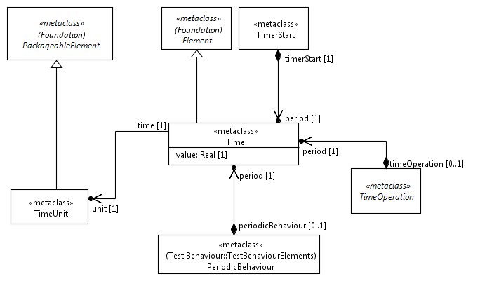
Figure 9.1: Time Concept
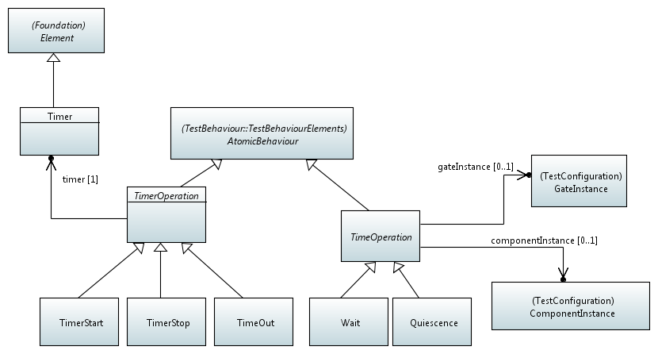
Figure 9.2: Timer and Time Operations
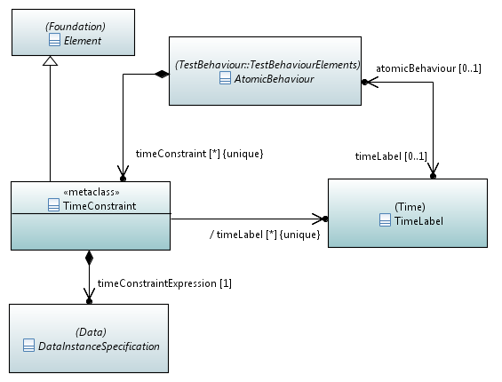
Figure 9.3 Time Constraints

9.3 Classifier Description

9.3.1 Time
Semantics
'Time' represents the concept of time. Time in TDL is considered to be global and progresses in discrete quantities of arbitrary granularity. Progress in time is expressed as a monotonically increasing function. A time instance or a time duration are expressed by a positive 'value' of type 'Real'. The measurement unit is set by the property 'unit' which defines a predefined and user-extensible set of measurement units.
Time starts with the execution of an unreferenced 'TestDescription' (with time value 0.0).
Generalizations
- Element
Properties
- value : Real [1]
Represents a 'value' of a time instance or a time duration.
- unit : TimeUnit [1]
Defines the measurement unit of a time value or a time duration value.
Constraints
Time value shall be non-negative
The attribute 'value' shall be non-negative.

9.3.2 TimeUnit
Semantics
'TimeUnit' describes the unit of a 'Time' value. There exists a list of predefined instances for the time unit (see clause 10.2), which can be extended by the user.
Generalizations
- PackageableElement
Properties
There are no properties specified.
Constraints
There are no constraints specified.

9.3.3 TimeOperation
Semantics
A 'TimeOperation' summarizes the two possible time operations that can occur at a 'GateInstance' of a 'Tester' 'ComponentInstance': 'Wait' and 'Quiescence'. A 'TimeOperation' refers to either a 'GateInstance' or a 'ComponentInstance'. In the former case it means that the 'TimeOperation' applies only on the referenced 'GateInstance', while in the latter case it applies on all the 'GateInstance's of the referenced 'Tester' 'ComponentInstance'.
Generalizations
- AtomicBehaviour
Properties
- period : Time [1]
The 'period' defines the time duration of the 'TimeOperation'.
- gateInstance : GateInstance [0..1]
The 'GateInstance' element, to which the 'TimeOperation' is associated.
- componentInstance : ComponentInstance [0..1]
The 'ComponentInstance' element, to which the 'TimeOperation' is associated.
Constraints
Time operations on tester components only
A 'TimeOperation' shall be performed only on a 'Tester' 'ComponentInstance' or on a 'GateInstance' that is associated with a 'ComponentInstance' in the role 'Tester'.
Association to gate or component instance is mutually exclusive
It is mandatory to set an association of a 'TimeOperation' to a 'GateInstance' or a 'ComponentInstance'. However the association shall be mutually exclusive, i.e. both associations shall not be given at the same time.

9.3.4 Wait
Semantics
'Wait' defines the time duration that a 'Tester' 'ComponentInstance' instance waits at a given 'GateInstance' (if 'Wait' is associated to a gate instance) or waits at all the 'GateInstance's the 'Tester' 'ComponentInstance' contains (if 'Wait' is associated to a component instance) before performing the next behaviour.
Generalizations
- TimeOperation
Properties
There are no properties specified.
Constraints
There are no constraints specified.

9.3.5 Quiescence
Semantics
'Quiescence' defines the time duration during which a 'Tester' component instance shall expect no input from a 'SUT' component instance at a given gate instance (if 'Quiescence' is associated to a gate instance) or at all the gate instances the tester component instance contains of (if 'Quiescence' is associated to a component instance).
Generalizations
- TimeOperation
Properties
There are no properties specified.
Constraints
There are no constraints specified.

9.3.6 TimeConstraint
Semantics
A 'TimeConstraint' is used to express a timing requirement over 'AtomicBehaviour' elements. The time constraint shall be formulated over two or more 'AtomicBehaviour' elements. A 'TimeConstraint' element limits the execution time of the 'AtomicBehaviour' element that is to be executed at latest, relative to other 'AtomicBehaviour' elements in that time constraint. Time constraints reside within a test description.
Currently, there is no formal notation to express time constraints. However it is understood that the names of affected 'AtomicBehaviour' elements, i.e. their labels, are used in a Boolean expression together with one or more 'Time' elements expressing time values.
EXAMPLE: In the expression "|L2 – L1| < 5,0 sec" the names L2 and L1 shall be the labels of two atomic behaviour elements. Then the expression states that atomic behaviour element L2 shall occur in less than 5,0 sec after L1.
Generalizations
- Element
Properties
- expression : String [1]
Defines the time constraint as an informal string.
- atomicBehaviour : AtomicBehaviour [1..*] {ordered}
The 'AtomicBehaviour' elements that are affected by this time constraint.
Constraints
There are no constraints specified.

9.3.7 Timer
Semantics
A 'Timer' element defines a timer that is used by different timer operations. A 'Timer' is contained within a 'ComponentType' element assuming that each 'ComponentInstance' of the given 'ComponentType' has its local copy of that timer in the operational mode.
Generalizations
- Element
Properties
- componentType : ComponentType [1]
The 'ComponentType' element, in which the 'Timer' is defined.
Constraints
Named timer
A timer shall have a name.
Initial state of a timer
When a timer is defined, it is operationally in the state idle.

9.3.8 TimerOperation
Semantics
A 'TimerOperation' operates on an associated 'Timer'. 'TimerOperation' is an abstract element that summarizes the operations on timers: timer start, timeout and timer stop.
Generalizations
- AtomicBehaviour
Properties
- timer : Timer [1]
This property refers to the 'Timer' element on which the 'TimerOperation' operates.
Constraints
There are no constraints specified.

9.3.9 TimerStart
Semantics
A 'TimerStart' operation starts a specific timer. The state of that timer becomes then running. If a running timer is started, the timer is stopped first implicitly and then (re-)started.
Generalizations
- TimerOperation
Properties
- period : Time [1]
Defines the duration of the timer from start to timeout.
Constraints
There are no constraints specified.

9.3.10 TimeOut
Semantics
A 'TimeOut' element is used to specify the occurrence of a timeout event when the period set by the 'TimerStart' operation of that timer has elapsed. In operational mode, the timer changes then from running state to the idle state.
Generalizations
- TimerOperation
Properties
There are no properties specified.
Constraints
Running timer
The state of the timer shall be in state running in order to allow the 'TimeOut' to occur in the operational mode.

9.3.11 TimerStop
Semantics
A 'TimerStop' operation stops a running timer. If an idle timer is stopped, then no action shall be taken. After performing a 'TimerStop' operation, the state of that timer becomes idle.
Generalizations
- TimerOperation
Properties
There are no properties specified.
Constraints
There are no constraints specified.

10 Predefined Types

10.1 Overview
This clause lists the predefined element instances for the meta-model elements 'VerdictType' and 'TimeUnit' that shall be a part of a standard-compliant TDL implementation. It is not specified how these predefined instances are made available to the user.
Clause 10.2 lists the basic predefined instances of 'VerdictType' elements that shall be used either in explicit 'VerdictAssignment' elements or in the implicit verdict setting mechanism of TDL. Clause 10.3 afterwards lists the basic predefined instances of 'TimeUnit' elements that shall be used in any instances of 'Time' elements of TDL.

10.2 Predefined Element Instances of 'VerdictType'

10.2.1 pass
The predefined instance 'pass' of the element 'VerdictType' indicates the valid behaviour of the SUT as observed by the tester. See definition in ISO 9646-1 [3].

10.2.2 fail
The predefined instance 'fail' of the element 'VerdictType' indicates the invalid behaviour of the SUT as observed by the tester. See definition in ISO 9646-1 [3].

10.2.3 inconclusive
The predefined instance 'inconclusive' of the element 'VerdictType' can be used if neither 'pass' nor 'fail' verdict can be given. See definition in ISO 9646-1 [3].

10.3 Predefined Element Instances of 'TimeUnit'

10.3.1 tick
The time unit instance 'tick' represents an arbitrary, but fixed duration of time.

10.3.2 nanosecond
The time unit instance 'nanosecond' represents the duration of a nanosecond (i.e. 10⁻⁹ seconds).

10.3.3 microsecond
The time unit instance 'microsecond' represents the duration of a microsecond (i.e. 10⁻⁶ seconds).

10.3.4 millisecond
The time unit instance 'millisecond' represents the duration of a millisecond (i.e. 10⁻³ seconds).

10.3.5 second
The time unit instance 'second' represents the duration of a seconds.

10.3.6 minute
The time unit instance 'minute' represents the duration of a minute (i.e. 60 seconds).

10.3.7 hour
The time unit instance 'hour' represents the duration of an hour (i.e. 3 600 seconds).

Annex A (informative):
Technical Representation of the TDL Meta-Model
The technical representation of the TDL meta-model is included as an electronic attachment es_203119v010101p0.zip which accompanies the present document. The purpose of this annex is to serve as a possible starting point for implementing the TDL meta-model conforming to the present document. See the readme contained in the zip file for details.

Annex B (informative):
Examples of a TDL Concrete Syntax

B.1 Introduction
The applicability of the TDL meta-model that is described in the main part of the present document depends on the availability of TDL concrete syntaxes that implement the meta-model (abstract syntax). Such a TDL concrete syntax can then be used by end users to write TDL specifications. Though a concrete syntax will be based on the TDL meta-model, it can implement only parts of the meta-model if certain TDL features are not necessary to handle a user's needs.
This annex illustrates an example of a possible TDL concrete syntax in a textual format that supports all features of the TDL meta-model, called "TDLan". Three examples are outlined below - two examples translated from existing test descriptions taken from [i.2] and [i.3], as well as an example illustrating some of the TDL data parameterization and mapping concepts. The examples are accompanied by a complete reference description of the textual syntax of TDLan given in EBNF.

B.2 A 3GPP Conformance Example in Textual Syntax
This example describes one possible way to translate clause 7.1.3.1 from TS 136 523-1 [i.2] into the proposed TDL textual syntax, by mapping the concepts from the representation in the source document to the corresponding concepts in the TDL meta-model by means of the proposed textual syntax. The example has been enriched with additional information, such as explicit data definitions and test configuration details for completeness where applicable.
//Translated from [i.2], Section 7.1.3.1
TDLan Specification Layer_2_DL_SCH_Data_Transfer {
//Procedures carried out by a component of a test configuration
//or an actor during test execution
Action preCondition : "Pre-test Conditions:
RRC Connection Reconfiguration" ;
Action preamble : "Preamble:
The generic procedure to get UE in test state Loopback
Activated (State 4) according to TS 36.508 clause 4.5
is executed, with all the parameters as specified in the
procedure except that the RLC SDU size is set to return no
data in uplink.
(reference corresponding behaviour once implemented" ;

//User-defined verdicts
//Alternatively the predefined verdicts may be used as well
Verdict PASS ;
Verdict FAIL ;

//User-defined annotation types
Annotation TITLE ; //Test description title
Annotation STEP ; //Step identifiers in source documents
Annotation PROCEDURE ; //Informal textual description of a test step
Annotation PRECONDITION ; //Identify pre-condition behaviour
Annotation PREAMBLE ; //Identify preamble behaviour.

//User-defined time units
Time Unit seconds;

//Test objectives (copied verbatim from source document)
Test Objective TP1 {
from : "36523-1-a20_s07_01.doc::7.1.3.1.1 (1)" ;
description : "with { UE in E-UTRA RRC_CONNECTED state }
ensure that {
when { UE receives downlink assignment on the PDCCH
for the UE's C-RNTI and receives data in the
associated subframe and UE performs HARQ
operation }
then { UE sends a HARQ feedback on the HARQ
process }
}" ;
}
Test Objective TP2 {
from : "36523-1-a20_s07_01.doc::7.1.3.1.1 (2)" ;
description : "with { UE in E-UTRA RRC_CONNECTED state }
ensure that {
when { UE receives downlink assignment on the PDCCH
with a C-RNTI unknown by the UE and data is
available in the associated subframe }
then { UE does not send any HARQ feedback on the
HARQ process }
}" ;
}

//Relevant data set and data instance definitions
Data Set PDU {
instance MAC_PDU ;
}
Data Set ACK {
instance HARQ_ACK ;
}
Data Set C_RNTI {
instance UE_C_RNTI ;
instance unknown_C_RNTI ;
}
Data Set OTHER {
instance PDCCH ( C_RNTI ) ;
instance RRCConnectionReconfiguration ;
}

//Gate type definitions
Gate Type defaultGT accepts ACK, PDU, OTHER, C_RNTI ;

//Component type definitions
Component Type defaultCT {
gate types : defaultGT ;
}

//Test configuration definition
Test Configuration defaultTC {
instantiate SS as Tester of type defaultCT having {
gate SSgate of type defaultGT ;
}
instantiate UE as SUT of type defaultCT having {
gate UEgate of type defaultGT ;
}
connect UEgate to SSgate ;
}

//Test description definition
Test Description TD_7_1_3_1 {
use configuration : defaultTC ;
{
//Pre-conditions and preamble from the source document
perform action preCondition with { PRECONDITION ; } ;
perform action preamble with { PREAMBLE ; } ;

//Test sequence
SSgate sends instance PDCCH ( UE_C_RNTI ) to UEgate with {
STEP "1" ;
PROCEDURE "SS transmits a downlink assignment
including the C-RNTI assigned to
the UE" ;
} ;
SSgate sends instance MAC_PDU to UEgate with {
STEP "2" ;
PROCEDURE "SS transmits in the indicated
downlink assignment a RLC PDU in
a MAC PDU" ;
} ;
UEgate sends instance HARQ_ACK to SSgate with {
STEP "3" ;
PROCEDURE "Check: Does the UE transmit an
HARQ ACK on PUCCH?" ;
test objectives : TP1 ;
} ;
set verdict to PASS ;
SSgate sends instance PDCCH ( unknown_C_RNTI ) to UEgate with {
STEP "4" ;
PROCEDURE "SS transmits a downlink assignment
to including a C-RNTI different from
the assigned to the UE" ;
} ;
SSgate sends instance MAC_PDU to UEgate with {
STEP "5" ;
PROCEDURE "SS transmits in the indicated
downlink assignment a RLC PDU in
a MAC PDU" ;
} ;

//Interpolated original step 6 into an alternative behaviour,
//covering both the incorrect and the correct behaviours of the UE
alternatively {
UEgate sends instance HARQ_ACK to SSgate ;
set verdict to FAIL ;
} or {
gate SSgate is quiet for (5.0 seconds);
set verdict to PASS ;
} with {
STEP "6" ;
PROCEDURE "Check: Does the UE send any HARQ ACK
on PUCCH?" ;
test objectives : TP2 ;
}
}
} with {
Note : "Note 1: For TDD, the timing of ACK/NACK is not
constant as FDD, see Table 10.1-1 of TS 36.213." ;
}
} with {
Note : "Taken from 3GPP TS 36.523-1 V10.2.0 (2012-09)" ;
TITLE "Correct handling of DL assignment / Dynamic case" ;
}

B.3 An IMS Interoperability Example in Textual Syntax
This example describes one possible way to translate clause 4.5.1 from TS 186 011-2 [i.3] into the proposed TDL textual syntax, by mapping the concepts from the representation in the source document to the corresponding concepts in the TDL meta-model by means of the proposed textual syntax. The example has been enriched with additional information, such as explicit data definitions and test configuration details for completeness where applicable.
//Translated from [i.3], Clause 4.5.1.
TDLan Specification IMS_NNI_General_Capabilities {
//Procedures carried out by a component of a test configuration
//or an actor during test execution
Action preConditions : "Pre-test conditions:
- HSS of IMS_A and of IMS B is configured according to table 1
- UE_A and UE_B have IP bearers established to their respective
IMS networks as per clause 4.2.1
- UE_A and IMS_A configured to use TCP for transport
- UE_A is registered in IMS_A using any user identity
- UE_B is registered user of IMS_B using any user identity
- MESSAGE request and response has to be supported at II-NNI
see tables 6.1 and 6.3)" ;

//User-defined verdicts
//Alternatively the predefined verdicts may be used as well
Verdict PASS ;
Verdict FAIL ;

//User-defined annotation types
Annotation TITLE ; //Test description title
Annotation STEP ; //Step identifiers in source documents
Annotation PROCEDURE ; //Informal textual description of a test step
Annotation PRECONDITION ; //Identify pre-condition behaviour
Annotation PREAMBLE ; //Identify preamble behaviour.
Annotation SUMMARY ; //Informal textual description of test sequence

//Test objectives (copied verbatim from source document)
Test Objective TP_IMS_4002_1 {
//Location in source document
from : "ts_18601102v030101p.pdf::4.5.1.1 (CC 1)" ;
//Further reference to another document
from : "ts_124229v081000p.pdf, clause 4.2A, paragraph 1" ;
description : "ensure that {
when { UE_A sends a MESSAGE to UE_B
containing a Message_Body greater than 1 300
bytes }
then { IMS_B receives the MESSAGE containing the
Message_Body greater than 1 300 bytes }
}" ;
}
Test Objective UC_05_I {
//Only a reference to corresponding clause in the source document
from : "ts_18601102v030101p.pdf::4.4.4.2" ;
}

//Relevant data set and data instance definitions
Data Set MSG {
instance MESSAGE ;
instance MESSAGE_TCP ( TCP ) ;
instance TCP ;
instance DING ;
instance DELIVERY_REPORT ;
instance M_200_OK ;
}

//Gate type definitions.
Gate Type defaultGT accepts MSG ;

//Component type definitions
//In this case they may also be reduced to a single component type
Component Type USER {
gate types : defaultGT ;
}
Component Type UE {
gate types : defaultGT ;
}
Component Type IMS {
gate types : defaultGT ;
}
Component Type IBCF {
gate types : defaultGT ;
}

//Test configuration definition
Test Configuration CF_INT_CALL {
instantiate USER_A as Tester of type USER having {
gate gUSER_A of type defaultGT ;
}
instantiate UE_A as Tester of type UE having {
gate gUE_A of type defaultGT ;
}
instantiate IMS_A as Tester of type IMS having {
gate gIMS_A of type defaultGT ;
}
instantiate IBCF_A as Tester of type IBCF having {
gate gIBCF_A of type defaultGT ;
}
instantiate IBCF_B as Tester of type IBCF having {
gate gIBCF_B of type defaultGT ;
}
instantiate IMS_B as SUT of type IMS having {
gate gIMS_B of type defaultGT ;
}
instantiate UE_B as Tester of type UE having {
gate gUE_B of type defaultGT ;
}
instantiate USER_B as Tester of type USER having {
gate gUSER_B of type defaultGT ;
}
connect gUSER_A to gUE_A ;
connect gUE_B to gUSER_B ;
connect gUE_A to gIMS_A ;
connect gIMS_A to gIBCF_A ;
connect gIBCF_A to gIBCF_B ;
connect gIBCF_B to gIMS_B ;
connect gIMS_B to gUE_B ;
}

//Test description definition
Test Description TD_IMS_MESS_0001 {
use configuration : CF_INT_CALL ;
{
//Pre-conditions from the source document
perform action preConditions with { PRECONDITION ; };

//Test sequence
gUSER_A sends instance MESSAGE to gUE_A with { STEP "1" ; } ;
gUE_A sends instance MESSAGE to gIMS_A with { STEP "2" ; } ;
gIMS_A sends instance MESSAGE to gIBCF_A with { STEP "3" ; } ;
gIBCF_A sends instance MESSAGE to gIBCF_B with { STEP "4" ; } ;
gIBCF_B sends instance MESSAGE_TCP to gIMS_B with { STEP "5" ; } ;
gIMS_B sends instance MESSAGE to gUE_B with { STEP "6" ; } ;
gUE_B sends instance DING to gUSER_B with { STEP "7" ; } ;
gUE_B sends instance M_200_OK to gIMS_B with { STEP "8" ; } ;
gIMS_B sends instance M_200_OK to gIBCF_B with { STEP "9" ; } ;
gIBCF_B sends instance M_200_OK to gIBCF_A with { STEP "10" ; } ;
gIBCF_A sends instance M_200_OK to gIMS_A with { STEP "11" ; } ;
gIMS_A sends instance M_200_OK to gUE_A with { STEP "12" ; } ;

optionally {
gUE_A sends instance DELIVERY_REPORT to gUSER_A with { STEP "13" ; } ;
} ;
}
} with {
SUMMARY "IMS network shall support SIP messages greater than
1 500 bytes" ;
}
} with {
Note : "Taken from ETSI TS 186 011-2 V3.1.1 (2011-06)" ;
TITLE "SIP messages longer than 1 500 bytes" ;
}

B.4 An Example Demonstrating TDL Data Concepts
This example describes some of the concepts related to data and data mapping in TDL by means of the proposed TDL textual syntax. It illustrates how data instances can be parameterized, mapped to concrete data entities specified in an external resource, e.g. a TTCN-3 file, or to a runtime URI where dynamic concrete data values might be stored by the execution environment during runtime in order to facilitate some basic data flow of dynamic values between different interactions. The example considers a scenario where the SUT is required to generate and maintain a session ID between subsequent interactions using a similar test configuration as defined for the first example in clause B.2.
//A manually constructed example illustrating the data mapping concepts
TDLan Specification DataExample {

//User-defined verdicts (the predefined verdicts may be used as well)
Verdict PASS ;
Verdict FAIL ;

//Test objectives
Test Objective CHECK_SESSION_ID_IS_MAINTAINED {
//Only a description
description : "Check whether the session id is maintained
after the first response." ;
}

//Data definitions
Data Set SESSION_ID {
instance SESSION_ID_1 ;
instance SESSION_ID_2 ;
}

Data Set MSG {
instance REQUEST_SESSION_ID ;
instance RESPONSE ( SESSION_ID ) ;
instance MESSAGE ( SESSION_ID ) ;
}

//Data mappings

//Load resource.ttcn3 containing the concrete data representations
Use "resource.ttcn3"
as TTCN_RESOURCE;

//Map sets and instances to TTCN-3 records and templates, respectively
//(located in the loaded TTCN-3 file)
Map MSG
to "record_message"
in TTCN_ RESOURCE
as MSG_mapping ;

Map REQUEST_SESSION_ID
to "template_request"
in TTCN_ RESOURCE
as REQUEST_mapping ;

Map RESPONSE
to "template_response"
in TTCN_ RESOURCE
as RESPONSE_mapping ;

Map MESSAGE
to "template_message"
in TTCN_MAPPING
as MESSAGE_mapping ;

//Use a runtime URI for dynamic data available at runtime, such as
//session IDs
Use "runtime://sessions/"
as RUNTIME_RESOURCE ;

//Map session ID data instances to locations within the runtime URI
Map SESSION_ID_1
to "id_1"
in RUNTIME_RESOURCE
as SESSION_ID_1_mapping ;

Map SESSION_ID_2
to "id_2"
in RUNTIME_RESOURCE
as SESSION_ID_2_mapping ;

//Gate type definitions
Gate Type defaultGT accepts MSG ;

//Component type definitions
Component Type defaultCT {
gate types : defaultGT ;
}

//Test configuration definition
Test Configuration defaultTC {
instantiate UE as SUT of type defaultCT having {
gate UEgate of type defaultGT ;
}

instantiate SS as Tester of type defaultCT having {
gate SSgate of type defaultGT ;
}

connect SSgate to UEgate ;
}

//Test description definition
Test Description exampleTD {
use configuration : defaultTC ;
{
//Tester requests a session id
SSgate sends instance REQUEST_SESSION_ID to UEgate ;

//SUT responds with a session id that is assigned to the
//runtime URI provided by the execution environment
UEgate sends instance RESPONSE ( SESSION_ID_1 ) to SSgate ;

//Tester sends a message with the session id
//from the runtime URI
SSgate sends instance MESSAGE ( SESSION_ID_1 ) to UEgate ;

alternatively {

//SUT responds with the same session id
UEgate sends instance RESPONSE ( SESSION_ID_1 ) to SSgate ;
set verdict to PASS;

} or {

//SUT responds with a different session id
UEgate sends instance RESPONSE ( SESSION_ID_2 ) to SSgate ;
set verdict to FAIL;

} with {
test objectives : CHECK_SESSION_ID_IS_MAINTAINED ;
}
}
}
}

B.5 TDL Textual Syntax Reference

B.5.1 Conventions for the TDLan Syntax Definition
This annex describes the grammar of the used concrete textual syntax in the Extended Backus-Naur Form (EBNF) notation. The EBNF representation is generated from a reference implementation of the TDL meta-model. The EBNF representation can be used either as a concrete syntax reference for TDL end users or as input to a parser generator tool. Table B.1 defines the syntactic conventions that are to be applied when reading the EBNF rules. To distinguish this concrete textual syntax from other possible concrete textual syntax representations, it is referred to as "TDLan". This proposed syntax is complete in the sense that it covers the whole TDL meta-model.
Table B.1: Syntax definition conventions used
::= | is defined to be
abc | the non-terminal symbol abc
abc xyz | abc followed by xyz
abc | xyz | alternative (abc or xyz)
[abc] | 0 or 1 instance of abc
{abc}+ | 1 or more instances of abc
{abc} | 0 or more instances of abc
'a'-'z' | all characters from a to z
(...) | denotes a textual grouping
'abc' | the terminal symbol abc
; | production terminator
\ | the escape character

B.5.2 TDL Textual Syntax EBNF Production Rules
TDLSpec | ::= | ( 'TDLan Specification' Identifier '{'
 |  | [ ElementImport { ElementImport } ]
 |  | [ PackageableElement { PackageableElement } ]
 |  | '}'
 |  | [ 'with' '{'
 |  | [ Comment { Comment } ]
 |  | [ Annotation { Annotation } ]
 |  | '}' ] ) ;
Package | ::= | ( 'Package' Identifier '{'
 |  | [ ElementImport { ElementImport } ]
 |  | [ PackageableElement { PackageableElement } ]
 |  | '}'
 |  | [ 'with' '{'
 |  | [ Comment { Comment } ]
 |  | [ Annotation { Annotation } ]
 |  | '}' ] ) ;
Identifier | ::= | ID ;
PackageableElement | ::= | ( AnnotationType
 |  | | Package
 |  | | TestObjective
 |  | | DataSet
 |  | | DataResourceMapping
 |  | | DataElementMapping
 |  | | ComponentType
 |  | | GateType
 |  | | TimeUnit
 |  | | TestConfiguration
 |  | | TestDescription
 |  | | VerdictType
 |  | | Action ) ;
TestObjectiveRealizer | ::= | ( TimerStart
 |  | | TimerStop
 |  | | TimeOut
 |  | | Wait
 |  | | Quiescence
 |  | | TestDescription
 |  | | CompoundBehaviour
 |  | | PeriodicBehaviour
 |  | | AlternativeBehaviour
 |  | | ParallelBehaviour
 |  | | BoundedLoopBehaviour
 |  | | UnboundedLoopBehaviour
 |  | | ConditionalBehaviour
 |  | | Stop
 |  | | TestDescriptionReference
 |  | | VerdictAssignment
 |  | | ActionReference
 |  | | Interaction
 |  | | OptionalBehaviour
 |  | | DefaultBehaviour
 |  | | InterruptBehaviour
 |  | | Break ) ;
DataElement | ::= | ( DataInstance | DataSet ) ;
ExceptionalBehaviour | ::= | ( DefaultBehaviour | InterruptBehaviour ) ;
AtomicBehaviour | ::= | ( TimerStart
 |  | | TimerStop
 |  | | TimeOut
 |  | | Wait
 |  | | Quiescence
 |  | | Stop
 |  | | TestDescriptionReference
 |  | | VerdictAssignment
 |  | | ActionReference
 |  | | Interaction
 |  | | Break ) ;
Behaviour | ::= | ( TimerStart
 |  | | TimerStop
 |  | | TimeOut
 |  | | Wait
 |  | | Quiescence
 |  | | CompoundBehaviour
 |  | | PeriodicBehaviour
 |  | | AlternativeBehaviour
 |  | | ParallelBehaviour
 |  | | BoundedLoopBehaviour
 |  | | UnboundedLoopBehaviour
 |  | | ConditionalBehaviour
 |  | | Stop
 |  | | TestDescriptionReference
 |  | | VerdictAssignment
 |  | | ActionReference
 |  | | Interaction
 |  | | OptionalBehaviour
 |  | | DefaultBehaviour
 |  | | InterruptBehaviour
 |  | | Break ) ;
Comment | ::= | ( 'Note' Identifier ':' String
 |  | [ 'with' '{'
 |  | [ Comment { Comment } ]
 |  | [ Annotation { Annotation } ]
 |  | '}' ] ';' ) ;
Annotation | ::= | ( Identifier String
 |  | [ 'with' '{'
 |  | [ Comment { Comment } ]
 |  | [ Annotation { Annotation } ] Identifier
 |  | '}' ] ';' ) ;
String | ::= | STRING ;
ElementImport | ::= | ( 'Import' Identifier { ',' Identifier } ';'
 |  | [ 'with' '{'
 |  | [ Comment { Comment } ]
 |  | [ Annotation { Annotation } ] Identifier
 |  | '}' ] ';' ) ;
AnnotationType | ::= | ( 'Annotation' Identifier
 |  | [ 'with' '{'
 |  | [ Comment { Comment } ]
 |  | [ Annotation { Annotation } ]
 |  | '}' ] ';' ) ;
TestObjective | ::= | ( 'Test Objective' Identifier '{'
 |  | [ 'from' ':' String ';' { 'from' ':' String ';' } ]
 |  | [ 'description' ':' String ';' ]
 |  | '}'
 |  | [ 'with' '{'
 |  | [ Comment { Comment } ]
 |  | [ Annotation { Annotation } ]
 |  | '}' ] ) ;
DataSet | ::= | ( 'Data Set' Identifier '{'
 |  | [ DataInstance { DataInstance } ]
 |  | '}'
 |  | [ 'with' '{'
 |  | [ Comment { Comment } ]
 |  | [ Annotation { Annotation } ]
 |  | '}' ] ) ;
DataResourceMapping | ::= | ( 'Use' String
 |  | [ 'as' Identifier ]
 |  | [ 'with' '{'
 |  | [ Comment { Comment } ]
 |  | [ Annotation { Annotation } ]
 |  | '}' ] ';' ) ;
DataElementMapping | ::= | ( 'Map' Identifier
 |  | [ 'to' String ] 'in' Identifier
 |  | [ 'as' Identifier ]
 |  | [ 'with' '{'
 |  | [ Comment { Comment } ]
 |  | [ Annotation { Annotation } ]
 |  | '}' ] ';' ) ;
ComponentType | ::= | ( 'Component Type' Identifier '{'
 |  | [ Timer { Timer } ] 'gate' 'types' ':' Identifier { ',' Identifier } ';'
 |  | '}'
 |  | [ 'with' '{'
 |  | [ Comment { Comment } ]
 |  | [ Annotation { Annotation } ]
 |  | '}' ] ) ;
GateType | ::= | ( 'Gate Type' Identifier 'accepts' Identifier { ',' Identifier }
 |  | [ 'with' '{'
 |  | [ Comment { Comment } ]
 |  | [ Annotation { Annotation } ]
 |  | '}' ] ';' ) ;
TimeUnit | ::= | ( 'Time Unit' Identifier
 |  | [ 'with' '{'
 |  | [ Comment { Comment } ]
 |  | [ Annotation { Annotation } ]
 |  | '}' ] ';' ) ;
TestConfiguration | ::= | ( 'Test Configuration' Identifier '{'
 |  | ComponentInstance { ComponentInstance } Connection { Connection }
 |  | '}'
 |  | [ 'with' '{'
 |  | [ Comment { Comment } ]
 |  | [ Annotation { Annotation } ]
 |  | '}' ] ) ;
TestDescription | ::= | ( 'Test Description' Identifier
 |  | [ '(' DataProxy { ',' DataProxy } ')' ] '{'
 |  | use' 'configuration' ':' Identifier ';' CompoundBehaviour
 |  | '}'
 |  | [ 'with' '{'
 |  | [ Comment { Comment } ]
 |  | [ Annotation { Annotation } ]
 |  | [ 'test objectives' ':' Identifier { ',' Identifier } ';' ]
 |  | [ 'time constraints' ':' TimeConstraint { ',' TimeConstraint } ';' ]
 |  | '}' ] ) ;
VerdictType | ::= | ( 'Verdict' Identifier
 |  | [ 'with' '{'
 |  | [ Comment { Comment } ]
 |  | [ Annotation { Annotation } ]
 |  | '}' ] ';' ) ;
Action | ::= | ( 'Action' Identifier ':' String
 |  | [ 'with' '{'
 |  | [ Comment { Comment } ]
 |  | [ Annotation { Annotation } ]
 |  | '}' ] ';' ) ;
TimerStart | ::= | ( 'start' Identifier 'for' '(' Time ')'
 |  | [ 'with' '{'
 |  | [ Comment { Comment } ]
 |  | [ Annotation { Annotation } ]
 |  | [ 'test objectives' ':' Identifier { ',' Identifier } ';' ]
 |  | [ 'name' Identifier ]
 |  | [ 'time constraints' '(' Identifier { ',' Identifier } ')' ]
 |  | '}' ] ';' ) ;
TimerStop | ::= | ( 'stop' Identifier
 |  | [ 'with' '{'
 |  | [ Comment { Comment } ]
 |  | [ Annotation { Annotation } ]
 |  | [ 'test objectives' ':' Identifier { ',' Identifier } ';' ]
 |  | [ 'name' Identifier ]
 |  | [ 'time constraints' '(' Identifier { ',' Identifier } ')' ]
 |  | '}' ] ';' ) ;
TimeOut | ::= | ( Identifier 'times' 'out'
 |  | [ 'with' '{'
 |  | [ Comment { Comment } ]
 |  | [ Annotation { Annotation } ]
 |  | [ 'test objectives' ':' Identifier { ',' Identifier } ';' ]
 |  | [ 'name' Identifier ]
 |  | [ 'time constraints' '(' Identifier { ',' Identifier } ')' ]
 |  | '}' ] ';' ) ;
Wait | ::= | (
 |  | [ ( 'gate' | Identifier ) | ( 'component' | Identifier ) ] 'waits for' '(' Time ')'
 |  | [ 'with' '{'
 |  | [ Comment { Comment } ]
 |  | [ Annotation { Annotation } ]
 |  | [ 'test objectives' ':' Identifier { ',' Identifier } ';' ]
 |  | [ 'name' Identifier ]
 |  | [ 'time constraints' '(' Identifier { ',' Identifier } ')' ]
 |  | '}' ] ';' ) ;
Quiescence | ::= | (
 |  | [ ( 'gate' | Identifier ) | ( 'component' | Identifier ) ] 'is quiet for' '(' Time ')'
 |  | [ 'with' '{'
 |  | [ Comment { Comment } ]
 |  | [ Annotation { Annotation } ]
 |  | [ 'test objectives' ':' Identifier { ',' Identifier } ';' ]
 |  | [ 'name' Identifier ]
 |  | [ 'time constraints' '(' Identifier { ',' Identifier } ')' ]
 |  | '}' ] ';' ) ;
CompoundBehaviour | ::= | ( Block
 |  | [ 'with' '{'
 |  | [ Comment { Comment } ]
 |  | [ Annotation { Annotation } ]
 |  | [ 'test objectives' ':' Identifier { ',' Identifier } ';' ]
 |  | [ 'name' Identifier ]
 |  | [ PeriodicBehaviour { PeriodicBehaviour } ]
 |  | [ ExceptionalBehaviour { ExceptionalBehaviour } ]
 |  | '}' ] ) ;
PeriodicBehaviour | ::= | ( 'every' '(' Time ')' Block
 |  | [ 'with' '{'
 |  | [ Comment { Comment } ]
 |  | [ Annotation { Annotation } ]
 |  | [ 'test objectives' ':' Identifier { ',' Identifier } ';' ]
 |  | [ 'name' Identifier ]
 |  | '}' ] ) ;
AlternativeBehaviour | ::= | ( 'alternatively' Block { 'or' Block }
 |  | [ 'with' '{'
 |  | [ Comment { Comment } ]
 |  | [ Annotation { Annotation } ]
 |  | [ 'test objectives' ':' Identifier { ',' Identifier } ';' ]
 |  | [ 'name' Identifier ]
 |  | [ PeriodicBehaviour { PeriodicBehaviour } ]
 |  | [ ExceptionalBehaviour { ExceptionalBehaviour } ]
 |  | '}' ] ) ;
ParallelBehaviour | ::= | ( 'run' Block { 'in' 'parallel' 'to' Block }
 |  | [ 'with' '{'
 |  | [ Comment { Comment } ]
 |  | [ Annotation { Annotation } ]
 |  | [ 'test objectives' ':' Identifier { ',' Identifier } ';' ]
 |  | [ 'name' Identifier ]
 |  | [ PeriodicBehaviour { PeriodicBehaviour } ]
 |  | [ ExceptionalBehaviour { ExceptionalBehaviour } ]
 |  | '}' ] ) ;
BoundedLoopBehaviour | ::= | ( 'repeat' Integer 'times' Block
 |  | [ 'with' '{'
 |  | [ Comment { Comment } ]
 |  | [ Annotation { Annotation } ]
 |  | [ 'test objectives' ':' Identifier { ',' Identifier } ';' ]
 |  | [ 'name' Identifier ]
 |  | [ PeriodicBehaviour { PeriodicBehaviour } ]
 |  | [ ExceptionalBehaviour { ExceptionalBehaviour } ]
 |  | '}' ] ) ;
UnboundedLoopBehaviour | ::= | ( 'repeat' Block
 |  | [ 'with' '{'
 |  | [ Comment { Comment } ]
 |  | [ Annotation { Annotation } ]
 |  | [ 'test objectives' ':' Identifier { ',' Identifier } ';' ]
 |  | [ 'name' Identifier ]
 |  | [ PeriodicBehaviour { PeriodicBehaviour } ]
 |  | [ ExceptionalBehaviour { ExceptionalBehaviour } ]
 |  | '}' ] ) ;
ConditionalBehaviour | ::= | ( 'if' Block
 |  | [ ( ( 'else' Block ) ) | ( { 'else' 'if' Block } | ( 'else' Block ) ) ]
 |  | [ 'with' '{'
 |  | [ Comment { Comment } ]
 |  | [ Annotation { Annotation } ]
 |  | [ 'test objectives' ':' Identifier { ',' Identifier } ';' ]
 |  | [ 'name' Identifier ]
 |  | [ PeriodicBehaviour { PeriodicBehaviour } ]
 |  | [ ExceptionalBehaviour { ExceptionalBehaviour } ]
 |  | '}' ] ) ;
Stop | ::= | ( 'terminate'
 |  | [ 'with' '{'
 |  | [ Comment { Comment } ]
 |  | [ Annotation { Annotation } ]
 |  | [ 'test objectives' ':' Identifier { ',' Identifier } ';' ]
 |  | [ 'name' Identifier ]
 |  | [ 'time constraints' '(' Identifier { ',' Identifier } ')' ]
 |  | '}' ] ';' ) ;
TestDescriptionReference | ::= | ( 'execute' Identifier
 |  | [ '(' ArgumentSpecification { ',' ArgumentSpecification } ')' ]
 |  | [ 'with' '{'
 |  | [ Comment { Comment } ]
 |  | [ Annotation { Annotation } ]
 |  | [ 'test objectives' ':' Identifier { ',' Identifier } ';' ]
 |  | [ 'time constraints' '(' Identifier { ',' Identifier } ')' ]
 |  | [ 'name' Identifier ]
 |  | '}' ] ';' ) ;
VerdictAssignment | ::= | ( 'set verdict to' Identifier
 |  | [ 'with' '{'
 |  | [ Comment { Comment } ]
 |  | [ Annotation { Annotation } ]
 |  | [ 'test objectives' ':' Identifier { ',' Identifier } ';' ]
 |  | [ 'name' Identifier ]
 |  | [ 'time constraints' '(' Identifier { ',' Identifier } ')' ]
 |  | '}' ] ';' ) ;
ActionReference | ::= | ( 'perform action' Identifier
 |  | [ 'on component' Identifier ]
 |  | [ 'with' '{'
 |  | [ Comment { Comment } ]
 |  | [ Annotation { Annotation } ]
 |  | [ 'test objectives' ':' Identifier { ',' Identifier } ';' ]
 |  | [ 'name' Identifier ]
 |  | [ 'time constraints' '(' Identifier { ',' Identifier } ')' ]
 |  | '}' ] ';' ) ;
Interaction | ::= | ( Identifier 'sends' ArgumentSpecification 'to' Identifier { ',' Identifier }
 |  | [ 'with' '{'
 |  | [ Comment { Comment } ]
 |  | [ Annotation { Annotation } ]
 |  | [ 'test objectives' ':' Identifier { ',' Identifier } ';' ]
 |  | [ 'name' Identifier ]
 |  | [ 'time constraints' '(' Identifier { ',' Identifier } ')' ]
 |  | '}' ] ';' ) ;
OptionalBehaviour | ::= | ( 'optionally' Block
 |  | [ 'with' '{'
 |  | [ Comment { Comment } ]
 |  | [ Annotation { Annotation } ]
 |  | [ 'test objectives' ':' Identifier { ',' Identifier } ';' ]
 |  | [ 'name' Identifier ]
 |  | '}' ]
 |  | [ ExceptionalBehaviour { ExceptionalBehaviour } ]
 |  | [ PeriodicBehaviour { PeriodicBehaviour } ] ';' ) ;
DefaultBehaviour | ::= | ( 'default'
 |  | [ 'on' Identifier ] Block
 |  | [ 'with' '{'
 |  | [ Comment { Comment } ]
 |  | [ Annotation { Annotation } ]
 |  | [ 'test objectives' ':' Identifier { ',' Identifier } ';' ]
 |  | [ 'name' Identifier ]
 |  | '}' ] ) ;
InterruptBehaviour | ::= | ( 'interrupt'
 |  | [ 'on' Identifier ] Block
 |  | [ 'with' '{'
 |  | [ Comment { Comment } ]
 |  | [ Annotation { Annotation } ]
 |  | [ 'test objectives' ':' Identifier { ',' Identifier } ';' ]
 |  | [ 'name' Identifier ]
 |  | '}' ] ) ;
Break | ::= | ( 'break'
 |  | [ 'with' '{'
 |  | [ Comment { Comment } ]
 |  | [ Annotation { Annotation } ]
 |  | [ 'test objectives' ':' Identifier { ',' Identifier } ';' ]
 |  | [ 'time constraints' '(' Identifier { ',' Identifier } ')' ]
 |  | [ 'name' Identifier ]
 |  | '}' ] ';' ) ;
TimeConstraint | ::= | ( Identifier String
 |  | [ 'with' '{'
 |  | [ Comment { Comment } ]
 |  | [ Annotation { Annotation } ]
 |  | '}' ]
 |  | '}' ) ;
Timer | ::= | ( 'timer' Identifier
 |  | [ 'with' '{'
 |  | [ Comment { Comment } ]
 |  | [ Annotation { Annotation } ]
 |  | '}' ] ';' ) ;
Time | ::= | ( Real Identifier
 |  | [ 'with' '{'
 |  | [ Comment { Comment } ]
 |  | [ Annotation { Annotation } ]
 |  | [ 'name' Identifier ]
 |  | '}' ] ) ;
Real | ::= | (
 |  | ['-'] {INT}+ '.' {INT}+ ) ;
GateInstance | ::= | ( 'gate' Identifier 'of type' Identifier
 |  | [ 'with' '{'
 |  | [ Comment { Comment } ]
 |  | [ Annotation { Annotation } ]
 |  | '}' ] ';' ) ;
Block | ::= | (
 |  | [ '
 |  | [' String ']' ] '{'
 |  | [ Comment { Comment } ]
 |  | [ Annotation { Annotation } ]
 |  | [ 'name' Identifier ] Behaviour { Behaviour }
 |  | '}' ) ;
ComponentInstance | ::= | ( 'instantiate' Identifier 'as' ComponentInstanceRole 'of type' Identifier 'having' '{'
 |  | GateInstance { GateInstance }
 |  | '}'
 |  | [ 'with' '{'
 |  | [ Comment { Comment } ]
 |  | [ Annotation { Annotation } ]
 |  | '}' ] ) ;
Integer | ::= | (
 |  | ['-'] {INT}+ ) ;
DataInstance | ::= | ( 'instance' Identifier
 |  | [ '(' Identifier { ',' Identifier } ')' ]
 |  | [ 'with' '{'
 |  | [ Comment { Comment } ]
 |  | [ Annotation { Annotation } ]
 |  | '}' ] ';' ) ;
Connection | ::= | ( 'connect' Identifier
 |  | [ 'to' Identifier ] { 'and' Identifier }
 |  | [ 'with' '{'
 |  | [ Comment { Comment } ]
 |  | [ Annotation { Annotation } ] Identifier
 |  | '}' ] ';' ) ;
ArgumentSpecification | ::= | ( DataInstanceArgumentSpecification
 |  | | DataSetArgumentSpecification
 |  | | DataProxyArgumentSpecification ) ;
DataProxy | ::= | ( Identifier 'from' Identifier
 |  | [ 'with' '{'
 |  | [ Comment { Comment } ]
 |  | [ Annotation { Annotation } ]
 |  | '}' ] ) ;
DataInstanceArgumentSpecification | ::= | ( 'instance' Identifier
 |  | [ '(' Identifier { ',' Identifier } ')' ]
 |  | [ 'with' '{'
 |  | [ 'name' Identifier ]
 |  | [ Comment { Comment } ]
 |  | [ Annotation { Annotation } ]
 |  | '}' ] ) ;
DataProxyArgumentSpecification | ::= | ( 'data bound to' Identifier
 |  | [ 'with' '{'
 |  | [ 'name' Identifier ]
 |  | [ Comment { Comment } ]
 |  | [ Annotation { Annotation } ]
 |  | '}' ] ) ;
DataSetArgumentSpecification | ::= | ( 'any instance from data set' Identifier
 |  | [ 'with' '{'
 |  | [ 'name' Identifier ]
 |  | [ Comment { Comment } ]
 |  | [ Annotation { Annotation } ]
 |  | '}' ] ) ;
ComponentInstanceRole | ::= | ( 'SUT' | 'Tester' ) ;
ID | ::= | (
 |  | ['^'] ( 'a'-'z' | 'A'-'Z' | '_' ) { 'a'-'z' | 'A'-'Z' | '_' | '0'-'9' } ) ;
INT | ::= | '0'-'9' ;
STRING | ::= | ( ( '"' | { ( '\\' | ( 'b' | 't' | 'n' | 'f' | 'r' | 'u' | '"' | "'" | '\\' ) ) | ( '\\' | '"' ) } | '"' ) | ( "'" | { ( '\\' | ( 'b' | 't' | 'n' | 'f' | 'r' | 'u' | '"' | "'" | '\\' ) ) | ( '\\' | "'" ) } | "'" ) ) ;
ML_COMMENT | ::= | ( '/*' '*/') ;
SL_COMMENT | ::= | ( '//' ( '\\n' | '\\r' )
 |  | [ ['\\r'] '\\n' ] ) ;
WS | ::= | { ' '
 |  | | '\\t'
 |  | | '\\r'
 |  | | '\\n' }+ ;

Annex C (informative):
Bibliography
ETSI ES 202 553 (V1.2.1): "Methods for Testing and Specification (MTS); TPLan: A notation for expressing Test Purposes".
ISO/IEC/IEEE 29119-3:2013: "Software and Systems Engineering - Software Testing; Part 3: Test Documentation".
OMG: "UML Testing Profile (UTP) V1.2", formal/2013-04-03.

History
Document history
V1.1.1 | February 2014 | Membership Approval Procedure MV 20140418: 2014-02-17 to 2014-04-18
V1.1.1 | April 2014 | Publication

