Early Draft ES 203 119-3 V0.0.1 (2014-09)
Methods for Testing and Specification (MTS);
The Test Description Language (TDL);
Exchange Format

<

ETSI SPECIFICATION
Reference
DES/MTS-203119part 2
Keywords
language, MBT, methodology, testing,
TSS&TP, TTCN-3, UML
ETSI
650 Route des Lucioles
F-06921 Sophia Antipolis Cedex - FRANCE

Tel.: +33 4 92 94 42 00 Fax: +33 4 93 65 47 16

Siret N° 348 623 562 00017 - NAF 742 C
Association à but non lucratif enregistrée à la
Sous-Préfecture de Grasse (06) N° 7803/88

Important notice
The present document can be downloaded from:
http://www.etsi.org
The present document may be made available in electronic versions and/or in print. The content of any electronic and/or print versions of the present document shall not be modified without the prior written authorization of ETSI. In case of any existing or perceived difference in contents between such versions and/or in print, the only prevailing document is the print of the Portable Document Format (PDF) version kept on a specific network drive within ETSI Secretariat.
Users of the present document should be aware that the document may be subject to revision or change of status. Information on the current status of this and other ETSI documents is available at http://portal.etsi.org/tb/status/status.asp
If you find errors in the present document, please send your comment to one of the following services:
http://portal.etsi.org/chaircor/ETSI_support.asp
Copyright Notification
No part may be reproduced or utilized in any form or by any means, electronic or mechanical, including photocopying and microfilm except as authorized by written permission of ETSI.
The content of the PDF version shall not be modified without the written authorization of ETSI.
The copyright and the foregoing restriction extend to reproduction in all media.

© European Telecommunications Standards Institute 2014.
All rights reserved.
DECTTM, PLUGTESTSTM, UMTSTM and the ETSI logo are Trade Marks of ETSI registered for the benefit of its Members.
3GPPTM and LTE™ are Trade Marks of ETSI registered for the benefit of its Members and
of the 3GPP Organizational Partners.
GSM® and the GSM logo are Trade Marks registered and owned by the GSM Association.

Contents
If you need to update the table of content you would need to first unlock it.
To unlock the Table of Contents: select the Table of Contents, click simultaneously: Ctrl + Shift + F11.
Then lock it: reselect the Table of Contents and then click simultaneously: Ctrl + F11.
Contents 3
Intellectual Property Rights 5
Foreword 6
Multi-part documents 6
Introduction 6
1 Scope 7
2 References 7
2.1 Normative references 7
2.2 Informative references 8
3 Definitions, symbols and abbreviations 8
3.1 Definitions 8
3.2 Symbols 8
3.3 Abbreviations 9
4 Basic principles 9
4.1 Introduction 9
4.2 Document Structure 9
4.3. Notational Conventions 9
4.4. Conformance 9
5. Schema Derivation 9
5.1 Schema Production Rules 9
5.2 Examples 9
5.2.1 … 9
6. Document Serialisation 10
6.1 Document Production Rules 10
6.2 Examples 10
6.2.1 Package 10
6.2.2 Test Configuration 10
6.2.3 Test Description 10
User defined subdivisions of clause(s) from here onwards 10
Proforma copyright release text block 10
Annexes 10
Annex A (normative): TDL XMI Schema 10
Annex B (informative): Complete Document Serialisation Examples 11
<X.1> The TTCN-2 Machine Processable form (TTCN.MP) (style H1) 11
Annex <X+1> (normative): ATS in TTCN-3 (style H8) 11
<X+1.1> TTCN-3 files and other related modules (style H1) 11
<X+1.2> HTML documentation of TTCN-3 files (style H1) 11
Annex <X+2> (informative): Title of informative annex (style H8) 12
Annex <X+3> (informative): Change History 12
Annex <X+4> (informative): Bibliography 13
History 13
A few examples: 13

<PAGE BREAK>

Intellectual Property Rights
IPRs essential or potentially essential to the present document may have been declared to ETSI. The information pertaining to these essential IPRs, if any, is publicly available for ETSI members and non-members, and can be found in ETSI SR 000 314: "Intellectual Property Rights (IPRs); Essential, or potentially Essential, IPRs notified to ETSI in respect of ETSI standards", which is available from the ETSI Secretariat. Latest updates are available on the ETSI Web server (http://ipr.etsi.org).
Pursuant to the ETSI IPR Policy, no investigation, including IPR searches, has been carried out by ETSI. No guarantee can be given as to the existence of other IPRs not referenced in ETSI SR 000 314 (or the updates on the ETSI Web server) which are, or may be, or may become, essential to the present document.

Foreword
This early draft ETSI Standard (ES) has been produced by ETSI Technical Committee Methods for Testing and Specification (MTS), and is now submitted for the ETSI standards Membership Approval Procedure.
The present document is part 1 of a multi-part deliverable on the Test Description Language as detailed below:
Part 1: Abstract Syntax and Associated Semantics
Part 2: Graphical Syntax
Part 3: Exchange Format

Introduction
This clause is optional. If it exists, it is always the third unnumbered clause.
Clause numbering starts hereafter.
Check http://portal.etsi.org/edithelp/Files/other/EDRs_navigator.chm clauses 5.2.3 and A.4 for help.
<PAGE BREAK>

1 Scope
The ES (ETSI Standard) shall be chosen when the document contains normative provisions and it is considered preferable or necessary that the document be submitted to the whole ETSI membership for its approval.
The scope shall always be clause 1 of each ETSI deliverable and shall start on a new page (more details can be found in clause 11 of the EDRs).
No text block identified. Forms of expression such as the following should be used:
The present document specifies the exchange format of the Test Description Language (TDL) in the form of an XML Schema derived from the TDL meta-model[1]. The intended use of the present document is to serve as the spefication of the format used for exchange of model instances and tool interoperability between TDL-compliant tools.
<PAGE BREAK>

2 References
The following text block applies. More details can be found in clause 12 of the EDRs.
References are either specific (identified by date of publication and/or edition number or version number) or non-specific. For specific references,only the cited version applies. For non-specific references, the latest version of the referenced document (including any amendments) applies.
Referenced documents which are not found to be publicly available in the expected location might be found at http://docbox.etsi.org/Reference.
NOTE: While any hyperlinks included in this clause were valid at the time of publication, ETSI cannot guarantee their long term validity.

2.1 Normative references
Clause 2.1 only shall contain normative (essential) references which are cited in the document itself. These references have to be publicly available and in English.
The following referenced documents are necessary for the application of the present document.
[1] ETSI ES 203 119-1 (V1.1.1.): “Methods for Testing and Specification (MTS); The Test Description Language (TDL); Specification of the Abstract Syntax and Associated Semantics"
[2] XMI.
[3] Canonical XMI.

2.2 Informative references
Clause 2.2 shall only contain informative references which are cited in the document itself.
The following referenced documents are not necessary for the application of the present document but they assist the user with regard to a particular subject area.
[i.1] ETSI TR 102 473: "<Title>".
[i.2] ETSI TR 102 469: "<Title>".
<PAGE BREAK>

3 Definitions, symbols and abbreviations
Delete from the above heading the word(s) which is/are not applicable, (see clauses 13 and 14 of EDRs).
Definitions and abbreviations extracted from ETSI deliverables can be useful when drafting documents and can be consulted via the Terms and Definitions Interactive Database (TEDDI) (http://webapp.etsi.org/Teddi/).

3.1 Definitions
Clause numbering depends on applicability.
- A definition shall not take the form of, or contain, a requirement.
- The form of a definition shall be such that it can replace the term in context. Additional information shall be given only in the form of examples or notes (see below).
- The terms and definitions shall be presented in alphabetical order.
For the purposes of the present document, the [following] terms and definitions [given in ... and the following] apply:
Definition format
<defined term>: <definition>
example 1: text used to clarify abstract rules by applying them literally
NOTE: This may contain additional information.

3.2 Symbols
Clause numbering depends on applicability.
For the purposes of the present document, the [following] symbols [given in ... and the following] apply:
Symbol format
<symbol> <Explanation>
<2nd symbol> <2nd Explanation>
<3rd symbol> <3rd Explanation>

3.3 Abbreviations
Abbreviations should be ordered alphabetically.
Clause numbering depends on applicability.
For the purposes of the present document, the [following] abbreviations [given in ... and the following] apply:
Abbreviation format
<ACRONYM1> <Explanation>
<ACRONYM2> <Explanation>
<ACRONYM3> <Explanation>
<PAGE BREAK>

4 Basic principles
<Text>

4.1 Introduction
Interchange of TDL models is done by using XMI. XMI stands for XML: Metadata Interchange and describes a unified way to serialize, persists, exchange and de-serialize MOF-based models. The XMI specification [@@XMI] describes both production rules to create an XMI XML Schema for a MOF-based model and the production rules to create XMI documents for instances of a MOF-based model.
This document describes the production rules of both a TDL XML Schema according to the TDL metamodel definition as a MOF model and TDL XMI documents for TDL models. A TDL XML Schema is useful to validate whether a TDL XMI document is compliant with the TDL XMI serialization rules specified in this document. A complete validation of the represented TDL model cannot be performed with the TDL XML Schema due to the additional semantics introduced by XMI. Full validation can only be performed by a tool that is able to understand (de-serialize) XMI and to create an instance of the TDL metamodel. This may result in TDL XMI documents that are valid with respect to the TDL XML Schema but invalid with respect to the MOF-based TDL metamodel definition.

4.2 Document Structure

4.3. Notational Conventions

4.4. Conformance
TDL XMI documents must be valid and well-formed as defined by the XML recommendation [@@W3C_XML].
TDL XMI documents must be valid acoording the TDL XML Schema described in this specification.

5. TDL XMI Schema
The TDL XML schema production rules refines the general XMI Schema derivation rules [@@XMIspec]. The TDL XML Schema production rules unify the way how TDL XMI documents shall be represented. XML Schema and the capabilities of XMI vary. XMI is more expressive than XML Schema in some parts which are relevant for MOF-based models. The following statements clarify how are defined for TDL XML Schemas:
- Multiple inheritance: Multiple inheritance is supported by MOF, but not by XML Schema. The TDL XML Schema deals with multiple inheritance in the following way:
  - Only the first general metaclass listed in the specific metaclass description is used for XSD inheritance.
  - All attributes of the remaining general metaclasses are multiplied into the specific metaclasses.
- Identification: Element identification is based on the XMI attribute ‘ID’ as specified in the XMI specification [@@XMI]. The value of a element’s ID attribute is derived according to the algorithm for generating globally universal unique identifier (UUID) described in ITU-T Recommendation X.667.
- Add, Replace, Delete: TDL XML Schema does not support the XMI elements Add, Replace, Delete.
- Bidirectionality: Bidirectional associations (i.e., associations end that have an opposite association end that can be directly navigated from each other) are resolved into two
The TDL XML Schema described in this document is not recommend to re-engineer the TDL MOF-based metamodel from. In fact, a TDL MOF-based metamodel re-engineered from the TDL XML Schema will not be identical to the TDL metamodel specification [@@TDL].

5.1 TDL XMI Schema Production Rules
The structure of the TDL XMI Schema document comlplies with the XMI specification and contains the following concepts:
- An XML version processing instruction with an encoding character set information, e.g., <?XML version=”1.0” encoding=”UTF-8”>.
- Any other valid XML processing instructions
- A XML schema element, i.e., the root of the XML Schema document.
- An import XML element for the XMI namespace.
- Any other valid import XML elements to referenced XML Schema documents.
- Declarations of concepts for the TDL metamodel.

5.1.1 TDL XMI Schema element
The TDL XMI Schema element (root element of the TDL XMI Schema definition) has to comply with the following rules:
- The namespace declaration of XML Schema shall be present and set to xsd=’http://www.w3.org/2001/XMLSchema’
- The namespace declaration of XMI shall be present and set to xmi=’http://www.omg.org/spec/XMI/20100901’
- The namespace declaration of the TDL metamodel shall be present and set to
tdl=’ http://www.etsi.org/spec/TDL/20130606’
- The target namespace declaration shall be the same as the namespace declaration for the TDL metamodel

5.1.2 Import statements
For the definition of import statements, the following rules shall be met:
- An import of the fixed declarations that are mandatory for every XMI schemas shall be given as first import statement after the XMI Schema element. These declarations are in the namespace http://www.omg.org/spec/XMI/20100901. For further information about the fixed declarations of XMI schema element, please refer to the XMI specification [@@XMI], clause “XMI Document and Schema Design Principles”.
- Import element for other XML Schema documents are allowed as long as they do not contradict with the concepts provided by the TDL metamodel or rules specified for the TDL XMI Schema document.

5.1.2 Representation of the TDL metamodel
The declaration of the concepts contained in the TDL metamodel shall comply with the following rules:
- Metaclasses are represented as combination of the XML Schema elements complexType and element.
- Abstract metaclasses are represented similar to normal metaclasses, but with XML Schema attribute abstract=”true” set in the complexType declaration.
- Enumerations are represented as XML Schema simpleType. A restriction is used with base set to XML Schema NCName.
- Metaclass attributes of simple type represent properties of a metaclass that are typed by MOF primitive types (e.g., String, Integer etc.) or TDL metamodel enumerations. The name is set to the property name of the metaclass, the type is set to the XML Schema primitive type equivalent to the MOF primitive types. The mapping is defined as follows:
  - MOF::String -> xs:string
  - MOF::Integer -> xs:integer
  - MOF::Boolean -> xs:Boolean
  - MOF::Real -> xs:decimal
- Metaclass attributes of simple type with a upper bound of 1 are represented as attribute elements of the complex type. If the lower value of the metaclass attribute is set 1 (i.e., the attribute value is mandatoey), the attribute element shall declare the attribute use=”required”.
- Metaclass attributes of simple type with an upper bound greater than 1 are represented as nested elements in the complexType structure, embedded in a choice-structure with minOccurs = 0 and maxOccurs = “unbounded”.
- Associations of the TDL metamodel are not represented in the TDL XMI Schema.
- Metaclass attributes of metaclass type referencing metaclasses represent properties of a TDL metaclass that are typed by another TDL metaclass with a non-compositional reference among those metaclases. These attributes are represented as XML Schema attribute of the complexType of the metaclass. The attribute name is set to the name of the TDL metaclass property and the type is set to anyURI.
- Metaclass attributes of metaclass type composing metaclasses represent properties of a TDL metaclass that are typed by another TDL metaclass with compositional association among those metaclases. These attributes are represented as XML schema elements of the complexContent of the complexType of the metaclass.
- Single inheritance is represented by the XML Schema extension with base-attribute set to the name of the general metaclass.
- Multiple inheritance is not permitted by XML Schema and need to be circumvented. The TDL XMI Schema copes with multiple inheritance in the following way:
  - The first general metaclass listed in the subsection Generalization of the corresponding TDL metaclass of the TDL metamodel is used for XML Schema-based element extension. This is similar to the rules for single inheritance.
  - Metaclass attributes inherited from the other general metaclasses are copied into the complexType structure of the specific metaclass.

5.1.3 Specifics on the TDL metaclass Element
The TDL metaclass Element represents the single root metaclass for any other TDL metaclass. As such, it declares both XMI-specific and TDL-specific attributes which are inherited by any other TDL metaclass. This section describes the rules that shall hold for the TDL metaclass Element:
- The Element compleyType declaration contains the XMI-specific attibutes for object identity, i.e.,
<xsd:attribute ref=’xmi:id’/>
<xsd:attributeGroup ref=’xmi:ObjectAttribs’/>
- The Element complexType declaration contains the XMI:Extension element in its structure, i.e.,
<xsd:choice
…
<xsd:element ref="xmi:Extension"/>
</xsd:choice>

5.3 Examples

5.2.1 TDL metaclass Element
The example below shows the declaration of the TDL metaclass Element. Element has a special meaning in the metamodel, since it represents the super class of every TDL metaclass.
TDL metamodel representation
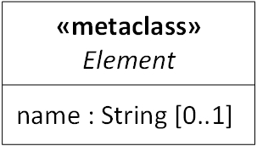
Figure 1. TDL Element metaclass definition (simplified)
XML Schema representation
<xsd:complexType abstract="true" name="Element">
<xsd:choice maxOccurs="unbounded" minOccurs="0">
<xsd:element name="comment" type="tdl:Comment"/>
<xsd:element name="annotation" type="tdl:Annotation"/>
<xsd:element ref="xmi:Extension"/>
</xsd:choice>
<xsd:attribute ref="xmi:id"/>
<xsd:attributeGroup ref="xmi:ObjectAttribs"/>
<xsd:attribute name="name" type="xsd:string">
</xsd:complexType>

<xsd:element name="Element" type="tdl:Element"/>

5.2.1 Enumerations
The example below shows the XML Schema representation of enumerations defined in the TDL metamodel.
TDL metamodel representation
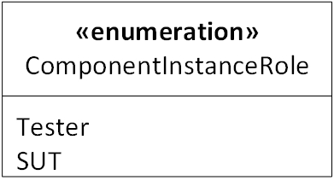
Figure 2. TDL enumeration ComponentInstanceRole example
XML Schema representation
<xsd:simpleType name="ComponentInstanceRole">
<xsd:restriction base="xsd:NCName">
<xsd:enumeration value="SUT"/>
<xsd:enumeration value="Tester"/>
</xsd:restriction>
</xsd:simpleType>

5.2.1 Metaclasses
The example below deomstrates the representation of several aspects related to more complex metaclass definitions. It shows both the definition of simple type attributes (role property of metaclass ComponentInstance), compositional associatons and non-compositional associations. Simple type attribute declarations and non-compositional associations do not differ from each other in the corresponding XML Schema representation except from their type. The use of xsd:anyType allows references to metaclasses contained in different TDL models (and XMI Documents).
TDL metamodel representation
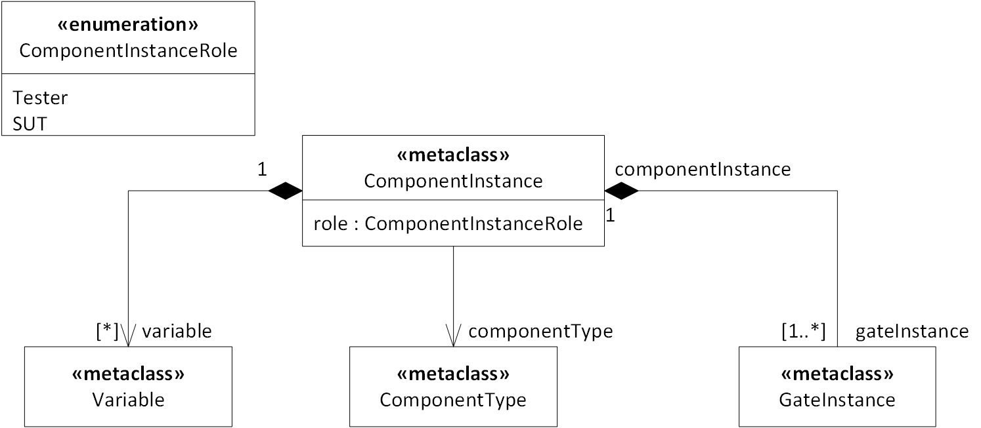
Figure 3. Examples on composition and non-compositional associations
XML Schema representation
<xsd:complexType name="ComponentInstance">
<xsd:complexContent>
<xsd:extension base="tdl:Element">
<xsd:choice maxOccurs="unbounded" minOccurs="0">
<xsd:element name="gateInstance" type="tdl:GateInstance"/>
<xsd:element name="variable" type="tdl:Variable"/>
</xsd:choice>
<xsd:attribute name="componentType" type="xsd:anyURI">
<xsd:attribute name="role" type="tdl:ComponentInstanceRole">
</xsd:extension>
</xsd:complexContent>
</xsd:complexType>

<xsd:element name="ComponentInstance" type="tdl:ComponentInstance"/>

5.2.1 Multiple inheritance
The example shown below demonstrates the handling of multiple inheritance in the XML Schema. Only the metaclass PackageableElement is extended. Since the metaclass MappableDataElement does not provie any additional properties, the semantics for the XML Schema is equivalent to a single inheritance from PackageableElement solely.
TDL metamodel representation
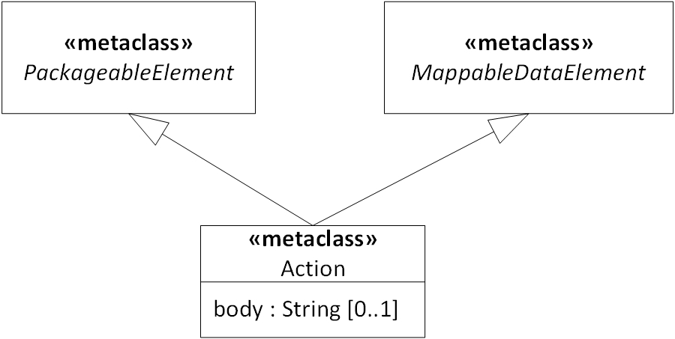
Figure 4. Handling of multiple inheritance in the TDL XML Schema
XMl Schema representation
<xsd:complexType name="Action">
<xsd:complexContent>
<xsd:extension base="tdl:PackageableElement">
<xsd:attribute name="body" type="xs:string">
</xsd:extension>
</xsd:complexContent>
</xsd:complexType>

<xsd:element name="Action" type="tdl:Action"/>

6. TDL XMI Document Serialisation
The TDL XMI Document (i.e., the serialization of an instance model of the TDL metamodel) must syntactically comply with the TDL XMI Schema definition. Since the concept space and validation capabilities of XML Schema are not sufficient to guarantee validity of XMI Documents with respect to a MOF metamodel, an additional set of rules for the construction of XMI Documents is required.

6.1 TDL XMI Document Production Rules
This clause describes the overall production rules for producing valid TLD XMI Documents for serialization and tool interchange.

6.1.1 TDL XMI Document Header Structure
The TDL XMI Document header structure includes all information that are required to build a valid TDL XMI Document without considering the serialized model. That means that the header structure described in the subsection will be identical for the all TDL XMI Documents, even though it might just be a subset of the entire header structure, e.g., due to user-specific extensions.
The production rules for TDL XMI Document header structures are:
- An XML version processing instruction with an encoding character set information, e.g.,
<?XML version=”1.0” encoding=”UTF-8”>.
- Any other valid XML processing instructions
- A XMI element, i.e., the root of the TDL XMI Document.
- The xmi:version attribute is set to http://www.omg.org/spec/XMI/20100901.
- The XMI element specifies at least the following namespace declarations:
  - xmlns:xmi="http://www.omg.org/spec/XMI/20100901"
  - xmlns:xsi="http://www.w3.org/2001/XMLSchema-instance"
  - xmlns:tdl="http://www.etsi.org/spec/TDL/20130606"

6.1.2 TDL XMI Document Content Structure
The TDL XMI Document content structure specifies the TDL model serialization format. Each serialized TDL model represents a valid instance of the TDL metamodel at a given point in time. Valid means that the serializd TDL XMI Document shall be both
- successfully validated against the TDL XML Schema (as specified in this document) by any XML Schema validator, and
- successfully deserialized by a tool that has implemented the TDL metamodel (as specified in the TDL specification [@@TDL_MM].
In addition to the validity rules, the following rules shall apply for any content structure of an TDL XMI Document:
- Derived values are not serialized, for they can be entirely calculated from other values present in the model.
- Attributes representing the opposite end of a compositional association (i.e., the property referring to the container metaclass) are not serialized.
- Properties whose values are the default values are not serialized.
- The predefined attribute type from the XMI namespace shall always be used, except for the root element of the TDL model. The value of the attribute shall match with the qualified name of the TDL metaclasses of the referenced instance.

6.2 Examples

6.2.1 TDL XMI Document Header Structure Example
This example shows the minimal information for valid TDL XMI Documents which shall be identical for each serialized TDL model.
<?XML version=”1.0” encoding=”UTF-8”>
<xmi:XMI xmi:version="20100901"
xmlns:xmi="http://www.omg.org/spec/XMI/20131001" xmlns:xsi="http://www.w3.org/2001/XMLSchema-instance" xmlns:tdl="http://www.etsi.org/spec/TDL/20130606">
<!—any TDL XMI Document Content -->
</xmi:XMI>

6.2.2 TDL XMI Document Content Structure Examples

6.2.2.1 Instance of TDL metaclass
This example shows the serialization of an instance of the metaclass Package. It has no content and represents the root Package of the model. The xmi:type declaration is not required here, because the type of the element can be precisely inferred from the XMI element declaration.
Concrete syntax and model instance representation
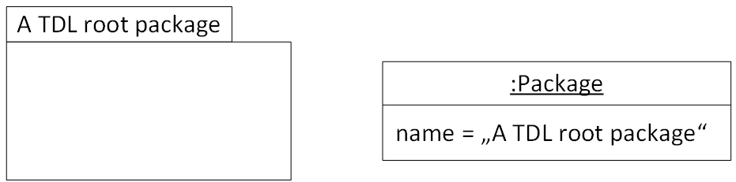
Figure 5. Concrete syntax (left) and model instance representation of a TDL root Package (right)
XMI Document representation
<tdl:Package xmi:id=”f5d8e27c714049d4913e71661658558c” name=”A TDL root package”/>

6.2.2.1 Compositional references to TDL metaclasses
This example shows the serialization of compositional references to instances of TDL metaclasses as complex content of the containing XMI element. In addition, it demonstrate the omission of the attribute that represents the containing instance. This information can precisely inferred from the XMI element that contains the nested XMI elements.
Concrete syntax and underlying model representation
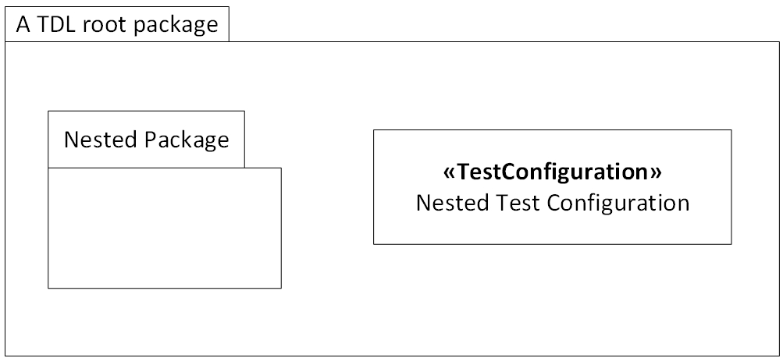
Figure 6. Concrete syntax representation of compositional references example

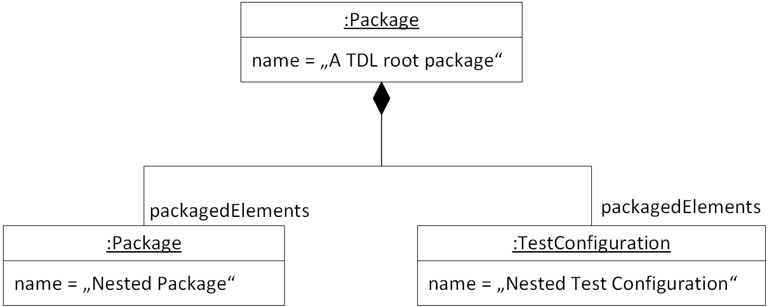
Figure 7. Model instance representation for compositional references example
XMI Document representation
<tdl:Package xmi:id=”f5d8e27c714049d4913e71661658558c” name=”A TDL root package”>
<packagedElements xmi:id=”6e973c47caf84687851ea7bbf8551e93” xmi:type=”tdl:Package” name=”Nested Package”/>
<packagedElements xmi:id=”58923a3a160649aaa37f3d8d228ec53c” xmi:type=”tdl:TestConfiguration” name=”Nested Test Configuration”/>
</tdl:Package>

6.2.2.1 Non-compositional references to TDL metaclasses
This example shows the serialization of non-compositional references to instances of TDL metaclasses as attributes of referencing XMI element.
Concrete syntax and underlying model representation
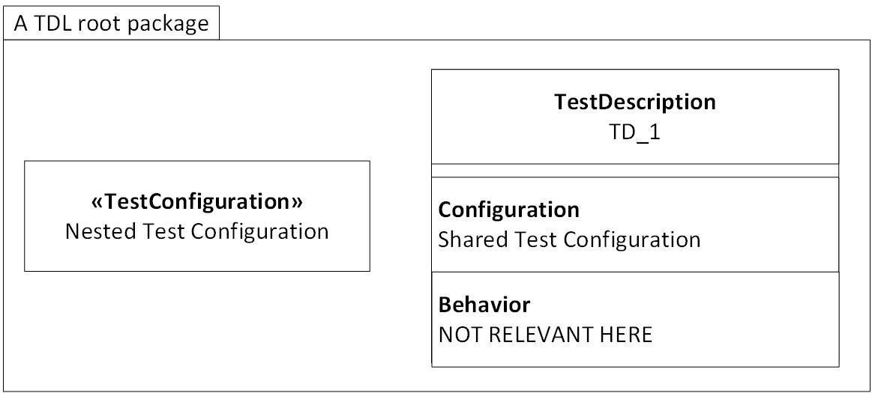
Figure 8. Concrete syntax representation of non-compositional references example
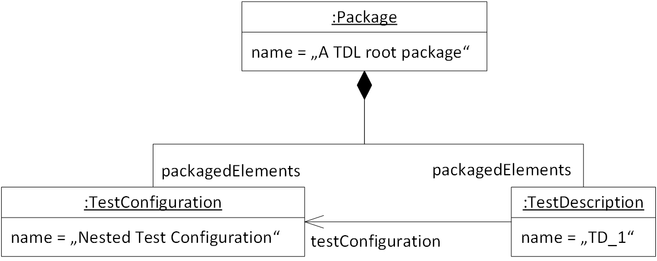
Figure 9. Model instance representation of non-compositional references example
XMI Document representation
<tdl:Package xmi:id=”f5d8e27c714049d4913e71661658558c” name=”A TDL root package”>
<packagedElements xmi:id=”58923a3a160649aaa37f3d8d228ec53c” xmi:type=”tdl:TestConfiguration” name=”Nested Test Configuration”>
<!— content of TestConfiguration -->
</packagedElements>
<packagedElements xmi:id=”c0776b9fa8df49599196e3154d895d80” xmi:type=”tdl:TestDescription” name=”TD_1” testConfiguration=”58923a3a160649aaa37f3d8d228ec53c”>
<!- content of Test Description -->
</packagedElements>
</tdl:Package>

6.2.2.1 Instance of TDL metaclasses with attributes of simple type
This example shows the serialization of simple type properties of TDL metaclasses, i.e., properties of TDL metaclasses that are typed either a MOF PrimitiveType or TDL enumeration.
Concrete syntax and underlying model representation
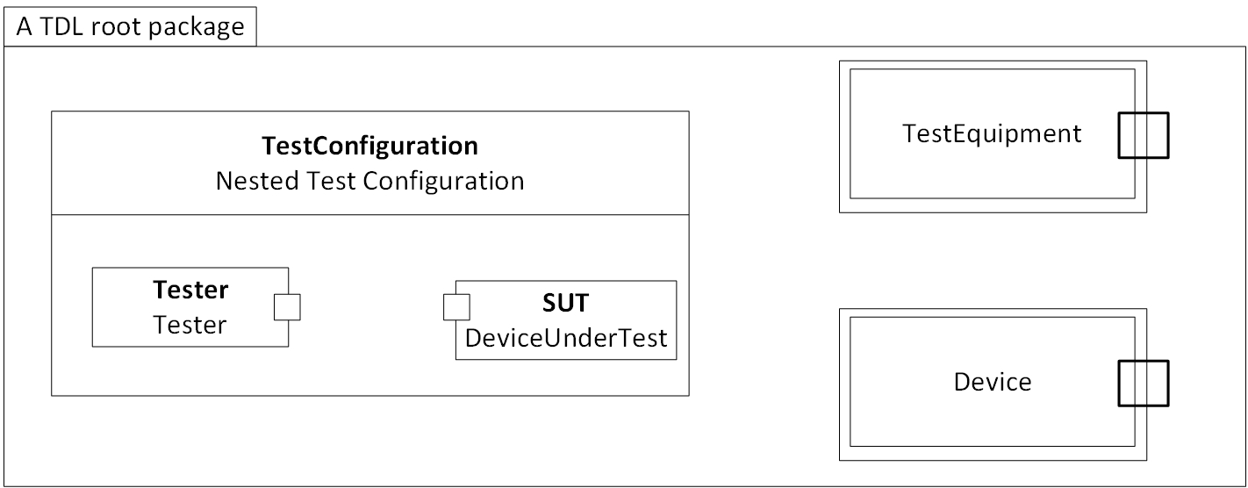
Figure 10. Concrete syntax representation of simple type attributes example
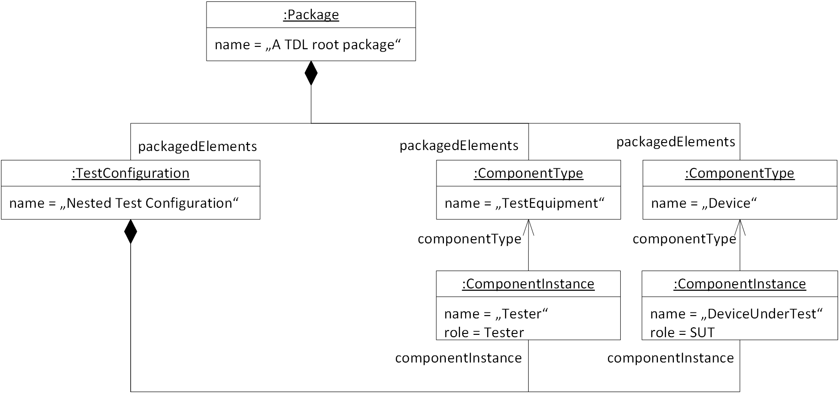
Figure 11. Instance model representation of simple type attributes example
XMI Document representation
<tdl:Package xmi:id=”f5d8e27c714049d4913e71661658558c” name=”A TDL root package”>
<packagedElements xmi:id=”a87c7d462c734d94ad277f4f33b63f37” xmi:type=”tdl:ComponentType” name=”TestEquipment” >
<!- content of ComponentType -->
</packagedElements>
<packagedElements xmi:id=”38fc40c72e1c4abaac9c66d3ab29120e” xmi:type=”tdl:ComponentType” name=”Device” >
<!- content of ComponentType -->
</packagedElements>
<packagedElements xmi:id=”58923a3a160649aaa37f3d8d228ec53c” xmi:type=”tdl:TestConfiguration” name=”TestConfiguration”>
<componentInstance xmi:id=” 931c879e1f6a4abb9aadb43fec029e48” xmi:type=”tdl:ComponentInstance” componentType=” a87c7d462c734d94ad277f4f33b63f37” role=”Tester” name=”Tester”/>
<componentInstance xmi:id=” 0272f014ed1e40d48458f883b8795bd7” xmi:type=”tdl:ComponentInstance” componentType=”38fc40c72e1c4abaac9c66d3ab29120e” role=”SUT” name=”DeviceUnderTest”/>
</packagedElements>
</tdl:Package>

6.2.2.1 Handling of default values for properties
This example shows the handling of default values for the serialization. As specified in Clause 6.2.2 TDL XMI Document Content Structure Examples values of property are not serialized of the value is identical with the default value declared for this property. In the above mentioned example both situations are defined. On the left hand side, an instance of the ComponentInstance is shown with its property role set to the Tester. Since the TDL metamodel does not declare a default value for this property, the given value needs to be serialized. On the right hand side, an instance of the TDL metaclass DataInstance is shown with value of property isValue set to true. This value is not serialized, since the TDL metamodel declares the value true as default value for the property isValue.
<componentInstance xmi:id=” 931c879e1f6a4abb9aadb43fec029e48” xmi:type=”tdl:ComponentInstance” componentType=” a87c7d462c734d94ad277f4f33b63f37” role=”Tester” name=”Tester”/>
<packagedElements xmi:id=”931c879e1f6a4abb9aadb43fec029e48” xmi:type=”tdl:SimpleDataInstance” name=”AnInstance”/>

Proforma copyright release text block
This text box shall immediately follow after the heading of an element (i.e. clause or annex) containing a proforma or template which is intended to be copied by the user. Such an element shall always start on a new page.
Notwithstanding the provisions of the copyright clause related to the text of the present document, ETSI grants that users of the present document may freely reproduce the <proformatype> proforma in this {clause|annex} so that it can be used for its intended purposes and may further publish the completed <proformatype>.

Annexes
Each annex shall start on a new page (insert a page break between annexes A and B, annexes B and C, etc.).
Use the Heading 8 style for the title and the Normal style for the text.
Specify if the annex is normative or informative.
<PAGE BREAK>

Annex A (normative):
TDL XMI Schema
<Text>
Abstract Test Suite (ATS) text block
This text should be used for ATSs using either TTCN-2 or TTCN-3. In case:
- TTCN-2 is used: attach the TTCN.MP;
- TTCN-3 is used: attach the TTCN-3 files and other related modules, as well as the HTML documentation of the TTCN-3 files.

Annex B (informative):
Complete Document Serialisation Examples
This text shall only be used for ATSs using TTCN version 2 (TTCN-2):
This ATS has been produced using the Tree and Tabular Combined Notation version 2 (TTCN-2) according to ISO/IEC 9646-3 [<x>].

<X.1> The TTCN-2 Machine Processable form (TTCN.MP) (style H1)
The TTCN.MP representation corresponding to this ATS is contained in an ASCII file (<any_name>.MP contained in archive <Shortfilename>.ZIP) which accompanies the present document.
<PAGE BREAK>

Annex <X+1> (normative):
ATS in TTCN-3 (style H8)
This text shall only be used for ATSs using TTCN version 3 (TTCN-3):
This ATS has been produced using the Testing and Test Control Notation (TTCN) according to ES 201 873-1 [<x>].
Indicated here which parts of the ES 201 873 series and its versions (editions) have been used; also indicate any extensions which have been used.

<X+1.1> TTCN-3 files and other related modules (style H1)
The TTCN-3 and other related modules are contained in archive <Shortfilename>.zip which accompanies the present document.

<X+1.2> HTML documentation of TTCN-3 files (style H1)
The HTML documentation of the TTCN-3 and other related modules are contained in archive <Shortfilename>.zip which accompanies the present document.
<PAGE BREAK>

Annex <X+2> (informative):
Title of informative annex (style H8)
<Text>
<X+2.1 >First clause of the annex (style H1)
<Text>
<X+2.1.1> First subdivided clause of the annex (style H2)
<Text>
<PAGE BREAK>

Annex <X+3> (informative):
Change History
This informative annex is optional. If present, it describes the list of changes implemented in a new version of the deliverable.
Its format is tabular, it may contain the Change Request numbers and titles or textual explanations of the changes that lead to each new version number of the deliverable.
date | Version | Information about changes
October 2011 | v1.1.1 | First publication of the TS after approval by TC SPAN at SPAN#19  (30 September - 2 October 2011; Prague)
February 2012 | v1.2.1 | Implemented Change Requests:  SPAN(12)20_019 Error message information clarifications  SPAN(12)20_033 Revised error message information  SPAN(12)20_046 update of figure 3 clause 9.2  These CRs were approved by TC SPAN#20 (3 - 5 February 2012; Sophia)  Version 1.2.1 prepared by the Rapporteur
July 2013 | v1.3.1 | Implemented Changes:  Correction needed because the previously approved version did not contain the last version of the ASN.1 and XML attachments.  Version 1.3.1 prepared by the Rapporteur

<PAGE BREAK>

Annex <X+4> (informative):
Bibliography
The annex entitled "Bibliography" is optional.
It shall contain a list of standards, books, articles, or other sources on a particular subject which are not mentioned in the document itself (see clause 12.2 of the EDRs http://portal.etsi.org/edithelp/Files/other/EDRs_navigator.chm).
It shall not include references mentioned in the document.
Use the Heading 8 style for the title and B1+ or Normal for the text.
- <Publication>: "<Title>".
OR
<Publication>: "<Title>".
<PAGE BREAK>

History
This clause shall be the last one in the document and list the main phases (all additional information will be removed at the publication stage).
Document history
<Version> | <Date> | <Milestone>

A few examples:
Document history
V1.1.1 | April 2001 | Publication
V1.2.1 | February 2002 | Membership approval Procedure MV XXXX: yyyy-mm-dd to yyyy-mm-dd
V1.3.1 | June 2011 | Pre-Processing done before TB approval  e-mail: mailto:edithelp@etsi.org
V1.3.2 | July 2013 | Clean-up done by editHelp!  e-mail: mailto:edithelp@etsi.org

Latest changes made on 2014-02-19

