Draft EG 202 934 V0.1.11 (2011-10)
User Group;
The assessment of the overall Quality of Services (QoS) as perceived by the users;
Definition of QoS indexes for all the customer relationship stages

<

ETSI GUIDE
Reference
DEG/USER-00028
Keywords
QoS, QUALITY, USER
ETSI
650 Route des Lucioles
F-06921 Sophia Antipolis Cedex - FRANCE

Tel.: +33 4 92 94 42 00 Fax: +33 4 93 65 47 16

Siret N° 348 623 562 00017 - NAF 742 C
Association à but non lucratif enregistrée à la
Sous-Préfecture de Grasse (06) N° 7803/88

Important notice
Individual copies of the present document can be downloaded from:
http://www.etsi.org
The present document may be made available in more than one electronic version or in print. In any case of existing or perceived difference in contents between such versions, the reference version is the Portable Document Format (PDF). In case of dispute, the reference shall be the printing on ETSI printers of the PDF version kept on a specific network drive within ETSI Secretariat.
Users of the present document should be aware that the document may be subject to revision or change of status. Information on the current status of this and other ETSI documents is available at http://portal.etsi.org/tb/status/status.asp
If you find errors in the present document, please send your comment to one of the following services:
http://portal.etsi.org/chaircor/ETSI_support.asp
Copyright Notification
No part may be reproduced except as authorized by written permission.
The copyright and the foregoing restriction extend to reproduction in all media.

© European Telecommunications Standards Institute yyyy.
All rights reserved.
DECTTM, PLUGTESTSTM, UMTSTM and the ETSI logo are Trade Marks of ETSI registered for the benefit of its Members.
3GPPTM and LTE™ are Trade Marks of ETSI registered for the benefit of its Members and
of the 3GPP Organizational Partners.
GSM® and the GSM logo are Trade Marks registered and owned by the GSM Association.

Contents
Intellectual Property Rights 5
Foreword 5
Introduction 5
1 Scope 6
2 References 6
2.1 Normative references 6
2.2 Informative references 6
3 Definitions, Symbols and abbreviations 7
3.1 Definitions 7
3.2 Symbols 8
3.3 Abbreviations 10
4 General context of the information on QoS assessment 10
4.1 Overall organization of the QoS information 10
4.2 Aspects impacting the QoS of the utilization stage 11
4.2.1 Access 11
4.2.2 Bearer service 11
4.2.3 Service usage 11
4.2.4 Presentation and user interface 12
4.3 Requirements for the QoS parameter assessment 12
4.4 QoS parameter selection 12
4.5 Processing of the results 12
5 Segmentation of the results 12
6 Definition of a reference threshold for each QoS parameter 13
7 Aggregation of the results within each CRS 13
8 Aggregation of the QoS results of the various CRS of a specific service 15
8.1 Qualitative aggregation 15
8.2 Quantified aggregation 16
8.2.1 QoS value ranges 16
8.2.2 Highest QoS limit of the range 16
8.2.3 Lowest QoS limit of the range 17
8.2.4 Definition of a QoS index 17
Annex A (informative): Weighted aggregation of the results of the CRS of a specific service 18
Annex B (informative): Graphical representation 19
B.1 Representation of the results within a CRS 19
B.2 Representation of the QoS results for the various CRS of a specific service 21
Annex C (informative): Alternate graphical representation based on the "one-view visualization (OVV) methodology" described in the ITU-T Recommendation P.505 24
C.1 Representation of the results within a CRS 24
C.2 Representation of the QoS results for the various CRS of a specific service 25
Annex D: Bibliography 27
History 28

Intellectual Property Rights
IPRs essential or potentially essential to the present document may have been declared to ETSI. The information pertaining to these essential IPRs, if any, is publicly available for ETSI members and non-members, and can be found in ETSI SR 000 314: "Intellectual Property Rights (IPRs); Essential, or potentially Essential, IPRs notified to ETSI in respect of ETSI standards", which is available from the ETSI Secretariat. Latest updates are available on the ETSI Web server (http://ipr.etsi.org).
Pursuant to the ETSI IPR Policy, no investigation, including IPR searches, has been carried out by ETSI. No guarantee can be given as to the existence of other IPRs not referenced in ETSI SR 000 314 (or the updates on the ETSI Web server) which are, or may be, or may become, essential to the present document.

Foreword
This final draft ETSI Guide (EG) has been produced by Special Committee USER GROUP (USER), and is now submitted for the ETSI standards Membership Approval Procedure.

Introduction
The proposals contained in the present document are based on actual market realities: state of the art of the service provided and current users' perceptions of the QoS provided. They aims at providing guidance on how consolidating the various QoS assessments provided from various sources in a synthetic view that users can easily understand and use.
The intention is not to define values that providers should absolutely comply with in order to get some kind of label but rather to help the customer to identify which providers are expected to fulfil their requirements. As these requirements might strongly differ from one user to another one, the guidance are given in such a way that the consolidation can be carried out differently to better fit the aim of the study and the kind of users under consideration.

1 Scope
The present document describes a methodology for the aggregation of QoS parameter results in order to obtain a view onto the overall quality of the ICT services provided by Service Providers (SP) from an individual customer's perspective; a suggestion for graphical representations including one following Recommendation ITU-T P.505 is proposed in chapter 9 and in Annex A. The purpose is not to identify the best SP but those whose QoS is complying in every aspect with references considered as satisfactory from the users viewpoint.
The aim of this methodology is to be able to take into account preferences and expectations of individual customers as well as the subjective and objective QoS assessments.
The present document does not define parameter value threshold nor specific weighting factors for the QoS parameters but rather suggests possible ways for a weighted aggregation if so wished.
QoS indexes are defined using the QoS parameters provided in EG 202 009 part 2 for all the stages of the customer relationship including service utilization.

2 References
References are either specific (identified by date of publication and/or edition number or version number) or non-specific. For specific references,only the cited version applies. For non-specific references, the latest version of the referenced document (including any amendments) applies.
Referenced documents which are not found to be publicly available in the expected location might be found at http://docbox.etsi.org/Reference.
NOTE: While any hyperlinks included in this clause were valid at the time of publication, ETSI cannot guarantee their long term validity.

2.1 Normative references
The following referenced documents are necessary for the application of the present document.
Not applicable.

2.2 Informative references
The following referenced documents are not necessary for the application of the present document but they assist the user with regard to a particular subject area.
[i.1] ETSI EG 202 009-1: "User Group; Quality of Telecom Services; Part 1: Methodology for identification of parameters relevant to the Users".

[i.2] ETSI EG 202 009-2: " User Group; Quality of telecom services; Part 2: User related parameters on a service specific basis".
[i.3] ETSI EG 202 057-1: "User related QoS parameter definitions and measurements; Part 1: General".
[i.4] ETSI EG 202 057-2: " Speech and multimedia Transmission Quality (STQ); User related QoS parameter definitions and measurements; Part 2: Voice telephony, Group 3 fax, modem data services and SMS".
[i.5] ETSI EG 202 057-3: " Speech and multimedia Transmission Quality (STQ); User related QoS parameter definitions and measurements; Part 3: QoS parameters specific to Public Land Mobile Networks (PLMN)".
[i.6] ETSI EG 202 057-4: "Speech and multimedia Transmission Quality (STQ); User related QoS parameter definitions and measurements; Part 4: Internet access".
[i.7] ETSI ES 202 737: "Speech and multimedia Transmission Quality (STQ); Transmission requirements for narrowband VoIP terminals (handset and headset) from a QoS perspective as perceived by the user".
[i.8] ETSI ES 202 738: "Speech and multimedia Transmission Quality (STQ); Transmission requirements for narrowband VoIP loudspeaking and handsfree terminals from a QoS perspective as perceived by the user".
[i.9] ETSI ES 202 739: "Speech and multimedia Transmission Quality (STQ); Transmission requirements for wideband VoIP terminals (handset and headset) from a QoS perspective as perceived by the user".
[i.10] ETSI ES 202 740: "Speech and multimedia Transmission Quality (STQ); Transmission requirements for wideband VoIP loudspeaking and handsfree terminals from a QoS perspective as perceived by the user".
[i.11] ETSI EG 202 765-1: "Speech and multimedia Transmission Quality (STQ); QoS and network performance metrics and measurement methods; Part 1: General considerations".
[i.12] ETSI EG 202 765-2: "Speech and multimedia Transmission Quality (STQ); QoS and network performance metrics and measurement methods; Part 2 Transmission Quality Indicator combining Voice Quality Metrics".
[i.13] ETSI EG 202 765-3:"Speech and multimedia Transmission Quality (STQ); QoS and network performance metrics and measurement methods; Part 3: Network performance metrics and measurement methods in IP networks".
[i.14] ETSI EG 202 843: "User Group; Quality of ICT Services; Definitions and Methods for Assessing the QoS parameters of the Customer Relationship Stages other than utilization".
[i.15] ETSI ES 202 667: "Speech and multimedia Transmission Quality (STQ); Audiovisual QoS for communication over IP networks".
[i.16] ETSI ES 202 765-4: "Speech and multimedia Transmission Quality (STQ); QoS and network performance metrics and measurement methods; Part 4: Indicators for supervision of Multiplay services".
[i.17] ETSI TR 102 805-1 (V1.1.1): "User Group; End-to-end QoS management at the Network Interfaces; Part 1: User's E2E QoS - Analysis of the NGN interfaces (user case)".
[i.18] ETSI TR 102 805-3 (V1.1.1): "User Group; End-to-end QoS management at the Network Interfaces; Part 3: QoS informational structure".
[i.19] ETSI TR 102 806: "User Group; Analysis of current End-to-End QoS standardization state".
[i.20] ETSI TR 102 854: "User Group; Quality of ICT Services; Review of practical examples of services"
[i.21] ETSI TS 102 250-1: "Speech and multimedia Transmission Quality (STQ); QoS aspects for popular services in GSM and 3G networks; Part 1: Identification of Quality of Service criteria
[i.22] ETSI TS 102 250-2: "Speech Processing, Transmission and Quality Aspects (STQ); QoS aspects for popular services in GSM and 3G networks; Part 2: Definition of Quality of Service parameters and their computation"
[i.23] ETSI ES 202 746: "Human Factors (HF); Personalization and User Profile Management; User Profile Preferences and Information".
[i.24] ETSI TS 102 844: "User Group; Quality of Telecom Services; Conformity assessment; Requirements for bodies providing QoS assessments and surveys".
[i.25] ETSI TS 102 852: "User Group; Quality of ICT Services; Assessment process of the QoS parameters of the customer relationship stages".
[i.26] ITU-T Recommendation E.802 (02/2007): "Framework and methodologies for the determination and application of QoS parameters".
[i.27] ITU-T Recommendation G.1010 (11/2001): "End-user multimedia QoS categories".
[i.28] ITU-T Recommendation P.505 (11/2005): "One-view visualization of speech quality measurement results".

3 Definitions, Symbols and abbreviations

3.1 Definitions
For the purposes of the present document, the following terms and definitions apply:
Cessation: activities associated with the cessation of a telecommunication service from the time it is requested by a customer, to the time it is completed to the satisfaction of the customer.
Commercial support: activities associated with the commercial support of a telecommunication service.
Complaint management: activities associated with the management of customer's complaints to the provider about the service provided.
Documentation: activities associated with the provision of documentation to install, set-up and use the various features of the service as well as to identify and fix possible troubles.
NOTE: These activities include: Documentation for service activation and set-up and documentation for service use.
Establishment of the contract (Terms and conditions): activities from the customer decision to contract with the provider to the time of effective contract.
NOTE: Establishment of the contract is meant here for agreeing to the contractual conditions, conditions of use, customer and provider commitments whether or not there is a formal signature of the contract.
Metering/Charging/Billing: activities associated with the metering, charging and billing of a telecommunication service to a customer.
NOTE: This could be for one call, for a specified period or for a given billing amount, depending whether it is about a bill or any other type of expense information, e.g. ebill, expense signal, real time expense information on the provider website, AoC-S supplementary service, etc.
Preliminary information/Advertisement: activities related to information on the service provided on request of the prospect or in newspapers, magazines, booklets, etc. to help him choosing the service and provider most appropriate to his needs.
Repair-Troubleshooting: activities associated with the restoration of a telecommunication service to the customer after a fault resulting in partial or complete loss of service or service features.
Service alteration: activities associated with the alteration of a telecommunication service, from the time alteration to a service is requested by the customer to the time this alteration is carried to the satisfaction of the customer.
Service provisioning: activities associated with the provision of a telecommunication service, from the time of effective contract to the time the customer is able to use the service.
Technical support: activities associated with the technical support of a telecommunication service to help users experiencing problems in the use of the service.
Technical upgrade: activities associated with the technical evolution of any component of the service at the provider initiative.

3.2 Symbols
For the purposes of the present document, the following symbols apply (this list of symbols covers only the parameters Pnnnn used in this document using the EG 202 843 definitions. Additional ones PTnnnn have been added to cover QoS parameters concerning the use of telephony service) :
P100 Frequency of customer complaints about PI [N/t]: Number of customers' complaints about PI per million subscribers
P101a Integrity of PI [OR]: Content - Was the relevant information provided as you expected?
P101b Integrity of PI [OR]: Language - Was the information provided clear and understandable without any ambiguity?
P101c Integrity of PI [OR]: Style - How would you rate the overall style, presentation and professionalism of the preliminary information provided?
P102 Pricing transparency [OR]: Did you find the pricing information comprehensible?
P103 Availability of PI [%]: Could you retrieve the preliminary information easily?
P200 Frequency of customer complaints about contract establishment [N/t]: Number of customers' complaints about contract establishment per million subscribers
P201 Integrity of contract information [OR]: How would you rate the integrity of the contractual document?
P202 Compliance of contractual terms with PI [%]: Was the contract document compliant to the previously provided preliminary information?
P203 Flexibility for customisation before contract [OR]: How would you rate the flexibility of your service provider to customise the contract before signature e.g. by applying options?
P204 Ease and flexibility to amend terms after formal contract [OR]: How would you rate the flexibility of your service provider to further adapt the contract after signature e.g. by applying options?
P300 Frequency of customer complaints about provisioning [N/t]: Number of customers' complaints about provisioning per million subscribers
P303a Successful provisioning within a specified period [%] - existing subscriber line
P303b Successful provisioning within a specified period [%] - new subscriber line
P309a Provisioning time [Time & %] - existing subscriber line
P309b Provisioning time [Time & %] - new subscriber line
P600 Frequency of customer complaints about service support [N/t]: Number of customers complaints about service support per million subscribers
P628a Response time of the technical support [Time & %]
P628b Response time of the technical support [Time & %]
P661 Accessibility of the complaint management desk [%]: Concerning your latest attempt to access the complaint management desk of your service provider: Did you succeed in accessing it?
P662 Recognition of the customer complaints [%]: Concerning your latest attempt to access the complaint management desk of your service provider: Was your complaint accepted?
P663 Complaint solutions not complete and correct first time [%]: Was the complaint solved to your satisfaction at the first attempt by the service provider?
P664 Complaint solutions achieved within a specified period [%]: Concerning your latest accepted complaint: Was the complaint finally solved to your satisfaction by the service provider?
P665 Integrity of complaint resolution [%]: Concerning your latest accepted complaint: Was your complaint resolved correctly?
P666a Customer perception of the complaint management [OR]: Customer perception of complaint management (Assurance): How would your rate the service provider's complaint management related to assurance at all?
P666b Customer perception of the complaint management [OR]: Customer perception of complaint management (Empathy): How would your rate the service provider's complaint management related to empathy at all?
P666c Customer perception of the complaint management [OR]: Customer perception of complaint management (Responsiveness): How would your rate the service provider's complaint management related to responsiveness at all?
P667 Overall quality of the complaint management process [OR]: How would your rate the overall handling of the complaint management process?
P706a Fault repair time [Time & %] - Time for 95% fault repair
P706b Fault repair time [Time & %] - % faults repaired within a 48 hours delay.
P707 Frequency of customer complaints related to repair services [N/t]: Number of customers complaints related to repair services per million subscribers
P800 Frequency of customer complaints about billing [N/t]: Number of customers complaints about billing per million subscribers
P801 Accessibility of the tariff information [%]: Concerning your latest attempt to access your provider's tariff information: Were you able to access the tariff information?
P802 Successful notification of exceeding billing budget [%]: If you are using a notification service when you reach a predefined budget level: Concerning your latest exceeding of budget: Were you notified accordingly when you exceeded your budget?
P804 Accessibility of the account management [%]: Concerning your latest attempt to access the account status at your service provider: Did you succeed in accessing it?
P806 Timeliness of bill delivery [%]: Did you receive all the expected bills throughout the last 6 months?
P807 Bill delivery delay [Time]: If you experienced a delay in bill delivery: How many days was the bill delayed?
P808 Late notification of amount due [%]: Has the bill been received before the direct debit was executed?
P809 Modes of billing information transfer [Number]: How many ways do you have to access your accounting information?
P810 Bill correctness complaints [%]: Percentage of bills resulting in a customer complaint per point of billing per year.
P1004a Contractual cessation achieved [%] within 10 days
P1004b Contractual cessation achieved [%]: time needed (days) to achieved 95% of cessations requested
P1004c Contractual cessation achieved [%]: time needed (days) to achieved 99% of cessations requested
P1008 Frequency of customer complaints related to cessation [N/t]: Number of customers' complaints related to cessation per million subscribers
PT000 Frequency of customer complaints related to use of service [N/t]: Number of customers complaints related to use of service per million subscribers
PT001a Fault report rate per fixed access lines
PT001b Fault report rate per fixed access lines within 30 days after the delivery.
PT002a Unsuccessful call ratio - domestic calls
PT002b Unsuccessful call ratio - international calls
PT003a Call set up time - domestic calls
PT003b Call set up time - international calls
PT004 Speech Quality (MOS)

3.3 Abbreviations
For the purposes of the present document, the following abbreviations apply:
CRS Customer Relationship Stage
OVV One-View Visualization
QoE Quality of Experience
QoS Quality of Service
SP Service Provider

4 General context of the information on QoS assessment
A vast array of documentation is today available on the QoS assessment from the user viewpoint e.g. among others, ITU-T Recommendation E.802 [i.26], ETSI EG 202 009-2 [i.1], ETSI EG 202 843 [i.14] or ETSI TS 102 852[i.25]. The use of such standards should take into account the features of each service and even the specific QoS requirements of each component of this service as detailed in ETSI TR 102 805-1 [i.17], TR 102 805-3 [i.18] and TR 102 806 [i.19]. Some generic principles to tackle the specificities of services like voice, IP-TV web surfing or emails, are given in ES 202 765 Part 2 & Part 4, TS 102 250 Part 2 as well as in ITU-T Recommendation G.1010 [i.27]. Each document provides only a part of the overall QoS as perceived by the user, but there is a lack of document to define the overall quality for the whole CRS.
Current studies are also developing the concept of Quality of Experience (QoE) that takes into account in addition to QoS, the context of use, the user’s expectations … In particular QoE takes into account value for money as well as the psychological aspects that may influence user satisfaction. In particular, users could get from fora or social networks such as "Facebook", "YouTube" or alike feedback from other users that might influence their expectations and perception of the quality.
Whatever assessment is carried out, it results in a collection of various and multiple pieces of information: measured data (Number of calls, response time, Opinion Rating (OR), etc.) and also purely subjective information gathered in carrying out user surveys.
As the purpose of the present document is to provide a mode of presentation of the information expected to show the users' overall satisfaction for a category of service, if the assessment of this users' satisfaction is not carried out on all the SP's customers, particular care should be given to the choice of the customer panel to be assessed to ensure the obtained results represent both the complexity of the customer environment and his expectations.
Moreover, since the experience has shown that in many cases, the results of the QoS parameters assessment for a service from a single SP and different users are spread over a wide scale, it is crucial to provide the spreading of these results.

4.1 Overall organization of the QoS information
The QoS information includes many aspects, a large number of them being listed in EG 202 009 [i.1] and defined in details in EG 202 843 [i.14]. Even if not all these parameters are relevant at a given time and therefore if a realistic description of the service quality from a SP is not expected to use all of them, end-users would hardly understand how to use them to select the provider most suited to meet their expectations. If QoS is extended to user satisfaction, then an even larger number of pieces of information is expected. There is therefore a need to make this information more synthetic.
In fact, to make the QoS information more easily understandable by common end-users the available pieces of information should be aggregated so that it is summarized in a small number of indicators.
The Annex A of EG 202 843 [i.14] provides some indications and warnings about the aggregate ratings. The EG 202 843 [i.14] is related to the QoS parameters of the Customer Relationship Stages (CRS) other than utilization but these considerations can easily be extended to the utilization stage.
A first mean to make the QoS information more synthetic is to gather it with respect to the Customer Relationship Stages. A crucial point to notice is that the QoS in utilization stage is largely dependent of the service considered while, in most cases, the QoS in the other stages is independent of the service. As a consequence, to catch a clear picture of the utilization stage QoS provided by an SP, it is necessary to assess the QoS separately for each service proposed. Moreover, as detailed in Annex A of ETSI TR 102 805-1 [i.17], the QoS requirements might be quite different for each component of a service. As a consequence, the QoS assessment of a given service needs to take into account its components and this might result in increasing again the number of indicators to consider.

4.2 Aspects impacting the QoS of the utilization stage
As explained in the previous chapter, the performances of a service are the result of the performances of the various layers of the service provision. Therefore, the QoS parameters representing the overall QoS of the service should take into account the performance of all the layers. Nevertheless, in an end-to-end perspective, the QoS of the underlying layers is often perceived via the QoS parameters of the service layer.

4.2.1 Access
This aspect of the utilization stage characterizes the connection to the SP network, i.e. the subscriber line for a fixed network or network registration for a mobile network.
Some QoS indicators related to the access can be found in the ETSI ES 202 765-4 [i.16] or in ETSI TS 102 250-1 [i.21].
EXAMPLE: Availability of Internet access, Internet Login Time, Radio network unavailability, Network non-accessibility, Attach failure ratio, etc.

4.2.2 Bearer service
The QoS of this aspect of the utilization stage characterizes the network performance.
Some QoS indicators related to the bearer service can be found in the ETSI ES 202 765-4 [i.16] or in ETSI TS 102 250-1 [i.21].
EXAMPLE: Internet Download Bit Rate, Internet Upload Bit Rate, Ping Delay, Mean Data Rate, Session Failure Ratio, etc.

4.2.3 Service usage
The QoS of this aspect of the utilization stage characterizes the SP servers' performance.
Obviously, the indicators are there strongly linked to the type of service considered. The main standards related to this aspect can be found in ETSI EG 202 009 Part 2 [i.1]. Some other standards were not available when the last version of this standard was written but they will be included in the next revision. Hereafter are given the major standards in this area:
ETSI EG 202 057-2 [i.4]
ETSI EG 202 057-3 [i.5]
ETSI EG 202 057-4 [i.6]
ETSI EG 202 765-2 [i.12]
ETSI ES 202 667 [i.15]
ETSI ES 202 765-4 [i.16]
ETSI TS 102 250-1 [i.21]
ETSI TS 102 250-2 [i.22]

4.2.4 Presentation and user interface
At the moment, the list of standards dedicated to this issue is quite poor, except for speech quality. The following references give some indications on how to include user QoS requirements in a user profile but none how to measure it:
ETSI TR 102 805-3 [i.18].
ETSI ES 202 746 [i.23]
For Speech Quality, e.g.:
ETSI ES 202 737 [i.7]
ETSI ES 202 738 [i.8]
ETSI ES 202 739 [i.9]
ETSI ES 202 740 [i.10]
It is known that the terminal quality significantly influences the overall quality. It should be taken into account even if it is not always under the responsibility of the SP.

4.3 Requirements for the QoS parameter assessment
For the sake of accuracy and representativeness, the QoS parameters should be assessed according to EG 202 843 [i.14], TS 102 852 [i.25] and other relevant documents like the EG 202 057 [i.3], [i.4], [i.5], [i.6] and EG 202 765 [i.7] ETSI ES 202 737: "Speech and multimedia Transmission Quality (STQ); Transmission requirements for narrowband VoIP terminals (handset and headset) from a QoS perspective as perceived by the user"., [i.12], [i.13], [i.16] sets. To ensure the reliability of the assessment process of these parameters, its conformity to these standards should have been audited according to TS 102 844 [i.24].

4.4 QoS parameter selection
The selection of the relevant QoS parameters to assess should be done according to the current users' expectations that could be identified by surveys carried out by various authorities and report from the consumer organizations. Such surveys and reports could usefully try to assess the relative importance of each of these QoS parameters with regard to the users' concerns. This could strongly help in the management of the assessment results.

4.5 Processing of the results
The assessment of the QoS parameters is described in several standards, e.g. ETSI EG 202 057, ETSI EG 202 934, ETSI EG 202 009-1, ETSI ES 202 765-2 & 4, etc. but to make easier the comparison of different SP, it is crucial to have a consistent presentation of these results. In this aim, the principle was taken to figure out the results with values increasing with the QoS, as customers better understand such a presentation mode. This principle has led in some cases to a processing of the raw data resulting from the assessments made according to the standards. Details are provided in clause 7.

5 Segmentation of the results
As explained above, a useful means to provide a synthetic overview of the pieces of information related to users' satisfaction is to segment them with respect to the Customer Relationship Stages, i.e., as detailed in EG 202 009-1 [i.1]:
Table 1: Customer Relationship Stage
Customer Relationship Stage |  | CRS detail
Sales |  | Preliminary information, advertisement
 |  | Establishment of the contract (Terms and conditions)
Service management | Service provisioning | Installation
Service management | Service provisioning | Activation and acceptance
Service management | Service alteration / Technical upgrade | Customer initiative
Service management | Service alteration / Technical upgrade | Provider initiative
Service management | Service support | Documentation for service activation and set-up  Documentation for service use
Service management | Service support | Technical support
Service management | Service support | Commercial support
Service management | Service support | Complaint management
Service management | Repair/Troubleshooting
Service management | Metering/Charging/Billing
Service management | Cessation
Use of Service | Network/service management by the customer
Use of Service | Service utilization | Access
Use of Service | Service utilization | Bearer service
Use of Service | Service utilization | Service usage
Use of Service | Service utilization | Presentation and user interface

This means to have a single representation (with an indication of the related spreading) for each of these stages.
The purpose of the present document is to identify who are the services whose QoS is in the upper part of the current state of the art of the market. Therefore, a first step is to define what are the indicators to take into account in the assessment of each Customer Relationship Stage. These can be a selection of those listed in EG 202 009-2 [i.1]. Some others pieces of information found relevant can be added, provided they are also objective, representative and reproducible.
Having built this list, the next step is to synthesize the results obtained for these parameters in a single representation, with nevertheless in mind that the purpose is not to hide every detail that can be interesting but to ease to the service selection by highlighting those whose QoS is compliant with the user requirements. As a matter of fact, users have different needs and expectations depending of their culture and type of usage and therefore each QoS parameter may have different weight for the assessment dedicated to a particular user.
How to achieve that is detailed in the next clause.

6 Definition of a reference threshold for each QoS parameter
This is the most delicate task to deal with to achieve the expected result. To assess the QoS achieved, there is a need to define for each QoS parameter a reference threshold corresponding to the current best practices. Some of these QoS parameters have a built-in reference, e.g. 3 for OR. Others can refer to widely accepted figures (e.g. MOS = 4 for speech quality). When such references are not available, references can be obtained in computing the results achieved for the services among the selected set to assess and then in defining statistically a threshold, e.g. the mean value, the median or the upper 40% of the results. It is very important that any reference threshold matches the satisfaction of a wide range of users. Therefore, each time it is possible, such assessment should use surveys allowing for simultaneously catching both users' opinion on perceived QoS and objective QoS parameter measurement. The purpose being to identify the SP whose QoS is complying in every aspect with references considered as satisfactory from the users viewpoint, therefore the references should be relatively stable over time to allow for monitoring the QoS evolution.

7 Aggregation of the results within each CRS
Once the reference thresholds have been defined, checking what are the results above these thresholds will provide a table like Table 2 representing examples of the Service provisioning results with:
P303a Successful provisioning within a specified period [%] - existing subscriber line
P303b Successful provisioning within a specified period [%] - new subscriber line
P309a Provisioning time [Time & %] - existing subscriber line
P309b Provisioning time [Time & %] - new subscriber line
More details for the practical way setting these thresholds are available in ETSI TR 102 854 [i.20]. The green boxes contain the values above the reference thresholds. The white boxes correspond to values below the reference threshold or when the parameter is not applicable (or not available).
Table 2: Example of Service provisioning results.
 | Unit | SP A Service | SP B Service | SP C Service | SP D Service | SPE Service | SPF Service | SP G Service | Threshold
P303a ex. line | d | v_{a} | v_{b} | v_{c} | v_{d} | v_{e} | v_{f} | v_{g} | d₀
P303b new line | d | w_{a} | w_{b} | N/A | w_{d} | w_{e} | w_{f} | w_{g} | d₁
P309a ex. line | % | x_{a} | x_{b} | x_{c} | x_{d} | x_{e} | x_{f} | x_{g} | p₁
P309b new line | % | y_{a} | y_{b} | N/A | y_{d} | y_{e} | y_{f} | y_{g} | p₂
Service provisioning |  |  |  | OK |  | OK | OK

For the two first parameters the best quality is reached for the lower values for the parameter (Provisioning time) while for the two last parameters the best quality is reached for the higher values. Table 2 indicates that Service provided by SP C, E and F have reached the given thresholds for this CRS.
The same should be done for each CRS, taking care that depending on the type of parameter, the best quality may be given for values above the threshold but in other cases for values below the threshold. The rule to set the threshold may differ for each CRS but it is crucial to define it carefully for each of them.
Some CRS such as the service support are specific cases as they include different sub-stages. Therefore these could be summarized in two steps:
- First aggregation of each sub-stages: Documentation, Technical support, Commercial support and Complaint management in the service support case;
- Then aggregation in a single table as service support.
Another specific case is Service utilization since there might be significant differences in QoS among the different service provided by one SP. Therefore it is crucial to define in detail the content of the service to be assessed in order to compare services with the same content. There might be quite different lists of parameters to take into account, depending on which service is considered. It may also be task dependent or may depend on other factors, e.g. SLA.
As explained in ETSI EG 202 009-1 [i.1], it is also crucial for a realistic assessment of a service to take into account all the stages of the customer relationship and for each of them enough QoS parameters to realistically assess each criterion defined in this ETSI guide.
For example for a telephony service the following list could apply:
Availability
- Unsuccessful call ratio
- Dropped call ratio
- Retainability rate
- Outage rate
Integrity (Fidelity/accuracy)
- Predictable speech connection quality
- Assessed voice quality
- Signalling failure rate
Speed
- Call set-up time
- Post Dialing Delay
Capacity
Availability of the voice and signaling channels (provider)
Reliability
- Rate of overall technical reliability
- Level of customer complaints
- Fault report rate per fixed access lines
Flexibility
Ease to change the contractual specifications
Usability
- User friendliness of the interface
- Adaptability to make use easier to people with disabilities
Security
- Protection against user identity theft
- Protection against intrusion, fraudulent listening and breach of customer's privacy
The next step is how to aggregate the results of the CRS. The results of the CRS as the aggregate results depend on a specific service. This is detailed in the next clause.

8 Aggregation of the QoS results of the various CRS of a specific service

8.1 Qualitative aggregation
If the aggregation detailed in the previous clause has been carried out as expected for each stage of a specific service, it will be possible to fulfil a table like table 3 where the green cases match the QoS reaching the requirements for the given service and each CRS. The white boxes correspond to values below the requirements.
IMPORTANT:
A proposal for a weighted aggregation is provided in Annex A but such a weighting should be managed with much care: In fact users have different requirements and any weighting may provide unappropriate results in particular if it is intended to lead to a single figure.
Table 3: Summary of the CRS results.
Unit | SP A Service | SP B Service | SP C Service | SP D Service | SP E Service | SP F Service | SP G Service
Preliminary information
Contract Establishment
Service provisioning
Service alteration
Technical upgrade
Service Support
Repair services
Metering, Charging, Billing
Network/Service (N/S)
Management by the customer
Cessation
Service utilization
Summary | 1 | 5 | 8 | 2 | 7 | 5 | 4

Ideally it would be nice from the user viewpoint to find some services with a whole green column in the table 3 resulting without any ambiguity in a green box in the bottom line.
Unfortunately, this does not always occur. A possible means to identify the services, with quality closest to the target, is to indicate in the bottom line the number of green boxes of each column. Then, the SP services with the highest QoS level obtain the highest score are given a green box in this line. The SP services with a low QoS level are shown with the red boxes and those which are in-between the boxes are in yellow.

8.2 Quantified aggregation
For a more precise aggregation, a common quantifier scale should be defined. To help the users to identify which services are able to ensure the expected QoS, it should not be forgotten that the outcome of any assessment of the quality of the service provided by a SP is a collection of different user cases and that a particular user can be in a context where the QoS achieved is far from the mean value of this collection. This is why, as specified in many ETSI deliverables on the assessment of the QoS, it is crucial to make available not only a mean value but also the distribution of the results. Furthermore, to represent the full picture of the QoS, the results of the assessment of the QoS parameters should be presented in a comparable way, i.e. their relative level with regard to the target thresholds and the extreme values. Therefore, defining a common quantifier scale means defining the QoS value range, i.e. the highest and lowest QoS limit of the range.

8.2.1 QoS value ranges
These values match either a natural limit (e.g. 0, 100%, 5 for MOS or 6 for OR) or an ideal value (e.g. 0 default) or, when such references are not available, in studying the results achieved for the services among the selected set to assess.
They should also be chosen so that the differences between the results of the various providers rightly represent significant differences from the perceived QoS viewpoint.
In the aim to easily follow the evolution of the results, these values should also not change too often.

8.2.2 Highest QoS limit of the range
For instance, in the case of a QoS parameter like "the number of customer complaints", an ideal score would be 0. 0 can be taken as the highest QoS limit of the range provided all the sample values are spread over a large part of the range, so that the differences between the different providers are easily seen. If this not the case, then 0 should be changed for a value closer to the reference threshold taking into account the maximum value observed in the sample, but ensuring there is a sufficient ratio between the target threshold and the upper limit. The experience has shown that a ratio of 2 is appropriate in many cases.
In the case of a QoS parameter like "the percentage of orders completed within 20 days", an ideal score would be 100%. Again 100% can be taken as the highest QoS limit of the range provided all the sample values are spread over a large part of the range. Otherwise and adjustment similar to that done in the previous case should be done.
In the case of QoS parameters like "Speech Quality MOS" an ideal score would be 5. Again 5 can be taken as the highest QoS limit of the range provided all the sample values are spread over a large part of the range. Otherwise an adjustment similar to that done in the previous case should be done.
In the case of QoS parameters like "Overall quality of the complaint management process" (Opinion Rating) an ideal score would be 6. This value can be taken or should be tuned as in the previous example.

8.2.3 Lowest QoS limit of the range
The context for the setting-up of the lowest QoS limit of the range is a bit different from the highest limit because there is not always an obvious natural limit (e.g. 0, 1 for MOS, etc.). A possible choice in most cases can be the minimum value observed in the sample, provided the range rightly represents significant differences between the various QoS parameters. If this not the case, then this value should be changed for a value farer from the reference threshold so that this objective is reached. A ratio of 2 is usually also suitable.
In the case of a QoS parameter like "the percentage of orders completed within 20 days" the lowest QoS limit can't nevertheless be less than 0.
In the case of QoS parameters like "Speech Quality MOS" the lowest possible QoS limit is 1.
In the case of QoS parameters like "Overall quality of the complaint management process" (Opinion Rating) the lowest possible QoS limit is 0.

8.2.4 Definition of a QoS index
On the basis defined in clauses 8.2.3 to 8.2.1 it is now possible to define a QoS index according to the following principles:
1) 1 is the value given to the QoS index when the QoS parameter value just reaches the reference threshold.
2) 2 is the value given to the QoS index when the QoS parameter value reaches the value agreed for the highest QoS (upper limit of the range) according to the rules given in clause 8.2.2.
3) 0 is the value given to the QoS index when the QoS parameter value reaches the value for the lowest QoS (lower limit of the range) according to the rules given in clause 8.2.3.
4) Between 0 and 1 the QoS index is given an interpolated value based on the values of the lower limit and the target.
5) Between 1 and 2 the QoS index is given an interpolated value based on the values of the target and the upper limit.
An example of the results that could be seen in a practical case is given in annex

Annex A (informative):
Weighted aggregation of the results of the CRS of a specific service
IMPORTANT:
A proposal for a weighted aggregation is provided hereafter but it should be reminded that such a weighting should be managed with much care: In fact users have different requirements and any weighting may provide unappropriate results in particular if it is intended to lead to a single figure.
Each stage is given a weight indicated in the right column according to the users' concerns regarding this stage. As these weightings have a key impact on the final results, it is crucial to take great care in defining them. The findings of the surveys and reports mentioned in clause 4.3 would be helpful but other methods could be used, provided they are based on actual users' expectations.
Each box in the last column provides the weight for each CRS. The values for each CRS and SP service are expressed as for the non-weighted aggregation (the threshold is also the same, defining the green boxes). The bottom line provides the calculated result using the weights. It gives the QoS results for the services from the various SPs. This again allows for identifying the services with quality closest to the targets.
Table A.1: Example of Weighted compilation of the CRS results.
Unit | SP A Service | SP B Service | SP C Service | SP D Service | SP E Service | SP F Service | SP G Service | Weight
Preliminary information |  |  |  |  |  |  |  | a
Contract Establishment |  |  |  |  |  |  |  | b
Service provisioning |  |  |  |  |  |  |  | c
Service alteration |  |  |  |  |  |  |  | d
Technical upgrade |  |  |  |  |  |  |  | d
Service Support |  |  |  |  |  |  |  | e
Repair services |  |  |  |  |  |  |  | f
Metering, Charging, Billing |  |  |  |  |  |  |  | g
Network/Service Mgt by the customer |  |  |  |  |  |  |  | h
Cessation |  |  |  |  |  |  |  | i
Service utilization |  |  |  |  |  |  |  | j
Summary | 1.3 | 6.7 | 6.9 | 2.2 | 4.9 | 4.3 | 4.8

The colour meanings are the same as for the non-weighted aggregation.
Therefore the results of table A.1 can appear quite different from those of the table 3.
Keeping in mind that users may have different priorities and expectations, a still more refined aggregation method could be used in applying a customized weighting method for this aggregation. Such customized weighting taking into account the specific requirements and expectations of a particular user could be used not only in table A.1 but also at each CRS level (i.e. every table similar to table 2).
A questionnaire can be designed to help the user defining his own requirements and the resulting weightings. For instance an on-line questionnaire can help the user to build a list of services suited to his own requirements. Such questionnaire should start with a description of the specific user requirements, e.g. the level of priority he gives, on a 0-6 scale, to the main types of services or applications (Brodacast TV, VoD, on line games, ToIP, etc.). Then, the tool should provide the scores of the various offers according to a weighting defined on the basis of his requirements.

Annex B (informative):
Graphical representation
The graphical representations proposed hereafter (see an example in figure .1) are all based on the following principles:
- The graph is of the radar type.
- A red area drawn in the middle of the chart delineates the best practices quality measure.
- Each QoS parameter is represented by a dot on an axis with a different scale for each QoS parameter.
- The location of this dot depends on the axis scales defined by the values for the border of the red area (reference threshold) and both ends of the axis.
- The value on the border of the red area is defined by the reference threshold set according to one of the possible methods described in clause 6.
- The value for the top end of the axis (highest QoS) is defined by the highest value set for the agreed range (Cf. 8.2.2).
- The value for the origin of the axis (lowest QoS) is defined by the lowest value set for the agreed range (Cf. 8.2.3).
- As a consequence, depending on the type of QoS parameter, the scale can be increasing or decreasing from the centre to the outside end and the scale of the lower part of the axis can be different from that of the upper part.
- The principle is that the farther the dot from the centre, the better the QoS. Additionally when a dot is outside the red area, this means the QoS is compliant with the best practices and on the opposite when a dot is within the red area the QoS is below these best practices.
- Where appropriate, this type of display allows for a representation of the extremes of the distribution of the assessment results.
Therefore, it is very easy to check what are the parameters outside the red area, hence being compliant with the best practices.
The adopted graphic display given as an example is using a freely available software (Google chart). Of course, other representations can be used depending of the communication target.

B.1 Representation of the results within a CRS
As explained in clause 6, the assessment of the CRS QoS is the result of the aggregation of several QoS parameters.
It was also explained that a better understanding of the QoS is achieved in showing the main elements of the assessment rather than in providing a single figure obtained by a calculation based on its various elements.
The process described in clause 7 is not applicable to design such a graph since a value is needed for each CRS of each service. According to ETSI EG 202 843 [i.14], each parameter is expressed in one of the following unit: Rate (%), Time, Number or Opinion Rating. The ETSI EG 202 843 [i.14] and the other one associated to it (ETSI TS 102 852 [i.25] explain that, according to the sample size, the results should take into account the distribution of data, e.g. histograms, Probability Density Functions (PDF) or Cumulative Distribution Functions. Therefore in many cases, the result of the assessment of a QoS parameter will result in a percentage of values above a reference.
The application to the Billing CRS is given in table .1, using the QoS parameters P800, P801, P802, P804, P806, P807, P808, P809 and P810 with:
P800 Frequency of customer complaints about billing [N/t]: Number of customers complaints about billing per million subscribers
P801 Accessibility of the tariff information [%]: Concerning your latest attempt to access your provider's tariff information: Were you able to access the tariff information? (% of consumers unable to access the tariff information)
P802 Successful notification of exceeding billing budget [%]: If you are using a notification service when you reach a predefined budget level: Concerning your latest exceeding of budget: Were you notified accordingly when you exceeded your budget? (% of consumers who were not notified)
P804 Accessibility of the account management [%]: Concerning your latest attempt to access the account status at your service provider: Did you succeed in accessing it? (% of consumers who did not succeed to access the account management)
P806 Timeliness of bill delivery [%]: Did you receive all the expected bills throughout the last 6 months? (% of consumers who did not receive all the expected bills)
P807 Bill delivery delay [Time]: If you experienced a delay in bill delivery: How many days was the bill delayed? (% of consumers who experienced a delay in bill delivery)
P808 Late notification of amount due [%]: Has the bill been received before the direct debit was executed? (% of consumers who did not receive the bill before the direct debit was executed)
P809 Modes of billing information transfer [Number]: How many ways do you have to access your accounting information? (% of consumers who did not succeed to access their accounting information)
P810 Bill correctness complaints [%]: Percentage of bills resulting in a customer complaint per point of billing per year.
Table B.1: Example for QoS of Billing CRS
 | P800 | P801 | P802 | P804 | P806 | P807 | P808 | P809 | P810
Parameter value | 12.4 | 8.3% | 56% | 7.1% | 7.1% | 9.1% | 31% | 0.0% | 0.09%
Reference threshold | 23 | 22% | 67% | 14% | 17% | 13% | 27% | 3.7% | 0.04%
Max value | 12.4 | 8.3% | 55.6% | 7.1% | 7.1% | 9.1% | 13.2% | 0.0% | 0.01%
Min value | 32.4 | 37% | 79% | 17% | 33% | 17% | 42% | 8.2% | 0.09%
Upper range limit | 0 | 0% | 0% | 0% | 0% | 0% | 0% | 0% | 0%
Lower range limit | 47 | 44% | 100% | 29% | 34% | 25% | 54% | 9% | 0.18%

The figure .1 provides an example of such a representation for the Billing stage using the software mentioned in the previous clause.
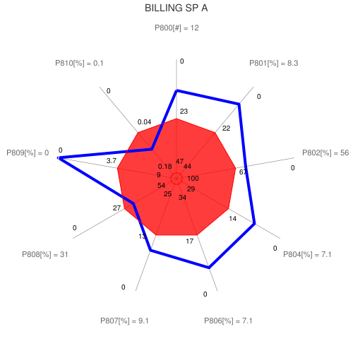
Figure B.1: QoS of the Billing CRS
The figures given in blue close to each dot show the scores achieved for the related parameters. Scales on the axes can be different in the red area and in the other part.
Such a graphical representation would lead to as much graphs as CRS. Taking into account that for multiplay offers different graphs would be needed to display the "utilization of the service" CRS (one for each service included in the offer), this could result in more than a dozen of graphs for each service.
As indicated earlier, this type of display allows also for a representation of the extremes of the distribution of the assessment results, provided the corresponding data are available. This can be particularly useful in the case of the "use of service" case to show how the results differ with regard to the consumer location or any other factor.

B.2 Representation of the QoS results for the various CRS of a specific service
As explain in the previous clause, users could find difficult to handle a big number of graphs and therefore would like to have a tool to embrace in a single graph the QoS of each Service.
Thanks to the QoS index defined in clause 8.2.4, a new line and a new column can be added to the table .1 leading to table .2: A QoS index is determined for each QoS parameter enabling to calculate a consolidated index for the whole related CRS.
Table B.2: Example of Billing CRS QoS indexes
 | P800 | P801 | P802 | P804 | P806 | P807 | P808 | P809 | P810 | Consolidated Billing QoS index
Parameter value | 12.4 | 8.3% | 55% | 7.1% | 7.1% | 9.1% | 31% | 0.0% | 0.09%
Reference threshold | 23 | 22% | 67% | 14% | 17% | 13% | 27% | 3.7% | 0.04%
Max value | 12.4 | 8.3% | 55% | 7.1% | 7.1% | 9.1% | 13% | 0.0% | 0.01%
Min value | 32 | 37% | 79% | 17% | 33% | 17% | 42% | 8.2% | 0.09%
Upper range limit | 0 | 0% | 0% | 0% | 0% | 0% | 0% | 0% | 0%
Lower range limit | 40 | 40% | 100% | 32% | 33% | 21% | 44% | 8% | 0.18%
QoS index | 1.47 | 1.62 | 1.17 | 1.50 | 1.58 | 1.27 | 0.83 | 2.00 | 0.64 | 1.3
The consolidation of the indexes of the QoS parameters within each CRS for a given service from an SP will provide a "consolidated" index representing the QoS of this CRS as the example shown in table .2. The following examples are using assessments from various sources, bearing on the following selection of QoS parameters:
Table B.3: Example of consolidation of telephony service QoS indexes
Preliminary information | Contract Establishment | Service provisioning | Service use (technical QoS) | Customer Support | Repair services | Metering, Charging, Billing | Cessation
P100 | P200 | P300 | PT000 | P600 | P706 | P800 | P1004
P101 | P201 | P303 | PT001 | P628 | P706a | P801 | P1004a
P101a | P202 | P303a | PT001a | P628a | P706b | P802 | P1004b
P101b | P203 | P303b | PT001b | P628b | P707 | P804 | P1004c
P101c | P204 | P309 | PT002 | P661 |  | P806 | P1008
P102 |  | P309a | PT002a | P662 |  | P807
P103 |  | P309b | PT002b | P663 |  | P808
 |  |  | PT003 | P664 |  | P809
 |  |  | PT003a | P665 |  | P810
 |  |  | PT003b | P666
 |  |  | PT004 | P666a
 |  |  |  | P666b
 |  |  |  | P666c
 |  |  |  | P667
This results in table .4 showing the values of the consolidated indexes of a specific telephony services from 4 SP among a bigger set of SP. More details on the content of this table are available in ETSI TR 102 854 [i.20].
Table B.4: Example of consolidated indexes of the telephony services of 4 SP
Consolidated QoS indexes | Preliminary information | Contract Establishment | Service provisioning | Service use (technical QoS) | Customer Support | Repair services | Metering, Charging, Billing | Cessation
SP A | 1.7 | 1.5 | 0.4 | 0.9 | 1.4 | 0.9 | 1.3 | 1.1
SP B | 1.1 | 0.9 | 0.6 | 1.0 | 0.7 | 0.8 | 0.7 | 0.9
SP C | 0.6 | 0.8 | 1.3 | 1.0 | 1.0 | 1.1 | 0.8 | 1.3
SP D | 0.7 | 0.7 | 1.0 | 1.2 | 0.9 | 1.0 | 1.2 | 0.9
The figures .2 to .5 provide examples of the representation described above showing the QoS results for the CRS of the telephony service from the 4 SP given in table .4. With such a representation it could be possible to have an axis for the utilization of each service component included in the offer. Hence, it would be easier to compare several offers in order to choose the one expected to reach the required QoS taking into account all the CRS and all the component of the offer.
Thus, it is very easy to check on a single view where the strengths and weaknesses of a specific service from several providers are.
Depending on the purpose of the study, a weighted consolidation is also possible, provided as mentioned earlier that such a weighting is fully representative of the users' expectations.
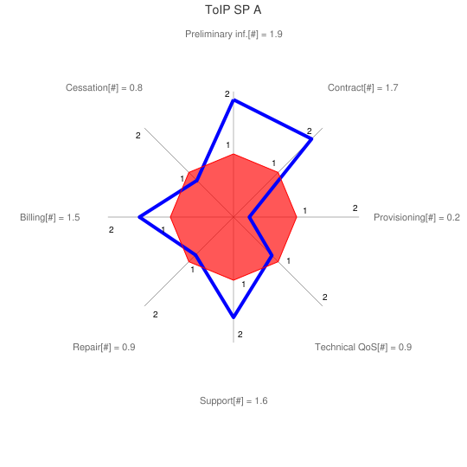  Figure B.2: QoS indexes of the telephony service of SP A | 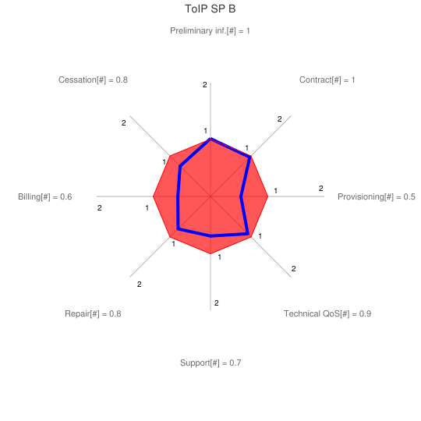  Figure B.3: QoS indexes of the telephony service of SP B
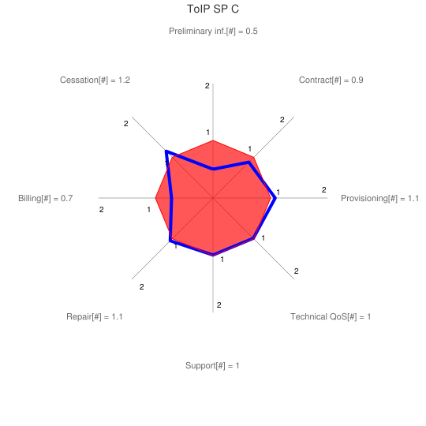  Figure B.4: QoS indexes of the telephony service of SP C | 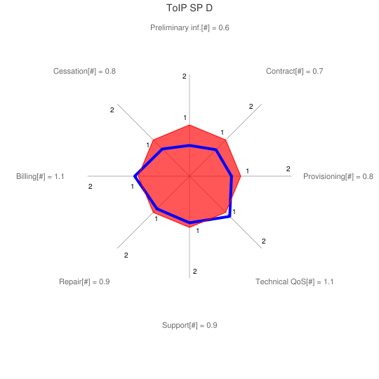  Figure B.5: QoS indexes of the telephony service of SP D

Annex C (informative):
Alternate graphical representation based on the "one-view visualization (OVV) methodology" described in the ITU-T Recommendation P.505
Although the ITU-T Recommendation P.505 is focusing on the representation of speech quality measurement results, it was found useful to use the "one-view visualization methodology" described in this recommendation to represent the CRS quality results as an alternative to those given in clause .1 and .2. This representation is based on circle segments ("pie diagram", "star plot") according to the following principles (see Figure C.1 example):
- Similar to a "cobweb" representation the axes are shown with a common origin.
- By means of a suitable axis scaling, a concentric circle (in red colour) around the origin can be defined which delineates the best practices quality measure. Falling below this segment size (radius) indicates a non-compliance with this limit value.
- The value on the border of the red area is defined by the reference threshold set according to one of the methods described in clause 6.
- Each QoS parameter is represented by a circle segment whose radius match the parameter value with a different scale for each QoS parameter. This segment appears in green colour for parameter value above the reference and in yellow colour in the other case.
- The radius of this segment depends on the axis scales defined by the values for the border of the red area and both ends of the axis.
- The value for the top end of the axis (highest QoS) is defined by the highest value set for the agreed range.
- The value for the origin of the axis (lowest QoS) is defined by the lowest value set for the agreed range.
- As a consequence, depending on the type of QoS parameter, the scale can be increasing or decreasing from the centre to the outside end.
- The principle is that the bigger the segment, the better the QoS. Additionally when a segment completely hides the red area, this means the QoS is compliant with the best practices and on the opposite when a segment let a part of the red area appear, the QoS is below these best practices.
- If needed various colours can be given to the segments to highlight which ones are most important than the others.
A tool enabling to draw the chart according to the OVV methodology is expected to be made publicly available by the ITU-T in the coming year.

C.1 Representation of the results within a CRS
The Figure C.1 provides an example of an alternative to the representation given in clause .1of the QoS of the Billing stage according to the OVV methodology.
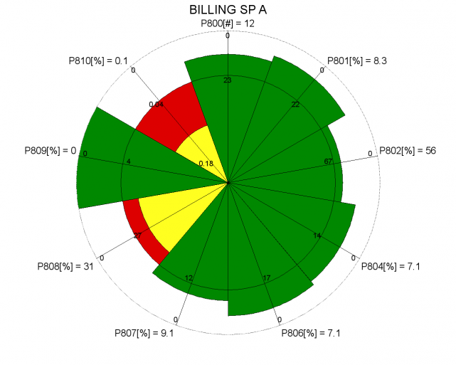
Figure C.1: QoS of the Billing CRS

C.2 Representation of the QoS results for the various CRS of a specific service
The figures .2 to .5 provide examples of an alternative to the representation given in clause .2 of the QoS results for the CRS of the telephony service from 4 SP according to the OVV methodology.
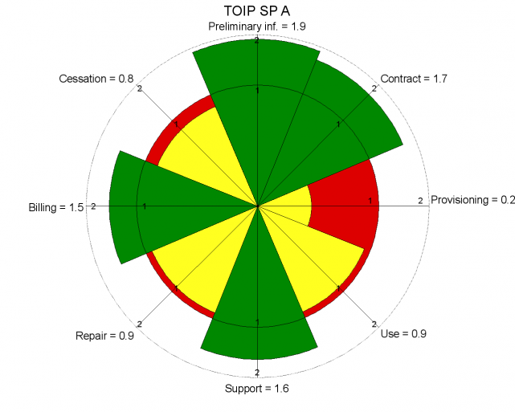  Figure C.2: QoS indexes of the telephony service of SP A | 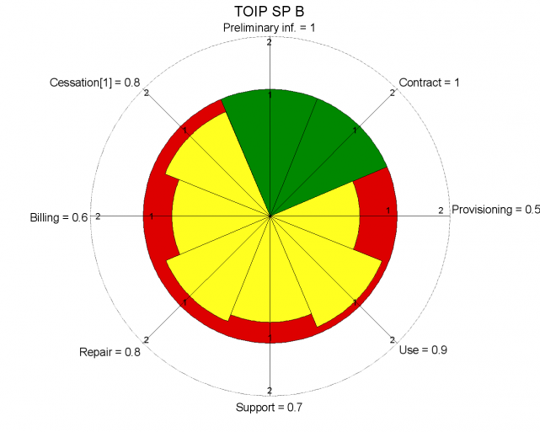  Figure C.3: QoS indexes of the telephony service of SP B
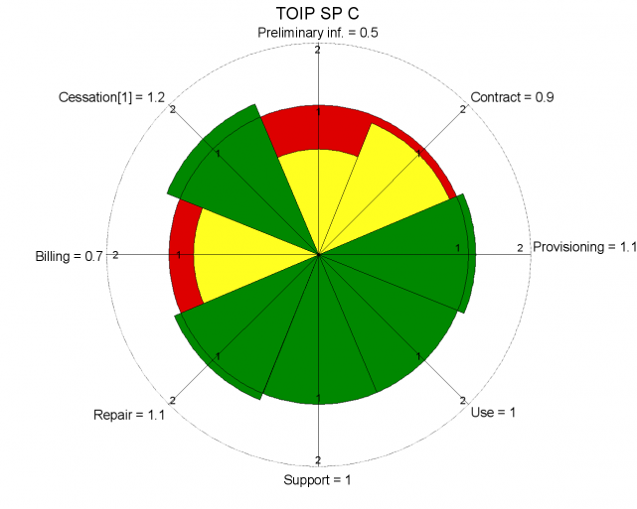  Figure C.4: QoS indexes of the telephony service of SP C | 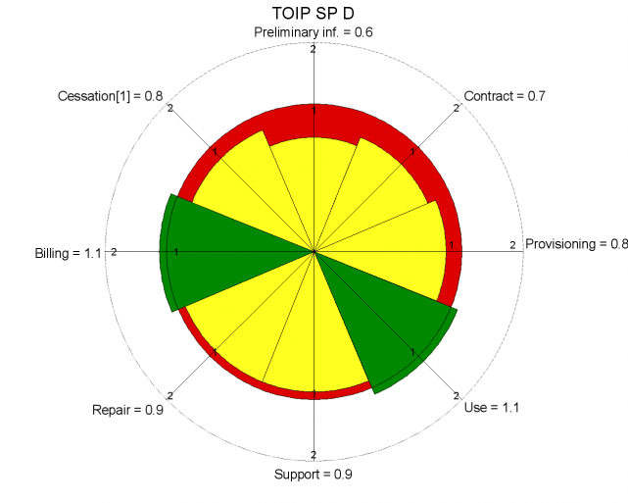  Figure C.5: QoS indexes of the telephony service of SP D

Annex D:
Bibliography
Google Chart Tools are available at " http://code.google.com/intl/fr/apis/chart/image/docs/gallery/radar_charts.html ".
OVV Chart tools are available at " http://quality-pie.de/workplace/ "

History
V0.1.0 | October 2010 | First draft
V0.1.2 | January 2011 | Draft for discussion at UG#41
V0.1.3 | February 2011 | Draft for presentation at STQ#36
V0.1.4 | May 2011 | Draft for discussion at UG#42
V0.1.5 | May 2011 | Revision for UG#42 with improvements after Qostic#38 meeting
V0.1.6 | June 2011 | Revision during the drafting session at UG#42
V0.1.7 | June 2011 | Revision for consistency with DTR102854 and presentation to STQ#37
V0.1.8 | September 2011 | Revision for UG#43 including chart examples following Recommendation ITU-T P.505
V0.1.9 | October 2011 | Revision during STQ#38
V0.1.10 | October 2011 | Revision for UG#43 after STQ#38

