TR 102 854 V0.0.6 (2011-10)
User Group;
The assessment of the overall Quality of Services (QoS) as perceived by the users;
Review of practical examples of service QoS assessments

<

TECHNICAL REPORT

Reference
DTR/USER-0037
Keywords
QoS, Interfaces

ETSI
650 Route des Lucioles
F-06921 Sophia Antipolis Cedex - FRANCE

Tel.: +33 4 92 94 42 00 Fax: +33 4 93 65 47 16

Siret N° 348 623 562 00017 - NAF 742 C
Association à but non lucratif enregistrée à la
Sous-Préfecture de Grasse (06) N° 7803/88

Important notice
Individual copies of the present document can be downloaded from:
http://www.etsi.org
The present document may be made available in more than one electronic version or in print. In any case of existing or perceived difference in contents between such versions, the reference version is the Portable Document Format (PDF). In case of dispute, the reference shall be the printing on ETSI printers of the PDF version kept on a specific network drive within ETSI Secretariat.
Users of the present document should be aware that the document may be subject to revision or change of status. Information on the current status of this and other ETSI documents is available at http://portal.etsi.org/tb/status/status.asp
If you find errors in the present document, please send your comment to one of the following services:
http://portal.etsi.org/chaircor/ETSI_support.asp
Copyright Notification
No part may be reproduced except as authorized by written permission.
The copyright and the foregoing restriction extend to reproduction in all media.

© European Telecommunications Standards Institute yyyy.
All rights reserved.
DECTTM, PLUGTESTSTM, UMTSTM and the ETSI logo are Trade Marks of ETSI registered for the benefit of its Members.
3GPPTM and LTE™ are Trade Marks of ETSI registered for the benefit of its Members and
of the 3GPP Organizational Partners.
GSM® and the GSM logo are Trade Marks registered and owned by the GSM Association.
Contents
Intellectual Property Rights 4
Foreword 4
Introduction 4
1 Scope 5
2 References 5
2.1 Normative references 5
2.2 Informative references 5
3 Definitions, symbols and abbreviations 6
3.1 Definitions 6
3.2 Symbols 6
3.3 Abbreviations 7
4 Overall organization of the QoS information 7
4.1 Segmentation of the results 7
4.2 Implementation of the ETSI EG 202 934 principles 8
4.3 Principles for graphical representation 8
4.3.1 Radar type graphical representation 8
4.3.2 OVV type graphical representation 9
4.4 Processing of the results 10
5 Representation of the results within each CRS 10
5.1 Sales - Preliminary information (PI) 10
5.1.1 Reference threshold of PI QoS parameter 10
5.1.2 Highest QoS boundary of the range of PI QoS parameter 11
5.1.3 Lowest QoS boundary of the range of PI QoS parameter 11
5.1.4 Aggregation of the PI QoS assessment results 11
5.1.4.1 Comparison Table 11
5.1.4.2 QoS indexes 11
5.1.4.3 Radar type graphical representation 12
5.1.4.4 OVV type graphical representation 13
5.1.4.5 Conclusion 13
5.2 Sales - Contract Establishment 13
5.2.1 Reference threshold of each QoS parameter 14
5.2.2 Highest QoS boundary of the range of each QoS parameter 14
5.2.3 Lowest QoS boundary of the range of each QoS parameter 14
5.2.4 Aggregation of the Contract Establishment QoS assessment results 14
5.2.4.1 Comparison Table 14
5.2.4.2 QoS indexes 14
5.2.4.3 Radar type graphical representation 15
5.2.4.4 OVV type graphical representation 16
5.2.4.5 Conclusion 16
5.3 Service management - Service provisioning 16
5.3.1 Reference threshold of each QoS parameter 17
5.3.2 Highest QoS boundary of the range of each QoS parameter 17
5.3.3 Lowest QoS boundary of the range of each QoS parameter 17
5.3.4 Aggregation of the Provisioning QoS assessment results 17
5.3.4.1 Comparison Table 17
5.3.4.2 QoS indexes 18
5.3.4.3 Radar type graphical representation 18
5.3.4.4 OVV type graphical representation 19
5.3.4.5 Conclusion 19
5.4 Service use (technical QoS) 19
5.4.1 Reference threshold of each QoS parameter 20
5.4.2 Highest QoS boundary of the range of each QoS parameter 20
5.4.3 Lowest QoS boundary of the range of each QoS parameter 20
5.4.4 Aggregation of the Service use QoS assessment results 20
5.4.4.1 Comparison Table 20
5.4.4.2 QoS indexes 21
5.4.4.3 Radar type graphical representation 21
5.4.4.4 OVV type graphical representation 22
5.6.4.4.5 Conclusion 22
5.5 Service management - Customer Support 23
5.5.1 Reference threshold of each QoS parameter 24
5.5.2 Highest QoS boundary of the range of each QoS parameter 24
5.5.3 Lowest QoS boundary of the range of each QoS parameter 24
5.5.4 Aggregation of the Customer Support QoS assessment results 24
5.5.4.1 Comparison Table 24
5.5.4.2 QoS indexes 25
5.5.4.3 Radar type graphical representation 25
5.5.4.4 OVV type graphical representation 26
5.6.4.5 Conclusion 26
5.6 Service management - Repair services 27
5.6.1 Reference threshold of each QoS parameter 27
5.6.2 Highest QoS boundary of the range of each QoS parameter 27
5.6.3 Lowest QoS boundary of the range of each QoS parameter 27
5.6.4 Aggregation of the Repair service QoS assessment results 27
5.6.4.1 Comparison Table 27
5.6.4.2 QoS indexes 28
5.6.4.3 Radar type graphical representation 28
5.6.4.4 OVV type graphical representation 29
5.6.4.5 Conclusion 29
5.7 Service management - Metering, Charging and Billing 30
5.7.1 Reference threshold of each QoS parameter 30
5.7.2 Highest QoS boundary of the range of each QoS parameter 30
5.7.3 Lowest QoS boundary of the range of each QoS parameter 31
5.7.4 Aggregation of the Billing QoS assessment results 31
5.7.4.1 Comparison Table 31
5.7.4.2 QoS indexes 31
5.7.4.3 Radar type graphical representation 32
5.7.4.4 OVV type graphical representation 32
5.8 Service management - Cessation 33
5.8.1 Reference threshold of each QoS parameter 33
5.8.2 Highest QoS boundary of the range of each QoS parameter 33
5.8.3 Lowest QoS boundary of the range of each QoS parameter 34
5.8.4 Aggregation of the Cessation QoS assessment results 34
5.8.4.1 Comparison Table 34
5.8.4.2 QoS indexes 34
5.8.4.3 Radar type graphical representation 35
5.8.4.4 OVV type graphical representation 35
5.8.4.6 Conclusion 36
6 Representation of the QoS results for the various CRS of a particular service 36
6.1 QoS indexes and Comparison Table 36
6.2 Graphical representation 37
6.2.1 Radar type chart 37
6.2.2 OVV type graphical representation 38
6.2.3 Conclusion 39
Annex A: Bibliography 39
History 40

Intellectual Property Rights
IPRs essential or potentially essential to the present document may have been declared to ETSI. The information pertaining to these essential IPRs, if any, is publicly available for ETSI members and non-members, and can be found in ETSI SR 000 314: "Intellectual Property Rights (IPRs); Essential, or potentially Essential, IPRs notified to ETSI in respect of ETSI standards", which is available from the ETSI Secretariat. Latest updates are available on the ETSI Web server (http://ipr.etsi.org).
Pursuant to the ETSI IPR Policy, no investigation, including IPR searches, has been carried out by ETSI. No guarantee can be given as to the existence of other IPRs not referenced in ETSI SR 000 314 (or the updates on the ETSI Web server) which are, or may be, or may become, essential to the present document.

Foreword
This Technical Report (TR) has been produced by ETSI USER GROUP (USER).

Introduction
This TR details some examples of QoS assessments results from available surveys in 2010.
These examples are used to illustrate the principles described in EG 202 934 [i.4].
The present document takes into account the following CRS: Sales - Preliminary information (PI), Service management - Service provisioning, Service use (technical QoS), Customer Support, Repair services, Metering, Charging, Billing and Cessation.

1 Scope
The present document aims at explaining how the methodology described in EG 202 843 [i.2] can be implemented using QoS assessments from different sources resulting of various surveys among end-users to compare the QoS of services provided by different Service Providers (SP). Some of these results, used as examples in EG 202 934 [i.4] are more detailed in the present document.
The data used for this report have been collected from actual users according to best practices in this area. Nevertheless, this document should not to be taken as an actual comparison of SP but rather as a tutorial about how such comparison should be done provided fully comparable data is available.

2 References
References are either specific (identified by date of publication and/or edition number or version number) or non-specific. For specific references,only the cited version applies. For non-specific references, the latest version of the referenced document (including any amendments) applies.
Referenced documents which are not found to be publicly available in the expected location might be found at http://docbox.etsi.org/Reference.
NOTE: While any hyperlinks included in this clause were valid at the time of publication ETSI cannot guarantee their long term validity.

2.1 Normative references
The following referenced documents are necessary for the application of the present document.
Not applicable.

2.2 Informative references
The following referenced documents are not necessary for the application of the present document but they assist the user with regard to a particular subject area.
[i.1] ETSI EG 202 009-1: "User Group; Quality of Telecom Services; Part 1: Methodology for identification of parameters relevant to the Users".
[i.2] ETSI EG 202 843: "User Group; Quality of ICT Services; Definitions and Methods for Assessing the QoS parameters of the Customer Relationship Stages other than utilization".
[i.3] ETSI EG 202 057: "Speech and multimedia Transmission Quality (STQ); User related QoS parameter definitions and measurements; Part 1: General
[i.4] ETSI EG 202 934: "User Group; The assessment of the overall Quality of Services (QoS) as perceived by the users; Definition of QoS indexes for all the customer relationship stages".
[i.5] ETSI ES 202 765-2: "Speech and multimedia Transmission Quality (STQ); QoS and network performance metrics and measurement methods; Part 2: Transmission Quality Indicator combining Voice Quality Metrics
[i.6] ETSI ES 202 765-4: "Speech and multimedia Transmission Quality (STQ); QoS and network performance metrics and measurement methods; Part 4: Indicators for supervision of Multiplay services".
[i.7] ETSI TS 102 852: "User Group; Quality of ICT Services; Assessment process of the QoS parameters of the customer relationship stages".

3 Definitions, symbols and abbreviations

3.1 Definitions
For the purposes of the present document, the terms and definitions given in ETSI EG 202 934 [i.4] and the following apply.

3.2 Symbols
For the purposes of the present document, the symbols given in ETSI EG 202 934 [i.4] and the following apply.
P100 Frequency of customer complaints about PI [N/t]: Number of customers' complaints about PI per million subscribers
P101a Integrity of PI [OR]: Content - Was the relevant information provided as you expected?
P101b Integrity of PI [OR]: Language - Was the information provided clear and understandable without any ambiguity?
P101c Integrity of PI [OR]: Style - How would you rate the overall style, presentation and professionalism of the preliminary information provided?
P102 Pricing transparency [OR]: Did you find the pricing information comprehensible?
P103 Availability of PI [%]: Could you retrieve the preliminary information easily?
P200 Frequency of customer complaints about contract establishment [N/t]: Number of customers' complaints about contract establishment per million subscribers
P201 Integrity of contract information [OR]: How would you rate the integrity of the contractual document?
P202 Compliance of contractual terms with PI [%]: Was the contract document compliant to the previously provided preliminary information?
P203 Flexibility for customisation before contract [OR]: How would you rate the flexibility of your service provider to customise the contract before signature e.g. by applying options?
P204 Ease and flexibility to amend terms after formal contract [OR]: How would you rate the flexibility of your service provider to further adapt the contract after signature e.g. by applying options?
P300 Frequency of customer complaints about provisioning [N/t]: Number of customers' complaints about provisioning per million subscribers
P303a Provisioning time [Time & %] - existing subscriber line
P303b Provisioning time [Time & %] - new subscriber line
P309a Successful provisioning within a specified period [%] - existing subscriber line
P309b Successful provisioning within a specified period [%] - new subscriber line
P600 Frequency of customer complaints about service support [N/t]: Number of customers complaints about service support per million subscribers
P628a Response time of the technical support [Time & %]
P628b Response time of the technical support [Time & %]
P661 Accessibility of the complaint management desk [%]: Concerning your latest attempt to access the complaint management desk of your service provider: Did you succeed in accessing it?
P662 Recognition of the customer complaints [%]: Concerning your latest attempt to access the complaint management desk of your service provider: Was your complaint accepted?
P663 Complaint solutions not complete and correct first time [%]: Was the complaint solved to your satisfaction at the first attempt by the service provider?
P664 Complaint solutions achieved within a specified period [%]: Concerning your latest accepted complaint: Was the complaint finally solved to your satisfaction by the service provider?
P665 Integrity of complaint resolution [%]: Concerning your latest accepted complaint: Was your complaint resolved correctly?
P666a Customer perception of the complaint management [OR]: Customer perception of complaint management (Assurance): How would your rate the service provider's complaint management related to assurance at all?
P666b Customer perception of the complaint management [OR]: Customer perception of complaint management (Empathy): How would your rate the service provider's complaint management related to empathy at all?
P666c Customer perception of the complaint management [OR]: Customer perception of complaint management (Responsiveness): How would your rate the service provider's complaint management related to responsiveness at all?
P667 Overall quality of the complaint management process [OR]: How would your rate the overall handling of the complaint management process?
P706a Fault repair time [Time & %] - Time for 95% fault repair
P706b Fault repair time [Time & %] - % faults repaired within a 48 hours delay.
P707 Frequency of customer complaints related to repair services [N/t]: Number of customers complaints related to repair services per million subscribers
P800 Frequency of customer complaints about billing [N/t]: Number of customers complaints about billing per million subscribers
P801 Accessibility of the tariff information [%]: Concerning your latest attempt to access your provider's tariff information: Were you able to access the tariff information?
P802 Successful notification of exceeding billing budget [%]: If you are using a notification service when you reach a predefined budget level: Concerning your latest exceeding of budget: Were you notified accordingly when you exceeded your budget?
P804 Accessibility of the account management [%]: Concerning your latest attempt to access the account status at your service provider: Did you succeed in accessing it?
P806 Timeliness of bill delivery [%]: Did you receive all the expected bills throughout the last 6 months?
P807 Bill delivery delay [Time]: If you experienced a delay in bill delivery: How many days was the bill delayed?
P808 Late notification of amount due [%]: Has the bill been received before the direct debit was executed?
P809 Modes of billing information transfer [Number]: How many ways do you have to access your accounting information?
P810 Bill correctness complaints [%]: Percentage of bills resulting in a customer complaint per point of billing per year.
P1004a Contractual cessation achieved within 10 days [%]
P1004b Contractual cessation achieved [%]: time needed (days) to achieved 95% of cessations requested
P1004c Contractual cessation achieved [%]: time needed (days) to achieved 99% of cessations requested
P1008 Frequency of customer complaints related to cessation [N/t]: Number of customers' complaints related to cessation per million subscribers
PT000 Frequency of customer complaints related to use of service [N/t]: Number of customers complaints related to use of service per million subscribers
PT001a Fault report rate per fixed access lines
PT001b Fault report rate per fixed access lines within 30 days after the delivery.
PT002a unsuccessful call ratio - domestic calls
PT002b unsuccessful call ratio - international calls
PT003a call set up time - domestic calls
PT003b call set up time - international calls
PT004 Speech Quality (MOS)

3.3 Abbreviations
For the purposes of the present document, the abbreviations given in ETSI EG 202 934 [i.4] and the following apply:
CRS Customer Relationship Stage
OVV One-View Visualization
QoS Quality of Service
SP Service Provider
ToIP Telephony over IP

4 Overall organization of the QoS information

4.1 Segmentation of the results
As explained in ETSI EG 202 934 [i.4], a useful means to provide a synthetic overview of the pieces of information related to users' satisfaction is to segment them with respect to the Customer Relationship Stages, i.e., as detailed in EG 202 009-1 [i.1]:
Table 1: Customer Relationship Stage
Customer Relationship Stage |  | CRS detail
Sales |  | Preliminary information, advertisement
 |  | Establishment of the contract (Terms and conditions)
Service management | Service provisioning | Installation
 |  | Activation and acceptance
 | Service alteration / Technical upgrade | Customer initiative
 |  | Provider initiative
 | Service support | Documentation for service activation and set-up  Documentation for service use
 |  | Technical support
 |  | Commercial support
 |  | Complaint management
 | Repair/Troubleshooting
 | Metering/Charging/Billing
 | Cessation
Use of Service | Network/service management by the customer
 | Service utilization | Access
 |  | Bearer service
 |  | Service usage
 |  | Presentation and user interface

This means to have a single representation (with an indication of the related spreading) for each of these stages.

4.2 Implementation of the ETSI EG 202 934 principles
The purpose of the present document is to detail for each QoS parameter of each CRS how the principles of ETSI EG 202 934 [i.4] can be used:
1) to choose the reference thresholds according to clause 6 of ETSI EG 202 934 [i.4], in order to make available a table showing which SP provide a QoS egal or above these thresholds.
2) then to choose a realistic range of variation of the values of the QoS parameters within a given CRS so that the differences between the results of the various providers rightly represent significant differences from the perceived QoS viewpoint. This range will be used for the scales of the axis of the graph comparisng the results of the SP within a CRS as well as for the calculation of the indexes used for the aggregation of the results for a whole service. These ranges are defined according to clauses 8.2.2 and 8.2.3 of ETSI EG 202 934 [i.4].
3) and finally to determine the QoS indexes of each CRS according to clause 8.2.4 of ETSI EG 202 934 [i.4] in order to provide a graph displaying the QoS assessed for the selected services of the providers under study.

4.3 Principles for graphical representation
Whatever aggregation scenario is chosen, an appropriate graphical representation of the results is probably the best means to help the users to identify which services are able to ensure the expected QoS.
The graphical representations proposed hereafter (see examples in figure 1) are all based on the principles proposed in ETSI EG 202 843 [i.2] and detailed in ETSI EG 202 934 [i.4].
Two types of chart are proposed:
- A radar type graphical representation and
- A "cobweb" type graphical representation based on the "one-view visualization (OVV) methodology" described in the ITU-T Recommendation P.505.
Each type of chart has advantages and drawbacks and of course, other representations can be used depending of the communication target.

4.3.1 Radar type graphical representation
- The graph is of the radar type.
- A red area drawn in the middle of the chart delineates the best practices quality measure.
- Each QoS parameter is represented by a dot on an axis with a different scale for each QoS parameter.
- The location of this dot depends on the axis scales defined by the values for the border of the red area (reference threshold) and both ends of the axis.
- The value on the border of the red area is defined by the reference threshold set according to one of the possible methods described in clause 6.
The value for the top end of the axis (highest QoS) is defined by the highest value set for the agreed range (Cf. 4.2).
- The value for the origin of the axis (lowest QoS) is defined by the lowest value set for the agreed range (Cf. 4.2).
- As a consequence, depending on the type of QoS parameter, the scale can be increasing or decreasing from the centre to the outside end and the scale of the lower part of the axis can be different from that of the upper part.
- The principle is that the farther the dot from the centre, the better the QoS. Additionally when a dot is outside the red area, this means the QoS is compliant with the best practices and on the opposite when a dot is within the red area the QoS is below these best practices.
- Where appropriate, this type of display allows for a representation of the extremes of the distribution of the assessment results.
Therefore, it is very easy to check what are the parameters outside the red area, hence being compliant with the best practices.
This type of graphic display is using a freely available software (Google chart).

4.3.2 OVV type graphical representation
- Although the ITU-T Recommendation P.505 is focusing on the representation of speech quality measurement results, it was found useful to use the "one-view visualization methodology" described in this recommendation to represent the CRS quality results as an alternative to that given in clause 4.3.1. This representation is based on circle segments ("pie diagram", "star plot") according to the following principles (see Figure 2 example):
- Similar to a "cobweb" representation the axes are shown with a common origin.
- By means of a suitable axis scaling, a concentric circle (in red colour) around the origin can be defined which delineates the best practices quality measure. Falling below this segment size (radius) indicates a non-compliance with this limit value.
- The value on the border of the red area is defined by the reference threshold set according to one of the methods described in clause 6.
- Each QoS parameter is represented by a circle segment (in green colour) whose radius match the parameter value with a different scale for each QoS parameter.
- The radius of this segment depends on the axis scales defined by the values for the border of the red area and both ends of the axis.
- The value for the top end of the axis (highest QoS) is defined by the highest value set for the agreed range.
- The value for the origin of the axis (lowest QoS) is defined by the lowest value set for the agreed range.
- As a consequence, depending on the type of QoS parameter, the scale can be increasing or decreasing from the centre to the outside end.
- The principle is that the bigger the segment, the better the QoS. Additionally when a segment completely hides the red area, this means the QoS is compliant with the best practices and on the opposite when a segment let a part of the red area appear, the QoS is below these best practices.
- If needed various colours can be given to the segments to highlight which ones are most important than the others.
A tool enabling to draw the chart according to the OVV methodology is expected to be made publicly available by the ITU-T in the coming year. In the meantime a tentative link to such a tool is provided in Annex A.

4.4 Processing of the results
The assessment of the QoS parameters is described in several standards, e.g. ETSI EG 202 057 [i.3], ETSI EG 202 843 [i.2], ETSI TS 102 852 [i.7], ETSI EG 202 009-1 [i.1], ETSI ES 202 765-2 [i.5] & 4 [i.6], etc. but to make easier the comparison of different SP, it is crucial to have a consistent presentation of these results. In this aim, the principle was taken to display the results with values increasing with the QoS, as customers better understand such a presentation mode. This principle has led in some cases to a processing of the raw data resulting from the assessments made according to the standards. Details are provided in clause 5.

5 Representation of the results within each CRS
The present document uses the principles described in EG 202 934 [i.4] for a detailed comparison of different SP using various available QoS assessments. Nevertheless, as explained in the scope, due to the lack of comparability of the data used, it should not to be taken as an actual comparison of SP but rather as a tutorial about how such comparison could be done provided fully comparable data are available.
Even if the results have been obtained from a sample of 7 SP, only 4 are used in the present document.

5.1 Sales - Preliminary information (PI)
The QoS parameters used for this stage are the following:
P100 Frequency of customer complaints about PI [N/t]:
Measure: Number of customers' complaints about PI per million subscribers
P101a Integrity of PI [OR]: Content
Question: Was the relevant information provided as you expected? Measure: % NO
P101b Integrity of PI [OR]: Language
Question: Was the information provided clear and understandable without any ambiguity? Measure: % NO
P101c Integrity of PI [OR]: Style
Question: How would you rate the overall style, presentation and professionalism of the preliminary information provided? Measure: % NO
P102 Pricing transparency [OR]:
Question: Did you find the pricing information comprehensible? Measure: % NO
P103 Availability of PI [%]:
Question: Could you retrieve the preliminary information easily? Measure: % NO
The values obtained for 4 SP are as follows:
Table 1.1: Preliminary Information (PI) results
 | P100 | P101a | P101b | P101c | P102 | P103
SP A | 2.48 | 0.0% | 0.0% | 5.6% | 5.9% | 5.9%
SP B | 4.29 | 20.7% | 17.9% | 16.0% | 19.2% | 26.9%
SP C | 3.30 | 31.7% | 36.1% | 34.2% | 40.7% | 45.8%
SP D | 3.10 | 30.4% | 31.8% | 30.2% | 35.4% | 46.9%
QoS max | 2.48 | 0.0% | 0.0% | 5.6% | 5.9% | 5.9%
QoS min | 4.29 | 31.7% | 36.1% | 34.2% | 40.7% | 46.9%

5.1.1 Reference threshold of PI QoS parameter
In this example, the mean values of each QoS parameter in the sample are taken as the reference thresholds.
Table 1.2: PI QoS reference thresholds
 | P100 | P101a | P101b | P101c | P102 | P103
Threshold | 3.3 | 21% | 21% | 22% | 25% | 31%

5.1.2 Highest QoS boundary of the range of PI QoS parameter
Although no SP was able to reach the ideal value 0 for all these QoS parameters, this target has been taken as upper threshold for these QoS parameters since it is not too far from the current practices and figure out an aim to look at..
Table 1.3: PI Highest QoS boundaries
 | P100 | P101a | P101b | P101c | P102 | P103
Highest QoS boundaries | 0 | 0% | 0% | 0% | 0% | 0%

5.1.3 Lowest QoS boundary of the range of PI QoS parameter
For all the QoS parameters in this sample, the ratio between the QoS minimum and the reference threshold is lower than 2. Therefore higher values will be taken for the lowest QoS boundaries so that a ratio of 2 is obtained.
Table 1.4: PI Lowest QoS boundaries
 | P100 | P101a | P101b | P101c | P102 | P103
Lowest QoS boundaries | 6.6 | 42% | 42% | 44% | 50% | 62%

5.1.4 Aggregation of the PI QoS assessment results

5.1.4.1 Comparison Table
Taking into account the values from the previous tables, the results reaching a QoS above or equal to the reference thresholds are shown in green in the table 1.5
Table 1.5: PI QoS better than the reference threshold
 | P100 | P101a | P101b | P101c | P102 | P103
SP A | 2.48 | 0.0% | 0.0% | 5.6% | 5.9% | 5.9%
SP B | 4.29 | 20.7% | 17.9% | 16.0% | 19.2% | 26.9%
SP C | 3.30 | 31.7% | 36.1% | 34.2% | 40.7% | 45.8%
SP D | 3.10 | 30.4% | 31.8% | 30.2% | 35.4% | 46.9%
Threshold | 3.3 | 21% | 21% | 22% | 25% | 31%
This shows clearly that the best PI QoS for this service is provided by SP A.

5.1.4.2 QoS indexes
To determine the QoS indexes for each parameter, a calculation has to be made on the basis of the previous tables according to the principles given in ETSI EG 202 934 [i.4] and summarized in clause 4.2.
The results appear in table 1.5:
Table 1.6: PI QoS indexes
 | P100 | P101a | P101b | P101c | P101 | P102 | P103 | Overall
SP A | 1.2 | 2.0 | 2.0 | 1.7 | 1.9 | 1.8 | 1.8 | 1.7
SP B | 0.7 | 1.0 | 1.1 | 1.3 | 1.1 | 1.2 | 1.1 | 1.1
SP C | 1.0 | 0.5 | 0.3 | 0.4 | 0.4 | 0.4 | 0.5 | 0.6
SP D | 1.1 | 0.6 | 0.5 | 0.6 | 0.6 | 0.6 | 0.5 | 0.7
In this table the P101 values are the mean values of P101a, P101b and P101c. The overall value is the mean value of P100, P101, P102 and P103.
These values will be used to draw the graphical representations showing the PI QoS of the service provided by the 4 SP in clause 5.1.4.3 while the overall QoS indexes will be used for the graphical representations showing the QoS of all the CRS of a service given in clause 6.

5.1.4.3 Radar type graphical representation
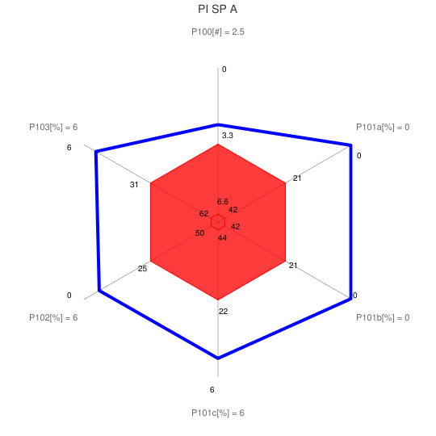 | 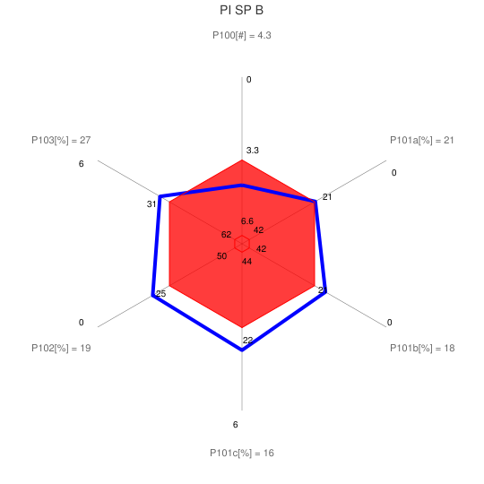
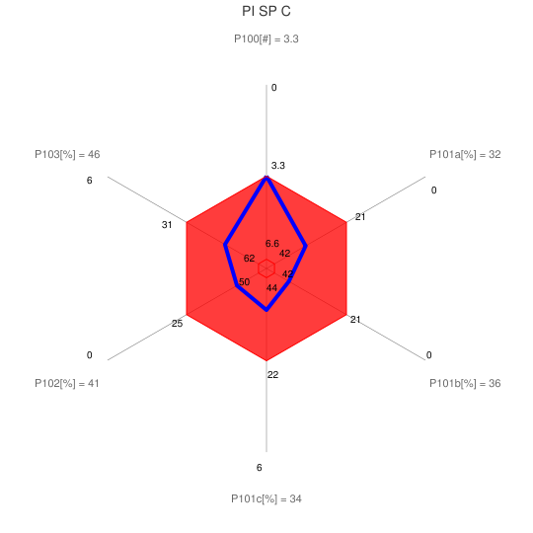 | 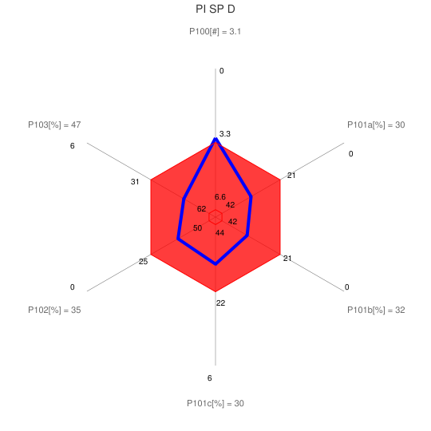
Figure 1: PI CRS QoS comparison

5.1.4.4 OVV type graphical representation
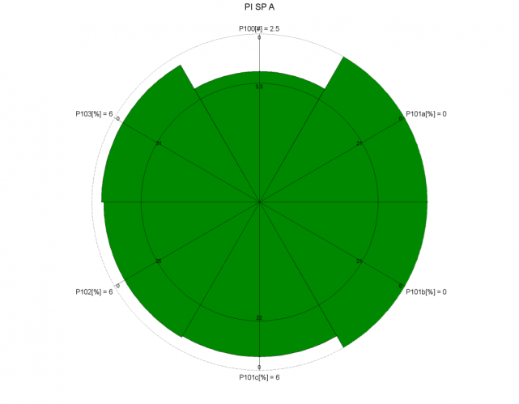 | 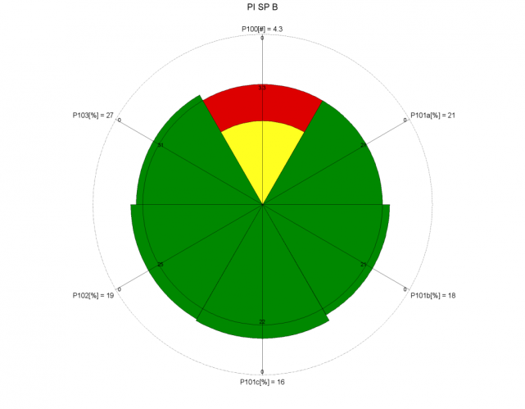
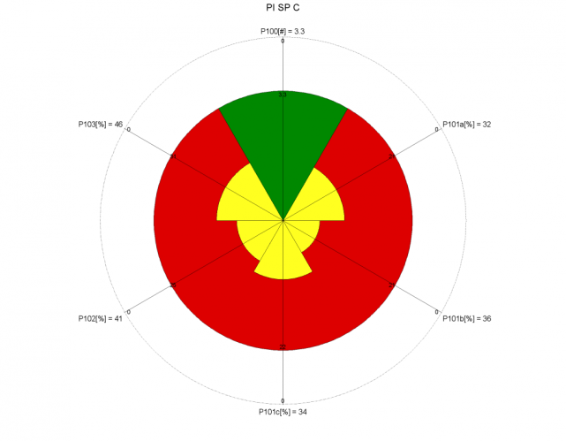 | 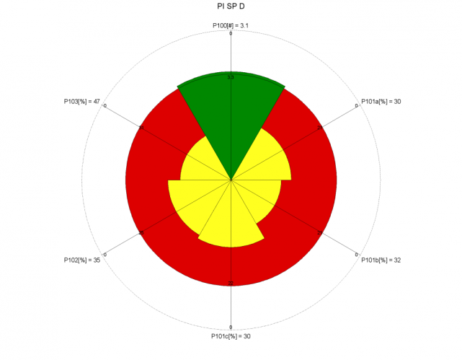
Figure 2: PI CRS QoS comparison

5.1.4.5 Conclusion
The comparison of the graphs for the 4SP shows clearly their strengths and weaknesses with regard to the PI QoS of the telephony service. SPA is the only one whose PI QoS for telephony service is acceptable in all aspects, followed by SPB.

5.2 Sales - Contract Establishment
The QoS parameters used for this stage are the following:
P200 Frequency of customer complaints about contract establishment [N/t]:
Measure: Number of customers' complaints about contract establishment per million subscribers
P201 Integrity of contract information [OR]:
Question: How would you rate the integrity of the contractual document?
Measure: % OR ≤ 3
P202 Compliance of contractual terms with PI [%]:
Question: Was the contract document compliant to the previously provided preliminary information?
Measure: % NO
P203 Flexibility for customisation before contract [OR]:
Question: How would you rate the flexibility of your service provider to customise the contract before signature e.g. by applying options?
Measure: % OR ≤ 3
P204 Ease and flexibility to amend terms after formal contract [OR]:
Question: How would you rate the flexibility
Measure: % OR ≤ 3
The values obtained for 4 SP are as follows:
Table 2.1: Contract Establishment results
 | P200 | P201 | P202 | P203 | P204
SP A | 7.43 | 22.2% | 0.0% | 25.0% | 23.5%
SP B | 9.00 | 32.0% | 20.8% | 43.5% | 57.1%
SP C | 7.92 | 45.8% | 26.0% | 50.5% | 48.1%
SP D | 12.63 | 50.0% | 26.3% | 43.3% | 56.6%
QoS max | 7.43 | 22.2% | 0.0% | 25.0% | 23.5%
QoS min | 12.63 | 50.0% | 26.3% | 50.5% | 57.1%

5.2.1 Reference threshold of each QoS parameter
In this example, the mean values of each QoS parameter in the sample are also taken as the reference thresholds.
Table 2.2: Contract Establishment QoS reference thresholds
 | P200 | P201 | P202 | P203 | P204
Threshold | 9.2 | 38% | 18% | 41% | 46%

5.2.2 Highest QoS boundary of the range of each QoS parameter
Although no SP was able to reach the ideal value 0 for all these QoS parameters, this target has been taken as upper threshold for these QoS parameters since it is not too far from the current practices and figure out an aim to look at..
Table 2.3: Contract Establishment Highest QoS boundaries
 | P200 | P201 | P202 | P203 | P204
Highest QoS boundaries | 0 | 0% | 0% | 0% | 0%

5.2.3 Lowest QoS boundary of the range of each QoS parameter
For all the QoS parameters in this sample, the ratio between the QoS minimum and the reference threshold is lower than 2. Therefore higher values will be taken for the lowest QoS boundaries so that a ratio of 2 is obtained.
Table 2.4: Contract Establishment Lowest QoS boundaries
 | P200 | P201 | P202 | P203 | P204
Lowest QoS boundaries | 18.4 | 76% | 36% | 82% | 92%

5.2.4 Aggregation of the Contract Establishment QoS assessment results

5.2.4.1 Comparison Table
Taking into account the values from the previous tables, the results reaching a QoS above or equal to the reference thresholds are shown in green in the table 2.5
Table 2.5: Contract Establishment QoS better than the reference threshold
 | P200 | P201 | P202 | P203 | P204
SP A | 7.43 | 22.2% | 0.0% | 25.0% | 23.5%
SP B | 9.00 | 32.0% | 20.8% | 43.5% | 57.1%
SP C | 7.92 | 45.8% | 26.0% | 50.5% | 48.1%
SP D | 12.63 | 50.0% | 26.3% | 43.3% | 56.6%
Threshold | 9.2 | 38% | 18% | 41% | 46%
This shows again clearly that the best Contract Establishment QoS for this service is provided by SPA.

5.2.4.2 QoS indexes
The same principles as for PI are used to determine the QoS indexes of the Contract Establishment CRS that appear in the table 2.6.
Table 2.6: Contract Establishment QoS indexes
 | P200 | P201 | P202 | P203 | P204 | Overall
SP A | 1.19 | 1.42 | 2.00 | 1.39 | 1.49 | 1.50
SP B | 1.02 | 1.16 | 0.84 | 0.94 | 0.76 | 0.94
SP C | 1.14 | 0.79 | 0.56 | 0.77 | 0.95 | 0.84
SP D | 0.63 | 0.68 | 0.54 | 0.94 | 0.77 | 0.71
In this table the overall value is the mean value of P200, P201, P202, P203 and P204.
These values will be used to draw the graphical representations showing the Contract Establishment QoS of the service provided by the 4 SP in clause 5.2.4.3 while the overall QoS indexes will be used for the graphical representations showing the QoS of all the CRS of a service given in clause 6.

5.2.4.3 Radar type graphical representation
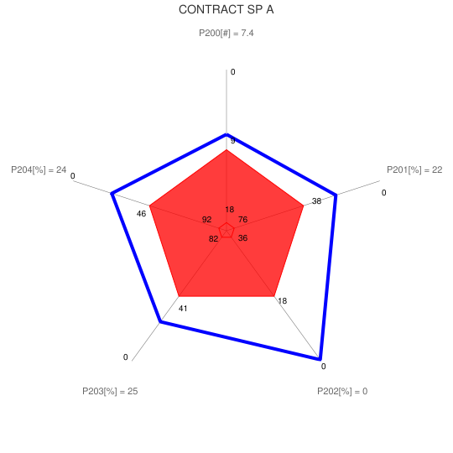 | 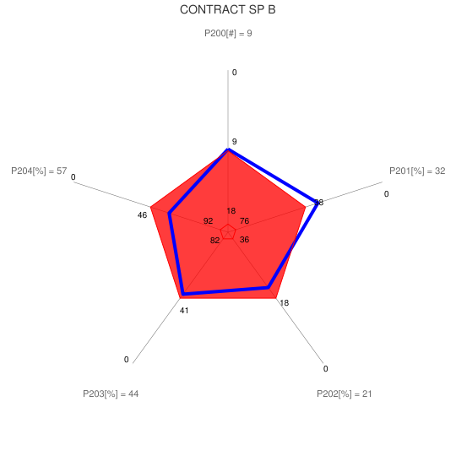
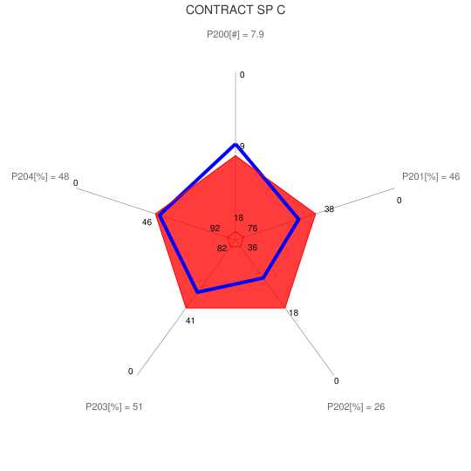 | 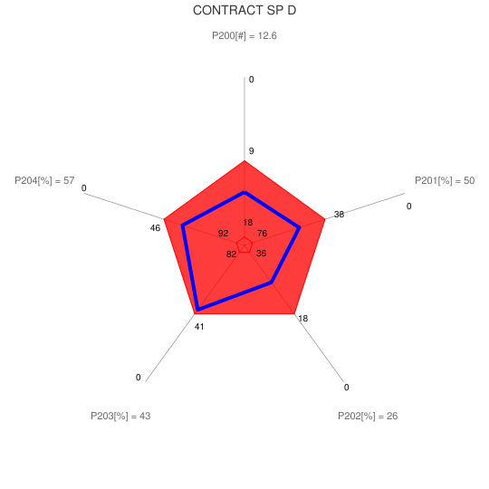
Figure 3: Contract CRS QoS comparison

5.2.4.4 OVV type graphical representation
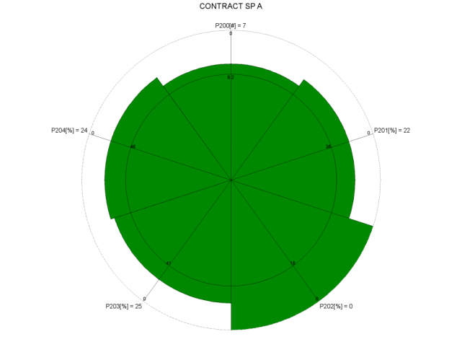 | 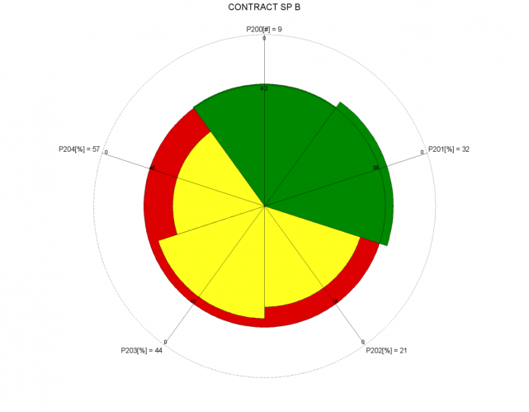
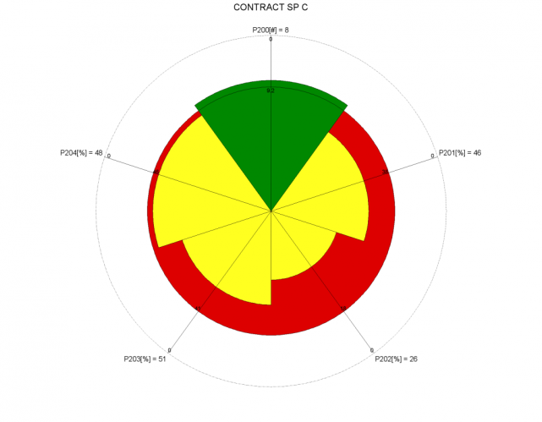 | 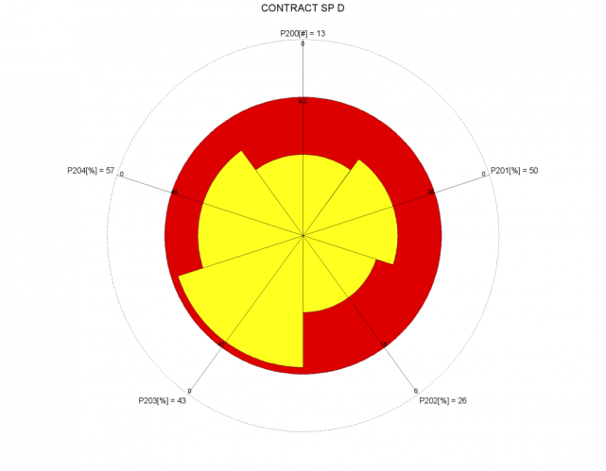

Figure 4: Contract CRS QoS comparison

5.2.4.5 Conclusion
These graphs show that SPC is the only one whose Contract Establishment QoS for telephony service is acceptable in all aspects..

5.3 Service management - Service provisioning
The QoS parameters used for this stage are the following:
P300 Frequency of customer complaints about provisioning [N/t]:
Measure: Number of customers' complaints about provisioning per million subscribers
P303a Provisioning time [Time & %] - existing subscriber line
Measure: the time by which the fastest 95 % of orders are completed
P303b Provisioning time [Time & %] - new subscriber line
Measure: the time by which the fastest 95 % of orders are completed
P309a Successful provisioning within a specified period [%] - existing subscriber line
Measure: % Successful provisioning within 20 days
P309b Successful provisioning within a specified period [%] - new subscriber line
Measure: % Successful provisioning within 20 days
The values obtained for the 4 SP under study given hereafter are taken from a wider set of operators. The calculations of the QoS reference thresholds, maximum and minimum are coming from the whole set and not only from the 4 SP:
Table 3.1: Service provisioning results
 | P300 | P303a | P303b | P309a | P309b
SP A | 22.3 | 25.7 | 42.7 | 89% | 75%
SP B | 11.4 | 21.0 | 62.0 | 95% | 48%
SP C | 9.0 | 10.8 | 22.7 | 98% | 94%
SP D | 12.6 | 16.9 | 28.8 | 97% | 85%
QoS max | 9.0 | 8.0 | 19.0 | 99% | 95%
QoS min | 22.3 | 26.9 | 66.0 | 88% | 44%

5.3.1 Reference threshold of each QoS parameter
In this example, as P303 and P309 have been assessed for each quarter of 2010, the best value of the quarterly assessments in the whole sample is taken as the reference threshold.
Table 3.2: Service provisioning QoS reference thresholds
 | P300 | P303a | P303b | P309a | P309b
Threshold | 13.8 | 13.9 | 26.2 | 97% | 90%

5.3.2 Highest QoS boundary of the range of each QoS parameter
Although no SP was able to reach the ideal value 0 for the QoS parameters P300 and P303 and 100% for P309, these targets have been taken as upper threshold for these QoS parameters since they are not too far from the current practices and figure out an aim to look at..
Table 3.3: Service provisioning Highest QoS boundaries
 | P300 | P303a | P303b | P309a | P309b
Highest QoS boundaries | 0 | 0 | 0 | 100% | 100%

5.3.3 Lowest QoS boundary of the range of each QoS parameter
For the P300 QoS parameter in this sample, the ratio between the QoS minimum and the reference threshold is lower than 2. Therefore higher values will be taken for the lowest QoS boundaries so that a ratio of 2 is obtained. For the other QoS parameters, the ratio between the QoS minimum and the reference threshold is higher than 2 and therefore the minimum are kept as Lowest QoS boundaries.
Table 3.4: Service provisioning Lowest QoS boundaries
 | P300 | P303a | P303b | P309a | P309b
Lowest QoS boundaries | 27.6 | 27.8 | 66.0 | 88% | 44%

5.3.4 Aggregation of the Provisioning QoS assessment results

5.3.4.1 Comparison Table
Taking into account the values from the previous tables, the results reaching a QoS above or equal to the reference thresholds are shown in green in the table 3.5:
Table 3.5: Provisioning QoS better than the reference thresholds
 | P300 | P303a | P303b | P309a | P309b
SP A | 22.3 | 25.7 | 42.7 | 89% | 75%
SP B | 11.4 | 21.0 | 62.0 | 95% | 48%
SP C | 9.0 | 10.8 | 22.7 | 98% | 94%
SP D | 12.6 | 16.9 | 28.8 | 97% | 85%
Threshold | 13.8 | 13.9 | 26.2 | 97% | 90%
In this case the best Provisioning QoS for this service is provided by SPC.

5.3.4.2 QoS indexes
The same principles as for the previous CRS are used to determine the QoS indexes of the Provisioning CRS that appear in the table 3.6.
Table 3.6: Provisioning QoS indexes
 | P300 | P303a | P303b | P303 | P309a | P309b | P309 | Overall
SP A | 0.39 | 0.15 | 0.59 | 0.4 | 0.09 | 0.67 | 0.38 | 0.38
SP B | 1.18 | 0.49 | 0.10 | 0.3 | 0.71 | 0.09 | 0.40 | 0.62
SP C | 1.35 | 1.23 | 1.13 | 1.2 | 1.43 | 1.36 | 1.40 | 1.31
SP D | 1.08 | 0.79 | 0.93 | 0.9 | 0.96 | 0.88 | 0.92 | 0.96
P303 values are the mean values of P303a and P303b, while P309 values are the mean values of P309a and P309b. The overall values are the mean values of P300, P303 and P309.
As for the previous CRS, these values will be used to draw the graphical representations showing the Provisioning QoS of the service provided by the 4 SP in clause 5.3.4.3 while the overall QoS indexes will be used for the graphical representations showing the QoS of all the CRS of a service given in clause 6.

5.3.4.3 Radar type graphical representation
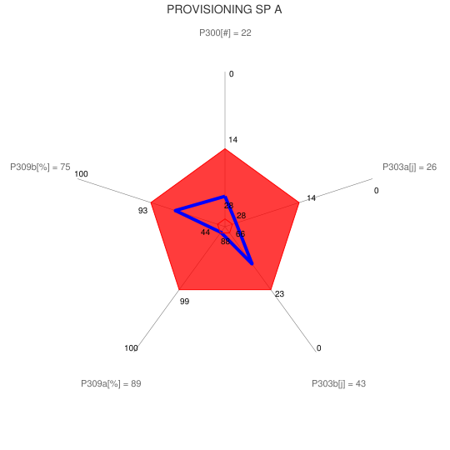 | 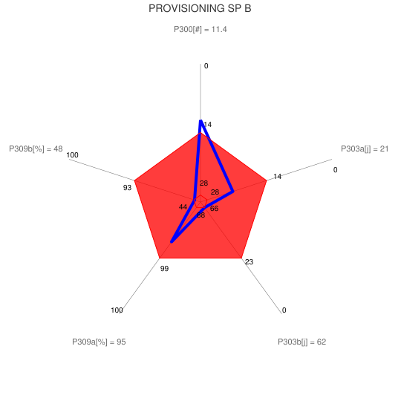
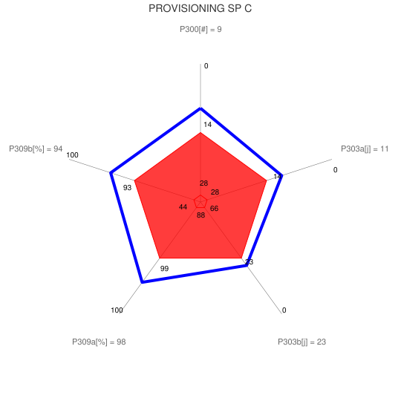 | 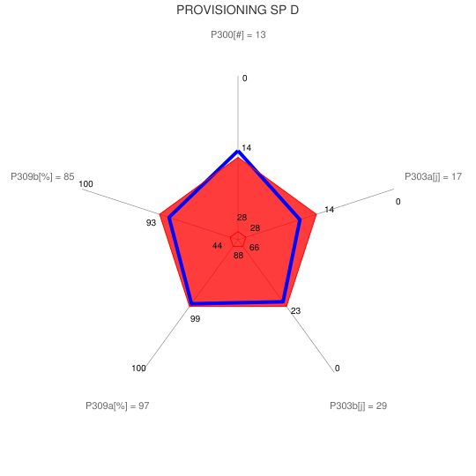
Figure 5: Provisioning CRS QoS comparison

5.3.4.4 OVV type graphical representation
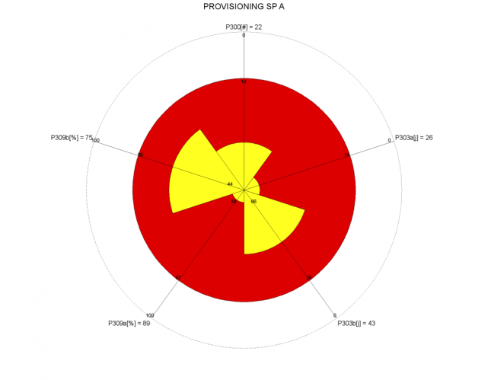 | 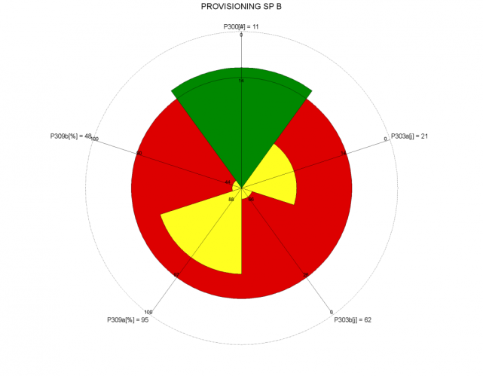
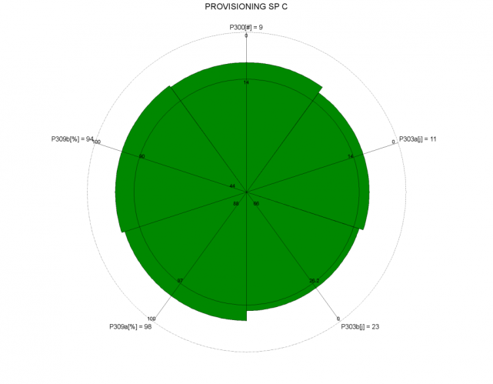 | 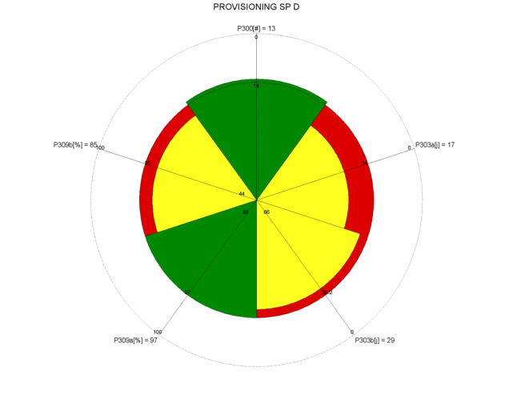
Figure 6: Provisioning CRS QoS comparison

5.3.4.5 Conclusion
The comparison of the graphs for the 4SP shows clearly their strengths and weaknesses with regard to the Provisioning QoS of the telephony service. In this regard SPC is the only one whose provisioning QoS for telephony service is satisfactory in all aspects.

5.4 Service use (technical QoS)
The QoS parameters used for this stage are the following:
PT000 Frequency of customer complaints related to use of service [N/t]:
Measure: Number of customer's complaints related to use of service per million subscribers
PT001a Fault report rate per fixed access lines [%]
PT001b Fault report rate per fixed access lines within 30 days after the delivery [%]
PT002a unsuccessful call ratio - domestic calls [%]
PT002b unsuccessful call ratio - international calls [%]
PT003a call set up time - domestic calls [Time]
PT003b call set up time - international calls [Time]
PT004 Speech Quality [MOS]
The values obtained for the 4 SP under study given hereafter are taken from a wider set of operators. The calculations of the QoS reference thresholds, maximum and minimum are coming from the whole set and not only from the 4 SP:
Table 4.1: Service use results
 | PT000 | PT001a | PT001b | PT002a | PT002b | PT003a | PT003b | PT004
SP A | 16,1 | 2,8% | 14,0% | 0,3% | 0,9% | 1,7 | 3,7 | 4,3
SP B | 13,1 | 1,8% | 12,4% | 0,1% | 0,4% | 1,3 | 8,5 | 4,2
SP C | 7,8 | 1,8% | 10,8% | 0,2% | 1,3% | 1,3 | 7,6 | 4,3
SP D | 13,1 | 2,6% | 12,6% | 0,1% | 0,4% | 1,2 | 1,2 | 4,3
QoS max | 0,0 | 0,6% | 2,5% | 0,0% | 0,1% | 0,9 | 1,1 | 4,4
QoS min | 16,1 | 4,9% | 16,4% | 2,0% | 2,1% | 1,8 | 8,7 | 4,1

5.4.1 Reference threshold of each QoS parameter
In this example, the PT000 reference threshold is the mean value of the 4 SP. As PT001, PT002 and PT003 are taken from a wider sample and have been assessed for each quarter of 2010, the best value of the quarterly assessments in the whole sample has been taken as the reference threshold. Finally, as PT004 is a MOS value, 3.8 is a recognized QoS threshold for voice quality and has been taken as the reference threshold.
Table 4.2: Service use QoS reference thresholds
 | PT000 | PT001a | PT001b | PT002a | PT002b | PT003a | PT003b | PT004
Threshold | 12.5 | 1% | 10% | 0.2% | 0.3% | 1.3 | 4.7 | 3.8

5.4.2 Highest QoS boundary of the range of each QoS parameter
Although no SP was able to reach the ideal value 0 for the QoS parameters PT000 and PT001 and PT002, this target has been taken as upper threshold for these QoS parameters since it is not too far from the current practices and figure out an aim to look at. The best QoS value from the calculation will be kept for PT003 and 5 as the maximum of the MOS range for PT004.
Table 4.3: Service use Highest QoS boundaries
 | PT000 | PT001a | PT001b | PT002a | PT002b | PT003a | PT003b | PT004
Highest QoS boundaries | 0 | 0% | 0% | 0% | 0% | 0.7 | 1.1 | 5

5.4.3 Lowest QoS boundary of the range of each QoS parameter
For the PT000, PT001b and PT003a QoS parameters in this sample, the ratio between the QoS minimum and the reference threshold is lower than 2. Therefore higher values will be taken for the lowest QoS boundaries so that a ratio of 2 is obtained. For the other QoS parameters, the ratio between the QoS minimum and the reference threshold is higher than 2 and therefore the minimum are kept as Lowest QoS boundaries.
Table 4.4: Service use Lowest QoS boundaries
 | PT000 | PT001a | PT001b | PT002a | PT002b | PT003a | PT003b | PT004
Lowest QoS boundaries | 25 | 4.9% | 20.0% | 2.0% | 2.1% | 2.6 | 9.4 | 1

5.4.4 Aggregation of the Service use QoS assessment results

5.4.4.1 Comparison Table
Taking into account the values from the previous tables, the results reaching a QoS above or equal to the reference thresholds are shown in green in the table 4.5:
Table 4.5: Service use QoS better than the reference thresholds
 | PT000 | PT001a | PT001b | PT002a | PT002b | PT003a | PT003b | PT004
SP A | 16.1 | 2.8% | 14.0% | 0.3% | 0.9% | 1.7 | 3.7 | 4.3
SP B | 13.1 | 1.8% | 12.4% | 0.1% | 0.4% | 1.3 | 8.5 | 4.2
SP C | 7.8 | 1.8% | 10.8% | 0.2% | 1.3% | 1.3 | 7.6 | 4.3
SP D | 13.1 | 2.6% | 12.6% | 0.1% | 0.4% | 1.2 | 1.2 | 4.3
Threshold | 12.5 | 1.4% | 10% | 0.2% | 0.3% | 1.3 | 4.7 | 3.8
NOTE: For the understanding of this table, it is important to bear in mind that there are other SP in the sample assessed that are not in this table but can have achieved a better QoS than those in the table.
In this example, no SP is clearly better than the other ones.

5.4.4.2 QoS indexes
The same principles as for the previous CRS are used to determine the QoS indexes of the Service use CRS that appear in the table 4.6.
Table 4.6: Service use QoS indexes
 | PT000 | PT001a | PT001b | PT001 | PT002a | PT002b | PT002 | PT003a | PT003b | PT003 | PT004 | Overall
SP A | 0.71 | 0.61 | 0.60 | 0.6 | 0.9 | 0.7 | 0.8 | 0.7 | 1.3 | 1.0 | 1.4 | 0.91
SP B | 0.95 | 0.89 | 0.76 | 0.8 | 1.5 | 0.9 | 1.2 | 1.0 | 0.2 | 0.6 | 1.3 | 0.99
SP C | 1.37 | 0.89 | 0.92 | 0.9 | 1.0 | 0.4 | 0.7 | 1.0 | 0.4 | 0.7 | 1.4 | 1.02
SP D | 0.95 | 0.67 | 0.75 | 0.7 | 1.7 | 0.9 | 1.3 | 1.2 | 2.0 | 1.6 | 1.4 | 1.19
PT001 values are the mean values of PT001a and PT001b, while PT002 values are the mean values of PT002a and PT002b and PT003 values are the mean values of PT003a and PT003b. The overall values are the mean values of PT000, PT001, PT002, PT003 and PT004.
As for the previous CRS, these values will be used to draw the graphical representations showing the Service use QoS of the service provided by the 4 SP in clause 5.4.4.3 while the overall QoS indexes will be used for the graphical representations showing the QoS of all the CRS of a service given in clause 6.

5.4.4.3 Radar type graphical representation
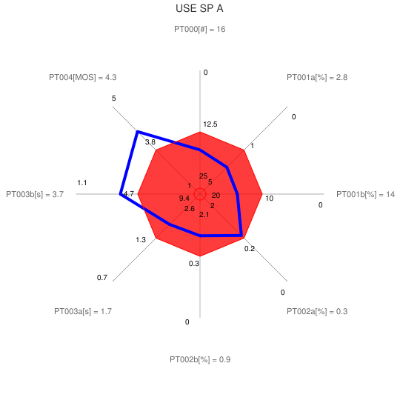 | 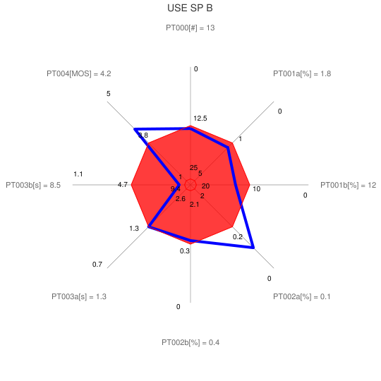
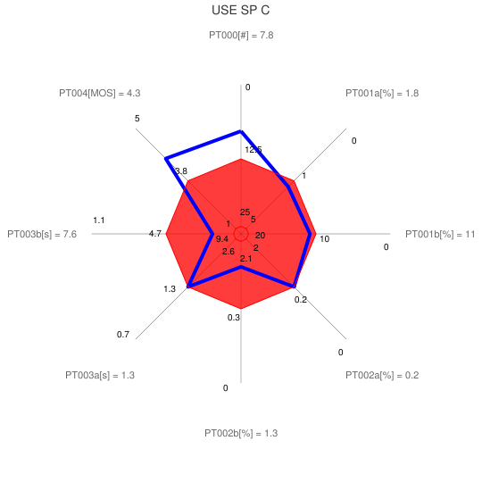 | 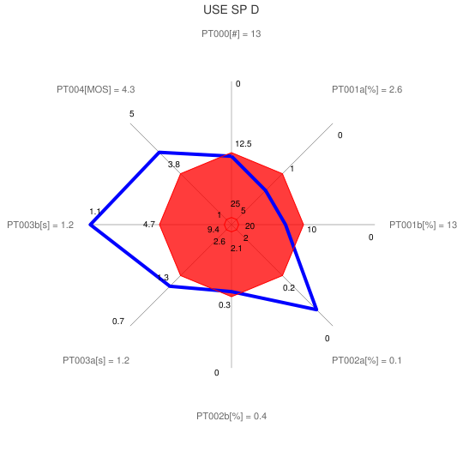
Figure 7: Use CRS QoS comparison

5.4.4.4 OVV type graphical representation
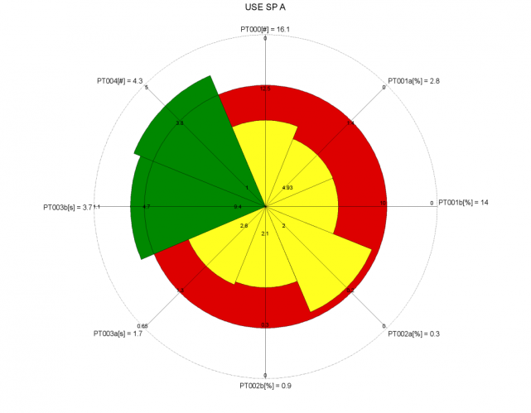 | 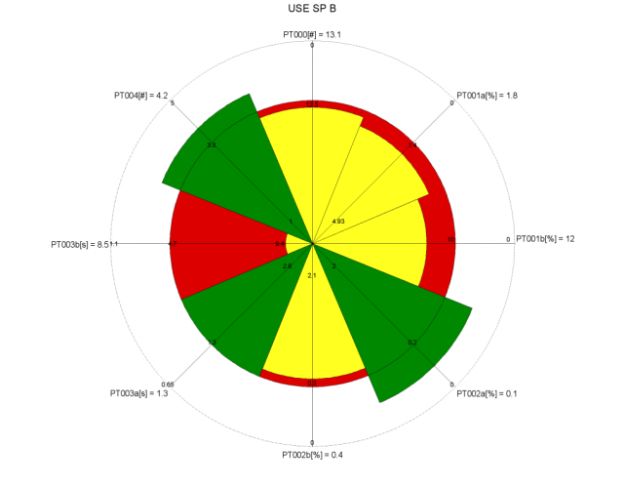
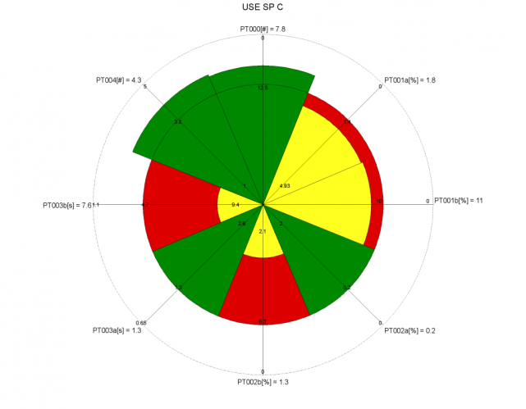 | 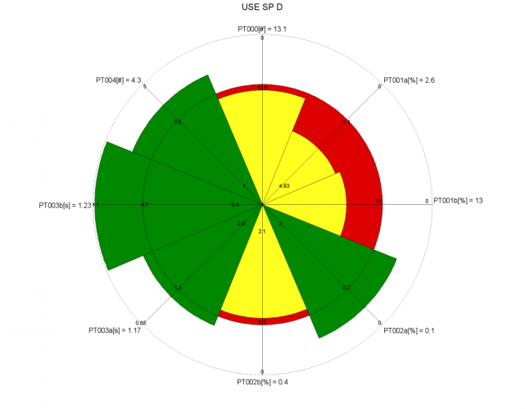
Figure 8: Use CRS QoS comparison

5.6.4.4.5 Conclusion
These graphs show that despite weakness on some aspects, SPD provides a better Telephony Service Use QoS than the other SP.

5.5 Service management - Customer Support
The QoS parameters used for this stage are the following:
P600 Frequency of customer complaints about service support [N/t]: Number of customers complaints about service support per million subscribers
P628a Response time of the technical support [Time & %]
Measure: Time elapsed between the end of dialling and reaching a technical operator
P628b Response time of the technical support [Time & %]
Measure:
P661 Accessibility of the complaint management desk [%]:
Question: Concerning your latest attempt to access the complaint management desk of your service provider: Did you succeed in accessing it?
Measure: % NO
P662 Recognition of the customer complaints [%]:
Question: Concerning your latest attempt to access the complaint management desk of your service provider: Was your complaint accepted?
Measure: % NO
P663 Complaint solutions not complete and correct first time [%]:
Question: Was the complaint solved to your satisfaction at the first attempt by the service provider?
Measure: % NO
P664 Complaint solutions achieved within a specified period [%]:
Question: Concerning your latest accepted complaint: Was the complaint finally solved to your satisfaction by the service provider?
Measure: % NO
P665 Integrity of complaint resolution [%]:
Question: Concerning your latest accepted complaint: Was your complaint resolved correctly?
Measure: % NO
P666a Customer perception of the complaint management [OR]:
Question: Customer perception of complaint management (Assurance): How would your rate the service provider's complaint management related to assurance at all?
Measure: % OR ≤ 3
P666b Customer perception of the complaint management [OR]:
Question: Customer perception of complaint management (Empathy): How would your rate the service provider's complaint management related to empathy at all?
Measure: % OR ≤ 3
P666c Customer perception of the complaint management [OR]:
Question: Customer perception of complaint management (Responsiveness): How would your rate the service provider's complaint management related to responsiveness at all?
Measure: % OR ≤ 3
P667 Overall quality of the complaint management process [OR]:
Question: How would your rate the overall
Measure: % OR ≤ 3
Some values obtained for the 4 SP under study given hereafter are taken from a wider set of operators. The calculations of the QoS reference thresholds, maximum and minimum are coming from the whole set and not only from the 4 SP:
Table 5.1: Customer Support results
 | P600 | P628a | P628b | P661 | P662 | P663a | P663b | P664 | P665 | P666a | P666b | P666c | P667
SP A | 3.71 | 02:13 | 88% | 15% | 16% | 17% | 93% | 9% | 9% | 8.3% | 7.7% | 18% | 18%
SP B | 2.79 | 01:45 | 84% | 32% | 46% | 57% | 90% | 38% | 38% | 58% | 58% | 65% | 68%
SP C | 2.53 | 03:25 | 84% | 21% | 27% | 57% | 94% | 28% | 28% | 42% | 45% | 45% | 54%
SP D | 3.10 | 01:12 | 93% | 16% | 33% | 58% | 90% | 36% | 36% | 57% | 57% | 57% | 55%
Q max | 2.53 | 00:47 | 95% | 15% | 17% | 17% | 94% | 9% | 9% | 8% | 8% | 18% | 18%
Q min | 3.71 | 06:12 | 53% | 32% | 46% | 58% | 85% | 38% | 38% | 58% | 58% | 65% | 68%

5.5.1 Reference threshold of each QoS parameter
In this example, the reference thresholds are the mean value of the 4 SP for all QoS parameters except P628a, P628b and P663b. As P628a, P628b and P663b are taken from a wider sample and have been assessed for each quarter of 2010, the best value of the quarterly assessments in the whole sample has been taken as the reference threshold.
Table 5.2: Customer Support QoS reference thresholds
 | P600 | P628a | P628b | P661 | P662 | P663a | P663b | P664 | P665 | P666a | P666b | P666c | P667
Threshold | 3.0 | 02:01 | 89% | 22% | 31% | 47% | 90% | 28% | 28% | 41% | 42% | 46% | 49%

5.5.2 Highest QoS boundary of the range of each QoS parameter
Although no SP was able to reach the ideal value 0 for the QoS parameters P600, P661 to P667, this target has been taken as upper threshold for these QoS parameters since it is not too far from the current practices and figure out an aim to look at. Similarly 100% has been taken as upper threshold for parameters P628b and P663b. A reference threshold of 20 seconds has been taken for P628a as a widely accepted reference threshold for response time of the helpdesk.
Table 5.3: Customer Support Highest QoS boundaries
 | P600 | P628a | P628b | P661 | P662 | P663a | P663b | P664 | P665 | P666a | P666b | P666c | P667
Highest QoS boundaries | 0 | 00:20 | 100% | 0% | 0% | 0% | 100% | 0% | 0% | 0% | 0% | 0% | 0%

5.5.3 Lowest QoS boundary of the range of each QoS parameter
For all the QoS parameters in this sample, except P626a and P626b, the ratio between the QoS minimum and the reference threshold is lower than 2. Therefore higher values have been taken for the lowest QoS boundaries so that a ratio of 2 is obtained. For P626a and P626b QoS parameters, the ratio between the QoS minimum and the reference threshold is higher than 2 and therefore the minimum are kept as Lowest QoS boundaries.
Table 5.4: Customer Support Lowest QoS boundaries
 | P600 | P628a | P628b | P661 | P662 | P663a | P663b | P664 | P665 | P666a | P666b | P666c | P667
Lowest QoS boundaries | 6,0 | 06:12 | 53% | 43% | 61% | 94% | 80% | 55% | 55% | 82% | 84% | 93% | 98%

5.5.4 Aggregation of the Customer Support QoS assessment results

5.5.4.1 Comparison Table
Taking into account the values from the previous tables, the results reaching a QoS above or equal to the reference thresholds are shown in green in the table 5.5:
Table 5.5: Customer Support QoS better than the reference thresholds
 | P600 | P628a | P628b | P661 | P662 | P663a | P663b | P664 | P665 | P666a | P666b | P666c | P667
SP A | 3.71 | 02:13 | 88% | 15% | 16% | 17% | 93% | 9% | 9% | 8.3% | 7.7% | 18% | 18%
SP B | 2.79 | 01:45 | 84% | 32% | 46% | 57% | 90% | 38% | 38% | 58% | 58% | 65% | 68%
SP C | 2.53 | 03:25 | 84% | 21% | 27% | 57% | 94% | 28% | 28% | 42% | 45% | 45% | 54%
SP D | 3.10 | 01:12 | 93% | 16% | 33% | 58% | 90% | 36% | 36% | 57% | 57% | 57% | 55%
Threshold | 3.0 | 02:01 | 89% | 22% | 31% | 47% | 90% | 28% | 28% | 41% | 42% | 46% | 49%
NOTE: For the understanding of this table, the reader should bear in mind that there are other SP in the sample assessed that are not in this table but can have achieved a better QoS than those in this table.
Regarding the Customer Support QoS for telephony service, SPA appears the best.

5.5.4.2 QoS indexes
The same principles as for the previous CRS are used to determine the QoS indexes of the Customer Support CRS that appear in the table 5.7. Nevertheless, due to the number of parameters, those resulting from multiple indicators have been consolidated in a separate table (5.6).
Table 5.6: Consolidation of P628, P663 and P666 Customer Support QoS indexes
 | P628a | P628b | P628 | P663a | P663b | P663 | P666a | P666b | P666c | P666
SP A | 0.95 | 0.98 | 0.97 | 1.64 | 1.28 | 1.46 | 1.80 | 1.82 | 1.61 | 1.74
SP B | 1.16 | 0.88 | 1.02 | 0.80 | 1.03 | 0.91 | 0.58 | 0.61 | 0.59 | 0.60
SP C | 0.66 | 0.86 | 0.76 | 0.80 | 1.39 | 1.09 | 0.99 | 0.92 | 1.03 | 0.98
SP D | 1.49 | 1.38 | 1.43 | 0.76 | 0.96 | 0.86 | 0.63 | 0.65 | 0.78 | 0.69

Table 5.7: Customer Support QoS indexes
 | P600 | P628 | P661 | P662 | P663 | P664 | P665 | P666 | P667 | Overall
SP A | 0.76 | 0.97 | 1.28 | 1.45 | 1.46 | 1.67 | 1.67 | 1.74 | 1.63 | 1.40
SP B | 1.07 | 1.02 | 0.51 | 0.50 | 0.91 | 0.64 | 0.64 | 0.60 | 0.61 | 0.72
SP C | 1.16 | 0.76 | 1.00 | 1.11 | 1.09 | 0.99 | 0.99 | 0.98 | 0.88 | 1.00
SP D | 0.97 | 1.43 | 1.21 | 0.93 | 0.86 | 0.70 | 0.70 | 0.69 | 0.88 | 0.93
As for the previous CRS, these values will be used to draw the graphical representations showing the Customer Support QoS of the service provided by the 4 SP in clause 5.5.4.3 while the overall QoS indexes will be used for the graphical representations showing the QoS of all the CRS of a service given in clause 6.

5.5.4.3 Radar type graphical representation
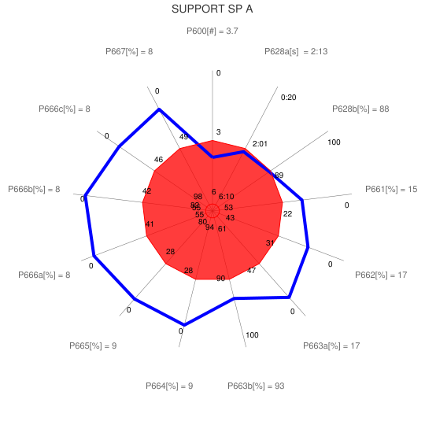 | 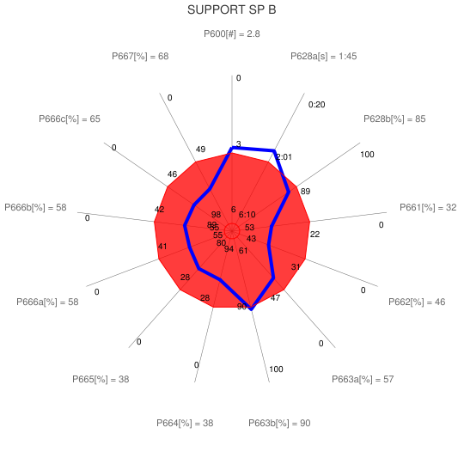
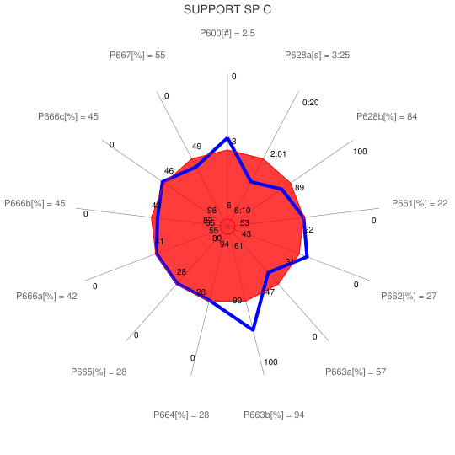 | 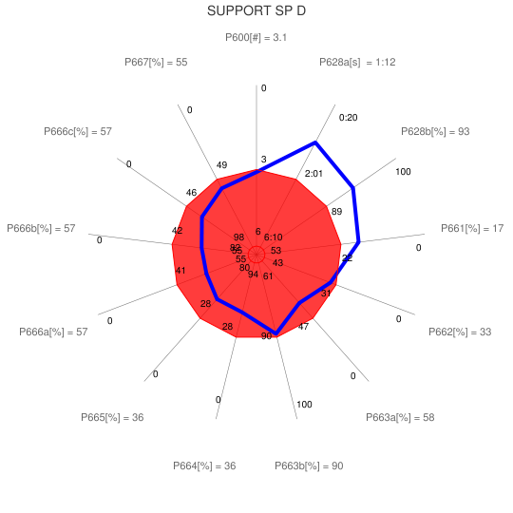
Figure 9: Customer support CRS QoS comparison

5.5.4.4 OVV type graphical representation
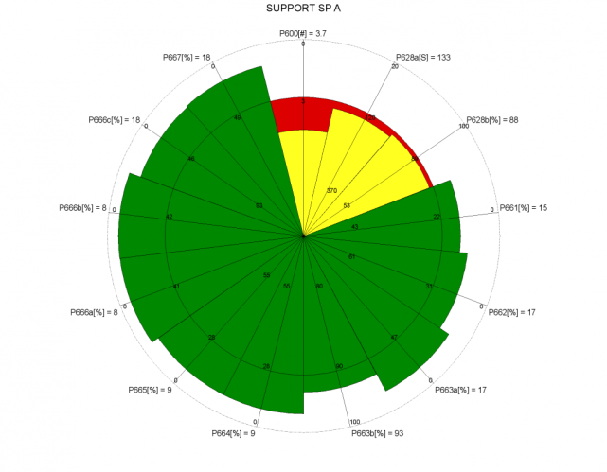 | 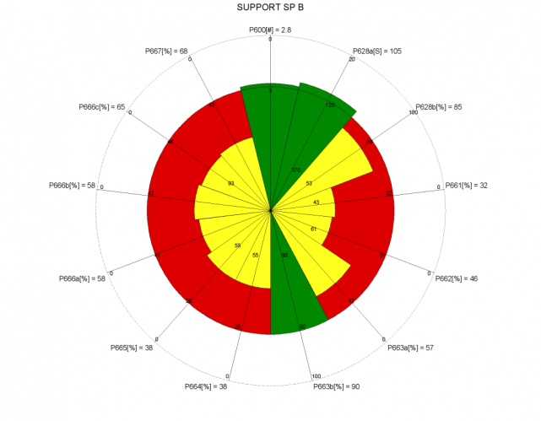
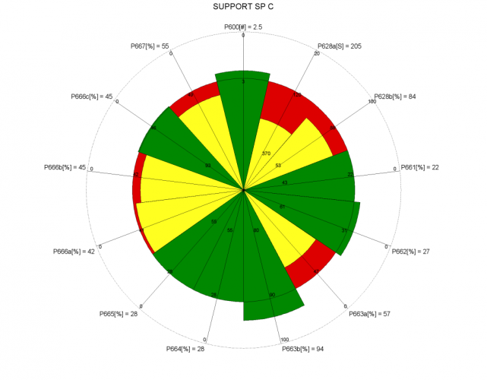 | 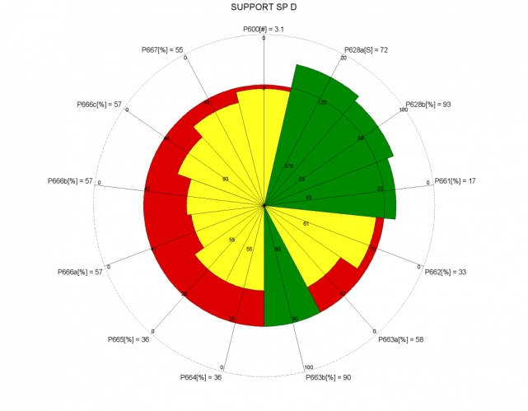
Figure 10: Customer support CRS QoS comparison

5.6.4.5 Conclusion
It appears that, despite its weakness on a few aspects SPA provides the best Customer Support QoS, followed by SPC.

5.6 Service management - Repair services
The QoS parameters used for this stage are the following:
P706a Fault repair time [Time & %] - Time for 95% fault repair
P706b Fault repair time [Time & %] - % faults repaired within a 48 hours delay.
P707 Frequency of customer complaints related to repair services [N/t]:
Measure: Number of customers' complaints related to repair services per million subscribers
Some values (P706a and P706b) obtained for the 4 SP under study given hereafter are taken from a wider set of operators. The calculations of the QoS reference thresholds, maximum and minimum are coming from the whole set and not only from the 4 SP:
Table 5.1: Repair results
 | P706a | P706b | P707
SP A | 8.4 | 90.2% | 6.19
SP B | 18.7 | 81.5% | 3.86
SP C | 11.5 | 68.6% | 1.65
SP D | 10.3 | 85.6% | 4.43
Q max | 5.4 | 94.2% | 1.65
Q min | 25.0 | 64.8% | 6.19

5.6.1 Reference threshold of each QoS parameter
In this example, the reference thresholds are the mean values of the 4 SP for QoS parameters P707 but P706a and P706b are taken from a wider sample and have been assessed for each quarter of 2010, the best value of the quarterly assessments in the whole sample has been taken as the reference threshold.
Table 6.2: Repair QoS reference thresholds
 | P706a | P706b | P707
Threshold | 4.0 | 10.80 | 84%

5.6.2 Highest QoS boundary of the range of each QoS parameter
Although no SP was able to reach the ideal value 100% for the QoS parameter P706a and 0 for the QoS parameter P707, these targets have been taken as upper threshold for these QoS parameters since they are not too far from the current practices and figure out an aim to look at.. Similarly 1 has been taken as upper threshold for parameters P706a as users are expecting a repair in a single day.
Table 6.3: Repair Highest QoS boundaries
 | P706a | P706b | P707
Highest QoS boundaries | 1 | 100% | 0

5.6.3 Lowest QoS boundary of the range of each QoS parameter
For the QoS parameter P707, the ratio between the QoS minimum and the reference threshold is lower than 2. Therefore higher values have been taken for the lowest QoS boundaries so that a ratio of 2 is obtained. For P706a and P706b QoS parameters, the ratio between the QoS minimum and the reference threshold is higher than 2 and therefore the minimum are kept as Lowest QoS boundaries.
Table 6.4: Repair Lowest QoS boundaries
 | P706a | P706b | P707
Lowest QoS boundaries | 25 | 65% | 8

5.6.4 Aggregation of the Repair service QoS assessment results

5.6.4.1 Comparison Table
Taking into account the values from the previous tables, the results reaching a QoS above or equal to the reference thresholds are shown in green in the table 6.5:
Table 6.5: Repair QoS better than the reference thresholds
 | P706a | P706b | P707
SP A | 8.4 | 90.2% | 6.2
SP B | 18.7 | 81.5% | 3.9
SP C | 11.5 | 68.6% | 1.7
SP D | 10.3 | 85.6% | 4.4
Threshold | 10.8 | 84% | 4
NOTE: For the understanding of this table, the reader should bear in mind that there are other SP in the sample assessed that are not in this table but can have achieved a better QoS than those in this table.
From this table, it is difficult to conclude which SP provides the best Repair QoS.

5.6.4.2 QoS indexes
The same principles as for the previous CRS are used to determine the QoS indexes of the Repair CRS that appear in the table 6.6. P706 values are the mean values of PT706a and P706b. The overall values are the mean values of P706 and P707.
Table 6.6: Repair QoS indexes
 | P706a | P706b | P706 | P707 | Overall
SP A | 1,25 | 1,38 | 1,32 | 0,45 | 0,88
SP B | 0,45 | 0,87 | 0,66 | 1,04 | 0,85
SP C | 0,95 | 0,20 | 0,57 | 1,59 | 1,08
SP D | 1,05 | 1,10 | 1,08 | 0,89 | 0,98
In this table the P706 values are the mean values of P706a and P706b. The overall value is the mean value of P706 and P707.
As for the previous CRS, these values will be used to draw the graphical representations showing the Customer Support QoS of the service provided by the 4 SP in clause 5.6.4.3 while the overall QoS indexes will be used for the graphical representations showing the QoS of all the CRS of a service given in clause 6.

5.6.4.3 Radar type graphical representation
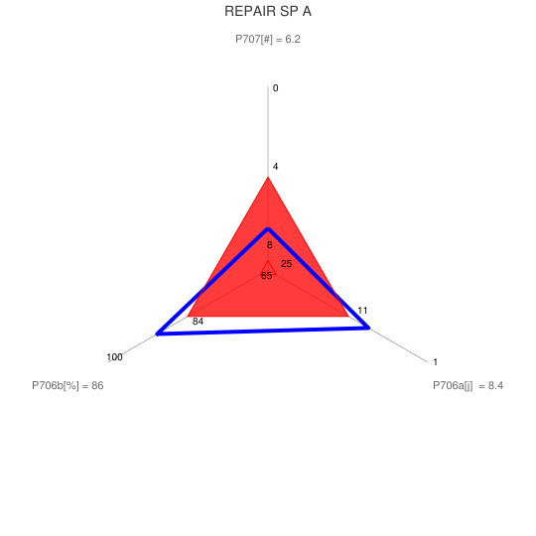 | 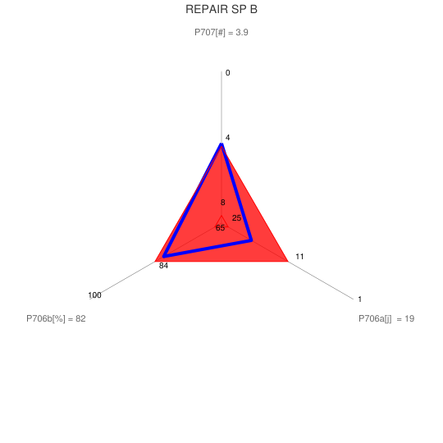
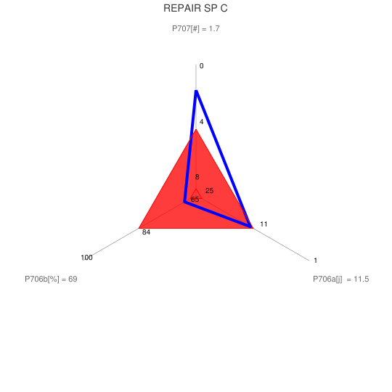 | 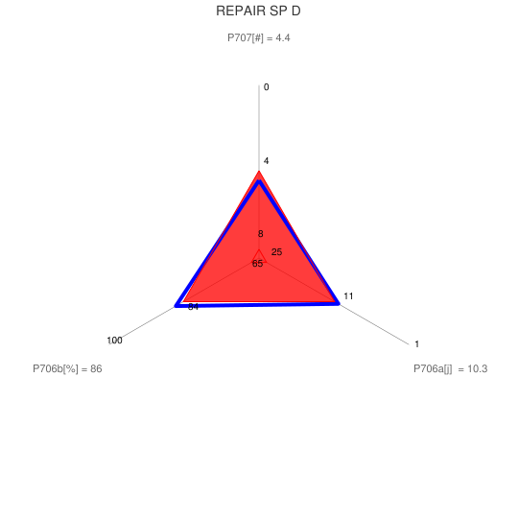
Figure 11: Repair CRS QoS comparison

5.6.4.4 OVV type graphical representation
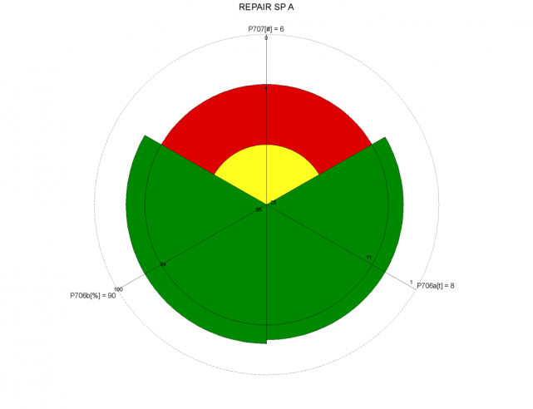 | 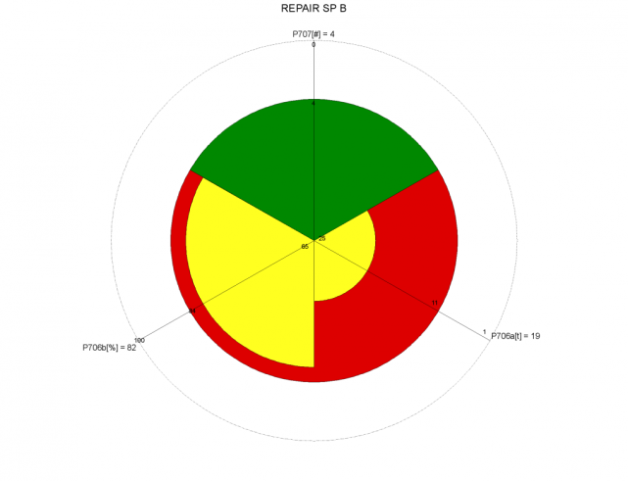
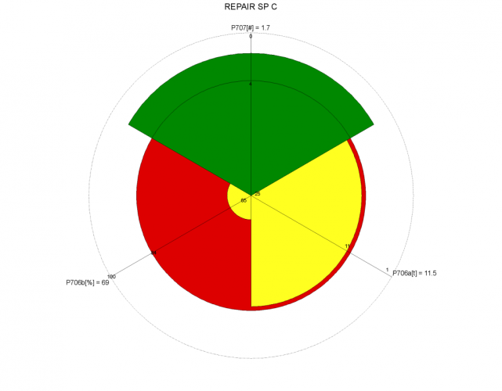 | 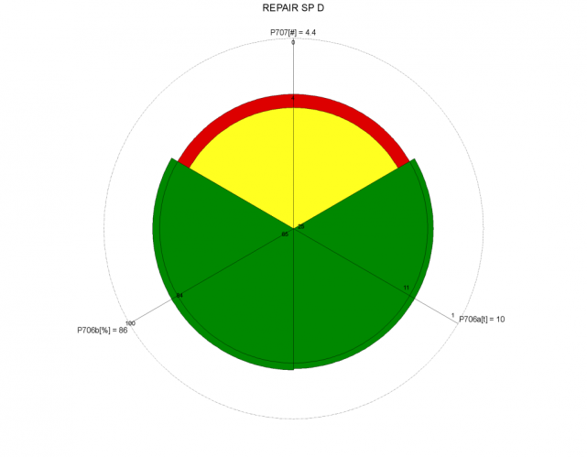
Figure 12: Repair CRS QoS comparison

5.6.4.5 Conclusion
These graphs show that despite weakness on some aspects, SPD provides a better Telephony Service Repair QoS than the other SP.

5.7 Service management - Metering, Charging and Billing
The QoS parameters used for this stage are the following:
P800 Frequency of customer complaints about billing [N/t]:
Measure: Number of customers complaints about billing per million subscribers
P801 Accessibility of the tariff information [%]:
Question: Concerning your latest attempt to access your provider's tariff information: Were you able to access the tariff information?
Measure: % NO
P802 Successful notification of exceeding billing budget [%]:
Question: If you are using a notification service when you reach a predefined budget level: Concerning your latest exceeding of budget: Were you notified accordingly when you exceeded your budget?
Measure: % NO
P804 Accessibility of the account management [%]:
Question: Concerning your latest attempt to access the account status at your service provider: Did you succeed in accessing it?
Measure: % NO
P806 Timeliness of bill delivery [%]:
Question: Did you receive all the expected bills throughout the last 6 months?
P807 Bill delivery delay [Time]:
Question: If you experienced a delay in bill delivery: How many days was the bill delayed?
Measure: Nb days of delay ≥ 1
P808 Late notification of amount due [%]:
Question: Has the bill been received before the direct debit was executed?
Measure: % NO
P809 Modes of billing information transfer [Number]:
Question: How many ways do you have to access your accounting information?
Measure: % OR=0
P810 Bill correctness complaints [%]:
Measure: Percentage of bills resulting in a customer complaint per point of billing per year.
P810 values obtained for the 4 SP under study given hereafter are taken from a wider set of operators. The calculations of the QoS reference thresholds, maximum and minimum are coming from the whole set and not only from the 4 SP:
Table 7.1: Metering, Charging and Billing results
 | P800 | P801 | P802 | P804 | P806 | P807 | P808 | P809 | P810
SP A | 12.4 | 8.3% | 56% | 7.1% | 7.1% | 9.1% | 31% | 0% | 0.09%
SP B | 32.4 | 22% | 79% | 17% | 33% | 14.3% | 42% | 4.5% | 0.04%
SP C | 17.3 | 37% | 60% | 17% | 14% | 17% | 20% | 8.2% | 0.07%
SP D | 31.8 | 20% | 74% | 16% | 13% | 10% | 13% | 1.9% | 0.01%
Q max | 12.4 | 8.3% | 55.6% | 7.1% | 7.1% | 9.1% | 13.2% | 0.0% | 0.01%
Q min | 32.4 | 37% | 79% | 17% | 33% | 17% | 42% | 8.2% | 0.09%

5.7.1 Reference threshold of each QoS parameter
In this example, the reference thresholds are the mean value of the 4 SP for all QoS parameters except P810. As P810 values are taken from a wider sample and have been assessed for each quarter of 2010, the best value of the quarterly assessments in the whole sample has been taken for reference threshold.
Table 7.2: Metering, Charging and Billing QoS reference thresholds
 | P800 | P801 | P802 | P804 | P806 | P807 | P808 | P809 | P810
Threshold | 23 | 22% | 67% | 14% | 17% | 13% | 27% | 3.7% | 0.04%

5.7.2 Highest QoS boundary of the range of each QoS parameter
Although no SP was able to reach the ideal value 0 for these QoS parameters, this target has been taken as upper threshold for these QoS parameters since it is not too far from the current practices and figure out an aim to look at.
Table 7.3: Metering, Charging and Billing Highest QoS boundaries
 | P800 | P801 | P802 | P804 | P806 | P807 | P808 | P809 | P810
Highest QoS boundaries | 0 | 0% | 0% | 0% | 0% | 0% | 0% | 0% | 0,00%

5.7.3 Lowest QoS boundary of the range of each QoS parameter
For all these QoS parameters except P809, the ratio between the QoS minimum and the reference threshold is lower than 2. Therefore higher values have been taken for the lowest QoS boundaries so that a ratio of 2 is obtained. For P809, the ratio between the QoS minimum and the reference threshold is higher than 2 and therefore the minimum has been kept as Lowest QoS boundary. For P802, 100% has been set for Lowest QoS boundary although this does not provide a 2 ratio.
Table 7.4: Metering, Charging and Billing Lowest QoS boundaries
 | P800 | P801 | P802 | P804 | P806 | P807 | P808 | P809 | P810
Lowest QoS boundaries | 46 | 44% | 100% | 29% | 34% | 25% | 54% | 9% | 0,18%

5.7.4 Aggregation of the Billing QoS assessment results

5.7.4.1 Comparison Table
Taking into account the values from the previous tables, the results reaching a QoS above or equal to the reference thresholds are shown in green in the table 5.5:
Table 7.5: Metering, Charging and Billing QoS better than the reference thresholds
 | P800 | P801 | P802 | P804 | P806 | P807 | P808 | P809 | P810
SP A | 12.4 | 8.3% | 56% | 7.1% | 7.1% | 9.1% | 31% | 0% | 0.09%
SP B | 32.4 | 22% | 79% | 17% | 33% | 14.3% | 42% | 4.5% | 0.04%
SP C | 17.3 | 37% | 60% | 17% | 14% | 17% | 20% | 8.2% | 0.07%
SP D | 31.8 | 20% | 74% | 16% | 13% | 10% | 13% | 1.9% | 0.01%
Threshold | 23 | 22% | 67% | 14% | 17% | 13% | 27% | 3.7% | 0.04%
SPA and SPB seem providing the better Metering, Charging and Billing QoS.

5.7.4.2 QoS indexes
The same principles as for the previous CRS are used to determine the QoS indexes of the Repair CRS that appear in the table 6.6.
Table 7.6: Metering, Charging and Billing QoS indexes
 | P800 | P801 | P802 | P804 | P806 | P807 | P808 | P809 | P810 | Overall
SP A | 1.47 | 1.62 | 1.17 | 1.50 | 1.58 | 1.27 | 0.83 | 2.00 | 0.64 | 1.3
SP B | 0.60 | 1.00 | 0.65 | 0.83 | 0.04 | 0.86 | 0.43 | 0.85 | 0.99 | 0.7
SP C | 1.26 | 0.32 | 1.11 | 0.83 | 1.20 | 0.66 | 1.26 | 0.15 | 0.79 | 0.8
SP D | 0.67 | 1.09 | 0.79 | 0.89 | 1.21 | 1.22 | 1.50 | 1.49 | 1.81 | 1.2
As for the previous CRS, these values will be used to draw the graphical representations showing the Metering, Charging and Billing QoS of the service provided by the 4 SP in clause 5.7.4.3 while the overall QoS indexes will be used for the graphical representations showing the QoS of all the CRS of a service given in clause 6.

5.7.4.3 Radar type graphical representation
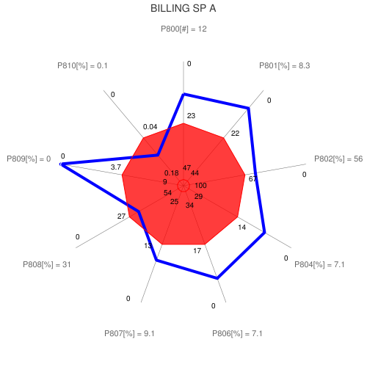 | 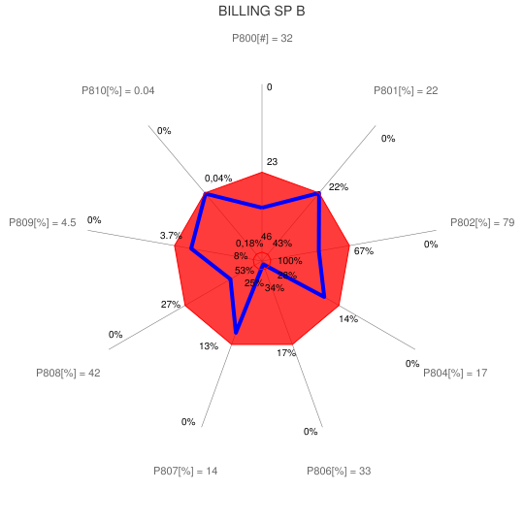
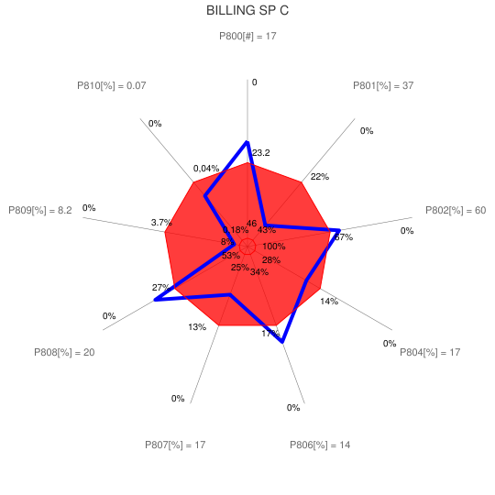 | 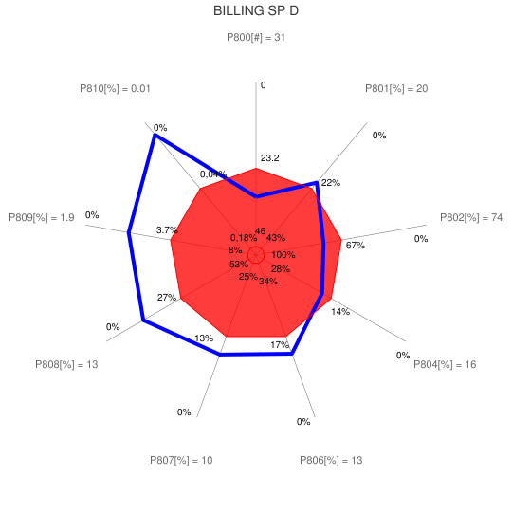
Figure 13: Billing CRS QoS comparison

5.7.4.4 OVV type graphical representation
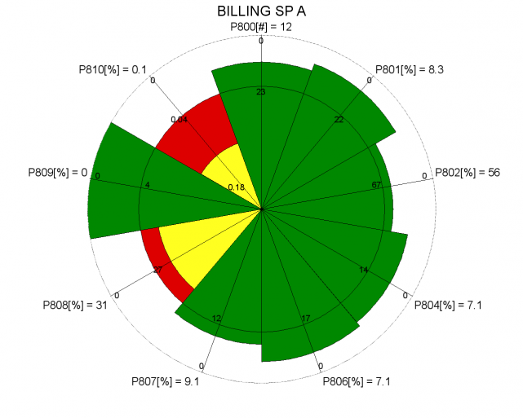 | 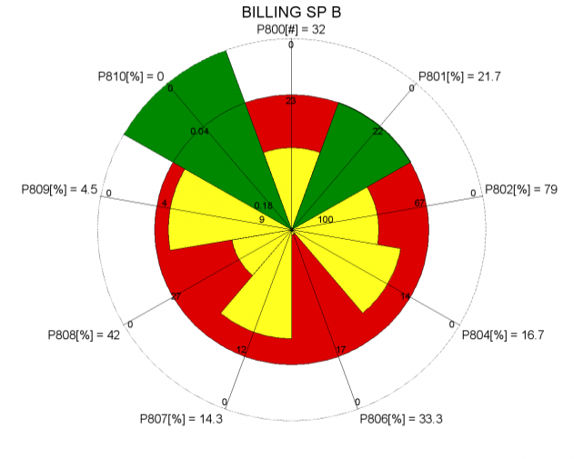
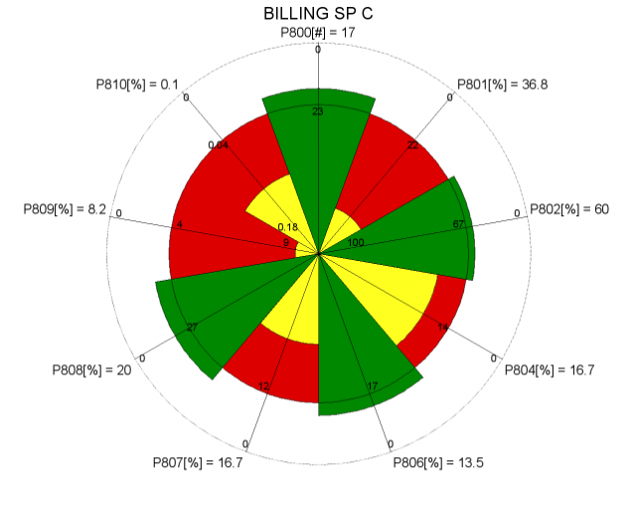 | 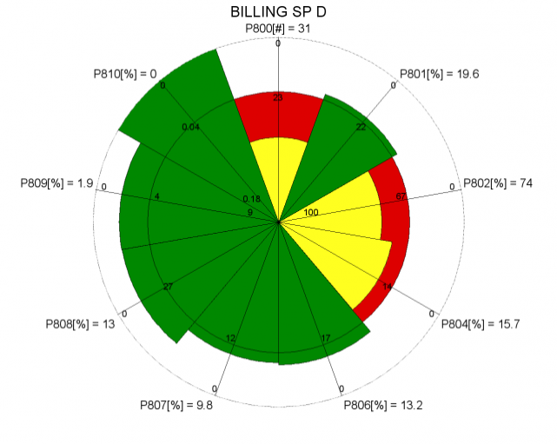
Figure 14: Billing CRS QoS comparison

5.8 Service management - Cessation
The QoS parameters used for this stage are the following:
P1004a Contractual cessation achieved within 10 days [%]
P1004b Contractual cessation achieved [%]:
Measure: time needed (days) to achieved 95% of cessations requested
P1004c Contractual cessation achieved [%]:
Measure: time needed (days) to achieved 99% of cessations requested
P1008 Frequency of customer complaints related to cessation [N/t]:
Measure: Number of customers' complaints related to cessation per million subscribers
Some values (P1004a, P1004b and P1004c) obtained for the 4 SP under study given hereafter are taken from a wider set of operators. The calculations of the QoS reference thresholds, maximum and minimum are coming from the whole set and not only from the 4 SP:
Table 8.1: Cessation results
 | P1004a | P1004b | P1004c | P1008
SP A | 31% | 15 | 18 | 9.9
SP B | 16% | 17 | 23 | 19.3
SP C | 14% | 15 | 22 | 7.9
SP D | 14% | 16 | 21 | 21
Q max | 14% | 15 | 18 | 8
Q min | 33% | 17 | 23 | 21

5.8.1 Reference threshold of each QoS parameter
In this example, the reference thresholds are the mean values of the 4 SP for QoS parameters P1008 but P1004a, P1004b and P1004c are taken from a wider sample and have been assessed for each quarter of 2010, the best value of the quarterly assessments in the whole sample has been taken as the reference threshold.
Table 8.2: Cessation QoS reference thresholds
 | P1004a | P1004b | P1004c | P1008
Threshold | 21% | 15 | 19 | 15

5.8.2 Highest QoS boundary of the range of each QoS parameter
Although no SP was able to reach the ideal value 0 for the QoS parameter P1004a and P1008, this target has been taken as upper threshold for these QoS parameters since it is not too far from the current practices and figure out an aim to look at.. Similarly 2 has been taken as upper threshold for parameters P1004b and P1004c since it is a value that SP should achieved shortly according to the EC Directives even it is currently quite far from the practices.
Table 8.3: Cessation Highest QoS boundaries
 | P1004a | P1004b | P1004c | P1008
Highest QoS boundaries | 0% | 2 | 2 | 0

5.8.3 Lowest QoS boundary of the range of each QoS parameter
For all these QoS parameter, the ratio between the QoS minimum and the reference threshold is lower than 2. Therefore higher values have been taken for the lowest QoS boundaries so that a ratio of 2 is obtained.
Table 8.4: Cessation Lowest QoS boundaries
 | P1004a | P1004b | P1004c | P1008
Lowest QoS boundaries | 42% | 30 | 38 | 30

5.8.4 Aggregation of the Cessation QoS assessment results

5.8.4.1 Comparison Table
Taking into account the values from the previous tables, the results reaching a QoS above or equal to the reference thresholds are shown in green in the table 8.5:
Table 8.5: Cessation QoS better than the reference thresholds
 | P1004a | P1004b | P1004c | P1008
SP A | 31% | 15 | 18 | 9.9
SP B | 16% | 17 | 23 | 19.3
SP C | 14% | 15 | 22 | 7.9
SP D | 14% | 16 | 21 | 21
Threshold | 21% | 15 | 19 | 15
NOTE: For the understanding of this table, the reader should bear in mind that there are other SP in the sample assessed that are not in this table but can have achieved a better QoS than those in this table.
From this table, it is difficult to conclude which SP provides the best Cessation QoS.

5.8.4.2 QoS indexes
The same principles as for the previous CRS are used to determine the QoS indexes of the Cessation CRS that appear in the table 8.6.
Table 8.6: Cessation QoS indexes
 | P1004a | P1004b | P1004c | P1004 | P1008 | Overall
SP A | 0.52 | 1.00 | 1.06 | 0,78 | 0.52 | 1,06
SP B | 1.24 | 0.87 | 0.79 | 1,04 | 1.24 | 0,87
SP C | 1.32 | 1.00 | 0.84 | 1,12 | 1.32 | 1,30
SP D | 1.34 | 0.93 | 0.89 | 1,13 | 1.34 | 0,85
In this table the P1004 values are calculated in two steps: first the mean values of P1004b and P1004c then the mean values of the previous results and P1004a. The overall value is the mean value of 1004 and P1008.
As for the previous CRS, these values will be used to draw the graphical representations showing the Cessation QoS of the service provided by the 4 SP in clause 5.8.4.3 while the overall QoS indexes will be used for the graphical representations showing the QoS of all the CRS of a service given in clause 6.

5.8.4.3 Radar type graphical representation
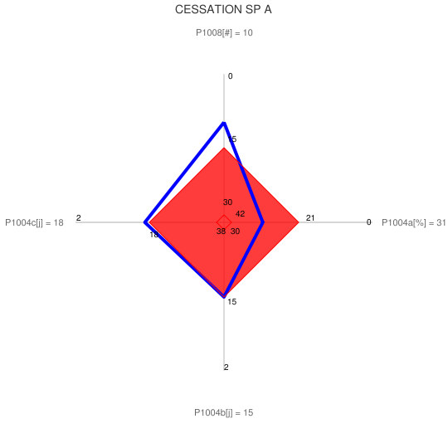 | 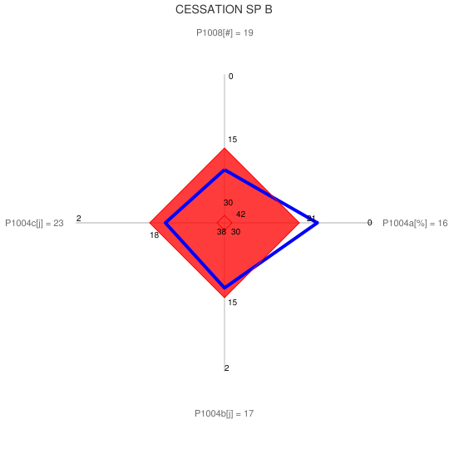
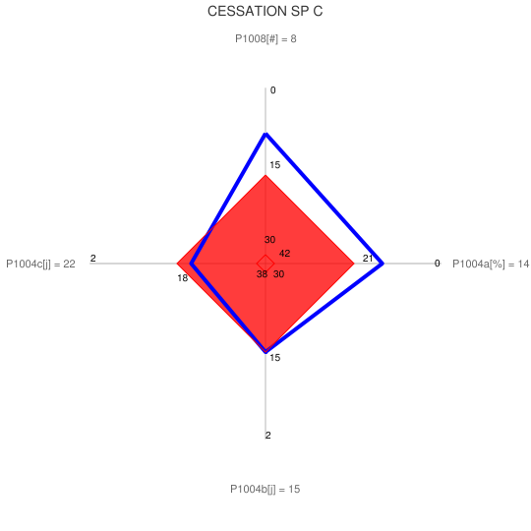 | 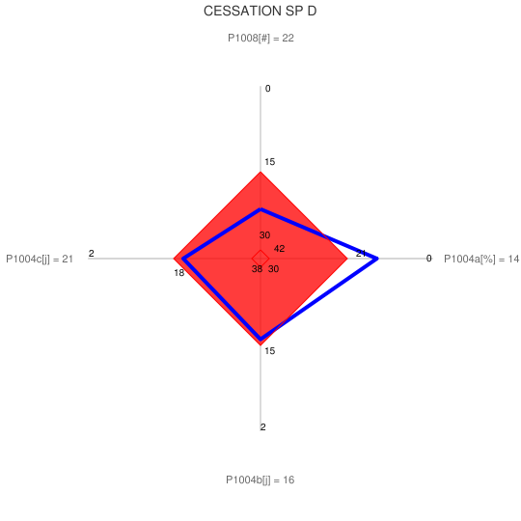
Figure 15: Cessation CRS QoS comparison

5.8.4.4 OVV type graphical representation
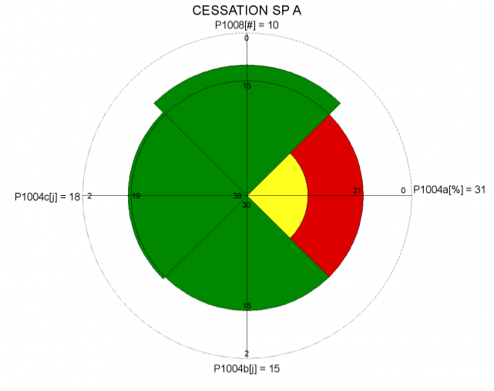 | 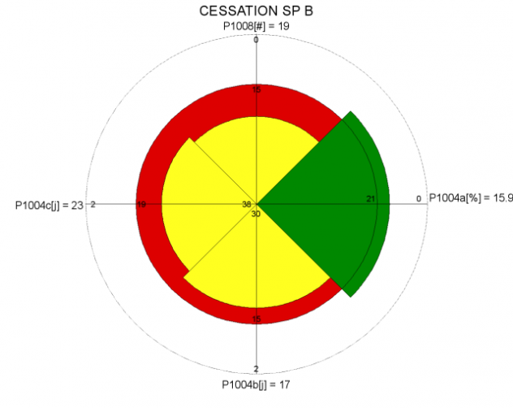
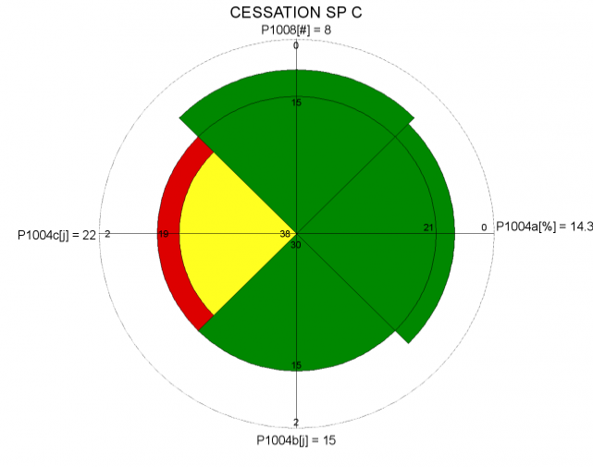 | 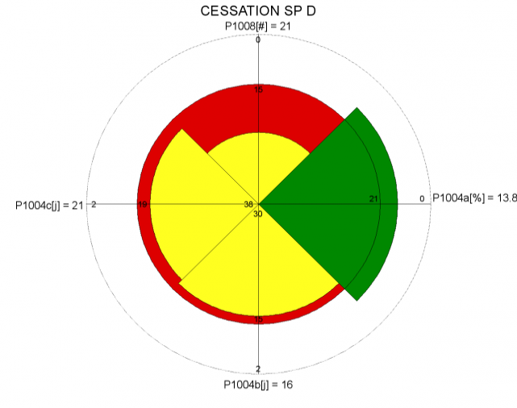
Figure 16: Cessation CRS QoS comparison

5.8.4.6 Conclusion
SPC is the only SP whose cancellation QoS for telephony service is satisfactory in almost all aspects.

6 Representation of the QoS results for the various CRS of a particular service
In this example, the comparison of the QoS of the telephony services of 4 SP is based on the QoS parameters detailed in clause 5 and summarized in table 6.1.
Table 6.1: List of QoS parameters used for the comparison of 4 telephony services
Preliminary information | Contract Establishment | Service provisioning | Service use (technical QoS) | Customer Support | Repair services | Metering. Charging. Billing | Cessation
P100 | P200 | P300 | PT000 | P600 | P706 | P800 | P1004
P101 | P201 | P303 | PT001 | P628 | P706a | P801 | P1004a
P101a | P202 | P303a | PT001a | P628a | P706b | P802 | P1004b
P101b | P203 | P303b | PT001b | P628b | P707 | P804 | P1004c
P101c | P204 | P309 | PT002 | P661 |  | P806 | P1008
P102 |  | P309a | PT002a | P662 |  | P807
P103 |  | P309b | PT002b | P663 |  | P808
 |  |  | PT003 | P664 |  | P809
 |  |  | PT003a | P665 |  | P810
 |  |  | PT003b | P666
 |  |  | PT004 | P666a
 |  |  |  | P666b
 |  |  |  | P666c
 |  |  |  | P667

This list should not be taken as a template as it is just a collection of assessments available for the comparison of the services taken as example. As explained in ETSI EG 202 934 [i.4], what is important is to achieve a collection of QoS parameters fully representative of the market segment considered and of the QoS criteria defined in ETSI EG 202 009-1 [i.1] as well as in clause 7 of ETSI EG 202 934 [i.4]. Therefore, such list can be enhanced depending of the available assessments.

6.1 QoS indexes and Comparison Table
Taking into account the values from the previous tables, the results reaching a QoS above or equal to the reference thresholds (i.e. QoS index >1) are shown in the green boxes of the table 6.2:
Table 6.2: consolidation of the QoS indexes of the telephony service of 4 SP
QoS indexes | Preliminary information | Contract Establishment | Service provision-ing | Service use (technical QoS) | Customer Support | Repair services | Metering Charging Billing | Cessation | Overall
SP A | 1.7 | 1.5 | 0.4 | 0.9 | 1.4 | 0.9 | 1.3 | 1.1 | 1.1
SP B | 1.1 | 0.9 | 0.6 | 1.0 | 0.7 | 0.8 | 0.7 | 0.9 | 0.8
SP C | 0.6 | 0.8 | 1.3 | 1.0 | 1.0 | 1.1 | 0.8 | 1.3 | 1.0
SP D | 0.7 | 0.7 | 1.0 | 1.2 | 0.9 | 1.0 | 1.2 | 0.9 | 0.9

These values will be used to draw the graphical representations given in clause 6.2 and showing the QoS of all the CRS of the telephony service provided by the 4 SP.
The overall QoS index is the mean value of all the QoS indexes of all the CRS. This overall value provides an general view of the QoS of the SP telephony service but, as explained in ETSI EG 202 934 [i.4], this single figure does not give any indication on the QoS of the different CRS. The whole table is necessary to identify what are the CRS where the QoS is complying to the agreed level or not. This is necessary to the user to check which service better meets his expectations with respect to each CRS. As a matter of fact, it is crucial to know when the overall QoS index value looks fine if there is no deep weakness in a specific CRS where the user expects a good QoS. The graphs shown in the clause 6.2 make such identification very easy.

6.2 Graphical representation

6.2.1 Radar type chart
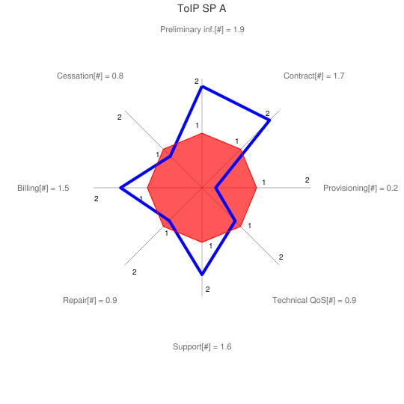 | 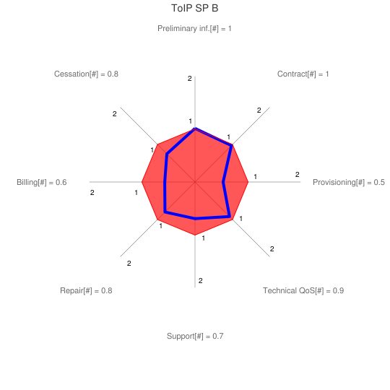
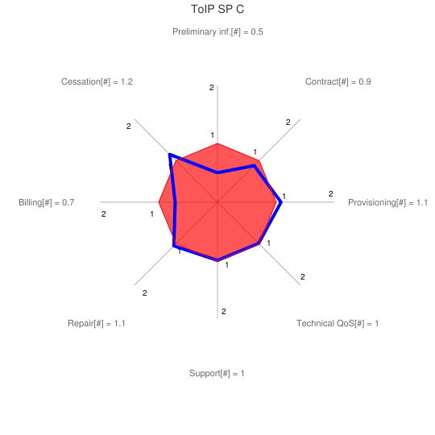 | 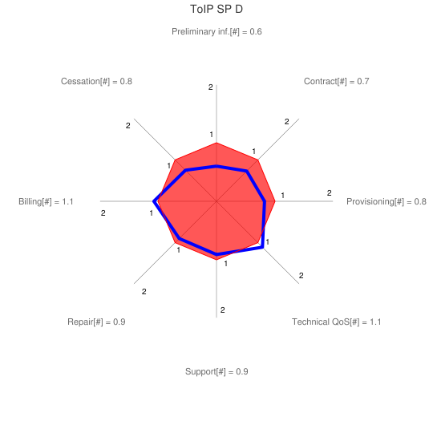
Figure 17: comparison of the QoS of 4 ToIP Services

6.2.2 OVV type graphical representation
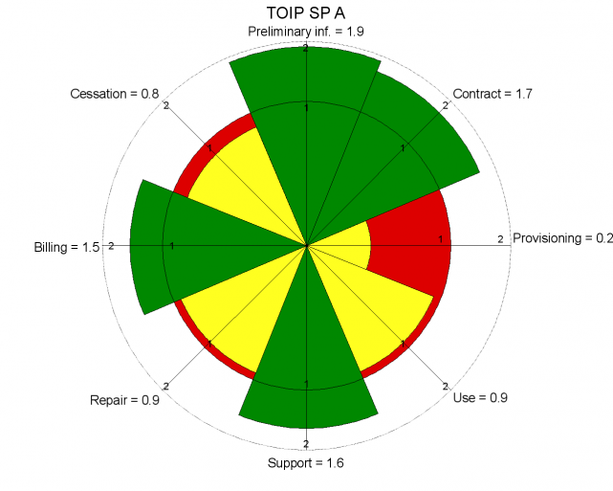 | 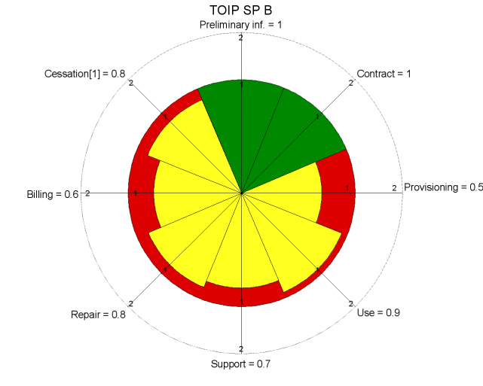
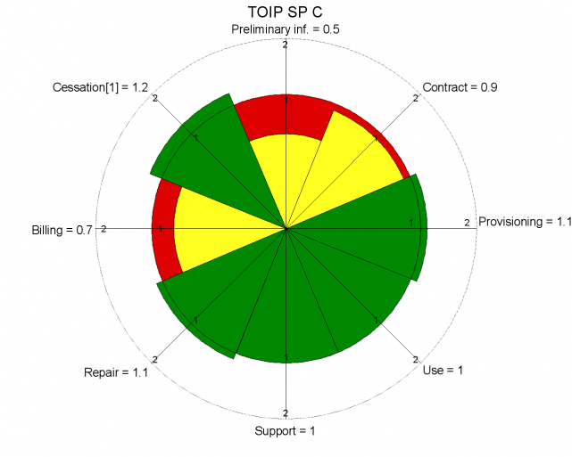 | 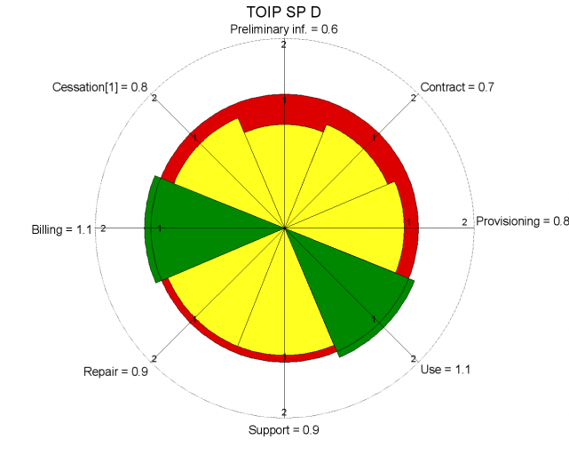
Figure 18: comparison of the QoS of 4 ToIP Services

6.2.3 Conclusion
These graphs show that the ToIP services provided by SP A and SP C have the best QoS despite some weaknesses. The ToIP from SP A has one deep weakness on provisioning and three smaller ones on cessation, repair and use. The ToIP from SP C has a QoS closer to the reference thresholds with its weaknesses on preliminary information, contract and billing. Therefore it is to the user to make his choice according to his specific expectations. The ToIP from SP D is farer from the reference thresholds than the previous ones but without any deep weaknesses and a stronger technical QoS.
Therefore, the user can make his choice according to his specific expectations. Nevertheless, he should keep in mind that the assessments used to determine these results were made on a wide sample of users and that the QoS achieved in his specific case can be different from the mean value, depending on his specific environment.

Annex A:
Bibliography
Google Chart Tools: are available at " http://code.google.com/intl/fr/apis/chart/image/docs/gallery/radar_charts.html ".
OVV Chart tools are available at " http://quality-pie.de/workplace/ "

History
Document history
V0.0.1 | 5/06/2011 | Early draft to UG#42
V0.0.2 | 7/06/2011 | Revision taking into account the discussions within UG#42
V0.0.3 | 10/06/2011 | Draft for STQ#37
V0.0.4 | September 2011 | Draft for UG#43
V0.0.5 | October 2011 | Draft revised within STQ#38
V0.0.6 | October 2011 | Draft revised after STQ#38
V0.0.7 | October 2011 | Draft revised in UG#43

