ETSI TR 103 437 V.0.0.2 (2018-11)
USER; Quality of ICT services;
Evaluation of reference values for a selection of services

TECHNICAL REPORT
Reference
<Workitem>
Keywords
<keywords>
ETSI
650 Route des Lucioles
F-06921 Sophia Antipolis Cedex - FRANCE

Tel.: +33 4 92 94 42 00 Fax: +33 4 93 65 47 16

Siret N° 348 623 562 00017 - NAF 742 C
Association à but non lucratif enregistrée à la
Sous-préfecture de Grasse (06) N° 7803/88

Important notice
The present document can be downloaded from:
http://www.etsi.org/standards-search
The present document may be made available in electronic versions and/or in print. The content of any electronic and/or print versions of the present document shall not be modified without the prior written authorization of ETSI. In case of any existing or perceived difference in contents between such versions and/or in print, the only prevailing document is the print of the Portable Document Format (PDF) version kept on a specific network drive within ETSI Secretariat.
Users of the present document should be aware that the document may be subject to revision or change of status. Information on the current status of this and other ETSI documents is available at https://portal.etsi.org/TB/ETSIDeliverableStatus.aspx.
If you find errors in the present document, please send your comment to one of the following services:
https://portal.etsi.org/People/CommiteeSupportStaff.aspx
Copyright Notification
No part may be reproduced or utilized in any form or by any means, electronic or mechanical, including photocopying and microfilm except as authorized by written permission of ETSI.
The content of the PDF version shall not be modified without the written authorization of ETSI.
The copyright and the foregoing restriction extend to reproduction in all media.

© European Telecommunications Standards Institute yyyy.
All rights reserved.
DECTTM, PLUGTESTSTM, UMTSTM and the ETSI logo are Trade Marks of ETSI registered for the benefit of its Members.
3GPPTM and LTE™ are Trade Marks of ETSI registered for the benefit of its Members and
of the 3GPP Organizational Partners.
GSM® and the GSM logo are Trade Marks registered and owned by the GSM Association.

Contents
1. Contents 3
Intellectual Property Rights 4
Foreword 4
Modal verbs terminology 4
Executive summary 4
Introduction 4
2. References 5
2.1 Normative references 5
2.2 Informative references 5
3. Definitions, symbols and abbreviations 6
3.1 Definitions 6
3.2 Symbols 6
3.3 Abbreviations 6
4. Service 6
4.1 Definition 6
4.2 Requirements 7
5. Service structuring : new way to design services 7
6. Service Modelling 8
6.1 Usage interface 8
6.2 Monitoring interface 8
6.3 Control and management interfaces 9
7. Design approach for “as-a-service" modelling 9
8. Calibration 11
8.1 QoS values (Conception and threshold values) 11
8.2 IMSaaS Assessment Results 11
9. Catalogue 12
9.1 MySQL Service 13
9.2 Service « digest access authentication ». 13
9.3 Image capture service 14
10. Service Composition (Service Architecture) 15
11. Annex : Title of annex 15
12. Annex : Bibliography 16
13. Annex : Change History 17
14. History 18

Intellectual Property Rights
IPRs essential or potentially essential to the present document may have been declared to ETSI. The information pertaining to these essential IPRs, if any, is publicly available for ETSI members and non-members, and can be found in ETSI SR 000 314: "Intellectual Property Rights (IPRs); Essential, or potentially Essential, IPRs notified to ETSI in respect of ETSI standards", which is available from the ETSI Secretariat. Latest updates are available on the ETSI Web server (https://ipr.etsi.org).
Pursuant to the ETSI IPR Policy, no investigation, including IPR searches, has been carried out by ETSI. No guarantee can be given as to the existence of other IPRs not referenced in ETSI SR 000 314 (or the updates on the ETSI Web server) which are, or may be, or may become, essential to the present document.

Foreword
This Technical Report (TR) has been produced by {ETSI Technical Committee|ETSI Project|<other>} <long techbody> (<short techbody>).

Modal verbs terminology
In the present document "should", "should not", "may", "need not", "will", "will not", "can" and "cannot" are to be interpreted as described in clause 3.2 of the ETSI Drafting Rules (Verbal forms for the expression of provisions).
"must" and "must not" are NOT allowed in ETSI deliverables except when used in direct citation.

Executive summary

Introduction

Nowadays, the user is at the center of the architecture. He has access to any service, from any network and by any means, from anywhere, all the time.

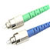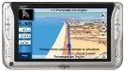1 Scope
Utilisateur
User
The present document presents the evaluation of reference values for users in order to identify their needs (SLO). These values also help to select the supplier in a competitive offer (QoS). This study will be based on a selection of representative telecommunication services such as video streaming , web RTC, and MMS, and not composed services such as authentication and load balancing, using EG 202 009-1, 2 and 3.

References

Normative references
As informative publications shall not contain normative references this clause shall remain empty.

Informative references
References are either specific (identified by date of publication and/or edition number or version number) or non-specific. For specific references, only the cited version applies. For non-specific references, the latest version of the referenced document (including any amendments) applies.
NOTE: While any hyperlinks included in this clause were valid at the time of publication ETSI cannot guarantee their long term validity.
The following referenced documents are not necessary for the application of the present document but they assist the user with regard to a particular subject area.

Definitions, symbols and abbreviations

Definitions
For the purposes of the present document, the [following] terms and definitions [given in ... and the following] apply:

Symbols

Abbreviations
For the purposes of the present document, the [following] abbreviations [given in ... and the following] apply:

Service

Definition

TErms and Definitions Database Interactive (TEDDI) :
(basic) service; telecommunications service | .See ITU-T Recommendation I.112 (Glossaire des termes relatif au RNIS) , section 2.2, definition 201 | NA EN 301 082 V1.1.1 EN 301 084 V1.1.1  SPAN EN 301 084 V2.1.1

(electronic) trust service | service which enhances trust and confidence in electronic transactions (typically but not necessarily using cryptographic techniques or involving confidential material) | ESI TS 102 231 V1.1.1 TS 102 231 V2.1.1

(emergency) service identifier | (emergency) service identifier describes the (emergency) service, independent of the user interface mechanism, the signalling protocol that is used to reach the service, or the caller's geographic location | TISPAN TR 184 005 V1.1.1

(Home Gateway) Service Platform (HG_SP) | Primary function of the Home Gateway Service Platform is to manage the execution lifecycle of Service Modules. The Service Platform is capable of dynamically loading, activating, deactivating, updating, and unloading the Service Modules. The HG_SP ispart of the HG_EE as defined in clause 4.2 | SmartM2M TS 103 426 V1.1.1

Requirements

Service
Provider
User
Requirements
Capabilities
SLA
Contracted

Figure : Service Requirements

A system is currently built to carry out a set of actions and services to meet users requirements: functional requirements.
The expected result depends on system characteristics which impact on the service behaviour : non-functional requirements (QoS).

Service structuring : new way to design services


Cloud Service
QoS Composent
Usage
Interface
Control
Interface
Management
Interface
op1
op2
op5
op4
op3
Functional aspects
Non-functional aspects

Figure : New way to design services

Service Modelling

Usage interface

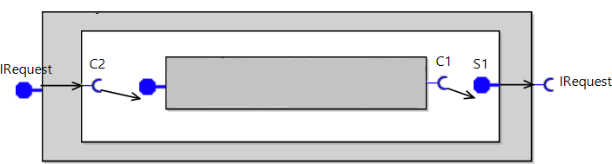
Figure : usage interface

Monitoring interface

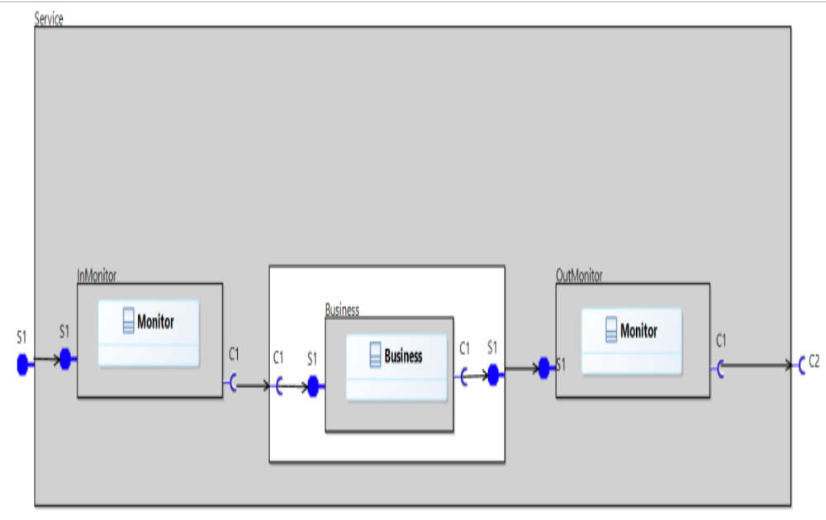
Figure : service integrated monitoring interface

Control and management interfaces

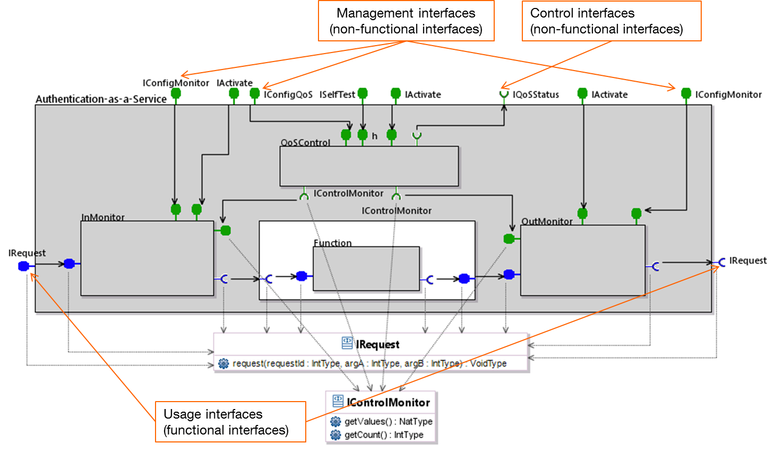
Figure : control and management interfaces

Design approach for “as-a-service" modelling
We present in this section an approach to design a software component as a service in order to make it compliant with SOA and micro-services service design requirements. We propose an approach that allows to cover progressively the required properties for its design. Design approach involves five steps.
Step 1: To structure
In a system where a service is available through the network and where the service is considered as a node of an architecture, we need to distinguish, and thus structure, the service. The structuring applies to services according to two aspects: the functional aspect representing the offered functionality and the non-functional aspect containing control functionality representing the automation and policies serving the management and control functionality. A component needs to have control and management interfaces. That is why we propose to adopt the GCM structure. The resulting component structure at this step will be transformed to become a component including a management membrane with two interfaces: a control interface and a management interface. TheMembrane is proposed in GCM and standardized by ETSI [ ]. Thus, the service is represented with a functional part, i.e., the business content, and a non-functional part, i.e., the membrane.
Step 2: To integrate
To integrate a component into a global service environment, there is a need to link it to other components. Therefore, we propose he integration of a service through a definition of its functional and non-functional interfaces. It is related to the links that the interfaces provide. They allow the component to be invoked (functional) and managed (non-functional). Moreover, these interfaces allow to realize compositions based on the desired organization. This latter can be hierarchical, distributed or even centralized. Consequently, the service component is integrated in its service environment with: a business content with external interface representing the functional part, and a membrane for the non-functional aspects, with management and control interfaces to be linked to other components and to communicate within the service environment.
Step 3: To self-control
For the control aspect, we propose to embed a QoS Control agent in order to introduce the needed autonomic aspect in an environment that is meant to scale and is subject to become rapidly more complex. The aim of introducing autonomic control of components is to enforce monitoring mechanisms that collect information concerning the behavior of the component in order to control the respect of service level agreement (SLA) and QoS level and react in case of non-compliance. Thus, at this stage, the service becomes a self-controlled service. We rely on a recursive service architecture, where a service may comprise a set of self-controlled service components. Therefore, the service can be integrated within a global self-controlled service architecture.

Step 4: To design as-a-service
This step aims at ensuring that the offered service component can be added, removed or composed with other services, without crashing the whole organization, i.e., the global service architecture. The “as-a-service" design should allow flexibility in composing service offers and thus service customization, adaptability of services and solutions, as well as “on-the-fly" deployments. For this purpose, a set of properties needs to be satisfied for designing a “simple" service as an “as-a-service" service. The service design needs to rely on the following main properties: statelessness, loose coupling and reuse.
Statelessness: a service should perform the same processing to all requests without keeping any information about their data or their contexts. This allows a service to always offer the same function to all clients and requests. It should have a single type of interface and its the operations should be conceived to perform the processing without depending on information received during a precedent invocation.
Loose Coupling: the bindings or links between services in a service composition should be as loose as possible without any predefined sequence between services. This is to eliminate all types of functional coupling between services. Thus, loose coupling ensures a flexible composition of service components. Service composition consists of generating a global service by composing or chaining a set of elementary service components. The composition would thus be flexible for customization by adding, replacing, and removing service elements according to users’ needs.
In addition, for software engineering needs, the reuse property and is strongly recommended in this approach. Reuse: the possibility of reuse is needed to simplify the software development of services that meet the new needs. Services designed based on this approach and properties (as-a-Service) would be reusable thanks to the generic character of their interfaces (usage, control and management).
We detail other properties further in Section x.
Step 5: To describe in catalogue
A Service needs to be correctly described by the service provider and visible by users that would request it. For that, there is a need for service description and service registry using formal processes. These two properties allow establishing a service catalogue. To design an application or a service, the architect selects multi-tenant services in the provider’s catalogue. Using the QoS-based as-a-Service model, the selection would be based on the specified offered QoS and thresholds values. At run-time, in order to introduce agility and eliminate static configurations, a service has to be invoked through standardized API. A service would include interfaces dedicated to QoS compliance control, service control and service programming.

Calibration

QoS values (Conception and threshold values)

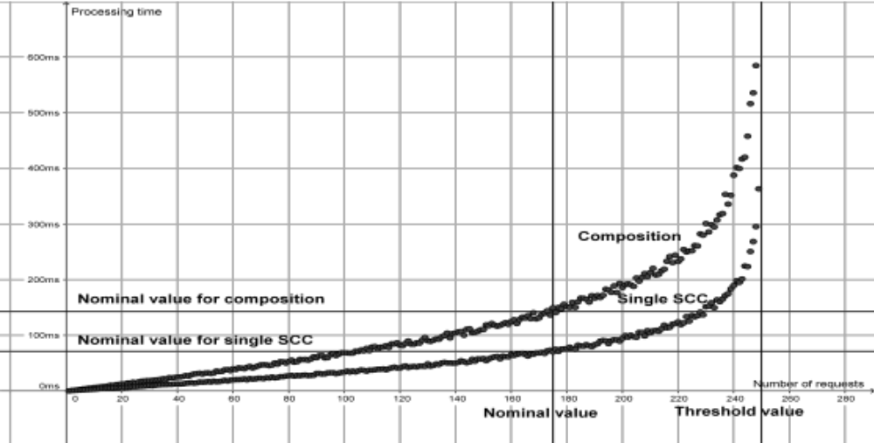

IMSaaS Assessment Results

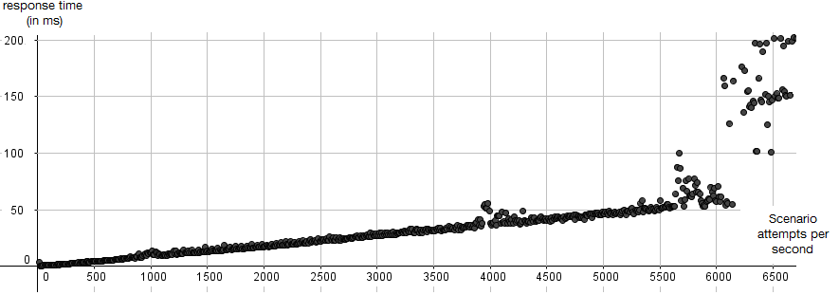
Figure : Processing capacity of authentication service

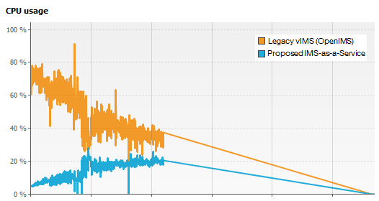
Figure : Resource consumption (CPU) of authentication service

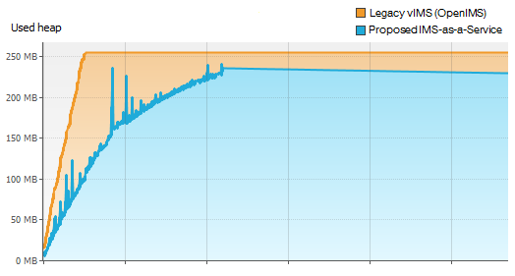
Figure : Resource consumption (RAM) of authentication service

Catalogue

Each service to be described through specifications :
- Functionnal
- Non – functionnal (QoS)

MySQL Service
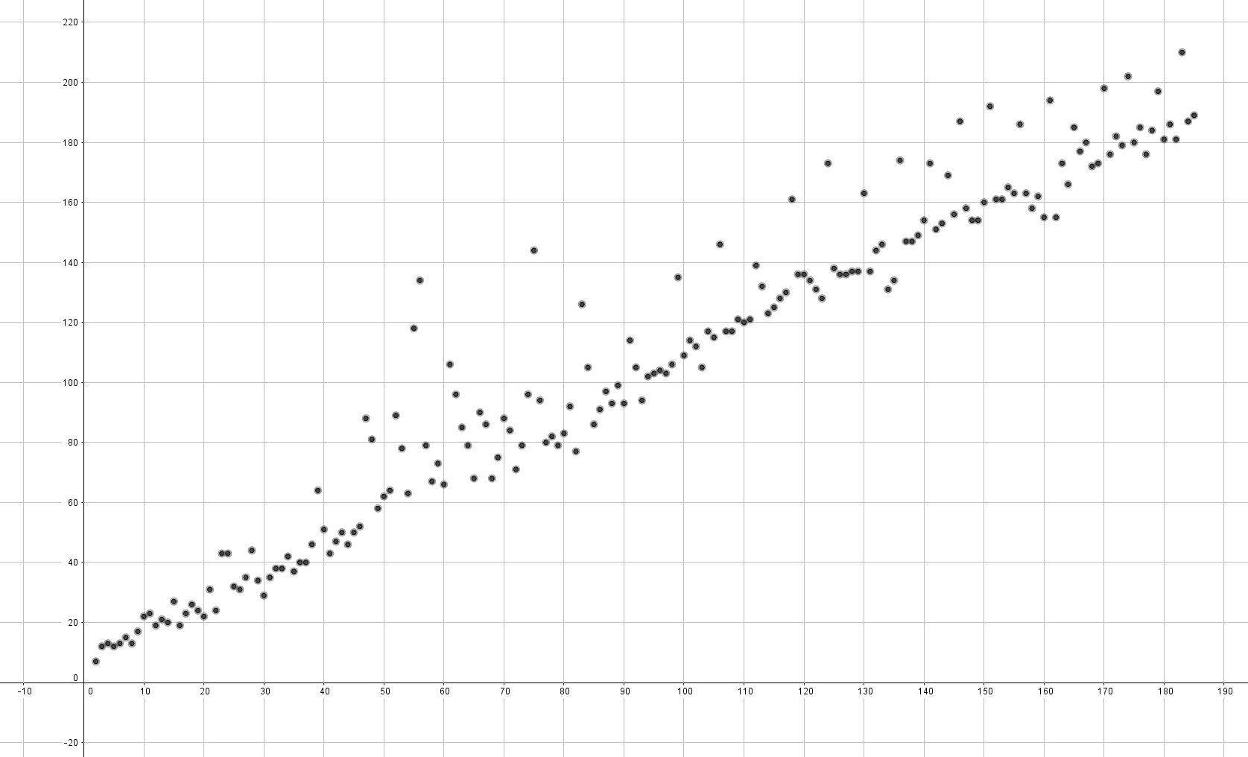
QoS offered :
Number of requests: 180
Total processing time: 247 ms
Average processing time per request: 1.37 ms
Hardware:
CPU: Intel Core i5 3.6 GHz
Memory : 8Go

Service « digest access authentication ».
QoS offered :
Number of requests: 4900
Total processing time: 433 ms
Average processing time per request: 0.09 ms
La valeur de seuil au-delà duquel le service est instable est d’environ 6000 requêtes.
Hardware :
CPU: Intel Core i5 3.6 GHz
Memory : 8Go

Image capture service

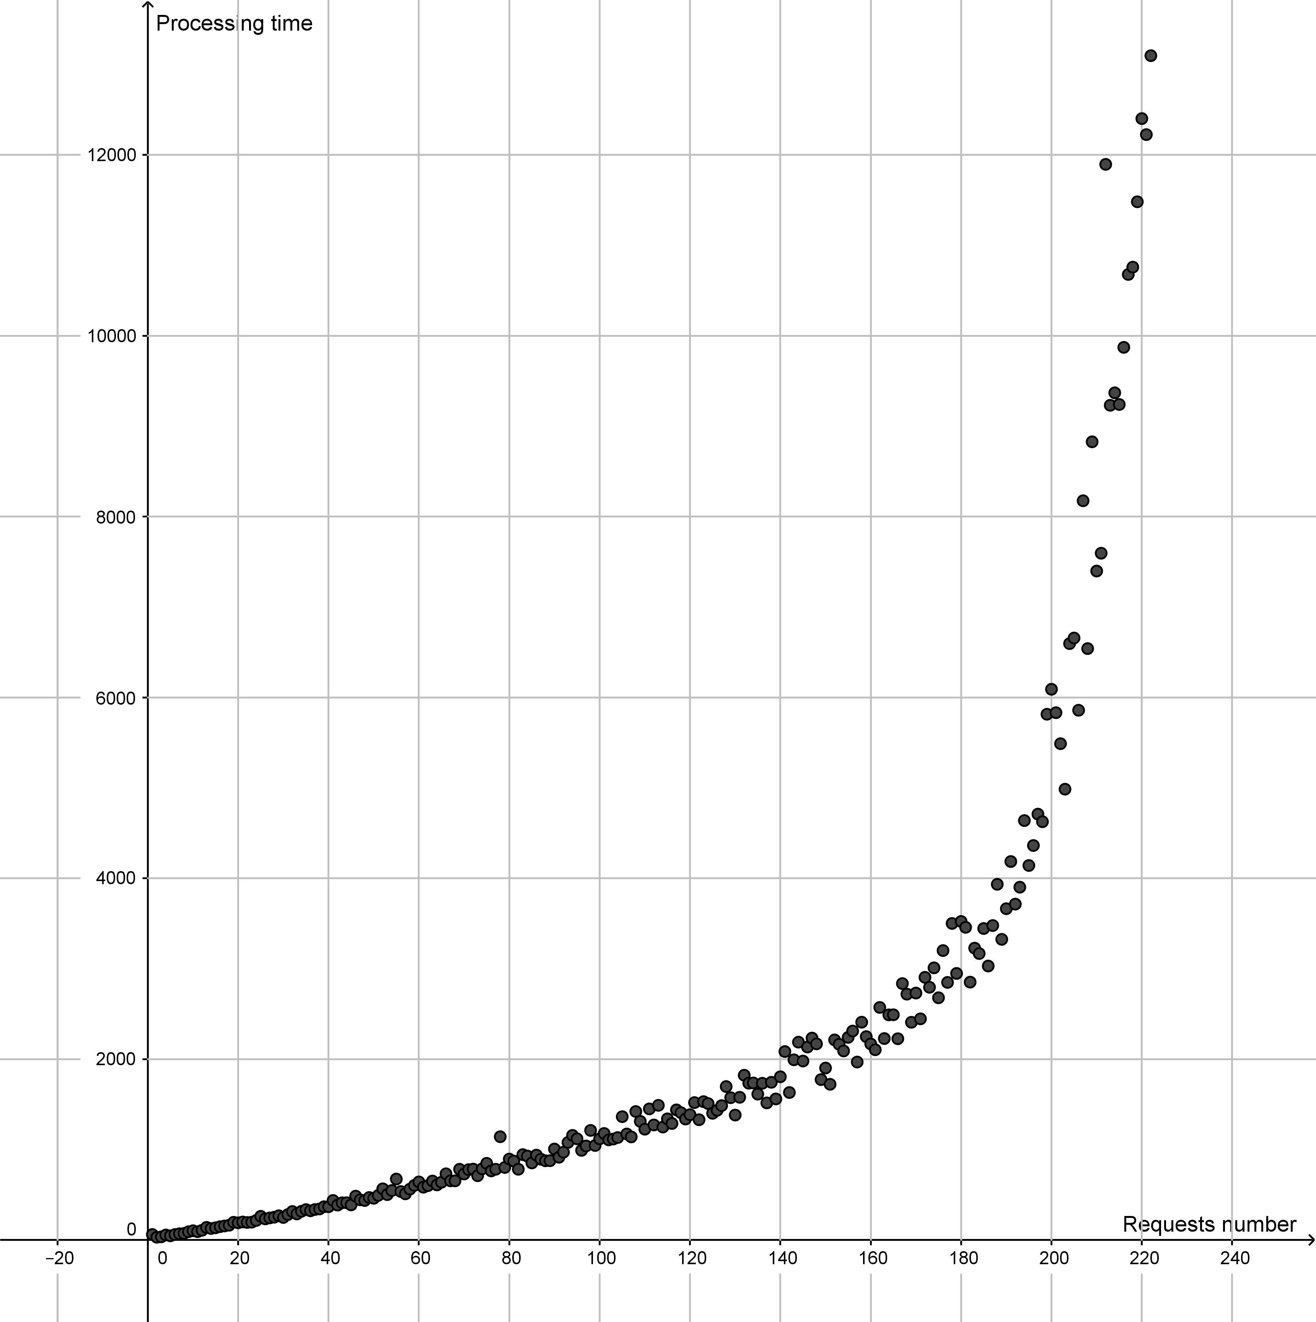

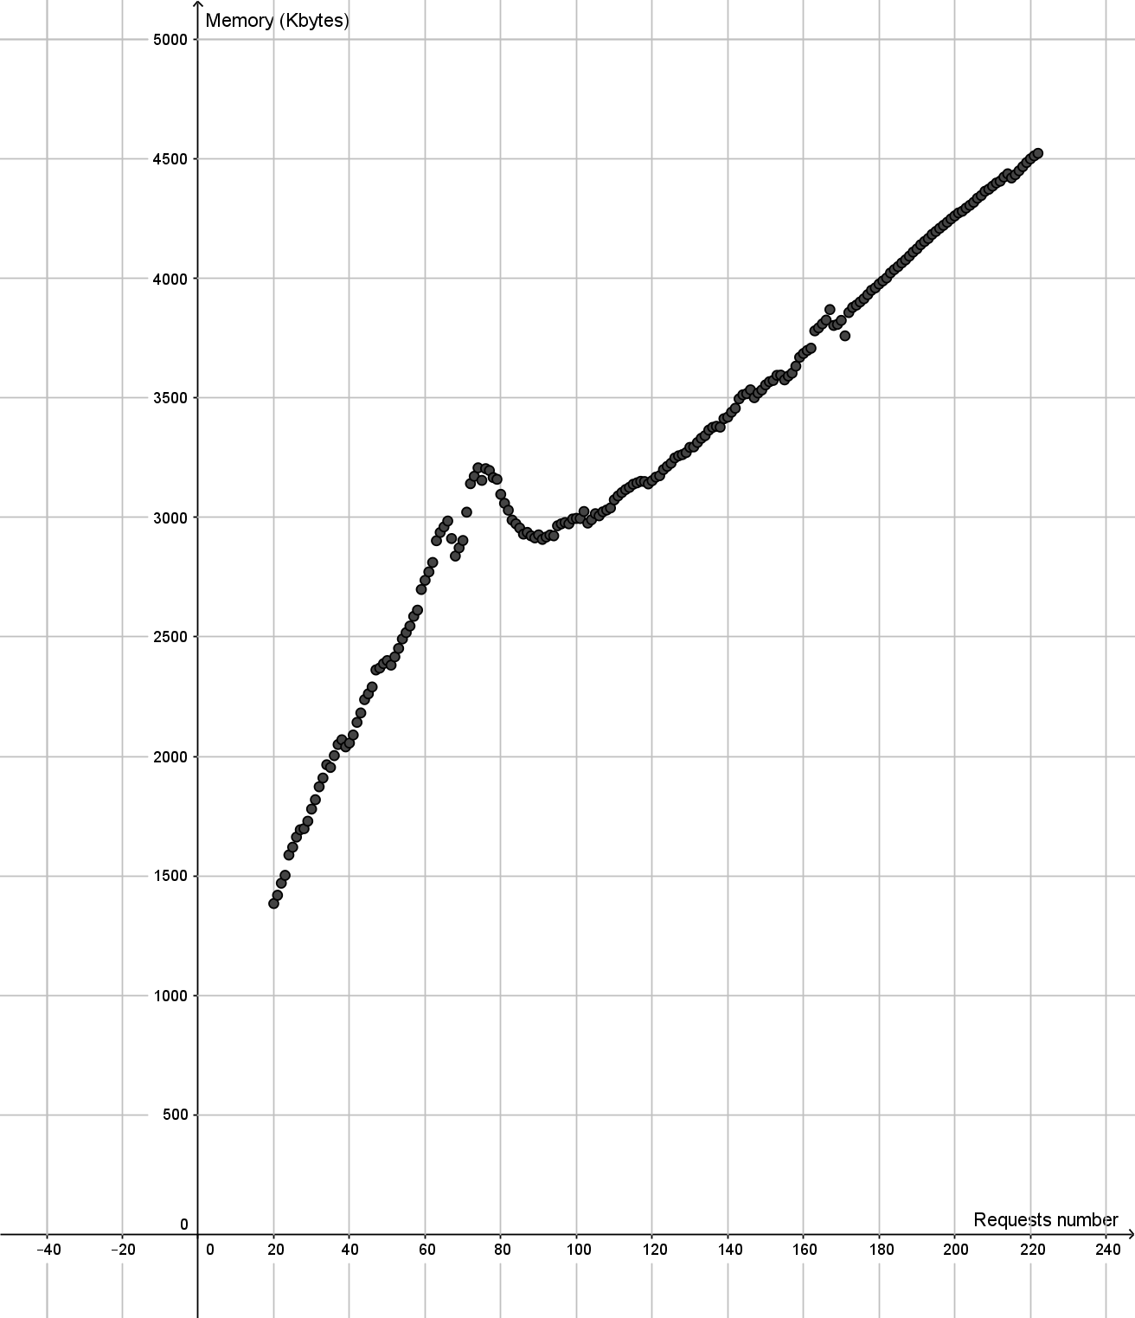

Service Composition (Service Architecture)

A new method based on approach “as-a-service" includes four steps:
1) First, the calibration of as a service components.
2) Secondly, the service provider creates his catalogue by putting into the preceding calibrated components.
3) Thirdly, to design application or service, the user chooses multi-tenant in providers catalogues, based on the specified nominal/offered QoS and thresholds value.
4) Finally, we propose SLA management actions to ensure the adequacy of his nominal QoS to the requested QoS (SLO).

Annex :
Title of annex

Annex :
Bibliography
[1] Stefani, J-B., The Fractal component model.
[2] “ETSI TS 102 827: GRID; Grid Component Model; Part 1: GCM Interoperability Deployment,” European Telecommunications Standards Institute (ETSI), Tech. Rep., 2008,standard.
[3] “ETSI TS 102 828: GRID; Grid Component Model; Part 2: GCM Application Description,” European Telecommunications Standards Institute (ETSI), Tech. Rep., 2008, standard.
[4] “ETSI TS 102 829: GRID; Grid Component Model; Part 3: GCM Fractal Architecture Description Language (ADL),” European Telecommunications Standards Institute (12571284 (ETSI), Tech. Rep., 2009, standard.
[5] M Fowler and J Lewis. Microservices. ThoughtWorks, 2014.
[6] Fabrizio Montesi, Claudio Guidi, and Gianluigi Zavattaro. Service-Oriented Programming with Jolie. In Web Services Foundations, pages 81-107. Springer, 2014
[7] Andrew Prunicki. Apache thrift, 2009.
[8] Kenton Varda. Protocol buers: Google's data interchange format. Google Open Source Blog, Available at least as early as Jul, 2008.
[9] Tony Mauro. Adopting microservices at netix: Lessons for team and process design. http://nginx.com/blog/ adopting-microservices-at-netflix-lessons-for-team-and-process-design/, 2015.

.

Annex :
Change History
Date | Version | Information about changes
<Month year> | <#> | <Changes made are listed in this cell>

History
Document history
<Version> | <Date> | <Milestone>

Latest changes made on 2017-10-19

