ETSI TR 103 438 V0.0.2 (2018-05)
User Group;
User centric approach in digital ecosystem

<

TECHNICAL REPORT
Reference
DTR/USER-0046
Keywords
IoT, M2M, QoS, SLO, USER
ETSI
650 Route des Lucioles
F-06921 Sophia Antipolis Cedex - FRANCE

Tel. : +33 4 92 94 42 00 Fax : +33 4 93 65 47 16

Siret N° 348 623 562 00017 - NAF 742 C
Association à but non lucratif enregistrée à la
Sous-préfecture de Grasse (06) N° 7803/88

Important notice
The present document can be downloaded from:
http://www.etsi.org/standards-search
The present document may be made available in electronic versions and/or in print. The content of any electronic and/or print versions of the present document shall not be modified without the prior written authorization of ETSI. In case of any existing or perceived difference in contents between such versions and/or in print, the only prevailing document is the print of the Portable Document Format (PDF) version kept on a specific network drive within ETSI Secretariat.
Users of the present document should be aware that the document may be subject to revision or change of status. Information on the current status of this and other ETSI documents is available at https://portal.etsi.org/TB/ETSIDeliverableStatus.aspx.
If you find errors in the present document, please send your comment to one of the following services:
https://portal.etsi.org/People/CommiteeSupportStaff.aspx
Copyright Notification
No part may be reproduced or utilized in any form or by any means, electronic or mechanical, including photocopying and microfilm except as authorized by written permission of ETSI.
The content of the PDF version shall not be modified without the written authorization of ETSI.
The copyright and the foregoing restriction extend to reproduction in all media.

© ETSI yyyy.
All rights reserved.
DECTTM, PLUGTESTSTM, UMTSTM and the ETSI logo are trademarks of ETSI registered for the benefit of its Members.
3GPPTM and LTE™ are trademarks of ETSI registered for the benefit of its Members and
of the 3GPP Organizational Partners.
oneM2M logo is protected for the benefit of its Members.
GSM® and the GSM logo are trademarks registered and owned by the GSM Association.

Contents
Intellectual Property Rights 4
Foreword 4
Modal verbs terminology 4
Executive summary 4
Introduction 4
1 Scope 5
2 References 5
2.1 Normative references 5
2.2 Informative references 5
3 Definitions, symbols and abbreviations 6
3.1 Definitions 6
3.2 Abbreviations 6
4. Definition of the context 7
5 « User centric»: usage identification 7
5.1 User at the heart of the architecture 7
5.2 Evolutions 8
5.2.1 Context evolution 8
The figure shows the evolution of the user’s environment, from system centric to user Centric. Between the initial context and the expected “user centric” context, several intermediate contexts have been needed. 8
5.2.2 Telecom evolution 8
The telecommunications, along the past years, have experienced a strong evolution, displayed in the figure. 9
5.2.3 IoT evolution 9
5.3 User maturity 9
5.4 User expectations 9
5.4.1 Requirements (SLO) 9
5.4.2 Non-Functional Requirements (QoS, security, usability, flexibility) 9
6 Ecosystem digital identification 10
6.1 Ecosystem digital use cases 10
6.1.1 Use Case: Smart Meters 11
6.1.1.1 Services 11
6.1.1.2 Actors of Home Digital Ecosystem 12
6.1.2 Use Case: Surveillance of pets 13
To be completed 13
6.1.2.1 Services 13
6.1.2.2 Process for Surveillance of pets 13
6.1.2.3 Actors of Surveillance of pets 13
6.1.3 Use Case: Home Entertainment Services 13
6.1.3.1 Services 13
6.1.3.2 Process for Home Entertainment Services 14
6.1.3.3 Actors of Home Entertainment Services 14
6.1.4 Use Case: Video on Demand 14
6.1.4.1 Services 14
6.1.4.2 Process for Video on Demand 14
6.1.4.3 Actors of Video on Demand 14
6.1.5 Use Case: Travel Management 15
6.1.5.1 Services 15
6.1.5.2 Process for Travel management 16
6.1.5.3 Actors of Travel Management 16
End node-Users 16
Connecotr/Gateways 16
Network Serers 16
Application Servers 16
Bring Your Own Device (BYOD) 16
Connected Work Appliances e.g. printing 16
IoT Devices 16
Smartphones 16
Desktop PC/Laptops 16
Conference Equipment 16
Fax machine 16
Payment. 16
Modem Routes 16
Phone Network Base Stations 16
Public/Community Wi-fi networks 16
Internet Serivce Providers 16
Telecommunication Companies 16
Cloud Computing/Hosting Providers 16
Technology Companies 16
Business Service Providers 16
Software License Providers 16
Application and Device Support Providers 16
Financial Process providers 16
Public Utility and Transportion companies that support the function of businesses 16
5.1.6 Use Case: Independent Living 17
5.1.6.1 Services 17
6.1.6.2 Process for Independent Living 17
6.1.6.3 Actors of Independent Living 18
End node-Users 18
Connector/Gateways 18
Network Servers 18
Application Servers 18
BYOD 18
Emergency buttons 18
Monitoring Devices – security/visual 18
Smartphones 18
Desktop PC/laptops 18
Medical Equipment 18
Smart-assistant devices 18
Modem Routers 18
Phone Network Base stations 18
Public/Community Wi-fi networks 18
Internet Service Providers 18
Telecommunication Companies 18
Cloud Computing/Hosting Providers 18
DNS Providers 18
Technology/Cloud Companies 18
Medical Service Providers 18
Software License Providers 18
Application/Device Support Providers 18
Care-Support companies 18
Local Community Support 18
Health Services (Local clinics/hospitals) 18
6.1.7.1 User Interaction with IoT Devices 19
Services 19
Actors 19
Ass 19
Interactions 19
Network and Internet Providers 19
End-User 19
(single/household) 19
IoT Device 19
Set-up and use the IoT 19
for a general specific 19
function 19
Device usage and support 19
Device 19
Manufacturer 19
Support 19
Smartphones 19
Can be used as means 19
to control and interact 19
the IoT device 19
Technology Companies cloud support 19
Application 19
Provider 19
Device connected hubs 19
Central hub to update 19
and change the settings 19
of IoT devices 19
Security 19
Any company that 19
provides the 19
service offered by 19
the IoT device 19
The User data and 19
billing information 19
connected to the IoT 19
device 19
How the company 19
chooses to protect and 19
handle the collected 19
data under GDPR and 19
other regulations 19
5.2 Generic model 22
6.3 Profile of user centric according to different digital environment 22
7 Typical use cases identification (Composition of Personalized Services) 22
7.1 Use case A: user interaction in IoT (Internet of Things) 22
7.1.1 Activity diagram 24
7.1.2 Sequence and communication diagrams 24
7.2 Use case B: eHealth Independent Living 24
7.2.1 Activity diagram 25
7.2.2 Sequence and communication diagrams 26
7.3 Use case C: User interaction within multi-device environment 27
7.3.1 Activity diagram 28
7.3.2 Sequence and communication diagrams 28
7.4 Services delivery and organization 28
Annex A: Description of the survey 29
Annex: Bibliography 29
Annex : Change History 30
History 31

Intellectual Property Rights
IPRs essential or potentially essential to the present document may have been declared to ETSI. The information pertaining to these essential IPRs, if any, is publicly available for ETSI members and non-members, and can be found in ETSI SR 000 314: "Intellectual Property Rights (IPRs); Essential, or potentially Essential, IPRs notified to ETSI in respect of ETSI standards", which is available from the ETSI Secretariat. Latest updates are available on the ETSI Web server (https://ipr.etsi.org).
Pursuant to the ETSI IPR Policy, no investigation, including IPR searches, has been carried out by ETSI. No guarantee can be given as to the existence of other IPRs not referenced in ETSI SR 000 314 (or the updates on the ETSI Web server) which are, or may be, or may become, essential to the present document.

Foreword
This Technical Report (TR) has been produced by ETSI User Group, and Special Task Force 543.

Modal verbs terminology
In the present document "should", "should not", "may", "need not", "will", "will not", "can" and "cannot" are to be interpreted as described in clause 3.2 of the ETSI Drafting Rules (Verbal forms for the expression of provisions).
"must" and "must not" are NOT allowed in ETSI deliverables except when used in direct citation.

Executive summary

Introduction

The Technical Report has been produced by the STF 543 experts.

1 Scope
The digital ecosystem includes all sectors of activity in which the user through smartphone, and objects are connected, that is to say capable, in addition to their main function, to send or receive information via a telecommunication network which allows to extend or diversify the functions of the smartphone and the object.
Connected objects fall, for example, in the fields of transport (connected vehicle), health (connected self-measurement), industry (connected tools), home automation (interactive electricity meter) or even daily life (connected watch).
This is why the notion that interests us in the digital ecosystem is that of considering that the user is at the heart of the architecture.
The present document considers digital ecosystem through user's point of view under the following two directions:
(1) identification of user's needs such as, Service Level Objectives (SLO) but also QoS, security, usability, flexibility; (2) study impact of technical implementations related to user's requirements/concerns.
The TR details the following aspects:
- User centric usages in digital ecosystem (Usage identification)
- Profile of user centric according to different digital environment (digital ecosystem identification)
- Significant “use cases” (identification of the typical use cases).

2 References

2.1 Normative references
As informative publications shall not contain normative references this clause shall remain empty.

2.2 Informative references
References are either specific (identified by date of publication and/or edition number or version number) or non-specific. For specific references, only the cited version applies. For non-specific references, the latest version of the referenced document (including any amendments) applies.
NOTE: While any hyperlinks included in this clause were valid at the time of publication, ETSI cannot guarantee their long term validity.
The following referenced documents are not necessary for the application of the present document but they assist the user with regard to a particular subject area.
[i.1] EN 301 549: Accessibility requirements for ICT products and services
[i.2] TR 103 304: CYBER; Personally Identifiable Information (PII) Protection in mobile and cloud services
[i.3] TR 103 309 CYBER; Secure by Default - platform security technology
[i.4] TS 102 165-1 Telecommunications and Internet converged Services and Protocols for Advanced Networking (TISPAN); Methods and protocols; Part 1: Method and proforma for Threat, Risk, Vulnerability Analysis
[i.5] EG 202 009-2 User Group; Quality of telecom services; Part 2: User related indicators on a service specific basis

3 Definitions, symbols and abbreviations

3.1 Definitions
For the purposes of the present document, the following terms and definitions apply:

3.2 Abbreviations
For the purposes of the present document, the following abbreviations apply
AES
API Application Programming Interface
BYOD Bring Your Own Device
DNS Domain Name System
GDPR General Data Protection Regulation
IoT Internet of Things
ITS Intelligent Transportation System
LoRa RF Long Range Radio Frequency
LoRa WAN Long Range Wide Area Network
Lte Long term evolution
M2M Machine to Machine
NFC Near Field Communication
NGO Non Governmental Organization
OS Operating System
PC Personal Computer
QoE Quality of Experience
QoS Quality of Service
RTC Réseau téléphonique Commuté = Switched Telephone Network
SLA Servie level Agreement
SLO Service Level Objectives
SMS Short Message Service
SSL Secure Sockets Layer
TCP/IP Transmission Control Protocol / Internet Protocol
TV Television
VoD Video on Demand
VoIP Voice over Internet Protocol
WIFI Wireless Fidelity

4. Definition of the context

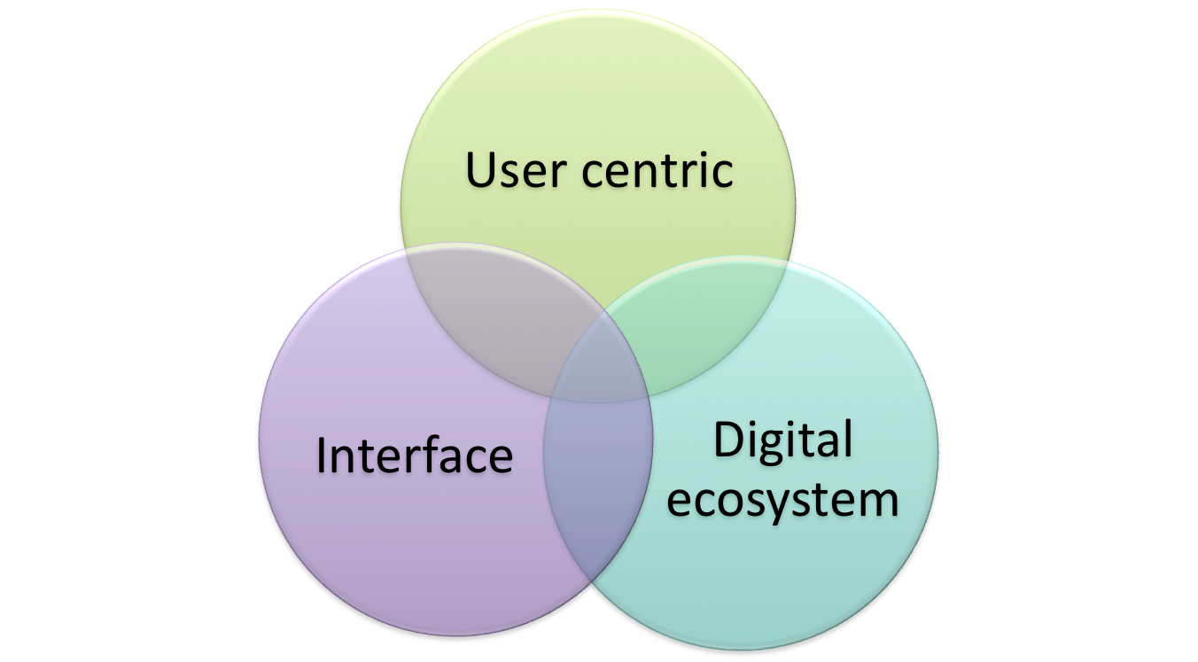
2 - QoE
Service Composition
Content
1-IHM
Architecture
User Profile
Device Profile

The figure defines the context of the Technical Report. IHM and QoE are two main factors be documented in the different documents associated to the current Technical Report.

5 « User centric»: usage identification

5.1 User at the heart of the architecture
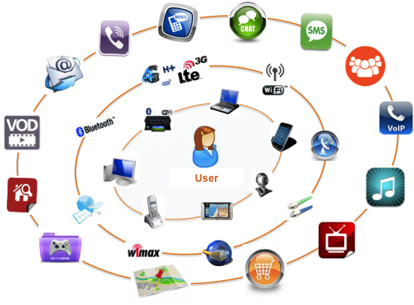

The figure shows a user’environment. Due to the number of services, applications, networks, terminals, it is needed for the user to be the heart of the architecture, in order to make the life simpler and to offer all the potential services with high quality of service, security, safety, …

5.2 Evolutions

5.2.1 Context evolution
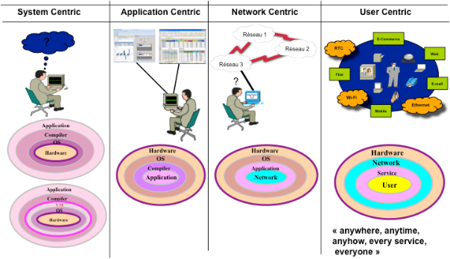

The figure shows the evolution of the user’s environment, from system centric to user Centric. Between the initial context and the expected “user centric” context, several intermediate contexts have been needed.

5.2.2 Telecom evolution
In the past | Yesterday | To-day | To-morrow

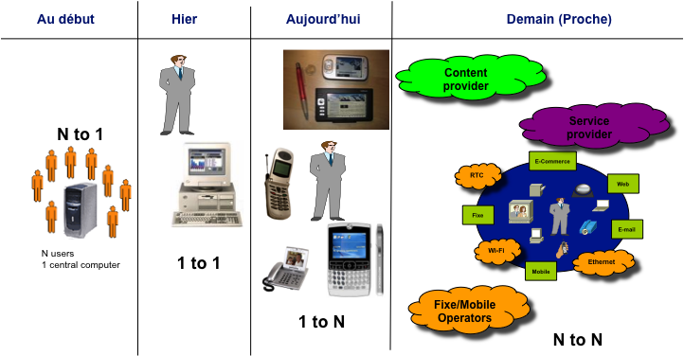

The telecommunications, along the past years, have experienced a strong evolution, displayed in the figure.

5.2.3 IoT evolution
To be inserted

5.3 User maturity
In the Digital paradigm, users have the ability to access a large number of digital services applications and contents covering almost every time and averywhere a big part of their daily life activities, personal or professional.

So, the question is : are they able to master all these services by themselves, or at least are they properly informed of what they can do with their subscriptions and equipment and what they consume ?

Maturity is mainly measured by the degree of knowledge of the user about the services available, how to activate them, how to configure them, how to control them.

The degree of maturity of the user is partly due to his involvement, his expectations of control, and of course the diversity and frequency of the services he uses.

But this maturity can be greatly improved by the level of information and help tools available, the transparent attitude of the supplier, the ease of use of the services, of their configuration and customization.
The architecture and sofware oriented next genération network are able to improve the flexibility and dynamic management and control of the services.

This is why it is important to look at the maturity of uses in the digital ecosystem.

5.4 User expectations

5.4.1 Requirements (SLO)
ETSI EG 202 009-2 [i.5] provides help to define SLO on every aspect of the a large scope of the available ICT services with the related metrics and indicators to assess and monitor them.

5.4.2 Non-Functional Requirements (QoS, security, usability, flexibility)
Regulation is crucial in the QoS area. Although some big users can have a specific private contract with a provider dedicated to QoS measurements, most users have to rely on third party to monitor the QoS either via information made publicly available by a trusted party or via information provided by their own provider in a SLA context. Therefore, the accuracy and truthfulness of the process of the QoS measurements should be certified by a trusted party so that users can have confidence on the reliability of these measurements.

6 Ecosystem digital identification

6.1 Ecosystem digital use cases

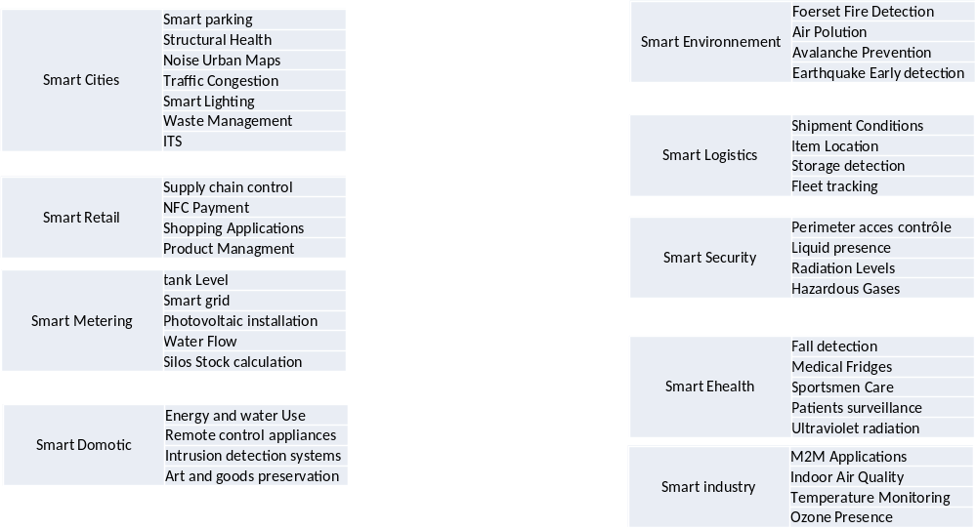

These chosen Use Cases will be first illustrated by a combination of process models, tables and text description. The use cases of smart cities, IoT and eHealth will be further developed by UML diagrams and descriptions. It should be noted that a digital eco-system can be rich and diverse in what is included but also can be bare and minimal because it changes with the user and their requirements and needs. Each digital eco-system are made up of multiple interconnected use cases. They will aim to show how the different components are controlled and the user interaction. The use cases will use generic examples of the chosen scenarios with no references to actual named products and services.
The home digital eco-system can be a single user or many. The use case will focus on single household. And how they interacts with services and software applications by using devices. The devices may be single use or multi-use. The home digital eco-system is not confined to the geolocation of the home as many of services need access to external assets. Thus, whilst the eco-system may include smart home devices, home banking, entertainment, home shopping, the root of many of these services are outside the home.
The services can be solely in used in-house whiles others need access to resources outside the house. For example, smart metering for utilities are stand-alone in that they report usage of resources and how much money has been spent. Apart from when they send meters updates to the utility company. In theory they allow for better budgeting by allowing users to know accurately how much a household is spending on power or water. But a dedicated budgeting application needs to pull in data from a households banking services and other financial services the user might use often this is from the outside the house and can also be used outside the house. The user(s) is (are) consumer(s) but may also be producer(s) (e.g. energy, applications, etc.)
The workplace digital ecosystem can be made up of a single user or many users. They can either have a clearly defined role or multiply roles within a business eco-system. The scale can change with the size of the business from a one person operation carrying out all roles to hundreds of workers each having there unique role in a business. The user interaction and access with the different services should have common UX experience between different devices and tools. Services can include organising of work schedules, travel to meeting/conferences, organisation and co-operation of projects or work between different users within the same work environment. These services can be solely intra-business or inter-business. The user experience and interaction across smart city services and applications must be consistent and seamless. The user should experience no barriers when moving between different services.
The Smart city digital ecosystem is vast web of interconnected IoT devices, sensors, cloud computing, services and big data all brought together into the urban infrastructure. The end-user only interacts with a small part of the smart city digital ecosystem. The end-user benefits from the complexity of the smart city since the feedback of collected data from users can be used by planners and organisations to improve the user services and experience. Most of the time the end-user doesn’t interact directly with the applications that make up the smart city. But for utility services and transport a user will interact with through dedicated applications or web portals in order to use them.
The eHealth digital ecosystem use case examines what is needed to enable users with medical disabilities/old-age aim to achieve independent living. This use case shares elements with the home and workplace digital ecosystem. The services include remote monitoring of health by doctors, automatic response with emergency services in case of accidents. The scheduling of care nurses or helpers between clients and care organisations. If the user is living by themselves they can are able to make use of smart-assistants similar Amazons Alexa to aid in day-to-day activities. This use case builds upon earlier ETSI eHealth work to develop the it. Users are not limited to the elderly for example users with psychical disabilities share elements with home, work and eHealth use case elements. They make use of modified devices and tools for access and usability. Users with cognitive disabilities also share elements with home, work and eHealth. In order to allow better user interaction with devices and applications. For these user there is a focus on UX experience and accessibility. For example, greater use of voice interaction instead of touch/button interfaces.

6.1.1 Use Case: Smart Meters

6.1.1.1 Services

Services | Actors | Assets¹/Resources | Interactions
Budget control. | Home user – single or multi-person household | Meters – moving from ‘dumb’ to ‘smart’ | If smart able to better monitor energy and water usage and cost. Still possible if dumb but requires greater effort to estimate cost and usage.
Energy/water usage. Billing | Energy supplier  Water/Sewage suppliers  Metering companies. Maintain and check. | Supply networks.  Collected Data. – Requires permission from customer for use and to share with 3rd parties. | Unless the user must supply metering, readings there is no direct interaction.
Energy, applications production | Energy supplier  Metering companies.  Friends or partners.  Maintain and check. | Production networks.  Data collection and analysis of energy consumption | The user must control the production, the relationships with partners and collaborators.
Security (of the home digital eco-system) | Network Provider  Device manufacture (secure-by-default) | Standards and regulations set by Govt bodies and NGOs. ETSI TR 103 304  ETSI TR 103 309 | communication between the meter and the utility company
Data protection and privacy | The companies that handle the metering, billing, data storage and transfer. Must follow data protection regulations. | Directive on Security of Network and Information Systems and the  General Data Protection Regulation (GDPR) (Regulation (EU) 2016/679) | The energy supplier must obtain permission/consent from the bill payer to use for a stated purpose.
Special needs | Equipment, network providers | Standards such as EN 301 549 [i.1] | The interaction means depend on the type of impairments and the special needs.

6.1.1.2 Actors of Home Digital Ecosystem

End node-Users | Connector/Gateways | Network Servers | Applcation Servers
Smart Utility Meters  Connected Home-Applicances  IoT Devices  Smartphones  Desktop PC/Laptops  Smart TVs | Modem Routers  Phone Network Base Stations  Public/Community Wi-fi networks | Internet Service Providers  Telecommunication Providers  Cloud Computing/Hosting Providers  DNS Providers | Utility Companies  Technology Companies  Home Service Providerrs  Applcation and Device Support Providers  Cloud service Providers

6.1.2 Use Case: Surveillance of pets

To be completed

6.1.2.1 Services

6.1.2.2 Process for Surveillance of pets

6.1.2.3 Actors of Surveillance of pets

6.1.3 Use Case: Home Entertainment Services

6.1.3.1 Services

Services | Actors | Assets/Resources | Interactions
Entertainment - | Household – single user or multiple | Network devices – modems/routers  Remote control | Access to chosen streaming service and consumption.
Internet access | Internet Providers (IP)  Can give internet connections and give bundles of media entertainment packages. | Users Devices – TVs (smart/dumb), computers (portable/not), smartphones, tablets.  Games consoles (if they support it), traditional set-top boxes.  Screens | Setting up access on chosen devices. Are they shared with friends or families?
Over the air broadcasting. – Screen share with TV to other devices. | Entertainment and Media Providers | Internet Browser. Means of access without dedicated application or devices. | Security – controlling access / 2FA.  Protection of customer billing information and data.

6.1.3.2 Process for Home Entertainment Services

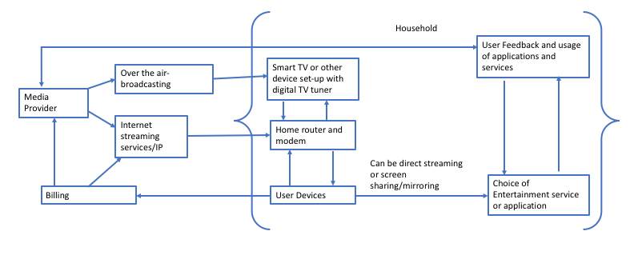

6.1.3.3 Actors of Home Entertainment Services
End node-Users | Connector/Gateways | Network Servers | Applcation Servers
Smart Utility Meters  Connected Home-Applicances  IoT Devices  Smartphones  Desktop PC/Laptops  Smart TVs | Modem Routers  Phone Network Base Stations  Public/Community Wi-fi networks | Internet Service Providers  Telecommunication Providers  Cloud Computing/Hosting Providers  DNS Providers | Utility Companies  Technology Companies  Home Service Providerrs  Applcation and Device Support Providers  Cloud service Providers

6.1.4 Use Case: Video on Demand
To be completed

6.1.4.1 Services

6.1.4.2 Process for Video on Demand

6.1.4.3 Actors of Video on Demand

6.1.5 Use Case: Travel Management

6.1.5.1 Services

Table 1 Travel Management
Services | Actors | Assets/Resources | Interactions
Booking firms. | Business user – single individual or multiple. Same or distinct roles. | Devices – use for work and to carrying out daily tasks. | When they book or propose travel arrangements.
There is a dynamic relationship between the users and the service providers. The user can have full autonomy, partial or none when interacting with the digital eco-system.
Special needs | Equipment, network providers | Standards such as EN 301 549 | The interaction means depend on the type of impairments and the special needs.
Transportation (airlines, train services, bus/coaches, taxis, personal transport) | Company or organisation the user works for. Made of different elements that are responsible running the company. | Software – access to sites and services. | Another part of the company can organise the travel for their workers. Or reimburse if a user has paid for travel out of their own pocket.
A business or provider can offer a composition of services to the users. | Transport companies. | Modes of transport | How the user undertakes the travel.

6.1.5.2 Process for Travel management
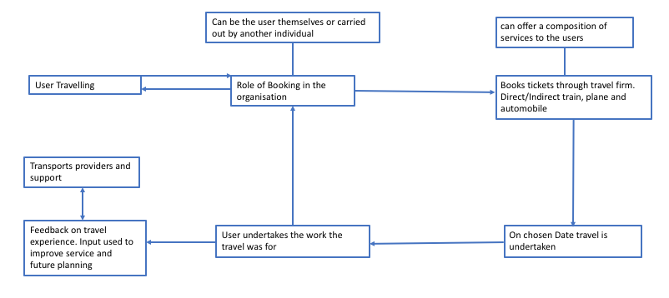

6.1.5.3 Actors of Travel Management

End node-Users | Connecotr/Gateways | Network Serers | Application Servers
Bring Your Own Device (BYOD)  Connected Work Appliances e.g. printing  IoT Devices  Smartphones  Desktop PC/Laptops  Conference Equipment  Fax machine  Payment Systems  Payment. | Modem Routes  Phone Network Base Stations  Public/Community Wi-fi networks  Wide Local Area Network (WLAN) | Internet Serivce Providers  Telecommunication Companies  Cloud Computing/Hosting Providers  DNS Providers | Technology Companies  Business Service Providers  Software License Providers  Application and Device Support Providers  Financial Process providers  Public Utility and Transportion companies that support the function of businesses  Cloud Service Providers

5.1.6 Use Case: Independent Living

5.1.6.1 Services

Services | Actors | Assets/Resources | Interactions
Medical care | Medical Professional (GPs, nurses) | Medical devices | Can give remote or in-situ medical care.
Social care | Community providers and services. | Household assistant devices | Aid in helping for day-today tasks. Varies by user requirements.
General Assistance | Household user. | Monitoring devices (security/visual aids) | Enable safety and security. Once set-up they should need no effort from the user. The means to provide security are same as in the home digits eco-system.
Internet Providers | Smart/virtual assistants – a software and/or device agent that can perform tasks or services for an individual. |  | Means of control over their environment through voice control. Also allows them to access services and communicate in natural language.
Special needs | Users with any disability  Service and device providers | Personal equipment  Household assistant devices | To ensure that the facilities and features are made available anywhere, anytime, with equivalent level of aid

6.1.6.2 Process for Independent Living
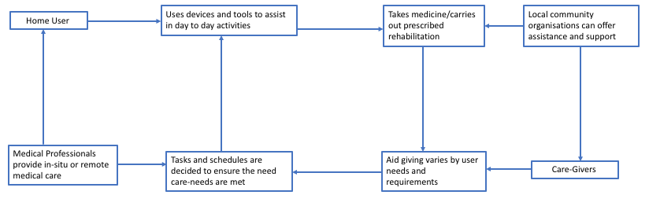

6.1.6.3 Actors of Independent Living
End node-Users | Connector/Gateways | Network Servers | Application Servers
BYOD  Emergency buttons  Monitoring Devices – security/visual  Smartphones  Desktop PC/laptops  Medical Equipment  Smart-assistant devices  Household assistant tools | Modem Routers  Phone Network Base stations  Public/Community Wi-fi networks  Pagers | Internet Service Providers  Telecommunication Companies  Cloud Computing/Hosting Providers  DNS Providers | Technology/Cloud Companies  Medical Service Providers  Software License Providers  Application/Device Support Providers  Care-Support companies  Local Community Support  Health Services (Local clinics/hospitals)

6.1.7.1 User Interaction with IoT Devices
Services | Actors | Ass | Interactions
Network and Internet Providers | End-User  (single/household) | IoT Device | Set-up and use the IoT  for a general specific  function
Device usage and support | Device  Manufacturer  Support | Smartphones | Can be used as means  to control and interact  the IoT device
Technology Companies cloud support | Application  Provider | Device connected hubs | Central hub to update  and change the settings  of IoT devices
Security | Any company that  provides the  service offered by  the IoT device | The User data and  billing information  connected to the IoT  device | How the company  chooses to protect and  handle the collected  data under GDPR and  other regulations

6.1.7.2 Process model of User Interaction with IoT
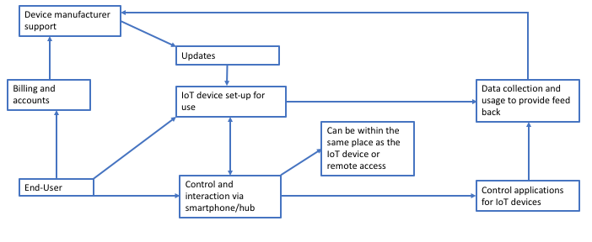
6.1.7.3 Actors of User Interaction with IoT

End node-Users | Connector/Gateways | Network Servers | Applcation Servers
Smart Utility Meters  Connected Home-Applicances  IoT Devices  Smartphones  Desktop PC/Laptops  Smart TVs | Modem Routers  Phone Network Base Stations  Public/Community Wi-fi networks | Internet Service Providers  Telecommunication Providers  Cloud Computing/Hosting Providers  DNS Providers | Utility Companies  Technology Companies  Home Service Providerrs  Applcation and Device Support Providers  Cloud service Providers

6.1.8.1 User Interaction within the Smart City

Services | Actors | Assets/Resources | Interactions
Civic service providers and organisations | End-User | Smartphone/Web portal | How the user reports or gives feedback.
Collection of data | Companies or organisation involved in handling the collected data | Connected sensors/cameras/tracking devices or software | Remote means to gather data.
Acting on collected data | Companies or organisation responsible for providing solutions to problems shown by data | Tools, equipment and materials | The means to collect the data and analysis it to turn it into useful information.
Security | Any company that handles the data collected | The data and information collected | How the company chooses to protect and handle the collected data under GDPR and other regulations

6.1.8.2 Process Model of User Smart City Interaction

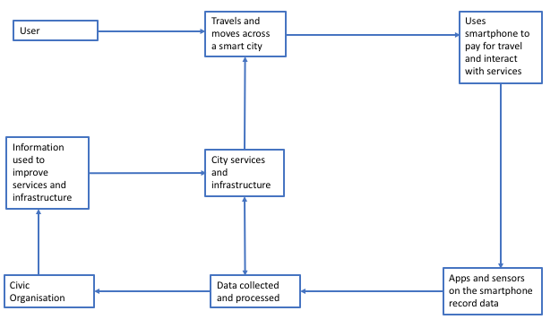

6.8.3 Actors of User Smart City Interaction

End node-Users | Connector/Gateways | Network Servers | Application Servers
IoT Devices  Smartphones  Payment Systems  Connected Smart CCTV  Enviromental Sensors  Web-based sites to provide feedback and report information | Modem Routers  Phones network Base Stations  Public/Community Wi-fi networks  WLAN | Internet Service Providers  Telecommunication Companies  Cloud Computing/Hosting Providers  DNS Providers | Technology Companies  Civic Service Providers  Software License Providers  Applcation and Device Providers  Financial Process Providets  Public Utility and trabsportation companies that support the function of a city  Cloud Service Providers

5.2 Generic model

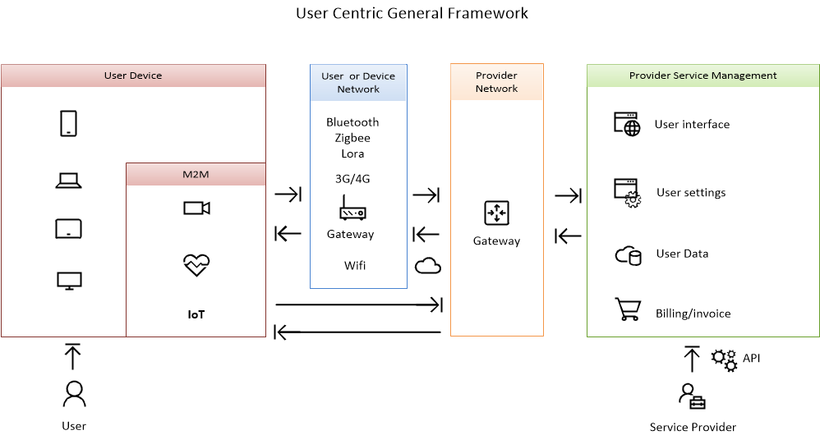

6.3 Profile of user centric according to different digital environment

7 Typical use cases identification (Composition of Personalized Services)

7.1 Use case A: user interaction in IoT (Internet of Things)
Nominal scenario

- Step 1 and 2: Sensors send measures to the nearest IoT Gateway.
- Step 3: Iot Gateway analyse and make decision. His functions are as follows:
  - Monitor the current state of the patient
  - Provide a means to predict future medical condition via machine learning methods and artificial intelligence algorithms.
  - Collect and aggregate data from the available sensors
  - Implement data analysis
  - Extract valuable information and knowledge from the incoming raw data
  - Make decisions
  - Detect emergency and make prediction
  - Do data compression and encryption
  - Adapt data capture frequency
If needed, in case of emergency:
- Step 4: IoT gateway call rescue teams.
- Step 5: IoT gateway reserve a hospital room.
- Step 6: IoT gateway send information to the referring physician.

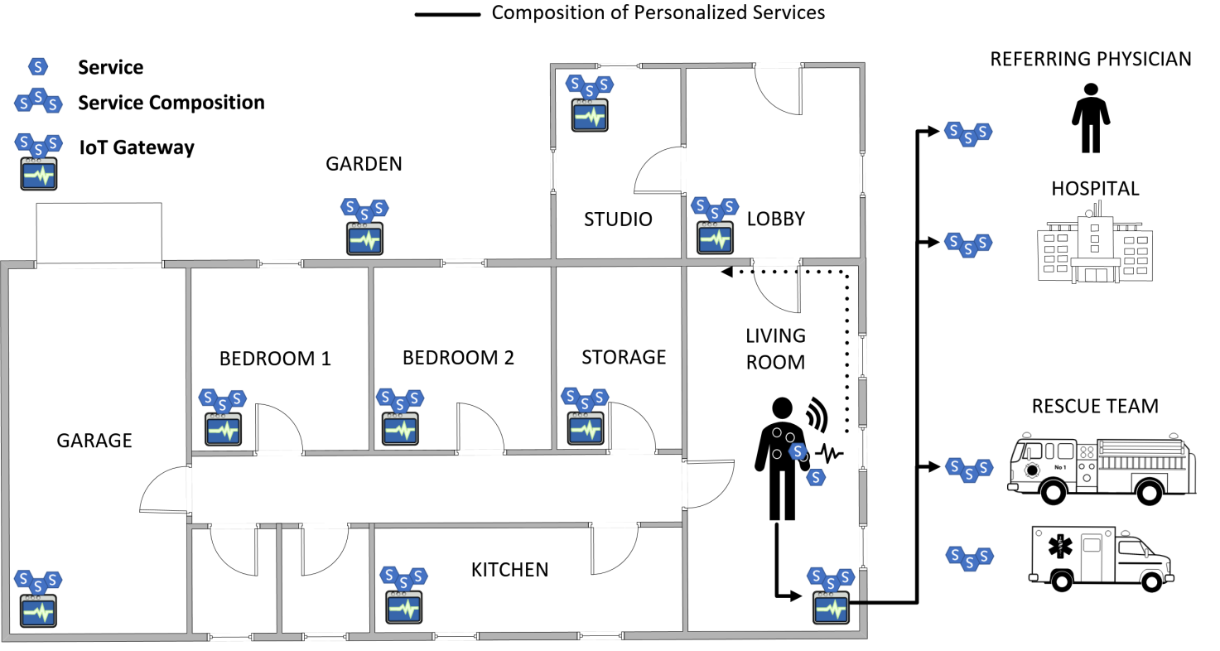

User needed resources

- Internal and external network infrastructure.
- IoT gateways distributed in all relevant places.
- Wearable sensors.
- Composition of personnalised services. Examples: 1) We can reinforce the confidentiality of the composition with specialised services. 2) The user can also warn a trusted person.

7.1.1 Activity diagram

7.1.2 Sequence and communication diagrams
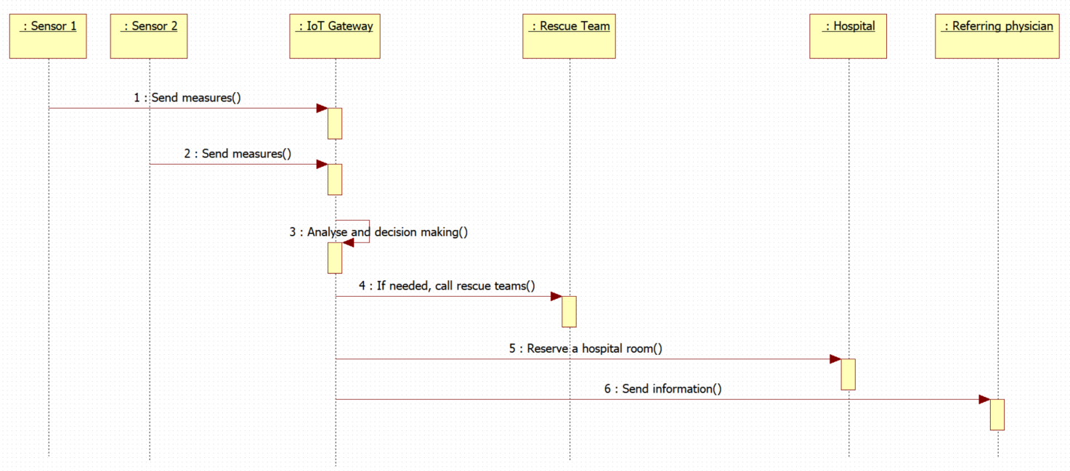

7.2 Use case B: eHealth Independent Living
The eHealth digital ecosystem use case examines what is needed to enable home users with medical disabilities and/or old-age impairments with the aim to achieve independent living. This use case shares elements with the home and workplace digital ecosystem. The services include remote monitoring of health by doctors and automatic response with emergency services in case of accidents. Also, the scheduling of care nurses or helpers between clients and care organizations. If the home user is living by themselves, they are able to make use of smart-assistants similar to Amazons Alexa, Apple’s Siri, Google Home and Microsoft Cortana to aid in their day-to-day activities. This use case builds upon earlier ETSI eHealth work in order to develop the use case. The home users are not limited to the elderly, for example, users with psychical disabilities share the same elements. They both make use of devices and tools for accessibility. As well, users with cognitive disabilities fit within this use case. By allowing better user interaction with devices and applications with a focus on UX experience and accessibility. For example, greater use of voice interaction instead of touch/button interfaces.

7.2.1 Activity diagram
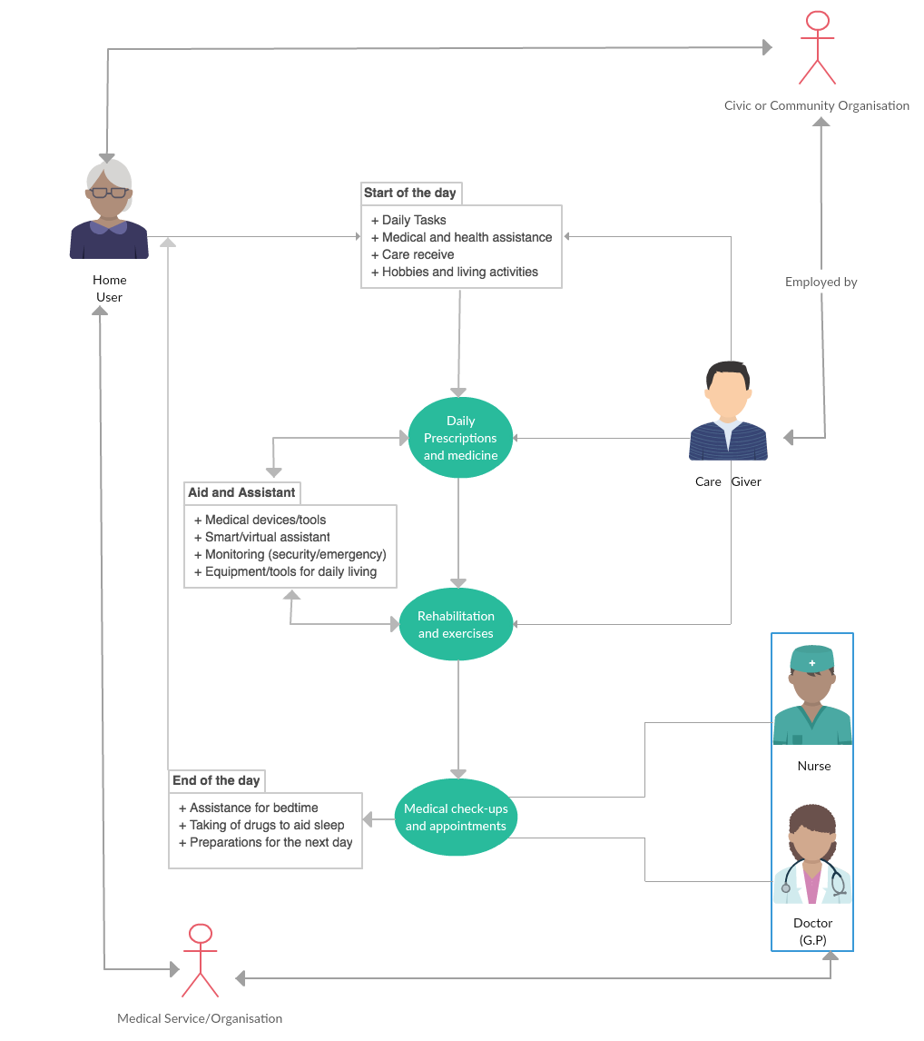

7.2.2 Sequence and communication diagrams
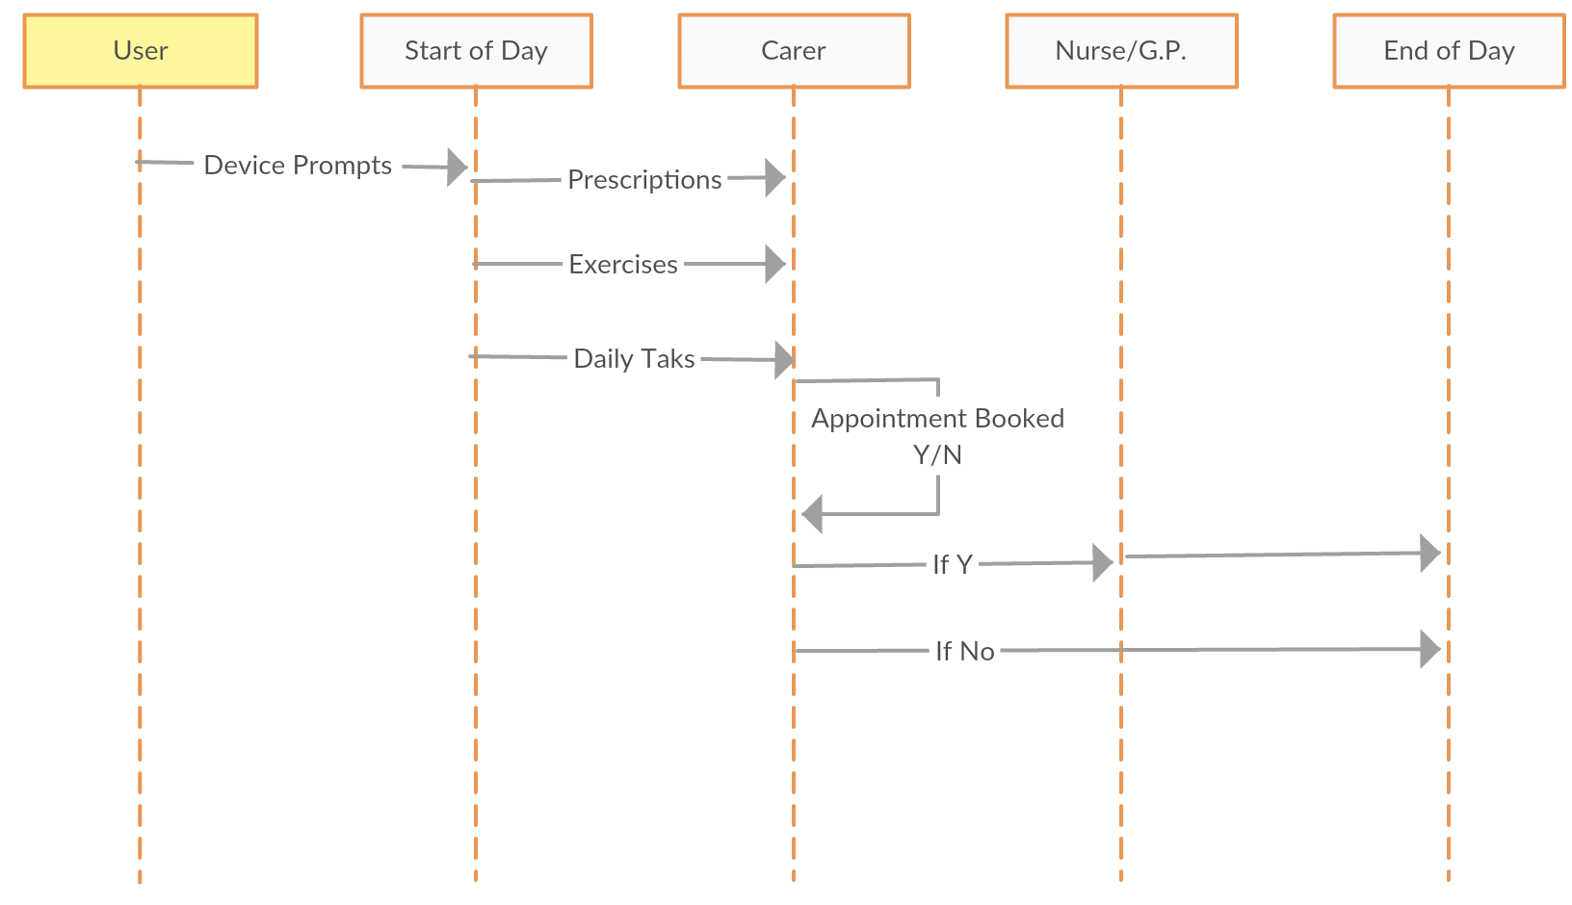
Start of day:
Begings with the daily rituals of the end-user. They use their chosen devices to aid in getting up and organising activities for the day.
Care giver:
They can be live in, a single visitor, or a revolving number of carers through the day or week. They can help to ensure that the end-user take their daily prescriptions and medicines. These can also be reminders that can be given by a smart device. They can also perform rehabilition and exercises which are often vital to mainting health. This is helped by devices that measure activity and status of heartrate/blood pressure/sugar levels etc. Which carers, nurse and doctors can use to track health over a period of time.
If scheduled medical check-ups and appointments:
Reminders can come through phone/tablet/watch. The appointment is carried out by a nurse and/or doctor who provide treatment, diagnosis and ensure well-being of the patient.
Role of nurse is is to give healthcare services to communities, families and individuals through communication, decision making, teaching and management of care services. So they may attain, maintain, or recover optimal health and quality of life.
Role of Doctor is concerned with promoting, maintaining, or restoring health through the study, diagnosis, and treatment of disease, injury, and other physical and mental impairments.
Feedback – can be as often or as little as required. With it either being Scheduled or only when circumstances change for the end-user.
Civic organisations have to be able provide resources and help that is appropriate to the requirements of the user. Informed through tests and advice from GPs.
Medical orgnastions assess wether the user needs to change the rehabilitation and/preseciptions for the user require to maintain their health which is a key part for independent living.
End of day:
Daily rituals of end-user: Set prompts and reminders on devices for the next day. Carry out nightime activities.

User Needed Resources;
- Medical devices, household assistant devices, monitoring devices (security/visual aids)
- Smart/virtual assistant – a software and/or device agent that perform tasks or services for an individual.
- Personal equipment and/or household assistant devices.
- Computers/tablet/smartphone.
- Networks – telecommunications/internet
- Civic/Medical applications for scheduling appointments, carrying out office work and data storage management.

7.3 Use case C: User interaction within multi-device environment

Nominal scenario

- Step 1 to 5: The user asks the devices who has the capabilities of printing a document (Print services).
- Step 6 and 7: Devices who are not concerned by this question, do not respond. Printer1 and Printer 2 answer the question. They inform the user that they have this capability and give their features (QoS, location, etc.).
- Step 8: According to their features, the user chooses a printer (example Printer1) and run the print command.

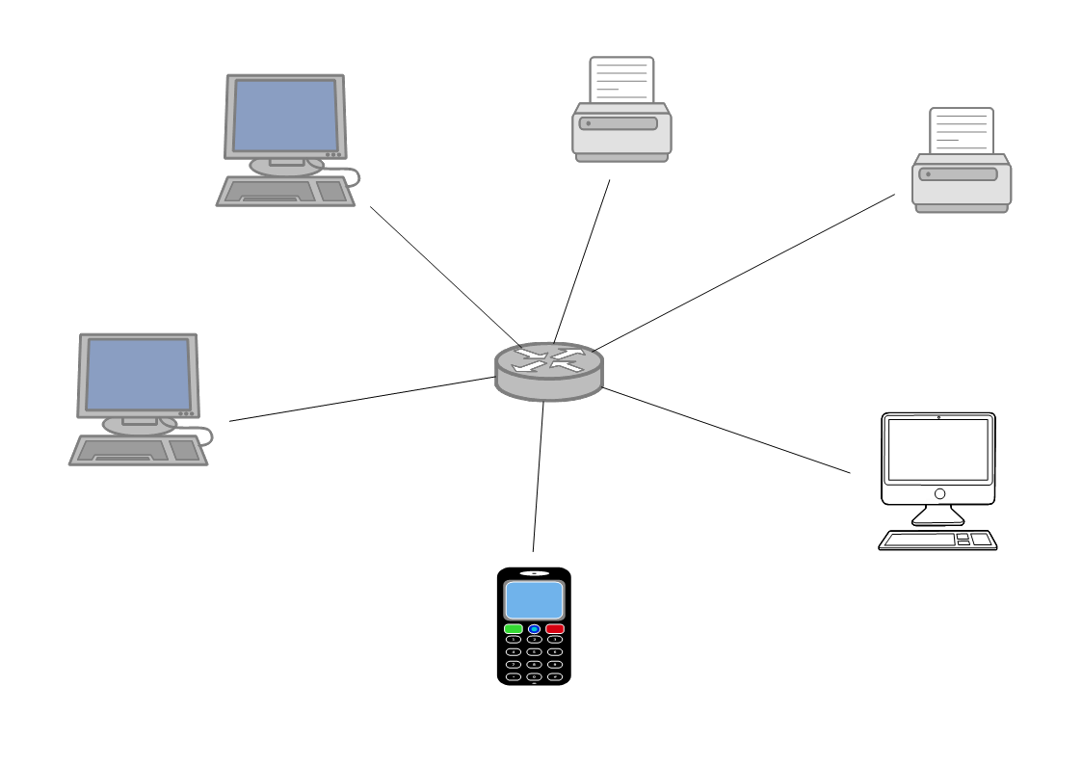
Marc computer
Pierre computer
Marie computer
Jean smartphone
Printer 1
Printer 2
Who can print this document?

User needed resources

- Internal and external network infrastructure.
- Connected devices
- Composition of personnalised services between the user and the device including the researched service.

7.3.1 Activity diagram

7.3.2 Sequence and communication diagrams
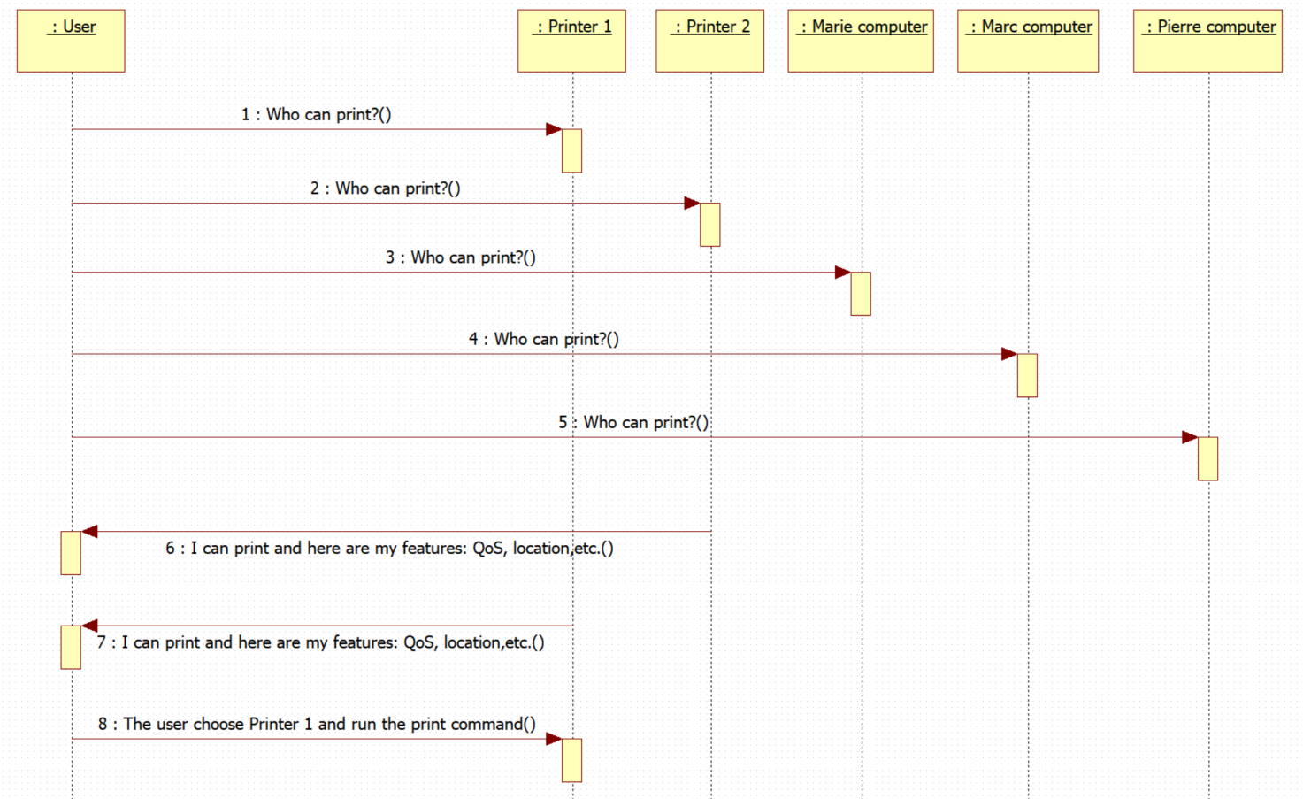

7.4 Services delivery and organization

Annex A: Description of the survey

The survey has been produced both in French and in English

English Survey


French Survey



Annex:
Bibliography

Annex :
Change History
Date | Version | Information about changes
02/2018 | 0.0.1 | Initial draft for UG 62
22/05/2018 | 0.0.2 | Early draft

History
Document history
<Version> | <Date> | <Milestone>
V0.0.1 | 20/03/2018 | UG#63 meeting

Latest changes made on 2016-05-20

