ETSI TR 103 438 V0.0.3 (2018-08)
User Group;
User centric approach in digital ecosystem

<

TECHNICAL REPORT
Reference
DTR/USER-0046
Keywords
IoT, M2M, QoE, USER
ETSI
650 Route des Lucioles
F-06921 Sophia Antipolis Cedex - FRANCE

Tel. : +33 4 92 94 42 00 Fax : +33 4 93 65 47 16

Siret N° 348 623 562 00017 - NAF 742 C
Association à but non lucratif enregistrée à la
Sous-préfecture de Grasse (06) N° 7803/88

Important notice
The present document can be downloaded from:
http://www.etsi.org/standards-search
The present document may be made available in electronic versions and/or in print. The content of any electronic and/or print versions of the present document shall not be modified without the prior written authorization of ETSI. In case of any existing or perceived difference in contents between such versions and/or in print, the only prevailing document is the print of the Portable Document Format (PDF) version kept on a specific network drive within ETSI Secretariat.
Users of the present document should be aware that the document may be subject to revision or change of status. Information on the current status of this and other ETSI documents is available at https://portal.etsi.org/TB/ETSIDeliverableStatus.aspx.
If you find errors in the present document, please send your comment to one of the following services:
https://portal.etsi.org/People/CommiteeSupportStaff.aspx
Copyright Notification
No part may be reproduced or utilized in any form or by any means, electronic or mechanical, including photocopying and microfilm except as authorized by written permission of ETSI.
The content of the PDF version shall not be modified without the written authorization of ETSI.
The copyright and the foregoing restriction extend to reproduction in all media.

© ETSI yyyy.
All rights reserved.
DECTTM, PLUGTESTSTM, UMTSTM and the ETSI logo are trademarks of ETSI registered for the benefit of its Members.
3GPPTM and LTE™ are trademarks of ETSI registered for the benefit of its Members and
of the 3GPP Organizational Partners.
oneM2M logo is protected for the benefit of its Members.
GSM® and the GSM logo are trademarks registered and owned by the GSM Association.

Contents
Intellectual Property Rights 5
Foreword 5
Modal verbs terminology 5
Executive summary 5
Introduction 5
1 Scope 7
2 References 7
2.1 Normative references 7
2.2 Informative references 7
3 Definitions, symbols and abbreviations 8
3.1 Definitions 8
3.2 Abbreviations 8
4. User context 9
4.1 Evolution of the context with the concept "user centric" 9
4.2 User at the center of the architecture that leads us to "as a service" 10
5. User experience 11
5.1 User maturity 11
5.2 User expectations 13
6 User-Centric Deliverables. An overview 14
7 Ecosystem digital identification 16
7.1 Introduction to digital Ecosystem 16
7.2 Use cases 18
7.2.1 Use Case: Smart Meters 18
7.2.1.1 Services 18
7.2.1.2 Process 19
7.2.1.3 Actors of Home Digital Ecosystem 20
7.2.2 Use Case: Home Entertainment Services 20
7.2.2.1 Services 20
7.2.2.2 Process for Home Entertainment Services 21
7.2.2.3 Actors of Home Entertainment Services 22
7.2.3 Use Case: Travel Management 22
7.2.3.1 Services 22
7.2.3.2 Process for Travel management 23
7.2.3.3 Actors of Travel Management 24
7.2.4 Use Case: Video on Demand 24
7.2.4.1 Services 24
7.2.4.2 Process for Video on Demand 25
7.2.4.3 Actors of Video on Demand 25
7.2.5 Use Case: Surveillance of pets 25
7.2.5.1 Services 25
7.2.5.2 Process for Surveillance of pets 26
7.2.5.3 Actors of Surveillance of pets 26
7.3 Generic model 26
8 New vision of digital use cases for Composition of Personalized Services 26
8.1 Use Case A: eHealth Independent Living 26
8.1.1 Daily cares and day-to-day activities 27
8.1.2 Patient monitoring 29
8.2 Use Case B: User interaction within multi-device environment 31
9. Conclusions 33
To be completedAnnex A: Description of the survey 33
Annex A: Description of the survey 34
Annex B: Additional Use Cases 35
B.1 User Interaction with IoT Devices 35
B.2 Process model of User Interaction with IoT 35
B.3 Actors of User Interaction with IoT 36
B.4 User Interaction within the Smart City 36
B.5 Process Model of User Smart City Interaction 37
B.6 Actors of User Smart City Interaction 37
ANNEX Bibliography 39
History 40

Intellectual Property Rights
IPRs essential or potentially essential to the present document may have been declared to ETSI. The information pertaining to these essential IPRs, if any, is publicly available for ETSI members and non-members, and can be found in ETSI SR 000 314: "Intellectual Property Rights (IPRs); Essential, or potentially Essential, IPRs notified to ETSI in respect of ETSI standards", which is available from the ETSI Secretariat. Latest updates are available on the ETSI Web server (https://ipr.etsi.org).
Pursuant to the ETSI IPR Policy, no investigation, including IPR searches, has been carried out by ETSI. No guarantee can be given as to the existence of other IPRs not referenced in ETSI SR 000 314 (or the updates on the ETSI Web server) which are, or may be, or may become, essential to the present document.

Foreword
This Technical Report (TR) has been produced by ETSI User Group, and Special Task Force 543.

Modal verbs terminology
In the present document "should", "should not", "may", "need not", "will", "will not", "can" and "cannot" are to be interpreted as described in clause 3.2 of the ETSI Drafting Rules (Verbal forms for the expression of provisions).
"must" and "must not" are NOT allowed in ETSI deliverables except when used in direct citation.

Executive summary

Introduction

The Technical Report has been produced by the STF 543 experts.
The concept of the full Project is to define 5-dimension model called “ACIFO” The 5-dimension model is based on 5 sub-models defined as:
• Architectural Model « Acifo » : defines the global structure, including semantics and is optimized for the stated objectives.
• Communication Model aCifo : defines the exchange protocols, including APIs and HMIs, over three planes :
-Management (Monitoring)
-Control
-Usage
• Information Model acIfo : defines the information of the whole ecosystem (equipment, network, applications, services, HMIs, User,…) from the offer to the availability of resources for Users, Providers and any other partners. It is a knowledge data base representing the whole ecosystem.
• Functional Model aciFo : defines the functionalities (the process) to compose any service based on « micro-services ».
• Organization Model acifO : defines the role of any actor and which actor is responsible of each action. (« Who is doing what? »).
These five dimensions should be shared by the user and the supplier/provider. For the user, it should be possible to define (or to choose) the level of autonomy and control for the personalized composition of services.

The four deliverables produced by STF 543 define the different dimensions
TR 103 438 (the present document) focuses on the Architecture and the Organization
It includes the use cases and the results of the survey.
EG 203 602 (D2) focuses on the information and the functionalities
It is dedicated to the user. It provides analysis and recommendations from the information and functionalities.
TR 103 603 (D3) addresses all the dimensions to the supplier, in order to produce the APIs according to the user expectations and whatever the number and types of additional suppliers.
TR 103 604 (D4) focuses on the communication and in particular on the HMIs.

For example, for Energy (production, distribution, consumption), the supplier will create an API for the user. The information will be exchanged between the supplier and the user but will not be used only by the supplier: the user will have access to all the information and will be able to use this information to optimize their energy consumption. This data base is a source to provide new services and new applications (for the user and for the supplier). One major challenge and constraint is to ensure that all the private data may be checked and monitored by the user (the contract needs to define clearly these points). The data are not used only by the supplier, the user should have access to the data and may refuse that the data be used or known → an interaction “cursor” between the user and the supplier defines the freedom (GDPR)

1 Scope
The digital ecosystem includes all sectors of activity in which the user through smartphone, and objects are connected, that is to say capable, in addition to their main function, to send or receive information via a telecommunication network which allows to extend or diversify the functions of the smartphone and the object.
Connected objects fall, for example, in the fields of transport (connected vehicle), health (connected self-measurement), industry (connected tools), home automation (interactive electricity meter) or even daily life (connected watch).
This is why the notion that interests us in the digital ecosystem is that of considering that the user is at the heart of the architecture.
The present document focuses on the Architecture and the Organization dimensions of ACIFO, including User’s QoE.
The Technical Report details the following aspects to achieve a generic model
- Overall results of the survey intended to collect information about user’s experience, expectations and behaviours.
- User centric usages in digital ecosystem.
- New vision of digital “use cases” .

2 References

2.1 Normative references
As informative publications shall not contain normative references this clause shall remain empty.

2.2 Informative references
References are either specific (identified by date of publication and/or edition number or version number) or non-specific. For specific references, only the cited version applies. For non-specific references, the latest version of the referenced document (including any amendments) applies.
NOTE: While any hyperlinks included in this clause were valid at the time of publication, ETSI cannot guarantee their long-term validity.
The following referenced documents are not necessary for the application of the present document, but they assist the user with regard to a particular subject area.
[i.1] EN 301 549: Accessibility requirements for ICT products and services
[i.2] TR 103 304: CYBER; Personally Identifiable Information (PII) Protection in mobile and cloud services
[i.3] TR 103 309 CYBER; Secure by Default - platform security technology
[i.4] TS 102 165-1 Telecommunications and Internet converged Services and Protocols for Advanced Networking (TISPAN); Methods and protocols; Part 1: Method and proforma for Threat, Risk, Vulnerability Analysis
[i.5] EG 202 009-2 User Group; Quality of telecom services; Part 2: User related indicators on a service specific basis
[i.6] ISO 20000-1: Service management system requirements
[i.7] EG 203 602: User centric approach Best practices to interact with digital ecosystem
[i.8] TR 103 603: User centric approach Recommendations for providers and standardization makers
[i.9] TR 103 604: User centric approach – Qualification of the interaction with the digital ecosystem

3 Definitions, symbols and abbreviations

3.1 Definitions
For the purposes of the present document, the following terms and definitions apply:
ACIFO: a 5-dimension model, based on recommendations and common objectives for Users and Providers, giving the capability for the User to compose the needed services. The 5-dimension model creates one unique and integrated solution.
Micro-services: basic and simple services (with SoA properties) that be combined for the composition of services as expected by the User.
User-Centric: the user who is the heart of the ecosystem, instead of application-centric, network-centric,... where the user is one of the components of the ecosystem

3.2 Abbreviations
For the purposes of the present document, the following abbreviations apply
ACIFO : Architecture, Communication, Information, Functionality, Organization
AES Advanced Encryption Standard
API Application Programming Interface
BYOD Bring Your Own Device
CES Customer effort score
DNS Domain Name System
GDPR General Data Protection Regulation
GSM Global System for Mobile communications
IoT Internet of Things
ITS Intelligent Transportation System
LoRa RF Long Range Radio Frequency
LoRa WAN Long Range Wide Area Network
Lte Long term evolution
M2M Machine to Machine
NFC Near Field Communication
NGO Non-Governmental Organization
OS Operating System
PC Personal Computer
QoE Quality of Experience
QoS Quality of Service
RTC Réseau téléphonique Commuté = Switched Telephone Network
SLA Service level Agreement
SLO Service Level Objectives
SMS Short Message Service
SSL Secure Sockets Layer
TCP/IP Transmission Control Protocol / Internet Protocol
TV Television
VoD Video on Demand
VoIP Voice over Internet Protocol
WIFI Wireless Fidelity

4. User context

4.1 Evolution of the context with the concept "user centric"
The first important notion of our context is that of "User-Centric" in a digital ecosystem. That is to say that this user is above all elements. First, they want to be able to connect to several seamless heterogeneous networks to access their services. Connectivity does not stop at link establishment, connectivity does not just mean maintaining the link, but it should allow the user to be easily connected at all times during their moving, to any network, which they have the rights of access and from any terminal.
The main impact of this approach is that the ecosystem is "in the service" of the user, unlike other approaches where the user should comply with different processing constraints (System Centric) or application (Application Centric), or more connections (Network Centric).

Indeed:

- "System Centric" (Fig. 1, a) is based on the OS (Operating System) supported by the hardware where it is installed. The applications run parallel on this OS thanks to the "Compiler" which makes the translation and the static optimization to have a better execution of service. Although today, it should be noted that to avoid re-translations for an application because of OS changes, virtualization (VM - Virtual Machine) is proposed to hide the heterogeneity of OS. With this middle layer (Hypervisor), applications can be used on any OS.
- " Application Centric " (Fig. 1, b) focuses on the application and considers it as the starting point. The whole process takes place, from the point of view of the application, without taking into account the preferences and changes of the different actors. Only options are considered.
- "Network-Centric" (Fig. 1, c) implies that the infrastructures of the network are at the heart of the architecture, they condition all requests for services. The heterogeneity of the network imposes different solutions for a requested service through a connection support.
- With a "User Centric" approach (Fig. 1, d), it is the user who is at the centre of the architecture, they should be able to personalize their services, access them dynamically through the accesses offered during their actions, according to the QoS (Quality of Service) desired. These are the properties that the digital ecosystem should offer.

To ensure all kinds of personalization, such as tracking the mobility of the user, take into account their preferences according to the location, adapt to the profile, designers can no longer be satisfied with a "client/server" application architecture with options. They need to build a chain of services with a personalized service logic. But this service logic can only be achieved if designers have composable services. It is therefore important to have a good approach to the service. A service is neither an application nor a transaction, let alone a system. ISO 20000 [i.6] defines it as "a composable service that should be a source of value for the consumer and the supplier".

Designers need to think about services differently. By having an architecture allows the user to do, if they wish, their own composition of service, with dynamic changes according to the proposals made to them, throughout their moving.
In conclusion, today's user moves and changes environment (network access), changes handsets, desires seamless service continuity and end-to-end service QoS. The digital ecosystem should respond to "anywhere, anytime, anyhow, every service, everyone", with a concern for transparency and automation.
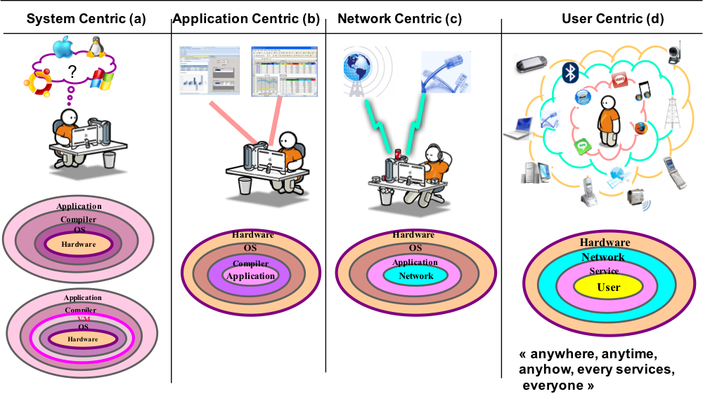

Figure 1. Evolution of the context, from System Centric to User Centric

4.2 User at the center of the architecture that leads us to "as a service"

What does that mean?
Firstly, it means that the user should be able to request any service in the digital ecosystem. But how to do this, when the ecosystem is very heterogeneous.
Indeed, service providers have the equipment (PC, smartphone, tablet), which allow them to access the ecosystem; or the connected objects (sensors, ...), which monitor the user. Then service providers have the networks, which allow them the ability to optimize the delivery of the ecosystem.
The user should therefore first position themselves on the right service that offers their objectives and budgets. However, the choice of services among service providers in a highly competitive and heterogeneous environment is not easy. It requires a consistent understanding of all end-to-end services.

That's why service providers need to understand this digital ecosystem with the new paradigm "as a service".
Thus, service providers can say, secondly, that:
- the user can, depending on their level of desired personalization, make their choice and if necessary make "their composition of service",
- suppliers can submit their offers, according to a variety of specialized services offered in "self-service" and then billed at consumption.
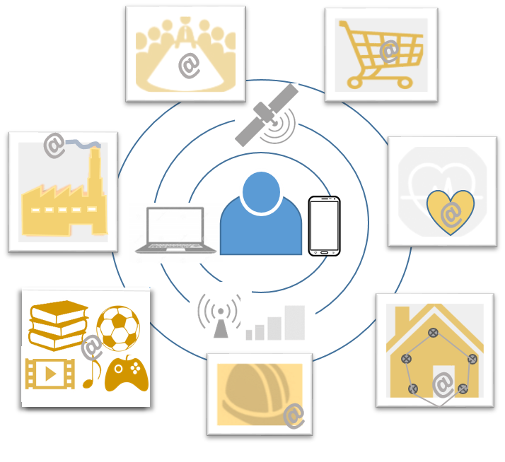
Figure 2: User’s environment

Figure 2 shows a users’ environment. Due to the number of services, applications, networks, terminals, it is needed for the user to be the heart of the architecture, in order to make the life simpler and to offer all the potential services with high quality of service, security, safety, …

5. User experience
A survey has been carried out in order to collect information about user’s experience, expectations and behaviours

The figure defines the context of the Technical Report. HMI and QoE are two main factors to be documented in the different documents associated to the current Technical Report.

5.1 User maturity
In the Digital paradigm, users have the ability to access a large number of digital services applications and contents covering almost every time and everywhere a big part of their daily life activities, personal or professional.

So, the question is: are they able to master all these services by themselves, or at least are they properly informed of what they can do with their subscriptions and equipment and what they consume?

Maturity is mainly measured by the degree of knowledge of the user about the services available, how to activate them, how to configure them, how to control them.

A survey has been conducted during two and half months. The questionnaire (both in french and English), the results and analysis are available in Annex A.
The main lessons are :
- Currently, setting up a smartphone is far from easy according to most respondents. More than half of them say that they do not know how to fully configure their smartphone, of which 15% say they do not really know how to do it.
It’s seems like the difficulty for setting a box is a little bit higher. The survey allowed to score what we call the CES (customer effort score),
- A lot of people (42%) do not really know the differences between the successive generations of GSM technologies. This could lead to difficulties with the advent of 5G. Specially because according to responders, cellular parameters are more difficult to set than the bluetooth and the WIFI connexion.

The degree of maturity of the user is partly due to his involvement, his expectations of control, and of course the diversity and frequency of the services he uses.

- 34% of people change the setting of their smartphone less than once a year.
- 56% of survey respondents never or rarely get on line to the personal page of their fix subscription and it is quite the same for the mobile (53%). Obviously, for these people, it is difficult to have a good level of knowledge and control.

But this maturity can be greatly improved by the level of information and help tools available, the transparent attitude of the supplier, the ease of use of the services, of their configuration and customization. . From this point of view there is progress to be made;

- There is a very large majority of people who would like to be able to challenge much more their provider
- It is currently difficult to make is own composition of services because of the low scalability of the offers, and there is few value to do that because of the tariff advantages of the package
- Currently 23% of respondents often or sometimes have problems with the invoices. For a mass market product it is quite high value, and not very good for confidence between consumers and providers.

The architecture and software oriented next generation networks are able to improve the flexibility and dynamic management and control of the services.

This is why it is important to look at the maturity of uses in the digital ecosystem.

The second set of lessons of the survey focuses on the user expectations.

5.2 User expectations
The survey sought to know the expectations of users for non fonctional but essential services for a good digital experience.
First of all we can see that there is a clear willing to use new services as long as their benefits are clear. That is not the today for the internet of things.
Secondly, we asked a series of questions about some new possible services able to improve the digital experience on a NGN network.
People would like :
- to be informed when they are risking entering into an area with low or without coverage and may loose the continuity of service. Losing the continuity of mobile service on move is a problem for 90% of people. This shows that communication everywhere and even on move is a standard request today for users
- more control on the battery life
- more control on the location data of their devices
- to find their professional configuration on different devices (for those who are in employment)
- 44% of people would appreciate a service of bandwidth on demand fix line and 38% on mobile line. The percentage of people interested and not interesred by this service are quite the same.
Of course, security and privacy issues are in the heart of the confidence for the future digital ecosystem.
The survey shows there is a very large majority of people who would like to be able to challenge their provider on what we can call “essential characteristics” of the contract, ie privacy, security, quality and price.

6 User-Centric Deliverables. An overview

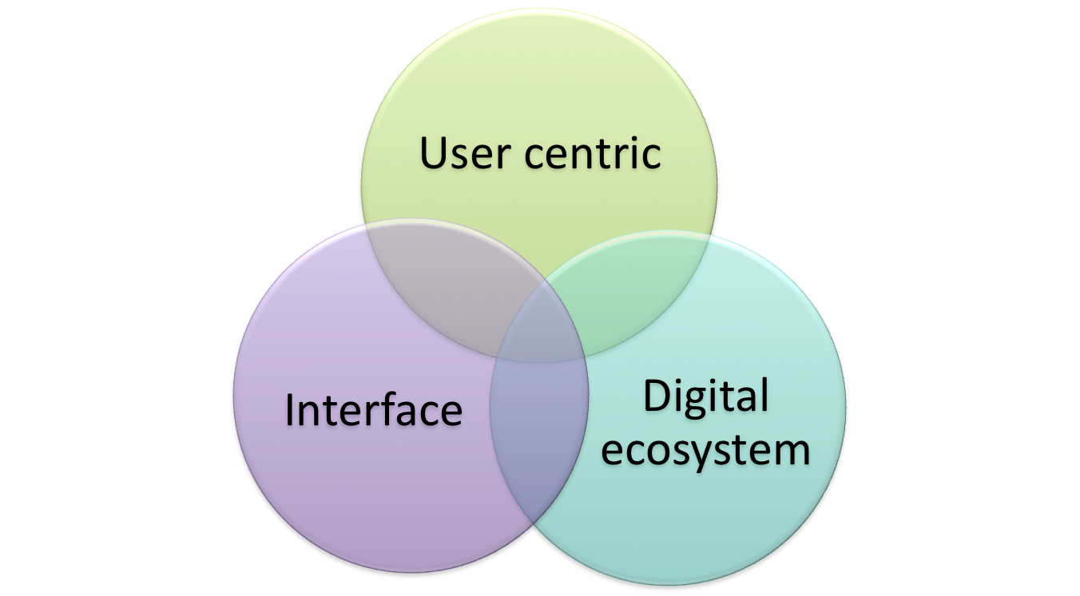
2 - QoE
- Service Composition
- API
- Data Content

-API
1-HMI
Architecture
- User Profile
- Device Profile

Figure 3 : Perimeter of addressed problematic
Figure 3 defines the perimeter of the problematic addressed and so the content of the Technical Report. HMI and QoE are our main concerns in our context, but it is necessary to analyze the entire environment to understand the new challenges.
As part of the project “User Centric approach in the Digital Ecosystem”, it has been identified three areas of interest that are:
- User centric (1),
- Digital Ecosystem (2),
- and user interfaces (3).
- User centric: This concept, as introduced previous, covers the approach where everything is developed around the user, which allows the user to access all the possibilities of the system through service components, which they can compose in a personalized way. This, during a session with continuity of quality of service (QoS). This concept has created new paradigms by introducing new ways to consume resources. With a "User centric" approach, the user is at the earth of the architecture. They should be able to customize his services, access them dynamically while they move and according to the desired quality of service (QoS).
- Digital Ecosystem: Represents the new digital environment where we evolve by considering all equipments, all technologies and their interactions. A digital ecosystem is a set formed by a community of services that interrelates with its environment. Components of the ecosystem develop a dense network of dependencies, of information exchanges to meet the user needs evolution. End consumers have service requirements that vary depending on their context which may vary over time. Important limitations inherent to the current silo based architectures (vertical architectures) and the lack of agility in our platforms and services infrastructure impose to think differently about making services.
Mobility, ubiquity and services personalization are keywords that characterize the needs of digital applications, and should be taken into account by future service architectures.

- User Interface: is the software or the application on a platform that allows the user to interact with the equipment and services. User Interface has a more important role in the future ecosystem digital. It is described as the interaction and communication between human users and a machine via a human-machine interface (HMI). It encompasses the underlying processes which produce the interactions, its design and implementation. The HMI can be described as the point of communication between the human user and the machine. TR 103 604 [i.9] details the User Interface.

The intersections of these three domains introduce the first modifications of the today context and the challenges tomorrow.

We find :

- The intersection of the “user centric” and the “user interface” contains the different profiles of the user and equipment to adapt to the new needs of the user. Thus according to the possibilities offered by the equipment, the networks and the software platforms, a personalization is possible. Informational and functional elements are described in EG 203 602[i.7].

- The intersection of the” user centric” and the “digital ecosystem” defines the links between the service request and the service offer. This is where we should find the possibility of service composition. The user should be able to compose his service according to their needs, according to their position and according to their activities. This new vision is presented in section 8. TR 103 603 [i.8] details these aspects in order to define the APIs according to the user expectations. ).

- The intersection of the “digital ecosystem” and the “user interface” covers the architectural dimension. The architecture should take into consideration the customer's requirements, and should also take into account the performance factors (security, reliability and throughput) as well as the cost and budget constraints. User requirements include interface design, operational capabilities, and usability of the interface. Ecosystem requirements include hardware, networking, and the capabilities and constraints of the runtime environment. Architectural and organizational dimensions may be found in section 7 of the presentdocument.

The intersection of the 3 domains is Quality perceived by the user of services, QoE (Quality of Experience).
In our connected world, applications should interact with other applications and services, and run in different environments such as the cloud and mobile devices. The current monolithic designs of the past have been replaced by service-oriented software components that use structures, operating systems, runtime hosts, and networks to implement functions that were not yet known a few years ago. All applications are designed and developed with the objective of improving the quality of experience. Improving the quality of the experience cannot be achieved without taking into account all the needs of the user, the improvement of the digital ecosystem and its diversification as well as the improvement of the human machine interface .

7 Ecosystem digital identification
Our objective, in this chapter, is to be able to identify a suitable architecture for the new digital ecosystem. To do this, we have drawn up a table presenting a typology of use cases (§ 7.1), then studying some of them (§ 7.2). A general and generic framework is presented (§7.3) in order to address, in the following, the other dimensions of the context "user centric"

7.1 Introduction to digital Ecosystem

The potential use cases are listed below
Smart Cities | Smart parking  Structural Health  Noise Urban maps  Traffic congestion  Smart lighting  Wage Management  ITS |  | Smart Environment | Forest fire Detection  Air pollution  Avalanche Prevention  Earthquake Early Detection
Smart Retail | Supply Chain Control  NFC Payment  Shopping Applications  Product Management |  | Smart Logistics | Shipmen Conditions  Item Location  Storage Detection  Fleet Tracking
Smart Metering | Tank Level  Smart Grid  Photovoltaic Installation  Water Flow  Silos Stock Calculation |  | Smart Security | Perimeter Access control  Liquid presence  Radiation Levels  Hazardous Gazes
Smart Domestic | Energy and water Use  Remote Control Appliances  Intrusion Detection Systems  Art and goods preservation |  | Smart e-Health | Fall Detection  Medical Fridges  Sportsmen Care  Patients Surveillance  Ultraviolet Radiation
 |  |  | Smart Industry | M2M Applications  Indoor Air Quality  Temperature Monitoring  Ozone Presence

These chosen Use Cases will be first illustrated by a combination of process models, tables and text description. The use cases of smart cities, IoT and eHealth will be further developed by UML diagrams and descriptions. It should be noted that a digital eco-system can be rich and diverse in what is included but also can be bare and minimal because it changes with the user and their requirements and needs. Each digital eco-systems are made up of multiple interconnected use cases. They will aim to show how the different components are controlled and the user interaction. The use cases will use generic examples of the chosen scenarios with no references to actual named products and services.
The home digital eco-system can be a single user or many. The use case will focus on single household. And how they interact with services and software applications by using devices. The devices may be single use or multi-use. The home digital eco-system is not confined to the geolocation of the home as many of services need access to external assets. Thus, whilst the eco-system may include smart home devices, home banking, entertainment, home shopping, the root of many of these services are outside the home.
The services can be solely in used in-house whiles others need access to resources outside the house. For example, smart metering for utilities are stand-alone in that they report usage of resources and how much money has been spent. Apart from when they send meters updates to the utility company. In theory they allow for better budgeting by allowing users to know accurately how much a household is spending on power or water. But a dedicated budgeting application needs to pull in data from a households banking services and other financial services the user might use often this is from the outside the house and can also be used outside the house. The user(s) is (are) consumer(s) but may also be producer(s) (e.g. energy, applications, etc.)
The workplace digital ecosystem can be made up of a single user or many users. They can either have a clearly defined role or multiply roles within a business eco-system. The scale can change with the size of the business from a one-person operation carrying out all roles to hundreds of workers each having their unique role in a business. The user interaction and access with the different services should have common UX experience between different devices and tools. Services can include organising of work schedules, travel to meeting/conferences, organisation and co-operation of projects or work between different users within the same work environment. These services can be solely intra-business or inter-business. The user experience and interaction across smart city services and applications should be consistent and seamless. The user should experience no barriers when moving between different services.
The Smart city digital ecosystem is vast web of interconnected IoT devices, sensors, cloud computing, services and big data all brought together into the urban infrastructure. The end-user only interacts with a small part of the smart city digital ecosystem. The end-user benefits from the complexity of the smart city since the feedback of collected data from users can be used by planners and organisations to improve the user services and experience. Most of the time the end-user doesn’t interact directly with the applications that make up the smart city. But for utility services and transport a user will interact with through dedicated applications or web portals in order to use them.
The eHealth digital ecosystem use case examines what is needed to enable users with medical disabilities/old-age aim to achieve independent living. This use case shares elements with the home and workplace digital ecosystem. The services include remote monitoring of health by doctors, automatic response with emergency services in case of accidents. The scheduling of care nurses or helpers between clients and care organisations. If the user is living by themselves, they can be able to make use of smart-assistants similar Amazons Alexa to aid in day-to-day activities. This use case builds upon earlier ETSI eHealth work to develop the it. Users are not limited to the elderly for example users with psychical disabilities share elements with home, work and eHealth use case elements. They make use of modified devices and tools for access and usability. Users with cognitive disabilities also share elements with home, work and eHealth. In order to allow better user interaction with devices and applications. For these users there is a focus on UX experience and accessibility. For example, greater use of voice interaction instead of touch/button interfaces.

7.2 Use cases

These chosen Use Cases will be first illustrated by a combination of process models, tables and text description. The use cases of smart cities, IoT and eHealth will be further developed by UML diagrams and descriptions. It should be noted that a digital eco-system can be rich and diverse in what is included but also can be bare and minimal because it changes with the user and their requirements and needs. Each digital eco-systems are made up of multiple interconnected use cases. They will aim to show how the different components are controlled and the user interaction. The use cases will use generic examples of the chosen scenarios with no references to actual named products and services.
Each Use case is made up of three parts the Service Table, the process model and the table of actors. The chosen use case are Smart Meters, Home Entertainment Services, Travel Management, Video on Demand and Surveillance of pets. The service tables identifies the principle Agents and the interactions between them. The Process model diagrams illustrate the movement of data and information between the principle providers. It highlights the key activities and interactions within the process model between the different agents. The table of actors identifies the principle users and service providers and their network domains and the information connections between the service providers and the end-users.

The use cases inform the generic model of the User Centric General Framework which is made of four parts User Devices and M2M, User or device networks, Provider networks and provider service management. As well the typical use case identification (composition of personalised services) which are Use Case A: User Interaction with IoT Devices and Use Case B: User interaction within multi-device environment.

7.2.1 Use Case: Smart Meters
The home digital eco-system can be a single user or many. The use case will focus on single household. And how they interact with services and software applications by using devices. The devices may be single use or multi-use. The home digital eco-system is not confined to the geolocation of the home as many of services need access to external assets. Thus, whilst the eco-system may include smart home devices, home banking, entertainment, home shopping, the root of many of these services are outside the home.
The services can be solely in used in-house whiles others need access to resources outside the house. For example, smart metering for utilities are stand-alone in that they report usage of resources and how much money has been spent. Apart from when they send meters updates to the utility company. In theory they allow for better budgeting by allowing users to know accurately how much a household is spending on power or water. But a dedicated budgeting application needs to pull in data from a households banking services and other financial services the user might use often this is from the outside the house and can also be used outside the house. The user(s) is (are) consumer(s) but may also be producer(s) (e.g. energy, applications, etc.)

7.2.1.1 Services

Services | Principal Agent | Assets¹/Resources | Interactions
Energy/water usage. Billing | Energy supplier  Water/Sewage suppliers  Metering companies. Maintain and check. | Supply networks.  Collected Data. – Requires permission from customer for use and to share with 3rd parties. | Unless the user should supply metering, readings there is no direct interaction.
Energy, applications production | Energy supplier  Metering companies.  Friends or partners.  Maintain and check. | Production networks.  Facilitate interaction between households and providers  Data collection and analysis of energy consumption | The user should control the production, the relationships with partners and collaborators.
Security (of the home digital eco-system) | Network Provider  Device manufacture (secure-by-default) | Standards and regulations set by Govt bodies and NGOs. ETSI TR 103 304  ETSI TR 103 309 | communication between the meter and the utility company
Data protection and privacy | The companies that handle the metering, billing, data storage and transfer. Should follow data protection regulations. | Directive on Security of Network and Information Systems and the  General Data Protection Regulation (GDPR) (Regulation (EU) 2016/679) | The energy supplier should obtain permission/consent from the bill payer to use for a stated purpose.
Special needs | Equipment, network providers | Standards such as EN 301 549 [i.1] | The interaction means depend on the type of impairments and the special needs
Budget control. | Home user – single or multi-person household | Meters – moving from ‘dumb’ to ‘smart’ | If smart able to better monitor energy and water usage and cost. Still possible if dumb but requires greater effort to estimate cost and usage.

7.2.1.2 Process

Smart Meter
Home User - Payer
Send collected Data over network
Meter Data Collection Company
Utility: Gas, Electricity and Water
Billing/Detailed Usage of Power/Water
Can actively monitor behaviour to change usage habits.
Home Solar Panels/Storage
National Grid
Electricity/Gas
Collected Data – Requires permission from customer for use and to share with 3rd parties
Provider
Receiver / User
Facilitator between User and Provider

7.2.1.3 Actors of Home Digital Ecosystem

End node-Users | Connector/Gateways | Network Servers | Service Providers
Smart Utility Meters  Connected Home-Appliances  IoT Devices  Smartphones  Desktop PC/Laptops  Smart TVs | Modem Routers  Phone Network Base Stations  Public/Community Wi-fi networks | Internet Service Providers  Telecommunication Providers  Cloud Computing/Hosting Providers  DNS Providers | Utility Companies  Technology Companies  Home Service Providers  Application and Device Support Providers  Cloud service Providers

7.2.2 Use Case: Home Entertainment Services

7.2.2.1 Services

Services | Principal Agents | Assets/Resources | Interactions
Entertainment - | Household – single user or multiple | Network devices – modems/routers  Remote control | Access to chosen streaming service and consumption.
Internet access | Internet Providers (IP)  Can give internet connections and give bundles of media entertainment packages. | Users Devices – TVs (smart/dumb), computers (portable/not), smartphones, tablets.  Games consoles (if they support it), traditional set-top boxes.  Screens | Setting up access on chosen devices. Are they shared with friends or families?
Over the air broadcasting. – Screen share with TV to other devices. | Entertainment and Media Providers | Internet Browser. Means of access without dedicated application or devices. | Security – controlling access / 2FA.  Protection of customer billing information and data.

7.2.2.2 Process for Home Entertainment Services

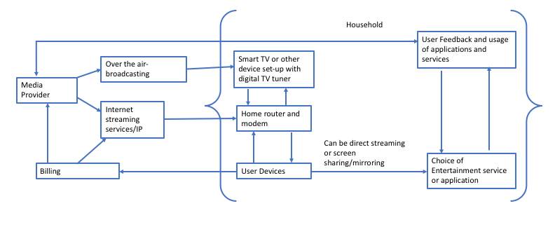

7.2.2.3 Actors of Home Entertainment Services
End node-Users | Connector/Gateways | Network Servers | Service Providers
Chosen User services and/or applications  User Devices – laptops/Desktops/ tablets/smartphone/ games console  Household devices – Smart TVs / streaming devices or dongles | Modem Routers  Phone Network Base Stations  Public/Community provided networks | Internet Service Providers  Telecommunication Providers  Cloud Computing/Hosting  Providers  DNS Providers  Over the air broadcasting | Technology Companies  Home Service Providers  Application and Device Support Providers  Cloud service Providers  Media Providers

7.2.3 Use Case: Travel Management
The workplace digital ecosystem can be made up of a single user or many users. They can either have a clearly defined role or multiply roles within a business eco-system. The scale can change with the size of the business from a one-person operation carrying out all roles to hundreds of workers each having their unique role in a business. The user interaction and access with the different services should have common UX experience between different devices and tools. Services can include organising of work schedules, travel to meeting/conferences, organisation and co-operation of projects or work between different users within the same work environment. These services can be solely intra-business or inter-business. The user experience and interaction across smart city services and applications must be consistent and seamless. The user should experience no barriers when moving between different services.
The Smart city digital ecosystem is vast web of interconnected IoT devices, sensors, cloud computing, services and big data all brought together into the urban infrastructure. The end-user only interacts with a small part of the smart city digital ecosystem. The end-user benefits from the complexity of the smart city since the feedback of collected data from users can be used by planners and organisations to improve the user services and experience. Most of the time the end-user doesn’t interact directly with the applications that make up the smart city. But for utility services and transport a user will interact with through dedicated applications or web portals in order to use them.

7.2.3.1 Services

Table 1 Travel Management
Services | Principal Agents | Assets/Resources | Interactions
Booking firms. | Business user – single individual or multiple. Same or distinct roles. | Devices – use for work and to carrying out daily tasks. | When they book or propose travel arrangements.
There is a dynamic relationship between the users and the service providers. The user can have full autonomy, partial or none when interacting with the digital eco-system.
Special needs | Equipment, network providers | Standards such as EN 301 549 | The interaction means depend on the type of impairments and the special needs.
Transportation (airlines, train services, bus/coaches, taxis, personal transport) | Company or organisation the user works for. Made of different elements that are responsible running the company. | Software – access to sites and services. | Another part of the company can organise the travel for their workers. Or reimburse if a user has paid for travel out of their own pocket.
A business or provider can offer a composition of services to the users. | Transport companies. | Modes of transport | How the user undertakes the travel.

7.2.3.2 Process for Travel management
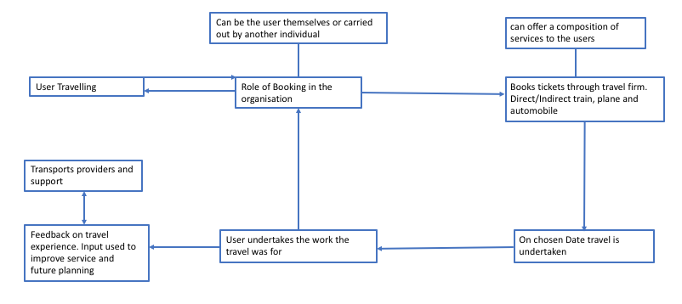

7.2.3.3 Actors of Travel Management

End node-Users | Connector/Gateways | Network Servers | Service Providers
Bring Your Own Device (BYOD)  Connected Work Appliances e.g. printing  IoT Devices  Smartphones  Desktop PC/Laptops  Conference Equipment  Fax machine  Payment Systems  Payment. | Modem Routes  Phone Network Base Stations  Public/Community Wi-fi networks  Wide Local Area Network (WLAN) | Internet Service Providers  Telecommunication Companies  Cloud Computing/Hosting Providers  DNS Providers | Technology Companies  Business Service Providers  Software License Providers  Application and Device Support Providers  Financial Process providers  Public Utility and Transportation companies that support the function of businesses  Cloud Service Providers

7.2.4 Use Case: Video on Demand
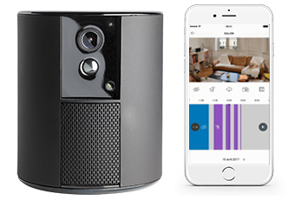
In this use case the user wishes to keep watch on their home via a connected video camera.
They subscribe to an on-line service. They monitor the video camera and connect it to their personnal network(Ethernet but more often Wifi) and supplies energy to it. They install the application on their smartphone. The account is created and their options and preferences are configured.
The user may keep watch on their phone via the application. Their data are stored in the Cloud of the service provider.

7.2.4.1 Services
The complete transmission chain is built on:
-The user devices communicate in one way or both ways.
When the user is at home, the user private network is used, when they are out of house the connection id done through the operator network.
-The operator network, both for access network and Cloud network.
-On the other end the services of the service providers where the client data and preferences and stored.
The application providing the service and the billing service are located at the service provider. The service provider may have access to the client data for assistance or to provide (sell) new options.

7.2.4.2 Process for Video on Demand
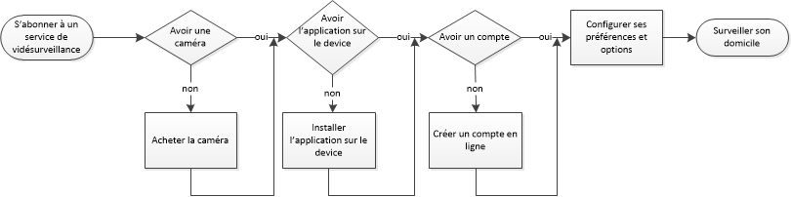

7.2.4.3 Actors of Video on Demand

7.2.5 Use Case: Surveillance of pets
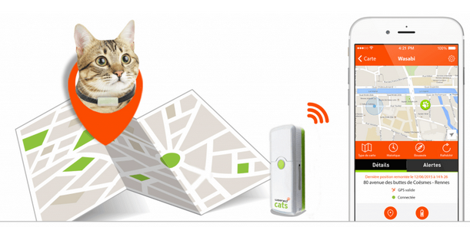
AS an example : the intelligent collar including a GPS chip and a real time following device. Some devices may also a communicationn with the pet,(eg through a microphone/loudspeaker).

7.2.5.1 Services
The tramsmission process is the following :
-The user devices communicate in one way or both ways.
When the user is at home, the user private network is used, when they are out of house the connection is done through the operator network.
For some usages such as 3G/4G or long distance network. The transmission id done through the operator network.
-The operator network, both for access network and Cloud network.
-On the other end the services of the service providers where the client data and preferences and stored.
The application providing the service and the billing service are located at the service provider. The service provider may have access to the client data for assistance or to provide (sell) new options.

7.2.5.2 Process for Surveillance of pets

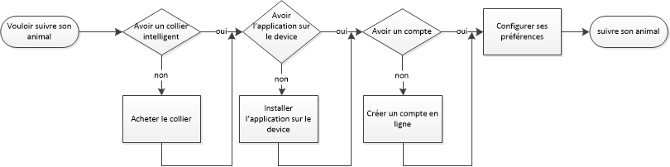

7.2.5.3 Actors of Surveillance of pets

7.3 Generic model

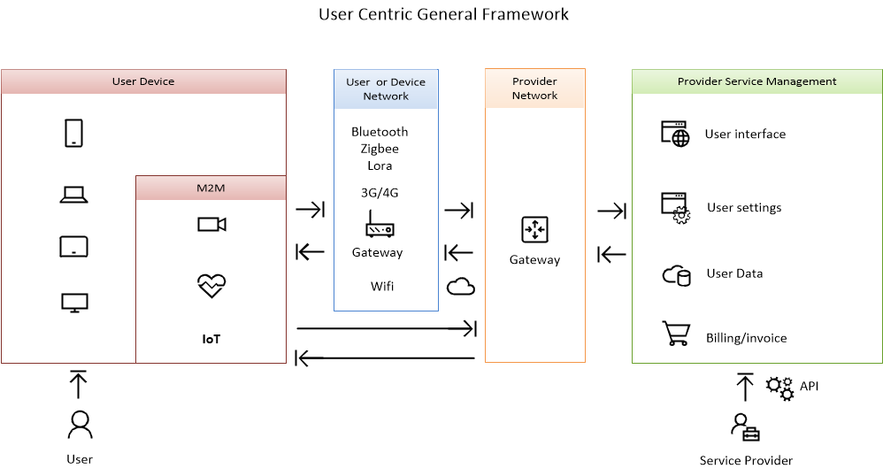

8 New vision of digital use cases for Composition of Personalized Services

8.1 Use Case A: eHealth Independent Living

The eHealth digital ecosystem use case examines what is needed to enable home users with medical disabilities and/or old-age impairments with the aim to achieve independent living. This use case shares elements with the home and workplace digital ecosystem. The workplace digital ecosystem can be made up of a single user or many users. They can either have a clearly defined role or multiply roles within a business eco-system. The scale can change with the size of the business from a one-person operation carrying out all roles to hundreds of workers each having their unique role in a business. The user interaction and access with the different services should have common UX experience between different devices and tools. Services can include organising of work schedules, travel to meeting/conferences, organisation and co-operation of projects or work between different users within the same work environment. These services can be solely intra-business or inter-business. The user experience and interaction across smart city services and applications must be consistent and seamless. The user should experience no barriers when moving between different services.
The Smart city digital ecosystem is vast web of interconnected IoT devices, sensors, cloud computing, services and big data all brought together into the urban infrastructure. The end-user only interacts with a small part of the smart city digital ecosystem. The end-user benefits from the complexity of the smart city since the feedback of collected data from users can be used by planners and organisations to improve the user services and experience. Most of the time the end-user doesn’t interact directly with the applications that make up the smart city. But for utility services and transport a user will interact with through dedicated applications or web portals in order to use them.

The services are classified in 2 categories: (i) daily cares and day-to-day activities, and (ii) patient monitoring.
In the first (Section 8.1.1), the services deal with remote monitoring of health by doctors and automatic response with emergency services in case of accidents.
In the second (Section 8.1.2), they deal with daily cares, scheduling of care nurses or helpers between clients and care organizations, and better accessibility like greater use of voice interaction instead of touch/button interfaces.
The home users are not limited to the elderly but users with psychical disabilities or diseases share the same elements.
They both make use of devices and tools for accessibility.
Better accessibility like voice interaction and health monitoring can be by done by IoT Gateways to aid them in their day-to-day activities.

A continuous remote patient monitoring is essential to observe medical state of patients who are suffering from acute diseases, especially cardiovascular diseases.
Wearable wireless sensors provide a continual access to medical parameters of a patient.
IoT Gateways are located in every room in the house as a way to follow the patient. They are gathering sensors data.
They can provide real-time analytical services, prediction and alerts in case of emergency. They can recognise an abnormal user activity, by using algorithms, and are able to contact the rescue teams according to the type of emergency and to notify the nearest hospital of arrival.
These smart gateways make early recognition of deterioration more reliable by bringing the decision-making core and critical notifications closer to the patient.
This system is critical. Due to the constant incoming data in a continuous medical monitoring, the system may encounter problems such as latency in system response, data transmission and computations related to data analytics. Quality of service should be controlled from end to end.

8.1.1 Daily cares and day-to-day activities

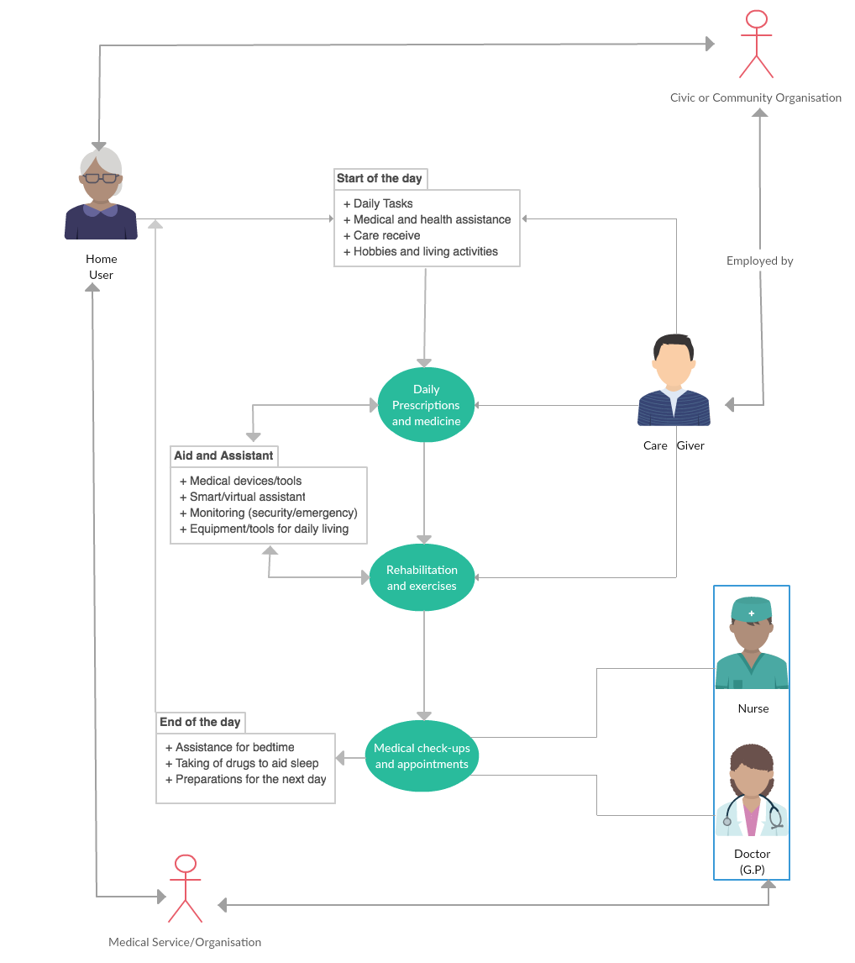
Activity diagram for daily cares and day-to-day activities

Nominal scenario for daily cares and day-to-day activities
Start of day:
Begins with the daily rituals of the end-user. They use their chosen devices to aid in getting up and organising activities for the day.
Care giver:
They can be live in, a single visitor, or a revolving number of carers through the day or week. They can help to ensure that the end-user take their daily prescriptions and medicines. These can also be reminders that can be given by a smart device. They can also perform rehabilitation and exercises which are often vital to maintaining health. This is helped by devices that measure activity and status of heartrate/blood pressure/sugar levels etc. Which carers, nurse and doctors can use to track health over a period.
If scheduled medical check-ups and appointments:
Reminders can come through phone/tablet/watch. The appointment is carried out by a nurse and/or doctor who provide treatment, diagnosis and ensure well-being of the patient.
Role of nurse is to give healthcare services to communities, families and individuals through communication, decision making, teaching and management of care services. So, they may attain, maintain, or recover optimal health and quality of life.
Role of Doctor is concerned with promoting, maintaining, or restoring health through the study, diagnosis, and treatment of disease, injury, and other physical and mental impairments.
Feedback – can be as often or as little as required. With it either being Scheduled or only when circumstances change for the end-user.
Civic organisations should provide resources and help that is appropriate to the requirements of the user. Informed through tests and advice from GPs.
Medical organisations assess whether the user needs to change the rehabilitation and/prescriptions for the user require to maintain their health which is a key part for independent living.
End of day:
Daily rituals of end-user: Set prompts and reminders on devices for the next day. Carry out night activities.

The user takes advantages of a personalization of services and their composition.
For example, a watch reminds the patient with a sound that he should take medication.
In this use-case, a service composition would include:
- services located on a watch for scheduling and medication reminding.
- services located in IoT gateways or Cloud for medication taking agenda.
Service compositions are thus personalized.
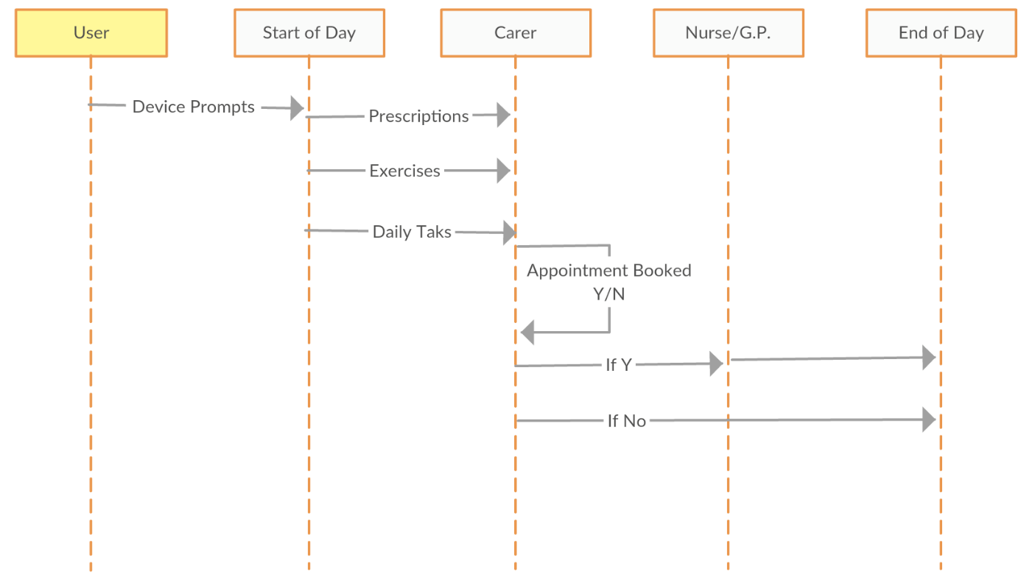
Sequence diagram

User Needed Resources for daily cares and day-to-day activities:
- Medical devices, household assistant devices, monitoring devices (security/visual aids)
- Smart/virtual assistant – a software and/or device agent that perform tasks or services for an individual.
- Personal equipment and/or household assistant devices.
- Computers/tablet/smartphone.
- Networks – telecommunications/internet
- Civic/Medical applications for scheduling appointments, carrying out office work and data storage management.

8.1.2 Patient monitoring

Nominal scenario for patient monitoring
- Step 1 and 2: Sensors send measures to the nearest IoT Gateway.
- Step 3: IoT Gateway analyse and make decision. His functions are as follows:
  - Monitor the current state of the patient
  - Provide a means to predict future medical condition via machine learning methods and artificial intelligence algorithms.
  - Collect and aggregate data from the available sensors
  - Implement data analysis
  - Extract valuable information and knowledge from the incoming raw data
  - Make decisions
  - Detect emergency and make prediction
  - Do data compression and encryption
  - Adapt data capture frequency
If needed, in case of emergency:
- Step 4: IoT gateway call rescue teams.
- Step 5: IoT gateway reserve a hospital room.
- Step 6: IoT gateway send information to the referring physician.

The user takes advantages of a personalization of services and their composition.
In this use-case, a service composition would include:
- services for continual access to medical parameters of a patient
- services located in IoT gateways for analyse and decision making
- and services for rescue team and hospital alerting
Service compositions are thus personalized.

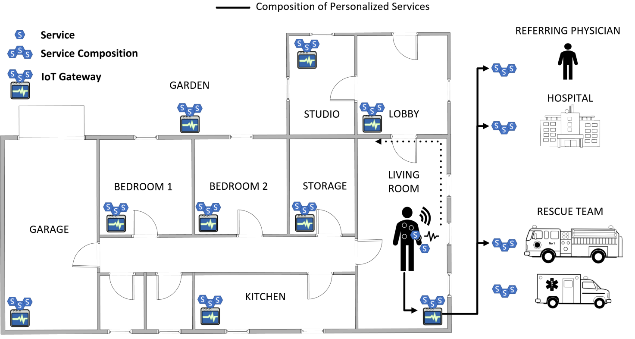
Digital eco-system for patient monitoring

User needed resources for patient monitoring
- Internal and external network infrastructure.
- IoT gateways distributed in all relevant places.
- Wearable sensors.
- Composition of personalised services. Examples: 1) We can reinforce the confidentiality of the composition with specialised services. 2) The user can also warn a trusted person.

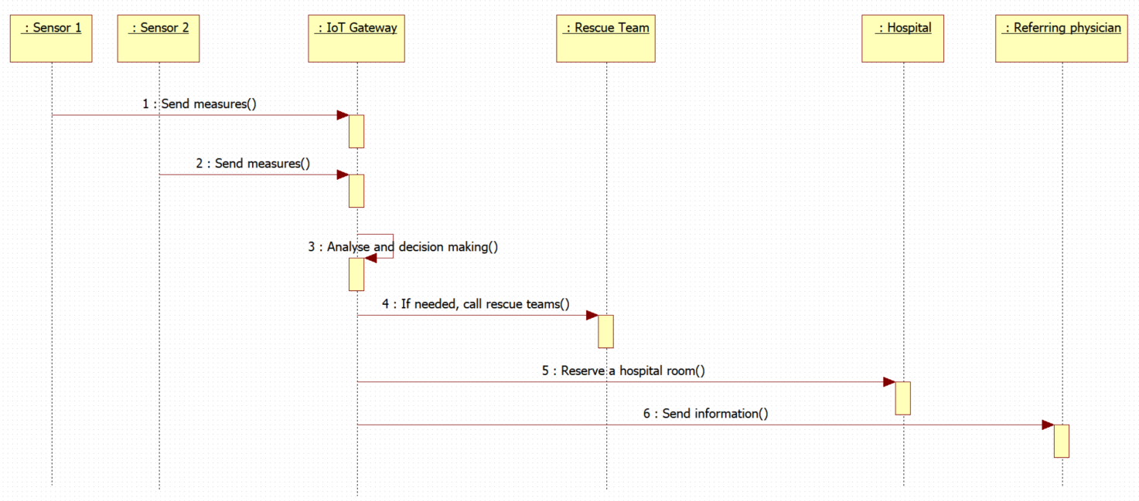
Sequence diagram

8.2 Use Case B: User interaction within multi-device environment

This use case shows a user interaction within multi-device environment.
It gives an application access to services that other devices provide on a local network.
It allows applications to request services by specifying a type of service and the name of a device instance that provides the desired type of service.
It allows users to identify other devices on the local network that support the services an application requests. This is useful for a variety of peer-to-peer applications such as file sharing or multi-player gaming.
Devices supported include printers, webcams, HTTPS servers, and other mobile devices.
The key is service discovery. Applications need to listen to service broadcasts on the network to see what services are available and filter out anything the application can't work with.
Note that the increasing number of devices make them difficult to assemble to achieve a common goal.

Nominal scenario
- Step 1 to 5: The user asks the devices who has the capabilities of printing a document (Print services).
- Step 6 and 7: Devices who are not concerned by this question, do not respond. Printer1 and Printer 2 answer the question. They inform the user that they have this capability and give their features (QoS, location, etc.).
- Step 8: According to their features, the user chooses a printer (example Printer1) and run the print command.
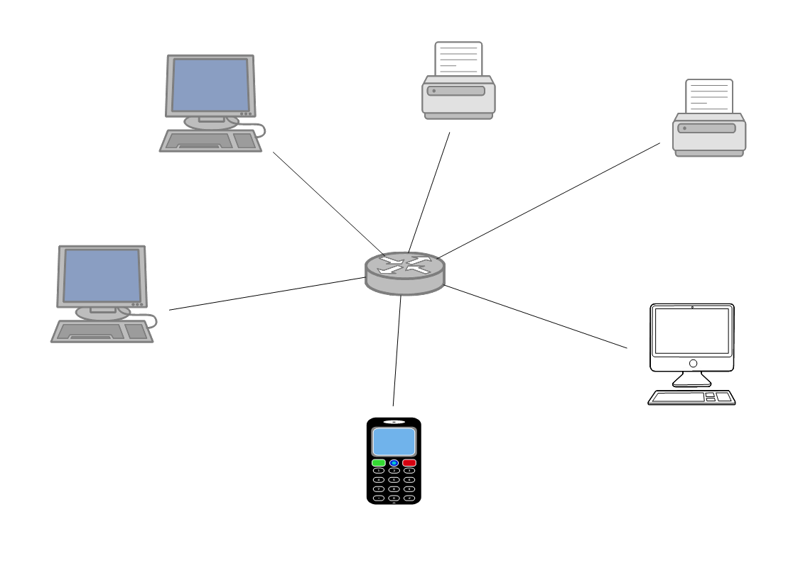
Marc computer
Pierre computer
Marie computer
Jean smartphone
Printer 1
Printer 2
Who can print this document?
User interaction within multi-device environment
User needed resources
- Internal and external network infrastructure.
- Connected devices
- Composition of personalised services between the user and the device including the researched service.

Service discovery is the base for a personalised composition. Once the services are discovered, they can be assembled to form a composition.
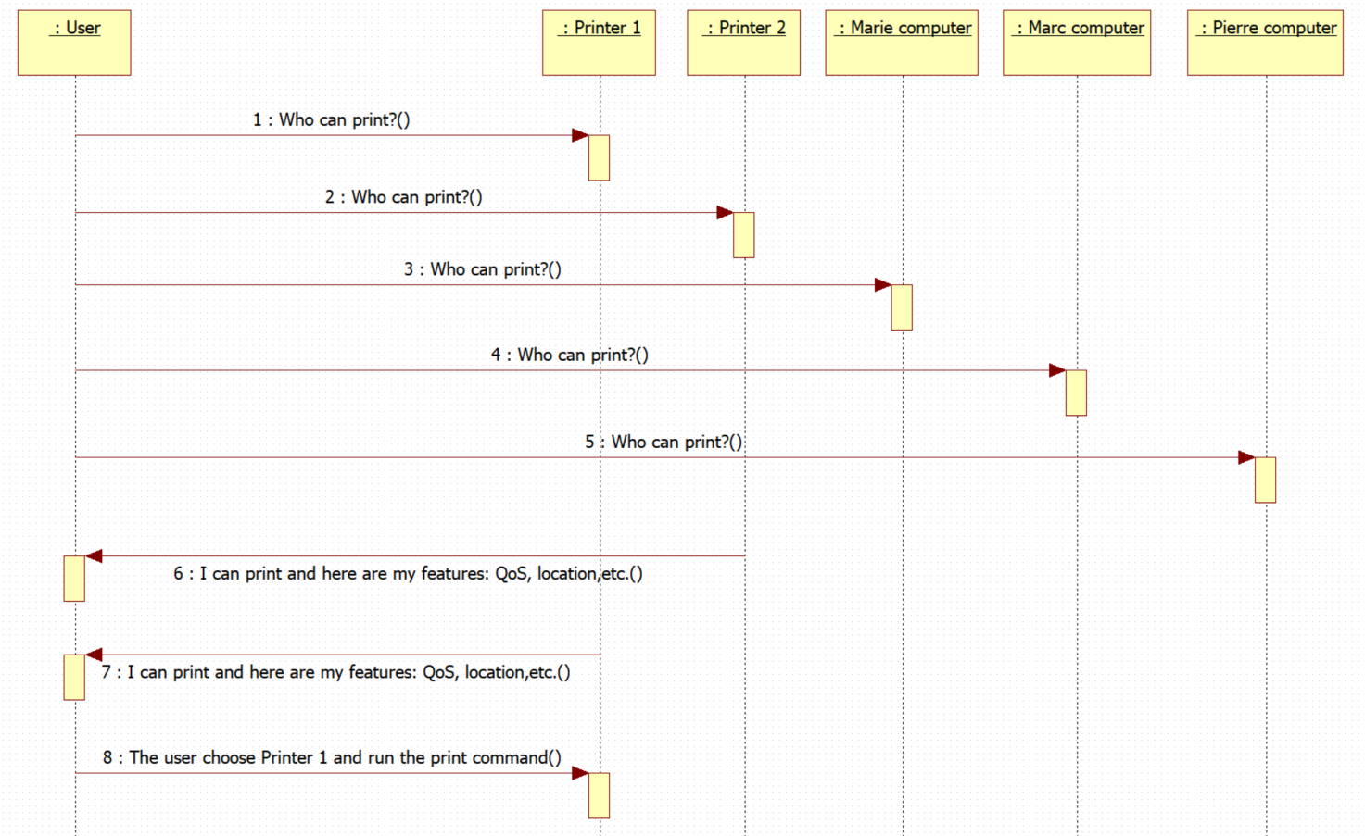
Sequence diagram

9. Conclusions

To be completed

Annex A: Description of the survey

The survey has been produced both in French and in English

English Survey


French Survey


Results of the survey and analysis

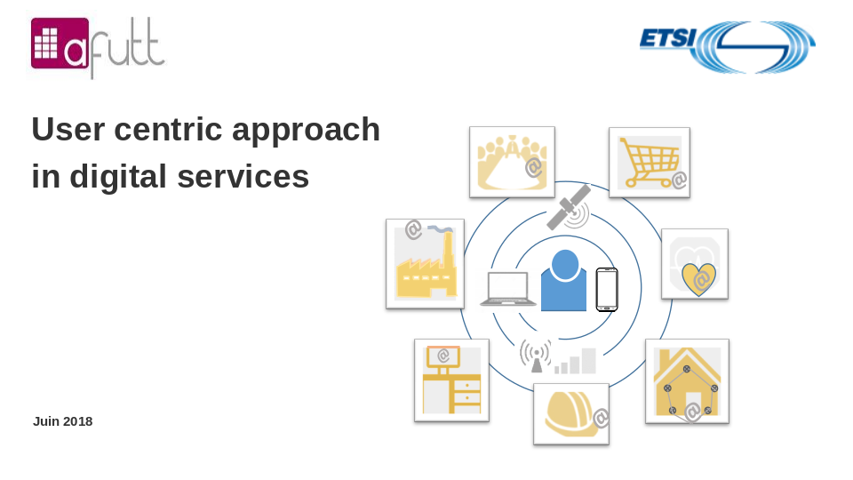

Annex B: Additional Use Cases
These Use Case were originally developed alongside the use cases in the main text. They were deemed to be surplus to requirements for the main body of the report. They are kept here as additional information and to show the many diverse areas where a user-centric digital eco-system can be applied to. How the user interactions with IoT Devices and Smart Cities will become an important design consideration that will need to be understood in order for the user to have the best quality of experience when interacting with IoT devices and Smart Cities services in the future.

B.1 User Interaction with IoT Devices
Services | Principal agents | Assets/resources | Interactions
Network and Internet Providers | End-User  (single/household) | IoT Device | Set-up and use the IoT  for a general specific  function
Device usage and support | Device  Manufacturer  Support | Smartphones | Can be used as means  to control and interact  the IoT device
Technology Companies cloud support | Application  Provider | Device connected hubs | Central hub to update  and change the settings  of IoT devices
Security | Any company that  provides the  service offered by  the IoT device | The User data and  billing information  connected to the IoT  device | How the company  chooses to protect and  handle the collected  data under GDPR and  other regulations

B.2 Process model of User Interaction with IoT
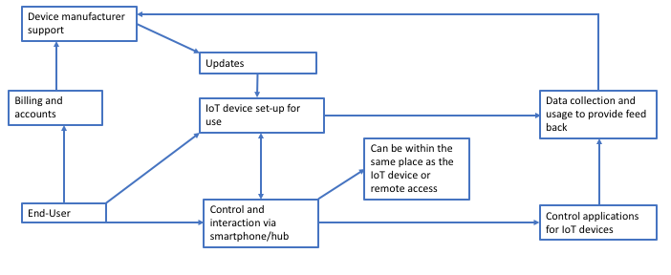

B.3 Actors of User Interaction with IoT

End node-Users | Connector/Gateways | Network Servers | Application Servers
Smart Utility Meters  Connected Home-Appliances  IoT Devices  Smartphones  Desktop PC/Laptops  Smart TVs | Modem Routers  Phone Network Base Stations  Public/Community Wi-fi networks | Internet Service Providers  Telecommunication Providers  Cloud Computing/Hosting Providers  DNS Providers | Utility Companies  Technology Companies  Home Service Providers  Application and Device Support Providers  Cloud service Providers

B.4 User Interaction within the Smart City

Services | Principal Agents | Assets/Resources | Interactions
Civic service providers and organisations | End-User | Smartphone/Web portal | How the user reports or gives feedback.
Collection of data | Companies or organisation involved in handling the collected data | Connected sensors/cameras/tracking devices or software | Remote means to gather data.
Acting on collected data | Companies or organisation responsible for providing solutions to problems shown by data | Tools, equipment and materials | The means to collect the data and analysis it to turn it into useful information.
Security | Any company that handles the data collected | The data and information collected | How the company chooses to protect and handle the collected data under GDPR and other regulations

B.5 Process Model of User Smart City Interaction

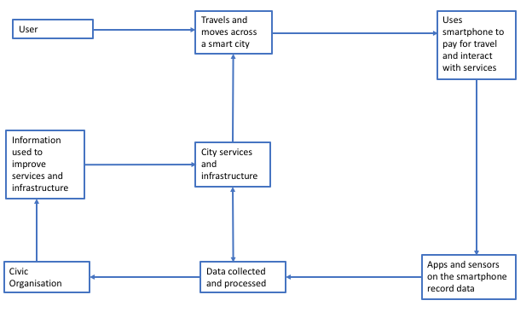

B.6 Actors of User Smart City Interaction

End node-Users | Connector/Gateways | Network Servers | Application Servers
IoT Devices  Smartphones  Payment Systems  Connected Smart CCTV  Environmental Sensors  Web-based sites to provide feedback and report information | Modem Routers  Phones network Base Stations  Public/Community Wi-fi networks  WLAN | Internet Service Providers  Telecommunication Companies  Cloud Computing/Hosting Providers  DNS Providers | Technology Companies  Civic Service Providers  Software License Providers  Application and Device Providers  Financial Process Providers  Public Utility and transportation companies that support the function of a city  Cloud Service Providers

ANNEX Bibliography

History
Document history
<Version> | <Date> | <Milestone>
V0.0.1 | 20/03/2018 | UG#63 meeting
V.0.0.2 | 18/06/2018 | Early draft for UG#64 meeting.
V.0.0.3 | 20/08/2018 | Stable draft for UG#65 meeting

