ETSI TR 103 875-2 Vm.t.e (2022-10)
Smart interface for digital ecosystem:
Smart identity, a Proof of Concept

<

TECHNICAL REPORT

Reference
<Workitem>
Keywords
<keywords>

ETSI
650 Route des Lucioles
F-06921 Sophia Antipolis Cedex - FRANCE

Tel.: +33 4 92 94 42 00 Fax: +33 4 93 65 47 16

Siret N° 348 623 562 00017 - APE 7112B
Association à but non lucratif enregistrée à la
Sous-préfecture de Grasse (06) N° w061004871

Important notice
The present document can be downloaded from:
http://www.etsi.org/standards-search
The present document may be made available in electronic versions and/or in print. The content of any electronic and/or print versions of the present document shall not be modified without the prior written authorization of ETSI. In case of any existing or perceived difference in contents between such versions and/or in print, the prevailing version of an ETSI deliverable is the one made publicly available in PDF format at www.etsi.org/deliver.
Users of the present document should be aware that the document may be subject to revision or change of status. Information on the current status of this and other ETSI documents is available at https://portal.etsi.org/TB/ETSIDeliverableStatus.aspx
If you find errors in the present document, please send your comment to one of the following services:
https://portal.etsi.org/People/CommiteeSupportStaff.aspx
If you find a security vulnerability in the present document, please report it through our
Coordinated Vulnerability Disclosure Program:
https://www.etsi.org/standards/coordinated-vulnerability-disclosure
Notice of disclaimer & limitation of liability
The information provided in the present deliverable is directed solely to professionals who have the appropriate degree of experience to understand and interpret its content in accordance with generally accepted engineering or
other professional standard and applicable regulations.
No recommendation as to products and services or vendors is made or should be implied.
No representation or warranty is made that this deliverable is technically accurate or sufficient or conforms to any law and/or governmental rule and/or regulation and further, no representation or warranty is made of merchantability or fitness for any particular purpose or against infringement of intellectual property rights.
In no event shall ETSI be held liable for loss of profits or any other incidental or consequential damages.

Any software contained in this deliverable is provided "AS IS" with no warranties, express or implied, including but not limited to, the warranties of merchantability, fitness for a particular purpose and non-infringement of intellectual property rights and ETSI shall not be held liable in any event for any damages whatsoever (including, without limitation, damages for loss of profits, business interruption, loss of information, or any other pecuniary loss) arising out of or related to the use of or inability to use the software.
Copyright Notification
No part may be reproduced or utilized in any form or by any means, electronic or mechanical, including photocopying and microfilm except as authorized by written permission of ETSI.
The content of the PDF version shall not be modified without the written authorization of ETSI.
The copyright and the foregoing restriction extend to reproduction in all media.

© ETSI yyyy.
All rights reserved.
Contents
Intellectual Property Rights 4
Foreword 4
Modal verbs terminology 4
Executive summary 4
Introduction 4
1 Scope 5
2 References 5
2.1 Normative references 5
2.2 Informative references 5
3 Definition of terms, symbols and abbreviations 5
3.1 Terms 5
3.2 Symbols 5
3.3 Abbreviations 5
4 smart identity: from definition to PoC design 5
5 data collection 6
6 data processing 6
7 PoC : use case presentation 6
8 PoC : realization (results) 6
Annex A: Title of annex 7
Annex: Bibliography 8
Annex: Change History 9
History 10

Intellectual Property Rights
Essential patents
IPRs essential or potentially essential to normative deliverables may have been declared to ETSI. The declarations pertaining to these essential IPRs, if any, are publicly available for ETSI members and non-members, and can be found in ETSI SR 000 314: "Intellectual Property Rights (IPRs); Essential, or potentially Essential, IPRs notified to ETSI in respect of ETSI standards", which is available from the ETSI Secretariat. Latest updates are available on the ETSI Web server (https://ipr.etsi.org).
Pursuant to the ETSI Directives including the ETSI IPR Policy, no investigation regarding the essentiality of IPRs, including IPR searches, has been carried out by ETSI. No guarantee can be given as to the existence of other IPRs not referenced in ETSI SR 000 314 (or the updates on the ETSI Web server) which are, or may be, or may become, essential to the present document.
Trademarks
The present document may include trademarks and/or tradenames which are asserted and/or registered by their owners. ETSI claims no ownership of these except for any which are indicated as being the property of ETSI, and conveys no right to use or reproduce any trademark and/or tradename. Mention of those trademarks in the present document does not constitute an endorsement by ETSI of products, services or organizations associated with those trademarks.
DECT™, PLUGTESTS™, UMTS™ and the ETSI logo are trademarks of ETSI registered for the benefit of its Members. 3GPP™ and LTE™ are trademarks of ETSI registered for the benefit of its Members and of the 3GPP Organizational Partners. oneM2M™ logo is a trademark of ETSI registered for the benefit of its Members and of the oneM2M Partners. GSM® and the GSM logo are trademarks registered and owned by the GSM Association.

Foreword
This Technical Report (TR) has been produced by {ETSI Technical Committee|ETSI Project|<other>} <long techbody> (<short techbody>).

Modal verbs terminology
In the present document "should", "should not", "may", "need not", "will", "will not", "can" and "cannot" are to be interpreted as described in clause 3.2 of the ETSI Drafting Rules (Verbal forms for the expression of provisions).
"must" and "must not" are NOT allowed in ETSI deliverables except when used in direct citation.

Executive summary

Introduction

1 Scope
The present document …

2 References

2.1 Normative references
Normative references are not applicable in the present document.

2.2 Informative references
References are either specific (identified by date of publication and/or edition number or version number) or non-specific. For specific references, only the cited version applies. For non-specific references, the latest version of the referenced document (including any amendments) applies.
NOTE: While any hyperlinks included in this clause were valid at the time of publication ETSI cannot guarantee their long term validity.
The following referenced documents are not necessary for the application of the present document but they assist the user with regard to a particular subject area.
[i.1] <Standard Organization acronym> <document number><version number/date of publication>: "<Title>".
[i.2]  etc.

3 Definition of terms, symbols and abbreviations

3.1 Terms
For the purposes of the present document, the [following] terms [given in ... and the following] apply:

3.2 Symbols

3.3 Abbreviations
For the purposes of the present document, the [following] symbols [given in ... and the following] apply:

For the purposes of the present document, the [following] abbreviations [given in ... and the following] apply:

4 Smart Identity: from definition to PoC design

4.1 Identity definition
The notion of identity is complex and polysemous.

It depends on the point of view to consider what an individual can be, and on the use that we want to make of this identity.

We can identify 3 domains of identification which are cumulative:

> civil and legal identity
This identity traditionally and mainly consists of the following elements:
surname, first name, sex, nationality, filiation (relationships), date and place of birth.
This identity is deemed to be stable throughout life

> biological identity: Height, weight, eye color, retina, fingerprint, DNA
Some attributes of this identity can be used to formally identify a person, in addition to the civil identity.

> social and personal identity
It is made up of many sociological and psychological elements: place of residence, profession, standard of living, hobbies, tastes, friends, beliefs, commitments, etc.
It is built, it evolves and is enriched during life, it is never fixed

These are identities that can be described as objective or suffered. But there are also subjective and desired identities, corresponding to the way an individual decides for himself how he intends to present himself to others. It is a sort of narrative identity. Social networks and the use of pseudonyms and avatars in cyberspace are a tangible manifestation of this. It can be noted in this regard that in the digital world it is possible to have several identities

For our smart ID we start from the attributes of the objective identity of the person
We add the resources (equipment, services) available
We consider the sequence of his roles in space-time: his objectives, his activities, his tasks, his schedule.
We are also interested in the information it uses to make awareness choices.

More simply, the smart ID is thus the representation of a person:

for what it is
for what it has
for what it does
for what it knows

4.2 from Identity to User Profile
what we are

what we have (ressources)

what we do

What

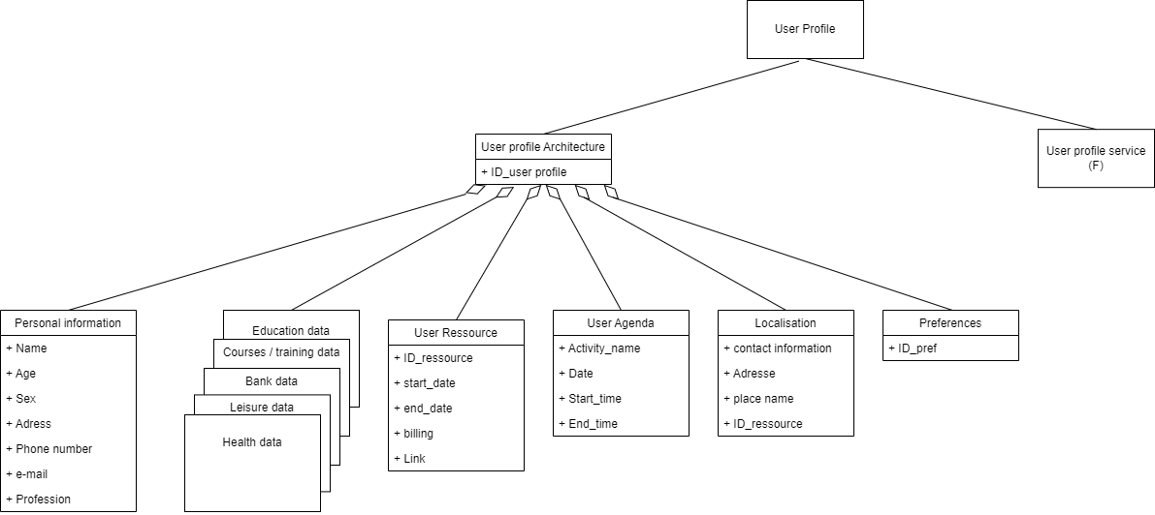

Figure 1 : Relationship between Identity définition and user profil model
The "user profile" Is therefore the informational representation of the user's identity (figure 1) in the digital ecosystem, including
- Personnal informations
  - legal identity
  - Identifications
according to the role :
    - Work ID
    - Health ID
    - …
- User centric characteristics that impact configurations
Actions according to :
  - Preferences
  - Space-time (agenda)
  - Localisation
- The ressource description according to the localisation
  - internal ressources (equipment, network, services)
  - external ressources (equipments, network, services)
More precisely the personnal sheet / template (figure 2) identity can be as following:
PERSONAL INFORMATIONS
Social ID
- Social ID
- Last Name
- First name(s)
- Last name
- Gender
- Date of birth
- Country of birth
- City of birth
- Nationality (s)
- Occupation
Personal contact information
- Address
- Postcode
- Town or city
- Mobile phone / landline
- E-mail address
Professional contact information
- Business address
- Postcode
- City or town
- Mobile phone / landline
- E-mail address
Other
- Residence permit
- Visa
- Passport

Figure 2 : personal informations template
Moreover, with the evolution of paradigms, the relationship between the user and the system is now an n to n relationship meaning that the user has n profiles (figure 3).

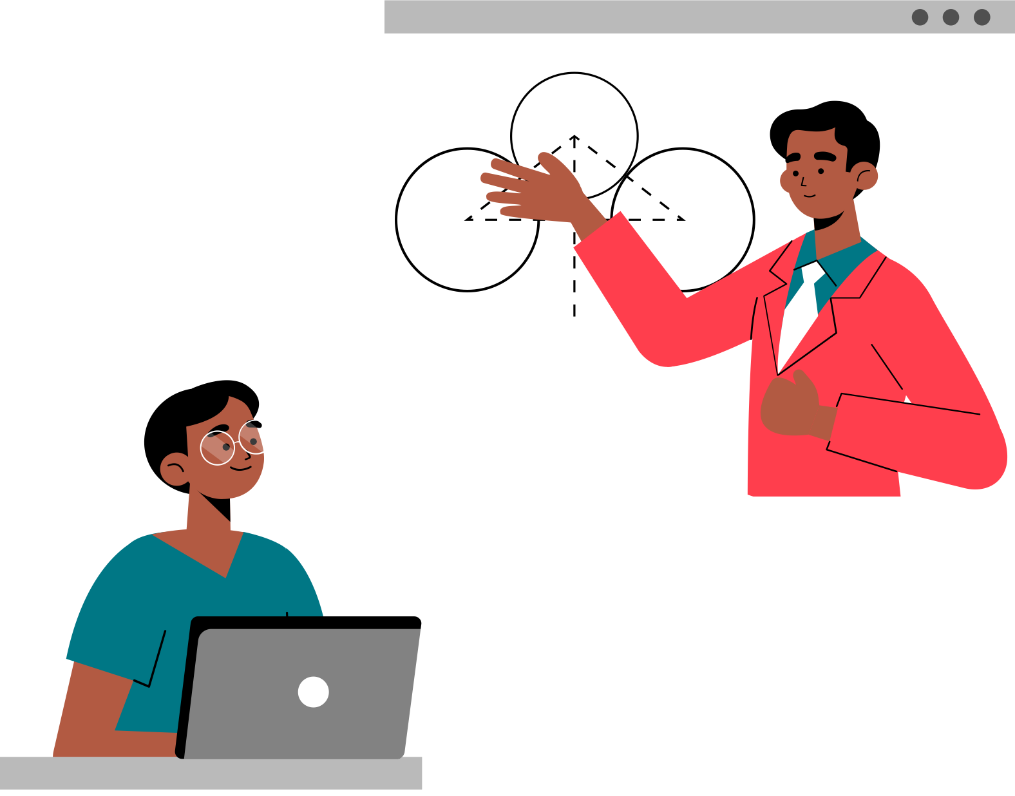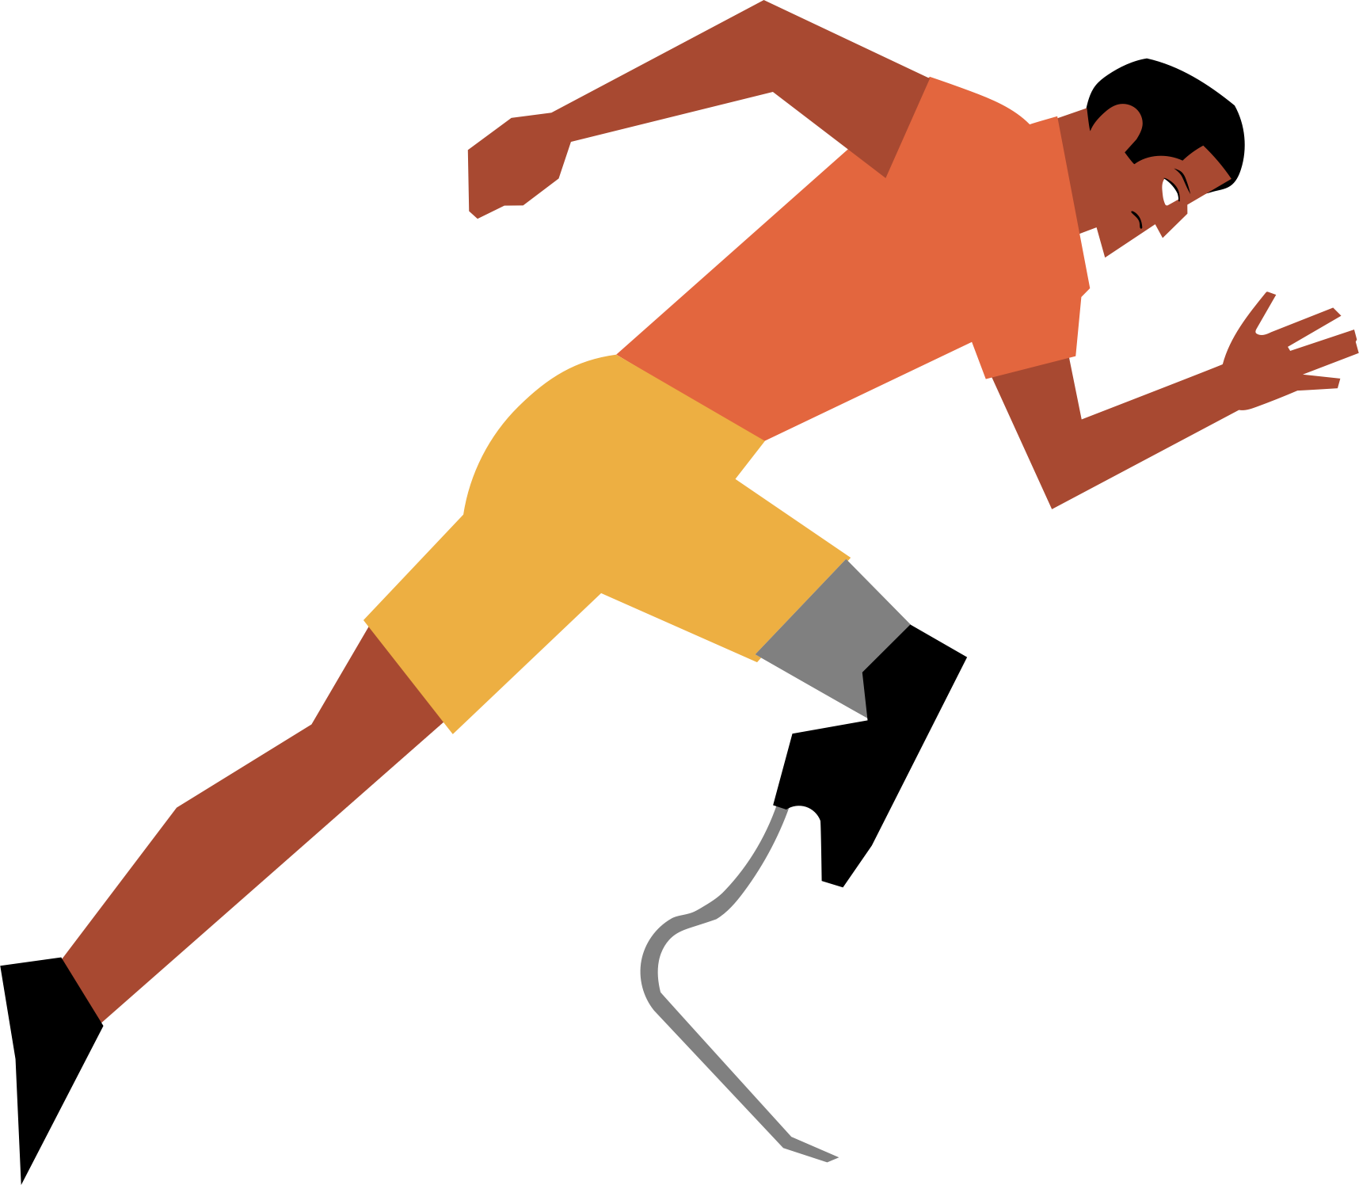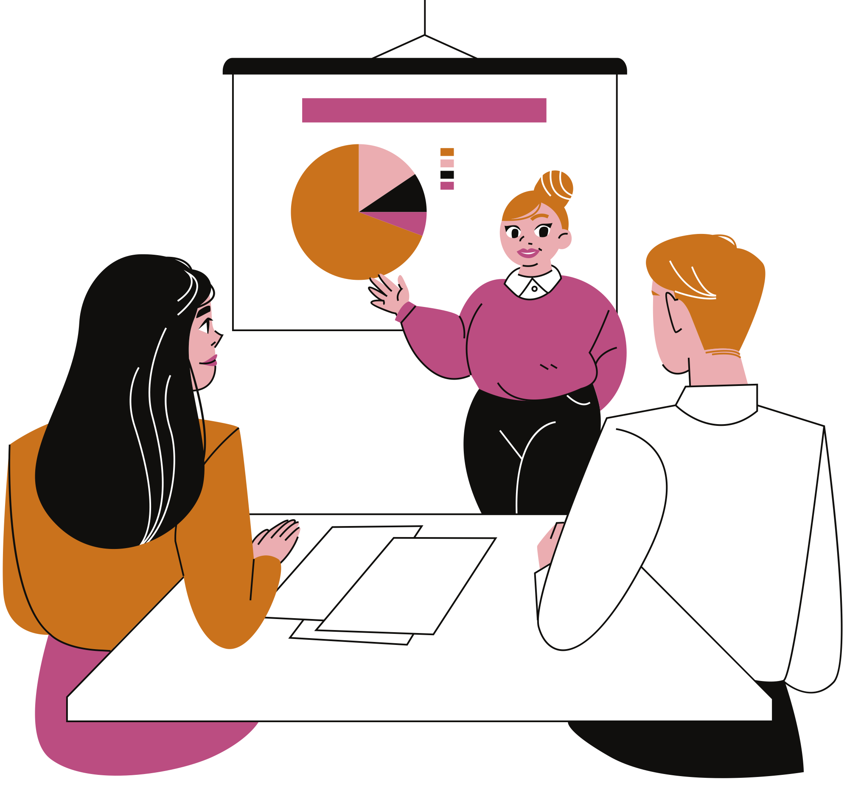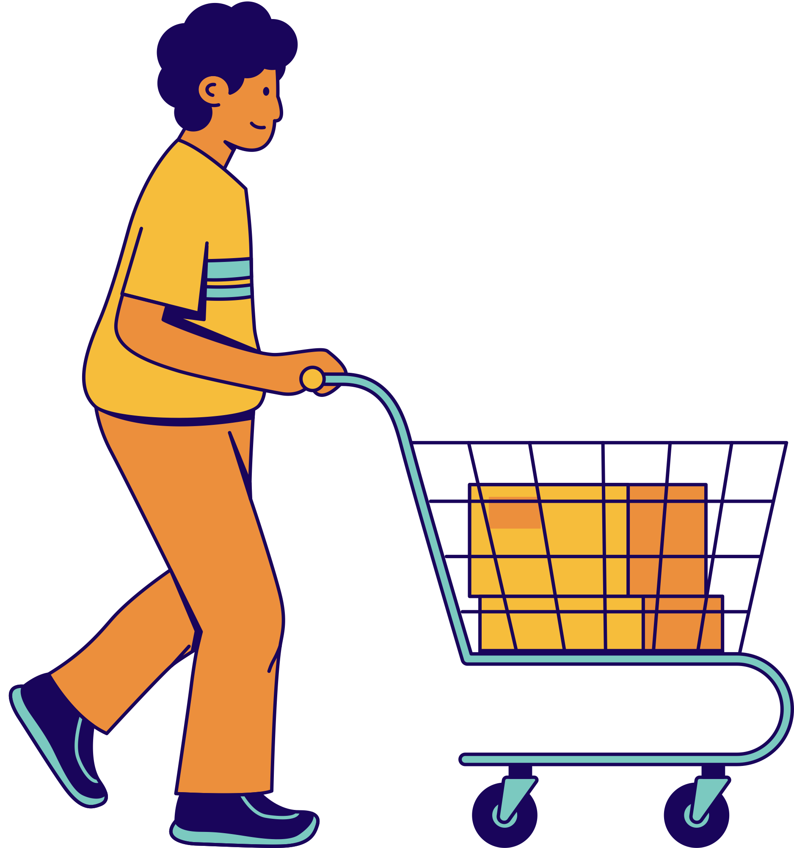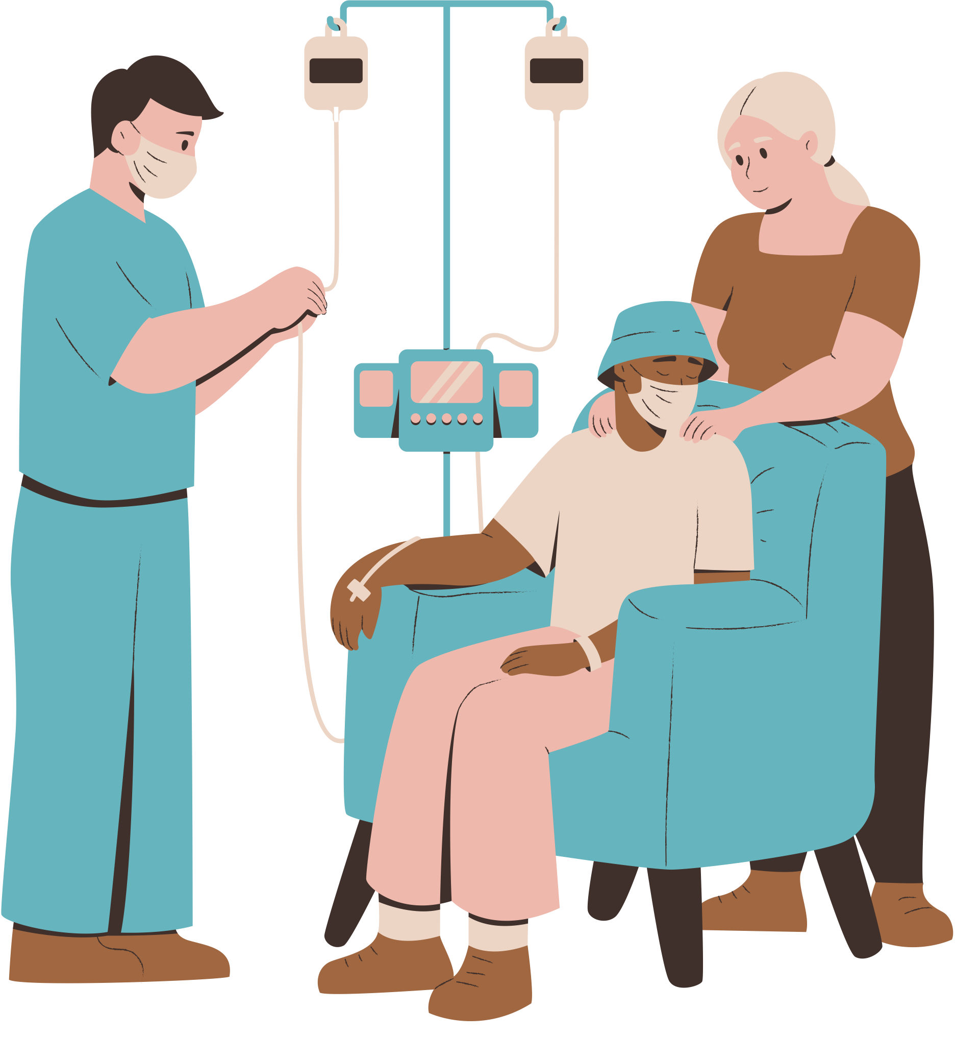
…

Figure 3: Les n profils potentiels d’un utilisateur

The instantiation of the User Profile model will give the complete picture of the user according to his roles in space-time, his preferences, and his location.

4.3 knowledge base for Smart Identity: Potential profile
Our identity is also “what we know”. This is why we integrate our knowledge of the characteristics of the different areas and the external services requested in order to carry out the different tasks in good awareness.
What we know : potential profile (information allowing choice to be made awareness)
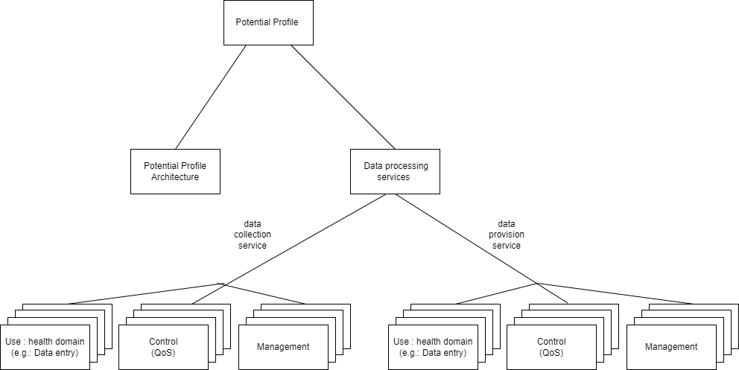

Figure 4: knowledge base
Like any entity, the Potential Profile has an architecture and a service interface. The first service consists of data collection (instantiation of the Potential Profile model) to store architecture information. The architecture of the Potential Profile enriches the architecture of the User Profile by informing all the areas relating to a temporal action. The second service will be all the processing on the analysis of the data in order to have additional decision-making information
Each role played by the user requires data from each of the domains. That is to say for each action we need transversal data (figure 5). For example, during a medical appointment for payment, we will need the finance domain template as for all actions that will require payment.

Health template
Sport template
Work template
Purchase template
Entertainment template
Financial template

Medical appointment

Indoor sport

Professional Meeting

Purchase of winter clothes

Outing with friends

Figure 5 : transversal data
For the Poc we will need templates corresponding to the most common roles, that is to say the basic roles (figure 6) involved in areas such as health, work, finance, travel, etc.
HEALTH TEMPLATE
- Social security number
- Mutual insurance (CMU, professional, etc.)
Health information
- General information
- Weight
- Height
- Health parameters
- Temperature
- Pulse/heart rate
- Oxygen saturation
- Respiratory rate
- Blood pressure
Medical record
- Blood type
- Rhesus
- Vaccination booklet
- Vaccination certificates (covid-19)
- Current treatment(s)
- Allergies
- Last tests
- Latest prescriptions
- Medical appointments (past and future)
- Doctor of record
- Emergency contacts

TEMPLATE SPORT (well-being)
- Membership card
Information
- User behaviours
- Time spent sleeping / in bed
- Inactivity time
- Number of steps
- Distance (walking and running)
- Stages climbed
- Stability of walking
- Other
- Calories
Information sheet
- Type of subscription (classic, premium)
- Duration of subscription
- Wellness goal(s)

TEMPLATE DISPLACEMENT
Informations
- Tickets / tickets for transport
Ticketing
- Air / train / bus tickets
- Advantage / discount card
Carpooling information
- Name and contact of the driver
- Departure time
- Meeting point (departure)
- Arrival point
Stay
- - Hotel/accommodation reservation

TEMPLATE WORK
- Registration number
- Access badge
- Tickets / restaurant card
Professional file
- Job function
- Office
- Department / service
Other
- Employment contract / internship agreement
- Pay slips

TEMPLATE EDUCATION
- Personnel number
- INE number
- Education card
Student information
- Education
- Timetable
- Teaching units
- Documents
- Grades

TEMPLATE SHOPPING / PURCHASES
Informations
- Item preferences
- Product size
Customer record by supplier
- Customer number
- Membership / loyalty card
- Username
- Gift card
- Discount coupons
- Ordering
- Points
- My addresses (delivery and billing)
- My payment methods (credit card, multiple payments, etc.)

TEMPLATE DOMOTIC
- Access card / key
- Charges
- EDF
- Hot and cold water
- Heating
- Maintenance costs
- Green space
- Common areas
- Household waste collection tax
- Connected house
- Management of: security, access, lighting, temperature, fans, objects, etc.
- Other
- Lease agreement / certificate of residence

TEMPLATE FINANCIAL
Bank information / current account
- RIB
- Authorised overdraft
- Bank card
- Cheques
- Transfers & direct debits
Savings (passbook)
Insurance
- Home insurance
- Life insurance
- …
Loan(s)
Sponsorship
Other
- - Bank documents

Figure 6 : common knowledge templates

4.4 Poc Design
4.4.1 data collection
Data collection consists of filling in the Potential Profile, which includes User Profile data, data on the various user domain interest, and data from the services requested (e.g. weather, etc.), as well as data processing contributions.
4.4.2 SmartID : active profile
The intelligent user profiling process, after the collection of their data, begins with the consideration of their user centric parameters (space-time, space-place and preferences), which constitute the system input data allowing the obtaining the active profile.
Then an identification of the activity and a classification in relation to the different areas will be made using artificial intelligence algorithms during the data processing phase. There will then follow a selection of templates that may correspond to the areas of user action during this time slot. For example, a medical appointment might require the health, finance, and travel templates.
The preferences will make it possible to finalize the personalization of the active profile (FIG. 7) and to select the user's preferred resources (equipment, networks, services) according to his location.

user centric caracteristics
Space-time (schedule)

Selection of templates corresponding to the domain of user action during this time slot
Localisation
Identification and classification of the activity in relation to the domain
Preferences
Prediction of the domains to which the activity belongs
Health, education, finance, etc.

According to the localisation
According to the preferences
active profile display
ressources selection (equipments, networks, services)

Figure 7: Smart user profiling process and active profile procurement

5 data collection
Model, Structure ; tools

5.1 User profil service : data collection process

5.2 Knowledge base tools
Xampp

5.3 final knowledge base

6 data processing
Filtering, validation…
6.1 shaping the problem
6.2 resolution tools
6.3 results

7 PoC : use case presentation
7.1 User Story
Considérons l’Agenda et la Localisation prévisionnels du 19 septembre 2022 soir présenté à la figure 8.
 | AGENDA | LOCALISATION
15h – 17h | Réunion d’équipe | Bureau
17h15 – 18h | (Déplacement)
18h – 18h30 | Préparation pour la salle de sport | Maison
18h45 – 20h | Séance de sport | Salle de sport la plus proche
20h15 – 21h | Dîner | Maison
21h – 22h | Achat des vêtements automne / hiver | En ligne
22h | Repos

Figure 8 : Agenda et localisation prévisionnels de l’utilisateur
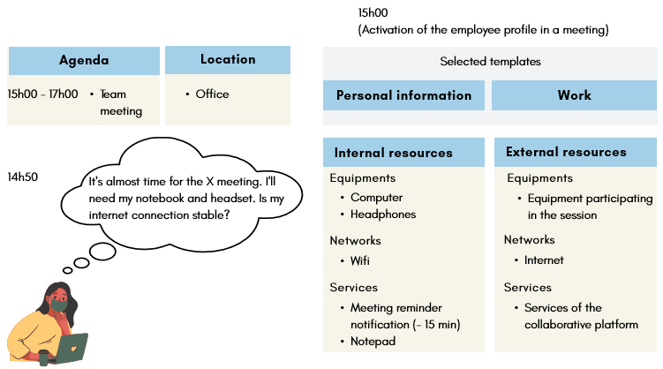
Figure 9 : Profil actif de l’utilisateur à 15h (employée en réunion)
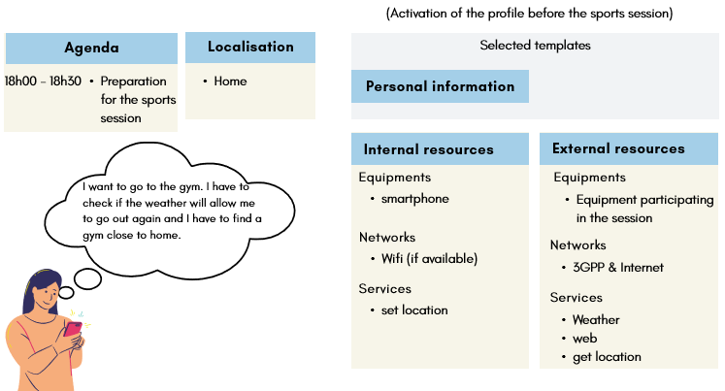
Figure 10 : Profil actif de l’utilisateur à 18h (réflexion pour aller à la salle de sport)
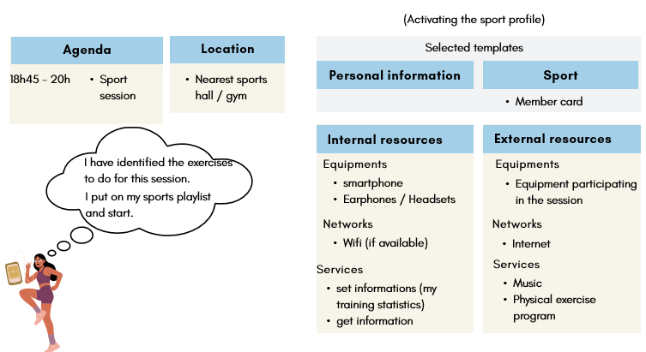
Figure 11 : Profil actif de l’utilisateur à 18h45 (sportive)
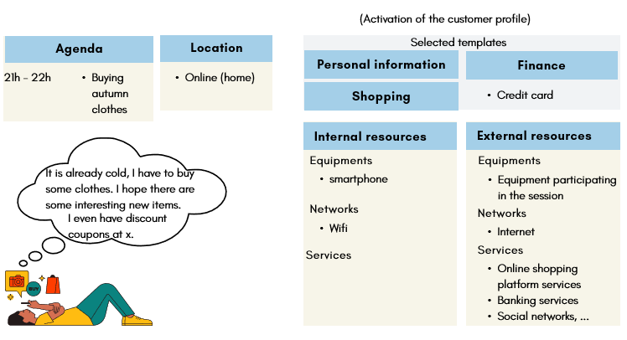
Figure 12 : Profil actif de l’utilisateur à 21h (cliente)

7.2 Les données de l’user profil
7.3 Les données du potentiel Profil
7.4 Le profil Actif

8 PoC : realization (results)
8.1 Description de la maquette
8.2 Les modèles complémentaires
8.3 Le traitement de l’user story

Annex A:
Title of annex

Annex:
Bibliography

Annex:
Change History
Date | Version | Information about changes
<Month year> | <#> | <Changes made are listed in this cell>

History
Document history
<Version> | <Date> | <Milestone>

Latest changes made on 2022-03-14

