ETSI TR 103 875-2 V0.0.6 (2023-01)
User Centric approach in Digital Ecosystem;
The Smart Interface;
Smart Identity; Part 2 : A Proof of concept

<

TECHNICAL REPORT

Reference
DTR/USER-0053
Keywords
Cybersecurity, INTERFACE, QoS, USER
ETSI
650 Route des Lucioles
F-06921 Sophia Antipolis Cedex - FRANCE

Tel.: +33 4 92 94 42 00 Fax: +33 4 93 65 47 16

Siret N° 348 623 562 00017 - APE 7112B
Association à but non lucratif enregistrée à la
Sous-préfecture de Grasse (06) N° w061004871

Important notice
The present document can be downloaded from:
http://www.etsi.org/standards-search
The present document may be made available in electronic versions and/or in print. The content of any electronic and/or print versions of the present document shall not be modified without the prior written authorization of ETSI. In case of any existing or perceived difference in contents between such versions and/or in print, the prevailing version of an ETSI deliverable is the one made publicly available in PDF format at www.etsi.org/deliver.
Users of the present document should be aware that the document may be subject to revision or change of status. Information on the current status of this and other ETSI documents is available at https://portal.etsi.org/TB/ETSIDeliverableStatus.aspx
If you find errors in the present document, please send your comment to one of the following services:
https://portal.etsi.org/People/CommiteeSupportStaff.aspx
If you find a security vulnerability in the present document, please report it through our
Coordinated Vulnerability Disclosure Program:
https://www.etsi.org/standards/coordinated-vulnerability-disclosure
Notice of disclaimer & limitation of liability
The information provided in the present deliverable is directed solely to professionals who have the appropriate degree of experience to understand and interpret its content in accordance with generally accepted engineering or
other professional standard and applicable regulations.
No recommendation as to products and services or vendors is made or should be implied.
No representation or warranty is made that this deliverable is technically accurate or sufficient or conforms to any law and/or governmental rule and/or regulation and further, no representation or warranty is made of merchantability or fitness for any particular purpose or against infringement of intellectual property rights.
In no event shall ETSI be held liable for loss of profits or any other incidental or consequential damages.

Any software contained in this deliverable is provided "AS IS" with no warranties, express or implied, including but not limited to, the warranties of merchantability, fitness for a particular purpose and non-infringement of intellectual property rights and ETSI shall not be held liable in any event for any damages whatsoever (including, without limitation, damages for loss of profits, business interruption, loss of information, or any other pecuniary loss) arising out of or related to the use of or inability to use the software.
Copyright Notification
No part may be reproduced or utilized in any form or by any means, electronic or mechanical, including photocopying and microfilm except as authorized by written permission of ETSI.
The content of the PDF version shall not be modified without the written authorization of ETSI.
The copyright and the foregoing restriction extend to reproduction in all media.

© ETSI yyyy.
All rights reserved.
Contents
Intellectual Property Rights 4
Foreword 4
Modal verbs terminology 4
Executive summary 4
Introduction 4
1 Scope 5
2 References 5
2.1 Normative references 5
2.2 Informative references 5
3 Definition of terms, symbols and abbreviations 5
3.1 Terms 5
3.2 Symbols 5
3.3 Abbreviations 5
4 Smart Identity: from definition to PoC design 5
4.1 Identity definition 5
4.2 from Identity to User Profile 6
4.3 knowledge base for Smart Identity: Potential profile 8
4.4 PoC Design 12
5 data collection 13
5.1 User profil service : data collection process 13
6 data processing 13
7 PoC : use case presentation 14
8 PoC : realization (results) 16
Annex A: Title of annex 17
Annex: Bibliography 18
Annex: Change History 19
History 20

Intellectual Property Rights
Essential patents
IPRs essential or potentially essential to normative deliverables may have been declared to ETSI. The declarations pertaining to these essential IPRs, if any, are publicly available for ETSI members and non-members, and can be found in ETSI SR 000 314: "Intellectual Property Rights (IPRs); Essential, or potentially Essential, IPRs notified to ETSI in respect of ETSI standards", which is available from the ETSI Secretariat. Latest updates are available on the ETSI Web server (https://ipr.etsi.org).
Pursuant to the ETSI Directives including the ETSI IPR Policy, no investigation regarding the essentiality of IPRs, including IPR searches, has been carried out by ETSI. No guarantee can be given as to the existence of other IPRs not referenced in ETSI SR 000 314 (or the updates on the ETSI Web server) which are, or may be, or may become, essential to the present document.
Trademarks
The present document may include trademarks and/or tradenames which are asserted and/or registered by their owners. ETSI claims no ownership of these except for any which are indicated as being the property of ETSI, and conveys no right to use or reproduce any trademark and/or tradename. Mention of those trademarks in the present document does not constitute an endorsement by ETSI of products, services or organizations associated with those trademarks.
DECT™, PLUGTESTS™, UMTS™ and the ETSI logo are trademarks of ETSI registered for the benefit of its Members. 3GPP™ and LTE™ are trademarks of ETSI registered for the benefit of its Members and of the 3GPP Organizational Partners. oneM2M™ logo is a trademark of ETSI registered for the benefit of its Members and of the oneM2M Partners. GSM® and the GSM logo are trademarks registered and owned by the GSM Association.

Foreword
This Technical Report (TR) has been produced by the special Committee USER Group, as a result of the STF 626.

Modal verbs terminology
In the present document "should", "should not", "may", "need not", "will", "will not", "can" and "cannot" are to be interpreted as described in clause 3.2 of the ETSI Drafting Rules (Verbal forms for the expression of provisions).
"must" and "must not" are NOT allowed in ETSI deliverables except when used in direct citation.

Executive summary

Introduction
The document is associated with a video showing the Smart Identity Proof of Concept.

1 Scope
The present document is intended to demonstrate the feasability of the Smart Identity as it is defined in TR 103 875-1[i.1]
It defines, for a specific use case (e-health) the Smart Identity (ID) and provides an associated Proof of Concept (PoC)

2 References

2.1 Normative references
Normative references are not applicable in the present document.

2.2 Informative references
References are either specific (identified by date of publication and/or edition number or version number) or non-specific. For specific references, only the cited version applies. For non-specific references, the latest version of the referenced document (including any amendments) applies.
NOTE: While any hyperlinks included in this clause were valid at the time of publication ETSI cannot guarantee their long term validity.
The following referenced documents are not necessary for the application of the present document but they assist the user with regard to a particular subject area.
[i.1] TR 103 875-1 User Centric Approach in Digital Ecosystem; The Smart Interface; Part 1: Smart Identity, User digital clone

3 Definition of terms, symbols and abbreviations

3.1 Terms
For the purposes of the present document, the following term applies:
Deep Learning : Deep learning is a type of artificial intelligence derived from machine learning where the machine is able to learn by itself, unlike execute rules predetermined.

3.2 Symbols

3.3 Abbreviations
For the purposes of the present document, the following abbreviations apply:
AI Artificial Intelligence
DB Database
IBAN International Bank Account Number
ID Identity
PHP Personal Home Page (PHP: Hypertext Preprocessor
PoC Proof of Concept
SGBD Système de gestion de base de données / Database Management System
UML Unified Modeling Language
XNLI Multilingual Natural Language Inference

4 Smart Identity: from definition to PoC design

4.1 Identity definition
The notion of identity is complex and polysemous. A definition is available in [B.1]

It depends on the point of view to consider what an individual can be, and on the use that the Smart ID want to make of this identity.

It is possible to identify 3 domains of identification which are cumulative:

> civil and legal identity
This identity traditionally and mainly consists of the following elements:
surname, first name, gender, nationality, filiation (relationships), date and place of birth.
This identity is deemed to be stable throughout life.

> biological identity: Height, weight, eye color, retina, fingerprint, DNA
Some attributes of this identity can be used to formally identify a person, in addition to the civil identity.

> social and personal identity
It is made up of many sociological and psychological elements: place of residence, profession, standard of living, hobbies, tastes, friends, beliefs, commitments, etc.
It is built, it evolves and is enriched during life, it is never fixed

These are identities that can be described as objective or suffered (civil, legal, biological). But there are also subjective and desired identities, corresponding to the way an individual decides for themselves how they intend to present themselves to others. It is a kind of narrative identity. Social networks and the use of pseudonyms and avatars in cyberspace are a tangible manifestation of this. It can be noted in this regard that in the digital world it is possible to have several identities

The Smart ID is created with
-the attributes of the objective identity of the person
-the available resources (equipments, services)
It considers the sequence of the user roles in space-time: objectives, activities, tasks, schedule.
It takes care of the information used to make awareness choices.

More simply, the Smart ID is thus the representation of a person:

What the user is
What the user has
What the user is doing
What is the user knowledge

4.2 From Identity to User Profile
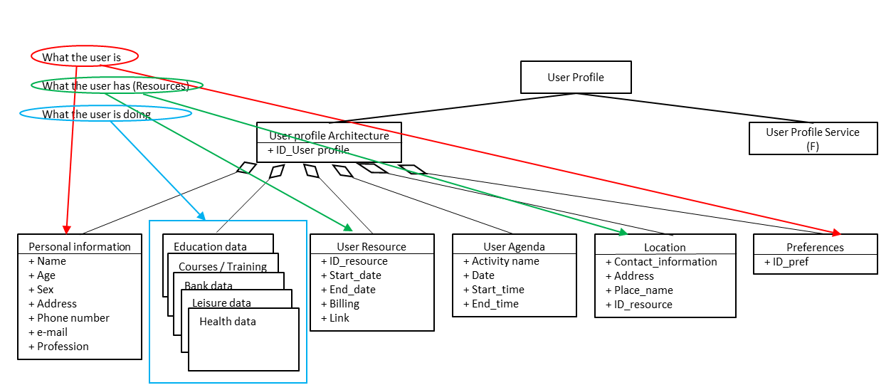
Figure 1: Relationship between Identity definition and user profile model
The "user profile" is therefore the informational representation of the user's identity (figure 1) in the digital ecosystem, including
- Personnal information
  - legal identity
  - Identifications
  - Roles (worker, patient, parent, bienvaillant…)
- User centric characteristics that impact configurations
Actions according to :
  - Preferences
  - Space-time (agenda)
  - Location
- The ressource description according to the location
  - internal ressources (equipments, network, services)
  - external ressources (equipments, network, services)
More precisely the personnal sheet / template (figure 2) identity can be as following:
PERSONAL INFORMATION
Social ID
- Social ID
- Last Name
- First name(s)

- Gender
- Date of birth
- Country of birth
- City of birth
- Country of birth
- Nationality (s)
- ProfessionPersonal contact information
- Address
- Postcode
- Town or city
- Country
- Mobile phone (s) / landline (s)
- E-mail address (es)
Professional contact information
- Business address
- Postcode
- Town or city
- Country
- Mobile phone(s) / landline(s)
- E-mail address(es)
Other
- Residence permit
- Visa
- Passport
- Identity Card
- Licences (eg Driving licence)

Figure 2 : Personal information template
Moreover, with the evolution of paradigms, the relationship between the user and the system is now an N to N (figure 3) relationship meaning that the user has N profiles according to the role (figure 4).

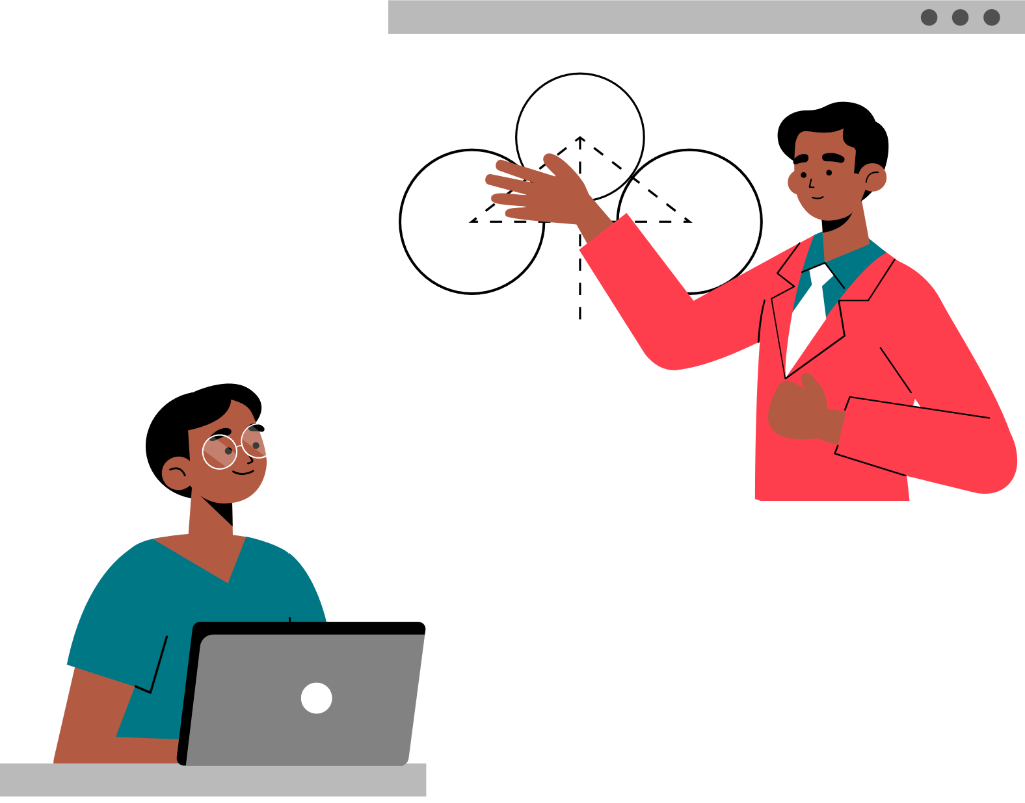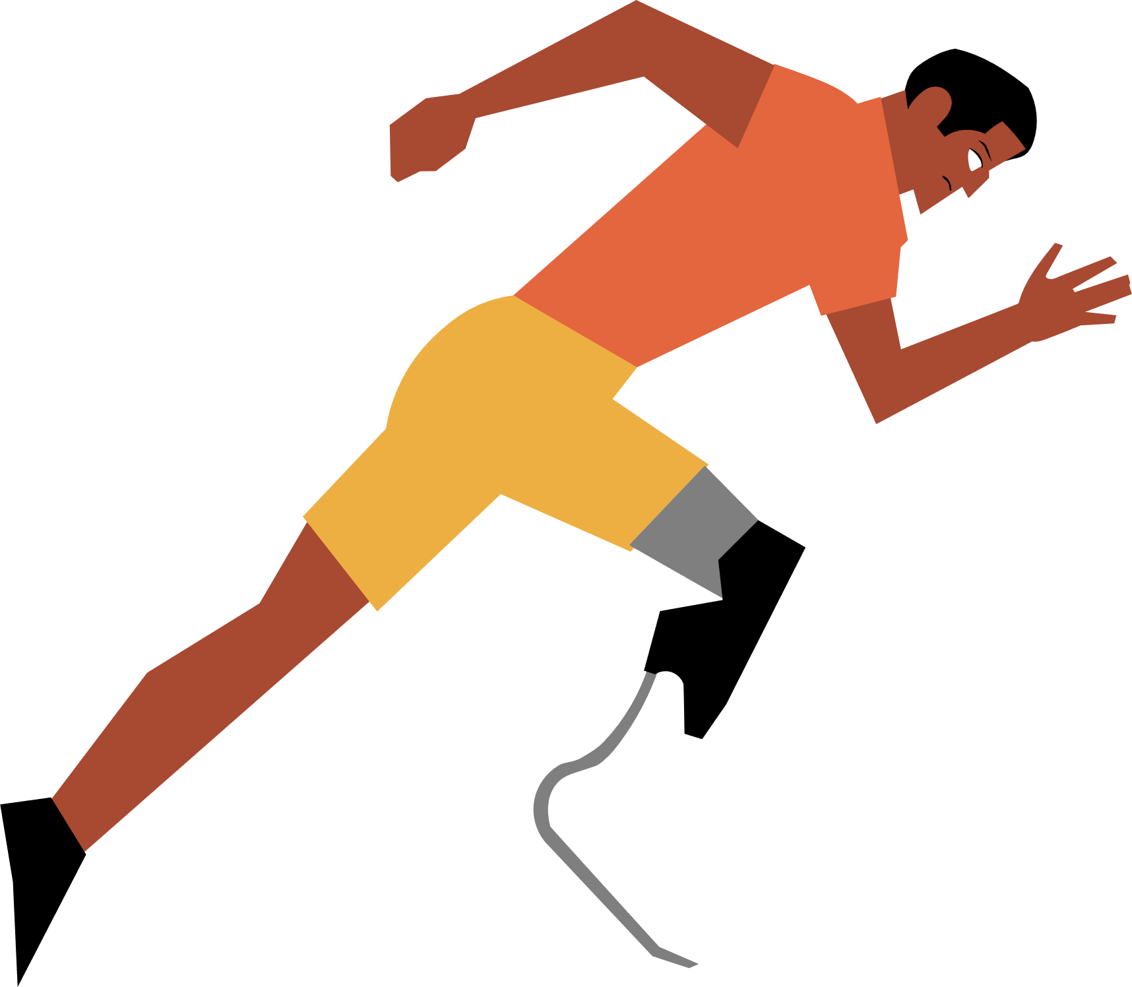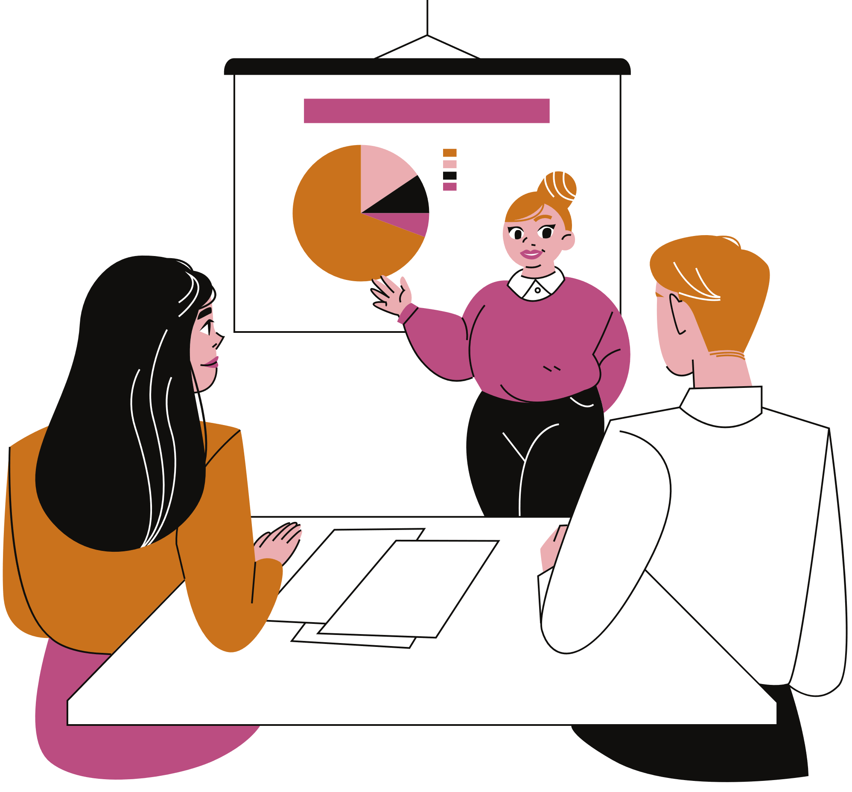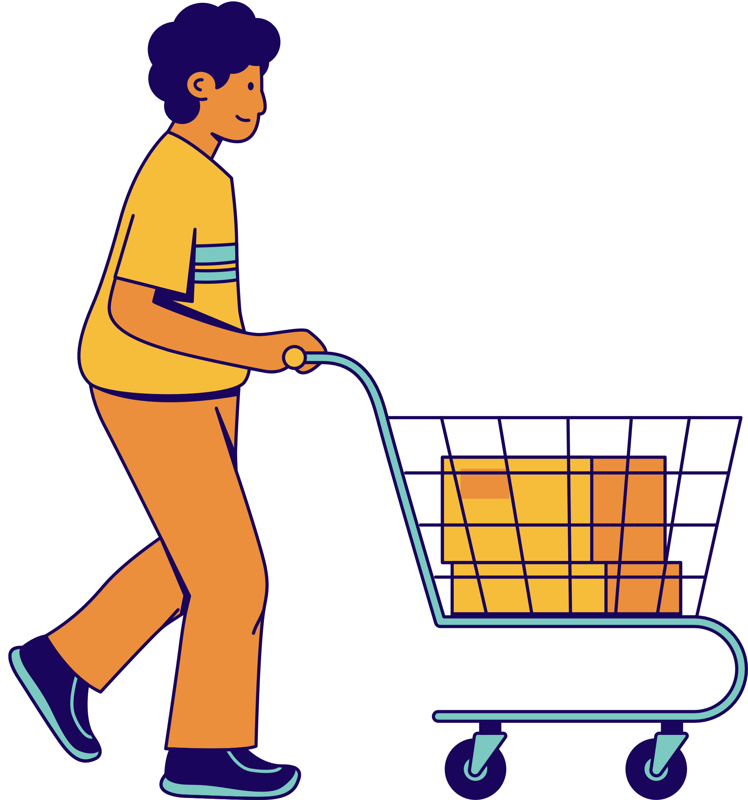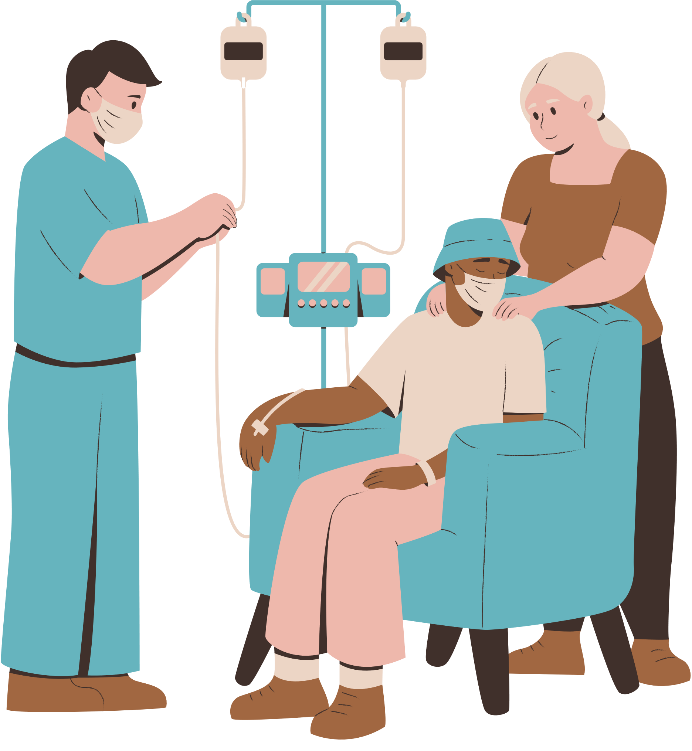
…

Figure 4: N user potentials roles
The instanciation of the User Profile model will give the complete picture of the user according to their roles in space-time, preferences, and location.

4.3 Knowledge base for Smart Identity: Potential profile
The user identity also takes care of “what the user knows”
”. This is why the integration of knowledge of the characteristics of the different domains and activities, and the external services requested in order to carry out the different tasks in good awareness.

What it know : potential profile (information allowing choice to be made awareness)
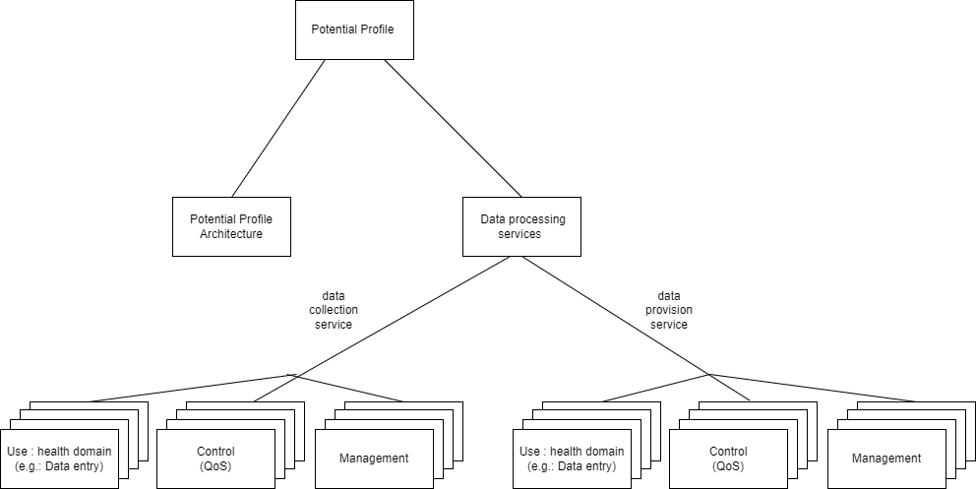

Figure 5: knowledge base
Like any entity, the Potential Profile has an architecture and a service interface.
The first service consists of data collection (instanciation of the Potential Profile model) to store architecture information. The architecture of the Potential Profile enriches the architecture of the User Profile by informing all the areas relating to a temporal action.
The second service will be all the processings on dataanalysis in order to have additional decision-making information
Each role played by the user requires data from each of the domains. That is to say for each action the Smart ID needs transversal data (figure 5). For example, when user has a medical appointment the profile will need the finance domain template as for all the actions requiring payment

Health template
Sport template
Work template
Purchase template
Entertainment template
Financial template

Medical appointment

Indoor sport

Professional Meeting

Purchase of winter clothes

Outing with friends

Figure 6 : Example of transversal data
For the PoC it will need templates corresponding to the most common roles, that is to say the basic roles (figure 6) involved in areas such as health, work, finance, travel, etc.
HEALTH TEMPLATE
- Social security number
- Mutual insurance (personal, professional, etc.)
Health information
- General information
- Weight
- Height
- Health parameters
- Temperature
- Pulse/heart rate
- Oxygen saturation
- Respiratory rate
- Blood pressure
Medical record
- Blood type
- Rhesus
- Vaccination booklet
- Vaccination certificates (covid-19)
- Current treatment(s)
- Allergies
- Last tests
- Latest prescriptions
- Medical appointments (past and future)
- Doctor notesEmergency contacts

TEMPLATE SPORT (well-being)
- Membership card
Information
- User behaviours
- Time spent sleeping / in bed
- Inactivity time
- Number of steps
- Distance (walking and running)
- Stages climbed
- Stability of walking
- Other
- Calories
Information sheet
- Type of subscription (classic, premium)
- Duration of subscription
- Wellness goal(s)

TEMPLATE TRAVEL
Information
- Tickets / tickets for transport
Ticketing
- Flight / train / bus tickets
- Advantage / discount card
Carpooling information
- Name and contact of the driver
- Departure time
- Meeting point (departure)
- Arrival point
Stay
- Hotel/accommodation reservation

TEMPLATE WORK
- Registration number
- Access badge
- Tickets / restaurant card
Professional file
- Job function
- Office
- Department / service
Other
- Employment contract / internship agreement
- Pay slips

TEMPLATE EDUCATION
- Personnel number
- INE number
- Education card
Student information
- Education
- Timetable
- Teaching units
- Documents
- Graduations

TEMPLATE SHOPPING / PURCHASES
Information
- Item preferences
- Product size
Customer record by supplier
- Customer number
- Membership / loyalty card
- Username
- Gift card
- Discount coupons
- Ordering
- Points
- My addresses (delivery and billing)
- My payment methods (credit card, multiple payments, etc.)

TEMPLATE DOMOTIC
- Access card / key
- Charges
- Energy supplier
- Hot and cold water
- Heating
- Maintenance costs
- Green space
- Common areas
- Household waste collection tax
- Connected house
- Management of: security, access, lighting, temperature, fans, objects, etc.
- Other
- Lease agreement / certificate of residence

TEMPLATE FINANCIAL
Bank information / current account
- IBAN
- Authorised overdraft
- Bank card
- Cheques
- Transfers & direct debits
Savings (passbook)
Insurance
- Home insurance
- Life insurance
- …
Loan(s)
Sponsorship
Other
- Bank documents

Figure 7 : common knowledge templates

4.4 PoC Design
4.4.1 Data Collection
Data collection consists of filling in the Potential Profile, which includes User Profile data, data on the various user domain interest, and data from the services requested (e.g. weather, etc.), as well as data processing contributions.
4.4.2 SmartID : active profile
The intelligent user profiling process, after the collection of the user data, begins with the consideration of their user centric parameters (space-time, space-place and preferences), which constitute the system input data allowing the obtaining the active profile.
Then an identification of the activity and a classification in relation to the different domain will be made using artificial intelligence algorithms during the data processing phase. There will then follow a selection of templates that may correspond to the areas of user action during this time slot. For example, a medical appointment might require the health, finance, and travel templates.
The preferences will make it possible to finalize the personalization of the active profile (figure 8) and to select the user's preferred resources (equipment, networks, services) according to user location.
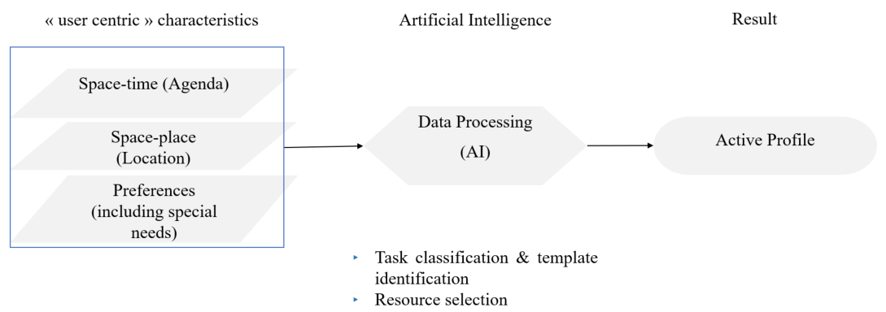
Figure 8: Smart user profiling process and active profile procurement

5 Data collection

5.1 User Profile service : data collection process

The dataset included a set of information allowing AI (Deep Learning) models to understand the challenge of Smart ID and to become familiar with user-centric characteristics.

Given that the objective is to have independent data of application services, a dataset using a relational database could not meet these linkage requirements.
The approach was to create a dataset written in Python ® and containing key information, including the task, internal resources (equipments, networks, and services) by location, external resources and templates.

5.2 Knowledge base tools
The tools used to create the dataset to build and train Artificial Intelligence models are as follows:
Jupyter Notebooks implementation is used, allowing to write programs in different languages.
”Python ®” is a Programming language used for the dataset
,”Pandas™ ” is the Python ® library to create datasets as dataframes.

5.3 Knowledge base
Figure 9 below shows the draft of our dataset used to build and train the built deep learning models.

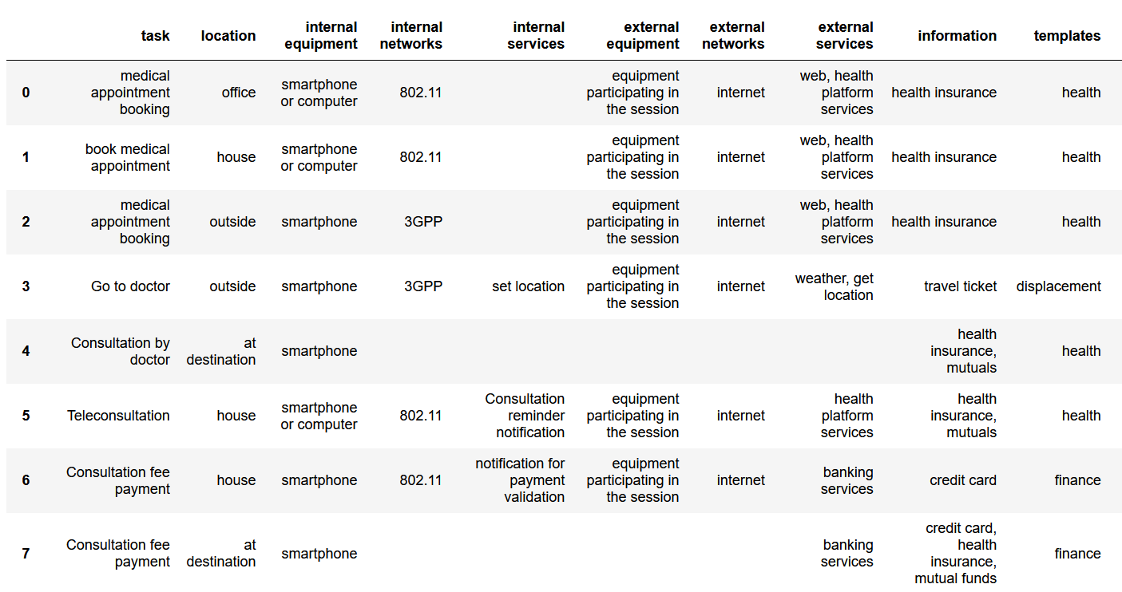
Figure 9: Draft dataset used for Smart ID

6 Data processing

6.1 Shaping the problem
Before using Artificial Intelligence algorithms, it is necessary to transform the input textual data (user-centric characteristics) into number vectors of the same size (embeddings) so that they can be understood by neural networks.
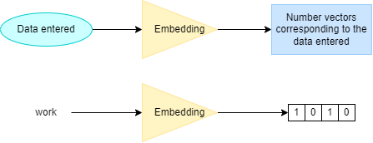
Figure 10: Embedding generation

The steps generally performed for this processing of textual data are as follows:
- "Lowercase", to put all the characters of the sentences in lower case.
- Remove punctuation, numbers, and special characters.
- Remove phrases in English (or French, depending on the problem to be solved)
"Tokenization" to reduce the size of vocabulary needed to encode a message.

6.2 Resolution tools
For the Smart ID, the Transformers model and its AutoTokenizer library were used to pre-process the data presented in 6.1.
Figure11: Line of code used to pre-process data

7 PoC : use case presentation
7.1 User Story
As an example, the use case for the PoC is to consider the Provisional Agenda and Location of September 19, 2022, as presented in Figure 12.
 | SCHEDULE | LOCATION
15h – 17h | Team Meeting | Office
17h15 – 18h | (Travel)
18h – 18h30 | Preparation for the gym | House
18h45 – 20h | Sports session | Nearest gym
20h15 – 21h | Dinner | House
21h – 22h | Purchase of autumn / winter clothes | Online
22h | Rest
Figure 12 : Day Program of September 19, 2022

7.2 Potentiel Profile data
In the following example, it is 6pm and the user has just returned home. Users would like to go for a workout and need to know if the weather allows them to go out, but also to find a gym close to their home

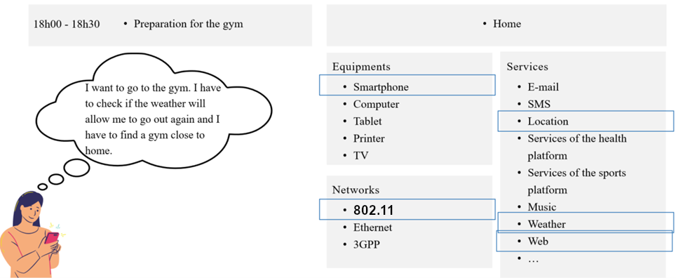
Figure 13 : Available Resources for the specific use case
The resources available in the user's environment are shown in Figure 13.

7.3 Active profile
To perform the tasks presented in 7.2, the user needs a terminal, network access and services.
Since the users are at home, they will choose:
- the Smartphone as a terminal for mobility concerns,
- wifi (802.11), to save mobile data and to respect the environment,
- weather, location, and web services.

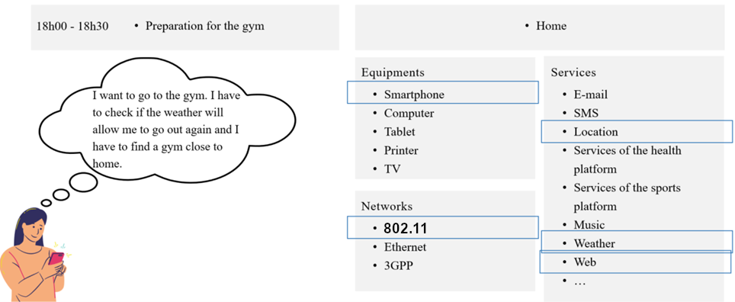
Figure 14: Active user profile from 6 p.m. to 6:30 p.m.
The active profile of the user from 6 p.m. to 6:30 p.m. at home is shown in Figure 14.

8 PoC : realization (results)

8.1 Platform description
8.1.1 Activity diagram
The activity diagram is the representation of the behavior of the system in the form of flows or sequences of activities.
The diagram in Figure 15 shows the operations performed to process user data and build AI models relevant to Smart ID.

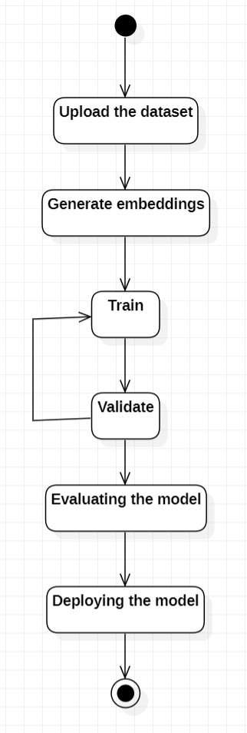

Figure 15: Choosing the right AI model for Smart ID

8.1.2 UML diagram of components
Figure 16 shows the UML diagram of the components of the Smart ID system. The data entered as text correspond to the tasks in the user's agenda. These are classified by the text classification component that will output the percentages of the different domains to which the task can belong to facilitate the choice of "templates".
Next, the semantic similarity component will browse the dataset to find an existing task that can be like the one the user wants to perform. The output of the semantic similarity component is therefore the set of textual data that are like the input data.
Finally, the prediction component will determine the resources required by the user to perform this task.
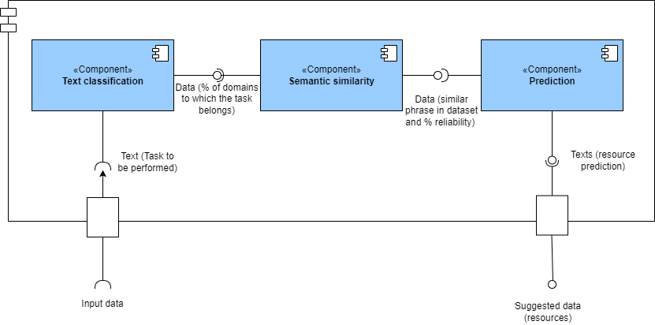
Figure 16: UML diagram of system components

8.2 Models building
8.2.1 Operating principle of Transformers
The Trasnformer is a deep learning model that uses attention by differentially weighting the importance of each part of the input data to increase its training speed.
The Transformer consists of two main components, namely: the encoder and the decoder and the connections between them (figure 17).
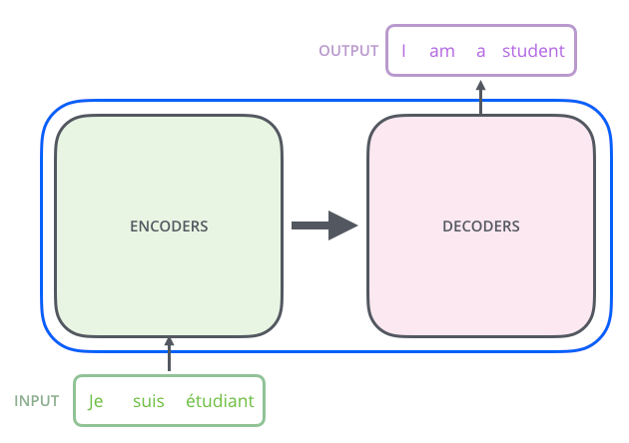
Figure 17: Components of a transformer
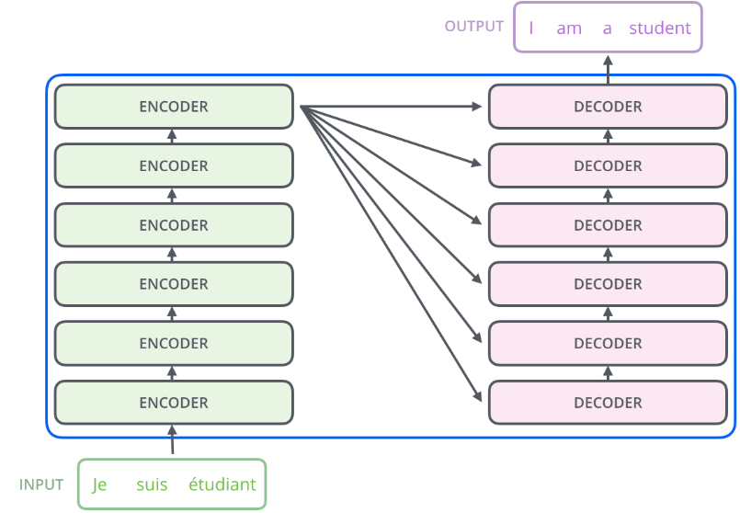
Figure 18: Encoders – Decoders

The encoding component is generally composed of six (6) encoders stacked on top of each other (Figure 18).
The decoding component is composed of decoders stacked on top of each other of the same number as the encoding component.
The overall architecture of the transformer is shown in Figure 19.
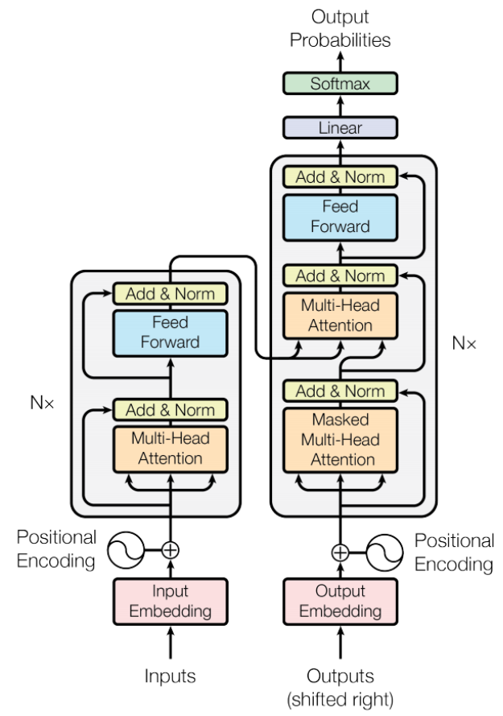
Figure 19: Global transformer architecture

In accordance with the overall architecture of the transformer (Figure 19), there are three (3) attention mechanisms:
1. Self-Attention in the encoder
It is a layer that helps the encoder look at other words in the input phrase when encoding a specific word.

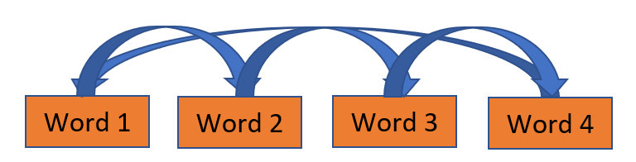
Figure 20: Self-Attention Mechanism
2. Self-attention with all previously generated elements in the input of the decoder (at the level of "Encoder-decoder Attention" to help the decoder focus on the relevant parts of the input sentence.

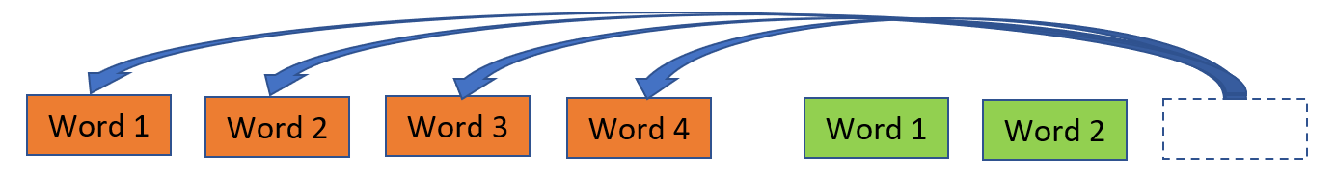
Figure 21: Mechanism of "Encoder-Decoder Attention"
3. "Masked” Attention between the element generated by the decoder and all the elements of the encoder. This mechanism can be used for text generation or simultaneous translation and is autoregressive.

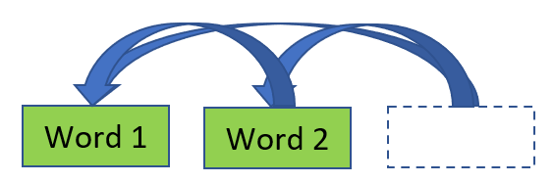
Figure 22: "Masked Attention" mechanism

8.2.2 Model used for Smart-ID
For the creation of AI models for Smart ID, a pre-trained neural network model based on Transformers was used. It is called CamemBERT ™.
The Camembert ™-Base-XNLI zero-stroke pre-trained transfer learning algorithm was used because classical machine learning algorithms did not give accurate results during training on the dataset.
Camembert ™-base-XNLI is a transformer-based natural language processing model written in Python®. It was trained on XNLI (Multilingual Natural Language Inference) which was published by Facebook. It is mainly used to determine the probability of a corpus of text belonging to a predefined class.

8.2.3 Similarity calculation
To obtain the similarity score between two (2) sentences, the system takes as input:
- the reference phrase from the dataset
- the candidate phrase to be challenger (entered by the user).
Embeddings (number vector) are generated from this textual data and these will be used to calculate the cosine similarity (cosine similarity per word pair + linear regression) between sentences.

8.3 Choice of tools and technologies
To implement the Camembert-Base-XNLI algorithm for data entry and resource prediction, the tools used are:

Tools / Technologies | Version | Role
Python ® | 3.7 | The most widely used programming language for data analysis, ML and AI in general.  It is platform independent.
Transformers | 4.24.0 | Library for downloading and training pre-trained natural language processing models.
Tensorflow ®-Text | 2.9.0 | It is a library of TensorFlow® to perform operations on texts for pre-processing.
Pandas ™ | 1.3.5 | For managing datasets using dataframes
Google Colab ® | 1.0.0 | A cloud service offered by Google ®, based on Jupyter Notebook and allowing to train ML models directly online, without the need to install anything.

For a better visualization of the results of the main model, web interfaces have been developed with the Gradio API version 3.12.1. Gradio allows for deploying locally to test models.

8.4 Results
8.4.1 First Model Use Scenario
Before running the model corresponding to the first component of the Smart ID, the pipeline library was imported to link to the camemBERT ™ pre-trained model. Then a classifier based on this model was defined.
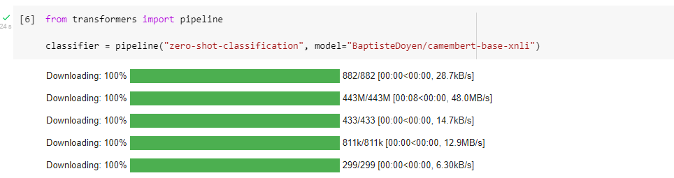
Figure 23: Task classifier definition

To test Model 1, the Gradio interface developed for this purpose is run. Then simply fill in the task to be executed as well as the templates that constitute here the candidate classes.
The behaviour of Model 1 is shown in Figure 24.

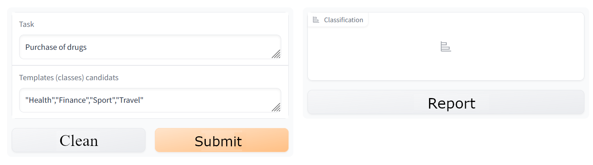
Figure 24: Entering the task to classify in relation to the different templates

Figure 25 shows the result after clicking “submit”. Model 1 is therefore able to classify a given task in relation to domains, giving the probabilities that it belongs to one class rather than another.

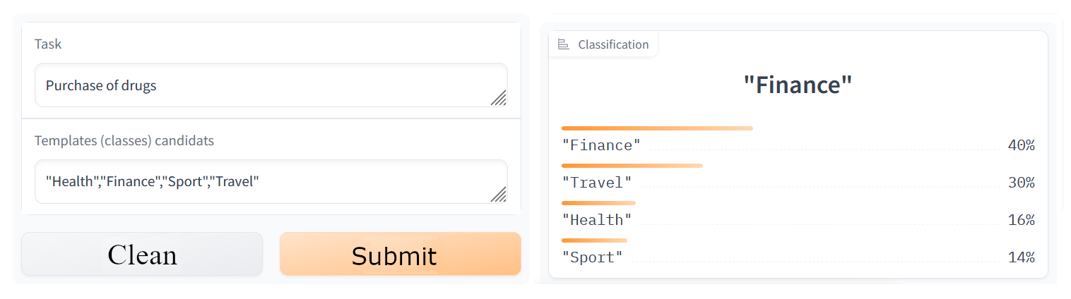
Figure 25: Result of Model 1

8.4.2 Second Model Use Scenario

8.4.2.1 Similarity between sentences
For model 2, you must first do the embedding with the AutoTekenizer library of the Transformers library so that the model can understand and process the candidate task that will be entered.
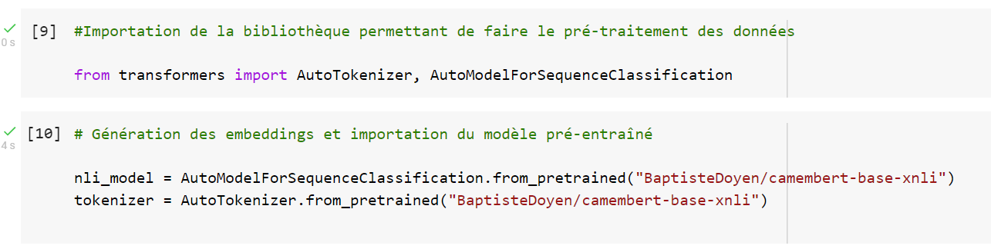
Figure 26: Embeddings

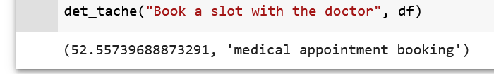

Figure 27: Result

This component gives the result of the similarity calculation between the candidate sentence (task to be performed) and the reference phrase (task that is in the dataset), as well as the sentence that it considers to be reference.
Figure 27 shows the result of the template for the "book a slot with doctor" task.
Score : 52,56%
Reference phrase: Medical appointment booking.

8.4.2.2 Resource Prediction
The resource prediction model considers the task at hand, the calculation of similarity between sentences, as well as the location to propose internal and external resources (equipments, networks, services) that may be useful.
Here is the behavior of Model 2.

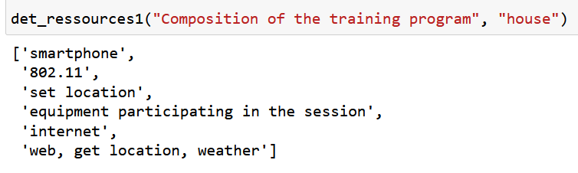

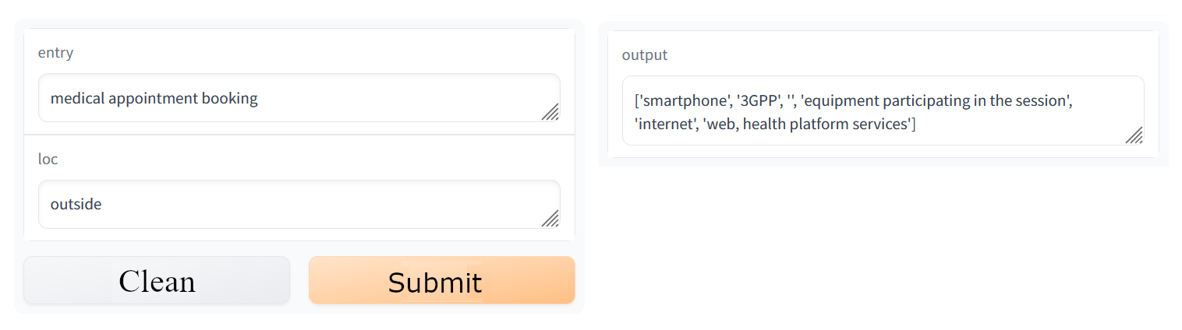
Figure 28: Proposal of internal and external resources for the entered task

Annex A:
A.0 Code file for Proof of Concept
The Smart Identity Proof of Concept is run in the Google Colaboratory notebook (https://colab.research.google.com/).
The code file for the present document is available on the ETSI Forge repository, at the following link:
https://forge.etsi.org/rep/user/tr-103-875-2/smartid-poc/-/tree/v0.0.7
The POC_SmartID_v3.ipynb file is to be uploaded to Google Colaboratory and the PoC is executed from there.

Annex:Bibliography
[B.1] Workbook N°1.Digital identities. Personal Information Values ​​and Policies Chair. Mines Telecom Institut

Annex:
Change History
Date | Version | Information about changes
01-2023 | V.0.0.5 | Final draft for Approval

History
Document history
V.0.06 | 01-2023 | Final draft for approval

Latest changes made on 2022-03-14

