INVITATION AND REGISTRATION

Global Standards Collaboration (GSC-11)
TIA Host, Chicago, Illinois
28 May 2006 - 2 June 2006

Dear ______ (invited Observer),

Matthew J Flanigan, the President of TIA, and Dan Bart, Senior Vice President, Standards and Special Projects of TIA, are pleased to invite you or representative from your organization to be Observers to the 11th GSC meeting. Observer Delegate Organizations are limited to 1-2 participants.

The GSC-11 meeting will begin on Sunday, 28 May 2006 (HoD-only lunch, and afternoon HoD/management meeting followed by an evening welcome reception for everybody) and will continue until the afternoon of Friday, 2 June 2006. Our planning is based on Delegations from Participating Standards Organizations and the ITU of typically 4-8 Delegates, with a maximum of ten, as has been our custom.

All GSC-11 Delegates including Observers will also be pre-registered as TIA Guests for GLOBALCOMM2006™ which runs from June 4, 2006 until June 8, 2006 at the Convention Center connected with the Hyatt McCormick Hotel.

Registration for GSC-11 can be made by completing and returning the attached Registration form (See Annex 1) or by sending the same information by email to GSC_Reservations@tiaonline.org.

We plan to use a GSC-11 Rooming List administered by TIA for reservations with the principal Hotel, but you can also stay at any hotel of your choice, in which case you will need to make your own arrangements. We urge you to make hotel reservations, air travel, and apply for Visas, if needed, as soon as possible. Please see Annexes 2 and 3 and provide the information to TIA for hotel needs if staying at the Hyatt. Note different rates apply for the actual GSC meeting week and the GLOBALCOMM meeting week. After the hotel room block is filled or after the cut-off date of April 24, 2006, you may have a problem finding space since GLOBALCOMM is expecting in the neighborhood of 20,000 attendees.

If you have any questions or difficulties do not hesitate to contact Stephanie Montgomery (SMontgomery@tiaonline.org or +1.703.907.7735) or Dan Bart (DBart@tiaonline.org or +1.703.907.7703). We are looking forward to another successful GSC meeting.

Best regards,

Dan Bart

ANNEX 1 – GSC-11 Registration Form

Please fill in this form and send to:
GSC_Reservations@tiaonline.org
FAX: +1.703.907.7728

DELEGATE details (please complete)
Prefix (Mr. Ms. Dr.)
First Name:
Last Name:
Name that you wish on your Badge:
Company/Organization:
Business Address:

Title or Position at your organization:
Phone No.:
Fax No.:
Mobile No.:
E-mail address:
Observer Delegation:
(please indicate organization you are representing.)

GSC Meeting Participation (please indicate)
GSC Plenaries
Joint GRSC/GTSC
GRSC
GTSC
IPR WG
USER WG
User Workshop (1st June)

Accompanying person(s) (please complete if appropriate)
Prefix (Mr. Ms. Dr.)
First Name:
Last Name:
Relationship:
(e.g., Spouse, Partner, Son, Daughter, etc.)
Would Accompanying Person(s) be interested in having TIA arrange Spouse/Auxiliary Programs e.g., Sightseeing, Shopping, etc.?
If so, number of persons.

Hotel selected (please indicate for our Rooming list if at Hyatt, or for information only if not at Hyatt.)
Hyatt Regency McCormick Place (Please X) | ___Via Rooming List from TIA
Other, please identify

Please provide your Hotel needs as soon as possible (see Annexes 2 and 3), or make your own arrangements with another hotel of your choice.

Social events
Event | Delegate | Accompanied By
Welcome Reception - Sunday 28th May
Welcome Dinner - Monday 29th May
Dinner Cruise
Farewell Dinner - Thursday 1st June
Spouse/Auxiliary programs - Monday and Wednesday
(if sufficient interest)

GLOBALCOMM2006™

Location: Near Hyatt Regency McCormick Place, across the street at McCormick Place Convention Center (but actually connected with Hotel, you do not even need to go outside).

WHEN: 4 -8 June 2006, Show Floor Opens on June 5

URL: http://www.globalcomm2006.com/

Meetings:

GSC Delegates including Observers are invited to attend GLOBALCOMM™ 2006, you will be automatically pre-registered for GLOBALCOMM™ 2006 and the on-line registration fee will be waived.

GLOBALCOMM2006™ Want more information
about this activity?
I will be attending GLOBALCOMM (Yes/No)
I am interested in attending Service Provider Track (Yes/No) (M-W)
I am interested in attending Enterprise Track. (Yes/No)
(M-W)
I am interested in attending GLOBALCOMM Innovations Track. (Yes/No) (Tues-Wed afternoons)
I am interested in attending GLOBALCOMM Summit Track. (Yes/No). Indicate Regions of interest [Region 1 (EU/ME/A), Region 2 (The Americas), and Region 3 (Asia/Pac)]
(Region 2, Monday; Region 1, Tuesday; and Region 3, Wednesday, afternoons)
I am interested in attending TIA Supplier Diversity Event (Yes/No)
I am interested in having a booth at GLOBALCOMM.

ANNEX 2
Hotel information
GSC-11 (28 May 2006 - 2 June 2006)
GLOBALCOMM2006™ (4 June 2006 – 8 June 2006)

In order to make the necessary arrangements for your accommodation, please send the “Hotel Requirements Form” to GSC_Reservations@tiaonline.org if you want to be at the Hyatt Regency Hotel or you can use it with other Hotels of your choice.
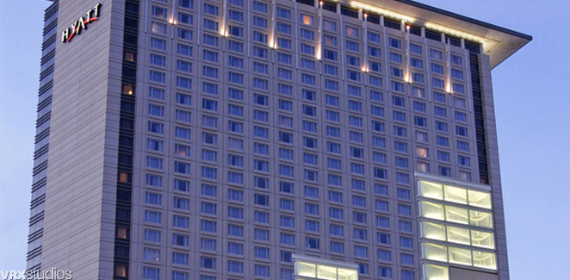
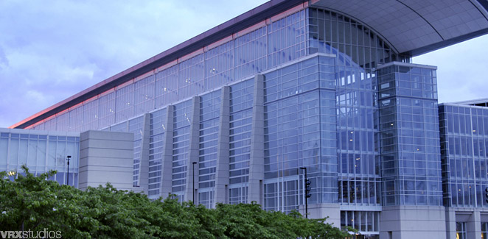
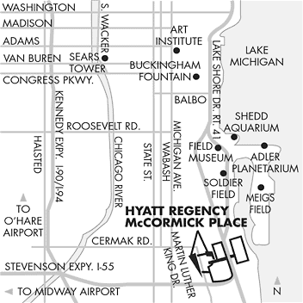

Hyatt Regency McCormick Place  2233 S. Martin L. King Dr.,  Chicago, Illinois, USA  Tel: +1 312 567 1234 Fax: +1 312 528 4000  http://mccormickplace.hyatt.com/hyatt/hotels/ | Negotiated GSC rates of $160 USD (single); $180 USD (double);  $205 (triple); and $230 (quad), plus taxes for GSC-11.  GLOBALCOMM dates at GLOBALCOMM rates: $229, $254, $274, and $294, respectively.  HOTEL ROOM BLOCK CUT-OFF DATE April 24, 2006, after that normal prices, if availability.

The Hotel Web site provides the following current information:

Transportation
FROM O'HARE INT'L AIRPORT:
AIRPORT EXPRESS - 1-800-654-7871 or 312-454-7800 Ticket counters are located across from baggage claim areas of terminals 1, 2 and 3 and outside US Customs in terminal 5.
COST: $20.00pp (1 person one-way)
$15.00pp (2 people)
Children under 12 years of age $7.75 one way.
Pair Fare (Round trip or 2 one-way tickets) - $15.00 each
Group Fare (3 or more passengers traveling together to the same destination) - $11.00 each
Private van service is available for up to 10 passengers for $130.00 one way; Service runs 6:00am-11:30 pm daily. Vans depart airport approximately every 10 minutes. Vans depart hotel at 10 after the hour and 40 after the hour beginning at 4:40am. The last run is at 10:10 pm. Vans are blue and white with red lettering. For more information call 800-654-7871. ++ Service for physically challenged is available. Reservations are requested 1 day in advance for this service.
LIMOUSINE SERVICE:
Please contact the Guest Services Department at 312-528-6513 for reservations.
TAXI SERVICE:
Located on the lower level of each terminal, taxis are available at the taxi staging area. A ride from O'Hare to Hyatt Regency McCormick Place takes approximately 45 minutes (depending on traffic) and costs between $40-$45.

ANNEX 3

Hotel Requirements Form

This "Requirements Form" must be sent directly to GSC_Reservations@tiaonline.org for rooms at the Hyatt for GSC-11, or may be used with another hotel of your choice.

Name First Name

Company/Address

Tel: Fax: E-mail:

From Time of Arrival To

 Single Room Double Room
Triple Room Quad Room

Credit Card to guarantee this reservation:

AMEX VISA DINERS MC Other

Number Validity Code

Date Signature

Meeting:

TIA/GSC-11 meeting hosted at Hyatt Regency McCormick Place

From: 28 May 2006 To: 2 June 2006
GLOBALCOMM2006 4 June 2006 until 8 June 2006

Name of the Hotel: Hyatt or (Please indicate where you have made your own arrangements)

