ETSI EG 202 373 V1.1.1 (2005-08)
ETSI Guide
Electromagnetic compatibility
and Radio spectrum Matters (ERM);
Guide to the methods of measurement of
Radio Frequency (RF) fields

Reference
DEG/ERM-TG27-006
Keywords
measurement uncertainty, radio, site engineering
ETSI
650 Route des Lucioles
F-06921 Sophia Antipolis Cedex - FRANCE

Tel.: +33 4 92 94 42 00 Fax: +33 4 93 65 47 16

Siret N° 348 623 562 00017 - NAF 742 C
Association à but non lucratif enregistrée à la
Sous-Préfecture de Grasse (06) N° 7803/88

Important notice
Individual copies of the present document can be downloaded from:
http://www.etsi.org
The present document may be made available in more than one electronic version or in print. In any case of existing or perceived difference in contents between such versions, the reference version is the Portable Document Format (PDF). In case of dispute, the reference shall be the printing on ETSI printers of the PDF version kept on a specific network drive within ETSI Secretariat.
Users of the present document should be aware that the document may be subject to revision or change of status. Information on the current status of this and other ETSI documents is available at http://portal.etsi.org/tb/status/status.asp
If you find errors in the present document, please send your comment to one of the following services:
http://portal.etsi.org/chaircor/ETSI_support.asp
Copyright Notification
No part may be reproduced except as authorized by written permission.
The copyright and the foregoing restriction extend to reproduction in all media.

© European Telecommunications Standards Institute 2005.
All rights reserved.
DECTTM, PLUGTESTSTM and UMTSTM are Trade Marks of ETSI registered for the benefit of its Members.
TIPHONTM and the TIPHON logo are Trade Marks currently being registered by ETSI for the benefit of its Members. 3GPPTM is a Trade Mark of ETSI registered for the benefit of its Members and of the 3GPP Organizational Partners.
Contents
Intellectual Property Rights 4
Foreword 4
Introduction 4
1 Scope 6
2 References 6
3 Definitions and abbreviations 6
3.1 Definitions 6
3.2 Abbreviations 7
4 Test conditions 7
4.1 General 7
4.2 Radio site information 8
4.3 Test equipment requirements 8
4.3.1 General 8
4.3.2 Wideband RF probes 8
5 RF field strength measurement 9
5.1 General 9
5.2 Method of measurement RF field strengths using portable RF field strength measuring equipment, connected to a wide band probe 9
5.3 Method of measurement at specific frequencies to determine the relative RF field strengths, using RF field strength measuring equipment connected to a calibrated RF antenna 10
Annex A (informative): Personal monitors 11
A.1 General 11
Annex B (informative): Practical guidelines on the use of RF broadband probes 12
B.1 General 12
B.2 Characteristics of RF broadband probes 12
B.2.1 General construction 12
B.2.2 Detectors 12
B.2.2.1 Small signal diode detector 12
B.2.2.2 Bolometer (thermistor) detector 13
B.2.2.3 Thermo-element detector 13
B.3 Measurement at radio sites 13
B.4 Calibration limitations 13
Annex C (informative): A comparison of RF field strength measurement test results, using portable measuring equipment connected to broad-band probes 14
C.1 General 14
C.1.1 Methodology 14
C.1.2 Conclusions 15
Annex D (informative): EMF measurement test results at a radio site 16
Annex E (informative): Bibliography 29
History 30

Intellectual Property Rights
IPRs essential or potentially essential to the present document may have been declared to ETSI. The information pertaining to these essential IPRs, if any, is publicly available for ETSI members and non-members, and can be found in ETSI SR 000 314: "Intellectual Property Rights (IPRs); Essential, or potentially Essential, IPRs notified to ETSI in respect of ETSI standards", which is available from the ETSI Secretariat. Latest updates are available on the ETSI Web server (http://webapp.etsi.org/IPR/home.asp).
Pursuant to the ETSI IPR Policy, no investigation, including IPR searches, has been carried out by ETSI. No guarantee can be given as to the existence of other IPRs not referenced in ETSI SR 000 314 (or the updates on the ETSI Web server) which are, or may be, or may become, essential to the present document.

Foreword
This ETSI Guide (EG) has been produced by ETSI Technical Committee Electromagnetic compatibility and Radio spectrum Matters (ERM).
This ETSI Guide is dedicated to the memory of Gerald H David OBE, founder and chairman of the Radio Site Engineering Task Group. His wise counsel and professional approach resulted in a number of practical standards being published to the benefit of the radio community and the wider engineering field.
The present document is a guide to practical methods of measurement that can be used for the assessment of the radiated RF fields at radio sites and other locations where radio signals are encountered.

Introduction
The main objective of the present document is to set out guidelines in respect of methods of measurement for radiated RF field strength, and to determine the level(s) in relation to the limits for RF energy levels set out in the harmonized standards for human exposure, published in the European Union (EU) Official Journal (OJ). These limits (Reference Levels) conform with the levels of RF energy contained in these standards which have been agreed as those limits that can be used to demonstrate conformity to the following European Community Directives.
Council Recommendation 1999/519/EC (July 1999), on the limitation of exposure of the general public to electromagnetic fields (0 Hz to 300 GHz) [2] and Directive 2004/40/EC [3] of the European Parliament and the Council of 29 April 2004, on the minimum health and safety requirements regarding the exposure of workers to the risks arising from physical agents electromagnetic fields (18th individual Directive within the meaning of Article 16(1) of
Directive 89/391/EEC).
Prior to any measurement of the RF fields at locations other than radio sites, it is vital that a risk assessment is carried out to establish if there are radio transmitting equipment at the location or in the near vicinity. The information gathered from this assessment should be used to decide whether or not RF field measurements are necessary at the location. It is also important to carry out an assessment at radio sites, prior to the commencement of measurements.
Set out in these guidelines are 2 sets of methods of measurement:
Level 1:
Level 1 is the measurement of RF field strength, using portable measurement equipment connected to a broad-band probe, which enables the user to survey the area of the radio site and the boundary of the radio site, or any other location where RF fields are encountered, and to measure the RF field strengths present. This method of measurement can also be used to carry out regular audits of radio sites or any other location where RF fields are encountered and for measurements external to the radio site or other locations.
Level 2:
Level 2 is the measurement of RF field strength, using an instrument which has the capability of examining individual frequencies of interest. This type of instrument will normally be transportable, but may not be capable of battery operation. This approach is normally used to examine in more detail the measurements made in level 1. This method of measurement can be used on the radio site, or any other location where RF fields are encountered.
The methods of measurement of RF field strength described in the present document use a radio site as the location for the measurement, but the methods described are applicable to any location where RF fields are encountered.
NOTE: It is vital that the immunity of the instruments used to measure the RF field strength are such that they are capable of working, without degradation, and reproduce accurate results in the RF environments being investigated.
Personal Monitors:
There are propriety personal monitors available on the open market, but these are not covered by the present document, as they are used as field strength indicators, by personnel visiting and/or working on a radio site, and not for the measurement of field strength. Information regarding these devices can be found in an informative annex A of the present document.
Annex B of the present document sets out practical guidelines on the use of RF broadband probes.
Annex C of the present document sets out a comparison of RF field strength measurement test results, using portable measuring equipment connected to broad- band RF probes.
Annex D of the present document sets out the results of EMF measurements at a radio site, which is a good example of the type of RF environment, where a large mixture of radio services is present.

1 Scope
The present document provides a guide to practical methods of measurement of RF fields encountered on Radio sites, including immediate surrounding area, and any other location where radiated RF fields are encountered.
The measurements described are such that they should be carried out by a competent technician(s) with experience of working with RF equipment and its installation.
The purpose of the present document is to cover:
- methods of measurement of Radiated RF fields;
- recommendations for the type of equipment required to carry out the measurement of Radiated RF fields.
There are two types of measurement methods set out in the present document, which are based on those set out in the introduction.

2 References
The following documents contain provisions which, through reference in this text, constitute provisions of the present document.
- References are either specific (identified by date of publication and/or edition number or version number) or non-specific.
- For a specific reference, subsequent revisions do not apply.
- For a non-specific reference, the latest version applies.
Referenced documents which are not found to be publicly available in the expected location might be found at http://docbox.etsi.org/Reference.
[1] Directive 1999/5/EC of the European Parliament and of the Council of 9 March 1999 on radio equipment and telecommunications terminal equipment and the mutual recognition of their conformity (R&TTE Directive).
[2] Council Recommendation 1999/519/EC on limitation of exposure of the general public to electromagnetic fields 0 Hz-300 GHz.
[3] Directive 2004/40/EC of the European Parliament and of the Council of 29 April 2004 on the minimum health and safety requirements regarding the exposure of workers to the risks arising from physical agents (electromagnetic fields) (18th individual Directive within the meaning of Article 16(1) of Directive 89/391/EEC).

3 Definitions and abbreviations

3.1 Definitions
For the purposes of the present document, the following terms and definitions apply:
multiple fixed station site: when two radio sites are in close proximity, the decision governing whether they should be classed as a single site or two sites shall be decided by the RF isolation between them, and the health and safety considerations
NOTE: The minimum isolation shall be 60 dB, but this isolation should ideally exceed 70 dB at all frequencies of operation. In any case, any signal received from a neighbouring site should not exceed -20 dBm and ideally -30 dBm.
radio site: physical location, comprising a land site, a building roof top ,accommodation in a building or other appropriate premises, in which one or more transmitter(s) and receivers, plus associated equipment, antenna(s) and the support structures are located
NOTE: The location will normally have a barrier (fence) to prevent access by members of the public. The associated equipment may include control equipment, RF filters, RF combining equipment, modems, line interface, and emergency power supplies etc. The location of the radio site may include one or more equipment rooms, or separate buildings used to house the equipment.
single fixed station site: radio site at which only one Radio Frequency (RF) carrier is radiated at any one time
NOTE: Although the associated transmitter must meet all the specified performance parameters of the relevant standard, it is only the intermodulation characteristic and health and safety issues that need careful consideration in the site planning.
worker: person who may be occupationally exposed to emf above the limits applicable to the General Public, and who has received instructions according to the Relevant Regulations

3.2 Abbreviations
For the purposes of the present document, the following abbreviations apply:
AC Alternating Current
dB decibel
dBuv/m decibels relative to a microvolt per metre (field strength)
dBV/m decibels relative to a volt per metre (field strength)
emf electromagnetic field
EU European Union
fsm field strength meter
GHz Gigahertz
GSM Global System for Mobile
Hz Hertz
ICNIRP International Commission on Non-Ionizing Radiation Protection
kHz kilohertz
m metre
MHz Megahertz
ns nanoseconds
OJ Official Journal
PM Personal Monitors
ps picoseconds
RF Radio Frequency
TETRA TErrestrial Trunked RAdio
V Volt
W Watt

4 Test conditions

4.1 General
Prior to any measurement of the RF fields at locations other than radio sites, it is vital that a risk assessment is carried out to establish if there are radio transmitting equipment(s) at the location or in the near vicinity. The information gathered from this assessment should be used to decide whether or not RF field measurements are necessary at the location. It is also important to carry out an assessment at radio sites, prior to the commencement of measurements.
The present document covers radio sites and any location where RF signals are encountered, and therefore the example set out below although centred on a radio site, may be used at any location.

4.2 Radio site information
The test conditions may vary from radio site to radio site, and are dependant on the site location and surrounding terrain. It is essential to gather as much data as possible in respect of the radio site, before measurements are performed.
The following information would be helpful, prior to any visit and measurement of field strength on radio sites, and the immediate surrounding area:
- radio site location, details taken from an ordnance survey map, including details of the perimeter and area surrounding the radio site. This information is useful for visits to the site, and an important part of the RF field measurement test report;
- details of the radio equipment installed on the radio site, frequency of operation, RF power, etc. This information is useful when making the measurement of the field strength and for analysis of the measurement results;
- a plan or map of the site should be obtained;
- details of the location/dispersion of the radio equipment on the site, including antenna mast/tower and antenna location. This information is useful and is helpful with the recording of locations on the site and/or surrounding area, where measurements have been carried out, and also for future reference if changes are made to the site;
- security, safety, and site entry details, this is necessary as part of normal working practice;
- detail of areas surrounding the radio site with access to the general public. This is needed for protection of the general public;
- location of other radio sites in the vicinity, which is useful as the measurement results may be affected by the other radio site;
- health and safety requirements, which are necessary as part of normal working practice.
NOTE 1: In many cases not all of the radio site information requested above is available, particularly where there are other adjacent radio sites. In these cases, measurements should be made as outlined in clause 5.
NOTE 2: Although the list of information set out above is specific to radio sites, the information can be used where appropriate, as a guide for information required for any location where RF fields are encountered.

4.3 Test equipment requirements

4.3.1 General
Examples of the test equipment used to carry out the field strength measurement are described in annex C and D.
All test equipment used should be traceable to current National Standards, and be within its calibration date. The calibration of the test equipment should be carried out by an Accredited Test House, or by the manufacturer of the test equipment.

4.3.2 Wideband RF probes
The characteristics and performance and of these probes is set out in annex B of the present document. It follows from the information set out in the annex, that for radio site measurement or measurement at locations where RF fields exist, the recommended system to use would be a thermo-element detector with the widest RF bandwidth.

5 RF field strength measurement

5.1 General
The main objective of the RF field strength measurement is to determine the maximum levels of the field strength present at any part of a radio site and its surrounding area, or any other location where RF fields are encountered. This can be achieved in the following way:
- measurement using portable RF field strength measuring equipment connected to a wide band probe, which can be used to survey the radio site and the surrounding area, or any other location where RF fields are encountered;
- measurements of the relative field strength at specifically identified frequencies of interest, using transportable equipment connected to a calibrated antenna, which can be used to survey the radio site and surrounding area or any other location where RF fields are encountered.
The engineer/technician carrying out the measurements must be experienced/competent of the measurement of RF field strength.
A test report of the measurements should be prepared, including the locations at which the measurements are made, together if possible with a plan or map of the radio site and surrounding area, or any other location where RF fields are encountered.
All test equipment used in the measurement process should be calibrated as described in clause 4.3.

5.2 Method of measurement RF field strengths using portable RF field strength measuring equipment, connected to a wide band probe
- The test equipment will comprise of a hand held wide band calibrated probe/antenna, connected to a portable selective voltmeter/field strength meter (fsm), capable of broadband measurements over the frequency range covered by the probe. To cover the full frequency range of the measurement it may be necessary to use more than one calibrated probe, and repeat the measurement for each of these wide band probes.
- The field strength measurement should start at a known location on the radio site map, and should used as the reference measurement point. This location should be recorded in the test report. Holding the wide band probe in a forward position, the test equipment should be moved slowly over the radio site, until an indication on the fsm is observed. If available the "peak hold" facility of the measuring instrument should be used to find the peak reading.
- At each location at which an indication is observed the measurements should be carried out holding the probe at a height of approximately 1 m above the ground, the probe should then be orientated to obtain the maximum reading. The measurement should then be repeated holding the probe at different heights to obtain the maximum reading. If the level of the indicated measurement is 3 dB or greater below the limit value, then no further measurement is required, but the exact location on the radio site should be recorded in the test report. For measurements that indicate a result less than 3 dB below the limit value, the measurement and the location should be recorded in the test report
- The measurement shall be repeated for the whole of the radio site to establish the maximum levels on the site. The levels and locations should be recorded in the test report.
- The measurement shall be repeated for each of the calibrated probes needed to cover the full frequency range of the measurement.
- The tests should be repeated in the immediate surrounding area of the radio site, as described in b) to e) above, but a new reference measurement point should be selected. The measurement should cover the total area surrounding the radio site and include locations, where the general public has access.
- For measurements that indicate a result less than 3 dB below the limit value, the test should be repeated as set out in clause 5.3, to determine the frequency(s) involved and relative field strength involved.

5.3 Method of measurement at specific frequencies to determine the relative RF field strengths, using RF field strength measuring equipment connected to a calibrated RF antenna
- The test equipment should comprise of a calibrated antenna connected to a transportable selective voltmeter/field strength meter (fsm), capable of measuring the field strength at a specific frequency over the appropriate frequency range. To cover the full frequency range of the measurement it may be necessary to use more than one calibrated antenna, and repeat the measurement for each of these antenna. The antenna shall be supported on a tripod, capable of being adjusted in height, between 0,8 m to 2 m.
- The equipment should be transportable, but may need an AC mains supply input.
- The field strength measurement should start at a known location on the radio site, and be used as the reference measurement point. This should be noted in the test report. The measurements should be performed at specific location(s), highlighted by the measurement results made in clause 5.2.
- At each location the measurements should be carried out with the tripod adjusted such that the calibrated antenna is 1 m above the ground, and the antenna should then be orientated to obtain the maximum reading. The measurement should then be repeated at different antenna heights to obtain the maximum reading. If the level of the indicated measurement is 3 dB or greater below the limit value, then no further measurement is required, but the exact location on the radio site should be recorded in the test report. For measurements that indicate less than 3 dB below the limit, the measurement and location should be recorded in the test report. The above measurement should be repeated at all the specific locations highlighted in clause 5.2, and at each frequency at which an indication is observed a measurement shall be performed. If the indicated measurement is 3 dB or greater below the limit value, then it shall be disregarded for the purpose of the measurement results. The level in dB/UV/m shall be recorded for each frequency.
- The measurement shall be repeated for the whole of the radio site, to establish the maximum levels on the site. Alternatively the measurements may be performed at specific location(s), highlighted from the measurement results recorded in clause 5.2. The levels and locations should be recorded in the test report.
- The measurement shall be repeated for each of the calibrated antenna used to cover the full frequency range of the measurement.
- The tests should be repeated in the immediate surrounding area of the radio site, as described in b), to d) above, with a new reference measurement point selected (clause 5.2 step f). The measurement should cover the total surrounding area of the radio site, where the public have access, and include all the locations highlighted from the measurement results recorded in clause 5.2.
NOTE 1: The measured field strength on any radio site or location will depend on how many transmitters are transmitting at the time of measurement.
NOTE 2: For TDMA systems (e.g. GSM and TETRA) the power output is dependant on how many channels are in use at the time of measurement.

Annex A (informative):
Personal monitors

A.1 General
Personal Monitors (PM) are proprietary equipment offered in the open market, by several specialized companies involved in the design and manufacture of field strength measurement and monitoring equipment. This type of equipment is normally used by personnel working on a radio site or by visitors to the radio site or any location where RF fields are encountered. These monitors are used to indicate specific level(s) of field strength present at any location, but are not normally used to carry out an assessment of RF field strength.

Annex B (informative):
Practical guidelines on the use of RF broadband probes

B.1 General
A field strength measuring system consists of the following components:
- a measuring sensor in the form of a antenna or a isotropic probe;
- a detector;
- a transmission system for transfer of measured values; and
- some form of display unit.
For the purposes of a RF broadband probe these components are normally integrated into a single unit, or may consist of the RF section feeding the measured value by a cable to a display unit.

B.2 Characteristics of RF broadband probes

B.2.1 General construction
An RF broadband probe can be constructed as an H-field or E-field probe. For the purposes of radio site surveys it is normal to use only the E- field probe and the frequency coverage currently available on the commercial market has a maximum frequency range up to 60 GHz.
The measuring sensor normally consists of three very short dipoles with integrated detectors in the X, Y and Z planes and the measured values are summed to provide an isotropic single value in volts/metre on a simple display.

B.2.2 Detectors
There are three fundamental detectors used to translate the received E- field in the dipoles to a voltage value that can be displayed. These are:
- small signal diode;
- thermistor; and
- thermo element.
Each of these detectors has different operational performance.

B.2.2.1 Small signal diode detector
The small signal diode detector operates in two distinct situations. For very small signals the detected output is proportional to the square of the signal voltage and for large signals the detected voltage is directly proportional to the signal voltage.
If both large and small signals are present in the dipole elements of the probe then the measurements indicated will be incorrectly evaluated and combined in a single unit display. This error is further increased where a mixture of radio transmissions and radar transmissions can exist at the same time.
Semiconductor diodes are also sensitive to light and infrared radiation (defined as photoelectric effect) and also are sensitive to temperature changes. These effects can lead to a dc zero offset being created in the diode and give a change in sensitivity.

B.2.2.2 Bolometer (thermistor) detector
A bolometer detector normally consists of a thermistor whose resistance changes due to heating effect of the E-field voltage fed to the device. However, significant errors can be produced if the device is used in an uncontrolled temperature environment and are generally not suitable for use on radio sites.

B.2.2.3 Thermo-element detector
A thermo-element detector consists of a thermocouple that is fed with the E-field voltage from the dipole elements. The thermocouple changes the RF into heat that can be measured and displayed as volts/metre. The main advantage of such a detector is that it is generally insensitive to environmental temperature change. However, the thermocouple is sensitive to damage from even a short time overload that can destroy the detector. This effect can also happen even when the equipment is not in use.
A high power thermo-element detector is the most suitable for use on radio sites.

B.3 Measurement at radio sites
Most modern complex radio sites consist of constant amplitude and pulsed digital radio transmissions. To accommodate this mixture of radio systems it is necessary to ensure that the RF broadband probe has sufficient bandwidth to capture the fastest pulse created by the relevant radio system.
As a general rule the bandwidth of the measuring system. This ensures that 99 % of the power in the pulse and its associated components are included within the measurement system.
EXAMPLE 1: Pulsewidth = 50 ns
BW = 4/50 ns
= 80 MHz.
EXAMPLE 2: Pulsewidth = 300 ps
BW = 4/300 ps
= 13,33 GHz.
It can be seen from the above that the best measurement solution is to use a RF broadband thermo-element probe with the largest frequency bandwidth as possible.

B.4 Calibration limitations
RF broadband probes can be calibrated to traceable international reference standards up to frequencies of 40 GHz. However, this calibration only is given for constant amplitude RF signals. Ongoing research is being carried out to ascertain the real effects of pulsed type radio transmissions.
If the recommended RF broadband probe identified in clause B.3 are used at radio sites for evaluating field strength then the potential errors can be minimized, and the measurement uncertainty calculations will comply with international standards requirements i.e. ±30 %.

Annex C (informative):
A comparison of RF field strength measurement test results, using portable measuring equipment connected to
broad-band probes

C.1 General
The main objective of the tests was to determine whether a consistent set of test results could be obtained under the same test condition, using test equipment produced by different manufacturers. Three different manufacturers test equipment used as follows:
- Wandel and Goltermann, ERM 300 with 2 antennas;
- Narda SRM 3000 with wideband probes;
- Anritsu handheld equipment with HE 200 Antenna.
Tests were carried out in 2 frequency bands:
- TETRA frequency band;
- GSM 900 MHz frequency band.

C.1.1 Methodology
Three teams were set up to carry out the measurements, each using one set of equipment. Each set of results were passed to a team of scrutineers who checked the measurement results for consistency, completeness and readability. The indicated results were then corrected using the manufacturer's antenna correction factor.
1) The first test was conducted at the TETRA frequency of 454,625 MHz, using the Narda SRM 3000 portable field strength meter connected to a wideband probe.
The test arrangement and measurement was as follows:
a) the test source comprised of a Hewlett Packard signal generator connected to an AFL 20 watt linear power amplifier, which in turn was connected to the TETRA test antenna, a 2 element Yagi, set at a height of 2 m;
b) the broad-band probe was connected to the RF field strength meter and held in line with the TETRA test antenna;
c) measurements were then made at distances of 1,5 m, 3 m, 6 m, 12 m,18 m and
24 m from the test antenna;
d) the manufacturer's antenna correction factor was applied to all the test results to arrive at the measured field strength value in volts/metre;
e) the test was repeated, using the W&G ERM 300 field strength meter connected to the broadband probe, and the final measurements were made using the Anritsu hand held equipment with the HE200 antenna;
f) the results of all three tests were collated are a shown in table C.1.
2) The tests were then repeated as in 1) above, but at a GSM frequency of 947,2 MHz, using an 8 element Yagi, connected to the same RF test source as in 1 a) above. The Yagi was set at a height of 1,2 m.
Steps b) to f) were then repeated and the collated results are set out in table C.2.

C.1.2 Conclusions
The results of the tests set out in tables C.1 and C.2, indicated a high degree of confidence using 3 different manufacturer's equipment which gave results where the differences were not significant for radiated RF field measurements, and therefore could be used in the assessment of locations at which it is necessary to measure the presence of RF fields at specific levels.
It is important to note that the tests carried out only involved individual frequencies, and further work is needed to determine the situation in a multi-frequency environment.
Table C.1: Collated results for the RF field strength measurement
Test frequency 454,625 MHz
Equipment type | Narda  SRM 3000 | W&G  ERM 300 | Anritsu handheld
Equipment serial number | C-0004 | AS-001B | MS2711A
Antenna type | E-field probe | E-probe 18 | 39019
Measurement distance metres | Result, including antenna correction factor Volts/metre | Result, including antenna correction factor Volts/metre | Result, including antenna correction factor  Volts/metre
1,5 m | 20,0 | 21,25 | 24,0
3,0 m | 12,8 | 12,45 | 13,5
6,0 m | 8,8 | 8,26 | 6,4
12,0 m | 5,0 | 4,08 | 5,1
18,0 m | 3,7 | 3,54 | 4,8
24,0 m | 2,8 | 3,33 | 4,0

Table C.2: Collated results for the RF field strength measurement
Test frequency 947,20 MHz
Equipment type | Narda  SRM 3000 | W&G  ERM 300 | Anritsu handheld
Equipment serial number | C-0004 | AS-001B | MS2711A
Antenna type | E-field probe | E-probe 18 | 39019
Measurement distance metres | Result, including antenna correction factor Volts/metre | Result, including antenna correction factor Volts/metre | Result, including antenna correction factor  Volts/metre
1,5 m | 47,0 | 64,14 | 67,60
3,0 m | 26,0 | 35,85 | 30,20
6,0 m | 13,30 | 15,08 | 13,80
12,0 m | 8,10 | 13,37 | 8,70
18,0 m | 6,10 | 8,34 | 8,50
24,0 m | 4,80 | 6,50 | 5,60

Annex D (informative):
EMF measurement test results at a radio site
The tests were conducted at Sunnydown Hill Radio Site, Guildford, England, by Field Measurement Services Ltd.
The tests were conducted as part of an ongoing process to establish a practical method of measurement that can be used for the assessment of the Radiated RF fields at radio sites and other locations where radio signals are present.
The annex on this subject is presented in the form of a report, and is a specific example of the type of RF environment found on a radio site, where a large mixture of radio services is present.
The report of the findings including pictures and graphical presentations is set out below:
EMF ASSESSMENT
Sunnydown Hill
Guildford
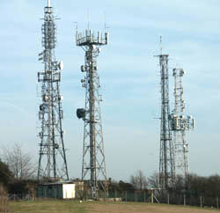

CONTENT
1: Background

2: Introduction

3: Method of measurement
3.1: RF Meter Measurements
3.2: Spectrum Analyser Measurements

4: Results
4.1: RF Meter Results
4.2: Spectrum Analyser Results

5: Conclusion
Appendix A: Site Photographs
Appendix B: Analyser Traces

1: Background
There has been, and still is, considerable public concern regarding the possible adverse health effects caused by radio signals emitted from mobile phone "masts". A number of national and international guidelines have been developed that offer "safe" limits to such exposure. These guidelines are based on the well documented heating effect to the body caused by high power radio signals. This is a biological effect and the basic measurements used to quantify the effect i.e. watts per kilogram, reflect this discipline. A conversion to more familiar radio measurements has been established, these limits, known as reference levels, are measured in volts per metre and watts per square metre.
Whereas laboratory style measurements can ensure a single radio source, an urban rooftop environment can contain many radio sources. A field measurement technique has been proposed that seeks to establish quickly whether a location is compliant or not, and if not, to establish the dominant cause of failure. This study was carried to assess the practicality of this proposed technique.
The radio site chosen is located in Surrey, England, about 1 Km south west of Guildford on a ridge of high ground known as the Hogs Back. The exact location is N51:13:42, W0:36:25 at an altitude of 140m above sea level. A 3D map of the area is shown below
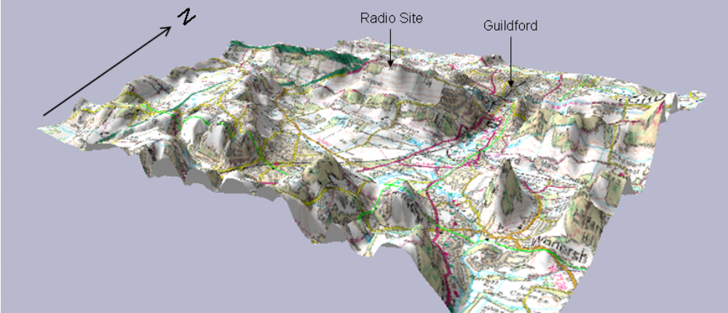
Figure 1
The site is owned by Thames Water and consists of four substantial towers accommodating at least 70 transmitters operating on frequencies between 70 MHz and microwave.
2: Introduction
These tests were carried out in order to confirm site compliance with current European RF health and safety guidelines. The site under test has a large number of users present on four adjacent towers, and is located on a hilltop overlooking Guildford.
Measurements were made at ground level in and around the site compound, and have been related to current guidelines on public exposure to electromagnetic fields issued by European regulatory bodies (ICNIRP).
The measurements are intended to be a simple check of compliance, and are likely to over-estimate long term exposure levels, as peak values have been recorded. This removes the need for long term averaging of discontinuous or time variable signals, which would defeat the objective of performing a quick and simple initial risk assessment.
If the results were to indicate levels close to or over the ICNIRP reference level, then a more in depth assessment would be required.
Test Location: Sunnydown Hill;
Hogs Back;
Guildford;
England.
Ordnance survey map grid references:
Tower 1 Location: | NGR 497433 148608
Tower 2 Location: | NGR 497468 148586
Tower 3 Location: | NGR 497485 148587
Tower 4 Location: | NGR 497476 148616

Test Date: 28th September 2004.
Calibrated equipment:
Rohde and Schwarz FSH3 spectrum analyser and HE200.
Antenna Set. Maximum input level +20 dBm.
Ser No. 832106/028.
Wandel and Goltermann EMR 300 RF Meter.
Serial No. U-0044.
Wandel and Goltermann Type 8 probe (100 kHz to 3 GHz).
Ser No. S-0050.
3: Method of measurement
Measurements were made with both a broadband RF probe and spectrum analyser. The aim of these tests was to provide an easily achievable assessment of RF safety compliance at the site. Since spectrum analyser measurements are time consuming, the initial measurements were made using the broadband RF probe. Normally if the conclusion using the wideband RF probe is a "pass" no further measurements would be carried out, but as part of the exercise was to evaluate the two test methods, the second method using a spectrum analyser was performed. The spectrum analyser method was used to determine the composition of this signal at the point where the RF probe indicated its highest reading.
3.1: RF meter measurements
Measurements were made with a Wandel and Goltermann EMR-300 field strength meter with a 100 kHz to 3 GHz probe. The readings obtained from this instrument indicate the total field strength produced by all sources in its operating band (100 kHz to 3 GHz). This includes all normal terrestrial signal sources, such as broadcast radio, TV, mobile radio, paging and cellular operators.
Readings were taken at a number of locations surrounding the site. These are shown on the drawing, figure 2. Measurements were made in peak hold mode, over a 1 min period, with the probe moved through an approx 0,5 m3 volume around the measurement point.
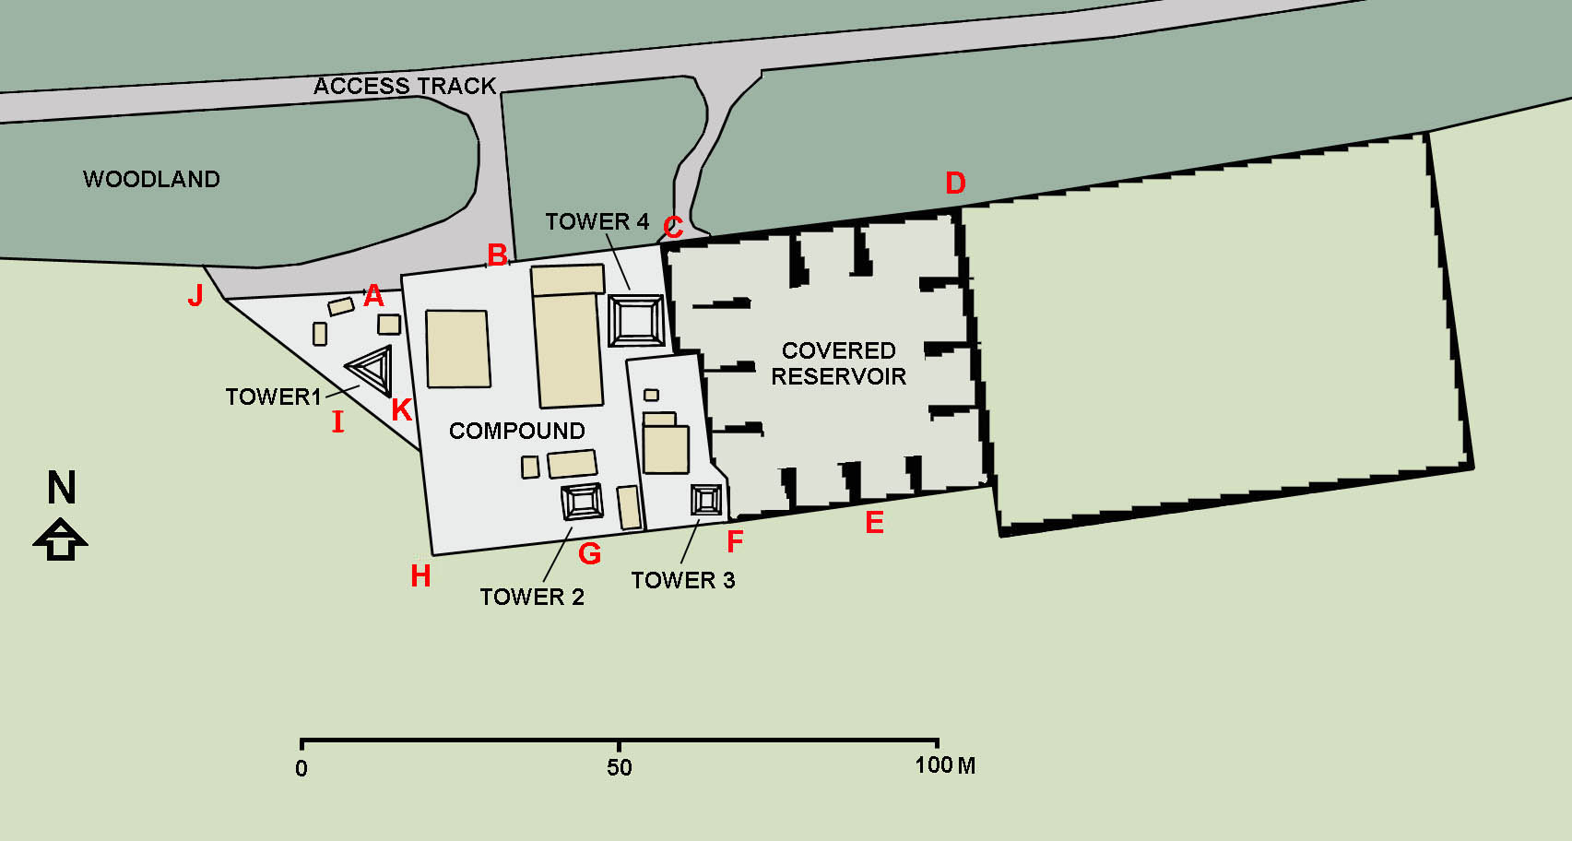
Figure 2: Locations at which measurements were made
3.2: Spectrum Analyser Measurement
ICNIRP reference levels are frequency dependant. Assuming that the results from the probe measurements exceed or are close to the appropriate worst case ICNIRP guideline limits (i.e. 28 V/m for the general public or 61 V/m for occupational), a second set of measurements is required to determine the appropriate ICNIRP reference level that should be applied.
Irrespective of the wideband RF probe result and in this case as part of the method of measurement evaluation exercise, the composition of the field at the location of the highest broadband RF probe reading (Location K) was determined using a spectrum analyser.
Measurements were made with a Rohde and Schwarz FSH3 analyser and Rohde and Schwarz HE200 broadband antenna set, characteristics of which are enclosed in the form of antenna factor graphs.
The analyser was used in peak hold mode, so the values recorded show the maximum value of any non-continuous or time variable signals. All values are a maximum recorded for all receiving antenna orientations and polarizations at the measurement point.
4: Results
4.1: RF Meter Results
Table 1
Location | Field Strength
A | 8,2 V/m
B | 6,6 V/m
C | 6,5 V/m
D | 4,1 V/m
E | 5,7 V/m
F | 3,3 V/m
G | 3,2 V/m
H | 5,1 V/m
I | 4,2 V/m
J | 6,1 V/m
K | 9,1 V/m

Without frequency selective measurement, the exact relationship between this composite field strength and the ICNIRP reference level cannot be determined. However, as the lowest ICNIRP reference level is 28 V/m for general public exposure between 10 MHz and 400 MHz, it can be stated without further investigation that the site is compliant with ICNIRP guidelines.
4.2: Spectrum Analyser Results
As can be seen, the maximum field strength measured was 9,1 V/m, at location K. Spectrum analyser measurements were hence made at this location, enabling the composition of this field to be determined. Microwave link frequencies have not been measured. With a typical beam width of 1 degree to 2 degrees, it can be assumed that field strengths produced at ground level by these systems will be negligible.
The spectrum analyser measurement results are expressed in dBm (dB relative to 1 mW). These values can be converted into field strength as follows:
Field Strength E (V/m) = (Inv Log10 (dBm + 107 + Antenna factor)/20)/106
Antenna factors are taken from the HE200 manufacturers data graph shown below.
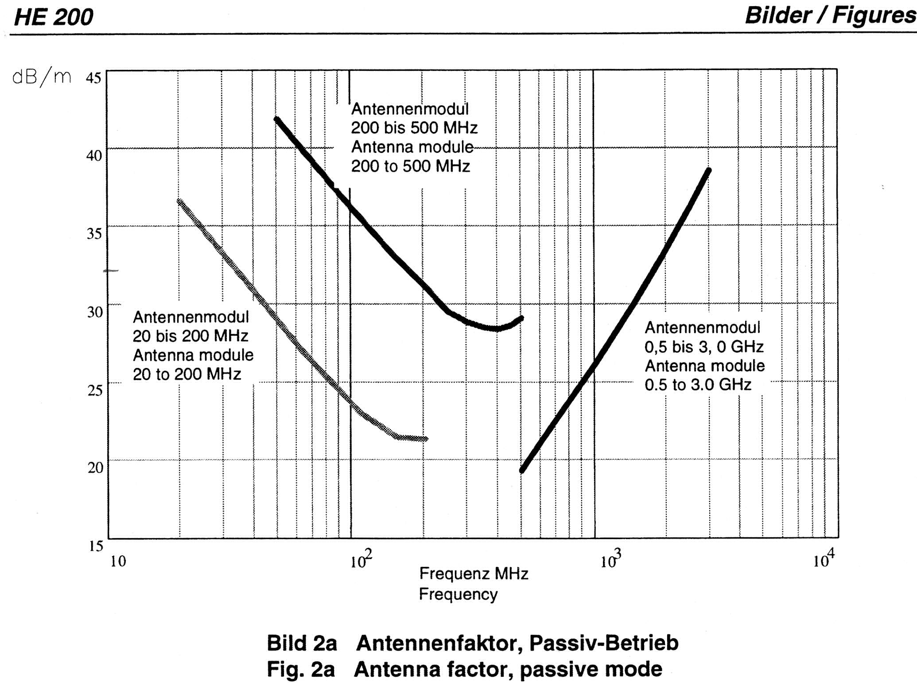
Figure 3
Freq.  (MHz) | Level  (dBm) | Antenna factor  (dB/m) | Field Strength  (V/m) | Source | EiRP | ICNIRP Ref. Level.  General Public  (V/m) | ICNIRP Ref. Level.  Occupational  (V/m) | Exposure Quotient  General Public | Exposure Quotient  Occupational
70,5 | -20,3 | 26 | 0,43 | Emergency Services |  | 28,0 | 61,0 | 0,00023751 | 0,00005004
82,4 | -31,6 | 24,5 | 0,10 | Emergency Services |  | 28,0 | 61,0 | 0,00001246 | 0,00000263
87,8 | -11,4 | 23,5 | 0,90 | Broadcast FM Radio | 3 kW | 28,0 | 61,0 | 0,00103677 | 0,00021844
90,2 | -12,9 | 23,5 | 0,76 | Broadcast FM Radio | 3 kW | 28,0 | 61,0 | 0,00073398 | 0,00015465
92,6 | -13,6 | 23,5 | 0,70 | Broadcast FM Radio | 3 kW | 28,0 | 61,0 | 0,00062472 | 0,00013163
96,2 | -11,4 | 23,5 | 0,90 | Broadcast FM Radio | 3 kW | 28,0 | 61,0 | 0,00103677 | 0,00021844
97,4 | -12,9 | 23,5 | 0,76 | Broadcast FM Radio | 3 kW | 28,0 | 61,0 | 0,00073398 | 0,00015465
104,6 | -11,5 | 23,5 | 0,89 | Broadcast FM Radio | 3 kW | 28,0 | 61,0 | 0,00101317 | 0,00021347
138,2 | -15,9 | 22 | 0,45 | Emergency Services |  | 28,0 | 61,0 | 0,00026043 | 0,00005487
153,2 | -16,7 | 21,5 | 0,39 | Paging |  | 28,0 | 61,0 | 0,00019306 | 0,00004068
164,6 | -19,7 | 21,5 | 0,28 | PBR |  | 28,0 | 61,0 | 0,00009676 | 0,00002039
167,6 | -23,9 | 21,5 | 0,17 | PBR |  | 28,0 | 61,0 | 0,00003679 | 0,00000775
185,2 | -49,4 | 21,5 | 0,01 | PAMR/PBR |  | 28,0 | 61,0 | 0,00000010 | 0,00000002
206,2 | -29,0 | 30,5 | 0,27 | PAMR/PBR |  | 28,0 | 61,0 | 0,00009030 | 0,00001903
222,2 | -20,8 | 30 | 0,65 | DAB | 7 kW | 28,0 | 61,0 | 0,00053172 | 0,00011203
223,8 | -25,9 | 30 | 0,36 | DAB | 7 kW | 28,0 | 61,0 | 0,00016432 | 0,00003462
225,6 | -20,6 | 30 | 0,66 | DAB | 7 kW | 28,0 | 61,0 | 0,00055678 | 0,00011731
227,8 | -30,0 | 30 | 0,22 | DAB | 7 kW | 28,0 | 61,0 | 0,00006393 | 0,00001347
454,0 | -22,7 | 28 | 0,41 | Paging |  | 29,3 | 63,9 | 0,00019785 | 0,00004156
623,0 | -19,5 | 21,5 | 0,28 | Broadcast TV | 10 kW | 34,3 | 74,9 | 0,00006744 | 0,00001417
629,0 | -28,1 | 21,5 | 0,10 | Broadcast TV | 10 kW | 34,5 | 75,2 | 0,00000922 | 0,00000194
647,0 | -18,7 | 21,5 | 0,31 | Broadcast TV | 10 kW | 35,0 | 76,3 | 0,00007807 | 0,00001640
653,0 | -29,7 | 21,5 | 0,09 | Broadcast TV | 10 kW | 35,1 | 76,7 | 0,00000614 | 0,00000129
671,0 | -11,2 | 22 | 0,78 | Broadcast TV | 10 kW | 35,6 | 77,7 | 0,00047498 | 0,00009978
677,0 | -23,8 | 22 | 0,18 | Broadcast TV | 10 kW | 35,8 | 78,1 | 0,00002587 | 0,00000543
703,0 | -16,9 | 22 | 0,40 | Broadcast TV | 10 kW | 36,5 | 79,5 | 0,00012202 | 0,00002563
709,0 | -26,5 | 22 | 0,13 | Broadcast TV | 10 kW | 36,6 | 79,9 | 0,00001327 | 0,00000279
847,3 | -39,5 | 23,5 | 0,04 | Broadcast TV | 10 kW | 40,0 | 87,3 | 0,00000079 | 0,00000017
925,3 | -47,3 | 24,5 | 0,02 | E-GSM 900 | 400 W | 41,8 | 91,3 | 0,00000015 | 0,00000003
927,8 | -46,2 | 24,5 | 0,02 | E-GSM 900 | 400 W | 41,9 | 91,4 | 0,00000019 | 0,00000004
928,8 | -35,6 | 24,5 | 0,06 | E-GSM 900 | 400 W | 41,9 | 91,4 | 0,00000222 | 0,00000047
931,2 | -47,2 | 24,5 | 0,02 | E-GSM 900 | 400 W | 42,0 | 91,5 | 0,00000015 | 0,00000003
932,0 | -46,5 | 24,5 | 0,02 | E-GSM 900 | 400 W | 42,0 | 91,6 | 0,00000018 | 0,00000004
932,4 | -38,7 | 24,5 | 0,04 | E-GSM 900 | 400 W | 42,0 | 91,6 | 0,00000108 | 0,00000023
934,2 | -41,5 | 24,5 | 0,03 | E-GSM 900 | 400 W | 42,0 | 91,7 | 0,00023751 | 0,00005004

Freq.  (MHz) | Level  (dBm) | Antenna factor  (dB/m) | Field Strength  (V/m) | Source | EiRP | ICNIRP Ref. Level.  General Public  (V/m) | ICNIRP Ref. Level.  Occupational  (V/m) | % of  ICNIRP  Ref. Level  General Public | % of  ICNIRP  Ref. Level  Occupational
0
935,2 | -41,7 | 24,5 | 0,03 | GSM 900 | 400 W | 42,0 | 91,7 | 0,00000057 | 0,00000012
935,8 | -30,5 | 24,5 | 0,11 | GSM 900 | 400 W | 42,1 | 91,8 | 0,00000054 | 0,00000011
936,4 | -29,4 | 24,5 | 0,13 | GSM 900 | 400 W | 42,1 | 91,8 | 0,00000712 | 0,00000149
937,4 | -47,3 | 24,5 | 0,02 | GSM 900 | 400 W | 42,1 | 91,9 | 0,00000916 | 0,00000192
938,2 | -37,7 | 24,5 | 0,05 | GSM 900 | 400 W | 42,1 | 91,9 | 0,00000015 | 0,00000003
940,6 | -42,5 | 25 | 0,03 | GSM 900 | 400 W | 42,2 | 92,0 | 0,00000135 | 0,00000028
941,8 | -38,2 | 25 | 0,05 | GSM 900 | 400 W | 42,2 | 92,1 | 0,00000050 | 0,00000011
943,6 | -36,8 | 25 | 0,06 | GSM 900 | 400 W | 42,2 | 92,2 | 0,00000135 | 0,00000028
944,8 | -38,0 | 25 | 0,05 | GSM 900 | 400 W | 42,3 | 92,2 | 0,00000186 | 0,00000039
945,8 | -35,1 | 25 | 0,07 | GSM 900 | 400 W | 42,3 | 92,3 | 0,00000141 | 0,00000030
949,6 | -38,3 | 25 | 0,05 | GSM 900 | 400 W | 42,4 | 92,4 | 0,00000274 | 0,00000058
951,2 | -26,7 | 25 | 0,18 | GSM 900 | 400 W | 42,4 | 92,5 | 0,00000131 | 0,00000027
952,6 | -35,7 | 25 | 0,07 | GSM 900 | 400 W | 42,4 | 92,6 | 0,00001884 | 0,00000396
954,2 | -36,8 | 25 | 0,06 | GSM 900 | 400 W | 42,5 | 92,7 | 0,00000237 | 0,00000050
955,4 | -45,9 | 25 | 0,02 | GSM 900 | 400 W | 42,5 | 92,7 | 0,00000184 | 0,00000039
956,6 | -44,4 | 25 | 0,02 | GSM 900 | 400 W | 42,5 | 92,8 | 0,00000023 | 0,00000005
957,0 | -38,0 | 25 | 0,05 | GSM 900 | 400 W | 42,5 | 92,8 | 0,00000032 | 0,00000007
959,6 | -44,7 | 25 | 0,02 | GSM 900 | 400 W | 42,6 | 92,9 | 0,00000139 | 0,00000029
1 064,0 | -49,1 | 25,5 | 0,01 | Radionavigation |  | 44,9 | 97,9 | 0,00000030 | 0,00000006
1 292,8 | -48,8 | 27,5 | 0,02 | Amateur |  | 49,4 | 107,9 | 0,00000011 | 0,00000002
1 317,0 | -48,6 | 28 | 0,02 | Amateur |  | 49,9 | 108,9 | 0,00000015 | 0,00000003
1 341,3 | -45,9 | 28 | 0,03 | Amateur |  | 50,4 | 109,9 | 0,00000018 | 0,00000004
1 372,5 | -43,3 | 28,5 | 0,04 | Civil Fixed Links |  | 50,9 | 111,1 | 0,00000032 | 0,00000007
1 473,0 | -48,6 | 29,5 | 0,02 | Civil Fixed Links |  | 52,8 | 115,1 | 0,00000064 | 0,00000013
1 810,0 | -48,4 | 31,5 | 0,03 | GSM 1800 | 200 W | 58,5 | 127,6 | 0,00000022 | 0,00000005
1 811,2 | -42,1 | 31,5 | 0,07 | GSM 1800 | 200 W | 58,5 | 127,7 | 0,00000030 | 0,00000006
1 813,4 | -37,6 | 31,5 | 0,11 | GSM 1800 | 200 W | 58,6 | 127,8 | 0,00000127 | 0,00000027
1 814,6 | -40,2 | 31,5 | 0,08 | GSM 1800 | 200 W | 58,6 | 127,8 | 0,00000359 | 0,00000075
1 816,0 | -49,8 | 31,5 | 0,03 | GSM 1800 | 200 W | 58,6 | 127,8 | 0,00000197 | 0,00000041
1 851,4 | -37,1 | 31,5 | 0,12 | GSM 1800 | 200 W | 59,2 | 129,1 | 0,00000022 | 0,00000005
1 855,4 | -34,0 | 32 | 0,18 | GSM 1800 | 200 W | 59,2 | 129,2 | 0,00000394 | 0,00000083
1 858,0 | -45,6 | 32 | 0,05 | GSM 1800 | 200 W | 59,3 | 129,3 | 0,00000901 | 0,00000189
1 859,4 | -34,3 | 32 | 0,17 | GSM 1800 | 200 W | 59,3 | 129,4 | 0,00000062 | 0,00000013
1 861,4 | -39,4 | 32 | 0,10 | GSM 1800 | 200 W | 59,3 | 129,4 | 0,00000840 | 0,00000176
1 862,6 | -42,9 | 32 | 0,06 | GSM 1800 | 200 W | 59,3 | 129,5 | 0,00000259 | 0,00000054
1 868,0 | -38,8 | 32,5 | 0,11 | GSM 1800 | 200 W | 59,4 | 129,7 | 0,00000116 | 0,00000024

For thermal considerations, the calculation of exposure to multiple frequency fields is defined in the ICNIRP guidelines as:
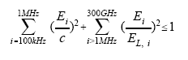
where Ei is the measured field strength at a specific frequency, EL i is the ICNIRP reference level at that frequency, and c is 610/f V/m for occupational and 87/f1/2 V/m for general public exposure.
Hence, from the table above, the overall general public exposure quotient is 0,009, or approximately 1 % of the ICNIRP reference level, and the occupational exposure quotient is 0,002 %, or 0,2 % of the ICNIP reference level.
It was noted at the time of measurement that no Tetra signals were present, despite the fact that this location is a live Tetra station. As the Tetra signals at ground level would be expected to be of similar magnitude as the GSM cellular signals recorded, it is not expected that they would raise the overall composite field strength by a significant amount.
5: Conclusion
The measured results have been related to current standards relating to human exposure to electromagnetic fields, specifically:
- ICNIRP International Committee on Non-Ionizing Radiation Protection;
- Guidelines for Limiting Exposure to Time-Varying Electric, Magnetic and Electromagnetic Fields (up to
300 GHz).
It can be seen from the table above that the maximum signal level recorded is 40 % of the ICNIRP reference level for general public exposure.
It can thus be stated that the site is compliant with current RF hazard regulations.
Appendix A: Site Photographs
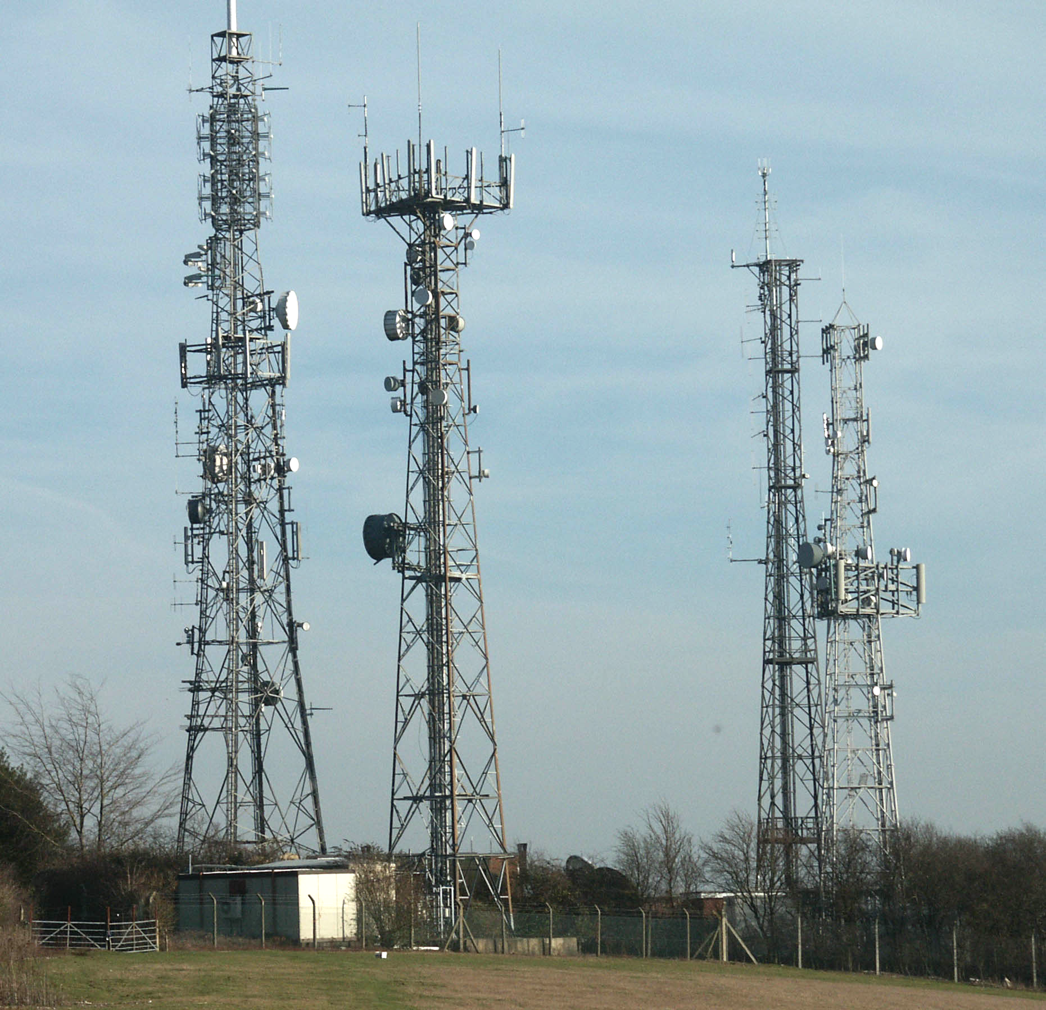
Full Site
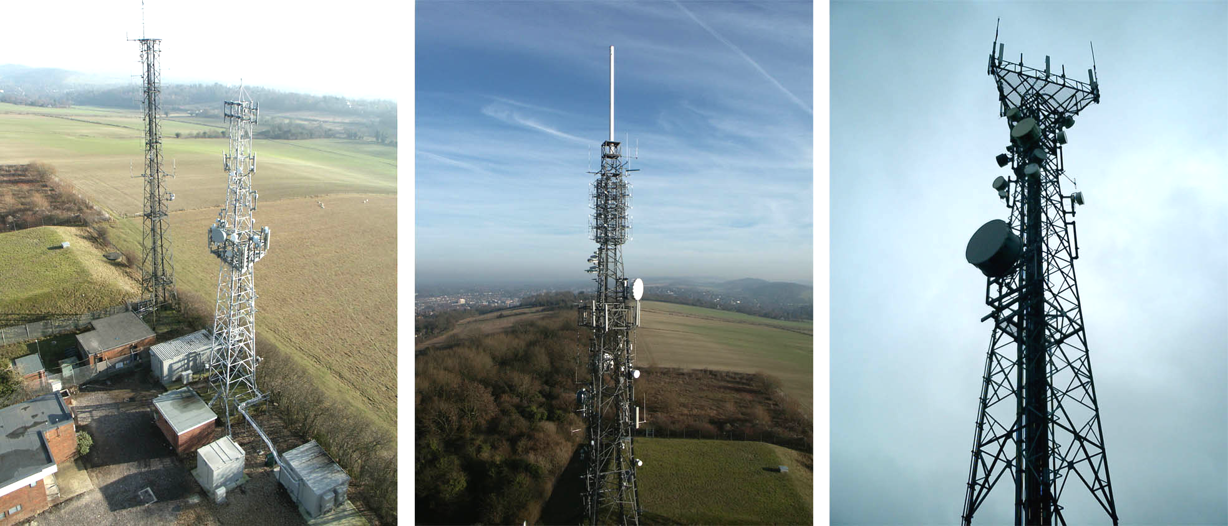
Towers 2 and 3 | Tower 4 | Tower 1

Appendix B: Analyser Traces
20 MHz to 200 MHz
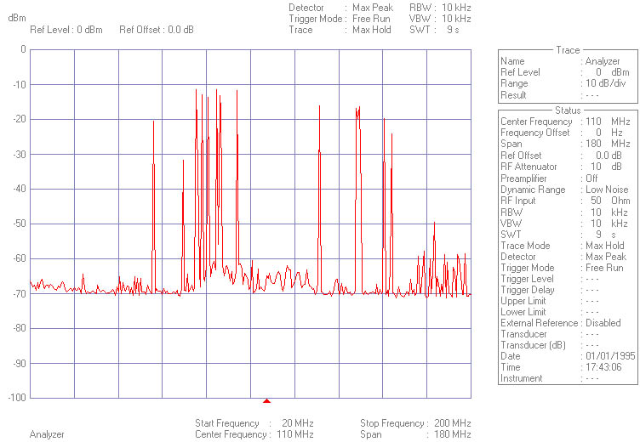

200 MHz to 500 MHz
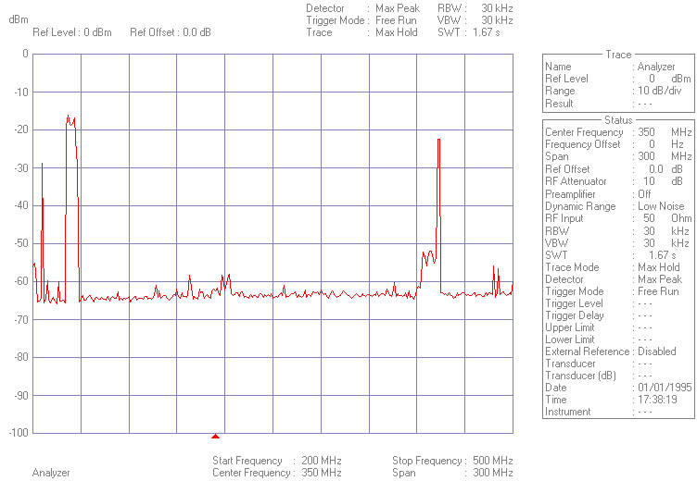

DAB Detail
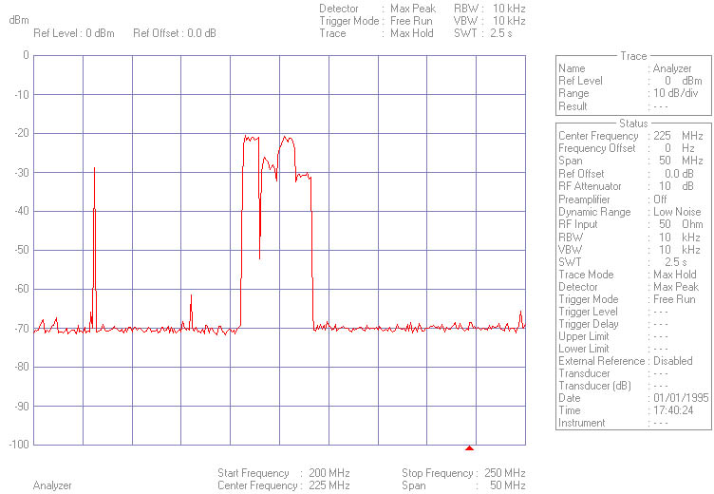

500 MHz to 800 MHz
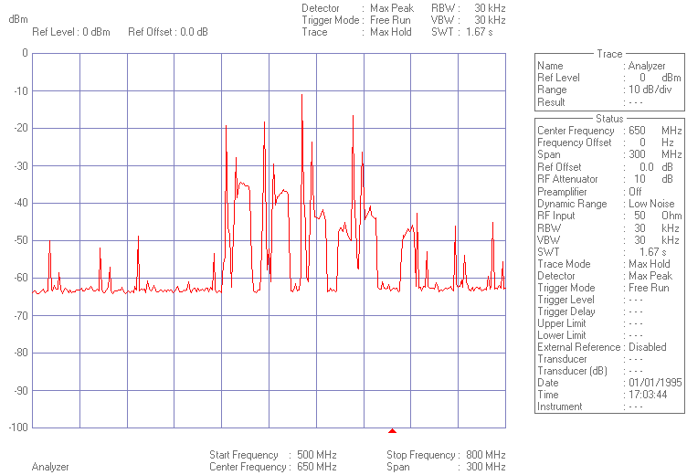

800 MHz to 1 GHz
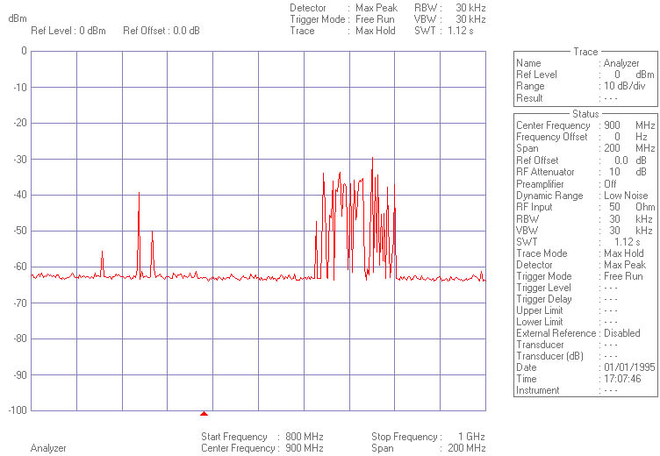

900 MHz Cellular Band Detail
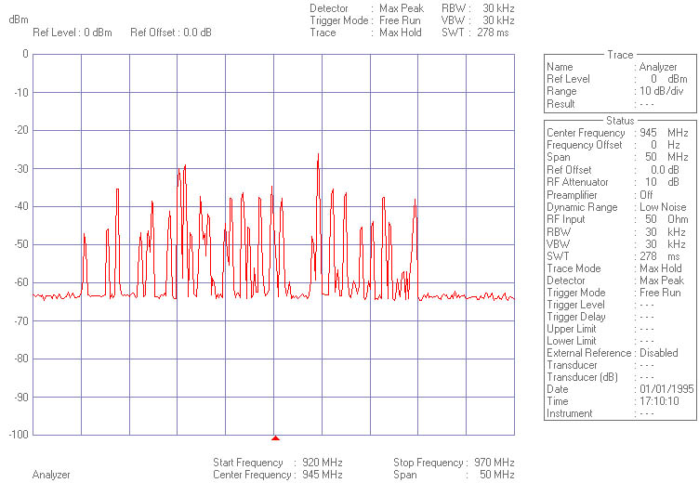

1 GHz to 2 GHz
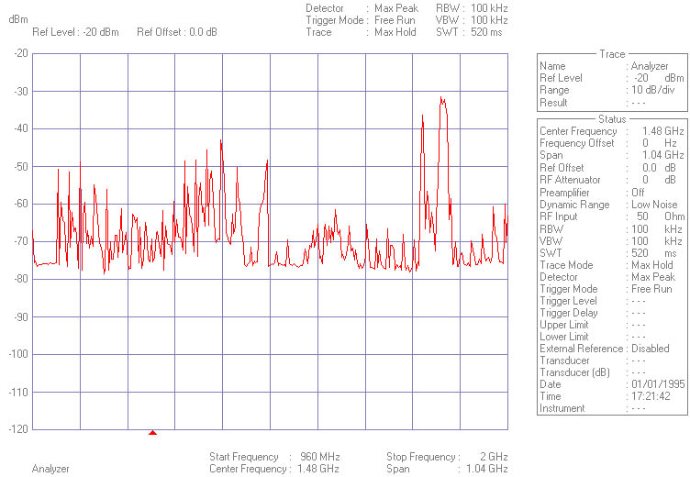

1 800 MHz Cellular Band Detail
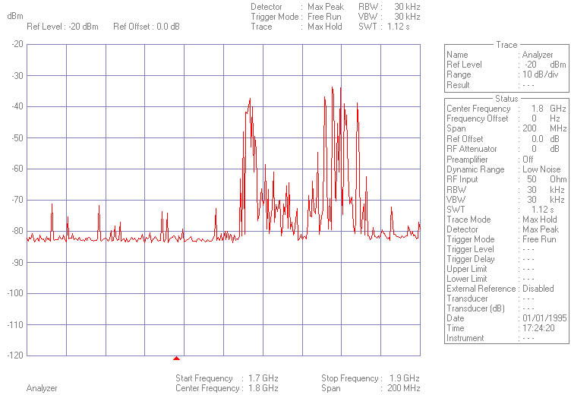

2 GHz to 3 GHz
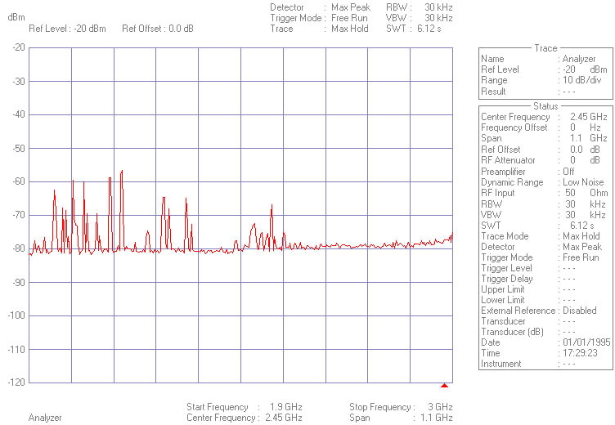

Annex E (informative):
Bibliography
- Council Directive 73/23/EEC of 19 February 1973 on the harmonization of the laws of Member States relating to electrical equipment designed for use within certain voltage limits.
- ETSI EG 200 053 (V1.5.1): "Electromagnetic compatibility and Radio spectrum Matters (ERM); Radio site engineering for radio equipment and systems".
- ETSI TR 101 870 (V1.1.1): "Fixed radio transmitter sites; Exposure to non-ionizing electromagnetic fields; Guidelines for working conditions".
- ETSI ETR 028 (1994): "Radio Equipment and Systems (RES); Uncertainties in the measurement of mobile radio equipment characteristics".
- ETSI ETR 273: "Electromagnetic Compatibility and Radio Spectrum Matters (ERM): Improvement of radiated methods of measurement (using test sites) and evaluation of the corresponding measurement uncertainties".

History
Document history
V1.1.1 | June 2005 | Membership Approval Procedure MV 20050819: 2005-06-21 to 2005-08-19
V1.1.1 | August 2005 | Publication

