Installation of Meeting Presence Confirmation

Installation of IIS Web Deploy

If not already installed, install IIS Web Deploy. This will add deployment facilities to IIS management interface.

No need to install the remote part from the time being.

Installation of the meeting presence application
Open IIS manager and navigate to the 3gpp website.

Right click on the 3GPP website and click deploy, Import application.
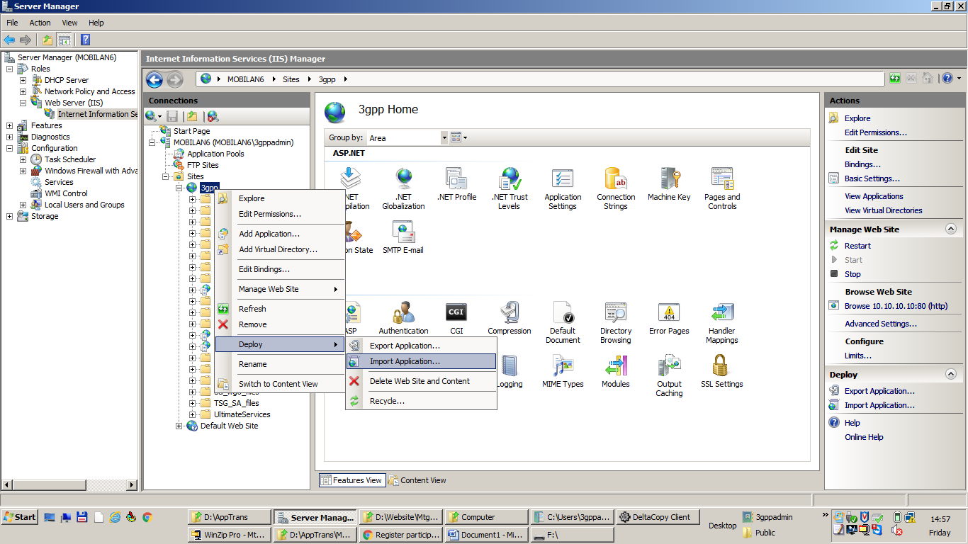

When prompted for selection of a package, select the attached zip file.

Click next until the application is installed. It should have created a MtgPresence application and folder, as well as an application pool name MtgPresence.

The application can be tested via http://10.10.10.10/MtgPresence/RegisterPresence.aspx
You can enter any token 30-character long.

Now a CSV file MeetingRegistration.csv is created in d:\AppTrans\MeetingRegistration \MtgReg\

Configuration of RSync
The generated CSV file has to be syncronized to the local FTP server. This is done via RSync
Add d:\AppTrans\MeetingRegistration\ in the RSync profile and Modify Target path to be MtgReg\

