ETSI GS NFV 006 V4.4.2 (2024-01)
Network Functions Virtualisation (NFV) Release 4;
Management and Orchestration;
Architectural Framework Specification

Disclaimer
The present document has been produced and approved by the Network Functions Virtualisation (NFV) ETSI Industry Specification Group (ISG) and represents the views of those members who participated in this ISG.
It does not necessarily represent the views of the entire ETSI membership.
Group Specification

Reference
RGS/NFV-006ed441
Keywords
architecture, management, MANO, NFV
Important notice
The present document can be downloaded from:
http://www.etsi.org/standards-search
The present document may be made available in electronic versions and/or in print. The content of any electronic and/or print versions of the present document shall not be modified without the prior written authorization of ETSI. In case of any existing or perceived difference in contents between such versions and/or in print, the prevailing version of an ETSI deliverable is the one made publicly available in PDF format at www.etsi.org/deliver.
Users of the present document should be aware that the document may be subject to revision or change of status. Information on the current status of this and other ETSI documents is available at https://portal.etsi.org/TB/ETSIDeliverableStatus.aspx
If you find errors in the present document, please send your comment to one of the following services:
https://portal.etsi.org/People/CommiteeSupportStaff.aspx
If you find a security vulnerability in the present document, please report it through our
Coordinated Vulnerability Disclosure Program:
https://www.etsi.org/standards/coordinated-vulnerability-disclosure
Notice of disclaimer & limitation of liability
The information provided in the present deliverable is directed solely to professionals who have the appropriate degree of experience to understand and interpret its content in accordance with generally accepted engineering or
other professional standard and applicable regulations.
No recommendation as to products and services or vendors is made or should be implied.
No representation or warranty is made that this deliverable is technically accurate or sufficient or conforms to any law and/or governmental rule and/or regulation and further, no representation or warranty is made of merchantability or fitness for any particular purpose or against infringement of intellectual property rights.
In no event shall ETSI be held liable for loss of profits or any other incidental or consequential damages.

Any software contained in this deliverable is provided "AS IS" with no warranties, express or implied, including but not limited to, the warranties of merchantability, fitness for a particular purpose and non-infringement of intellectual property rights and ETSI shall not be held liable in any event for any damages whatsoever (including, without limitation, damages for loss of profits, business interruption, loss of information, or any other pecuniary loss) arising out of or related to the use of or inability to use the software.
Copyright Notification
No part may be reproduced or utilized in any form or by any means, electronic or mechanical, including photocopying and microfilm except as authorized by written permission of ETSI.
The content of the PDF version shall not be modified without the written authorization of ETSI.
The copyright and the foregoing restriction extend to reproduction in all media.

© ETSI 2022.
All rights reserved.

ETSI
650 Route des Lucioles
F-06921 Sophia Antipolis Cedex - FRANCE

Tel.: +33 4 92 94 42 00 Fax: +33 4 93 65 47 16

Siret N° 348 623 562 00017 - APE 7112B
Association à but non lucratif enregistrée à la
Sous-Préfecture de Grasse (06) N° w061004871

Contents
Intellectual Property Rights 6
Foreword 6
Modal verbs terminology 6
Introduction 6
1 Scope 8
2 References 8
2.1 Normative references 8
2.2 Informative references 8
3 Definition of terms, symbols and abbreviations 9
3.1 Terms 9
3.2 Symbols 9
3.3 Abbreviations 9
4 Management and orchestration aspects 10
4.1 NFV-MANO constructs 10
4.1.1 NFV Network Service (NS) 10
4.1.2 Virtualised Network Function (VNF) 10
4.1.3 Virtualised Network Function Forwarding Graph (VNFFG) 11
4.1.4 Virtual Link (VL) 11
4.1.5 Physical Network Function (PNF) 11
4.1.6 Container Infrastructure Service cluster (CIS cluster) 11
4.1.7 Managed CIS Cluster Object (MCCO) 12
4.1.8 Managed Container Infrastructure Object (MCIO) 12
5 NFV-MANO Architectural Framework 12
5.1 General architecture overview 12
5.2 Architecture diagram 14
5.3 Functional Blocks 16
5.3.1 NFV Orchestrator (NFVO) 16
5.3.2 VNF Manager (VNFM) 17
5.3.3 Virtualised Infrastructure Manager (VIM) 18
5.3.4 Functional blocks interacting with NFV-MANO 18
5.3.4.1 OSS/BSS 18
5.3.4.2 Element Management (EM) 19
5.3.4.3 Virtualised Network Function (VNF) 19
5.3.4.4 Network Function Virtualised Infrastructure (NFVI) 19
5.3.5 WAN Infrastructure Manager (WIM) 19
5.4 Reference points 20
5.4.1 Interfaces approach 20
5.4.2 Os-Ma-nfvo reference point 20
5.4.3 Or-Vnfm reference point 20
5.4.4 Ve-Vnfm reference points 20
5.4.5 Or-Vi reference point 21
5.4.6 Vi-Vnfm reference point 21
5.4.7 Nf-Vi reference point 21
5.4.8 Or-Wi reference point 21
5.4.9 Or-Or reference point 21
5.5 Functions 22
5.5.1 Container Infrastructure Service Management (CISM) 22
5.5.2 Container Image Registry (CIR) 22
5.5.3 CIS Cluster Management (CCM) 22
5.5.4 Management Data Analytics Function (MDAF) 22
5.5.5 Intent Management (IM) 22
5.6 Service interfaces 23
5.6.1 Interfaces approach 23
5.6.2 OS container workload management service interface 23
5.6.3 OS container compute management service interface 23
5.6.4 OS container storage management service interface 23
5.6.5 OS container network management service interface 23
5.6.6 OS container configuration management service interface 23
5.6.7 CIS instance management service interface 23
5.6.8 CIS MCCO management service interface 24
5.6.9 CIS cluster lifecycle management service interface 24
5.6.10 CIS cluster fault management service interface 24
5.6.11 CIS cluster configuration management service interface 24
5.6.12 CIS cluster performance management service interface 24
5.6.13 CIS cluster security management service interface 24
5.6.14 Data analytics service interface 24
5.6.15 Intent management service interface 25
6 NFV-MANO reliability considerations 25
7 NFV-MANO security considerations 25
Annex A (informative): Change History 26
History 28

Intellectual Property Rights

Essential patents
IPRs essential or potentially essential to normative deliverables may have been declared to ETSI. The declarations pertaining to these essential IPRs, if any, are publicly available for ETSI members and non-members, and can be found in ETSI SR 000 314: "Intellectual Property Rights (IPRs); Essential, or potentially Essential, IPRs notified to ETSI in respect of ETSI standards", which is available from the ETSI Secretariat. Latest updates are available on the ETSI Web server (https://ipr.etsi.org/).
Pursuant to the ETSI Directives including the ETSI IPR Policy, no investigation regarding the essentiality of IPRs, including IPR searches, has been carried out by ETSI. No guarantee can be given as to the existence of other IPRs not referenced in ETSI SR 000 314 (or the updates on the ETSI Web server) which are, or may be, or may become, essential to the present document.

Trademarks
The present document may include trademarks and/or tradenames which are asserted and/or registered by their owners. ETSI claims no ownership of these except for any which are indicated as being the property of ETSI, and conveys no right to use or reproduce any trademark and/or tradename. Mention of those trademarks in the present document does not constitute an endorsement by ETSI of products, services or organizations associated with those trademarks.
DECT™, PLUGTESTS™, UMTS™ and the ETSI logo are trademarks of ETSI registered for the benefit of its Members. 3GPP™ and LTE™ are trademarks of ETSI registered for the benefit of its Members and of the 3GPP Organizational Partners. oneM2M™ logo is a trademark of ETSI registered for the benefit of its Members and of the oneM2M Partners. GSM® and the GSM logo are trademarks registered and owned by the GSM Association.

Foreword
This Group Specification (GS) has been produced by ETSI Industry Specification Group (ISG) Network Functions Virtualisation (NFV).

Modal verbs terminology
In the present document "shall", "shall not", "should", "should not", "may", "need not", "will", "will not", "can" and "cannot" are to be interpreted as described in clause 3.2 of the ETSI Drafting Rules (Verbal forms for the expression of provisions).
"must" and "must not" are NOT allowed in ETSI deliverables except when used in direct citation.

Introduction
Network Functions Virtualisation (NFV) adds new capabilities to communications networks and requires a new set of management and orchestration functions to be added to the current model of operations, administration, maintenance and provisioning. In legacy networks, the Network Function (NF) implementations are often tightly coupled with the infrastructure they run on.
NFV decouples software implementations of NFs from the physical resources offered by the hardware they use, such as computation, storage, and networking. The virtualisation insulates the NFs from those physical resources through a virtualisation layer which partitions them to create virtualisation containers, defined in ETSI GR NFV 003 [i.1].
The software and infrastructure decoupling exposes a new set of entities, the Virtualised Network Functions (VNFs), and a new set of relationships between them and the NFV Infrastructure (NFVI). The VNFs can be chained with other VNFs and/or Physical Network Functions (PNFs) to realize a Network Service (NS).
The virtualisation principle stimulates a multi-vendor ecosystem where the different components of the NFVI, the VNF software, and their management and orchestration functions are likely to follow different lifecycles (e.g. on procurement, upgrading, etc.). This requires interoperable standardized interfaces and proper resource abstraction among them.
The present document focuses on the management aspects introduced by the NFV technology and describes the architecture of the management and orchestration subset of the NFV architectural framework.

1 Scope
The present document describes the high-level functional architectural framework for the Management and Orchestration part of the NFV architectural framework.

2 References

2.1 Normative references
References are either specific (identified by date of publication and/or edition number or version number) or non-specific. For specific references, only the cited version applies. For non-specific references, the latest version of the referenced document (including any amendments) applies.
Referenced documents which are not found to be publicly available in the expected location might be found at https://docbox.etsi.org/Reference/.
NOTE: While any hyperlinks included in this clause were valid at the time of publication, ETSI cannot guarantee their long term validity.
The following referenced documents are necessary for the application of the present document.
[1] ETSI GS NFV-IFA 010: "Network Functions Virtualisation (NFV) Release 4; Management and Orchestration; Functional Requirements Specification".

2.2 Informative references
References are either specific (identified by date of publication and/or edition number or version number) or non-specific. For specific references, only the cited version applies. For non-specific references, the latest version of the referenced document (including any amendments) applies.
NOTE: While any hyperlinks included in this clause were valid at the time of publication, ETSI cannot guarantee their long term validity.
The following referenced documents are not necessary for the application of the present document but they assist the user with regard to a particular subject area.
[i.1] ETSI GR NFV 003: "Network Functions Virtualisation (NFV); Terminology for Main Concepts in NFV".
[i.2] ETSI GS NFV-IFA 013: "Network Functions Virtualisation (NFV) Release 4; Management and Orchestration; Os-Ma-nfvo reference point - Interface and Information Model Specification".
[i.3] ETSI GS NFV-IFA 014: "Network Functions Virtualisation (NFV) Release 4; Management and Orchestration; Network Service Templates Specification".
[i.4] ETSI GS NFV-IFA 005: "Network Functions Virtualisation (NFV) Release 4; Management and Orchestration; Or-Vi reference point - Interface and Information Model Specification".
[i.5] ETSI GS NFV-IFA 006: "Network Functions Virtualisation (NFV) Release 4; Management and Orchestration; Vi-Vnfm reference point - Interface and Information Model Specification".
[i.6] ETSI GS NFV-IFA 007: "Network Functions Virtualisation (NFV) Release 4; Management and Orchestration; Or-Vnfm reference point - Interface and Information Model Specification".
[i.7] ETSI GS NFV-IFA 008: "Network Functions Virtualisation (NFV) Release 4; Management and Orchestration; Ve-Vnfm reference point -Interface and Information Model Specification".
[i.8] ETSI GS NFV-IFA 011: "Network Functions Virtualisation (NFV) Release 4; Management and Orchestration; VNF Descriptor and Packaging Specification".
[i.9] ETSI GS NFV-IFA 032: "Network Functions Virtualisation (NFV) Release 4; Management and Orchestration; Interface and Information Model Specification for Multi-Site Connectivity Services".
[i.10] ETSI GS NFV-IFA 030: "Network Functions Virtualisation (NFV) Release 4; Management and Orchestration; Multiple Administrative Domain Aspect Interfaces Specification".
[i.11] ETSI GS NFV-IFA 040: "Network Functions Virtualisation (NFV) Release 4; Management and Orchestration; Requirements for service interfaces and object model for OS container management and orchestration specification".
[i.12] ETSI GS NFV-IFA 036: "Network Functions Virtualisation (NFV) Release 4; Management and Orchestration; Requirements for service interfaces and object model for container cluster management and orchestration specification".
[i.13] ETSI GR NFV-REL 012: "Network Functions Virtualisation (NFV); Reliability; Report on availability and reliability under failure and overload conditions in NFV-MANO".
[i.14] ETSI GS NFV-IFA 047: "Network Functions Virtualisation (NFV) Release 4; Management and Orchestration; Management data analytics Service Interface and Information Model Specification".
[i.15] ETSI GS NFV-IFA 050: "Network Functions Virtualisation (NFV) Release 4; Management and Orchestration; Intent Management Service Interface andInformation Model Specification ".

3 Definition of terms, symbols and abbreviations

3.1 Terms
For the purposes of the present document, the terms given in ETSI GR NFV 003 [i.1] apply.

3.2 Symbols
Void.

3.3 Abbreviations
For the purposes of the present document, the abbreviations given in ETSI GR NFV 003 [i.1] apply.

4 Management and orchestration aspects

4.1 NFV-MANO constructs

4.1.1 NFV Network Service (NS)
An NFV Network Service (NS) is a composition of Network Functions (NF) arranged as a set of functions and/or NSs. As illustrated in figure 4.1.1-1, the NS construct, as used by the NFV Management and Orchestration (NFV-MANO) functions to deploy an NS instance, includes several possible constituent objects:
- Virtualised Network Function (VNF);
- Physical Network Function (PNF);
NOTE: NFV-MANO manages only the connectivity aspects of the PNF(s).
- Nested Network Service(s) (NS);
- Virtual Link(s) (VL).
From management and orchestration perspective, the NFV-MANO uses the NS Descriptor (NSD) defined in ETSI GS NFV-IFA 014 [i.3] to manage the lifecycle of an NS.
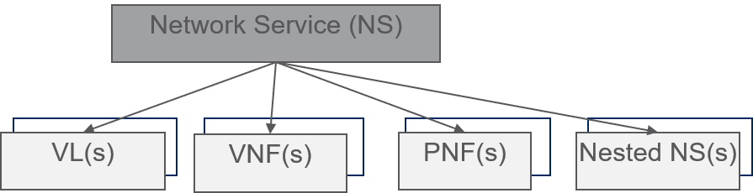

Figure 4.1.1-1: NS constituents overview

4.1.2 Virtualised Network Function (VNF)
The Virtualised Network Function (VNF) construct is defined in ETSI GR NFV 003 [i.1] and represents an NF implementation that can be deployed on a virtualised infrastructure. The VNF construct is agnostic to the functionality of the NF it represents.
From the NFV-MANO perspective, the deployment and operational behaviour requirements of each VNF are captured in a VNF Descriptor (VNFD), which is on-boarded as part of a file archive known as a VNF Package, specified in ETSI GS NFV-IFA 011 [i.8]. The VNFD describes the attributes and requirements necessary to realize an instance of the VNF and captures, in an abstracted manner, the requirements to manage its lifecycle.
NFV-MANO performs the lifecycle management of a VNF instance based on the requirements in the VNFD defined in ETSI GS NFV-IFA 011 [i.8].

4.1.3 Virtualised Network Function Forwarding Graph (VNFFG)
The Virtualised Network Function Forwarding Graph (VNFFG) construct is defined in ETSI GR NFV 003 [i.1] and is used to specify a set of forwarding rules known as Network Forwarding Paths (NFP) applicable to the traffic relayed over a set of Connection Points (CPs) and/or Service Access Points (SAPs) attached to the various NS constituents, where at least one of the constituents is a VNF.
From management and orchestration perspective, NFV-MANO uses the VNFFG Descriptor (VNFFGD) defined in ETSI GS NFV-IFA 014 [i.3].
An example showing a VNFFG is depicted in figure 4.1.3-1.
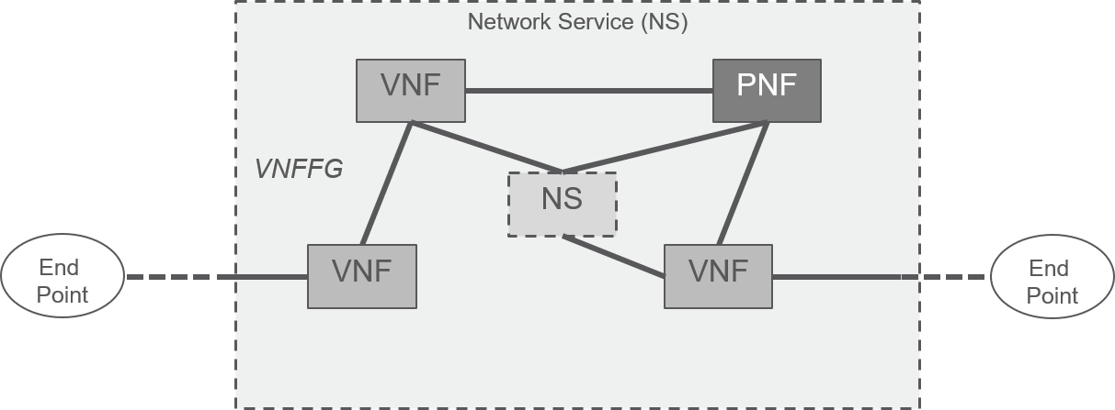

Figure 4.1.3-1: Depiction of a VNF Forwarding Graph

4.1.4 Virtual Link (VL)
The Virtual Link (VL) construct is defined in ETSI GR NFV 003 [i.1]. It abstracts the connectivity type and properties between any two or more of the following: VNF Components (VNFCs), VNFs, PNFs, and nested NSs. From management and orchestration perspective, the NFV-MANO uses the VNF VL Descriptor (VLD) defined in ETSI GS NFV-IFA 011 [i.8] and NS VL descriptor defined in ETSI GS NFV-IFA 014 [i.3].
A VL can span across one or more Wide Area Networks (WANs) when the connectivity requirements are fulfilled between different sites, also known as NFVI-PoPs as defined in ETSI GR NFV 003 [i.1].

4.1.5 Physical Network Function (PNF)
The Physical Network Function (PNF) construct is defined in ETSI GR NFV 003 [i.1] and represents a software workload tightly coupled with the hardware it is deployed on. When a PNF is part of an NS, NFV-MANO uses the PNF Descriptor (PNFD) specified in ETSI GS NFV-IFA 014 [i.3] to manage the PNF connectivity with the other constituents of this NS instance. The PNFD is on-boarded as part of a file archive known as the PNFD archive.
The functional requirements on PNF archive and how a PNF is handled as part of the NS resources, are described in ETSI GS NFV-IFA 010 [1].

4.1.6 Container Infrastructure Service cluster (CIS cluster)
The Container Infrastructure Service cluster (CIS cluster) construct is defined in ETSI GS NFV-IFA 036 [i.12] and represents a set of CIS instances and CISM instances hosted on one or multiple CIS cluster nodes. CIS cluster nodes can be realized as virtual machines or as bare-metal servers.
From the NFV-MANO perspective, the deployment and operational behaviour requirements of the CIS cluster are captured in a CIS Cluster Descriptor (CCD) as specified in ETSI GS NFV-IFA 036 [i.12], which is on-boarded to the CCM and used by the CCM to manage the lifecycle of a CIS cluster.
The CCD references one or multiple CIS Cluster Node Descriptors (CCND) for describing characteristics of CIS cluster nodes that the CIS cluster is hosted on. The CCND references a CIS Cluster Node Resource Descriptor (CCNRD) for describing the CIS cluster node's resource characteristics and necessary information for the basic instantiation of the CIS cluster. Both the CCND and the CCNRD are specified in ETSI GS NFV-IFA 036 [i.12].

4.1.7 Managed CIS Cluster Object (MCCO)
The Managed CIS Cluster Objects (MCCO) construct is defined in ETSI GS NFV-IFA 036 [i.12] and represents an abstract NFV object for CIS Cluster Management characterized by its configuration, state, requested and allocated infrastructure resources and applicable operational policies.
From the NFV-MANO perspective, the CCM uses the MCCO declarative descriptor as specified in ETSI GS NFV-IFA 036 [i.12] to deploy and manage the lifecycle of the MCCOs.

4.1.8 Managed Container Infrastructure Object (MCIO)
The Managed Container Infrastructure Objects (MCIO) construct is defined in ETSI GS NFV-IFA 040 [i.11] and represents an abstract NFV object for container infrastructure service management characterized by the desired and actual state of a containerized workload or subset of it, including the requested and allocated infrastructure resources and applicable operational policies.
From the NFV-MANO perspective, the CISM uses the MCIO declarative descriptor as specified in ETSI GS NFV-IFA 040 [i.11] to deploy and manage the lifecycle of containerized workloads. The aggregate of information objects including MCIO declarative descriptors and configuration files forms a Managed Container Infrastructure Object Package (MCIOP).
The VNF Package contains both the VNFD and MCIOPs, in which the VNFD of a containerized VNF has references to one or multiple MCIOPs that contain declarative descriptors and configuration files for MCIOs consumed by the containerized VNF.

5 NFV-MANO Architectural Framework

5.1 General architecture overview
The NFV-MANO architectural framework is composed of functional blocks and functions realizing management and orchestration capabilities.
The following functional blocks shall be part of the NFV-MANO architectural framework and shall fulfil the functional requirements defined in ETSI GS NFV-IFA 010 [1]:
- Network Functions Virtualisation Orchestrator (NFVO);
- Virtualised Network Function Manager (VNFM);
- Virtualised Infrastructure Manager (VIM);
- Wide area network Infrastructure Manager (WIM).
Additional functional blocks and functions represented in the NFV architectural framework, which interact with the NFV-MANO functional blocks and functions are:
- Element Management (EM);
- Virtualised Network Function (VNF);
- Operation Support System (OSS) and Business Support System functions (BSS);
- NFV Infrastructure (NFVI), including the CIS and WAN.
The NFV-MANO architectural framework shall comprise the following reference points:
- Os-Ma-nfvo, a reference point between OSS/BSS and NFVO;
- Or-Vnfm, a reference point between NFVO and VNFM;
- Or-Vi, a reference point between NFVO and VIM;
- Ve-Vnfm-em, a reference point between EM and VNFM;
- Ve-Vnfm-vnf, a reference point between VNF and VNFM;
- Vi-Vnfm, a reference point between VIM and VNFM;
- Nf-Vi, a reference point between NFVI and VIM;
- Or-Or, a reference point between NFVOs in different administrative domains;
- Or-Wi, a reference point between an NFVO and a WIM.
The following functions shall be part of the NFV-MANO architectural framework and shall fulfil the functional requirements defined in ETSI GS NFV-IFA 010 [1]:
- Container Infrastructure Service Management (CISM);
- Container Image Registry (CIR);
- Container Infrastructure Service Cluster Management (CCM);
- Management Data Analytics Function (MDAF);
- Intent Management (IM).
A series of management service interfaces are exposed by the CISM, CIR, CCM, MDAF and IM functions, which are invoked by consumers within NFV-MANO and/or consumers outside NFV-MANO. The consumers within NFV-MANO include:
- The NFVO consumes management service interfaces produced by the CISM.
- The VNFM consumes management service interfaces produced by the CISM.
- The NFVO consumes management service interfaces produced by the CIR.
- The VNFM consumes management service interfaces produced by the CIR.
- The NFVO consumes management service interfaces produced by the CCM.
- The NFVO consumes management service interfaces produced by the MDAF.
The consumers outside NFV-MANO include:
- The OSS/BSS consumes management service interface produced by the IM.
The CCM, CISM, MDAF and IM function also consume management interfaces produced by other functional blocks or functions, which include:
- The CCM consumes management interfaces produced by the NFVO.
- The CCM consumes management interfaces produced by the VIM.
- The CCM consumes management service interfaces produced by the CISM.
- The CISM consumes management interfaces produced by the VIM.
- The MDAF consumes management interfaces produced by the NFVO.
- The MDAF consumes management interfaces produced by the VNFM.
- The MDAF consumes management interfaces produced by the VIM.
- The MDAF consumes management interfaces produced by the CISM.
- The MDAF consumes management interfaces produced by the CCM.
- The MDAF consumes management interfaces produced by the WIM.
- The IM consumes management interfaces produced by the NFVO.

5.2 Architecture diagram
The NFV-MANO architectural framework defined in the present document is illustrated in figures 5.2-1 and 5.2-2.
Figure 5.2-1 shows the NFV-MANO architectural framework with the WIM as part of NFV-MANO.
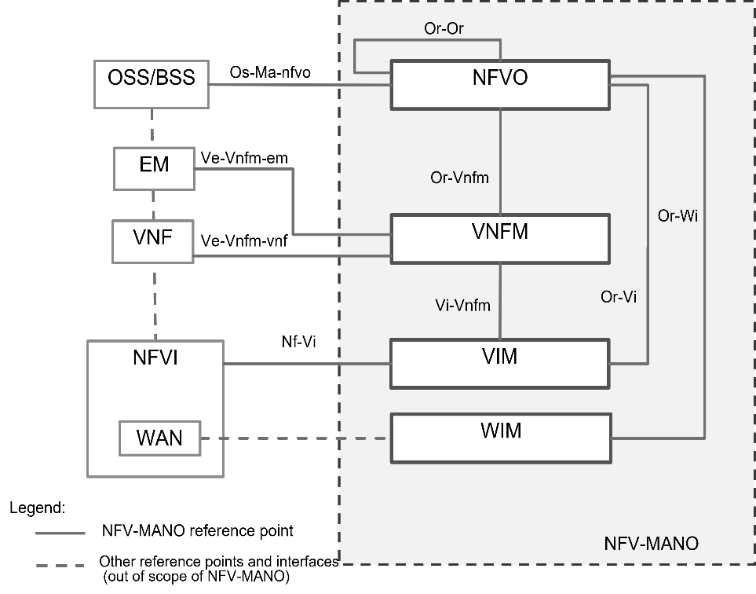

NOTE: The VIM does not manage the whole NFVI, specific parts such as the WAN are managed by the WIM.

Figure 5.2-1: NFV-MANO architectural framework with WIM as part of NFV-MANO
Figure 5.2-2 shows the NFV-MANO architectural framework with the WIM external to NFV-MANO.
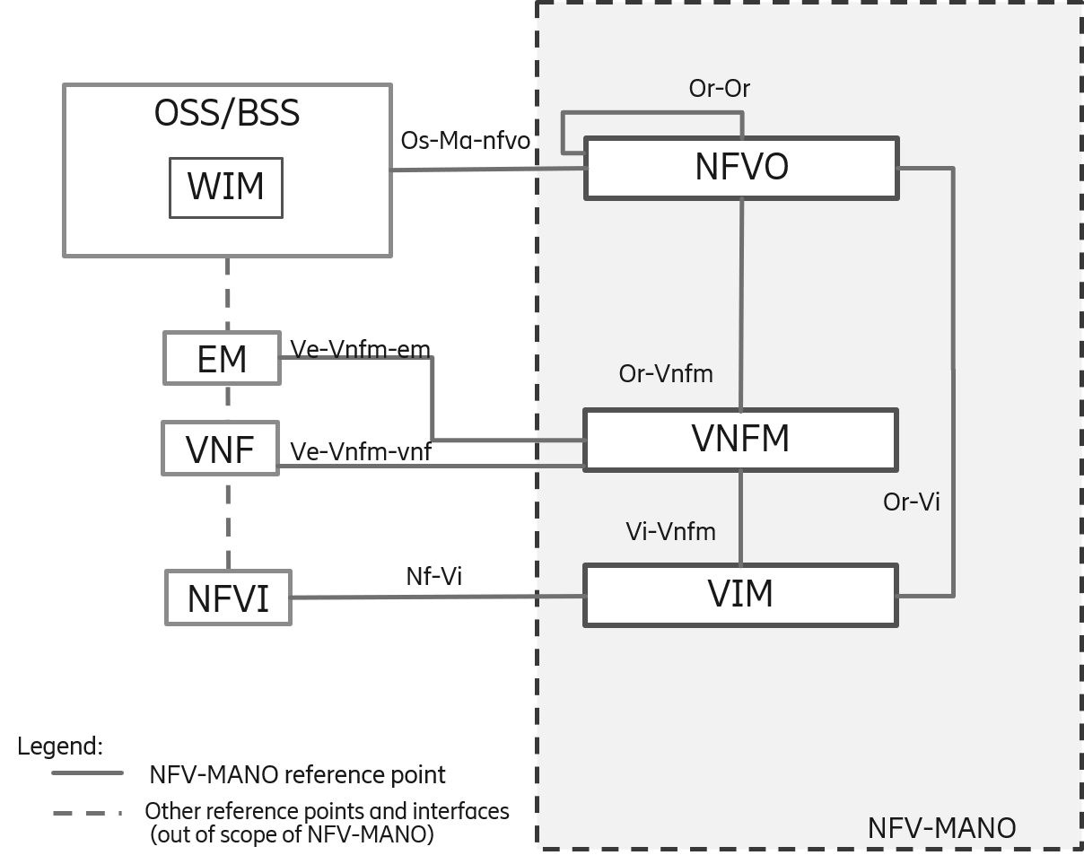

Figure 5.2-2: NFV-MANO architectural framework, WIM external to NFV-MANO
The functions and service interfaces introduced for support of containerized deployments are shown in figure 5.2-3.
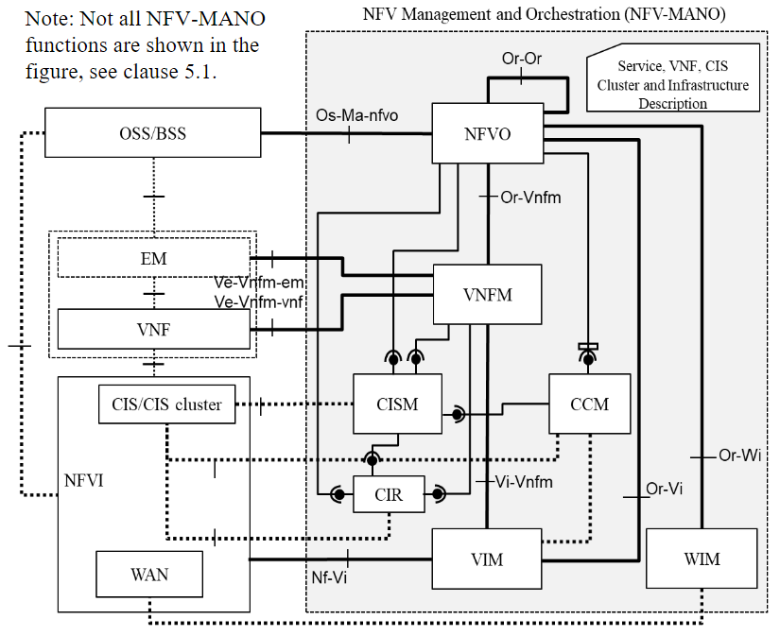

Figure 5.2-3: NFV-MANO architectural framework with support for containers
NOTE 1: The VIM does not manage the whole NFVI, such as the WAN is managed by the WIM, the CIS is managed by the CISM. For the sake of simplicity, this figure only shows the option where the WIM is in NFV-MANO, although the WIM can be external to NFV-MANO.
NOTE 2: There are interactions expected between the CCM and the VIM which are to be specified in a next version of the present document.
The subsequent clauses define the functional blocks, the reference points, the functions and the service interfaces which are composing the NFV-MANO architectural framework. The WIM architecture options are further described in clause 5.3.5.

5.3 Functional Blocks

5.3.1 NFV Orchestrator (NFVO)
The NFVO is a functional block with a definition provided in ETSI GR NFV 003 [i.1]. Its main functions are:
- NS orchestration, including:
- handling the lifecycle management of NSs (NS LCM) and their constituents;
NOTE: In the present document, the management of the composite and nested NSs is provided by NFVOs that reside in same or different administrative domains, or it can be supported within the same NFVO.
- NS performance management (PM) and NS Fault Management (FM);
- on-boarding and management of NSDs;
- on-boarding and management of PNFD archives;
- on-boarding and management of VNF Packages;
- management of software images;
- orchestration of NFVI resources managed by one or more VIMs used for the realization of the NSs and their constituents, including:
- VIM resources allocation and availability tracking;
- virtual resources granting;
- resource reservation management;
- quota and resource capacity management;
- resource performance management;
- resource fault management;
- resource information management;
- permitted allowance management;
- management of connectivity services, used for the realization of the connectivity between NSs and/or NS constituents deployed over different NFVI-PoPs (sites), including:
- management of MSCS between multiple sites;
- management of the WAN capacity and topology information needed for the connectivity between NSs, and/or NS constituents deployed over different NFVI-PoPs, and/or VNFC of a VNF in the case of a multi-site VNF deployment;
- obtaining MSCS fault management data; and
- management of the MSCS performance management data.

5.3.2 VNF Manager (VNFM)
The decoupling of Network Functions (NFs) from the physical infrastructure resulted in a new set of management functions focused on the creation and lifecycle management of the VNF, handled by the VNF Manager (VNFM).
The VNFM is a functional block with a definition provided in ETSI GR NFV 003 [i.1].
The VNFM main functions are to provide:
- VNF LifeCycle Management (LCM).
- VNF configuration management of the configuration parameters of a VNF/VNF Component (VNFC).
- VNF information management for the value changes of VNF related indicators.
- VNF performance management (PM).
- VNF fault management (FM).
In addition, the VNFM can gather and offer information on the VNF behaviour in the form of VNF indicators. VNF indicators are information supplied by the VNF or the EM.
In order to realize these functions, the VNFM consumes interfaces offered by other NFV-MANO functional blocks. The VNFM maintains the mapping between virtual resources and the VNF instance using them. The VNFM acts upon the virtualised resources that support the VNF functionality, but without interfering with it.

5.3.3 Virtualised Infrastructure Manager (VIM)
The Virtualised Infrastructure Manager (VIM) is a functional block with a definition provided in ETSI GR NFV 003 [i.1]. It is responsible for controlling and managing the NFVI virtual resources used by the VNFs and the VLs: compute, storage and network resources, usually within one Infrastructure Domain (e.g. all resources within an NFVI-PoP, resources across multiple NFVI-PoPs, or a subset of resources within an NFVI-PoP).
The VIM northbound interfaces expose one or more of the following: management of NFVI virtualised compute, storage, and networking resources. In order to achieve that, the VIM interacts with the virtualisation layer of the NFVI and this interaction is out of scope of the present document.
A VIM can be specialized in handling a certain type of NFVI resource (e.g. compute-only, storage-only, network-only), or may be capable of managing multiple types of NFVI resources.
The VIM provides the following functionality:
- Software image management.
- Virtualised resources management (compute, storage, network):
- fault management (FM), performance management (PM), configuration management, reservation management, quota management, capacity management, resource information management and Network Forwarding Path (NFP) management.
- Infrastructure resource fault and performance management.
- NFV acceleration capabilities management:
- Some VNFs can have acceleration requirements specified in their VNFD. The VIM has the capability to expose and perform NFV acceleration management on acceleration resources offered by the NFVI.

5.3.4 Functional blocks interacting with NFV-MANO

5.3.4.1 OSS/BSS
The OSS/BSS are the combination of the operator's other operations and business support functions that are not otherwise explicitly captured in the present architectural framework but are expected to have information exchanges with functional blocks in the NFV-MANO architectural framework.
The NFV-MANO interacts with other OSS entities and with BSS, which are consolidated under the OSS/BSS functional block (FB) in the NFV-MANO architectural framework.
The OSS/BSS includes the collection of systems and management applications that service providers use to operate their business, besides NFV-MANO functions like e.g. NFVO, VNFM. Within OSS, these include the other OSS management and orchestration functions which are consuming the NFV-MANO interfaces in order to deliver their own services. These exclude OSS management functions which have a more specialized role in their interaction with NFV-MANO, such as the EM.
The OSS/BSS interacts with NFV-MANO by communicating with the NFVO, via the Os-Ma-nfvo reference point specified in ETSI GS NFV-IFA 013 [i.2].

5.3.4.2 Element Management (EM)
The Element Management (EM) represents the consolidation of all management entities performing the FCAPS management for the application functions of the VNF.
NOTE: The term "Element Manager" is also used in some other documents referred in the present document.
The EM interacts with NFV-MANO by communicating with the VNFM, via the Ve-Vnfm-em reference point specified in ETSI GS NFV-IFA 008 [i.7].
The EM consumes the VNF LCM, VNF PM and VNF FM functionality exposed by the VNFM over Ve-Vnfm-em.
The EM exposes information on the VNF behaviour (VNF indicators) to be reported to the VNFM.

5.3.4.3 Virtualised Network Function (VNF)
The VNF is the entity managed by the VNFM and has an associated VNFD which provides deployment and operational information to manage its lifecycle. The NFV-MANO interacts with the VNF via the Ve-Vnfm-vnf reference point specified in ETSI GS NFV-IFA 008 [i.7].
The VNF consumes the VNF LCM, VNF PM and VNF FM functionality exposed by the VNFM over Ve-Vnfm-vnf and exposes interfaces enabling VNF Configuration and enabling reporting VNF Indicators to the VNFM.

5.3.4.4 Network Function Virtualised Infrastructure (NFVI)
The NFVI definition is available in ETSI GR NFV 003 [i.1]. The NFVI encompasses all the underlying components of the infrastructure, the hardware and the software, which are used to host VNFs. The NFVI exposes the infrastructure resources as virtualised resources to be used by the VNFs and NSs: virtual compute, virtual storage and virtual network resources.
The VIM is the NFV-MANO entity that manages the NFVI resources used by the VNFs and NSs, as well as by the CIS clusters, via the Nf-Vi reference point.
The Container Infrastructure Service (CIS) is a service provided by the NFVI and has a definition in ETSI GR NFV 003 [i.1]. It refers to the service that provides runtime environment for one or more container virtualisation technologies. The CIS is exposed by one or multiple CIS clusters. Containerized VNFs are deployed and managed on CIS instances and make use of container cluster networks deployed in the CIS clusters. The Container Infrastructure Service Management (CISM) is the function that manages the CIS.

5.3.5 WAN Infrastructure Manager (WIM)
The WAN Infrastructure Manager (WIM) is a functional block which provides management of Multi-Site Connectivity Services (MSCS). The WIM establishes the connectivity between NFVI-PoP connectivity service endpoints (e.g. offered by a network gateway) in different NFVI-PoPs using MSCS which abstracts the details of the connections between the NFVI-PoPs on the transport network/WAN.
When considering connectivity between NFVI-PoPs realized over transport network/WAN to fulfil NS level connectivity, a multi-site NS VL encompasses virtual networks in each of the involved NFVI-PoP provided by the VIM and MSCS on the transport/WAN provided by the WIM.
The NFV-MANO architectural framework supports the integration of the WIM with the following two options:
- the WIM may be part of the NFV-MANO; or
- the WIM may be external to NFV-MANO, e.g. under control or part of other OSS/BSS systems.
Annex G of ETSI GS NFV-IFA 010 [1] provides additional information about WIM integration options.
When the WIM is part of the NFV-MANO, it exchanges information with the NFVO using the Or-Wi reference point.

5.4 Reference points

5.4.1 Interfaces approach
NFV-MANO interfaces are defined focusing on the capability they expose. The collection of the interfaces exposed by an NFV-MANO functional block and consumed by another NFV-MANO functional block is mapped into an NFV-MANO reference point. An NFV-MANO interface can be exposed by an NFV-MANO producer on more than one NFV-MANO reference point, where applicable. In such a case, the exposure of the same NFV-MANO interface on different NFV-MANO reference points might lead to certain differences in terms of functionality (e.g. set of allowed operations) or exchanged information (e.g. different sets of operation input/output parameters). The NFV-MANO producer and consumer are described in the present document for each of the NFV-MANO reference points.
While reference points are a way to identify peer-to-peer relationships between functional blocks, descriptions of the interfaces provide a deeper understanding of how capabilities provided by a producer functional block are exposed to other consumer functional block(s).

5.4.2 Os-Ma-nfvo reference point
The reference point Os-Ma-nfvo is used for information exchanges between the OSS/BSS and the NFVO. The interfaces associated with the Os-Ma-nfvo reference point are based on the functional requirements specified in ETSI GS NFV-IFA 010 [1] for the NFVO functional block.
The Os-Ma-nfvo reference point and its interfaces are specified in ETSI GS NFV-IFA 013 [i.2].
Os-Ma in short, is also used as a more generalized indication of the interfaces exposed by NFV-MANO to OSS/BSS.

5.4.3 Or-Vnfm reference point
The Or-Vnfm reference point enables the information exchanges between the NFVO and the VNFM. The interfaces associated with the Or-Vnfm reference point are based on the functional requirements specified in ETSI GS NFV-IFA 010 [1] for the NFVO and the VNFM functional blocks.
The Or-Vnfm reference point and its interfaces are specified in ETSI GS NFV-IFA 007 [i.6].

5.4.4 Ve-Vnfm reference points
Ve-Vnfm is a composition of the reference points between VNFM and EM, and between VNFM and VNF:
- The reference point Ve-Vnfm-em enables information exchanges between the VNFM and the EM.
- The reference point Ve-Vnfm-vnf enables information exchanges between the VNFM and the VNF.
The functionality provided over the Ve-Vnfm reference points are based on the functional requirements specified in ETSI GS NFV-IFA 010 [1] for the VNFM functional block (FB).
The Ve-Vnfm reference point and its interfaces are specified in ETSI GS NFV-IFA 008 [i.7].

5.4.5 Or-Vi reference point
The Or-Vi reference point enables the information exchanges between the NFVO and the VIM. The interfaces associated with the Or-Vi reference point are based on the functional requirements specified in ETSI GS NFV-IFA 010 [1] for the VIM and NFVO functional blocks.
The Or-Vi reference point and its interfaces are specified in ETSI GS NFV-IFA 005 [i.4].

5.4.6 Vi-Vnfm reference point
The Vi-Vnfm reference point enables the information exchanges between the VNFM and the VIM. The interfaces associated with the Vi-Vnfm reference point are based on the functional requirements specified in ETSI GS NFV-IFA 010 [1] for the VIM and VNFM functional blocks.
The Vi-Vnfm reference point and its interfaces are specified in ETSI GS NFV-IFA 006 [i.5].

5.4.7 Nf-Vi reference point
The reference point Nf-Vi enables the external interaction of NFV-MANO with the NFVI.
Nf-Vi is a representation of the information exchanges between the NFVI and the management and orchestration functions in the VIM.

5.4.8 Or-Wi reference point
The reference point Or-Wi enables the information exchanges between NFVO and the WIM. A detailed specification of the interfaces supported over the Or-Wi reference point is available in ETSI GS NFV-IFA 032 [i.9].
The reference point Or-Wi offers the WIM capabilities to the NFVO via the following interfaces:
- MSCS Management interface;
- WAN Capacity Management interface;
- MSCS Fault Management interface; and
- MSCS Performance Management interface.

5.4.9 Or-Or reference point
The reference point Or-Or is used for information exchanges between the NFVOs handling NSs in a hierarchical relationship (i.e. composite NS and nested NS) across multiple NFV administrative domains. The interfaces associated with the Or-Or reference point are based on the functional requirements specified in ETSI GS NFV-IFA 010 [1] for the NFVO functional block.
The Or-Or reference point and its interfaces are specified in ETSI GS NFV-IFA 030 [i.10].

5.5 Functions

5.5.1 Container Infrastructure Service Management (CISM)
The CISM is a function specified in ETSI GS NFV-IFA 040 [i.11] and ETSI GS NFV-IFA 036 [i.12]. Its main capabilities are the handling of:
- OS container workload management.
- OS container compute management.
- OS container storage management.
- OS container network management.
- OS container configuration management.
- CIS instance management.
- CIS storage management.
- Managed CIS Cluster Objects (MCCO) management.

5.5.2 Container Image Registry (CIR)
The CIR is a function specified in ETSI GS NFV-IFA 040 [i.11]. Its main capabilities are the handling of:
- OS container image management;

5.5.3 CIS Cluster Management (CCM)
The CCM is a function specified in ETSI GS NFV-IFA 036 [i.12]. Its main capabilities are the handling of:
- CIS cluster lifecycle management.
- CIS cluster configuration management.
- CIS cluster performance management.
- CIS cluster fault management.

5.5.4 Management Data Analytics Function (MDAF)
The MDAF is a function specified in ETSI GS NFV-IFA 047 [i.14]. Its main capabilities are the handling of:
- Data analytics.

5.5.5 Intent Management (IM)
The IM is a function specified in ETSI GS NFV-IFA 050 [i.x]. Its main capabilities are the handling of:
- Intent management.

5.6 Service interfaces

5.6.1 Interfaces approach
The concept of service interface is introduced in the NFV architectural framework from Release 4. It specifies an interface from the viewpoint of the producer of the interface (i.e. an NFV-MANO function). The requirements describing the relationship between a consumer and its consumed service interfaces are specified in ETSI GS NFV-IFA 010 [1].

5.6.2 OS container workload management service interface
The OS container workload management service interface produced by the CISM provides the capability to a consumer to manage OS container workloads. The interface associated to OS container workload management service is based on the service interface requirements specified in ETSI GS NFV-IFA 040 [i.11].

5.6.3 OS container compute management service interface
The OS container compute management service interface produced by the CISM provides the capability to a consumer to manage Compute MCIOs. The interface associated to OS container compute management service is based on the service interface requirements specified in ETSI GS NFV-IFA 040 [i.11].

5.6.4 OS container storage management service interface
The OS container storage management service interface produced by the CISM provides the capability to a consumer to manage Storage MCIOs. The interface associated to OS container storage management service is based on the service interface requirements specified in ETSI GS NFV-IFA 040 [i.11].

5.6.5 OS container network management service interface
The OS container network management service interface produced by the CISM provides the capability to a consumer to manage Network MCIOs. The interface associated to OS container network management service is based on the service interface requirements specified in ETSI GS NFV-IFA 040 [i.11].

5.6.6 OS container configuration management service interface
The OS container configuration management service interface produced by the CISM provides the capability to a consumer to manage configurations related to OS containers. The interface associated to OS container configuration management service is based on the service interface requirements specified in ETSI GS NFV-IFA 040 [i.11].

5.6.7 CIS instance management service interface
The CIS instance management service interface produced by the CISM provides the capability to a consumer to manage CIS instances. The interface associated to CIS instance management service is based on the service interface requirements specified in ETSI GS NFV-IFA 036 [i.12].

5.6.8 CIS MCCO management service interface
The CIS MCCO management service interface produced by the CISM provides the capability to a consumer to manage MCCOs. The interface associated to CIS MCCO management service is based on the service interface requirements specified in ETSI GS NFV-IFA 036 [i.12].

5.6.9 CIS cluster lifecycle management service interface
The CIS cluster lifecycle management service interface produced by the CCM provides the capability to a consumer to manage the lifecycle of CIS clusters. The interface associated to CIS cluster lifecycle management service is based on the service interface requirements specified in ETSI GS NFV-IFA 036 [i.12].

5.6.10 CIS cluster fault management service interface
The CIS cluster fault management service interface produced by the CCM provides the capability to a consumer to request fault management related to CIS clusters. The interface associated to CIS cluster fault management service is based on the service interface requirements specified in ETSI GS NFV-IFA 036 [i.12].

5.6.11 CIS cluster configuration management service interface
The CIS cluster configuration management service interface produced by the CCM provides the capability to a consumer to request configuration management related to CIS clusters. The interface associated to CIS cluster configuration management service is based on the service interface requirements specified in ETSI GS NFV-IFA 036 [i.12].

5.6.12 CIS cluster performance management service interface
The CIS cluster performance management service interface produced by the CCM provides the capability to a consumer to request performance management related to CIS clusters. The interface associated to CIS cluster performance management service is based on the service interface requirements specified in ETSI GS NFV-IFA 036 [i.12].

5.6.13 CIS cluster security management service interface
The CIS cluster security management service interface produced by the CCM provides the capability to a consumer to request security management related to CIS clusters. The interface associated to CIS cluster security management service is based on the service interface requirements specified in ETSI GS NFV-IFA 036 [i.12].

5.6.14 Data analytics service interface
The data analytics service interface produced by the MDAF provides the capability to a consumer to manage data analytics processes. The interface associated to data analytics service is based on the service interface requirements specified in ETSI GS NFV-IFA 047 [i.14].

5.6.15 Intent management service interface
The intent management service interface produced by the IM provides the capability to a consumer (e.g., OSS/BSS) to manage intents. The interface associated to intent management service is based on the service interface requirements specified in ETSI GS NFV-IFA 050 [i.15].

6 NFV-MANO reliability considerations
The reliability of NFV-MANO is studied in ETSI GR NFV-REL 012 [i.13]. Furthermore, the services provided by NFV-MANO functional blocks include some considerations for the reliability of VNFs and NSs.
For example, fault management interfaces produced by the different NFV-MANO functional blocks and consumed by other NFV-MANO functional blocks, as well as by non-MANO functional blocks (such as EM, VNF and OSS/BSS), allow transferring information about alarms in the form of notifications. In cases of e.g. resource failures, the consumer functional blocks can further trigger appropriate actions to maintain the VNF and NS availability levels, e.g. perform a healing.
Likewise, the NFV-MANO descriptors include information that can be used for reliability and availability purposes. Such examples include:
- an indication on whether VNF auto-healing can be triggered by the VNFM;
- the possibility to include anti-affinity constraints used by NFV-MANO for making resource placement decisions, i.e. setting an anti-affine relation between instances of the same object reduces the risk that they all fail at the same time within the scope of that constraint.

7 NFV-MANO security considerations
Security aspects corresponding to NFV-MANO capabilities concentrate on:
- Protection of the information exchanges over the reference points via:
a) authentication and authorization; and
b) message encryption and integrity.
- Integrity protection of the VNF Package, PNF archive file and the NSD archive file. Additional confidentiality protection of the VNF Package artifacts can also be done at onboarding, based on the service provider security policies.
Security requirements specified in ETSI GS NFV-IFA 010 [1] cover authentication, authorization, encryption and integrity protection of the data exchanges, within the NFV-MANO architectural framework as well as with external functional blocks.

Annex A (informative):
Change History
Date | Version | Information about changes
February 2020 | 0.0.1 | First draft, introducing the document skeleton and introduction based on:  - NFVIFA(20)000070r2_NFV006_Skeleton  - NFVIFA(20)000107r1_NFV006_Introduction
March 2020 | 0.0.2 | Incorporates approved contributions:  - NFVIFA(20)000108r2_NFV006_clause_4_NS  - NFVIFA(20)000111r1_NFV006_clause_4_VNF  - NFVIFA(20)000112r1_NFV006_clause_5_Interfaces
May 2020 | 0.0.3 | Incorporates approved contributions:  - NFVIFA(20)000283r2_NFV006_clause4_VNFFG  - NFVIFA(20)000317r1_NFV006_NFV-MANO_architecture_overview  - NFVIFA(20)000323r2_NFV006_NFVO_FB_clause5_3_1  - NFVIFA(20)000362r1_NFV006_VNFM_FB__clause5_3_2  - NFVIFA(20)000364r1_NFV006_VIM_FB_clause5_3_3  - NFVIFA(20)000363r3_NFV006_architecture_figure_5_2
July 2020 | 0.0.4 | Incorporates approved contributions:  - NFVIFA(20)000398r1_NFV006_OSS_BSS_FB_new_clause  - NFVIFA(20)000486r2_NFV006_VL_description  - NFVIFA(20)000488r1_NFV006_VNF_FE_new_clause  - NFVIFA(20)000489r1_NFV006_PNF_description  NFVIFA(20)000490r1_NFV006_NFVI_FE_new_clause
September 2020 | 0.0.5 | Incorporates approved contributions:  - NFVIFA(20)000487r3_NFV006_EM_FE_new_clause  - NFVIFA(20)000506r1_NFV006_OsMa_rp_new_clause  - NFVIFA(20)000507r1_NFV006_OrVnfm_rp_new_clause  - NFVIFA(20)000508r1_NFV006_VeVnfm_rps_new_clause  - NFVIFA(20)000509_NFV006_OrVi_rp_new_clause  - NFVIFA(20)000510r1_NFV006_ViVnfm_rp_new_clause  - NFVIFA(20)000511r2_NFV006_NfVi_rp_new_clause  - NFVIFA(20)000513r2_NFV006_NFV-MANO_security_new_clause
September 2020 | 0.0.6 | Stable draft, incorporates approved contributions:  - NFVIFA(20)000512r2_NFV006_NFV-MANO_reliability_new_clause  Editorials:  Removed empty Annexes
November 2020 | 0.0.7 | Final draft, incorporates approved contributions:  - NFVIFA(20)000686_NFV006_stable_draft_review_with_editorial_changes  - NFVIFA(20)000700r1_NFV006_Normative_language_comments  - NFVIFA(20)000704r2_NFV006_-_Editorial_Review  - NFVIFA(20)000705r2_NFV006_-_Small_technical_enhancements  Editorials:  Aligned the numbering for the informative references throughout the document
August 2021 | 3.0.1 | Initial draft for Release 3, based on the approved Release 2 specification version.  The references to Release 2 are replaced with Release 3.
January 2022 | 3.0.2 | Incorporated approved contributions:  - NFVIFA(21)0001083r1  - NFVIFA(21)0001091r1  - NFVIFA(21)0001095  - NFVIFA(21)0001096r1  - NFVIFA(22)000017r1
February 2022 | 3.0.3 | Incorporated approved contributions:  - NFVIFA(21)0001084r3
April 2022 | 3.0.4 | Incorporated approved contribution:  - NFVIFA(22)000219r1_NFV006rel3_Architecture_figure_EN
April 2022 | 3.0.5 | Final draft ed361, incorporates approved contributions:  - NFVIFA(22)000271r1_NFV006ed361_Multiple_clauses_review_of_WIM_aspects  - NFVIFA(22)000272_NFV006ed361_Multiple_clauses_review_of_multi-domain_aspects  - NFVIFA(22)000273_NFV006ed361_Annex_A_Bringing_back_contribution_history
June 2022 | 4.0.1 | Initial draft version for NFV Rel-4 (ed441) based on the published version of NFV006ed361
Sept 2022 | 4.0.2 | Incorporate approved contributions:  - NFVIFA(22)000421r2_NFV006ed441_General_architecture_overview_extension  - NFVIFA(22)000439r4_NFV006ed441_Architecture_diagram_update  - NFVIFA(22)000440r1_NFV006ed441_Add_function_description  - NFVIFA(22)000523r1_NFV006ed441_Add_CIS_description  - NFVIFA(22)000525r1_NFV006ed441_Add_CISM_and_CCM_related_managed_objects_and_dec  - NFVIFA(22)000526r1_NFV006ed441_Add_service_interface_description  - NFVIFA(22)000563r1_NFV006ed441_Add_interfaces_approach_for_service_interfaces  - NFVIFA(22)000564_NFV006ed441_EN_s_resolution_for_Figure_5_2-3_in_NFVIFA_22_00  - NFVIFA(22)000597_NFV006ed441_EN_s_resolution_for_synchronizing_with_IFA036_fi
October 2022 | 4.0.3 | Incorporate approved contributions:  - NFVIFA(22)000701r1_NFV006_two_review_comments
October 2022 | 4.0.4 | Incorporate approved contributions:  - NFVIFA(22)000708r1_NFV006_add_description_of_Vi-Cc_reference_point
November 2022 | 4.0.5 | Incorporate approved contributions:  - NFVIFA(22)000694r1_NFV006_-_Review_Comments_-_Miscellaneous_improvements  - NFVIFA(22)000775r4_NFV006ed441_Consistency_fix_on_figure_and_708_NWI.docx  Final draft for ISG approval for ed441.
November 2022 | 4.0.6 | Two editorials in clause 4.1.6 and 5.3.4.4 that were missed from:  - NFVIFA(22)000694r1_NFV006_-_Review_Comments_-_Miscellaneous_improvements
January 2024 | 4.2.0 | Incorporate approved contributions:  - NFVIFA(23)000729r2_NFV006ed451_Add_MDAF_related_architectural_specification  - NFVIFA(23)000831r2_NFV006ed451_Add_IM_related_architectural_specification

History
Document history
V4.4.1 | December 2022 | Publication

